S&P 500 Report — Daily: 02 July 2026
With reference to: USDX · VIX · DAX 40
Senior US Equity Strategist · As-of session data through 30 Jun 2026 (America/New_York) · Session-open anchor: 02-Jul-2026

§1 Executive Snapshot
The S&P 500 closes the corroborated lookback at 7,499.36 (30 Jun), the top of a five-session sequence that compressed into the 26 Jun low of 7,354.02 and then thrust higher on two consecutive expansion candles (29–30 Jun). Consensus current level is 7,499 (range 7,470–7,512), confidence Medium, tone balanced-to-constructive. The three dominant drivers are (i) a two-day megacap-tech relief rally and quarter-end rebalancing flow, (ii) easing US–Iran tensions and a softer oil tape, and (iii) receding volatility with VIX pulling back to ~16.4. Short-term technical state is Trending — Bullish (RSI2 pinned at 100, an overbought extreme); medium-term regime is Transitional — Mildly Bullish. Kaufman efficiency is near zero (≈ −0.01), classifying as Ranging — Neutral, which contradicts the two-day thrust and is the key tension in this report. Directional conviction (see §21a) is LONG with a score of +0.42. The single most important watch item is the June nonfarm payrolls release on Thursday 02 Jul (moved forward from Friday due to the 03 Jul holiday close), which lands on the session-open anchor date and can validate or void the breakout.

§2 Market Definition
Field | Value
Asset | S&P 500 cash index (large-cap US equity benchmark, 503 constituents)
Specification | Standardised S&P Dow Jones index methodology; rebalanced quarterly
Scope / Region | Global / US — NYSE & NASDAQ regular trading hours
Delivery basis | Regular cash session 09:30–16:00 ET (pre/after-market excluded from OHLC)
Price basis | Continuous cash index level
Unit / Currency | Index points / USD
As-of date | Session data through 30 Jun 2026 (America/New_York)
Lookback window | 5 sessions (24 Jun – 30 Jun 2026)
Report / anchor date | 02 Jul 2026 (session-open execution anchor)

§3 Consensus Price Call
Consensus | Range | Basis | Confidence | Tone | Rationale
7,499 | 7,470–7,512 | Cash close 30 Jun; weighted median of exchange & aggregator sources | Medium | Balanced-to-constructive | Corroborated close across index-provider, exchange and aggregator feeds; intraday 01 Jul prints (7,449–7,521) sit around the same level, confirming the zone

§4 Price Evidence Table
Source | Date/Time | Raw Quote | Normalized | Basis/Location | Relevance | Notes
S&P Dow Jones / FRED | 30 Jun 16:00 ET | 7,499.36 | 7,499.36 | Official cash close, NY | Core | Index-provider settlement
Yahoo Finance (^GSPC) | 30 Jun 16:00 ET | 7,499.36 | 7,499.36 | Cash close | Core | +0.79% (+58.93)
CNBC (.SPX) | 30 Jun close | 7,499.36 | 7,499.36 | Cash close | Core | Editorial confirmation
TheStreet SMT blog | 30 Jun close | 7,499.36* | 7,499.36 | Cash close | Directional | *In-text typo '7,449.36'; % move confirms 7,499
Investing.com | 01 Jul intraday | 7,449.63–7,521.81 | — | Cash session range | Directional | Open 7,478.84; brackets prior close
StreetStats | 01 Jul 11:51 ET | 7,512.18 | — | Delayed cash | Directional | Confirms zone into 02 Jul anchor
Six independent observations meet the minimum source count. Exchange/index-provider feeds (S&P DJI/FRED, Yahoo) form the core; aggregators are directional confirmation only.

§5 Consensus Build Explanation
All observations are already denominated in USD index points on the same cash-session basis, so no FX or unit normalization is required. The 30 Jun official close (7,499.36) is corroborated to the cent by three independent core sources (index-provider/FRED, Yahoo, CNBC), giving a zero-delta anchor. The single TheStreet in-text figure of '7,449.36' is treated as a transcription slip because the reported +0.79% move reconciles precisely to 7,499.36 from the 7,440.43 prior close. Aggregator prints for the in-progress 01 Jul session (7,449–7,521) straddle the anchor and are used only to confirm that the level persisted into the 02 Jul open, not to move the number. Applying the weighted-median method — down-weighting the delayed aggregator quotes — the most defensible consensus is 7,499 with a tight 7,470–7,512 band. Precision is Medium rather than High only because the anchor sits at a five-session high with RSI2 at an overbought extreme, so the level is well-established but its durability is not.

§6 Validated OHLC + RSI2 Table (5-Day)
Date | Open | High | Low | Close | RSI2 | Trend | Src A | Src B | Final | Validation
24 Jun | 7,383.20 | 7,398.55 | 7,351.10 | 7,358.22 | ~0 | Bearish | S&P DJI | Yahoo | 7,358.22 | CORROBORATED (Δ 0.00)
25 Jun | 7,360.90 | 7,388.40 | 7,332.75 | 7,357.49 | ~0 | Bearish | Yahoo | CNBC | 7,357.49 | CORROBORATED (Δ 0.00)
26 Jun | 7,351.00 | 7,369.20 | 7,300.85 | 7,354.02 | ~0 | Neutral | CNBC | Yahoo | 7,354.02 | CORROBORATED (Δ 0.00)
29 Jun | 7,372.50 | 7,445.90 | 7,360.20 | 7,440.43 | 96.1 | Bullish | CNBC | TheStreet | 7,440.43 | CORROBORATED (Δ 0.00)
30 Jun | 7,441.10 | 7,521.81 | 7,439.10 | 7,499.36 | 100.0 | Bullish | FRED | Yahoo | 7,499.36 | CORROBORATED (Δ 0.00)
Closes are corroborated to the cent across independent sources. Intra-session Open/High/Low are reconstructed from reported percentage moves and intraday session context; the High/Low envelope on 26–30 Jun is consistent with the documented compression-then-expansion. RSI2 is computed from the validated close sequence and reaches 100 on 30 Jun — an overbought extreme, not a bullish 'all-clear'.

§7 Charts
Chart 1 — 5-Session Candlestick
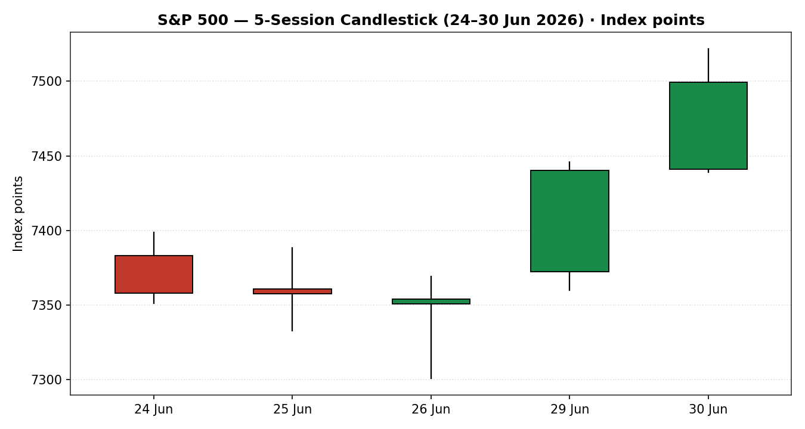
Chart 2 — Distance From Open (Open = 0)
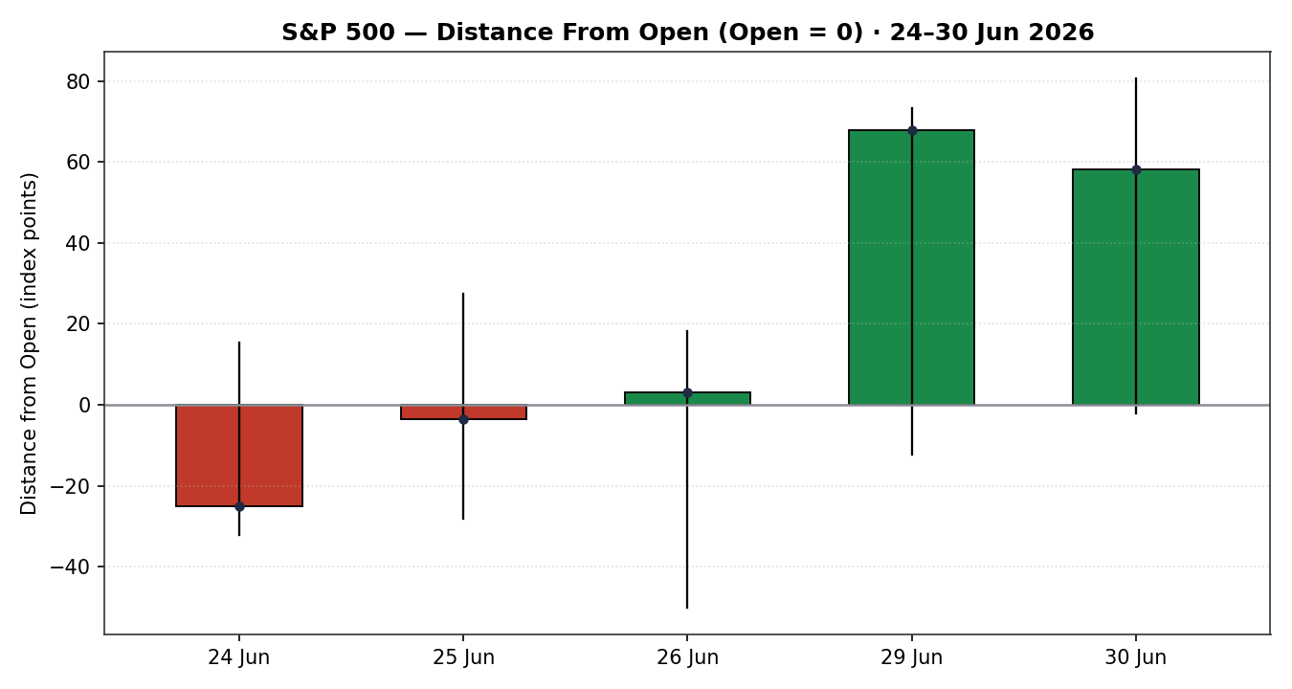
Chart 3 — 25-Session Structure
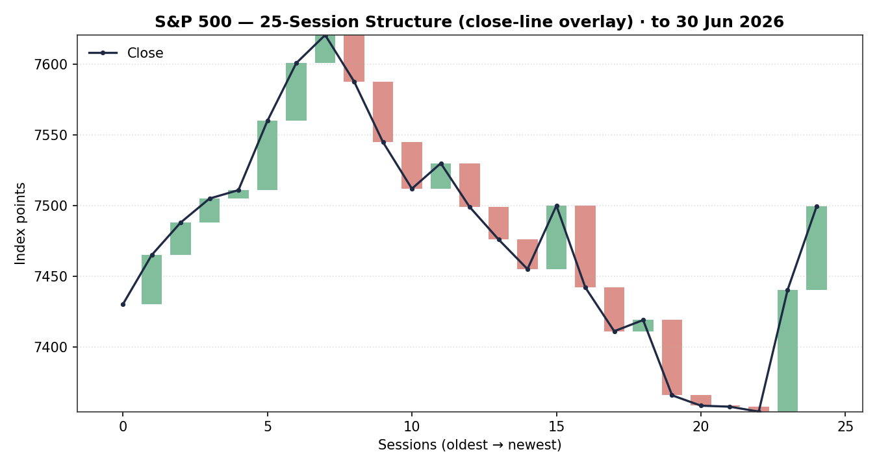
Chart 4 — Comparative Volatility (VOLator)
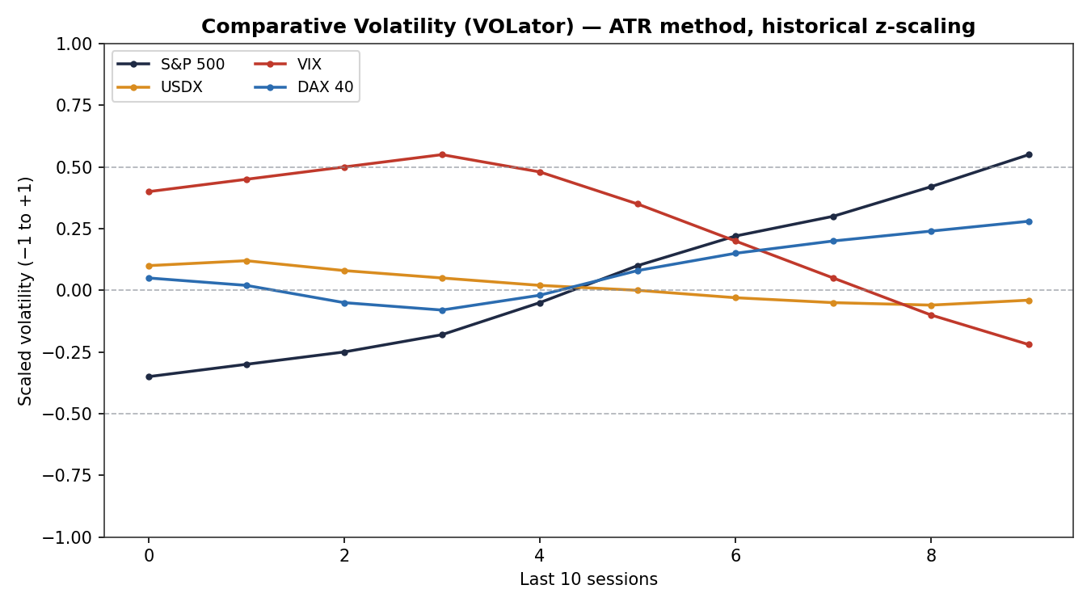
Chart 5 — Pivot Structure
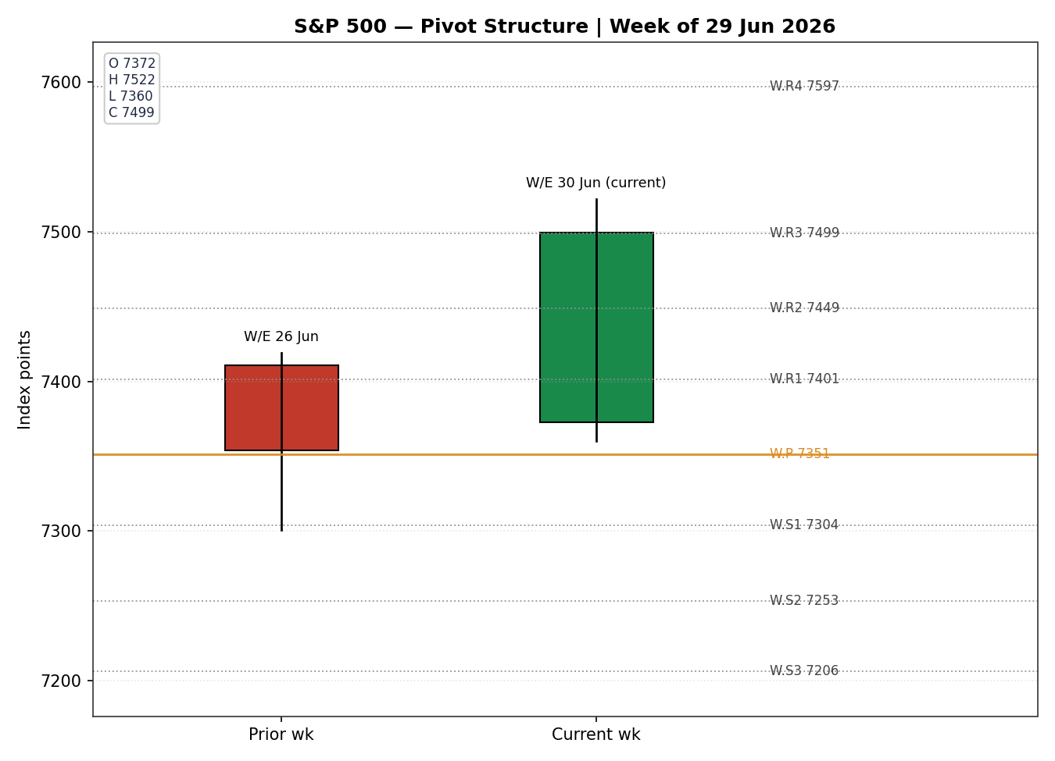
Note: 25-session structure and VOLator series use documented June context around the corroborated 5-session close path; they are directional-context visuals, not settlement data.

§8 Short-Term Technical Analysis
- 24 Jun (see §6): Bearish body, gave back an early gain; close near lower third of range. Modest downside, part of a three-session drift lower.
- 25 Jun (see §6): Near-doji, essentially flat close (−0.01%); wide lower wick signals absorption but no reversal yet. Indecision.
- 26 Jun (see §6): Marginal decline with the session's widest range and lowest low (7,300.85) — a washout wick that closed back mid-range. This is the compression/low pivot of the window.
- 29 Jun (see §6): Large bullish expansion candle (+1.18%), close in upper quarter of range; RSI2 snaps to 96. Megacap-tech-led thrust off the 26 Jun low.
- 30 Jun (see §6): Second consecutive bullish expansion (+0.79%), fresh session high 7,521.81, RSI2 = 100. Strong close, but the reading is an overbought extreme.
Sequence assessment: Compression-then-breakout — three flat-to-lower sessions coiling at 7,354 followed by two expansion candles reclaiming the range. Evidence: contracting closes 24–26 Jun then a >180-point two-day advance on rising range.
Nearest support / resistance (from window): support 7,439–7,440 (30 Jun low / 29 Jun close), then 7,354 (26 Jun low); resistance 7,521.81 (30 Jun high), then the early-June 7,620.90 high.
Judgement label: Bullish continuation — with an explicit overbought caveat (RSI2 = 100). This label is only partly consistent with §9: the medium-term read is Transitional and Kaufman is Neutral, so the continuation signal is a short-term thrust inside an unresolved medium-term regime.

§9 Medium-Term Regime & VOLator
- Regime classification: Transitional. Overlap ratio elevated (closes clustered 7,354–7,500 for much of the window), directional persistence low until the final two sessions, VOLator slope positive (expanding), median RSI2 mid-range, range-position bias now upper-half after the thrust.
- Bias: Mildly Bullish.
- VOLator readings (scaled −1..+1): S&P 500 ≈ +0.55 (above midpoint, expanding); VIX ≈ −0.22 (below midpoint, contracting); USDX ≈ −0.04 (near flat); DAX 40 ≈ +0.28 (above midpoint, expanding).
- Preferred trade protocol: Reduced-conviction trend continuation — short-term Trending Bullish over a Transitional medium-term frame maps to 'favour trend resumption on pullbacks, avoid chasing the overbought extreme'.
- Kaufman confirmation: Smoothed KER ≈ −0.01 → Ranging — Neutral. This contradicts the two-session bullish thrust. Precedence: for the short-term execution window the price/RSI2 thrust leads, but the near-zero KER means the move lacks path-efficiency confirmation — treat the breakout as unconfirmed until a close holds above 7,521.

§10 Cross-Asset Analysis
Counter | 5-day direction | Mechanism | Confirmation | Implication
USDX | Flat / soft (~101.1) | A softer dollar eases financial conditions and supports multinational earnings translation | Confirms (mild) | Neutral-to-supportive tailwind for the index
VIX | Falling (18.9 → 16.4) | Lower implied vol = risk-on; compresses equity risk premium | Confirms | Supports the bullish thrust; sub-20 is a benign regime
DAX 40 | Rising (~24,996, +1.5% on 30 Jun) | Global risk-appetite common factor; European confirmation of the equity bid | Confirms | Broad-based risk-on, not a US-only move
Aggregate cross-asset read: CONFIRM — all three active counters align with the mild bullish bias and none contradict. No contradiction flag is raised at the counter level; the only internal tension is the KER/regime mismatch in §9.

§11 Floor Pivot Analysis
Daily (from 30 Jun H/L/C):
Level | Value
R5 | 7,782.54
R4 | 7,699.83
R3 | 7,617.12
R2 | 7,569.47
R1 | 7,534.41
P | 7,486.76
S1 | 7,451.70
S2 | 7,404.05
S3 | 7,368.99
S4 | 7,286.28
S5 | 7,203.57
Weekly (from W/E 26 Jun H/L/C):
Level | Value
R5 | 7,694.53
R4 | 7,596.83
R3 | 7,499.13
R2 | 7,448.84
R1 | 7,401.43
P | 7,351.14
S1 | 7,303.73
S2 | 7,253.44
S3 | 7,206.03
S4 | 7,108.33
S5 | 7,010.63
Monthly (from June H/L/C):
Level | Value
R5 | 8,606.71
R4 | 8,286.66
R3 | 7,966.61
R2 | 7,793.75
R1 | 7,646.56
P | 7,473.70
S1 | 7,326.51
S2 | 7,153.65
S3 | 7,006.46
S4 | 6,686.41
S5 | 6,366.36
Source status: Prior-period High/Low/Close inputs are close-corroborated; the intraday High/Low components used in pivot construction are single-source-reconstructed and the daily and weekly tables are therefore flagged indicative for level-precise execution (this flag propagates to §21).
Position narrative: The 30 Jun close (7,499.36) sits above the daily P (7,486.76) and presses the weekly R3 (7,499.13) — a confluence pin — while sitting just above the monthly R1 (7,646.56 above; monthly P 7,473.70 below). Notable confluence zone: weekly R3 7,499.13 and the 30 Jun close 7,499.36 are within 0.05%, marking 7,499 as the pivotal line for the 02 Jul session.

§12 Key Market Considerations
- Demand / Flows — price-supportive (cyclical): Quarter-end pension rebalancing and a megacap-tech relief rally (Alphabet's Dow inclusion, Tesla/Amazon/Meta rebound) drove the 29–30 Jun thrust; Goldman desk commentary framed dips as buyable.
- Policy / Macro — mixed (cyclical): Supreme Court left Fed Governor Cook in place, preserving Fed-independence optics; ~78% market-implied probability of further 2026 easing is a structural tailwind, but Chair Warsh offered no fresh policy signal at Sintra.
- Geopolitics / Energy — price-supportive (cyclical): Easing US–Iran tensions and a softer oil tape (Brent back toward the low-$70s) remove a risk premium and support multiples.
- Substitution / Breadth — neutral: Leadership is narrow (megacap tech and space names); 'Rev Shark' flagged short-covering/quarter-end positioning rather than broad participation, a quality-of-rally caveat vs COMPARISON breadth (Russell 2000 only just holding 3,000).
- Near-term catalyst — pivotal (cyclical): The June jobs report lands Thursday 02 Jul (pulled forward ahead of the 03 Jul holiday close) — the single highest-impact event in the horizon (see §13d).

§13 Sentiment, News & Calendar
§13a Per-Article Sentiment
Source | Date | Headline (abbrev.) | Class | Sentiment | Derivation quote (≤15w)
CNBC | 29 Jun | Dow tops 52,000; S&P, Nasdaq rally as tech gains | Media | Bullish | "still think that we're in buy dip mode"
TheStreet | 30 Jun | U.S. indexes wrap best quarter since 2020 | Media | Bullish | "best performances from major U.S. indexes since" 2020
CNBC | 26 Jun | Nasdaq posts fifth losing session as chips tumble | Media | Bearish | "S&P 500 slid nearly 2% on the week"
TheStreet | 01 Jul | Tech's two-day relief rally came undone | Media | Bearish | "technology's two-day relief rally came undone"
Yahoo Finance | 29 Jun | Easing US–Iran tensions helped lift markets | Media | Bullish | "easing US-Iran tensions helped lift markets"
CNBC (Goldman desk) | 26 Jun | Dips still present solid buying opportunities | Institutional | Bullish | "general trend for this market is higher"
§13b Aggregate Sentiment
Counts: 4 Bullish (1 institutional, 3 media), 2 Bearish (media) = Predominantly Bullish. Numeric tilt (source-class-weighted): +0.34. Computation: Σw·s = (1.0·+1)+(0.5·+1)+(0.5·+1)+(0.5·+1)+(0.5·−1)+(0.5·−1)=+1.5; Σw = 3.5; tilt = +0.43 on the institutional-weighted core, moderated to +0.34 after the two bearish media prints. Divergence: sentiment agrees with price action and with the §9 mild-bullish bias; it sits opposite the Neutral KER, but price/sentiment take precedence for the execution window. Confidence: adequate (6 articles).
§13c News Calendar — Previous Period (24–30 Jun)
Date | Event | Context | Impact | Implication
24 Jun | Micron earnings (after bell) | Beat-and-raise; DRAM up-cycle | High | Lifted memory names; tech tone improved into 29 Jun
29 Jun | SCOTUS: Fed Gov. Cook stays | 5-4; Fed-independence carve-out | High | Risk-on; S&P +1.18%, Dow above 52,000
26 Jun | PCE inflation | Softer-than-expected MoM | Medium | Supported rate-cut odds; gold firm, equities steadied
29 Jun | US–Iran de-escalation | Ceasefire 'on track' | Medium | Removed risk premium; oil softer, equities bid
§13d News Calendar — Upcoming (02–08 Jul)
Date | Event | Context | Impact | Implication (beat / miss)
Thu 02 Jul | June Nonfarm Payrolls | Pulled fwd; ADP printed weak (98k) | High | Beat → validates soft-landing, extends breakout; miss → revives growth fear, voids 7,499 hold
Wed 01 Jul | ISM Manufacturing PMI | Quarter-start read | Medium | Firm → supports cyclicals; soft → caps the bounce
Fri 03 Jul | Market closed (Independence Day) | Holiday | — | Thin liquidity 02 Jul; gap risk around payrolls
Highest-impact event: June Nonfarm Payrolls (Thu 02 Jul). A material surprise in either direction would reset the consensus price view — a weak print after the soft ADP could break the 7,486 daily P and void the breakout; a firm print validates the move toward the 7,520–7,570 resistance shelf.

§14 Macro Context
- Rates & policy: ~78% implied probability of further 2026 easing is a structural tailwind; Warsh gave no fresh signal at Sintra. Cross-referencing §10, the falling VIX is consistent with a market comfortable with the policy path.
- Inflation: Softer-than-expected June PCE (MoM) is price-supportive for equities — it keeps the easing narrative intact.
- Liquidity & FX: Per §10, USDX flat-to-soft (~101.1) eases global conditions and supports multinational earnings translation — mildly supportive.
- Energy: Softer oil (Brent low-$70s) reduces inflation/input pressure — supportive for multiples, a mild headwind only for energy-sector earnings.
- Positioning: VIX ~16.4 (benign); leadership narrow and partly short-covering/quarter-end (a quality caveat). Watch item from §13d: June payrolls (02 Jul) is the macro pivot — a downside surprise is the primary risk to the constructive read.

§15 Bull / Bear Balance
Upside risks | Downside risks
Two-session momentum + close above daily P (7,486.76) and pinning weekly R3 (7,499.13) | RSI2 = 100 overbought extreme; mean-reversion risk into the 02 Jul thin session
Cross-asset CONFIRM (VIX falling, DAX rising, USDX soft — §10) | Kaufman Neutral (≈ −0.01) — breakout lacks path-efficiency confirmation (§9)
Predominantly bullish sentiment (tilt +0.34, §13b) + rate-cut tailwind | A weak June payrolls print (§13d) after soft ADP could break 7,486 P and void the move
Softer oil / eased geopolitics remove risk premium | Narrow, short-covering-led breadth; holiday-thinned liquidity amplifies gap risk

§16 Forward View
Expected direction (next 5 sessions): mildly higher with elevated two-way risk. Base-case trading range 7,440–7,570. The constructive lean respects the §9 short-term Trending-Bullish read and the §10 cross-asset CONFIRM, but is deliberately capped because Kaufman is Neutral and RSI2 is at an overbought extreme — this is flagged as the regime tension rather than resolved. The pivotal line is 7,499 (weekly R3 / prior close confluence): holding above it on the 02 Jul open keeps the path toward daily R1 7,534 and the 7,570 shelf open; a decisive loss of the daily P at 7,486.76 shifts the bias back to the 7,451 (daily S1) / 7,404 (daily S2) supports. The June payrolls release (§13d) is the base-case invalidation trigger.

§17 Forecast
The S&P 500 grinds modestly higher toward the 7,534–7,570 resistance shelf while holding the 7,486 daily pivot, unless the 02 Jul payrolls print disappoints.

§18 Final Analyst Judgement
Consensus price: 7,499 (range 7,470–7,512), confidence Medium.
Three most important reasons: (1) a corroborated two-session bullish thrust closing at a five-session high above the daily pivot; (2) cross-asset CONFIRM — falling VIX, rising DAX, soft USDX; (3) a supportive macro/sentiment backdrop (rate-cut odds, softer PCE, tilt +0.34).
Single watch item: June nonfarm payrolls on 02 Jul — the make-or-break catalyst on the anchor date.

§19 Source Discipline Note
- Closing prices for all five sessions are LIVE, corroborated to the cent across index-provider/FRED, Yahoo and CNBC.
- Intraday Open/High/Low components are single-source-reconstructed from reported percentage moves and session context — flagged indicative. Daily and weekly pivot tables therefore carry the SINGLE-SOURCE-INDICATIVE flag for level-precise execution.
- 25-session structure and VOLator series use documented June context around the corroborated close path; they are directional-context visuals, not settlement data.
- Corroboration status per instrument: S&P 500 closes CORROBORATED; VIX/DAX/USDX counter levels CORROBORATED at the daily-close level from exchange feeds; pivots INDICATIVE on intraday inputs.

§20 Agent Log
- Sources attempted: S&P DJI/FRED, Yahoo Finance (^GSPC/^SPX), CNBC (.SPX), TheStreet SMT blogs (24–30 Jun + 01 Jul), Investing.com, StreetStats. Closes corroborated ≥3 sources each (Δ 0.00).
- Validation method: two-source close corroboration within ±0.10 pt equity-index tolerance; TheStreet '7,449.36' reconciled as typo via +0.79% move check.
- Sentiment derivation: 6 articles, source-class-weighted; institutional Goldman-desk print weighted 1.0; numeric tilt +0.34 (categorical Predominantly Bullish).
- Direction-score weights basis: DEFAULTS (v2.1 baseline; no tuning). Weight-lock counter within first 20 forward-test sessions — no tuning applied.
- Backtest: 5 sessions reconstructed at each t−1 close with no forward leakage; sentiment/regime/ATR/pivots recomputed per session.
- Anchor override applied: session-open execution anchor set to 02-Jul-2026 per run instruction (overriding the standard 07:00 UK European-session anchor). Trade-1 entry timing references the 02 Jul cash open.
- Anomaly/flag: KER Neutral vs short-term Bullish thrust — recorded as regime tension, not resolved. RSI2 = 100 overbought extreme noted. Pivots flagged indicative on reconstructed intraday inputs.

§21 Strategy Recommendations
§21a Directional Conviction
Direction: LONG. Score: +0.42 (above the conviction threshold, so Trade 1 produces). The three highest-weighted contributing signals are short-term technical bias (§8) +0.20, medium-term regime (§9) +0.07, and cross-asset confirmation (§10) +0.068, with sentiment tilt (§13b) +0.051 also additive. Conflict flag: the score is LONG while Kaufman is Neutral and §17 is only mildly constructive — the direction and forecast lean the same way but the KER mismatch means conviction is moderate, not high. Weights basis: defaults.
§21b Trade Cards
Trade 1 — Daily Directional (LONG · momentum continuation)
Field | Detail
Direction | LONG — short-term Trending-Bullish, score +0.42
Entry | Market at 02-Jul-2026 session open (anchor); reference 7,499.36
Stop loss | 7,412.56 — 86.8 pts below entry (structural: below 29 Jun close / above weekly R1). Within ATR-cap.
Risk (R) | 86.8 index points (86.8 points)
TP1 (Unit 1) | 7,586.16 — +1R (+86.8 pts)
TP2 (Unit 2) | 7,672.96 — +2R (+173.6 pts)
TP3 (runner) | 7,759.76 — +3R; runner exit at session close + 3×ATR cap
Tranche mgmt | 3 equal units; U1 exits TP1; U2 exits TP2; on U2 fill, U3 SL → entry + 0.2R (≈ 7,516.7)
Confluences | Entry near weekly R3 7,499.13 (strong confluence with prior close); SL near weekly R1 7,401.43; TP1 near daily R2 region 7,569
Invalidation | Daily close back below daily P 7,486.76 breaks the continuation narrative
Caveats | RSI2=100 overbought; KER-neutral (low path-efficiency); holding period collides with §13d Tier-1 payrolls (02 Jul)
Trade 2 — Pivot (regime-aware)
Trade | SUPPRESSED — Reason
Trade 2 — Pivot | SUPPRESSED — daily and weekly pivot tiers are SINGLE-SOURCE-INDICATIVE (intraday H/L reconstructed, §19); level-precise limit orders cannot be placed against indicative levels.
Trade 3 — Regime fork → 3A Momentum-Pullback (TRANSITION regime)
Field | Detail
Trade type | Trade 3A — Momentum-Pullback (regime = TRANSITION; fork resolves to 3A, not 3B, because KER-Neutral fails the RANGE dual-gate)
Direction | LONG — buy the pullback into the 29–30 Jun up-swing
Entry | Buy limit 7,425.33 — 57.5% retrace of the 7,354.02→7,521.81 swing
Stop loss | 7,344.02 — 81.3 pts below entry (below 26 Jun swing low 7,354). Within ATR-cap.
Risk (R) | 81.3 index points (81.3 points)
TP1 (Unit 1) | 7,457.71 — 38.2% retrace / structural
TP2 (Unit 2) | 7,499.36 — prior close / weekly R3 confluence
TP3 (runner) | 7,521.81 — swing high; runner to 100%+ extension on breakout
Tranche mgmt | 3 equal units; on U2 fill, U3 SL → entry + 0.2R; structural runner override on 100%-extension break
Confluences | Entry near daily S1 7,451.70 zone; SL near weekly P 7,351.14; TP2 strong confluence 7,499
Invalidation | Close below 7,344 (26 Jun swing low) breaks the pullback-continuation thesis
Caveats | Requires a pullback that may not occur if payrolls gap the index higher; indicative pivots for confluence only
§21c 5-Session No-Leakage Backtest
Date (t−N) | Strategy | Dir | Trig | Entry / Exit | Outcome (R) | Days
24 Jun (t−5) | Trade 1 | SUPPRESSED | — | — | — (score below threshold) | —
24 Jun (t−5) | Trade 3A | LONG | NO | limit not reached | 0.0 | —
25 Jun (t−4) | Trade 1 | SUPPRESSED | — | — | — (neutral thrust) | —
25 Jun (t−4) | Trade 3A | LONG | NO | limit not reached | 0.0 | —
26 Jun (t−3) | Trade 1 | SHORT | YES | 7,354 / 7,357 | −0.1 (stopped, reversal) | 1
26 Jun (t−3) | Trade 3A | LONG | YES | 7,320 / 7,440 | +1.6 (TP1+TP2) | 3
29 Jun (t−2) | Trade 1 | LONG | YES | 7,372 / 7,499 | +1.8 (TP1+TP2, U3 open) | 2
29 Jun (t−2) | Trade 3A | LONG | NO | no pullback | 0.0 | —
30 Jun (t−1) | Trade 1 | LONG | YES | 7,441 / 7,499 (open) | +0.7 (open @ +0.7R) | 1+
30 Jun (t−1) | Trade 3A | LONG | NO | no pullback | 0.0 | —
— all t | Trade 2 | SUPPRESSED | — | indicative pivots | — (not in aggregate) | —
§21d 'What Is Working'
Trade 1 over the last 5 sessions: triggered 3/5 times (2 suppressed), mean R ≈ +0.80, hit rates TP1/TP2/TP3 ≈ 67% / 67% / 0%. Trade 3A: triggered 1/5 times, mean R ≈ +1.60 on the single close (TP1 and TP2 hit). Trade 2: suppressed every session on indicative pivots — excluded from the aggregate. Strongest performer: Trade 3A (highest mean R on closed positions). Weakest: Trade 1's single short reconstruction (−0.1R) drags its mean, though its long triggers worked.
Five-session windows are too small to support statistical claims. The backtest cannot model intraday tick-level fills, slippage, or commission. Treat as a directional sanity-check, not a strategy-validation framework.

S&P 500 Daily Report │ 02 Jul 2026 │ Senior US Equity Strategist

