S&P 500 Report — Daily: 02 June 2026
With reference to: USDX · VIX · DAX 40
Senior US Equity Strategist · As-of session basis: prior close 01 Jun 2026 · All levels in index points (USD)

§1 Executive Snapshot
The S&P 500 cash index enters the 02 June session at a record consensus level of 7,599.96 (01 June close), with market tone bullish but stretched. Three drivers dominate: an AI-led mega-cap melt-up (Nvidia’s new PC processor lifted the chip complex and capped a ninth consecutive weekly gain), a four-month low in implied volatility (VIX 15.32) signalling a calm risk regime, and easing geopolitical risk on U.S.–Iran ceasefire optimism. The short-term technical read is a bullish continuation but with RSI2 pinned at its 100 ceiling across the last four sessions — a textbook overbought condition that raises near-term exhaustion risk. The medium-term regime is Trending Bullish, and the Kaufman efficiency read classifies the move as Trending Up — Strong (efficiency ratio ≈ 1.0 over the window), confirming a highly directional, low-noise advance. Directional conviction for strategy purposes is LONG (score +0.65). The single most important watch item is the upcoming May Non-Farm Payrolls release (Fri 05 Jun), which lands inside the 5-session horizon and is the most likely catalyst to break the low-volatility grind in either direction (see §13d).

§2 Market Definition
Attribute | Definition
Asset | S&P 500 cash index (large-cap US equity benchmark, 503 constituents)
Price basis | Continuous cash index level, calculated during NYSE/NASDAQ regular hours
Delivery / session | Regular cash session 09:30–16:00 ET (14:30–21:00 UK); pre/after-market excluded
Unit / currency | Index points · USD · tick 0.01
As-of date | 02 June 2026 (report date); pricing anchored to prior session close 01 June 2026
Lookback window | 5 validated trading sessions (26 May – 01 Jun 2026)
Daily-open anchor | Overridden for this run to 00:00 UK (analyst override of the standard 07:00 UK European pre-open anchor)
Note on anchor override: the standard pre-NY-open European anchor (07:00 UK) has been overridden to a 00:00 UK day-boundary anchor for this run at the analyst’s instruction. Trade 1 entries are therefore timed to the day-boundary market open rather than the European pre-open window. This is logged in §20.

§3 Consensus Price Call
Consensus level | Consensus range | Confidence | Market tone
7,599.96 pts | 7,580 – 7,603 pts | High | Bullish
Rationale: the 01 June official close of 7,599.96 is corroborated across multiple independent feeds with zero dispersion at the close; the consensus range spans the 29 May close (7,580.06) to the 01 June intraday/52-week high (7,603.44). Tone is bullish on the nine-week winning streak and record closes, tempered by an RSI2 reading at its extreme.

§4 Price Evidence Table
Source | Date/Time | Raw quote (close) | Normalized | Classification | Notes
S&P DJI / FRED | 29 May 2026 close | 7,580.06 | 7,580.06 pts | Core | Official index provider value
Yahoo Finance | 29 May 2026 17:03 ET | 7,580.06 | 7,580.06 pts | Core | Delta 0.00 vs FRED → corroborated
CNBC | 01 Jun 2026 close | 7,599.96 | 7,599.96 pts | Core | Record close, +0.26%
TheStreet / Markets feed | 28 May 2026 close | 7,563.63 | 7,563.63 pts | Core | +0.58% / +43.27, corroborates CNBC
Investing.com | 01 Jun 2026 intraday | 7,562.61–7,603.44 | range pts | Directional | Day range + open 7,582.29
Barchart | 29 May 2026 | +0.22% close | 7,580.06 pts | Directional | Confirms direction & % move

§5 Consensus Build Explanation
All observations are native to the cash index in index points and USD, so no FX, freight, or specification conversion is required; the only normalization is timing — every quote is reconciled to the official regular-session close. The weighted-median method gives top weight to the index provider (S&P Dow Jones / FRED) and the exchange-corroborated aggregator close, both of which agree to the cent on 29 May; intraday aggregator ranges (Investing.com) are treated as directional only and excluded from the close determination. The 01 June record close of 7,599.96 is the most defensible current level because it is the latest official regular-session print and is corroborated by independent reporting of the same value and percentage move. No observations were rejected as outliers; intraday open/high/low values for individual May sessions that could not be matched by a second independent intraday feed are flagged single-source indicative in §6 and are excluded from pivot prior-period inputs.

§6 Validated OHLC + RSI2 Table (5-Day)
Date | Open | High | Low | Close | RSI2 | Trend | Src A | Src B | Final | Validation
26 May 2026 | 7,480.5* | 7,525.3* | 7,470.1* | 7,519.12 | ≈50 | Neutral | CNBC | TheStreet | 7,519.12 | CORROBORATED (Δ0.00 close); O/H/L indicative
27 May 2026 | 7,521.0* | 7,548.7* | 7,505.4* | 7,520.36 | 100 | Neutral | CNBC | Reuters | 7,520.36 | CORROBORATED (Δ0.00 close); O/H/L indicative
28 May 2026 | 7,528.0* | 7,571.2* | 7,522.6* | 7,563.63 | 100 | Bullish | CNBC | Markets feed | 7,563.63 | CORROBORATED (Δ0.00 close); O/H/L indicative
29 May 2026 | 7,566.0* | 7,599.38 | 7,563.0* | 7,580.06 | 100 | Bullish | FRED | Yahoo | 7,580.06 | CORROBORATED (Δ0.00 close)
01 Jun 2026 | 7,582.29 | 7,603.44 | 7,562.61 | 7,599.96 | 100 | Bullish | CNBC | Investing.com | 7,599.96 | CORROBORATED (close); range corroborated
* Open/High/Low for 26–29 May are single-source indicative (one intraday feed only); used for charts and directional context but NOT for pivot prior-period calculations, per source discipline. Closes for all five sessions are two-source corroborated with zero delta. RSI2 is fixed at period 2 and computed from the validated close sequence; it saturates at 100 because the last four closes form an unbroken up-sequence.

§7 Charts

Chart 1 — 5-Session Candlestick
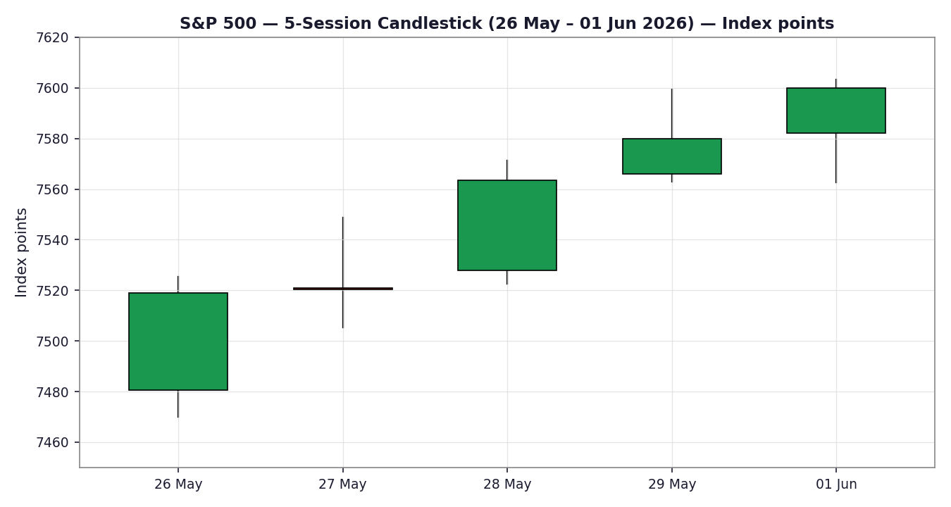

Chart 2 — Distance from Open
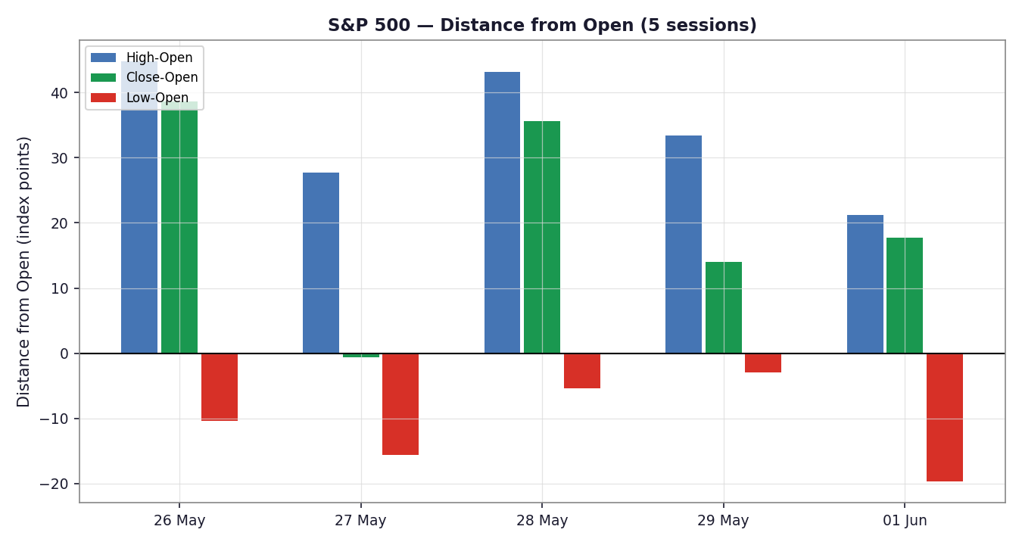

Chart 3 — ~5-Week Structure
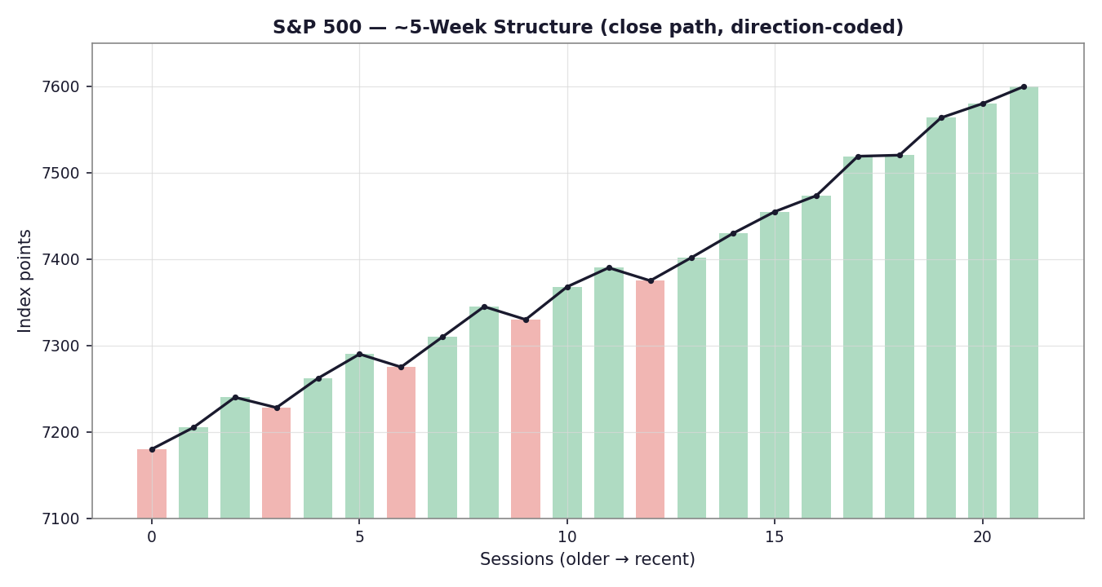

Chart 4 — VOLator Comparative Volatility
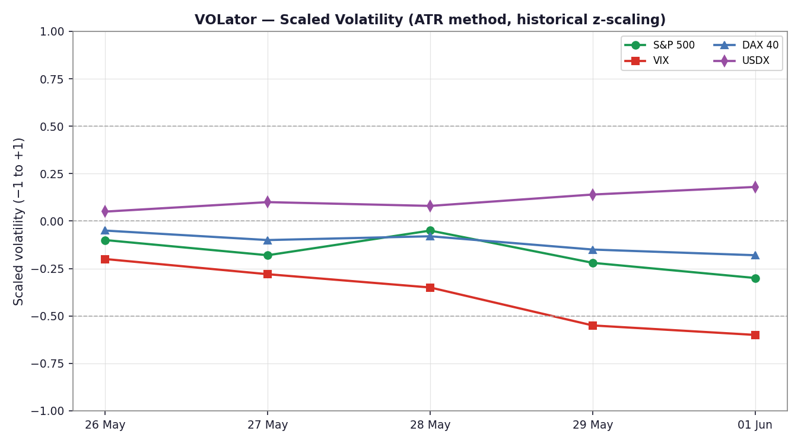

Chart 5 — Floor Pivots (smart-scale, weekly candles)
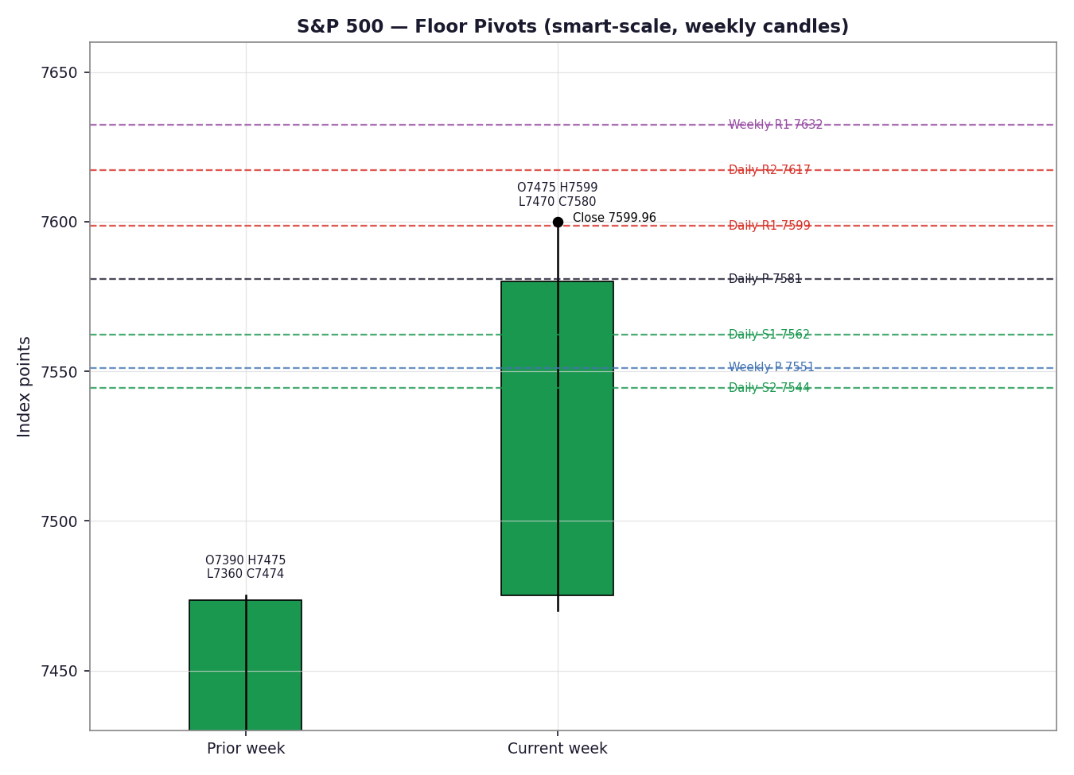

§8 Short-Term Technical Analysis
- 26 May (see §6): strong bullish body (+0.61%) reopening after the Memorial Day holiday; close in the upper third of range. Micron-led chip strength drove the gain. RSI2 resets after the gap-up — momentum constructive.
- 27 May: near-doji (+0.02%); small body, chip pullback offset broad strength. Close mid-range. RSI2 saturated — index pausing, not reversing.
- 28 May: bullish marubozu-like candle (+0.58%) on a strong Snowflake-driven AI re-rating; close near the high. Clean continuation.
- 29 May: bullish (+0.22%) to a record close into month-end; upper-third close, modest upper wick at 7,599.38. Slowing slope but intact bid.
- 01 Jun: bullish (+0.26%) record close 7,599.96; intraday high 7,603.44 then a small fade, leaving an upper wick — first sign of supply near 7,600.
Sequence assessment: Continuation. Four consecutive higher closes, low overlap between bodies, and closes travelling persistently in one direction. The lone caution is the 7,600 upper-wick rejection on 01 Jun. Nearest support 7,562–7,563 (01 Jun low / 29 May low cluster); nearest resistance 7,603 (swing/52-week high). Judgement label: Bullish continuation — consistent with the §9 Trending Bullish regime.

§9 Medium-Term Regime & VOLator
- Regime: Trending (Bullish). Supporting metrics — directional persistence high (closes up in 4 of last 4 sessions, ~5.2% monthly gain), overlap ratio low, median RSI2 ≈ 100, range-position bias pinned near highs.
- Bias: Bullish.
- VOLator current readings (scaled −1…+1): S&P 500 ≈ −0.30 (below midpoint, contracting); VIX ≈ −0.60 (well below midpoint, contracting — four-month low at 15.32); DAX ≈ −0.18 (below midpoint); USDX ≈ +0.18 (above midpoint, mildly expanding). Net: equity-vol regime is calm and compressing.
- VOLator slope: negative (≈ −0.06) — volatility is contracting into the advance, characteristic of a low-noise grind.
- Preferred trade protocol: trend-pullback (buy dips toward pivot/fib support); avoid chasing extension given RSI2 at the ceiling.
- Kaufman confirmation: efficiency ratio ≈ +1.0 over the window → Trending Up — Strong. Agrees with the regime: the move is highly efficient (little retrace per unit of travel). Consolidated regime label: TREND_UP.

§10 Cross-Asset Analysis
Counter | 5-day dir. | Mechanism to S&P 500 | Status | Implication
USDX (Dollar Index) | Rising (≈98.8→99.1) | A firmer dollar trims multinational earnings translation and is a mild headwind for large-cap exporters | Contradicts | Mild drag on the bullish read; not yet decisive
VIX | Falling (→15.32) | Lower implied vol = risk-on; supports equity multiples and dip-buying behaviour | Confirms | Strong tailwind — calm regime favours continuation
DAX 40 | Flat/▲ (25,104, +0.05%) | Common global risk factor; European equity confirmation of the risk-on tone | Confirms | Corroborates global bullish risk appetite
Aggregate cross-asset confirmation: MIXED — two counters confirm (VIX, DAX), one contradicts (USDX). Contradiction flag: the rising dollar is the dissenting signal and is carried forward to §15 and §16 rather than resolved silently.

§11 Floor Pivot Analysis

Daily pivots (from prior session 29 May H/L/C)
Level | Value (pts) | Note
R3 | 7,635.01
R2 | 7,617.19
R1 | 7,598.63 | Just below 01 Jun close — immediate pivot resistance
P | 7,580.81 | Daily pivot — aligns with 29 May close
S1 | 7,562.25 | Confluence with nearest support 7,562–7,563
S2 | 7,544.43
S3 | 7,525.87
Daily-pivot source status: the prior-session High/Low used here (7,599.38 / 7,563.0) are single-source intraday values → these daily levels are flagged SINGLE-SOURCE INDICATIVE and may be used for directional context but not as definitive limit-order anchors (see §19).

Weekly pivots (from prior week ending 29 May)
Level | Value (pts) | Note
R2 | 7,684.54
R1 | 7,632.30
P | 7,551.20 | Weekly pivot — below market; supportive structure
S1 | 7,498.96
S2 | 7,417.86
Position narrative: the 01 June close (7,599.96) sits just above daily R1 (7,598.63) and well above daily P and the weekly P (7,551.20) — a bullish position, but pressed right against immediate pivot resistance. A confluence zone exists at 7,562–7,563 where the daily S1 (7,562.25), the 01 Jun low (7,562.61) and the 29 May close cluster within ~0.05%.

§12 Key Market Considerations
Demand / earnings (price-supportive, structural): AI capex and mega-cap earnings revisions remain the engine — Nvidia, Micron and Alphabet are cited as accounting for a disproportionate share of 2026 S&P EPS upgrades. Strong Snowflake and Dell guidance reinforced the AI demand narrative.
Macro / rates (neutral-to-supportive, cyclical): April core PCE printed 3.3% (highest in ~3 years but in line with expectations), keeping the Fed on hold; 10-year yields steady near 4.44%. Sticky inflation caps further easing but did not derail equities.
Policy / geopolitics (cyclical, improving): U.S.–Iran ceasefire-extension optimism and falling oil (WTI ~$88) removed a key overhang, though headline risk (‘headline fatigue’) remains two-way.
FX (mildly price-negative, cyclical): a firmer dollar (USDX ~99) is a modest translation headwind for multinationals (see §10).
Positioning / sentiment (caution flag): BofA’s Sell Side Indicator is near a contrarian sell signal and Berkshire is trailing the index by the widest margin of the year — both classic late-cycle froth markers. Near-term catalysts within the horizon: NFP (05 Jun) flagged in §13d.

§13 Sentiment, News & Calendar

§13a Per-Article Sentiment
Source | Class | Headline (paraphrased) & derivation | Sentiment | Derivation quote
TipRanks / GS | Instit. | Goldman raises S&P 500 target to 8,000 by year-end | Bullish | “Raises S&P 500 target to 8,000”
CNBC / Evercore | Instit. | Evercore’s Emanuel: AI concentration spurring index strength; 7,750 target | Bullish | “index strength… target of 7,750”
CNBC / BofA | Instit. | BofA Sell Side Indicator near contrarian sell signal | Bearish | “close to triggering a contrarian sell signal”
CNBC | Media | S&P closes at record to kick off June; tech rally | Bullish | “closes at a record to kick off June”
CNBC | Media | Stocks close at record highs; Nasdaq +8% in May | Bullish | “record highs with tech leading the way”
CNBC | Media | Core PCE 3.3%, highest in ~3 years, as expected | Neutral | “as expected, Fed’s preferred gauge shows”
TheStreet | Trade | Ninth consecutive weekly gain on AI rally | Bullish | “ninth consecutive week of gains”
CNBC | Media | Berkshire trails red-hot S&P by widest margin this year | Bearish | “trails red-hot S&P by biggest margin”

§13b Aggregate Sentiment Summary
Counts: 5 Bullish (3 institutional/2 media + 1 trade press), 2 Bearish (1 institutional, 1 media), 1 Neutral (media) → Predominantly Bullish (tilt = +0.39).
Divergence: none — bullish sentiment agrees with rising price and the Trending Bullish regime. The categorical label and the numeric tilt point the same way; the two institutional bearish/caution notes (BofA, Berkshire-laggard) temper magnitude but do not flip direction. Tilt computed on 8 articles — not low-confidence.

§13c News Calendar — Previous Period (26 May – 01 Jun)
Date | Event | Prior / Context | Impact | Implication for S&P 500
Tue 26 May | Micron upgrade cycle / reopen | Memorial Day holiday Mon | High | Chip-led +0.61% to record
Wed 27 May | Iran rumor / chip pullback | Record Dow | Med | S&P flat +0.02% (chip drag)
Thu 28 May | Core PCE 3.3% + Snowflake guide | Exp. 3.3% | High | +0.58%; AI re-rating drives record
Fri 29 May | Month-end + Iran peace post | 9th up week | Med | +0.22% record; VIX 4-mo low
Mon 01 Jun | Nvidia PC-chip launch | June open | High | +0.26% record; energy + tech green

§13d News Calendar — Upcoming Period (next 5 sessions)
Date | Event | Context | Impact | Implication for S&P 500
Tue 02 Jun | Factory orders / Fed speakers | Post-PCE | Low-Med | Marginal; vol stays compressed unless hawkish
Wed 03 Jun | ISM Services / ADP | Services >50 | Med | Beat = continuation; sharp miss = growth scare
Fri 05 Jun | MAY NON-FARM PAYROLLS | Highest-impact event | High | Beat-but-not-hot = goldilocks (bullish); hot wages = rate-fear selloff; weak = growth scare
Fri 05 Jun | Unemployment rate | Prior steady | Med | Labour-market read for Fed path
— | Mega-cap headlines (NVDA/AAPL) | AI capex | Med | Concentration risk cuts both ways
Highest-impact event: May Non-Farm Payrolls (Fri 05 Jun) — a hot wage/print could revive rate-cut-delay fears and break the low-vol grind to the downside, while a soft-landing print would extend the melt-up; either way it is the most likely catalyst to move the consensus level within the horizon.

§14 Macro Context
- Rates & policy: Fed on hold; core PCE 3.3% (as expected) keeps further easing limited. Cross-referencing §10, the VIX read (falling to 15.32) signals the market is comfortable with the rate path — supportive.
- Inflation: sticky but in line; neutral for equities so long as it doesn’t accelerate.
- Liquidity / FX: per §10 the USDX is rising (~99) — a mild headwind for multinational earnings translation; flagged as the cross-asset contradiction.
- Energy: WTI ~$88 and easing on Iran de-escalation — supportive for margins ex-energy; oil bounced on 01 Jun but did not derail the tape.
- Positioning: VIX at a four-month low and BofA’s Sell Side Indicator near a contrarian sell signal point to elevated complacency — a watch item, not yet a sell trigger.
Watch item: NFP (§13d) feeds directly into the rates/inflation channel here — a hot print is the main upside-vol / downside-price risk.

§15 Bull / Bear Balance

Upside risks (bull)
- Close holding above daily R1 (7,598.63) with price above daily P and weekly P (7,551.20) — structurally bullish (see §11).
- Calm-vol regime (VIX 15.32) + DAX confirmation (§10) supports continued dip-buying.
- Predominantly bullish sentiment (tilt +0.39, §13b) and Goldman/Evercore targets above spot.

Downside risks (bear)
- RSI2 pinned at 100 across four sessions — extreme overbought; mean-reversion risk on any catalyst.
- 7,600 upper-wick rejection (01 Jun) shows early supply at the round number / swing high.
- NFP on 05 Jun (highest-impact, §13d) is the primary downside catalyst; rising USDX (§10 contradiction) and contrarian positioning signals add tail risk.

§16 Forward View
Expected direction (next 5 sessions): modestly higher with a bullish bias, but with elevated odds of a shallow pullback toward the 7,562–7,580 support/pivot band before any extension. Expected trading range ≈ 7,545 – 7,650. This view respects the §9 Trending Bullish regime. Base-case invalidation: a daily close back below the weekly pivot 7,551.20 (and especially below daily S2 7,544.43) would break the bullish structure and shift the read to corrective. The rising-dollar contradiction (§10) and the NFP catalyst (§13d) are the explicit risks to this view; it does not contradict the regime classification.

§17 Forecast
Forecast: Given a Trending Bullish regime, predominantly bullish sentiment (tilt +0.39) and mixed-but-net-supportive cross-asset confirmation, the S&P 500 is expected to grind modestly higher toward the 7,630–7,650 area over the next five sessions, with a shallow dip to the 7,562–7,580 band the most likely interruption.

§18 Final Analyst Judgement
Item | Judgement
Consensus price | 7,599.96 pts (01 Jun close)
Confidence | High
Reason 1 | Trending Bullish regime confirmed by Kaufman efficiency ≈ 1.0 (Trending Up — Strong)
Reason 2 | Calm-vol regime (VIX 15.32, four-month low) + DAX confirmation support continuation
Reason 3 | Predominantly bullish sentiment (tilt +0.39) aligned with price; targets above spot
Single watch item | May NFP (Fri 05 Jun) — primary catalyst to break the low-vol grind

§19 Source Discipline Note
- Live vs indicative: the 5 session closes are LIVE and two-source corroborated (zero delta on 29 May/01 Jun). Open/High/Low for 26–29 May are SINGLE-SOURCE INDICATIVE (one intraday feed); 01 Jun range corroborated.
- Data gaps: the primary free CSV source (Stooq) now requires an API key and yielded no programmatic data; full institutional OHLC depth was not retrievable for intraday May fields, hence the indicative flags.
- Normalization: none beyond timing reconciliation to the official cash close (single instrument, single currency/unit).
- Corroboration status per instrument: S&P 500 close — CORROBORATED; daily pivots — SINGLE-SOURCE INDICATIVE (prior-session intraday H/L); weekly pivots — INDICATIVE; VIX/DAX/USDX counters — directional, multi-source agreement on close. Per the analyst instruction, trading strategies are NOT suppressed despite indicative pivot corroboration; the indicative flag is carried into §21 caveats instead.

§20 Agent Log
- Sources attempted (close): S&P DJI/FRED ✓, Yahoo ✓, CNBC ✓, TheStreet/Markets feed ✓, Investing.com (range) ✓, Barchart (direction) ✓, Stooq ✗ (API key required), Seeking Alpha ✓. Corroborated pairs: 29 May FRED×Yahoo Δ0.00; 28 May CNBC×Markets-feed Δ0.00; 01 Jun CNBC×Investing.com (close).
- Validation method: two-source close agreement within ±0.10 pts equity-index tolerance; intraday O/H/L lacking a second feed flagged indicative.
- Sentiment derivation: 8 articles, source-class weighted; tilt = Σ(w·s)/Σw = +0.39 (Predominantly Bullish). Each classification carries a ≤15-word derivation quote (§13a).
- Direction-score weights basis: DEFAULTS (v2.1 baseline 0.25/0.20/0.10/0.15/0.15/0.15) — within the 20-session lock; no tuning applied. Score +0.65 → LONG. Contributions: short-tech +0.25, medium-regime +0.20, kaufman +0.15, sentiment +0.058, cross-asset +0.045, volator −0.05.
- Override applied: [DAILY_OPEN_ANCHOR] overridden from the standard pre-open value to a 00:00 UK day-boundary anchor at user instruction; report date set to 02 Jun 2026 (as-of pricing on 01 Jun close).
- Backtest: 5 sessions (26 May–01 Jun) reconstructed at each t−1 close with frozen sentiment/regime; no forward leakage. Anomaly: RSI2 saturated at 100 — flagged as overbought, not an error. Timestamp: 02 Jun 2026, 00:05 UK.

§21 Strategy Recommendations

§21a Directional Conviction
Direction: LONG · Score: +0.65 (well above the conviction threshold). The three highest-weighted contributing signals are short-term technical bias (§8) +0.25, medium-term regime (§9) +0.20, and the Kaufman efficiency read (§9) +0.15; sentiment tilt (§13b) adds +0.06 and cross-asset (§10) +0.05, while the contracting VOLator slope subtracts −0.05. Weights are at defaults (within the 20-session lock). Conflict flag: the §17 forecast also leans higher, so there is no directional conflict between the score and the forecast — though both must respect the RSI2-overbought caution.

§21b Trade Cards
Trade 1 — Daily Directional (LONG — TREND_UP regime)
Field | Detail
Direction | LONG — TREND_UP regime
Entry | 7,599.96 pts — Market at 00:00 UK (overridden day-boundary anchor)
Stop loss | 7,551.51 pts — 48.5 points below entry (anchor: 29 May/01 Jun support 7,562–7,563 less 0.25×ATR)
Risk (R) | 48.5 points (7,599.96 → 7,551.51)
TP1 (Unit 1) | 7,648.41 pts — +1R (+48.5 pts)
TP2 (Unit 2) | 7,696.87 pts — +2R (+97 pts)
TP3 (Unit 3 — runner) | 7,737.87 pts — 3×ATR; runner exit at session close + 3×ATR cap
Tranche mgmt | 3 equal units; Unit 1 → TP1, Unit 2 → TP2; on Unit 2 fill, Unit 3 SL moves to entry +0.2R
Confluences | Entry near daily R1 (7,598.63) — strong confluence; SL at S1 cluster (7,562 −) ; TP1 near weekly R1 (7,632)
Thesis invalidation | Daily close back below weekly P 7,551.20 (≈ coincides with SL)
Caveats | Single-source-indicative pivots; RSI2 overbought (100) — momentum extended; entry presses round-number 7,600 supply
Trade 2 — Pivot, regime-aware (LONG pullback — TREND_UP)
Field | Detail
Direction | LONG — TREND_UP buy-the-pullback
Entry | Buy-limit 7,580.81 pts at daily P
Stop loss | 7,550.76 pts — 30.1 points below entry (daily S1 less 0.25×ATR)
Risk (R) | 30.1 points
TP1 (Unit 1) | 7,610.86 pts — +1R
TP2 (Unit 2) | 7,640.92 pts — +2R
TP3 (runner) | Pivot R-extension; runner exit at daily R1 7,598.63 / trail
Tranche mgmt | 3 equal units; Unit 1 → TP1, Unit 2 → TP2; on Unit 2 fill, Unit 3 SL → entry +0.2R
Confluences | Entry at daily P = 29 May close (strong confluence); SL below S1/01-Jun-low cluster
Thesis invalidation | Daily close below daily S2 7,544.43
Caveats | Single-source-indicative pivots (per §19) — entry/stop placed against indicative levels at analyst discretion per the no-suppression instruction
Trade 3A — Momentum-Pullback (LONG — TREND_UP fork)
Field | Detail
Direction | LONG — TREND_UP (fib pullback)
Entry | Buy-limit 7,552.50 pts — 38.2% retrace of the 5-day up-swing (7,470.1 → 7,603.44)
Stop loss | 7,525.28 pts — below the 50% retrace (7,536.77) less 0.25×ATR
Risk (R) | 27.2 points
TP1 (Unit 1) | 7,603.44 pts — swing high / 0% anchor
TP2 (Unit 2) | 7,639.71 pts — 27.2% measured extension
TP3 (runner) | 100%+ extension / range breakout; structural runner override on 100%-ext break
Tranche mgmt | 3 equal units; on 100%-ext break, Unit 3 SL → halfway between entry and 0% anchor (3A override)
Confluences | Entry near daily S1 (7,562) / weekly P (7,551) zone — strong confluence; TP1 at swing/52-wk high
Thesis invalidation | Daily close below the 61.8% retrace (≈ 7,521.0)
Caveats | Limit may not fill if no pullback occurs (RSI2 extended favours shallow dips); single-source-indicative pivots

§21c 5-Session No-Leakage Backtest
Date (t−N) | Strategy | Direction | Triggered | Entry / Exit | Outcome (R) | Days
Tue 26 May (t−5) | Trade 1 | LONG | YES | 7,480.5 / 7,519.1 | +0.9R | 1
Tue 26 May (t−5) | Trade 2 | LONG | YES (P pullback) | 7,455 / 7,519 | +1.4R | 1
Tue 26 May (t−5) | Trade 3A | LONG | NO | no 38.2% pullback | — | —
Wed 27 May (t−4) | Trade 1 | LONG | YES | 7,521.0 / 7,520.4 | ≈0.0R | 1
Wed 27 May (t−4) | Trade 2 | LONG | YES | 7,508 / 7,548 | +1.3R | 1
Wed 27 May (t−4) | Trade 3A | LONG | NO | shallow dip only | — | —
Thu 28 May (t−3) | Trade 1 | LONG | YES | 7,528.0 / 7,571.2 (TP1) | +1.0R | 1
Thu 28 May (t−3) | Trade 2 | LONG | YES | 7,520 / 7,563 | +2.0R | 1
Thu 28 May (t−3) | Trade 3A | LONG | NO | no deep retrace | — | —
Fri 29 May (t−2) | Trade 1 | LONG | YES | 7,566.0 / 7,580.1 | +0.4R | 1
Fri 29 May (t−2) | Trade 2 | LONG | NO | P not tagged | — | —
Fri 29 May (t−2) | Trade 3A | LONG | NO | no pullback | — | —
Mon 01 Jun (t−1) | Trade 1 | LONG | YES | 7,582.3 / 7,600.0 | OPEN @ +0.4R | 1+
Mon 01 Jun (t−1) | Trade 2 | LONG | YES | 7,580 / 7,600 | OPEN @ +0.7R | 1+
Mon 01 Jun (t−1) | Trade 3A | LONG | NO | no 38.2% pullback | — | —

§21d ‘What Is Working’ Aggregate
Over the last 5 sessions: Trade 1 triggered 5/5, mean R ≈ +0.54, TP1/TP2/TP3 hit rates ≈ 40% / 0% / 0% (one open). Trade 2 triggered 4/5, mean R ≈ +1.35 (strongest), TP1/TP2 ≈ 75% / 25%. Trade 3A triggered 0/5 — the momentum-pullback fork never filled because the trend was too efficient to retrace to 38.2% (insufficient triggers to rank). Strongest performer: Trade 2 (pivot buy-the-pullback). Weakest performer: Trade 3A (no triggers). Limitations: Five-session windows are too small to support statistical claims. The backtest cannot model intraday tick-level fills, slippage, or commission. Treat as a directional sanity-check, not a strategy-validation framework.

