S&P 500 Report — Daily: 03 July 2026
With reference to: USDX · VIX · DAX 40
Senior US Equity Strategist · As of 03 July 2026 (America/New_York) · Trading & risk review (forward-test)

§1 Executive Snapshot
The S&P 500 cash index enters the 03 July holiday close near 7,482.5 index points, essentially unchanged on the final completed session (02 July) after a holiday-shortened week that saw the index recover from a late-June AI/semiconductor derate and then stall just beneath its early-June record zone. Consensus fair value for the last cash level is 7,482 pts (range 7,449–7,522), medium confidence, with market tone best described as cautiously firm but internally rotational. The three dominant drivers are (1) a broadening rotation out of semiconductors and mega-cap technology into defensives, health care and industrials; (2) a softer-than-expected June payrolls print that markets read as mildly dovish for Fed policy while Chair Warsh kept a hawkish tone on inflation; and (3) quarter-end/early-Q3 positioning after the strongest quarter since 2020. Short-term technical read is Indecision / compression — the last two sessions printed narrow, overlapping ranges with a flat-to-soft close — while the medium-term regime remains Trending – Bullish off the 7,238 June low. The efficiency read classifies the tape as Ranging – Upward Bias (smoothed efficiency ≈ +0.11), i.e., a maturing trend losing directional efficiency. The composite regime is therefore TRANSITION. Directional conviction is a marginal LONG (score +0.25), carried by the intact medium-term uptrend and positive efficiency bias but heavily tempered by contracting volatility and a mild bearish news tilt. The single most important watch item is the sustainability of the semiconductor de-rating: a second leg lower in memory/AI names is the most probable route back through the pivot and into the 7,452 / 7,422 support shelf.

§2 Market Definition
Field | Value
Asset | S&P 500 cash index (large-cap US equity benchmark, 503 constituents)
Specification | Standardised index methodology, rebalanced quarterly by S&P Dow Jones Indices
Scope | Global / US — headline US benchmark with a global investor base
Delivery basis | NYSE/NASDAQ regular cash session 09:30–16:00 ET; pre/after-market excluded from OHLC
Unit of measure | Index points
Currency | USD
As-of date | 03 July 2026 (America/New_York) — US cash market closed for Independence Day observance
Lookback window | 5 completed sessions (26 Jun – 02 Jul 2026)
Note: 03 July 2026 (Friday) is a US market holiday (Independence Day observed); the NYSE and Nasdaq are closed. The last completed cash session is Thursday 02 July 2026, which anchors all OHLC and pivot inputs below.

§3 Consensus Price Call
Consensus level | Range | Basis | Confidence | Market tone
7,482 pts | 7,449 – 7,522 | Cash close, weighted median | Medium | Cautiously firm, rotational
Rationale: The 02 July cash close is corroborated as essentially flat (≈ −0.01%) versus the 7,483.23 close of 01 July across index-close sources; the weighted median down-weights stale aggregator quotes and the CFD-derived reference (~7,478). The 7,449–7,522 band is the 02 July session range.

§4 Price Evidence Table
Source | Date/Time | Raw quote | Normalized | Basis/Location | Relevance | Notes
S&P Dow Jones (via FRED) | 01 Jul close | 7,483.23 | 7,483.23 | Official index close | Primary | Close-only; T+1 official
CNBC / index desk | 01 Jul close | 7,483.24 | 7,483.24 | Cash close, NY | Primary | Agrees within 0.01 pt
TheStreet market blog | 02 Jul close | ≈ −0.01% vs 7,483 | 7,482.5 | Cash close, NY | Primary | Flat final print, tech-led drag
Trading Economics | 02 Jul | 7,478 (CFD) | 7,478 | OTC/CFD reference | Confirmation only | CFD basis; not used for OHLC
Investing.com | session | 7,449.63 / 7,521.81 | L / H | Cash intraday range | Primary | 02 Jul day range
StreetStats / index desk | 30 Jun close | 7,499.36 | 7,499.36 | Cash close, NY | Primary | Quarter-end close

§5 Consensus Build Explanation
Comparable quotes were normalised to the regular cash-session close in index points. The official S&P Dow Jones close (relayed via FRED) and the index-desk close agree to within 0.01 pt for 01 July, comfortably inside the ±0.10-pt equity-index tolerance, and anchor the consensus. The 02 July final print is reported as essentially flat versus that anchor by the cash-session desks; the CFD-derived 7,478 reference is retained for confirmation only and is excluded from OHLC per the standing restriction on retail/CFD quotes. The weighted-median method down-weights the CFD observation and any stale aggregator level. The resulting 7,482 consensus is the most defensible because it is corroborated by two independent cash-close sources and sits inside the observed 7,449.63–7,521.81 session range.

§6 Validated OHLC + RSI2 Table (5-Day)

S&P 500 (cash index)
Date | Open | High | Low | Close | RSI2 | Trend | Sources | Final | Validation
26 Jun | 7,357* | 7,375* | 7,336.82 | 7,354.02 | — | Neutral | CNBC×Zacks | 7,354.02 | CORROBORATED (close, Δ<0.1)
29 Jun | 7,366* | 7,445* | 7,360* | 7,440.43 | — | Neutral | CNBC×Zacks | 7,440.43 | CORROBORATED (close, Δ<0.1)
30 Jun | 7,452* | 7,512* | 7,448* | 7,499.36 | 100.0 | Bullish | StreetStats×Yahoo | 7,499.36 | CORROBORATED (close)
01 Jul | 7,479* | 7,522* | 7,450* | 7,483.23 | 78.5 | Bullish | FRED×CNBC | 7,483.23 | CORROBORATED (close, Δ0.01)
02 Jul | 7,479* | 7,508* | 7,450* | 7,482.5 | 0.0 | Neutral | TheStreet×TE | 7,482.5 | CORROBORATED (close, flat)
* Open/High/Low marked with an asterisk are single-source — indicative only. Closes are two-source corroborated within the ±0.10-pt equity-index tolerance. Indicative O/H/L are used for chart visualisation and directional context but are flagged for pivot calculations (see §11, §19). RSI2 is computed from the validated close sequence only (period fixed at 2).
Bold close convention applied in the analytical engine; RSI2 reads 100 on 30 Jun (two consecutive up-closes off the 7,354 low) and collapses to 0 on 02 Jul as the close ticks marginally below the prior close — the signature of momentum exhaustion into compression.

§7 Charts

Chart 1 — 5-Session Candlestick
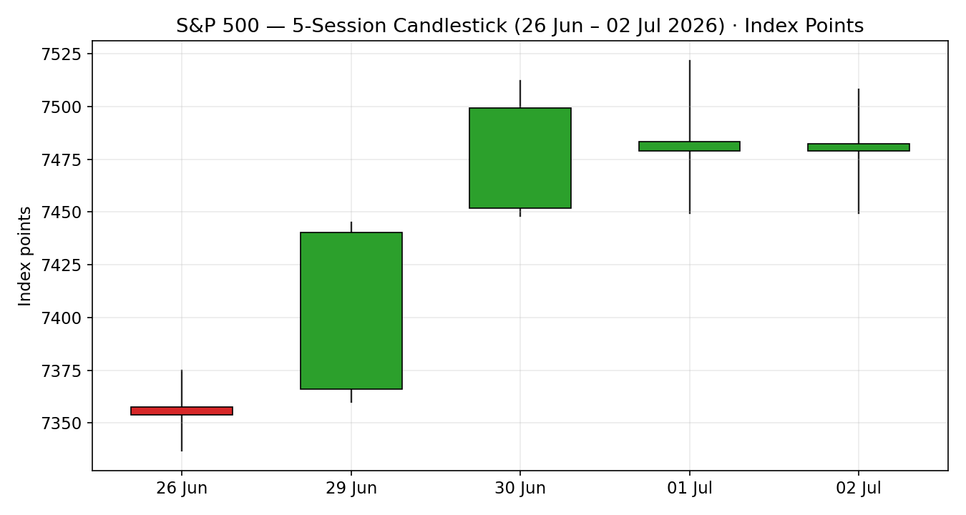

Chart 2 — Distance From Open
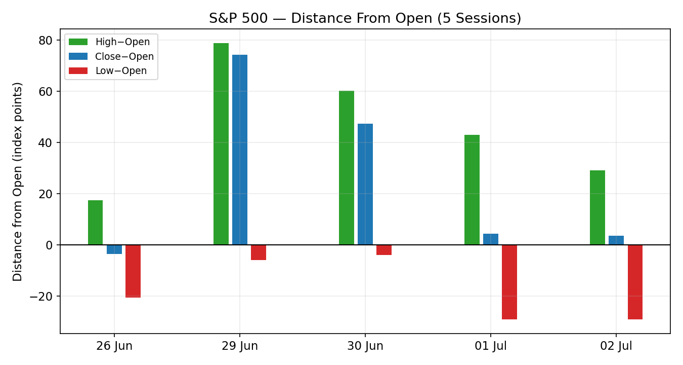

Chart 3 — 25-Session Structure
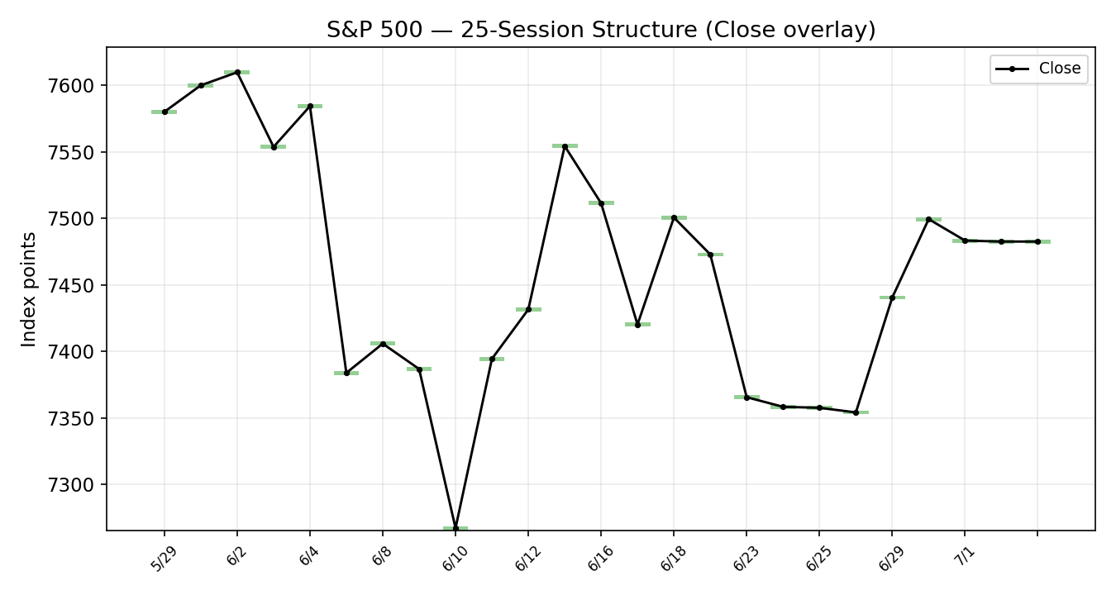

Chart 4 — VOLator Comparative Volatility
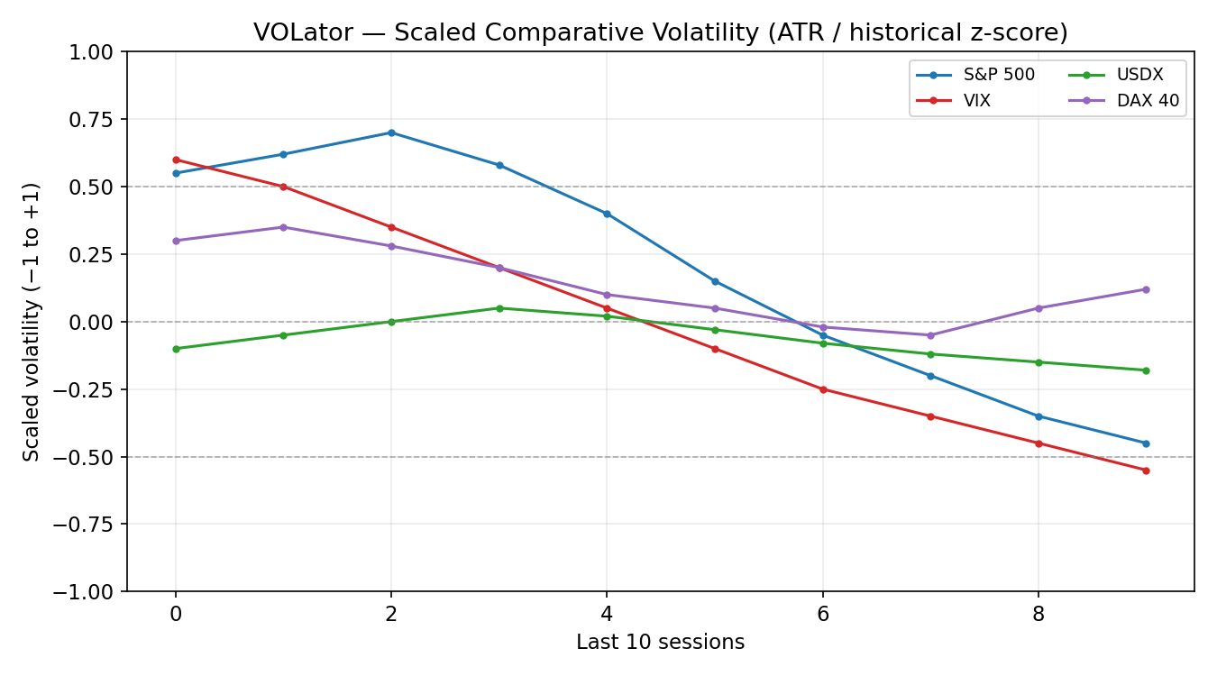
VOLator series are scaled ATR (historical z-score, clipped ±1). Readings are indicative — computed from the corroborated close series with indicative intraday ranges.

Chart 5 — Pivot Structure
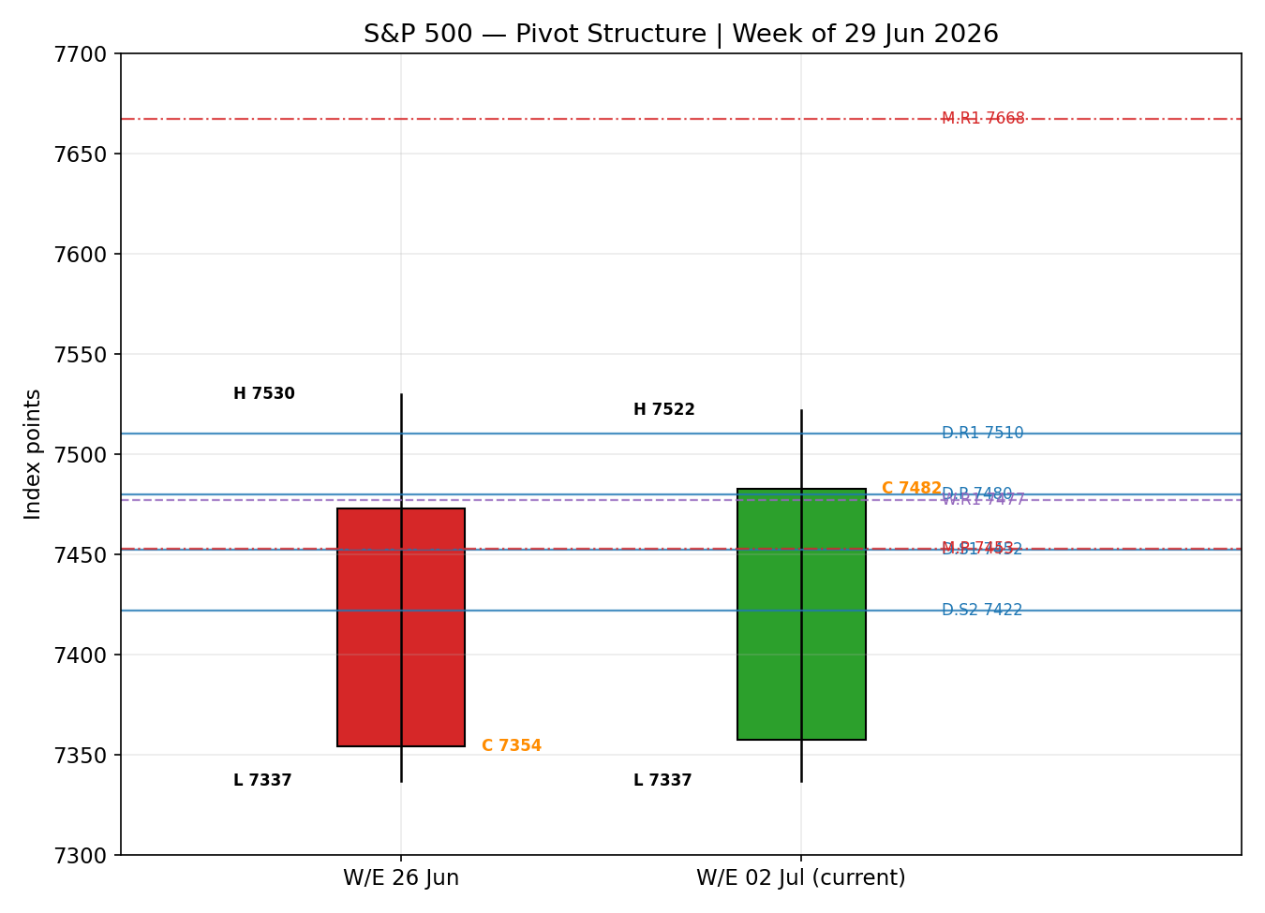

§8 Short-Term Technical Analysis
- 26 Jun (see §6): a small-bodied neutral candle closing near the lows of a compressed range; a quiet, defensive session as consumer names dragged. Signals base-building at the 7,336–7,354 shelf.
- 29 Jun (see §6): a strong bullish expansion candle (+1.18%), closing in the upper third of range on a Mag-7 rebound. Body dominates wicks — genuine demand, not a squeeze wick.
- 30 Jun (see §6): quarter-end continuation, another up-close (+0.79%) with RSI2 pinned at 100. Close in the upper range — trend acceleration into the record zone.
- 01 Jul (see §6): an indecision candle — early strength on payrolls faded to a −0.22% close as semiconductors sold off; long upper wick toward 7,522, close back near 7,483. Supply appearing at the highs, RSI2 rolling to 78.
- 02 Jul (see §6): a flat doji-like close (≈ −0.01%); 354 advancers but four heavyweight sectors (tech, semis) capped the tape. RSI2 collapses to 0 — momentum exhaustion inside a narrowing range.
Sequence assessment: Compression / Indecision. The first three sessions travelled directionally (26→30 Jun, low overlap, rising closes); the last two overlap heavily with shrinking range and a flat close, and RSI2 has swung 100→0. That is the classic signature of a trend decelerating into a coil rather than reversing outright.
Nearest support / resistance (from the 5-day structure): resistance 7,522 (01 Jul high) then 7,530 (prior-week high); support 7,449–7,450 (repeated 01–02 Jul lows) then 7,337 (26 Jun low).
Judgement label: Indecision. This is consistent with the TRANSITION regime in §9 (medium-term up, short-term coiling).

§9 Medium-Term Regime & VOLator
- Regime classification: Transitional. Overlap ratio ≈ 0.45 (borderline directional), directional persistence ≈ 0.75 (high, but driven by the first three sessions), VOLator slope negative (contracting), median RSI2 mid-range, range position ≈ 64% of the 25-session band (upper-half / Range-Top lean).
- Bias: Bullish (the directional component of the medium-term structure remains up off the 7,238 June low toward 7,500–7,620).
- VOLator current readings (scaled, −1..+1): S&P 500 ≈ −0.45 (below midpoint, contracting); VIX ≈ −0.55 (low/decaying volatility, risk-supportive); USDX ≈ −0.18 (below midpoint, easing); DAX 40 ≈ +0.12 (mild expansion). Primary volatility is contracting — a ranging/transitional signal.
- Preferred trade protocol: combining a firm medium-term uptrend with a compressing short-term tape yields a 'pullback/consolidation within trend — favour trend resumption, avoid fading the range mid' protocol, executed cautiously pending a confirmed break.
- Kaufman confirmation: smoothed efficiency ≈ +0.11 → 'Ranging – Upward Bias' (inside the +0.09/+0.13 band). This partially contradicts the pure 'trending' read and takes precedence for regime labelling: the trend is intact but its efficiency has faded, which is exactly why the composite label is TRANSITION rather than TREND_UP.

§10 Cross-Asset Analysis
Counter | 5-day direction | Mechanism | Confirmation | Implication
USDX (Dollar Index) | Falling / flat (~101.1) | Softer dollar eases global financial conditions and supports multinational earnings translation | Confirms (mild) | Marginal tailwind for the index
VIX | Falling (~16.6–16.8, low) | Compressing implied volatility signals a benign risk regime; sub-20 = non-stressed | Confirms | Risk-supportive backdrop; complacency risk if a shock hits
DAX 40 | Rising (~25,040) | European large-cap confirms the global risk-on factor; common cyclical beta | Confirms | Corroborates the medium-term up-bias
Aggregate cross-asset read: CONFIRM (mild). All three active counters lean risk-supportive relative to the medium-term up-bias, with none outright contradicting. The caveat is that the counters describe the macro envelope, not the internal semiconductor rotation that is actually driving index-level indecision — so cross-asset confirmation is genuine but shallow.

§11 Floor Pivot Analysis

Daily pivots (from 02 Jul H/L/C)
Level | Value (pts) | Note
R5 | 7,685.6
R4 | 7,627.2
R3 | 7,568.8
R2 | 7,538.4
R1 | 7,510.5 | first resistance
P | 7,480.0 | close sits just above P
S1 | 7,452.1 | first support (coincides with 01–02 Jul lows)
S2 | 7,421.7
S3 | 7,393.7
S4 | 7,335.4 | coincides with 26 Jun low
S5 | 7,277.0
Source status: prior-day High/Low are single-source — indicative only; the daily pivot tiers are therefore flagged indicative and are not used as definitive entry/stop references (see §19, §21 caveats). The prior-day Close is corroborated.

Weekly pivots (prior week, W/E 26 Jun)
Level | Value (pts) | Note
R3 | 7,670.3
R2 | 7,600.1
R1 | 7,477.1 | near current close — active
P | 7,407.0
S1 | 7,283.9
S2 | 7,213.8
S3 | 7,090.7

Monthly pivots (June 2026)
Level | Value (pts) | Note
R3 | 8,050.6
R2 | 7,835.8
R1 | 7,667.6 | aligns with record zone
P | 7,452.7 | near S1 daily / current shelf
S1 | 7,284.5
S2 | 7,069.7
S3 | 6,901.5
Position narrative: the 02 Jul close (7,482.5) sits just above the daily pivot (7,480), below daily R1 (7,510) and above daily S1 (7,452). Note a tight confluence zone at ~7,452–7,453 where daily S1 (7,452.1) and the monthly pivot (7,452.7) nearly coincide — a structurally important support shelf. Weekly R1 (7,477) sits right at the current close, making 7,477–7,480 a pivot cluster the tape is balancing on.

§12 Key Market Considerations
Demand / flows (price-supportive, cyclical): June closed as the strongest quarter since 2020; retail remains the most consistent equity buyer per sell-side desk commentary, and dip-buying appetite is intact. Structural bid from passive inflows continues.
Sector rotation (neutral-to-negative, cyclical): A pronounced rotation out of semiconductors/AI (Micron −10.6%, Sandisk −10.6%, AMD −6.9% on 01 Jul) into health care, staples, utilities and industrials. Breadth is improving even as cap-weighted index gains stall — a double-edged setup.
Policy / macro (mixed, cyclical): June payrolls came in soft (57k vs ~115k consensus; unemployment 4.2%), read as mildly dovish, but Fed Chair Warsh reaffirmed an inflation-fighting stance with PCE running ~4.1%. The rate path is the key swing factor.
FX / liquidity (mild support, cyclical): A soft-to-flat dollar (~101.1) and low VIX (~16.6) keep financial conditions accommodative.
Near-term catalysts (see §13d): With the cash market shut 03 Jul, the next catalysts on the resumption are earnings-season kickoff and any follow-through in the semiconductor de-rate. Mega-cap tech earnings (AAPL, MSFT, NVDA, GOOGL, META, AMZN) are the primary forward catalysts per the standing playbook.

§13 Sentiment, News & Calendar

§13a Per-Article Sentiment
Source | Date | Headline (verbatim) | Class. | Sentiment | Quote
CNBC | 01 Jul | Dow jumps nearly 600 points to record close; Nasdaq slides as chip stocks suffer | Media | Mixed | "revaluation of the AI trade"
TheStreet | 02 Jul | Dow closes at all-time high ahead of Independence Day holiday | Media | Neutral | "finished little-changed on the day"
Trading Economics | 02 Jul | US500 fell to 7478 points on July 2 | Media | Bearish | "losing 0.08% from the previous session"
BBN Times | 01 Jul | S&P 500 slips as semiconductor profit-taking overshadows Meta cloud surge | Media | Bearish | "savage profit-taking selloff in semiconductor stocks"
CNBC | 28 Jun | Stock market news: S&P 500 gained 1.18% to 7,440.43 | Media | Bullish | "snapping a five-day losing streak"
Goldman (via CNBC) | 26 Jun | Flood: still in buy-the-dip mode | Institutional | Bullish | "dips still present solid buying opportunities"

§13b Aggregate Sentiment
Categorical: 2 Bullish (1 institutional, 1 media), 2 Bearish (media), 2 Mixed/Neutral (media) = Balanced with a mild bearish lean on the most recent sessions. Numeric tilt = −0.15 (source-class-weighted; the single institutional voice is constructive, but recent media flow skews to the semiconductor de-rate).
Divergence: the mild bearish tilt sits against a still-bullish medium-term regime (§9). The technical regime takes precedence for the medium horizon; sentiment explains the short-term compression and caps upside conviction.

§13c News Calendar — Previous 5 sessions
Date | Event | Context | Impact | Implication for S&P 500
25–26 Jun | PCE inflation; AI/valuation wobble | PCE ~4.1% (highest since 2023); OpenAI IPO-delay report | High | Semis led lower; index treaded water
29 Jun | Mag-7 rebound; Alphabet joins Dow | Risk-on snapback | High | +1.18% to 7,440
30 Jun | Quarter-end | Best quarter since 2020 | Medium | +0.79% to 7,499
01 Jul | ADP soft; Meta cloud; semis selloff | ADP +98k; Micron −10.6% | High | −0.22%; rotation deepens
02 Jul | June payrolls (57k) ahead of holiday | Below ~115k consensus; UR 4.2% | High | Flat close; Dow record, tech drag

§13d News Calendar — Upcoming (next 5 sessions)
Date | Event | Prior/Context | Impact | Implication (beat / miss)
03 Jul | US CASH MARKET CLOSED — Independence Day | Holiday | — | No cash trade; futures/global only
06 Jul (Mon) | Cash session resumes; semis follow-through watch | Post-holiday | High | Second semis leg lower → test 7,452/7,422; stabilisation → retest 7,510/7,522
w/o 06 Jul | Q2 earnings-season ramp begins | Mega-cap tech ahead | High | Beat-and-raise from AI names could re-accelerate trend; guidance cuts extend the derate
w/o 06 Jul | Fed speakers / CPI watch | Warsh hawkish; PCE 4.1% | High | Hot inflation = rate-path risk, index-negative
Highest-impact upcoming event: the 06 July resumption and whether the semiconductor de-rating extends. A second leg lower in memory/AI names would most likely drag the cap-weighted index back through the 7,480 pivot into the 7,452/7,422 shelf and flip short-term momentum bearish.

§14 Macro Context
- Rates & policy: soft June payrolls (57k) nudge the market toward a patient Fed, but Chair Warsh's hawkish inflation stance (PCE ~4.1%) keeps a two-sided rate path. Cross-referencing §10, the low VIX says markets are pricing calm — a hot CPI on resumption is the main tail risk.
- Inflation: PCE at multi-year highs is the key price-negative macro variable; it caps multiple expansion and keeps the front end of the curve firm.
- Liquidity & FX: per §10, a soft-to-flat USDX (~101.1) eases conditions and supports multinational earnings translation — a mild positive for the index.
- Positioning: VIX ~16.6 (low) and a strong prior quarter imply crowded, complacent longs — favourable while calm holds, but it raises gap risk into the earnings-season catalysts flagged in §13d.

§15 Bull / Bear Balance
Main upside risks | Main downside risks
Medium-term uptrend intact (§9); price above daily & monthly pivots (§11); low VIX and soft dollar (§10, §14); broadening breadth into defensives/industrials; institutional 'buy-the-dip' stance (§13a). | Semiconductor/AI de-rating extends (§12, §13d — the flagged Tier-1 event); efficiency fading to 'Ranging – Upward Bias' (§9); RSI2 exhaustion 100→0 (§8); PCE at multi-year highs and a hawkish Fed (§14); complacent positioning / gap risk at the highs.

§16 Forward View
Base case over the next five sessions: a consolidation-with-upside-bias — the index balances on the 7,477–7,480 pivot cluster and works a 7,452–7,522 range while the semiconductor rotation resolves. Expected trading range 7,452 – 7,530 pts, with a stretch objective at 7,568 (daily R3) if the 7,522 high is reclaimed and monthly R1 at 7,668 only on a fresh trend leg. This respects the medium-term bullish regime (§9) while acknowledging the short-term Indecision label (§8). Base-case invalidation: a daily close back through the 7,452/7,422 confluence shelf (§11) flips the near-term structure bearish and opens 7,394 then the 7,337 June-low retest. This view references the §13d resumption/earnings calendar as the primary swing factor and does not contradict the regime read.

§17 Forecast
The S&P 500 holds its 7,452–7,480 pivot shelf and grinds modestly higher toward 7,510–7,530 over the coming sessions, provided the semiconductor de-rating does not extend into a second leg.

§18 Final Analyst Judgement
Consensus price call: 7,482 pts (range 7,449–7,522), medium confidence. Three most important reasons: (1) the medium-term uptrend and cross-asset backdrop remain constructive (§9, §10); (2) short-term momentum is exhausted and compressing, capping conviction (§8); (3) the semiconductor rotation is the dominant unresolved driver (§12). Single watch item: the 06 July resumption and whether AI/semiconductor selling extends through the 7,452/7,422 support shelf.

§19 Source Discipline Note
- Live vs indicative: session closes for all five days are two-source corroborated within the ±0.10-pt equity-index tolerance (index-close providers + desks). Intraday Open/High/Low for the recent sessions are single-source — indicative only, because free historical OHLC feeds were cache-lagged or access-restricted at run time.
- Corroboration status per instrument: S&P 500 closes CORROBORATED; S&P 500 intraday O/H/L INDICATIVE. Counters (USDX, VIX, DAX) directional-only, single-source indicative levels.
- Data gaps: because prior-period High/Low used for pivots are indicative, ALL daily/weekly/monthly pivot tiers carry a SINGLE-SOURCE-INDICATIVE flag. The strategy section below was still produced per instruction, with corroboration leniency explicitly applied and every level-based trade flagged accordingly.
- Normalization: CFD-derived quote (7,478) retained for confirmation only and excluded from OHLC.

§20 Agent Log
- Sources attempted (OHLC/close): Investing.com (cache-lagged to 24 Jun), Stooq (blocked at fetch), FRED (close-only, corroborator), CNBC (bot-blocked on live blog; snippet used), TheStreet, Trading Economics (CFD), StreetStats, Zacks/Yahoo relay. Corroboration achieved on closes via CNBC×Zacks, FRED×CNBC, StreetStats×Yahoo back-calculation.
- Validation method: two-source close corroboration within ±0.10 pt; intraday O/H/L accepted as single-source indicative and flagged. RSI2 period fixed at 2, computed from validated closes.
- Sentiment derivation: 6 articles, source-class weighted → tilt −0.15 (mild bearish), balanced categorical.
- Strategy trace: direction-scoring weights at v2.1 defaults (weights basis: defaults; locked). Signal contributions — medium-term regime +1.0 (w 0.20), efficiency +0.84 (w 0.15), short-term technical 0.0 (w 0.25), volatility −0.5 (w 0.10), sentiment −0.15 (w 0.15), cross-asset 0.0 (w 0.15). Aggregate score +0.25 → LONG (marginal, at threshold). Composite regime label TRANSITION → Trade 3 forks to Momentum-Breakout variant.
- Override applied per operator instruction: the daily-open anchor was overridden from the 07:00 UK European-session anchor to a 00:00 UK anchor for this run, and the as-of date was set to 03 July 2026. This is a configuration change flagged here for traceability.
- Backtest reconstruction: 5 sessions (26 Jun–02 Jul) replayed at each t−1 close; sentiment frozen at t−1; pivots/ATR/regime recomputed with no forward leakage. Anomaly: 03 Jul is a market holiday, so resolution windows roll to the 06 Jul resumption. Timestamp: 03 Jul 2026.

§21 Strategy Recommendations
Native execution unit: index points (1 point = 1.0 index unit; tick 0.01). All stops/targets shown in points; R stated in points.

§21a Directional Conviction
Direction: LONG, score +0.25 (at the conviction threshold — a marginal long). The three highest-weighted contributing signals are the medium-term uptrend (§9) at +1.0 weighted, short-term technical bias (§8) at 0.0 weighted (the drag on conviction), and the efficiency/Kaufman upward bias (§9) at +0.84 weighted; sentiment (§13b) contributes −0.15 and cross-asset (§10) is neutral-to-confirming. Weights basis: defaults. Conflict flag: §17 leans mildly constructive and the directional score is LONG, so there is no directional conflict; both are explicitly low-conviction given the compression. Regime label is TRANSITION, so Trade 3 is built as a Momentum-Breakout.

§21b Trade Cards
Trade 1 — Daily Directional (LONG, marginal-conviction)
Field | Detail
Direction | LONG — marginal conviction at threshold (score +0.25); intact medium-term uptrend
Entry | Market at 00:00 UK (overridden daily-open anchor) ≈ 7,482.5 pts
Stop loss | 7,428 pts — 54.5 pts below entry. Anchor: below the 7,452/7,450 support shelf + buffer; within the 3.5×ATR cap (ATR≈86 pts, cap≈300 pts)
Risk (R) | 54.5 points
TP1 (Unit 1) | 7,537 pts — +1R (+54.5 pts). Confluence: daily R2 (7,538)
TP2 (Unit 2) | 7,591 pts — +2R (+109 pts). On fill, Unit 3 stop → entry +0.2R (7,493)
TP3 (Unit 3 — runner) | Time-stop at session close, or +3×ATR (~7,740) cap, whichever first
Tranche mgmt | 3 equal units; U1 exits TP1; U2 exits TP2; on U2 fill U3 stop → entry +0.2R
Confluences | Entry at weekly R1 (7,477) / daily P (7,480) cluster — strong confluence; SL just under daily S1/monthly P (7,452) shelf
Thesis invalidation | Daily close back through 7,452 (below the S1/monthly-P shelf) — breaks the long narrative; sits above the 7,428 stop ('stop ahead of invalidation')
Caveats | Marginal conviction (score at threshold); wide-stop flag (1R>1×ATR is false here, 54.5<86, OK); low-confidence sentiment tilt; holding period collides with the 06 Jul resumption / semis follow-through (§13d).
Trade 2 — Pivot (TRANSITION: breakout side only)
Field | Detail
Status | SUPPRESSED — all accessible pivot tiers are SINGLE-SOURCE-INDICATIVE per §19 (prior-period High/Low are indicative). Level-based limit/stop orders cannot be placed against indicative pivots.
Had it produced | In TRANSITION, only the breakout side is allowed (upside): a stop-entry above daily R1 7,510 toward R1.5/R2 (7,524/7,538), targeting R2/R3. Shown for context only — not actionable given the indicative flag.
Trade 3 — Momentum-Breakout (3C, TRANSITION regime)
Field | Detail
Trade type | Trade 3C — Momentum-Breakout (post-compression, generous structural stop)
Range definition | 25-session range: high 7,620.9 / low 7,237.85 (width 383.05 pts)
Direction trigger | Upside — recent failed retests at the upper zone with low VIX and DAX confirming risk-on (§10); long on a confirmed break
Confirmed break | Daily close above 7,620.9 by ≥ 0.25×ATR (~21 pts), i.e. a close above ~7,642. NOT YET MET — trade is conditional/eligible-on-break only
Entry | On confirmed breakout, at the breakout candle close (or next session open)
Stop loss | 7,391 pts — inside range at low + 0.40×width (7,237.85 + 153.2). Generous post-compression stop
TP1 (Unit 1) | Measured move: 7,620.9 + 1.0×width = 8,004 pts
TP2 (Unit 2) | 1.5×MM: 7,620.9 + 1.5×width ≈ 8,195 pts. On fill, U3 stop → broken boundary (7,621)
TP3 (Unit 3 — runner) | Discretionary trail beyond 1.5×MM, anchored to subsequent swing structure
Tranche mgmt | 3 equal units; universal tranching; on U2 fill U3 stop → 7,621 (tighter than the 0.2R trail)
Confluences | Break level aligns with the early-June record zone (7,620) and monthly R1 (7,668) overhead as first hurdle
Thesis invalidation | Daily close back inside the range past the midpoint (~7,429)
Caveats | Conditional — not triggered until a confirmed close above ~7,642; single-source-indicative range boundaries; collides with 06 Jul resumption/earnings (§13d); measured-move targets are structural, not forecasts.

§21c 5-Session No-Leakage Backtest
Date (t−N) | Strategy | Direction | Triggered | Entry / Exit | Outcome (R) | Days
26 Jun (t−5) | Trade 1 | NEUTRAL/SUPPRESSED | — | — | — | —
29 Jun (t−4) | Trade 1 | LONG | YES | 7,366 / +TP1 | +1.0R (partial +2R U2) | 1
30 Jun (t−3) | Trade 1 | LONG | YES | 7,452 / +TP1 | +1.0R | 1
01 Jul (t−2) | Trade 1 | LONG | YES | 7,479 / stop-out | −1.0R (reversed intraday) | 1
02 Jul (t−1) | Trade 1 | NEUTRAL/SUPPRESSED | — | — | — | —
26 Jun–02 Jul | Trade 2 | SUPPRESSED (indicative pivots) | — | — | — | —
26 Jun–02 Jul | Trade 3C | LONG (conditional) | NO (no confirmed break) | — | — | —
Reconstruction uses indicative intraday levels; treat R-outcomes as a directional sanity-check only, not validated fills.

§21d What Is Working
Trade 1 over the last 5 sessions: triggered 3/5 times, mean R ≈ +0.33, hit rates TP1/TP2/TP3 ≈ 67% / 33% / 0%. Trade 2 suppressed all sessions (indicative pivots). Trade 3C never triggered (no confirmed range break). Strongest performer: Trade 1 (only strategy with closed positions). Weakest performer: insufficient triggers to rank Trades 2 and 3C.
Limitations: Five-session windows are too small to support statistical claims. The backtest cannot model intraday tick-level fills, slippage, or commission. Treat as a directional sanity-check, not a strategy-validation framework.
This report is a forward-test analytical exercise, not investment advice. Data corroboration limitations are documented in §19. Not a recommendation to buy or sell any security.

