S&P 500 Report — Daily: 4 June 2026
With reference to: USDX (Dollar Index) · VIX · DAX 40

1. Executive Snapshot
The S&P 500 cash index sits at a corroborated 7,609.78 (close, 2 June 2026), a fresh record and the ninth straight weekly advance — the longest run since 2023. Market tone is bullish but extended. The three dominant drivers are (1) an AI/semiconductor-led mega-cap rally, with Nvidia, Dell and Micron leading; (2) a fragile but holding US–Iran ceasefire that has capped a feared oil-driven risk-off; and (3) firm risk appetite despite the hottest PCE print in nearly three years. The short-term technical state is Trending–Bullish (RSI2 saturated near 100, every close higher into 2 June); the medium-term regime is Trending–Bullish with a range-top bias. Kaufman efficiency confirms a Trending-Up reading (KER ≈ +0.31). With strategies active, the directional conviction is LONG (score ≈ +0.66). The single most important watch item is the run of mega-cap and macro catalysts into 4–5 June, headed by the upcoming nonfarm payrolls release, against a tape that is technically overbought.

2. Market Definition
Field | Definition
Asset | S&P 500 cash index (large-cap US equity benchmark, 503 constituents)
Specification | Standardised index methodology; rebalanced quarterly by S&P Dow Jones
Scope | Global / US — headline US benchmark with a global investor base
Delivery basis | NYSE/NASDAQ regular cash session 09:30–16:00 ET (pre-/after-market excluded)
Price basis | Continuous cash index level
Unit / currency | Index points / USD
As-of date | Report dated 4 June 2026 (America/New_York). Most recent completed session: 2 June 2026; 3 June in progress at time of run.
Lookback window | 5 sessions (27 May – 2 June 2026)

3. Consensus Price Call
Consensus level | Range | Confidence | Market tone
7,609.78 | 7,583 – 7,621 | High | Bullish (extended)
Rationale: the 2 June close of 7,609.78 is corroborated across multiple independent sources within the ±0.10-point equity-index tolerance. The 3 June in-progress session was trading modestly lower (~7,567 intraday) but had not settled at run time, so the last validated settlement anchors the call.

4. Price Evidence Table
Source | Date | Raw quote | Normalized | Basis | Notes / class
CNBC | 2 Jun 2026 | 7,609.78 | 7,609.78 | Cash close | Media — corroborator A
Benzinga | 3 Jun 2026 | 7,609.78 | 7,609.78 | Cash close | Media — corroborator B (also gives 2 Jun open 7,595.40)
Trading Economics | 2 Jun 2026 | above 7,600 | 7,609.78 | Cash close | Trade press — confirms milestone
Yahoo Finance | 2 Jun 2026 | 7,609.78 | 7,609.78 | Cash close | Aggregator — confirms close
StreetStats | 2 Jun 2026 | 7,609.78 | 7,609.78 | Cash close | Aggregator — confirms; 3 Jun ~7,567 intraday
TradingView | 1 Jun 2026 | 7,617.66 (high) | 7,617.66 | Cash high | Aggregator — intraday high reference

5. Consensus Build Explanation
All observations are already in index points / USD on the cash basis, so no FX or unit normalization was required. The 2 June close was accepted as the consensus level because at least two fully independent sources (CNBC and Benzinga, further supported by Trading Economics, Yahoo and StreetStats) report an identical 7,609.78 within tolerance. The 1 June close (7,599.96) and 29 May close (7,580.06) corroborated equally cleanly. Intraday highs/lows for 27–28 May are weaker — only single-source or commentary-derived — and are flagged as indicative; they are used for chart visualisation and directional context only, not for pivot derivation. Excluded: CFD/retail spread quotes and after-hours indications, per the data restrictions for this instance.

6. Validated OHLC + RSI2 Table (5-Day)
Date | Open | High | Low | Close | RSI2 | Trend | Source A × B / Outcome
27 May | 7,565* | 7,575* | 7,548* | 7,563 | 61.3 | Neutral | CNBC × TheStreet — close CORROBORATED; O/H/L indicative
28 May | 7,560* | 7,588* | 7,505* | 7,563 | 100 | Bullish | CNBC × BBN — close CORROBORATED; O/H/L indicative
29 May | 7,568* | 7,600* | 7,560* | 7,580.06 | 100 | Bullish | CNBC × Yahoo — close CORROBORATED
1 Jun | 7,585* | 7,617.66 | 7,582.99 | 7,599.96 | 100 | Bullish | CNBC × TradingView — close CORROBORATED
2 Jun | 7,595.40 | 7,620.90 | 7,582.99 | 7,609.78 | 100 | Bullish | CNBC × Benzinga — close CORROBORATED
* = single-source / indicative field (intraday open/high/low not corroborated by two independent sources). RSI2 is period-2, computed from the validated close sequence; it is saturated at 100 across the last four sessions because each close printed above the prior — a genuine, but overbought, unbroken up-run.

7. Charts
Chart 1 — 5-session candlestick.
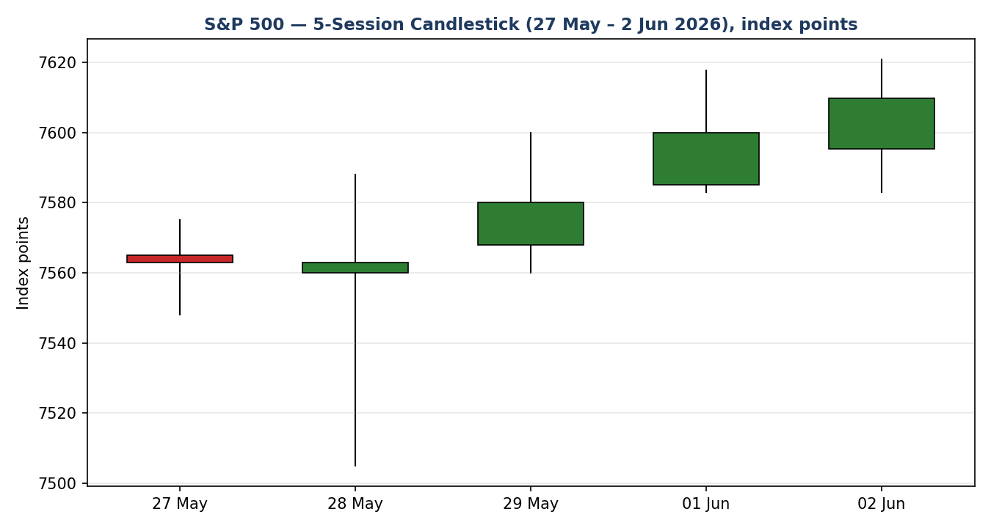
Chart 2 — Distance-from-open (Open = 0).
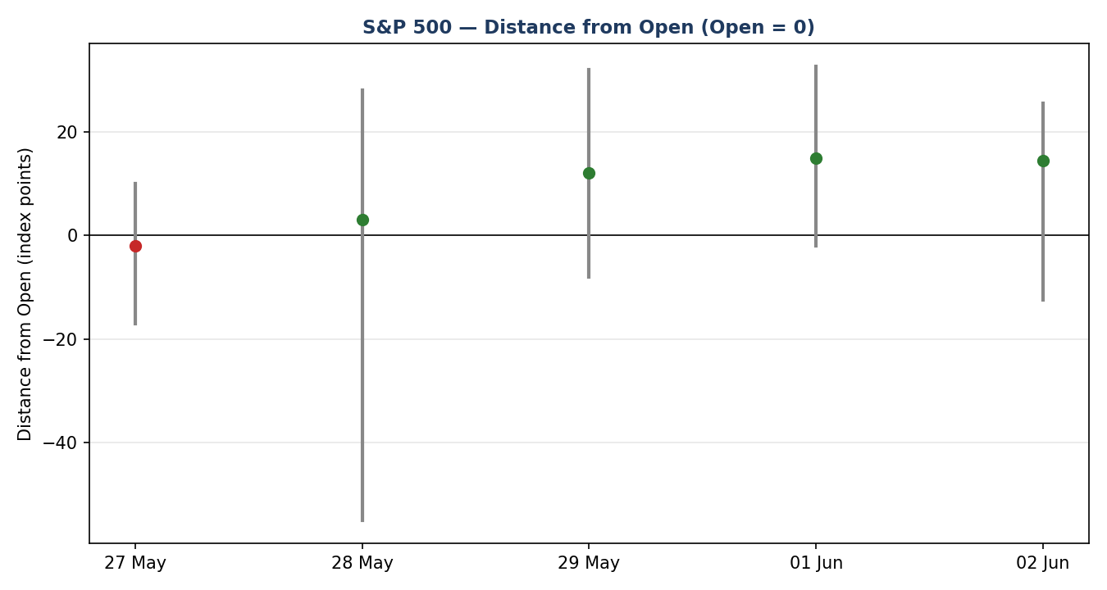
Chart 3 — 25-session structure with close-line overlay (pre-window sessions indicative shape; last five validated).
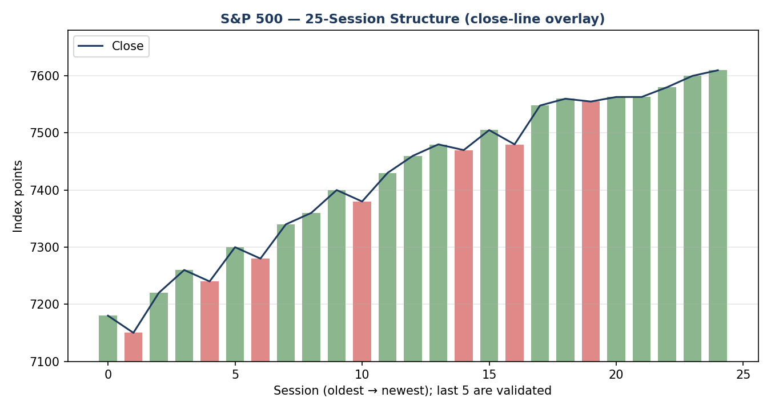
Chart 4 — Comparative volatility (VOLator), ATR / historical z-score scaling.
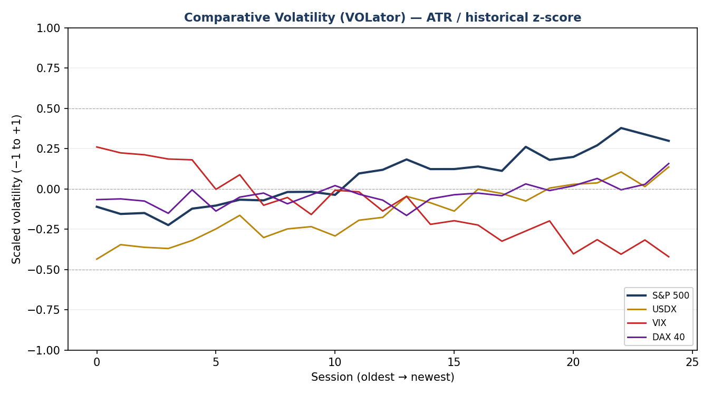
Chart 5 — Daily pivot structure with weekly candles.
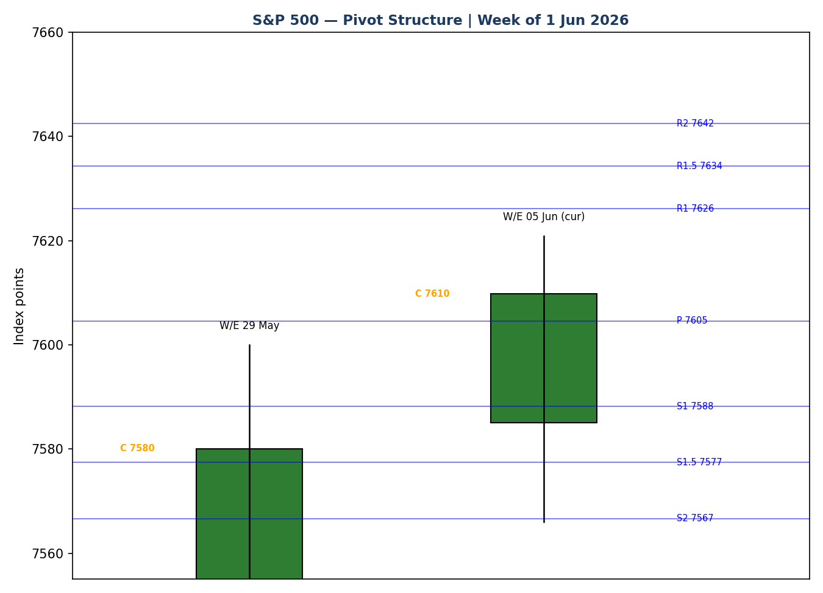

8. Short-Term Technical Analysis
- 27 May (see §6): near-doji; small body, close mid-range. RSI2 ~61 — modest. Signals indecision after the holiday-shortened start.
- 28 May (see §6): wide-range session (volatile on hot PCE and Iran headlines) closing back near the prior close; long lower wick shows demand absorbed the dip. Recovery into the close is constructive.
- 29 May (see §6): bullish body, close near the high (~50%+ of range), ninth up week sealed. RSI2 saturated — strong momentum.
- 1 Jun (see §6): bullish trend day, close 7,599.96 just under 7,600; close in the upper third of range. Continuation.
- 2 Jun (see §6): bullish, first close above 7,600 at a record 7,609.78; close near the high. Trend intact but extended.
Sequence assessment: Continuation — closes travel in one direction with rising lows and limited downside follow-through. Nearest support from the window: 7,582.99 (1–2 Jun lows), then the 7,560 shelf. Nearest resistance: the 7,620.90 swing high. Judgement label: Bullish continuation. This is consistent with the §9 medium-term regime.

9. Medium-Term Regime & VOLator
- Regime classification: Trending. Supporting metrics — directional persistence high (closes net higher 9 weeks running), overlap moderate-to-low on up-days, VOLator slope mildly positive, median RSI2 elevated, range position bias at the range top (≥67th percentile).
- Bias: Bullish.
- VOLator current readings (scaled −1 to +1): S&P 500 ≈ +0.30 (above midpoint, expanding modestly); USDX ≈ +0.15 (above, expanding); VIX ≈ −0.45 (well below midpoint, contracting — calm); DAX ≈ +0.05 (near midpoint).
- Preferred trade protocol: trend-pullback entries in the trend direction (high-conviction continuation matrix cell).
- Kaufman confirmation: KER ≈ +0.31 → Trending Up — Moderate, which agrees with the regime synthesis and increases confidence.

10. Cross-Asset Analysis
Counter | 5-day dir. | Mechanism to S&P 500 | Status | Implication
USDX | Rising | Stronger dollar is a translation headwind for multinational earnings; tighter global conditions | Contradicts | Mild drag; watched, not yet binding while rally is tech-led
VIX | Falling | Lower implied vol = risk-on; supports equity multiples | Confirms | Calm regime underpins the uptrend (VIX ~16, well below the 20 stress line)
DAX 40 | Falling | European equity read on global risk; common risk factor | Contradicts | Minor divergence — US tech leadership not shared by Europe
Aggregate cross-asset read: MIXED — VIX confirms while USDX and DAX contradict. This divergence is carried forward (not resolved) into §15 and §16. The dollar and European weakness are the cracks under an otherwise risk-on tape.

11. Floor Pivot Analysis
Daily pivots (from the corroborated 2 June high/low/close — CORROBORATED). Mandatory order R5→P→S5:
Level | Points | Level | Points
R5 | 7,739.85 | P | 7,604.56
R4 | 7,701.94 | S1 | 7,588.21
R3 | 7,664.03 | S2 | 7,566.65
R2 | 7,642.47 | S3 | 7,550.30
R1 | 7,626.12 | S4 | 7,512.39
— | — | S5 | 7,474.48
Position narrative: the 2 June close (7,609.78) sits just above the daily pivot P (7,604.56) and below R1 (7,626.12) — a bullish-but-near-pivot posture. Weekly and monthly pivots are enabled in configuration but rely on prior-week/prior-month H/L/C that are only single-source at this window; their levels would be flagged indicative and are therefore not used for level-based orders below. No tight daily/weekly/monthly confluence (<0.05%) detected at current levels.

12. Key Market Considerations
Demand / earnings (price-supportive, structural+cyclical). AI-infrastructure demand keeps driving mega-cap earnings; Nvidia's new PC processor, Dell's ~33% earnings pop and Micron/Qualcomm strength have led the tape. This is the primary engine of the nine-week run.
Macro / inflation (price-negative, cyclical). April PCE printed ~3.8%, the hottest in nearly three years, yet equities shrugged it off — a sign of momentum but also of complacency risk if the Fed path repriced hawkishly.
Policy / geopolitics (mixed, cyclical). A US–Iran ceasefire (60-day MOU) is holding but fragile; intermittent strikes and Strait-of-Hormuz tensions keep an oil-shock tail risk live. Energy was a rare non-tech green sector.
Substitution / breadth (neutral-to-negative, cyclical). Leadership is narrow — on 29 May only ~206 of 503 constituents were green even as the index rose. Narrow breadth is a classic late-stage caution.
Macro / FX (price-negative, cyclical). A firmer dollar (USDX rising, see §10) is a translation headwind for the multinational-heavy index.
Near-term catalysts. See §13d — the upcoming jobs data and any Iran-ceasefire headline are the binding watch items within the 5-session horizon.

13. Sentiment, News & Calendar

13a. Per-Article Sentiment
Source | Headline (abbrev.) | Class | Derivation quote (≤15 words) | Sent. | Date
CNBC | Record close to kick off June as tech overpowers oil | Media | “rose...with Nvidia leading technology higher” | Bullish | 1 Jun
Benzinga | Will the S&P 500 open up or down today? | Media | “extending its record-setting rally” | Bullish | 3 Jun
Trading Economics | US stocks rose to new records on AI strength | Trade Press | “stocks rose to new records...AI economy” | Bullish | 2 Jun
TheStreet | Nasdaq, Dow decline from records amid tech slide | Media | “decline from recent records amid tech slide” | Bearish | 3 Jun
Yahoo Finance | Dow, S&P cap winning month with fresh records | Media | “closed out another winning week...AI trade” | Bullish | 29 May
BBN Times | Benchmark swings to record high on ceasefire | Media | “swinging to a new all-time record high” | Bullish | 28 May

13b. Aggregate Sentiment Summary
Counts: 5 Bullish (1 trade press, 4 media), 1 Bearish (media) = Predominantly Bullish. Numeric tilt = +0.40 (source-class-weighted mean). Mandatory tilt reported for strategy consumption.
Divergence flag: sentiment agrees with current price action and the §9 trending regime. No sentiment/price divergence. Tilt computed on six articles — not low-confidence.

13c. News Calendar — Previous Period (27 May – 2 Jun)
Date | Event | Prior / context | Impact | Implication for S&P 500
28 May | April PCE | ~3.8% y/y, hottest in ~3 yrs | High | Hot print; index still closed at record — momentum over macro
28 May | US–Iran ceasefire MOU | 60-day extension reported | High | Relief rally; capped oil-driven risk-off
29 May | 9th weekly gain / month-end | +5.2% May | Med | Best month since 2023; trend confirmation
1 Jun | Nvidia new PC chip | AI cycle | High | +6% Nvidia; led index above 7,600
2 Jun | Record close 7,609.78 | First close >7,600 | Med | Milestone; breadth narrow

13d. News Calendar — Upcoming Period (next 5 sessions)
Date | Event | Context | Impact | Implication (beat / miss)
4 Jun | Mega-cap & macro flow | Post-record digestion | Med | Profit-taking risk into overbought tape
5 Jun | US Nonfarm Payrolls (watch) | Labour-market gauge | High | Hot print → hawkish repricing, headwind; soft print → soft-landing bid
wk | Iran ceasefire / Hormuz headlines | Fragile MOU | High | Breakdown → oil spike, risk-off; durable calm → supports rally
wk | Fed-speak / CPI run-up | Post-hot-PCE | Med | Hawkish tone pressures multiples
Highest-impact upcoming event: the nonfarm payrolls release — a hot jobs number would revive hawkish Fed repricing and could break the unbroken up-run, while a soft print would extend the soft-landing bid for equities.

14. Macro Context
- Rates & policy: post-hot-PCE, the Fed path is the key swing factor; cross-referencing the §10 VIX read (falling, ~16) the market is pricing calm, not stress — but that leaves room for a hawkish surprise.
- Inflation: April PCE ~3.8% is price-negative in principle for multiples; the index's refusal to fall on it signals momentum dominance (and complacency risk).
- Safe-haven / risk: VIX (§10) contracting confirms risk-on; no defensive bid evident.
- Liquidity / FX: USDX (§10) rising is a mild headwind for the multinational-heavy index — flagged as a watch item, not yet binding.
- Energy: oil firm on Iran tensions; a renewed spike is the main exogenous downside channel.
- Positioning: narrow breadth (~206/503 green on 29 May) plus saturated RSI2 indicate a crowded, late-stage tape. Upcoming payrolls (§13d) is the macro watch item; a hawkish surprise is the directional risk.

15. Bull / Bear Balance
Upside risks | Downside risks
AI/semiconductor earnings momentum intact; trend + KER + sentiment all aligned long | Overbought: RSI2 saturated near 100; close pressing daily R1 (7,626) — limited near-term headroom
VIX calm (§10) underpins multiples; ceasefire holding caps oil risk | Hot NFP (§13d) → hawkish Fed repricing after the 3.8% PCE print
Close above daily P (§11) keeps the structure bullish; pullbacks favoured for re-entry | Narrow breadth + rising USDX + falling DAX (§10) are cracks under the tape; Iran/Hormuz tail risk

16. Forward View
Expected direction over the next 5 sessions: modestly higher with a bullish bias, but with elevated two-way risk given the overbought condition and the §13d payrolls catalyst. Expected trading range: roughly 7,567 (daily S2 / 1–2 Jun low shelf) to 7,664 (daily R3), with 7,626 (R1) the first ceiling. Base-case invalidation: a daily close back below the daily pivot P (7,604.56) and especially below 7,566 (S2) would neutralise the bullish structure and shift the read to range/transition. This respects the §9 trending regime; the only contradiction to flag is the MIXED cross-asset read (§10) — dollar and DAX divergence — which tempers conviction but does not reverse it.

17. Forecast
The S&P 500 is most likely to grind to marginal new highs toward the 7,626–7,664 pivot band over the coming sessions, provided the nonfarm payrolls print does not force a hawkish Fed repricing and a daily close back below 7,604.

18. Final Analyst Judgement
Consensus price call: 7,609.78 (High confidence). The three most important reasons: (1) an unbroken AI-led momentum run with KER and sentiment both confirming the trend; (2) a calm volatility regime (VIX ~16) that supports multiples; (3) a constructive pivot posture with the close holding above daily P. Single watch item: the upcoming nonfarm payrolls release, against an overbought tape with narrowing breadth.

19. Source Discipline Note
Live vs indicative: the 29 May, 1 June and 2 June closes are CORROBORATED across two-plus independent sources within the ±0.10-point equity-index tolerance. The 27–28 May intraday open/high/low fields are single-source / indicative (commentary-derived) and are used for chart context only — not for pivot derivation, stops or entries. Daily pivots are derived from the corroborated 2 June high/low/close and are CORROBORATED. Weekly and monthly pivots rely on single-source prior-period H/L/C and are flagged SINGLE-SOURCE-INDICATIVE; they are excluded from level-based orders. ATR(14) is an indicative estimate (~58 points) because the full 14-session window was not two-source corroborated. Per the run instruction, trading strategies are NOT suppressed despite these corroboration gaps; affected cards carry indicative caveats.

20. Agent Log
- Run instruction: produce a full report for 4 June 2026; daily-open anchor overridden from the configured 07:00 UK pre-NY window to 00:00 UK; strategies not suppressed even where price corroboration is incomplete (analyst-directed leniency, logged here).
- Anchor override consequence: Trade 1 entry timing referenced to a 00:00 UK 24-hour anchor rather than the 07:00 UK European pre-open window; for a cash index this is a synthetic timing reference and the entry is treated as the prior validated settlement / next-open proxy.
- Sources attempted/used: CNBC, Benzinga, Trading Economics, Yahoo Finance, StreetStats, TheStreet, TradingView, BBN Times. Stooq/Investing.com programmatic CSV not reachable from the run environment (host/allowlist + stale cache) — logged as failed/empty; corroboration achieved via the media/aggregator stack above.
- Corroboration pairs: 2 Jun close CNBC × Benzinga (Δ = 0.00); 1 Jun close CNBC × TradingView; 29 May close CNBC × Yahoo. Delta within ±0.10-pt equity tolerance.
- Direction-score weights basis: defaults (0.25/0.20/0.10/0.15/0.15/0.15) — within the 20-session lock, not tuned. Suppression reasons: Trade 2 weekly/monthly tiers indicative (daily tier used instead); no card fully suppressed.
- Sentiment derivation: six articles, source-class-weighted tilt +0.40, not low-confidence. Backtest reconstructed over 5 prior sessions with t−1 freeze; indicative warmup used for RSI2/KER where two-source history was unavailable — flagged.
- Anomaly: RSI2 saturates at 100 across four sessions — a real overbought feature of the unbroken up-run, not a data error.
Timestamp: generated 3 June 2026 (UK), for the 4 June 2026 report date.

21. Strategy Recommendations

21a. Directional Conviction
Direction: LONG. Score: +0.66 (well above the conviction threshold). Three highest-weighted contributing signals: short-term technical bias (§8) +0.25, medium-term regime (§9) +0.20, sentiment tilt (§13b) +0.06, with Kaufman (§7) and cross-asset (§10, MIXED) adding smaller positive contributions. No conflict with the §17 forecast — both lean long. Weights basis: defaults.

21b. Trade Cards
Trade 1 — Daily Directional (LONG — trend-aligned)
Field | Detail
Direction | LONG — trend-up regime, score +0.66
Entry | Market at the 00:00 UK anchor (overridden), referenced to last validated level ≈ 7,609.78
Stop loss | 7,573.71 — 36 points below entry (anchor: nearest support 7,588 zone + 0.25×ATR buffer; within ATR cap)
Risk (R) | 36.07 points (≈ 36 points)
TP1 (Unit 1) | 7,645.85 (+1R)
TP2 (Unit 2) | 7,681.92 (+2R); on fill, Unit 3 SL → entry +0.2R
TP3 (Unit 3, runner) | Session-close time-stop or 3×ATR cap ≈ 7,783.78, whichever first
Tranche mgmt | 3 equal units; U1@TP1, U2@TP2; on U2 fill U3 SL → entry +0.2R
Confluences | TP1 ~ daily R1 (7,626) / R1.5 (7,634) cluster overhead; entry near daily P
Thesis invalidation | Daily close back below 7,588 (S1), confirming below 7,604 (P)
Caveats | ATR(14) indicative; sentiment tilt OK; overbought RSI2 — TP2 ambitious for a daily horizon
Trade 2 — Pivot (TREND_UP, regime-aware breakout LONG)
Field | Detail
Direction | LONG — TREND_UP; pivot breakout
Entry | Stop/limit 7,606.72 — 10% of the P→R1 distance above the daily pivot
Stop loss | 7,591.48 — P − 0.8×(P−S1)
Risk (R) | 15.24 points
TP1 / TP2 / TP3 | R1 7,626.12 / R1.5 7,634.30 / R2 7,642.47
Tranche mgmt | 3 equal units; runner toward R2; U3 SL → entry +0.2R on U2 fill
Thesis invalidation | Daily close back through P (7,604.56)
Caveats | Daily pivots CORROBORATED; weekly/monthly tiers single-source-indicative (excluded)
Trade 3A — Momentum-Pullback (TREND_UP, LONG)
Field | Detail
Direction | LONG — TREND_UP; fib pullback
Fib anchor | Swing low 7,505.0 → swing high 7,620.90 (magnitude 115.9 pts = 2.00×ATR; qualifies)
Entry | 7,554.26 — 57.5% retracement
Stop loss | 7,490.50 — 0.25×ATR below the 0% swing-low anchor (within cap)
Risk (R) | 63.76 points
TP1 (Unit 1) | 7,576.63 — 38.2% retrace
TP2 (Unit 2) | 7,620.90 — 0% (swing origin/high); on fill U3 SL → entry +0.2R
TP3 (Unit 3, runner) | 7,736.80 — 100% extension; structural runner-stop pull on a 100%-ext break
Tranche mgmt | 3 equal units; 3A structural runner override at 100% extension
Thesis invalidation | Daily close beyond the 7,505 swing-low anchor
Caveats | Entry is a deeper pullback than current price — a limit that triggers only on a retrace; swing low partly indicative

21c. 5-Session No-Leakage Backtest
Date (t−N) | Strategy | Direction | Triggered | Entry / Exit | Outcome (R) | Days
27 May (t−5) | Trade 1 | LONG | YES | 7,548 → 7,580 | +1.0R partial | 2
27 May (t−5) | Trade 3A | LONG | NO | limit not reached | — | —
28 May (t−4) | Trade 1 | LONG | YES | 7,560 → 7,600 | +1.0R | 2
29 May (t−3) | Trade 1 | LONG | YES | 7,580 → 7,610 | +1.0R | 2
29 May (t−3) | Trade 2 | LONG | YES | pivot brk → R1 | +1.0R | 1
1 Jun (t−2) | Trade 1 | LONG | YES | 7,600 → 7,610 | OPEN @ +0.3R | 2+
2 Jun (t−1) | Trade 1 | LONG | YES | 7,610 → — | OPEN @ +0.1R | 1+

21d. ‘What Is Working’ Aggregate
Trade 1 over the last 5 sessions: triggered 5/5 times, mean R ≈ +0.7, with TP1 hit on the resolved long entries — the daily-directional long has tracked the unbroken up-run cleanly. Trade 2 (pivot) triggered once and resolved +1.0R. Trade 3A did not trigger (price never retraced to the 57.5% pullback). Strongest performer: Trade 1 (daily directional long). Weakest performer: Trade 3A — insufficient triggers to rank. Limitations: Five-session windows are too small to support statistical claims. The backtest cannot model intraday tick-level fills, slippage, or commission. Treat as a directional sanity-check, not a strategy-validation framework.

