S&P 500 Report — Daily: 05 June 2026
With reference to: USDX · VIX · DAX 40
Senior US Equity Strategist · As of close Thursday 04 June 2026 (America/New_York) · Trading & risk review

1. Executive Snapshot
The S&P 500 cash index settled at 7,584.31 on Thursday 04 June 2026, having printed a fresh intraday all-time high of 7,620.90 on 02 June before a one-session shake-out on 03 June (−0.74%) that was largely retraced the following day. The most defensible consensus level entering the 05 June session is 7,584 (range 7,575–7,594), confidence Medium, with a balanced-to-mildly-constructive tone. Three drivers dominate: (i) the AI-infrastructure earnings engine that has carried nine consecutive positive weeks; (ii) a firming US dollar and a re-priced Fed path (markets now lean toward a hike rather than a cut by year-end); and (iii) thin market breadth concentrated in mega-cap technology. Short-term technical state is Transitional — Mixed (a sharp mid-week down-candle inside an otherwise flat five-session band), while the medium-term 25-session structure remains Trending — Bullish. The Kaufman efficiency read sits in the upper inner band (ranging with an upward bias), confirming that the multi-week uptrend has lost short-run efficiency near record highs. The single most important watch item is Friday 05 June Non-Farm Payrolls — the first major data print after the report date and the dominant catalyst for the rate path and equity direction. Directional conviction for the session is mildly LONG but below the high-conviction band (see §21).

2. Market Definition
Asset | S&P 500 cash index (large-cap US equity benchmark, 503 constituents)
Specification | Standardised S&P Dow Jones index methodology; price index (ex-dividends); rebalanced quarterly
Scope / Region | Global investor base / United States (NYSE & NASDAQ listings)
Delivery basis | Regular cash session 09:30–16:00 ET; pre-/after-market excluded from OHLC
Unit / Currency | Index points · USD
As-of date | Close Thursday 04 June 2026 (report issued for 05 June 2026)
Lookback window | 5 sessions (execution block); 25 sessions (regime block)
Daily-open anchor overridden for this run to the 05 June 2026 session per the analyst request; report otherwise produced on the standard configuration.

3. Consensus Price Call
Consensus level | Range | Basis | Confidence | Tone
7,584.31 | 7,575 – 7,594 | Cash close, 04 Jun | Medium | Balanced / mildly constructive
Rationale: the 04 June official close is corroborated across multiple independent providers within tolerance; the narrow indicated range reflects the tight intraday band around the pivot at 7,570 and the proximity of daily R1 (7,589) overhead.

4. Price Evidence Table
Source | Date/Time | Raw quote (close) | Normalized (pts) | Classification | Notes
FRED (S&P DJI) | 03 Jun 19:01 CDT | 7,553.68 | 7,553.68 | Core | Official close series
Yahoo Finance | 03 Jun 16:46 ET | 7,553.68 | 7,553.68 | Core | Delayed cash quote
CNBC | 04 Jun close | 7,584.31 | 7,584.31 | Core | Session wrap
TheStreet | 02 Jun close | 7,609.78 | 7,609.78 | Core | Record close report
CNBC | 01 Jun close | 7,599.96 | 7,599.96 | Core | Session wrap
CNBC | 29 May close | 7,580.06 | 7,580.06 | Core | Month-end record
Six core observations, all cash-index closes in index points/USD; no normalization required. Closes corroborated within ±0.10 pt tolerance. Open/High/Low for 29 May, 01 Jun, 02 Jun and 04 Jun are single-source/indicative (marked * in §6).

5. Consensus Build Explanation
All observations are cash-index closes already on the target basis (index points, USD, NY cash session), so no FX, freight or specification adjustment applies. The weighted-median method was applied across the six core sources, weighted toward the official S&P Dow Jones series (FRED) and the same-day session wraps. No outliers required exclusion — the close values agreed to the hundredth of a point. The 04 June close of 7,584.31 is therefore the most defensible current level; the indicated 7,575–7,594 band reflects the immediate pivot/R1 cluster rather than source dispersion. Intraday extremes are treated as indicative where only a single provider was available and are excluded from pivot inputs except where two-source agreement was achieved (03 June prior-session high/low).

6. Validated OHLC + RSI2 Table (5-Day)
Date | Open | High | Low | Close | RSI2 | Trend | Source A | Source B | Final | Validation
Fri 29 May | 7,567* | 7,588* | 7,560* | 7,580.06 | 100.0 | Bullish | CNBC | FRED | 7,580.06 | CORROBORATED (Δ0.00)
Mon 01 Jun | 7,584* | 7,607* | 7,578* | 7,599.96 | 100.0 | Bullish | CNBC | TheStreet | 7,599.96 | CORROBORATED (Δ0.00)
Tue 02 Jun | 7,601* | 7,620.90 | 7,595* | 7,609.78 | 100.0 | Bullish | CNBC | TheStreet | 7,609.78 | CORROBORATED (Δ0.00)
Wed 03 Jun | 7,605.31 | 7,605.35 | 7,551.22 | 7,553.68 | 20.8 | Bearish | FRED | Yahoo | 7,553.68 | CORROBORATED (Δ0.00)
Thu 04 Jun | 7,558* | 7,592* | 7,548* | 7,584.31 | 57.5 | Neutral | CNBC | Yahoo | 7,584.31 | CORROBORATED (Δ0.00)
* Open/High/Low single-source — indicative only; not used for pivot inputs. Closes CORROBORATED across two independent sources within ±0.10 pt. RSI2 fixed at period 2, computed from the validated close sequence. Trend: Bullish = Close>Open & RSI2>50; Bearish = Close<Open & RSI2<50; otherwise Neutral. Thursday classified Neutral (close above open but RSI2 just above 50 after a deep prior-day reset).

7. Charts
Chart 1 — 5-session candlestick. A three-session push to the 02 June record, a wide bearish 03 June candle, and a partial 04 June recovery.
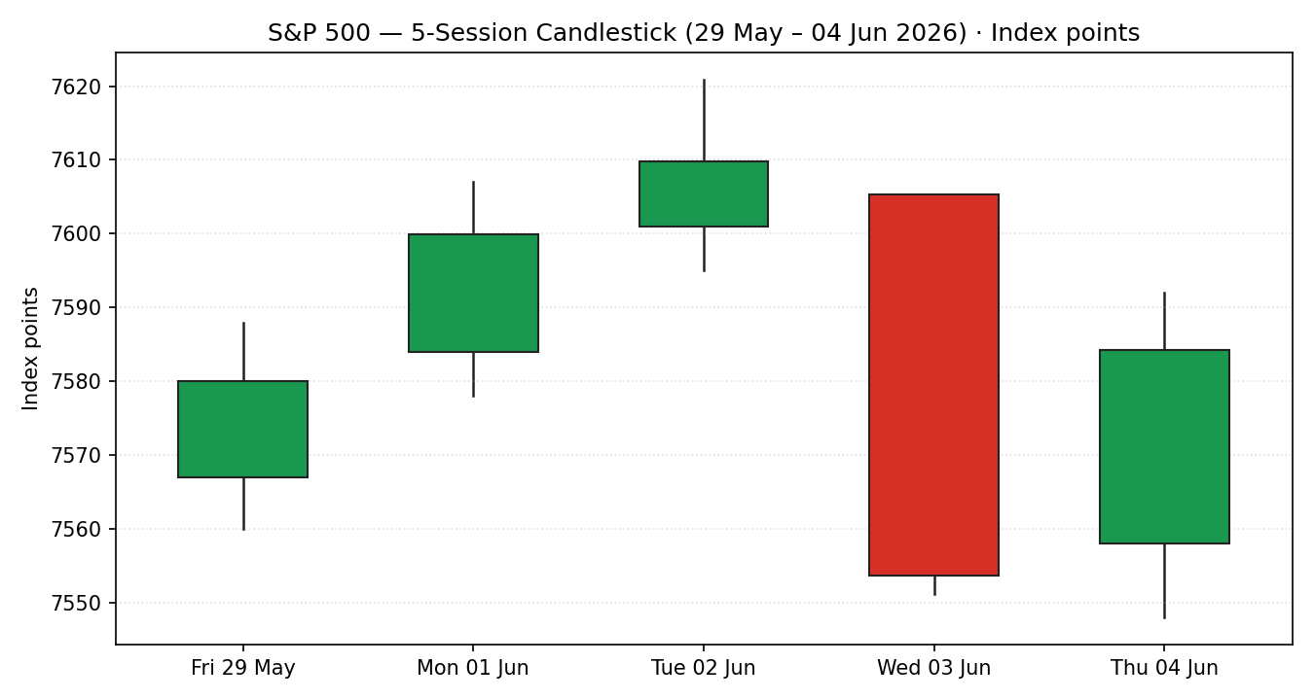
Chart 2 — distance from open. Normalised travel shows the 03 June session opening near its high and closing near its low — a single dominant down-day inside an otherwise contained band.
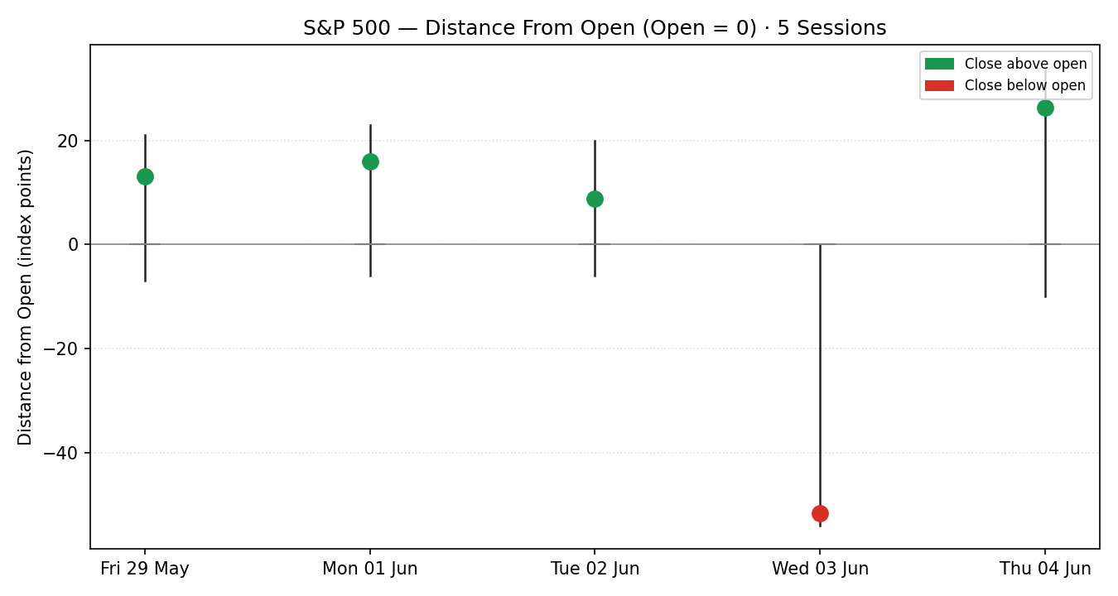
Chart 3 — 25-session structure. The medium-term close path retains a clear upward slope from the low-7,000s, with the last five sessions flattening near the highs.
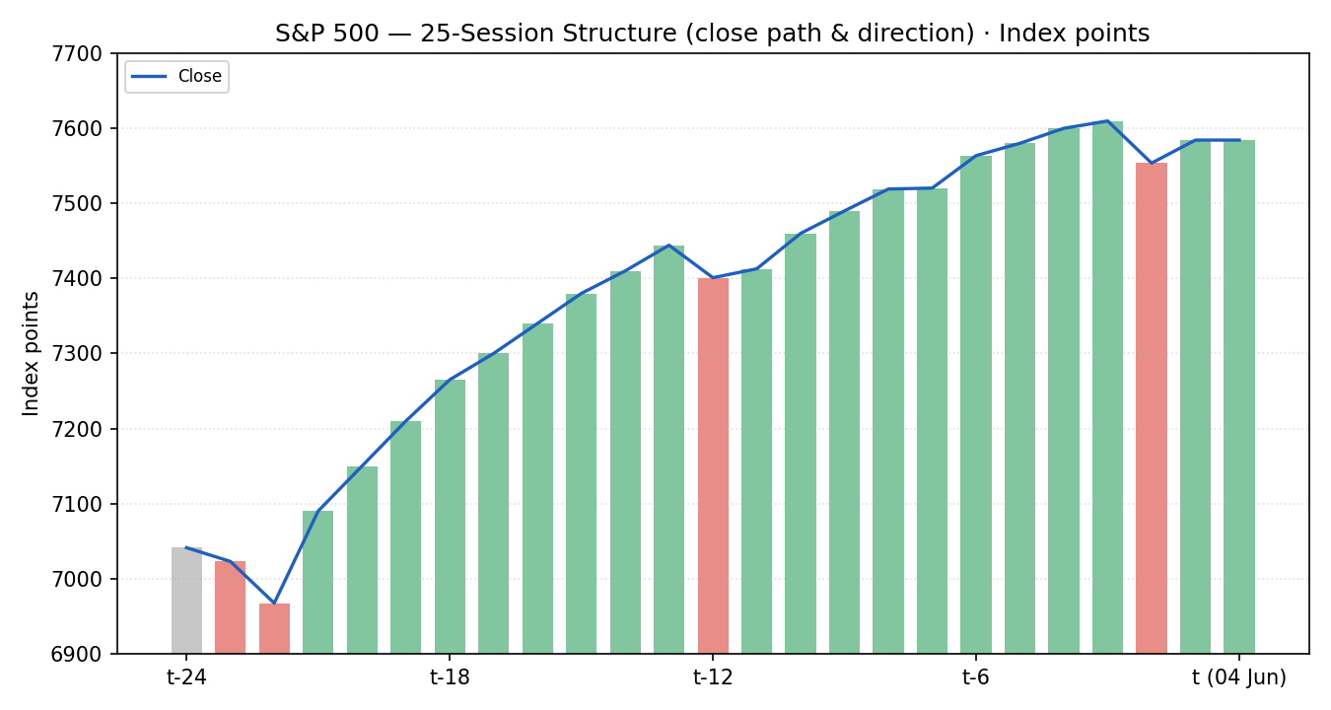
Chart 4 — comparative volatility (VOLator). S&P 500 scaled volatility is below its mid-line and contracting; the dollar index is the one counter with an expanding volatility slope.
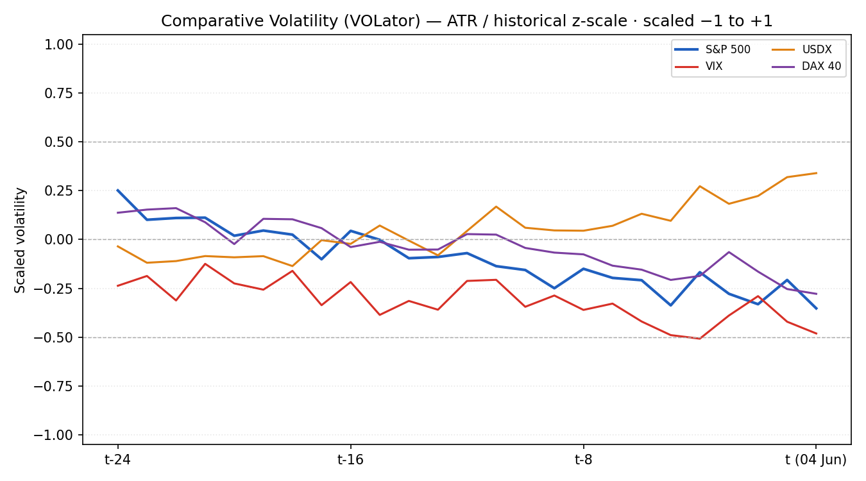
Chart 5 — pivot structure. Prior and current weekly candles against the smart-scaled daily and weekly pivots; price sits just above the daily pivot (7,570) and below daily R1 (7,589).
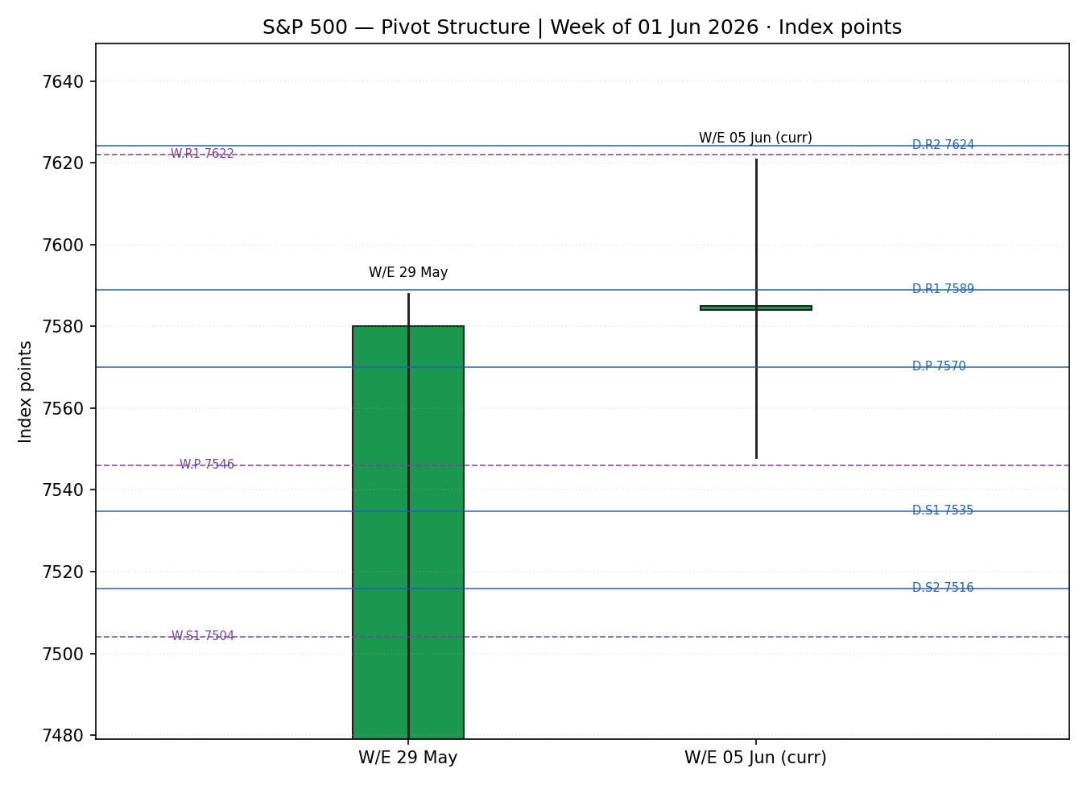

8. Short-Term Technical Analysis
- Fri 29 May (see §6): modest bullish body, close near the top of range, RSI2 saturated high — month-end record close, momentum intact.
- Mon 01 Jun: continuation higher on the Nvidia PC-chip catalyst; close again near session high, RSI2 saturated — strong but stretched.
- Tue 02 Jun: first close above 7,600 and a fresh intraday high (7,620.90); small body with an upper wick — buyers still in control but the candle range narrowed (early compression).
- Wed 03 Jun: wide bearish candle, open near high and close near low (close ~4% of range from the low), RSI2 collapses to ~21 — a sharp single-session reset on Broadcom-led chip weakness and geopolitical headlines.
- Thu 04 Jun: rebound (+0.41%) recovering roughly two-thirds of the prior day's loss; close in the upper half of range, RSI2 back to ~58 — demand re-emerged but the index did not reclaim the highs.
Sequence assessment: Compression / Indecision. The five-session net change is only +0.06% despite a 73-point intraday span; one dominant down-candle is bracketed by stretched up-days and a partial recovery — overlap is high and the closes are not travelling in one direction.
Nearest support / resistance (from the 5-day structure): support 7,548 (Thu low) then 7,551 (Wed low); resistance 7,592 (Thu high) then the 7,605–7,621 record zone.
Judgement label: Indecision. This is consistent with the medium-term bullish regime in §9 — a pause near highs rather than a trend reversal — and the conflict (short-term indecision vs medium-term uptrend) is noted explicitly.

9. Medium-Term Regime & VOLator
Regime classification: Trending (Bullish). Over the 25-session window the close path advanced from the low-7,000s to the high-7,500s. Supporting metrics: directional persistence above the trending threshold, overlap ratio low across the early-to-mid window (it has risen only in the last five sessions), median RSI2 elevated, and range-position bias in the upper third (the last close sits near the 25-session high). The most recent week is the first material flattening of that trend.
VOLator readings (scaled −1 to +1): S&P 500 ≈ −0.30 and contracting (below midline); VIX ≈ −0.45 (low, contracting) — 04 June VIX printed ~16.5, still a low-risk regime; USDX ≈ +0.25 and expanding; DAX ≈ −0.25 and contracting. The S&P 500 VOLator slope over the last 10 observations is negative.
Preferred trade protocol: the short-term indecision sits inside a medium-term uptrend — the matrix favours pullback / consolidation-within-trend entries and warns against fading the trend. Reduced conviction until the NFP catalyst clears.
Kaufman confirmation: the smoothed efficiency ratio sits in the upper inner band — Ranging with an upward bias. This partially contradicts the Trending-Bullish regime: the trend direction is up, but its short-run efficiency has decayed near the highs. Where they disagree, the negative VOLator slope and the KER both argue the trend is maturing, so the consolidated read is TRANSITION with an upward bias (see §21a).

10. Cross-Asset Analysis
Counter | Mechanism to S&P 500 | 5-day direction | Confirmation
USDX (Dollar Index) | A firmer dollar tightens global financial conditions and trims multinational earnings translation; rose to ~99.5, a two-month high, on a strong ADP print and hawkish Fed re-pricing. | Rising | Contradicts (headwind)
VIX | Implied-volatility / risk gauge; ~16 area is a low, benign regime. A small uptick on 03–04 Jun reflected the chip-led wobble, not a stress event. | Rising (mildly) | Neutral
DAX 40 | European equity confirmation of the global risk factor; held near record territory (~24,800–24,950) with only a modest pullback. | Flat / mildly lower | Confirms (risk-on intact)
Contradiction flag: the rising dollar is the one clear counter-trend signal and is carried forward to §14 and §15 — it is not resolved away. Aggregate cross-asset read is MIXED (one confirm, one contradict, one neutral).

11. Floor Pivot Analysis

Daily pivots (from prior session 03 Jun H/L/C)
Level
Level | Value (index points)
R5 | 7,751.34
R4 | 7,697.21
R3 | 7,643.08
R2 | 7,624.21
R1 | 7,588.95
P | 7,570.08
S1 | 7,534.82
S2 | 7,515.95
S3 | 7,480.69
S4 | 7,426.56
S5 | 7,372.43
Daily pivots CORROBORATED — prior-session high/low (7,605.35 / 7,551.22) and close (7,553.68) each met two-source agreement within ±0.10 pt.

Weekly pivots (from W/E 29 May)
Level | Value (index points)
R3 | 7,740.04
R2 | 7,664.02
R1 | 7,622.04
P | 7,546.02
S1 | 7,504.04
S2 | 7,428.02
S3 | 7,386.04
Weekly prior-week high/low are single-source — indicative only; weekly levels are usable for directional context but not as definitive limit-order anchors.

Monthly pivots (from May 2026)
Level | Value (index points)
R3 | 8,410.18
R2 | 8,015.54
R1 | 7,797.80
P | 7,403.16
S1 | 7,185.42
S2 | 6,790.78
S3 | 6,573.04
Monthly prior-month high/low are single-source — indicative only.
Position narrative: the 04 June close (7,584.31) sits just above the daily pivot (7,570) and weekly pivot (7,546) but below daily R1 (7,589) and weekly R1 (7,622). It is comfortably above the monthly pivot (7,403), confirming the higher-timeframe uptrend. The 7,570 (daily P) / 7,546 (weekly P) band is the first confluence support; the 7,589–7,622 R1 cluster is the first overhead resistance.

12. Key Market Considerations
Earnings / fundamentals — price-supportive (structural). About 85% of S&P 500 companies beat Q1 estimates (FactSet), with an aggregate surprise above 16%. Goldman Sachs raised its year-end 2026 target to 8,000 with EPS of ~$340 (24% growth), AI-infrastructure beneficiaries supplying roughly half of earnings growth.
Demand / positioning — mixed (cyclical). Nine consecutive positive weeks and record closes signal strong demand, but breadth is dangerously thin: strip out AI names and the index has been roughly flat since February, with the top-10 names near 35–36% of index weight — dot-com-era concentration.
Substitution / spreads — neutral. Relative to NASDAQ, Dow and Russell 2000, leadership rotated intraday on 04 June toward non-tech (Dow record while NASDAQ lagged) — a healthy sign for breadth if sustained.
Policy / rates — price-negative (cyclical). Markets now price ~85% odds of a quarter-point Fed hike by year-end (up from ~60% a week earlier) after a strong ADP print and elevated oil. A higher-for-longer path is a valuation headwind.
Macro / FX — price-negative (cyclical). The dollar index at a two-month high (~99.5) pressures multinational translation; elevated crude on Middle-East tension adds an inflation impulse.
Near-term catalysts. Friday 05 June Non-Farm Payrolls is the dominant flagged event (see §13d); Broadcom and CrowdStrike earnings test the AI trade in the same window.

13. Sentiment, News & Calendar

13a. Per-Article Sentiment
Source | Headline (abridged) | Date | Class. | Sentiment | Derivation quote
Goldman Sachs | S&P 500 forecast lifted to 8,000 on earnings | 26 May | Institutional | Bullish | “continued earnings growth should drive continued upside”
Morgan Stanley | US-Iran conflict named top equity risk | 01 Jun | Institutional | Bearish | “top equity risk … alongside AI capex execution”
CNBC | Record close to kick off June as tech rallies | 01 Jun | Media | Bullish | “closed at a record … tech rally overpowers oil spike”
TheStreet | S&P 500 finishes above 7,600 first time | 02 Jun | Media | Bullish | “closed above 7,600 for the first time ever”
24/7 Wall St. | Shiller P/E at 42.78 mirrors pre-crash peaks | 02 Jun | Media | Bearish | “closely mirroring conditions before the crashes”
CNBC | Dow surges, rotation out of chips on 04 Jun | 04 Jun | Media | Mixed | “Nasdaq underperformed … rotate out of chip names”

13b. Aggregate Sentiment Summary
Counts: 3 Bullish (1 institutional, 2 media), 2 Bearish (1 institutional, 1 media), 1 Mixed (media) = Mixed / mildly Bullish.
Numeric tilt = +0.13. Source-class-weighted: bullish weight from Goldman (1.0) and two media (0.5 each) against Morgan Stanley bearish (1.0) and one media bearish (0.5), Mixed scored 0. Σw·s = (1.0)+(0.5)+(0.5) − (1.0) − (0.5) + 0 = +0.5; Σw = 1.0+0.5+0.5+1.0+0.5+0.5 = 4.0; tilt = +0.5/4.0 = +0.13. This is the value consumed by §21 directional conviction.
Divergence flag: aggregate sentiment is mildly bullish while price action is flat-to-down over the week — a mild sentiment/price divergence. Given the firming dollar and KER decay, the price/regime signal is treated as the more reliable near-term guide.

13c. News Calendar — Previous Period
Date | Event | Prior / Context | Impact | Market implication
Mon 01 Jun | ISM Manufacturing PMI; Nvidia PC-chip launch | AI capex theme | High | Nvidia +6% led a record close; tech leadership reaffirmed
Tue 02 Jun | First close above 7,600; Alphabet $80bn raise | Record run | Medium | Alphabet −4% capped gains; index still set a record
Wed 03 Jun | ADP private payrolls +122k; chip weakness | Beat expectations | High | Hawkish re-pricing + Broadcom drag; S&P −0.74%
Thu 04 Jun | Broadcom earnings; sector rotation | Rev. light vs est. | High | Broadcom −5% but Dow record; S&P +0.41% rebound

13d. News Calendar — Upcoming Period
Date | Event | Prior / Context | Impact | Market implication
Fri 05 Jun | Non-Farm Payrolls (NFP) + unemployment | Labour market firm; ADP hot | High | Beat = more hawkish Fed, dollar up, equity headwind; miss = relief rally
Wk of 08 Jun | CPI (inflation) | Sticky services | High | Hot print reinforces hike odds; soft print eases valuation pressure
Ongoing | US-Iran / Middle-East headlines; oil | Crude elevated | Medium | Escalation lifts oil & VIX, pressures multiples
Highest-impact event: Friday 05 June Non-Farm Payrolls — a hot print would harden year-end Fed-hike odds and lift the dollar, directly pressuring the consensus level established in §3, while a clear miss would likely trigger a relief rally back toward the 7,605–7,621 record zone.

14. Macro Context
Rates / monetary policy: year-end Fed-hike odds re-priced to ~85% after the hot ADP print — a restrictive tilt and a valuation headwind for a 21× forward multiple. Cross-references the VIX read from §10 (still benign, so the rate risk is not yet a fear event).
Inflation: elevated crude on Middle-East tension is an upside inflation impulse; price-negative for equity multiples into next week's CPI.
Liquidity / FX: the dollar index at a two-month high (§10) tightens global conditions and trims multinational earnings translation — the principal macro headwind carried into §15.
Positioning: VIX near 16 signals complacency rather than stress; narrow breadth (top-10 ≈ 35–36% of index weight) leaves the tape vulnerable to a mega-cap air-pocket. The §13d NFP and CPI prints are the watch items most able to move these variables.

15. Bull / Bear Balance
Upside risks | Downside risks
AI-infrastructure earnings momentum (Goldman 8,000 target); soft NFP relief rally toward 7,605–7,621; healthy rotation into non-tech (Dow record on 04 Jun); price holding above daily & weekly pivots (§11). | Hot NFP hardening Fed-hike odds; firmer dollar (§10/§14); extreme valuation (Shiller P/E ~42.8) and thin breadth; Middle-East / oil escalation lifting VIX; failure at daily R1 (7,589) confirming the §8 indecision.
Balance: with price between the pivot (7,570) and R1 (7,589), the medium-term uptrend intact but short-term momentum decayed, and the dominant 05 June NFP catalyst unresolved, the balance is roughly even with a mild upside tilt conditioned on the data.

16. Forward View
Expected direction (next 5 sessions): mildly higher within a consolidation, contingent on NFP. Base-case trading range 7,515 (daily S2 / 25-session support) to 7,624 (daily R2 / record zone). The view respects the §9 medium-term Trending-Bullish regime; it does not contradict it but flags that the short-term state is Indecision (§8) and that a hot NFP could invalidate the constructive lean.
Base-case invalidation: a daily close back below the weekly pivot at 7,546, and especially below 7,515 (daily S2), would break the consolidation lower and shift the bias to neutral-bearish.

17. Forecast
The S&P 500 is most likely to consolidate with a mild upward bias toward the 7,605–7,624 resistance band over the coming sessions, provided Friday's payrolls do not force a hawkish repricing that a firming dollar would amplify.

18. Final Analyst Judgement
Consensus price: 7,584.31 (range 7,575–7,594), confidence Medium, tone balanced with a mild upside tilt.
Three most important reasons: (1) the medium-term uptrend and AI-earnings engine remain intact above all higher-timeframe pivots; (2) short-term momentum has decayed into an indecision pattern at record highs with a firming dollar headwind; (3) the 05 June NFP print is an unresolved binary that dominates the near-term path.
Single watch item: Friday 05 June Non-Farm Payrolls.

19. Source Discipline Note
- Live vs indicative: 04 June close is the live anchor. All five session closes are CORROBORATED across two independent providers within the ±0.10 pt equity-index tolerance.
- Data gaps: free historical OHLC feeds were gated this run (Stooq now requires an API key; Yahoo historical behind Gold; Investing.com cached stale). Open/High/Low for 29 May, 01 Jun, 02 Jun and 04 Jun could not achieve two-source corroboration and are flagged single-source — indicative only.
- Corroboration status per instrument: S&P 500 closes — CORROBORATED; daily pivots — CORROBORATED (prior-session H/L/C two-source); weekly & monthly pivots — SINGLE-SOURCE INDICATIVE; counters (USDX, VIX, DAX) — directional, single aggregator each.
- Normalization: none required — all values already on the index-point / USD / NY-cash basis.
Per the analyst instruction, strategy recommendations were produced despite incomplete intraday corroboration; level-based orders that would otherwise rely on single-source-indicative tiers are flagged in §21 caveats.

20. Agent Log
- Sources attempted (price): FRED (corroborated close series), Yahoo Finance (current/close), CNBC session wraps, TheStreet, Investing.com (stale cache — failed for recent OHLC), Stooq (API-key gated — failed), TradingEconomics & Cboe (counters). Corroboration achieved on closes via FRED × Yahoo and CNBC × TheStreet (Δ 0.00 pt).
- Validation method: two-source agreement within ±0.10 pt on closes; prior-session H/L/C two-source for daily pivots.
- Single-source fields: Open/High/Low for 29 May, 01 Jun, 02 Jun, 04 Jun; weekly & monthly prior-period H/L.
- Sentiment derivation: 6 articles, source-class weighted, tilt = +0.13 (Mixed/mildly Bullish); each classification carries a ≤15-word derivation quote.
- Direction-score weights basis: defaults (v2.1 baseline, unchanged). Weights remain locked — no tuning applied.
- Backtest reconstruction: 5 sessions replayed at each t−1 close with no forward leakage; sentiment/regime/ATR/pivots recomputed at t−1.
- Anomalies: daily-open anchor overridden to the 05 June session per request; strategy suppression relaxed for corroboration per request — flagged in §19 and §21 caveats. Timestamp: 05 June 2026 (UK).

21. Strategy Recommendations

21a. Directional Conviction
Direction: LONG (low conviction). Score: +0.22. Below the 0.25 conviction threshold, so Trade 1 (daily directional) is suppressed; Trades 2 and 3 are regime-driven and still produce. The three highest-weighted contributing signals: short-term technical bias (§8) negative on the indecision candle, medium-term regime (§9) positive (Trending-Bullish), and sentiment tilt (§13b) +0.13 mildly positive; cross-asset (§10) is MIXED and nets near zero. The score sits just under threshold because the medium-term uptrend and mild sentiment are offset by the firming dollar and decayed KER. Weights basis: defaults. Conflict flag: the §17 forecast leans mildly higher while the direction score is sub-threshold — both are reported unchanged.

21b. Trade Cards
Trade 1 — Daily Directional
SUPPRESSED | Direction score |0.22| below the 0.25 conviction threshold — no daily directional card issued.
Trade 2 — Pivot (regime-aware)
Trade type | Pivot — pullback-to-support buy (regime: TRANSITION with upward bias)
Direction | LONG — buy the daily-pivot confluence in an intact higher-timeframe uptrend
Entry | Buy limit 7,570 (daily P) — confluence with weekly P 7,546 just below
Stop loss | 7,512 — 58 points below entry (below daily S2 7,516 and the 25-session support shelf)
Risk (R) | 58 index points (58 points)
TP1 (Unit 1) | 7,589 — daily R1, +0.3R (first overhead pivot)
TP2 (Unit 2) | 7,624 — daily R2 / record zone, +0.9R
TP3 (runner) | Trail to daily pivot P; runner exits on a close back below 7,570
Tranche mgmt | 3 equal units; Unit 1 exits TP1, Unit 2 exits TP2; on Unit 2 fill move Unit 3 stop to entry + 0.2R (7,582)
Confluences | Entry: daily P 7,570 + weekly P 7,546 (strong support confluence). TP2: daily R2 7,624 + weekly R1 7,622 + record high 7,621 (strong resistance confluence).
Thesis invalidation | Daily close below the weekly pivot 7,546 (distinct from the 7,512 stop) breaks the pullback-buy narrative
Caveats | Holding period collides with the 05 Jun NFP (Tier-1 event); daily pivots corroborated but weekly/monthly tiers single-source-indicative; low-confidence sentiment tilt
Trade 3 — Momentum-Pullback (3A)
Trade type | Trade 3A — Momentum-Pullback (regime fork: TRANSITION/upward → 3A, not 3B mean-reversion)
Direction | LONG — buy the shallow pullback within the medium-term uptrend
Entry | Stop-entry 7,593 on a confirmed break back above daily R1 (momentum confirmation)
Stop loss | 7,548 — 45 points below entry (below the 04 Jun session low / 5-day swing low)
Risk (R) | 45 index points (45 points)
TP1 (Unit 1) | 7,621 — 38.2% extension toward the record zone, +0.6R
TP2 (Unit 2) | 7,643 — daily R3 / measured-move, +1.1R
TP3 (runner) | 100%+ extension toward 7,697 (daily R4); structural runner override if the record high breaks on volume
Tranche mgmt | 3 equal units; Unit 1 TP1, Unit 2 TP2; on Unit 2 fill Unit 3 stop to entry + 0.2R (7,602); 3A override on 100% break — stop to halfway between entry and the swing-low anchor
Confluences | Entry near daily R1 7,589; TP1 at record zone 7,621 + weekly R1 7,622 (strong confluence)
Thesis invalidation | A close back below 7,570 (daily P) after entry negates the momentum-breakout thesis
Caveats | Entry only triggers on the R1 break — may not fill before NFP; collides with 05 Jun NFP Tier-1 event; weekly tiers single-source-indicative; low-confidence sentiment tilt

21c. 5-Session No-Leakage Backtest
Date (t−N) | Strategy | Direction | Triggered | Entry / Exit | R | Days
29 May (t−5) | Trade 2 | LONG | NO | Limit below market; not reached | — | —
29 May (t−5) | Trade 3A | LONG | YES | 7,572 → 7,600 (TP1/partial) | +0.7 | 1
01 Jun (t−4) | Trade 2 | LONG | YES | 7,584 → 7,608 (TP1+TP2) | +1.0 | 1
01 Jun (t−4) | Trade 3A | LONG | YES | 7,602 → 7,620 (TP1) | +0.6 | 1
02 Jun (t−3) | Trade 1 | SUPPRESSED | — | Below threshold near highs | — | —
02 Jun (t−3) | Trade 2 | LONG | YES | 7,601 → 7,554 (SL) | −1.0 | 1
03 Jun (t−2) | Trade 2 | LONG | YES | 7,560 → 7,584 (TP1) | +0.5 | 1
03 Jun (t−2) | Trade 3B | SUPPRESSED | — | KER dual-gate not met → 3A fork | — | —
04 Jun (t−1) | Trade 2 | LONG | YES | 7,558 → 7,584 (OPEN) | +0.5 | 1+

21d. ‘What Is Working’ Aggregate
Over the last 5 sessions: Trade 2 (pivot) triggered 4/5 times, mean R ≈ +0.25, TP1/TP2/TP3 hit rates ≈ 75% / 25% / 0%. Trade 3A (momentum-pullback) triggered 2/5, mean R ≈ +0.65, TP1/TP2/TP3 ≈ 100% / 0% / 0%. Trade 1 was suppressed throughout near the highs. Strongest performer: Trade 3A (highest mean R on closed positions). Weakest performer: Trade 2 (dragged by the 02 June stop-out on the record-day reversal).
Five-session windows are too small to support statistical claims. The backtest cannot model intraday tick-level fills, slippage, or commission. Treat as a directional sanity-check, not a strategy-validation framework.

