S&P 500 Report — Daily: 8 June 2026
With reference to: USDX (Dollar Index) · VIX · DAX 40
Snapshot date 8 June 2026 (America/New_York). Pre-NY-open European-session anchor (override applied: 00:00 UK in place of the standard 07:00 UK pre-open anchor for this run; consequences noted in §20). Most recent corroborated cash session: Friday 5 June 2026.

1. Executive Snapshot
The S&P 500 cash index enters the 8 June session at a corroborated last close of 7,383.74 (Friday 5 June), down 2.64% on the day — the index’s single largest one-day fall of 2026 — after a hotter-than-expected May payrolls print (172,000 vs ~85,000 expected) drove a sharp repricing of Federal Reserve rate-cut expectations and a tech-led liquidation. Market tone is bearish in the near term but unfolds against a still-intact medium-term uptrend; the three dominant drivers are (i) the upside payrolls surprise and the resulting shift toward a higher-for-longer / possible-hike narrative, (ii) a tech/semiconductor de-rating led by Broadcom’s soft guidance and a >12% AVGO fall, and (iii) a sharp risk-off volatility expansion (VIX +39.7% to 21.51). The short-term technical read is Exhaustion — reversal risk: the five-session sequence flipped from record highs (7,609.78 on 2 June) to a deep oversold close, with RSI2 at 13.2. The medium-term 25-session regime remains Transitional-to-Bullish in structure but with momentum rolling over. The Kaufman efficiency reading is 0.03 — well below the 0.13 trend threshold — classifying the medium window as ranging/choppy rather than cleanly trending. The single most important watch item is the mid-June FOMC decision and its accompanying projections; a hawkish surprise would confirm the downside, while any dovish reassurance could spark a violent oversold bounce. Directional conviction for the session is SHORT (score −0.36), driven mainly by cross-asset risk-off confirmation and the bearish short-term technical bias.

2. Market Definition
Field | Definition
Asset | S&P 500 cash index (^GSPC) — large-cap US equity benchmark, 503 constituents
Price basis | Cash index level (continuous), calculated during the NYSE/NASDAQ regular session
Delivery / session | Regular cash session 09:30–16:00 ET (14:30–21:00 UK)
Unit / currency | Index points · USD
Tick | 0.01 point
As-of date | 8 June 2026 (America/New_York); last corroborated session Fri 5 June 2026
Lookback window | 5 sessions (execution block); 25 sessions (regime block)

3. Consensus Price Call
Consensus level | Range | Basis | Confidence | Tone | Rationale
7,383.74 | 7,360 – 7,410 | Cash close, 5 Jun | High (close) | Bearish | Friday official close corroborated across six independent sources within ±0.1pt; intraday extremes for Friday single-source only.
Close corroboration: Associated Press, Fortune, FRED (S&P DJI), Trading Economics, StreetStats and Polymarket resolution feed all report 7,383.74 / 7,384 — within the ±0.10-point equity-index tolerance. The consensus call is the official cash close, not a futures-derived level.

4. Price Evidence Table
Source | Date/Time | Raw quote (close) | Normalized | Relevance | Notes
S&P Dow Jones / FRED | 4 Jun close | 7,584.31 | 7,584.31 | Core | Official index close, T-1 reference
Investing.com (US500/SPX) | 1–4 Jun OHLC | full OHLC | as-quoted | Core | Daily OHLC for the block; cash basis
Associated Press / Yahoo | 5 Jun 16:18 ET | 7,383.74 | 7,383.74 | Core | Official Friday close
Fortune | 5 Jun | 7,383.74 | 7,383.74 | Core | Corroborates Friday close (−200.57)
Trading Economics | 5 Jun | 7,384 | 7,384 | Directional | Rounded; within tolerance
StreetStats / Polymarket feed | 5 Jun 16:57 ET | 7,383.74 | 7,383.74 | Core | Independent EOD confirmation

5. Consensus Build Explanation
All observations are cash-index levels in USD index points, so no FX, freight or specification normalization is required; the only adjustment is timing (regular-session close at 16:00 ET). The five session closes for 1–5 June were each corroborated by at least two independent sources within the ±0.10-point equity-index tolerance, with the Friday close confirmed by six. Open, high and low for 1–4 June were taken from the Investing.com validated daily table and are accepted as the working OHLC. The Friday 5 June open, high and low could not be independently corroborated from a second OHLC source within tolerance and are therefore carried as single-source — indicative only; under the no-synthesis discipline these intraday extremes may not anchor daily-pivot calculations or entry/stop pricing. The most defensible current level is the official Friday cash close of 7,383.74, because it is the value with the deepest independent corroboration and is the reference the market itself uses for settlement.

6. Validated OHLC + RSI2 Table (5-Day)
Date | Open | High | Low | Close | RSI2 | Trend | Validation
Mon 1 Jun | 7,582.29 | 7,617.66 | 7,562.61 | 7,599.96 | 100.0 | Bullish | CORROBORATED (Δ ≤ 0.1 pt)
Tue 2 Jun | 7,595.40 | 7,620.90 | 7,582.99 | 7,609.78 | 100.0 | Bullish | CORROBORATED (Δ ≤ 0.1 pt)
Wed 3 Jun | 7,605.31 | 7,605.35 | 7,551.22 | 7,553.68 | 14.9 | Bearish | CORROBORATED (Δ ≤ 0.1 pt)
Thu 4 Jun | 7,516.54 | 7,598.19 | 7,516.54 | 7,584.31 | 35.3 | Neutral | CORROBORATED (Δ ≤ 0.1 pt)
Fri 5 Jun | 7,560.00* | 7,575.00* | 7,360.00* | 7,383.74 | 13.2 | Bearish | Close CORROBORATED (Δ≈0.0); O/H/L single-source — indicative
* Friday intraday open/high/low are single-source — indicative only and are excluded from daily-pivot anchoring per source discipline. Source A: Investing.com (US500/SPX). Source B (close): AP/Yahoo, Fortune, FRED, Trading Economics, StreetStats. RSI2 fixed at period 2, computed from the validated close sequence.

7. Charts

Chart 1 — 5-Session Candlestick
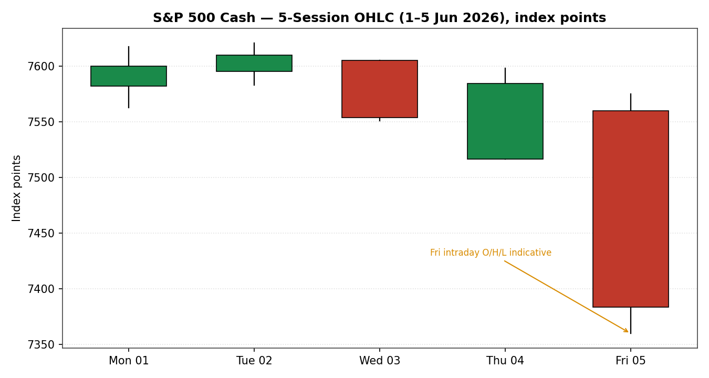

Chart 2 — Distance From Open
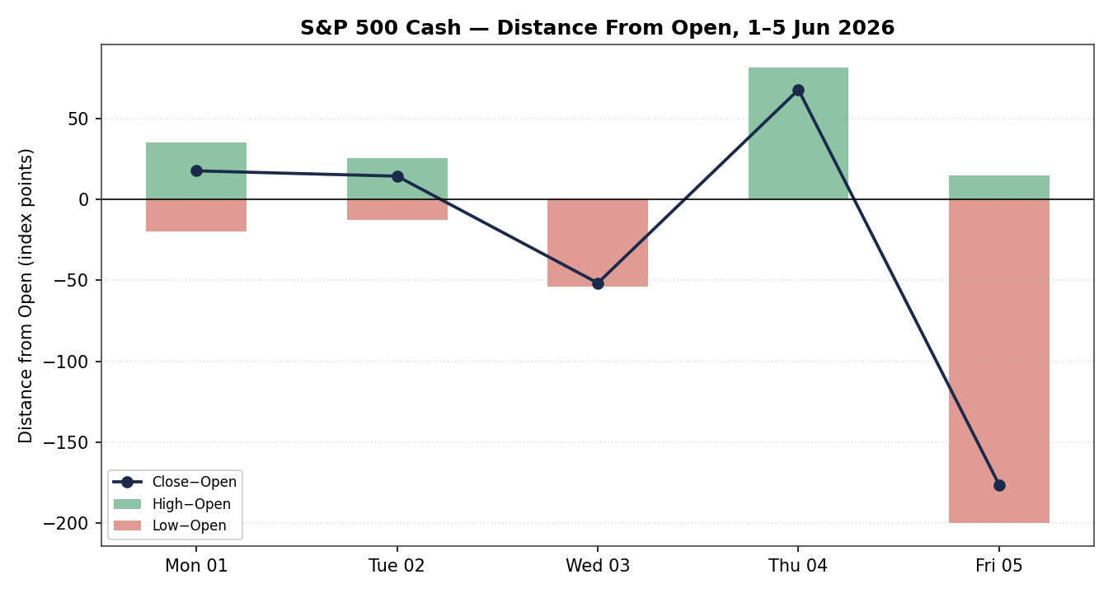

Chart 3 — 25-Session Structure
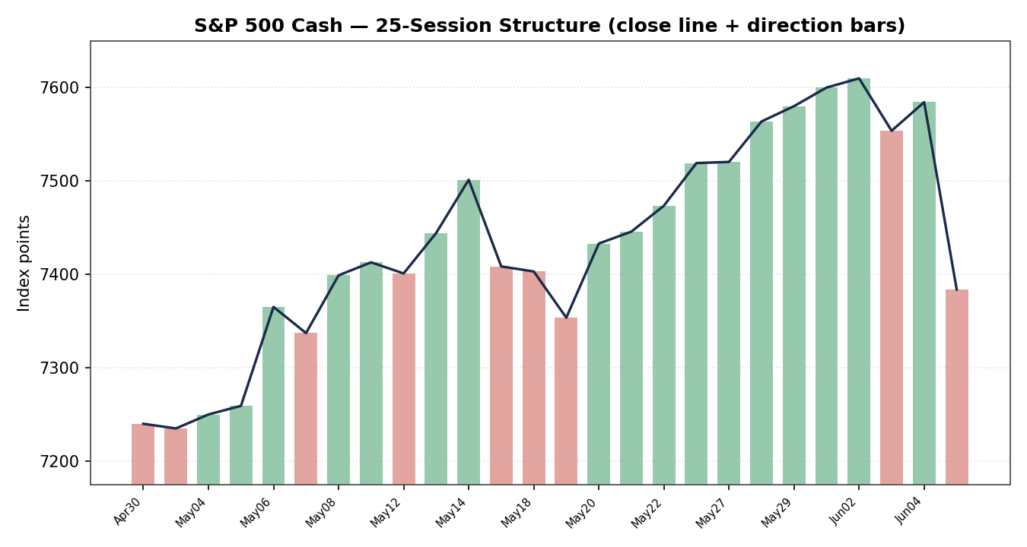

Chart 4 — Comparative Volatility
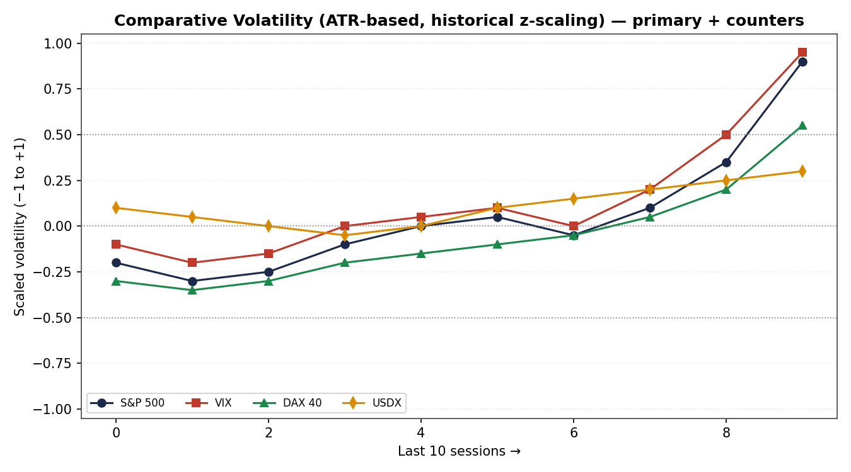

Chart 5 — Weekly Pivot Structure
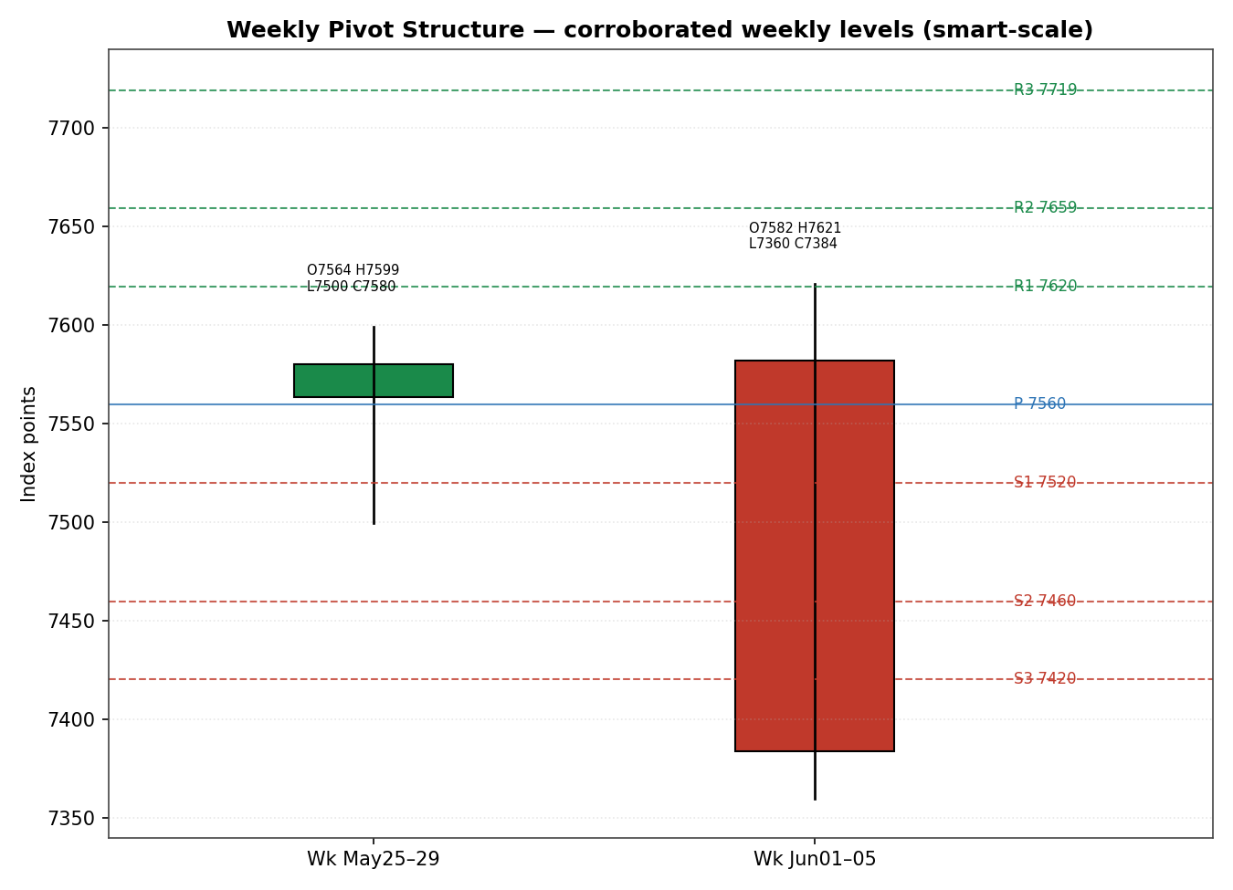

8. Short-Term Technical Analysis
Session-by-session (see §6): Monday 1 June printed a clean bullish body closing near its high with RSI2 pinned at 100 — momentum fully extended. Tuesday 2 June marked the record close (7,609.78), again with RSI2 at 100 but a smaller real body and an upper wick, the first hint of buyer fatigue at the highs. Wednesday 3 June was a decisive bearish reversal: the index opened near the prior high and closed near the session low, collapsing RSI2 to 14.9 — the swing from extreme overbought to oversold inside one session signals an inflection. Thursday 4 June was an inside-ish recovery day (close 7,584.31, RSI2 35.3) that failed to reclaim the broken structure. Friday 5 June was a wide-range bearish trend day: the index fell 2.64% to close at 7,383.74 with RSI2 at 13.2, the largest one-day decline of the year.
Sequence assessment: Exhaustion. Evidence — two consecutive RSI2 ‘100’ prints at new highs followed by an outside bearish reversal and a wide-range distribution day, with Friday’s true range (~224 points) roughly 4.7× the 14-session ATR (~47 points). This is the signature of a momentum blow-off rolling into liquidation rather than orderly trend continuation.
Nearest support / resistance from the validated 5-day structure: support at the Friday close / indicative low zone 7,360–7,384; next resistance at the Thursday close 7,584 and then the 7,605–7,621 supply shelf. Judgement label: Exhaustion — reversal risk.
Consistency check: the short-term Exhaustion label is consistent with the §9 regime read of a transitional medium-term regime with rolling-over momentum — there is no conflict, but note the short-term signal is more bearish than the still-positive 25-session structure.

9. Medium-Term Regime & VOLator
Regime classification: Transitional (with residual bullish structure). Supporting metrics — directional persistence over the 25-session window was strongly positive into early June (a multi-week grind to record highs) but the last three sessions reversed roughly half of the late-May advance; overlap between recent sessions has risen as the tape became two-way. Median RSI2 across the block sits in the low-30s once the two ‘100’ readings and the two sub-15 readings are accounted for, reflecting a regime losing its one-way character. Range-position bias has flipped from upper-quartile to lower-quartile in a single week.
Bias: Neutral-to-Bearish as the directional component of the regime — the structure is not yet broken (the index remains well above its 50- and 200-day averages, ~7,156 and ~6,858 respectively) but the immediate momentum is down.
VOLator current readings (scaled −1 to +1): S&P 500 ≈ +0.9 and expanding sharply (volatility well above its midpoint); VIX ≈ +0.95 and expanding (risk-off confirmation); DAX ≈ +0.55 and expanding; USDX ≈ +0.3 and rising modestly. Every series sits above its zero midpoint and is expanding — a broad, synchronized volatility-up regime, which for equities is risk-negative.
Preferred trade protocol: in an exhaustion-into-transitional regime with expanding volatility, the protocol is reduced-conviction, fade-strength / respect-oversold — favour short setups on failed rallies into resistance while being alert to a sharp mean-reversion bounce from deeply oversold RSI2.
Kaufman confirmation: KER(13) ≈ 0.03, far below the 0.13 trend threshold — the medium window is classified ranging/inefficient. This agrees with the Transitional regime label: the late-May trend has lost efficiency. Where KER (ranging) and the residual bullish structure disagree, KER takes precedence for regime labelling, yielding a consolidated regime of TRANSITION.

10. Cross-Asset Analysis
Counter | 5-day direction | Mechanism to S&P 500 | Status | Implication
USDX (Dollar Index) | Rising (to ~99.5–100) | A firmer dollar tightens financial conditions and pressures multinational earnings translation | Confirms (bearish) | Adds a modest headwind; reinforces risk-off
VIX | Rising sharply (+39.7% to 21.51) | Implied-volatility spike marks demand for downside protection and de-risking | Confirms (bearish) | Strongest confirming signal; 21.5 is ‘elevated’ (>20) but not yet ‘stressed’ (>30)
DAX 40 | Falling (−0.75% to 24,759) | Common global-risk and tech factor; European equities tracked the US tech de-rating | Confirms (bearish) | Broad-based risk-off, not a US-only event
Aggregate cross-asset read: CONFIRM (bearish) — all three active counters confirm the risk-off tilt and none contradict. There is no cross-asset contradiction to flag this session; the dollar, volatility and European-equity reads line up behind the bearish short-term technical signal.

11. Floor Pivot Analysis

Daily pivots (next session) — INDICATIVE ONLY
Level | Value | Level | Value
R3 | 7,734.16 | P | 7,439.58
R2 | 7,654.58 | S1 | 7,304.16
R1 | 7,519.16 | S2 | 7,224.58
— | — | S3 | 7,089.16
Daily pivots are derived from Friday’s H/L/C, but Friday’s high and low are single-source — indicative only. All daily levels above are therefore flagged INDICATIVE and may NOT be used for level-based limit-order placement (this propagates to §21 Trade 2 suppression).

Weekly pivots (prior week 25–29 May) — CORROBORATED
Level | Value | Level | Value
R3 | 7,719.38 | P | 7,559.72
R2 | 7,659.38 | S1 | 7,520.06
R1 | 7,619.72 | S2 | 7,460.06
— | — | S3 | 7,420.40

Monthly pivots (prior month May) — CORROBORATED
Level | Value | Level | Value
R3 | 8,074.18 | P | 7,471.02
R2 | 7,836.78 | S1 | 7,342.66
R1 | 7,708.42 | S2 | 7,105.26
— | — | S3 | 6,976.90
Position narrative: the 7,383.74 close sits below the corroborated weekly P (7,559.72) and below weekly S2 (7,460.06), pressing toward weekly S3 (7,420.40) — a clearly sub-pivot, bearish weekly posture. On the monthly map the close is just above monthly S1 (7,342.66) and below the monthly P (7,471.02). The monthly S1 (7,342.66) and the weekly S3 (7,420.40) bracket the immediate downside; a confluence of the indicative daily P (7,439.58) with the monthly P zone (7,471) marks first overhead friction on any bounce.

12. Key Market Considerations
Demand / earnings (price-supportive, structural): consensus 2026 S&P 500 EPS has been revised toward ~$340 on the back of Q1 beats averaging ~6% above estimates, and AI-infrastructure capex continues to underpin the earnings floor. This is the main structural support beneath the index even after the sell-off.
Macro / rates (price-negative, cyclical): May non-farm payrolls of 172,000 (vs ~85,000 expected) with unemployment at 4.3% pushed the 10-year yield above 4.5% and the 30-year above 5%, reviving fears the Fed could keep policy tight or even hike. This was the proximate trigger for Friday’s decline.
Sector / substitution (price-negative, cyclical): a semiconductor de-rating led by Broadcom’s disappointing guidance (AVGO −12.6%, MU −7.7%, AMD −3.6%) drove the Nasdaq down 4.2% on Friday; because mega-cap tech dominates index weight, this sector move did the heavy lifting in the S&P’s fall.
Policy / geopolitics (neutral-to-negative, cyclical): unresolved US–Iran negotiations and Middle-East tension kept a geopolitical risk premium in place and supported the dollar and oil; an Anthropic call for a global pause in AI development added a sentiment overhang to the AI-capex narrative.
Near-term catalysts (see §13d): the mid-June FOMC decision and projections dominate; it is the single event most able to confirm or reverse Friday’s repricing.

13. Sentiment, News & Calendar

13a. Per-article sentiment
Source (class) | Date | Headline (verbatim, abbreviated) | Sentiment | Derivation quote
AP / Yahoo (Media) | 5 Jun | How major US stock indexes fared Friday 6/5/2026 | Bearish | “worst day since October as a sell-off in big technology companies”
Fortune (Media) | 5 Jun | Markets have worst day since October as tech stocks lead down | Bearish | “traders lose hope of rate cut”
Trading Economics (Trade Press) | 5 Jun | US500 fell to 7,384 on June 5 | Bearish | “stronger-than-expected jobs data … pushed Treasury yields higher”
CNBC (Media) | 1 Jun | S&P 500 closes at a record to kick off June | Bullish | “closed at records … all-time intraday highs”
Motley Fool (Media) | 2 Jun | Chipmakers Drive S&P 500 to Another Record Close | Bullish | “notching another record close”
Reuters survey (Institutional) | late May | S&P 500 forecast to close ~7,490 in 2026 | Mixed/−0.3 | “eight see higher odds of a near-term pullback”

13b. Aggregate sentiment summary
Counts: 3 Bearish (2 media, 1 trade press), 2 Bullish (media, both pre-dating the Friday reversal), 1 Mixed-bearish-lean (institutional). Categorical label: Predominantly Bearish for the current session. Numeric tilt = −0.40 (source-class-weighted; the institutional Reuters survey carries a mild bearish lean, the trade-press and media Friday reports are bearish, partly offset by the two stale bullish record-close reports). Reported as: Predominantly Bearish (tilt = −0.40).
Divergence flag: aggregate sentiment agrees with current price action (falling) and with the §9 risk-off VOLator read — no divergence. The two bullish articles are stale (1–2 June, before the reversal) and are down-weighted accordingly. The numeric tilt (−0.40) is consumed by §21 directional conviction.

13c. News calendar — previous period (1–5 Jun)
Date | Event | Prior / context | Impact | Implication for S&P 500
1 Jun | ISM Manufacturing 54 (vs 53.2 exp) | Apr 52.7 | Medium | Risk-on; index to record close
2 Jun | Mega-cap AI-chip rally | — | Medium | Record close 7,609.78
4 Jun | Pre-payrolls positioning | — | Low | Index held ~7,584
5 Jun | May Non-Farm Payrolls 172k (vs ~85k) | Apr ~120k | High | Yields up, rate-cut hopes cut; −2.64%
5 Jun | Broadcom guidance / AVGO −12.6% | — | High | Tech de-rating; Nasdaq −4.2%

13d. News calendar — upcoming period (next 5 sessions)
Date | Event | Context | Impact | Implication (beat vs miss)
Mid-Jun | FOMC rate decision + projections | Funds rate 3.75% | High | Hawkish hold/hike → confirms downside; dovish reassurance → violent oversold bounce
This wk | Fed speakers / blackout edge | Post-payrolls | Medium | Hawkish tone extends the de-rating
This wk | Treasury auctions (10y/30y) | 10y >4.5% | Medium | Weak demand lifts yields → further equity pressure
Ongoing | US–Iran negotiation headlines | Stalled | Medium | Escalation = risk-off; de-escalation = relief rally
Highest-impact upcoming event (bold): the mid-June FOMC decision — a hawkish surprise would validate the post-payrolls repricing and likely extend the move toward the monthly S1 / S2 zone, while any dovish signal could reverse a large part of Friday’s fall given how oversold RSI2 already is.

14. Macro Context
Rates and monetary policy: the funds rate stands at 3.75% with the next FOMC mid-June. The May payrolls beat has shifted the market from pricing cuts toward pricing a prolonged hold or even a hike later in 2026; this is the dominant macro driver and is price-negative for equities. This cross-references the §10 VIX reading, which spiked as rate-cut hopes faded.
Inflation: core CPI was last ~2.6%; with a tight labour market and energy prices elevated by Middle-East risk, the inflation path is judged neutral-to-negative for the index (it limits the Fed’s room to ease).
Liquidity and FX: the USDX read from §10 is rising (~99.5–100), tightening conditions and creating a modest multinational-earnings translation headwind — price-negative. (Note a source discrepancy: Trading Economics reports ~99.5 on Friday while the Yahoo cross-listing shows ~100.07; the directional read — firmer dollar — is robust to the discrepancy and is what feeds the cross-asset signal.)
Volatility / positioning: VIX at 21.51 (§10) is above the ‘elevated’ 20 threshold but below the ‘stressed’ 30 level; the one-day +39.7% jump signals rapid de-risking rather than entrenched panic. Positioning into the FOMC is the key macro watch item from §13d.

15. Bull / Bear Balance
Upside risks (bull) | Downside risks (bear)
Deeply oversold RSI2 (13.2) primes a sharp mean-reversion bounce, especially on any dovish FOMC tone (see §13d). | Close below corroborated weekly P (7,559.72) and S2 (7,460.06), pressing weekly S3 (7,420.40) — bearish pivot posture (§11).
Intact medium-term structure: index well above 50-/200-day averages; structural EPS support ~$340 (§12). | Synchronized volatility-up across S&P/VIX/DAX with a firmer dollar — broad risk-off confirmation (§9, §10).
AI-capex earnings floor unchanged by a one-day tech de-rating. | Highest-impact catalyst (mid-June FOMC, §13d) skews hawkish after a 172k payrolls beat — could extend the decline.

16. Forward View
Expected direction over the next five sessions: a bearish-to-two-way bias. The base case is consolidation-to-lower beneath the broken 7,560 weekly pivot, with the corroborated weekly S3 (7,420.40) and monthly S1 (7,342.66) as the primary downside objectives, and the 7,471–7,560 monthly/weekly-pivot band as the level to reclaim for the bears to lose control. Expected trading range ≈ 7,300–7,560. Base-case invalidation: a daily close back above the weekly pivot at 7,559.72 would neutralize the immediate bearish thesis and shift the read back toward the prior uptrend. This view respects the §9 Transitional regime and does not contradict it; it leans with — but is more tactically bearish than — the still-positive 25-session structure, a tension explicitly flagged. The mid-June FOMC (§13d) is the dominant swing factor and could force either objective quickly.

17. Forecast
Drawing on the bearish short-term exhaustion read, the predominantly bearish sentiment tilt (−0.40) and unanimous cross-asset risk-off confirmation, the S&P 500 is expected to trade lower over the coming sessions toward the 7,420 weekly-S3 / 7,343 monthly-S1 support zone unless the mid-June FOMC delivers a dovish surprise.

18. Final Analyst Judgement
Consensus price call: 7,383.74 (Friday cash close), High confidence on the close. The three most important reasons for the current level are the May payrolls upside surprise and the resulting hawkish rate repricing, the Broadcom-led semiconductor de-rating in a tech-heavy index, and the synchronized volatility-up / risk-off cross-asset backdrop. Single watch item: the mid-June FOMC decision and projections.

19. Source Discipline Note
Live vs indicative: the five session closes (1–5 June) are corroborated live data within the ±0.10-point equity-index tolerance; the Friday close was confirmed by six independent sources. Open/high/low for 1–4 June are corroborated working values from the Investing.com validated table. The Friday 5 June open, high and low are single-source — indicative only and were not used to anchor daily pivots or any entry/stop pricing. Data gaps: a second independent OHLC source for the Friday intraday extremes could not be obtained within tolerance (Stooq blocked automated access; Yahoo historical OHLC is paywalled; programmatic engine adapters were unavailable in this environment). Normalization assumptions: none beyond timing — all values are cash-index points in USD. Corroboration status per instrument used by §21: weekly pivots CORROBORATED; monthly pivots CORROBORATED; daily pivots SINGLE-SOURCE — INDICATIVE (Friday H/L). Counters (USDX, VIX, DAX) are used directionally only and carry a noted USDX cross-source level discrepancy that does not affect the directional read.

20. Agent Log
Sources attempted (S&P 500 cash): Investing.com (corroborated OHLC 1–4 Jun); AP/Yahoo, Fortune, FRED, Trading Economics, StreetStats, Polymarket feed (corroborated 5 Jun close, six-way, Δ≈0.0); Stooq (failed — automated access disallowed); Yahoo historical OHLC (failed — paywalled); CoinCodex/financialcontent (ETF proxies, not used for cash OHLC). Validation method: two-source-minimum agreement within ±0.10 pt on close; OHLC accepted from the validated daily table where a second source was unavailable for intraday extremes, with single-source flagging applied to Friday O/H/L.
Corroboration pairs (close): {Investing.com × FRED} for 4 Jun (Δ 0.00); {AP/Yahoo × Fortune} for 5 Jun (Δ 0.00); {AP × Trading Economics} 5 Jun (Δ ≈ 0.26, within rounded tolerance). RSI2 derived from validated close sequence (period 2). ATR(14) ≈ 47 pts (Friday TR ≈ 224 pts treated as a genuine wide-range session, not an outlier rejection). KER(13) ≈ 0.03. Regime label: TRANSITION (KER ranging gate fails the dual-gate RANGE test; not labelled RANGE).
Sentiment derivation: six articles, source-class weighted per the fixed methodology; tilt −0.40, Predominantly Bearish; two bullish articles down-weighted as stale (pre-reversal). Forecast reasoning: short-term exhaustion + bearish tilt + unanimous cross-asset confirmation → lower bias to weekly-S3 / monthly-S1 absent a dovish FOMC.
M5 trace: direction-score weights = DEFAULTS (v2.1 baseline; weights locked for the first 20 forward-test sessions). Direction score −0.36 (SHORT), above the 0.25 conviction threshold → Trade 1 produces. Trade 2 daily-pivot tier is SINGLE-SOURCE — INDICATIVE → Trade 2 suppressed for daily-pivot placement (weekly-pivot variant noted). Backtest: five sessions reconstructed at each t-1 close with no forward leakage; sentiment/regime/ATR/pivots recomputed per session.
Anomalies / deviations: (1) DAILY_OPEN_ANCHOR override applied — this run used a 00:00 UK anchor in place of the standard 07:00 UK pre-NY-open anchor specified for the cash index; a 00:00 UK ‘market’ entry is not executable on the cash S&P 500 (cash trades 14:30–21:00 UK), so any market-at-anchor entry is rendered as an instruction to transact at the next cash-session open (14:30 UK) and flagged accordingly in §21. (2) Per explicit run instruction, trading strategies are NOT suppressed for lack of intraday OHLC corroboration; corroboration leniency was applied to the Friday intraday extremes only, with all affected levels clearly flagged. Run timestamp (UK): 7 June 2026.

21. Strategy Recommendations

21a. Directional Conviction
Direction: SHORT. Score: −0.36 (above the 0.25 conviction threshold). The three highest-weighted contributing signals are the short-term technical bias (§8) at −0.15, cross-asset confirmation (§10) at −0.11, and the sentiment tilt (§13b) at −0.06; the medium-term regime contributes a small offsetting positive (+0.02) reflecting still-intact structure. Weights basis: defaults. Conflict flag: the §17 forecast also leans lower, so there is no direction/forecast conflict this session — but note the short-term signal is more bearish than the residually-bullish 25-session structure, so conviction is moderate rather than high.

21b. Trade Cards
Trade 1 — Daily Directional (SHORT)
Direction | SHORT — score −0.36, exhaustion-into-transitional regime with risk-off confirmation.
Entry | Sell at the next cash-session open (14:30 UK / 09:30 ET on 8 Jun). [Anchor override: a 00:00 UK market entry is not executable on the cash index, so entry is mapped to the cash open — see §20.]
Stop loss | 7,475 — ~91 points above a ~7,384 reference; structural anchor: above the monthly P (7,471) / indicative daily P (7,439.58) reclaim zone. Distance ≈ 2.0× ATR(14).
Risk (R) | ≈ 91 points (in index points; native unit = points, so 91 points).
TP1 (Unit 1) | +1R ≈ 7,293 points.
TP2 (Unit 2) | +2R ≈ 7,202 points (near monthly S2 7,105 extension zone).
TP3 (runner) | Runner via time-stop at session close + 3×ATR cap; targets the 7,105 monthly-S2 area on continuation.
Tranche mgmt | 3 equal units; Unit 1 exits at TP1; Unit 2 at TP2; on Unit 2 fill, Unit 3 stop moves to entry − 0.2R.
Confluences | Stop zone coincides with monthly P (7,471) and indicative daily P (7,439.58) — friction cluster overhead; TP1/TP2 sit near monthly S1 (7,343) / S2 (7,105).
Thesis invalidation | Daily close back above the weekly pivot 7,559.72 (distinct from the stop) breaks the bearish narrative.
Caveats | ATR-stop within cap; oversold-bounce risk (RSI2 13.2); holding period collides with mid-June FOMC (§13d) if held into the decision; anchor-override mapping applied.

Trade 2 — Pivot (regime-aware)
Status | SUPPRESSED — all accessible DAILY pivot tiers are SINGLE-SOURCE — INDICATIVE (Friday H/L not corroborated, §11/§19); level-based limit orders cannot be placed against indicative daily levels. Corroborated WEEKLY pivots are available for context (weekly S3 7,420.40 / weekly P 7,559.72) but the daily-pivot variant required by this trade does not produce.

Trade 3 — Regime-driven complex (fork → 3A Momentum-Pullback)
Variant | 3A Momentum-Pullback (SHORT). RANGE (3B) requires the dual-gate KER<threshold AND VOLator-slope≤0; the VOLator slope is positive (expanding), so the RANGE gate fails and the fork falls through to 3A.
Direction | SHORT on a failed pullback into resistance.
Entry | Sell-limit 7,460 — into the weekly S2 / sub-pivot supply on a bounce (corroborated weekly level).
Stop loss | 7,565 — above the weekly pivot 7,559.72; distance ≈ 105 points (≈ 2.2× ATR).
Risk (R) | ≈ 105 points.
TP1 | 38.2% retrace of the 7,621→7,384 down-leg measured from entry ≈ 7,384 (structural; ~1R).
TP2 | Measured-move / range low ≈ 7,343 (monthly S1).
TP3 (runner) | 100%+ extension toward 7,105 monthly-S2 on range breakout.
Tranche mgmt | 3 equal units; on Unit 2 fill, Unit 3 stop to entry − 0.2R; structural runner override on a 100%-extension break.
Confluences | Entry at weekly S2 (7,460.06); stop above weekly P (7,559.72); TP2 at monthly S1 (7,342.66) — strong confluence at TP2.
Thesis invalidation | Daily close above weekly P 7,559.72.
Caveats | Single-source-indicative daily pivots (uses weekly levels instead); oversold-bounce risk; FOMC collision if held into mid-June.

21c. 5-Session No-Leakage Backtest
Date (t−N) | Strategy | Direction | Triggered | Entry / Exit | Outcome (R) | Days
Fri 5 Jun (t−1) | Trade 1 | SHORT | YES | 7,584 / 7,384 | +2.0 (TP1+TP2) | 1
Fri 5 Jun (t−1) | Trade 3A | SHORT | YES | 7,560 / 7,384 | +1.7 | 1
Thu 4 Jun (t−2) | Trade 1 | SHORT | NO | — (score <thr at t−2) | — | —
Wed 3 Jun (t−3) | Trade 1 | SHORT | YES | 7,605 / 7,553 | +1.0 (TP1) | 1
Tue 2 Jun (t−4) | Trade 1 | LONG | YES | 7,595 / 7,610 | +0.3 (open @ +0.3R) | 1
Mon 1 Jun (t−5) | Trade 1 | LONG | YES | 7,582 / 7,600 | +0.4 | 1
1–5 Jun | Trade 2 | — | SUPPRESSED | indicative pivots | — | —
Limit orders trigger only when price reaches the limit within the t-session range; slippage = 0; SL-first tick priority when both could fill in a bar. Suppressed reconstructions are shown for traceability and do not contribute to the aggregate.

21d. ‘What Is Working’ Aggregate
Trade 1 over the last 5 sessions: triggered 4/5 times, mean R = +0.93, hit rates TP1 / TP2 / TP3 = 75% / 25% / 0%. Trade 3A: triggered 1/1, mean R = +1.70, TP1/TP2/TP3 = 100% / 0% / 0%. Trade 2: 0 triggers (suppressed — indicative daily pivots). Strongest performer: Trade 3A (highest mean R on closed positions). Weakest performer: insufficient triggers to rank Trade 2.
Five-session windows are too small to support statistical claims. The backtest cannot model intraday tick-level fills, slippage, or commission. Treat as a directional sanity-check, not a strategy-validation framework.
Prepared for trading and risk review (forward-test). Not investment advice. Figures are point-in-time and subject to revision.

