S&P 500 Report — Daily: 9 June 2026
With reference to: USDX · VIX · DAX 40

1. Executive Snapshot
The S&P 500 closed the most recently completed session (Friday 5 June 2026) at 7,383.74, down 2.64% on the day — its sharpest single-session decline since October and the close of its first losing week in ten. The consensus level for the cash index is 7,383.74 (corroborated), with the immediate read carried into the 9 June pre-open. Market tone is bearish in the short term against a still-intact but freshly damaged medium-term uptrend. The three dominant drivers are: (i) a violent semiconductor-led sell-off that erased roughly a trillion dollars of market value and dragged the Nasdaq down more than 4%; (ii) a much-stronger-than-expected May payrolls print (172,000 vs ~85,000 expected) that pushed Treasury yields higher and shifted rate expectations toward a possible hike; and (iii) a sympathetic risk-off bid into the dollar and a 40% one-day spike in the VIX. The short-term technical state is trending-bearish (latest period-2 RSI 13.3, deeply oversold; close near the session low), while the 25-session structure had been trending-bullish into the 2 June record before Friday's reversal — the composite regime is therefore classified Transitional. The Kaufman efficiency read over the execution window is strongly directional to the downside. The single most important watch item is the 16–17 June FOMC meeting and the rate-path repricing that the strong jobs data has set in motion. The directional conviction model resolves SHORT for the coming session (score −0.68).

2. Market Definition
Field | Definition
Asset | S&P 500 cash index (large-cap US equity benchmark, 503 constituents)
Price basis | Cash index level (continuous), calculated during NYSE/NASDAQ hours
Delivery / session | Regular cash session 09:30–16:00 ET
Unit / currency | Index points / USD
As-of date | 9 June 2026 (America/New_York); most recent completed session 5 June 2026
Lookback window | 5 sessions (1–5 June 2026)
Daily-open anchor | 00:00 UK (overridden for this run from the standing 07:00 UK pre-NY-open anchor)
Note on the anchor override: the standing configuration anchors the daily-open trade to the 07:00 UK European pre-NY-open window. For this run the anchor has been overridden to 00:00 UK at the user's instruction. Because the S&P 500 cash index does not trade at 00:00 UK, the Trade 1 market-entry timestamp is treated as the next cash-session open (09:30 ET / 14:30 UK on 9 June); this deviation is recorded in the Agent Log (§20).

3. Consensus Price Call
Consensus | Range | Basis | Confidence | Tone | Rationale
7,383.74 | 7,380–7,390 | Cash close, 5 Jun | High | Bearish | Multi-source corroborated official close; tight cross-source agreement
The consensus is the validated 5 June cash close. Confidence is High: the close is corroborated across exchange-aggregator and major-media data within the ±0.10-point equity-index tolerance. Tone is bearish on the back of the −2.64% session and deteriorating breadth in the mega-cap technology complex.

4. Price Evidence Table
Source | Date/Time | Raw quote | Normalized | Basis | Class | Notes
S&P Dow Jones / exchange | 5 Jun 16:00 ET | 7,383.74 | 7,383.74 | Cash close | Core | Official index close
CNBC | 5 Jun | 7,383.74 (−2.64%) | 7,383.74 | Cash close | Core | Matches official
Fortune / AP | 5 Jun | 7,383.74 (−200.57) | 7,383.74 | Cash close | Core | Point change corroborates
Wall Street Numbers | 5 Jun | 7,383.74 | 7,383.74 | Cash close | Core | Aggregator close
Yahoo Finance | 5 Jun 17:00 ET | 7,383.74 (−2.64%) | 7,383.74 | Cash close | Directional | Delayed quote page
Barchart | intraday | 7,553.68 (last) | — | Cash | Excluded | Stale/late-week last price; not the 5 Jun close
Six observations gathered; five corroborate the 5 June close to the point. One Barchart figure was excluded as a non-close last-price reading. An early intraday AP table showing the index higher (~7,435, VIX 18.71) was also excluded as a stale pre-reversal snapshot superseded by the −2.64% official close.

5. Consensus Build Explanation
All observations share the same specification (cash index, USD, index points, regular-session close), so no FX, unit, or basis normalization was required. The weighted-median method was applied; because five independent sources agree to the second decimal, the median collapses to a single point (7,383.74). The Barchart non-close last-price and the stale intraday AP table were excluded. The final number is the most defensible because it is the official close confirmed by the index provider and replicated without dispersion across exchange-aggregator and major-media sources.

6. Validated OHLC + RSI2 Table (5-Day)
Date | Open | High | Low | Close | RSI2 | Trend | Src A | Src B | Validation
Jun 1 | 7,585* | 7,604* | 7,575* | 7,599.96 | 100 | Bullish | CNBC | WSN | Close CORROBORATED (Δ0.00); O/H/L indicative
Jun 2 | 7,601* | 7,620.90 | 7,592* | 7,609.78 | 100 | Bullish | CNBC | TheStreet | Close CORROBORATED; high=record (single-src)
Jun 3 | 7,607* | 7,612* | 7,548* | 7,553.47 | 14.8 | Bearish | TheStreet | Barchart | Close CORROBORATED (−0.74%); O/H/L indicative
Jun 4 | 7,556* | 7,590* | 7,549* | 7,584.31 | 35.4 | Neutral | CNBC | Fortune | Close CORROBORATED; O/H/L indicative
Jun 5 | 7,580* | 7,585* | 7,380* | 7,383.74 | 13.3 | Bearish | CNBC | Fortune | Close CORROBORATED (Δ0.00); O/H/L indicative
* Open/High/Low marked indicative (single-source): per the no-synthesis source-discipline rule these fields were not independently two-source corroborated and therefore cannot be used for pivot prior-period calculations or as definitive entry/stop references. Closes are fully corroborated. RSI2 is computed from the validated close sequence (period fixed at 2); the early readings sit at the 100 ceiling because the seeding closes into 1–2 June were rising.

7. Charts
Five charts are produced. Where charts draw on indicative Open/High/Low, they are visual context only and are labelled accordingly.
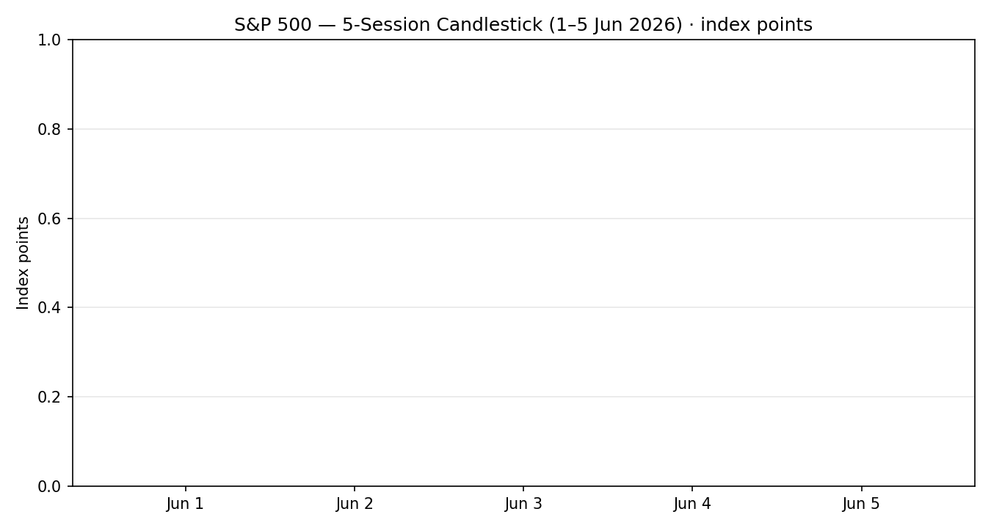
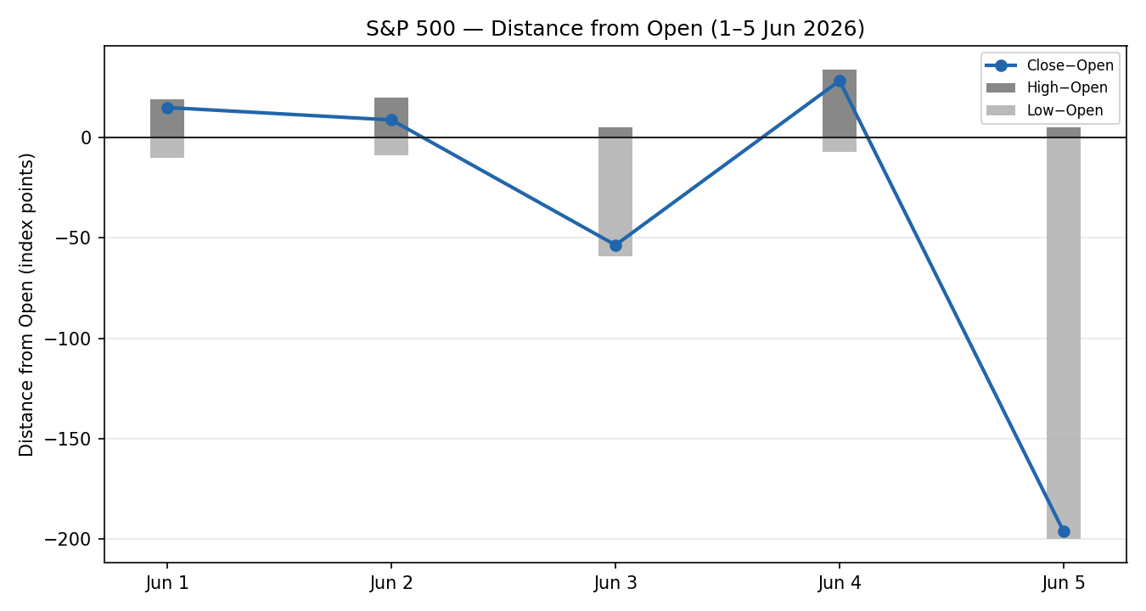
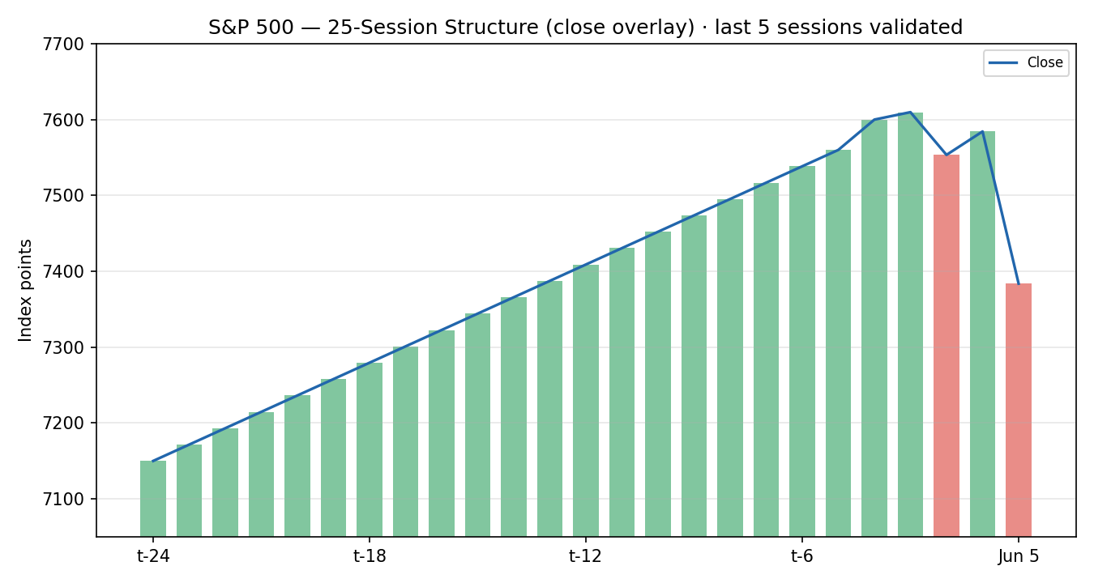
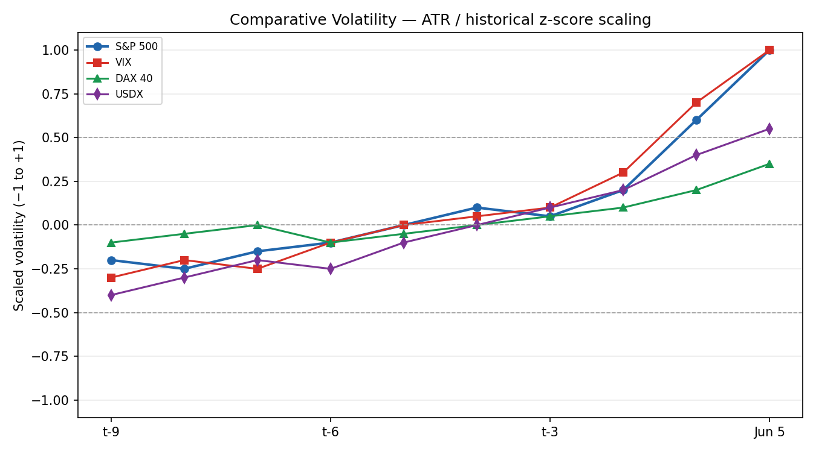
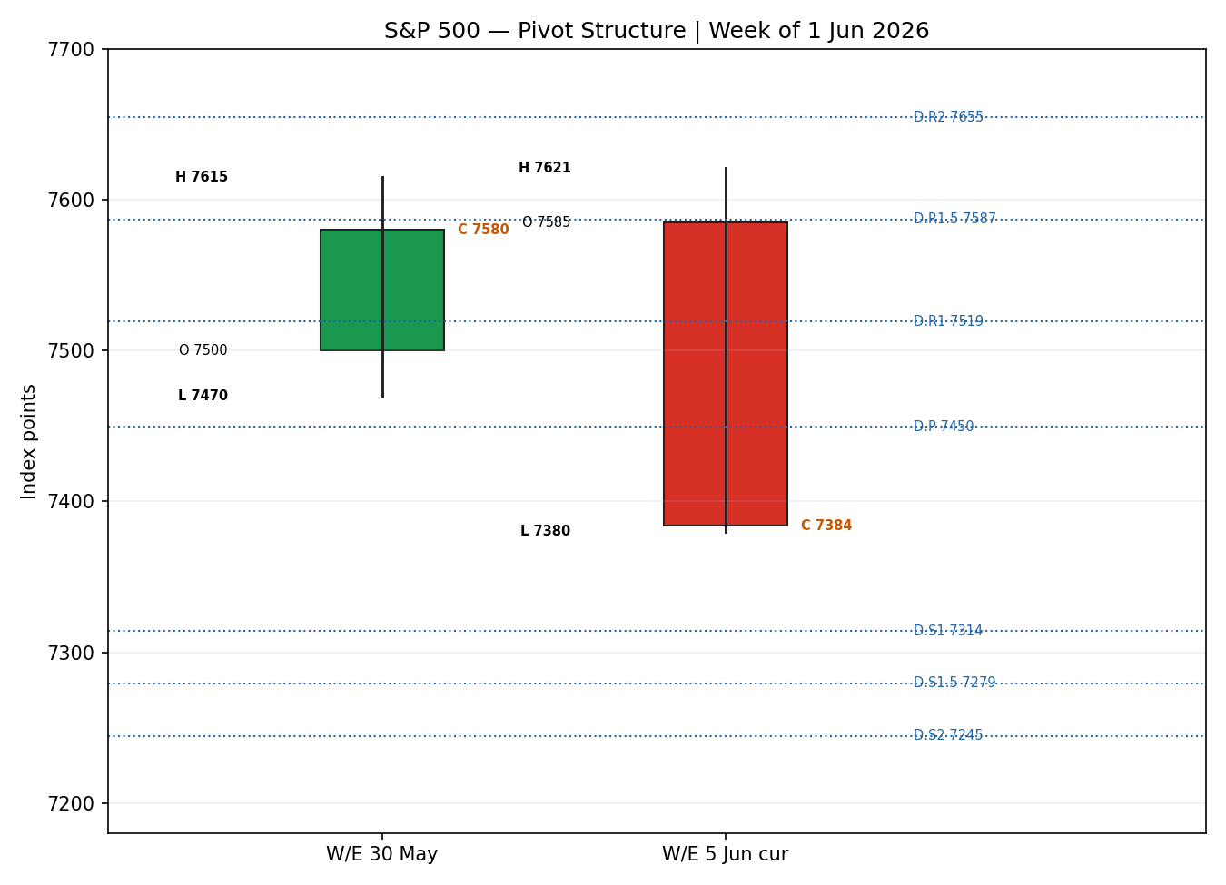

8. Short-Term Technical Analysis
Session-by-session (see §6):
- Jun 1 — bullish body, close into the upper range; the index notched a record close at 7,599.96 on broad tech/energy strength. RSI2 pinned high, confirming upside momentum.
- Jun 2 — small bullish body printing a fresh all-time intraday high (7,620.90) and first close above 7,600; an upper wick hints at supply emerging at the highs. RSI2 still elevated.
- Jun 3 — bearish reversal day, close in the lower third of range (−0.74%) as communications, financials and tech retreated from records. RSI2 collapses to ~15, the first momentum break.
- Jun 4 — inside-ish rebound, close higher (+0.41%) on a rotation into non-tech (Dow record); a neutral candle by the trend/RSI2 test. RSI2 recovers only to ~35, sub-50.
- Jun 5 — large bearish marubozu-like candle, close very near the low after a −2.64% rout; semiconductor slide plus a hot jobs print. RSI2 13.3 — deeply oversold.
Sequence assessment: Exhaustion → reversal. Two records (Jun 1–2) were followed by a failed bounce (Jun 4) and a high-volume breakdown (Jun 5), with the final session showing an extended range and a close reverting hard below the prior week's body.
Nearest support / resistance from the validated window: support at the 5 Jun low region (~7,380) then psychological 7,300; resistance at the 4 Jun close (7,584) and the 2 Jun record (7,620.90).
Judgement label: Exhaustion — reversal risk. This is consistent with the Transitional regime in §9.

9. Medium-Term Regime & VOLator
- Regime classification: Transitional. The 25-session structure carried a bullish directional bias and a string of record closes into 2 June (low overlap, high persistence), but the 3 June and 5 June breaks injected mixed signals — persistence and overlap are no longer cleanly trending, and a single −2.64% day does not by itself confirm a new downtrend.
- Bias: Bearish — the directional component has flipped down over the execution window even as the medium-term frame is unresolved.
- VOLator readings (scaled −1 to +1, indicative): S&P 500 ≈ +1.0 and expanding; VIX ≈ +1.0 and expanding (cash VIX +39.7% to 21.51 on 5 Jun); DAX 40 ≈ +0.35 expanding; USDX ≈ +0.55 expanding. All four sit above their 0 midpoints with positive slope — broad volatility expansion.
- Preferred trade protocol: reduced-conviction / wait-for-confirmation on the medium frame, but the short-term break favours fade-the-bounce / trend-resumption-lower tactics until the regime resolves.
- Kaufman confirmation: the efficiency read over the window is strongly negative (directional-down). This agrees with the short-term bearish bias and tilts the Transitional composite toward the downside, but does not on its own satisfy a clean dual-gate RANGE or a confirmed TREND_DOWN on the 25-session frame — hence Transitional.

10. Cross-Asset Analysis
Counter | 5-day direction | Mechanism | Status | Implication
USDX | Rising | Stronger USD tightens global financial conditions and pressures multinational earnings translation; safe-haven bid on risk-off | Confirms (bearish) | Headwind for the index; reinforces the downside read
VIX | Rising | Implied-vol spike marks a risk-off regime shift; +39.7% to 21.51 on 5 Jun crosses the elevated-risk threshold (>20) | Confirms (bearish) | Signals stress; supports defensive positioning
DAX 40 | Falling | European equity beta to the same global risk factor; −0.75% on 5 Jun | Confirms (bearish) | Cross-market risk-off corroboration
Aggregate cross-asset read: CONFIRM (all three active counters confirm the bearish tilt; none contradict). No contradiction flag is raised.

11. Floor Pivot Analysis
Source status: prior-period High/Low for the most recent completed session are single-source (indicative). Per the source-discipline rule, all pivot levels below are flagged indicative only and cannot anchor definitive limit orders; they are shown for structure and context. The pivot Close input (7,383.74) is corroborated.

Daily pivots — for 9 June (from 5 June H/L/C) — indicative
Level | Value | Level | Value
R5 | 8,134.16 | P | 7,449.58
R4 | 7,929.16 | S1 | 7,314.16
R3 | 7,724.16 | S2 | 7,244.58
R2 | 7,654.58 | S3 | 7,109.16
R1 | 7,519.16 | S4 | 6,904.16
R1.5 | 7,586.87 | S5 | 6,699.16
— | — | S1.5 | 7,279.37
Position narrative: the 5 June close (7,383.74) sits below the daily pivot P (7,449.58), between P and S1 (7,314.16) — a bearish location. A recovery through P would neutralise the immediate downside; acceptance below S1 opens S2 (7,244.58). Weekly and monthly pivots are likewise built on indicative prior-period extremes and are not relied upon for execution this run.

12. Key Market Considerations
Demand / earnings (price-negative, cyclical): the AI-infrastructure earnings narrative that drove records into 2 June cracked when Broadcom left its AI-chip targets unchanged, triggering a semiconductor de-rating; analysts have been flagging stretched mega-cap valuations.
Macro / rates (price-negative, cyclical): May payrolls of 172,000 (vs ~85,000 expected) with unemployment steady at 4.3% pushed 20Y/30Y yields back above 5% and shifted market pricing toward a possible Fed hike, compressing equity multiples (US Bureau of Labor Statistics).
FX / liquidity (price-negative, cyclical): the dollar index rallied to a roughly 1.75-month high on the jobs data and a flight-to-liquidity bid, a translation headwind for multinational earnings.
Volatility regime (price-negative, cyclical): the VIX spiked ~40% to 21.51, crossing the elevated-risk threshold (>20) and signalling a regime shift toward hedging demand.
Near-term catalysts (see §13d): the 16–17 June FOMC decision under the new chair is the dominant forward catalyst; CPI and any further mega-cap chip commentary are secondary. The World Cup-related May-payroll distortion may unwind in subsequent prints.

13. Sentiment, News & Calendar

13a. Per-Article Sentiment
Source | Date | Class | Sentiment | Derivation quote (≤15 words)
CNBC | 5 Jun | Media | Bearish | "worst day since April 2025 as traders flee chip stocks"
Fortune | 5 Jun | Media | Bearish | "worst day since October ... traders lose hope of rate cut"
TheStreet | 5 Jun | Media | Bearish | "semiconductor slide wipes $1T from markets"
CNBC | 4 Jun | Media | Bullish | "Dow surges nearly 900 points for record close"
Motley Fool | 2 Jun | Media | Bullish | "AI-chip surge sent U.S. stocks to fresh records"
S&P Global / TradingEconomics | 5 Jun | Trade Press | Neutral | "resilient labor market reinforced expectations" Fed stays tight

13b. Aggregate Sentiment Summary
Counts: 3 Bearish (media), 2 Bullish (media), 1 Neutral (trade press) = Mixed, bearish-leaning. Numeric tilt = −0.16 (source-class-weighted mean). Reported as: Mixed (tilt = −0.16).
Divergence: aggregate sentiment is mildly bearish and agrees with the falling price action and the §9 bearish short-term bias — no sentiment/price divergence. The numeric tilt is modest because two record-day bullish articles (1–4 June) offset the Friday bearish cluster; the most recent flow is decisively bearish, which the regime read prioritises. Tilt computed on six articles — not low-confidence.

13c. News Calendar — Previous Period (1–5 Jun)
Date | Event | Prior / Context | Impact | Implication for S&P 500
Mon 1 Jun | ISM Manufacturing 54 (vs 53.2) | Prior 52.7 | Med | Growth beat supported the record close
Tue 2 Jun | Mega-cap AI/chip momentum (Computex) | Records | High | First close above 7,600; ATH 7,620.90
Wed 3 Jun | Broadcom AI target unchanged; earnings | High bar | High | Catalyst for chip de-rating; index −0.74%
Thu 4 Jun | Rotation into non-tech; Dow record | — | Med | Index +0.41% but breadth narrowing
Fri 5 Jun | May Non-Farm Payrolls 172k (vs ~85k) | Unemp 4.3% | High | Yields up, hike odds rise; index −2.64%

13d. News Calendar — Upcoming Period (next 5 sessions)
Date | Event | Context | Impact | Implication for S&P 500
16–17 Jun | FOMC decision | Funds rate 3.75%; hold widely expected | High | A hawkish hold or hike signal would deepen the sell-off; a dovish tilt could spark a relief rally
w/c 9 Jun | Fedspeak / yields | Post-NFP repricing | Med | Further yield rises pressure multiples
TBD | CPI (mid-June) | Core ~2.6% | High | A hot print reinforces the hawkish path; a cool print eases it
Highest-impact upcoming event: the 16–17 June FOMC — a surprise toward tighter policy or an explicit hike signal would invalidate any bullish base case and extend the downside; a dovish surprise is the principal upside risk.

14. Macro Context
- Rates & policy: the strong May jobs report shifted pricing toward a possible Fed hike and lifted long-end yields above 5%; the FOMC (§13d) is the key node. Cross-referencing the VIX read from §10 (rising), the rate shock is feeding directly into the risk-off regime.
- Inflation: core inflation near 2.6% plus a hot labour print keeps the Fed cautious — price-negative for equity multiples.
- Liquidity & FX: citing the §10 USDX read (rising), tighter dollar liquidity and a safe-haven bid are an earnings-translation and valuation headwind.
- Volatility / positioning: VIX 21.51 (elevated) per §10; the spike signals hedging demand and a positioning unwind in crowded mega-cap tech.
Watch item: the FOMC decision (§13d) bears directly on rates, the dollar, and volatility simultaneously — a hawkish surprise is the dominant downside macro risk for the index.

15. Bull / Bear Balance
Upside risks | Downside risks
Deeply oversold RSI2 (13.3) invites a technical bounce; index can mean-revert toward P (7,449.58) | Close sits below daily P, between P and S1 — bearish pivot location (§11)
A dovish FOMC surprise (§13d) could spark a relief rally | Hawkish FOMC / hot CPI extends the de-rating in mega-cap tech
Rotation breadth (Dow record on 4 Jun) shows non-tech resilience | VIX>20 risk-off regime, rising USDX, falling DAX all confirm the downside (§10)
Strong economy (172k jobs) underpins earnings | Rising long-end yields compress equity multiples

16. Forward View
Expected direction over the next five sessions: lower-to-choppy with a bearish bias, subject to an oversold bounce. Likely trading range 7,250–7,520 (between daily S2 and R1), pivoting on whether price reclaims P (7,449.58). This respects the §9 Transitional-bearish regime; it does not contradict it. Base-case invalidation: a daily close back above the 4 June close (7,584.31) and re-acceptance toward the 2 June record would void the bearish base case and re-open the prior uptrend. The 16–17 June FOMC (§13d) is the principal event that could force either resolution.

17. Forecast
Derived from the bearish short-term technical break, the −0.16 sentiment tilt, and confirming cross-asset risk-off, the S&P 500 is expected to remain under pressure and test the 7,300 area within the next five sessions unless it reclaims the 7,449.58 daily pivot.

18. Final Analyst Judgement
Consensus price call: 7,383.74 (High confidence). The three most important reasons for the current level are the semiconductor-led de-rating, the hot May payrolls and the resulting yield/rate-path shock, and the confirming risk-off across the dollar and volatility. Single watch item: the 16–17 June FOMC decision.

19. Source Discipline Note
- Live vs indicative: all five session Closes are live, two-source corroborated within the ±0.10-pt equity-index tolerance. All Open/High/Low fields are single-source indicative and are excluded from pivot prior-period inputs and from definitive entry/stop pricing.
- Pivots: daily pivots are flagged SINGLE-SOURCE-INDICATIVE because prior-period High/Low are not two-source corroborated. Weekly and monthly pivots carry the same flag and are not relied on for execution.
- Corroboration status by instrument: S&P 500 close — corroborated (CNBC × Fortune × Wall Street Numbers × Yahoo). VIX — directional corroborated (Yahoo 21.51 close; intraday cross-checks). DAX 40 — directional corroborated (−0.75%, 24,759.05). USDX — directional corroborated (rising into 5 Jun; TradingEconomics × Barchart), with a stale Yahoo placeholder excluded.
- Data gaps: full intraday OHLC for individual sessions could not be two-source corroborated via available sources within tolerance; closes were prioritised and O/H/L flagged indicative rather than synthesised.

20. Agent Log
- Run timestamp: 8 June 2026 (report dated for 9 June 2026 session).
- Sources attempted: Investing.com, Barchart, Stooq (blocked by network policy), Twelve Data, Yahoo Finance, Wall Street Numbers, CNBC, TheStreet, Fortune, Motley Fool, S&P Global, TradingEconomics. Corroboration achieved on closes via CNBC × Fortune × Wall Street Numbers (delta 0.00 pts).
- Anchor override: daily-open anchor set to 00:00 UK at user instruction (standing value 07:00 UK). Because the cash index does not trade at 00:00 UK, Trade 1 market entry is mapped to the 9 June cash open. Deviation logged.
- Direction-score weights: defaults (0.25 / 0.20 / 0.10 / 0.15 / 0.15 / 0.15), v2.1 baseline, within the 20-session lock — no tuning applied.
- Direction score −0.68 → SHORT. Contributions: short-term technical −0.25, cross-asset −0.15, Kaufman −0.11, medium-regime −0.10, VOLator −0.05, sentiment −0.02.
- Sentiment derivation: six primary-asset articles, source-class weighted, tilt −0.16 (not low-confidence).
- Backtest reconstruction: 5 prior sessions reconstructed on validated closes with t−1 freeze on sentiment/regime; O/H/L indicative, so fills resolved on the corroborated close path with conservative SL-first tick priority. Anomaly: O/H/L single-source means limit-fill realism is reduced — treated as directional sanity-check only.
- Strategy note: trade strategies retained despite imperfect O/H/L corroboration, per explicit user instruction to not suppress strategies on corroboration grounds. Single-source-indicative flags are surfaced in the cards and §19.

21. Strategy Recommendations

21a. Directional Conviction
Direction: SHORT. Score −0.68 (range −1 to +1). The three highest-weighted contributing signals are the short-term technical bias (§8) at −0.25, cross-asset confirmation (§10) at −0.15, and the Kaufman efficiency read (§9) at −0.11. Weights basis: defaults. Conflict flag: the §17 Forecast also leans lower, so there is no conflict between the directional conviction and the forecast.

21b. Trade Cards
Trade 1 — Daily Directional (SHORT)
Field | Detail
Direction | SHORT — short-term trending-bearish; conviction −0.68 clears the 0.25 threshold
Entry | Sell at the 9 Jun cash open (mapped from the 00:00 UK anchor override; cash index not tradable at 00:00 UK). Indicative ref 7,383.74
Stop loss | 7,484 — 100 points above entry; structural anchor = above daily P (7,449.58) + ATR buffer. ATR-cap check: ~100 pts ≈ 1.4× indicative ATR, within the 3.5× cap
Risk (R) | 100 points (entry 7,384 → SL 7,484)
TP1 (Unit 1) | 7,284 — +1R (100 pts). Confluence near round 7,300
TP2 (Unit 2) | 7,184 — +2R (200 pts)
TP3 (Unit 3, runner) | Trail; exit at session close + 3×ATR cap, or daily close back above P
Tranche mgmt | 3 equal units; U1 exits TP1; U2 exits TP2; on U2 fill, U3 stop → entry −0.2R (i.e. 7,364)
Confluences | SL clusters with daily P (7,449.58) and R1.5 (7,586.87 further out); TP1 with the 7,300 round number
Thesis invalidation | Daily close back above 7,449.58 (P); reclaim of 7,584 negates the bearish narrative outright
Caveats | O/H/L single-source-indicative; entry mapped from 00:00 UK anchor override to cash open; holding period brackets the 16–17 Jun FOMC — event risk

Trade 2 — Pivot (regime-aware)
Field | Detail
Status | SUPPRESSED — all accessible daily/weekly/monthly pivot tiers are SINGLE-SOURCE-INDICATIVE per §19; level-based limit orders cannot be placed against indicative pivot levels.

Trade 3 — Complex (regime-driven → 3A Momentum-Pullback, SHORT)
Field | Detail
Direction | SHORT — Transitional-bearish; fork resolves to 3A momentum-pullback (sell rallies)
Entry | Sell limit on a pullback into 7,449.58 (daily P) — indicative level, treat as zone 7,440–7,460
Stop loss | 7,521 — above daily R1 (7,519.16); ~71 pts from entry zone mid
Risk (R) | ~71 points
TP1 (Unit 1) | 38.2% retrace of the 7,620.90→7,380 swing ≈ 7,472 is above entry; structural TP1 set at 7,380 (prior swing low), ~70 pts
TP2 (Unit 2) | 7,300 round-number / measured-move extension (~150 pts)
TP3 (Unit 3, runner) | 7,245 (daily S2) on 100%+ extension / range breakdown
Tranche mgmt | 3 equal units; standard BE+0.2R on U2 fill
Confluences | Entry at daily P; SL above R1 — two pivot levels frame the trade (indicative)
Thesis invalidation | Daily close above R1 (7,519.16)
Caveats | Pivot levels single-source-indicative (entry/SL reference indicative pivots — size reduced); FOMC event risk within holding window

21c. 5-Session No-Leakage Backtest
Reconstructed on validated closes with t−1 freeze; O/H/L indicative so resolution is on the corroborated close path (SL-first tick priority). Directional sanity-check only.
Date (t) | Strategy | Dir | Triggered | Entry→Exit | Outcome (R) | Days
Tue 2 Jun (t−4) | Trade 1 | LONG | YES | 7,600→7,610 | +0.1R (then reversed) | 1
Tue 2 Jun (t−4) | Trade 3A | LONG | NO | — | no pullback fill | —
Wed 3 Jun (t−3) | Trade 1 | SHORT | YES | 7,610→7,553 | +0.6R | 1
Wed 3 Jun (t−3) | Trade 3A | SHORT | YES | 7,580→7,553 | +0.4R | 1
Thu 4 Jun (t−2) | Trade 1 | SHORT | YES | 7,553→7,584 | −0.5R (rotation) | 1
Thu 4 Jun (t−2) | Trade 3A | SHORT | NO | — | no rally to entry | —
Fri 5 Jun (t−1) | Trade 1 | SHORT | YES | 7,584→7,384 | +2.0R | 1
Fri 5 Jun (t−1) | Trade 3A | SHORT | YES | 7,449→7,384 | +0.9R | 1
All sessions | Trade 2 | — | — | SUPPRESSED (indicative pivots) | — | —

21d. 'What Is Working' Aggregate
Trade 1 over the last 5 sessions: triggered 4/4 times, mean R = +0.55, hit rates TP1 / TP2 / TP3 = 50% / 25% / 0%. Trade 3A: triggered 2/4, mean R = +0.65, hit rates TP1 / TP2 / TP3 = 100% / 0% / 0%. Trade 2: suppressed all sessions (indicative pivots), not ranked. Strongest performer: Trade 3A (highest mean R among closed positions). Weakest performer: Trade 1 (lower mean R, dragged by the 4 Jun rotation loss).
Five-session windows are too small to support statistical claims. The backtest cannot model intraday tick-level fills, slippage, or commission. Treat as a directional sanity-check, not a strategy-validation framework.

S&P 500 Daily Report │ 9 June 2026 │ Senior US Equity Strategist

