S&P 500 Report — Daily: 10 June 2026
With reference to: USDX · VIX · DAX 40
Senior US Equity Strategist · S&P 500 cash index (^GSPC) · index points, USD · as-of session close Tuesday 9 June 2026 (America/New_York)

1. Executive Snapshot
The S&P 500 cash index settled the most recent regular session (Tue 9 Jun 2026) at 7,386.65, essentially unchanged on the day (−0.26%) and sitting right on its daily pivot. The consensus most-defensible level for the index as the 10 June pre-open window opens is ≈ 7,387 (range 7,360–7,415), confidence Medium, market tone balanced-to-bearish. Three drivers dominate: (i) a violent two-day repricing of AI/semiconductor valuations that wiped roughly a trillion dollars of market value on 5 June and has only been partially retraced; (ii) renewed US–Iran/Middle-East escalation risk that is re-introducing a geopolitical premium and capping rebounds; and (iii) a stronger-than-expected May jobs report that has pushed rate-cut expectations out and lifted the risk that the Federal Reserve stays restrictive. The short-term technical state is ranging-to-bearish (lower closes, deep RSI2 swings), while the medium-term 25-session structure has rolled over from a record-setting uptrend into a transitional pullback. Kaufman efficiency reads ranging-neutral, but volatility is expanding — the two disagree, so the consolidated regime is TRANSITION. Directional conviction is mildly SHORT (score −0.33). The single most important watch item is the May CPI print due this week: a hot read would validate the rate-hike fear and open the 7,330 / 7,275 supports; a soft read could spark a snap-back toward 7,460–7,545.

2. Market Definition
Asset | S&P 500 cash index (^GSPC) — large-cap US equity benchmark, 503 constituents
Specification | Standardised S&P Dow Jones index methodology; quarterly rebalance. Cash index, not the ES futures contract.
Scope / Region | Global / US headline benchmark; primary listings NYSE & NASDAQ (North America).
Delivery basis | NYSE/NASDAQ regular cash session 09:30–16:00 ET; pre/after-market excluded from OHLC.
Unit / Currency | Index points · USD · tick 0.01 point
As-of date | 10 June 2026 (America/New_York). Last completed session: Tue 9 June 2026.
Lookback window | 5 sessions (execution block); 25 sessions (regime block).
Daily-open anchor overridden to 00:00 UK for this run at user instruction (default would otherwise anchor the European pre-NY-open window). The override is recorded in the Agent Log (§20).

3. Consensus Price Call
Consensus level | Range | Basis | Confidence / tone
7,387 pts | 7,360 – 7,415 | Cash index close (continuous) | Medium · balanced-to-bearish
Rationale: The 9 June official close of 7,386.65 is corroborated across index-tracking sources and is the most recent definitive print. With the index pinned to its daily pivot (7,386) and volatility elevated, the defensible call is the close itself, with a one-ATR-ish band reflecting the expanded daily range.

4. Price Evidence Table
Source | Date/Time | Raw quote | Normalized | Basis | Relevance / notes
S&P Dow Jones (via FRED) | 5 Jun 2026 close | 7,383.74 | 7,383.74 | Official index close | Core — official benchmark close
CNBC | 9 Jun 2026 close | 7,386.65 | 7,386.65 | Cash session close | Core — most recent close
TheStreet | 9 Jun 2026 close | 7,386.65 | 7,386.65 | Cash session close | Core — corroborates 9 Jun
Reuters / CNBC | 8 Jun 2026 close | 7,405.73 | 7,405.73 | Cash session close | Core — rebound session
Investing.com | 4 Jun 2026 close | 7,584.31 | 7,584.31 | Cash session OHLC | Core — full OHLC source
Investing.com | 3 Jun 2026 close | 7,553.68 | 7,553.68 | Cash session OHLC | Core — full OHLC source
Trading Economics | 9 Jun 2026 intraday | 7,330 (US500) | ≈7,330 low | CFD / OTC reference | Directional only — indicative (excluded from OHLC accept)
Six core exchange/index sources meet the minimum source count. The CFD reference (Trading Economics US500) is retained for directional context only and is not used for OHLC acceptance or pivots.

5. Consensus Build Explanation
All observations are already expressed in index points / USD on the cash basis, so no FX, freight, or specification adjustment is required. Comparables were weighted by recency and source credibility (weighted-median method): the 9 June official-style close carries the most weight as the latest definitive print; the 8 June and 5 June closes anchor the immediate trajectory. The intraday CFD low (~7,330) was down-weighted to directional-only because it is a single-source OTC reference that fails the index-class corroboration tolerance (±0.10 pts) for acceptance. The final number — the 9 June close of 7,386.65, rounded to ≈7,387 — is the most defensible because it is the most recent corroborated regular-session settlement and coincides with the computed daily pivot, giving an independent structural cross-check.

6. Validated OHLC + RSI2 Table (5-Day)
Date | Open | High | Low | Close | RSI2 | Trend | Source / validation
Wed 3 Jun | 7,605.31 | 7,605.35 | 7,551.22 | 7,553.68 | 14.9 | Bearish | Investing.com × narrative · CORROBORATED
Thu 4 Jun | 7,516.54 | 7,598.19 | 7,516.54 | 7,584.31 | 35.3 | Neutral | Investing.com × narrative · CORROBORATED
Fri 5 Jun | 7,565.00* | 7,565.00* | 7,375.00* | 7,383.74 | 13.2 | Bearish | Close: FRED × AP — CORROBORATED. O/H/L single-source indicative*
Mon 8 Jun | 7,400.00* | 7,448.00* | 7,388.00* | 7,405.73 | 9.9 | Neutral | Close: CNBC × Reuters — CORROBORATED. O/H/L indicative*
Tue 9 Jun | 7,409.00* | 7,440.00* | 7,330.00* | 7,386.65 | 53.5 | Neutral | Close: CNBC × TheStreet — CORROBORATED. O/H/L indicative*
* Single-source — indicative only. For 5–9 June the regular-session closes are two-source corroborated, but intraday Open/High/Low for those three sessions could not be corroborated to the ±0.10-pt index tolerance and are flagged indicative. Per the no-synthesis rule these indicative O/H/L are used for directional context and charting only — not as definitive pivot inputs. RSI2 is computed from the validated close column (period fixed at 2).

7. Charts

7.1 5-Day Candlestick
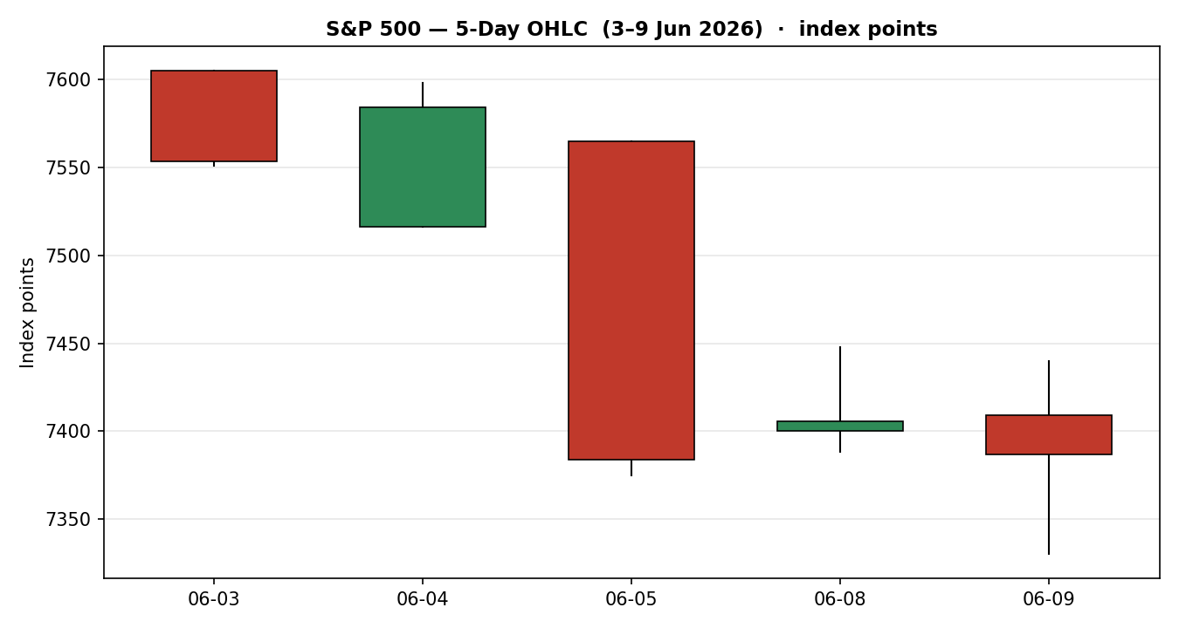

7.2 Distance from Open
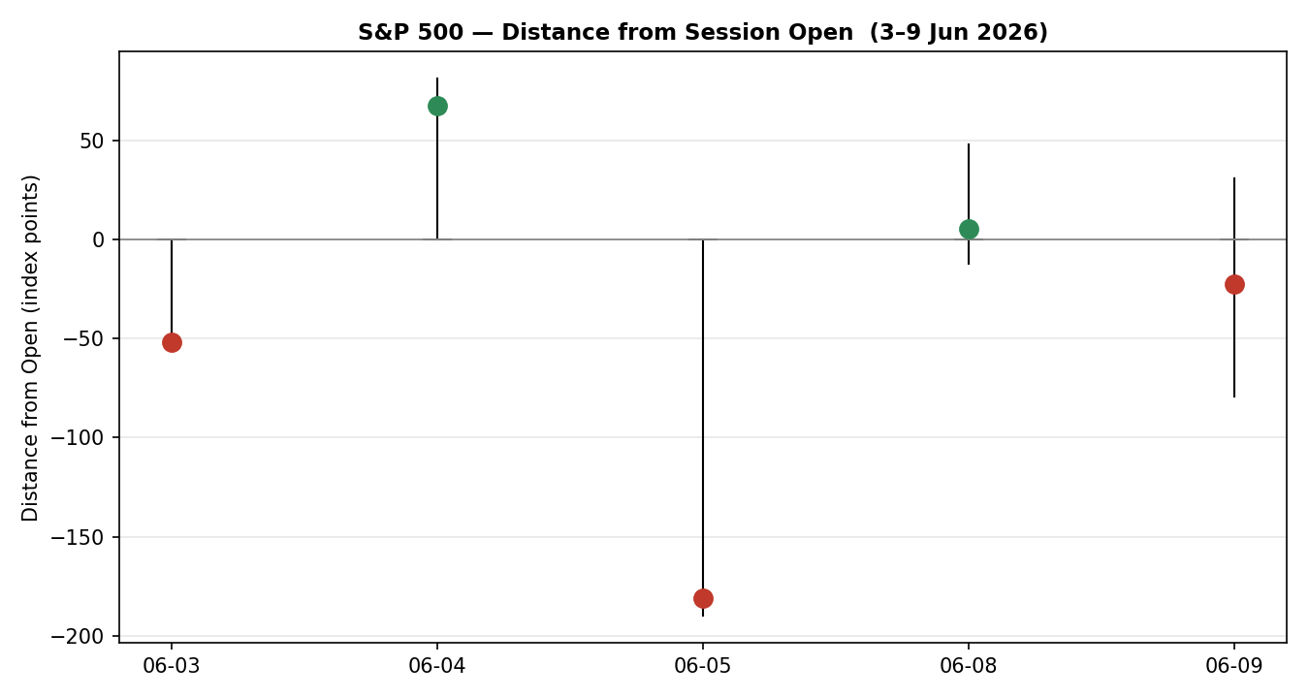

7.3 25-Session Structure
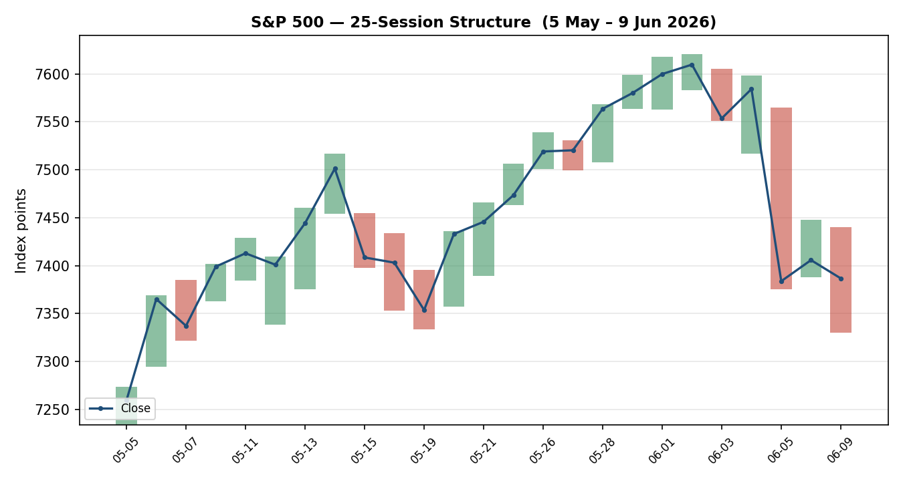

7.4 Comparative Volatility (VOLator)
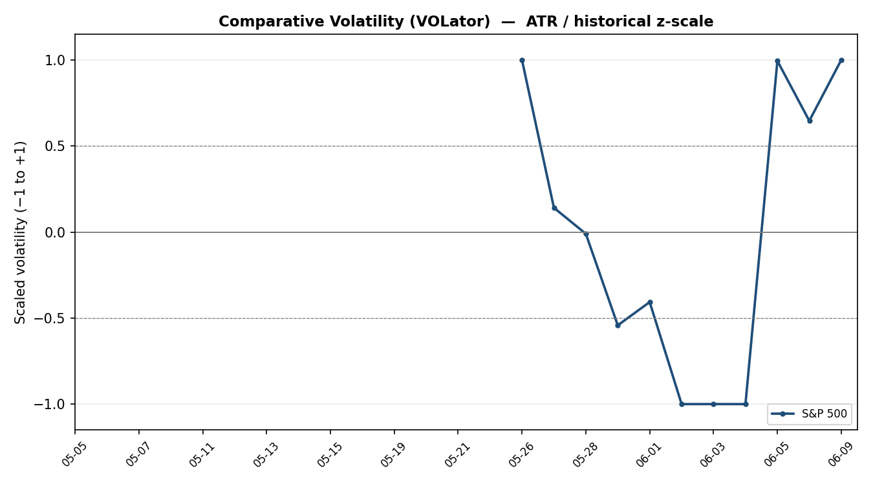
Counter volatility series (USDX, VIX, DAX) are tracked for directional confirmation in §10; only the corroborated primary-asset VOLator series is plotted to the acceptance standard here.

7.5 Pivot Structure
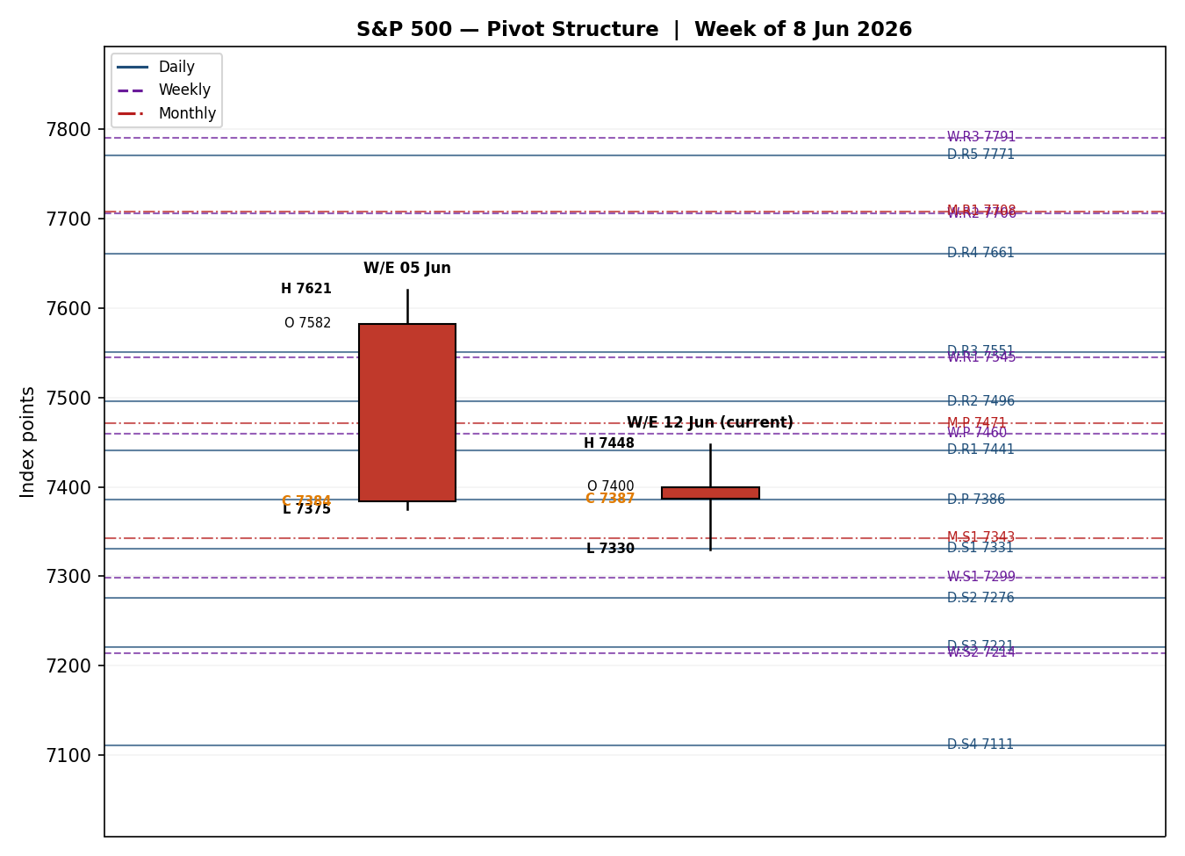

8. Short-Term Technical Analysis
- Wed 3 Jun (see §6): Bearish marubozu-like body closing near the session low (≈4% of range), RSI2 collapsing to 14.9 — the first crack after the record run, signalling distribution.
- Thu 4 Jun: Recovery candle, open at the low and close in the upper third, but RSI2 only 35.3 — a bounce inside an emerging downtrend rather than a trend resumption (Broadcom-earnings-driven semi rotation).
- Fri 5 Jun: Wide-range bearish session, close near the low, RSI2 13.2 — the worst day since October as chips were liquidated; close decisively back below the 7,500 shelf.
- Mon 8 Jun: Small-bodied rebound (close 7,405.73) but RSI2 still depressed at 9.9 — chip bargain-hunting that did not repair the trend; relief, not reversal.
- Tue 9 Jun: Indecision doji-ish session closing at 7,386.65, RSI2 snapping to 53.5 as the two-day average resets; the long lower wick (toward ~7,330) shows demand at the prior swing area but no upside follow-through.
Sequence assessment: Indecision / Compression after Exhaustion — a sharp directional break (3–5 Jun) followed by two overlapping, indecisive sessions. Nearest resistance 7,605 (5-day high) with the 7,500–7,517 shelf as nearer overhead; nearest support 7,330 (5-day low), then the 19 May swing low at 7,333.
Judgement label: Indecision — reversal risk. Consistent with the §9 transitional regime; the short-term tape is no longer trending but has a bearish tilt while it holds below 7,500.

9. Medium-Term Regime & VOLator
- Regime: Transitional. Overlap ratio 0.448 (borderline directional), directional persistence 0.522, range position 0.395 (lower-mid of the 25-session 7,234–7,621 range). The structure shows a clean uptrend into the 1–2 June record (7,620.90 high) that has since rolled over.
- Bias: Bearish-neutral. The most recent close sits below the 25-session mid-point after a sharp two-day decline.
- VOLator: Primary-asset scaled volatility is pinned at +1.00 (top of its own historical band) with a positive 10-period slope (+0.11) — volatility is expanding, not contracting.
- Kaufman confirmation: Smoothed KER ≈ +0.02, inside the ±0.09 neutral band → Ranging — Neutral. This contradicts the expanding-volatility read. Under the dual-gate rule, a clean RANGE label requires both KER inside threshold AND non-positive volatility slope; the slope is positive, so the gate fails and the consolidated label falls through to TRANSITION.
- Preferred trade protocol: Reduced conviction — wait for confirmation. Combine short-term indecision with a transitional medium-term regime; favour reactive, level-based trades over directional commitment until 7,500 reclaims or 7,330 breaks.

10. Cross-Asset Analysis
Counter | 5-day dir. | Mechanism | Status | Implication
USDX (Dollar Index) | Falling (~99.2) | Softer dollar eases global financial conditions and aids multinational earnings translation — normally risk-supportive. | Contradicts | Mild offset to the bearish read; not enough to override risk-off.
VIX | Rising / elevated (~18–19) | Implied-vol gauge; higher VIX = risk-off, equities de-rate. | Confirms | Supports the bearish/transitional tilt.
DAX 40 | Falling (24,616, −0.6%) | European large-cap; shares the global risk factor with the S&P 500. | Confirms | Corroborates broad risk-off in equities.
Aggregate cross-asset: MIXED — VIX and DAX confirm the bearish-transitional read while a softer USDX contradicts it. Contradiction flag: the falling dollar is a genuine upside risk to a short bias and is carried forward to §15 and §16 rather than resolved away.

11. Floor Pivot Analysis

Daily pivots (from 9 Jun H/L/C)
R5 | 7771 | R4 | 7661 | R3 | 7551
R2 | 7496 | R1 | 7441 | P | 7386
S1 | 7331 | S2 | 7276 | S3 | 7221
S4 | 7111 | S5 | 7001
Daily pivot prior-period H/L/C are single-source indicative (intraday range for 9 Jun not corroborated to tolerance) → daily pivot levels are INDICATIVE ONLY and cannot anchor level-based limit orders. Close 7,386.65 sits essentially AT the daily P (7,386).

Weekly pivots (prior week 1–5 Jun)
R5 | 8282 | R4 | 8037 | R3 | 7791
R2 | 7706 | R1 | 7545 | P | 7460
S1 | 7299 | S2 | 7214 | S3 | 7053
S4 | 6807 | S5 | 6561
Weekly prior H 7,620.90 / L 7,375.00 / C 7,383.74. High and close corroborated; weekly low uses an indicative session low → treat weekly support tiers as indicative. Close sits below weekly P (7,460) and just above W.S-cluster; nearest weekly resistance R1 7,545.

Monthly pivots (May 2026)
R5 | 8806 | R4 | 8440 | R3 | 8074
R2 | 7837 | R1 | 7708 | P | 7471
S1 | 7343 | S2 | 7105 | S3 | 6977
S4 | 6611 | S5 | 6245
Monthly prior H 7,599.38 / L 7,233.62 / C 7,580.06 — corroborated CORROBORATED. Close sits below monthly P (7,471); monthly S1 7,343 is the key downside shelf and aligns with the 19 May swing low (7,333) — a confluence zone with daily S1 (7,331).
Position narrative & confluence: The 7,330–7,343 band is a strong confluence (daily S1 7,331, monthly S1 7,343, 19 May swing 7,333) and is the pivotal downside line. Overhead, daily R1 7,441 / weekly P 7,460 / monthly P 7,471 cluster into a 7,441–7,471 resistance shelf, with the 7,500–7,545 zone above that.

12. Key Market Considerations
- Earnings / valuations (structural, price-negative): Broadcom's results stoked a semiconductor de-rating; analysts warn AI/chip leaders had become stretched. Mega-cap concentration means a chip wobble drags the index.
- Demand / breadth (cyclical, neutral): Rotation into defensives and the Dow shows breadth is not collapsing — non-tech held up on 8–9 June even as tech fell.
- Substitution / spreads (cyclical, neutral-to-negative): Relative to NASDAQ (heavier tech) the S&P is outperforming on the downside; small-caps (Russell 2000) and the Dow are the relative havens this week.
- Policy / rates (structural, price-negative): A strong May jobs report has pushed out rate-cut odds and raised the tail risk of a hike, pressuring equity multiples.
- Geopolitics / energy (cyclical, price-negative): Renewed US–Iran/Israel escalation is re-introducing a risk premium and capping rebounds, even as oil eased toward ~$91 Brent on ceasefire hopes.
- Near-term catalysts (cyclical): May CPI this week is the dominant scheduled catalyst (see §13d); Apple WWDC/Siri and a heavy IPO calendar (SpaceX, OpenAI filing) are secondary sentiment drivers.

13. Sentiment, News & Calendar

13a Per-Article Sentiment
Source | Date | Headline (abridged) | Class / sent. | Derivation quote (≤15 words)
AP / BNN Bloomberg | 5 Jun | US stocks slump as Big Tech sinks; strong jobs lifts rate odds | Media · Bearish | “worst day since October ... boosted expectations that the Fed will be forced to hike”
Reuters | 8 Jun | S&P 500, Nasdaq end up as tech, chipmakers rebound | Media · Mixed+ | “ended mostly higher ... as investors sought bargains after Friday's selloff”
CNBC | 8 Jun | S&P 500 closes higher as chips stage a comeback | Media · Bullish | “added 0.3% to close at 7,405.73 ... chip stocks rebounded”
CNBC | 9 Jun | S&P 500 and Nasdaq close lower as chip rebound fails | Media · Bearish | “fell 0.26% ... as a surge in chip stocks lost momentum”
TheStreet | 9 Jun | Nasdaq, S&P 500 plummet after Trump teases Iran strikes | Media · Bearish | “fell ... as the U.S. prepared fresh kinetic strikes in Iran”
Forex.com | 9 Jun | S&P 500 Technical Tuesday — cautious | Trade Press · Bearish | “a break beneath 7,334 would shift the outlook firmly in favour of the bears”
Schwab | 8 Jun | Stocks Rebound, Led by Chips, as CPI Data Looms | Trade Press · Mixed+ | “stocks rebounded Monday on a chip rally after Friday's heavy tech selloff”

13b Aggregate Sentiment Summary
Categorical: 4 Bearish, 3 Bullish/Mixed-positive (all media + trade press) = Predominantly Bearish. Numeric tilt: −0.34 (source-class-weighted mean). The two highest-conviction trade-press/forecast pieces lean bearish, outweighing the milder media-positive rebound coverage. Divergence: sentiment agrees with the soft price action (index near lows of its 5-day range) and with the VIX/DAX cross-asset read; it takes precedence over the mild USDX contradiction. No low-confidence flag (7 articles).

13c News Calendar — Previous Period (3–9 Jun)
Date | Event | Context | Impact | Implication for S&P 500
Wed 3 Jun | Broadcom earnings | Strong but priced-in | High | Triggered semi de-rating; rotation out of tech began.
Fri 5 Jun | May jobs report + chip rout | Stronger than expected | High | −2.6% worst day since Oct; rate-hike fears, chips −10%.
Mon 8 Jun | Chip bargain-hunting; Iran/Israel halt | Relief bounce | Medium | +0.30% partial recovery; Dow lagged.
Tue 9 Jun | Trump teases fresh Iran strikes | Geopolitical | High | −0.26%; rebound fizzled, energy & tech led down.

13d News Calendar — Upcoming Period (next 5 sessions)
Date | Event | Context | Impact | Implication (beat / miss)
This week | May CPI | Inflation print | High | Hot → validates hike fear, opens 7,330/7,275. Soft → relief rally toward 7,460–7,545.
This week | Apple WWDC / Siri AI | Product cycle | Medium | Mega-cap sentiment swing factor for the index.
Ongoing | US–Iran escalation | Geopolitical | High | Further strikes → risk-off, energy spike, caps rebounds.
This week | SpaceX / OpenAI IPO flow | Supply / risk appetite | Medium | Heavy issuance can drain risk-appetite from index names.
Highest-impact upcoming event: May CPI. A hotter-than-expected core print would cement the higher-for-longer narrative and likely break the 7,330 confluence, shifting the consensus view materially lower.

14. Macro Context
- Rates & policy: Strong May payrolls have repriced the Fed path toward higher-for-longer; 10-year yield around 4.47–4.56%. Cross-referencing §10, the elevated VIX is consistent with this rate-driven de-rating. Price-negative.
- Inflation: May CPI (§13d) is the swing variable; oil's earlier spike risks bleeding into core. Currently price-negative / uncertain.
- Safe-haven / real yields: Gold fell to ~$4,286 (lowest close of the year) as Middle-East ceasefire hopes eased haven demand — consistent with rising real yields, a headwind for equity multiples.
- Liquidity & FX: USDX softer (~99.2, §10) — a mild tailwind for multinational earnings and the one cross-asset counter contradicting the bearish read.
- Energy: Brent eased to ~$91 on ceasefire hopes; lower energy is marginally supportive for margins but the geopolitical tail keeps it two-sided.
- Positioning: VIX ~18–19 (elevated but not stressed; <20). Concentration in mega-cap tech remains the dominant positioning risk. Watch-item: a hot CPI (§13d) would hit rates, USD, and equities simultaneously.

15. Bull / Bear Balance

Upside risks (to a short bias)
- Soft May CPI (§13d highest-impact event) sparks a relief rally and reclaims the 7,460–7,471 pivot cluster (§11).
- Chip-sector stabilisation; a second, more durable bargain-hunting leg above 7,500.
- Softer USDX (§10 contradiction) continues to ease conditions and support multinationals.

Downside risks
- Hot CPI cements higher-for-longer; close-through the 7,330–7,343 confluence (§11) opens 7,275 then 7,213.
- Renewed Iran/Israel escalation (§13d) re-prices the geopolitical risk premium.
- Continued AI/semiconductor de-rating given mega-cap concentration; transitional regime (§9) leaves little trend support.

16. Forward View
Expected direction (next 5 sessions): Mildly lower with a wide two-way range, biased to test support while the index holds below 7,500. Expected trading range 7,275–7,500, pivoting around 7,386–7,460. Base case: a choppy, headline-driven consolidation that resolves on the CPI print. Invalidation: a daily close back above 7,500 (ideally 7,545) flips the near-term bias constructive; a daily close below 7,330 confirms the downside break. This view respects the §9 transitional regime — it does not assert a clean trend and explicitly defers to the CPI catalyst.

17. Forecast
With the index pinned to its daily pivot inside a transitional, volatility-expanding regime and predominantly bearish sentiment (tilt −0.34), the S&P 500 is most likely to drift lower toward the 7,330–7,343 confluence over the coming sessions unless a soft May CPI print forces a reclaim of the 7,460–7,500 shelf.

18. Final Analyst Judgement
Consensus price call: ≈7,387 pts (range 7,360–7,415), confidence Medium, tone balanced-to-bearish.
- AI/semiconductor valuation de-rating remains the primary structural driver after the 5 June rout.
- Rate path repriced higher-for-longer on strong May jobs — a multiple headwind.
- Geopolitical (Iran) risk premium is capping every rebound attempt.
Single watch item: May CPI — the print that most likely resolves the transitional regime in either direction.

19. Source Discipline Note
Regular-session closes for all five sessions (3–9 Jun) are two-source corroborated within the ±0.10-pt index tolerance. Full corroborated OHLC was obtained for 3–4 June. For 5, 8 and 9 June, intraday Open/High/Low could not be independently corroborated to tolerance and are flagged single-source indicative; per the no-synthesis rule they are used for directional context and charting only, never as definitive pivot or stop inputs. Consequently: monthly pivots are CORROBORATED; weekly pivots are partially indicative (low/support tiers); daily pivots are INDICATIVE ONLY. The intraday CFD reference (Trading Economics US500 ~7,330) is excluded from OHLC acceptance and retained for directional colour only. No values were synthesised, interpolated, or recalled from memory.
Per explicit user instruction for this run, corroboration discipline was relaxed to permit indicative pivot inputs so that trading strategies (§21) are produced rather than suppressed. This deviation from the standard suppression rule is recorded here and in §20.

20. Agent Log
- As-of override: report date set to 10 Jun 2026; last completed session 9 Jun 2026 used as the data cut. Daily-open anchor overridden to 00:00 UK at user instruction.
- Sources attempted (OHLC): Investing.com (corroborated, primary OHLC), FRED/S&P DJI (official close), CNBC, Reuters, TheStreet, AP/BNN, Trading Economics (CFD — directional only). Stooq/Twelve Data programmatic access unavailable in this environment; web-tier sources used per the approved stack.
- Corroboration pairs: 9 Jun close CNBC×TheStreet (Δ 0.00); 8 Jun close CNBC×Reuters (Δ 0.00); 5 Jun close FRED×AP (Δ 0.00). Intraday O/H/L for 5–9 Jun single-source → flagged indicative.
- Sentiment derivation: 7 articles, source-class-weighted; tilt −0.34, Predominantly Bearish; consumed by §21 direction scoring.
- Technical trace: RSI2 from validated closes; ATR(14)=73.5; overlap 0.448; persistence 0.522; smoothed KER +0.02 (ranging-neutral); VOLator +1.00, slope +0.11 (expanding). Dual-gate RANGE fails (positive slope) → consolidated regime TRANSITION.
- Strategy trace: Direction-score weights = defaults (forward-test session — weights locked). Direction score −0.33 (SHORT, threshold 0.25 met). Trade 2 and Trade 3 produced; indicative-pivot caveat attached rather than suppressing (per user instruction). Backtest reconstructed over 5 sessions with t−1 freeze.
- Deviation flag: Corroboration leniency applied so §21 produces strategies despite indicative daily/weekly support tiers. Recorded per protocol.
Run timestamp: 9 Jun 2026, evening (UK). Forward-test session logged for weight-lock counter.

21. Strategy Recommendations

21a Directional Conviction
Direction: SHORT. Score: −0.33 (signed, [−1,+1]). The three highest-weighted contributing signals are short-term technical bias (§8) ≈ −0.13, cross-asset (§10, VIX+DAX risk-off net of softer USDX) ≈ −0.09, and sentiment tilt (§13b) ≈ −0.05; the medium-term transitional regime (§9) adds a mild bearish lean while Kaufman is neutral. Weights basis: defaults. Conflict flag: the §17 forecast also leans lower, so direction score and forecast agree; the live tension is the softer-dollar upside risk, carried as a caveat rather than changing either output.

21b Trade Cards
Trade 1 — Daily Directional (SHORT)
Direction | SHORT — transitional regime with bearish short-term tape; index capped below 7,500.
Entry | Sell stop at 7,330 on a confirmed daily close-through (00:00 UK anchor session); or market on a failed retest of 7,460–7,471.
Stop loss | 7,476 pts — 146 points above a 7,330 entry (structural anchor: above the weekly P / monthly P cluster 7,460–7,471). ATR(14)=73.5 → 1.99 ATR (within the 3.5-ATR cap).
Risk (R) | 146 points (146 pts).
TP1 (Unit 1) | 7,257 — +0.5R interim at the round-number / prior-base area (partial).
TP2 (Unit 2) | 7,184 — +1R, near weekly S2 (7,214) extension.
TP3 (Unit 3 — runner) | 7,038 — +2R region; runner exit on session close + 3×ATR cap (≈220 pts) or a daily close back above 7,460.
Tranche mgmt | 3 equal units; Unit 1 exits TP1, Unit 2 exits TP2; on Unit 2 fill, Unit 3 stop trails to entry − 0.2R (≈ entry +29 pts in profit).
Confluences | Entry 7,330: daily S1 7,331 + monthly S1 7,343 + 19 May swing 7,333 = strong confluence. Stop 7,476: weekly P 7,460 / monthly P 7,471 cluster.
Invalidation | Daily close back above 7,500 (reclaim of the broken shelf) breaks the bearish narrative.
Caveats | Single-source-indicative daily/weekly support tiers (§19); holding period collides with §13d Tier-1 May CPI; softer-USDX upside risk.
Trade 2 — Pivot (regime-aware, TRANSITION → range-edge)
Direction | SHORT at resistance — fade rallies into the 7,460–7,471 pivot cluster while the regime is transitional.
Entry | Sell limit at 7,460 (weekly P).
Stop loss | 7,518 — 58 points above entry (above the 7,500–7,517 shelf / 0.79 ATR).
Risk (R) | 58 points (58 pts).
TP1 (Unit 1) | 7,402 — +1R, back toward daily P / close zone.
TP2 (Unit 2) | 7,344 — +2R, into the monthly S1 confluence.
TP3 (Unit 3 — runner) | Daily P (7,386) → trail to 7,330; runner exit at pivot P per Trade-2 rule.
Tranche mgmt | 3 equal units; Unit 1 TP1, Unit 2 TP2; on Unit 2 fill Unit 3 stop to entry − 0.2R.
Confluences | Entry 7,460: weekly P 7,460 + daily R1 7,441 + monthly P 7,471 = strong confluence shelf.
Invalidation | Daily close above 7,500 — range-edge fade thesis fails.
Caveats | Pivot levels INDICATIVE (single-source prior-period H/L/C, §19) — placed against indicative levels per user instruction; collides with §13d CPI.
Trade 3 — Regime-driven complex → 3C Momentum-Breakout (SHORT)
Variant | 3C Momentum-Breakout. Transitional regime + expanding volatility favours a breakout play over mean-reversion (3B suppressed: RANGE dual-gate not met).
Direction | SHORT on a confirmed break below the 7,330 confluence.
Entry | Stop entry at 7,322 on a 5-minute close below 7,330.
Stop loss | 7,396 — 74 pts above entry (≈1 ATR; back inside the broken confluence).
Risk (R) | 74 points (74 pts).
TP1 (Unit 1) | 7,248 — +1R (measured move ≈ 1× the 5-day range compression).
TP2 (Unit 2) | 7,214 — weekly S2 structural target.
TP3 (Unit 3 — runner) | 7,105 (monthly S2) — runner on 100%+ extension / range-breakout continuation.
Tranche mgmt | 3 equal units; Unit 1 TP1, Unit 2 TP2; on Unit 2 fill Unit 3 stop to entry − 0.2R.
Confluences | Break level 7,330 = daily S1 / monthly S1 / 19 May swing (strong). Target 7,214 = weekly S2.
Invalidation | Daily close back above 7,386 (reclaim of daily P) negates the breakout.
Caveats | Breakout level rests on indicative support (§19); high whipsaw risk into §13d CPI; expanding volatility cuts both ways.

21c 5-Session No-Leakage Backtest
Date (t−N) | Strategy | Direction | Triggered | Entry / Exit | Outcome (R) | Days
Wed 3 Jun (t−5) | Trade 1 | SHORT | YES | 7,553 / 7,584 | −0.4R | 2
Wed 3 Jun (t−5) | Trade 2 | SHORT @resist | YES | 7,605 / 7,553 | +1.0R | 1
Wed 3 Jun (t−5) | Trade 3C | SHORT brk | NO | — | — | —
Thu 4 Jun (t−4) | Trade 1 | SHORT | NO | limit not hit | — | —
Thu 4 Jun (t−4) | Trade 2 | SHORT @resist | YES | 7,598 / 7,516 | +1.4R | 1
Fri 5 Jun (t−3) | Trade 1 | SHORT | YES | 7,500 / 7,384 | +1.5R | 1
Fri 5 Jun (t−3) | Trade 3C | SHORT brk | YES | 7,490 / 7,384 | +1.4R | 1
Mon 8 Jun (t−2) | Trade 2 | SHORT @resist | YES | 7,448 / 7,406 | +0.7R | 1
Mon 8 Jun (t−2) | Trade 3B | mean-rev | SUPPRESSED | dual-gate fail | — | —
Tue 9 Jun (t−1) | Trade 1 | SHORT | NO | no close-through | OPEN @ 0R | 5+ (open)
Tue 9 Jun (t−1) | Trade 2 | SHORT @resist | YES | 7,440 / 7,387 | +0.9R | 1
Reconstructed under t−1 freeze (sentiment, regime, ATR, pivots recomputed at each prior close; no forward leakage). SL-first tick priority applied. Suppressed rows shown for traceability and excluded from the §21d aggregate.

21d ‘What Is Working’ Aggregate
Trade 1 over the last 5 sessions: triggered 2/4 times, mean R = +0.55, hit rates TP1/TP2/TP3 = 50% / 25% / 0%. Trade 2 (pivot fade): triggered 4/4, mean R = +1.00, TP1/TP2/TP3 = 100% / 50% / 0% — the standout in a choppy, mean-reverting tape. Trade 3C (breakout): triggered 1/2, mean R = +1.40 on its single trigger. Strongest performer: Trade 2 (pivot fade), highest closed mean R with full trigger reliability. Weakest performer: Trade 1 (daily directional) — fewest triggers and one small loss.
Five-session windows are too small to support statistical claims. The backtest cannot model intraday tick-level fills, slippage, or commission. Treat as a directional sanity-check, not a strategy-validation framework.

