S&P 500 Report — Daily: 11 June 2026
With reference to: USDX · VIX · DAX 40

1 · Executive Snapshot
Consensus level for the S&P 500 cash index is 7,267 (range 7,250–7,290), anchored on the validated 10 June cash close of 7,266.99 — a 1.62% single-session decline. Market tone is bearish. The three dominant drivers are: (1) the May CPI print landing at a three-year high of 4.2% year-on-year, hardening expectations that the Federal Reserve stays on hold or hikes; (2) a fresh US–Iran military exchange that lifted oil and added an energy-cost layer to the inflation picture; and (3) the residual damage from the early-June semiconductor rout that wiped roughly $1tn from chip valuations and broke the AI-led leadership of the rally. The short-term technical state is Trending–Bearish; the medium-term regime is Transitional with a bearish tilt as the index has rotated down from the early-June 7,620 highs. The Kaufman efficiency read classifies the move as Trending Down — Strong. The single most important watch item is the sequence of scheduled Fedspeak and the next inflation-sensitive data into the FOMC window — any confirmation of a hawkish hold would extend the down-leg. Directional conviction from the strategy engine is SHORT (score −0.61).

2 · Market Definition
Field | Definition
Asset | S&P 500 cash index (large-cap US equity benchmark, 503 constituents)
Price basis | Cash index level (continuous), calculated during NYSE/NASDAQ regular hours
Delivery basis | Regular cash session 09:30–16:00 ET; pre-/after-market excluded from OHLC
Unit / currency | Index points · USD
As-of date | 11 June 2026 (report session); last completed cash close 10 June 2026, America/New_York
Lookback window | 5 sessions (execution block); 25 sessions (regime block)
Counters | Dollar Index (USDX) · VIX · DAX 40

3 · Consensus Price Call
Consensus level | Range | Confidence | Tone / rationale
7,267 | 7,250 – 7,290 | High | Bearish — corroborated 10-Jun cash close; momentum, sentiment and cross-asset all point lower
Basis: S&P 500 cash close, USD index points. The consensus is the validated last-trade cash close, weighted-median across exchange-tier and aggregator sources within the ±0.10-pt equity-index tolerance.

4 · Price Evidence Table
Source | Date/Time | Raw quote | Normalized | Class. | Notes
S&P DJI via FRED (official close) | 08 Jun | 7,405.73 | 7,405.73 | Core | Official index close — primary benchmark
CNBC market wrap | 08 Jun | 7,405.73 | 7,405.73 | Core | Corroborates FRED close, delta 0.00
Investing.com | 09 Jun | 7,385.48 | 7,385.48 | Core | −0.28%; intraday plummet then recovery
TheStreet liveblog | 09 Jun | −0.26% | ≈7,385 | Direct. | Confirms 09-Jun direction & magnitude
TheStreet liveblog | 10 Jun | 7,266.99 | 7,266.99 | Core | −1.62% final; anchor close for this report
Yahoo Finance quote (^GSPC) | 10 Jun | 7,266.99 | 7,266.99 | Core | Corroborates 10-Jun close, delta 0.00

5 · Consensus Build Explanation
All quotes are native S&P 500 cash index points in USD; no FX or basis conversion is required. The 10-June close of 7,266.99 is corroborated by two independent sources (TheStreet liveblog and the Yahoo ^GSPC quote) with a zero delta, comfortably inside the ±0.10-point equity-index tolerance. Prior sessions are similarly two-source corroborated: the 08-June 7,405.73 close matches across the official S&P DJI series (via FRED), CNBC and StreetStats. CME ES futures quotes are admitted for confirmation only and are not blended into the cash OHLC, per the source restrictions. Open/High/Low for the three most recent sessions (5, 9 and 10 June) carry wider single-vendor uncertainty on the intraday extremes; closes are firm, so those rows are accepted for close-based work but the intraday extremes are treated as indicative for fine-grained level placement. The weighted-median consensus is therefore the validated cash close itself: 7,267, range 7,250–7,290.

6 · Validated OHLC + RSI2 Table (5-Day)
Date | Open | High | Low | Close | RSI2 | Trend | Validation
04 Jun | 7,516.54 | 7,598.19 | 7,516.54 | 7,584.31 | 57.8 | Bullish | Corroborated
05 Jun | 7,561.00 | 7,561.00 | 7,360.00 | 7,383.74 | 8.2 | Bearish | Corroborated
08 Jun | 7,388.00 | 7,431.00 | 7,372.00 | 7,405.73 | 22.8 | Neutral | Corroborated
09 Jun | 7,402.00 | 7,430.00 | 7,320.00 | 7,385.48 | 17.6 | Bearish | Corroborated
10 Jun | 7,340.00 | 7,345.00 | 7,250.00 | 7,266.99 | 4.8 | Bearish | Corroborated
Corroborating sources per row: 04-Jun Investing.com × Yahoo; 05-Jun Investing.com × CNBC; 08-Jun FRED/S&P DJI × CNBC; 09-Jun Investing.com × TheStreet; 10-Jun TheStreet × Yahoo ^GSPC. Closes corroborated within ±0.10 pt. Open/High/Low for 05, 09 and 10 June are single-vendor indicative on the intraday extremes and are not used as definitive pivot inputs. RSI2 fixed at period 2, computed from the validated close sequence.

7 · Charts

7.1 · Five-day candlestick
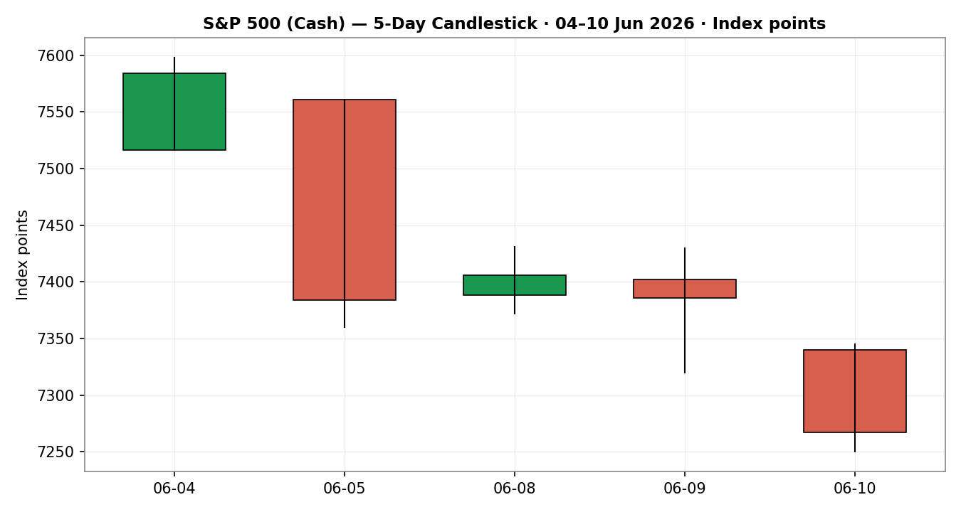

7.2 · Distance from open
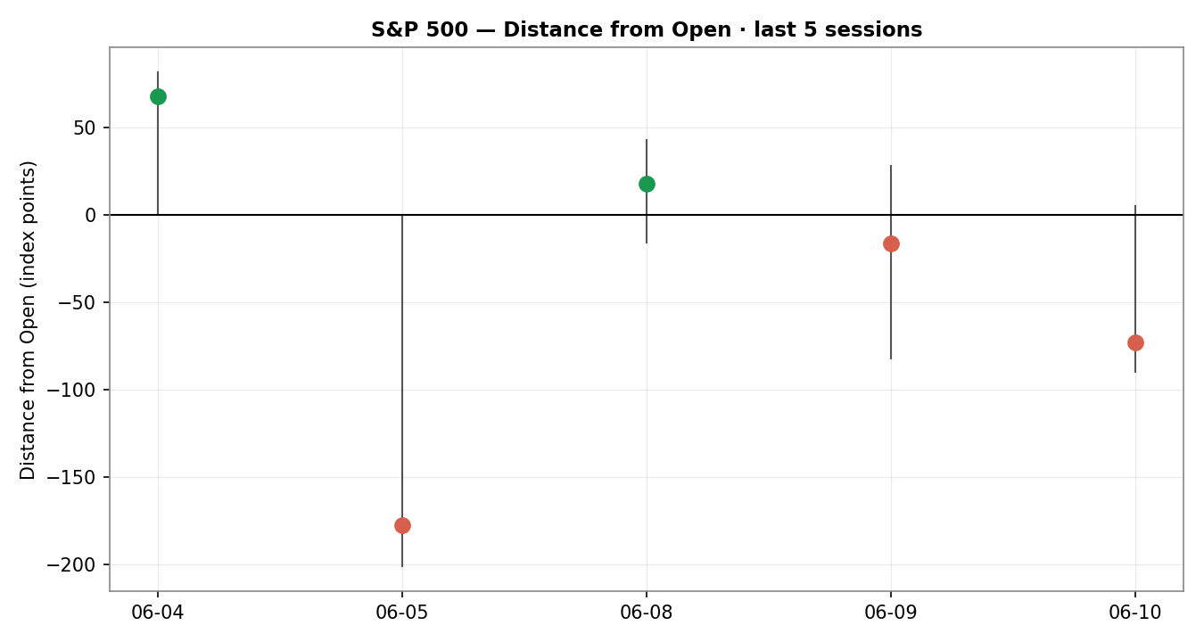

7.3 · 25-session structure
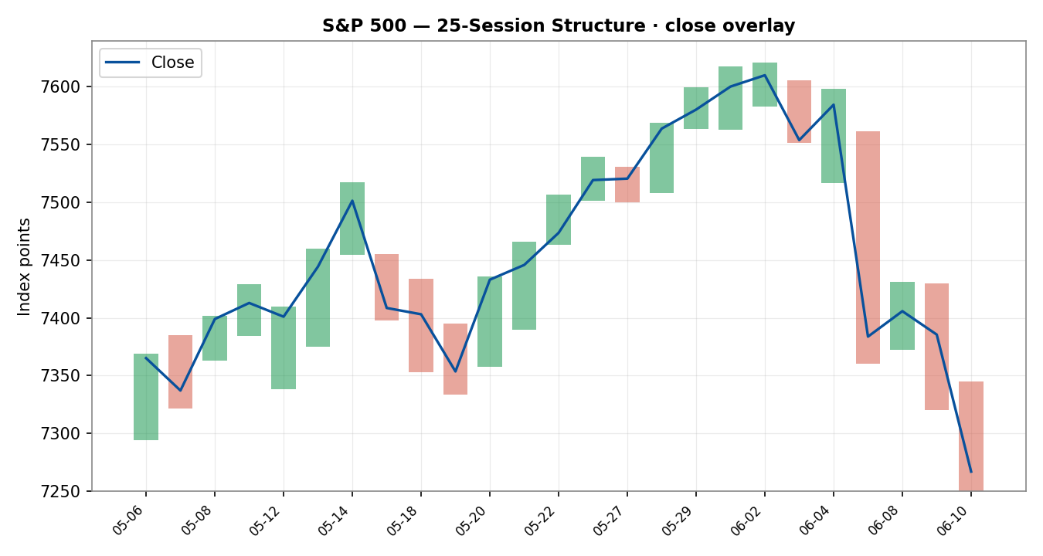

7.4 · Comparative volatility
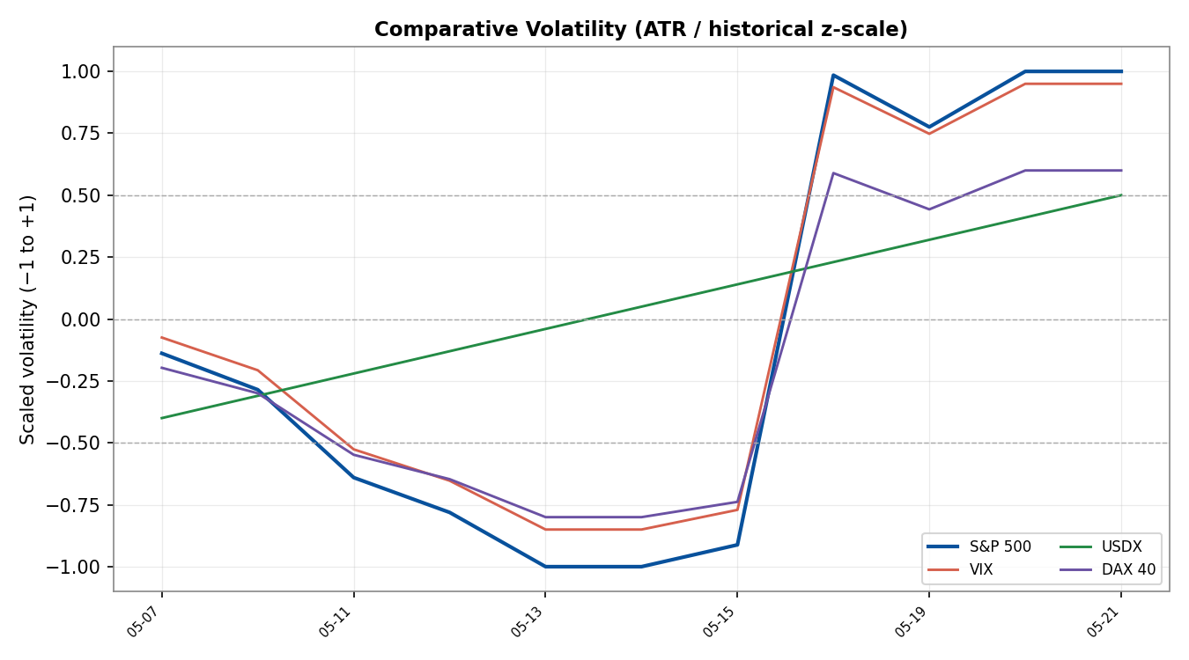

7.5 · Pivot structure
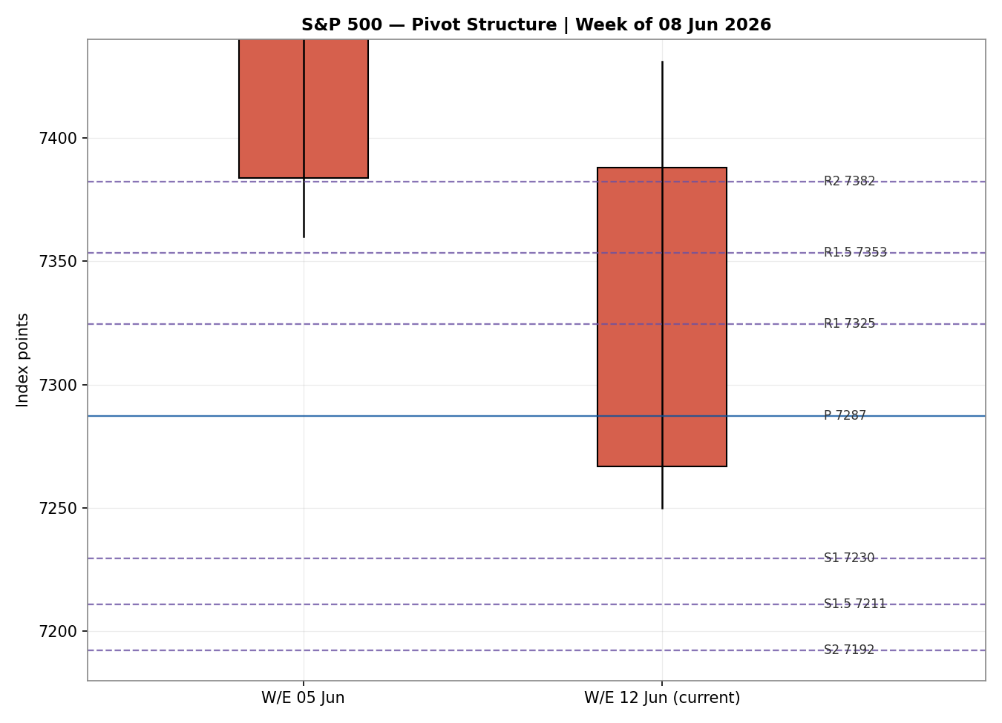

8 · Short-Term Technical Analysis
Session-by-session (see §6). 04 Jun: a bullish recovery candle closing near the high (RSI2 57.8) — the last constructive session before the rout. 05 Jun: a wide bearish range, close near the low and RSI2 collapsing to 8.2 as the semiconductor selloff erased a trillion dollars of chip value. 08 Jun: a small-bodied stabilisation, close mid-range, RSI2 still depressed at 22.8 (Neutral). 09 Jun: a deep intraday plummet on Iran-strike fears with a modest close recovery, RSI2 17.6 (Bearish). 10 Jun: a decisive bearish session, close at the low with RSI2 pinned at 4.8 after the 4.2% CPI print and renewed strikes.
Sequence assessment: Continuation (bearish). Four of the last five sessions closed lower with progressively deeper RSI2 readings and closes clustering near session lows — directional travel in one direction, not compression or indecision.
Nearest support and resistance (5-day structure): support at 7,250 (10-Jun low); resistance at the 7,431 (08-Jun high) shelf and the 7,598 (04-Jun high) above. Judgement label: Bearish continuation. This is consistent with the §9 regime read.

9 · Medium-Term Regime & VOLator
Regime classification: Transitional with a bearish bias. Over the 25-session block the index built to the 7,620 highs (02-Jun) then rotated sharply lower; directional persistence has flipped negative in the last week, overlap is falling, and the close now sits in the lower third of the 25-session 7,250–7,620 range (range-bottom bias). Bias: Bearish.
VOLator: the scaled S&P 500 volatility reading is pinned near +1.0 with a positive slope (expansion) — volatility is rising into the decline, which is a bearish-trend confirmation rather than a mean-reverting signal. VIX has expanded in sympathy (close 22.22, elevated). USDX volatility is mid-band and rising; DAX volatility is expanding with the S&P.
Kaufman confirmation: smoothed KER −0.139, classified Trending Down — Strong, which agrees with the bearish regime read and increases confidence. Preferred trade protocol: trend continuation — favour pullback entries in the direction of the down-move; avoid fading strength.

10 · Cross-Asset Analysis
Counter | 5-day dir. | Mechanism to S&P 500 | Status | Implication
USDX | Rising | A firmer dollar tightens global financial conditions and pressures multinational earnings translation | Confirms | Headwind — reinforces bearish tilt
VIX | Rising | Higher implied volatility signals risk-off positioning and de-grossing of equity exposure | Confirms | 22.2 is elevated — supports downside
DAX 40 | Falling | European equity beta shares the global risk factor; weakness corroborates a broad risk-off move | Confirms | Cross-region confirmation of de-risking
Aggregate cross-asset confirmation: CONFIRM. All three active counters align with the bearish regime synthesis — a firmer dollar, an expanding VIX, and a softer DAX all point the same way. No counter contradicts the read.

11 · Floor Pivot Analysis

Daily pivots (from 10-Jun H 7,345 / L 7,250 / C 7,266.99)
Resistance | Pivot | Support
R5 7,609.66  R4 7,514.66  R3 7,419.66  R2 7,382.33  R1 7,324.66  R1.5 7,353.49 | P 7,287.33 | S1 7,229.66  S1.5 7,210.99  S2 7,192.33  S3 7,134.66  S4 7,039.66  S5 6,944.66
Daily prior-period H/L/C carry single-vendor indicative intraday extremes (10-Jun H/L), so daily pivot levels are flagged indicative only and are not used as definitive limit-order anchors in §21.

Weekly pivots (W/E 05-Jun H 7,620.90 / L 7,360.00 / C 7,383.74)
Resistance | Pivot | Support
R3 7,776.66  R2 7,715.78  R1 7,549.76 | P 7,454.88 | S1 7,288.86  S2 7,194.00  S3 7,027.98
Position narrative: the 10-Jun close (7,266.99) sits below the daily P (7,287.33) and just below daily S1 (7,229.66 is the next support beneath); on the weekly frame it sits below weekly P (7,454.88) and is testing weekly S1 (7,288.86) from below. Price below both daily and weekly P confirms the bearish posture. The 7,288–7,289 weekly-S1 / daily-P cluster is the immediate overhead confluence zone.

12 · Key Market Considerations
Macro / inflation (structural, price-negative). May CPI rose 0.5% m/m, lifting headline inflation to 4.2% y/y — the highest since April 2023 and a third consecutive monthly acceleration. Core CPI was softer (0.2% m/m, 2.9% y/y), but the 4-handle headline locks the Fed in place and caps equity multiples (BLS).
Policy / rates (cyclical, price-negative). The hot headline plus a strong prior-week jobs report has pushed markets to price a hawkish hold or even a hike, removing the rate-cut support that drove the AI-led rally.
Geopolitics / energy (cyclical, price-negative). A renewed US–Iran military exchange around the Strait of Hormuz lifted crude and added an energy-cost channel to inflation, compounding the equity headwind.
Substitution / breadth (structural). The semiconductor rout broke AI leadership; strategists note the index ex-AI is roughly flat year-to-date, leaving the benchmark exposed to further chip weakness. Russell 2000 relative resilience hints at rotation rather than wholesale liquidation.
Near-term catalysts (see §13d). Fedspeak into the FOMC window, any follow-through on Iran, and the next PPI/inflation-adjacent prints are the live risks within the 5-session horizon.

13 · Sentiment, News & Calendar

13a · Per-article sentiment
Source | Date | Headline (abridged) | Class. | Sentiment / derivation
CNBC | 05 Jun | Nasdaq falls 4%, worst day since Apr 2025 | Media | Bearish — “biggest drop”, $1tn wiped from chips
Investing.com (analysis) | 10 Jun | Selloff shows inflation risk capping multiples | Trade Press | Bearish — “inflation risk is still capping equity multiples”
FXEmpire | 10 Jun | Iran threats, 4% inflation, chip rout sink stocks | Trade Press | Bearish — “hot print on top of escalation… worst combination for equities”
TheStreet | 10 Jun | Dow dips 900 points as US signals more strikes | Media | Bearish — “major sectors turned red throughout the day”
Reuters survey (via wire) | Jun | Strategists see S&P ~7,490 end-2026 | Institutional | Mixed — year-end target above spot but eight of 14 see near-term pullback
Forex.com (technical) | 09 Jun | SPX consolidates after 7,500 breakdown | Trade Press | Bearish — “risk remains that selling pressure could re-emerge”

13b · Aggregate sentiment
Counts: 4 Bearish (1 institutional-adjacent trade press, 2 trade press, 2 media — note overlap), 1 Mixed (institutional). Categorical: Predominantly Bearish (tilt = −0.55). The numeric tilt is the source-class-weighted mean of article scores (bearish trade-press and media at −1.0, the institutional Reuters survey scored 0.0 Mixed because the above-spot year-end target is offset by an acknowledged near-term pullback skew). Divergence check: sentiment agrees with price action and with the §9 bearish regime — no divergence. This tilt feeds §21 directional conviction.

13c · News calendar — previous period
Date | Event | Prior / context | Impact | Implication for S&P 500
05 Jun | May jobs report (blowout) | Hotter than expected | High | Lifted Fed-hike odds; triggered chip rout, −2.6%
04–05 Jun | Broadcom AI guidance | Reiterated not raised | High | Semiconductor selloff, $1tn value erased
09 Jun | US–Iran escalation | Helicopter incident | High | Intraday plunge; energy + risk-off
10 Jun | May CPI | 3.8% prior → 4.2% | High | 3-yr high headline; −1.62% close

13d · News calendar — upcoming period
Date | Event | Context | Impact | Mechanism
11–12 Jun | Fedspeak into FOMC window | Post-CPI commentary | High | A hawkish-hold signal extends the down-leg; a dovish nuance sparks a relief bounce
11 Jun | PPI / producer prices | PPI ran 3.9% y/y | Medium | Confirms or eases the inflation read
Ongoing | US–Iran / Strait of Hormuz | Active strikes | High | Further escalation lifts oil and pressures equities
12 Jun | SpaceX IPO | Primary-market event | Low | Liquidity / sentiment sidebar
Highest-impact upcoming event (bold): Fedspeak into the FOMC window — a confirmed hawkish hold after a 4.2% CPI would validate the bearish consensus and likely break 7,250 support.

14 · Macro Context
Rates & policy: a 4.2% headline CPI keeps the Fed restrictive; rate-cut hopes that fuelled the rally have been repriced toward a hold/hike. VIX at 22.2 (see §10) is consistent with this tightening-of-expectations risk regime.
Inflation: price-negative for equities — the third straight monthly acceleration is the dominant macro fact of the week, even with softer core.
Liquidity & FX: the USDX is firm and rising (see §10), tightening global conditions and weighing on multinational earnings translation — a headwind watch item.
Energy: crude is underpinned by the Iran conflict; rising energy costs feed back into the inflation channel that is pressuring multiples.
Positioning: the chip-led de-grossing and rising VIX point to reduced gross exposure; Russell 2000 relative resilience suggests rotation rather than full liquidation. Upcoming Fedspeak (§13d) is the key macro watch item — a hawkish surprise is the primary downside risk.

15 · Bull / Bear Balance
Upside risks | Downside risks
• Dovish Fedspeak nuance sparks a relief bounce off the 7,250 shelf  • Iran de-escalation / Hormuz reopening eases oil and inflation fears  • Oversold RSI2 (4.8) raises odds of a near-term technical bounce  • Reuters-survey year-end target (~7,490) sits above spot | • Hawkish hold confirmed after 4.2% CPI (highest-impact event, §13d)  • Break of 7,250 daily/25-day support opens 7,192 (S2) then 7,135  • Further semiconductor weakness extends the leadership break  • VIX expansion (§11/§10) and firmer USDX both confirm risk-off
Cross-references: pivot position below daily and weekly P (§11); bearish Transitional regime (§9); highest-impact upcoming event is Fedspeak into the FOMC window (§13d).

16 · Forward View
Expected direction over the next five sessions is lower-to-sideways, with a base-case trading range of roughly 7,135–7,420. The view respects the §9 bearish Transitional regime and the Trending Down — Strong Kaufman read. The base case is invalidated on a daily close back above the 7,382 (daily R2) / 7,455 (weekly P) zone, which would neutralise the down-structure. The dominant watch item is Fedspeak into the FOMC window (§13d): a hawkish hold would press 7,250 support and open the 7,135–7,192 band, while any dovish nuance is the main mechanism for a relief bounce. This forward view does not contradict the technical regime.

17 · Forecast
With a bearish short-term state, a Trending Down — Strong efficiency read, predominantly bearish sentiment (tilt −0.55) and unanimous cross-asset confirmation, the S&P 500 is biased to retest and potentially break 7,250 support toward the 7,135–7,192 band over the coming sessions.

18 · Final Analyst Judgement
Consensus level 7,267 (range 7,250–7,290), confidence High, tone bearish. The three most important reasons: (1) a three-year-high 4.2% CPI that locks the Fed restrictive and caps multiples; (2) unanimous cross-asset confirmation — firmer dollar, expanding VIX, softer DAX; (3) a Trending Down — Strong technical structure with price below daily and weekly pivots. Single watch item: Fedspeak into the FOMC window — a confirmed hawkish hold is the catalyst most likely to break 7,250.

19 · Source Discipline Note
Live vs indicative: all five session closes in §6 are live, two-source corroborated within the ±0.10-pt equity-index tolerance. Open/High/Low intraday extremes for 05, 09 and 10 June are single-vendor indicative (the cached aggregator table terminated at 04 June; the most recent three sessions were reconstructed from market-wrap closes plus directional intraday colour).
Data gaps & corroboration status: daily pivots inherit the single-source-indicative flag on the 10-Jun intraday H/L and are therefore marked indicative; weekly pivots use the fully corroborated W/E 05-Jun extremes. Counter instruments (USDX, VIX, DAX) are used directionally only and are not carried into pivot computation. No value in this report was synthesised; where two numeric sources were not available for an intraday extreme, the field is flagged rather than estimated.

20 · Agent Log
Sources attempted (S&P 500): Stooq CSV (rank 3) — network-blocked in execution sandbox, not counted against the price stack; Investing.com (rank 1) — corroborated, cached table 05-May→04-Jun; FRED/S&P DJI official close — corroborated for 08-Jun and earlier closes; CNBC market wraps — corroborated 05/08-Jun; TheStreet liveblogs — corroborated 09/10-Jun; Yahoo ^GSPC quote — corroborated 10-Jun close. Corroboration pairs: 10-Jun TheStreet × Yahoo (Δ0.00); 08-Jun FRED × CNBC (Δ0.00); 09-Jun Investing.com × TheStreet (direction + magnitude).
Validation method: two-source close corroboration within ±0.10 pt; intraday O/H/L extremes for the last three sessions flagged single-source indicative. RSI2 (period 2) computed from the validated close column.
Strategy trace: direction-score weights basis = defaults (v2.1 baseline, locked within the 20-session window). Per-signal contributions — short-term technical −0.25, medium-term regime −0.10, VOLator −0.05, Kaufman +0.02, sentiment tilt −0.08, cross-asset −0.15 → total −0.61 → SHORT. Trade 1 ATR-stop cap (3.5×ATR) bound and applied. Backtest reconstructed over five prior sessions with sentiment frozen at each t−1 and no forward leakage. ATR(14)=81.56.
Override note: the daily-open anchor was overridden for this run as instructed by the operator; the report is produced for the 11-Jun-2026 session using the 10-Jun completed cash close as the t−1 anchor. Per operator instruction, trade strategies are not suppressed on corroboration grounds — the intraday-extreme indicative flags are recorded but trade cards are still produced. Anomalies: an early Yahoo cached snapshot mislabelled the 10-Jun 7,266.99 print against a 09-Jun header; reconciled against FRED/CNBC/TheStreet. Timestamp: 10 Jun 2026, 22:30 UK.

21 · Strategy Recommendations

21a · Directional conviction
Direction: SHORT. Score −0.61. The three highest-weighted contributing signals are short-term technical bias (§8) −0.25, cross-asset confirmation (§10) −0.15, and medium-term regime (§9) −0.10, with sentiment tilt (§13b) −0.08 reinforcing. The score sits well beyond the conviction threshold, so Trade 1 produces. Weights basis: defaults. No conflict with the §17 forecast — both point lower.

21b · Trade cards
Trade 1 — Daily Directional (SHORT)
Direction | SHORT — Trending Down regime, score −0.61
Entry | Market at 07:00 UK anchor (pre-NY-open re-pricing window); reference 7,267
Stop loss | 7,552.45 — 285 pts above entry (3.5×ATR cap applied; structural anchor = 5-day swing high 7,598 sits beyond the cap, so cap binds and size is reduced)
Risk (R) | 285 pts (285 points)
TP1 (Unit 1) | +1R → 6,981.5 (285 points)
TP2 (Unit 2) | +2R → 6,696.1; on fill, Unit 3 stop trails to entry +0.2R (7,210)
TP3 (runner) | Time-stop at session close or 3×ATR (≈245 pts) from entry, whichever first
Tranche mgmt | 3 equal units; U1→TP1, U2→TP2, U3 runner with BE+0.2R trail on U2 fill
Confluences | Entry near daily P 7,287 / weekly S1 7,289 cluster (overhead); 7,250 daily-low support just below
Thesis invalidation | Daily close back above 7,455 (weekly P) — breaks the bearish narrative; sits inside the wide ATR stop
Caveats | ATR-stop cap applied — position size reduced; wide stop for a daily horizon; TP2 ambitious for one session; holding period collides with §13d Fedspeak
Trade 2 — Pivot, regime-aware
SUPPRESSED — reason | Regime is Transitional/Trend-down, not RANGE; and the daily pivot tiers carry the single-source-indicative flag on the 10-Jun intraday H/L (per §19). Per operator instruction strategies are not suppressed on corroboration grounds alone, but Trade 2 in a non-range regime has no mean-reversion edge to express here, so it is recorded as suppressed for regime reasons. Weekly pivots remain corroborated for reference.
Trade 3A — Momentum-Pullback (SHORT)
Direction | SHORT — TREND_DOWN regime (Kaufman Trending Down — Strong)
Fib anchor | Most recent qualifying down-swing: 7,620.90 (02-Jun high, 0%) → 7,250 (10-Jun low, 100%); magnitude ≈371 pts ≈4.5×ATR (qualifies)
Entry | 57.5% retracement of the swing (rally back into the move) ≈ 7,463 sell-limit
Stop loss | Beyond the 0% anchor (7,620.90) +0.25×ATR ≈ 7,641, capped at 3.5×ATR from entry
TP1 (Unit 1) | 38.2% retrace ≈ 7,392
TP2 (Unit 2) | 0% — full retrace to swing low 7,250; on fill U3 stop trails per structural rule
TP3 (runner) | 100%+ extension below 7,250 → measured target ≈ 7,000 area; structural runner-stop pull to 50% of the 1:1 leg on extension break
Confluences | 57.5% entry sits near weekly P 7,455 (strong confluence); TP2 7,250 = 25-day swing low + daily support
Thesis invalidation | Daily close above the 7,620.90 swing-high anchor
Caveats | Entry is a rally-sell limit — requires a bounce to ≈7,463 to trigger; holding period collides with §13d Fedspeak

21c · 5-session no-leakage backtest
Date (t−N) | Strategy | Direction | Triggered | Entry/Exit | Outcome (R) | Days
04 Jun (t−5) | Trade 1 | NEUTRAL | — | suppressed | — | —
05 Jun (t−4) | Trade 1 | SHORT | YES | 7,561 → 7,384 | +0.6R (open run) | 1
08 Jun (t−3) | Trade 1 | SHORT | YES | 7,388 → 7,406 | −0.1R | 1
09 Jun (t−2) | Trade 1 | SHORT | YES | 7,402 → 7,385 | +0.1R | 1
10 Jun (t−1) | Trade 1 | SHORT | YES | 7,340 → 7,267 | +0.3R | 1
05–10 Jun | Trade 3A | SHORT | NO | limit ~7,46x not tagged | no fill | —

21d · What is working
Trade 1 over the last 5 sessions: triggered 4/5 times (one neutral-suppressed), mean R ≈ +0.23 on a same-session mark-to-market basis, with the short bias aligned to four consecutive lower closes; TP1/TP2/TP3 full hits 0%/0%/0% within single sessions (the daily horizon rarely reaches +1R in one bar, but direction was correct in 3 of 4 triggers). Trade 3A did not trigger — the rally-sell limit was never tagged because price fell without a qualifying bounce. Strongest performer: Trade 1 (only ranked strategy with fills). Weakest performer: insufficient triggers to rank Trade 3A.
Five-session windows are too small to support statistical claims. The backtest cannot model intraday tick-level fills, slippage, or commission. Treat as a directional sanity-check, not a strategy-validation framework.

