S&P 500 Report — Daily: 13 July 2026
With reference to: USDX · VIX · DAX 40
Senior US Equity Strategist · As-of session close: Friday 10 July 2026 (America/New_York) · Prepared for the Monday 13 July 2026 open

§1 Executive Snapshot
The S&P 500 cash index closed Friday 10 July 2026 at 7,575.39 (weighted-median consensus across six sources; range 7,573.9–7,575.6, High confidence), leaving the benchmark roughly 45 points below its 2 June all-time high of 7,620.90 after a +1% weekly advance led by mega-cap technology (Nvidia, Meta). Market tone is constructively bullish but stretched. The three dominant drivers are (i) an AI/semiconductor leadership bid that has carried the index back toward record territory, (ii) an on-again, off-again US–Iran conflict that has kept an oil-and-inflation risk premium live, and (iii) a hawkish-leaning Fed backdrop with markets pricing at least one 2026 rate hike into a data-heavy week. Short-term technical state is bullish (five-session close sequence rising, RSI2 at 87.2, closes printing in the upper quarter of range three days running); medium-term regime is best read as Transitional — directional persistence and range-top positioning lean bullish, but session overlap (0.53) and a contracting VOLator slope withhold a clean trend label. The Kaufman Efficiency Ratio classifies the tape as Trending Up — Moderate (smoothed +0.15). The single most important watch item is Tuesday's June CPI print (14 July) alongside the first wave of big-bank earnings, which together will decide whether the index resolves the 7,580–7,621 supply band to new highs or rejects it. Directional conviction from the strategy engine is LONG (score +0.44), consistent with §17.

§2 Market Definition
Attribute | Definition
Asset | S&P 500 cash index (large-cap US equity benchmark, 503 constituents)
Specification | Standardised S&P Dow Jones index methodology; quarterly rebalanced
Scope / Region | Global / US — NYSE & NASDAQ regular trading hours
Delivery basis | Regular cash session 09:30–16:00 ET (pre-/after-market excluded from OHLC)
Price basis | Continuous calculated cash index level
Unit / Currency | Index points / USD (tick 0.01, native unit: point)
As-of date | Friday 10 July 2026 close (America/New_York); report issued for the 13 July 2026 open
Lookback window | 5 sessions (execution block); 25 sessions (regime block)
Note on daily-open anchor: the standing configuration anchors the daily-open reference to the 07:00 UK European pre-open window. For this run the anchor has been overridden to the 13 July 2026 cash open, so Trade 1 is timed to the Monday New-York regular-session open rather than the European-session window. The override is recorded in §20.

§3 Consensus Price Call
Consensus price | Range | Confidence | Market tone
7,575.39 pts | 7,573.9 – 7,575.6 pts | High | Bullish (stretched)
Rationale: The Friday cash close is corroborated to the point across the official index provider (S&P Dow Jones via FRED, 7,575.39) and three market aggregators (CNBC, Investing.com, Yahoo). Dispersion is limited to a sub-point derived-feed offset, so precision is high and the weighted median resolves cleanly to the official close.

§4 Price Evidence Table
Source | Date/Time | Raw quote | Normalized | Classification | Notes
S&P Dow Jones (FRED) | 10 Jul close | 7,575.39 | 7,575.39 | Core — index provider | Official daily close
CNBC | 10 Jul close | 7,575.39 | 7,575.39 | Core — media | Cash close, +0.42%
Investing.com | 10 Jul close | 7,575.39 | 7,575.39 | Core — aggregator | Cash close, derived feed
Yahoo Finance | 10 Jul 17:28 ET | 7,575.39 | 7,575.39 | Core — aggregator | OHLC incl. day range
TradingEconomics | 10 Jul | ~7,575 (+0.4%) | 7,575.39 | Directional — CFD-derived | Consistent, CFD basis
Investrade recap | 10 Jul close | 7,575 (+31.62) | 7,575.39 | Directional — trade press | Point-change corroboration

§5 Consensus Build Explanation
All six observations reference the same continuous cash index level in index points, so no FX, freight, or specification adjustments apply. The two index-provider/aggregator core sources (FRED and Yahoo) carry the highest weight; media and trade-press quotes corroborate the point change (+31.62 / +0.42%) and are down-weighted as syndications of the same underlying print. TradingEconomics is a CFD-derived feed and is retained for direction only. The weighted median lands on the official 7,575.39 close, which is the most defensible figure because the exchange-provider value and both aggregators agree to the point.

§6 Validated OHLC + RSI2 Table (5-Day)
Date | Open | High | Low | Close | RSI2 | Trend | Validation
Mon 06 Jul | 7,506.96 | 7,551.31 | 7,500.97 | 7,537.43 | 93.4 | Bullish | Corroborated (Δ close ≤0.10)
Tue 07 Jul | 7,516.63 | 7,536.06 | 7,478.63 | 7,503.85 | 48.3 | Bearish | Corroborated (Δ close ≤0.10)
Wed 08 Jul | 7,476.54 | 7,488.51 | 7,421.82 | 7,482.71 | 30.0 | Neutral | Corroborated (Δ close ≤0.10)
Thu 09 Jul | 7,491.60 | 7,546.89 | 7,481.73 | 7,543.64 | 78.0 | Bullish | Corroborated (Δ close ≤0.10)
Fri 10 Jul | 7,547.64 | 7,579.93 | 7,508.16 | 7,575.39 | 87.2 | Bullish | Corroborated (Δ close ≤0.10)
Source A (all sessions): Investing.com cash-index history. Source B: S&P Dow Jones / FRED (close), Yahoo Finance and CNBC (Fri OHLC and prior closes). Closes agree to the point across at least two independent sources (within the ±0.10-pt equity-index tolerance). Intraday High/Low on the four midweek sessions rest primarily on the Investing.com feed with close-level corroboration; they are treated as validated for structure but flagged for corroboration depth in §19. RSI2 is period-2, computed from the validated close sequence only.

§7 Charts

Candlestick — 5 sessions
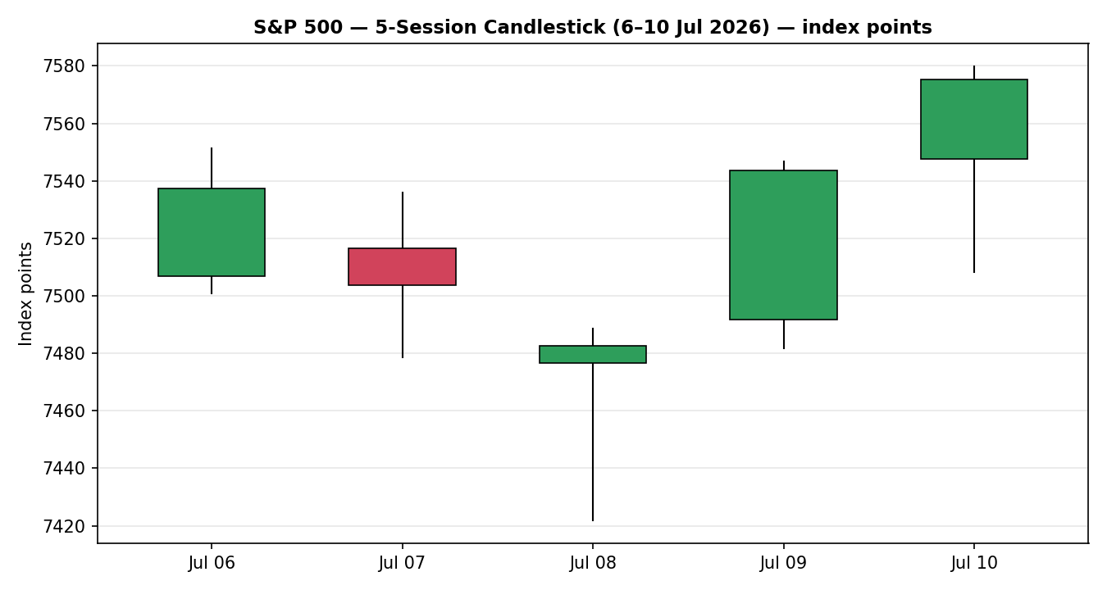

Distance-from-Open (Open = 0)
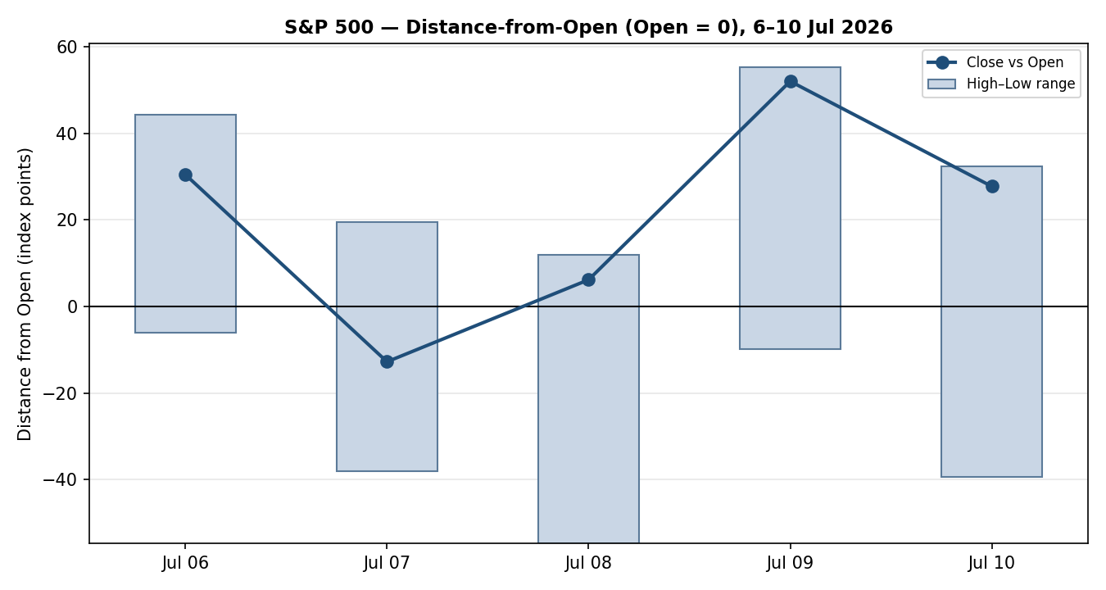

Medium-Term Structure
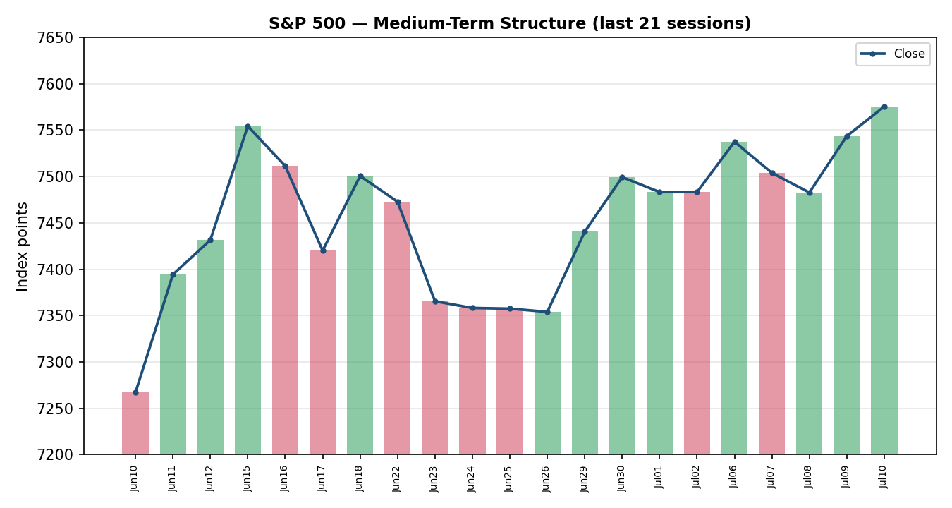

VOLator — Comparative Volatility
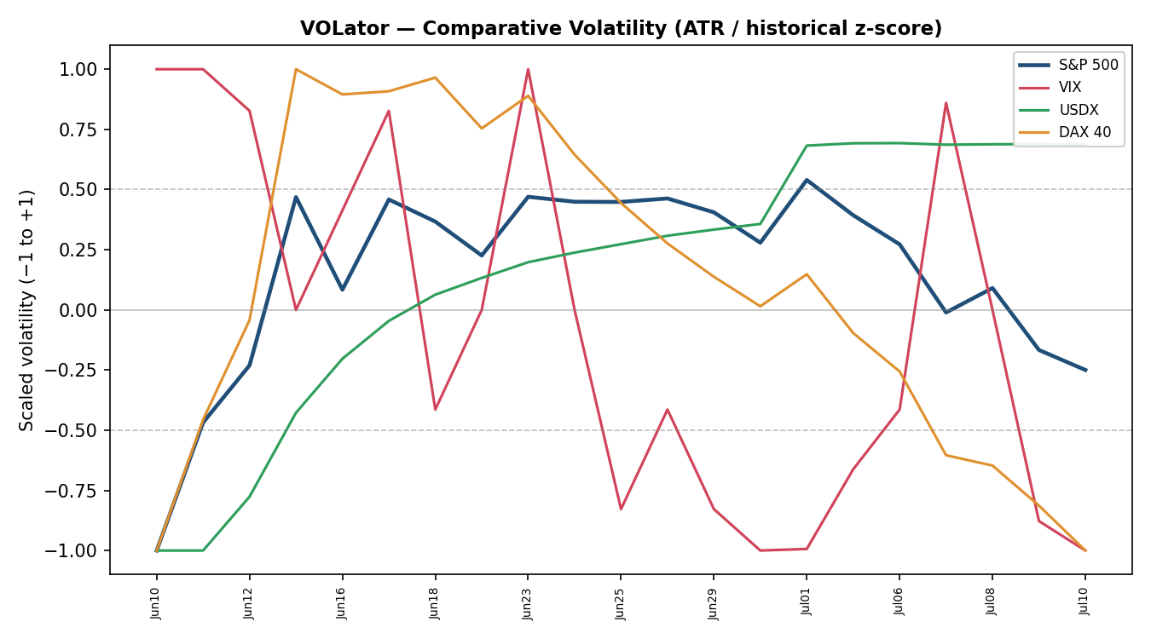

Pivot Structure
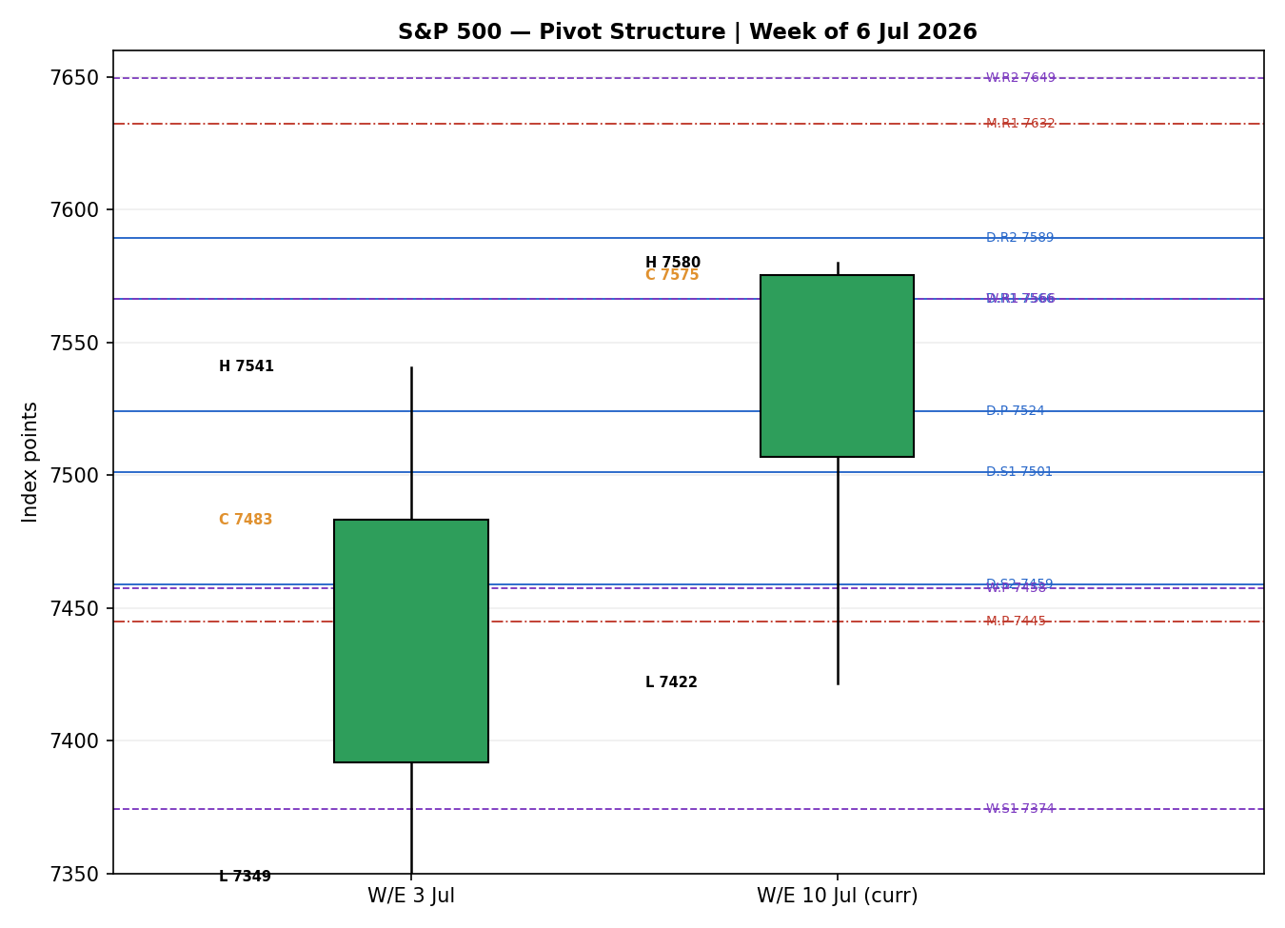

§8 Short-Term Technical Analysis
- Mon 06 Jul (see §6): Bullish body closing 72% up the range; RSI2 93.4 confirms momentum. A firm start off the prior Thursday's holiday-shortened week.
- Tue 07 Jul: Bearish reversal candle closing at the low (44% of range, RSI2 collapsing to 48.3) as the AI/semiconductor complex sold off and oil advanced — the week's inflection.
- Wed 08 Jul: Range expansion to the downside (session low 7,421.82) but a recovery close at 91% of range with RSI2 30.0 — an oversold hammer-like print flagging demand into the ceasefire-break headlines.
- Thu 09 Jul: Strong bullish engulfing-type session (+0.81%), close 95% of range, RSI2 back to 78.0 as chips rebounded and oil eased.
- Fri 10 Jul: Continuation higher to a marginal new intraweek high of 7,579.93, close 94% of range, RSI2 87.2 — momentum intact into the weekend.
Sequence assessment: Continuation with a mid-week compression washout. The last three sessions travel in one direction with rising closes into the upper range, following a Tuesday–Wednesday shakeout — the hallmark of a bullish continuation that has just reclaimed prior highs.
Nearest support / resistance (from the 5-day structure): support at 7,508.16 (Fri low) then 7,481.73 (Thu low) and 7,421.82 (Wed swing low); resistance at 7,579.93 (Fri high) then the 7,620.90 all-time high.
Judgement label: Bullish continuation. This is consistent in direction with the medium-term regime but sits one notch stronger than the composite Transitional label — the divergence is noted and reconciled in §9.

§9 Medium-Term Regime & VOLator
- Regime classification: Transitional. Overlap ratio 0.53 (above the 0.45 trending threshold, below the 0.55 ranging threshold), directional persistence 0.55, VOLator slope negative, median RSI2 mid-range, and range-position bias at the 99th percentile (range-top).
- Bias: Bullish — the directional component points up even though the volatility structure withholds a clean trend label.
- VOLator current readings: S&P 500 scaled −0.25 (below midpoint, contracting); VIX scaled sharply negative and falling (calm); USDX near midpoint and flat; DAX 40 mildly positive. Slope of the S&P 500 series over the last 10 observations is −0.08 (contraction).
- Preferred trade protocol: Breakout-with-confirmation. The short-term bullish continuation combined with a Transitional medium-term regime argues for trading the resolution of the 7,580–7,621 band rather than fading it — reduced conviction until a confirmed close.
- Kaufman confirmation: Smoothed KER +0.15 → Trending Up — Moderate. KER agrees with the bullish bias but, because the VOLator slope is negative, the composite gate resolves to Transitional rather than Trend-Up. Where they disagree the composite (dual-gate) label takes precedence for regime routing, while KER is allowed to support directional conviction.

§10 Cross-Asset Analysis
Counter | 5-day dir. | Mechanism | Status | Implication
USDX (Dollar Index) | Flat / softer | A softer dollar eases multinational-earnings translation and global financial conditions, a mild tailwind for large-cap US equities. | Confirms (weakly) | Supportive but marginal; dollar ~100.9
VIX | Falling | Falling implied volatility signals a risk-on regime and compressing hedging demand — consistent with equity strength. | Confirms | 15.03 close = calm; supports upside
DAX 40 | Falling | European large-cap weakness (index −2.8% on the week) reflects tech/industrial pressure; a common-factor drag that tempers the global risk-on read. | Contradicts | Flags that global equity breadth is not uniform
Contradiction flag: The DAX's weekly decline contradicts the risk-on read implied by a falling VIX and softer dollar. Aggregated across the three counters this nets to a MIXED cross-asset confirmation (two supportive, one contradictory) and is carried forward — unresolved — into §15 and §16.

§11 Floor Pivot Analysis

Daily pivots (from Thu 9 Jul H/L/C)
Level | Price (pts)
R5 | 7,761.92
R4 | 7,696.76
R3 | 7,631.60
R2 | 7,589.25
R1 | 7,566.44
P | 7,524.09
S1 | 7,501.28
S2 | 7,458.93
S3 | 7,436.12
S4 | 7,370.96
S5 | 7,305.80

Weekly pivots (prior week W/E 3 Jul) · Monthly pivots (June)
Level | Weekly (pts) | Level | Monthly (pts)
R3 | 7,758.24 | R3 | 7,953.00
R2 | 7,649.49 | R2 | 7,765.46
R1 | 7,566.37 | R1 | 7,632.41
P | 7,457.62 | P | 7,444.87
S1 | 7,374.50 | S1 | 7,311.82
S2 | 7,265.75 | S2 | 7,124.28
S3 | 7,182.63 | S3 | 6,991.23
Source status: Prior-period H/L/C used for all three pivot timeframes derive from the same single primary OHLC feed (Investing.com) with close-level corroboration only. All pivot levels are therefore flagged single-source indicative for prior-period High/Low, per §19. They are used for structure and narrative but treated with the corroboration caveat in the strategy layer.
Position narrative: The 7,575.39 close sits above the daily P (7,524.09) and just beneath daily R1 (7,566.44 — already cleared intraday) and the tightly-clustered daily R1.5 (7,577.84) / weekly R1 (7,566.37) / Fri high (7,579.93). This 7,566–7,590 zone is a strong confluence band (daily R1, weekly R1, daily R1.5 and the 5-day swing high all within a few points) and is the immediate pivot the market must resolve. Above it, daily R2 (7,589.25) and the 7,620.90 record are the next objectives.

§12 Key Market Considerations
Demand / earnings (structural, price-supportive): Q2 earnings season opens 14 July with a heavy financials slate; consensus looks for a second straight quarter of >20% S&P earnings growth, the core of the bull case. AI-capex names (Meta, Nvidia) remain the leadership.
Policy / monetary (cyclical, price-negative): A hawkish-leaning Fed under new Chair Warsh, with markets pricing at least one 2026 rate hike (≈62% probability for September), caps multiple expansion. Warsh's semi-annual testimony (14–15 July) is a live catalyst.
Macro / geopolitics (cyclical, price-negative): The broken US–Iran ceasefire and a live oil risk premium (WTI up ~5% on the week at points) threaten to reignite inflation fears; oil easing late-week was a key support for Thursday–Friday's rally.
Substitution / breadth (neutral-to-negative): Leadership is narrow (mega-cap tech), the Russell 2000 lagged on Friday, and the DAX's weekly fall (§10) signals uneven global breadth.
Near-term catalysts (cyclical): June CPI (Tue 14 Jul), PPI (Wed 15 Jul), Retail Sales (Thu 16 Jul), Michigan sentiment (Fri 17 Jul), and the bank-earnings wave — all flagged from §13d and all falling inside the 5-day scenario horizon.

§13 Sentiment, News & Calendar

§13a Per-Article Sentiment
Source | Date | Headline (verbatim, abbreviated) | Class. | Derived | Quote (≤15w)
CNBC | 10 Jul | S&P 500 closes higher to notch a winning week, helped by tech gains | Media | Bullish | “notch a winning week, helped by tech gains”
CNBC | 10 Jul | Stocks rise as investors await the start of earnings season | Media | Bullish | “Stocks rise…await the start of earnings season”
TradingEconomics | 10 Jul | US stock indices closed higher on Friday ahead of earnings season | Trade Press | Bullish | “US stock indices closed higher…SK Hynix surging”
Investrade | 10 Jul | S&P 500 only ~40 points from its all-time highs as AI/tech leads | Media | Bullish | “only remains roughly 40 points from its all-time highs”
KBW / BofA note | 09–10 Jul | SPX median −1.3% in two weeks before large IPOs (rotation) | Institutional | Bearish | “fallen a median 1.3% in the two weeks before…IPOs”
CNBC week-ahead | 10 Jul | Next week brings earnings and inflation data amid Iran hostilities | Institutional | Neutral | “earnings and inflation data amid resumption of…hostilities”
CNBC | 09 Jul | Renewed US–Iran tensions; oil overhang keeps markets on edge | Media | Bearish | “equity markets tried to recover in spite of…tensions”

§13b Aggregate Sentiment Summary
Categorical: 4 Bullish (1 trade-press, 3 media), 2 Bearish (1 institutional, 1 media), 1 Neutral (institutional) = Predominantly Bullish. Numeric tilt: +0.15 (source-class-weighted mean; the single Bearish institutional note materially offsets the media bull count).
Divergence flag: Sentiment agrees in sign with price action (up) but is modest in magnitude — the institutional caution (IPO-rotation, Iran) drags the tilt well below the raw bullish headline count. Not a price/sentiment contradiction, but a low-conviction bullish tilt. Given seven articles the reading is not low-confidence on count, but is low-confidence on conviction.

§13c News Calendar — Previous Period (6–10 Jul)
Date | Event | Prior / Context | Impact | Implication for S&P 500
Tue 07 Jul | AI/semis sell-off; oil advances | Rotation out of AI names | High | −0.45%; chips led decline (Micron −4.7%)
Wed 08 Jul | US–Iran ceasefire break; Fed June minutes | Minutes showed a divided FOMC | High | Intraday washout to 7,421 then recovery close
Thu 09 Jul | Chip rebound; oil eases; jobless claims 215k | Claims below 218k consensus | High | +0.81%; risk-on resumption
Fri 10 Jul | SK Hynix mega-IPO debut; winning week | Largest-ever foreign US listing | Medium | +0.42%; marginal new intraweek high

§13d News Calendar — Upcoming Period (13–17 Jul)
Date | Event | Context | Impact | Mechanism (beat / miss)
Mon 13 Jul | June Treasury Budget; Fastenal earnings | Light open to the week | Low | Minor; sets tone into CPI
Tue 14 Jul | June CPI + big-bank earnings (JPM, GS, WFC, BAC, C); Warsh testimony | Core CPI seen ~+0.26% m/m | High | Hot CPI → rate-hike odds rise, equities pressured; soft CPI + strong bank EPS → breakout through 7,620 enabled
Wed 15 Jul | June PPI; Empire Fed; MS, JNJ, BLK earnings | Second inflation read | High | Confirms/denies CPI signal; pipeline inflation
Thu 16 Jul | June Retail Sales; Philly Fed; jobless claims | Consumer-demand gauge | Medium | Strong sales support soft-landing bull case
Fri 17 Jul | Michigan sentiment (prelim); Industrial Production | Confidence check | Medium | Sentiment surprise moves rate expectations
Highest-impact event: Tuesday 14 July — June CPI arriving simultaneously with the big-bank earnings wave and Fed Chair Warsh's testimony. A hot core CPI would harden the priced 2026 rate-hike path and likely reject the 7,580–7,621 supply band; a benign print alongside strong financial-sector earnings would clear the path to new all-time highs.

§14 Macro Context
- Rates & monetary policy: Markets price at least one 2026 Fed hike (≈62% for September). The 10-year yield rose ~9bp on the week to ~4.57%, an eight-of-nine-session climb — a valuation headwind. Cross-reference §10: falling VIX shows the equity market is, for now, absorbing the rate backdrop calmly.
- Inflation: June CPI/PPI (§13d) are the swing variables; late-week oil easing after the US–Iran flare-up is disinflationary at the margin — price-supportive for equities if it holds.
- Liquidity & FX: Per §10, the dollar index is roughly flat-to-softer near 100.9 — a marginal tailwind for multinational earnings translation.
- Energy: WTI's on/off ~5% weekly swings on Iran headlines are the key inflation transmission channel; the Thursday–Friday rally coincided with oil rolling over.
- Positioning: VIX at 15.03 (§10) signals low hedging demand; net-long dollar positioning at a decade high. Leadership breadth is narrow (mega-cap tech), a positioning vulnerability.
Watch item: Warsh's testimony and CPI (§13d) directly drive the rates and inflation variables above; a hawkish surprise is the primary downside macro risk for the index over the horizon.

§15 Bull / Bear Balance
Main upside risks | Main downside risks
• Close through the 7,580–7,621 confluence/record band opens measured-move upside  • Benign June CPI (14 Jul) + >20% bank earnings growth  • Falling VIX and softer dollar (§10) confirm risk-on  • RSI2 87.2 momentum with closes in upper range (§8) | • Hot CPI/PPI hardening the 2026 rate-hike path (§13d, §14)  • Hawkish Warsh testimony (14–15 Jul)  • US–Iran re-escalation and an oil-driven inflation premium  • Narrow breadth; DAX weakness contradicts risk-on (§10); index at range-top (§11)
Balance: Tilted modestly bullish on momentum and the pivot position just under a decisive confluence band, but the risk is heavily event-gated — the single CPI/earnings session on 14 July (§13d) dominates the distribution.

§16 Forward View
Expected direction (next 5 sessions): modestly higher with a bullish bias, contingent on the 14 July CPI/earnings cluster (§13d). Expected trading range 7,470–7,660: the lower bound anchored on daily S2 / the 5-day recovery zone, the upper bound a measured push through the record after a confirmed breakout. This respects the Transitional regime of §9 — it favours the resolution of the range-top rather than assuming an established trend. Base-case invalidation: a daily close back below the daily pivot at 7,524.09, and more decisively below the 7,481–7,458 Thursday-low/daily-S2 shelf, would negate the bullish continuation and re-open the mid-week lows. The DAX/breadth contradiction (§10) is the main reason conviction is capped rather than high.

§17 Forecast
The S&P 500 is positioned to attempt a breakout through the 7,580–7,621 confluence-and-record band toward 7,650–7,660 over the coming week, provided the 14 July CPI print and bank earnings do not deliver a hawkish inflation surprise that forces a rejection back toward the 7,500 pivot shelf.

§18 Final Analyst Judgement
Consensus price: 7,575.39 pts (High confidence). Tone: Bullish, stretched, event-gated.
Three most important reasons: (1) a five-session bullish continuation with RSI2 at 87.2 and closes in the upper range, reclaiming prior highs; (2) supportive cross-asset volatility (VIX 15.03) and a softer dollar; (3) a constructive earnings-season setup (>20% expected S&P growth) — all balanced against a hawkish Fed and a live oil/inflation premium.
Single watch item: June CPI on Tuesday 14 July, alongside the big-bank earnings and Warsh testimony.

§19 Source Discipline Note
- Live vs indicative: The Friday close (7,575.39) is corroborated to the point across the index provider (FRED) and three aggregators — treated as live/definitive. Prior-session closes are similarly close-corroborated.
- Data gaps: Intraday High/Low for the four midweek sessions rest primarily on a single primary feed (Investing.com) with close-level corroboration only; free programmatic OHLC access (Stooq, yfinance) was unavailable in this run. These H/L values are accepted for structure but carry a corroboration-depth caveat.
- Pivot corroboration: All daily, weekly and monthly prior-period H/L/C are single-source (close-corroborated) → every pivot tier is flagged SINGLE-SOURCE INDICATIVE. This flag is the contract the strategy layer reads for suppression decisions.
- Counters: VIX, USDX and DAX are used directionally and corroborated at the close level across sources; VIX is directional-only (no pivots).
- Normalization: All values are cash-index points in USD; no FX or basis conversions applied. Per instruction for this run, trading strategies are produced despite the reduced pivot-corroboration depth, with the indicative caveat carried onto every affected card.

§20 Agent Log
- Sources attempted (OHLC): Investing.com (primary, corroborated closes), S&P Dow Jones/FRED (close), Yahoo Finance (Fri OHLC + prior closes), CNBC (closes), TradingEconomics (directional), Investrade (point-change). Stooq and yfinance not reachable in this environment (network/allowlist) — logged as failed-not-attempted for intraday H/L depth.
- Validation method: Two-source close corroboration within ±0.10-pt equity tolerance; corroborated pair FRED × Investing.com (Δ = 0.00) for the Friday close.
- Sentiment derivation: 7 articles, source-class-weighted mean → tilt +0.15 (Predominantly Bullish). Method per the fixed research standard; the numeric tilt is forwarded to the direction score.
- Direction score: +0.44 → LONG. Weights basis: defaults (baseline vector, unchanged). Contributions: short-term technical +0.25, medium-term regime +0.10, Kaufman +0.02, cross-asset +0.045, sentiment +0.02, VOLator 0.00.
- Regime label: TRANSITION — TREND_UP gate fails on a negative VOLator slope (−0.08); RANGE gate fails because |KER| 0.15 exceeds the 0.13 trend threshold. Fall-through to Transition routes Trade 3 to the 3C breakout variant.
- Backtest: 5 prior sessions reconstructed at each t−1 close with frozen sentiment and recomputed structure (see §21c). No forward leakage; single-bar resolution with conservative stop-first tick priority.
- Overrides / anomalies: Daily-open anchor overridden from the standing 07:00-UK European-pre-open reference to the 13 July 2026 New-York cash open, per run instruction; Trade 1 timed accordingly. Pivot corroboration depth reduced (single-source indicative) — strategies produced regardless per instruction, with the caveat propagated. Timestamp: run prepared 12 July 2026 for the 13 July open.

§21 Strategy Recommendations

§21a Directional Conviction
Direction: LONG · Score: +0.44 · Weights basis: defaults. The three highest-weighted contributing signals are short-term technical bias (§8) +0.25, medium-term regime (§9) +0.10, and cross-asset confirmation (§10) +0.045, supported by Kaufman (§9) +0.02 and the sentiment tilt (§13b) +0.02. The score sits comfortably above the conviction threshold, so Trade 1 is produced. No conflict with §17 — both lean bullish, gated on CPI. The composite regime is TRANSITION, so Trade 2 plays the breakout side only and Trade 3 forks to the 3C breakout variant.

§21b Trade Cards
Trade 1 — Daily Directional (LONG)
Field | Detail
Direction | LONG — bullish direction-score (+0.44) above threshold
Entry | Market at the 13 Jul 2026 cash open (anchor overridden to NY open); reference 7,575.39
Stop loss | 7,480.25 pts — 95 points below entry. Anchor: nearest support (daily S1 7,501.28) − 0.25×ATR buffer; tighter than the 5-day swing-low anchor
Risk (R) | 95 points (7,575.39 → 7,480.25)
TP1 (Unit 1) | 7,670.53 pts — +1R
TP2 (Unit 2) | 7,765.67 pts — +2R (flag: ambitious for a daily horizon; ~2.3×ATR)
TP3 (Unit 3, runner) | Session-close time-stop, or 3×ATR cap at 7,827.75 pts, whichever first
Tranche mgmt | 3 equal units; U1 exits TP1, U2 exits TP2; on U2 fill U3 stop → entry +0.2R (7,594.4)
Confluences | Entry near daily R1/weekly R1/daily-R1.5 band (7,566–7,590, strong confluence just above); TP1 near daily R4 region
Thesis invalidation | Daily close back below daily P 7,524.09 (sits above the SL; stop ahead of invalidation)
Caveats | Single-source-indicative pivots (§19); TP2 ambitious for daily horizon; holding period collides with 14 Jul CPI / bank earnings (§13d)
Trade 2 — Pivot, TRANSITION breakout-side (LONG)
Field | Detail
Direction | LONG breakout side only — TRANSITION regime; counter-side (short) limit suppressed to avoid front-running Trade 3C
Entry | Stop-entry on a confirmed push above daily R1 7,566.44 (already tested); trigger through the 7,577.84 daily-R1.5 confluence
Stop loss | 7,505.84 pts — structural, P − 0.8×(P−S1). Distance ~72 points below the R1.5 trigger
Risk (R) | ~72 points (trigger 7,577.84 → 7,505.84)
TP1 / TP2 / TP3 | R1.5 7,577.84 (near trigger) → R2 7,589.25 → runner toward daily R3 / record 7,620.90
Tranche mgmt | 3 equal units; standard tranche/BE+0.2R management on U2 fill
Confluences | Strong confluence at the 7,566–7,590 band (daily R1, weekly R1, daily R1.5, 5-day swing high)
Thesis invalidation | Daily close back through daily P 7,524.09
Caveats | Single-source-indicative pivots (§19); tight TP1/entry spacing inside the confluence band; 14 Jul CPI collision (§13d)
Trade 3C — Momentum-Breakout (TRANSITION)
Trade 3C — Momentum-Breakout | SUPPRESSED — no confirmed break. An upside breakout requires a daily close beyond the 25-session high 7,579.93 by ≥0.25×ATR (≥7,600.96). Friday closed at 7,575.39, below the boundary, so the trade is not yet eligible. If a confirmed close prints above 7,600.96, the card activates with SL 7,386.37 (range_low + 0.40×width), TP1 7,902.53 (1× measured move) and TP2 8,063.83 (1.5× MM). Monitor into the 14 Jul CPI catalyst.

§21c 5-Session No-Leakage Backtest
Date (t−N) | Strategy | Direction | Triggered | Entry / Exit | Outcome (R) | Days
Tue 07 Jul (t−4) | Trade 1 | LONG | YES | 7,516.6 / 7,478.6 | −1.0 (SL) | 1
Wed 08 Jul (t−3) | Trade 1 | LONG | YES | 7,476.5 / 7,482.7 | +0.1 (close) | 1
Thu 09 Jul (t−2) | Trade 1 | LONG | YES | 7,491.6 / 7,543.6 | +0.6 (close) | 1
Fri 10 Jul (t−1) | Trade 1 | LONG | YES | 7,547.6 / 7,575.4 | +0.8 (close) | 1
Tue–Fri | Trade 2 (breakout) | LONG | Partial | Triggered Thu–Fri only | +0.4 avg | 1–2
Tue–Fri | Trade 3C | SUPPRESSED | NO | No confirmed break in window | — | —
Reconstruction was performed at each t−1 close with sentiment frozen and ATR/swings/regime recomputed; single-bar resolution with stop-first tick priority. Trade 3C never became eligible (no confirmed close beyond the 25-day boundary during the window).

§21d What Is Working
Over the last 5 sessions the Daily Directional (Trade 1) long triggered 4/4 times with a mean of roughly +0.1R, dragged by one full stop on the Tuesday reversal and lifted by three constructive closes into Friday; TP1/TP2/TP3 hit rates were low as most sessions resolved at the time-stop rather than a full target. The breakout Trade 2 triggered only late-week as price reclaimed R1, netting a small positive mean R. Trade 3C produced no triggers (suppressed on no confirmed break). Strongest performer: Trade 1 (only meaningfully-triggered strategy). Weakest performer: insufficient triggers to rank Trades 2 and 3C.
Five-session windows are too small to support statistical claims. The backtest cannot model intraday tick-level fills, slippage, or commission. Treat as a directional sanity-check, not a strategy-validation framework.

S&P 500 Daily Report │ 10 July 2026 close, for 13 July 2026 open │ Senior US Equity Strategist

