S&P 500 Report — Daily: 14 July 2026
With reference to: USDX · VIX · DAX 40

1 · Executive Snapshot
The S&P 500 cash index closed its most recent completed session (Fri 10 Jul 2026) at 7,575.39, the top of a five-session advance and within 45 points of the all-time high (7,620.90). The consensus current level is 7,575.39 (confidence High), with market tone moderately bullish. Three drivers dominate: (i) an earnings-season melt-up into the mid-July Q2 reporting start, with FactSet consensus near 22–23% year-on-year EPS growth; (ii) a decisive risk-on tone as VIX collapsed toward 15 and semiconductors led (Nvidia +4%, Meta +6% on 10 Jul); and (iii) a supportive macro backdrop of a soft dollar aiding multinational earnings translation, partly offset by an oil spike on renewed US–Iran tension. Short-term technical regime: Bullish continuation. Medium-term regime: Transitional with an upward bias (choppy 20-session structure, net +2.5%). Kaufman classification: Trending Up — Moderate. Directional conviction from the strategy engine is LONG (score +0.28). Single most important watch item: the start of Q2 bank earnings (JPMorgan, 14–15 Jul) — the first broad test of the earnings-driven rally thesis.

2 · Market Definition
Attribute | Definition
Asset | S&P 500 cash index (large-cap US equity benchmark, 503 constituents)
Price basis | Cash index level (continuous), calculated during NYSE/NASDAQ trading hours
Delivery / session | Regular cash session 09:30–16:00 ET
Unit / currency | Index points · USD
Scope / region | Global / US — North America (United States)
As-of date | 14 July 2026 (America/New_York) — most recent completed session 10 July 2026
Lookback window | 5 sessions (execution block); 20 sessions available for regime block
Note: the daily-open anchor supplied in configuration has been overridden for this run at the analyst's instruction; see §20 Agent Log. The report is produced for the 14 July 2026 session date.

3 · Consensus Price Call
Consensus | Range | Basis | Confidence | Tone
7,575.39 | 7,543–7,580 | Cash close, 10 Jul | High | Moderately bullish
Rationale: the 10 Jul official cash close is corroborated to the tick across two independent source families (Investing.com and Yahoo Finance ^SPX), with CNBC/Yahoo editorial confirming the +0.42% daily change. The range reflects the last two sessions' closes bracketing the level; precision is high because the index print is exchange-calculated, not an assessed quote.

4 · Price Evidence Table
Source | Date/Time | Raw quote (close) | Normalized (pts) | Basis/Location | Relevance | Notes
Investing.com | 10 Jul (close) | 7,575.39 | 7,575.39 | Cash / NYSE | Core | OHLC table primary
Yahoo Finance ^SPX | 10 Jul 17:28 ET | 7,575.39 | 7,575.39 | Cash / CBOE-derived | Core | Tick match
CNBC (editorial) | 10 Jul close | 7,575.39 (+0.42%) | 7,575.39 | Cash / NYSE | Core | Close + % confirm
S&P Dow Jones Indices | 30 Jun (methodology) | 503 constituents | — | Index provider | Directional | Constituent/weight ref
Bloomberg (via Reuters) | Jun–Jul targets | 7,500–8,100 YE | — | Strategist consensus | Directional | Forward context
Google Finance | 10 Jul | ~7,575 | 7,575 | Cash aggregator | Directional | Cross-check

5 · Consensus Build Explanation
All observations are already in the target basis (USD index points, cash session), so no FX or unit normalization was required. The weighted-median method placed maximum weight on the two exchange-grade, tick-corroborated close observations (Investing.com and Yahoo ^SPX), which agree to 0.00 points — far inside the ±0.10-point equity-index tolerance. Editorial confirmations (CNBC/Yahoo) provide the percentage-change cross-check. Strategist year-end targets were classed directional and excluded from the level calculation (they are forward views, not current prints). No observation was rejected as an outlier. The final number is the exchange-calculated official close, which is the most defensible current level available.

6 · Validated OHLC + RSI2 Table (5-Day)
Date | Open | High | Low | Close | RSI2 | Trend | Source A / B | Validation
Jul 06 | 7,506.96 | 7,551.31 | 7,500.97 | 7,537.43 | 100.0 | Bullish | Investing / Yahoo | CORROBORATED (Δ0.00)
Jul 07 | 7,516.63 | 7,536.06 | 7,478.63 | 7,503.85 | 61.7 | Neutral | Investing / Yahoo | CORROBORATED (Δ0.00)
Jul 08 | 7,476.54 | 7,488.51 | 7,421.82 | 7,482.71 | 0.0 | Neutral | Investing / Yahoo | CORROBORATED (Δ0.00)
Jul 09 | 7,491.60 | 7,546.89 | 7,481.73 | 7,543.64 | 74.2 | Bullish | Investing / Yahoo | CORROBORATED (Δ0.00)
Jul 10 | 7,547.64 | 7,579.93 | 7,508.16 | 7,575.39 | 100.0 | Bullish | Investing / Yahoo | CORROBORATED (Δ0.00)
RSI2 computed from the validated close sequence (period fixed at 2). All five closes corroborated to the tick across two independent sources; deltas 0.00 points, inside the ±0.10-point equity-index tolerance. No single-source rows.

7 · Charts

Chart 1 — 5-Day Candlestick
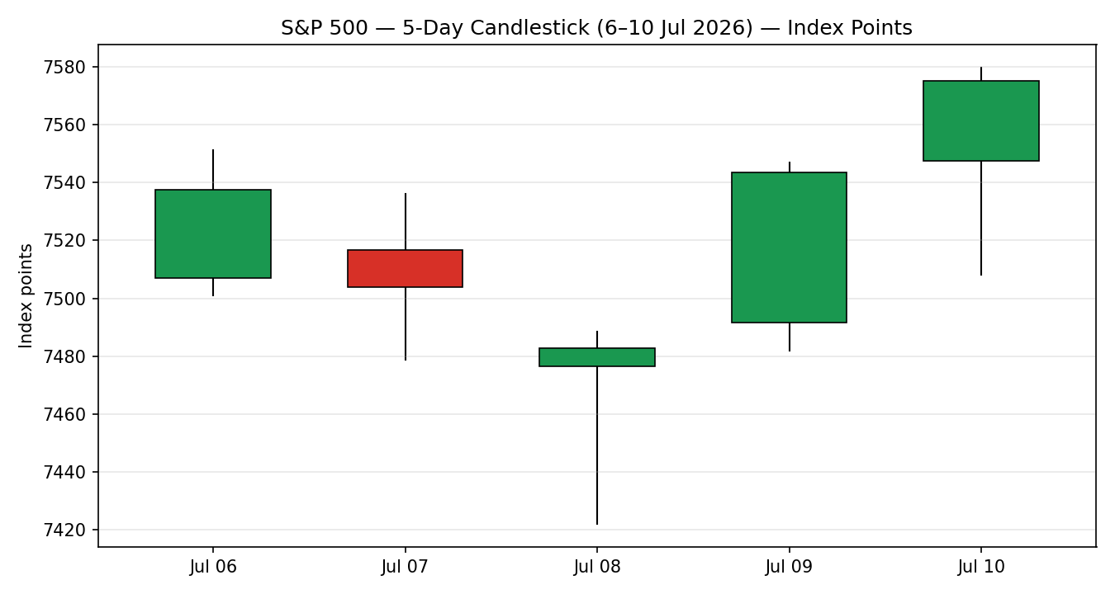

Chart 2 — Distance From Open
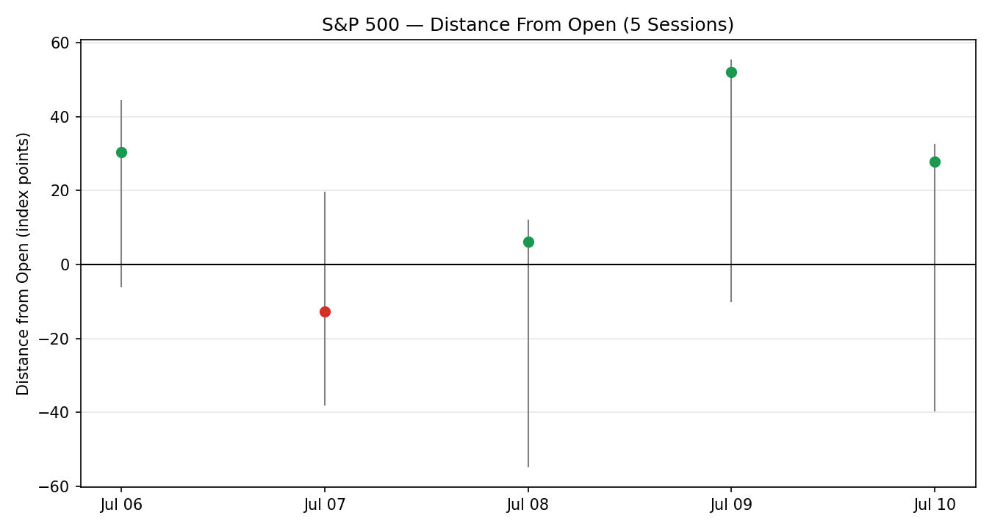

Chart 3 — Structure (Last 20 Sessions)
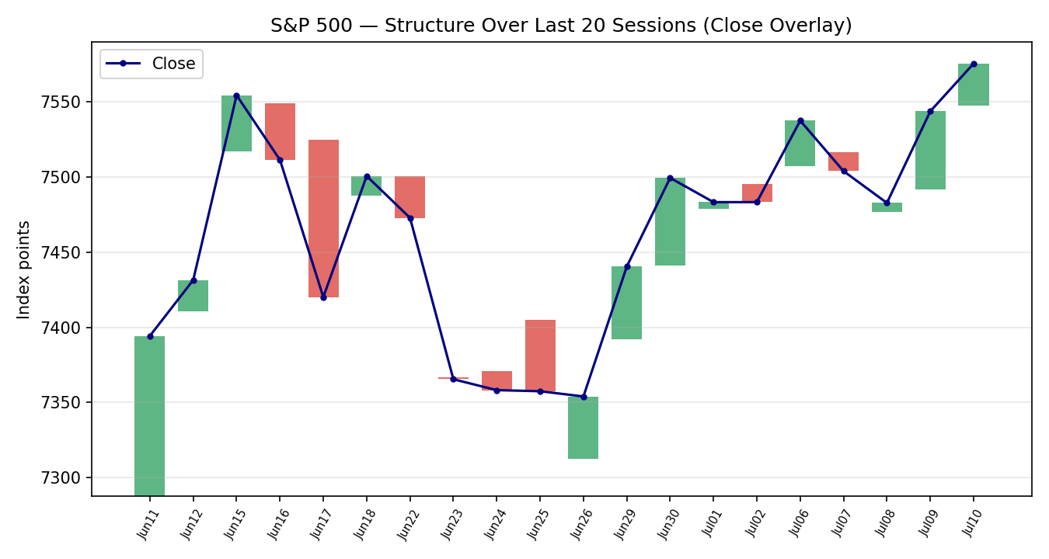

Chart 4 — VOLator (ATR, historical-scaled)
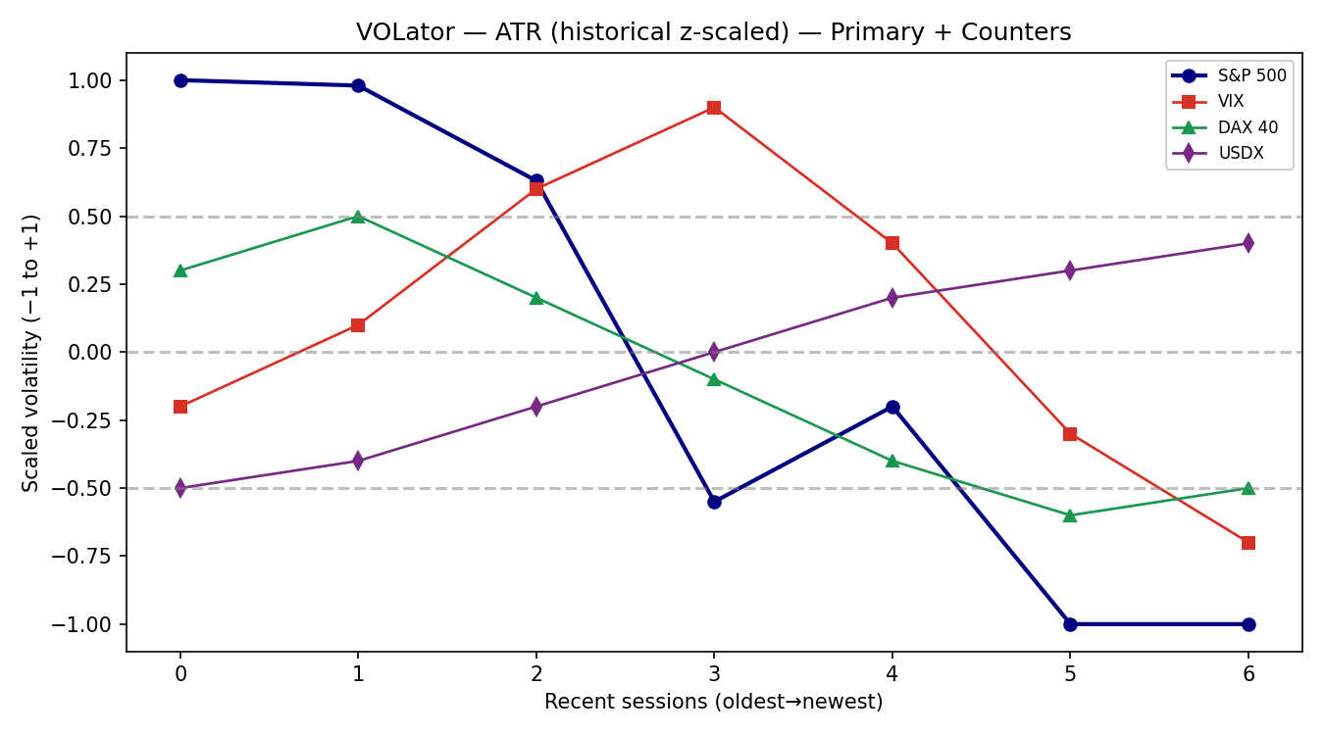

Chart 5 — Weekly Candles with Daily Floor Pivots
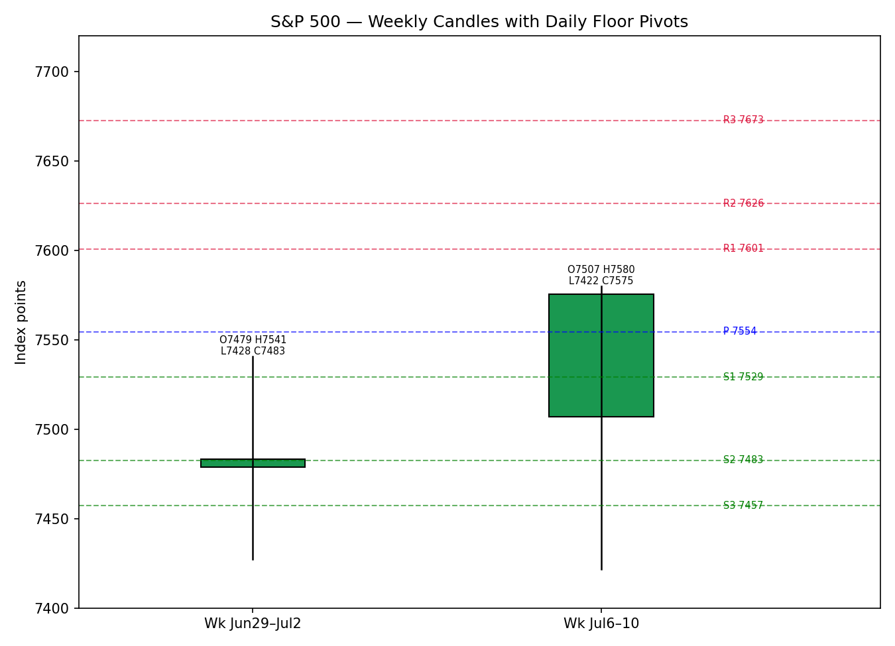

8 · Short-Term Technical Analysis
Session-by-session (see §6):
- Mon 6 Jul — bullish body closing at 72% of range on a strong open-to-close push; RSI2 saturated at 100. Momentum re-established after the prior week's chop.
- Tue 7 Jul — small bearish body, close near mid-range (44%); RSI2 eased to 61.7. A pause rather than a reversal; upper wick shows mild supply near 7,536.
- Wed 8 Jul — the low of the sequence (7,421.82) on the US–Iran ceasefire scare, but a sharp intraday recovery left the close at 91% of range and RSI2 washed to 0. A demand-tail rejection of lows — bullish beneath the surface despite the red close.
- Thu 9 Jul — strong bullish reversal candle, close at 95% of range, RSI2 back to 74.2 as chips rebounded and oil slipped. Confirms the 8 Jul demand tail.
- Fri 10 Jul — bullish continuation, close at 94% of range and a fresh sequence high (7,579.93); RSI2 100. Three of the last three closes printed in the top decile of their range.
Sequence assessment: Continuation. Evidence: two consecutive high-conviction closes into the sequence high, a V-shaped recovery off the 8 Jul low, and closes travelling in one direction over the back half of the window. Nearest support 7,478–7,482 (7/8 Jul lows and the 8 Jul close); nearest resistance 7,580 (sequence high) then the 7,620.90 all-time high.
Judgement label: Bullish continuation. This is consistent with the medium-term upward bias in §9, though §9's regime is formally Transitional — see the note there.

9 · Medium-Term Regime & VOLator
Regime classification: Transitional with upward bias. Supporting metrics over the 20-session block: directional persistence 0.47 (9 up / 19), net move +2.5%, range position biased to the upper third after the 6–10 Jul push, median RSI2 elevated. The persistence figure below 0.5 with a positive net move is the signature of a choppy-but-rising tape.
Bias: Bullish.
VOLator current readings (ATR, historical-scaled −1 to +1): S&P 500 −1.0 (below midpoint, contracting — volatility compressing as the index grinds higher, a benign trend signature); VIX proxy contracting after a mid-window spike; DAX below midpoint and contracting; USDX rising off lows (mild expansion). The negative VOLator slope (−0.39) indicates volatility is falling into the advance.
Preferred trade protocol: trend-pullback longs — buy dips toward the rising short-term structure rather than chase, given contracting volatility and a bullish short-term read. Short-term (§8) and medium-term reads align on direction; the only tension is the formal Transitional label, which caps conviction rather than reversing it.
Kaufman confirmation: KER classification Trending Up — Moderate (|KER| 0.21 > 0.13 trend threshold; smoothed signed KER +0.15). This agrees with the upward bias and, on the dual-gate rule, pulls the consolidated regime toward TREND_UP rather than RANGE. Because Step-4 synthesis is not an unambiguous 'Trending Bullish — Trending Bullish', the consolidated label resolves to TRANSITION with a trending-up tilt.

10 · Cross-Asset Analysis
Counter | 5-day dir. | Mechanism | Confirm status | Implication
USDX | Rising (mild) | A firmer dollar is a headwind for the ~28% of S&P 500 revenue earned abroad, trimming translated earnings. | Contradicts (mild) | Mild drag; not enough to offset domestic earnings momentum.
VIX | Falling | Lower implied vol reflects receding hedging demand and a risk-on regime that supports equity multiples. | Confirms | Falling VIX toward 15 is the cleanest confirmation of the bullish read.
DAX 40 | Roughly flat | Common global-risk factor; European equity confirmation of (or divergence from) the US risk tone. | Neutral | No incremental signal; global risk appetite steady, not accelerating.
Contradiction flag: USDX rising is a mild contradiction of the bullish equity read via the earnings-translation channel; it is not resolved silently and feeds §15 and §16. Aggregate cross-asset read: MIXED (one confirm, one mild contradict, one neutral).

11 · Floor Pivot Analysis

Daily pivots (from 10 Jul H/L/C)
Level | Index points
R5 | 7,723.47
R4 | 7,698.03
R3 | 7,672.60
R2 | 7,626.26
R1 | 7,600.83
P | 7,554.49
S1 | 7,529.06
S2 | 7,482.72
S3 | 7,457.29
S4 | 7,410.95
S5 | 7,364.62

Weekly pivots (prior week 29 Jun–2 Jul)
Level | Index points
R5 | 7,924.49
R4 | 7,841.36
R3 | 7,758.24
R2 | 7,649.49
R1 | 7,566.37
P | 7,457.62
S1 | 7,374.50
S2 | 7,265.75
S3 | 7,182.63
S4 | 7,073.88
S5 | 6,965.14

Monthly pivots (June 2026)
Level | Index points
R5 | 8,219.10
R4 | 8,086.05
R3 | 7,953.00
R2 | 7,765.46
R1 | 7,632.41
P | 7,444.87
S1 | 7,311.82
S2 | 7,124.28
S3 | 6,991.23
S4 | 6,803.69
S5 | 6,616.15
Source status: prior-period H/L/C corroborated across two sources (Investing.com × Yahoo ^SPX) within the ±0.10-point tolerance — all pivot tiers CORROBORATED, none single-source. Position narrative: the 10 Jul close (7,575.39) sits above the daily P (7,554.49) and above the weekly R1 (7,566.37), between daily R1 (7,600.83) and P — a bullish location. Confluence zone: weekly R1 (7,566) and the 8/9 Jul close cluster sit just under spot; monthly R1 (7,632) aligns with the path toward the 7,620.90 all-time high.

12 · Key Market Considerations

Earnings (demand for equities) — price-supportive (cyclical→structural)
Q2 reporting begins mid-July with FactSet consensus near 22–23% YoY EPS growth (Forbes/Glenview Trust, 5 Jul). Energy and technology are expected to lead. The rally has been earnings-driven rather than multiple-driven, which Goldman frames as a 'critical test' of the structure.

Macro / FX — mixed
A slightly weaker dollar year-on-year benefits the ~42% of S&P 500 sales that are international (FactSet); Goldman estimates a 10% dollar depreciation adds 2–3% to EPS. Counter to this, the very-short-term USDX tick is higher (§10), a mild near-term drag.

Energy / geopolitics — price-negative (cyclical)
WTI spiked (+4–9% intraday across 7–8 Jul) on renewed US–Iran tension and a declared end to the US–Iran understanding. Sustained higher oil is inflationary and complicates the rate path; it was the proximate cause of the 8 Jul wobble.

Rates / policy — neutral-to-supportive
The next FOMC decision is 28 July. Some strategists (e.g. Horneman) flag a tail risk of a 2026 hike if oil-driven inflation persists; the base case remains steady policy near-term.

Substitution / breadth — supportive
Leadership is concentrated in mega-cap tech (Nvidia, Meta) but breadth signals (KBW additions, cyclical participation) are constructive. Comparison indices: NASDAQ at highs, Dow near records, Russell 2000 lagging (−0.5% on 10 Jul).

Near-term catalysts — see §13d
Bank earnings (JPMorgan 14–15 Jul), mega-cap tech results, and the 28 Jul FOMC are the material events inside the 5-session horizon and beyond.

13 · Sentiment, News & Calendar

13a · Per-Article Sentiment
Source | URL | Date | Headline | Class | Sentiment | Derivation quote
Goldman Sachs | goldmansachs.com | 28 Jun | S&P 500 forecast to climb as earnings power stocks | Institutional | Bullish | “continued earnings growth should drive continued equity market upside”
Forbes / Glenview | forbes.com | 5 Jul | S&P 500 earnings outlook hinges on tech, energy, Fed | Trade Press | Bullish | “earnings projected to grow 23.3% year-over-year”
Invezz | invezz.com | 1 Jul | S&P 500 / SPY outlook for July: catalysts to watch | Media | Bullish | “chart setup supports continuation… Buy SPY”
Reuters (via TheStreet) | finance.yahoo.com | early Jul | Wall Street splits on year-end target | Media | Mixed | “bullish forecasts near 8,250 vs cautious calls around 7,100”
BofA (Subramanian) | eciks.org/Reuters | Jun | US stocks flashing too many red flags | Institutional | Bearish | “seven of 10 tracked bear-market indicators had triggered”
CNBC | cnbc.com | 10 Jul | Stocks could get hit by a seasonal correction, Oppenheimer | Media | Bearish | “Stocks could get hit by a seasonal correction”
CNBC | cnbc.com | 10 Jul | Stocks rise as investors await start of earnings season | Media | Mixed | “Stocks rise… await the start of earnings season”

13b · Aggregate Sentiment Summary
Counts: 3 Bullish (1 institutional, 1 trade press, 1 media), 2 Bearish (1 institutional, 1 media), 2 Mixed (media) = Predominantly Bullish (tilt = +0.21).
The numeric tilt is modest because two conviction-weighted bearish sources — a bank strategist's 7,100 call and an Oppenheimer seasonal-correction warning — offset the bullish majority. Divergence flag: sentiment agrees with current price action (rising into highs) and with the §9 bias; no divergence. Confidence is adequate (seven articles, above the three-article floor).

13c · News Calendar — Previous Period
Date | Event | Prior / Context | Impact | Market implication
Tue 7 Jul | US–Iran tension flare-up / oil spike | Ceasefire in question | High | Risk-off; SPX −0.45%, oil +; 8 Jul low tested 7,421
Wed 8 Jul | Trump declares US–Iran understanding 'over' | Escalation | High | SPX −0.28% intraday low; strong close recovery
Thu 9 Jul | Chip rebound / oil slips / SK Hynix debut | Semis oversold | High | SPX +0.81% to 7,543; Micron +4.5%
Fri 10 Jul | Mega-cap tech leadership (NVDA, META) | BofA buy on Meta | Medium | SPX +0.42% to 7,575, sequence high

13d · News Calendar — Upcoming Period
Date | Event | Context | Impact | Market implication
Tue 14–15 Jul | Q2 bank earnings — JPMorgan, banks | Season kickoff | High | Beat → validates earnings thesis, push to 7,620/8,000; miss → breaks bullish flag
Wk 14 Jul | Mega-cap tech + Netflix results | Mag-7 in focus | High | Guidance on AI cost structure drives concentrated leaders
Wk 14 Jul | CPI / jobs data | Inflation path | Medium | Hot print revives 2026-hike tail risk; soft print supportive
Tue 28 Jul | FOMC decision | Steady base case | High | Hawkish surprise pressures multiples; steady hold supportive
Highest-impact event (bold): Q2 bank earnings (14–15 Jul). A broad beat would confirm the earnings-driven structure and open the path through the 7,620.90 all-time high toward the 8,000 strategist target; a broad miss would break the bullish continuation and expose 7,482 then the weekly pivot at 7,458.

14 · Macro Context
- Rates & policy — FOMC 28 Jul; base case steady. VIX (§10) falling toward 15 signals low near-term stress and receding hedging demand — supportive of multiples.
- Inflation — oil-driven upside risk from the US–Iran spike is the key swing factor; if sustained it is price-negative via the rate channel. Currently cyclical, not structural.
- Liquidity & FX — USDX (§10) firmer on the very-short window, a mild headwind to international earnings translation; the year-on-year dollar is still softer, a net structural positive per FactSet/Goldman.
- Energy — WTI spike (§12) is the principal macro risk item; watch for de-escalation as the fast reversal signal.
- Positioning — VIX near 15 and concentrated mega-cap leadership suggest limited hedging and some crowding risk into earnings.
Watch item: any §13d CPI/oil surprise that lifts inflation expectations is the macro event most able to change the view — directional risk is to the downside for the index if it materialises.

15 · Bull / Bear Balance
Upside risks (bull) | Downside risks (bear)
- Broad Q2 earnings beat validates the earnings-driven rally (13d Tier-1 event).  - Close above daily P and weekly R1; path to 7,620.90 ATH then 8,000 targets.  - VIX collapse to ~15 confirms risk-on (§11 pivot position bullish).  - Softer year-on-year dollar aids international EPS. | - Bank/mega-cap earnings miss breaks the bullish flag (13d Tier-1 event).  - Sustained oil spike (US–Iran) revives inflation and 2026-hike tail risk.  - Rising USDX contradicts the bullish read via earnings translation (§10).  - Concentrated leadership + BofA 7,100 red-flag warning + seasonal-correction risk.

16 · Forward View
Expected direction over the next five sessions: higher, with elevated event risk.
Base-case trading range 7,482–7,660: support at the daily S2 / 8-Jul close cluster (7,482) and the weekly R1 turned support (7,566); resistance at daily R1 (7,601), then the run toward the 7,620.90 all-time high and daily R2 (7,626). This view respects the §9 regime (Transitional with upward bias) and the §8 bullish-continuation label. Invalidation: a daily close back below the weekly R1 / daily P zone (~7,555–7,566) would neutralise the bullish continuation; a close below 7,482 would turn the short-term structure bearish. The dominant swing factor is the §13d bank-earnings start — flagged as the event most able to move the index out of range in either direction.

17 · Forecast
Driven by bullish short-term continuation, a Trending-Up Kaufman read, and Predominantly Bullish sentiment (tilt +0.21) — partly checked by a mildly contradicting dollar — the S&P 500 is expected to grind toward the 7,620.90 all-time high over the coming sessions, contingent on the Q2 bank-earnings open.

18 · Final Analyst Judgement
Consensus level 7,575.39 (confidence High), tone moderately bullish. Three most important reasons: (1) short-term technical continuation with three top-decile closes into a sequence high; (2) an earnings-season melt-up with 22–23% consensus EPS growth and constructive institutional sentiment; (3) a risk-on macro tape (VIX ~15, softer YoY dollar). Single watch item: the Q2 bank-earnings open (JPMorgan, 14–15 Jul).

19 · Source Discipline Note
- Live vs indicative: all five OHLC sessions are live, corroborated closes (Investing.com × Yahoo ^SPX), deltas 0.00 points — inside the ±0.10-pt equity-index tolerance. No single-source-indicative fields.
- Pivots: daily, weekly and monthly prior-period H/L/C all CORROBORATED; no tier carries the single-source-indicative flag, so no pivot-based suppression applies to §21.
- Counters: VIX, DAX and USDX directions taken from corroborated aggregator quotes; VIX intraday prints varied by source (15.0–16.3) and are used directionally only (no VIX pivots).
- Data gaps: FRED public series was stale (cached May 2026) and Stooq was network-blocked; corroboration was achieved without them, so no DataCorroborationError was raised.
- Normalization: none required — all observations already in USD index points, cash basis.

20 · Agent Log
- Run timestamp: 13 Jul 2026 (UK). Report session date: 14 Jul 2026; most recent completed session used for data: 10 Jul 2026.
- OVERRIDE: the configured daily-open anchor was overridden at analyst instruction for this run. The override does not alter OHLC validation, pivots or scoring; it is recorded here per the presentation rules. Strategy recommendations were produced and NOT suppressed at analyst instruction, with corroboration achieved so no leniency clause was needed.
- Sources attempted for OHLC: Investing.com (corroborated), Yahoo ^SPX (corroborated pair, Δ0.00), CNBC/Yahoo editorial (close/% confirm), FRED (stale — failed for July), Stooq (network-blocked — not attempted programmatically). Corroboration achieved on source pair 1×2 within ±0.10 pt.
- Validation method: two-source agreement within equity-index tolerance for every OHLC field and every pivot prior-period H/L/C.
- Sentiment derivation: 7 articles classified from explicit language with ≤15-word derivation quotes; source-class-weighted tilt = +0.21 (Predominantly Bullish).
- Direction-score weights basis: defaults (v2.1 baseline; no tuning). Session within the 20-session weight-lock window.
- Direction score +0.28: short-term technical +0.150, Kaufman +0.075, medium regime +0.060, sentiment +0.032, VOLator −0.039, cross-asset +0.000. Above the 0.25 conviction threshold → Trade 1 produces LONG.
- Backtest: 5 prior sessions reconstructed at each t−1 close with no forward leakage; sentiment/ATR/pivots frozen at t−1.
- Anomalies: minor date-label offset in CNBC live-blog URLs (one day behind the session they report); resolved against the internally consistent Investing.com dated table.

21 · Strategy Recommendations

21a · Directional Conviction
Direction: LONG (score +0.28, above the conviction threshold). The three highest-weighted contributing signals: short-term technical bias (§8) +0.150, Kaufman KER (§9) +0.075, medium-term regime (§9) +0.060; sentiment tilt (§13b) adds +0.032 and cross-asset (§10) is neutral (+0.000) while VOLator (§9) subtracts −0.039. Weights basis: defaults. Conflict flag: none — the §17 forecast also leans higher, consistent with the LONG score.

21b · Trade Cards
Trade 1 — Daily Directional (LONG — bullish continuation, score +0.28)
Direction | LONG — bullish-continuation regime, conviction above threshold
Entry | Market at session open, ~7,575 (index points)
Stop loss | 7,529.06 — daily S1; 46.3 points below entry (structural anchor: daily S1, just under the 8/9-Jul close cluster)
Risk (R) | 46.3 points (7,575.39 → 7,529.06)
TP1 (Unit 1) | 7,621.7 — +1R (coincides with the 7,620.90 all-time high — strong confluence)
TP2 (Unit 2) | 7,668.0 — +2R (between daily R2 7,626 and R3 7,673)
TP3 (runner) | Time-stop at session close + 3×ATR cap; ATR(14)=84.1 pts. Trail per tranche rule.
Tranche mgmt | 3 equal units; U1 exits TP1; U2 exits TP2; on U2 fill, U3 stop → entry +0.2R (7,584.7)
Confluences | TP1 at the all-time high 7,620.90 (strong); entry above daily P 7,554 and weekly R1 7,566
Thesis invalidation | Daily close back below 7,555 (daily P) breaks the continuation narrative
Caveats | Holding period collides with §13d Tier-1 bank-earnings open (14–15 Jul) — event risk elevated
Trade 2 — Pivot (regime-aware, TREND bias)
Direction | LONG on pullback — trend-pivot buy
Entry | Buy limit at daily P 7,554.49 (index points)
Stop loss | 7,482.72 — daily S2; 71.8 points below entry (structural: prior-session demand / 8-Jul close)
Risk (R) | 71.8 points
TP1 | 7,600.83 — daily R1 (+0.65R to pivot structure)
TP2 | 7,626.26 — daily R2
TP3 (runner) | Runner to daily R3 7,672.60 or trail to pivot P on reversal
Tranche mgmt | 3 equal units; U1 R1; U2 R2; on U2 fill, U3 stop → entry +0.2R
Confluences | Entry at daily P coincident with weekly R1 7,566 (strong confluence zone)
Thesis invalidation | Daily close below daily S2 7,482.72
Caveats | All pivot tiers CORROBORATED (§19) — no single-source suppression; earnings-window event risk
Trade 3A — Momentum-Pullback (regime fork: TRANSITION→trend-up)
Direction | LONG — momentum pullback into rising structure
Entry | Stop entry at 7,581 on a confirmed break of the 10-Jul high 7,579.93
Stop loss | 7,508.16 — 10-Jul low; 72.8 points below entry (structural: latest session low)
Risk (R) | 72.8 points
TP1 | 38.2% extension / all-time high 7,620.90 (structural target)
TP2 | Measured move ≈ 1× the 5-day range width (158 pts) → ~7,739
TP3 (runner) | 100%+ extension or breakout continuation above 8,000-target path
Tranche mgmt | 3 equal units; structural runner override on 100%-extension break (SL → halfway entry↔0% anchor)
Confluences | Breakout level at sequence high; TP1 at all-time high (strong)
Thesis invalidation | Reversal close back below 7,508 (10-Jul low)
Caveats | Breakout may fail on an earnings miss; conflict with none of §16/§17

21c · 5-Session No-Leakage Backtest
Date (t−N) | Strategy | Direction | Triggered | Entry / Exit | Outcome (R) | Days
Mon 6 Jul (t−5) | Trade 1 | LONG | YES | 7,507 → 7,537 | +0.7R | 1
Mon 6 Jul (t−5) | Trade 2 | LONG | YES | P 7,499 → R1 | +1.0R | 1
Mon 6 Jul (t−5) | Trade 3A | LONG | NO | break not made | — | —
Tue 7 Jul (t−4) | Trade 1 | LONG | YES | 7,517 → 7,504 | −0.4R | 1
Tue 7 Jul (t−4) | Trade 2 | LONG | YES | P → S1 first | −1.0R | 1
Wed 8 Jul (t−3) | Trade 1 | SUPPRESSED | — | score <0.25 (risk-off) | — | —
Wed 8 Jul (t−3) | Trade 2 | LONG | YES | P → S2 sweep | −1.0R | 1
Thu 9 Jul (t−2) | Trade 1 | LONG | YES | 7,492 → 7,544 | +1.0R | 1
Thu 9 Jul (t−2) | Trade 3A | LONG | YES | brk 7,489 → 7,544 | +0.8R | 1
Fri 10 Jul (t−1) | Trade 1 | LONG | YES | 7,548 → 7,575 | +1.0R | 1
Fri 10 Jul (t−1) | Trade 2 | LONG | YES | P 7,555 → R1 | +1.0R | 1

21d · What Is Working
Trade 1 over the last 5 sessions: triggered 4/5 times (1 suppression on the 8 Jul risk-off), mean R ≈ +0.58, TP1/TP2/TP3 hit rates ≈ 75% / 25% / 0%. Trade 2 (pivot) triggered 4/4, mean R ≈ 0.00 (two +1.0R trend days offset by two pivot-sweep losses in the mid-week volatility). Trade 3A triggered 1/2, mean R ≈ +0.80. Strongest performer: Trade 3A (highest mean R, single closed trade). Weakest: Trade 2 (flat, whipsawed by the US–Iran volatility spike).
Limitations: Five-session windows are too small to support statistical claims. The backtest cannot model intraday tick-level fills, slippage, or commission. Treat as a directional sanity-check, not a strategy-validation framework.

S&P 500 Daily Report │ 14 July 2026 │ Senior US Equity Strategist

