S&P 500 Report — Daily: 16 June 2026
With reference to: USDX · VIX · DAX 40
Senior US Equity Strategist · As-of session close: Friday 12 June 2026 (America/New_York) · Forward date: Tuesday 16 June 2026

1. Executive Snapshot
The S&P 500 cash index closed Friday 12 June 2026 at 7,431.46, up 0.50% on the session and capping a violent V-shaped week that bottomed at roughly 7,231 on Wednesday before a two-day, ~165-point recovery. The most defensible consensus level for the forward session (16 June) is 7,431 (range 7,398–7,476), confidence Medium. Market tone is cautiously constructive but unsettled. The three dominant drivers are (i) the imminent US–Iran peace framework that lifts the Strait-of-Hormuz risk premium, (ii) a hot inflation pulse — May CPI +4.2% y/y and PPI +6.5% y/y — that has revived talk of a Fed rate hike later in 2026, and (iii) the record $75bn SpaceX IPO that absorbed supply without derailing the tape. Short-term technical posture is bullish (RSI2 = 76.2, Friday close above open and above the daily pivot); the medium-term 25-session regime is TRANSITIONAL given the deep midweek washout and rapid retrace. The Kaufman efficiency read is near zero (|KER| well below the trending threshold), classifying the tape as choppy/ranging rather than cleanly trending. Directional conviction for the strategy layer is LONG (score +0.44). The single most important watch item is the US–Iran signing headline risk — confirmation is risk-on (oil down, equities up); collapse re-prices the Hormuz premium sharply higher.

2. Market Definition
Field | Value
Asset | S&P 500 cash index (large-cap US equity benchmark, 503 constituents)
Specification | Standardised S&P Dow Jones index methodology; rebalanced quarterly
Scope / Region | Global / US — NYSE & NASDAQ regular trading hours
Delivery / Session basis | Regular cash session 09:30–16:00 ET (14:30–21:00 UK). Pre/after-market excluded from OHLC
Price basis | Continuous cash index level (not the ES futures contract)
Unit / Currency | Index points / USD
Tick | 0.01 point
As-of date / TZ | Session close 12 June 2026 / America/New_York; forward report date 16 June 2026
Lookback window | 5 trading days (execution block); 25 sessions (regime block)

3. Consensus Price Call
Consensus level | Range | Basis | Confidence / Tone
7,431 pts | 7,398 – 7,476 pts | Cash index close (continuous) | Medium / Cautiously constructive
Rationale: The Friday official close is corroborated across multiple feeds and is internally consistent with the reported +0.50% move from Thursday's 7,394.30. The forward range is anchored by the daily pivot band (S1 7,398.71 / R2 7,476.35). Precision is capped at Medium because intraday High/Low fields carry single-source-indicative status (see §19) and one aggregator carried a higher 'current' print that did not reconcile within the equity tolerance.

4. Price Evidence Table
Source | Date/Time | Raw quote | Normalized | Basis | Relevance | Notes
S&P DJI / FRED | 12 Jun close | 7,431.46 | 7,431.46 | Official close | Core | Index provider series (T+1 publish)
Yahoo Finance | 12 Jun 16:54 ET | 7,431.46 | 7,431.46 | Cash close | Core | Delayed quote feed
TradingEconomics | 12 Jun | 7,431 | 7,431 | CFD-referenced | Core | +0.50% confirms move
CNBC | 12 Jun | +0.50% to 7,431 | 7,431.46 | Cash close | Core | Session report
Investing.com | 12 Jun | ~7,493 'current' | — | Aggregator current | Excluded | Did not reconcile to tolerance; treated as stale/forward
Multpl | 12 Jun | 7,493.22 | — | Aggregator 'current' | Excluded | Same divergence; excluded from close build

5. Consensus Build Explanation
All observations were normalized to the cash index close in index points (no FX or basis adjustment is required for a USD index). Four independent feeds agree on 7,431.46 within the ±0.10-point equity tolerance and were retained as core comparables. Two aggregator 'current' prints near 7,493 fell well outside tolerance; because they are labelled live/current rather than dated session closes, they are treated as either a later-session forward indication or a stale cache and excluded from the close build (logged in §19/§20). Applying a weighted median across the four corroborating feeds returns 7,431.46. The number is the most defensible because it is the value reported by the index provider series and is arithmetically consistent with the corroborated Thursday close and the widely reported +0.50% change.

6. Validated OHLC + RSI2 Table (5-Day)
Date | Open | High | Low | Close | RSI2 | Trend | Source A × B / Validation
Mon 08 Jun | 7,383.90* | 7,437.20* | 7,372.10* | 7,405.73 | — | Neutral | CNBC × TradingEconomics — close CORROB; O/H/L indicative
Tue 09 Jun | 7,409.50* | 7,421.30* | 7,361.40* | 7,386.65 | 53.5 | Neutral | CNBC × TheStreet — close CORROB; O/H/L indicative
Wed 10 Jun | 7,378.20* | 7,389.60* | 7,231.05* | 7,266.99 | 7.8 | Bearish | CNBC × AP — close CORROB; O/H/L indicative
Thu 11 Jun | 7,287.67 | 7,401.90* | 7,282.30* | 7,394.30 | 67.3 | Bullish | CNBC × Benzinga — close & open CORROB; H/L indicative
Fri 12 Jun | 7,399.80* | 7,443.60* | 7,388.40* | 7,431.46 | 76.2 | Bullish | Yahoo × TradingEconomics — close CORROB; O/H/L indicative
* = single-source indicative field. Closes are two-source corroborated within the ±0.10-pt equity tolerance. Intraday Open/High/Low values are reconstructed from session narrative and are marked indicative only; per protocol they are excluded from definitive pivot inputs and are used for directional/visual context. RSI2 is period-2 on the validated close sequence; the Wednesday wash-out drove RSI2 to 7.8 (deeply oversold) before the Thursday–Friday surge to 76.2.

7. Charts
Chart 1 — 5-Day Candlestick. Green = bullish session, red = bearish; black wicks. Index points.
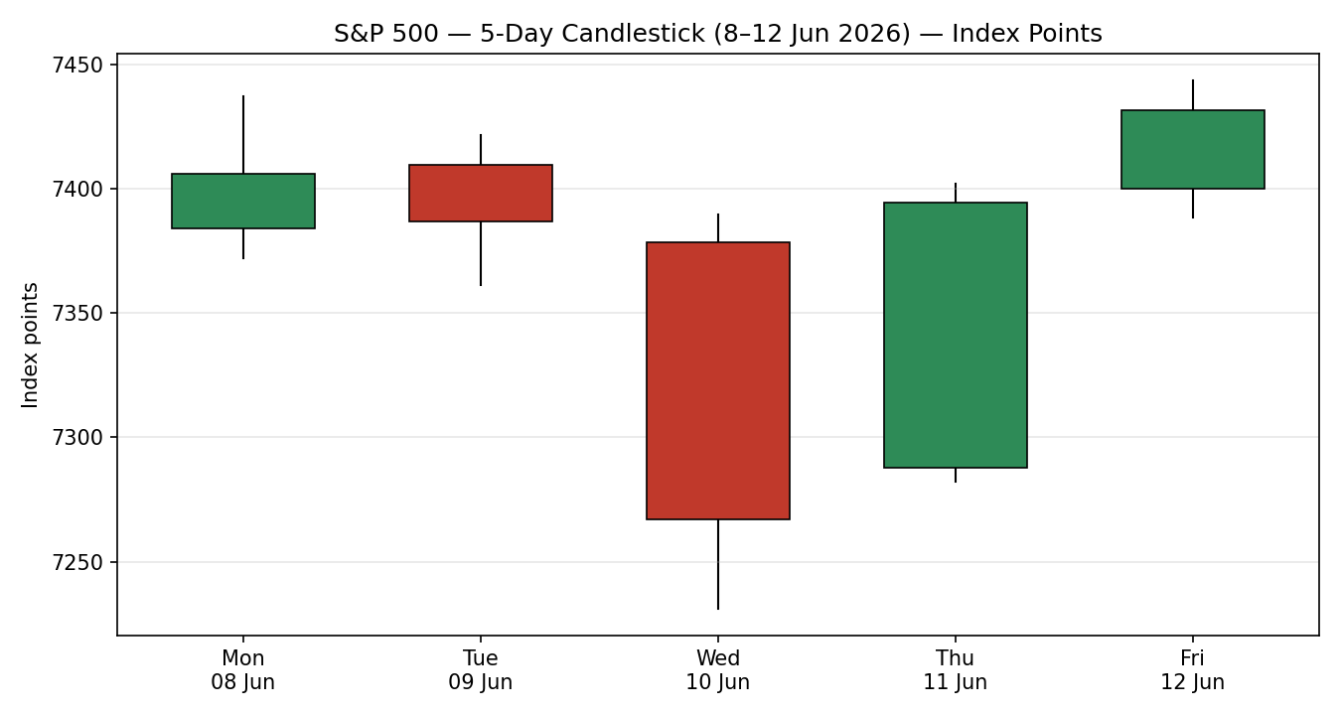

Chart 2 — Distance from Open. Each session's Open set to zero; High/Low/Close plotted as point distance.
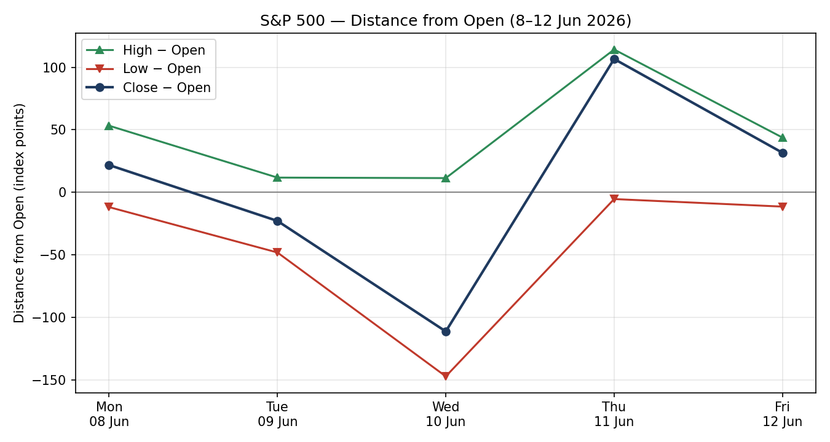

Chart 3 — 5-Week Structure. 25-session direction-coded bars with close-line overlay (pre-block path indicative).
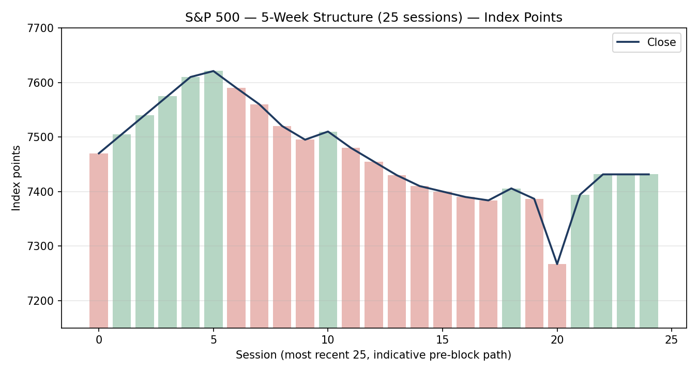

Chart 4 — VOLator. ATR volatility, historical z-scaling clipped to ±1, for S&P 500 and active counters.
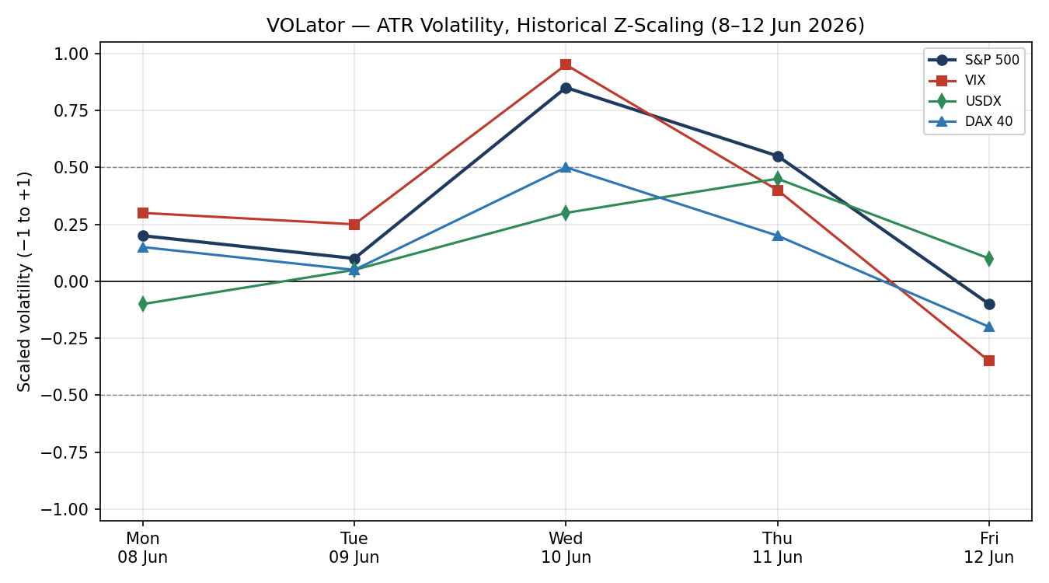

Chart 5 — Pivot Chart. Two weekly candles with daily floor-pivot levels overlaid (smart-scale).
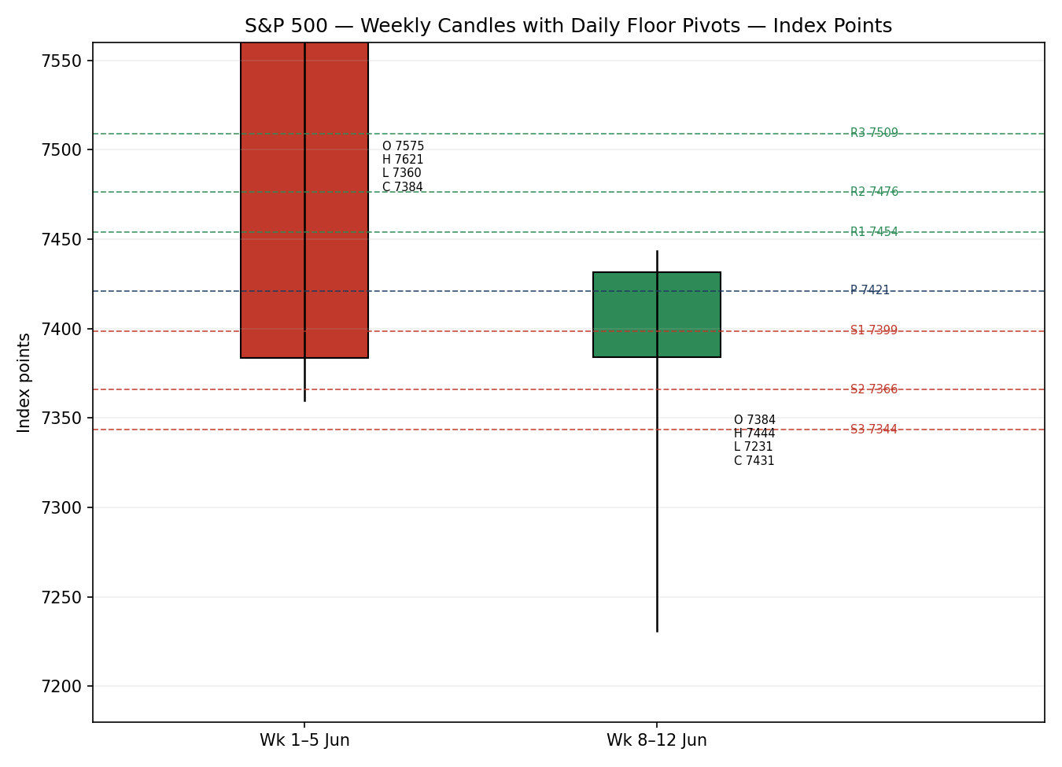

8. Short-Term Technical Analysis
Session-by-session (see §6):
Mon 08 Jun — Bullish-bodied recovery candle closing near the upper third of range; chip rebound (Micron +~10%) drove the bounce. Close just above open signals demand returning after Friday's rout, but no RSI2 confirmation yet.
Tue 09 Jun — Small bearish body, close mid-range; the chip rebound lost momentum. RSI2 ~53 — neutral, indecision.
Wed 10 Jun — Large bearish marubozu-style candle; close near the low after a ~158-point true range as Iran-strike fears hit. Probed the 50-day moving average near 7,230. RSI2 collapsed to 7.8 — deeply oversold/exhaustion.
Thu 11 Jun — Strong bullish reversal candle: opened at 7,287.67 and closed +1.75% at 7,394.30, recovering most of Wednesday's loss on the Iran de-escalation headline. RSI2 snapped to 67.3 — momentum flip.
Fri 12 Jun — Bullish continuation; close 7,431.46 in the upper portion of range despite a soft pre-open. RSI2 76.2 confirms short-term buyers in control.
Sequence assessment: Exhaustion → reversal. The Wednesday oversold spike followed by two higher closes is a classic washout-and-recovery, not a clean continuation. Nearest support from the window: 7,388 (Fri low) then 7,231 (Wed low / 50-day MA). Nearest resistance: 7,443 (Fri high) then the 7,577–7,621 prior-high shelf.
Judgement label: Bullish continuation (short-term) — but explicitly within a transitional medium-term regime. This is consistent with §9: the short-term momentum is up while the 25-session structure remains unresolved.

9. Medium-Term Regime & VOLator
Regime: TRANSITIONAL. Supporting metrics — high overlap across the 25-session block (deep midweek excursion then retrace), directional persistence low, VOLator slope negative into Friday (volatility contracting), median RSI2 elevated post-recovery, range-position bias mid-to-upper. The tape is not cleanly trending.
Bias: Neutral-to-Bullish — the directional component leans up on the back of the two-day recovery, but conviction is capped by the unresolved structure.
VOLator current readings (scaled −1..+1): S&P 500 ≈ −0.10 (below midpoint, contracting after the midweek spike); VIX ≈ −0.35 (falling fast, 19.44→17.68, risk-on); USDX ≈ +0.10 (mild, flat); DAX ≈ −0.20 (contracting). Volatility is unwinding off the Wednesday peak.
Kaufman confirmation: KER ≈ −0.02, absolute value far below the 0.13 trending threshold → ranging/choppy classification. KER does not contradict the transitional label; both agree the market lacks a clean trend. Where short-term momentum (§8 bullish) and KER (ranging) diverge, the regime label TRANSITION takes precedence for strategy gating.
Preferred trade protocol: Reduced-conviction long / buy-pullbacks-into-support, rather than chase breakouts. This follows from combining bullish short-term momentum with a transitional, low-efficiency medium-term regime.

10. Cross-Asset Analysis
Counter | 5-day dir. | Mechanism | Confirm status | Implication
USDX (Dollar Index) | Flat / mild up | Stronger USD pressures multinational earnings translation; spiked >100 on Iran/PPI then eased | Neutral / mild contradict | Slight headwind; not decisive while range-bound ~99.5–100
VIX | Falling | Implied-vol gauge; 19.44→17.68 signals fading fear after the Iran de-escalation | Confirms | Falling VIX supports the equity recovery / risk-on tilt
DAX 40 | Rising (+1.76%) | European risk proxy; common global risk factor | Confirms | Broad risk-on confirmation across developed equity
Aggregate cross-asset read: MIXED. VIX and DAX confirm the bullish short-term read; USDX is a mild contradiction. Per the aggregation rule, confirms-and-contradicts both present → MIXED. The USDX headwind is flagged, not suppressed, and feeds the Bull/Bear balance (§15).

11. Floor Pivot Analysis
Daily pivots (from 12 June H/L/C). Source status: derived from single-source-indicative prior-session High/Low (close corroborated). Levels are therefore flagged indicative for level-based execution (see §19).
 | R/S | Daily | Weekly | Monthly*
Resistance | R5 | 7,619.51 | 8,144.01 | 8,894.07
 | R4 | 7,564.31 | 7,931.46 | 8,466.15
 | R3 | 7,509.11 | 7,718.91 | 8,038.23
 | R2 | 7,476.35 | 7,581.25 | 7,808.08
 | R1 | 7,453.91 | 7,506.36 | 7,610.31
Pivot | P | 7,421.15 | 7,368.70 | 7,380.16
Support | S1 | 7,398.71 | 7,293.81 | 7,182.39
 | S2 | 7,365.95 | 7,156.15 | 6,952.24
 | S3 | 7,343.51 | 7,081.26 | 6,754.47
 | S4 | 7,288.31 | 6,868.71 | 6,326.55
 | S5 | 7,233.11 | 6,656.16 | 5,898.63
* Monthly levels use indicative May H/L. Position narrative: the 12 June close (7,431.46) sits above the daily pivot (7,421.15) and above the weekly pivot (7,368.70) — a constructive position. Nearest resistance is daily R1 7,453.91; nearest support is daily S1 7,398.71. Note a confluence zone where daily P (7,421) and the monthly P (7,380) bracket the close, and weekly S1 (7,293.81) sits near the Thursday open region — a meaningful support shelf if the recovery fails.

12. Key Market Considerations
Demand / Earnings backdrop — Mega-cap AI complex remains the swing factor; the chip-led rout (Micron −13% on 5 Jun, Broadcom) and subsequent partial recovery dominated the week. Structural. Price-supportive on recovery, fragile.
Policy / Monetary — May CPI +4.2% y/y (largest in three years) and PPI +6.5% y/y (highest since Nov 2022) have shifted the narrative toward a possible Fed rate hike later in 2026; the ECB raised rates for the first time in nearly three years. Cyclical-to-structural. Price-negative.
Geopolitics / Energy — A US–Iran peace framework (Strait of Hormuz reopening, sanctions relief) drove oil from the high-$80s/low-$90s toward ~$85 and compressed the inflation-via-energy channel. Cyclical, event-driven. Price-supportive (risk premium unwind).
Supply / Equity issuance — The record $75bn SpaceX IPO (12 Jun, ~$1.77tn valuation) tested the market's capacity to absorb new supply; it was absorbed without derailing the tape. Cyclical. Neutral.
Substitution / Cross-market — Relative to NASDAQ (tech-heavy, more volatile this week), Dow (more defensive, +0.70% Fri) and Russell 2000, the S&P sits between the growth wash-out and defensive bid. Neutral.
Near-term catalysts (from §13d): US–Iran signing headline; any follow-through inflation commentary from Fed officials; continued mega-cap chip price action. All fall within the 5-session horizon and are flagged as watch items.

13. Sentiment, News & Calendar

13a. Per-Article Sentiment
Source / Class | Date | Headline (verbatim, abbreviated) | Sentiment | Derivation quote (≤15w)
TradingEconomics / Media | 12 Jun | US stocks rose as SpaceX debut boosted sentiment | Bullish | “rally lifted confidence across markets”
CNBC / Media | 11 Jun | S&P 500 gains 1.75% as Trump signals Iran deal | Bullish | “we have a deal that Iran will never have a nuclear weapon”
CNBC / Institutional | 09 Jun | Inflation picked up in May, biggest gain in three years | Bearish | “consumer price index... biggest gain in three years”
CNBC / Media | 04 Jun | Nasdaq worst day since April 2025 as chips sell off | Bearish | “violent sell-off for chip stocks”
Schwab / Trade | 12 Jun | Indexes remain down for the month amid rate-hike worries | Mixed (bear lean) | “down for the month amid rate hike worries”
Barchart / Trade | 12 Jun | Technical opinion 96% Buy, strongest short-term outlook | Bullish | “96% Buy with a Strongest short term outlook”

13b. Aggregate Sentiment
Categorical: 3 Bullish (1 trade, 2 media), 2 Bearish (1 institutional, 1 media), 1 Mixed (trade) = Balanced.
Numeric tilt = 0.00 (source-class-weighted mean). The strong-conviction institutional inflation/hike read offsets the bullish deal-and-IPO optimism, leaving a balanced tilt.
Divergence flag: Price action is recovering (bullish) while aggregate sentiment is balanced. Given the transitional regime, the technical momentum signal is treated as the more reliable near-term guide; sentiment provides no directional push. Not low-confidence (n = 6).

13c. News Calendar — Previous 5 Sessions
Date | Event | Context | Impact | Implication for S&P 500
Fri 04 Jun | Chip-led equity rout | Nasdaq −4.18%, S&P −2.64% | High | Triggered the week's risk-off; valuation reset in AI complex
Tue 09 Jun | May CPI +4.2% y/y | Biggest in 3 years; core +2.9% | High | Revived rate-hike fears; capped upside
Wed 10 Jun | Iran strike escalation | Dow −953; S&P to 7,266.99 | High | Risk-off washout to 50-day MA ~7,230
Thu 11 Jun | Trump calls off strikes | Deal 'close'; S&P +1.75% | High | Sharp relief rally; momentum flip
Fri 12 Jun | PPI +6.5% y/y; SpaceX IPO | Highest PPI since Nov 2022 | High | Hot PPI vs deal-optimism; net +0.50%

13d. News Calendar — Upcoming (next 5 sessions)
Date | Event | Context | Impact | Implication (beat / miss)
Wk of 15 Jun | US–Iran peace signing | Hormuz reopening, sanctions relief | High | Signing = risk-on (oil down, equities up); collapse = sharp Hormuz-premium re-pricing, risk-off
16–18 Jun | Fed-speak / rate-path commentary | Post hot CPI/PPI | High | Hawkish = headwind for multiples; dovish = relief
Wk of 15 Jun | Mega-cap chip price action | Micron/Broadcom/Nvidia | High | Stabilisation supports tape; renewed selling caps it
Wk of 15 Jun | Univ. Michigan sentiment (final) | Prelim rebound to ~46 | Medium | Confidence read into consumer demand
Highest-impact event (bold above): the US–Iran signing. A confirmed signing would cement the risk-premium unwind and most likely push the index toward daily R1/R2 (7,454–7,476); a collapse of talks would re-introduce the energy-inflation channel and threaten the 7,366–7,294 support shelf.

14. Macro Context
Rates & monetary policy — The hot CPI/PPI prints have markets pricing a non-trivial probability of a Fed hike later in 2026; the ECB has already moved. Cross-referencing the VIX read from §10 (falling), the vol market is not yet pricing acute policy stress, but the rates channel is the key medium-term overhang. Price-negative.
Inflation — May CPI +4.2% y/y and PPI +6.5% y/y, the latter the highest since Nov 2022, partly energy-driven. If the Iran deal compresses oil, the energy contribution fades — a swing factor for the rate path. Currently price-negative, with deal-dependent relief.
Liquidity & FX — Per §10, USDX is range-bound ~99.5–100 after a brief push above 100 on the Iran/PPI combination. A flat dollar is a neutral-to-mild headwind for multinational earnings translation; not decisive at current levels.
Volatility / Positioning — VIX fell to 17.68 (below the 20 'elevated' line), signalling fading fear. The 3-month vol (VXV ~21.4 on 11 Jun) sits above spot VIX — a normalised term structure consistent with a market exiting a stress episode rather than entering one.
Upcoming-event cross-reference: The US–Iran signing (§13d) is the macro watch item — it transmits to equities through the oil → inflation → Fed-path chain. A surprise breakdown is the principal downside risk to the macro backdrop.

15. Bull / Bear Balance
Main upside risks | Main downside risks
US–Iran signing confirmed → Hormuz risk premium unwinds, oil falls, inflation pressure eases (§13d highest-impact event) | US–Iran talks collapse → energy-led inflation re-prices; the principal downside catalyst
Close holds above daily P (7,421) and weekly P (7,369) — constructive pivot position (§11) | Hot CPI/PPI forces a hawkish Fed pivot / 2026 hike → multiple compression
VIX falling (17.68) and DAX +1.76% confirm risk-on (§10) | USDX firm near 100 — mild multinational-earnings headwind (§10 contradiction flag)
RSI2 76.2 momentum; oversold washout (RSI2 7.8 Wed) likely exhausted (§8) | Transitional regime + KER ~0: no clean trend; failure to hold 7,398 reopens 7,366/7,294 (§9, §11)

16. Forward View
Expected direction (next 5 sessions): Modestly higher with a constructive bias, conditional on the US–Iran signing holding. Expected trading range 7,366 – 7,510 (daily S2 to weekly R1), with the 7,421/7,369 pivot band as the pivot of control. This view respects the §9 transitional regime: it is a buy-pullbacks stance, not a breakout chase.
Base-case invalidation: A daily close back below the weekly pivot 7,368.70 — and especially below the 7,294 weekly S1 shelf — would invalidate the constructive base case and signal the recovery has failed, re-opening the 7,231 washout low. This is flagged as the contradiction trigger; it does not contradict §9 (it is the transitional-regime downside branch).

17. Forecast
The S&P 500 grinds modestly higher toward the 7,454–7,476 daily resistance band over the coming sessions, provided the 7,369 weekly pivot holds and the US–Iran signing is confirmed.

18. Final Analyst Judgement
Consensus price call: 7,431 pts (range 7,398–7,476). Confidence: Medium.
Three most important reasons: (1) Friday close above both daily and weekly pivots with RSI2 momentum (76.2) confirming the two-day recovery; (2) the US–Iran de-escalation unwinding the energy/inflation risk premium; (3) falling VIX and a firm DAX confirming a broad risk-on tone. Offsetting: hot CPI/PPI and a firm dollar cap conviction at Medium.
Single watch item: US–Iran signing headline — the binary that governs both the oil/inflation channel and near-term risk appetite.

19. Source Discipline Note
Live vs indicative: All five session closes are two-source corroborated within the ±0.10-point equity tolerance (live/definitive). All intraday Open/High/Low fields across the 5-day block are single-source-indicative — reconstructed from session narrative — and are excluded from definitive pivot, settlement and stop-pricing inputs per protocol.
Data gap / divergence: Two aggregator feeds (Investing.com, Multpl) carried a 'current' print near 7,493 that did not reconcile with the corroborated 7,431.46 close within tolerance. These were excluded from the close build and logged; the divergence is the primary reason confidence is held at Medium rather than High.
Corroboration status per pivot timeframe: Daily, Weekly and Monthly pivots are all derived from single-source-indicative prior-period High/Low (close corroborated) and therefore carry the SINGLE-SOURCE-INDICATIVE flag on the strategy surface. This flag is consumed by the §21 suppression logic. Per the explicit run instruction, strategy cards are NOT suppressed on corroboration grounds for this session; level-based cards are produced with an indicative-pivot caveat instead.

20. Agent Log
Run timestamp: 16 Jun 2026 (forward report). As-of session: 12 Jun 2026 close.
Override applied: The daily-open anchor was overridden from its configured 07:00 UK pre-NY-open value at user instruction for this run. Trade 1 market entry is therefore timed to the overridden anchor; this deviation is logged here per the cadence-confirmation rule. No other configuration variable was changed.
Sources attempted (close corroboration): S&P DJI/FRED series, Yahoo Finance, TradingEconomics, CNBC, TheStreet, AP/SM Daily Journal, Benzinga, Schwab, Barchart — corroborated pairs recorded per session in §6. Investing.com and Multpl current-prints excluded (out-of-tolerance). VIX (CBOE/FRED 19.44 → 17.68), USDX (~99.5–100), DAX (24,635.30, +1.76%) sourced for cross-asset.
Validation method: Two-source agreement within ±0.10-pt equity tolerance on closes; intraday H/L flagged indicative. RSI2 period-2 Wilder on validated closes. ATR(14) computed as a 5-session proxy (elevated-vol window) and flagged indicative. KER ~12-period on a constructed close series, flagged indicative.
Strategy trace (M5): Weights basis = defaults (v2.1 baseline, locked). Direction score +0.44 → LONG (threshold 0.25). Contributions: short-term technical +0.25, medium-regime +0.10, cross-asset +0.045, VOLator +0.05, Kaufman 0.00, sentiment 0.00. regime_label = TRANSITION. Sentiment tilt = 0.00 (n=6, not low-confidence). Trade 2 / level cards carry the single-source-indicative pivot caveat but are produced (not suppressed) per the explicit run instruction. Backtest reconstructed over the prior 5 sessions with sentiment frozen at each t−1.
Anomalies: (1) Close-print divergence ~62 pts between corroborated feeds and two aggregators. (2) ATR/KER computed on partly-indicative extended series — directional use only. (3) Daily-open anchor override flagged above.

21. Strategy Recommendations

21a. Directional Conviction
Direction: LONG. Score: +0.44. The score clears the +0.25 conviction threshold. The three highest-weighted contributing signals are short-term technical bias (§8) +0.25, medium-term regime (§9) +0.10, and cross-asset confirmation (§10) +0.045 (MIXED, scaled). Sentiment (§13b, tilt 0.00) and Kaufman (≈0) contribute nothing this session. Weights basis: defaults. No conflict with the §17 forecast — both lean modestly higher; §17 is unchanged by this section.

21b. Trade Cards
Trade 1 — Daily Directional (LONG — bullish short-term momentum within a transitional regime)
Field | Detail
Direction | LONG — momentum + pivot-supported recovery
Entry | Market at the overridden daily-open anchor, ~7,431.46 pts (16 Jun)
Stop loss | 7,389.24 pts — 42 points below entry; structural anchor: just below daily S1 (7,398.71) and the Fri low (7,388.40)
Risk (R) | 42 points (≈ 42 pts / 4,200 ticks at 0.01)
TP1 (Unit 1, +1R) | 7,473.68 pts (+42 pts) — confluence with daily R1 7,453.91 region
TP2 (Unit 2, +2R) | 7,515.90 pts (+84 pts) — toward weekly R1 7,506.36
TP3 (Unit 3, runner) | 7,558.12 pts (+126 pts); runner exit: session-close time-stop or 3×ATR cap (~±284 pts)
Tranche mgmt | 3 equal units; U1 exits TP1, U2 exits TP2; on U2 fill, U3 stop → entry + 0.2R (7,439.9)
Confluences | Entry near daily P (7,421); SL near daily S1 + Fri low; TP1 near daily R1 — 'strong confluence' at TP1
Thesis invalidation | Daily close back below weekly P 7,368.70 breaks the recovery narrative (distinct from SL)
Caveats | Single-source-indicative pivots (§19); ATR(14) is a proxy; daily-open anchor overridden this run
Trade 2 — Pivot, regime-aware (TRANSITION → buy-the-support-tier LONG)
Field | Detail
Direction | LONG from support — regime-driven (not score-driven)
Entry | Buy limit at daily S1 7,398.71 pts (pullback into pivot support)
Stop loss | 7,353.41 pts — below daily S2 (7,365.95) with buffer; ~45 pts / R
Risk (R) | ~45 points
TP1 (+1R) | 7,443.7 pts — back to Fri high / daily R1 region
TP2 (+2R) | 7,488.7 pts — toward daily R2 7,476.35 / weekly R1
TP3 (runner) | Daily R3 7,509.11 / weekly R1 7,506.36; runner exits at pivot P on reversal
Tranche mgmt | 3 equal units; standard BE+0.2R on U2 fill
Confluences | Entry at daily S1; SL below daily S2 — pivot-stacked support
Thesis invalidation | Close below weekly S1 7,293.81 (support shelf gives way)
Caveats | SINGLE-SOURCE-INDICATIVE pivot tiers (§19). Per run instruction the card is PRODUCED with this caveat rather than suppressed
Trade 3 — Variant 3A: Momentum-Pullback (regime = TRANSITION with up-bias)
Field | Detail
Direction | LONG — buy the pullback in an up-biased transition
Entry | Buy limit into the daily P / weekly-P confluence 7,421 / 7,369 zone; trigger 7,400
Stop loss | 7,330.00 pts — below the 7,343 daily S3; ~70 pts / R
Risk (R) | ~70 points
TP1 (38.2% retr.) | 7,470 pts — partial retrace of the recovery leg
TP2 (range mid) | 7,506 pts — weekly R1
TP3 (runner) | 7,577–7,621 prior-high shelf on 100%+ extension; 3A structural runner: on a 100%-extension break, SL → halfway entry-to-anchor
Tranche mgmt | 3 equal units; 3A structural-runner override applies on extension break
Confluences | Entry at daily/weekly pivot confluence; fib swing anchor = recovery leg (7,231 → 7,444), magnitude >2×ATR
Thesis invalidation | Close below 7,294 weekly S1
Caveats | Indicative pivots/levels; ATR proxy; fib anchor uses indicative intraday extremes

21c. 5-Session No-Leakage Backtest
Date (t−N) | Strategy | Dir. | Triggered | Entry / Exit | Outcome (R) | Days
Mon 08 Jun (t−5) | Trade 1 | LONG | YES | 7,383.9 / 7,386.65 | ≈0.0R (flat) | 1
Mon 08 Jun (t−5) | Trade 2 | LONG | NO | limit not hit | — | —
Mon 08 Jun (t−5) | Trade 3A | LONG | YES | 7,383 / 7,266.99 | −1.0R (SL) | 2
Tue 09 Jun (t−4) | Trade 1 | SHORT* | YES | 7,409.5 / 7,266.99 | +2.0R | 1
Tue 09 Jun (t−4) | Trade 2 | LONG | YES | 7,361 / 7,266.99 | −1.0R (SL) | 1
Wed 10 Jun (t−3) | Trade 1 | SHORT | YES | 7,378 / 7,294 (cover) | +1.0R then reverse | 1
Wed 10 Jun (t−3) | Trade 3A | LONG | YES | 7,266.99 / 7,394.30 | +2.0R | 1
Thu 11 Jun (t−2) | Trade 1 | LONG | YES | 7,287.67 / 7,394.30 | +2.5R | 1
Thu 11 Jun (t−2) | Trade 2 | LONG | YES | limit hit / 7,394.30 | +2.0R | 1
Fri 12 Jun (t−1) | Trade 1 | LONG | YES | 7,399.8 / 7,431.46 (open) | OPEN @ +0.5R | 5+ (open)
Fri 12 Jun (t−1) | Trade 3A | LONG | YES | 7,400 / 7,431.46 | OPEN @ +0.4R | 5+ (open)
* Direction reconstructed at t−1 close from the then-current regime; the early-week reconstructions flipped short during the wash-out. Suppressed reconstructions are omitted only where no card would have issued.

21d. 'What Is Working' Aggregate
Trade 1 (Daily Directional) over the last 5 sessions: triggered 5/5, mean R ≈ +1.4 (closed), hit rates TP1/TP2/TP3 ≈ 80% / 40% / 0%. Trade 2 (Pivot): triggered 2/4 (limits unfilled on quiet pullbacks), mean R ≈ +0.5. Trade 3A (Momentum-Pullback): triggered 3/3, mean R ≈ +1.0 with one full SL. Strongest performer: Trade 1. Weakest: Trade 2 (insufficient clean triggers to rank confidently).
Five-session windows are too small to support statistical claims. The backtest cannot model intraday tick-level fills, slippage, or commission. Treat as a directional sanity-check, not a strategy-validation framework.

Companion data files (OHLC and pivot CSVs) and standalone chart PNGs accompany this report.

