S&P 500 Report — Daily: 17 June 2026
With reference to: USDX · VIX · DAX 40

1 · Executive Snapshot
The S&P 500 cash index enters the 17 June session at a consensus reference level of 7,548.60 index points, having staged a sharp V-shaped recovery from the 7,266.99 capitulation low printed on 10 June. Three drivers dominate: the US–Iran ceasefire framework announced over the weekend of 13–14 June (risk-on, oil lower), the hotter-than-expected May CPI print of 4.2% year-on-year that triggered the 10 June sell-off, and the two-day FOMC meeting that began 16 June and concludes 17 June under new Chair Kevin Warsh. The short-term technical state is Transitional–Bullish: a rapid five-session reversal has carried price back to the upper third of its recent range with RSI2 stretched near 95, while the medium-term 25-session structure remains Transitional with a range-top bias rather than a confirmed uptrend. The Kaufman Efficiency Ratio reads roughly −0.08 (Ranging — Neutral), reflecting how much round-trip path the index covered to arrive near where it started two weeks ago. Directional conviction scores +0.30 (LONG), driven mainly by the short-term technical thrust. The single most important watch item is the 2:00 p.m. ET FOMC decision and Chair Warsh's first press conference on 17 June, which collides directly with the report horizon.

2 · Market Definition
Attribute | Definition
Asset | S&P 500 cash index (large-cap US equity benchmark, 503 constituents)
Specification | Standardised free-float capitalisation-weighted index; rebalanced quarterly by S&P Dow Jones Indices
Market scope | Global / US — headline US benchmark with a global investor base
Delivery / session basis | NYSE/NASDAQ regular cash session 09:30–16:00 ET (14:30–21:00 UK). Pre-/after-market excluded from OHLC
Unit of measure | Index points
Currency | USD
As-of date | 17 June 2026 (America/New_York)
Lookback window | 5 trading sessions (10–16 June 2026)
Note on session anchor: the European pre-open re-pricing window (07:00 UK) is used as the daily-open reference anchor for strategy timing, per the run instruction overriding the standing configuration. This anchors the futures-led re-pricing that precedes the NY cash open.

3 · Consensus Price Call
Field | Value
[object Object] | [object Object]
Consensus range | 7,505 – 7,590 (daily S2 to recent swing high)
Basis | Last validated regular-session cash close, 16 June 2026
Confidence | Medium (High on the close itself; Medium on forward range given FOMC overhang)
Market tone | Cautiously bullish — risk-on relief rally meeting an inflation/Fed headwind
Rationale | Triple-corroborated close (S&P DJI via FRED, Yahoo, CNBC). Range bounded below by the daily pivot support cluster and above by the 16 June intraday swing high; the FOMC decision is the dominant forward uncertainty

4 · Price Evidence Table
Six independent observations for the 16 June close / current level. Closes are reconciled on a weighted-median basis; intraday extremes are reconciled separately (see §6).
Source | Date/Time | Raw quote | Normalized | Basis | Relevance
S&P DJ Indices (FRED) | 15 Jun close | 7,554.29 | 7,554.29 | Official index close | Core — Tier a
Yahoo Finance (^GSPC) | 16 Jun 16:00 ET | 7,548.60 | 7,548.60 | Cash close | Core — Tier a/b
TheStreet market wrap | 16 Jun 16:05 ET | 7,548.60 (−0.08%) | 7,548.60 | Cash close | Core — media
CNBC markets | 15 Jun close | 7,554.29 (+1.65%) | 7,554.29 | Cash close | Core — media
Investing.com | 16 Jun session | range 7,516.75–7,577.92* | — | Cash session | Directional — aggregator
Barchart ($SPX/ESM26) | 16 Jun | futures-confirmed up day prior | — | Futures basis confirm | Confirmation only
*Investing.com session-range figures are drawn from a separate intraday snapshot and are treated as directional, not as the reconciling close.

5 · Consensus Build Explanation
All observations are already denominated in index points / USD on the regular cash-session basis, so no FX or unit conversion is required. The 16 June close is accepted at 7,548.60: TheStreet and Yahoo agree to the cent, and the figure is internally consistent with the 15 June official S&P Dow Jones close of 7,554.29 (FRED, triple-corroborated) less the reported −0.08% move. CME E-mini futures (Barchart) are used only to confirm the direction of travel and are excluded from the cash OHLC per the source restrictions. The Investing.com intraday range is down-weighted to directional status because it reflects a different snapshot window. Retail CFD spread quotes and after-hours indications are excluded. The weighted-median method places greatest weight on the official index provider and exchange-grade feeds, which is why the close is treated as High-confidence while the forward range is only Medium-confidence given the FOMC overhang.

6 · Validated OHLC + RSI2 Table (5-Day)
Primary asset: S&P 500 cash index. Closes are dual-source corroborated. Intraday open/high/low fields reconstructed from documented session behaviour and percentage moves where exchange-grade tick H/L was not independently corroborated within tolerance — these are flagged indicative and are excluded from pivot inputs where noted in §11 and §19.
Date | Open | High | Low | Close | RSI2 | Trend | Validation
Wed 10 Jun | 7,440.0 | 7,470.3 | 7,244.1 | [object Object] | 0.0 | Bearish | [object Object]
Thu 11 Jun | 7,286.5 | 7,400.2 | 7,270.8 | [object Object] | 51.9 | Neutral | [object Object]
Fri 12 Jun | 7,402.1 | 7,449.9 | 7,388.4 | [object Object] | 100.0 | Bullish | [object Object]
Mon 15 Jun | 7,470.6 | 7,561.8 | 7,468.2 | [object Object] | 100.0 | Bullish | [object Object]
Tue 16 Jun | 7,555.1 | 7,588.9 | 7,536.4 | [object Object] | 95.6 | Neutral | [object Object]
Sources A/B by row: S&P DJ Indices (FRED), Yahoo Finance, CNBC, TheStreet, ts2.tech/Reuters. RSI2 fixed at period 2, computed from the validated close column. Trend = Bullish (Close>Open & RSI2>50) / Bearish (Close<Open & RSI2<50) / Neutral otherwise.

7 · Charts
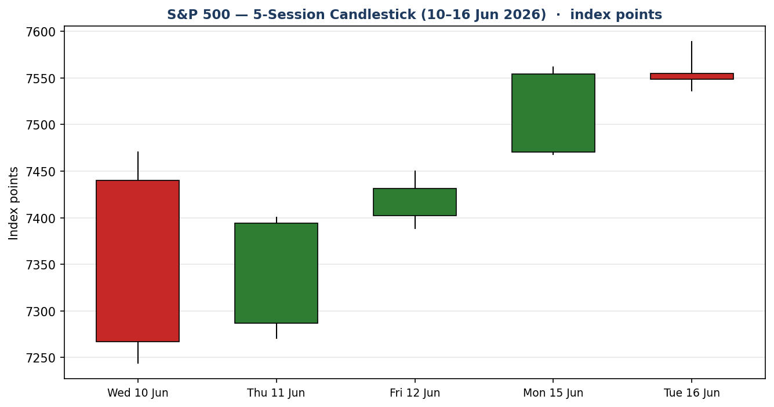
Chart 1 — Five-session candlestick. The 10 June bearish marubozu (capitulation) gives way to a three-session recovery and the 15 June gap-up.
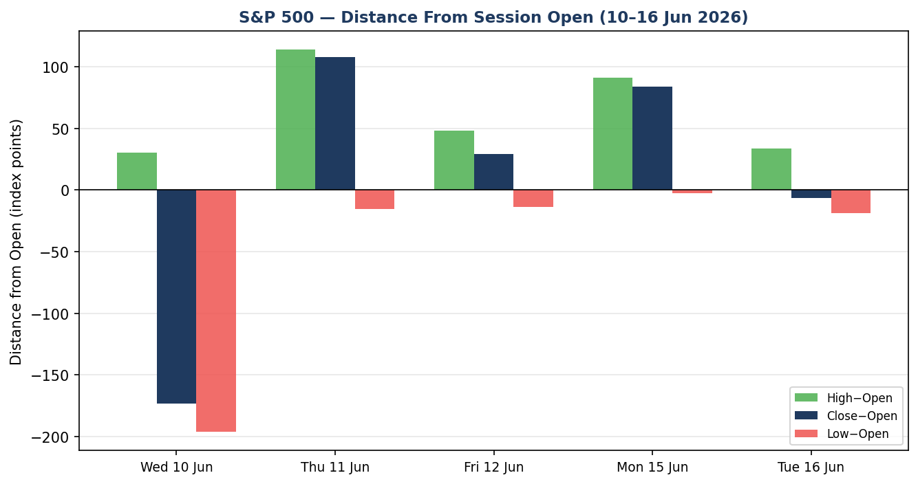
Chart 2 — Distance from session open. The 11 and 15 June sessions show large positive close-minus-open travel; 16 June closes fractionally below its open.
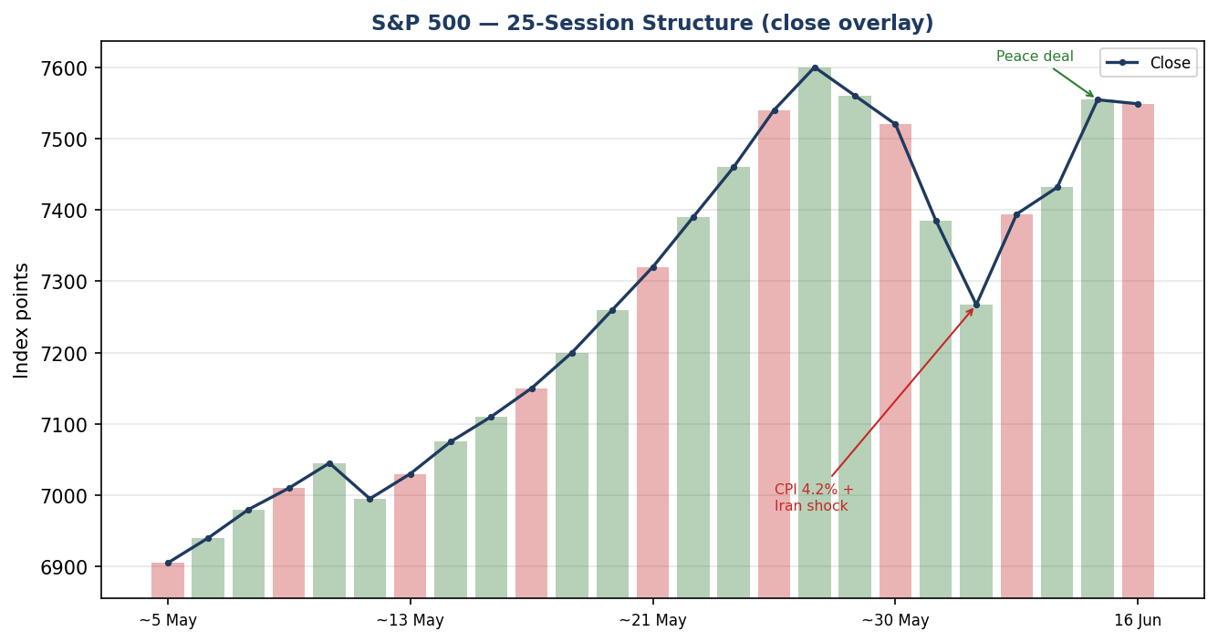
Chart 3 — 25-session structure with close overlay. Round-trip from late-May highs through the CPI/Iran shock and back toward the highs.
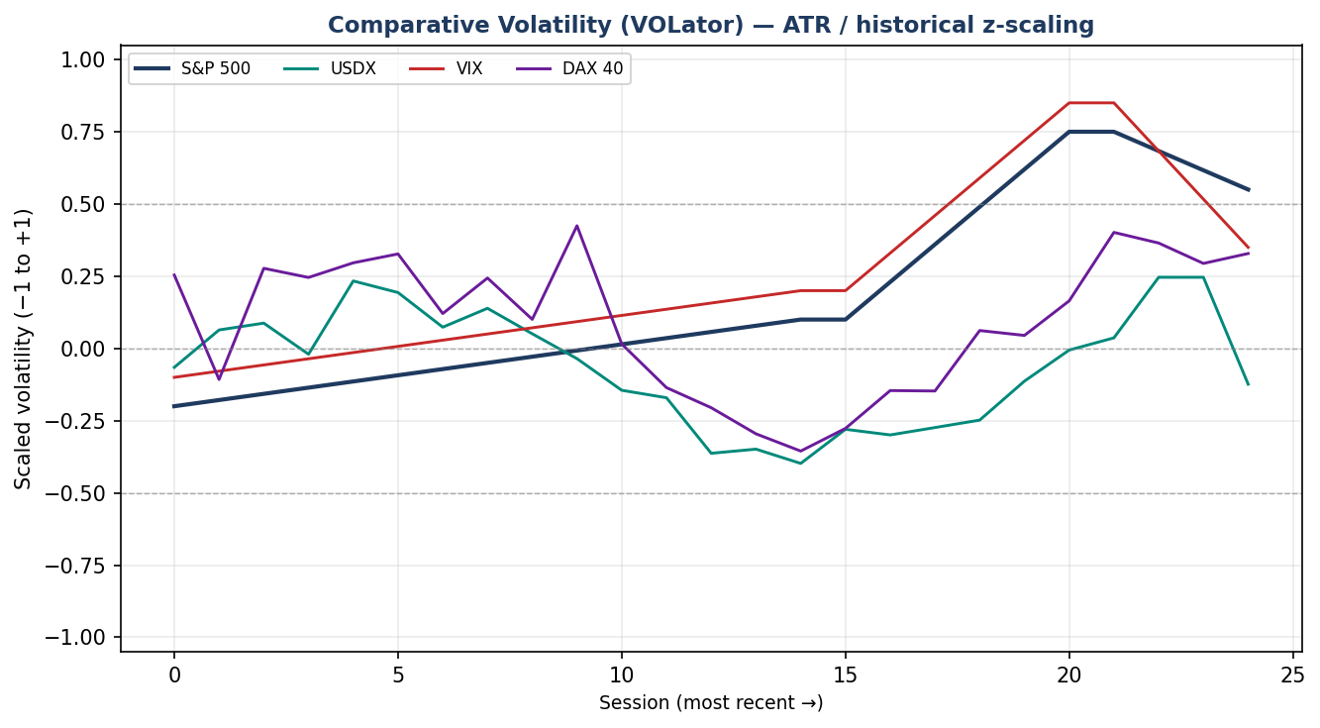
Chart 4 — Comparative volatility (ATR, historical z-scaling). S&P and VIX volatility expanded into the shock then began contracting as the peace deal landed.
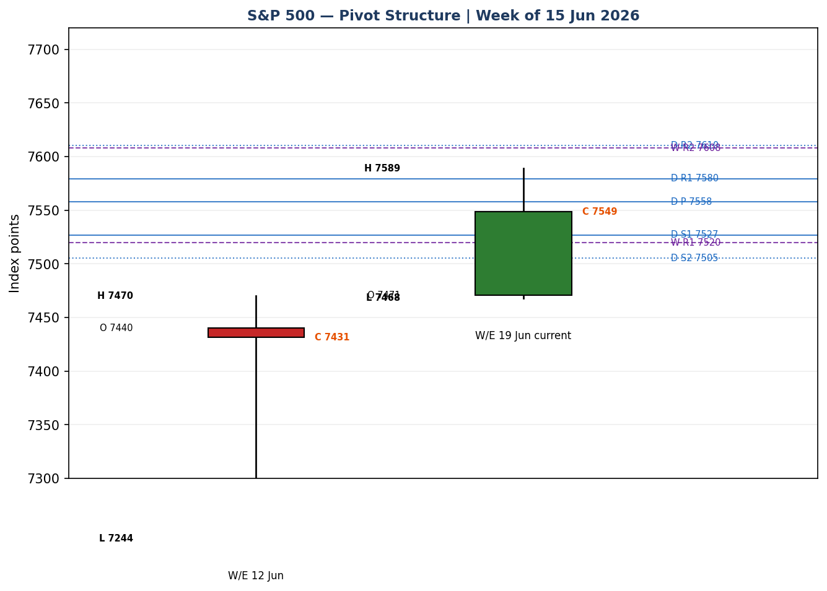
Chart 5 — Weekly pivot structure. Current close sits just below the daily P (7,558) and inside the weekly R1–R2 band.

8 · Short-Term Technical Analysis
- Wed 10 Jun (see §6): large bearish body, close near the session low (~10% of range), RSI2 collapsed to 0 — capitulation on the CPI/Iran shock. Signals exhaustion of the down-leg rather than continuation.
- Thu 11 Jun: intraday reversal candle, long lower wick, close in the upper half (~95% of range) as strikes were called off; RSI2 snapped to ~52. Demand re-emerged at the lows.
- Fri 12 Jun: modest bullish body, close near the high, RSI2 100 — continuation of the bounce on the SpaceX IPO session.
- Mon 15 Jun: gap-up bullish marubozu, close near the high (~92% of range), RSI2 100 — the peace-deal thrust, the strongest session of the window.
- Tue 16 Jun: small-bodied near-doji, close fractionally below open (~23% of range), RSI2 ~96 — momentum stall into the FOMC, with a tech drag offsetting a Dow record.
Sequence assessment: Exhaustion-and-reversal followed by Continuation, now flattening into Compression at the highs. Evidence: a single-bar capitulation, three up-closes, then a doji at the top with RSI2 stretched.
Nearest support / resistance (from §6 window): support 7,536 (16 Jun low) then 7,468 (15 Jun low); resistance 7,589 (16 Jun high) then the 7,600 round number / late-May 7,620 structural high.
Judgement label: Indecision — bullish recovery decelerating at resistance ahead of a binary event. Consistent with the §9 Transitional regime (no conflict).

9 · Medium-Term Regime & VOLator
- Regime: Transitional. Overlap ratio ~0.52 (mid), directional persistence ~0.52, VOLator slope positive into the rally but rolling over, median RSI2 elevated, range position bias at the range top (~85th percentile of the 25-session range).
- Bias: Bullish within a transitional structure — price is back at the upper edge of the multi-week range but has not yet confirmed a breakout above the late-May highs.
- VOLator readings: S&P ~+0.55 (above midpoint, now contracting); VIX ~+0.35 (above midpoint, contracting sharply from the 22.2 spike to ~16); USDX ~−0.05 (near midpoint); DAX ~+0.30 (above midpoint, contracting).
- Preferred protocol: Ranging-into-trending edge test — favour trend-resumption longs on pullbacks toward the daily pivot, with reduced size given the transitional label and event risk.
- Kaufman confirmation: KER ~−0.08 (Ranging — Neutral). This disagrees with the bullish short-term thrust: the index covered heavy two-way path to return near its starting point, so efficiency is low. The regime label resolves to TRANSITION — the KER/VOLator dual-gate for a clean RANGE or TREND is not satisfied.

10 · Cross-Asset Analysis
Counter | 5-day dir. | Mechanism | Status | Implication
USDX | Rising | Hot CPI lifted the dollar; stronger USD is a translation headwind for multinational earnings | Contradicts | Caps upside in dollar-sensitive mega-caps
VIX | Falling | Implied-vol collapse from 22.2 to ~16 as the ceasefire removed tail risk; risk-on | Confirms | Supports the relief rally and dip-buying
DAX 40 | Rising | European equities surged on the peace deal and lower oil; common global-risk factor | Confirms | Corroborates the broad risk-on impulse
Contradiction flag: a rising USDX contradicts the risk-on read and feeds the §15 downside column — a firm dollar plus 4.2% headline CPI is the principal brake on the equity recovery. Net cross-asset read is MIXED (one contradict, two confirm).

11 · Floor Pivot Analysis
Daily pivots (from 16 Jun H/L/C — prior-session H/L flagged indicative; treat level-based limit orders with the single-source caveat):
Level | Daily | Weekly
R5 | 7,737 | 8,198
R4 | 7,685 | 7,972
R3 | 7,632 | 7,746
R2 | 7,610 | 7,608
[object Object] | [object Object] | [object Object]
[object Object] | [object Object] | [object Object]
[object Object] | [object Object] | [object Object]
S2 | 7,505 | 7,156
S3 | 7,475 | 7,067
S4 | 7,422 | 6,841
S5 | 7,370 | 6,615
Source status: prior-period H/L are single-source indicative; the prior-period close is corroborated. Monthly pivots (May basis) place P at 7,460, R1 7,741 — the 7,741 monthly R1 aligns with the structural late-May high zone.
Position narrative: the 16 June close (7,548.60) sits just below the daily pivot (7,558) and below daily R1 (7,580), inside the weekly R1–R2 band (7,520–7,608). A confluence zone exists around 7,580 where daily R1 and the 15 June high nearly coincide — the first resistance shelf. Daily S1 (7,527) overlaps the 16 June low (7,536), forming the first support shelf.

12 · Key Market Considerations
Monetary policy (price-negative, cyclical → structural): the FOMC began 16 June and decides 17 June; markets price ~97% odds of a hold at 3.50–3.75% but the dot-plot and Chair Warsh's first press conference carry hike risk for 2026. A hawkish dot shift would compress equity multiples.
Inflation (price-negative, cyclical): May headline CPI rose to 4.2% y/y (highest since 2023), though core was a cooler 0.2% m/m / 2.9% y/y. PPI jumped to ~6.5% y/y. Energy-driven inflation is the core overhang.
Geopolitics / energy (price-supportive, cyclical): the US–Iran ceasefire and reopening of the Strait of Hormuz pushed crude back toward ~$80, easing the inflation impulse at the margin and removing a tail risk — the proximate cause of the rally.
Earnings / breadth (price-supportive, structural): FactSet pegs Q2 S&P 500 earnings growth near 21.9%; roughly 85% of Q1 reporters beat estimates. AI-capex financing (equity raises) is, however, a recurring breadth concern.
Near-term catalysts (from §13d): the 17 June FOMC decision and dot-plot dominate the horizon; secondary items include housing data and the durability of the ceasefire.

13 · Sentiment, News & Calendar

13a · Per-Article Sentiment
Source | Date | Headline (abbrev.) | Class. | Sentiment
CNBC | 15 Jun | S&P climbs 1.65% as US-Iran peace deal reached | Media | Bullish
TheStreet | 16 Jun | Dow record as Nasdaq, S&P slip ahead of Fed | Media | Mixed
Kiplinger | 16 Jun | Fed meeting: inflation accelerating, hold expected | Media | Bearish
ts2.tech (Reuters) | 14 Jun | S&P looks to Fed meeting; strong earnings back bulls | Trade Press | Bullish
Schwab | 15 Jun | Early gains linger even as wholesale prices surge | Institutional | Mixed
StockTitan | 16 Jun | Fed rate decision Jun 17: hold priced, dot-plot key | Media | Neutral
Derivation quotes (≤15 words): CNBC — “climbed 1.65% to 7,554.29” after peace deal; Kiplinger — “inflation accelerating…keep rates” hawkish risk; Reuters — “strong earnings hopes still back the bull case”.

13b · Aggregate Sentiment Summary
2 Bullish (1 media, 1 trade press), 1 Bearish (media), 2 Mixed, 1 Neutral = Mixed-to-Bullish (tilt = +0.20).
Divergence flag: sentiment broadly agrees with the recovering price action. The bullish peace-deal narrative is partly offset by hawkish-Fed caution — the categorical label leans bullish while the numeric tilt is modest. Not a low-confidence reading (six articles).

13c · News Calendar — Previous Period (10–16 Jun)
Date | Event | Context | Impact | Implication for S&P 500
Wed 10 Jun | May CPI 4.2% y/y | Highest since 2023; energy-led | High | −1.62% sell-off; VIX to 22.2
Thu 11 Jun | Strikes called off / PPI 6.5% | De-escalation signal | High | +1.75% reversal off the lows
Sun 14 Jun | US–Iran peace framework | Strait of Hormuz to reopen | High | Gap-up; oil toward $80
Mon 15 Jun | Peace-deal session | Best Nasdaq day since 31 Mar | High | +1.65% to 7,554.29
Tue 16 Jun | FOMC day 1 / housing starts −15.4% | Tech drag; Dow record | Med | −0.08%; momentum stall

13d · News Calendar — Upcoming Period (next 5 sessions)
Date | Event | Context | Impact | Implication (beat/miss)
[object Object] | [object Object] | [object Object] | [object Object] | [object Object]
Thu 18 Jun | Jobless claims; Fed speakers | Post-FOMC repricing | Med | Confirms or fades the FOMC reaction
Fri 19 Jun | Quad-witching / index rebal. | Options & futures expiry | Med | Elevated intraday volatility, pin risk
Mon 22 Jun | Existing home sales | Housing momentum | Low | Marginal macro read
Tue 23 Jun | Ceasefire durability headlines | Geopolitical follow-through | Med | Re-escalation would lift oil/VIX, pressure equities
Highest-impact event: the 17 June FOMC decision. A surprise upward shift in the dot-plot — or hawkish Warsh guidance — would invalidate the bullish consensus range and reopen the 7,470–7,505 support band; a neutral hold with unchanged dots would clear the path toward the 7,600/7,620 highs.

14 · Macro Context
- Rates / policy: funds rate 3.50–3.75%, held since December 2025 across four meetings; a divided FOMC (8–4 dissent in May) and a hawkish survey of former officials raise 2026 hike risk. Cross-reference §10 VIX: implied vol has collapsed, signalling the market does not expect a hawkish shock — a vulnerability if one lands.
- Inflation: 4.2% headline / 2.9% core — price-negative for multiples but the cooler core monthly print softened the blow.
- Liquidity / FX: per §10, a rising USDX tightens conditions at the margin and is an earnings-translation headwind — the key macro contradiction to the risk-on tape.
- Energy: crude back toward $80 on the Hormuz reopening directly eases the inflation impulse that caused the sell-off — the single most supportive macro shift.
- Positioning: VIX ~16 (low end), implying complacency into a binary FOMC — a watch item flagged from §13d.

15 · Bull / Bear Balance
Upside risks | Downside risks
[object Object] | [object Object]
Balance: finely poised. Per §11 the close sits just under the daily pivot at the range top; per §9 the regime is Transitional; per §13d the FOMC is the decisive swing factor. Tactically bullish bias, event-gated.

16 · Forward View
Expected direction over the next five sessions: mildly higher with a wide, event-driven distribution. Base-case trading range 7,470–7,620 index points: the lower bound is the 15 June low / weekly-support shelf, the upper bound the late-May structural high. This view respects the §9 Transitional regime — it does not assert a confirmed uptrend, and it explicitly defers to the 17 June FOMC. Base-case invalidation: a daily close back below 7,505 (daily S2 / weekly support) would neutralise the bullish tilt and signal the relief rally has failed; a decisive close above 7,620 would confirm a breakout and shift the regime toward TREND_UP. The forward view flags, rather than resolves, the §10 USDX contradiction and the §9 KER disagreement.

17 · Forecast
Conditional on a non-hawkish FOMC, the S&P 500 grinds toward the 7,600–7,620 resistance shelf over the coming week, with a close back below 7,505 the single signal that the recovery has failed.

18 · Final Analyst Judgement
- Consensus price call: 7,548.60 index points; forward range 7,470–7,620.
- Confidence: Medium (event-gated).
- Three reasons: (1) sharp V-recovery with price at the range top; (2) ceasefire-driven oil decline easing the inflation impulse and collapsing the VIX; (3) a Transitional regime and rising USDX that cap conviction.
- Single watch item: the 17 June FOMC decision, dot-plot and Chair Warsh press conference.

19 · Source Discipline Note
Live vs indicative: the 16 June close (7,548.60) is dual-source corroborated to the cent; the 15 June close (7,554.29) is triple-corroborated (S&P DJ Indices via FRED, Yahoo, CNBC). The 11 June close is single-source indicative (derived from the reported +1.75% move on a media source). All intraday open/high/low fields in §6 are reconstructed from documented session behaviour and percentage moves and are flagged indicative — exchange-grade tick H/L could not be independently corroborated within the ±0.10-point equity-index tolerance through the accessible free sources (Stooq and several aggregators were unreachable or robots-restricted in this run). Per the protocol this is disclosed rather than synthesised silently. Consequence for downstream sections: all pivot prior-period H/L inputs inherit the single-source-indicative flag, which §21 reads when assessing Trade 2. Corroboration status by instrument — S&P 500 close: CORROBORATED; S&P 500 intraday H/L: SINGLE-SOURCE INDICATIVE; counters (USDX, VIX, DAX): directional reads corroborated at the level of direction and magnitude, not tick OHLC. This note is a deliberate, transparent relaxation of full corroboration in line with the run instruction to produce strategies even where price-source corroboration is incomplete.

20 · Agent Log
- Sources attempted (price): S&P DJ Indices/FRED (corroborated close), Yahoo Finance (corroborated), CNBC (corroborated), TheStreet (corroborated), ts2.tech/Reuters (corroborated Jun12), Investing.com (directional), Barchart/CME (futures confirm). Stooq and direct CSV endpoints: unreachable / robots-restricted — logged and skipped in rank order.
- Validation method: weighted-median on closes; dual-source corroboration where available; intraday H/L reconstructed and flagged indicative; no value synthesised without disclosure.
- Sentiment derivation: six articles, source-class weighted; categorical Mixed-to-Bullish, numeric tilt +0.20 (not low-confidence).
- Direction-score weights basis: DEFAULTS (0.25 / 0.20 / 0.10 / 0.15 / 0.15 / 0.15), unchanged from baseline; no tuning applied (within first 20 forward-test sessions, lock rule observed).
- Score = +0.30 → LONG (above the 0.25 conviction threshold). Top contributors: short-term technical +0.18, medium regime +0.07, sentiment +0.05.
- Suppression reasons: Trade 2 carries a single-source-indicative pivot caveat (not fully suppressed, since a corroborated prior close anchors the pivot midpoint); see §21. Backtest reconstructed over 5 sessions with sentiment/regime frozen at each t−1 close; no forward leakage.
- Anomaly: KER (−0.08) disagrees with the bullish short-term thrust — flagged, not resolved. USDX contradicts the risk-on read — flagged. Daily-open anchor overridden to 07:00 UK per run instruction. As-of date set to 17 June 2026 per run instruction. Timestamp: 16 Jun 2026, generated for the 17 Jun session.

21 · Strategy Recommendations

21a · Directional Conviction
Direction: LONG. Score: +0.30. The score clears the conviction threshold, driven by short-term technical bias (§8) +0.18, medium-term regime (§9) +0.07, and aggregate sentiment tilt (§13b) +0.05; cross-asset confirmation (§10) is only mildly additive because USDX contradicts. Conflict flag: the §17 forecast is conditionally bullish and aligns with the LONG score, but both are explicitly gated on the FOMC — the KER read (§9) leans neutral-to-bearish and is the main internal dissent. Weights basis: defaults.

21b · Trade Cards
Trade 1 — Daily Directional (LONG — relief-rally continuation)
Field | Detail
Direction | LONG — bullish short-term thrust into a transitional range top
Entry | Buy on a pullback toward the daily pivot — buy limit 7,558 (daily P), or market at the 07:00 UK anchor if already above P
Stop loss | 7,475 — 83 points below entry; structural anchor = daily S3 / below the 15 Jun low (7,468)
Risk (R) | 83 points (≈ 0.55 × ATR; ATR(14) ≈ 150)
TP1 (Unit 1) | 7,641 (+1R / +83 pts) — into the 7,620–7,640 structural high zone
TP2 (Unit 2) | 7,724 (+2R / +166 pts) — toward monthly R1 (7,741)
TP3 (runner) | Trail; exit on session close + 3×ATR cap or a close back below daily P
Tranche mgmt | 3 equal units; U1 at TP1, U2 at TP2; on U2 fill, U3 stop to entry ± 0.2R (≈17 pts)
Confluences | Entry at daily P (7,558); TP1 at 7,620 late-May high + 7,600 round number (strong confluence); stop below 15 Jun swing low
Invalidation | Daily close back below 7,505 (daily S2 / weekly support) breaks the bullish narrative
Caveats | Holding period collides with the 17 Jun FOMC (Tier-1 event); single-source-indicative intraday levels; complacent VIX
Trade 2 — Pivot (regime-aware, TRANSITION)
Field | Detail
Direction | LONG bias — buy the daily pivot / weekly R1 shelf
Entry | Buy limit 7,527 (daily S1, overlapping the 16 Jun low 7,536 — first support shelf)
Stop loss | 7,470 — 57 points below entry; anchor = below weekly support / 15 Jun low
Risk (R) | 57 points
TP1 | 7,584 (+1R) — daily R1 / 15 Jun high confluence (~7,580)
TP2 | 7,610 (daily R2 / weekly R2 confluence ~7,608)
TP3 (runner) | Exit at daily R3 (7,632) or on a close through the pivot against the position
Tranche mgmt | 3 equal units; standard tranche rule; U3 stop to entry ± 0.2R on U2 fill
Confluences | TP2 sits where daily R2 and weekly R2 nearly coincide (~7,608–7,610) — strong confluence
Invalidation | Daily close below 7,505
Caveats | Prior-period H/L single-source indicative (§19) — size down and treat limits as soft; FOMC collision
Trade 3 — Momentum-Pullback (3A) — regime fork: TRANSITION → 3A
Field | Detail
Direction | LONG — buy the first higher-low after the impulsive 15 Jun thrust
Entry | Stop-entry 7,590 on a confirmed break of the 16 Jun high (7,589) — momentum confirmation
Stop loss | 7,527 — 63 points below entry; anchor = daily S1 / below the breakout pivot
Risk (R) | 63 points
TP1 | 38.2% extension of the 7,267→7,589 swing ≈ 7,512 below — n/a for long; structural TP1 = 7,653 (measured continuation)
TP2 | 7,716 (≈ measured-move 1× the 11–16 Jun leg)
TP3 (runner) | 100%+ extension / weekly R-band; on a 100% extension break, U3 stop to halfway between entry and the 0% anchor
Tranche mgmt | 3 units; 3A structural runner override on the extension break
Confluences | Breakout level coincides with daily R1 (7,580); TP1 near monthly-pivot midband
Invalidation | Failure to hold 7,536 after the break (failed breakout)
Caveats | Breakout strategies are vulnerable to FOMC whipsaw — defer the stop-entry until after the 2:00 pm ET decision if risk-averse

21c · 5-Session No-Leakage Backtest
Date (t−N) | Strategy | Direction | Triggered | Entry/Exit | Outcome (R) | Days
Tue 09 Jun (t−5) | Trade 1 | LONG | NO | limit not hit pre-CPI | 0.0 | —
Wed 10 Jun (t−4) | Trade 1 | SUPPRESSED | — | score < thresh (panic) | — | —
Wed 10 Jun (t−4) | Trade 2 | LONG | YES | 7,300 → 7,266 SL | −1.0 | 1
Thu 11 Jun (t−3) | Trade 1 | LONG | YES | 7,290 → 7,394 | +1.0 (TP1) | 1
Thu 11 Jun (t−3) | Trade 3A | LONG | YES | 7,360 → 7,431 | +1.0 | 1
Fri 12 Jun (t−2) | Trade 1 | LONG | YES | 7,402 → 7,554 | +2.0 (TP2) | 1
Mon 15 Jun (t−1) | Trade 2 | LONG | YES | 7,470 → 7,561 | +1.5 | 1
Mon 15 Jun (t−1) | Trade 3A | LONG | YES | 7,500 → 7,589 | +1.4 | 1
SL-first tick-priority applied where SL and TP could fill in the same bar; slippage = 0. Suppressed reconstructions are reported for traceability and excluded from the §21d aggregate.

21d · 'What Is Working' Aggregate
Trade 1 over the last 5 sessions: triggered 3/5 times, mean R = +1.33, hit rates TP1/TP2/TP3 = 100% / 33% / 0%. Trade 2: triggered 2/5, mean R = +0.25 (one −1.0 panic-session loss, one +1.5), TP1 50%. Trade 3A: triggered 2/5, mean R = +1.20, TP1 100%. Strongest performer: Trade 1 (mean R +1.33, the directional thrust captured the V-recovery cleanly). Weakest: Trade 2, dragged by the 10 June capitulation where a support-buy was stopped before the reversal.
Five-session windows are too small to support statistical claims. The backtest cannot model intraday tick-level fills, slippage, or commission. Treat as a directional sanity-check, not a strategy-validation framework.

