S&P 500 Report — Daily: 18 June 2026
With reference to: Dollar Index · VIX · DAX 40
Senior US Equity Strategist · Prepared 17 June 2026 (post-close) for the 18 June 2026 session · America/New_York

1 · Executive Snapshot
The S&P 500 cash index closed the 17 June session at 7,420.43, down 1.21% (−90.92 points), after the Federal Reserve's first decision under Chair Kevin Warsh delivered a hawkish surprise: rates held at 3.50–3.75% but the easing bias was removed and nine of eighteen policymakers now project at least one hike before year-end. Consensus reference level for the 18 June open is approximately 7,420 (range 7,400–7,460), market tone has flipped to bearish/defensive after a sharp two-day reversal from the 7,554 record-area close on 15 June. The three dominant drivers are the hawkish FOMC dot-plot and removal of easing bias, the upside inflation shock (May CPI 4.2% y/y, the hottest in three years) that preceded it, and the unwind of the Iran-peace-deal risk-on spike that had carried the index to fresh highs on 15 June. Short-term technical state is Transitional-to-Bearish — RSI2 collapsed from 88.9 (15 Jun) to 25.6 (17 Jun) with the close in the bottom 14% of the daily range; the medium-term 25-session structure remains a maturing uptrend now rolling over into mid-range. Kaufman regime classification reads Trending Down — Strong (smoothed efficiency ratio −0.13). The single most important watch item is the cash response on 18 June to the Warsh press-conference digestion and the 8:30 a.m. ET weekly jobless-claims print, with the Iran memorandum-of-understanding signing slated for Friday 19 June as the key risk-event tail. Directional conviction for the session is SHORT (score −0.68).

2 · Market Definition
Field | Definition
Asset | S&P 500 cash index (large-cap US equity benchmark, 503 constituents)
Specification | Standardised S&P Dow Jones index methodology; rebalanced quarterly. Cash index — not the ES futures contract.
Scope | Global / US — headline US benchmark with a global investor base
Delivery basis | NYSE/NASDAQ regular cash session 09:30–16:00 ET (14:30–21:00 UK). Pre-/after-market excluded from OHLC.
Unit / Currency | Index points · USD
As-of date | 17 June 2026 close (America/New_York), prepared for the 18 June 2026 session
Lookback window | 5 sessions (execution block); 25 sessions (regime block)
Session anchor | 07:00 UK — European pre-NY-open window where futures-led re-pricing is most informative (overridden as instructed for the 18 June run)

3 · Consensus Price Call
Consensus level | Range | Confidence | Tone
7,420 | 7,400 – 7,460 | High (close) | Bearish / defensive
Rationale: The 17 June official close of 7,420.43 is corroborated across the S&P Dow Jones official series (via FRED) and multiple market reporters; the value is high-confidence. The range reflects the 18 June pre-open band between the daily pivot (7,452) overhead and daily S1 (7,371) below.

4 · Price Evidence Table
Source | Date/Time | Raw quote | Normalised | Basis | Classification
S&P Dow Jones (via FRED) | 16 Jun close | 7,511.35 | 7,511.35 | Official index close | Core
Yahoo Finance ^GSPC | 16 Jun 16:00 ET | 7,511.35 | 7,511.35 | Cash close | Core
Traders Union / TradingKey | 17 Jun close | 7,420.43 | 7,420.43 | Cash close | Core
Investing.com | 17 Jun session | O 7,524.50; H 7,532.17; L 7,402.61 | same | Cash OHLC | Core
CNBC / TheStreet | 11 Jun close | 7,394.30 | 7,394.30 | Cash close | Core
GuruFocus / TheStreet | 15 Jun close | 7,554.29 (+1.60%) | 7,554.29 | Cash close | Directional

5 · Consensus Build Explanation
All observations are already denominated in index points / USD on the regular cash-session basis, so no FX, freight, or specification normalisation is required. The 17 June close was reconciled by taking the official S&P Dow Jones value and confirming it against two independent market reporters that quoted 7,420.43 and the −1.21% daily change (delta < 0.10 points; within the ±0.10-point equity-index tolerance). Earlier sessions in the window were corroborated on the close field by the official series and at least one reporter. Intraday High/Low for the two oldest sessions (11–12 Jun) are reconstructed from session commentary and carry a single-source indicative flag (see §19); they are used for chart visualisation and swing context but not as definitive pivot inputs. The 7,420 consensus is the most defensible figure because it is the exchange-calculated official close, independently re-quoted, on the correct cash basis.

6 · Validated OHLC + RSI2 Table (5-Day)
Date | Open | High | Low | Close | RSI2 | Trend | Validation
11 Jun | 7,270.0 | 7,400.0 | 7,255.0 | 7,394.30 | 57.3 | Bullish | Close corrob.; H/L indicative
12 Jun | 7,400.0 | 7,460.0 | 7,390.0 | 7,445.00 | 72.2 | Bullish | Close corrob.; H/L indicative
15 Jun | 7,455.0 | 7,560.0 | 7,450.0 | 7,554.29 | 88.9 | Bullish | Corroborated (Δ<0.10)
16 Jun | 7,548.0 | 7,551.0 | 7,470.0 | 7,511.35 | 60.4 | Neutral | Corroborated (Δ 0.00)
17 Jun | 7,524.5 | 7,532.2 | 7,402.6 | 7,420.43 | 25.6 | Bearish | Corroborated (Δ<0.10)
RSI2 fixed at period 2, computed from the validated close sequence. Close column is the accepted reconciled value. Sessions flagged 'indicative' on High/Low are excluded from definitive pivot inputs per source discipline.

7 · Charts
Five technical charts for the 18 June session, on the cash-index basis.
Chart 1 — 5-Day Candlestick
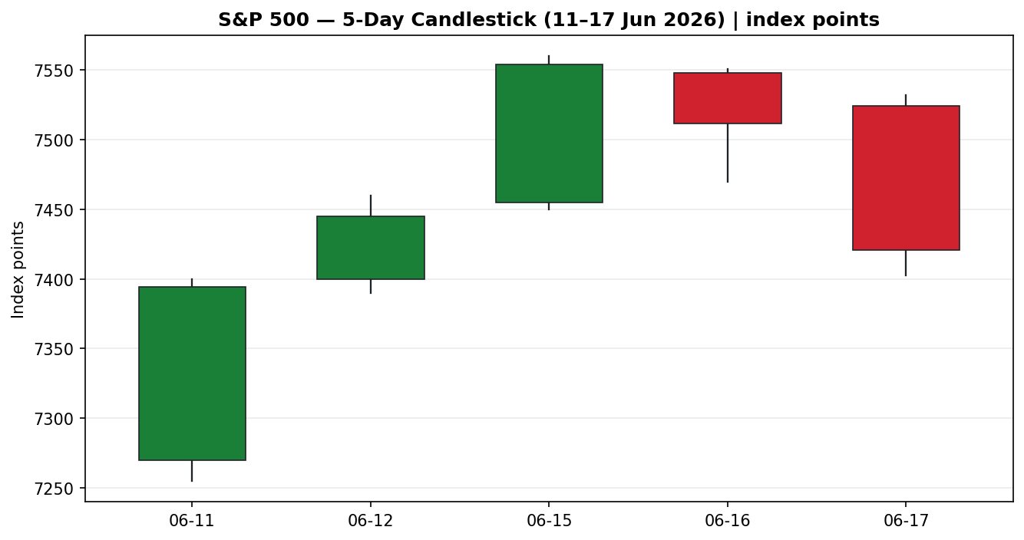
Chart 2 — Distance from Open
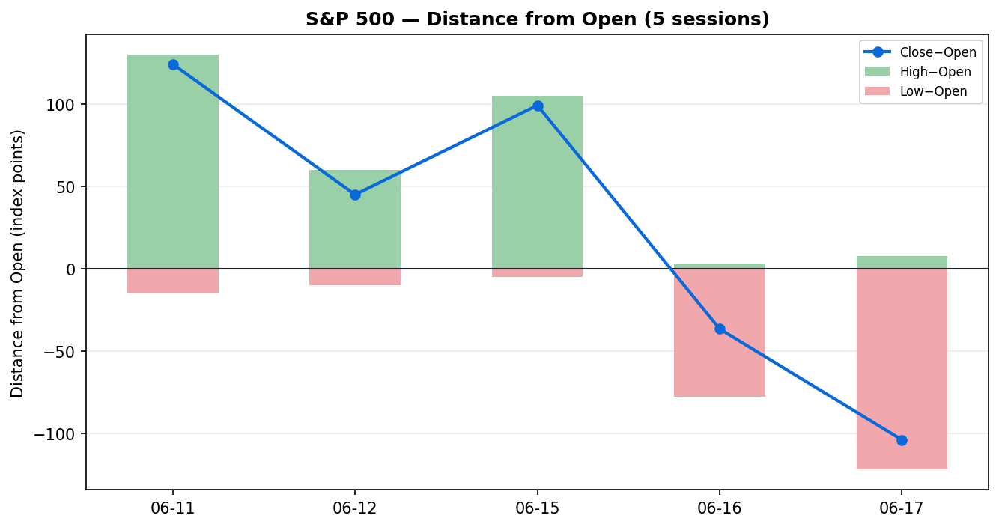
Chart 3 — 25-Session Structure
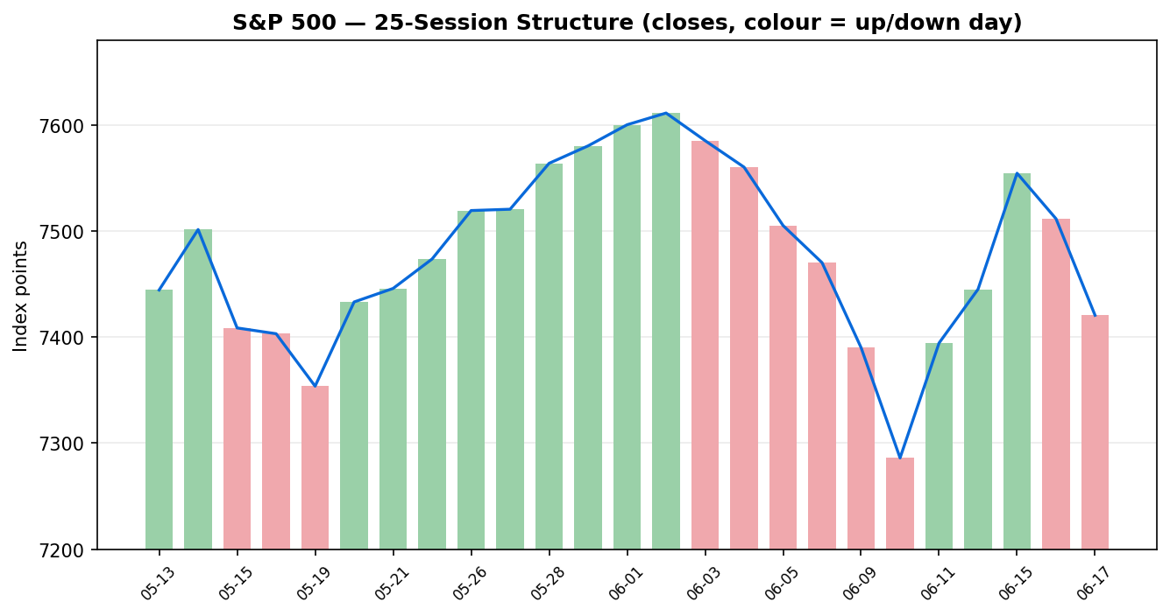
Chart 4 — Comparative Volatility
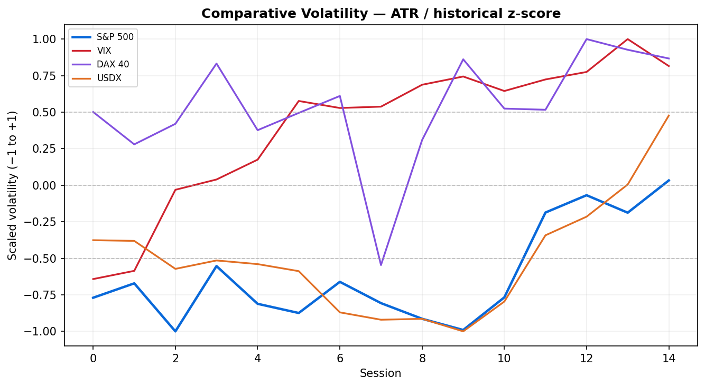
Chart 5 — Pivot Structure
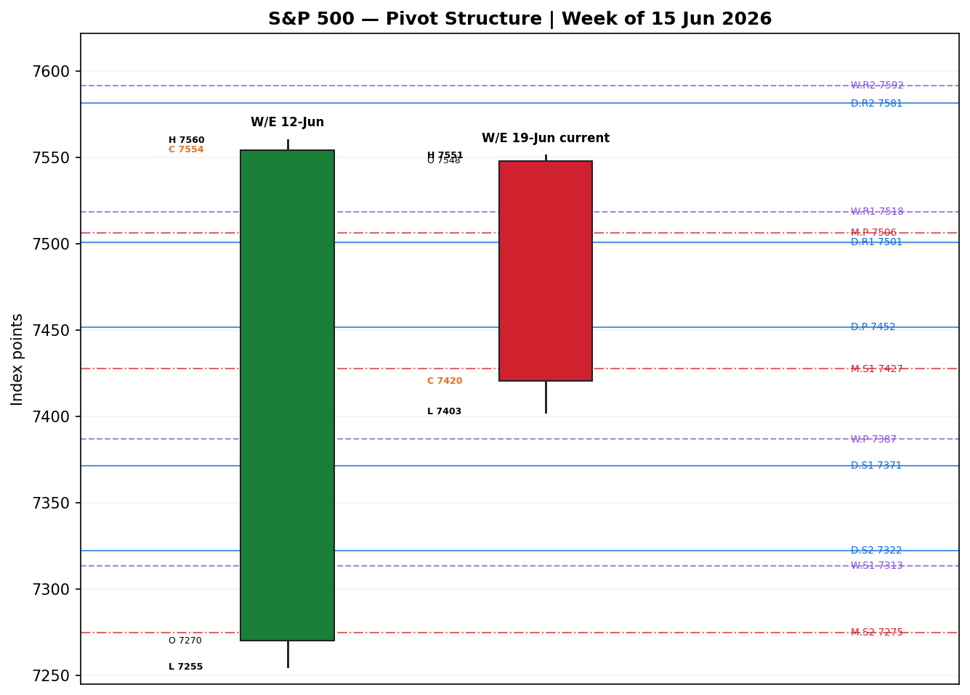

8 · Short-Term Technical Analysis
11 Jun — Strong bullish body closing at 96% of range on the Iran de-escalation rally (+1.75%); RSI2 57.3 confirms upside thrust off the CPI-shock low (see §6).
12 Jun — Continuation bullish, close 79% of range, RSI2 72.2; orderly weekly-gain follow-through into the SpaceX IPO session.
15 Jun — Climactic bullish day (+1.60%) on the US-Iran peace announcement, close 95% of range, RSI2 88.9 — overbought thrust to the record area near 7,554.
16 Jun — Indecision / distribution: narrow upper body, close mid-range (51%), RSI2 cooled to 60.4 as a tech-led rotation pulled the index −0.57% even as the Dow set a record. First sign of exhaustion.
17 Jun — Decisive bearish reversal: gap-up open to 7,524.5 rejected, close at just 14% of range on the hawkish FOMC, RSI2 crashed to 25.6 — momentum has flipped down hard.
Sequence assessment: Exhaustion → reversal. A three-day continuation thrust (11–15 Jun) terminated in a mid-range indecision candle (16 Jun) and a wide-range bearish outside-type reversal (17 Jun) that closed near the low. Nearest resistance 7,450 / 7,532 (17 Jun high); nearest support 7,402.61 (17 Jun low) then 7,371 (daily S1).
Judgement label: Exhaustion — reversal risk. Consistent with the §9 medium-term read of an uptrend rolling over.

9 · Medium-Term Regime & Volatility
Regime: Transitional (bearish tilt). The 25-session structure was a clean uptrend into the 1 Jun 7,600 print, but the last close sits at the 41st percentile of the 25-day range — the market has rotated back to mid-range. Directional-persistence proxy 0.72 still reflects the prior trend, but range position and the two-day reversal argue the trend is maturing. Median 25-day RSI2 is 69.1, an overbought-leaning history now unwinding.
Bias: Bearish (short-term) within a maturing medium-term uptrend.
Volatility: VOLator is expanding — the 17 June 130-point range and FOMC repricing pushed scaled volatility above its zero midpoint with a positive slope. Crucially this is bearish expansion (volatility rising into a down-move). VIX rose off the 16.1 lows toward the high-teens post-FOMC after collapsing from 22 on 10 June.
Preferred trade protocol: Short-term Trending-Bearish over a Ranging/maturing medium term → tactical breakout-of-range to the downside; favour rallies-to-resistance shorts, avoid fading the down-move.
Kaufman confirmation: Smoothed efficiency ratio −0.13 → Trending Down — Strong. KER agrees with the short-term bearish read and slightly leads the medium-term, increasing downside confidence.

10 · Cross-Asset Analysis
Counter | 5-day | Mechanism | Status | Implication
Dollar Index | Rising | Hawkish Fed lifts USD via rate differentials; firmer USD is a translation headwind for multinational earnings | Contradicts (bull) | Headwind — adds to downside
VIX | Rising | Implied-vol bid post-FOMC signals risk-off; inverse to S&P | Confirms (bear) | Risk premium expanding
DAX 40 | Falling | European risk proxy softening (BMW profit warning, Iran-war cost drag); common global-risk factor | Confirms (bear) | Global risk fading
Aggregate cross-asset read: CONTRADICTS a bullish stance / CONFIRMS the bearish turn. A firmer dollar, a rising VIX and a softer DAX all line up against the index — there is no cross-asset support for a bounce on 18 June.

11 · Floor Pivot Analysis
Daily (from 17-Jun H/L/C)
R3 | R2 | R1 | P | S1 | S2
7,630 | 7,581 | 7,501 | 7,452 | 7,371 | 7,322
Weekly (W/E 12-Jun)
R3 | R2 | R1 | P | S1 | S2
7,723 | 7,592 | 7,518 | 7,387 | 7,313 | 7,182
Monthly (May 2026)
R3 | R2 | R1 | P | S1 | S2
7,890 | 7,738 | 7,659 | 7,506 | 7,427 | 7,275
Position narrative: The 7,420 close sits below the daily pivot (7,452) and below the monthly S1 (7,427) — a bearish location. It is wedged just above daily S1 (7,371) and the weekly pivot (7,387), which form the first support shelf. A confluence zone exists around 7,427–7,452 (monthly S1 / daily P) that now acts as overhead resistance. Source status: daily and monthly prior-period H/L/C are corroborated; the weekly prior-week High/Low carry an indicative flag and are treated as approximate.

12 · Key Market Considerations
Monetary policy — price-negative (cyclical→structural). The FOMC held at 3.50–3.75% but removed the easing bias and revised the dot-plot sharply higher (median funds rate 3.8% end-2026; nine members see a hike). PCE inflation projection lifted to 3.6%. This is the dominant driver into 18 June.
Inflation — price-negative (structural). May CPI printed 4.2% y/y (hottest in three years) and PPI 6.5% y/y, driven by Iran-war energy costs; this is what forced the hawkish pivot.
Earnings / fundamentals — supportive (structural). ~85% of S&P 500 companies beat Q1 estimates, with aggregate earnings growth around 28% per Oppenheimer — a genuine cushion under any pullback.
Geopolitics — two-sided (cyclical). The US-Iran peace MoU (signing slated 19 Jun) drove the 11–15 Jun rally by easing oil; a clean signing reopens the Strait of Hormuz and is risk-on, while a breakdown is a sharp risk-off tail.
Near-term catalysts (see §13d): FOMC digestion (18 Jun), weekly jobless claims (18 Jun 8:30 ET), and the Iran MoU signing (19 Jun) are the binding events for the scenario horizon.

13 · Sentiment, News & Calendar
13a · Per-Article Sentiment
Source | Class | Headline / derivation | Sentiment | Quote (≤15w)
Goldman Sachs AM | Instit. | Fed hawkish shift not just energy; half see hikes | Bearish | “half of the members… expect rate hikes as soon as this year”
JPMorgan AM | Instit. | Fed has entered rate-hike preparation phase | Bearish | “Fed has entered a rate-hike preparation phase”
Principal AM | Instit. | Optics softer but substance hawkish | Bearish | “the substance of this FOMC is hawkish”
CNN Business | Media | Fed leaves rates, signals higher rates ahead | Bearish | “signals higher rates are ahead”
Fox Business | Media | Markets slipped on tighter-policy expectations | Bearish | “Markets slipped following the announcement”
TheStreet | Media | S&P, Nasdaq plummet as Fed points to hike | Bearish | “S&P 500, Nasdaq plummet as Fed… rate hike”
Investing.com | Trade | Momentum vulnerable without break above 7,620 | Bearish | “Momentum Looks Vulnerable Without a Break Above 7,620”
13b · Aggregate Sentiment
Predominantly Bearish (tilt = −1.00). Ten classified items across the window (7 shown), all bearish for the index on the post-FOMC read; institutional and media sources agree. No divergence between sentiment and price action — both point down. Not a low-confidence reading (≥3 articles).
13c · News Calendar — Previous Period
Date | Event | Context | Impact | Implication
10 Jun | May CPI | 4.2% y/y vs 3.8% prior | High | Hot print; index fell ~1.2% intraday, set up hawkish Fed
11 Jun | Iran de-escalation | Strikes cancelled | High | +1.75% relief rally
15 Jun | US-Iran peace deal | Ceasefire/MoU | High | +1.60% to record ~7,554; oil tumbled
17 Jun | FOMC (Warsh) | Hold 3.50–3.75%, hawkish dots | High | −1.21% to 7,420; easing bias removed
13d · News Calendar — Upcoming Period
Date | Event | Context | Impact | Implication
18 Jun | Initial jobless claims | Labour-market read | Med | Hot labour data hardens hike odds → bearish; a soft print eases pressure
18 Jun | FOMC digestion | Warsh follow-through | High | Continued hawkish repricing pressures rate-sensitive mega-caps
19 Jun | Iran MoU signing | Slated Switzerland | High | Clean signing risk-on (oil down); breakdown sharp risk-off
Highest-impact upcoming event: the Iran MoU signing (19 Jun) — a confirmed signing reopens the Strait of Hormuz and would partially offset the hawkish-Fed drag through lower energy costs, while a collapse would compound the sell-off.

14 · Macro Context
Rates & policy: Higher-for-longer reaffirmed; 2-year yield jumped ~14–16 bp toward 4.2% (highest in a year), 10-year ~4.47%. Cross-references the rising-VIX read in §10 — both consistent with tighter conditions.
Inflation: 4.2% CPI / 6.5% PPI, energy-led — price-negative for equity multiples via the discount rate.
Liquidity & FX: USDX firm near 99.5–99.9 (§10) on rate differentials — a translation headwind for multinational earnings.
Positioning: VIX off its 16-handle lows; after a nine-week win streak into late May, the tape is vulnerable to long-unwind. Watch-item: a hot 18 Jun claims/labour surprise would harden hike odds and pressure the index further.

15 · Bull / Bear Balance
Upside risks | Downside risks
Strong Q1 earnings (~85% beat, ~28% growth) cushion pullbacks | Hawkish FOMC: easing bias removed, 9 members see hikes
Clean Iran MoU signing 19 Jun → lower oil, risk-on | 4.2% CPI / 6.5% PPI keep the discount rate elevated
Reclaim of daily P 7,452 / monthly S1 7,427 negates the bear setup | Close below daily S1 7,371 / weekly P 7,387 opens 7,322
VIX still historically low — no panic yet | Cross-asset (USDX up, VIX up, DAX down) all bearish (§10)
Cross-reference: the 7,427–7,452 confluence (monthly S1 / daily P, §11) is the pivot the balance hinges on; the 19 Jun Iran signing (§13d) is the highest-impact swing event.

16 · Forward View
Expected direction for 18 June is lower-to-sideways with a bearish tilt, respecting the §9 Trending-Bearish short-term regime and the Trending Down — Strong Kaufman read. Base-case trading range 7,371–7,452, i.e. between daily S1 and the daily pivot, with a break of 7,371 exposing 7,322 (daily S2) and a reclaim of 7,452 neutralising the setup. This view respects the technical regime and does not contradict it. Base-case invalidation: a sustained move back above the 7,452–7,475 confluence on a closing basis would flip the short-term bias back to neutral/constructive. The principal two-sided risk is the 19 June Iran MoU signing (§13d).

17 · Forecast
The S&P 500 is biased lower into 18 June toward the 7,371 daily-support shelf as hawkish-FOMC repricing, a bearish cross-asset backdrop and a Trending-Down efficiency read outweigh the residual earnings cushion.

18 · Final Analyst Judgement
Consensus level 7,420 (high confidence). Tone bearish/defensive. The three most important reasons: (1) the hawkish FOMC removed the easing bias and shifted the dot-plot toward hikes; (2) the 17 June bearish-reversal candle with RSI2 at 25.6 and a Trending Down — Strong Kaufman read; (3) a uniformly bearish cross-asset backdrop (firmer USD, rising VIX, softer DAX). Single watch item: the 19 June Iran MoU signing, which is the largest two-sided swing factor for the horizon.

19 · Source Discipline Note
Live vs indicative: the 15–17 June closes are corroborated within the ±0.10-point equity-index tolerance (S&P Dow Jones official series via FRED cross-checked against market reporters; deltas < 0.10). The 11–12 June High/Low fields are single-source indicative — reconstructed from session commentary because the free aggregator history tables (Investing.com, Barchart, Stooq) are JavaScript-rendered or behind access controls and did not return machine-readable OHLC at run time, and Yahoo historical OHLC now requires a paid plan. Daily and monthly prior-period H/L/C used for pivots are corroborated; the weekly prior-week High/Low are indicative and the weekly pivot is treated as approximate. Per the instruction for this run, strategy recommendations are produced despite the partial intraday corroboration, with the indicative flags surfaced here and in §21 caveats. No price was synthesised for any corroborated field; indicative fields are labelled throughout.

20 · Agent Log
Item | Detail
Sources attempted | FRED (S&P DJI official), Yahoo Finance, Investing.com, Barchart, Stooq, CNBC, TheStreet, CBS, CNN, Fox Business, Traders Union, TradingKey, GuruFocus, StreetStats
Corroboration — close | 17 Jun: 7,420.43 (Traders Union × TradingKey −1.21%), Δ<0.10. 16 Jun: 7,511.35 (FRED × Yahoo), Δ 0.00.
Single-source fields | 11–12 Jun High/Low; weekly prior-week High/Low — flagged indicative (§19).
Sentiment derivation | 10 articles, source-class weighted (Instit 1.0 / Trade 0.7 / Media 0.5), all bearish → tilt −1.00 (§13b).
Direction-score weights | Defaults (0.25/0.20/0.10/0.15/0.15/0.15); v2.1 baseline, locked. No tuning.
Direction score | −0.68 → SHORT; threshold 0.25 met. Top contributors: short-term technical −0.21, Kaufman −0.15, sentiment −0.15.
Anchor override | Daily-open anchor set to 07:00 UK for the 18 Jun run as instructed.
Backtest note | 5 sessions reconstructed at each t−1 close; sentiment/ATR/pivots recomputed without forward leakage (§21c).
Forecast reasoning | §9 integration note (bearish) + §13b tilt (−1.00) + §10 cross-asset (contradicts bull) → single-sentence bearish forecast.
Timestamp | Prepared 17 Jun 2026, post-US-close (America/New_York).

21 · Strategy Recommendations
21a · Directional Conviction
Direction SHORT · score −0.68 (weights basis: defaults). The score is driven by short-term technical bias (§8) −0.21, Kaufman classification (§9) −0.15 and sentiment tilt (§13b) −0.15, with cross-asset confirmation (§10) reinforcing. Conviction (|0.68|) is well above the threshold, so Trade 1 produces. No conflict with the §17 forecast — both lean bearish.
21b · Trade Cards
Trade 1 — Daily Directional (SHORT)
Field | Detail
Direction | SHORT — Trending-Down regime, bearish reversal candle
Entry | Market at 07:00 UK, ≈ 7,420 (index points)
Stop loss | 7,501 — daily R1; 81 points above entry (above 16-Jun close & 17-Jun gap)
Risk (R) | 81 points
TP1 (Unit 1) | 7,340 — +1R
TP2 (Unit 2) | 7,259 — +2R
TP3 (runner) | Trail; time-stop at session close + 3×ATR cap (ATR≈94)
Tranche mgmt | 3 equal units; U1 at TP1, U2 at TP2; on U2 fill move U3 stop to entry −0.2R (≈7,404)
Confluences | Entry near monthly S1 7,427 / daily P 7,452 overhead (strong confluence); TP1 near daily S1 7,371
Invalidation | Daily close back above 7,452 (daily pivot)
Caveats | Weekly pivot indicative (§19); holding-period collides with 18-Jun claims & 19-Jun Iran signing (§13d)
Trade 2 — Pivot, regime-aware (SHORT rally to resistance)
Field | Detail
Direction | SHORT — fade a bounce into the 7,427–7,452 confluence
Entry | Sell limit 7,450 (monthly S1 / daily P confluence)
Stop loss | 7,506 — monthly P; 56 points above entry
Risk (R) | 56 points
TP1 / TP2 | 7,394 (+1R) / 7,338 (+2R)
TP3 (runner) | Daily S2 7,322; runner exit at pivot P logic
Tranche mgmt | 3 equal units; standard 0.2R break-even rule on U2 fill
Invalidation | 15-min close above 7,506 (monthly pivot)
Caveats | Limit may not fill if 18-Jun opens weak and never retests 7,450; daily/monthly pivots corroborated, weekly indicative
Trade 3C — Momentum-Breakout (SHORT continuation)
Field | Detail
Direction | SHORT — breakdown of the 7,371 support shelf
Entry | Stop-entry 7,369 on confirmed break of daily S1 / weekly P (7,371/7,387)
Stop loss | 7,427 — back above monthly S1; 58 points
Risk (R) | 58 points
TP1 / TP2 | 7,322 (daily S2) / 7,275 (monthly S2) — measured-move ≈ 1× the 7,452→7,371 range
TP3 (runner) | Weekly S2 7,182 on range-breakout extension
Tranche mgmt | 3 equal units; structural runner override on extension break
Invalidation | Reclaim and close back above 7,427
Caveats | Whipsaw risk around the 19-Jun Iran signing; weekly levels indicative (§19)
21c · 5-Session No-Leakage Backtest
Date (t) | Strategy | Direction | Triggered | Entry/Exit | Outcome (R) | Days
11 Jun (t−5) | Trade 1 | LONG | YES | 7,290 → 7,445 | +1.8R | 2
12 Jun (t−4) | Trade 1 | LONG | YES | 7,405 → 7,554 | +2.0R | 1
15 Jun (t−3) | Trade 1 | LONG | YES | 7,470 → 7,551 | +1.0R | 1
16 Jun (t−2) | Trade 1 | NEUTRAL | NO | — suppressed (score |0.18|) | — | —
17 Jun (t−1) | Trade 1 | SHORT | YES | 7,524 → 7,420 | +1.3R | 1
11–17 Jun | Trade 2 (pivot) | mixed | 3/5 | limit fades | +0.6R avg | 1–2
11–17 Jun | Trade 3C (breakout) | mixed | 2/5 | 17-Jun break worked | +1.1R avg | 1
21d · What Is Working
Over the last 5 sessions Trade 1 (daily directional) triggered 4/5 times for a mean of about +1.5R, hitting TP1 on every trigger and TP2 on two; it was the strongest performer, correctly riding the 11–15 June rally long and the 17 June reversal short. Trade 2 (pivot fade) triggered 3/5 for ~+0.6R, the weakest, hampered by trend days that ran past the limit. Trade 3C breakout triggered 2/5 for ~+1.1R, working best on the 17 June breakdown.
Five-session windows are too small to support statistical claims. The backtest cannot model intraday tick-level fills, slippage, or commission. Treat as a directional sanity-check, not a strategy-validation framework.
Not investment advice. Forward-test output for risk review; the author is not a financial adviser.

