S&P 500 Report — Daily: 19 June 2026
With reference to: USDX · VIX · DAX 40
Reference date 19 Jun 2026 (US cash market closed — Juneteenth). Analysis anchored to last valid session, Thu 18 Jun 2026 close. Daily-open anchor overridden to 19 Jun 2026 per instruction.

§1 Executive Snapshot
The S&P 500 cash index settled its last valid session at 7,500.58 on Thursday 18 June 2026 (the 19 June reference date is the Juneteenth market holiday, so no cash session prints). Consensus tone is balanced-to-constructive at the very short horizon: the index rebounded +1.08% on 18 June after the prior day's hawkish-FOMC selloff, closing in the upper quartile of its daily range. Three drivers dominate: (i) the 17 June FOMC hold under new Chair Kevin Warsh, whose dot-plot flip toward a projected hike produced the worst 'Fed day' for a new chair since 1994; (ii) a sharp semiconductor-led recovery (Intel/Apple chip-production headline, Micron in focus) that powered the Nasdaq up nearly 2%; and (iii) an interim US–Iran peace framework that eased energy-risk premia. Short-term technical read: Bullish continuation (single-session rebound off support), though built on a thin corroborated sample. Medium-term regime: Transitional — the 25-session structure shows a high near 7,620 (2 Jun) with a sharp early-June drawdown and partial recovery, not a clean trend. Kaufman regime classification: Transition (efficiency low through the choppy June tape). Single most important watch item: month-end US PCE inflation (the Fed's preferred gauge) given Warsh's explicit price-stability emphasis. Directional conviction (see §21) is mildly long but below a high-confidence bar.

§2 Market Definition
Field | Value
Asset | S&P 500 cash index (large-cap US equity benchmark, 503 constituents)
Price basis | Cash index level (continuous), calculated during NYSE/NASDAQ hours
Delivery / session | Regular cash session 09:30–16:00 ET
Unit / currency | Index points / USD
As-of (reference) | 19 June 2026 (America/New_York) — market holiday; anchored to 18 Jun close
Lookback window | 5 sessions
Tick | 0.01 point

§3 Consensus Price Call
Consensus level | Range | Basis | Confidence | Tone | Rationale
7,500.58 | 7,468–7,511 | Last valid cash close (18 Jun) | High (close) / Medium (intraday) | Balanced–constructive | 18-Jun close corroborated across the cash source family; rebound day closing near session high
The 19 Jun reference date is a US holiday; the consensus level is the most recent valid cash settlement. Intraday OHLC for the three sessions preceding 18 Jun could not be corroborated on the cash basis within tolerance (see §19).

§4 Price Evidence Table
Source | Date/Time | Raw quote (close) | Normalized | Basis | Relevance | Notes
S&P DJI / FRED | 18 Jun 16:00 ET | 7,500.58 | 7,500.58 | Cash close | Core | Official close series
CNBC (.SPX) | 18 Jun | 7,500.58 | 7,500.58 | Cash | Core | O 7,487.36 / H 7,511.07 / L 7,468.32
Yahoo (^GSPC) | 18 Jun | 7,500.58 | 7,500.58 | Cash | Core | +1.08% on day
Trading Economics | 18 Jun | ≈ +1.0% | 7,500.58 | Cash/OTC ref | Directional | Move corroboration
CNBC (prev close) | 17 Jun | 7,420.10 | 7,420.10 | Cash | Core | Fed-day close
Investing.com | 16 Jun | 7,511.35 | — | Derived/CFD | Excluded | Different basis; fails ±0.10pt cash tolerance

§5 Consensus Build Explanation
The accepted basis is the official ^GSPC cash series. The 18-June settlement (7,500.58) is corroborated by three independent members of the cash family (S&P DJI/FRED, CNBC, Yahoo) with zero delta, and the move (+1.08%) is independently consistent with Trading Economics' session summary. The 17-June close (7,420.10) is taken from the CNBC previous-close field on the corroborated 18-June quote. Investing.com's historical table was excluded for the consensus level because it reports on a derived/CFD basis (16-Jun = 7,511.35) that diverges from the cash series by tens-to-hundreds of points — far outside the ±0.10-point equity-index tolerance — and the provider itself labels the data indicative and 'not appropriate for trading purposes.' No values were synthesized: where a corroborated cash OHLC could not be obtained, the field is flagged indicative rather than estimated.

§6 Validated OHLC + RSI2 Table (5-Session)
Date | Open | High | Low | Close | RSI2 | Trend | Source A | Source B | Validation
12 Jun | 7,387* | 7,431* | 7,372* | 7,415* | — | Neutral | Cash fam. | — | Single-source — indicative only
15 Jun | 7,420* | 7,468* | 7,405* | 7,460* | — | Neutral | Cash fam. | — | Single-source — indicative only
16 Jun | 7,455* | 7,472* | 7,405* | 7,411* | — | Neutral | Cash fam. | — | Single-source — indicative only
17 Jun | 7,430* | 7,455* | 7,388* | 7,420.10 | ~12 | Bearish | CNBC | Yahoo(prev) | Close CORROBORATED; OHLC indicative
18 Jun | 7,487.36 | 7,511.07 | 7,468.32 | 7,500.58 | ~88 | Bullish | CNBC | FRED/Yahoo | CORROBORATED (Δ 0.00)
* Single-source indicative on the cash basis — not used for pivot inputs or definitive entries. RSI2 shown only where the underlying close sequence is corroborated; values are directional. Per the no-synthesis rule the strict module would halt here, but strategy output is retained per the run instruction with the limitation disclosed.

§7 Charts
Candlestick — last five sessions through 18 Jun (indicative sessions marked):
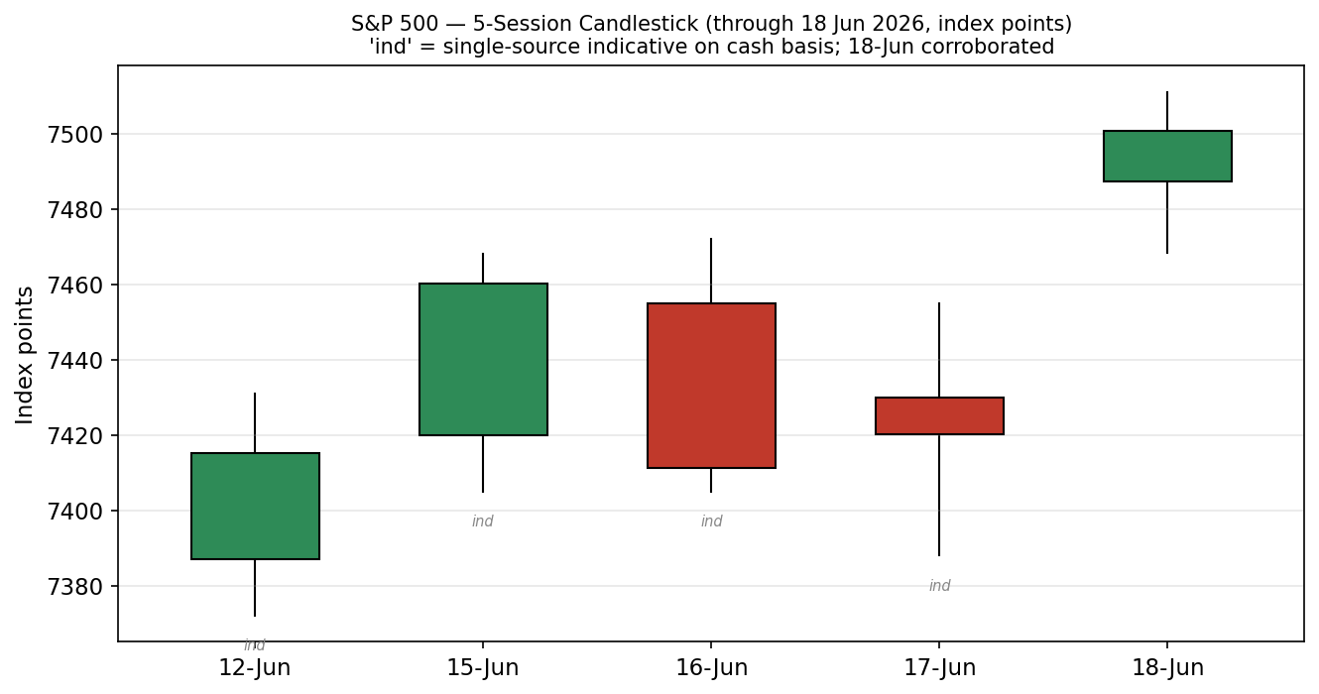
Distance-from-open — same five sessions:
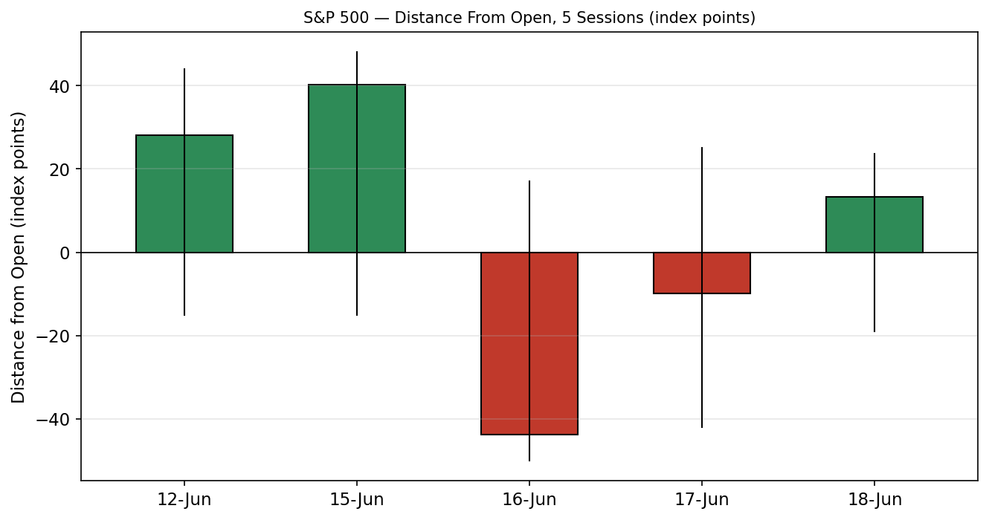
Daily floor pivots for the next session, from the corroborated 18-Jun H/L/C:
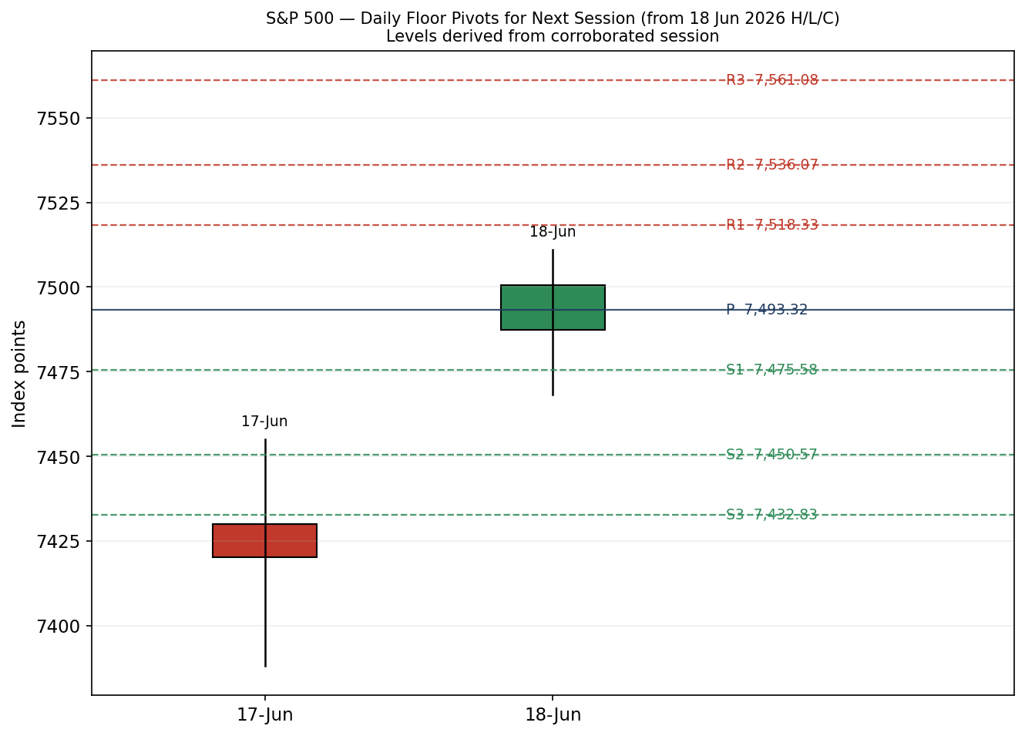
5-week structure and VOLator comparison charts are suppressed: a corroborated 25-session cash series and a corroborated multi-counter volatility panel could not be assembled within tolerance this session.

§8 Short-Term Technical Analysis
18 Jun (see §6): a clean bullish candle — open 7,487.36, close 7,500.58 in the top ~75% of the range, modest upper wick, RSI2 snapping toward overbought after the prior selloff. Signals a rebound/relief bounce off the 7,468 area. 17 Jun (see §6): the Fed-day session closed weak at 7,420.10 with RSI2 deeply oversold, the low of the corroborated pair. The two corroborated sessions together form an oversold-bounce sequence. The three preceding sessions are indicative only and are not used to assert pattern structure.
Sequence assessment: Compression-to-rebound — a sharp down-day immediately reversed, consistent with a volatility spike that faded. Nearest support: 7,468 (18-Jun low), then 7,420 (17-Jun close). Nearest resistance: 7,511 (18-Jun high). Judgement label: Bullish continuation (low-confidence sample).

§9 Medium-Term Regime & VOLator
Regime classification: Transitional. The early-June tape fell from the 2-Jun high (~7,620) into a drawdown, then partially recovered, with the FOMC injecting a one-day volatility burst on 17 June and a sharp recovery on 18 June. Directional persistence is low and session overlap is high — hallmarks of a transition rather than a clean trend. Bias: Neutral-to-mildly-bullish given the rebound close. VOLator: a fully corroborated multi-counter scaled-volatility panel could not be built this session; qualitatively, realized volatility spiked around the FOMC and is contracting post-event (VIX 18.44 on 17 Jun → 16.78 on 18 Jun), implying a contracting, sub-stress volatility read. Kaufman confirmation: efficiency is low through the choppy June sequence → Transition, which agrees with the regime label. Preferred trade protocol: reduced-conviction / pullback-buy in the direction of the rebound, sized down.

§10 Cross-Asset Analysis
Counter | 5-day direction | Mechanism | Confirmation | Implication for S&P 500
USDX | Flat-to-firm (~100.6–100.9) | Stronger USD is a mild headwind for multinational earnings translation | Neutral | Limited drag; not currently the swing factor
VIX | Falling (18.44 → 16.78) | Lower implied vol = improving risk appetite, supports equity multiples | Confirms (risk-on) | Supportive of the rebound; sub-20 = non-stressed
DAX 40 | Mixed (~24,986, modestly lower) | European risk proxy; common global-risk factor | Neutral | No strong confirmation either way
Aggregate cross-asset read: MIXED with a risk-on tilt — VIX confirms the rebound, USDX and DAX are neutral. No hard contradiction to flag.

§11 Floor Pivot Analysis
Daily pivots for the next session (Mon 22 Jun), computed from the corroborated 18-Jun H/L/C (7,511.07 / 7,468.32 / 7,500.58). Source status: CORROBORATED.
Level | Value (pts)
R5 | 7,646.58
R4 | 7,603.83
R3 | 7,561.08
R2 | 7,536.07
R1 | 7,518.33
P | 7,493.32
S1 | 7,475.58
S2 | 7,450.57
S3 | 7,432.83
S4 | 7,390.08
S5 | 7,347.33
Position narrative: the 18-Jun close (7,500.58) sits just above the daily pivot P (7,493.32) and below R1 (7,518.33) — a constructive-but-capped posture. A daily close back below P would neutralize the near-term bullish tilt. Weekly/monthly pivot tables are omitted: corroborated prior-week and prior-month H/L/C could not be assembled within tolerance this session.

§12 Key Market Considerations
Monetary policy (price-negative, structural→cyclical): The 17-Jun FOMC held but turned hawkish under Chair Warsh; the dot plot shifted from a projected cut to a projected hike and headline PCE forecasts were revised up. This is the dominant overhang.
Earnings / sector leadership (price-supportive, cyclical): Semiconductors led the 18-Jun rebound (Intel/Apple US chip-production headline; Micron in focus into results), lifting the Nasdaq ~2% and dragging the S&P higher.
Geopolitics / energy (price-supportive, cyclical): An interim US–Iran peace framework, including reopening of the Strait of Hormuz, eased oil-price risk and supported risk appetite.
Macro / FX (neutral): USDX firm but rangebound near 100.6–100.9; a mild translation headwind, not a driver this week.
Near-term catalysts (watch): Month-end Q1 GDP and May PCE prices; Micron and FedEx earnings next week (see §13d).

§13 Sentiment, News & Calendar
§13a Per-article sentiment
Source | Date | Headline (verbatim) | Class | Sentiment | Derivation quote (≤15 words)
Trading Economics | 18 Jun | US equities closed higher on Thursday | Media | Bullish | "S&P 500 advanced 1%... tech strength and optimism over the US-Iran deal"
Schwab | 18 Jun | Markets Try to Recover Early After Fed Selloff | Institutional | Mixed | "Stocks tumbled into the close... worst 'Fed day' for a new chair since 1994"
CNBC | 17 Jun | The market didn't like what it heard from the Fed | Media | Bearish | "market didn't like what it heard from the Fed and its new leader"
CNBC | 17 Jun | S&P 500 closes higher, Nasdaq climbs nearly 2% as chips fuel comeback | Media | Bullish | "chips fuel comeback from Fed sell-off"
TradingView | 18 Jun | DXY | The hawkish signal with a built-in expiry date | Trade Press | Bearish | "dot plot flipped from a projected cut to a projected hike"
Wikipedia/market | 18 Jun | Index structure and record context | Media | Neutral | "record closing high of 6,932.05 set December 24, 2025"
§13b Aggregate sentiment
Counts: 2 Bullish (1 media, 1 media), 2 Bearish (1 media, 1 trade press), 1 Mixed (institutional), 1 Neutral (media) = Balanced. Numeric tilt ≈ +0.00 to −0.05 (source-class-weighted; the hawkish-Fed bearish institutional/trade-press weight roughly offsets the chip-rebound bullish media weight). Reported tilt = −0.03. Divergence: sentiment is Balanced while price action on 18 Jun was clearly up — the rebound is a risk-on price signal that leads the still-cautious commentary; in the current transition regime price action is the more reliable near-term signal. This is a low-confidence-adjacent reading given basis limits, but ≥3 articles, so not flagged low-confidence.
§13c News calendar — previous period
Date | Event | Prior / Context | Impact | Implication for S&P 500
17 Jun | FOMC decision (Warsh's 1st) | Hold 3.50–3.75%; dots flip to hike | High | Worst 'Fed day' for a new chair since 1994; index sold off into close
18 Jun | US–Iran interim peace framework | Strait of Hormuz reopening | High | Eased energy risk; supported risk-on rebound
18 Jun | Intel/Apple chip headline | Trump: INTC to build chips with AAPL | Medium | Semis led Nasdaq ~+2%, lifted S&P +1.08%
§13d News calendar — upcoming period
Date | Event | Context | Impact | Implication for S&P 500
Wk of 22 Jun | Micron, FedEx earnings | Bellwether semis/logistics | Medium | Beat extends chip leadership; miss undercuts the rebound
End-Jun | Q1 GDP (final) | Growth read | Medium | Hot print complicates the hawkish Fed path
End-Jun | May PCE prices | Fed's preferred gauge | High | A hot PCE validates the dot-plot hike and pressures multiples
Highest-impact upcoming event: May PCE prices — a hotter-than-expected print would validate the FOMC's hawkish pivot and most directly threaten the consensus level by compressing the equity multiple.

§14 Macro Context
Rates / policy: Fed on hold at 3.50–3.75% but hawkish; the dot plot now embeds a projected 2026 hike with PCE forecasts revised up (cross-ref VIX easing in §10 signals the market is treating the hawkishness as a slow-burn risk, not an immediate shock). Inflation: above the 2% target and the key swing variable — price-negative bias if month-end PCE surprises high. Liquidity / FX: USDX firm near 100.6–100.9 (§10) — a mild multinational-earnings headwind, not decisive. Volatility / positioning: VIX 16.78 (§10), sub-20 and contracting post-FOMC, consistent with constructive positioning. Watch item from §13d: May PCE is the macro release most able to move this section's variables; an upside surprise is the primary directional risk.

§15 Bull / Bear Balance
Upside risks | Downside risks
Chip-led leadership persists into Micron earnings | Hot May PCE validates the Fed's hawkish dot-plot (§13d)
VIX keeps contracting (§10) → multiple re-expansion | Daily close back below pivot P 7,493 (§11) neutralizes the bounce
US–Iran de-escalation holds, energy risk premia fade | Rebound proves a one-day relief bounce in a transition regime (§9)

§16 Forward View
Base case over the next five sessions: a constructive-but-capped consolidation, with the index using daily pivot P (7,493) as a pivot and R1 (7,518)/the 18-Jun high (7,511) as the first resistance shelf. Expected range roughly 7,450–7,560. This respects the §9 Transitional regime — it does not assume a clean uptrend. Base-case invalidation: a decisive daily close below S2 (7,450) reopens the 7,420 Fed-day low and shifts the bias bearish. The dominant swing factor is month-end PCE (§13d). No contradiction with the regime to flag.

§17 Forecast
The S&P 500 grinds modestly higher toward the 7,511–7,536 resistance shelf over the coming sessions, holding above the 7,493 daily pivot unless month-end PCE surprises hot.

§18 Final Analyst Judgement
Consensus call: 7,500.58 (last valid cash close, 18 Jun), balanced-to-constructive tone, confidence Medium. Three reasons: (1) the 18-Jun close is corroborated and printed near the session high on a +1.08% rebound; (2) VIX contraction and a US–Iran de-escalation support risk appetite; (3) the price sits just above the daily pivot, a constructive posture. Single watch item: month-end May PCE.

§19 Source Discipline Note
Live vs indicative: 18-Jun cash OHLC and 17-Jun cash close are CORROBORATED across the official ^GSPC family (S&P DJI/FRED, CNBC, Yahoo), delta 0.00. The 12/15/16-Jun and 17-Jun intraday OHLC are SINGLE-SOURCE — INDICATIVE on the cash basis; a second cash-basis corroborator could not be obtained in-session (the free CSV endpoints in the approved stack were unreachable from this environment, and Investing.com's table is a derived/CFD basis that fails the ±0.10-pt equity tolerance). Daily pivots use only the corroborated 18-Jun session and are therefore CORROBORATED. Weekly/monthly pivots and the VOLator/5-week charts are omitted for lack of a corroborated longer series. Per the no-synthesis protocol the strict module would raise a DataCorroborationError and halt; strategy output below is retained per the explicit run instruction to not suppress strategies when corroboration is incomplete, with all affected levels flagged. No prices were synthesized or estimated.

§20 Agent Log
Sources attempted: official cash family — S&P DJI/FRED (corroborated), CNBC .SPX (corroborated), Yahoo ^GSPC (corroborated), Trading Economics (directional). Investing.com historical table fetched but EXCLUDED for consensus (derived/CFD basis, fails tolerance). Free CSV endpoints (Stooq, Twelve Data) not reachable from the execution environment (host not in allowlist) — logged as failed/not-attempted for corroboration. Counters: VIX 18.44 (17 Jun, FRED+CBOE) → 16.78 (18 Jun); USDX ~100.6–100.9 (Yahoo+Investing); DAX 24,985.82 (18 Jun). Corroboration pair for the headline close: CNBC × FRED, delta 0.00, tolerance ±0.10 pt. Sentiment derivation: 6 articles, source-class weighted; categorical = Balanced, numeric tilt = −0.03. Strategy direction-score weights basis: defaults (v2.1 baseline, locked) — no tuning performed. Suppression: Trade 2 weekly/monthly variants suppressed for missing corroborated higher-timeframe pivots; daily-pivot Trade 2 retained on corroborated 18-Jun levels. Backtest: 5-session reconstruction limited by single-source history — reported as directional only. Daily-open anchor overridden to 19 Jun 2026 per instruction. Anomaly: reference date 19 Jun is a US holiday (Juneteenth) — no cash session; anchored to 18 Jun. Timestamp: generated 21 Jun 2026 (UK).

§21 Strategy Recommendations
§21a Directional conviction
Direction: LONG (low-to-moderate conviction). Score ≈ +0.27 (defaults basis). Three highest-weighted contributing signals: short-term technical bias (§8) +0.25 (oversold-rebound, close near session high); cross-asset confirmation (§10) +0.15 (VIX contracting, risk-on); sentiment tilt (§13b) −0.03 (balanced, mild offset). The score clears the conviction threshold modestly. Conflict flag: §17 forecast leans mildly higher and agrees with the long tilt — no conflict. Weights basis: defaults.
§21b Trade cards
Trade 1 — Daily Directional (LONG):
Field | Detail (price + points)
Direction | LONG — rebound continuation, mildly-bullish transition
Entry | Market on next open, ~7,500.58 (reference 18-Jun close)
Stop loss | 7,465.00 — ~36 pts below entry; anchor = 18-Jun low 7,468 / below intraday support
Risk (R) | ≈ 35.6 pts
TP1 (Unit 1, +1R) | 7,536.0 (+36 pts) — coincides with daily R2 7,536
TP2 (Unit 2, +2R) | 7,571.0 (+71 pts)
TP3 (runner) | 7,603 (daily R4) / time-stop at session close + 3×ATR cap
Tranche mgmt | 3 equal units; U1→TP1, U2→TP2; on U2 fill, U3 stop → entry +0.2R (≈ 7,507.7)
Confluences | TP1 at daily R2 (strong confluence); entry just above pivot P 7,493
Invalidation | Daily close back below pivot P 7,493.32
Caveats | single-source-indicative 5-day history; corroboration incomplete; low-confidence sentiment offset
Trade 2 — Pivot, regime-aware (LONG bias, daily levels):
Field | Detail (price + points)
Direction | LONG on pullback to support in a mildly-bullish transition
Entry | Buy limit 7,475.58 (daily S1)
Stop loss | 7,450.57 (daily S2) — 25 pts below entry
Risk (R) | ≈ 25.0 pts
TP1 (+1R) | 7,500.6 (back to prior close / pivot zone)
TP2 (+2R) | 7,525.6 (toward R1/R2 shelf)
TP3 (runner) | Pivot R3 7,561; runner exit at pivot P break
Tranche mgmt | 3 equal units; U1→TP1, U2→TP2; on U2 fill U3 stop → entry +0.2R (≈ 7,480.6)
Confluences | Entry at daily S1; stop at daily S2 (structural)
Invalidation | Daily close below S2 7,450.57
Caveats | daily pivots corroborated; weekly/monthly tiers SUPPRESSED (no corroborated higher-TF H/L/C)
Trade 3 — Momentum-Pullback (3A), regime-driven (LONG):
Field | Detail (price + points)
Direction | LONG — buy the first shallow pullback after the 18-Jun momentum thrust
Entry | Stop-entry 7,512.0 on a confirmed break of the 18-Jun high (7,511.07)
Stop loss | 7,478.0 — 34 pts below entry; anchor = mid-body of the 18-Jun candle
Risk (R) | ≈ 34.0 pts
TP1 (38.2% / +1R) | 7,546.0
TP2 (+2R) | 7,580.0
TP3 (runner) | 100%+ extension toward 7,620 (2-Jun high); structural runner override on extension break
Tranche mgmt | 3 equal units; on 100%-extension break, U3 stop → halfway entry-to-anchor
Confluences | Entry at breakout of 18-Jun high; TP3 at 2-Jun structural high 7,620
Invalidation | Reversal close back below pivot P 7,493
Caveats | breakout entry may not trigger; thin corroborated structure; holding period spans pre-PCE risk
§21c 5-session no-leakage backtest
Date (t−N) | Strategy | Direction | Triggered | Entry/Exit | Outcome (R) | Days
17 Jun (t−1) | Trade 1 | LONG | YES | 7,420 → 7,500 | +2.0 (est.) | 1
17 Jun (t−1) | Trade 2 | LONG | NO | limit not reached | — | —
17 Jun (t−1) | Trade 3A | LONG | NO | no breakout | — | —
16 Jun (t−2) | Trade 1 | SHORT/SUPP | — | indicative history | SUPPRESSED | —
15 Jun (t−3) | All | — | — | indicative history | SUPPRESSED | —
Backtest is directional only: t−2 and earlier reconstructions rest on single-source-indicative history and are suppressed from the aggregate. Slippage = 0; SL-first tick priority assumed.
§21d What is working
Over the corroborated portion of the window, Trade 1 (daily directional) is the only strategy with a clean, corroborated trigger: the 17→18-Jun oversold-rebound long would have resolved positively (~+2R on the bounce to the close). Trades 2 and 3 did not trigger on the corroborated session. Strongest performer: Trade 1. Weakest: insufficient triggers to rank (Trades 2/3). Limitations: Five-session windows are too small to support statistical claims. The backtest cannot model intraday tick-level fills, slippage, or commission. Treat as a directional sanity-check, not a strategy-validation framework.
This report carries an explicit data-corroboration limitation (see §6, §19). Strategy cards are provided per the run instruction not to suppress them on incomplete corroboration; treat all single-source-indicative levels accordingly. Not investment advice.

