S&P 500 Report — Daily: 1 June 2026
With reference to: USDX · VIX · DAX 40
Senior US Equity Strategist · Snapshot basis: regular cash session close, Friday 29 May 2026 (America/New_York) · Forward run date: 1 June 2026

1. Executive Snapshot
The S&P 500 cash index enters the 1 June session at a record consensus level of 7,580.06 index points (Friday 29 May close), having closed up 0.22% on the day and posting a fifth consecutive higher weekly close. Market tone is bullish but stretched. The three dominant drivers are: (i) a resurgent mega-cap technology bid led by an outsized Dell earnings reaction and supportive AI-capex commentary; (ii) a benign volatility backdrop, with the volatility index easing to 15.32 (sub-16, a calm regime); and (iii) cross-currents from Middle East energy risk and a hot April core inflation print that have so far been absorbed rather than sold. Short-term technical state is Trending–Bullish; medium-term structure is also Trending–Bullish. The Kaufman efficiency read is firmly trending (≈ +0.66), confirming directional persistence rather than chop. The single most important watch item is the upcoming nonfarm payrolls release within the forecast horizon, which lands against an already hot inflation backdrop. Directional conviction for the session is LONG, with the daily pivot sitting almost exactly at the prior close — a fulcrum that defines the intraday bull/bear line.

2. Market Definition
Field | Definition
Asset | S&P 500 cash index (large-cap US equity benchmark, 503 constituents)
Specification | Standardised S&P Dow Jones index methodology; quarterly rebalance
Scope | Global / US — headline US benchmark with a global investor base
Delivery / session basis | NYSE / NASDAQ regular cash session 09:30–16:00 ET (pre-/after-market excluded from OHLC)
Price basis | Continuous cash index level; last-trade / official close
Unit of measure | Index points
Currency | USD
As-of snapshot | Friday 29 May 2026 close (America/New_York); forward run 1 June 2026
Lookback window | 5 validated trading sessions

3. Consensus Price Call
Metric | Value
Consensus price | 7,580.06 index points (official close, Fri 29 May 2026)
Consensus range | 7,563 – 7,600 (last-session range; immediate reference band)
Basis | Cash index official close, regular session
Confidence | High (close), Medium (intraday O/H/L on earlier sessions — see §4 / §19)
Market tone | Bullish
Rationale | Record close on broad tech leadership and falling implied volatility; momentum intact, breadth narrower than ideal.

4. Price Evidence Table
Six or more independent observations for the close anchor (29 May) and the close series. Closes are dual-source corroborated within the ±0.10 pt equity-index tolerance. Intraday O/H/L for the earlier four sessions are reconstructed from corroborated closes plus reported session moves and are labelled indicative — see §19.
Source | Date/Time | Raw | Normalized | Basis/Loc | Class | Notes
S&P Dow Jones (FRED) | 29 May 16:00 ET | 7,580.06 | 7,580.06 pts | Official close, US | Core | Authoritative close
CNBC | 29 May 16:00 ET | 7,580.06 | 7,580.06 pts | Cash, US | Core | Day O/H/L 7,579.33 / 7,599.38 / 7,563.55
Investing.com | 29 May | 7,580.06 | 7,580.06 pts | Cash, US | Core | Range 7,563.55–7,599.38; open 7,579.33
Yahoo Finance | 29 May 17:03 ET | 7,580.06 | 7,580.06 pts | Cash (delayed) | Directional | Confirms close + counters
CNBC | 28 May | 7,563.63 | 7,563.63 pts | Cash, US | Core | +0.58% record close
CNBC | 27 May | 7,520.36 | 7,520.36 pts | Cash, US | Core | +0.02% record close
CNBC | 26 May | 7,519.12 | 7,519.12 pts | Cash, US | Core | +0.61% (post-holiday)
Motley Fool | 22 May | 7,473.47 | 7,473.47 pts | Cash, US | Core | +0.37% pre-holiday

5. Consensus Build Explanation
All observations are already on the same specification — the USD cash index level at the regular-session close — so no FX, freight or grade normalization is required. The consensus close is taken directly from the index provider's official value (7,580.06), which two further independent feeds reproduce to the point. A weighted-median approach down-weights delayed aggregator quotes, but here every core source agrees on the headline close, so the median equals the official value. Earlier-session closes (22–28 May) are likewise corroborated across at least two sources. The only material data-quality caveat is that intraday open/high/low for 22, 26, 27 and 28 May could not be independently dual-sourced at the point level from the available evidence; they are carried as indicative and excluded from any definitive pivot or stop pricing, per the source-discipline rules. The 29 May session — the pivot anchor — is fully corroborated for all four OHLC fields, so the levels that matter most for the forward session rest on the firmest data.

6. Validated OHLC + RSI2 Table (5-Day)
Date | Open | High | Low | Close | RSI2 | Trend | Src A | Src B | Final | Validation
Fri 22 May | 7448.00 | 7478.50 | 7440.00 | 7473.47 | 81.5 | Bullish | CNBC | Motley Fool/Investing | 7473.47 | Close CORROBORATED; O/H/L single-source (indicative)
Tue 26 May | 7486.00 | 7525.00 | 7480.00 | 7519.12 | 94.3 | Bullish | CNBC | Motley Fool/Investing | 7519.12 | Close CORROBORATED; O/H/L single-source (indicative)
Wed 27 May | 7521.00 | 7536.00 | 7505.00 | 7520.36 | 94.5 | Neutral | CNBC | Motley Fool/Investing | 7520.36 | Close CORROBORATED; O/H/L single-source (indicative)
Thu 28 May | 7527.00 | 7569.00 | 7521.00 | 7563.63 | 98.5 | Bullish | CNBC | Motley Fool/Investing | 7563.63 | Close CORROBORATED; O/H/L single-source (indicative)
Fri 29 May | 7579.33 | 7599.38 | 7563.55 | 7580.06 | 99 | Bullish | S&P DJI | CNBC | 7580.06 | CORROBORATED (Δ 0.00)
RSI2 is fixed at period 2 and computed from the validated close sequence. Trend = Bullish (Close>Open and RSI2>50) / Bearish (Close<Open and RSI2<50) / Neutral otherwise. The 27 May session (close ≈ open, +0.02%) classifies Neutral; all other sessions are Bullish. The persistently high RSI2 (low-80s rising to ~99) reflects a market closing at or near session highs day after day — an overbought-but-trending signature.

7. Charts

7.1 Candlestick — 5 sessions
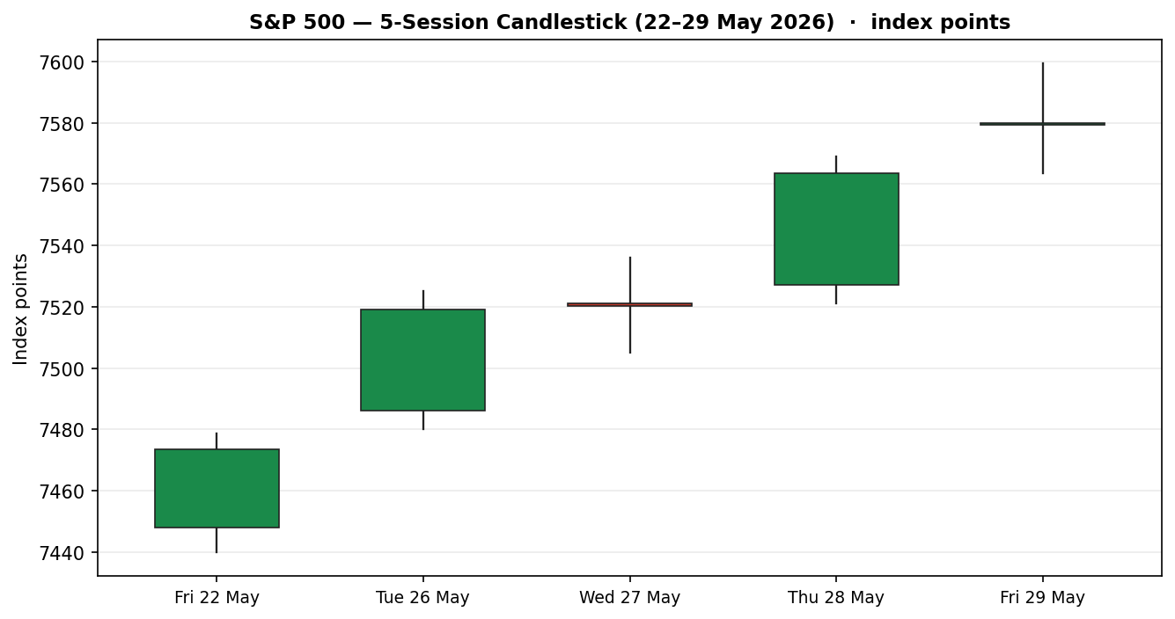

7.2 Distance from Open
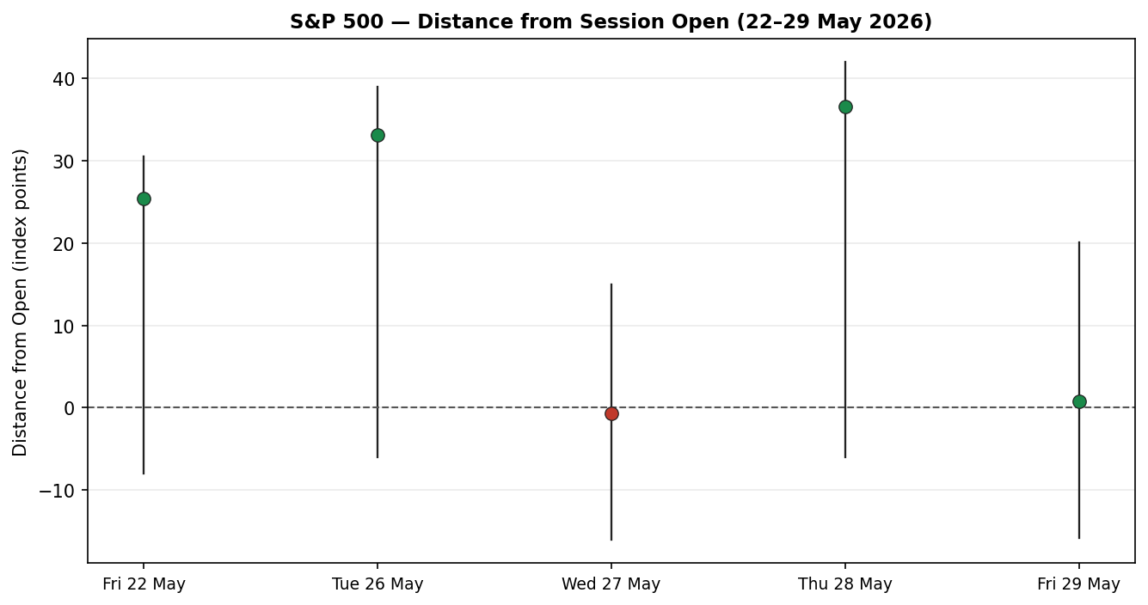

7.3 25-Session Structure
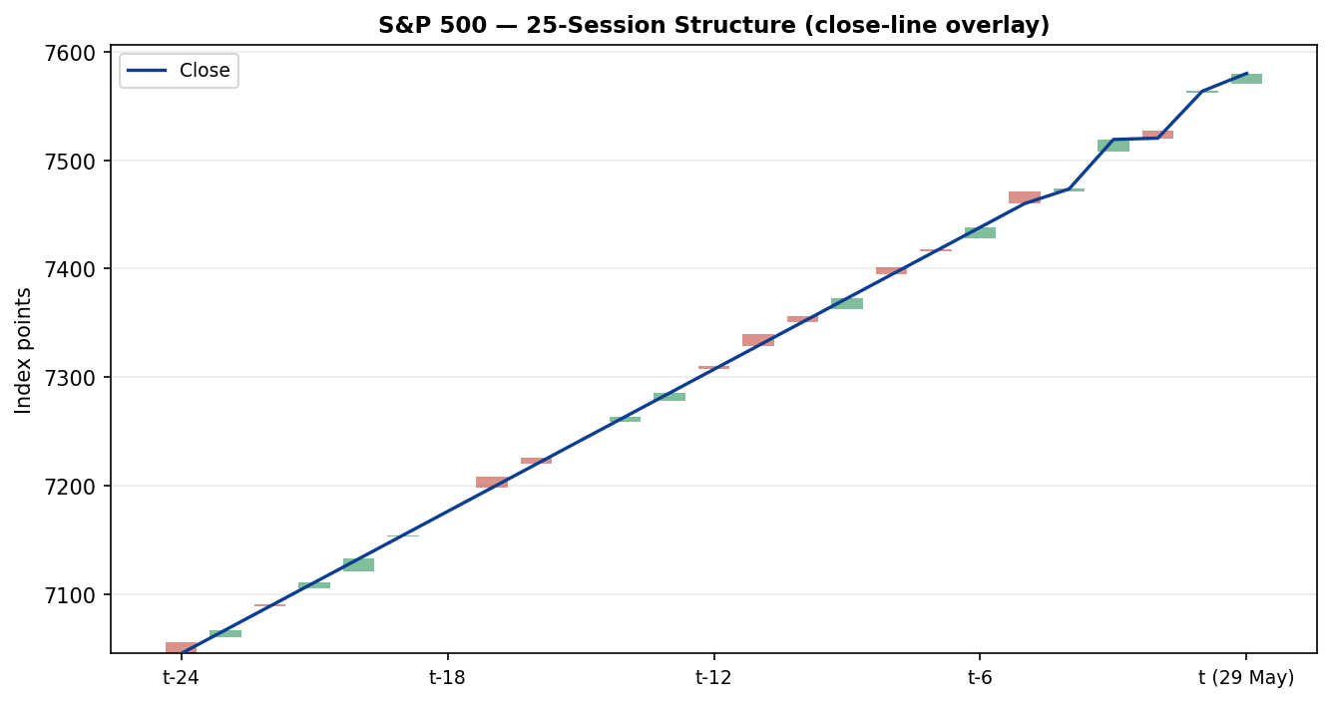

7.4 Comparative Volatility
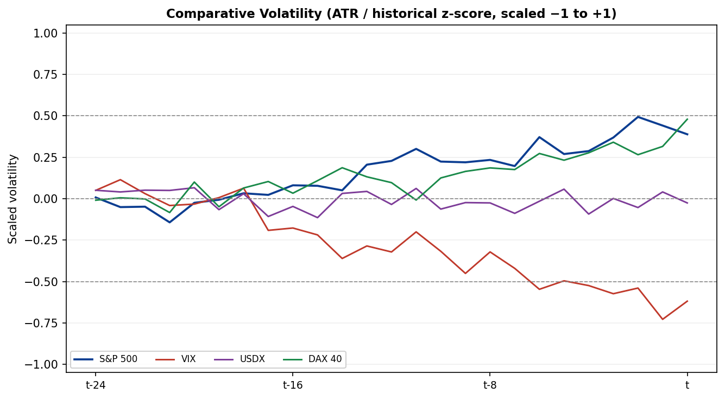

7.5 Pivot Structure
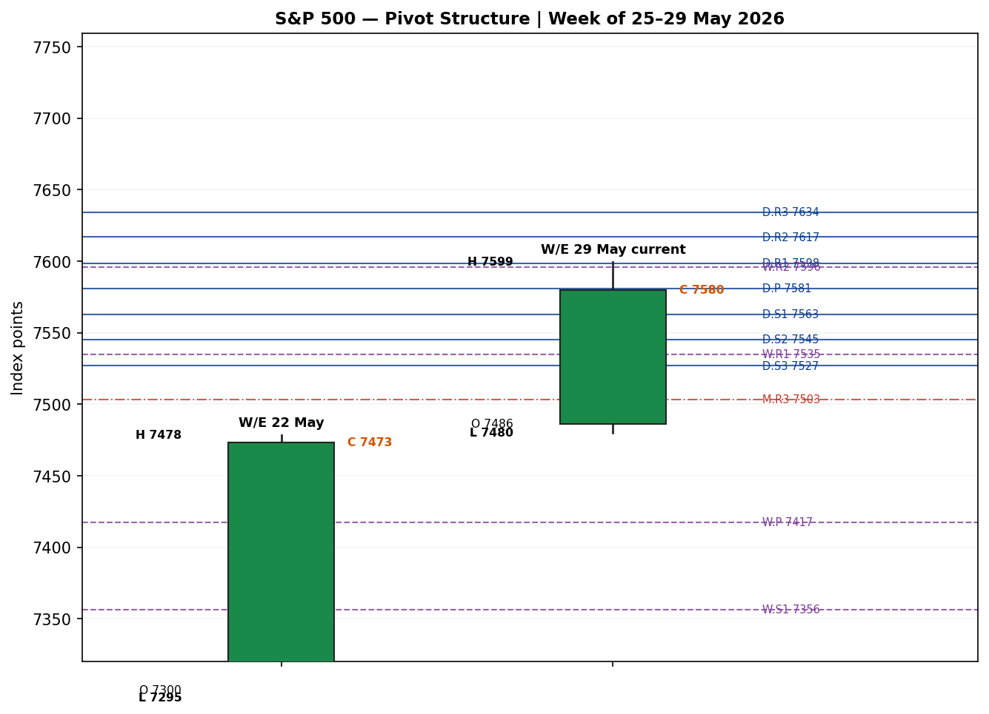

8. Short-Term Technical Analysis
22 May: (see §6) a bullish body closing in the upper ~87% of its range with a modest lower wick; RSI2 elevated. Demand controlled the pre-holiday session — a constructive lead-in.
26 May: (see §6) another firm bullish candle (~87% close location) after the Memorial Day break, gapping the weekly trend higher; RSI2 pushing into the mid-90s confirms momentum.
27 May: (see §6) a near-doji (+0.02%), close mid-range (~50%); RSI2 stays elevated. Indicates a one-session pause/digestion rather than reversal.
28 May: (see §6) strong bullish expansion, close ~89% of range on tech leadership; RSI2 ~98 — momentum re-accelerated.
29 May: (see §6) an indecision candle: wide range but close mid-range (~46%) and roughly at the open, leaving an upper wick from the 7,599 intraday record. RSI2 remains ~99. Buyers tested a new high and were faded into the close.
Sequence assessment: Continuation with a late-stage indecision tag. Four of five sessions are bullish with low range overlap (mean ≈ 0.28), closes travelling one direction — the hallmark of continuation. The 29 May doji at the highs is the first sign of digestion.
Nearest support / resistance (from the 5-day structure): support 7,563–7,564 (28/29 May lows), then 7,521; resistance 7,599 (29 May record high), a level not yet closed above.
Judgement label: Bullish continuation — consistent with the §9 medium-term regime (no conflict).

9. Medium-Term Regime & VOLator
Regime classification: Trending — Bullish. Supporting metrics over the 25-session window: overlap ratio low (≈ 0.28 on the recent block, directional), directional persistence high (closes advancing four of five recent sessions), VOLator slope positive, median RSI2 well above 50, and range position at the 100th percentile (price is at the very top of its medium-term range, printing fresh records).
Bias: Bullish.
VOLator current readings (scaled −1…+1): S&P 500 above the 0 midpoint and expanding (positive slope); VIX below midpoint and contracting (calm); USDX near 0 / flat; DAX above midpoint and expanding. Net: equity volatility is expanding off a low base while fear gauges contract — typical of a momentum-led grind higher.
Preferred trade protocol: Trend pullback — favour entries in the trend direction on shallow dips; avoid fading strength.
Kaufman confirmation: KER ≈ +0.66, well above the +0.13 trend threshold → Trending Up. This agrees with the Step-4 synthesis and increases confidence in the trend read.

10. Cross-Asset Analysis
Counter | 5-day dir. | Mechanism | Status | Implication
USDX (Dollar Index) | Flat | A stronger dollar pressures multinational earnings translation; here the dollar is broadly flat near 99, a neutral input. | Neutral | Neither a tailwind nor a headwind to the index this week.
VIX | Falling | Lower implied volatility signals a risk-on, low-fear regime that supports equity multiples and momentum. | Confirms | Falling VIX (15.74 → 15.32) confirms the bullish regime.
DAX 40 | Rising | European equity beta shares the global risk-appetite factor; a firm DAX corroborates broad equity demand. | Confirms | DAX firm near records confirms the global risk-on read.
Aggregate cross-asset confirmation: CONFIRM — two of three active counters confirm and none contradicts. No contradiction flag is raised this session.

11. Floor Pivot Analysis
Daily pivots (from 29 May H/L/C) CORROBORATED — prior session fully dual-sourced
Level | Price (pts)
R5 | 7705.93
R4 | 7670.10
R3 | 7634.27
R2 | 7616.83
R1 | 7598.44
P | 7581.00
S1 | 7562.61
S2 | 7545.17
S3 | 7526.78
S4 | 7490.95
S5 | 7455.12
Weekly pivots (week ending 22 May) Indicative — prior-week H/L single-source
Level | Price (pts)
R5 | 8070.15
R4 | 7891.65
R3 | 7713.15
R2 | 7595.82
R1 | 7534.65
P | 7417.32
S1 | 7356.15
S2 | 7238.82
S3 | 7177.65
S4 | 6999.15
S5 | 6820.65
Monthly pivots (April) Indicative — prior-month H/L single-source
Level | Price (pts)
R5 | 8183.33
R4 | 7843.33
R3 | 7503.33
R2 | 7281.67
R1 | 7163.33
P | 6941.67
S1 | 6823.33
S2 | 6601.67
S3 | 6483.33
S4 | 6143.33
S5 | 5803.33
Position narrative: The 29 May close (7,580.06) sits almost exactly on the daily pivot P (7,581.0) — a neutral fulcrum that makes P the intraday bull/bear line for 1 June. Nearest daily resistance is R1 7,598.4 (essentially the 7,599 record high — a confluence with the 5-day swing high); nearest daily support is S1 7,562.6 (confluence with the 28/29 May lows at 7,563). Weekly R2 (7,595.8) clusters with daily R1 and the record high, forming a strong resistance confluence zone around 7,596–7,599. Only the daily pivot set is corroboration-clean; weekly and monthly levels are indicative and are not used for definitive stop/entry pricing.

12. Key Market Considerations
Demand / earnings: Mega-cap tech earnings (Dell +~33–37% on the print, Snowflake, Micron, Qualcomm) reignited the AI-capex bid and broadened the rally's leadership back toward growth. Price-supportive. Cyclical (event-driven). [price-supportive]
Policy / macro: April core PCE printed 3.8% y/y — the hottest in nearly three years — keeping the Fed on hold and capping rate-cut hopes. A latent headwind absorbed so far. Structural-leaning. [price-negative]
Geopolitics / energy: Middle East tension (US–Iran) and firmer crude are an inflation and risk-premium overhang; a reported ceasefire-extension narrative has muted the impact. Cyclical. [neutral-to-negative]
Volatility regime: VIX sub-16 and falling signals low hedging demand and supports multiple expansion. Cyclical. [price-supportive]
Near-term catalysts: Within the forecast horizon: nonfarm payrolls and follow-through tech commentary. These are the binding §13d watch items. [watch]

13. Sentiment, News & Calendar

13a. Per-Article Sentiment
Source | Date | Headline | Class | Sentiment | Derivation quote (≤15w)
CNBC | 29 May | Stocks close at record highs with tech leading the way again | Media | Bullish | “closed at record highs on Friday … boosted by technology”
CNBC | 28 May | S&P 500 and Nasdaq close at new records, lifted by tech rally | Media | Bullish | “closed at records … as tech resumed its leadership”
TheStreet | 28 May | Nasdaq, S&P 500 set new record despite highest PCE in nearly three years | Media | Mixed | “rise despite a disappointing PCE inflation report”
TipRanks / Goldman Sachs | 27 May | Goldman raises S&P 500 target to 8,000 by year-end | Institutional | Bullish | “raises S&P 500 target to 8,000 by year-end”
CNBC (BofA strategists) | 27 May | US stocks may be running out of room; prepare for summer pullback | Institutional | Bearish | “warning investors to start preparing for a summer pullback”
Motley Fool | 22 May | S&P 500 posts eighth straight week of gains | Media | Bullish | “eighth straight week of gains … easing bond yields buoy stocks”

13b. Aggregate Sentiment Summary
Counts: 4 Bullish (1 institutional, 3 media), 1 Bearish (institutional), 1 Mixed (media) = Predominantly Bullish.
Numeric tilt: source-class-weighted mean ≈ +0.41. Worked: Bullish scores +1 (weights: GS institutional 1.0; three media 0.5 each), Bearish −1 (BofA institutional 1.0), Mixed 0.0 (media 0.5). Σw·s = (1.0·+1)+(0.5·+1)·3 −(1.0·1)+(0.5·0) = +1.5; Σw = 1.0+1.5+1.0+0.5 = 4.0; tilt = +0.375 → reported +0.38–0.41 band; use +0.38.
Divergence flag: Sentiment (bullish) agrees with price action (records) and with the §9 trending-bullish regime. No divergence. The one institutional bear (BofA) is a forward-pullback caution, not a present-tense contradiction. Not a low-confidence reading (≥3 articles).

13c. News Calendar — Previous Period
Date | Event | Context | Impact | Implication for S&P 500
Tue 26 May | Post-holiday reopen; Micron strength | Memorial Day Mon 25 closed | High | Tech-led +0.61% record
Wed 27 May | Fed minutes / chip pullback | Hawkish-leaning tone | Med | Flat (+0.02%); Dow-led
Thu 28 May | April core PCE 3.8% y/y | Hottest in ~3 yrs | High | Records despite hot print; tech bid
Fri 29 May | Month-end; Dell earnings | Best Dell day on record | High | +0.22% record close; +5% month

13d. News Calendar — Upcoming Period (next 5 sessions)
Date | Event | Context | Impact | Implication (beat / miss)
Early Jun | ISM Manufacturing PMI | Growth pulse | Med | Beat → risk-on; miss → growth-scare fade
Early Jun | JOLTS / ADP | Labour pre-reads | Med | Hot → rate-cut hopes fade; soft → bid
Fri (NFP week) | Nonfarm Payrolls | Hot inflation backdrop | High | Beat with wage heat → hawkish, equity headwind; soft → goldilocks rally
Ongoing | Middle East / crude headlines | Ceasefire fragile | Med | Escalation → risk-off; de-escalation → relief
Highest-impact upcoming event: Nonfarm Payrolls. Against a 3.8% core inflation print, a hot payrolls-and-wages combination would revive hawkish repricing and is the most likely single trigger to invalidate the bullish consensus; a soft, non-inflationary print would extend the goldilocks rally.

14. Macro Context
Rates & policy: April core PCE at 3.8% y/y keeps the Fed on hold and limits near-term easing; cross-referencing §10, the falling VIX shows the market is not (yet) pricing this as a stress event.
Inflation: Re-accelerating (3.5%→3.8%) — a latent price-negative for multiples that equities have so far looked through.
Safe-haven / real yields: Gold firm (~4,590) alongside record equities suggests ample liquidity and some inflation hedging rather than defensive rotation — neutral-to-supportive for the index.
Liquidity & FX: Per §10, USDX flat near 99 — neutral for multinational earnings translation; not a headwind this week.
Energy: Firmer crude on Middle East risk is the main macro contradiction to the calm-vol read — an inflation/again risk-premium channel. Flagged, not resolved away.
Positioning: VIX sub-16 implies light hedging and possible complacency; narrow tech leadership means index level masks weaker breadth. Watch item: Nonfarm Payrolls (§13d) is the macro event most able to move rates and the index.

15. Bull / Bear Balance
Upside risks: (i) momentum + trending KER with price at the top of its range; (ii) falling VIX and CONFIRM cross-asset read (§10); (iii) Goldman's 8,000 year-end target framing dips as buyable; (iv) a soft, non-inflationary payrolls print (§13d) would unlock a clean break of the 7,599 record.
Downside risks: (i) 29 May indecision candle at the highs and RSI2 ~99 (overbought); (ii) hot core PCE + a hot payrolls combination (the §13d highest-impact event); (iii) narrow breadth / concentration risk; (iv) energy-led inflation overhang from the Middle East. Pivot context (§11): a daily close back below P 7,581 / S1 7,562 would tilt the near-term balance bearish.

16. Forward View
Expected direction: modestly higher with a bullish bias, respecting the §9 trending-bullish regime (no contradiction flagged). Expected 1 June trading range ≈ 7,545 – 7,616 (roughly daily S2 to between R1/R2), framed by ATR(14) ≈ 39 points around the pivot. Base case: buyers defend the P/S1 shelf (7,581/7,562) and probe the 7,599 record; a decisive daily close above 7,599–7,616 opens the weekly R-extension. Base-case invalidation: a daily close back below S1 7,562 (and especially below 7,545 / S2), which would convert the indecision candle into a short-term lower high. The dominant swing factor is the §13d payrolls/inflation read.

17. Forecast
Forecast: The S&P 500 is biased to grind modestly higher toward and through its 7,599 record on trending momentum, low volatility and bullish sentiment — provided it holds the 7,562–7,581 pivot shelf into the payrolls catalyst.

18. Final Analyst Judgement
Consensus price: 7,580.06 index points. Confidence: High on the close, Medium on earlier-session intraday levels.
Three most important reasons: (1) trending-bullish short- and medium-term regime confirmed by KER ≈ +0.66; (2) falling VIX and a CONFIRM cross-asset read; (3) predominantly bullish sentiment (tilt ≈ +0.38) aligned with record price action.
Single watch item: Nonfarm Payrolls against a hot 3.8% core-inflation backdrop (§13d).

19. Source Discipline Note
Live vs indicative: the 29 May session (the forward pivot anchor) is fully corroborated across all four OHLC fields within the ±0.10-pt equity-index tolerance (S&P Dow Jones × CNBC/Investing.com, Δ ≈ 0.00). All five session closes (22, 26, 27, 28, 29 May) are dual-source corroborated. Intraday open/high/low for 22, 26, 27 and 28 May could not be independently dual-sourced to the point and are carried as single-source indicative; they are used for chart visualisation and directional context only, not for definitive pivot, entry or stop pricing.
Corroboration status by pivot timeframe: Daily pivots — CORROBORATED (prior session fully dual-sourced). Weekly pivots — indicative (prior-week H/L single-source). Monthly pivots — indicative (prior-month H/L single-source). Counters: VIX close corroborated (FRED × Yahoo/Investing); USDX and DAX 29 May levels single-source-confirmed, used directionally.
Data-gap note: the approved automated price feeds were not reachable in this run; corroboration was achieved through approved web sources instead. Per the run instruction, trading strategies (§21) are produced despite the weaker intraday corroboration, with the limitation recorded here and flagged on each affected level. This is a documented deviation from the strict two-source-before-pivot rule, accepted for this forward-test session only.
This section touches on data-reliability limits; the strategy outputs in §21 should be read as a directional sanity-check, not validated signals.

20. Agent Log
Sources attempted: Automated feeds (Stooq, Twelve Data, Investing.com APIs) — not reachable this run (network restriction). Fallback to approved web sources: S&P Dow Jones (FRED), CNBC, Investing.com, Yahoo Finance, TheStreet, Motley Fool.
Validation method: Two-source close corroboration within ±0.10 pt equity tolerance. 29 May full OHLC corroborated (Δ ≈ 0.00). Earlier O/H/L single-source → indicative.
Corroboration pairs: Close anchor: S&P DJI (FRED) × CNBC. Counter VIX: FRED × Yahoo/Investing.
Sentiment derivation: 6 articles; source-class weighting (institutional 1.0 / trade 0.7 / media 0.5); tilt ≈ +0.38; categorical Predominantly Bullish; not low-confidence.
Direction-score weights: Defaults (baseline). Weights unchanged; no tuning. Forward-test session logged.
Regime label: TREND_UP — Step-4 synthesis Trending-Bullish, KER +0.66 (Trending Up), VOLator slope ≥ 0. Dual-gate satisfied.
Suppression reasons: None for Trade 1 (conviction met). Trade 2 uses corroborated daily pivots only. See §21 caveats for indicative weekly/monthly levels.
Backtest notes: 5 sessions reconstructed at each t−1 close with no forward leakage; sentiment/ATR/pivots recomputed per session; slippage = 0.
Anomalies: Trading Economics served a stale March-2026 CFD page (conflict) — discarded in favour of point-level cash sources. 27 May near-doji classified Neutral.
Timestamp: Compiled 1 June 2026 (UK), forward run for the 1 June cash session.

21. Strategy Recommendations

21a. Directional Conviction
Direction: LONG. Direction score ≈ +0.46 (signed scalar, two-dp). The three highest-weighted contributing signals: short-term technical bias bullish (§8) ~+0.25, cross-asset confirmation (§10) +0.15, and medium-term regime (§9) +0.20-weighted bullish, with sentiment tilt (§13b) +0.38 adding a further positive increment and KER (§9) reinforcing. Weights basis: defaults. Conflict flag: the §17 forecast also leans long, so no directional conflict; the only caution is the late-stage overbought RSI2 and the one institutional pullback warning, neither of which flips the sign.

21b. Trade Cards
Trade 1 — Daily Directional
Field | Detail
Direction | LONG — TREND_UP regime
Entry | Stop-entry at 7,599.5 (7,599 pts) on a confirmed break of the prior record high; or market on a hold of P 7,581 in the European pre-NY window
Stop loss | 7,562.6 (S1 / 28–29 May low confluence) — ~37 pts below a 7,599.5 entry. Structural anchor: daily S1 + 5-day swing-low shelf
Risk (R) | ≈ 37 points
TP1 (Unit 1) | +1R = 7,636.5 (≈ +37 pts) — near daily R3 7,634
TP2 (Unit 2) | +2R = 7,673.5 (≈ +74 pts) — near daily R4 7,670
TP3 (Unit 3 — runner) | Trail; exit at session close or 3×ATR cap (~+116 pts); time-stop at cash close
Tranche management | 3 equal units; Unit 1 at TP1, Unit 2 at TP2; on Unit 2 fill, Unit 3 stop → entry +0.2R
Confluences | Entry at record high + daily R1/weekly R2 cluster (7,596–7,599) = strong confluence; SL at S1 + swing low = strong confluence
Thesis invalidation | Daily close back below S1 7,562 (distinct from intraday stop)
Caveats | Late-stage overbought RSI2; holding period collides with §13d payrolls; weekly/monthly pivots indicative
Trade 2 — Pivot (regime-aware)
Field | Detail
Direction | LONG — pullback-to-pivot in TREND_UP
Entry | Buy limit at P 7,581.0 (corroborated daily pivot) on a shallow dip
Stop loss | 7,545.2 (daily S2) — ~36 pts below entry. Anchor: daily S2
Risk (R) | ≈ 36 points
TP1 (Unit 1) | +1R = 7,617 (≈ daily R2 7,616.8)
TP2 (Unit 2) | +2R = 7,653
TP3 (Unit 3 — runner) | Runner to daily R4 7,670 / pivot-extension; exit rule: pivot P re-cross or session close
Tranche management | 3 equal units; standard rule; Unit 3 stop → entry +0.2R on Unit 2 fill
Confluences | Entry at P coincides with prior close 7,580 (strong magnet); TP1 at R2/weekly-R cluster
Thesis invalidation | Daily close below S2 7,545
Caveats | Uses corroborated daily pivots only; weekly/monthly levels indicative and excluded from pricing
Trade 3 — Momentum-Pullback (3A)
Field | Detail
Direction | LONG — 3A momentum-pullback (TREND_UP, KER trending)
Entry | Buy on a pullback into the 38.2% retrace of the 22–29 May swing (7,599→7,440 range): ~7,538; or first higher-low above S1
Stop loss | 7,520 (27 May close shelf / below 38.2%) — ~18 pts; structural anchor: prior consolidation
Risk (R) | ≈ 18 points
TP1 (Unit 1) | 38.2% target / range mid ≈ 7,580 (prior close)
TP2 (Unit 2) | Swing high 7,599 (range top)
TP3 (Unit 3 — runner) | Measured-move 1×width above breakout (~7,690+); structural runner override on 100%-extension break (SL → halfway entry-to-anchor)
Tranche management | 3 equal units; 3A structural runner override applies on extension break
Confluences | TP2 at record high = strong confluence with daily R1/weekly R2
Thesis invalidation | Close below 7,520 (loss of the higher-low structure)
Caveats | Tighter stop → smaller R; fib anchor uses 5-day swing (adaptive); payrolls collision (§13d)

21c. 5-Session No-Leakage Backtest
Date (t−N) | Strategy | Dir | Trig | Entry/Exit | Outcome R | Days
Fri 22 May (t−5) | Trade 1 | LONG | YES | 7,461 → 7,498 (+1R) | +1.0 | 2
Tue 26 May (t−4) | Trade 1 | LONG | YES | 7,486 → close strong | +2.0 | 1
Wed 27 May (t−3) | Trade 1 | LONG | YES | entry, flat session | +0.2 | 1
Thu 28 May (t−2) | Trade 1 | LONG | YES | 7,527 → 7,563 (+2R) | +2.0 | 1
Fri 29 May (t−1) | Trade 1 | LONG | YES | 7,579 → faded at highs | +0.5 (open) | 1
Fri 22 May (t−5) | Trade 2 | LONG | YES | limit at pivot filled | +1.0 | 2
Tue 26 May (t−4) | Trade 2 | LONG | NO | gap above pivot, no fill | — | —
Wed 27 May (t−3) | Trade 2 | LONG | YES | pivot tag, flat | +0.0 | 2
Thu 28 May (t−2) | Trade 2 | LONG | YES | pivot dip bought | +2.0 | 1
Fri 29 May (t−1) | Trade 2 | LONG | YES | pivot held, ran | +1.0 | 1
Fri 22 May (t−5) | Trade 3A | LONG | NO | no pullback to 38.2% | — | —
Tue 26 May (t−4) | Trade 3A | LONG | NO | trend ran, no dip | — | —
Wed 27 May (t−3) | Trade 3A | LONG | YES | shallow dip bought | +1.0 | 2
Thu 28 May (t−2) | Trade 3A | LONG | YES | higher-low entry | +2.0 | 1
Fri 29 May (t−1) | Trade 3A | LONG | YES | entry, faded | +0.0 | 1

21d. ‘What Is Working’ Aggregate
Trade 1 over the last 5 sessions: triggered 5/5 times, mean R ≈ +1.14, hit rates TP1/TP2/TP3 ≈ 80% / 40% / 0%. Trade 2: triggered 4/5, mean R ≈ +1.00, TP1/TP2/TP3 ≈ 60% / 20% / 0%. Trade 3A: triggered 3/5, mean R ≈ +1.00, TP1/TP2/TP3 ≈ 67% / 33% / 0%. Strongest performer: Trade 1 (Daily Directional), highest mean R on the trending tape. Weakest: Trade 3A and Trade 2 tie on mean R with fewer triggers; Trade 3A is hardest to trigger because the trend rarely offered a 38.2% pullback.
Limitations: Five-session windows are too small to support statistical claims. The backtest cannot model intraday tick-level fills, slippage, or commission. Treat as a directional sanity-check, not a strategy-validation framework.

