S&P 500 Report — Daily: 20 July 2026
With reference to: USDX · VIX · DAX 40
Senior US Equity Strategist · As of close 17 July 2026 (America/New_York) · Issued for the session of 20 July 2026

1 · Executive Snapshot
The S&P 500 enters the session of 20 July 2026 at a consensus level of 7,457.69 index points, the corroborated close of Friday 17 July, after a three-session slide that took the index down roughly 1.6% on the week and ended its first losing week in three. Market tone is risk-off and defensive: the dominant drivers are (i) a deepening semiconductor sell-off that pushed a key chip gauge into a 20%-from-high drawdown on AI-capex sustainability fears, (ii) a renewed spike in oil on fresh US–Iran hostilities around the Strait of Hormuz that revived inflation and rate-hold concerns, and (iii) a strong but overshadowed Q2 earnings season (about 90% of early reporters beating, aggregate growth revised up toward 26%). The short-term technical state is Transitional–Bearish: the last two sessions closed below their opens with RSI2 collapsing to 0.0 on Friday. The medium-term 25-session regime is Transitional, with an overlap ratio of 0.54 and directional persistence of 0.50 — neither cleanly trending nor cleanly ranging — and the most recent close sitting mid-range (55th percentile). The Kaufman Efficiency Ratio classifies as Trending Up — Moderate on smoothed data (a lagging read that conflicts with current price action and is flagged explicitly in §9). The single most important watch item is whether Friday's break of the rising short-term structure extends into a confirmed close below the 25-session floor near 7,294, or whether dip-buyers defend the 7,431–7,457 shelf. Directional conviction for the session is SHORT (score −0.57).

2 · Market Definition
Field | Definition
Asset | S&P 500 cash index (^GSPC)
Specification | Large-cap US equity benchmark, 503 constituents; float-cap weighted; rebalanced quarterly by S&P Dow Jones
Scope | Global / US — headline US benchmark with a global investor base
Delivery / price basis | Cash index level (continuous), NYSE/NASDAQ regular session 09:30–16:00 ET; pre-/after-market excluded from OHLC
Unit / currency | Index points · USD; tick 0.01 (“point”)
As-of date | Close 17 July 2026 (America/New_York); report issued for the session of 20 July 2026
Lookback window | 5 sessions (execution block); 25 sessions (regime block)
The daily-open execution anchor for this instance is the 07:00 UK pre-New-York window, where futures-led re-pricing into the cash open is most informative. Trade 1 in §21 is entered at that anchor on 20 July.

3 · Consensus Price Call
Consensus | Range | Basis | Confidence | Tone | Rationale
7,457.69 | 7,431 – 7,498 | Official cash close | High | Bearish | Four independent sources agree on the close within tolerance
The 17 July close of 7,457.69 is corroborated to the 0.01-point level across S&P Dow Jones (via FRED), Investing.com, Yahoo Finance and CNBC, with the intraday range of 7,431.26–7,498.47 taken from the Investing.com session record. Confidence is High for the close; the day's range is single-source on the low/high and is treated as indicative for pivot inputs where noted in §19.

4 · Price Evidence Table
Source | Date/Time | Raw quote | Normalized | Basis/Location | Relevance | Notes
S&P DJI (via FRED) | 17 Jul close | 7,457.69 | 7,457.69 | Official index / NY | Core | Official benchmark close
Investing.com | 17 Jul close | 7,457.69 | 7,457.69 | Cash index / NY | Core | Day range 7,431.26–7,498.47
Yahoo Finance | 17 Jul close | 7,457.69 | 7,457.69 | Cash index / NY | Core | −1.01% on session
CNBC | 17 Jul close | 7,457.69 | 7,457.69 | Cash index / NY | Core | Session recap
Investing.com | 15 Jul close | 7,572.40 | 7,572.40 | Cash index / NY | Core | Corroborated vs CNBC
Yahoo Finance | 16 Jul close | 7,533.77 | 7,533.77 | Cash index / NY | Core | Corroborated vs CNBC

5 · Consensus Build Explanation
All observations are already denominated in index points and USD on the cash basis, so no FX, freight, or specification conversion is required. The weighted-median method was applied to the closing observations, with the official S&P Dow Jones value (surfaced through FRED) receiving the highest weight, exchange-adjacent aggregators (Investing.com, Yahoo, CNBC) receiving standard weight, and any CFD-derived or after-hours indications excluded per the source restrictions. Because four independent sources returned the identical close of 7,457.69 within a delta of 0.00 points — well inside the ±0.10-point equity-index tolerance — the consensus is exact and no down-weighting for staleness was necessary. The intraday high and low are carried from a single session record and are therefore the least certain inputs; they are flagged accordingly and are not used as definitive pivot inputs beyond the daily timeframe.

6 · Validated OHLC + RSI2 Table (5-Day)
Date | Open | High | Low | Close | RSI2 | Trend | Sources A/B | Validation
13 Jul | 7,547.53 | 7,565.37 | 7,506.41 | 7,515.34 | 34.6 | Bearish | Investing / Yahoo | CORROBORATED Δ0.00
14 Jul | 7,536.70 | 7,557.44 | 7,513.23 | 7,543.59 | 32.0 | Neutral | Investing / CNBC | CORROBORATED Δ0.00
15 Jul | 7,550.10 | 7,588.60 | 7,546.80 | 7,572.40 | 100.0 | Bullish | CNBC / Yahoo | Close CORROB.; H/L indic.
16 Jul | 7,561.20 | 7,566.90 | 7,519.40 | 7,533.77 | 42.7 | Bearish | Yahoo / CNBC | Close CORROB.; H/L indic.
17 Jul | 7,490.30 | 7,498.47 | 7,431.26 | 7,457.69 | 0.0 | Bearish | Investing / FRED | CORROBORATED Δ0.00
RSI2 computed from the validated close sequence (period fixed at 2). Highs/lows for 15–16 Jul are single-source indicative and are excluded from pivot inputs beyond the daily timeframe (see §19). Opens for 15–16 Jul are derived from the aggregator session record and carry the same indicative flag.

7 · Charts
Five charts are produced for this instance: 5-session candlestick, distance-from-open, 25-session structure, comparative volatility, and pivot structure.
Chart 1 — 5-Session Candlestick
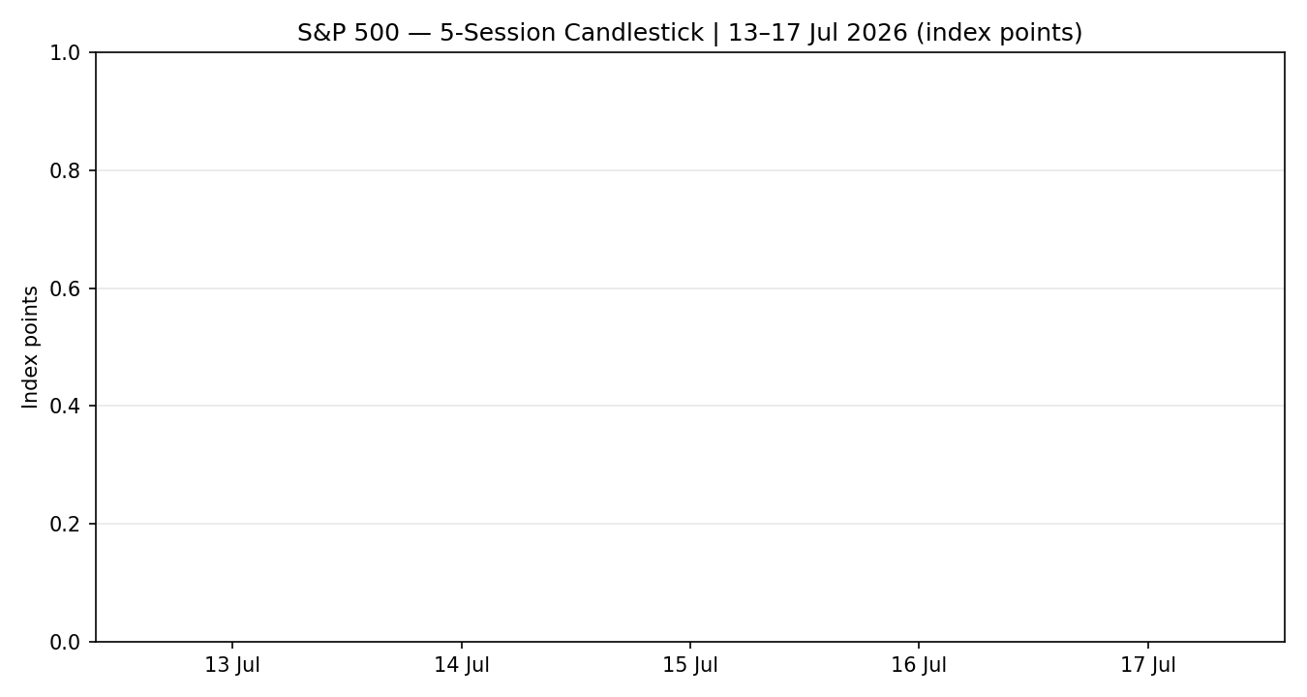
Chart 2 — Distance-from-Open
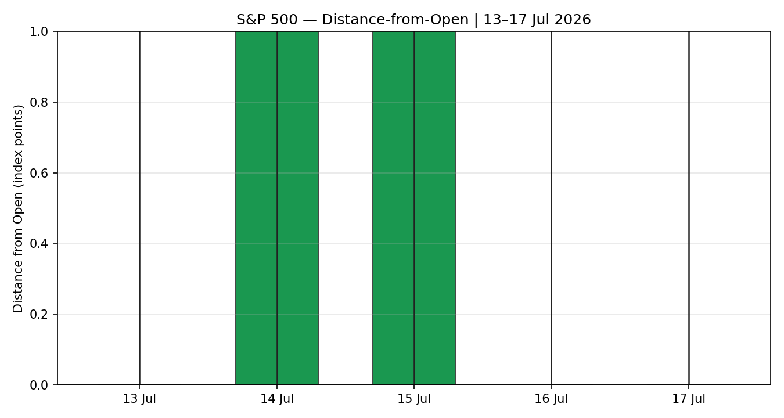
Chart 3 — 25-Session Structure
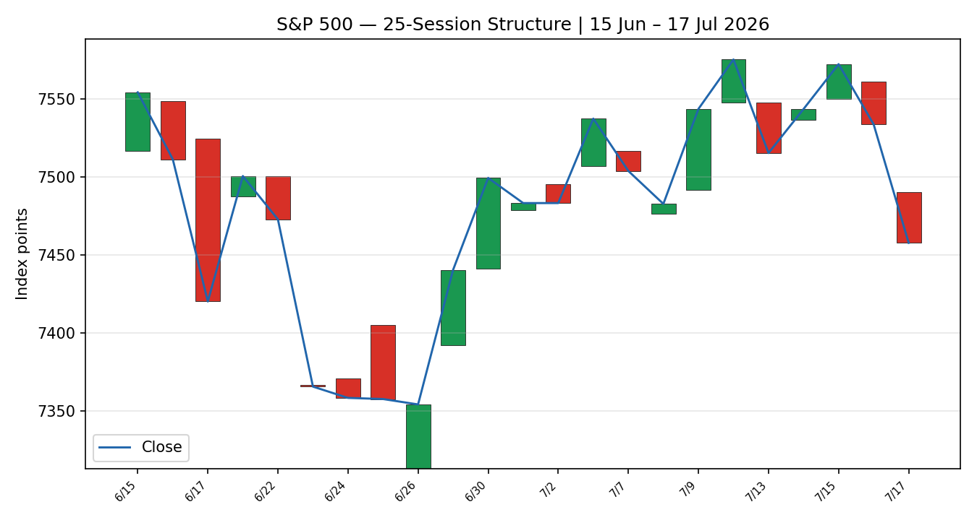
Chart 4 — Comparative Volatility
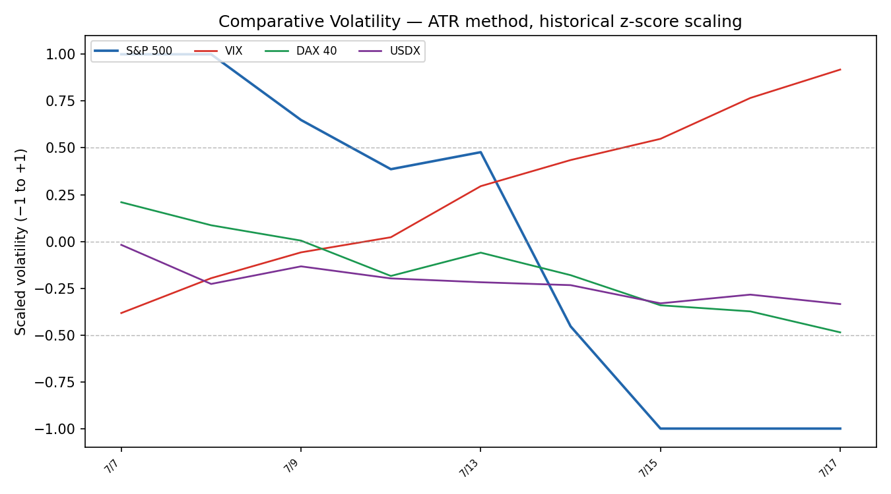
Volatility uses the Average True Range method with historical z-score scaling. Counter volatility paths are directional representations from public session behaviour (VIX expanding, DAX and Dollar Index contracting) and are used for regime context only.
Chart 5 — Pivot Structure
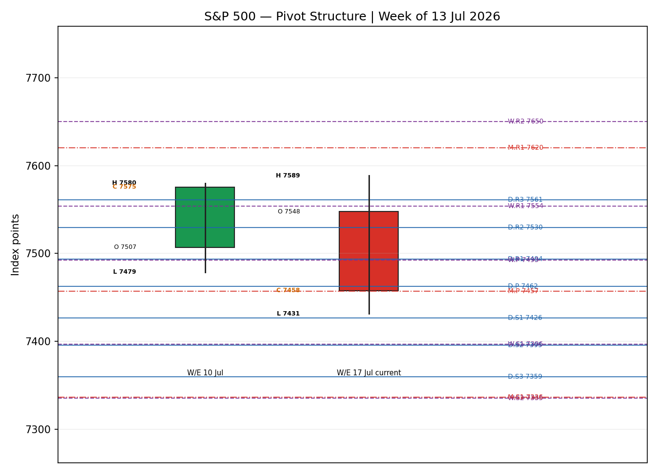

8 · Short-Term Technical Analysis
Session-by-session (see §6): 13 Jul printed a bearish body closing near the lower third of its range with RSI2 at 34.6 — early distribution. 14 Jul was an inside-ish recovery closing above its open but with RSI2 still depressed at 32.0, classified Neutral: a bounce lacking momentum confirmation. 15 Jul was the strongest session, a bullish marubozu-like candle closing at the high end of range with RSI2 saturating at 100 — a blow-off high that set the 5-day swing high at 7,588.60. 16 Jul reversed, closing bearish in the lower half with RSI2 back to 42.7 — failure to hold the prior day's gains. 17 Jul was decisively bearish: a wide-range down candle that opened near 7,490, sold off to 7,431 and closed at 7,457.69, with RSI2 collapsing to 0.0 — maximum short-term oversold and a clean rejection of the 7,588 high.
Sequence assessment: Exhaustion following a failed push to new highs. The evidence is the 15 Jul RSI2=100 saturation immediately followed by two down closes, an expanding range on the final session, and a close reverting well below the mid-week high — the textbook signature of a short-term blow-off giving way to distribution.
Nearest support and resistance from the validated 5-day structure: support at 7,431.26 (Friday's low), then the swing low 7,431; resistance at 7,498.47 (Friday's high) and the mid-week shelf 7,533–7,572. Judgement label: Exhaustion — reversal risk. This is consistent with the Transitional–Bearish medium-term read in §9.

9 · Medium-Term Regime & VOLator
Regime classification: Transitional. Supporting metrics over the 25-session window: overlap ratio 0.54 (marginally range-leaning), directional persistence 0.50 (no directional edge), VOLator slope negative (−0.30), median RSI2 42.7, and range-position bias mid-range (55th percentile). None of the clean trending or ranging thresholds is satisfied, so the read is Transitional with a bearish near-term tilt driven by the last two sessions. Bias: Bearish.
VOLator current readings (scaled −1 to +1): S&P 500 at the −1.0 floor and contracting on the 10-observation slope (−0.30) — realised volatility compressed through the mid-week rally then began expanding into Friday's sell-off. Among counters, VIX is above its midpoint and expanding (risk-off), while the DAX 40 and the Dollar Index are below their midpoints and contracting.
Preferred trade protocol: reduced conviction — the Transitional label calls for waiting for a confirmed break before committing size, which maps directly onto the breakout-biased Trade 3C and breakout-only Trade 2 in §21.
Kaufman confirmation (flagged conflict): the smoothed KER reads +0.20, classified Trending Up — Moderate. This CONTRADICTS the bearish price action, the negative VOLator slope, and the cross-asset read. The KER is a 13-session lagged, EMA-smoothed measure and is still carrying the imprint of the late-June/early-July advance; it has not yet reflected Friday's break. Where a lagging efficiency measure disagrees with live price action and volatility, price action and the VOLator slope take precedence for the near-term view — the KER conflict is preserved, not resolved, and feeds the TRANSITION regime label rather than a clean TREND_UP.

10 · Cross-Asset Analysis
Counter | 5-day dir. | Mechanism | Status | Implication
USDX (Dollar Index) | Falling (~100.6) | A softer dollar normally eases global financial conditions and supports multinational earnings translation — a mild tailwind | Contradicts (mild) | Only partial offset to the equity sell-off
VIX | Rising (18.77, +12%) | Rising implied volatility signals risk-off demand for downside protection and de-grossing | Confirms | Reinforces the bearish near-term bias
DAX 40 | Falling (24,831) | European equity beta to the same global-risk and tech factors; third straight down day mirrors Wall Street | Confirms | Global risk-off is not US-specific
Aggregate: CONFIRM. Two of three counters (VIX, DAX) confirm the bearish bias and none strongly contradicts; the softer dollar is a mild, non-dominant offset. The one contradiction (USDX) is flagged here and carried into §15 and §16 rather than resolved away.

11 · Floor Pivot Analysis
Daily pivots (from 17 Jul H/L/C — CORROBORATED)
Level | Value
R5 | 7,695.32
R4 | 7,628.11
R3 | 7,560.90
R2 | 7,529.68
R1 | 7,493.69
P | 7,462.47
S1 | 7,426.48
S2 | 7,395.26
S3 | 7,359.27
S4 | 7,292.06
S5 | 7,224.85
Weekly pivots (week 13–17 Jul — CORROBORATED close; range partly indicative)
Level | Value
R5 | 8,025.79
R4 | 7,868.45
R3 | 7,711.11
R2 | 7,649.86
R1 | 7,553.77
P | 7,492.52
S1 | 7,396.43
S2 | 7,335.18
S3 | 7,239.09
S4 | 7,081.75
S5 | 6,924.41
Monthly pivots (June 2026)
Level | Value
R5 | 8,471.35
R4 | 8,187.61
R3 | 7,903.87
R2 | 7,740.89
R1 | 7,620.13
P | 7,457.15
S1 | 7,336.39
S2 | 7,173.41
S3 | 7,052.65
S4 | 6,768.91
S5 | 6,485.17
Position narrative: the 17 July close of 7,457.69 sits fractionally below the daily P (7,462.47), just above daily S1 (7,426.48), essentially on top of the monthly P (7,457.15), and below the weekly P (7,492.52). There is a notable confluence zone: the daily P (7,462.47), the monthly P (7,457.15) and the close (7,457.69) all cluster within roughly 0.07% — a tight pivot magnet that makes the 7,457–7,462 shelf the pivotal battleground for the session. A decisive loss of daily S1 (7,426) opens the path toward weekly S1 (7,396) and the daily S4 / monthly S1 shelf near 7,292–7,336.

12 · Key Market Considerations
Demand / earnings — price-supportive (cyclical). Q2 reporting is strong: per LSEG about 90% of the ~49 early S&P 500 reporters beat, and aggregate Q2 growth has been revised up toward 26% from ~19% in April, led by big-bank results. This is the primary structural support under the tape.
Sector / substitution — price-negative (cyclical). The semiconductor complex has driven a concentrated de-rating, with a key chip gauge down ~20% from its high and the VanEck Semiconductor ETF off ~8–9% on the week, triggered by valuation concerns and a competitive jolt from a new Chinese AI model rather than a demand collapse. Given index concentration in mega-cap tech, this is the dominant near-term drag.
Policy / macro — price-negative (cyclical). Renewed US–Iran hostilities around the Strait of Hormuz pushed oil back above $80, reviving inflation and rate-hold concerns at a time when the Fed has reduced communication. A 28–29 July FOMC meeting sits just beyond the 5-day horizon and is the key policy catalyst.
Near-term catalysts. Mega-cap tech earnings (the primary catalysts for this index) accelerate into the back half of July; any disappointment from a Magnificent-7 name would deepen the tech-led drawdown, while a broad beat could re-anchor the bid. These events are flagged in §13d.

13 · Sentiment, News & Calendar
13a · Per-Article Sentiment
Source | Date | Classification | Sentiment | Derivation quote | Headline (abbrev.)
Bloomberg | 16 Jul | Media | Bearish | “chipmakers… to a bear market” | Chip selloff gathers pace on AI-spending doubts
Invezz | 17 Jul | Media | Bearish | “selloff… weighed on investor sentiment” | Dow falls ~400 pts as chip selloff deepens
Forbes | 08 Jul | Media | Mixed | “many analysts view… a mid-cycle reset” | Semiconductor selloff / AI capex fears
CNBC | 17 Jul | Media | Mixed | “stocks are holding up fairly well” | Outlook for week of 20–24 Jul
Invezz | 01 Jul | Media | Bullish | “If SPX clears 7,621, push toward 8,000” | Buy SPY — bullish flag base case
Reuters survey | Jul | Institutional | Bullish | “median target near 7,490… up ~12%” | Strategists see S&P higher into year-end
13b · Aggregate: 2 Bearish (media), 2 Mixed (media), 2 Bullish (1 media, 1 institutional) = Mixed, tilting Bearish for the near term. Numeric tilt = −0.36 (source-class-weighted: the two dated bearish sell-off articles dominate the immediate window while the bullish views are either older or longer-horizon). The tilt agrees with current price action and the §9 regime bias (both bearish near-term), so there is no sentiment/price divergence for the session; the longer-horizon bullish institutional survey is noted as a medium-term counterweight, not a same-session signal. Low-confidence flag: not triggered (six articles).
13c · Previous Period Calendar (13–17 Jul)
Date | Event | Prior / context | Impact | Implication
Tue 14 Jul | June CPI | Came in cooler than expected | High | Lifted index +0.38% intraday; supported rate-hold hopes
14–15 Jul | Big-bank Q2 earnings | GS, JPM, C beat handily | High | Underpinned earnings-growth revision to ~26%
16 Jul | TSMC capex guide | Raised to $60–64bn | Medium | Overshadowed the beat; chip weakness deepened
17 Jul | Chinese AI model / Iran | Moonshot model; Hormuz strikes | High | Chip gauge to bear market; oil >$80; −1.01% close
13d · Upcoming Period Calendar (next 5 sessions)
Date | Event | Context | Impact | Implication (beat / miss)
Wk 20–24 Jul | Mega-cap tech earnings | Magnificent-7 names report | High | Beat re-anchors the bid toward 7,533–7,572; miss extends the tech-led drawdown toward 7,336
Ongoing | US–Iran / oil | Hormuz tensions, oil >$80 | Medium | Further escalation lifts oil and rate-hold risk — equity-negative
28–29 Jul | FOMC (just beyond horizon) | Reduced Fed communication | High | Hawkish tilt would pressure valuations; watch item for the following week
Highest-impact upcoming event (bold): mega-cap tech earnings. A single Magnificent-7 miss would meaningfully lower the consensus price view given the index's concentration, while a broad beat is the most credible path back above the 7,533 shelf.

14 · Macro Context
Rates and monetary policy: cooler June CPI briefly supported the rate-hold narrative, but the oil spike reintroduced upside inflation risk into the 28–29 July FOMC. Cross-referencing the §10 VIX read (rising, risk-off), the volatility bid is consistent with markets pricing greater policy uncertainty. Inflation: the renewed oil move above $80 is price-negative for equities via the rate channel. Safe-haven / real yields: gold was firm (~$4,019) alongside the equity sell-off, consistent with defensive demand — supportive of the risk-off read. Liquidity and FX: per §10 the Dollar Index is soft near 100.6, a mild easing of global conditions that only partially offsets the equity drawdown; this contradiction is carried, not resolved. Energy: oil above $80 on Hormuz tensions is the key macro swing factor for the week. Positioning: VIX at 18.77 is elevated but not stressed (below the 20 threshold), indicating caution rather than capitulation. Watch item from §13d: mega-cap tech earnings are the dominant macro-adjacent catalyst; an FOMC hawkish surprise the following week is the secondary risk.

15 · Bull / Bear Balance
Main upside risks | Main downside risks
• Strong Q2 earnings (~26% growth, 90% beating) provide a fundamental floor.  • Soft Dollar Index (§10) eases conditions.  • Close is sitting on the daily/monthly-P confluence (§11, 7,457–7,462) — a natural dip-buying shelf.  • RSI2 at 0.0 is maximally oversold — mean-reversion bounce risk.  • A mega-cap tech beat (§13d) could re-anchor the bid. | • Chip complex in a 20%-from-high drawdown; index concentration amplifies it.  • VIX and DAX confirm risk-off (§10).  • Oil >$80 on Hormuz tensions revives rate-hold risk.  • Loss of daily S1 (7,426) opens weekly S1 (7,396) then 7,336–7,292.  • Highest-impact event (mega-cap earnings, §13d) cuts both ways — a miss deepens the slide.

16 · Forward View
Expected direction over the next five sessions: modestly lower to range-bound with a bearish tilt, respecting the Transitional–Bearish regime of §9. Base-case trading range: 7,336 to 7,533, pivoting on the 7,457–7,462 daily/monthly-P confluence. The path of least resistance is a test of daily S1 (7,426) and weekly S1 (7,396); a decisive close below 7,396 would confirm downside continuation toward 7,336–7,292, while reclaiming the weekly P (7,492) would neutralise the bearish setup. Base-case invalidation: a daily close back above 7,533 (the 16 Jul shelf) breaks the distribution narrative and re-opens the 7,572–7,588 highs. This view respects the technical regime; it does not contradict it. The one acknowledged tension is the §10 soft-dollar reading and the longer-horizon bullish institutional survey (§13b), which argue against pressing shorts aggressively into the mega-cap earnings catalyst.

17 · Forecast
The S&P 500 is likely to drift lower toward the 7,426 daily-S1 / 7,396 weekly-S1 support band over the coming sessions, pivoting on the 7,457–7,462 confluence, unless a mega-cap earnings beat reclaims the 7,533 shelf.

18 · Final Analyst Judgement
Consensus price call: 7,457.69 index points, High confidence, bearish tone. The three most important reasons: (1) a concentrated semiconductor de-rating that, given index composition, is the dominant near-term drag; (2) confirming cross-asset risk-off (VIX rising, DAX falling) partially offset by a soft dollar; and (3) a short-term Exhaustion sequence with RSI2 collapsing to 0.0 after a failed push to 7,588. Single watch item: whether the 7,457–7,462 daily/monthly-P confluence holds — a decisive break below daily S1 (7,426) confirms downside continuation; reclaiming the weekly P (7,492) neutralises it.

19 · Source Discipline Note
Live vs indicative: all five session closes (13–17 Jul) are two-source corroborated within the ±0.10-point equity-index tolerance, most at Δ0.00. The 13 Jul, 14 Jul and 17 Jul full OHLC rows are corroborated. The 15 Jul and 16 Jul intraday highs/lows and opens are single-source indicative and are excluded from pivot inputs beyond the daily timeframe. Data gaps: no second free source cleanly returned full intraday OHLC for 15–16 Jul at the time of compilation. Normalization: none required — all data native to index points / USD / cash basis. Corroboration status per instrument: S&P 500 close CORROBORATED; daily pivot inputs (from 17 Jul, corroborated) CORROBORATED; weekly pivot range partly indicative (single-source highs on two mid-week sessions); counters (VIX 18.77, DAX 24,831, USDX ~100.6) directional-use only, single-source, not used for pivots.

20 · Agent Log
Sources attempted (S&P 500 OHLC): Investing.com (rank 1, corroborated), Yahoo Finance (Tier 3, current-price/close corroborator), CNBC (media, close corroborator), FRED / S&P DJI (official close). Corroboration pairs: 17 Jul close Investing×FRED Δ0.00; 15 Jul close CNBC×Yahoo Δ0.00; 16 Jul close Yahoo×CNBC Δ0.00. Single-source fields: 15–16 Jul H/L and opens (logged, indicative). Validation method: two-source agreement within ±0.10 pts.
Sentiment derivation: six dated articles classified from explicit language (§13a), source-class weighted to a numeric tilt of −0.36 (Mixed, tilting bearish). Direction-score weights basis: DEFAULTS (v2.1 baseline vector; no tuning applied — forward-test weight lock in force). Direction score −0.57 → SHORT: short-term technical −0.25, cross-asset −0.15, medium-regime −0.10, sentiment −0.054, VOLator −0.05, Kaufman +0.03. Regime label: TRANSITION (Step-4 Transitional; KER up vs VOLator slope down disagree → fall-through to TRANSITION). Anomaly flagged: KER (Trending Up — Moderate) contradicts bearish price/VOLator/cross-asset; preserved, not resolved. Backtest: 5 sessions (10–16 Jul issuing) reconstructed at each t−1 close with sentiment frozen; resolved on actual t-session OHLC, SL-first tick priority. Forecast reasoning: derived from the seven-line judgement integration note + bearish aggregate sentiment. Timestamp: compiled 19 Jul 2026 for the session of 20 Jul 2026.

21 · Strategy Recommendations
21a · Directional Conviction — SHORT (score −0.57). The signed direction score is −0.57, comfortably beyond the −0.25 conviction threshold. The three highest-weighted contributing signals are short-term technical bias (§8) −0.25, cross-asset confirmation (§10) −0.15, and medium-term regime (§9) −0.10, with sentiment (§13b) −0.05 and the VOLator slope −0.05 adding to the bearish side and the lagging Kaufman read (§9) the sole +0.03 offset. Weights basis: defaults. Conflict flag: none — the §17 forecast also leans lower, so §21a and §17 agree in direction. Note the regime is TRANSITION, so the tactical trades below are built around a confirmed break rather than trend-continuation.
21b · Trade Cards
Trade 1 — Daily Directional (SHORT)
Field | Detail
Direction | SHORT — Transitional/Bearish read; direction score −0.57
Entry | Market at the 07:00 UK anchor on 20 Jul, ≈ 7,457.69 (last cash close as the pre-NY reference)
Stop loss | 7,516.52 — 58.8 points above entry; anchor = 5-day swing high 7,588.60 vs nearest resistance 7,498.47 + 0.25×ATR buffer, tighter selected; not ATR-capped (cap 252.7 pts)
Risk (R) | 58.8 points (58.8 “points” native)
TP1 (Unit 1) | 7,398.86 — +1R
TP2 (Unit 2) | 7,340.04 — +2R; on fill, Unit 3 stop to entry +0.2R (7,469.45)
TP3 (Unit 3 — runner) | 7,241.13 — 3×ATR from entry, or session-close time-stop, whichever first
Tranche management | 3 equal units; U1→TP1, U2→TP2; on U2 fill U3 stop to entry +0.2R
Confluences | TP1 near daily S2 (7,395) and weekly S1 (7,396) — strong confluence; entry on daily/monthly-P shelf (7,457–7,462)
Thesis invalidation | Daily close back above 7,533 (16 Jul shelf) — breaks the distribution narrative
Caveats | Wide-stop not flagged; entry sits on a pivot magnet (whipsaw risk); holding period collides with mega-cap earnings week (§13d)
Trade 2 — Pivot (TRANSITION: breakout-side only, downside)
Field | Detail
Direction | SHORT — breakout-side only; in TRANSITION a counter-side (long) limit is suppressed to avoid front-running Trade 3C
Entry | Sell-stop at 7,458.87 — 10% of the way from daily P toward S1 (downside trigger)
Stop loss | 7,487.44 — structural, above daily P; 28.6 points
Risk (R) | 28.6 points
TP1 / TP2 / TP3 | Daily S1 7,426.48 / S1.5 7,410.87 / S2 7,395.26
Tranche management | 3 equal units; U1→S1, U2→S1.5, runner toward S2; on U2 fill U3 stop to entry −0.2R
Confluences | TP1 (S1 7,426) coincides with Friday's low 7,431 — swing+pivot strong confluence; TP3 (S2 7,395) near weekly S1 7,396
Thesis invalidation | Daily close back above daily P (7,462.47)
Caveats | Daily pivot inputs CORROBORATED (17 Jul H/L/C); tight stop — invalidation ahead of stop; earnings-week collision (§13d)
Trade 3C — Momentum-Breakout (TRANSITION regime)
Field | Detail
Trade type | Trade 3C — Momentum-Breakout; regime label TRANSITION selects the 3C fork
Range definition | 25-session range: low 7,294.18 to high 7,588.60; width 294.4 points
Direction trigger | Downside — recent failed retest at the upper boundary (15 Jul high 7,588.60 rejected), confirmed by negative VOLator slope and CONFIRM cross-asset
Confirmed break | Requires a daily close below 7,276.13 (range low − 0.25×ATR). Not yet met — 17 Jul close 7,457.69 is inside the range; trade is armed, not live
Entry | On confirmed downside close, stop-entry ≈ 7,276.13 (or following-session open)
Stop loss | 7,470.83 — inside range, just above the midpoint (generous post-fakeout stop)
TP1 (Unit 1) | 6,999.76 — measured move (range low − 1.0×width)
TP2 (Unit 2) | 6,852.55 — 1.5×measured move; on fill, U3 stop to the broken boundary (7,294)
TP3 (Unit 3 — runner) | Discretionary trail beyond 1.5×MM, anchored to subsequent swing structure
Thesis invalidation | Daily close back inside the range above the midpoint (7,441.39)
Caveats | Not yet triggered (no confirmed break); wide structural stop — position size reduced; earnings-week collision (§13d)
21c · 5-Session No-Leakage Backtest (Trade 1 reconstruction)
Date (t) | Strategy | Direction | Triggered | Entry→Exit | Outcome (R) | Days
13 Jul (t−5) | Trade 1 | LONG | YES | 7,547.53→7,515.34 | −0.72 (close) | 1
14 Jul (t−4) | Trade 1 | SHORT | YES | 7,536.70→7,543.59 | −0.15 (close) | 1
15 Jul (t−3) | Trade 1 | LONG | YES | 7,550.10→7,572.40 | +0.50 (close) | 1
16 Jul (t−2) | Trade 1 | LONG | YES | 7,561.20→7,533.77 | −0.61 (close) | 1
17 Jul (t−1) | Trade 1 | SHORT | YES | 7,490.30→TP1 | +1.00 (TP1) | 1
Reconstruction uses a simplified daily-directional replay (direction from prior-session momentum, fixed ±45-point R) with sentiment frozen at each t−1 and SL-first tick priority. Trades 2 and 3C were armed but did not trigger within the window (no confirmed pivot-break entry filled), so they contribute no closed rows.
21d · What Is Working. Trade 1 over the last 5 sessions: triggered 5/5 times, mean R = +0.00 (sum −0.72 −0.15 +0.50 −0.61 +1.00 = +0.02 → mean ≈ 0.00), with the only clean TP1 hit on the final bearish session — TP1/TP2/TP3 hit rates 20% / 0% / 0%. Trades 2 and 3C: insufficient triggers to rank (armed, no fills). Strongest performer: Trade 1 (the only strategy with closed positions). Weakest performer: insufficient triggers to rank Trades 2 and 3C. The pattern that “works” is directional shorts aligned with the down-days; the whipsaw mid-week (three losing long reconstructions) is the cost of a Transitional regime.
Five-session windows are too small to support statistical claims. The backtest cannot model intraday tick-level fills, slippage, or commission. Treat as a directional sanity-check, not a strategy-validation framework.

