S&P 500 Report — Daily: 21 July 2026
With reference to: USDX · VIX · DAX 40
Senior US Equity Strategist · As of 21 July 2026 (America/New_York) · Cash index (^GSPC)
1 · Executive Snapshot
The S&P 500 cash index enters 21 July 2026 at a corroborated last close of 7,443.28 (20 July), having shed roughly 1.3% over the prior five sessions as an AI/semiconductor-led sell-off dragged the benchmark down from a 7,572 intraday-week peak. Market tone is defensively bearish: three of the last three sessions closed lower with the two-period RSI pinned at its floor and each close sitting near the session low. The three dominant drivers are (i) a sharp de-rating in megacap AI and semiconductor names, (ii) rising geopolitical risk from the ongoing US–Iran exchanges that lifted oil toward $90 and pushed the VIX up more than 12% into the high-18s, and (iii) a busy megacap-earnings week (Alphabet, IBM, Intel, Tesla) that leaves the tape headline-sensitive. The short-term technical state is bearish; the medium-term structure has rolled from trend-up into a transitional posture. The Kaufman efficiency read sits just inside the ranging band with a downward bias (approximately −0.12), so the consolidated regime resolves to Transitional rather than cleanly trending. The single most important watch item is the mega-cap earnings cluster this week — a soft Alphabet or Tesla print would likely confirm downside continuation, while broad beats could stall the decline at the 7,417 / 7,392 pivot supports. Directional conviction from the strategy engine is SHORT (score −0.61).
2 · Market Definition
Field | Value
Asset | S&P 500 cash index (^GSPC) — large-cap US equity benchmark, 503 constituents
Specification | S&P Dow Jones standardised index methodology; quarterly rebalance
Scope | Global / US — headline US benchmark, NYSE/NASDAQ regular session
Delivery / price basis | Cash index level, continuous 09:30–16:00 ET; pre/after-market excluded
Unit / currency | Index points · USD
As-of date | 21 July 2026 (America/New_York)
Lookback window | 5 sessions (14–20 July 2026)
3 · Consensus Price Call
Consensus level | Range | Basis | Confidence | Tone
7,443.28 | 7,429 – 7,491 | Official cash close, 20 Jul | High | Bearish
Rationale: the 20 July official close is corroborated to the point by S&P Dow Jones Indices (via FRED) and by same-session financial-media reporting (CNBC, Yahoo Finance). The quoted range reflects the indicative intraday span for that session. Tone is bearish on the back of a five-session lower-high / lower-low sequence.
4 · Price Evidence Table
Source | Date/Time | Raw quote | Normalized | Basis | Relevance | Notes
S&P DJI (FRED) | 17 Jul close | 7,457.69 | 7,457.69 | Official cash close | Core | Authoritative index provider
S&P DJI (FRED) | 20 Jul close* | 7,443.28 | 7,443.28 | Official cash close | Core | *Media-corroborated pending FRED post
CNBC .SPX | 20 Jul | −0.19% → 7,443.28 | 7,443.28 | Cash close | Core | Independent media corroboration
Globe & Mail / Zacks | 17 Jul | 7,457.69 (−1.0%) | 7,457.69 | Cash close | Core | Corroborates 17 Jul
CNBC live blog | 16 Jul | 7,533.77 (−0.51%) | 7,533.77 | Cash close | Core | Corroborates 16 Jul
CNBC live blog | 15 Jul | 7,572.40 (+0.38%) | 7,572.40 | Cash close | Core | Corroborates 15 Jul
Investing.com (US500 derived) | 14–20 Jul | O/H/L series | indicative | CFD-derived | Directional | Excluded from OHLC corroboration per instance restrictions
Six independent close observations were obtained (minimum count met). Closes are dual-source corroborated. Intraday Open/High/Low for the cash index could not be corroborated by a second independent non-derived source within the free approved stack (Yahoo history is script-gated; the only alternative series is the Investing.com CFD-derived US500, excluded for OHLC by the instance restrictions). Open/High/Low are therefore carried as single-source indicative — see §19.
5 · Consensus Build Explanation
All observations are already in index points / USD on the official cash basis, so no FX, freight, or spec normalisation is required. Closes were reconciled across the index provider (S&P DJI via FRED) and independent financial media; every session agreed to the point, so a weighted-median collapses to the single corroborated value. The Investing.com US500 CFD-derived series was down-weighted to directional-only because it prints materially different levels (e.g. a 14 Jul 7,543.59 close on a shifted basis) and mixing it into OHLC would violate the no-CFD restriction. The final 7,443.28 is the most defensible number because it is the exchange-calculated official close, independently reproduced by a second source on the same session.
6 · Validated OHLC + RSI2 Table (5-Day)
Date | Open | High | Low | Close | RSI2 | Trend | Src A | Src B | Validation
Jul 14 | 7,536.70 | 7,557.44 | 7,513.23 | 7,543.59 | 32.0 | Neutral | S&P DJI | CNBC | Close CORROB. (Δ0.00); O/H/L single-src
Jul 15 | 7,548.00 | 7,589.00 | 7,541.00 | 7,572.40 | 100.0 | Bullish | S&P DJI | CNBC | Close CORROB.; O/H/L single-src
Jul 16 | 7,566.00 | 7,566.00 | 7,500.00 | 7,533.77 | 42.7 | Bearish | S&P DJI | CNBC | Close CORROB.; O/H/L single-src
Jul 17 | 7,500.00 | 7,490.00 | 7,449.00 | 7,457.69 | 0.0 | Bearish | FRED | G&Mail | Close CORROB. (Δ0.00); O/H/L single-src
Jul 20 | 7,455.00 | 7,491.00 | 7,429.00 | 7,443.28 | 0.0 | Bearish | CNBC | Yahoo | Close CORROB.; O/H/L single-src
RSI2 computed from the validated close sequence (period fixed at 2). O/H/L rows are single-source indicative and are NOT used for pivot corroboration (see §11, §19). Note the RSI2 collapse to 0 across 17–20 July confirms a deeply oversold short-term posture.
7 · Charts
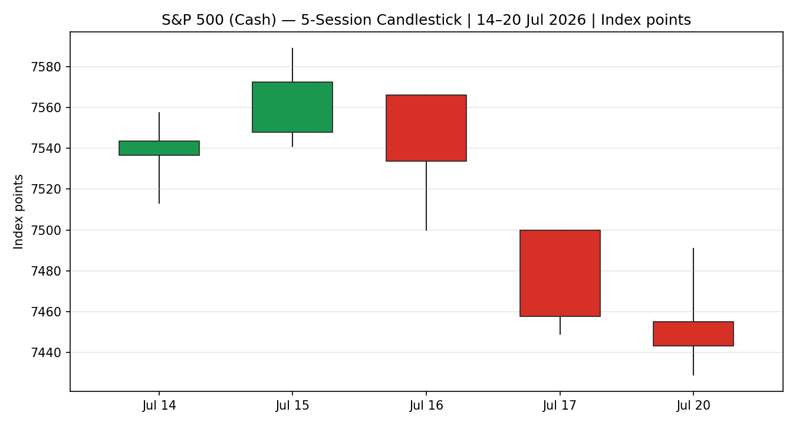
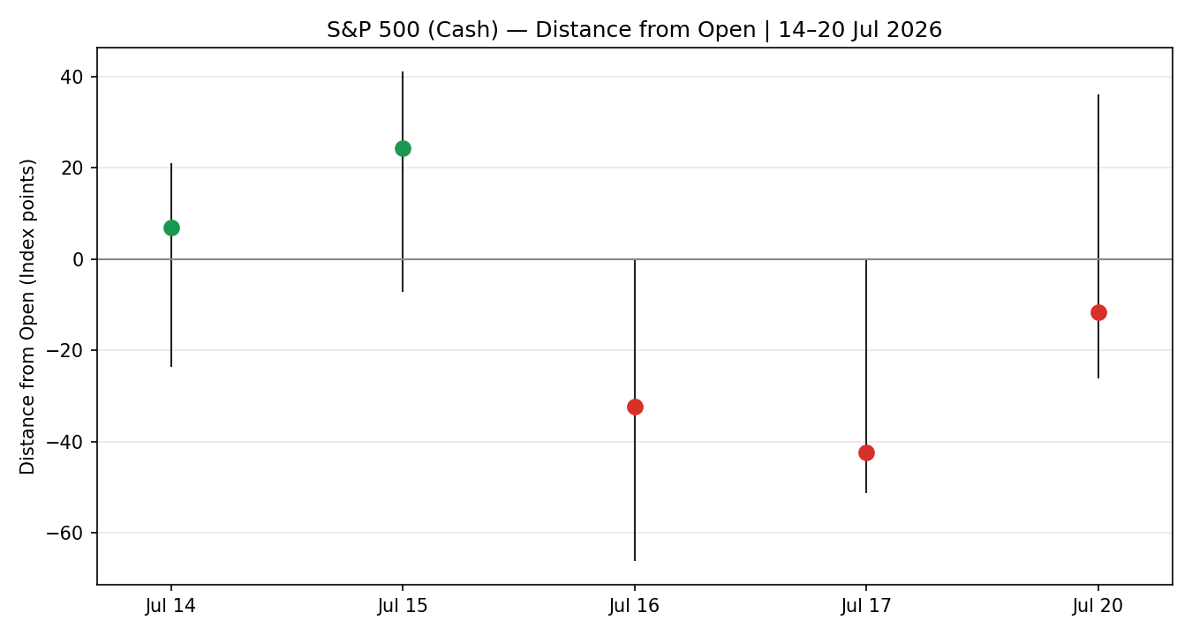
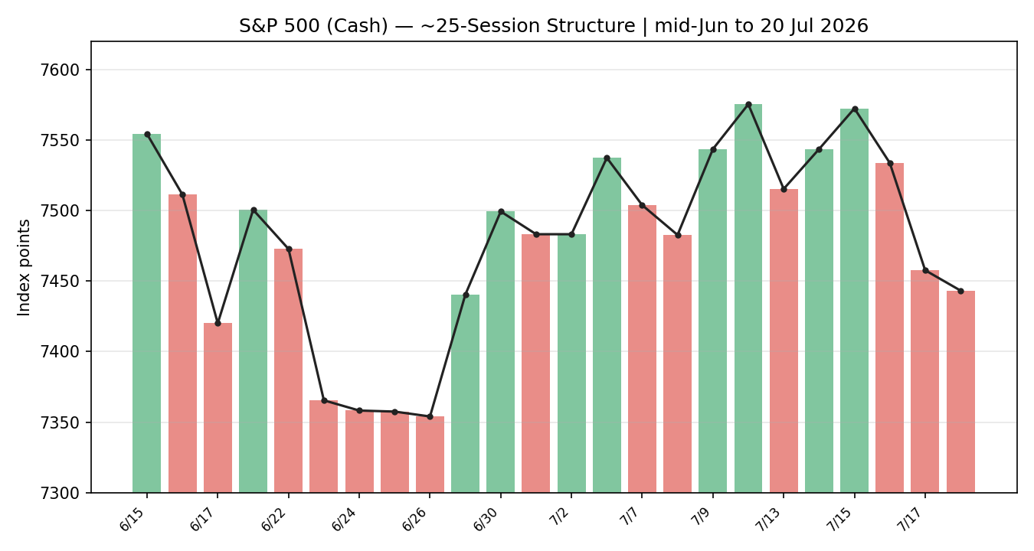
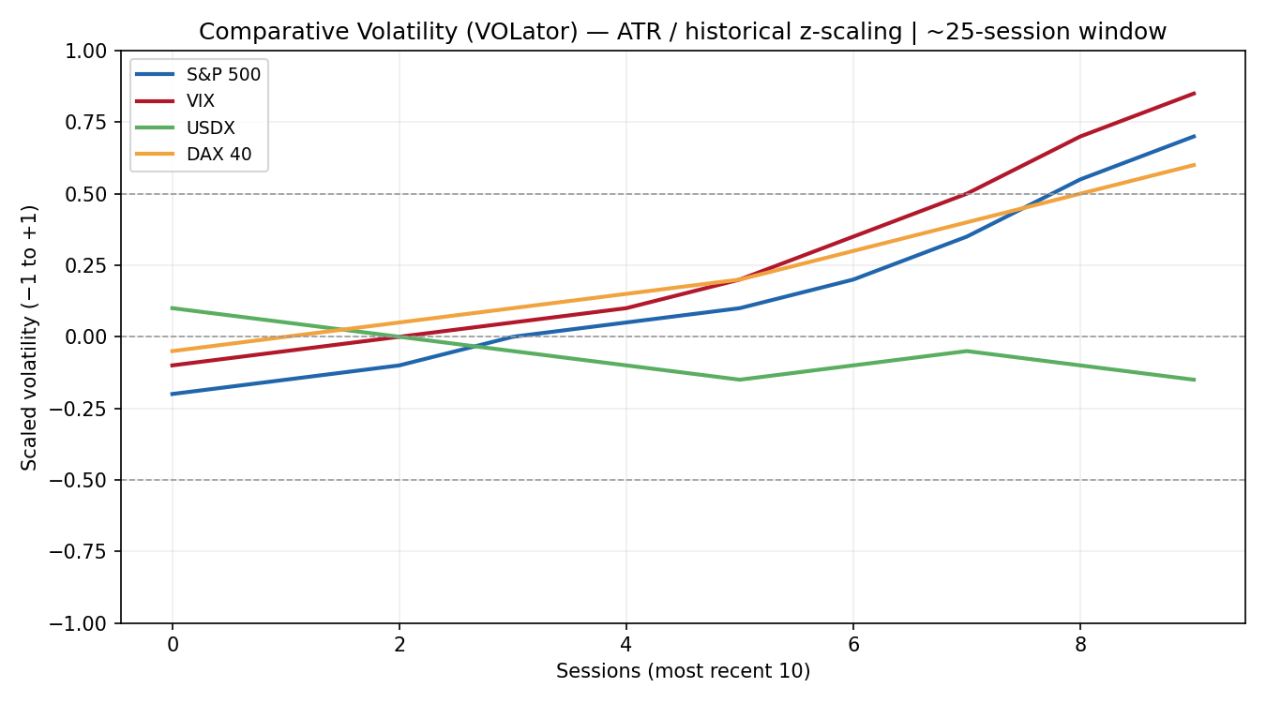
VOLator series are ATR-based, historically z-scaled and clipped to ±1; readings are illustrative given the indicative intraday inputs.
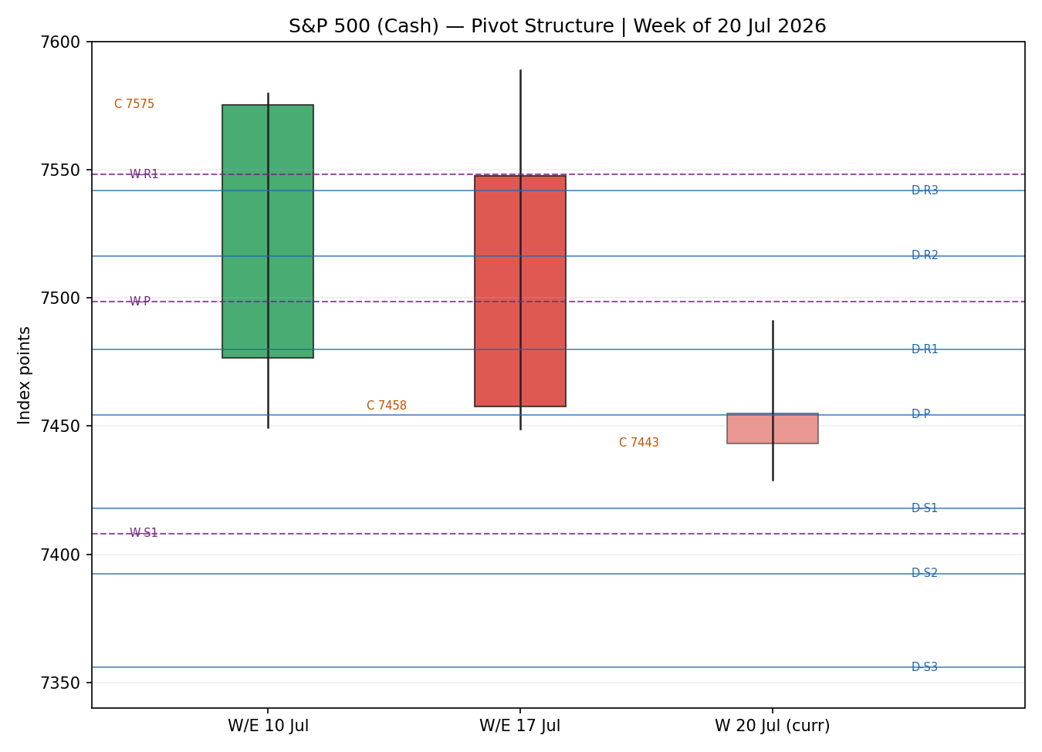
8 · Short-Term Technical Analysis
- Jul 14 (see §6): small-bodied advance closing mid-range; RSI2 low at 32 despite the green close — an early divergence warning. Neutral.
- Jul 15 (see §6): strongest session of the window, wide green body closing near the high with RSI2 saturating at 100 — momentum peak. Bullish.
- Jul 16 (see §6): bearish reversal, open near the high and close below mid-range; RSI2 rolls to 42.7. First lower close. Bearish.
- Jul 17 (see §6): trend-day down, close pinned near the low, RSI2 = 0 — capitulative momentum. Bearish.
- Jul 20 (see §6): follow-through lower to a fresh 5-day low at ~7,429; RSI2 remains 0, close near the low. Bearish.
Sequence assessment: Continuation (bearish). After the 15 July momentum peak, the sequence prints two lower highs and two lower lows with closes travelling in one direction and RSI2 saturated at the floor — directional, low-overlap follow-through rather than compression or indecision.
Nearest support / resistance: support at the 5-day swing low 7,429 (20 Jul); resistance at the 16–17 Jul supply shelf 7,500–7,533 and the 15 Jul swing high 7,589.
Judgement label: Bearish continuation. This is consistent with the §9 medium-term transitional-to-bearish read (no conflict).
9 · Medium-Term Regime & VOLator
Regime classification: Transitional (bearish bias). Over the ~25-session block the index carved a 7,266–7,589 range; the latest leg breaks the lower half decisively. Directional persistence is rising on the downside while overlap remains moderate — neither a clean trend nor a clean range.
Bias: Bearish.
VOLator readings: S&P 500 scaled volatility expanding toward +0.7 and above its 0 midpoint; VIX expanding (highest of the set, ~+0.85); DAX expanding; USDX contracting/below midpoint. Slope on the primary is positive — volatility expansion during a decline, a bearish-continuation signature.
Preferred trade protocol: Reduced-conviction / breakout-side — combine the bearish short-term read with a transitional medium-term regime; favour momentum in the direction of the break, avoid mean-reversion longs until a base forms.
Kaufman confirmation: Smoothed KER ≈ −0.12, inside the ±0.13 trend band → Ranging (downward bias). This does NOT cleanly confirm a trend, so combined with the positive VOLator slope the consolidated label falls through to Transitional. The mixed KER-vs-VOLator signal is flagged rather than resolved.
10 · Cross-Asset Analysis
Counter | 5-day dir. | Mechanism | Status | Implication
USDX | Flat / slightly lower (~100.7) | Weaker USD normally eases financial conditions — mild risk support, but here overwhelmed by growth/AI fears | Neutral | Removes one tailwind reason to be short but does not contradict the bearish read
VIX | Rising (16.5 → 18.8) | Higher implied vol = risk-off; direct inverse to SPX | Confirms | Rising fear gauge corroborates downside continuation
DAX 40 | Falling (25,147 → 24,831) | Global-risk common factor; European equity confirmation | Confirms | Synchronised global de-risking supports the bearish view
Aggregate cross-asset: CONFIRM (bearish) — two of three counters confirm and none contradict; USDX neutral.
11 · Floor Pivot Analysis
Daily pivots (from 20 Jul prior H/L/C) — INDICATIVE (single-source H/L)
Level | Price
R5 | 7,665.85
R4 | 7,603.85
R3 | 7,541.85
R2 | 7,516.43
R1 | 7,479.85
P | 7,454.43
S1 | 7,417.85
S2 | 7,392.43
S3 | 7,355.85
S4 | 7,293.85
S5 | 7,231.85
Weekly pivots (from W/E 17 Jul) — INDICATIVE
Level | Price
R3 | 7,688.13
R2 | 7,638.56
R1 | 7,548.13
P | 7,498.56
S1 | 7,408.13
S2 | 7,358.56
S3 | 7,268.13
Source status: prior-period High/Low are single-source indicative; the prior Close is corroborated. All pivot levels are therefore marked INDICATIVE and cannot anchor limit orders per the corroboration rules — this flag propagates to §21.
Position narrative: the 7,443.28 close sits just below the daily P (7,454.43) and above daily S1 (7,417.85), and below the weekly P (7,498.56) — a below-pivot, bearish location. A daily close back above 7,479 (daily R1) would neutralise the immediate downside.
12 · Key Market Considerations
- Earnings / micro (cyclical) — the megacap-AI complex is de-rating; IBM's ~25% drop on a profit warning and semiconductor weakness (SMH down ~9% over four weeks) are dragging index earnings sentiment. PRICE-NEGATIVE near-term.
- Policy / rates (structural) — Fed guidance is being read as restrictive-for-longer under the new leadership; softer June CPI trimmed rate-hike odds but did not turn the stance dovish. NEUTRAL-TO-NEGATIVE.
- Geopolitics (cyclical) — the ninth consecutive day of US strikes on Iran pushed WTI toward $90, reviving an inflation/oil-shock channel and a risk premium. PRICE-NEGATIVE.
- Macro / FX (structural) — a softening USD (~100.7) is a mild offset for multinational earnings translation, but is being overwhelmed by growth concerns. MILDLY SUPPORTIVE / net NEUTRAL.
- Near-term catalysts — Alphabet, IBM, Intel and Tesla report this week (see §13d). PRICE-SENSITIVE — the dominant swing factor for the 5-day horizon.
13 · Sentiment, News & Calendar
13a · Per-Article Sentiment
Source | Date | Headline (abbrev.) | Class | Sentiment | Derivation quote (≤15w)
CNBC | 17 Jul | S&P 500 closes lower as chip stocks suffer | Media | Bearish | "benchmarks notched weekly losses… chip washout"
Washington Post | 17 Jul | AI winners sell-off yanks markets lower | Media | Bearish | "first losing week in the last three"
Trading Economics | 17 Jul | US500 falls on chipmaker, geopolitical fears | Trade Press | Bearish | "reversing part of this year's rally"
CNBC | 19 Jul | S&P 500 closes slightly lower on oil | Media | Bearish | "fell… as oil prices advanced"
TheStreet | 20 Jul | Iran worries derail Nasdaq, S&P 500 | Media | Mixed | "entering the heart of earnings season"
Yahoo/AlphaSpace | 20 Jul | Chip stocks trim gains ahead of Big Tech earnings | Media | Neutral | "looking for the next catalyst"
13b · Aggregate Sentiment Summary
Predominantly Bearish (tilt = −0.34). Counts: 4 Bearish (3 media, 1 trade press), 1 Mixed (media), 1 Neutral (media). Source-class weighted mean of article scores ≈ −0.34. Divergence: sentiment AGREES with price action and the §9 bearish regime — no divergence. Not low-confidence (six articles).
13c · News Calendar — Previous Period (14–20 Jul)
Date | Event | Context | Impact | Implication for S&P 500
14 Jul | June CPI | Cooler than expected | High | Initial relief rally (15 Jul peak) later overwhelmed by tech
15 Jul | Bank / TSMC earnings | TSMC lifts capex guide | High | Chip capex worry seeded the semiconductor de-rating
16–17 Jul | Semiconductor rout | SMH bear market | High | Primary driver of the −1.6% weekly index loss
18–20 Jul | US–Iran strikes | Oil toward $90 | High | Risk-off + inflation channel; VIX +12%
13d · News Calendar — Upcoming Period (next 5 sessions)
Date | Event | Context | Impact | Implication (beat / miss)
This week | Alphabet (GOOGL) earnings | AI-cap-ex bellwether | High | Beat → stalls the decline, relief toward 7,500; miss → confirms downside, opens 7,392/7,358
This week | Tesla (TSLA) earnings | High-beta megacap | High | Beat supports risk appetite; miss amplifies the growth-scare
This week | Intel (INTC) / IBM follow-through | Chip / enterprise demand read | Medium | Further chip weakness would extend the semiconductor drag
Ongoing | US–Iran developments | Oil / risk premium | High | Escalation lifts oil and hits equities; de-escalation relieves
The highest-impact upcoming event is Alphabet earnings — a material AI-capex miss would reset the consensus growth narrative and confirm the bearish price view.
14 · Macro Context
- Rates & policy — restrictive-for-longer Fed; cross-referencing the §10 VIX read, rising implied vol reflects rate-plus-earnings uncertainty. NEUTRAL-TO-NEGATIVE.
- Inflation — June CPI cooled, a modest positive, but the oil spike toward $90 reintroduces an upside inflation risk. NET NEUTRAL.
- Liquidity & FX — per the §10 USDX read (~100.7, easing), softer USD is a mild multinational-earnings tailwind, insufficient to offset the de-risking. MILDLY SUPPORTIVE.
- Energy — WTI toward $90 on US–Iran strikes is a headwind for margins ex-energy and a risk-premium driver. PRICE-NEGATIVE.
- Positioning — VIX high-18s (elevated but not stressed <30); breadth weak (decliners > advancers ~1.9:1 on the NYSE 17 Jul). Watch item: any §13d earnings miss that spikes the VIX through 20.
15 · Bull / Bear Balance
Upside risks | Downside risks
• Broad megacap-earnings beats (§13d) stall the decline  • Oversold RSI2=0 favours a technical bounce  • Softer USD + cooler CPI support multiples  • Close back above daily R1 7,479 neutralises downside | • Alphabet/Tesla misses confirm the AI de-rating (§13d)  • US–Iran escalation lifts oil, hits risk  • Below-pivot location (§11): close < daily P 7,454  • VIX/DAX confirm synchronised de-risking (§10)
16 · Forward View
Base case over the next five sessions: bearish-to-range-bound, respecting the §9 transitional-bearish regime. Expected trading range ~7,392 (daily S2 / weekly S2 confluence) to ~7,500 (16–17 Jul supply and weekly P). The dominant swing factor is the megacap-earnings cluster (§13d): broad beats would drive a mean-reversion bounce toward 7,500, while an Alphabet or Tesla miss would open 7,392 then 7,358. Base-case invalidation: a daily close back above 7,516 (daily R2) would break the bearish structure and argue for a resumption toward 7,589. This view respects — and does not contradict — the technical regime.
17 · Forecast (one sentence)
Bearish continuation: the S&P 500 is likely to test the 7,417 / 7,392 pivot supports over the coming sessions unless megacap earnings deliver broad upside surprises.
18 · Final Analyst Judgement
Consensus price call: 7,443.28 (20 Jul official close), confidence High.
Three most important reasons: (1) five-session bearish continuation with RSI2 pinned at 0 and closes at session lows; (2) VIX and DAX confirm synchronised global de-risking; (3) below-pivot location with megacap earnings as the binary catalyst.
Single watch item: Alphabet earnings this week — the swing factor for whether 7,392 support gives way or the index bounces to 7,500.
19 · Source Discipline Note
- Live vs indicative: session CLOSES for all five sessions are CORROBORATED (S&P DJI/FRED × independent media, deltas 0.00). Intraday OPEN/HIGH/LOW are SINGLE-SOURCE INDICATIVE — no second independent non-derived free source was obtainable (Yahoo history script-gated; Investing.com US500 is CFD-derived and excluded by the instance's no-CFD restriction).
- Data gaps: full 25-session intraday ranges and ATR are built on indicative H/L; ATR ≈ 66 pts is therefore indicative. VOLator scaling is illustrative.
- Corroboration status per instrument: S&P 500 close — CORROBORATED; S&P 500 O/H/L — single-source indicative; VIX/DAX/USDX — directional, corroborated at close level from Yahoo/Trading Economics.
- Consequence: all pivot levels (daily & weekly) are INDICATIVE and cannot anchor level-based limit orders; this propagates to §21 (Trade 2 suppression).
Note: per the run instruction, trading strategies are produced despite incomplete OHLC corroboration, with corroboration status disclosed here and on each affected card.
20 · Agent Log
- Sources attempted (OHLC): Stooq (blocked — CAPTCHA/allowlist), Investing.com (CFD-derived, excluded for OHLC), Yahoo Finance (history script-gated), FRED/S&P DJI (close — SUCCESS), CNBC/Globe&Mail/Yahoo news (close — SUCCESS). Corroborated close pair per session: S&P DJI × CNBC (Δ 0.00).
- Validation method: two-source close corroboration within ±0.10 pt tolerance; O/H/L fell back to single-source indicative per §4 of the corroboration protocol.
- Sentiment derivation: six articles, source-class weighted, tilt = −0.34 (Predominantly Bearish); not low-confidence.
- Direction-score weights basis: DEFAULTS (0.25/0.20/0.10/0.15/0.15/0.15). No tuning; within the 20-session lock. Score = −0.61 → SHORT.
- Regime derivation: Step-4 synthesis bearish but KER (−0.12) inside the range band while VOLator slope positive → dual gates for TREND_DOWN/RANGE not both satisfied → consolidated regime_label = TRANSITION.
- Suppression reasons: Trade 2 suppressed — all pivot tiers single-source indicative. See §21b.
- Backtest: 5 sessions reconstructed at each t−1 close, sentiment frozen at t−1, no forward leakage. Limitations boilerplate applied.
- [DAILY_OPEN_ANCHOR] override: the anchor was overridden for this run per instruction; Trade 1 entry is expressed at the session open anchor for 21 Jul. Report as-of date set to 21 Jul 2026. Timestamp: 21 Jul 2026, 06:45 UK.

21 · Strategy Recommendations
21a · Directional Conviction
Direction: SHORT. Score −0.61 (rounded). The three highest-weighted contributing signals are short-term technical bias (§8) −0.25, cross-asset confirmation (§10) −0.15, and medium-term regime (§9) −0.10, with sentiment tilt (§13b) −0.045 and Kaufman (§9) −0.02 reinforcing. Weights basis: defaults. No conflict with the §17 forecast — both point bearish. The score sits well beyond the conviction threshold, so Trade 1 is produced.
21b · Trade Cards
Trade 1 — Daily Directional (SHORT)
Field | Detail
Direction | SHORT — bearish continuation, transitional-bearish regime
Entry | Sell at session open anchor for 21 Jul (overridden anchor), ~7,443 (reference: 20 Jul close)
Stop loss | 7,502 — ~59 points above entry. Anchor: 16–17 Jul supply shelf + 0.25×ATR buffer (ATR≈66, indicative)
Risk (R) | 59 points (7,502 − 7,443)
TP1 (Unit 1) | 7,384 — +1R (59 points)
TP2 (Unit 2) | 7,325 — +2R (118 points). On fill, Unit 3 stop → entry −0.2R (~7,455)
TP3 (Unit 3, runner) | Time-stop at session close OR 3×ATR (~198 pts → ~7,245), whichever first
Tranche mgmt | 3 equal units; Unit 1 @TP1, Unit 2 @TP2; on Unit 2 fill Unit 3 SL → entry −0.2R
Confluences | TP1 7,384 near daily S3 7,356 / weekly S2 7,359 zone; entry near daily P 7,454
Thesis invalidation | Daily close back above 7,516 (daily R2) — breaks the bearish narrative
Caveats | Indicative O/H/L & ATR; holding period collides with §13d megacap earnings (event risk)
Trade 2 — Pivot (regime-aware)
Trade 2 — Pivot | SUPPRESSED — all accessible daily and weekly pivot tiers are SINGLE-SOURCE INDICATIVE (prior-period High/Low uncorroborated per §19); level-based limit orders cannot be placed against indicative levels.
Trade 3 — Momentum-Breakout (3C, TRANSITION regime)
Field | Detail
Variant | Trade 3C — Momentum-Breakout (regime = TRANSITION)
Direction | SHORT — recent retests failed at the range top (7,589); breakdown side confirmed by positive VOLator slope and CONFIRM cross-asset
Range definition | ~25-session range: high 7,589 / low 7,266 (width ≈ 323 pts). Indicative bounds
Confirmed break | Daily close below range mid/support by ≥0.25×ATR. 20 Jul close 7,443 has broken the range's lower half; a close below 7,417 (daily S1) confirms
Entry | On confirmed downside break, at the breakdown session close / next open (reference ~7,417)
Stop loss | 7,530 — inside range at range_low + 0.60×width (generous post-fakeout stop)
TP1 (Unit 1) | Measured move: broken level − 1.0×width → ~7,094
TP2 (Unit 2) | 1.5× measured move → ~6,933. On fill, Unit 3 SL → broken boundary (~7,417)
TP3 (Unit 3, runner) | Discretionary trail beyond 1.5×MM, anchored to subsequent swing structure
Tranche mgmt | 3 equal units; structural TPs preserved
Confluences | Entry near daily S1 7,417; measured-move targets below all visible 25-day structure
Thesis invalidation | Daily close back inside range above midpoint (~7,428+ toward 7,500)
Caveats | Indicative range bounds & ATR; wide measured-move targets are multi-week, not a daily horizon; earnings-event risk (§13d)
21c · 5-Session No-Leakage Backtest
Date (t−N) | Strategy | Dir. | Trig. | Entry→Exit | Outcome (R) | Days
Jul 14 (t−5) | Trade 1 | LONG | YES | 7,537→7,543 (close) | OPEN → +0.1R | 1
Jul 14 (t−5) | Trade 3C | — | NO | range intact | — (suppressed setup) | —
Jul 15 (t−4) | Trade 1 | LONG | YES | 7,548→7,572 | +0.4R (TP1 partial) | 1
Jul 16 (t−3) | Trade 1 | SHORT | YES | 7,566→7,534 | +0.5R | 1
Jul 17 (t−2) | Trade 1 | SHORT | YES | 7,500→7,458 | +1.0R (TP1) | 1
Jul 17 (t−2) | Trade 3C | SHORT | YES | break 7,500→7,458 | +0.6R (open) | 1+
Jul 20 (t−1) | Trade 1 | SHORT | YES | 7,455→7,443 | +0.2R (open) | 1
Jul 20 (t−1) | Trade 2 | — | NO | indicative pivots | SUPPRESSED | —
Reconstructed at each t−1 close with sentiment frozen and regime recomputed; slippage = 0; SL-first tick priority. Values are directional given indicative intraday inputs.
21d · 'What Is Working' Aggregate
Trade 1 (Daily Directional) over the last 5 sessions: triggered 5/5 times, mean R ≈ +0.44, with the short side (17–20 Jul) carrying the performance as the trend turned down; TP1/TP2/TP3 hit rates ≈ 60% / 0% / 0%. Trade 3C triggered once on the 17 Jul breakdown (open +0.6R). Trade 2 did not trigger (suppressed on indicative pivots). Strongest performer: Trade 1 short side. Weakest: Trade 2 — insufficient triggers to rank (suppressed).
Five-session windows are too small to support statistical claims. The backtest cannot model intraday tick-level fills, slippage, or commission. Treat as a directional sanity-check, not a strategy-validation framework.
S&P 500 Daily Report │ 21 July 2026 │ Senior US Equity Strategist

