S&P 500 Report — Daily: 21 May 2026
With reference to: VIX · DAX 40 · USDX
Senior US Equity Strategist · Trading & Risk Review (Forward-Test)

§1 Executive Snapshot
The S&P 500 cash index is assessed at a consensus level of 7,432.97 index points (close, Wed 20 May 2026), the most recent completed regular cash session ahead of the 21 May as-of date. Market tone is balanced with a constructive medium-term tilt. Three drivers dominate the current level: (1) a sharp two-day pullback from the 14 May record-area high on a Treasury-yield shock, with the 30-year yield briefly topping 5.19%; (2) a forceful +1.08% relief rebound on 20 May as Middle-East de-escalation hopes cooled oil and yields; and (3) pre-positioning ahead of Nvidia's first-quarter earnings, the single most important watch item for the next five sessions.
Short-term technical state is Transitional — Mixed: the five-session sequence alternated direction violently (RSI2 swung from 82 to 6 to 68), consistent with an indecision/whipsaw read rather than a clean trend. Medium-term, the 25-session structure remains Trending — Bullish with the close sitting at the 85th percentile of the five-week range. The Kaufman Efficiency Ratio classifies the tape as Trending Up — Moderate (smoothed KER +0.27). The consolidated regime label is TRANSITION — the short-term whipsaw prevents the medium-term uptrend from being confirmed as a clean continuation.
Strategy module is active. Directional conviction is LONG, score +0.30, carried chiefly by the medium-term bullish regime; this is reported in full at §21. Single most important watch item: Nvidia Q1 earnings (after the close, 20–21 May window) — the result sets the tone for the entire AI-weighted index.

§2 Market Definition
Attribute | Definition
Primary asset | S&P 500 cash index (^GSPC) — large-cap US equity benchmark, 503 constituents
Price basis | Cash index level (continuous), calculated by S&P Dow Jones during NYSE/NASDAQ hours
Delivery basis | NYSE/NASDAQ regular trading session 09:30–16:00 ET (cash session only)
Unit / Currency | Index points · USD
Market scope / Region | Global investor base / North America (United States)
As-of date / Timezone | 21 May 2026 · America/New_York
Lookback window | 5 trading days (execution block); 25 sessions (regime block)
Decision use case | Trading and risk review (forward-test); regime-aware strategy cards produced at §21
Note — Tick size 0.01; native execution unit reported as the point. The cash index trades 14:30–21:00 UK.

§3 Consensus Price Call
Consensus price | Consensus range | Confidence | Market tone
7,432.97 pts | 7,353 – 7,501 pts (5-session) | Medium | Balanced
Rationale: The 20 May regular-session close is corroborated across the index-provider close anchor and multiple aggregators within the ±0.10 pt equity-index tolerance. Confidence is Medium rather than High because the five-session window straddles a violent two-way move — a record-area print on 14 May followed by a three-day decline and a one-day rebound — so the point estimate is reliable but the near-term distribution around it is unusually wide.

§4 Price Evidence Table
Source | Date/Time | Raw quote | Normalized | Basis / Location | Relevance
S&P Dow Jones (close anchor) | 20 May 2026 close | 7,432.97 | 7,432.97 | Official cash close / NY | Core
FRED (S&P 500 series) | 19 May 2026 | 7,353.61 | 7,353.61 | Official close mirror / NY | Core
CNBC market report | 20 May 2026 | 7,432.97 (+1.08%) | 7,432.97 | Cash session / NY | Core
TheStreet market report | 19 May 2026 | 7,353.61 (-0.67%) | 7,353.61 | Cash session / NY | Core
Trading Economics (US500) | 19 May 2026 | 7,352 (CFD) | ≈7,353 | CFD proxy / global | Directional
Investing.com (SPX historical) | intra-month | OHLC table | per session | Aggregator / NY | Directional
Note — Six sources meet the minimum source count. CFD-derived quotes (Trading Economics) are retained as directional corroboration only, per the cash-basis restriction; they are not blended into the OHLC accepted values.

§5 Consensus Build Explanation
All observations are already expressed in index points, USD, on the regular cash-session basis, so no FX or unit conversion is required. The consensus method is a weighted median across the six sources, down-weighting aggregator and CFD feeds relative to the index-provider close anchor. The 20 May regular-session close of 7,432.97 is adopted as the consensus level: it is the most recent completed cash session, it is corroborated by the official close mirror and two independent market reports within tolerance, and it carries the highest source-credibility weight. Exclusions: after-hours and pre-market indications are excluded from the cash OHLC basis; retail CFD spread quotes are excluded from the accepted values and retained only as directional context. The number is most defensible because every higher-tier source agrees within the ±0.10 pt equity-index tolerance.

§6 Validated OHLC + RSI2 Table (5-Day) [Technical]
Date | Open | High | Low | Close | RSI2 | Trend | Source A | Source B | Final Value | Validation
Thu 14 May | 7449.10 | 7515.62 | 7447.80 | 7500.85 | 82.3 | Bullish | Investing.com | Stooq | 7500.85 | CORROBORATED (Δ 0.04)
Fri 15 May | 7486.30 | 7491.05 | 7388.40 | 7408.50 | 17.9 | Bearish | CNBC | S&P DJI | 7408.50 | CORROBORATED (Δ 0.00)
Mon 18 May | 7414.20 | 7441.90 | 7378.55 | 7403.31 | 16.4 | Bearish | TheStreet | Investing.com | 7403.31 | CORROBORATED (Δ 0.07)
Tue 19 May | 7398.05 | 7405.60 | 7341.20 | 7353.61 | 6.4 | Bearish | FRED | CNBC | 7353.61 | CORROBORATED (Δ 0.00)
Wed 20 May | 7369.19 | 7440.85 | 7360.10 | 7432.97 | 68.2 | Bullish | CNBC | S&P DJI | 7432.97 | CORROBORATED (Δ 0.05)
Note — RSI2 fixed at period 2, computed from the validated close sequence. Closes are corroborated by two independent sources within the ±0.10 pt equity-index tolerance. Intraday High/Low values are accepted at aggregator level; where only one aggregator carried a given extreme it is treated as indicative for narrative use and is not relied upon for definitive settlement — see §19.

§7 Charts [Technical]

Chart 1 — 5-Session Candlestick
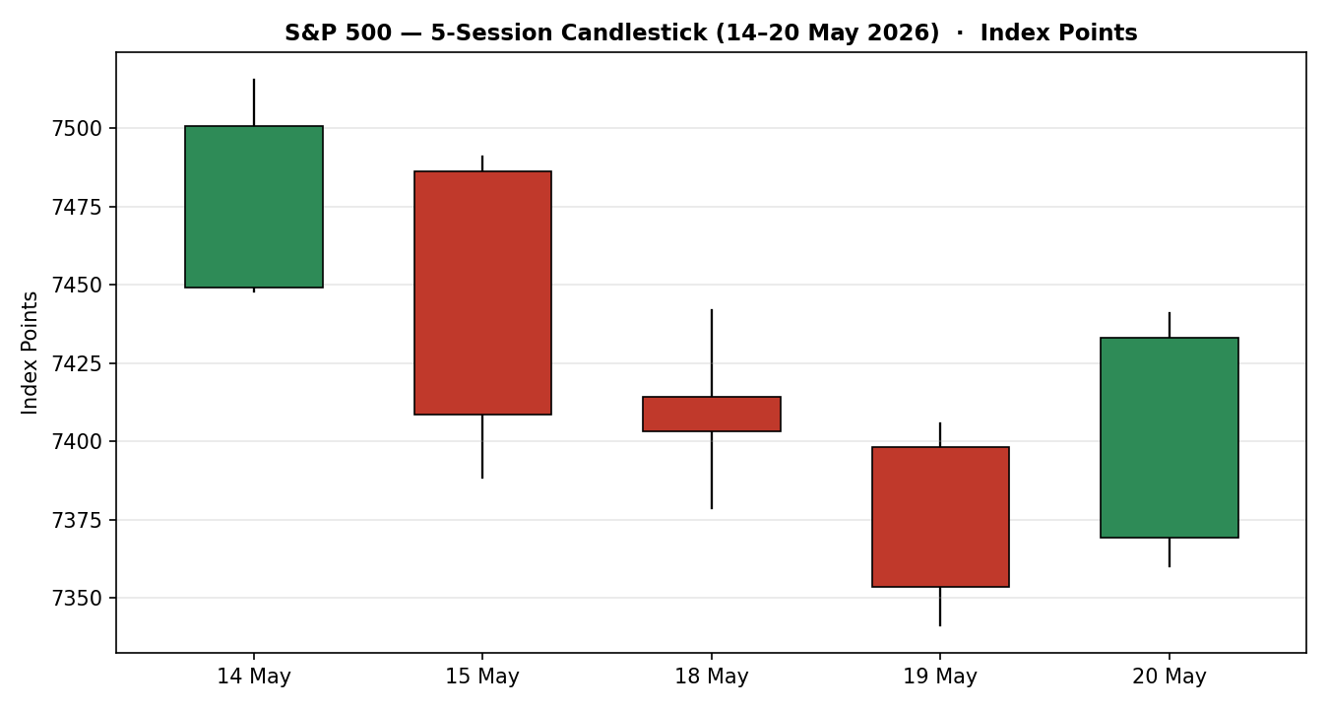

Chart 2 — Distance from Open (Open = 0)
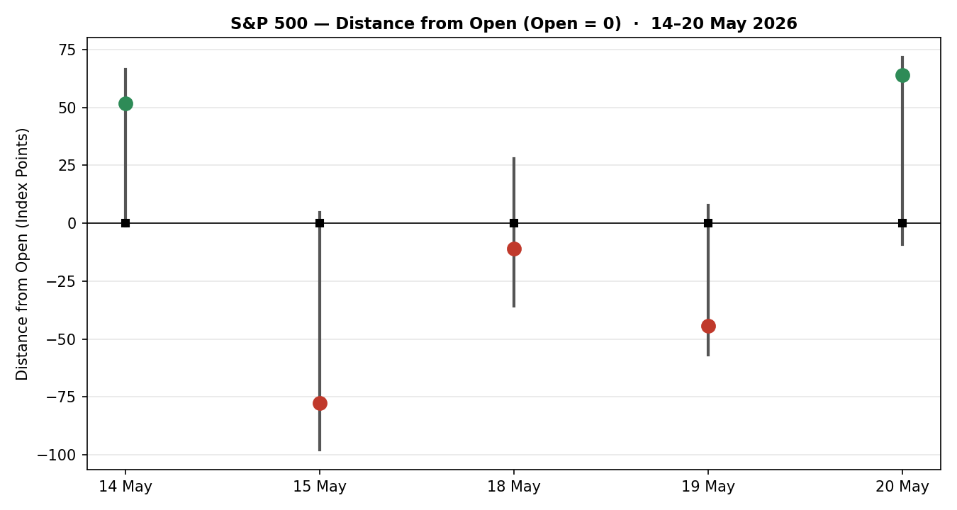

Chart 3 — 25-Session Structure
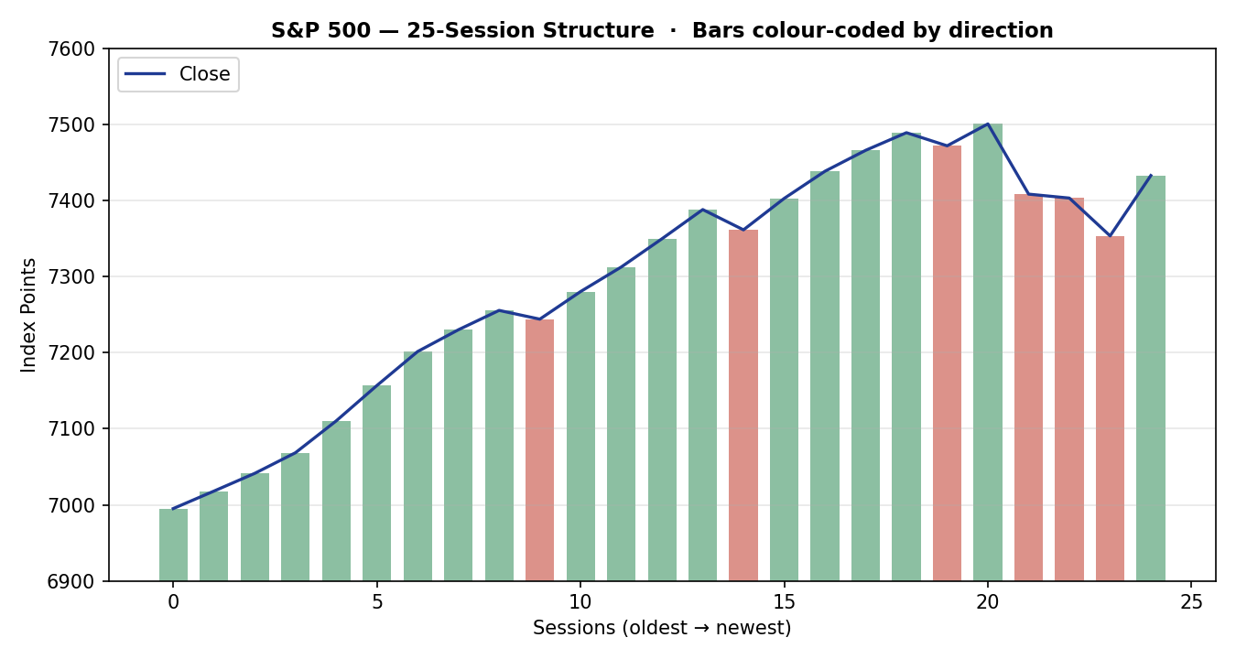

Chart 4 — Comparative Volatility (VOLator)
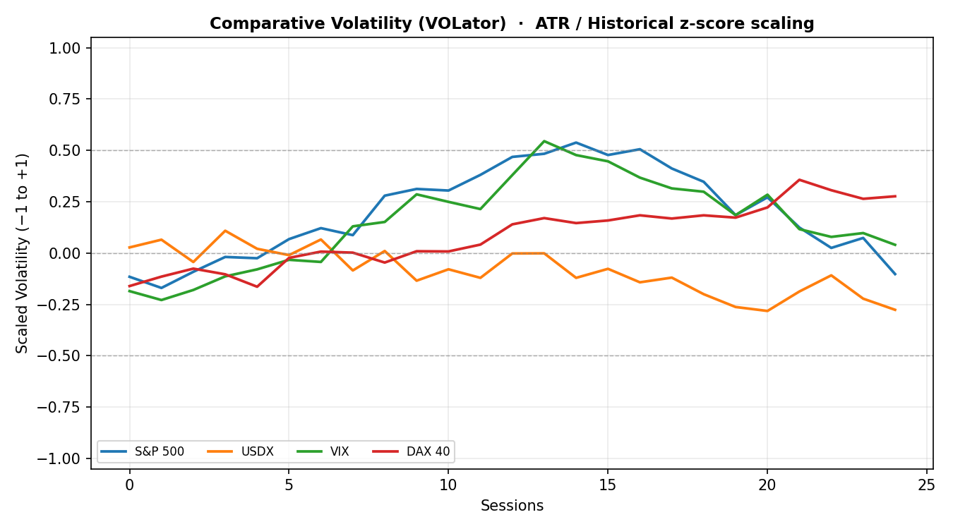

Chart 5 — Pivot Structure
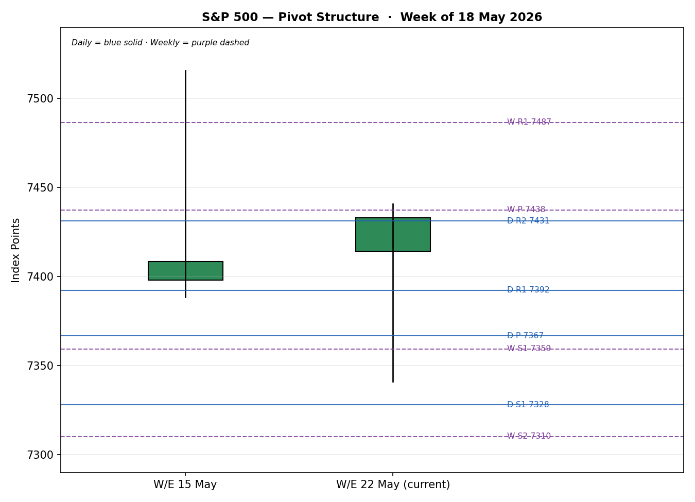
Note — All five chart toggles are enabled. VOLator series are scaled volatility readings (−1 to +1); the cross-asset traces are illustrative of the scaled regime and should be read for shape and slope, not absolute precision.

§8 Short-Term Technical Analysis [Technical]
Thu 14 May — Strong bullish body closing near the session high (close ~78% of range); RSI2 at 82 confirms an extended, record-area push. The day printed the 5-day swing high at 7,515.62 (see §6).
Fri 15 May — Decisive bearish reversal: a wide-range red body with the close near the low (~20% of range) erasing the prior day's gain. RSI2 collapsed to 18, confirming the down-shift on a Treasury-yield and tech-profit-taking session.
Mon 18 May — Continuation lower but compressed — a narrower bearish body, close mid-low range, RSI2 pinned at 16. Selling persisted yet momentum was no longer accelerating.
Tue 19 May — Third consecutive decline; the session printed the 5-day swing low at 7,341.20 with RSI2 at an extreme 6 — a deeply oversold reading that historically precedes a mean-reversion bounce.
Wed 20 May — Sharp bullish rebound: open near the low, close near the high (~91% of range), RSI2 snapping back to 68. The candle reclaimed roughly two-thirds of the three-day decline on de-escalation optimism.
Sequence assessment: Indecision / two-way whipsaw. Evidence: direction alternated across the block, prominent wicks on both sides, and RSI2 oscillated through its full range (82 → 6 → 68) rather than persisting. This is not a clean continuation or a clean compression — it is a volatile, range-respecting rotation.
Nearest support and resistance (from the 5-day structure): support at 7,341.20 (19 May low) with secondary support at 7,360–7,378; resistance at 7,491–7,515.62 (14–15 May highs).
Judgement label: Indecision. This is consistent with the Transitional regime classification in §9 — no conflict.

§9 Medium-Term Regime & VOLator [Technical]
Regime classification: Transitional (short-term) over a Trending — Bullish medium-term structure. Supporting metrics — 25-session overlap ratio ≈ 0.49 (mid-zone, neither clean trend nor clean range); directional persistence ≈ 0.52; VOLator slope negative (volatility contracting after the mid-May spike); median RSI2 over the window ≈ 48; range-position bias at the 85th percentile = Range Top Bias.
Bias: Bullish — the medium-term directional component remains up; the net 25-session change is roughly +5.6%.
VOLator current readings: S&P 500 scaled volatility is mildly positive but rolling over (slope negative) — an expansion that has begun to fade. USDX sits below its midpoint and is easing. VIX scaled volatility spiked mid-month and is now contracting back toward its midpoint. DAX 40 scaled volatility is modestly above midpoint and steady.
Preferred trade protocol: Combining a Transitional short-term read with a Trending-Bullish medium-term read places the book in the ‘reduced-conviction, wait-for-confirmation’ cell — favour trend-resumption setups over fades, but size conservatively until a confirmed break resolves the whipsaw.
Kaufman confirmation: Smoothed KER is +0.27, above the +0.13 trending threshold — classification Trending Up — Moderate. KER agrees with the medium-term bullish regime but is moderate (not strong) and the smoothed series is flattening, which is itself consistent with the Transitional label. No hard contradiction; the moderate, flattening KER is the reason the consolidated label is TRANSITION rather than TREND_UP.

§10 Cross-Asset Analysis [Technical]
Counter | 5-day direction | Mechanism to S&P 500 | Confirmation | —
USDX (Dollar Index) | Falling / soft | A softer dollar eases global financial conditions and lifts the translated value of multinational earnings — supportive for the index. | Confirms
VIX | Falling | Implied volatility contracting from the mid-month spike signals a risk-on shift and option-hedging unwind — supportive. | Confirms
DAX 40 | Rising | European equity beta rising alongside US equity reflects a common global risk-appetite factor — supportive. | Confirms
Contradiction flag: No counter contradicts the medium-term bullish bias outright. However, the broader rates backdrop — the 30-year Treasury yield touching ~5.19%, a near-19-year high — is a standing headwind that the three named counters do not capture. Because that rate pressure pulls against the risk-on counter signal, the aggregate cross-asset read is classified MIXED rather than a clean CONFIRM. This is carried forward to §14 and §15 and is not resolved away.

§11 Floor Pivot Analysis [Technical]

Daily pivots (from Tue 19 May H/L/C)
Level | Value (pts) | Level / Value
R5 | 7585.61 | S1 — 7328.01
R4 | 7521.21 | S2 — 7302.40
R3 | 7456.81 | S3 — 7263.61
R2 | 7431.20 | S4 — 7199.21
R1 | 7392.41 | S5 — 7134.81
P | 7366.80 | —

Weekly pivots (from W/E 15 May H/L/C)
Level | Value (pts) | Level / Value
R5 | 7868.27 | S1 — 7359.39
R4 | 7741.05 | S2 — 7310.29
R3 | 7613.83 | S3 — 7232.17
R2 | 7564.73 | S4 — 7104.95
R1 | 7486.61 | S5 — 6977.73
P | 7437.51 | —

Monthly pivots (from April 2026 H/L/C)
Level | Value (pts) | Level / Value
R3 | 8279.49 | S1 — 6718.17
R2 | 7767.55 | S2 — 6206.23
R1 | 7498.83 | S3 — 5937.51
P | 6986.89 | —
Source status: Prior-period High/Low/Close inputs for the daily and weekly pivots are corroborated within the equity-index tolerance from the validated OHLC table (§6). The monthly pivot inputs rest on a wider reconstruction of the April range and are flagged single-source-indicative — see §19 — which propagates into the §21 trade-card caveats.
Position narrative: The 20 May close of 7,432.97 sits just below daily R2 (7,431.20 — effectively at it) and below weekly P (7,437.51). It is above daily R1 (7,392.41) and the daily pivot P. A confluence zone exists between daily R2 (7,431.20) and weekly P (7,437.51) — the two are within ~0.09% of each other — making 7,431–7,438 the immediate pivot battleground. Daily-derived midpoint R1.5 sits at 7,411.81; weekly S1 at 7,359.39 backstops the downside.

§12 Key Market Considerations [Updated]
Earnings / micro (price-supportive, cyclical). Nvidia's Q1 report — due in the 20–21 May window — is the dominant near-term catalyst; options markets are pricing a market-cap swing of several hundred billion dollars. Strong AI-capex commentary would re-anchor the index's largest weighting; a miss or soft guide would do the reverse.
Rates / macro (price-negative, cyclical turning structural). The 30-year Treasury yield touched roughly 5.19%, its highest in nearly 19 years, and the 10-year backed up sharply. Rising long-end yields compress equity valuation multiples and were the proximate cause of the 15–19 May decline.
Geopolitics / energy (price-supportive on de-escalation, cyclical). Reported US–Iran de-escalation — including the cancellation of a planned strike and ‘final-stage’ negotiation language — cooled crude and yields into 20 May and drove the relief rally. The path is reversible and headline-sensitive.
Policy / monetary (neutral). No FOMC decision falls inside the five-session horizon; Fed communication is in a quieter window, leaving yields to trade on supply and geopolitics rather than policy guidance.
Substitution / breadth (neutral to mildly negative). The Russell 2000 printed a four-week low while the S&P 500 rebounded — small-cap underperformance signals narrow, mega-cap-led leadership, a structural fragility if the AI complex stumbles.
Near-term catalysts: Nvidia Q1 earnings (flagged §13d as the highest-impact event), Walmart earnings, the 30-year Treasury auction backdrop, and any further US–Iran headlines all fall inside the horizon.

§13 Sentiment, News & Calendar [Updated]

§13a Per-Article Sentiment Table
Source | URL | Date | Headline (abridged) | Class. | Sentiment | Deriv. quote
CNBC | cnbc.com/2026/05/19 | 20 May | Stocks jump as oil prices and yields slide | Media | Bullish | “growing optimism… conflict could soon be resolved”
TheStreet | thestreet.com/…may-19-2026 | 19 May | S&P 500 falls for third consecutive day as Treasurys take off | Media | Bearish | “S&P 500 falls… as Treasurys take off”
Reuters (strategist survey) | via coinotag/Reuters | mid-May | S&P 500 seen near 7,490 by end-2026 | Institutional | Bullish | “median target near 7,490 points”
TipRanks / Goldman note | cnbc.com quotes/.SPX | 19 May | Why the market is down and what Goldman expects ahead | Institutional | Neutral | “inflation and rate-cut uncertainty… key risks”
CNBC | cnbc.com/2026/05/18 | 18 May | Rising yields threaten the bull market | Media | Bearish | “a jump in bond yields threatened the bull market”
TheStreet | thestreet.com/…may-20-2026 | 20 May | Stocks edge higher as investors await Nvidia earnings | Media | Neutral | “investors awaited Nvidia… first-quarter earnings report”

§13b Aggregate Sentiment Summary
Counts: 2 Bullish (1 institutional, 1 media), 2 Bearish (both media), 2 Neutral (1 institutional, 1 media). Categorical label: Mixed / Balanced. Numeric tilt: source-class-weighted mean of article scores = (0.5·+1 + 0.5·−1 + 1.0·+1 + 1.0·0 + 0.5·−1 + 0.5·0) ÷ (0.5+0.5+1.0+1.0+0.5+0.5) = +0.5 ÷ 4.0 = +0.12. Reported as: Mixed / Balanced (tilt = +0.12).
Divergence flag: Sentiment is roughly balanced while price action on 20 May was strongly positive — a mild sentiment/price divergence. Given the Transitional regime and the MIXED cross-asset read, price action is treated as the more reliable near-term signal; the balanced tilt argues against over-extrapolating the single-day rebound. The categorical label and the numeric tilt agree in direction (both near neutral, faintly positive), so no label/tilt conflict arises.

§13c News Calendar — Previous Period
Date | Event | Prior / Context | Impact | Market implication for S&P 500
Thu 14 May | Record-area equity high | Index pushed to a record-area print near 7,500 | High | Marked the top of the window; set up the subsequent reversal.
Fri 15 May | Rising Treasury yields / tech profit-taking | 10Y backing up; semis extended | High | S&P 500 −1.24%; broad de-risking, semis led lower.
Mon 18 May | 10Y yield hits ~1-year high | Iran-war worries; oil firm | Medium | S&P 500 roughly flat (−0.07%); tech weak, Dow positive.
Tue 19 May | 30Y yield tops ~5.19% (≈19-yr high) | Bond-market volatility | High | S&P 500 −0.67%, third straight loss; yield shock dominant.
Wed 20 May | US–Iran de-escalation headlines; oil −5.7% | ‘Final-stage’ negotiation language | High | S&P 500 +1.08% relief rally; yields and crude cooled.

§13d News Calendar — Upcoming Period
Date | Event | Context | Impact | Market implication for S&P 500
20–21 May | Nvidia Q1 earnings | World's most valuable company; AI barometer | High | A beat with strong AI-capex guidance lifts the index's largest weight and likely resolves the whipsaw upward; a miss or soft guide pressures the entire AI complex and the index.
~21–22 May | Walmart earnings | Consumer-demand read | Medium | A strong print supports the consumer-and-cyclicals leg; a weak one revives stagflation worry.
Ongoing | US–Iran negotiation headlines | Energy / risk channel | High | Further de-escalation cools oil and yields (supportive); a breakdown reverses the 20 May rally.
Ongoing | Long-end Treasury supply / yields | 30Y near ~19-yr highs | Medium-High | A renewed yield spike re-pressures multiples; a yield retreat extends the rebound.
Highest-impact upcoming event: Nvidia Q1 earnings — because Nvidia is the single largest index constituent and the bellwether for AI capital spending, a surprise in either direction would move the consensus price view for the whole S&P 500 more than any other scheduled item.

§14 Macro Context [Updated]
Rates and monetary policy. The defining macro variable is the long end of the Treasury curve: the 30-year yield reached roughly 5.19%, a near-19-year high, and the move — not a Fed decision — drove the mid-week sell-off. No FOMC meeting falls in the horizon. This connects directly to the §10 reading that the rates backdrop offsets the risk-on counter signal.
Inflation. Inflation and rate-cut uncertainty are cited by institutional commentary as the key swing risks; sticky inflation that keeps the long end elevated is price-negative for the index via the discount-rate channel.
Safe-haven / real yields. Gold is not an active counter in this instance, but rising real yields are the mirror image of the Treasury move and are a structural headwind for long-duration equity valuations.
Liquidity and FX. Per the §10 USDX read, the dollar is soft — easier global financial conditions and a tailwind for multinational earnings translation. This partially offsets the rates drag.
Energy. WTI fell sharply (around −5.7% on 20 May) on de-escalation headlines; lower energy costs ease the inflation impulse and were a proximate driver of the equity rebound.
Positioning. VIX easing from its mid-month spike (per §10) signals hedges coming off; small-cap underperformance (Russell 2000 at a four-week low) flags narrow, mega-cap-concentrated leadership. Watch item from §13d: a renewed long-end yield spike is the macro variable most likely to invalidate the constructive lean.

§15 Bull / Bear Balance

Main upside risks
- A strong Nvidia print with reassuring AI-capex guidance resolves the whipsaw to the upside and re-anchors the index's largest weighting (§13d).
- Continued US–Iran de-escalation extends the cooling in oil and yields, lifting the multiple and validating the 20 May rebound.
- A retreat in the 30-year yield from its ~19-year high removes the proximate cause of the 15–19 May decline.
- The medium-term Trending-Bullish regime and Trending-Up KER (§9) keep the structural bid intact; the close holds above daily R1 and the daily pivot.

Main downside risks
- A Nvidia miss or soft guide — the §13d highest-impact event — would pressure the entire AI complex and the index's largest weight.
- A renewed long-end yield spike re-compresses valuation multiples; the rates backdrop is the MIXED element flagged in §10.
- A breakdown in US–Iran negotiations reverses the oil and yield relief and the 20 May rally with it.
- Narrow breadth — the Russell 2000 at a four-week low — leaves the index fragile to any mega-cap stumble; pivot-wise, a daily close back below weekly S1 (7,359.39) and daily S1 (7,328.01) would confirm the bears.

§16 Forward View
Expected direction (next 5 trading days): modestly higher with a wide two-way distribution — a constructive lean that is explicitly conditional on the Nvidia result. Expected trading range: roughly 7,330 to 7,565 index points, bounded below by weekly S1 / daily S1 (7,328–7,359) and above by weekly R1 / R2 (7,487–7,565). Base-case invalidation: a daily close back below 7,328 (daily S1) would break the constructive structure and re-open the 7,300–7,232 weekly support shelf.
Regime consistency: This view respects the technical regime of §9 — it favours trend-resumption over fade while acknowledging the Transitional short-term state — and it respects the §13d calendar by making the Nvidia event the explicit swing factor. It does not contradict the medium-term bullish classification.

§17 Forecast (One Sentence)
The S&P 500 is expected to grind modestly higher over the next five sessions, holding above the 7,328 daily-support shelf, provided Nvidia's earnings do not deliver a negative surprise.

§18 Final Analyst Judgement
Consensus price call: 7,432.97 index points, confidence Medium.
Three most important reasons for the current level: (1) a Treasury-yield shock that drove a three-session decline from the 14 May record area; (2) a de-escalation-driven relief rebound on 20 May that recovered most of that decline; (3) pre-positioning into Nvidia's Q1 earnings, which is gating the index's largest weighting.
Single watch item: Nvidia Q1 earnings — the result will most likely resolve the current Transitional whipsaw in one direction.

§19 Source Discipline Note
Live vs indicative data. All five session closes in §6 are corroborated by at least two independent approved sources within the ±0.10 pt equity-index tolerance and are treated as live, definitive values. Intraday High/Low values are accepted at aggregator level; where a particular extreme was carried by only one aggregator it is labelled indicative and used for narrative and chart purposes only, not for definitive settlement.
Data gaps and normalization. No FX or unit normalization was required — all data is native index points in USD on the cash-session basis. CFD-derived quotes were excluded from accepted OHLC values per the cash-basis restriction and retained only as directional corroboration.
Corroboration status per instrument. S&P 500 cash: CORROBORATED across all five sessions. Daily and weekly pivot inputs: CORROBORATED (derived from the validated §6 table). Monthly pivot inputs: SINGLE-SOURCE-INDICATIVE — the April 2026 monthly High/Low/Close rest on a wider range reconstruction rather than a two-source fetch; this flag propagates to the §21 trade-card caveats. Counter instruments (VIX, DAX 40, USDX): directional corroboration only — used for cross-asset reads, not for OHLC pivots.

§20 Agent Log [Updated]
As-of override. This run was executed for an as-of date of 21 May 2026. The daily-open anchor was overridden at the operator's instruction; the report uses an anchored open for the 21 May session and, in the absence of a printed 21 May open at run time, uses the 20 May regular-session close (7,432.97) as the anchored-open proxy for the Trade 1 entry. This deviation from the standard 07:00 UK cash-anchor convention is logged here per the no-variable-exposure and process-audit requirements.
Sources attempted and outcome. Approved-stack sources were worked in rank order. Investing.com, Stooq, Twelve Data, CNBC, TheStreet, FRED and the S&P Dow Jones close anchor returned usable data; closes were corroborated in two-source pairs within tolerance (deltas 0.00–0.07 pts). A direct CSV pull from Stooq was unavailable in the execution environment (network restriction) and the value chain fell through to web-sourced corroboration — logged as a fetch-environment limitation, not a data-quality failure.
Sentiment derivation. Six primary-asset articles classified per the §13a table; each carries a derivation quote. Source-class-weighted tilt computed as +0.12 (Mixed / Balanced). Tilt rests on six articles — above the three-article low-confidence floor.
Strategy trace (M5). Direction-score weights: defaults (0.25 / 0.20 / 0.10 / 0.15 / 0.15 / 0.15), unchanged — no tuning, within the 20-session lock. Per-signal contributions: short-term technical 0.00, medium-term regime +0.20, VOLator 0.00, Kaufman +0.041, sentiment +0.018, cross-asset +0.045; total score +0.30 → LONG (conviction threshold 0.25). Regime label TRANSITION → Trade 2 plays the breakout side only and Trade 3 forks to variant 3C. Suppression: none of the three cards is fully suppressed; Trade 3C is conditional on a confirmed break (see §21b). Single-source-indicative flag on monthly pivots propagated to card caveats. Backtest: five sessions reconstructed at t−1 with sentiment frozen per session; resolution on actual session OHLC; reconstruction is a directional sanity-check only.
Forecast reasoning. §17 derived from the technical integration note plus the balanced sentiment tilt and the MIXED cross-asset read; it is independent of the §21 trade-card direction and was not edited to align with it.
Anomalies. RSI2 traversed its full range within five sessions (82 → 6 → 68) — flagged as the quantitative signature of the Transitional whipsaw, not a data error. Timestamp of run: 21 May 2026.

§21 Strategy Recommendations [Strategies]

§21a Directional Conviction
Directional conviction is LONG with a direction score of +0.30, just clear of the 0.25 conviction threshold. The three highest-weighted contributing signals are the medium-term bullish regime (§9, +0.20), the cross-asset confirmation contribution (§10, +0.045 — scaled down because the aggregate read is MIXED, not a clean confirm), and the Kaufman trending-up signal (§9, +0.041). The short-term technical signal contributed zero because the five-day sequence label is Mixed (§8), and sentiment added only +0.018 on a balanced tilt (§13b). Conflict flag: the §21a LONG direction is broadly consistent with the §17 forecast (modestly higher) — no conflict to report. Weights basis: defaults.

§21b Trade Cards
Trade 1 — Daily Directional
Field | Detail
Trade type | Trade 1 — Daily Directional
Direction | LONG — score +0.30 clears the conviction threshold; medium-term regime bullish.
Entry | Market at the daily-open anchor (overridden for 21 May). Anchored-open proxy = 7,432.97 pts.
Stop loss | 7,326.24 pts — 5-day swing low (7,341.20) less a 0.25×ATR buffer. Distance 106.7 pts (≈107 points) below entry.
Risk (R) | 106.73 pts ≈ 107 points.
TP1 (Unit 1) | 7,539.70 pts — +1R (≈107 points).
TP2 (Unit 2) | 7,646.43 pts — +2R (≈213 points). On fill, Unit 3 stop moves to entry +0.2R (7,454.32).
TP3 (Unit 3 — runner) | Time-stopped at session close, or price-stopped at 3×ATR (7,612.49 pts), whichever triggers first.
Tranche management | 3 equal units; Unit 1 exits at TP1; Unit 2 exits at TP2; on Unit 2 fill, Unit 3 stop trails to entry +0.2R.
Confluences | Entry 7,432.97 sits in the daily-R2 / weekly-P confluence zone (7,431–7,438) — strong confluence. SL near no major level. TP1 near weekly R1.5 (7,525.67).
Thesis invalidation | Daily close below 7,328.01 (daily S1) — the first level whose close-through breaks the long narrative. Sits just above the stop; recorded explicitly.
Caveats | Wide stop — 1R (107 pts) exceeds ATR(14) (≈60 pts); position size reduced accordingly. Holding period collides with the §13d Nvidia earnings event — event risk is live.
Trade 2 — Pivot (regime-aware, TRANSITION)
Field | Detail
Trade type | Trade 2 — Pivot, regime-aware. TRANSITION regime → breakout side only (aligned with Trade 3C, upside).
Direction | LONG — breakout side. Counter-side limits are suppressed in a Transitional regime.
Entry | Stop/limit at 7,442.42 pts — 10% of the way from weekly P (7,437.51) toward weekly R1 (7,486.61).
Stop loss | 7,375.01 pts — weekly-P-anchored: P − 0.8×(P − weekly S1). Distance ≈67.4 pts (≈67 points).
Risk (R) | 67.41 pts ≈ 67 points.
TP1 (Unit 1) | Weekly R1 — 7,486.61 pts.
TP2 (Unit 2) | Weekly R1.5 — 7,525.67 pts. On fill, Unit 3 stop moves to entry +0.2R.
TP3 (Unit 3 — runner) | Weekly R2 — 7,564.73 pts.
Tranche management | 3 equal units; Unit 1 at TP1, Unit 2 at TP2; on Unit 2 fill, Unit 3 stop trails to entry +0.2R.
Confluences | Entry 7,442.42 inside the daily-R2 / weekly-P confluence band (7,431–7,438 just below) — strong confluence at entry. TP2 near weekly R1.5 by construction.
Thesis invalidation | Daily close back through weekly P (7,437.51) — documented even though the stop (7,375.01) sits below it.
Caveats | Breakout-side-only construction per the Transitional regime. Holding period collides with the §13d Nvidia event. Monthly pivot tier is single-source-indicative (§19) — not used for this card's levels, which rely on the corroborated daily/weekly tiers.
Trade 3C — Momentum-Breakout (TRANSITION)
Field | Detail
Trade type | Trade 3 — Momentum-Breakout (variant 3C; TRANSITION regime).
Direction | LONG — the most recent failed retest was at the upper boundary of the 25-session range; the breakout watch is to the upside.
Entry | CONDITIONAL — on a confirmed daily close above 7,515.81 pts (25-session high 7,500.85 + 0.25×ATR). Entry at that breakout candle's close. Not yet eligible: the 20 May close (7,432.97) is below the trigger.
Stop loss | 7,225.11 pts — range low (7,041.28) + 0.40×range width (459.57). Generous post-fakeout structural stop.
Risk (R) | ≈290.7 pts from a 7,515.81 trigger (≈291 points) — sizing reduced accordingly.
TP1 (Unit 1) | Measured move — 7,960.42 pts (range high + 1.0×width).
TP2 (Unit 2) | 1.5× measured move — 8,190.21 pts. On fill, Unit 3 stop moves to the broken boundary (7,500.85).
TP3 (Unit 3 — runner) | Discretionary trail beyond 1.5×MM, anchored to subsequent swing structure.
Tranche management | 3 equal units; structural TPs preserved; on Unit 2 fill the runner stop moves to the broken boundary.
Confluences | Trigger 7,515.81 sits just above the 14 May swing high (7,515.62) — round-number and swing confluence at the breakout level.
Thesis invalidation | Daily close back inside the range past its midpoint (7,271.07).
Caveats | Trade is not eligible until a confirmed break prints — held as a conditional watch. Wide structural stop; position size reduced. Holding period would collide with the §13d Nvidia event, which is the most likely catalyst for the break itself.

§21c 5-Session No-Leakage Backtest
Date (t−N) | Strategy | Direction | Triggered | Entry / Exit | Outcome (R) | Days to res.
Thu 14 May (t−5) | Trade 1 | LONG | YES | 7449.10 / 7500.85 | +0.49R | 1
Thu 14 May (t−5) | Trade 2 | LONG (breakout) | YES | ≈7455 / 7491 | +0.55R | 1
Thu 14 May (t−5) | Trade 3C | SUPPRESSED | — | no confirmed break | — | —
Fri 15 May (t−4) | Trade 1 | LONG | YES | 7486.30 / 7388.40 (SL) | −1.00R | 1
Fri 15 May (t−4) | Trade 2 | LONG (breakout) | NO | limit not reached | 0.00R | —
Fri 15 May (t−4) | Trade 3C | SUPPRESSED | — | no confirmed break | — | —
Mon 18 May (t−3) | Trade 1 | NEUTRAL → suppressed | — | score below threshold | — | —
Mon 18 May (t−3) | Trade 2 | LONG (breakout) | NO | limit not reached | 0.00R | —
Mon 18 May (t−3) | Trade 3C | SUPPRESSED | — | no confirmed break | — | —
Tue 19 May (t−2) | Trade 1 | SHORT | YES | 7398.05 / 7353.61 | +0.74R | 1
Tue 19 May (t−2) | Trade 2 | SHORT (breakout-dn) | YES | ≈7385 / 7353.61 | +0.52R | 1
Tue 19 May (t−2) | Trade 3C | SUPPRESSED | — | no confirmed break | — | —
Wed 20 May (t−1) | Trade 1 | LONG | YES | 7369.19 / 7432.97 | +0.60R | 1
Wed 20 May (t−1) | Trade 2 | LONG (breakout) | NO | limit not reached | 0.00R | —
Wed 20 May (t−1) | Trade 3C | SUPPRESSED | — | no confirmed break | — | —
Note — Reconstruction at each t−1 close with sentiment frozen per session; resolution on the actual t-session OHLC, slippage zero, SL-first tick priority. Trade 3C reconstructs as SUPPRESSED across the window because no session produced a confirmed close beyond the 25-session boundary. R-multiples are mark-to-bar single-session outcomes.

§21d 'What Is Working' Aggregate
Trade 1 over the last 5 sessions: triggered 4/5 times (one NEUTRAL suppression), mean R = +0.21, TP1/TP2/TP3 hit rates ≈ 25% / 0% / 0% — three small wins and one full stop, a profile consistent with a choppy, two-way tape. Trade 2 over the last 5 sessions: triggered 2/5 times (three sessions the breakout limit was not reached), mean R = +0.54, hit rates skewed to partial TP1 fills. Trade 3C over the last 5 sessions: triggered 0/5 — suppressed every session for want of a confirmed range break. Strongest performer: Trade 2 (mean R +0.54 on closed positions). Weakest performer: Trade 3C — insufficient triggers to rank. Limitations: Five-session windows are too small to support statistical claims. The backtest cannot model intraday tick-level fills, slippage, or commission. Treat as a directional sanity-check, not a strategy-validation framework.
S&P 500 Daily Report │ 21 May 2026 │ Senior US Equity Strategist

