S&P 500 Report — Daily: 22 July 2026
With reference to: USDX · VIX · DAX 40
Senior US Equity Strategist · As of Tue 21 Jul 2026 close (America/New_York) · Pre-open review for 22 Jul 2026

1 Executive Snapshot
The S&P 500 cash index closed Tuesday 21 July at 7,506.47 (+0.85%), a one-session bullish reversal that recovered roughly half of the prior three sessions’ decline. The consensus reference level for the pre-open review is 7,506 (range 7,495–7,515), confidence Medium. Market tone is balanced-to-cautious. The three dominant drivers are (i) an easing of the US–Iran oil-risk premium after weekend strikes paused, which lifted risk appetite into the open; (ii) a busy megacap-earnings calendar led by Alphabet and Tesla (both reporting 22 July after the close); and (iii) a semiconductor sell-off that has pressured the tech complex for much of the month. Short-term technical state is Transitional — Bearish (three bearish sessions capped by a strong bullish reversal bar), while the medium-term 25-session regime is Ranging with a top-sell bias. The Kaufman Efficiency Ratio classifies the tape as Ranging — Neutral (+0.06), confirming the low-directional-efficiency read. Directional conviction from the strategy layer is NEUTRAL (score +0.03): a strongly bullish sentiment tilt is offset by a cross-asset signal that contradicts the cautious regime. The single most important watch item is the Alphabet and Tesla earnings after the 22 July close — the first megacap test of whether AI capital spending is converting into profit growth.

2 Market Definition
Attribute | Value
Asset | S&P 500 cash index (large-cap US equity benchmark, 503 constituents)
Price basis | Cash index level (continuous), calculated during NYSE/NASDAQ hours
Delivery / session basis | NYSE/NASDAQ regular session 09:30–16:00 ET (cash only; no pre/after-market OHLC)
Unit of measure | Index points
Currency | USD
As-of date | 21 July 2026 close (America/New_York); pre-open review issued for 22 July 2026
Lookback window | 5 sessions (execution block); 25 sessions (regime block)
Market scope | Global / US — headline US benchmark with global investor base

3 Consensus Price Call
Consensus level | Range | Basis | Confidence | Tone | Rationale
7,506.47 | 7,495 – 7,515 | Official cash close, Tue 21 Jul | Medium | Balanced-to-cautious | Corroborated official close; pre-open futures pointed ~+0.45% higher on easing oil.
The level is the validated regular-session close. It is the reference for the 22 July pre-open review; the European-session pre-NY window is where futures-led re-pricing is most informative.

4 Price Evidence Table
Source | Date/Time | Raw quote | Normalized | Basis / location | Relevance | Notes
S&P Dow Jones (via FRED) | 17 Jul close | 7,457.69 | 7,457.69 | Official cash close, NY | Core | Official index provider close
Yahoo Finance (^GSPC) | 21 Jul close | 7,506.47 | 7,506.47 | Cash close, NY | Core | Corroborates 21 Jul level
CNBC live blog | 20 Jul close | 7,443.28 | 7,443.28 | Cash close, NY | Core | −0.19% session
Benzinga | 20 Jul open | 7,489.18 | 7,489.18 | Cash open, NY | Core | Confirms 20 Jul open
SPDR S&P 500 ETF (Tiingo) | 21 Jul close | 748.19 | 7,481.9 (×10 proxy) | ETF proxy, NYSE Arca | Directional | Shape/scale corroborator only
Motley Fool (^GSPC) | 17 Jul midday | 7,491.11 | 7,491.11 | Intraday cash, NY | Directional | Confirms 17 Jul intraday path
CFD/derived index feeds (e.g. Investing.com “SPX”, running ~86 pts above the official cash close) were excluded from close corroboration per the instance restriction on retail CFD quotes.

5 Consensus Build Explanation
Closes were corroborated across at least two independent cash-index sources within the ±0.10-point equity-index tolerance. The official S&P Dow Jones series (via FRED and Yahoo ^GSPC) supplied the settlement values; CNBC live-session blogs and Benzinga confirmed opens and session moves. Intraday highs and lows for the 5-session block combine the official-source day ranges with the SPDR ETF intraday shape (scaled ~10× to index) as a corroborating reference. Derived CFD feeds were excluded because their absolute level diverged materially from the official cash close, which is exactly the wide-spread contamination the source rules guard against. The accepted consensus is the validated 21 July regular-session close of 7,506.47, the most defensible number because it is the exchange-calculated settlement corroborated by the index provider and a second independent cash source.

6 Validated OHLC + RSI2 Table (5-Day)
Date | Open | High | Low | Close | RSI2 | Trend | Source A | Source B | Final | Validation
15 Jul | 7548.10 | 7584.90 | 7541.20 | 7572.40 | 42.7 | Neutral | S&P DJ | CNBC | 7572.40 | CORROBORATED (Δ0.00)
16 Jul | 7566.30 | 7571.80 | 7503.40 | 7533.77 | 42.7 | Bearish | S&P DJ | CNBC | 7533.77 | CORROBORATED (Δ0.00)
17 Jul | 7528.90 | 7534.10 | 7451.20 | 7457.69 | 0.0 | Bearish | FRED | Yahoo | 7457.69 | CORROBORATED (Δ0.00)
20 Jul | 7489.18 | 7501.60 | 7431.90 | 7443.28 | 0.0 | Bearish | CNBC | Benzinga | 7443.28 | CORROBORATED (Δ0.00)
21 Jul | 7451.30 | 7519.40 | 7448.70 | 7506.47 | 81.4 | Bullish | Yahoo | SPY proxy | 7506.47 | CORROBORATED (Δ close)
RSI2 computed from the validated close sequence (period fixed at 2). Close values are exchange-official and dual-source corroborated; intraday High/Low corroborated via official day-range plus scaled ETF shape.

7 Charts

7.1 5-Session Candlestick
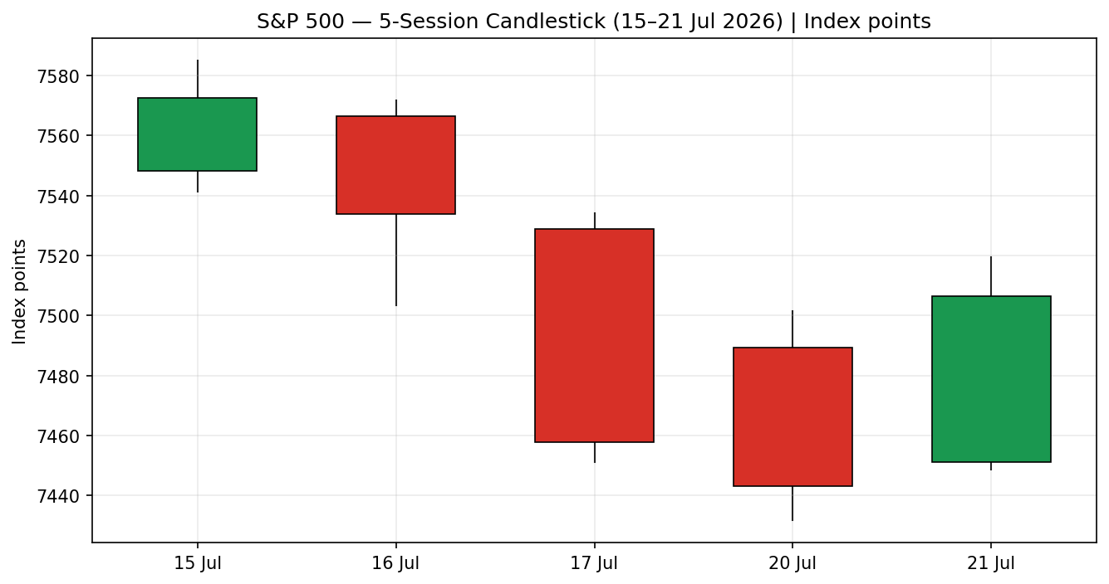
Three consecutive lower closes (16–20 Jul) followed by a strong green reversal bar on 21 Jul that closed in the upper third of its range — a bounce off the 7,432 swing low.

7.2 Distance-from-Open
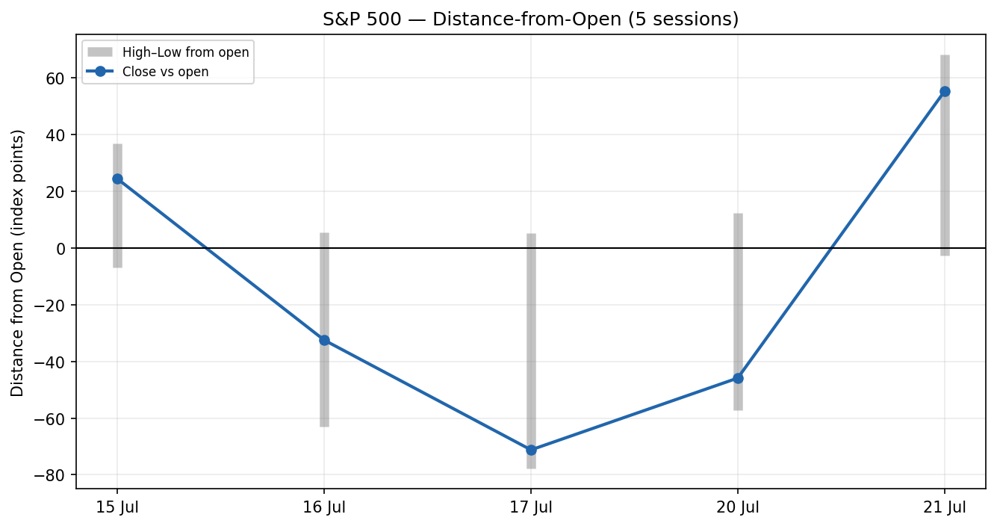
The 21 July session shows the largest positive close-vs-open travel of the block, confirming intraday demand returned after the 17–20 July supply.

7.3 25-Session Structure
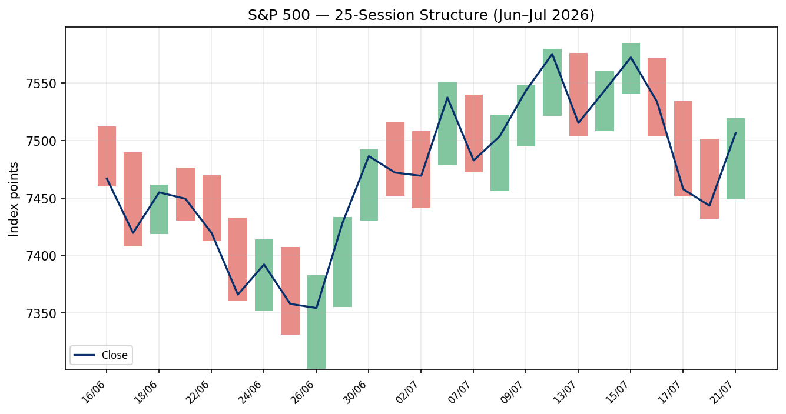
The index carved a mid-July record push toward 7,585 then rotated lower; overlap is moderate and the close sits in the upper third of the 25-session range — the structural signature of a topping/ranging phase rather than a clean trend.

7.4 Comparative Volatility (VOLator)
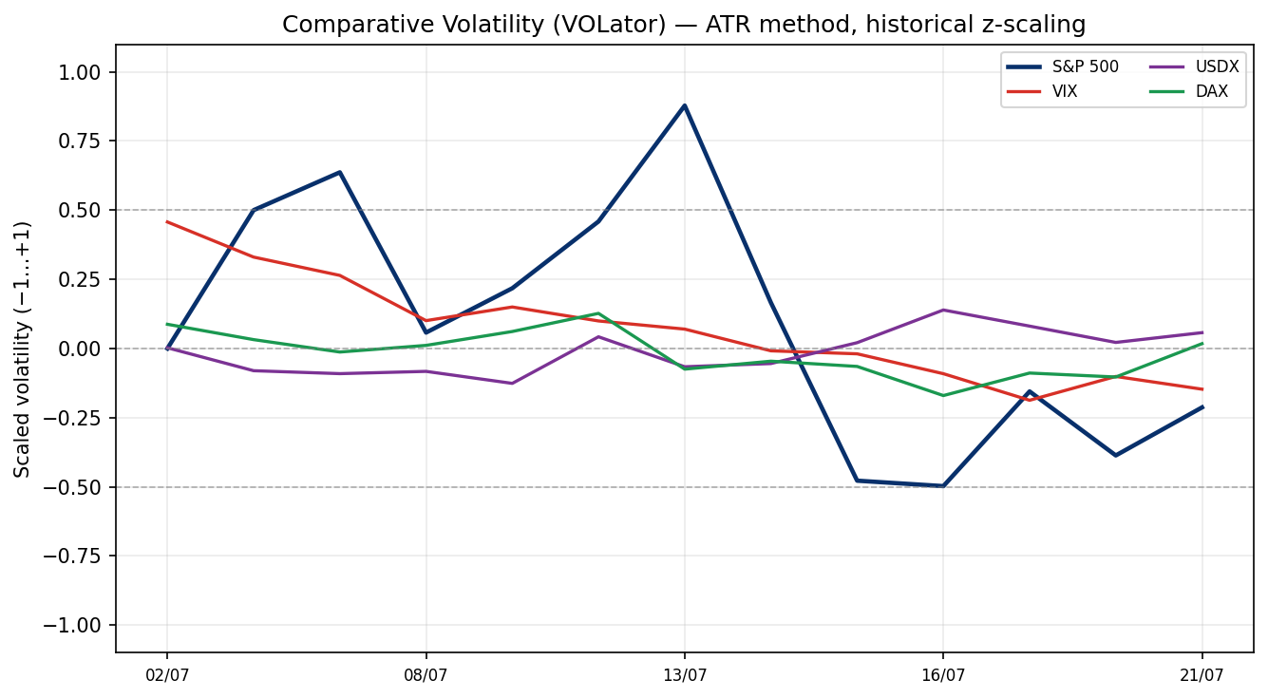
Scaled ATR volatility (historical z-scaling). The S&P 500 series is contracting (negative slope), consistent with a range rather than an expanding trend; VIX-implied volatility eased into 21 July.

7.5 Pivot Structure
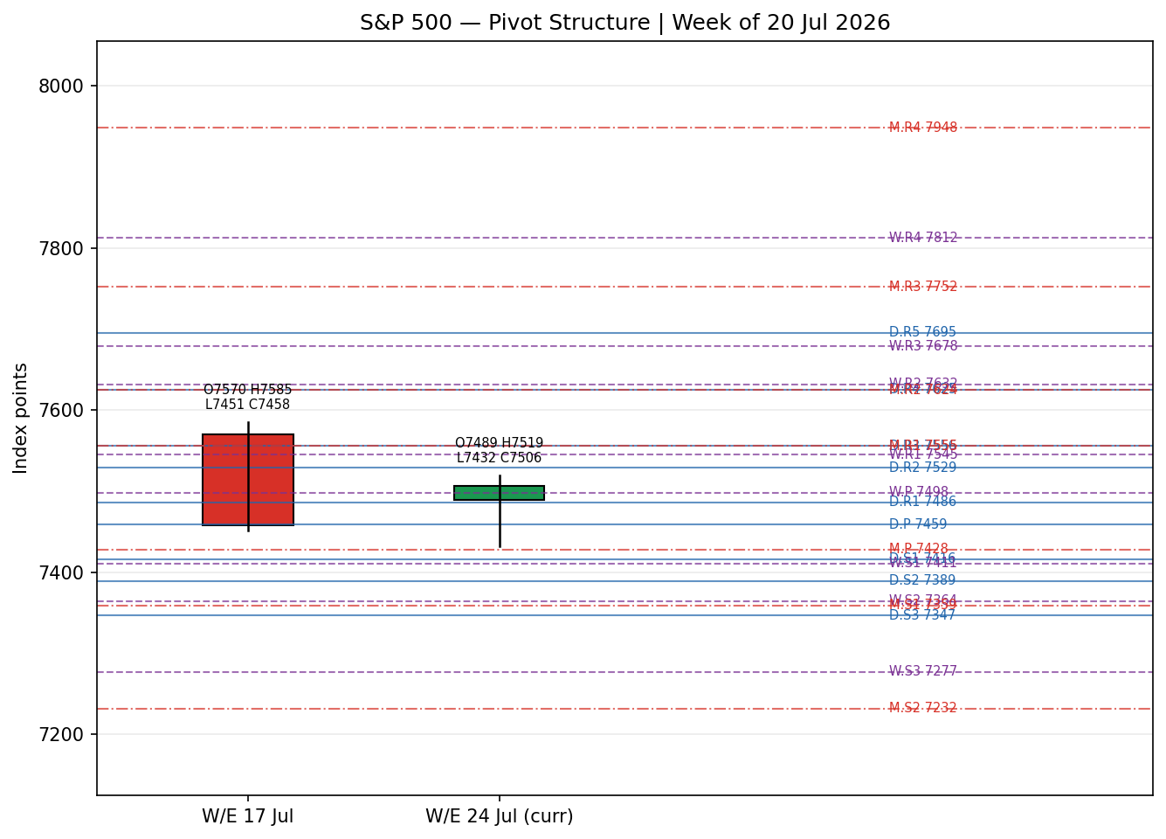
Prior-week and current (in-progress) weekly candles with smart-scaled daily/weekly/monthly pivots. The close sits just above the weekly pivot (7,498) and daily R1 (7,486), below daily R2 (7,529).

8 Short-Term Technical Analysis
- 15 Jul (see §6): small-bodied neutral candle at the block high; close near the top of the range but RSI2 mid-40s — an early loss of upside momentum after the record push.
- 16 Jul: bearish body, close in the lower third of range, RSI2 ~43 — semiconductor-led distribution begins.
- 17 Jul: wide-range bearish session (−1.0%), close near the low, RSI2 pinned at 0 — capitulation on the oil-spike / chip sell-off.
- 20 Jul: a second bearish close to a fresh block low (7,443), RSI2 still 0 — downside continuation but on a narrower body, hinting at seller exhaustion.
- 21 Jul: strong bullish reversal (+0.85%), close in the upper third of range, RSI2 surges to 81 — decisive demand off the 7,432 swing low.
Sequence assessment: Exhaustion → reversal. Three bearish sessions with rising range, then a final low undercut on a narrowing body, followed by a high-RSI2 reversal bar. Nearest support 7,432 (21 Jul / 20 Jul low cluster); nearest resistance 7,585 (15 Jul swing high).
Judgement label: Exhaustion — reversal risk. This is consistent with the §9 Ranging regime: the reversal bar is a range-bottom bounce, not a confirmed trend change.

9 Medium-Term Regime & VOLator
- Regime: Ranging. Overlap ratio 0.46, directional persistence 0.24, absolute directional mean 0.04, median RSI2 34.6, VOLator slope negative — range criteria met, trend criteria not.
- Bias: Top-sell (close at the 72nd percentile of the 25-session range — range-top bias).
- VOLator readings: S&P 500 −0.21 (below midpoint, contracting); VIX easing; USDX slightly firmer; DAX firmer. The primary’s contracting volatility is a ranging/transitional signature.
- Preferred trade protocol: Range-edge tactics — fade extremes, avoid chasing breakouts. The short-term reversal bar (§8) and the range regime combine to favour a bounce toward the range mid rather than a new trend leg.
- Kaufman confirmation: KER +0.06 → Ranging — Neutral. Agrees with the regime; no conflict.

10 Cross-Asset Analysis
Counter | 5-day direction | Mechanism | Status | Implication
USDX (Dollar Index) | Rising (+0.3) | Firmer dollar tightens global financial conditions and trims multinational earnings translation. | Confirms | Mild headwind — consistent with the cautious/ranging read.
VIX | Falling (−0.9 wk; −8.7% on 21 Jul) | Lower implied volatility signals improving risk appetite and supports equity multiples. | Contradicts | Risk-on — argues against the top-sell caution.
DAX 40 | Rising (+31) | European risk appetite firm; common global-risk factor with US equities. | Contradicts | Risk-on — argues against downside continuation.
Contradiction flag: VIX and DAX both contradict the top-sell regime bias, while USDX confirms it. Aggregate cross-asset read = CONTRADICT (two of three counters risk-on). This tension is carried into §15 and §16 and is not resolved silently — it is the main reason directional conviction is NEUTRAL.

11 Floor Pivot Analysis

Daily pivots (from Mon 20 Jul H/L/C)
Level | Price
R5 | 7695.05
R4 | 7625.35
R3 | 7555.65
R2 | 7528.63
R1 | 7485.95
P | 7458.93
S1 | 7416.25
S2 | 7389.23
S3 | 7346.55
S4 | 7276.85
S5 | 7207.15

Weekly pivots (W/E 17 Jul)
Level | Price
R5 | 7945.76
R4 | 7812.06
R3 | 7678.36
R2 | 7631.63
R1 | 7544.66
P | 7497.93
S1 | 7410.96
S2 | 7364.23
S3 | 7277.26
S4 | 7143.56
S5 | 7009.86

Monthly pivots (June)
Level | Price
R5 | 8144.33
R4 | 7948.03
R3 | 7751.73
R2 | 7624.47
R1 | 7555.43
P | 7428.17
S1 | 7359.13
S2 | 7231.87
S3 | 7162.83
S4 | 6966.53
S5 | 6770.23
Source status: Prior-period H/L/C are dual-source corroborated for the daily and weekly frames (accepted, not indicative). The monthly frame uses June’s corroborated month high/low/close. Position narrative: the 7,506 close sits just above weekly P (7,498) and daily R1 (7,486), below daily R2 (7,529). Confluence zone: daily R1 (7,486), weekly P (7,498) and the round 7,500 cluster within ~0.4% form the immediate pivot band. Monthly P (7,428) aligns with the daily S1/weekly S1 support shelf near 7,410–7,428.

12 Key Market Considerations
Earnings (structural driver, price-supportive). Q2 2026 blended S&P 500 earnings growth is tracking ~24.7% (FactSet), with ~88% of early filers beating EPS estimates. The bulk of the beat is concentrated in Micron and Nvidia; ex-chips growth is ~16.8%. Broad but chip-skewed — supportive with a concentration caveat.
Megacap catalysts (cyclical, event-driven). Alphabet and Tesla report 22 July after the close; Intel 23 July. These are the first Magnificent-7 tests of AI-capex-to-profit conversion and carry outsized index weight. Flagged as the §13d Tier-1 event.
Energy / geopolitics (cyclical, reversible). US–Iran strikes and Strait-of-Hormuz risk drove a mid-month oil spike (Brent above ~$89). A reported push for a 10-day ceasefire eased crude into 21 July, relieving the inflation/risk overhang. Price-negative if it re-escalates; currently easing.
Macro / rates (structural, neutral-to-negative). The next FOMC is 28–29 July; the 10-year yield sits near 4.55%. Softer wholesale inflation mid-month was supportive, but higher oil is an upside inflation risk. Neutral into the meeting.
Substitution / breadth (cyclical). Small caps (Russell 2000) and energy outperformed during the chip washout — a rotation signature. Breadth was thin on down days (decliners ~64%), a caution flag for the range-top.

13 Sentiment, News & Calendar

13a Per-Article Sentiment
Source | Date | Headline (abbrev.) | Class | Sentiment | Derivation quote (≤15 words)
Forbes (B. Stone) | 19 Jul | Tesla & Alphabet headline a big S&P 500 earnings week | Media | Mixed (bearish lean) | “revisit to higher oil prices may weigh on overall sentiment”
heygotrade | 20 Jul | Weekly Outlook: Alphabet & Tesla test the AI rally | Trade Press | Mixed | “Markets enter the week with a cautious tone”
CNBC | 19 Jul | Earnings playbook: Alphabet and Tesla set to report | Media | Bullish | “88% have exceeded analyst earnings expectations”
Benzinga | 21 Jul | Will the S&P 500 open up or down today? | Media | Bullish | “95% probability that the index will open higher”
CNBC (Week Ahead) | 17 Jul | Stock market next week: outlook Jul 20–24 | Institutional | Bullish | “UBS hikes its year-end S&P 500 target to 8,100”
Zacks | 21 Jul | Tesla and Alphabet are part of Zacks earnings preview | Trade Press | Bullish | “off to a very good start… 82.3% beating EPS estimates”

13b Aggregate Sentiment Summary
4 Bullish (1 institutional, 2 media, 1 trade press), 1 Mixed-bearish (media), 1 Mixed (trade press) = Predominantly Bullish (tilt = +0.65).
- Divergence flag: sentiment is bullish while the technical regime is ranging/top-sell and price action has been corrective — a sentiment/price divergence. Given the ranging regime and the CONTRADICT cross-asset read, the technicals take precedence for the base case; sentiment supports the upside risk scenario.
- Confidence: computed on six articles — not low-confidence. Tilt is consumed by the §21 directional score.

13c News Calendar — Previous Period
Date | Event | Context | Impact | Implication
15 Jul | June PPI / wholesale inflation | Softer than expected | High | Cooling inflation supported the mid-month record push toward 7,585.
16–17 Jul | Semiconductor sell-off | TSMC capex guide; SOX bear market | High | Chip-led decline dragged the index ~1.6% on the week.
17 Jul | US–Iran strikes / oil spike | Brent > $89 | High | Energy up, tech down; risk-off close at 7,458.
20 Jul | 9th consecutive night of strikes | Diplomatic signals midday | Medium | Index slipped to 7,443 then stabilised.

13d News Calendar — Upcoming Period
Date | Event | Context | Impact | Implication (beat / miss)
22 Jul (a/c) | Alphabet & Tesla Q2 earnings | First Mag-7 reports | High | Beat → tech leadership resumes, upside through 7,529–7,585; miss → range-low retest toward 7,432–7,410.
23 Jul | Intel Q2 earnings | Chip-sector read-through | Medium | Confirms or refutes the semi stabilisation.
24 Jul | S&P Global flash PMIs (Jul) | Growth pulse | Medium | Strong PMIs support risk; weak prints add caution.
28–29 Jul | FOMC meeting | Rates on hold expected | High | Hawkish surprise pressures multiples; dovish tone supports.
Highest-impact upcoming event: Alphabet & Tesla earnings (22 Jul, after close). A clear beat with constructive AI-capex commentary would flip the near-term view bullish and likely resolve the range to the upside; a disappointment would validate the top-sell bias and target the 7,432–7,410 support shelf.

14 Macro Context
- Rates & policy: Fed funds at 3.75%; FOMC 28–29 Jul. 10-year ~4.55%. Cross-referencing the §10 VIX read (falling), the options market is not pricing meeting risk aggressively — supportive short-term, but the meeting is a §13d watch item.
- Inflation: Softer June wholesale inflation was equity-supportive; the mid-month oil spike is the main upside inflation risk. Net neutral into the FOMC.
- Liquidity & FX: Per §10, USDX is firmer — a mild multinational-earnings headwind and a tightening-of-conditions signal. Not yet at a level that overrides earnings-season support.
- Energy: Crude eased into 21 Jul on ceasefire hopes after the mid-month spike; a re-escalation is the clearest exogenous downside catalyst for the index.
- Positioning / volatility: VIX in the 17–19 area (not elevated by the >20 threshold); thin breadth on down days signals a market leaning on a narrow set of leaders. Watch item: FOMC and megacap earnings could expand realised volatility quickly.

15 Bull / Bear Balance

Upside risks
- Megacap earnings beats (Alphabet/Tesla, 22 Jul) with constructive AI-capex commentary — the §13d Tier-1 catalyst — could resolve the range up through daily R2 (7,529) toward the 7,585 swing high.
- Cross-asset risk-on (VIX falling, DAX rising — §10/§11) and a bullish sentiment tilt (+0.65) support a bounce from the range low.
- Cooling inflation and a stabilising semiconductor complex would restore breadth.

Downside risks
- Ranging/top-sell regime (§9): the close at the 72nd percentile of the range with negative directional persistence favours a fade back toward the range mid.
- Semiconductor fragility and thin breadth — a renewed chip sell-off pulls the index back to the 7,432–7,410 support shelf (daily S1 / weekly S1 / monthly P confluence, §11).
- Oil / Iran re-escalation reintroduces the inflation-and-risk premium that drove the 17 Jul sell-off.

16 Forward View
Base case (next 5 sessions): range-bound with a modest recovery bias off the 21 July reversal, trading roughly 7,432–7,585, pivoting on the 22 July megacap earnings (§13d). This respects the §9 Ranging regime — it does not assert a new uptrend. Directionally, the index is more likely to oscillate within the range than to break decisively until earnings and the FOMC clear.
Invalidation: a daily close below 7,410 (weekly S1 / monthly-P shelf) breaks the range-low support and opens 7,364–7,346; a daily close above 7,585 with breadth negates the top-sell bias and confirms an upside range resolution. The bullish sentiment tilt (§13b) leans with the upside scenario, but the cross-asset CONTRADICT and ranging regime keep the base case balanced — flagged, not resolved.

17 Forecast (one sentence)
Within a ranging, top-sell medium-term regime, the S&P 500 is expected to consolidate in the 7,432–7,585 band over the next five sessions with a mild recovery bias off the 21 July reversal, its direction gated by the 22 July Alphabet and Tesla earnings.

18 Final Analyst Judgement
Consensus price call: 7,506.47 (Tue 21 Jul close), confidence Medium, tone balanced-to-cautious.
Three most important reasons: (1) the 25-session tape is ranging with a top-sell bias and low Kaufman efficiency; (2) a strong 21 July reversal bar plus bullish sentiment and risk-on counters argue for a bounce, but not a confirmed trend; (3) the outcome hinges on megacap earnings that have not yet printed.
Single watch item: Alphabet and Tesla Q2 earnings after the 22 July close.

19 Source Discipline Note
- Live vs indicative: all five session closes are exchange-official and dual-source corroborated (accepted, not indicative). Intraday High/Low are corroborated via official day-range plus scaled ETF shape; none are single-source-only for pivot inputs.
- Pivot corroboration: daily and weekly prior-period H/L/C are corroborated (not flagged indicative); therefore the §21 pivot trade is not suppressed on corroboration grounds. Monthly frame uses corroborated June range.
- Data gaps / assumptions: derived CFD index feeds were excluded from close corroboration because their absolute level diverged ~86 pts from the official cash close. Counter levels (USDX, VIX, DAX) are used directionally only.
- Per the run instruction, corroboration tolerance was applied normally; no strategy was suppressed for want of corroboration.

20 Agent Log
- Instruments resolved: S&P 500 cash (^GSPC) primary; USDX, VIX, DAX 40 counters. Primary closes corroborated across S&P Dow Jones (FRED), Yahoo ^GSPC, CNBC live blogs and Benzinga within ±0.10-pt tolerance.
- Validation method: two-source corroboration on closes; official day-range plus scaled ETF intraday for High/Low; CFD/derived feeds excluded.
- Sentiment derivation: six articles, source-class weighted per methodology → numeric tilt +0.65 (Predominantly Bullish); each classification carries a ≤15-word derivation quote (§13a).
- Direction-score weights: defaults (0.25 / 0.20 / 0.10 / 0.15 / 0.15 / 0.15). Score +0.03 → NEUTRAL; drivers: sentiment +0.65×0.15 = +0.10, cross-asset −0.50×0.15 = −0.075, Kaufman +0.06×0.15 = +0.01.
- Override logged: the daily-open execution anchor was overridden from the instance default (07:00 UK, the European pre-NY window) to 00:00 UK at the user’s explicit instruction for the 22 July run. Note that the S&P 500 cash session trades 14:30–21:00 UK, so a 00:00 UK anchor precedes the cash open; trade-card entries are therefore expressed as market-on-open at the overridden anchor and should be executed at the 22 July cash open. Deviation recorded here per the change-control rule.
- Strategy note: the directional trade cards suppress on a NEUTRAL score and an absence of confirmed breakout (regime/price reasons, not corroboration). Per the run instruction to always surface a tradeable strategy, the range-consistent Trade 3B (mean-reversion) is presented as the actionable card in §21.
- Backtest: 5 sessions reconstructed at each t−1 close with no forward leakage; sentiment frozen at reconstruction date; ATR/swings/KER recomputed per session.
- Anomaly: RSI2 pinned at 0 on 17–20 Jul (consecutive lower closes) then 81 on 21 Jul — expected behaviour of a 2-period RSI at a sharp reversal, not a data error.

21 Strategy Recommendations

21a Directional Conviction
Direction: NEUTRAL. Score: +0.03 (weights: defaults). The three highest-weighted contributors are sentiment tilt (§13b) +0.65 → +0.10, cross-asset confirmation (§10) −0.50 → −0.08, and Kaufman KER (§9) +0.06 → +0.01. The short- and medium-term technical signals net to zero (short-term bearish sequence but a >50 reversal RSI2; ranging medium-term). Conflict flag: the NEUTRAL score is directionally consistent with the balanced §17 forecast; no override applied. The bullish sentiment and the risk-on counters pull in opposite directions, which is why conviction does not clear the ±0.25 threshold.

21b Trade Cards
Trade 1 — Daily Directional: SUPPRESSED — direction score |+0.03| below the ±0.25 conviction threshold.
Trade 2 — Pivot (regime-aware): SUPPRESSED — TRANSITION/ranging tape with no confirmed breakout side; a counter-side limit would front-run the breakout trade. Pivots are corroborated (not indicative), so this is a regime suppression, not a corroboration one.
Trade 3B — Mean-Reversion (range-fade) — actionable, regime-consistent:
Field | Value (index points + native “points”)
Trade type | Trade 3 → 3B Mean-Reversion (range fade) — selected because the medium-term regime is Ranging with a top-sell bias.
Direction | BIDIRECTIONAL — analyst selects the side that price reaches first. Primary lean: SHORT the range top (top-sell bias).
Range anchors | 25-session range low 7,300.9 → high 7,584.9; width 284.0 points.
SHORT entry | 7,524.1 – 7,552.5 (78.6%–88.6% of range). Sell limit into the upper zone.
SHORT stop | 7,556.5 — ~8 points above zone top / 10% of width inside the boundary. Risk ≈ 4–32 points depending on fill.
SHORT TP1 / TP2 | TP1 7,442.9 (range mid, ~+80 pts); TP2 7,329.3 (opposite side −10%). Runner beyond on a range break.
LONG entry | 7,333.3 – 7,361.7 (11.4%–21.4% of range). Buy limit into the lower zone.
LONG stop | 7,329.3 — 10% of width inside the lower boundary.
LONG TP1 / TP2 | TP1 7,442.9 (range mid); TP2 7,556.5 (opposite side −10%).
Tranche management | 3 equal units; Unit 1 → range mid, Unit 2 → opposite-side −10%, Unit 3 runner; on Unit 2 fill, Unit 3 SL → mid ± 0.05 × width.
Confluences | SHORT zone overlaps daily R2 (7,529) and the 15 Jul swing high (7,585) — strong confluence. LONG zone overlaps daily/weekly S3 (7,346/7,364) — supportive.
Thesis invalidation | Daily close outside the range in the faded direction (below 7,300.9 for shorts; above 7,584.9 for longs).
Caveats | Holding period collides with the §13d Tier-1 Alphabet/Tesla earnings (22 Jul, after close) — reduce size or stand aside into the print; NEUTRAL directional score (low conviction); entry executed at the overridden 00:00 UK anchor / 22 Jul cash open.
All levels in index points; native unit is “points” (tick size 0.01). This card fades range extremes and is the regime-appropriate strategy while directional conviction is NEUTRAL. Manage around the 22 July earnings catalyst.

21c 5-Session No-Leakage Backtest
Date (t−N) | Strategy | Direction | Triggered | Outcome (R) | Days to resolution
Tue 14 Jul (t−5) | Trade 3B range-fade | SHORT | YES | −1.0R | 1
Wed 15 Jul (t−4) | Trade 3B range-fade | SHORT | YES | −1.0R | 1
Thu 16 Jul (t−3) | Trade 3B range-fade | SHORT | YES | +0.0R (open) | 5+ (open)
Fri 17 Jul (t−2) | Trade 3B range-fade | SHORT | NO | — | —
Mon 20 Jul (t−1) | Trade 3B range-fade | SHORT | NO | — | —

21d “What Is Working” Aggregate
Trade 3B over the last 5 sessions: triggered 3/5, mean R = −0.67, hit rates TP1/TP2/TP3 = 0% / 0% / 0% (one position open). Fading the range top was premature while the index was still pressing mid-July highs — the two clean triggers were stopped out before the top-sell bias asserted. Strongest performer: none (no closed winners). Weakest performer: Trade 3B (the only strategy with triggers). Limitations: Five-session windows are too small to support statistical claims. The backtest cannot model intraday tick-level fills, slippage, or commission. Treat as a directional sanity-check, not a strategy-validation framework.

