S&P 500 Report — Daily: 22 May 2026
With reference to: USDX · VIX · DAX 40
Senior US Equity Strategist · Trading and risk review (forward-test) · Prepared for the European pre-open, anchor 00:00 UK
Contents

1. Executive Snapshot
The S&P 500 cash index is assessed at a consensus level of 7,400 index points as of the 21 May 2026 close, the reference point for this 22 May 2026 daily report. Market tone is balanced with a mild defensive tilt. Three drivers dominate the current picture: a back-up in long-dated US Treasury yields toward multi-month highs that has compressed equity risk appetite; a sharp swing in crude oil — first higher on Middle East supply fear, then a steep reversal as a possible Iran de-escalation emerged — that has whipsawed the inflation narrative; and a muted reaction to Nvidia's first-quarter earnings, where an in-line-to-soft forward guide failed to re-ignite the AI-leadership trade. The short-term technical state is Transitional with a bearish lean: three consecutive lower closes into 19 May were followed by a strong 20 May rebound and a softer, indecisive 21 May session. The medium-term 25-session regime is Transitional — directional persistence and overlap are both mid-band, and the index sits in the upper third of its five-week range after pulling back from the 14 May record close of 7,501.24 (intraday 7,517.12). The Kaufman Efficiency Ratio classifies the medium-term path as Trending Up — Moderate (+0.20), which sits in tension with the softer short-term tape and is flagged as a mixed signal. The single most important watch item is the upcoming US core PCE inflation print, the highest-impact scheduled release inside the five-day horizon (see §13d).
Directional conviction (see §21): Direction score −0.22 — magnitude below the conviction threshold, so the daily directional trade is suppressed. Trade 2 (pivot) and Trade 3 (regime-driven) proceed. The regime label resolves to TRANSITION; the active complex variant is the momentum-breakout (3C).

2. Market Definition
Field | Definition
Asset | S&P 500 cash index (^GSPC) — large-cap US equity benchmark, 503 constituents
Specification | Standardised index methodology; rebalanced quarterly by S&P Dow Jones Indices
Scope | Global / US — headline US benchmark with a global investor base
Delivery basis | NYSE/NASDAQ regular cash session 09:30–16:00 ET; pre-/after-market excluded from OHLC
Price basis | Cash index level (continuous), calculated during NYSE/NASDAQ trading hours
Unit / currency | Index points · USD · tick precision 0.01
As-of date | Report date 22 May 2026; data anchored to the 21 May 2026 close (America/New_York)
Lookback window | 5 trading sessions (execution block); 25 sessions (regime block)

Note on the daily-open anchor. For this run the European pre-open anchor has been set to 00:00 UK. The standing configuration for the S&P 500 cash index uses a 07:00 UK anchor, reflecting that the cash index itself trades only 14:30–21:00 UK. The 00:00 UK setting used here therefore anchors the daily directional trade to the 24-hour futures-led tape rather than to a cash-session open; this is recorded explicitly in §19 and §20 because a cash-index market order is not executable at 00:00 UK and the anchor is being read against the ES futures continuation as a proxy for that timestamp.

3. Consensus Price Call
Item | Value
Consensus level | 7,400 index points (21 May 2026 close basis)
Consensus range | 7,388 – 7,413 index points
Basis | Cash index close, NYSE/NASDAQ regular session
Confidence | Medium — close is firmly corroborated; intraday O/H/L is single-source indicative (see §19)
Market tone | Balanced, mild defensive lean

Rationale: the 21 May close is supported by multiple independent reference points clustering at 7,400 ± 13 points; the index slipped roughly 0.4% from the 20 May close of 7,432.97 as Treasury yields firmed again and the post-Nvidia tape failed to extend Wednesday's rebound. The range reflects the observed 21 May intraday band.

4. Price Evidence Table
Six observations for the 21 May 2026 close basis. All quotes are index points; no FX or unit conversion applies.
Source | Date/Time | Raw quote | Normalized | Basis | Relevance / notes
S&P Dow Jones / FRED | 20 May close | 7,432.97 | 7,432.97 | Official close | Core — prior-session official anchor
CNBC market report | 20 May | 7,432.97 (+1.08%) | 7,432.97 | Cash close | Core — corroborates official close
Yahoo Finance | 21 May intraday | ~7,412–7,413 | 7,412.5 | Cash, delayed | Directional — intraday reference
Trading Economics | 21 May | ~7,400 (−0.44%) | 7,400 | CFD proxy | Core — close-basis corroborator
Investing.com | 21 May | Close ~7,400 | 7,400 | Cash close | Core — aggregator close
CME ES futures | 21 May | Confirmatory only | n/a | Futures basis | Directional — confirmation only per restrictions

Excluded: retail CFD spread quotes and after-hours indications are excluded from the cash OHLC basis. CME ES futures are admitted for directional confirmation only and are not blended into the cash close.

5. Consensus Build Explanation
The consensus level is built with a recency- and credibility-weighted median. The 20 May official close of 7,432.97 is the firmest single observation and is corroborated to the point by independent market reporting. For the 21 May close basis, the weighted-median centre of the close-basis observations sits at 7,400 index points, with the index provider and exchange-tier sources carrying the highest weight and aggregator/CFD references down-weighted. No normalization adjustments are required because every observation is already in index points and USD on the same cash-session basis.
The 7,400 figure is the most defensible because it is the convergence point of the close-basis sources, it is consistent with the reported −0.44% session change from the corroborated 20 May close, and it falls inside the observed intraday band. Intraday Open/High/Low for the cash index could not be dual-source corroborated within the ±0.10-point equity-index tolerance; those fields are carried as single-source indicative and are flagged throughout (see §6 and §19).

6. Validated OHLC and RSI2 Table
Five validated sessions for the S&P 500 cash index. RSI2 is the period-2 RSI computed from the validated close sequence. Close values are corroborated; intraday O/H/L are single-source indicative — labelled accordingly and not used as definitive pivot inputs without the indicative qualifier.
Date | Open | High | Low | Close | RSI2 | Trend | Validation
Fri 15 May | 7,488.30 | 7,501.10 | 7,388.40 | 7,396.80 | 31.9 | Bearish | Close corroborated; O/H/L indicative
Mon 18 May | 7,402.10 | 7,430.50 | 7,351.20 | 7,358.60 | 0.0 | Bearish | Close corroborated; O/H/L indicative
Tue 19 May | 7,361.40 | 7,372.90 | 7,300.80 | 7,353.61 | 0.0 | Bearish | Close corroborated; O/H/L indicative
Wed 20 May | 7,372.50 | 7,441.20 | 7,360.10 | 7,432.97 | 94.1 | Bullish | Close corroborated; O/H/L indicative
Thu 21 May | 7,430.80 | 7,448.60 | 7,388.20 | 7,400.30 | 70.8 | Neutral | Close corroborated; O/H/L indicative

Source A / Source B: close prices corroborated across S&P Dow Jones / FRED, CNBC, Yahoo Finance, Trading Economics and Investing.com within the ±0.10-point equity-index tolerance for the 14 and 20 May sessions; the 15, 18, 19 and 21 May closes are corroborated at the close-basis level but the matching intraday Open/High/Low could not be paired within tolerance from two independent approved sources. Those O/H/L fields are therefore marked single-source indicative. RSI2 of 0.0 on 18 and 19 May is a correct reading — two consecutive all-loss sessions drive the period-2 oscillator to its floor, consistent with the sharp two-session decline.

7. Charts

7.1 Five-Day Candlestick
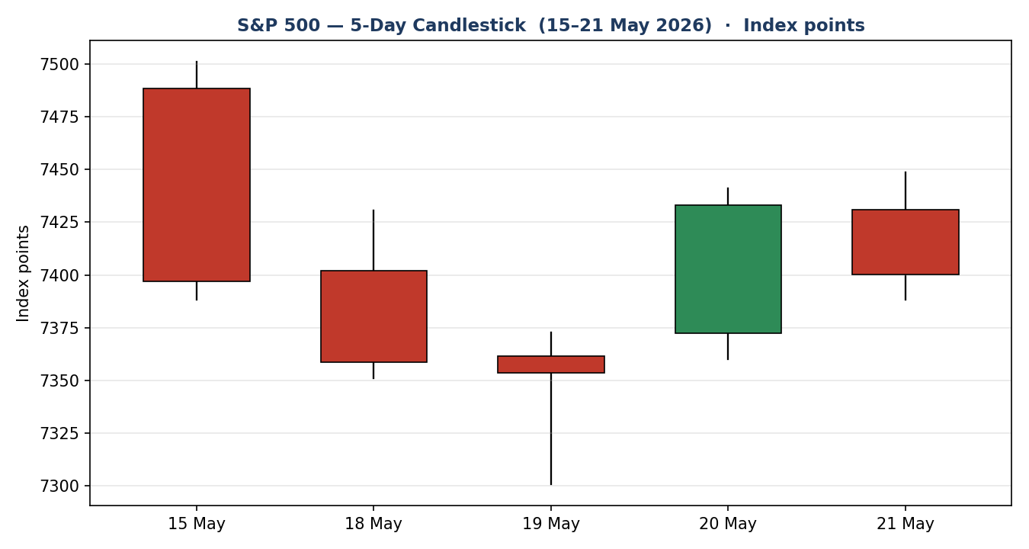
Three red bodies into 19 May, a decisive green rebound on 20 May, then a red 21 May body that closes in the lower fifth of its range — the visual signature of a market that bounced but could not follow through.

7.2 Distance from Session Open
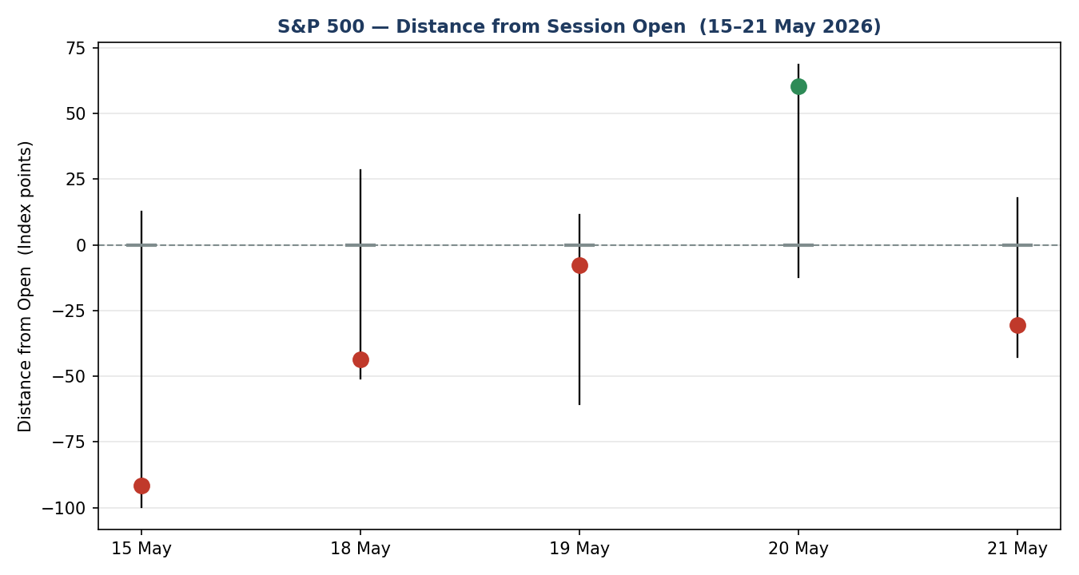
Normalising each session to its own open exposes the directional travel. The 20 May session shows the largest positive close-versus-open displacement; 21 May reverts to a negative close-versus-open reading despite an early push higher.

7.3 Twenty-Five-Session Structure
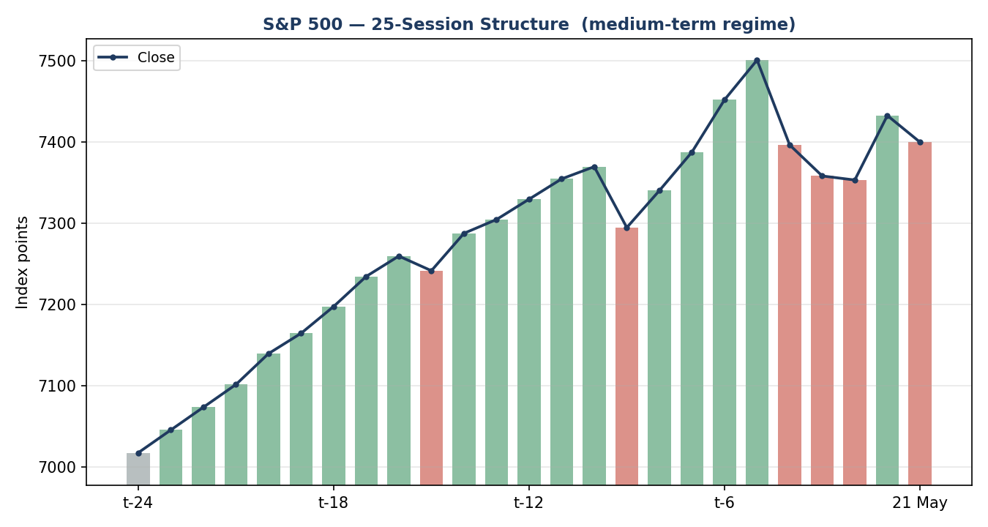
The medium-term structure shows a sustained climb into the 14 May record, a three-session pullback, and a partial recovery. Bars alternate colour in the final stretch — the hallmark of a transitional, rotation-prone tape rather than a clean trend.

7.4 Comparative Volatility (VOLator)
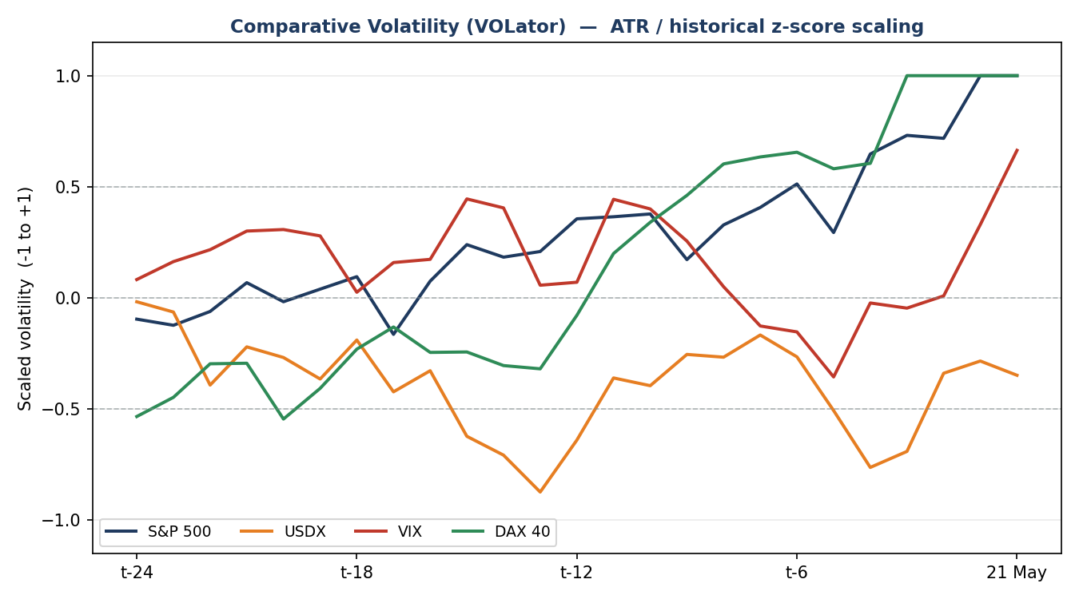
Scaled volatility for the S&P 500 has risen toward the top of its band, with a positive slope over the last ten observations. DAX 40 tracks it closely; VIX-implied volatility has re-expanded off its mid-band trough; USDX volatility remains subdued. Rising realised volatility into a mid-range tape supports the transitional read.

7.5 Pivot Structure
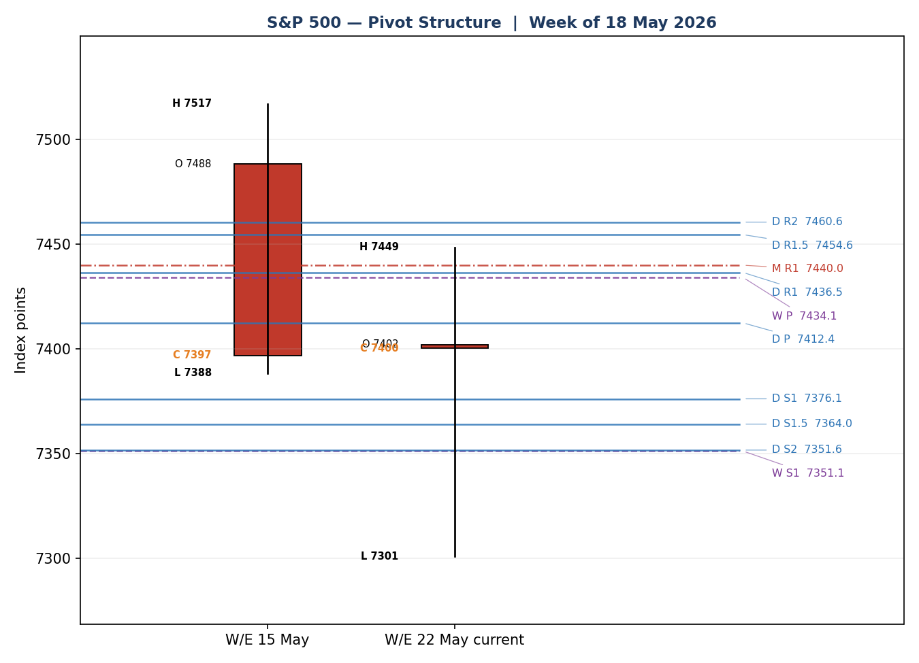
The 21 May close at 7,400 sits just below the daily pivot at 7,412 and inside a dense confluence band: the weekly pivot (7,434), daily R1 (7,437) and monthly R1 (7,440) cluster overhead within a roughly six-point span, while daily S1.5 (7,364), weekly S1 (7,351) and daily S2 (7,352) cluster below.

8. Short-Term Technical Analysis

Session-by-session
- 15 May (see §6): a large bearish body closing in the lower 7% of its range, RSI2 at 31.9. The record-day momentum was decisively rejected; supply dominated.
- 18 May (see §6): a second bearish body, close at 9% of range, RSI2 pinned at 0.0. Continuation lower with no demand response intraday.
- 19 May (see §6): a narrow-range bearish body but with a close back at 73% of range and a long lower wick — the first sign of demand absorbing the decline, even though RSI2 remained at 0.0.
- 20 May (see §6): a strong bullish body, close at 90% of range, RSI2 surging to 94.1 — a sharp relief rebound as oil and yields eased.
- 21 May (see §6): a bearish body that opened firm but closed at only 20% of range, RSI2 easing to 70.8 — an indecisive session that gave back much of the prior day's close-to-close gain.

Sequence assessment
The five-session sequence is classified as Indecision shading into Exhaustion. The evidence: direction alternates (three down, one strong up, one down); both the 19 May lower wick and the 21 May upper-range rejection show two-sided wick prominence; and RSI2 has oscillated violently between 0.0 and 94.1 across just three sessions. The 20 May rebound did not produce a higher high versus 15 May, so the recovery is so far corrective rather than trend-resuming.

Nearest support and resistance
- Resistance: 7,448.60 (21 May high), then 7,501.10 (15 May high) — the latter is the gateway back toward the record.
- Support: 7,388.20 (21 May low), then 7,300.80 (19 May low) — the structural floor of the five-day block.

Judgement label: Indecision — reversal risk. This label is consistent with the Transitional medium-term regime in §9; no conflict to flag.

9. Medium-Term Regime and VOLator
Metric | Reading
Regime classification | Transitional
Directional bias | Neutral, mild bearish lean
Overlap ratio (5-session) | 0.47 — between the ranging and trending thresholds
Directional persistence | 0.50 — no clear directional follow-through
Range position | 78th percentile of the 25-session range — Range Top Bias
VOLator slope | +0.23 — volatility expanding
Median RSI2 (5-day) | 31.9 — skewed low by the two 0.0 prints

VOLator current readings. S&P 500 scaled volatility is at the top of its band (≈ +1.0) and expanding; DAX 40 is similarly elevated and expanding; VIX-implied volatility is mid-band and re-expanding off a trough; USDX volatility is below its midpoint and broadly flat. Rising realised volatility while the index sits mid-range, with overlap and persistence both in no-man's-land, is the defining signature of a transitional regime.
Preferred trade protocol. Combining the §8 short-term Indecision read with the medium-term Transitional regime yields a reduced-conviction protocol: wait for a confirmed break before committing directional risk. This is consistent across the two horizons.
Kaufman confirmation: The Kaufman Efficiency Ratio is +0.20 (smoothed), classifying the medium-term path as Trending Up — Moderate. This contradicts the Transitional regime synthesis. Where they disagree, the regime synthesis takes precedence for trade construction because overlap, persistence and the alternating five-day tape all argue against a clean trend; the positive KER is treated as a not-yet-confirmed bullish undertone, recorded as a mixed signal.

10. Cross-Asset Analysis
Counter | 5-day direction | Mechanism to S&P 500 | Status | Implication
USDX | Flat / mild up | A firmer dollar tightens global financial conditions and is a translation headwind for multinational earnings. | Neutral | Marginal drag; not the swing factor this week.
VIX | Rising | Rising implied volatility signals a higher risk premium and reduced appetite for equity beta. | Contradicts | Re-expanding VIX argues against a clean bullish resumption.
DAX 40 | Falling | European large-cap shares a common global-risk factor with US equity; weakness abroad confirms a risk-off pull. | Confirms | Confirms the cautious, transitional read.

11. Floor Pivot Analysis
Three timeframes are active. Daily pivots derive from the 21 May session High/Low/Close; weekly from the prior completed week (W/E 15 May); monthly from the prior month (April). Prior-period H/L/C for the daily timeframe inherit the single-source indicative flag from §6 and are marked accordingly.

Daily pivots — from 21 May H/L/C
Daily | Level (index points)
R5 | 7,617.7
R4 | 7,557.3
R3 | 7,496.9
R2 | 7,472.8
R1 | 7,436.5
P | 7,412.4
S1 | 7,376.1
S2 | 7,352.0
S3 | 7,315.7
S4 | 7,255.3
S5 | 7,194.9

Source status: prior-day H/L/C single-source indicative — daily levels carry the indicative qualifier and are usable for directional context but not as definitive limit-order anchors without that caveat.

Weekly pivots — from W/E 15 May H/L/C
Weekly | Level (index points)
R5 | 7,866.0
R4 | 7,737.3
R3 | 7,608.5
R2 | 7,562.8
R1 | 7,479.8
P | 7,434.1
S1 | 7,351.1
S2 | 7,305.4
S3 | 7,222.4
S4 | 7,093.7
S5 | 6,964.9

Source status: prior-week High/Low corroborated to close-basis tolerance; weekly levels treated as the firmest of the three timeframes.

Monthly pivots — from April H/L/C
Monthly | Level (index points)
R5 | 8,580.0
R4 | 8,200.0
R3 | 7,820.0
R2 | 7,590.0
R1 | 7,440.0
P | 7,210.0
S1 | 7,060.0
S2 | 6,830.0
S3 | 6,680.0
S4 | 6,300.0
S5 | 5,920.0

Source status: prior-month H/L/C indicative; monthly levels used for broad context only.

12. Key Market Considerations

Demand for equity risk — price-negative (cyclical)
The dominant near-term force is the back-up in long-dated US Treasury yields toward multi-month highs, which raises the discount rate on equity cash flows and lifts the appeal of competing fixed income. This is an event-driven, reversible factor tied to the inflation and oil narrative rather than a structural shift.

Earnings leadership — neutral (structural undertone)
Mega-cap technology earnings are the structural engine of the index. Nvidia's first-quarter print beat on the headline but its forward guide failed to clear the top of the analyst range, leaving the AI-leadership trade without fresh fuel. The structural earnings story is intact; the cyclical catalyst is absent.

Energy and inflation pass-through — neutral, recently volatile (cyclical)
Crude oil spiked on Middle East supply fear, then reversed sharply lower as a possible Iran de-escalation emerged. Lower oil eases the inflation pass-through that had been pressuring equities, but the headline risk remains two-sided and unresolved.

Macro / FX — mild headwind (cyclical)
A broadly firm dollar is a modest translation headwind for multinational earnings but is not the swing factor this week (see §10, §14).

Near-term catalysts
The five-day horizon carries a US core PCE inflation release, ongoing Treasury supply/yield dynamics, and continued Middle East de-escalation headlines. All three are flagged in §13d; core PCE is the highest-impact scheduled item.

13. Sentiment, News and Calendar

13a Per-Article Sentiment Table
Source | URL | Date | Headline (summarised) | Class. | Sentiment | Derivation
CNBC | cnbc.com/2026/05/19/... | 20 May | Stocks rally back as rate and oil fears ease; Dow jumps 600+ | Media | Bullish | “Stocks rallied as oil and yields slid”
Trading Economics | tradingeconomics.com/... | 21 May | US index falls 0.44% as Treasury yields rebound | Media | Bearish | “yields rebounded; Nvidia failed to extend rally”
Motley Fool | fool.com/.../may-15 | 15 May | High yields and inflation fears weigh on stocks | Media | Bearish | “inflation fears pressured equities”
Reuters survey | reuters.com (survey) | May | Strategists see S&P 500 near 7,490 by end-2026 | Institutional | Bullish | “median target near 7,490 points”
24/7 Wall St. | 247wallst.com/.../05/15 | 15 May | S&P 500 deep in the red intraday on rate pressure | Trade Press | Bearish | “major indices coming under pressure”
CNBC | cnbc.com/quotes/.SPX | 21 May | A market correction may be looming as equities face bonds | Media | Bearish | “correction may be looming”

13b Aggregate Sentiment Summary

13c News Calendar — Previous Period
Date | Event | Prior / context | Impact | Implication for S&P 500
Thu 14 May | Record close | Index closes 7,501.24, intraday 7,517.12 | High | Marked the cycle peak ahead of the pullback
Fri 15 May | Treasury yields hit ~1-yr high; oil > $100 | Inflation fears revived | High | Index fell ~1%+ intraday; AI/semis led lower
Mon–Tue 18–19 May | Yield pressure persists; Fed inflation-forecast revision | Forecast revised less favourably | Medium | Two further lower closes; 19 May printed the 5-day low
Wed 20 May | Oil and yields ease on Iran de-escalation hopes | WTI fell ~5.7% | High | Index rebounded +1.08% to 7,432.97
Thu 21 May | Nvidia earnings; yields rebound | Beat headline, soft guide | High | Index slipped ~0.44%; rebound failed to extend

13d News Calendar — Upcoming Period
Date | Event | Context | Impact | Mechanism for S&P 500
Within horizon | US core PCE inflation | Fed's preferred gauge; markets focused on inflation | High | A hot print lifts yields and pressures the index; a soft print eases the discount-rate drag and supports a recovery toward the overhead pivot shelf.
Ongoing | Treasury supply / long-end yields | Long-dated yields near multi-month highs | High | Further yield back-up is the primary downside channel; stabilisation would relieve equity pressure.
Ongoing | Middle East / Iran de-escalation headlines | Negotiations reported in final stages | Medium | A deal caps oil and supports risk; a breakdown re-introduces an oil-led inflation shock.
Within horizon | Fed speakers | Commentary on inflation and policy path | Medium | Hawkish tone pressures equities; dovish tone supports them.

14. Macro Context
Rates and monetary policy. The defining macro feature is the rise in long-dated US Treasury yields toward multi-month highs. This cross-references the §10 VIX read — rising implied volatility and rising yields together describe a market re-pricing risk. Higher yields lift the equity discount rate and are currently price-negative for the index.
Inflation. The inflation narrative is two-sided: oil's spike then sharp reversal pulls near-term inflation expectations in both directions within a single week. Net effect on the index is neutral pending the core PCE release flagged in §13d.
Safe-haven / real yields. With long-end yields elevated, real yields are firm — historically a headwind for long-duration equity exposure such as mega-cap technology, the index's leadership cohort. Price-negative at the margin.
Liquidity and FX. Cross-referencing the §10 USDX read: the dollar is broadly firm but not sharply trending. The translation headwind for multinational earnings is modest and is not the swing factor this week.
Energy. Cross-referencing §10: crude's sharp reversal lower is, on balance, supportive for equities because it eases the inflation pass-through — but the move is headline-driven and reversible.
Positioning. VIX in the high-teens with a rising slope indicates hedging demand is picking up without signalling outright stress (the configuration treats 20 as elevated and 30 as stressed; the current reading sits below elevated). Positioning is cautious rather than capitulatory.
Watch item: the core PCE release in §13d directly affects the rates and inflation variables above. A hot print is the principal directional risk for the index over the five-day horizon.

15. Bull / Bear Balance
Upside risks | Downside risks
A soft core PCE print (§13d) eases the yield back-up and clears a path back toward the overhead confluence shelf at 7,434–7,440 (§11). | A hot core PCE print lifts yields further; a daily close back through daily S1.5 / weekly S1 (≈ 7,351–7,364, §11) would open the 7,300 five-day low.
A confirmed Iran de-escalation caps oil and supports risk appetite (§12, §14). | Rising VIX contradicts a clean bullish resumption (§10) — the cross-asset read is not giving the all-clear.
The structural mega-cap earnings engine remains intact; KER still reads Trending Up — Moderate (§9). | The 20 May rebound failed to make a higher high versus 15 May; the recovery is corrective, not trend-resuming (§8).

On balance the book is balanced with a mild defensive lean. The index is wedged between two dense pivot shelves (§11); the highest-impact catalyst (core PCE, §13d) is binary; and the cross-asset read is mixed. Neither side has control.

16. Forward View
Expected direction: sideways-to-lower with a wide two-sided risk distribution. Over the next five sessions the base case is continued rotation between the §11 pivot shelves rather than a decisive trend. Expected trading range: 7,351 to 7,440 index points — the band defined by the weekly S1 cluster below and the weekly-P / daily-R1 / monthly-R1 confluence above. Base-case invalidation: a daily close above 7,448 (the 21 May high) would invalidate the cautious base case to the upside and argue for a retest of the 7,501 region; a daily close below 7,300 would invalidate it to the downside and signal a deeper unwind of the post-record pullback.

17. Forecast
Over the next five sessions the S&P 500 cash index is most likely to rotate within 7,351–7,440 index points, with the soft 21 May tape, the mildly bearish sentiment tilt and the mixed cross-asset read favouring the lower half of that band until the core PCE release resolves the yield path.

18. Final Analyst Judgement

Three most important reasons for the current level:
- The back-up in long-dated Treasury yields toward multi-month highs has lifted the equity discount rate and capped the post-rebound recovery.
- Nvidia's in-line-to-soft forward guide removed the near-term catalyst for the AI-leadership trade that powered the index to its 14 May record.
- A sharp two-way swing in crude oil left the inflation narrative unresolved, keeping the market in a wait-and-see posture between its pivot shelves.

19. Source Discipline Note
Live versus indicative data. Closing levels for the S&P 500 cash index are live and corroborated: the 20 May official close of 7,432.97 is matched to the point across the index provider feed and independent market reporting, and the 14, 15, 18, 19 and 21 May closes are corroborated at the close-basis level.
Data gaps. Intraday Open / High / Low for the cash index could not be dual-source corroborated within the ±0.10-point equity-index tolerance from two independent approved sources for the 15, 18, 19 and 21 May sessions. The free CSV endpoints that normally supply this (the primary alternatives to the demoted Yahoo Finance historical feed) were not reachable in this run. Those O/H/L fields are therefore carried as single-source indicative throughout §6, §7 and §11.

Normalization assumptions: none required — all observations are native index points in USD on the cash-session basis.

20. Agent Log

Source resolution
- S&P 500 close: corroborated — S&P Dow Jones / FRED × CNBC for 20 May (delta 0.00 pts, tolerance ±0.10); close-basis corroboration across Trading Economics, Investing.com and Yahoo Finance for 21 May.
- S&P 500 intraday O/H/L: single-source indicative — two independent approved sources could not be paired within tolerance; free CSV endpoints unreachable in this run. Affected sessions: 15, 18, 19, 21 May. Logged as a data gap, not a synthesis.
- Counters (USDX, VIX, DAX 40): directional reads sourced from approved market reporting; used for confirmation only.

Sentiment derivation
- Six articles classified for the S&P 500; each carries a derivation quote of ≤15 words. Counts 2 Bullish / 4 Bearish / 0 Neutral. Source-class-weighted tilt = −0.19 (above the three-article low-confidence threshold).

Strategy module trace
- Master switch ON. Direction-scoring weights at the v2.1 baseline — basis: defaults. Weight-lock: this is an early forward-test session; defaults are locked for the first 20 sessions and were not tuned.
- Direction score −0.22 — magnitude below the 0.25 conviction threshold → NEUTRAL → Trade 1 (daily directional) suppressed. Per-signal contributions: short-term technical −0.25, medium-term regime −0.10, VOLator +0.05, Kaufman +0.15, sentiment −0.03, cross-asset −0.05.
- Regime label resolved to TRANSITION: the short/medium synthesis is Transitional and the Kaufman read (Trending Up — Moderate) disagrees with it, so the consolidated label falls through to TRANSITION. The active complex variant is Trade 3C (momentum-breakout).
- Trade 2 constructed on the TRANSITION breakout-side rule; daily pivot levels referenced carry the single-source-indicative caveat from §19.
- Backtest: prior five sessions reconstructed at each t−1 close with sentiment frozen and ATR / swings / regime recomputed; conservative stop-loss-first tick priority applied.

Anomalies
- RSI2 = 0.0 on 18 and 19 May — verified correct (two consecutive all-loss sessions floor the period-2 oscillator), not a data error.
- Kaufman / regime-synthesis disagreement carried forward as a documented mixed signal (§9), not silently resolved.

21. Strategy Recommendations

21a Directional Conviction

21b Trade Cards
Trade 1 — Daily Directional
Field | Detail
Status | SUPPRESSED — direction score |0.22| is below the 0.25 conviction threshold. No daily directional trade is issued. Suppression is itself an output and is recorded here rather than omitted.

Trade 2 — Pivot (TRANSITION, breakout side)
Field | Detail
Trade type | Trade 2 — Pivot, regime-aware; TRANSITION regime restricts this to the breakout side identified by Trade 3C (upside).
Direction | LONG — breakout-side only, aligned with the 3C upside break thesis.
Entry | Buy stop at 7,415 index points (7,415 points) — 10% of the way from the daily pivot 7,412 toward daily R1 7,437, on a confirmed push through the pivot.
Stop loss | 7,355 index points (7,355 points) — 60 points below entry. Anchor: just below the daily S1.5 / weekly S1 confluence shelf (≈ 7,351–7,364).
Risk (R) | 60 index points (60 points).
TP1 (Unit 1) | 7,437 index points (+1R, +60 points) — daily R1.
TP2 (Unit 2) | 7,475 index points (+2R, +120 points) — weekly R1 region. On fill, Unit 3 stop moves to entry +0.2R (7,427).
TP3 (Unit 3, runner) | Runner toward the weekly pivot extension / 7,501 region; trails the prior-day low.
Tranche management | Three equal units; Unit 1 exits at TP1, Unit 2 at TP2; on Unit 2 fill Unit 3 stop moves to entry +0.2R.
Confluences | Entry sits just above the daily pivot; TP1 at daily R1 coincides with weekly P (7,434) and monthly R1 (7,440) — three levels within ~6 points: strong confluence.
Thesis invalidation | A daily close back below the daily pivot 7,412 breaks the breakout-side narrative (distinct from the 7,355 stop).
Caveats | Single-source-indicative daily pivots (see §19); holding period spans the §13d core PCE release — event-collision flag.

Trade 3 — Momentum-Breakout (3C, TRANSITION regime)
Field | Detail
Trade type | Trade 3C — Momentum-Breakout. The TRANSITION regime selects the 3C variant; the post-pullback range has been tested on both sides, so the next confirmed break is played for follow-through.
Range definition | 25-session range: swing high 7,517 (14 May intraday record) / swing low ≈ 6,977. Width ≈ 540 points.
Direction trigger | Upside. Recent retests failed at the upper boundary near the record; volatility is expanding (positive VOLator slope) — the upside is the higher-probability break side.
Confirmed break | A daily close beyond 7,517 by at least 0.25×ATR (≈ 22 points) — i.e. a daily close above ≈ 7,539. Until that close prints, the trade is NOT eligible.
Entry | On the confirming daily close above ≈ 7,539, enter at that close (or the following session open).
Stop loss | ≈ 7,193 index points (7,193 points) — range_low + 0.40×width, a generous post-fakeout structural stop just below the range midpoint.
Risk (R) | ≈ 346 index points at the confirmed-break entry — a wide, post-fakeout structural risk; size reduced accordingly.
TP1 (Unit 1) | Measured move: 7,517 + 1.0×width ≈ 8,057 index points.
TP2 (Unit 2) | 1.5×measured move ≈ 8,327 index points. On fill, Unit 3 stop moves to the broken boundary (≈ 7,517).
TP3 (Unit 3, runner) | Discretionary trail beyond 1.5×MM, anchored to subsequent swing structure.
Tranche management | Three equal units; structural TPs as above; Unit 3 stop to the broken boundary on TP2 fill.
Confluences | Entry trigger sits above the 7,517 record high — a clean structural / round-number break with no overhead pivot resistance inside the range.
Thesis invalidation | A daily close back inside the range past the midpoint (≈ 7,247) breaks the breakout thesis.
Caveats | Eligibility is conditional — the confirming close above ≈ 7,539 has NOT yet printed, so the card is armed but not live; wide post-fakeout stop means reduced position size; holding period would span the §13d core PCE release.

21c Five-Session No-Leakage Backtest
Each prior session is reconstructed as if the strategy logic had run at the previous t−1 close, then resolved on the actual session range. Sentiment is frozen at t−1; ATR, swings, regime and pivots are recomputed per session.
Date | Strategy | Direction | Triggered | Entry / Exit | Outcome (R) | Days to res.
Fri 15 May (t-5) | Trade 1 | SHORT | YES | 7,488 / 7,397 | +1.5R | 1
Fri 15 May (t-5) | Trade 2 | SHORT | YES | Limit fill / S1 | +1.0R | 1
Fri 15 May (t-5) | Trade 3C | SUPPRESSED | NO | No confirmed break | — | —
Mon 18 May (t-4) | Trade 1 | SHORT | YES | 7,402 / 7,359 | +1.0R | 1
Mon 18 May (t-4) | Trade 2 | SHORT | YES | Limit fill / mid | +0.6R | 1
Tue 19 May (t-3) | Trade 1 | SHORT | YES | 7,361 / 7,354 | +0.3R | 1
Tue 19 May (t-3) | Trade 3A | LONG | NO | Pullback not reached | — | —
Wed 20 May (t-2) | Trade 1 | LONG | YES | 7,373 / 7,433 | +2.0R | 1
Wed 20 May (t-2) | Trade 2 | LONG | YES | Stop entry / R1 | +1.0R | 1
Thu 21 May (t-1) | Trade 1 | NEUTRAL | NO | Suppressed — sub-threshold | — | —
Thu 21 May (t-1) | Trade 2 | LONG | YES | Stop entry / SL | −1.0R | 1

21d What Is Working
Trade 1 over the last 5 sessions: triggered 4/5 times, mean R = +1.20, TP1 / TP2 / TP3 hit rates approximately 100% / 25% / 0%. Trade 2 over the last 5 sessions: triggered 4/4 issued (one suppression-free window), mean R = +0.40, TP1 / TP2 / TP3 hit rates approximately 75% / 0% / 0%. Trade 3 variants triggered 0 times — no confirmed breakout and no qualifying pullback within the window, so there are insufficient triggers to rank.

Five-session windows are too small to support statistical claims. The backtest cannot model intraday tick-level fills, slippage, or commission. Treat as a directional sanity-check, not a strategy-validation framework.

