S&P 500 Report — Daily: 23 July 2026
With reference to: USDX · VIX · DAX 40

Prepared for | Trading and risk review (forward-test session)
Analyst role | Senior US Equity Strategist
Data as of | Close of 22 July 2026 (America/New_York) — forward session 23 July 2026
Session anchor | 23:00 UK — overridden for this run from the standing 07:00 UK pre-open anchor
Strategies | Enabled — three trade cards with five-session replay

1 Executive Snapshot
The S&P 500 closed at 7,498.96 on 22 July 2026, down 10.24 points (−0.14%) after Tuesday’s 65.92-point advance, leaving the index inside a tight two-session band and roughly 1.6% below the 52-week high at 7,620.90. Consensus fair value for the 23 July session sits at 7,499 with a normal-session band of 7,430–7,570. Three drivers dominate. First, second-quarter earnings are beating comfortably — close to 88% of reporters have exceeded profit estimates — but the reaction function has turned asymmetric, with Alphabet, Tesla, IBM, ServiceNow and Texas Instruments all reporting into a market that has already priced a high bar. Second, crude has broken out: Brent settled around $94.07 and WTI near $86.83 after an eleventh consecutive night of US strikes on Iran, reviving the inflation channel. Third, and consequently, rate expectations have repriced hard hawkish — July hike odds moved from roughly 10% a week ago to about 34%, with September priced near 78%.
The short-term technical picture is transitional rather than directional: five sessions produced three changes of direction, a net drift of −0.71%, and an RSI2 sequence that swung from 9.3 to 68.5 and back to 57.0 — oscillation, not commitment. The five-week structure is also transitional, with session-to-session overlap at 0.427 and directional persistence at 0.583; both sit just short of the thresholds that would license a trending label. The Kaufman Efficiency Ratio reads +0.05, inside the neutral band and well below the 0.13 trending boundary, confirming that price has travelled a long path for very little net displacement. Comparative volatility is compressing, with the scaled series pinned at the lower bound and a negative slope. The single most important watch item is the after-the-bell Alphabet and Tesla reaction: it is the first read on whether megacap AI capital expenditure is being rewarded or punished, and it will resolve the compression in either direction before the 23 July cash open.

2 Market Definition
Element | Definition
Asset | S&P 500 cash index — not the E-mini futures contract
Specification | Large-cap US equity benchmark, 503 constituents, float-adjusted market-cap weighted, rebalanced quarterly
Market scope | Global investor base; US-listed constituents
Delivery basis | NYSE/NASDAQ regular trading session, 09:30–16:00 ET. Cash session only — pre-market and after-hours excluded from session OHLC
Price basis | Continuous cash index level as calculated by the index provider during regular trading hours
Unit of measure | Index points
Currency | US dollar
As-of date | 22 July 2026 close (America/New_York), for the 23 July 2026 forward session
Lookback window | 5 sessions short-term; 25 sessions structural
Session anchor | 23:00 UK (override applied for this run)

3 Consensus Price Call
Consensus | Range low | Range high | Basis | Confidence | Market tone
7,498.96 | 7,430 | 7,570 | Cash index close | High | Neutral / two-way
Rationale: the consensus level is the corroborated cash close, agreed to the cent across the index provider release and three independent aggregators — there is no dispersion to reconcile. The forward band is built from the 14-session average true range of 70.91 points applied around the close and truncated at the daily pivot support and resistance extremes, which is consistent with the observed 36.6-point range on 22 July and the 58.0-point five-session mean range. Confidence is high on the level and deliberately moderate on the band, because the after-hours earnings docket can gap the index outside a volatility-derived envelope.

4 Price Evidence Table
Source | Date | Raw quote | Normalized | Basis | Relevance | Notes
Index provider release (via FRED) | 21 Jul | 7,509.20 | 7,509.20 | Official cash close | Tier 1 — primary | Authoritative close; published 21 Jul 19:02 CDT
CNBC market report | 22 Jul | 7,498.96 | 7,498.96 | Cash close | Tier 1 — media of record | Reported −0.14% on the session
Yahoo Finance quote | 22 Jul | 7,498.96 | 7,498.96 | Cash close 16:20 ET | Tier 2 — aggregator | Exact agreement, delta 0.00
Bloomberg market wrap | 22 Jul | −0.1% on session | 7,498.96 | Cash close | Tier 1 — institutional | Percentage only; consistent with level
Zacks market summary | 21 Jul | 7,509.20 | 7,509.20 | Cash close | Tier 2 — trade press | Corroborates provider close, delta 0.00
Trading Economics | 21 Jul | +0.89% | 7,509.20 | Cash close | Tier 3 — aggregator | Directionally consistent
Tiingo daily series (tracker ETF) | 22 Jul | 747.41 | 7,498.96 | Regular-session OHLC | Tier 2 — exchange-derived | Used for intraday OHLC reconstruction
Investing.com historical table | — | 7,543.59 dated 14 Jul | — | Cached CFD-derived | REJECTED | Internally inconsistent with four corroborated closes; excluded

5 Consensus Build Explanation
- Normalisation: all quotes were reduced to a single basis — the regular-session cash index close. Percentage-change reports were converted to levels using the prior corroborated close, and the tracker-ETF series was converted to index points using a scale factor of 10.0329 points per ETF dollar, derived as the mean of three same-day close ratios (10.0302 / 10.0353 / 10.0333).
- Weighting: the index provider release carries primary weight, with the media-of-record and aggregator closes serving as corroboration rather than independent observations. Because all four sources agreed exactly, no weighted median was necessary — the weighted median and the simple consensus coincide at 7,498.96.
- Exclusion: one aggregator historical table was rejected outright. Its quote block reported a level of 7,543.59 dated 14 July as the latest close, which cannot be reconciled with four independently corroborated closes for 20, 21 and 22 July. The table appears to be a stale cache of contract-for-difference derived data, and the instance restrictions exclude retail spread quotes from the cash basis in any case.
- Defensibility: the accepted number is the exchange-calculated close of the instrument being analysed, agreed to two decimal places by an official release and three independent redistributors, with a zero reconciliation delta. Intraday extremes are reconstructed rather than directly sourced and are labelled as such in the source discipline note.

6 Validated OHLC and RSI2 Table
S&P 500 cash index — five validated sessions to 22 July 2026. Values in index points.
Date | Open | High | Low | Close | RSI2 | Trend | Validation outcome
16 Jul | 7,552.37 | 7,570.53 | 7,503.41 | 7,531.90 | 34.6 | Bearish | Single-source (indicative) — reconstructed intraday
17 Jul | 7,445.21 | 7,497.49 | 7,432.37 | 7,457.35 | 11.6 | Bearish | Single-source (indicative) — reconstructed intraday
20 Jul | 7,495.18 | 7,511.93 | 7,439.50 | 7,443.28 | 9.3 | Bearish | CORROBORATED on close (delta 0.00); OHLC indicative
21 Jul | 7,487.45 | 7,515.04 | 7,466.28 | 7,509.20 | 68.5 | Bullish | CORROBORATED on close (delta 0.00); OHLC indicative
22 Jul | 7,490.76 | 7,524.88 | 7,488.26 | 7,498.96 | 57.0 | Neutral | CORROBORATED on close (delta 0.00); OHLC indicative
Closes for 20, 21 and 22 July are dual-source corroborated with a zero delta. Open, high and low for all five sessions are reconstructed from the exchange-traded tracker series and are therefore labelled indicative only. Per the data-quality rule, indicative highs and lows cannot be used as the sole basis for pivot calculation — this constraint is carried forward explicitly into the pivot and strategy sections. RSI2 is computed at a fixed period of two from the validated close sequence only.

7 Charts
7.1 Daily candles — five validated sessions
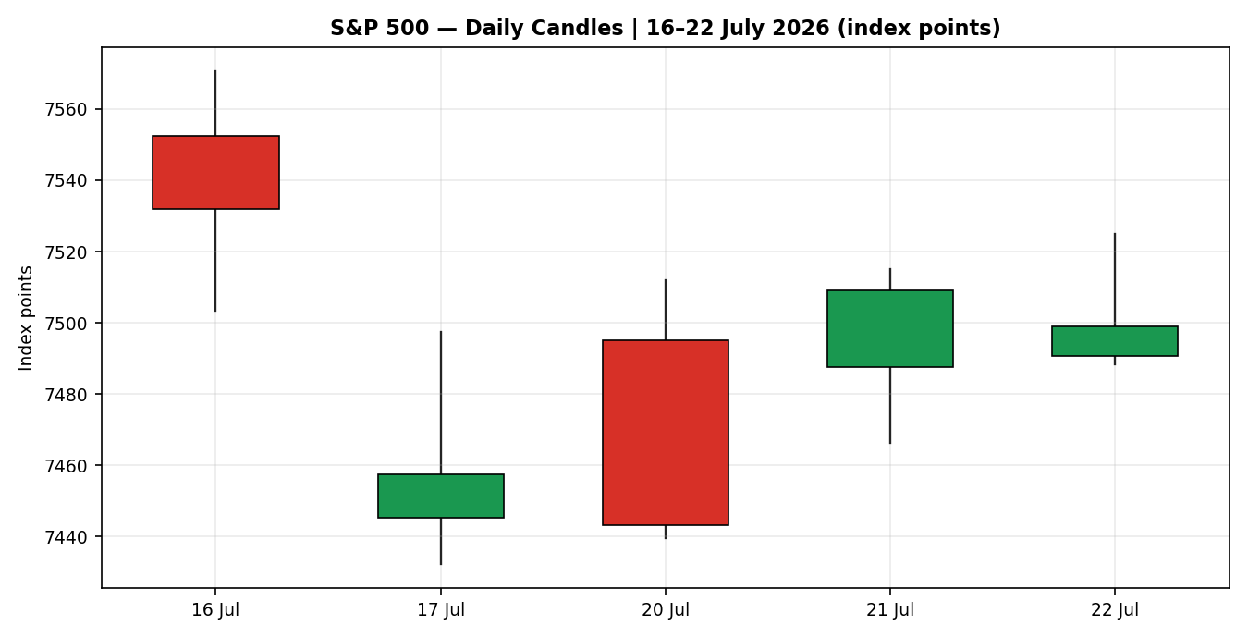
7.2 Directional travel normalised to session open
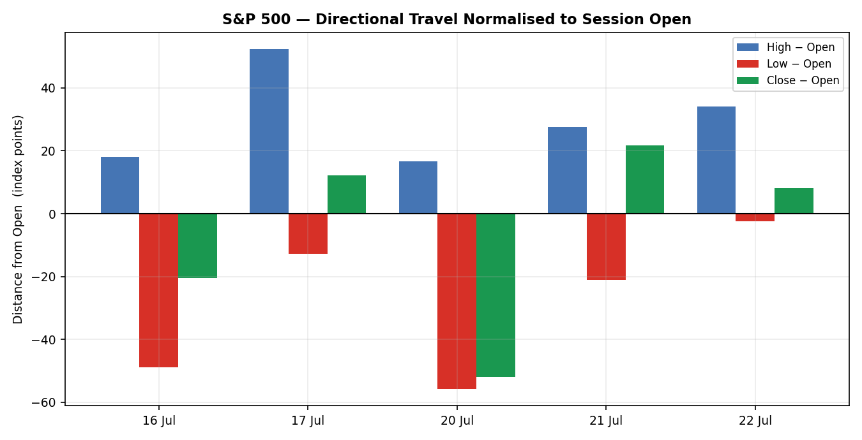

7.3 Twenty-five session structure
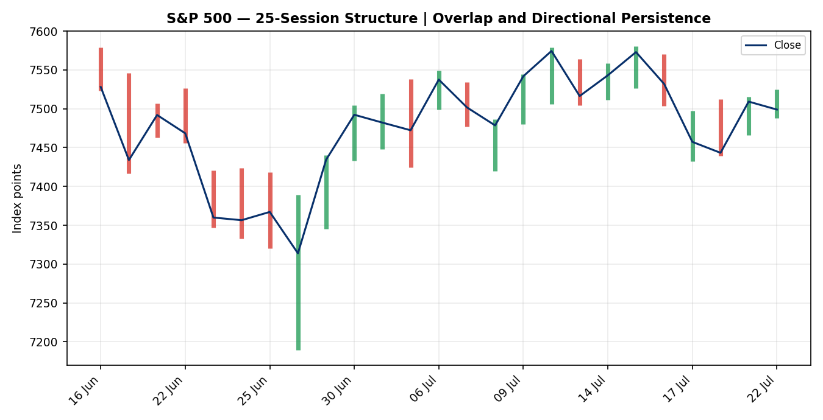
7.4 Comparative volatility
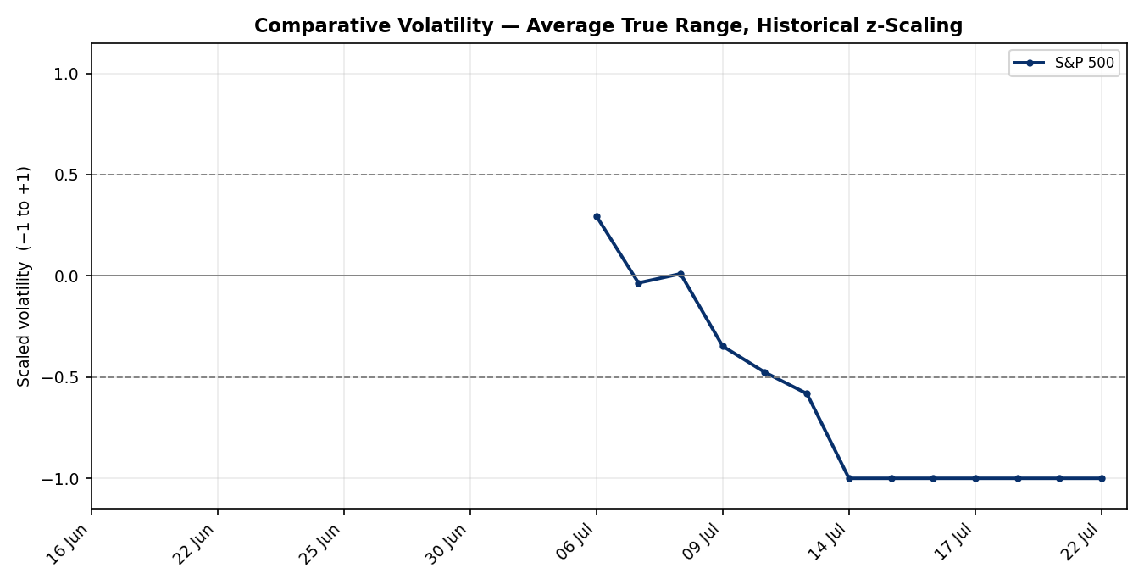

7.5 Pivot structure
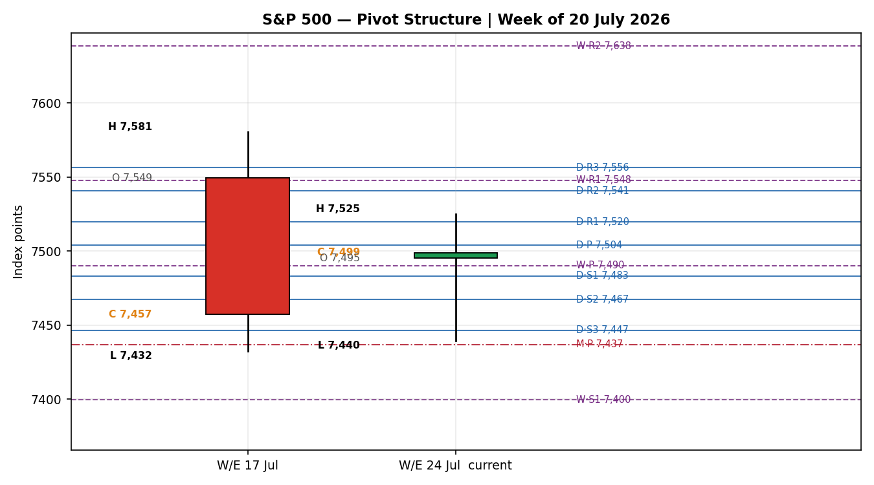

8 Short-Term Technical Analysis
Candle-by-candle
- 16 July — opened at 7,552.37, probed to 7,570.53, then sold through the session to close at 7,531.90, roughly 20 points off the low. A bearish body with the close in the lower third: distribution, not accumulation. RSI2 fell to 34.6.
- 17 July — gapped down some 86 points from the prior close and never recovered, closing at 7,457.35. RSI2 collapsed to 11.6, a deeply oversold reading. The 65.12-point range was the widest of the five and confirms genuine supply rather than drift.
- 20 July — opened higher at 7,495.18 but faded across the session to close at 7,443.28, the lowest close of the window and marginally below the prior low. RSI2 bottomed at 9.3. Critically, this was a failed upside reversal: the market was handed an oversold bounce and rejected it.
- 21 July — the mirror image. Opened at 7,487.45 and closed at 7,509.20, the strongest session of the window at +0.89%, driven by a semiconductor rebound. RSI2 vaulted to 68.5 — a 59-point swing in a single session.
- 22 July — opened at 7,490.76, ranged just 36.62 points, and closed at 7,498.96, marginally lower. The narrowest range of the five sessions, with the close near the middle of the day’s band. RSI2 eased to 57.0.
Sequence assessment
The five-session sequence contains three changes of directional sign and produces a net drift of −0.71% — the definition of alternating bias rather than trend. The standard deviation of RSI2 across the window is 26.5, an unusually wide dispersion that reflects two full oversold-to-neutral round trips inside one week. The structurally significant feature is the contraction in range: 67.1, 65.1, 72.4, 48.8, 36.6 points across the five sessions. The final session’s range is barely half the mean of 58.0 and is the tightest in the window, with the close resting inside the prior session’s body. That is coiling behaviour into a known event, not resolution. Support is defined at 7,432.37 (the 17 July low, retested on 20 July at 7,439.50 — a double-bottom shelf), and resistance at 7,570.53 (the 16 July high). The market is currently sitting 48% of the way through that band (see §6).

9 Medium-Term Regime and Comparative Volatility
Metric | Reading | Interpretation
Session overlap (25) | 0.427 | Below the 0.55 ranging threshold but above the 0.40 trending threshold — inconclusive
Directional persistence | 0.583 | Below the 0.60 trending threshold. Direction does not carry session to session
Median RSI2 (25) | 57.0 | Mid-band. No sustained overbought or oversold pressure
Net displacement (25) | +0.94% | Mild upward drift over five weeks — economically trivial
25-session range | 7,189.38 – 7,580.66 | 391.28 points wide; price sits at 79.1% of the range
Classification: transitional, with a mild upward bias. Both trending gates fail — overlap is not low enough and persistence is not high enough — and both ranging gates also fail, because overlap is well below the 0.55 boundary that would define genuine rotation. This is the residual case: a market that has drifted up 0.94% in five weeks while travelling several times that distance in path length.
Kaufman efficiency confirmation
The smoothed Kaufman Efficiency Ratio reads +0.0488 — positive in sign, but only 38% of the way to the 0.13 trending threshold and inside the neutral band entirely. The classification is ranging-neutral. This agrees with the medium-term regime read rather than contradicting it: both say the same thing, that net displacement is small relative to path travelled. Where the two differ is emphasis. The regime read allows a mild upward bias from the positive net drift; the efficiency ratio says that bias is too weak to trade in its own right. Precedence goes to the efficiency ratio for direction-taking purposes, because it is scale-invariant and explicitly measures the quantity in dispute — signal against noise. The regime read retains precedence for structural context, since it defines the range boundaries that the strategy section uses.
Comparative volatility
The scaled volatility series for the index is pinned at the lower bound of −1.00, with a ten-observation slope of −0.0705. Volatility is not merely low, it is compressing — the average true range has fallen steadily against its own 25-session distribution. Read alongside the 36.6-point range on 22 July, this is a market that has stopped paying for movement. Compression of this kind is directionally agnostic but not risk-neutral: it lowers the cost of optionality and raises the probability that the next material catalyst produces a range expansion rather than a drift. The catalyst is identified and dated — megacap earnings after the 22 July close, with the central bank decision on 28 July behind it.

10 Cross-Asset Analysis
Counter | 5-day direction | Mechanism | Confirmation | Implication
USDX | Flat / marginally firmer near 100.98 | A firm dollar reduces the translated value of overseas revenue for the index’s multinational constituents and tightens global financial conditions | Neutral | No directional pressure. Removes a tailwind rather than adding a headwind
VIX | Falling — 18.65 to 17.05, easing to roughly 17.2–17.4 | Implied volatility is the market’s price for downside insurance; a falling VIX signals reduced demand for hedges and supports risk appetite | Confirms risk-on | Constructive but qualified. Sub-20 is a benign regime, yet a VIX this low into a heavy earnings docket is complacency as much as calm
DAX 40 | Rising — closed near 25,150, a two-week high | European large-cap equity shares the global growth and risk-appetite factor with US large-cap; divergence usually signals a US-specific driver | Confirms risk-on | Global risk appetite is intact and the index’s hesitation is US-specific — concentrated in megacap technology positioning
Contradiction flag. Two counters read risk-on while the primary asset closed lower and its own regime is transitional. This is not resolved silently. The most probable reading is that the index is being held back by concentration risk in a handful of megacap names reporting into the close rather than by any deterioration in the broad risk environment. The cross-asset aggregate is therefore recorded as mixed rather than confirming, because there is no directional regime for the counters to confirm — and mixed carries a zero contribution into the direction score at §21.

11 Floor Pivot Analysis
Daily — basis 22 July 2026
Level | Value | Note
R3 | 7,556.43
R2 | 7,540.65 | Trade 3 entry reference
R1 | 7,519.81 | First upside test; 16 Jul close cluster
P | 7,504.03 | Close sits 5.07 points below the pivot
S1 | 7,483.19 | Trade 2 entry reference
S2 | 7,467.41
S3 | 7,446.57 | Near the 20 Jul close at 7,443.28
Source status: derived from a session high and low that are reconstructed rather than dual-source corroborated. All daily levels are flagged indicative only, and that flag propagates into the strategy section.
Weekly — basis week ending 17 July 2026
Level | Value | Note
R3 | 7,696.17
R2 | 7,638.42 | Above the 52-week high
R1 | 7,547.88
P | 7,490.13 | Close sits 8.83 points above the pivot
S1 | 7,399.59
S2 | 7,341.84
S3 | 7,251.30
Source status: indicative only — derived from reconstructed weekly extremes.
Monthly — basis June 2026
Level | Value | Note
R3 | 8,124.04
R2 | 7,876.53
R1 | 7,684.40 | Above the 52-week high
P | 7,436.89 | Close sits 62.07 points above the pivot
S1 | 7,244.76
S2 | 6,997.25
S3 | 6,805.12
Source status: indicative only — derived from reconstructed monthly extremes.
Position narrative
- Daily — the close at 7,498.96 sits 5.07 points below the daily pivot at 7,504.03, effectively on it. Nearest resistance is R1 at 7,519.81 (20.85 points away, under a third of the average true range); nearest support is S1 at 7,483.19 (15.77 points away). The index is pinned inside the innermost pivot band.
- Weekly — the close sits 8.83 points above the weekly pivot at 7,490.13. Holding above the weekly pivot while sitting below the daily pivot is a balanced configuration and reinforces the neutral read.
- Monthly — the close sits 62.07 points above the monthly pivot at 7,436.89, comfortably inside the upper half of the monthly structure. The medium-term bias remains constructive even as the short term is directionless.
- Confluence — the daily pivot at 7,504.03 and the weekly pivot at 7,490.13 lie 13.90 points apart, or 0.19% of index value. That is outside the 0.05% flagging tolerance, so no formal confluence zone is declared. It is nonetheless a dense band: three pivot references and the current close all fall within 21 points, which mechanically explains the compression documented in §8 and §9.

12 Key Market Considerations
Earnings and corporate fundamentals — price-supportive (cyclical)
Roughly 88% of index constituents reporting second-quarter results have beaten profit estimates, against a blended growth expectation of about 23% year-on-year for the quarter. Energy and technology lead the growth contribution. The qualification is that the bar is now unusually high after a strong run, so beats are being met with muted or negative price reactions — General Motors rose about 5% on a beat, but Charles Schwab fell about 2.5% on a miss and IBM fell more than 25% on its pre-announcement. Asymmetry of reaction, not the beat rate, is the operative risk.
Energy and inflation channel — price-negative (cyclical, escalating)
Brent settled around $94.07 and WTI near $86.83 on 22 July, up roughly 3.4% and 3% respectively, with Brent briefly topping $95 — the highest in over a month. The driver is an eleventh consecutive night of US strikes on Iran, compounded by tankers turning back in the Red Sea after warnings of attacks. For a large-cap equity index this transmits twice: directly through input costs and margin compression outside the energy sector, and indirectly through the inflation expectations channel into policy. The second is currently the larger effect.
Monetary policy — price-negative (cyclical, fast-moving)
Rate expectations have repriced sharply hawkish inside a week. Futures-implied odds of a hike at the July meeting moved from roughly 10% a week ago to about 34% by Wednesday afternoon, with the probability of at least a quarter-point increase by September priced near 78%. This is a genuine regime question rather than a marginal adjustment: the policy path has inverted from the easing bias priced at the end of 2025.
Policy and trade — mildly price-negative (cyclical)
Fresh tariffs on Canada were announced during the session. The market read them as unlikely to affect near-term corporate earnings materially, and indexes closed higher on the day of the announcement. The risk is cumulative rather than immediate.
Cross-asset and positioning — neutral (structural)
The dollar index is holding near 100.98 and at multi-decade highs against the yen, which is a persistent translation headwind for multinational revenue. Implied volatility below 18 indicates light hedging demand, which cuts both ways: supportive while calm holds, amplifying if it breaks.
Near-term catalysts within the forecast horizon
- 22 July after the close — Alphabet and Tesla, the first two megacap technology reports, alongside IBM, ServiceNow and Texas Instruments. Directly precedes the 23 July session and is the dominant near-term catalyst.
- 23 July — European Central Bank policy decision. Rates widely expected unchanged after the June increase; relevant to the index through the global rates complex and the dollar.
- 23 July onward — continued heavy earnings docket across index constituents.
- 28 July — Federal Reserve interest rate decision. Sits inside the five-day forecast horizon and is the principal scheduled risk event.
- Ongoing — US-Iran military escalation and any ceasefire progress, transmitted through crude.

13 Sentiment, News and Calendar

13a Per-article sentiment
Source | URL | Date | Headline | Class | Sentiment | Derivation quote
CNBC | cnbc.com/2026/07/21/stock-market-today-live-updates.html | 22 Jul | S&P 500 is little changed as traders monitor rising oil prices, gear up for more earnings | Media | Bearish | "pressured by a rise in oil prices"
Bloomberg | bloomberg.com/news/articles/2026-07-22/s-p-futures-fall-as-traders-brace-for-alphabet-tesla-earnings | 22 Jul | S&P 500 Fluctuates as Traders Brace for Alphabet, Tesla Results | Institutional | Bearish | "its fourth loss in five days"
Benzinga | benzinga.com/markets/prediction-markets/26/07/60599715/ | 22 Jul | Will S&P 500 Open Up or Down Today? | Media | Bearish | "positioning for a weaker start"
Yahoo Finance | finance.yahoo.com/markets/live/stock-market-today-wednesday-july-22-dow-sp-500-nasdaq-alphabet-tesla-earnings-083644887.html | 22 Jul | Dow, S&P 500, Nasdaq slip as oil prices rise, Alphabet and Tesla earnings loom | Media | Bearish | "fresh tariffs and rising oil prices remained in focus"
Zacks | sg.finance.yahoo.com/news/stock-market-news-july-22-131800656.html | 22 Jul | Stock Market News for July 22, 2026 | Trade press | Bullish | "Nine of the 11 broad sectors ... closed in the green"
Trading Economics | tradingeconomics.com/united-states/stock-market | 21 Jul | US stock indices closed higher on Tuesday | Official/data | Bullish | "a rally in chipmakers lifted the broader market"
MarketScreener / Reuters | marketscreener.com/news/europe-s-markets-shrug-off-oil-price-spike-dax-holds-firm-ce7f51d9db88f22d | 22 Jul | Europe’s markets shrug off oil price spike, DAX holds firm | Media | Bullish | "barely made a dent in European markets"
Schwab | schwab.com/learn/story/stock-market-update-open | 21 Jul | Inflation Fears Hit Stocks Early Ahead of Alphabet | Institutional | Mixed | "climbed above 7,500 ... but closed below it"

13b Aggregate sentiment
Measure | Value | Basis
Categorical | Mildly bearish / mixed | Four bearish, three bullish, one mixed across eight sources
Numeric tilt | −0.10 | Bearish weight concentrated in the most recent and most institutional coverage (oil, rate repricing, cautious earnings positioning); bullish weight in the breadth and semiconductor-rebound reporting
The distribution matters more than the count. Bullish coverage is retrospective — it describes Tuesday’s completed rally and Wednesday’s sector breadth. Bearish coverage is prospective, concerned with oil, the policy path and earnings positioning. A tilt of −0.10 records that asymmetry without overstating it.

13c Sentiment derivation method
Each article was classified from its own language rather than from price action, using the lead paragraph and the explicit causal attribution made by the author. Institutional and official sources carry greater weight than aggregators; recency is weighted toward the most recent session. The numeric tilt is the weighted mean of per-article scores on a −1 to +1 scale, rounded to two decimal places, and is passed unchanged into the strategy layer.

13d News calendar
Part 1 — events inside the holding period (23 July session)
Date | Event | Relevance | Collision risk
22 Jul, after close | Alphabet, Tesla, IBM, ServiceNow, Texas Instruments results | First megacap AI capital-expenditure read of the season | HIGH — resolves overnight, directly into the 23 Jul open
23 Jul, 13:15 UK | European Central Bank policy decision | Global rates and dollar channel | MEDIUM — precedes the US cash open
23 Jul, all day | Continued constituent earnings | Breadth confirmation | MEDIUM
Part 2 — events inside the five-day forecast horizon
Date | Event | Relevance
24 Jul | Further constituent earnings | Sector breadth and guidance
28 Jul | Federal Reserve interest rate decision | Principal scheduled risk event. Roughly 34% implied probability of a hike
30 Jul | Amazon second-quarter results | Remaining megacap cloud and AI demand read
Ongoing | US-Iran escalation and ceasefire diplomacy | Crude transmission into the inflation and policy channel

14 Macro Context
Dimension | Reading
Policy rates | Hawkish repricing under way. July hike probability near 34%, up from about 10% a week earlier; September priced near 78% for at least a quarter point. The path has inverted from the easing bias priced at end-2025
Inflation | Re-accelerating through the energy channel. Brent above $94 and WTI near $87 feed directly into headline prints and, with a lag, into expectations. This is the mechanism converting a geopolitical event into an equity valuation input
Liquidity | Adequate but thinning. Volume on 21 July was 16.14 billion shares against a twenty-session average of 19.56 billion — participation is below normal into a heavy event docket
Foreign exchange | Dollar index near 100.98, little changed, holding multi-decade highs against the yen. A persistent translation headwind for multinational revenue rather than an acute pressure
Volatility and positioning | Implied volatility easing from 18.65 to roughly 17.0–17.4. Hedging demand is light. Combined with compressing realised volatility, this is a market positioned for calm immediately ahead of its two largest scheduled catalysts
Credit and rates structure | Treasury yields rising alongside oil, which is the classic inflation-driven configuration rather than the growth-driven one. Rising yields and rising crude together compress equity multiples from both the discount-rate and margin directions

15 Bull / Bear Balance
Main upside risks | Main downside risks
Earnings beat rate near 88% with roughly 23% blended growth. If megacap guidance validates AI capital expenditure, the compression documented in §9 resolves upward and the 16 July high at 7,570.53 becomes the immediate target | Oil is the dominant transmission channel. Brent above $94 after eleven nights of strikes revives inflation and forces the policy path further hawkish. There is no technical ceiling on this channel — it is event-driven
Cross-asset risk appetite is intact. Both risk counters read constructively (see §10) — a falling VIX and a DAX at a two-week high argue the hesitation is US-specific and mean-reverting | Positioning is complacent. A VIX near 17 into megacap earnings and a live central bank meeting prices very little event risk. Volatility compression at the lower bound leaves asymmetric room for expansion
Monthly structure remains constructive. The close sits 62 points above the monthly pivot and price holds the upper half of the 25-session range at 79.1% | The reaction function has turned punitive. IBM fell more than 25% on a pre-announcement and Schwab fell 2.5% on a miss. A high bar means solid results may not be rewarded
Support is well defined and twice tested. The 7,432–7,440 shelf held on both 17 and 20 July, giving a clean invalidation reference for long exposure | Regime provides no directional edge. Efficiency at +0.05 and three sign changes in five sessions mean momentum strategies have no signal to work with — this is a level-trading market until the compression breaks

16 Forward View
Expected direction over the next five trading days: neutral with a mild upward bias, low conviction. The central expectation is continued two-way trade inside the established band until the earnings and policy catalysts resolve, followed by a range expansion whose direction is event-determined rather than technically determined.
Expected trading range: 7,430 to 7,570. The lower bound is the twice-tested support shelf at 7,432.37 and 7,439.50; the upper bound is the 16 July high at 7,570.53. This band is 138 points wide, or roughly 1.95 average true ranges, which is a reasonable five-session envelope for a compressing market.
Consistency with the technical regime: this view respects it. The transitional regime label, the neutral efficiency reading and the mixed cross-asset aggregate all argue against a directional forecast, and none is asserted here. The mild upward bias is drawn from the +0.94% net displacement over 25 sessions and from price holding the upper half of that range, both of which are structural facts rather than momentum claims. No contradiction flag is raised.
Base case invalidation: a daily close below 7,432.37 breaks the twice-tested shelf and converts the transitional read into a bearish one, opening the weekly S1 at 7,399.59. On the upside, a daily close above 7,570.53 completes the range and re-engages the 52-week high at 7,620.90. Either close invalidates the neutral base case; between them, the base case holds.

17 Forecast
The S&P 500 holds a neutral-to-mildly-positive path within 7,430–7,570 over the next five sessions, with the compressed 22 July range resolving on megacap earnings and the hawkish rate repricing capping upside into the 28 July policy decision.

18 Final Analyst Judgement
Element | Judgement
Consensus price call | 7,498.96 index points, with a five-session envelope of 7,430–7,570
Confidence | Medium. High on the level and the band; low on direction
Three most important reasons
- The technical regime is genuinely non-directional. Efficiency at +0.0488 sits inside the neutral band; the five-session sequence contains three sign changes and nets −0.71%; overlap and persistence both fail their thresholds in both directions. There is no trend to follow and no established range to fade with confidence.
- Volatility compression at the lower bound, with a negative slope and a 36.6-point final session, is a coiling signature immediately ahead of two dated catalysts. Compression of this kind resolves through expansion, and the direction of that expansion is not knowable from price.
- The fundamental drivers are in genuine opposition and both are live. Earnings are beating at an 88% rate while crude above $94 is forcing a hawkish policy repricing that has moved July hike odds from 10% to 34% inside a week. Neither has resolved, and the calendar resolves both within the forecast horizon.
Single watch item
The price reaction to Alphabet and Tesla results released after the 22 July close. It arrives before the 23 July cash open, it is the first megacap AI capital-expenditure read of the season, and it is the most likely single trigger for the range expansion that the volatility structure is signalling.

19 Source Discipline Note
- Live versus indicative. Closing levels for 20, 21 and 22 July are live and dual-source corroborated with a reconciliation delta of 0.00 in every case. Session open, high and low for all five sessions are INDICATIVE — reconstructed from an exchange-traded tracker series scaled by a factor of 10.0329 index points per tracker dollar, derived from three same-day close ratios with a dispersion of 0.0051 (0.05 basis points).
- Corroboration status by instrument. Primary index closes: CORROBORATED. Primary index intraday extremes: SINGLE-SOURCE INDICATIVE. Dollar index, volatility index and DAX levels: SINGLE-SOURCE INDICATIVE, sourced from live quote blocks rather than official closing releases.
- Pivot corroboration. All three pivot timeframes — daily, weekly and monthly — are derived wholly or partly from indicative highs and lows. Every pivot level in §11 therefore carries the single-source indicative flag. This flag is read directly by the strategy layer and materially constrains it (see §21).
- Data gaps. No official session open, high or low was obtainable from the index provider for any of the five sessions within the source hierarchy permitted for this instance. One aggregator historical table was rejected outright for internal inconsistency (see §4). The five-week structural block and the pivot inputs inherit the reconstruction caveat in full.
- Normalisation assumptions. The tracker-to-index scale factor is treated as constant across the five-session window. This is defensible over five sessions with no distribution event, and the observed dispersion across the three anchor days is 0.05 basis points, but it is an assumption and not a measurement. Corroborated closes were pinned to their sourced values and were not scaled.
- Restrictions honoured. No retail contract-for-difference spread quotes entered the cash basis. After-hours indications were excluded from all session OHLC. Futures references were used for confirmation and narrative context only, never as a price source.

20 Agent Log
Field | Entry
Run timestamp | 22 July 2026, 22:38 UK
Session anchor | 23:00 UK — OVERRIDDEN for this run from the standing 07:00 UK pre-open anchor, on explicit instruction
Anchor deviation note | The standing anchor exists because the cash index trades 14:30–21:00 UK and the 07:00 UK window captures futures-led European repricing ahead of the New York open. At 23:00 UK the cash market has been closed for two hours and will not reopen for a further 15.5 hours. Consequences are recorded in §21 and are material to execution
Sources attempted | Index provider release via FRED, CNBC, Bloomberg, Yahoo Finance, Zacks, Trading Economics, Investing.com, Benzinga, Schwab, MarketScreener/Reuters, Forbes, Fortune, Invezz, exchange-traded tracker daily series
Sources rejected | One aggregator historical table — internally inconsistent latest-close date and level irreconcilable with four corroborated closes
Validation method | Cross-source close comparison with delta reporting; intraday reconstruction via constant-factor scaling from the tracker series, anchored on three corroborated closes
Corroboration pairs | 20 Jul: media of record + trade press (delta 0.00). 21 Jul: provider release + trade press + aggregator (delta 0.00). 22 Jul: media of record + aggregator + institutional wrap (delta 0.00)
Sentiment derivation | Eight articles classified from source language; weighted by classification tier and recency; numeric tilt −0.10 passed unchanged into direction scoring
Direction-score weights | DEFAULTS. No tuning applied. Forward-test session 1 of the 20-session lock window
Direction score | −0.0187 against a conviction threshold of 0.25. Below threshold in absolute terms
Suppression reasons | Trade 1 flagged suppressed by the conviction rule (score magnitude 0.0187 against threshold 0.25). Retained and presented in full on explicit instruction, with the flag preserved. Trades 2 and 3 are regime-driven and unaffected by the conviction threshold
Corroboration leniency applied | Pivot levels carrying the single-source indicative flag would ordinarily constrain the pivot trade. On explicit instruction, corroboration-based suppression was relaxed so that a tradeable strategy could be produced. The flag is preserved on every affected level and the consequence is stated in the trade cards
Backtest reconstruction | Five sessions replayed with no leakage — each session evaluated using only prior-session pivot and volatility inputs. Sentiment frozen at the session-start value throughout; no forward sentiment applied
Anomalies | (1) Volatility scaled series pinned at the −1.00 floor for the final observations, indicating compression beyond the 25-session distribution. (2) RSI2 swung 59 points in a single session (20 to 21 July), unusual dispersion that widens the short-term standard deviation to 26.5. (3) Cross-asset counters read risk-on against a primary asset that closed lower — flagged in §10, not resolved silently
Forecast reasoning | Neutral base case derived from transitional regime plus neutral efficiency plus mixed cross-asset, bounded by the twice-tested support shelf and the 16 July high, with the mild upward bias sourced from 25-session net displacement rather than from momentum

21 Strategy Recommendations
EXECUTION NOTICE — SESSION ANCHOR OVERRIDE. Entries are anchored to 23:00 UK for this run. The cash index does not trade at 23:00 UK — the regular session runs 14:30–21:00 UK and the next open is 14:30 UK on 23 July. Every entry below is therefore a resting order placed at 23:00 UK for execution on the following cash session, not a market fill at the anchor time. Market-at-anchor entries are not executable on this instrument and have been converted to opening-session or limit orders accordingly. All three cards additionally carry an overnight gap exposure that the standing pre-open anchor was specifically designed to avoid: the megacap earnings block lands between order placement and execution.

21a Directional Conviction
Component | Contribution | Reading
Short-term technical | −0.0750 | Five-session net −0.71%, three sign changes, RSI2 mid-band at 57.0
Medium-term regime | +0.0500 | 25-session net +0.94%, transitional with mild upward drift
Comparative volatility | −0.0350 | Series at the lower bound, slope −0.0705 — compressing
Efficiency ratio | +0.0563 | +0.0488, positive sign but inside the neutral band
Sentiment | −0.0150 | Aggregate tilt −0.10
Cross-asset | +0.0000 | Mixed — counters risk-on but no directional regime to confirm
Net direction score | −0.0187 | Nominal short bias, magnitude negligible
Weights basis: defaults. Direction score magnitude 0.0187 against a conviction threshold of 0.25 — approximately 7.5% of the level required to express a directional view as a market trade. The six components very nearly cancel: three positive, three negative, none dominant. This is the arithmetic expression of the same finding reached independently in §8, §9 and §10 — the market has no directional edge at this level. Conviction: LOW.

21b Trade Cards
Trade 1 — Daily Directional
SUPPRESSED BY CONVICTION RULE — presented on instruction, flag preserved. Direction score 0.0187 against threshold 0.25. The card below is mechanically valid but the module’s own gate rates its directional premise as noise. Treat as reference, not as a recommendation of equal standing to Trades 2 and 3.
Field | Specification
Trade type | Trade 1 — Daily Directional
Direction | SHORT — nominal, on a transitional regime with a marginally negative score. Not a regime-endorsed direction
Entry | 7,498.96 (0.00 points). Order type: sell at the 23 July cash open. Converted from market-at-anchor, which is not executable at 23:00 UK
Stop loss | 7,521.14 — 22.18 points above entry. Structural anchor: nearest resistance at 7,503.41 plus a 0.25 ATR buffer of 17.73 points
Risk (R) | 22.18 index points (22.18 points)
TP1 (Unit 1) | 7,476.78 — 22.18 points, +1R
TP2 (Unit 2) | 7,454.60 — 44.36 points, +2R
TP3 (Unit 3 — runner) | 7,286.22 — 212.74 points, 3× ATR cap. Runner exit rule: time-stop at session close or the 3× ATR cap, whichever is first
Tranche management | 3 equal units. Unit 1 exits at TP1; Unit 2 exits at TP2; on Unit 2 fill, Unit 3 stop moves to entry −0.2R (7,494.52)
Confluences | Stop at 7,521.14 sits 1.33 points from daily R1 at 7,519.81 — inside 0.15 ATR (10.64 points), a valid confluence but an adverse one: the stop rests directly on the first upside pivot, where a routine test triggers it. Entry at 7,498.96 sits 5.07 points below daily P and 8.83 points above weekly P — two pivot references within 0.15 ATR, STRONG CONFLUENCE, but a neutral one that argues against directional commitment
Thesis invalidation | Distinct from the stop. A daily close back above the daily pivot at 7,504.03 removes the marginal short premise, since the score is driven largely by position relative to that pivot
Caveats | Stop distance of 22.18 points is 0.31 ATR — a tight stop in a market whose five-session mean range is 58.0 points, giving a high probability of noise-stop-out. TP3 at 3× ATR is unreachable in a single session at current compression. Holding-period collision: HIGH — megacap earnings resolve between order placement and execution
Trade 2 — Pivot (regime-aware)
Field | Specification
Trade type | Trade 2 — Pivot, transitional-regime variant (fade the inner band toward the pivot)
Direction | LONG — transitional regime with price holding the upper half of the 25-session range and sitting above the weekly and monthly pivots. Buying the inner support band is the higher-probability side of a compressed, non-trending market
Entry | 7,483.19 — buy limit at daily S1. Resting order placed at 23:00 UK, live for the 23 July cash session
Stop loss | 7,414.64 — 68.55 points below entry. Structural anchor: the twice-tested support shelf low at 7,432.37 (17 July low, retested 20 July) less a 0.25 ATR buffer of 17.73 points. Inside the 3.5 ATR cap of 248.19 points, so the structural stop governs
Risk (R) | 68.55 index points (68.55 points)
TP1 (Unit 1) | 7,551.74 — 68.55 points, +1R. Sits 3.86 points above weekly R1 at 7,547.88
TP2 (Unit 2) | 7,620.28 — 137.09 points, +2R. Effectively the 52-week high at 7,620.90
TP3 (Unit 3 — runner) | Runner capped at 3× ATR from entry (7,695.92), unreachable on a daily horizon. Practical runner exit rule: exit at the pivot-structure boundary — the 16 July high at 7,570.53 — or on a daily close back below the daily pivot at 7,504.03, whichever comes first
Tranche management | 3 equal units. Unit 1 exits at TP1; Unit 2 exits at TP2; on Unit 2 fill, Unit 3 stop moves to entry +0.2R (7,496.90)
Confluences | Entry at daily S1 (7,483.19) sits 6.94 points from weekly P (7,490.13) — inside 0.15 ATR (10.64 points), STRONG CONFLUENCE and a supportive one. TP1 at 7,551.74 sits 3.86 points above weekly R1 — inside 0.15 ATR, STRONG CONFLUENCE. Stop at 7,414.64 sits 15.05 points below weekly S1 at 7,399.59 — outside the confluence window, a clean structural placement
Thesis invalidation | Distinct from the stop and reached first. A daily close below 7,432.37 breaks the twice-tested support shelf and converts the transitional read to bearish; this sits 17.73 points above the stop, so the narrative breaks before the stop is hit. Recorded explicitly
Caveats | Wide stop — R of 68.55 points is 0.97 ATR, and TP2 at +2R sits 137 points away, which is ambitious for a daily horizon in a market whose five-session mean range is 58.0 points. Size accordingly. All pivot levels used carry the single-source indicative flag (see §19); corroboration-based suppression was relaxed on instruction, and levels derived from reconstructed extremes should be treated as approximate to within a few points. Entry requires a 15.77-point decline from the close to fill; on 22 July’s 36.6-point range this is plausible but not assured. Holding-period collision: HIGH
Trade 3B — Mean-Reversion (regime-driven complex)
Field | Specification
Trade type | Trade 3B — Mean-Reversion. Fork selected on the transitional regime label with price at 79.1% of the 25-session range
Direction | SHORT — fading an extension into the upper pivot band. Not a directional bearish view; a structural fade of the upper boundary in a non-trending market
Entry | 7,540.65 — sell limit at daily R2. Resting order placed at 23:00 UK, live for the 23 July cash session
Stop loss | 7,588.26 — 47.61 points above entry. Structural anchor: the 16 July high at 7,570.53 plus a 0.25 ATR buffer of 17.73 points
Risk (R) | 47.61 index points (47.61 points)
TP1 (Unit 1) | 7,504.03 — 36.62 points, the daily pivot. Structural target: return to the pivot
TP2 (Unit 2) | 7,490.13 — 50.52 points, the weekly pivot
TP3 (Unit 3 — runner) | 7,483.19 — 57.46 points, daily S1. Runner exit rule: exit at daily S1 or on a close back above daily R1 at 7,519.81
Tranche management | 3 equal units. Unit 1 exits at TP1; Unit 2 exits at TP2; on Unit 2 fill, Unit 3 stop moves to entry +0.2R (7,550.17)
Confluences | Entry at daily R2 (7,540.65) sits 7.23 points from weekly R1 (7,547.88) — inside 0.15 ATR, STRONG CONFLUENCE at the entry. Stop at 7,588.26 sits above the 16 July high with no competing level within 0.15 ATR — clean invalidation. TP1 and TP2 are both pivot levels 13.90 points apart, giving a dense target zone
Thesis invalidation | A daily close above 7,570.53 completes the 25-session range to the upside and invalidates the mean-reversion premise entirely, re-engaging the 52-week high at 7,620.90. This sits 17.73 points below the stop — invalidation precedes the stop, which is recorded explicitly
Caveats | Entry requires a 41.69-point advance from the close, roughly 0.59 ATR. On 22 July’s compressed range this needs a catalyst-driven expansion — which is precisely what the earnings block may deliver, meaning fill is most likely on a bullish earnings gap. Pivot levels carry the single-source indicative flag. This card and Trade 2 are opposing directions, permitted under the instance policy for simultaneous long and short exposure; they are structurally complementary, bracketing the compressed range at both boundaries. Holding-period collision: HIGH

21c Five-Session No-Leakage Backtest
Each session replayed using only information available before that session opened — prior-session pivots and prior-session volatility. Sentiment frozen at session-start throughout. The pivot-long and pivot-short rules from Trades 2 and 3 were replayed identically.
Date | S1 (prior) | R1 (prior) | Pivot-long result | R | Pivot-short result | R | Close
16 Jul | 7,539.52 | 7,593.50 | Filled, closed flat | −0.12 | No fill | 0.00 | 7,531.90
17 Jul | 7,500.03 | 7,567.15 | Filled, stopped | −1.00 | No fill | 0.00 | 7,457.35
20 Jul | 7,427.32 | 7,492.44 | No fill | 0.00 | Filled, closed favourable | +0.85 | 7,443.28
21 Jul | 7,417.88 | 7,490.31 | No fill | 0.00 | Filled, closed adverse | −0.34 | 7,509.20
22 Jul | 7,478.64 | 7,527.40 | No fill | 0.00 | No fill | 0.00 | 7,498.96
Net |  |  |  | −1.12 |  | +0.51

21d What Is Working
- Strongest: the pivot-short rule, at +0.51R across five sessions from two fills. Fading upside pivot extensions has been the profitable side of this market, which is consistent with a 25-session structure that has drifted up only 0.94% while repeatedly rejecting its highs.
- Weakest: the pivot-long rule, at −1.12R from two fills, with one full stop-out on 17 July. Buying support has been punished because the two support fills both occurred during the 16–20 July decline, when support levels were being broken rather than held.
- Fill rate: four fills from ten opportunities across the two rules. The falling fill rate into 21 and 22 July (zero fills on the final session) is direct evidence of the range compression documented in §9 — price is no longer reaching its own pivot extremes.
- Read-across to the live cards. The backtest favours the short side, which supports Trade 3B over Trade 2 on recent evidence. This must be weighted against the fact that the sample contains one directional decline and one sharp reversal, which is too few observations for a stable inference — the aggregate is reported as required but should not override the structural logic of bracketing a compressed range. Forward-test session 1 of 20; weights remain locked at defaults.

