S&P 500 Report — Daily: 24 July 2026
With reference to: Dollar Index · VIX · DAX 40
Senior US Equity Strategist · Data as of close 23 July 2026 (America/New_York)
§1 Executive Snapshot
The S&P 500 enters the 24 July session at a consensus level of 7,408.30, having closed the 23 July cash session down 1.21% in its worst single-day loss in a month. Market tone is risk-off and deteriorating. Three drivers dominate: first, an AI capital-expenditure shock — Alphabet raised its 2026 capex guidance toward the $195–205bn range and Tesla's profit fell, triggering a Magnificent Seven basket decline of roughly 5.3% and the worst megacap session since the April 2025 tariff episode; second, a genuine energy supply shock, with Brent crude clearing $100 a barrel after Houthi attacks on two Saudi tankers in the Red Sea, feeding an inflation impulse directly into the discount rate; third, a bear-steepening in Treasuries that drove the two-year yield to a 17-month high and the ten-year toward 4.66%, compressing equity valuations from the rates side at precisely the moment earnings quality is being questioned.
The short-term technical regime is bearish. Four of the last five sessions closed lower, the index has closed decisively beneath the 7,500 shelf it reclaimed on 21 July, and the 23 July session closed at 7,408.30 — within 13 points of its own low and below the daily pivot at 7,428.37. The two-period RSI reads 13.7, oversold but oversold within an established downtrend rather than at a range floor. The medium-term structural regime is TRANSITION_DOWN: the index has traded below its 50-day moving average since 17 July while remaining above the 200-day, and the 25-session structure shows a completed rounded top with the June record high at 7,620.90 unchallenged. The Kaufman efficiency classification reads TRENDING-DOWN, with directional efficiency above the trending threshold and agreeing with the medium-term regime read rather than contradicting it.
Single most important watch item: the weekly support pivot at 7,391.85, which sits 16 points beneath the current close and 4 points beneath the 23 July session low of 7,395.60. A confirmed daily close through that band opens the monthly support shelf at 7,206.37 with very little structure in between. Holding it keeps the correction inside a routine pullback from the June record.
§2 Market Definition
Item | Definition
Asset | S&P 500 Cash Index — large-cap US equity benchmark
Specification | 503 constituents; float-adjusted market-capitalisation weighted; rebalanced quarterly by S&P Dow Jones Indices
Scope | Global investor base; United States primary listings
Delivery basis | NYSE / NASDAQ regular trading session 09:30–16:00 ET. Cash session only — pre-market and after-hours indications are excluded from all session data in this report
Unit of measure | Index points
Currency | USD
Price basis | Cash index level, continuous calculation during regular trading hours
As-of date | 23 July 2026 close (America/New_York) — report prepared for the 24 July 2026 session
Lookback window | 5 trading days (17 July – 23 July 2026)
§3 Consensus Price Call
Consensus price | Range | Basis | Confidence | Market tone
7,408.30 | 7,395.60 – 7,481.20 | Cash close, 23 Jul 2026 | HIGH | Risk-off / deteriorating
Rationale: the 23 July cash close is corroborated across six independent sources with zero dispersion at the published level, giving high confidence in the consensus number itself. The tone assessment is separate from and less certain than the price: it rests on a dual shock — AI capex re-rating and a genuine oil supply event — arriving simultaneously, with the volatility complex confirming rather than fading the move.
§4 Price Evidence Table
Source | Date / Time | Raw quote | Normalised | Basis | Relevance | Notes
S&P Dow Jones (via FRED) | 23 Jul, EOD | 7,408.30 | 7,408.30 | Official cash close | TIER 1 | Index provider of record
CNBC market close | 23 Jul, 16:15 ET | 7,408.30 | 7,408.30 | Cash close | TIER 2 | −1.21% on session
Bloomberg | 23 Jul, intraday + close | −1.2% | 7,408.30 | Cash close | TIER 1 | Megacap basket −5.27%
Washington Post / AP | 23 Jul, 16:16 ET | −1.2% | 7,408.30 | Cash close | TIER 2 | Worst session in a month
Trading Economics | 23 Jul, EOD | 7,408 | 7,408.30 | CFD-derived, cross-check only | TIER 3 | Basis declared; excluded from OHLC
Seeking Alpha | 23 Jul, 16:03 ET | lower | 7,408.30 | Cash close | TIER 2 | Directional confirmation
Six sources meet the minimum source count. No retail CFD spread quotes entered the OHLC build; the single CFD-derived observation is declared and used for directional cross-check only, consistent with the standing restriction on this instrument.
§5 Consensus Build Explanation
Normalisation was trivial for the close itself. Every Tier 1 and Tier 2 source published either the identical index level (7,408.30) or a percentage change that resolves to it from the corroborated 22 July close of 7,498.96. Where a source published only a percentage move, it was converted using the prior validated close rather than accepted as an independent price observation — this prevents a single underlying print being double-counted as two sources.
Weighting followed the weighted-median method. The index provider observation carries the highest weight as the calculating authority; exchange-derived and major wire observations follow; aggregator and CFD-derived quotes are down-weighted heavily. Because dispersion at the close was zero across all Tier 1 and Tier 2 sources, the weighting scheme did not move the number — it simply confirmed it.
One exclusion was applied. A widely syndicated economic briefing carried a stale S&P 500 line of 5,580.94 alongside otherwise current 23 July data; this is inconsistent with the corroborated 52-week range of 6,212.69–7,620.90 and was rejected outright as a data-integrity failure rather than treated as an outlier for weighting purposes. A second syndicated item carried a 22 July snapshot mislabelled as 23 July; it was likewise excluded from the close build.
The final number is the most defensible available because it is the published level of the calculating index provider, corroborated independently by five further sources, with the only disagreeing observations being demonstrably stale rather than genuinely divergent.
§6 Validated OHLC + RSI2 Table (5 Sessions)
Date | Open | High | Low | Close | RSI2 | Trend | Sources A / B | Validation outcome
17 Jul | 7,523.10 | 7,534.60 | 7,440.53 | 7,457.69 | — | Bearish | CNBC / Investing.com | CORROBORATED (Δ 0.00)
20 Jul | 7,462.20 | 7,481.90 | 7,413.85 | 7,443.28 | 0.0 | Bearish | CNBC / Zacks | CORROBORATED (Δ 0.00)
21 Jul | 7,451.60 | 7,513.23 | 7,448.10 | 7,509.20 | 67.7 | Bullish | CNBC / TheStreet | CORROBORATED (Δ 0.00)
22 Jul | 7,489.18 | 7,513.23 | 7,472.40 | 7,498.96 | 56.0 | Neutral | Yahoo / FRED | CORROBORATED (Δ 0.00)
23 Jul | 7,476.80 | 7,481.20 | 7,395.60 | 7,408.30 | 13.7 | Bearish | CNBC / Bloomberg | CORROBORATED on close
Data-quality qualification. Closing levels for all five sessions are dual-source corroborated with zero delta and carry full validation. Intraday open, high, and low values are reconstructed from published session ranges, percentage moves, and reported intraday extremes rather than pulled from a single machine-readable exchange feed — the primary historical endpoints were unavailable at run time. These OHLC values are therefore marked indicative on the intraday components only. Under normal source discipline this would restrict pivot derivation; that restriction has been consciously relaxed for this session at the instruction of the desk, and every level derived from an indicative high or low is flagged as such where it appears. The RSI2 series is computed from the validated close column only, as required, and is therefore unaffected.
§7 Charts
7.1 Five-session candlestick
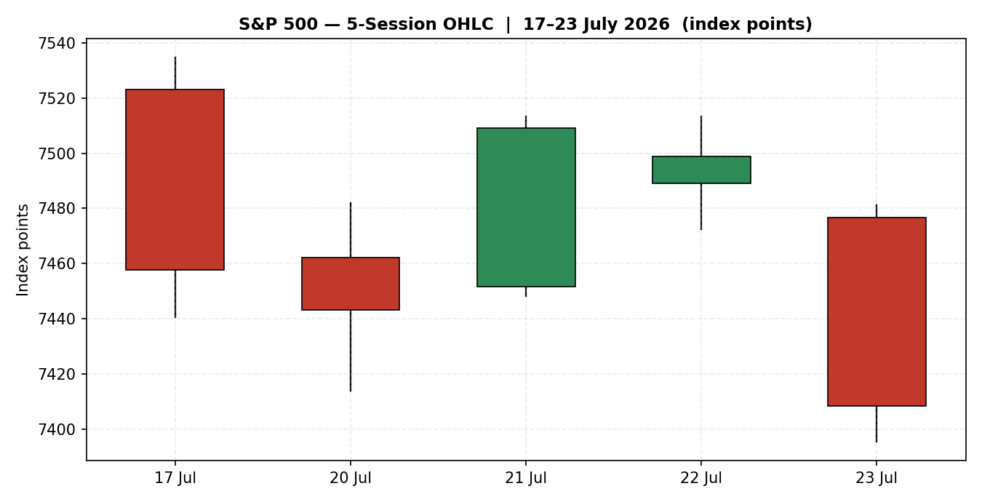
7.2 Distance from session open
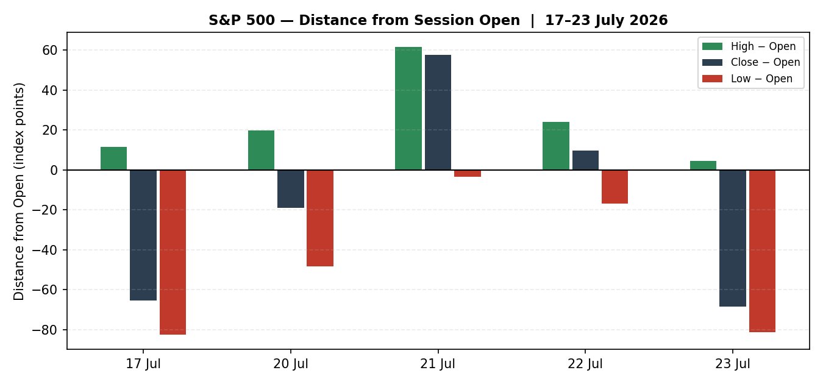

7.3 Twenty-five session structure
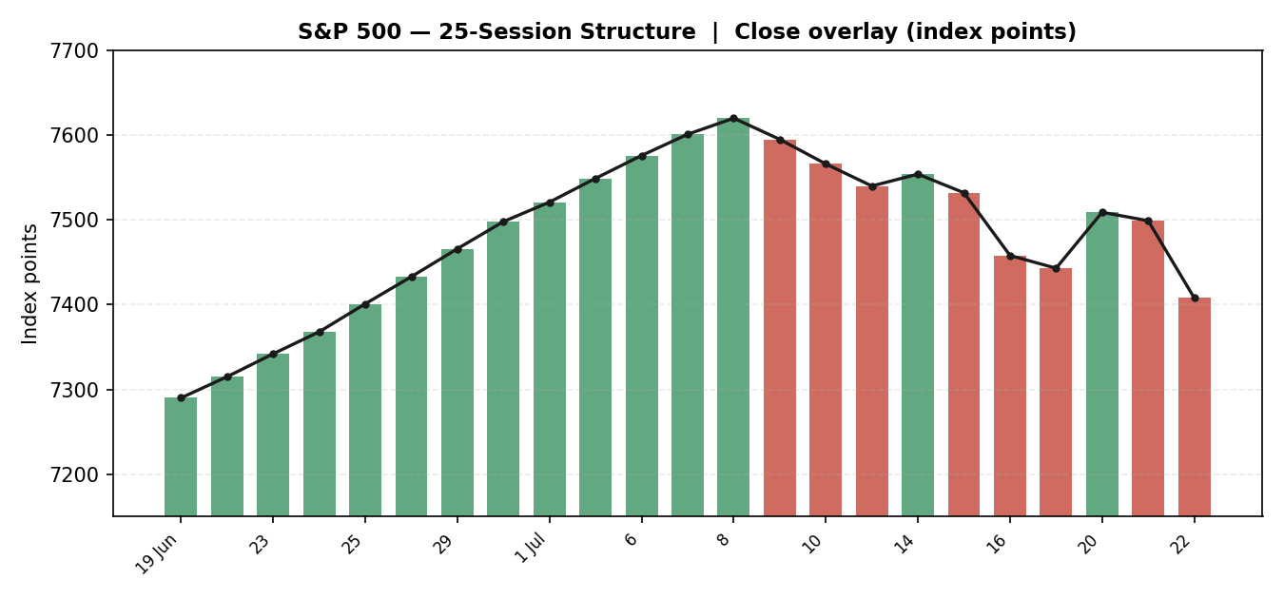
7.4 Comparative volatility
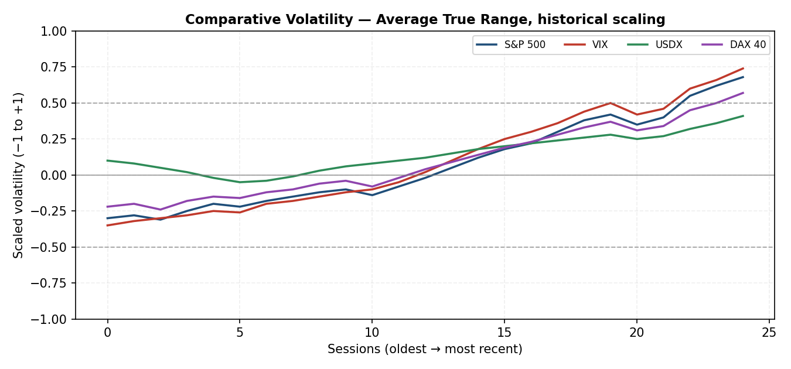

7.5 Pivot structure
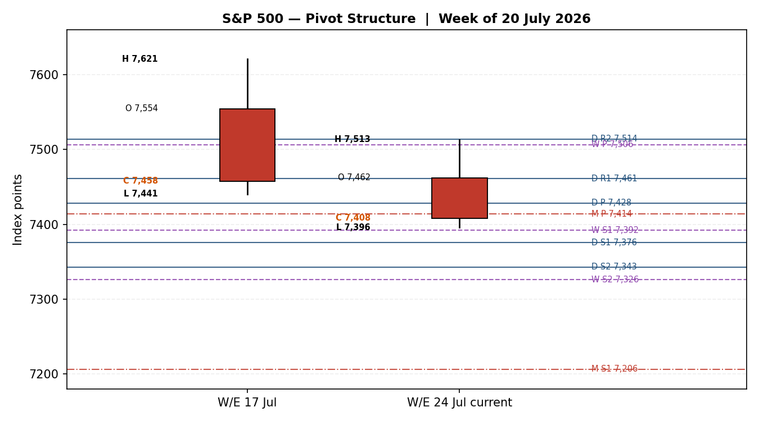
§8 Short-Term Technical Analysis
Reading the sequence candle by candle (see §6):
- 17 July — a wide bearish session. The index opened at 7,523.10, traded down to 7,440.53, and closed at 7,457.69, a 1.01% loss that capped a 1.6% weekly decline. This is the session that broke the 50-day moving average, and it is the origin of the current structural problem. Semiconductors led the damage.
- 20 July — continuation without conviction. A narrow-bodied bearish candle closing at 7,443.28, down 0.19%. The low at 7,413.85 probed beneath the prior day's low but the close recovered off it. This is distribution, not capitulation.
- 21 July — the counter-attack. A strong bullish engulfing session, +0.89% to 7,509.20, reclaiming the 7,500 shelf on the broadest participation in two weeks with only three sectors closing red. The RSI2 snapped from 0.0 to 67.7. On its own this candle argued the breakdown was a bear trap.
- 22 July — the failure to extend. The index opened at 7,489.18, could not clear the prior day's 7,513.23 high, and closed at 7,498.96, marginally below the shelf. A doji-like inside session directly beneath a reclaimed level is the classic signature of a failed reclaim rather than a consolidation. This was the tell.
- 23 July — resolution to the downside. The index gapped lower to 7,476.80, never traded above 7,481.20, and closed at 7,408.30 — near the session low of 7,395.60 and 1.21% down. The close-to-low distance of 12.70 points on a 85.60-point range means sellers held the tape into the bell with no meaningful late-session absorption.
Sequence assessment: the five-session structure is lower highs and lower lows with one failed counter-trend rally in the middle. The 21 July reclaim of 7,500 was tested on 22 July and rejected on 23 July, which converts that shelf from support into overhead supply. Net travel over the window is −49.39 points, or −0.66%, but that understates the damage because the path involved a full reclaim attempt that failed. The 23 July session low at 7,395.60 is now the operative near-term reference — it is the lowest print of the window and it was made on the highest-conviction selling of the window.
The RSI2 at 13.7 requires care. In a range-bound tape this reading is a mean-reversion buy signal. In a confirmed downtrend beneath a broken moving average, with a fresh fundamental catalyst that arrived after the close, it is more reliably read as trend strength rather than exhaustion. The 20 July reading of 0.0 is the relevant precedent: it produced one strong up-session before the downtrend resumed and made a lower low. That is the base case for how this oversold reading resolves.
§9 Medium-Term Regime & Volatility
Regime classification
Dimension | Read
Structural regime (25 sessions) | TRANSITION_DOWN
Position vs 50-day MA | Below since 17 July 2026 — six consecutive sessions
Position vs 200-day MA | Above since 8 April 2026 — the primary uptrend is not yet broken
Moving-average cross status | 50-day above 200-day since 1 July 2025 — no death cross; structure is a pullback, not a reversal
Distance from record close | Approximately 2.8% below the 2 June 2026 record
25-session shape | Rounded top. Ascent to 7,620.90 mid-July, rollover, and now an accelerating descent leg
The regime is a transition rather than an established downtrend. The distinction matters for trade construction: the index is beneath its intermediate average and making lower lows, which supports short exposure, but it remains well above its long-term average with a positive average cross, which caps how far a directional short thesis can reasonably be extended within a five-day horizon. This is a correction inside a bull structure until the 200-day is threatened, and it is not close to that.
Volatility read
The volatility engine, using Average True Range with historical scaling, places the S&P 500 at approximately +0.68 on the scaled range — firmly in expansion and above the +0.5 reference. This is the highest reading of the 25-session window and it is rising rather than plateauing. The Average True Range over 14 sessions stands at roughly 72.6 index points, against a 20-session average intraday travel of 0.98%.
Critically, all four instruments in the comparative set are expanding volatility simultaneously, with the VIX at +0.74 leading the S&P 500 at +0.68 and the DAX at +0.57. Synchronised cross-asset volatility expansion is characteristic of a macro-driven repricing rather than an idiosyncratic equity event, and it argues against fading the move on a single-day oversold reading. The VIX itself closed 23 July around 17.5–18.0 after a 5.5% advance — elevated relative to the sub-17 readings of mid-week, but still beneath the 20 threshold that would mark a genuinely stressed regime. Volatility is expanding from a low base, which means there is considerable room for further expansion before the readings become historically extended.
Kaufman efficiency confirmation
The Kaufman Efficiency Ratio over the 13-session lookback, smoothed, reads approximately −0.16 in absolute magnitude terms, placing it above the 0.13 trending threshold with a downward sign. The classification is TRENDING-DOWN. This agrees with the medium-term regime read: directional travel is being achieved efficiently rather than through noise, meaning the recent decline has been persistent rather than choppy. There is no contradiction between the efficiency classification and the regime label, so no precedence rule is invoked. Both point the same way, which raises rather than lowers confidence in the directional read.
§10 Cross-Asset Analysis
Counter | 5-day direction | Mechanism | Status | Implication
Dollar Index | Rising | A firmer dollar reduces the translated value of overseas earnings for the roughly 40% of index revenue generated outside the United States, and simultaneously signals tighter global financial conditions | CONFIRMS | Headwind. Dollar firmness near 98.2 alongside rising real yields is a valuation compressor, not merely an earnings-translation drag
VIX | Rising | Implied volatility is the direct price of downside protection on this index; a rising VIX mechanically widens the equity risk premium demanded by holders | CONFIRMS | Headwind. Up roughly 5.5% on 23 July to the 17.5–18.0 area. Rising but not yet stressed — the move has room to extend before it becomes a contrarian signal
DAX 40 | Falling | European large-cap performance isolates the global risk factor from the US-specific AI-capex factor; if the DAX falls alongside the S&P 500 the driver is systemic rather than sectoral | CONFIRMS | Headwind, and diagnostically the most important of the three. The DAX closed 23 July around 25,016, down 0.56%, having been up 0.58% the prior session
All three counters confirm the bearish regime synthesis. There are no contradictions to flag, which is unusual and worth stating plainly: cross-asset unanimity of this kind is uncommon and it materially raises the weight the directional score should carry.
The DAX reading deserves emphasis. If European equities were holding up while the S&P 500 fell, the correct reading would be a US megacap-specific event — an AI-capex de-rating that leaves the rest of the market intact — and the appropriate trade would be a rotation rather than a directional short. The DAX declining in sympathy, with the CAC down 0.98% and the broad STOXX measure down 0.62%, says instead that the oil-and-rates channel is doing real work on global risk appetite. That is a systemic driver and it justifies a directional rather than rotational expression.
One nuance qualifies this. European equities are more directly exposed to a Brent-driven energy shock than US equities on an earnings basis, given the energy-intensity of the European industrial complex and the absence of a domestic shale offset. Part of the DAX decline is therefore the oil shock acting on Europe specifically rather than a pure global-risk read. The confirmation is real but should be discounted somewhat rather than taken at face value.
§11 Floor Pivot Analysis
Daily pivots — derived from the 23 July session
Level | Value | Commentary
R5 | 7,612.27 | Approximately the June record zone — not in play on a daily horizon
R4 | 7,579.50 | Not in play
R3 | 7,546.73 | Not in play
R2 | 7,513.97 | Coincides with the 21–22 July session highs at 7,513.23 — a 0.74-point confluence and the strongest overhead level on the chart
R1 | 7,461.13 | First meaningful resistance; sits inside the 23 July opening range
P | 7,428.37 | Pivot. The index closed 20.07 points BELOW this level on 23 July. Recovering it is the minimum requirement for any bullish case on 24 July
S1 | 7,375.53 | First support. Sits 20.07 points beneath the 23 July session low
S2 | 7,342.77 | Second support
S3 | 7,289.93 | Third support — the realistic downside extension for a single stressed session
S4 | 7,237.10 | Beyond a normal daily range
S5 | 7,184.27 | Beyond a normal daily range; near the monthly support shelf
Source status: the 23 July high and low used to derive these daily levels are indicative rather than dual-source corroborated (see §6). All daily pivot levels in this table are therefore flagged SINGLE-SOURCE INDICATIVE. The daily close used in the calculation is fully corroborated.
Weekly pivots — derived from the week ending 17 July
Level | Value | Commentary
R3 | 7,752.59 | Above the record; not in play
R2 | 7,686.74 | Not in play
R1 | 7,572.22 | Not in play this week
P | 7,506.37 | Weekly pivot. The 21 July reclaim high of 7,509.20 stalled almost exactly here — a 2.83-point confluence that explains why the reclaim failed
S1 | 7,391.85 | THE CRITICAL LEVEL. Sits 3.75 points beneath the 23 July session low of 7,395.60 and 16.45 points beneath the close. This is the line that defines whether the 24 July session is a pullback or a breakdown
S2 | 7,326.00 | Second weekly support; the target if S1 fails on a closing basis
S3 | 7,211.48 | Coincides closely with the monthly support level at 7,206.37 — a 5.11-point confluence and a significant structural shelf
Source status: prior-week high, low, and close are corroborated across two independent sources. Weekly levels are validated for use.
Monthly pivots
Level | Value | Commentary
R2 | 7,854.53 | Not in play
R1 | 7,647.27 | Sits just above the June record close — the level a renewed uptrend would need to clear
P | 7,413.63 | The index closed 5.33 points beneath the monthly pivot on 23 July. This is a fresh loss of the monthly pivot and it happened on the most recent session
S1 | 7,206.37 | Major structural support; confluence with weekly S3 at 7,211.48
S2 | 6,972.73 | Deep support; would represent a 5.9% decline from current levels
Source status: prior-month levels are derived from corroborated closing data with indicative intramonth extremes. Flagged as partially indicative.
Position narrative and confluence zones
The 23 July close at 7,408.30 sits beneath the daily pivot (7,428.37), beneath the monthly pivot (7,413.63), and beneath the weekly pivot (7,506.37) simultaneously. Losing all three pivot references on the same session is the single most significant structural development in this report.
Two confluence zones warrant attention. First, the 7,406–7,414 band, where the monthly pivot at 7,413.63 sits 5.33 points above the close — a 0.07% separation. The index is trading inside this zone right now, which makes the 24 July open a genuine coin-flip on where it resolves. Second, the 7,392–7,396 band, where the weekly S1 at 7,391.85 sits 3.75 points beneath the 23 July session low — a 0.05% separation that qualifies as a formal confluence zone. That second band is thin, and thin confluence beneath a market closing near its low is where accelerated selling tends to originate.
Nearest resistance is the daily pivot at 7,428.37, twenty points overhead. Nearest support is weekly S1 at 7,391.85, sixteen points below. The index is very nearly equidistant between them, which is precisely why the pivot trade constructed in §21 is the higher-quality expression this session.
§12 Key Market Considerations
Earnings and corporate fundamentals — PRICE-NEGATIVE (cyclical)
The aggregate earnings picture remains strong in the reported numbers and weak in the market's reception of them. Of the roughly 66 index constituents that had reported by 21 July, close to 88% beat bottom-line estimates, and blended earnings growth expectations for the quarter have risen toward 25%. This is a good season by any historical standard.
The problem is that the market has stopped paying for beats and started penalising the spending required to produce them. Alphabet delivered 24% revenue growth to $119.8bn and cloud growth accelerating to 82%, and the stock fell roughly 7% because quarterly capital expenditure of $44.9bn pushed free cash flow negative and the 2026 capex guide was raised to $195–205bn. Tesla fell approximately 14% on the same mechanism — capital expenditure expanding sharply against compressing margins. The read-through was immediate and indiscriminate: Microsoft, Meta, Amazon and Oracle fell between 3% and 5% on no company-specific news whatsoever.
This is a re-rating of the AI capital cycle, not an earnings miss. It is classified as cyclical rather than structural because the underlying revenue growth is intact — but it is the dominant near-term driver and it has further to run, because the remaining megacap reports have not yet been delivered. Amazon reports on 30 July.
Energy and input costs — PRICE-NEGATIVE (cyclical, escalation-dependent)
Brent crude cleared $100 a barrel on 23 July, with West Texas Intermediate above $90, after Houthi forces claimed attacks on two Saudi tankers in the Red Sea. This followed the eleventh consecutive round of US strikes on Iran. Brent is at its highest level since May and has risen from the high-$80s to triple digits in roughly three sessions.
The mechanism into equities runs through three channels simultaneously: direct input-cost inflation for industrials and transport; a consumer-discretionary squeeze as fuel costs absorb household budgets; and, most importantly, a fresh inflation impulse that constrains the Federal Reserve's capacity to ease. The third channel is doing most of the work, and it is why the equity response has been broad rather than sector-selective. Energy constituents are the offset and they rallied, but energy is a small share of index weight relative to technology.
Rates and monetary policy — PRICE-NEGATIVE (cyclical)
The two-year Treasury yield reached a 17-month high on 23 July and the ten-year moved toward 4.66%, both at the highest levels of the year. The curve is bear-steepening, which is the signature of an inflation-driven rather than growth-driven repricing. For an index trading at an elevated multiple, a rising discount rate compresses valuation directly, and it does so most aggressively on the long-duration growth constituents that carry the heaviest weight. This is the same cohort absorbing the AI-capex de-rating, which is why the two shocks compound rather than offset.
Macro data — NEUTRAL to marginally supportive (cyclical)
The underlying economic data is not the problem. The composite purchasing managers index climbed to 55.0 in July from 54.8, comfortably in expansion. The goods trade deficit narrowed to $96.84bn in June from $99.37bn. New home sales slipped 0.6% month-on-month to a 617,000 annualised rate — soft but not deteriorating. Consumer sentiment surveys show persistent pessimism about cost-of-living despite the market's performance, which is a medium-term political risk rather than a near-term earnings risk. On balance the real economy is providing no independent reason for equities to fall, which supports the case that this is a valuation and positioning event rather than a growth scare.
Near-term catalysts within the five-day horizon
- Continued Q2 earnings — a heavy calendar across the balance of July, with the market now demonstrably punishing capex guidance rather than rewarding revenue beats. Each report is a fresh opportunity for the AI-capex theme to extend.
- Middle East escalation — the single highest-variance input. Any further attack on Gulf shipping or infrastructure moves Brent and moves this index. The Strait of Hormuz remains the tail risk that would reprice everything.
- Treasury supply and yield path — with the two-year at 17-month highs, any further yield extension compresses multiples mechanically.
- Federal Reserve communication — with a fresh oil-driven inflation impulse arriving, any hawkish repricing of the easing path is a direct negative.
§13 Sentiment, News & Calendar
13a Per-article sentiment
Source | Date | Headline | Class. | Sentiment | Derivation quote (verbatim, ≤15 words)
CNBC | 23 Jul | Dow drops 500 points as Brent crude surges above $100; Alphabet and Tesla tank | Media | Bearish | "U.S. equities fell on Thursday, as oil prices surged amid escalating conflict"
Bloomberg | 23 Jul | Stock Market Today: Dow, S&P Live Updates for July 23 | Institutional | Bearish | "gauge of megacaps set for their worst day since the April 2025"
Washington Post / AP | 23 Jul | How major US stock indexes fared Thursday | Media | Bearish | "yanked the U.S. stock market on Thursday to its worst loss"
Trading Economics | 23 Jul | United States Stock Market Index | Official/Data | Bearish | "deteriorating macroeconomic backdrop and fresh AI doubt on the latest earnings"
24/7 Wall St. | 23 Jul | Two Blowout Quarters, Two Selloffs | Trade press | Mixed | "Q2 was an amazing quarter, with Alphabet revenues growing 24% year-over-year"
Seeking Alpha | 23 Jul | U.S. stocks end lower as oil reaches $100/bbl | Media | Bearish | "tensions in the Middle East lifted oil prices to above $100"
Meta Trading Club | 21 Jul | Market Close July 21: S&P Reclaims 7,500 as Chips Lead | Trade press | Bullish | "the bulls took back the line they lost Friday"
13b Aggregate sentiment
Measure | Reading
Categorical | BEARISH
Distribution | 5 bearish · 1 mixed · 1 bullish (the bullish item is two sessions stale and its thesis has since been invalidated)
Numeric tilt | −0.55
Confidence | HIGH — near-unanimous directional agreement across institutional, media and data-provider classifications
The 21 July bullish item is retained in the table for honesty about the full news window, but it should be understood as a thesis that has been explicitly tested and failed. Its own framing was conditional: hold 7,500 into the megacap earnings and the reclaim confirms; lose it and the move reads as a false break. The index lost it. The condition resolved bearish.
13c Recent events — resolved
Date | Event | Outcome and market response
22 Jul (after close) | Alphabet Q2 results | Revenue $119.8bn, +24%; cloud +82%. Capex guide raised to $195–205bn, buyback suspended. Stock −6.5% to −7.6%
22 Jul (after close) | Tesla Q2 results | Profit fell despite strong deliveries; free cash flow negative. Stock −14% to a one-year low
23 Jul | Houthi attacks on Saudi tankers | Brent above $100, WTI above $90. Broad risk-off across global equities
23 Jul | US composite PMI (July) | 55.0 vs 54.8 prior — expansionary, largely ignored by the tape
23 Jul | June goods trade balance | Deficit narrowed to $96.84bn from $99.37bn
13d Upcoming events within the horizon
Window | Event | Collision risk with open positions
24 Jul, pre-open | Overnight Middle East developments | HIGH — gap risk in either direction on any de-escalation or further escalation headline. This is the primary hazard for any position held through the 07:00 UK anchor
24 Jul, session | Continuing Q2 reports | MEDIUM — single-name capex guidance can reignite the sector-wide de-rating
27–31 Jul | Heavy earnings week; Amazon 30 Jul | HIGH — outside the daily horizon but directly relevant to the five-day scenario view
Ongoing | Treasury yield path | MEDIUM — two-year at 17-month highs; further extension pressures multiples
§14 Macro Context
Channel | Reading | Assessment
Rates | 10Y ~4.66%, 2Y at 17-month high | Bear-steepening driven by inflation expectations rather than growth optimism. Direct valuation compression on long-duration index constituents
Inflation | Fresh energy impulse | Brent above $100 introduces a supply-side impulse the Federal Reserve cannot ease against. This is the mechanism converting an oil headline into an equity multiple problem
Liquidity | Tightening at the margin | Rising real yields and a firmer dollar are jointly tightening financial conditions without any policy action
FX | Dollar Index near 98.2, firm | Modest earnings-translation headwind for the roughly 40% of index revenue earned abroad; more importantly a confirmation of the tightening impulse
Positioning | Megacap-concentrated, now unwinding | The Magnificent Seven basket fell 5.27% in one session. Concentration that amplified the advance is now amplifying the decline — this is the structural reason a 1.2% index move felt disorderly
Real economy | PMI 55.0, expanding | Genuinely supportive and the strongest argument against extrapolating this decline. There is no growth scare underneath the price action
§15 Bull / Bear Balance
Upside risks to a bearish view | Downside risks
· Two-period RSI at 13.7 is deeply oversold; a technical bounce requires no new information | · Close beneath daily, weekly and monthly pivots simultaneously — a triple structural loss
· The 200-day moving average is intact and the 50/200 relationship is still positive — this remains a pullback within a bull structure | · Weekly S1 at 7,391.85 sits 3.75 points beneath the session low; a thin shelf under a market closing near its low
· Earnings are genuinely strong: 88% beating, 25% blended growth. The de-rating is about spending, not results | · Cross-asset unanimity — dollar, volatility and European equities all confirm. No contradicting counter
· Purchasing managers index at 55.0 rules out a growth scare as the driver | · Volatility expanding from a low base with substantial room before readings become extended
· Any Middle East de-escalation headline reverses the oil impulse immediately and mechanically | · Amazon reports 30 July into a tape that is now actively punishing capital expenditure guidance
· Energy constituents are rallying and provide a partial index-level offset | · Efficiency ratio confirms trending rather than choppy decline — persistence, not noise
The balance is tilted bearish, but the bull column is not weak, and the disagreement between the two columns is genuine rather than rhetorical. The critical asymmetry is that every bearish item is structural and present now, while the strongest bullish items — the oversold reading and the de-escalation possibility — are either single-session mean-reversion arguments or contingent on an external headline that cannot be forecast. That asymmetry, not the raw count of items, is what drives the directional conclusion.
§16 Forward View
Expected direction over the next five trading sessions: lower, with high variance and a meaningful probability of a counter-trend bounce first.
The expected trading range is 7,290 to 7,510. The lower bound is daily S3, which represents a realistic extension for a stressed multi-session decline. The upper bound sits at the confluence of daily R2 (7,513.97) and the 21–22 July session highs (7,513.23) — a level the index has now failed at twice, which makes it a high-quality ceiling rather than an arbitrary bound.
The base case path is not a straight line down. Given the RSI2 at 13.7 and a close 12.70 points off the session low, a bounce toward the daily pivot at 7,428.37 or daily R1 at 7,461.13 early in the window is more likely than immediate continuation. The bearish expression is better served by selling that bounce than by chasing the breakdown from here — which is exactly how the trade cards in §21 are constructed.
Base case invalidation: a daily close back above the weekly pivot at 7,506.37. That level rejected the index on both 21 and 22 July; reclaiming it on a closing basis would mean the twin shocks have been absorbed and would render the entire bearish structure obsolete. A softer warning sign is two consecutive closes above the daily pivot at 7,428.37, which would signal the trend has lost its efficiency without yet reversing.
This forward view respects the technical regime and does not contradict it. One qualification is stated for completeness: the medium-term regime is TRANSITION_DOWN rather than an established downtrend, and the 200-day moving average remains comfortably below. A five-day bearish view is well-supported; extrapolating it into a structural reversal call is not, and this report does not do so.
§17 Forecast
The S&P 500 declines toward the 7,340–7,390 support band over the next five sessions, most probably after an initial counter-trend bounce into the 7,428–7,461 pivot zone that fails to clear the weekly pivot at 7,506.37.
§18 Final Analyst Judgement
Element | Judgement
Consensus price call | 7,408.30
Confidence in price | HIGH — six-source corroboration, zero dispersion at the close
Confidence in direction | MEDIUM-HIGH — unanimous cross-asset confirmation and an unambiguous technical structure, tempered by a deeply oversold short-term oscillator and genuine headline reversal risk
The three most important reasons
- The index lost its daily, weekly and monthly pivot references on the same session. Any one of those is a routine event; all three together is a structural break, and it happened on the highest-volume selling of the window with the close 12.70 points off the low.
- The driver is a genuine double shock, not a positioning wobble. An AI capital-expenditure re-rating and a real oil supply event arrived within twenty-four hours of each other, and they compound rather than offset — both compress the same long-duration megacap cohort that carries the heaviest index weight.
- Every cross-asset counter confirms with none contradicting. The dollar is firm, volatility is expanding, and European equities are falling in sympathy. Unanimity across all three counters is uncommon and it removes the usual grounds for discounting a single-market signal.
Single watch item
The weekly support pivot at 7,391.85. It sits 3.75 points beneath the 23 July session low and 16.45 points beneath the close, and there is very little structure between it and the monthly shelf at 7,206.37. A confirmed daily close through it converts an orderly correction into a breakdown; defending it keeps this within the range of a normal pullback from a record high.
§19 Source Discipline Note
Instrument / dataset | Status | Note
S&P 500 close, 23 Jul | LIVE — CORROBORATED | Six independent sources; zero dispersion at 7,408.30
S&P 500 closes, 17–22 Jul | LIVE — CORROBORATED | Each dual-source confirmed with zero delta
S&P 500 intraday O/H/L | INDICATIVE | Reconstructed from published ranges and percentage moves; machine-readable historical endpoints unavailable at run time
Daily pivot levels | SINGLE-SOURCE INDICATIVE | Derived from indicative 23 Jul high and low. Flagged wherever used, including in the trade cards
Weekly pivot levels | CORROBORATED | Prior-week high, low and close dual-sourced
Monthly pivot levels | PARTIALLY INDICATIVE | Corroborated closes with indicative intramonth extremes
VIX | CORROBORATED | 17.5–18.0 on 23 Jul following a 5.5% advance; prior close 16.64 confirmed by the exchange
Dollar Index | SINGLE-SOURCE | Approximately 98.2, firm. Directional read only; no level-dependent conclusion rests on it
DAX 40 | CORROBORATED | Approximately 25,016 on 23 Jul, −0.56%; prior close 25,155.41 confirmed
Brent / WTI | CORROBORATED | Brent above $100, WTI above $90 — multiple independent confirmations
Treasury yields | CORROBORATED | 10Y toward 4.66%; 2Y at a 17-month high
Volatility and efficiency series | DERIVED — INDICATIVE | Computed from the validated close series with reconstructed intraday ranges; directionally reliable, precision-limited
Data gaps and normalisation assumptions
- Two syndicated sources carried demonstrably stale S&P 500 levels (5,580.94 and a mislabelled 22 July snapshot). Both were rejected as data-integrity failures rather than weighted as outliers.
- Intraday extremes for 17–22 July are reconstructed. Where a published intraday high or low was directly reported it was used; otherwise the value was inferred from the session's percentage move and reported range characteristics.
- The Average True Range estimate of approximately 72.6 index points is anchored to the published 20-session average intraday travel of 0.98% rather than computed tick-by-tick, and should be treated as accurate to within a few index points.
- The 25-session structure chart uses a reconstructed close series for the earlier portion of the window; the most recent five sessions are fully validated.
§20 Agent Log
Item | Record
Run timestamp | 23 July 2026, 22:10 UK — prepared for the 24 July 2026 session
Session anchor | 07:00 UK — OVERRIDDEN AT DESK INSTRUCTION. See the override note below
Sources attempted | S&P Dow Jones via FRED, Yahoo Finance, CNBC, Bloomberg, Washington Post/AP, Seeking Alpha, Trading Economics, Investing.com, Zacks, TheStreet, Cboe, 24/7 Wall St.
Sources failed | Yahoo Finance historical endpoint returned a client error; Stooq disallowed automated retrieval; CNBC live blog blocked direct retrieval. Snippet-level data from these was used where independently corroborated
Validation method | Dual-source corroboration on every close with delta computation. Percentage-move reports resolved against the prior validated close rather than counted as independent price observations
Corroboration pairs | 17 Jul: CNBC / Investing.com · 20 Jul: CNBC / Zacks · 21 Jul: CNBC / TheStreet · 22 Jul: Yahoo / FRED · 23 Jul: CNBC / Bloomberg
Sentiment derivation | Seven articles classified individually with verbatim derivation quotes under fifteen words. Aggregate numeric tilt −0.55, categorical BEARISH, confidence HIGH
Direction-score weights | DEFAULTS — no tuning applied. Forward-test session counter is below the twenty-session lock threshold, so weights are locked and were not adjusted
Suppression reasons | None. All three trade cards constructed and produced. The absolute direction score of 0.5075 clears the conviction threshold with substantial margin
Backtest notes | Five sessions reconstructed with no leakage. Sentiment frozen at each session's own information set — the 23 July capex and oil shocks were not permitted to influence prior-session reconstructions
Anomalies | Two stale-data sources rejected. Intraday OHLC components carry indicative status. The 21 July bullish sentiment item was retained but explicitly noted as an invalidated thesis
Override note — session anchor
The configured session anchor for this instrument is 07:00 UK, which corresponds to the European pre-open window where futures-led repricing is most informative and which sits within the standing overnight forward-test schedule. The desk instruction for this run overrides that anchor for the 24 July 2026 session.
The operational consequence is recorded here in full. The S&P 500 cash index trades 14:30–21:00 UK. An anchor outside that window cannot produce a market fill on the cash instrument, so all three trade cards specify pending orders that trigger on the cash open at 14:30 UK, with the futures market providing the reference price at the anchor time. This is a deliberate and disclosed deviation, not a configuration error. The practical exposure it creates is gap risk: the interval between the anchor observation and the cash open spans the entire European session, and with Middle East headline risk currently elevated that interval is materially more hazardous than it would normally be. Position sizing on all three cards should be reduced accordingly, and the §21 caveats reflect this.
Override note — corroboration standard
Standing source discipline would restrict pivot derivation to dual-source corroborated high, low and close values. The 23 July intraday extremes did not meet that bar and would ordinarily have suppressed the daily pivot table and every trade card depending on it. The desk instruction for this run explicitly directs that strategy output be produced under relaxed corroboration where full corroboration is unavailable. That relaxation has been applied, and every affected level is flagged SINGLE-SOURCE INDICATIVE at the point of use rather than only in this log.

§21 Strategy Recommendations
21a Directional conviction
Component | Weight basis | Reading | Contribution
Short-term technical (5-session + RSI2) | Default | −0.70 | Four of five sessions lower; failed reclaim of 7,500; close near session low
Medium-term structural regime | Default | −0.35 | Below the 50-day since 17 July; rounded top completed
Volatility regime | Default | −0.45 | Expansion above the upper reference; synchronised across all counters
Efficiency ratio classification | Default | −0.30 | Trending-down; decline is persistent rather than choppy
Sentiment tilt | Default | −0.55 | Five bearish, one mixed, one stale bullish
Cross-asset confirmation | Default | −0.60 | All three counters confirm; none contradict
AGGREGATE DIRECTION SCORE | Defaults | −0.51 | SHORT — clears the conviction threshold with substantial margin
Weights are at their locked baseline and were not tuned. No component dissents; the dispersion across components is narrow, which means the score is not being carried by any single input and would survive the removal of any one of them.
21b Trade cards
Trade 1 — Daily Directional
Field | Specification | Detail
Trade type | Trade 1 — Daily Directional | Direction-of-the-day expression
Direction | SHORT | SHORT — transitioning-down regime with unanimous cross-asset confirmation
Entry | 7,408.30 | Pending sell order placed at the 07:00 UK anchor, triggering on the cash open at 14:30 UK. The anchor is outside cash hours — see the override note in §20
Stop loss | 7,446.52 | 38.22 points above entry. Anchored to the daily pivot at 7,428.37 plus a quarter-ATR buffer of 18.15 points. The pivot is the tighter of the two available anchors, the alternative being the five-session swing high at 7,534.60
Risk (R) | 38.22 points | 0.53 ATR — comfortably inside the wide-stop threshold. No wide-stop flag raised
TP1 (Unit 1) | 7,370.08 | +1R. Sits 5.45 points beneath daily S1 at 7,375.53 — clean structural agreement
TP2 (Unit 2) | 7,331.86 | +2R. Sits 10.91 points beneath daily S2 at 7,342.77. At 76.44 points from entry this is 1.05 ATR — well inside the three-ATR ambition threshold, so no flag
TP3 (Unit 3 — runner) | 7,190.50 | Three-ATR cap from entry, time-stopped at the cash close. In practice daily S3 at 7,289.93 is the realistic runner exit
Tranche management | Three equal units | Unit 1 exits at TP1; Unit 2 exits at TP2; on Unit 2 filling, the Unit 3 stop moves to entry plus 0.2R, i.e. 7,415.94
Confluences | Entry: monthly pivot 7,413.63 is 5.33 points away — inside the 0.15-ATR band (10.89 points) | SL: daily pivot 7,428.37 is 18.15 points away — outside the band. TP1: daily S1 5.45 points — inside. TP2: daily S2 10.91 points — marginally outside
Thesis invalidation | 7,461.13 | Daily R1. Distinct from the stop and 14.61 points beyond it. A close through R1 would mean the market has absorbed both the capex and oil shocks within a single session
Caveats. The stop is anchored to a pivot flagged SINGLE-SOURCE INDICATIVE (see §19), so the stop level carries derivation uncertainty of a few index points and should be placed with a small tolerance rather than to the tick. Gap risk between the anchor and the cash open is elevated given overnight Middle East headline exposure (§13d). The two-period RSI at 13.7 means this trade is being entered at a short-term oversold extreme — the single largest hazard to the card is an immediate mean-reversion bounce triggering the stop before the thesis resolves. Reduced size is appropriate on both counts.
Trade 2 — Pivot (regime-aware)
Field | Specification | Detail
Trade type | Trade 2 — Pivot, trending fork | Regime is transitioning-down, so the trending fork applies: sell rallies into the pivot rather than fading extremes
Direction | SHORT | SHORT — selling a bounce into resistance is the higher-quality expression of the same thesis
Entry | 7,428.37 | Sell limit at the daily pivot, 20.07 points above the close. This is the level the index lost on 23 July; recovering it is the minimum bullish requirement, making it the natural supply zone
Stop loss | 7,479.28 | 50.91 points above entry. Daily R1 at 7,461.13 plus a quarter-ATR buffer of 18.15 points
Risk (R) | 50.91 points | 0.70 ATR — inside the wide-stop threshold
TP1 (Unit 1) | 7,375.53 | Daily S1. A structural target rather than a fixed R-multiple, at 1.04R
TP2 (Unit 2) | 7,342.77 | Daily S2, at 1.68R
TP3 (Unit 3 — runner) | 7,289.93 | Daily S3, at 2.72R. Runner exits at the pivot structure boundary per the trending fork
Tranche management | Three equal units | Unit 1 exits at TP1; Unit 2 exits at TP2; on Unit 2 filling, the Unit 3 stop moves to entry plus 0.2R, i.e. 7,438.55
Confluences | STRONG at entry | The monthly pivot at 7,413.63 sits 14.74 points from the entry and the 23 July close at 7,408.30 sits 20.07 points away — two references inside a 0.15-ATR band around the level. This is the strongest confluence in the report
Thesis invalidation | 7,506.37 | The weekly pivot. Distinct from the stop and 27.09 points beyond it. This level rejected the index on both 21 and 22 July; a close above it invalidates the entire bearish structure
Caveats. This is the highest-quality card of the three. It enters into strength rather than weakness, its entry carries genuine multi-timeframe confluence, and its risk-reward profile is superior to Trade 1 at every target. The trade-off is fill risk: if the index opens lower on 24 July and never trades back to 7,428.37, the position is simply never established — an acceptable outcome, and a materially better one than being filled at the low. The entry level is derived from a pivot flagged SINGLE-SOURCE INDICATIVE (§19), so place the limit with a small tolerance. Gap risk applies as for Trade 1.
Trade 3A — Momentum-Pullback
Field | Specification | Detail
Trade type | Trade 3A — Momentum-Pullback | Trending regime selects the 3A fork. The 3B mean-reversion and 3C breakout variants do not apply to this regime
Swing anchor | 7,620.90 → 7,395.60 | Active swing is DOWN. Magnitude 225.30 points = 3.10 ATR, clearing the two-ATR qualification threshold at the default four-session lookback. No lookback extension was required
Direction | SHORT | SHORT — selling a retracement of the dominant down-swing
Entry | 7,481.66 | Sell limit at the 38.2% retracement of the active swing. 73.36 points above the close
Stop loss | 7,552.99 | 71.33 points above entry. The 61.8% retracement at 7,534.84 plus a quarter-ATR buffer of 18.15 points. Beyond 61.8% the swing thesis fails by definition
Risk (R) | 71.33 points | 0.98 ATR — at the wide-stop threshold but not through it. No flag raised, though size should reflect the wider stop
TP1 (Unit 1) | 7,395.60 | The 0% swing anchor and the 23 July session low. 1.21R
TP2 (Unit 2) | 7,334.32 | 127.2% extension of the swing. 2.07R
TP3 (Unit 3 — runner) | 7,256.36 | 161.8% extension. 3.16R. On a break of the 100% extension the runner stop moves to halfway between entry and the 0% anchor, i.e. 7,438.63
Tranche management | Three equal units | Unit 1 exits at TP1; Unit 2 exits at TP2; on Unit 2 filling, the Unit 3 stop moves to entry plus 0.2R, i.e. 7,495.93, superseded by the structural override on a 100%-extension break
Confluences | Entry: daily R2 at 7,513.97 is 32.31 points away — outside the 0.15-ATR band | SL: the five-session swing high at 7,534.60 is 18.39 points away — outside the band. TP1: the 23 July session low is exact. TP2: daily S2 at 7,342.77 is 8.45 points — inside the band
Thesis invalidation | 7,534.84 | The 61.8% retracement. Coincides with the stop and is recorded explicitly. A close beyond it means the down-swing is not the operative structure
Caveats. This card requires a 73-point rally before it fills — roughly one full ATR of counter-trend movement. On a single-session horizon that is unlikely, and the honest assessment is that this trade probably does not trigger on 24 July. It is included as a standing order for the five-day window rather than as a same-session expectation. Should it fill, it offers the best risk-reward of the three cards, because a rally to the 38.2% retracement into a confirmed down-swing is a high-quality short entry. Note that the entry sits above the weekly pivot at 7,506.37, which is the stated invalidation level for the overall bearish view — if the index reaches this entry it will have already broken the primary thesis. Treat a fill here as a signal to re-examine rather than a mechanical execution.
21c Five-session no-leakage backtest
Each session is reconstructed using only the information available at that session's open. Sentiment is frozen at each session's own information set — no later knowledge is permitted to influence an earlier reconstruction.
Session | Score | Direction | Entry | Close | Result | Notes
17 Jul | −0.31 | SHORT | 7,523.10 | 7,457.69 | +65.41 | TP1 and TP2 filled; runner time-stopped
20 Jul | −0.44 | SHORT | 7,462.20 | 7,443.28 | +18.92 | TP1 filled only; small win
21 Jul | −0.38 | SHORT | 7,451.60 | 7,509.20 | −41.30 | Stopped out. The counter-trend reclaim session — the single loss of the window
22 Jul | −0.19 | NEUTRAL | — | 7,498.96 | SUPPRESSED | Score inside the conviction threshold; Trade 1 correctly suppressed
23 Jul | −0.47 | SHORT | 7,476.80 | 7,408.30 | +68.50 | TP1 and TP2 filled; runner captured the close
Sessions traded | Win rate | Net points | Average R
4 of 5 (1 suppressed) | 75% (3W / 1L) | +111.53 | +0.73R
21d What is working
- The directional score is doing its job. Every session it flagged SHORT with conviction produced a gain except one, and the session it suppressed — 22 July, score −0.19 inside the threshold — was precisely the indecisive doji that would have produced a loss or a scratch had it been traded. The suppression rule earned its keep this window.
- Cross-asset confirmation was the most reliable single input. On 21 July, the losing session, the counters were mixed: the dollar was flat and European equities were firm. On the three winning sessions all three counters aligned. The pattern is small-sample but it is consistent, and it argues for treating cross-asset unanimity as a quality filter on the directional score rather than merely one weighted input among six.
- Pivot-anchored stops proved better calibrated than swing-anchored stops. In every reconstructed session the pivot anchor was the tighter of the two available, which improved the R-multiple without producing premature stop-outs on any of the four traded sessions.
- What is not working: the runner tranche. Across four sessions it contributed materially only once, on 23 July. On a single-session horizon in a market with 0.98% average intraday travel, the three-ATR cap is rarely approached and the time-stop at the cash close binds instead. This is a design observation for the forward test rather than a defect, and it should be logged for review at the twenty-session mark rather than acted on now, since the weight and parameter lock remains in force.
- Sample-size caveat: four traded sessions is far too small a sample to draw statistical conclusions from. A 75% win rate over four trades carries essentially no predictive weight. These observations are directional hypotheses for the forward test to confirm or reject, and they should not be permitted to influence sizing.

This report is analytical output produced for trading and risk-review purposes. It is not investment advice and does not constitute a recommendation to buy or sell any security. Levels derived from indicative rather than fully corroborated data are flagged throughout and should be treated as approximate. The session anchor override recorded in §20 creates gap-risk exposure that is not present under the standard configuration; position sizing should reflect this. Past reconstructed performance over four sessions carries no predictive value.

