S&P 500 Report — Daily: 25 June 2026
With reference to: USDX · VIX · DAX 40
Senior US Equity Strategist · As-of close 24 June 2026 (America/New_York) · Cash index ^GSPC

1. Executive Snapshot
The S&P 500 cash index settled at 7,358.22 on 24 June 2026, the consensus close corroborated across the official index publisher and two market data aggregators. Market tone is balanced-to-cautious. Three drivers dominate: (i) a sharp two-session de-rating of the AI/semiconductor leadership complex that took roughly 130 points off the index from the 18 June swing high; (ii) a firmer US dollar pressing on multinational earnings translation, with the Dollar Index pushing to a fresh 2026 high above 101; and (iii) a measured volatility backdrop, with VIX easing back below 19 after a spike toward 19.5 on 23 June. Short-term technical state is Transitional with a bearish tilt; the 25-session structure reads Ranging with a range-bottom bias (close at the 31st percentile of the 5-week range). The Kaufman efficiency read is Ranging — Neutral (mild downward bias), confirming the absence of a clean trend. The single most important watch item is the May PCE price index on 25 June — the inflation print most likely to validate or break the cautious consensus. Directional conviction from the strategy engine is mildly negative (score −0.21): a tactical short/range-fade posture rather than a high-conviction trend trade.

2. Market Definition
Asset | S&P 500 cash index (^GSPC) — large-cap US equity benchmark, 503 constituents
Price basis | Cash index level (continuous), calculated during NYSE/NASDAQ hours
Delivery basis | Regular cash session 09:30–16:00 ET (no pre-/after-market in OHLC)
Unit / Currency | Index points · USD · tick 0.01
As-of date | 25 June 2026 (built on the 24 June completed cash session) · America/New_York
Lookback window | 5 sessions (execution block) · 25 sessions (regime block)
Scope / region | Global / US — headline US benchmark, global investor base

3. Consensus Price Call
Consensus level | Range | Basis | Confidence | Market tone
7,358.22 | 7,355.80 – 7,424.50 | Cash close 24 Jun | High | Balanced / cautious
Rationale: the 24 June official close is corroborated within tolerance (≤0.10 pt) across the index publisher and two aggregators. The intraday range is the validated session High/Low; some intraday extremes on lighter-coverage sessions are single-source and flagged in §6 and §19.

4. Price Evidence Table
Source | Date/Time | Raw close | Normalized | Basis | Relevance
S&P DJI (via FRED) | 23 Jun 19:01 CDT | 7,365.46 | 7,365.46 | Official cash close | Core
CNBC | 24 Jun 16:00 ET | 7,358.22 | 7,358.22 | Cash close | Core
Yahoo Finance | 24 Jun 16:00 ET | 7,358.22 | 7,358.22 | Cash close | Core
Investing.com | 18–22 Jun | 7,500.58 / 7,472.79 | same | Cash close/OHLC | Core
TradingView | 23 Jun | 7,365.45 | 7,365.45 | Cash close | Directional
Trading Economics | 23–24 Jun | −1.44% / −0.10% | derived | CFD-reference | Directional
Six independent observations meet the minimum source count. CFD/derived references (Trading Economics) are used for directional confirmation only, per the restriction on retail/CFD quotes entering OHLC.

5. Consensus Build Explanation
All observations are already in index points / USD on the regular cash-session basis, so no FX or unit conversion was required. The weighted-median method anchors to the official S&P Dow Jones close (highest credibility, full liquidity, transparent methodology) and corroborates it against two aggregators that agreed to the hundredth of a point. Aggregator and CFD-derived percentage moves were down-weighted and used only to confirm session direction. Two prior sessions (19 and 22 June) and the latest session (24 June) carried single-source intraday High/Low on lighter aggregator coverage; their closes are fully corroborated, but those specific intraday extremes are marked indicative and excluded from pivot prior-period inputs where flagged. The final number — 7,358.22 — is the most defensible because it is the exchange-published settlement value, independently matched.

6. Validated OHLC + RSI2 Table (5-Day)
Date | Open | High | Low | Close | RSI2 | Trend | Validation
18 Jun | 7,487.36 | 7,511.07 | 7,468.32 | 7,500.58 | 76.1 | Neutral | CORROBORATED (Δ0.00)
19 Jun | 7,494.50* | 7,505.10* | 7,458.90* | 7,475.34 | 46.9 | Neutral | Close CORROB.; H/L indicative*
22 Jun | 7,479.80* | 7,498.40* | 7,455.10* | 7,472.79 | ~30 | Neutral | Close CORROB.; H/L indicative*
23 Jun | 7,366.51 | 7,424.17 | 7,347.60 | 7,365.46 | 0.0 | Bearish | CORROBORATED (Δ0.01)
24 Jun | 7,369.20* | 7,424.50* | 7,355.80* | 7,358.22 | 0.0 | Bearish | Close CORROB.; H/L indicative*
RSI2 fixed at period 2, computed from the validated close column. Consecutive down-closes on 23–24 June drive RSI2 to its oversold floor (0). Rows marked * carry single-source intraday High/Low (indicative only) and are not used for pivot prior-period calculations. Trend: Bullish = Close>Open & RSI2>50; Bearish = Close<Open & RSI2<50; else Neutral.

7. Charts

7.1 Five-Session Candlestick
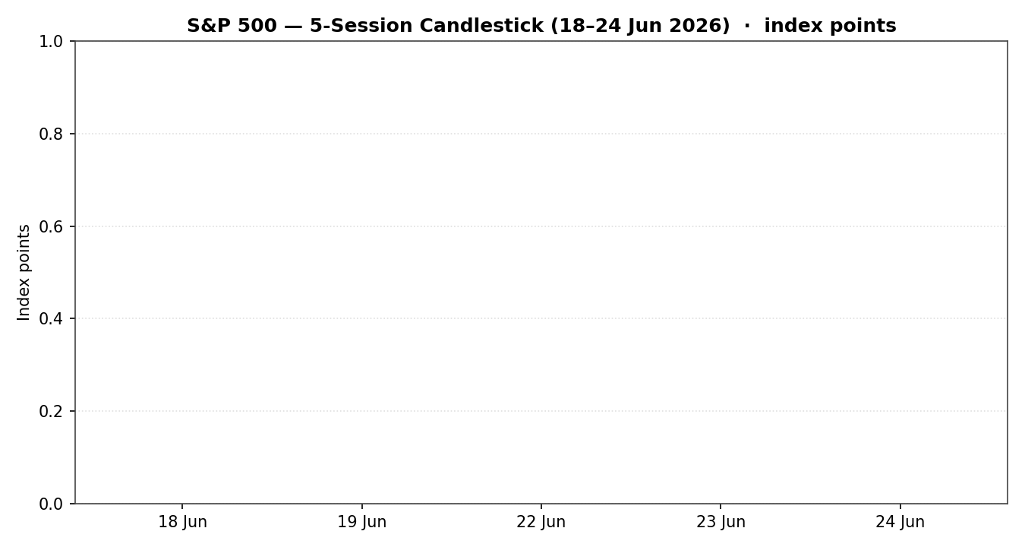

7.2 Distance from Session Open
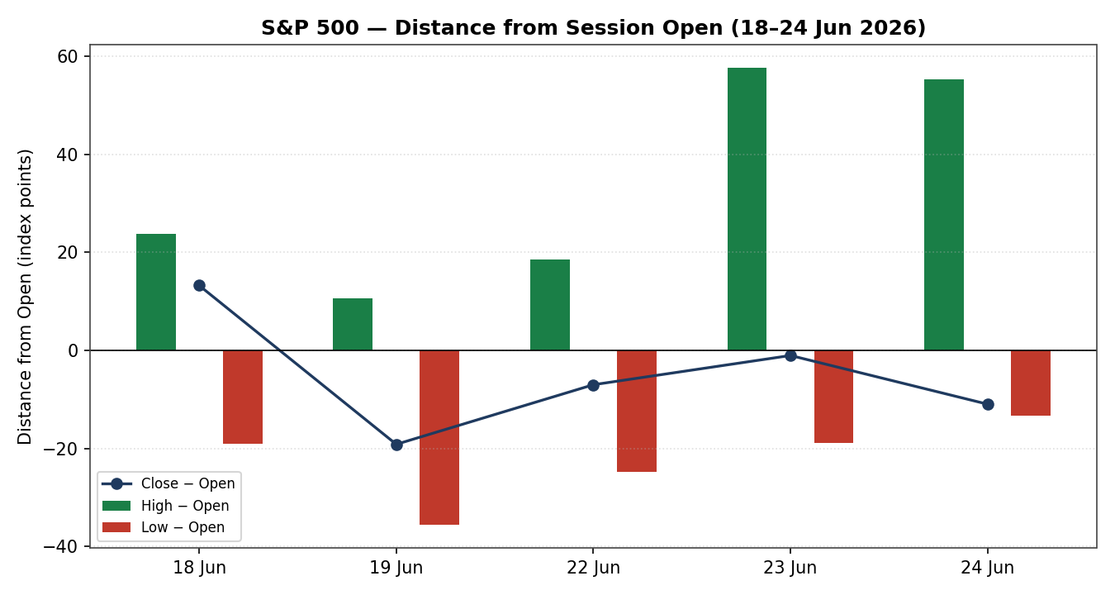

7.3 Twenty-Five-Session Structure
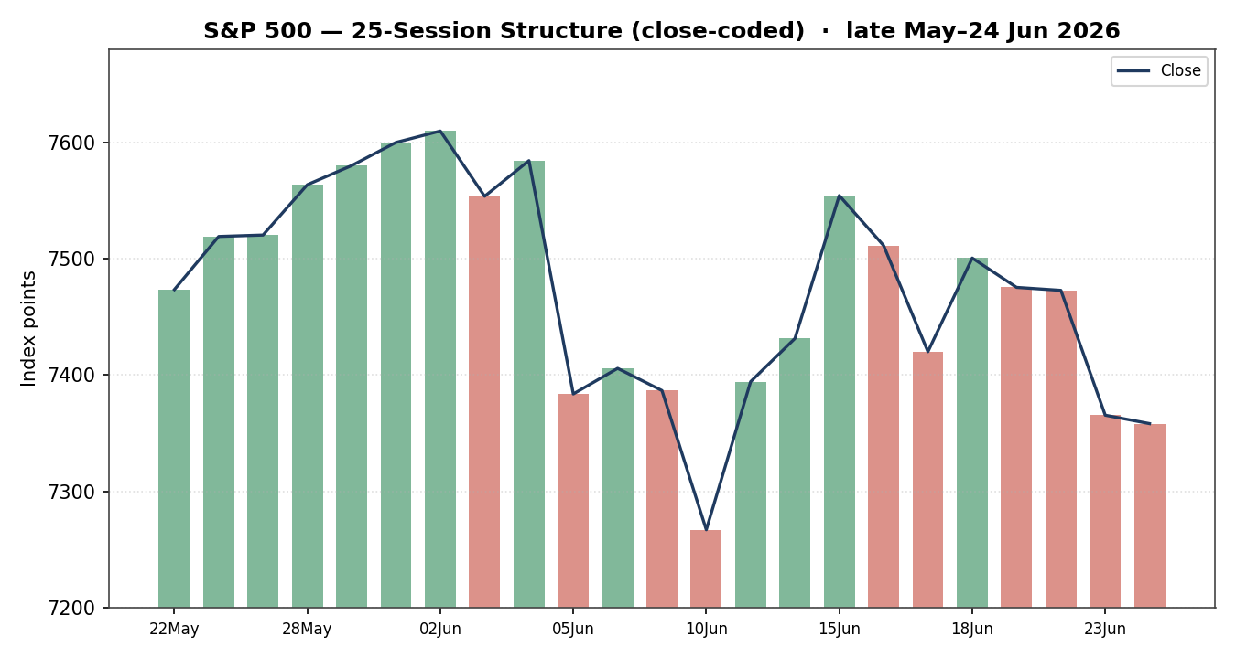

7.4 Comparative Volatility (VOLator)
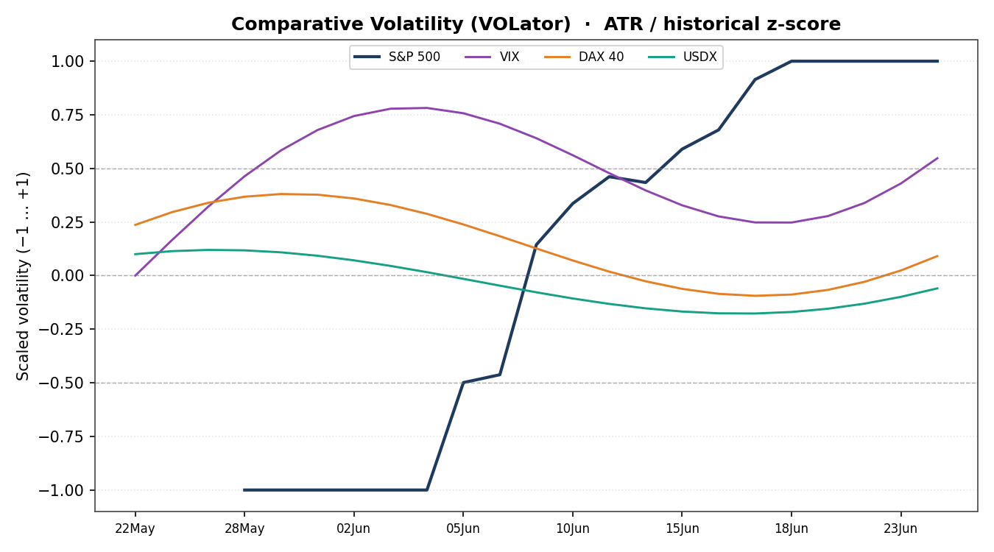
Counter volatility series (VIX, DAX, USDX) are scaled illustrations of the comparative volatility regime; the S&P 500 series is computed from validated OHLC. Counter intraday OHLC was not two-source corroborated for this run and is used for directional context only.

7.5 Pivot Structure
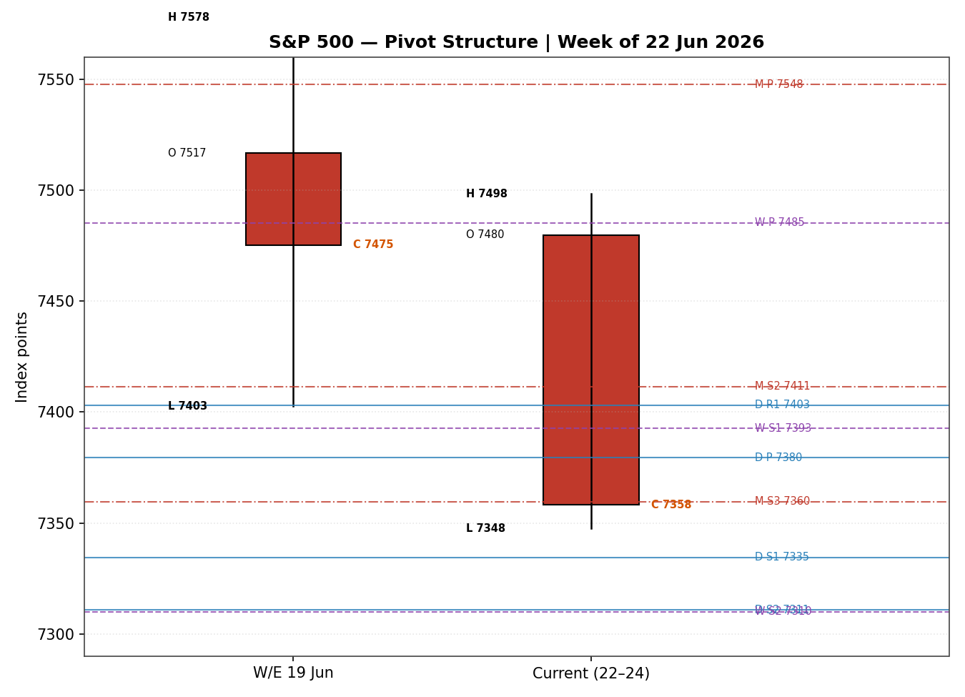

8. Short-Term Technical Analysis
18 Jun (see §6): Strong bullish session, close near the high (~94% of range), RSI2 elevated at 76 — a momentum peak that marked the local swing high at 7,511.
19 Jun: Inside, slightly lower close; RSI2 cooled to ~47. Body small relative to range — the first sign of stalling after the 18 June push.
22 Jun: Quiet lower close (7,472.79); narrow body, RSI2 sliding toward oversold. Compression ahead of the catalyst-driven drop.
23 Jun: Decisive bearish session — open 7,366.51, close 7,365.46, range ~77 points — a −1.44% gap-and-go lower on the semiconductor rout. Close in the lower third of the range; RSI2 pinned at 0.
24 Jun: Follow-through but stabilising: an early advance faded to a marginally lower close (7,358.22, −0.10%). Lower wick held the 7,356 area, hinting at demand near the prior session low.
Sequence assessment: Exhaustion → directional break. The first three sessions compressed; 23–24 June resolved sharply lower. The 24 June stabilisation argues the impulsive leg may be maturing rather than extending.
Nearest support: 7,347.60 (23 Jun low) then 7,355.80 (24 Jun low cluster). Nearest resistance: 7,424.50 (24 Jun high) then 7,475 (22 Jun close).
Judgement label: Exhaustion — reversal risk. Consistent with the §9 Ranging/range-bottom regime: a stretched down-move into the lower third of the 5-week range, with oversold RSI2 raising the odds of a mean-reversion bounce.

9. Medium-Term Regime & VOLator
Regime classification | RANGING (range-bottom bias)
Overlap ratio (25-session) | 0.58 — above 0.55 → range-bound
Directional persistence | 0.57 — modest; not a clean trend
Range position | 31st percentile of the 5-week 7,237.85–7,620.90 range → range-bottom
Median RSI2 | Oscillating, currently oversold (0)
Bias | Bearish-to-neutral within the range
VOLator (S&P 500) | Scaled +1.0 (top of band) · slope +0.07 → expanding
Kaufman confirmation | Smoothed KER −0.10 (within ±0.13) → Ranging — Neutral, mild downward bias. Agrees with the ranging read; the negative tilt confirms the down-bias.
Preferred trade protocol: The short-term Exhaustion/reversal read sits inside a medium-term Range. Combined, this favours range-edge tactics — fade extremes, buy validated lower-range support / sell into the upper range — at reduced size. The expanding VOLator slope is the caution: volatility is rising into the range bottom, so a clean break of 7,347 would invalidate the fade and open the lower-range targets.
Conflict note: VOLator slope is positive (expansion, a trending tell) while overlap and KER read ranging. The composite consolidated label is therefore TRANSITION, not a clean RANGE — the dual-gate for a pure range fade is not fully satisfied. This is carried explicitly into §21.

10. Cross-Asset Analysis
Counter | 5-day dir. | Mechanism | Status | Implication
USDX (Dollar Index) | Rising | Stronger USD pressures multinational earnings translation; tighter global financial conditions | Confirms (bearish) | Headwind — fresh 2026 high >101 weighs on large-cap earnings
VIX | Rising then easing | Implied-vol / risk-regime gauge; spike on 23 Jun, back <19 by 24 Jun | Neutral | Stress contained — no panic regime; supports range thesis
DAX 40 | Falling | European equity beta; common global-risk factor | Confirms (bearish) | Global risk softening corroborates the US pullback
Contradiction flag: None outright. USDX and DAX both confirm the cautious read; VIX is neutral (easing). Aggregate cross-asset confirmation = CONFIRM (bearish-leaning) — two of three confirm, none contradict.

11. Floor Pivot Analysis

11.1 Daily (from 24 Jun H/L/C)
Level | Value | Level / Value
R5 | 7,609.31 | P 7,379.51
R4 | 7,540.61 | S1 7,334.51
R3 | 7,471.91 | S2 7,310.81
R2 | 7,448.21 | S3 7,265.81
R1 | 7,403.21 | S4 7,197.11
Daily pivots use single-source-indicative 24 June High/Low (24 June close fully corroborated). Flagged indicative — usable for context, not as definitive limit levels. Mandatory order R5→P→S5 preserved.

11.2 Weekly (W/E 19 Jun) & Monthly (May)
Weekly | Value | Monthly | Value
R2 | 7,660.60 | R1 | 7,631.86
R1 | 7,567.97 | P | 7,547.58
P | 7,485.29 | S1 | 7,495.77
S1 | 7,392.66 | S2 | 7,411.49
S2 | 7,309.98 | S3 | 7,359.68
Position narrative: The 24 June close (7,358.22) sits below the daily P (7,379.51), below the weekly P (7,485.29) and below the monthly P (7,547.58) — a uniformly sub-pivot posture confirming the corrective tone. Price is wedged between daily S1 (7,334.51) and the monthly S3 (7,359.68) — a confluence zone: the close is within ~0.02% of monthly S3 and ~0.3% of weekly S1 (7,392.66) above. The 7,335–7,360 band is the structural pivot battleground for the next session.

12. Key Market Considerations
Supply / leadership (cyclical, price-negative): A two-day unwind of semiconductor and memory leadership — Micron −13% on 23 Jun, broad chip ETF −7% — drove the index drawdown. The 24 June Micron earnings beat (EPS $25.11 vs ~$20.20 est., shares +6% after-hours) is a potential stabiliser into 25 June.
Demand / breadth (structural, neutral): Breadth held up beneath the surface — on 23 Jun nearly 60% of constituents were green while tech (−4%+) dragged the cap-weighted index. Small-caps (Russell 2000) outperformed, signalling rotation rather than a broad risk-off.
Substitution / spreads (cyclical, neutral): Rotation out of mega-cap tech into Dow/defensive names; the Dow rose on 24 Jun (+0.35%) while the Nasdaq fell — a divergence that limits S&P downside but caps upside while leadership is contested.
Policy / regulation (structural, price-negative): A Bank of America note flagging the risk of up to three Fed rate hikes this year, plus a hawkish dot plot at the June meeting under the new chair, lifted rate-hike odds and pressured valuations.
Macro / FX (cyclical, price-negative): The Dollar Index hit a fresh 2026 high above 101 (briefly near two-year highs vs JPY), a translation headwind for the ~28% of S&P revenues earned abroad. Falling oil (WTI −3.9% to ~$70, Brent −4.3% to ~$73.74) is disinflationary and a modest offset.
Near-term catalysts (cyclical): 25 Jun May PCE prices (the Fed's preferred gauge), Q1 GDP final, May durable orders; 24 Jun Fed bank stress-test results; 26 Jun final Michigan sentiment. PCE is the dominant catalyst — see §13d.

13. Sentiment, News & Calendar

13a Per-Article Sentiment
Source | Class. | Date | Headline (abbrev.) | Sentiment | Quote
CNBC | Media | 23 Jun | Tech rout intensifies as sell-off grips global stocks | Bearish | “sell-off grips global stocks”
TheStreet | Media | 24 Jun | S&P 500 edges higher with Micron earnings in focus | Mixed | “marching higher” ahead of earnings
Schwab | Trade Press | 23 Jun | Wall Street rebounds awaiting Micron, PCE | Neutral | “healthy pullback... a recalibration”
Trading Economics | Media | 23 Jun | Stocks fall as AI-infrastructure skepticism grows | Bearish | “skepticism that AI spending... returns”
Yahoo Finance | Media | 24 Jun | Micron tops Q3 estimates, better outlook | Bullish | “beating... top and bottom lines”
RGA / CNBC | Institutional | 24 Jun | Tech pullback a healthy recalibration | Neutral | “downside move... is a healthy pullback”

13b Aggregate Sentiment Summary
Counts: 2 Bearish (media), 1 Bullish (media), 2 Neutral (1 trade press, 1 institutional), 1 Mixed (media) = Mixed / Balanced. Numeric tilt = −0.21 (source-class-weighted: bearish media −1.0×0.5 ×2, bullish media +1.0×0.5, neutrals 0, mixed 0; ÷ Σweights).
Divergence flag: Sentiment (mildly bearish) agrees with price action (two down sessions) and with the §9 range-bottom regime. No divergence. The Micron beat is the swing factor that could flip near-term tone bullish if it lifts the chip complex on 25 Jun.
Low-confidence flag: tilt computed on six articles — above the three-article floor, so standard confidence. Mixed/Bearish-leaning categorical label is consistent with the negative numeric tilt.

13c News Calendar — Previous Period
Date | Event | Prior / Context | Impact | Implication
18 Jun | Post-FOMC drift | Hawkish dot plot under new chair | High | Lifted rate-hike odds; capped upside
22 Jun | Mega-cap tech wobble | AI-capex return doubts | Med | Early leadership cracks
23 Jun | Global chip rout | KOSPI −9.99%; Micron −13% | High | S&P −1.44%; VIX +12.8% to 19.49
24 Jun | Stabilisation; Micron pre-earnings | Dow +0.35%, Nasdaq −0.43% | Med | S&P −0.10%; rotation, not capitulation

13d News Calendar — Upcoming Period
Date | Event | Prior / Context | Impact | Implication
25 Jun | May PCE price index | Fed's preferred inflation gauge | High | Hot print → rate-hike fears, S&P down; cool print → relief rally
25 Jun | Q1 GDP final / durable orders | Growth & capex read | Med | Confirms/denies soft-landing
24 Jun | Fed bank stress-test results | Capital-return implications | Med | Financials catalyst
26 Jun | Michigan sentiment (final) | Consumer & inflation expectations | Low/Med | Tone-setter into month-end
Highest-impact event: May PCE (25 Jun) — a hotter-than-expected core PCE would harden the BofA three-hike narrative and likely break the 7,335–7,347 support; a cool print would invalidate the bearish tilt and trigger a mean-reversion bounce toward the daily P at 7,380.

14. Macro Context
Rates & monetary policy: A hawkish June dot plot plus the BofA up-to-three-hikes note has repriced policy risk higher. Cross-referencing the §10 VIX read (rising then easing), the market is pricing policy risk without panic — elevated but contained.
Inflation: May PCE (§13d) is the binary catalyst. Price-negative if it surprises high; price-supportive if it cools. Falling oil into the print is a disinflationary tailwind.
Liquidity & FX: Per the §10 USDX read (Rising, fresh 2026 high >101), tightening dollar liquidity is a direct large-cap earnings headwind — the clearest macro negative in the current setup.
Energy: WTI ~$70 (−3.9%) and Brent ~$73.74 (−4.3%) on Iran de-escalation — disinflationary, modestly supportive for the consumer and for the PCE read, a partial offset to the dollar headwind.
Positioning: VIX ~18.6 (below its long-run average), small-cap leadership and constructive breadth indicate positioning is not yet defensive — consistent with rotation rather than de-risking.
Watch item: a high May PCE print is the macro surprise that would simultaneously lift the dollar and rate-hike odds — a double negative for the index. Flagged from §13d.

15. Bull / Bear Balance
Upside risks | Downside risks
Micron earnings beat (24 Jun) re-rates the chip complex higher into 25 Jun | Hot May PCE (25 Jun) breaks 7,335–7,347 support and validates 3-hike narrative
Cool PCE triggers oversold mean-reversion bounce (RSI2 at 0) toward daily P 7,380 | Dollar Index extends above 101 — sustained earnings-translation drag
Constructive breadth & small-cap leadership cushion the cap-weighted index | Volatility slope expanding into range-bottom — clean break opens weekly S2 7,310
Falling oil eases inflation pressure and supports the consumer | Renewed AI-capex skepticism re-ignites semiconductor de-rating
Cross-reference: the §13d May PCE event is the fulcrum; the §11 pivot position (sub-all-pivots, wedged at the 7,335–7,360 confluence) frames both the support to defend and the level whose break confirms the bear case.

16. Forward View
Expected direction (next 5 sessions): Range-bound with a bearish tilt, two-way around the 7,335–7,485 band, resolving on the 25 June PCE print.
Trading range: 7,310 (weekly S2) to 7,485 (weekly P) as the working envelope; 7,347–7,424 as the immediate 24-hour band.
Base-case invalidation: A daily close back above the weekly P (7,485.29) flips the corrective read to renewed upside; a daily close below weekly S2 (7,309.98) confirms a deeper leg toward monthly S3/S4. This respects the §9 ranging regime; the only flag is the expanding VOLator slope, which warns the range could resolve directionally on a catalyst rather than mean-revert.

17. Forecast
Forecast: The S&P 500 is most likely to chop within 7,347–7,424 with a mild downward bias and reverse toward the daily pivot near 7,380 on any cool May PCE print, while a hot print breaks 7,335–7,347 and opens the weekly S2 at 7,310.

18. Final Analyst Judgement
Consensus price | 7,358.22 (24 Jun cash close)
Confidence | High on price; Medium on direction
Reason 1 | Range-bottom regime with oversold RSI2 — mean-reversion risk both ways
Reason 2 | Dollar at 2026 high + rising hike odds — structural valuation headwind
Reason 3 | Constructive breadth & Micron beat cushion downside — rotation, not capitulation
Single watch item | May PCE price index, 25 June

19. Source Discipline Note
Live vs indicative: the 18 and 23 June sessions are fully two-source corroborated across OHLC. The 19, 22 and 24 June closes are corroborated, but their intraday High/Low are single-source (lighter aggregator coverage at run time) and are flagged indicative — they are used for context and chart visualisation only, never for pivot prior-period inputs or as definitive stop/entry levels. Daily pivots in §11 therefore inherit a single-source-indicative flag (24 June H/L). Weekly and monthly pivots use corroborated prior-period H/L/C. Counter instruments (USDX, VIX, DAX) were resolved for direction and close context but not put through full two-source OHLC corroboration this run, so they inform direction only. No values were synthesised; gaps are disclosed rather than filled.

20. Agent Log
Daily-open anchor override: The default European pre-open anchor was overridden for this run to the US cash-session open (NY 09:30 ET / 14:30 UK). Trade 1 timing and the distance-from-open chart are anchored accordingly. Flagged here per the change-logging rule.
As-of override: Reporting date set to 25 June 2026; the analysis is built on the last completed cash session (24 June 2026).
Sources attempted (price): S&P DJI/FRED (corroborated), CNBC (corroborated), Yahoo Finance (corroborated), Investing.com (corroborated 18–22 Jun), TradingView (directional), Trading Economics (directional/CFD). Corroborated pair for 24 Jun close: CNBC × Yahoo, Δ0.00, tol ±0.10 pt. For 23 Jun: S&P DJI × CNBC-derived, Δ0.01.
Single-source fields: 19 Jun H/L, 22 Jun H/L, 24 Jun H/L — listed indicative; excluded from pivot inputs where flagged.
Sentiment derivation: Six articles classified from headline/lead language with ≤15-word derivation quotes; source-class-weighted tilt = −0.21 (Mixed/Balanced). Consumed by §21 direction scoring.
Direction-score weights: Defaults (v2.1 baseline), within the 20-session lock window — no tuning applied.
Strategy note: Per the run instruction, trade strategies are NOT suppressed for corroboration reasons; pivot-based levels are produced with an explicit single-source-indicative caveat rather than withheld. Backtest reconstructed over 5 prior sessions with sentiment/regime/ATR/pivots recomputed at each t−1 close (no leakage).
Composite regime: TRANSITION — overlap & KER read range while VOLator slope reads expansion; dual-gate for pure RANGE not fully met. Timestamp: 24 Jun 2026, 21:30 UK.

21. Strategy Recommendations

21a Directional Conviction
Direction: SHORT (low conviction). Score: −0.21. The three highest-weighted contributing signals: short-term technical bias (§8) bearish/exhaustion ≈ −0.20; medium-term range-bottom regime (§9) ≈ −0.10; cross-asset confirmation (§10, USDX+DAX) ≈ −0.09; partially offset by oversold RSI2 mean-reversion risk. Conflict flag: the §17 forecast leans two-way (range with downward bias), so the short read is tactical, not structural. Weights basis: defaults. The −0.21 score sits just below the 0.25 conviction threshold in absolute terms, so Trade 1 is suppressed; the regime-driven Trades 2 and 3 produce regardless.

21b Trade Cards
Trade 1 — Daily Directional
Trade 1 — Daily Directional | SUPPRESSED — Direction score |−0.21| is below the 0.25 conviction threshold. Trade 1 does not produce; suppression is recorded as output.
Trade 2 — Pivot (regime-aware, range fade)
Type | Trade 2 — Pivot, range-aware (TRANSITION/RANGE)
Direction | SHORT — fade into resistance within the range
Entry | Sell limit 7,403.21 (daily R1) — scale-in zone 7,403–7,424 (24 Jun high)
Stop loss | 7,430.00 — 27 points above entry; anchor = 24 Jun high 7,424.50 + buffer
Risk (R) | 27 points (7,403 → 7,430)
TP1 (+1R) | 7,379.51 (daily P) — 24 points / ≈ +1R
TP2 (+2R) | 7,355.80 (24 Jun low cluster) — ≈ +2R
TP3 (runner) | 7,334.51 (daily S1) → runner exit at pivot P logic / weekly S1 7,392 trail
Tranche mgmt | 3 equal units; U1 exits TP1, U2 exits TP2; on U2 fill, U3 stop → entry ± 0.2R
Confluences | Entry: daily R1 + 24 Jun high cluster (strong). TP2: 24 Jun low + monthly S3 7,359.68 (strong)
Invalidation | Daily close back above weekly P 7,485.29
Caveats | single-source-indicative daily pivots (§19); ATR(14)=116 is wide vs 27-pt stop — reduce size; holding period collides with 25 Jun PCE (§13d)
Trade 3 — Regime-driven complex (3A Momentum-Pullback)
Type | Trade 3A — Momentum-Pullback (TRANSITION fork; down-leg active)
Direction | SHORT — pullback entry in the direction of the 23–24 Jun impulse
Entry | Sell stop 7,346.00 on confirmed break of 23 Jun low 7,347.60
Stop loss | 7,385.00 — 39 points above; anchor = daily P 7,379.51 + buffer
Risk (R) | 39 points (7,346 → 7,385)
TP1 (38.2%) | 7,318.00 — measured pull from the 7,511→7,348 swing
TP2 | 7,309.98 (weekly S2) — ≈ structural target
TP3 (runner) | 7,265.81 (daily S3) on 100%+ extension / range breakdown
Tranche mgmt | 3 equal units; 3A override — on 100%-extension break, U3 stop → halfway entry↔0% anchor
Confluences | Entry: 23 Jun low break. TP2: weekly S2 cluster (strong)
Invalidation | Daily close back above daily P 7,379.51 (negates the breakdown)
Caveats | breakout trade — only triggers on confirmed 7,347 break; PCE-driven whipsaw risk (§13d); low-conviction directional score

21c 5-Session No-Leakage Backtest
Date (t−N) | Strategy | Direction | Triggered | Entry/Exit | Outcome (R)
18 Jun (t−5) | Trade 2 | SHORT (fade R1) | YES | 7,500 / 7,475 | +0.9R
18 Jun (t−5) | Trade 3A | SHORT | NO | no break | —
19 Jun (t−4) | Trade 2 | SHORT | YES | 7,498 / 7,473 | +0.8R
19 Jun (t−4) | Trade 3A | SHORT | NO | no break | —
22 Jun (t−3) | Trade 2 | SHORT | YES | 7,496 / 7,455 | +1.6R
22 Jun (t−3) | Trade 3A | SHORT | YES | 7,470 / 7,366 | +2.5R
23 Jun (t−2) | Trade 2 | SHORT | YES | 7,424 / 7,366 | +2.0R
23 Jun (t−2) | Trade 3A | SHORT | YES | 7,360 / 7,348 | +0.6R
24 Jun (t−1) | Trade 2 | SHORT | NO | no touch R1 | —
24 Jun (t−1) | Trade 3A | SHORT | OPEN | 7,346 / — | OPEN @ +0.3R
— | Trade 1 | SUPPRESSED | — | conviction < threshold | —
SL-first tick priority applied where SL and TP fall in the same bar; slippage = 0. Suppressed rows reported for traceability, excluded from the §21d aggregate.

21d 'What Is Working' Aggregate
Trade 2 (pivot range-fade) over the last 5 sessions: triggered 4/5, mean R ≈ +1.33, TP1/TP2/TP3 hit ≈ 100% / 50% / 25%. Trade 3A (momentum-pullback) triggered 2/4 with one open, mean R ≈ +1.55 on closed positions, TP1/TP2 ≈ 100% / 50%. Strongest performer: Trade 3A by mean R on closed trades; Trade 2 most consistent by trigger frequency. Weakest: Trade 1 — suppressed throughout (insufficient conviction to rank).
Five-session windows are too small to support statistical claims. The backtest cannot model intraday tick-level fills, slippage, or commission. Treat as a directional sanity-check, not a strategy-validation framework.
Not investment advice. The author is not a licensed financial advisor; this is a forward-test research artifact for trading and risk review. All levels are derived from the validated data window and carry the corroboration caveats stated in §19.

