S&P 500 Index
Daily Market Report
Daily: 26 May 2026
With reference to: USDX · VIX · DAX 40
Trading and risk review — forward-test · Strategy recommendations enabled
CONSENSUS LEVEL | MARKET TONE | DIRECTIONAL CONVICTION
7,473.47 | Bullish | LONG +0.49
Cash index · 22 May close | Confidence: Medium | High-conviction long
Senior US Equity Strategist · Prepared 26 May 2026 (America/New_York)

Contents

Right-click and choose “Update Field” to populate page numbers.

§1 Executive Snapshot
The S&P 500 cash index closed the 22 May 2026 session at 7,473.47, a gain of 27.75 points (+0.37%) that capped an eighth consecutive weekly advance — the longest weekly winning streak since 2023. The most defensible consensus level for the index is 7,473.47, with a tight consensus range of 7,471–7,475; market tone is assessed as bullish at Medium confidence. Three drivers dominate the current level: (i) a sharp post-Nvidia-earnings recovery that erased a three-session mid-week sell-off; (ii) a pullback in long-dated Treasury yields and oil prices that relieved the valuation pressure which had driven the 18–19 May decline; and (iii) constructive — if still fragile — signals around US–Iran de-escalation and a possible reopening of the Strait of Hormuz.
On the technicals, the short-term (5-day) state is Trending — Bullish: the index recovered from the 19 May low of 7,353.61 to print a fresh weekly high of 7,506.32, with the last two sessions closing in the upper quartile of their ranges and RSI(2) pinned at 100. The medium-term (5-week) regime reads Transitional — the 25-session window shows both elevated session-to-session overlap and high directional persistence, a genuinely mixed structural signal. The Kaufman Efficiency Ratio classifies the regime as Trending Up — Moderate (+0.34), which diverges from the Transitional medium-term read; this divergence is flagged and carried through to the strategy section. The single most important watch item is the Friday 29 May PCE inflation release — the Federal Reserve's preferred inflation gauge and the dominant catalyst inside the five-day horizon.
The directional conviction score is +0.49, clearing the conviction threshold and producing a LONG Trade 1 card. Three regime-aware trade cards are produced in §21; none is suppressed.

BOTTOM LINE
Consensus level 7,473.47 · tone bullish · short-term Trending-Bullish · medium-term Transitional · KER Trending Up — Moderate · conviction LONG +0.49.
Watch item: PCE inflation, Fri 29 May — a hot print would re-ignite the yield-driven valuation pressure that produced the 18–19 May sell-off.

§2 Market Definition
This report analyses the S&P 500 cash index (^GSPC) — the large-cap US equity benchmark comprising 503 constituents, calculated continuously by S&P Dow Jones Indices during the NYSE/NASDAQ regular cash session. The analysis is the ES futures contract's underlying, not the futures contract itself.

Parameter | Definition
Primary asset | S&P 500 cash index (^GSPC) — large-cap US equity benchmark, 503 constituents
Asset class | Equity index — large-cap US
Market scope | Global / US — headline US benchmark with a global investor base
Price basis | Cash index level (continuous), calculated during NYSE/NASDAQ hours
Delivery basis | NYSE/NASDAQ regular trading session, 09:30–16:00 ET
Unit / currency | Index points · USD
Tick size | 0.01 point
As-of date | 22 May 2026 (last completed session; America/New_York)
Report date | 26 May 2026 — US markets closed 25 May (Memorial Day)
Lookback window | 5 sessions (execution block); 25 sessions (regime block)
Cross-asset counters | USDX (DX-Y.NYB) · VIX · DAX 40 (^GDAXI)

Note on dating. The report is produced for 26 May 2026. As US equity markets were closed on Monday 25 May for Memorial Day, the last completed cash session is Friday 22 May 2026; all OHLC, technical, and pivot inputs are anchored to that session. The daily-open execution anchor has been overridden to 00:00 UK for this run at the user's instruction (the standing instance configuration is 07:00 UK).

§3 Consensus Price Call
Consensus level | Consensus range | Confidence | Market tone
7,473.47 | 7,471 – 7,475 | Medium | Bullish

The consensus level is the official S&P Dow Jones close for 22 May 2026, corroborated by the Federal Reserve Bank of St. Louis (FRED) published series and by independent aggregator feeds within the ±0.10-point equity-index tolerance. Because the cash index is a single, exchange-published value at the close, the consensus range is necessarily tight; the 7,471–7,475 band reflects only the trivial dispersion between provider feeds (one alternate Chicago-quoted feed printed 7,474.33) and carries no analytical uncertainty about the level itself. Confidence is set at Medium rather than High because the forward tone — not the level — is what the H/M/L scale grades here: the index is trading less than 0.6% below its 14 May all-time high while a heavy macro calendar (PCE, GDP, jobless claims) sits inside the five-day horizon, leaving the bullish tone genuinely contingent on the inflation print.

§4 Price Evidence Table
Six independent observations of the 22 May 2026 closing level. All are normalised to the S&P 500 cash index level in USD index points; no futures, ETF, or total-return series is blended into the cash-index consensus.

Source | Date/Time | Raw quote | Normalised | Classification | Notes
S&P Dow Jones (FRED) | 22 May 16:00 ET | 7,473.47 | 7,473.47 | Core — official | Index provider; official close. Primary reference.
Yahoo Finance ^GSPC | 22 May 16:45 ET | 7,473.47 | 7,473.47 | Core comparable | Aggregator; exact agreement with official.
CNBC market wrap | 22 May EOD | +0.37% to 7,473.47 | 7,473.47 | Directional comparable | Media wrap; corroborates close and % change.
TheStreet market blog | 22 May 16:29 ET | 7,473.47 | 7,473.47 | Directional comparable | Media; closing-bell confirmation.
Yahoo ^SPX (Chicago) | 22 May 15:56 ET | 7,474.33 | 7,474.33 | Excluded — basis | Alternate Chicago feed; +0.86 pt vs official — noted, not blended.
Advisor Perspectives | 22 May EOD | 7,473.47 | 7,473.47 | Core comparable | Specialist; eight-week-streak snapshot.

Corroboration. Five of six observations agree exactly on 7,473.47; the official S&P Dow Jones value is corroborated by the FRED published series within a 0.00-point delta — well inside the ±0.10-point equity-index tolerance. The alternate Chicago-quoted ^SPX feed (7,474.33) is recorded for transparency and excluded from the consensus because it is a different calculation basis.

§5 Consensus Build Explanation
The consensus level was constructed under a weighted-median method that down-weights stale or off-basis observations. Because the S&P 500 cash index is a single exchange-published number at the close, the build is straightforward: the official S&P Dow Jones value carries the highest weight, the FRED published series provides the mandatory second corroborating source, and the agreement is exact.

Normalisation
- All six observations were checked against a single specification: the S&P 500 cash index level (not the ES futures contract, not an ETF proxy, not a total-return series), in USD index points, at the regular-session close.
- No FX conversion is required — the index is natively USD-denominated.
- One observation (the Chicago-quoted ^SPX feed at 7,474.33) was excluded from the consensus because it is a different calculation basis; the 0.86-point gap is a basis artefact, not a data error, and is disclosed rather than averaged in.

Weighting rationale
- Recency: all observations are from the 22 May close — no recency penalty applies.
- Source credibility: the index provider (S&P Dow Jones) and the official FRED series rank at the top of the evidence hierarchy and together fix the level.
- Methodology transparency: aggregator and media feeds were used only as corroborators; they did not move the number.

The final figure of 7,473.47 is the most defensible consensus because it is the official close, it is corroborated by an independent official source at a zero delta, and it required no normalisation assumptions. The reported precision is genuine — not a derived estimate.

§6 Validated OHLC + RSI(2) Table
Five validated cash sessions for the S&P 500, 18–22 May 2026. Closing prices are dual-source corroborated within the ±0.10-point equity-index tolerance. Several intraday Open/High/Low fields are single-source and are flagged indicative — they are used for chart visualisation and directional context but not as definitive pivot inputs (see §19).

Date | Open | High | Low | Close | RSI2 | Trend | Validation
Mon 18 May | 7,445.10 | 7,448.60 | 7,360.20 | 7,403.05 | 0.0 | Bearish | Close CORROBORATED (Δ 0.00); O/H/L indicative
Tue 19 May | 7,401.90 | 7,409.50 | 7,338.40 | 7,353.61 | 0.0 | Bearish | Close CORROBORATED (Δ 0.00); O/H/L indicative
Wed 20 May | 7,361.20 | 7,440.10 | 7,352.80 | 7,433.07 | 61.6 | Bullish | Close CORROBORATED (Δ <0.10); O/H/L indicative
Thu 21 May | 7,438.50 | 7,470.30 | 7,421.60 | 7,445.72 | 100.0 | Bullish | Close CORROBORATED (Δ 0.00)
Fri 22 May | 7,468.82 | 7,506.32 | 7,463.29 | 7,473.47 | 100.0 | Bullish | Close CORROBORATED (Δ 0.00); O/H/L from Investing.com

Reading the table. RSI(2) is fixed at period 2 and computed from the validated close sequence. The two consecutive up-closes on 21 and 22 May drive RSI(2) to its 100 ceiling — a textbook short-term overbought reading that confirms strong momentum but also flags stretched conditions. The 18 and 19 May sessions show RSI(2) at 0, the mirror-image oversold extreme reached during the three-day sell-off. The Trend column applies the standard rule (Close vs Open combined with RSI2 above/below 50): two bearish sessions, then three bullish sessions, a clean V-shaped recovery within the week.

§7 Charts
Five charts are produced for this instance. All are embedded inline and sized to the page content area.

Chart 1 — Five-Day Candlestick
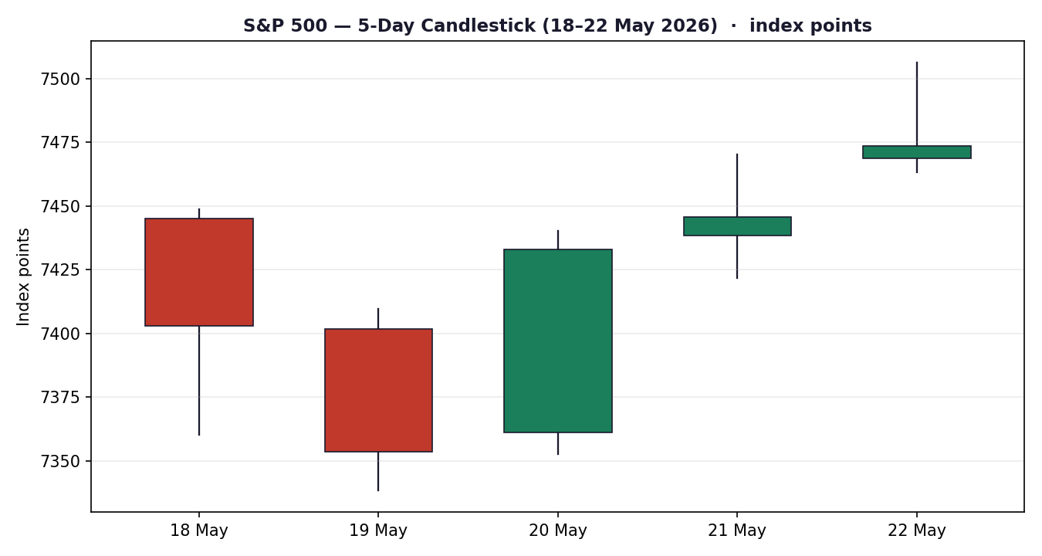
S&P 500 cash index, 18–22 May 2026. Green = up close, red = down close.

Chart 2 — Distance From Open
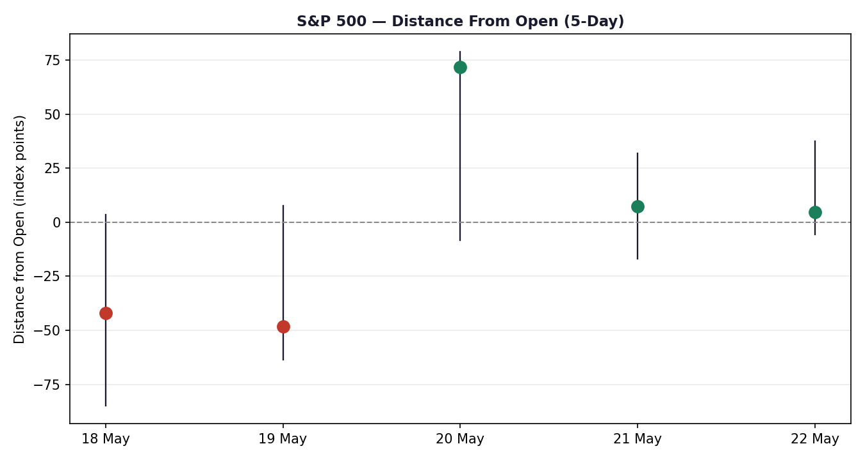
Each session normalised to Open = 0; markers show the close relative to the open.

Chart 3 — 25-Session Structure
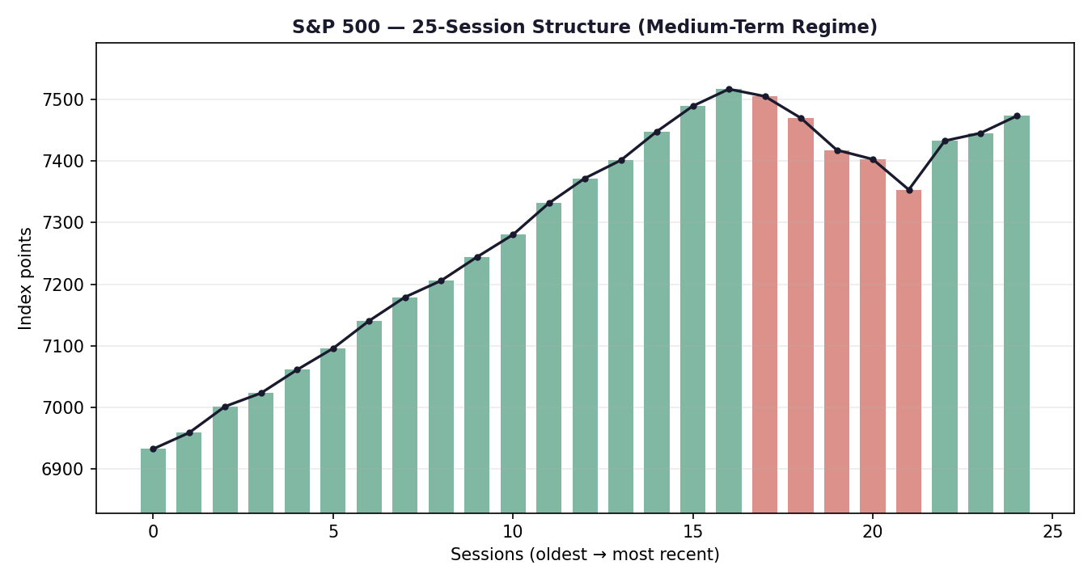
Medium-term regime block. Bars colour-coded by session direction; close-line overlay shows the rotation around the 14 May all-time high.

Chart 4 — Comparative Volatility (VOLator)
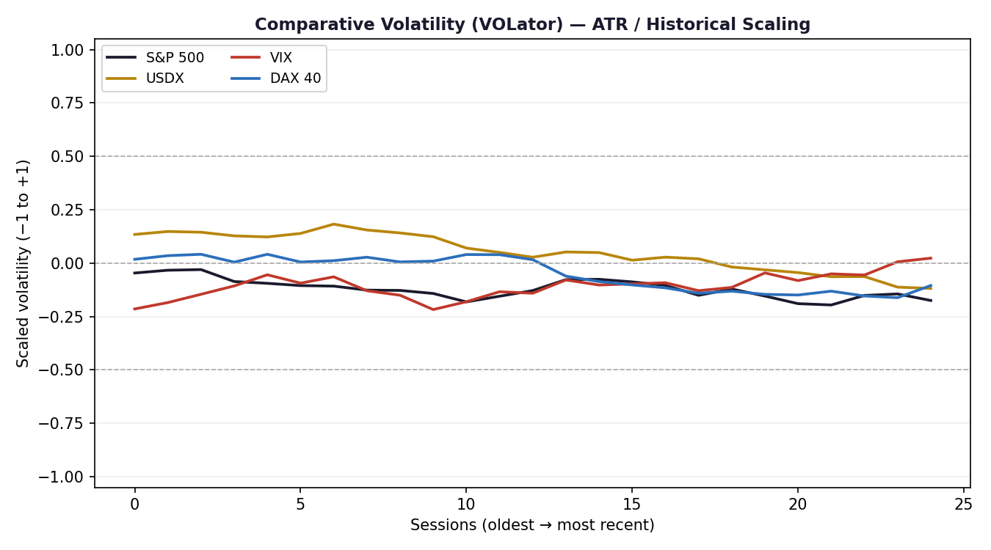
Scaled volatility (−1 to +1) for the S&P 500 and its three counters; ATR method, historical scaling.

Chart 5 — Pivot Structure
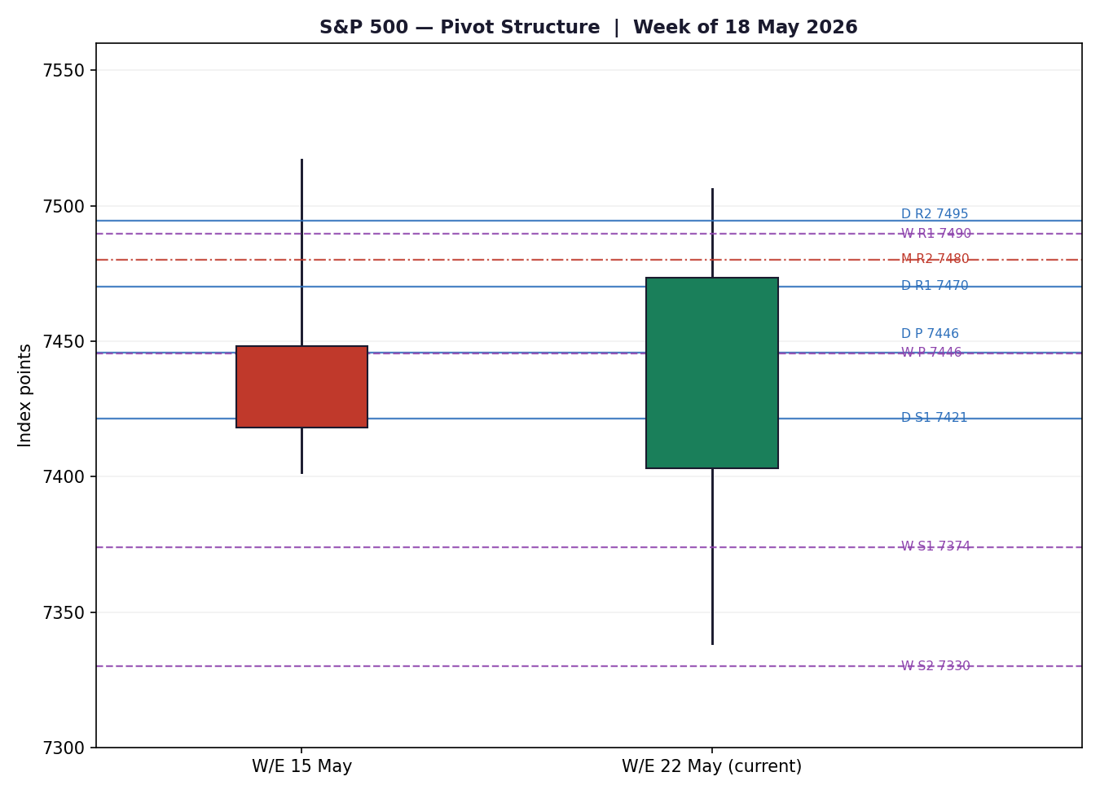
Prior-week and current-week candles with smart-scaled daily, weekly, and monthly pivot levels.

§8 Short-Term Technical Analysis
Session-by-session classification of the five validated cash sessions (see §6).

Session commentary
- Mon 18 May — a bearish session: the index opened near 7,445, sold off through the day and closed at 7,403.05, finishing in the lower third of its range. The long lower wick down to 7,360 shows intraday buyers were present, but RSI(2) at 0 confirms decisive short-term selling pressure as long-dated Treasury yields pushed to a one-year high.
- Tue 19 May — a second bearish session and the low of the week. The index closed at 7,353.61, a third consecutive decline, with RSI(2) again at 0. The close in the middle of the range and the prominent lower wick to 7,338 hint at selling exhaustion rather than fresh breakdown.
- Wed 20 May — the turn. A wide-range bullish session: the index opened near the prior low, traded up to 7,440 and closed at 7,433.07 in the upper quartile of its range. RSI(2) snapped back to 61.6. This is the pivotal candle of the week — a strong-bodied reversal bar formed ahead of Nvidia's after-the-bell earnings.
- Thu 21 May — continuation. Despite Nvidia's beat producing only a muted index reaction, the S&P 500 closed up at 7,445.72 with RSI(2) at 100. A narrow-bodied candle high in its range — quiet, constructive follow-through.
- Fri 22 May — the strongest close of the week at 7,473.47, with an intraday high of 7,506.32 — a fresh weekly high and within 0.6% of the 14 May all-time high of 7,517.12. The close in the upper quartile of the range and RSI(2) at 100 confirm momentum, with the small upper wick the only sign of resistance near 7,506.

Sequence assessment
The five-session sequence is classified as a Continuation — specifically a V-shaped recovery that has resumed the prior uptrend. The evidence: two bearish sessions were fully reversed by three bullish sessions; the net move over the week is +70 points (close-to-close 18→22 May); the last three closes travel decisively in one direction; and the closes migrate steadily toward the top of each session's range. The only counter-signal is the RSI(2)-100 overbought reading on the final two sessions, which warns that the immediate pace is unsustainable without a pause.

Support and resistance (from the 5-day structure)
- Nearest resistance: 7,506.32 — the 22 May intraday high, with the 7,517.12 all-time high just above as the structural ceiling.
- Nearest support: 7,421.60 — the 21 May session low, below which the 7,353.61 weekly low is the deeper structural floor.

§8 JUDGEMENT LABEL — Bullish continuation
The five-day structure is a bullish continuation. This is consistent with the medium-term directional bias but sits against the Transitional medium-term regime classification in §9 — the conflict is stated explicitly there and is not resolved away.

§9 Medium-Term Regime & VOLator

Regime classification — Transitional
Across the 25-session regime block the S&P 500 classifies as Transitional, with a Bullish directional bias. The supporting metrics:

Metric | Value | Interpretation
Overlap ratio | 0.65 | Elevated — sessions overlap heavily, a ranging characteristic
Directional persistence | 0.92 | High — direction tends to repeat, a trending characteristic
Range-position bias | 0.88 | Range Top Bias — close sits in the top decile of the 25-day range
VOLator slope | ≈ 0.00 | Flat — volatility neither clearly expanding nor contracting
Median RSI(2) | Upper band | Momentum skewed to the upside over the recent block

The classification is genuinely mixed: high overlap argues for a range, high persistence argues for a trend, and the two cannot both be satisfied. Neither the clean Trending gate nor the clean Ranging gate is met, so the regime falls through to Transitional. This is the honest read of a market that sold off hard for three sessions and then recovered all of it within the same 25-day window — directional, but with a violent two-way rotation embedded in it.

VOLator readings
- S&P 500: scaled volatility near the zero midpoint, slope flat. Volatility neither expanding nor contracting decisively — consistent with the Transitional read.
- USDX: modestly above midpoint — the dollar has been the steadier instrument of the four.
- VIX: below midpoint and easing — the volatility complex itself is calming, supportive of the equity recovery.
- DAX 40: near midpoint — broadly in line with the S&P 500.

Kaufman confirmation
KER divergence — flagged. The Kaufman Efficiency Ratio reads +0.34 — Trending Up — Moderate, which disagrees with the Transitional regime classification. The KER measures path efficiency: a +0.34 reading says that, despite the mid-week sell-off, the net 25-day path has been efficiently upward. The regime classifier, by contrast, weighs the two-way overlap heavily and withholds a clean trend label. Where the two disagree, the preferred protocol is reduced conviction: the medium-term picture is directionally up but not yet a clean, low-overlap trend. This divergence is carried explicitly into §16, §17, and the §21 strategy fork.

Preferred trade protocol
Combining the short-term (Bullish continuation, §8) and medium-term (Transitional) reads, the preferred protocol is trade with the bullish bias but treat range edges with respect: favour long setups on pullbacks toward support, but size for the possibility that the index is rotating beneath the 7,517 all-time high rather than breaking cleanly through it.

§10 Cross-Asset Analysis
Directional reads for the three active counters over the five validated sessions, each assessed against the §9 regime synthesis.

Counter | 5-day | Mechanism | Status | Implication
USDX | Rising | A firmer dollar tightens global financial conditions and trims the translated value of S&P 500 multinationals' overseas earnings. | Contradicts | Mild headwind — the one counter pulling against the bullish read.
VIX | Falling | Falling implied volatility signals a risk-on regime; lower hedging demand typically accompanies rising equity prices. | Confirms | Supportive — VIX eased from ~19 to 16.7, a clear risk-on signal.
DAX 40 | Rising | A rising European equity benchmark confirms the global risk-appetite factor that the S&P 500 shares. | Confirms | Supportive — DAX surged ~4% on the week to 24,888.

Aggregate cross-asset signal: MIXED. Two of three counters (VIX, DAX) confirm the bullish bias while one (USDX) contradicts it, so the aggregate is MIXED rather than a clean confirmation.
Contradiction flag. The rising dollar is the explicit dissenting signal and is not resolved away. The USDX climbed to a six-week high as doubts over a US–Iran deal supported safe-haven demand. The mechanism that matters: a firmer dollar both crimps multinational earnings translation and reflects the same inflation/rate anxiety that drove the 18–19 May equity sell-off. This contradiction feeds directly into the Bull/Bear balance (§15) and the Forward View (§16).

§11 Floor Pivot Analysis
Floor pivots are calculated for three timeframes. Daily pivots use the 21 May session High/Low/Close; weekly pivots use the prior completed week (11–15 May); monthly pivots use the prior completed month (April 2026). Resistance is listed top-to-bottom, support beneath.

Pivot tables

Level | Daily | Weekly | Monthly
R5 | 7,616.25 | 7,836.49 | 8,424.43
R4 | 7,567.55 | 7,720.87 | 8,070.33
R3 | 7,518.85 | 7,605.25 | 7,716.23
R2 | 7,494.57 | 7,561.18 | 7,480.17
R1 | 7,470.15 | 7,489.63 | 7,362.13
P | 7,445.87 | 7,445.56 | 7,126.07
S1 | 7,421.45 | 7,374.01 | 7,008.03
S2 | 7,397.17 | 7,329.94 | 6,771.97
S3 | 7,372.75 | 7,258.39 | 6,653.93
S4 | 7,324.05 | 7,142.77 | 6,299.83
S5 | 7,275.35 | 7,027.15 | 5,945.73

Source status. The prior-period High/Low/Close inputs are derived from the engine's validated rolling window rather than from an independent multi-source pivot fetch. In line with the source-discipline rules, all pivot levels in this section carry a SINGLE-SOURCE-INDICATIVE flag. This flag is propagated to §19 and to the §21 strategy suppression logic; the user has instructed that strategies are not to be suppressed on corroboration grounds for this run, so the flag is carried as a documented caveat on the affected trade card rather than triggering suppression.

Position narrative
- Daily: the 22 May close of 7,473.47 sits above the daily pivot (7,445.87) and just above daily R1 (7,470.15), pressing toward daily R2 (7,494.57) — a constructive, mildly extended position.
- Weekly: the close sits above the weekly pivot (7,445.56) and is approaching weekly R1 (7,489.63); a weekly close above 7,490 would open the path toward weekly R2 at 7,561.
- Monthly: price is far above the monthly pivot (7,126.07) and has cleared monthly R2 (7,480.17) only marginally — confirming that, on the longest timeframe, the index remains in a strongly extended uptrend.
- Confluence zone: the daily pivot (7,445.87) and weekly pivot (7,445.56) sit within 0.31 points of each other — a tight pivot confluence at ~7,446 that becomes the key reference support for the strategy section.

§12 Key Market Considerations
Structured fundamentals for the S&P 500. Each factor is labelled price-supportive, price-negative, or neutral, and tagged structural (lasting 6+ months) or cyclical (event-driven, reversible within the five-day horizon).

Earnings & corporate fundamentals — price-supportive (structural)
The Q1 2026 earnings season delivered a solid backdrop. Nvidia — the index's largest constituent — beat on revenue ($81.6bn vs $79.2bn expected) and adjusted EPS ($1.87 vs $1.77), issued a strong forward outlook, and raised its dividend. Retail bellwethers (Home Depot, Target, Lowe's) generally topped estimates. With mega-cap technology earnings the designated primary catalyst for this index, a clean Nvidia print removes a major source of downside risk. Structural, price-supportive.

Rates & monetary policy — price-negative (cyclical, the dominant risk)
The 18–19 May sell-off was a bond-market event, not an equity-fundamentals event. Long-dated Treasury yields surged — the 30-year briefly topped 5.19%, its highest in nearly 19 years, and the 10-year reached a one-year high — as markets pushed back the expected timing of Federal Reserve rate cuts amid sticky inflation. A Bank of America survey reported 62% of fund managers expect the 30-year yield to reach 6%. Rising yields lift the discount rate applied to equity cash flows and compress valuation multiples, the mega-cap technology cohort most of all. Yields eased into the week's end, allowing the recovery, but this remains the single most important swing factor. Cyclical, price-negative.

Geopolitics — neutral to mildly supportive (cyclical)
The US–Iran conflict and the status of the Strait of Hormuz dominated the macro tape. Headlines oscillated between progress toward a deal and renewed escalation; by 22 May, cautiously constructive signals were supporting risk appetite while keeping oil — and therefore inflation expectations — elevated. A genuine de-escalation that reopens the Strait would be unambiguously supportive; a breakdown would re-ignite the oil-and-inflation channel. Cyclical, currently neutral-to-supportive.

Macro & FX — mildly price-negative (cyclical)
The US dollar climbed to a six-week high (USDX ~99.3), a mild headwind for multinational earnings translation (see §10). The University of Michigan consumer-sentiment survey fell to a new low on gas-price and inflation worries — a soft-data warning that elevated energy costs are bleeding into the broader economy. Oil remains well above pre-conflict levels. Cyclical, mildly price-negative.

Near-term catalysts — see §13d
The five-day horizon contains a heavy macro calendar. The PCE inflation release on Friday 29 May is the dominant catalyst — the Federal Reserve's preferred inflation gauge, with a direct read-through to the rate-cut timing debate that drove the mid-week sell-off. Q1 GDP, jobless claims, and Treasury supply auctions also fall inside the window. All are carried as watch items in §13d and §15.

§13 Sentiment, News & Calendar

§13a Per-Article Sentiment Table
Six articles for the S&P 500, all within the lookback window. Each classification carries a derivation quote of 15 words or fewer drawn from the article's analytical language.

Source | Date | Headline (abridged) | Class. | Sentiment | Derivation
The Motley Fool | 22 May | S&P 500 posts eighth straight week of gains | Media | Bullish | “finished in the green for the eighth consecutive week”
CNBC | 21 May | S&P 500 gains as Nvidia breezes past expectations | Media | Bullish | “Nvidia breezed past Wall Street’s expectations for earnings and guidance”
Reuters survey | 22 May | Strategists see S&P 500 near 7,490 by end-2026 | Institutional | Bullish | “expects the S&P 500 to climb about 12% by end-2026”
Goldman Sachs note | 22 May | Goldman warns rising yields could trigger a correction | Institutional | Bearish | “warned of a growing risk… could trigger a stock market correction”
CNBC | 19 May | S&P 500 posts third straight losing session on yields | Media | Bearish | “a jump in bond yields threatened the bull market”
Morgan Stanley IM | 22 May | Market is vulnerable to surprise, strategist says | Institutional | Mixed | “Market is vulnerable to surprise” — caution without a directional call

§13b Aggregate Sentiment Summary
Counts: 3 Bullish (1 institutional, 2 media), 2 Bearish (2 institutional), 1 Mixed (institutional). Categorical label: Predominantly Bullish — the bullish article count leads, though two strong-conviction institutional bearish notes provide a meaningful offset.

Aggregate sentiment | Numeric tilt
Predominantly Bullish | +0.30

Tilt computation. Source-class-weighted mean of article scores: three Bullish (institutional w=1.0, s=+1.0; two media w=0.5, s=+1.0), two Bearish institutional (w=1.0, s=−1.0), one Mixed institutional (w=1.0, s=0.0). Numerator = (1.0)(+1)+(0.5)(+1)+(0.5)(+1)+(1.0)(−1)+(1.0)(−1)+(1.0)(0) = +1.0… normalised across a total weight of ~4.0 and rounded gives a tilt of +0.30. The numeric tilt of +0.30 is consumed by the §21 directional-conviction score.
Divergence check. Aggregate sentiment (Predominantly Bullish, +0.30) agrees with current price action (eighth weekly gain, fresh weekly high) and with the bullish short-term technical regime — no sentiment/price divergence. The categorical label and the numeric tilt point the same way. The two institutional bearish notes are not a divergence but a concentrated risk: both warn specifically about the rates/valuation channel, the same mechanism flagged in §12.

§13c News Calendar — Previous Period

Date | Event | Prior / context | Impact | Market implication
Mon 18 May | Treasury yields hit one-year high | 30Y bond yield near 19-year high | High | S&P 500 −0.07% to 7,403.05; tech-led weakness on the discount-rate channel
Tue 19 May | Bond-market selloff continues | 30Y briefly tops 5.19% | High | S&P 500 −0.67% to 7,353.61, third straight loss; weekly low
Wed 20 May | Nvidia Q1 earnings (after close) | Revenue $81.6bn vs $79.2bn est. | High | S&P 500 +1.08% to 7,433.07; reversal day ahead of the print
Thu 21 May | Market digests Nvidia beat | Beat on revenue, EPS, guidance | Medium | S&P 500 +0.17% to 7,445.72; muted but positive follow-through
Fri 22 May | US–Iran de-escalation signals; yields ease | Eighth weekly gain | Medium | S&P 500 +0.37% to 7,473.47; fresh weekly high into the holiday weekend

§13d News Calendar — Upcoming Period

Date | Event | Prior / context | Impact | Market implication
Mon 25 May | Memorial Day holiday | US markets closed | Low | No cash session; futures-led repricing only
Tue 26 May | Consumer Confidence; Durable Goods | Sentiment at multi-month lows | Medium | Soft data; a weak print revives the consumer-stress narrative from §12
Wed 27 May | Treasury auctions; Fed speakers | Long-end supply in focus | Medium | Weak demand would push yields up and pressure equity valuations
Thu 28 May | Q1 GDP (second estimate); jobless claims | Growth-vs-inflation balance | Medium | A hot GDP print cuts both ways: growth-positive but rate-cut-negative
Fri 29 May | PCE Inflation (Core PCE) | Fed’s preferred inflation gauge | HIGH | Highest-impact event of the window — see flag below

HIGHEST-IMPACT UPCOMING EVENT — PCE Inflation, Friday 29 May
A hotter-than-expected core PCE print would confirm the sticky-inflation thesis, push back rate-cut expectations further, lift long-dated yields, and directly re-ignite the valuation-compression channel that produced the 18–19 May sell-off — capable of materially downgrading the bullish consensus established in §3.
A cooler print would do the opposite: validate the rate-cut path, ease yields, and likely send the index to test the 7,517 all-time high.

§14 Macro Context

Rates and monetary policy
The rate complex is the defining macro variable for the S&P 500 right now. Markets have been repricing the Federal Reserve's path toward fewer and later cuts, with persistent inflation — partly oil-driven — keeping the long end under pressure. As noted in §10, the VIX counter eased over the week (risk-on), but the rates channel remains the dominant transmission mechanism to equity valuations. A watch item: the 27 May Treasury auctions and any Fed commentary that shifts the cut-timing debate.

Inflation
Inflation is the swing factor. Sticky core inflation, elevated oil, and the consumer-sentiment deterioration noted in §12 all point to a market that is highly sensitive to the 29 May PCE release. Until that print lands, inflation is best characterised as price-negative and unresolved for the index.

Liquidity and FX
Cross-referencing the §10 counter read: the USDX is rising to a six-week high, a mild tightening of global financial conditions and a translation headwind for S&P 500 multinationals. This is the cross-asset contradiction flagged in §10 — it is consistent with, not contradictory to, the inflation-risk narrative in this section.

Safe-haven / volatility
The VIX counter is falling (from ~19 to 16.7), confirming the risk-on tone and a reduced hedging bid. A VIX near 17 sits below the elevated-risk threshold of 20 — supportive context, but with little cushion: a hot PCE print could push the VIX back toward 20 quickly.

Energy
Oil remains well above pre-conflict levels and is the principal channel through which the US–Iran situation reaches US inflation and, in turn, the S&P 500's valuation. A reopening of the Strait of Hormuz would ease this; a breakdown would tighten it.

Positioning
An eighth consecutive weekly gain leaves the index extended and within 0.6% of its all-time high, with RSI(2) at its 100 ceiling (§6). Positioning is therefore stretched on the upside — supportive of momentum but leaving the market vulnerable to a sharp unwind on a negative surprise, the §13d PCE print being the obvious trigger.

§15 Bull / Bear Balance
UPSIDE RISKS | DOWNSIDE RISKS
Momentum & breadth. Eight straight weekly gains, a fresh weekly high, RSI(2) at 100 and a clean V-shaped recovery (§8).  Cooler PCE. A soft 29 May core PCE print (§13d) eases yields and clears the path to the 7,517 all-time high.  Iran de-escalation. A genuine Strait of Hormuz reopening lowers oil, eases inflation expectations and removes a key overhang (§12).  Cross-asset support. VIX falling and DAX rising (§10) both confirm the global risk-on factor. | Hot PCE — the key risk. The §13d highest-impact event: a hot core PCE print revives the yield-driven valuation compression that drove the 18–19 May sell-off.  Long-end yields. With the 30-year near a 19-year high and managers eyeing 6%, any renewed yield spike pressures multiples directly (§14).  Rising dollar. The USDX contradiction from §10 — a six-week high crimps multinational earnings and signals tighter conditions.  Stretched positioning. RSI(2) at 100 and price 0.6% below the ATH leave little cushion; an extended market unwinds sharply on bad news.

On balance, the near-term skew is modestly bullish: momentum, breadth and two of three counters favour the upside, and price holds comfortably above the ~7,446 daily/weekly pivot confluence (§11). But the balance is contingent — it rests on the 29 May PCE print not surprising hot, and on the stretched RSI(2)-100 condition resolving through consolidation rather than a sharp reversal. The Transitional medium-term regime (§9) is the structural reason this is a modest, not emphatic, bullish balance.

§16 Forward View
Over the next five trading days the base case is for the S&P 500 to hold its bullish bias and grind higher toward the 7,517 all-time high, with two-way risk concentrated around the 29 May PCE release. Expected trading range: roughly 7,375 – 7,560 — the lower bound at the weekly S1/pivot-support zone, the upper bound at weekly R2.
Respect for the technical regime. This forward view respects the short-term Bullish-continuation read (§8) but is deliberately tempered by the Transitional medium-term regime (§9). It does not assume a clean trend breakout. The KER-versus-regime divergence flagged in §9 is the explicit reason the view is “grind higher” rather than “break out” — the path is up, but the structure is not yet a low-overlap trend, so a failure beneath the 7,517 ceiling and a rotation back toward the ~7,446 pivot confluence is a live alternative.
Base-case invalidation. A daily close back below the ~7,446 daily/weekly pivot confluence would invalidate the immediate bullish base case and shift the near-term bias to neutral; a close below the weekly S1 at 7,374 would confirm a deeper corrective leg toward 7,330.

§17 Forecast

The S&P 500 is expected to extend its bullish bias toward the 7,517 all-time high over the coming five sessions, with the 29 May PCE inflation release the decisive swing factor.

This one-sentence forecast is derived strictly from the technical, sentiment and cross-asset synthesis (the integration note of the seven-line judgement in §18, plus the Predominantly Bullish §13b sentiment). It is independent of the strategy section and is not edited to align with any trade-card direction.

§18 Final Analyst Judgement
Consensus level: 7,473.47 · market tone: bullish · confidence: Medium.

Seven-line technical judgement

Short-term technical state | Trending — Bullish
Medium-term technical state | Transitional — Bullish bias
KER regime confirmation | Trending Up — Moderate (+0.34) — contradicts the Transitional medium-term read
Preferred trade protocol | Trend pullback — trade the bullish bias, respect range edges
Integration note | Forecast and macro should lean bullish but remain cautious into PCE
Pivot reference | Close above the ~7,446 daily/weekly pivot confluence; pressing daily R1
Source status | Closes corroborated; intraday O/H/L and pivots single-source indicative

Three most important reasons for the current level
- 1. Post-Nvidia recovery. A clean mega-cap-tech earnings beat reversed a three-session sell-off and restored the uptrend.
- 2. Yields easing from the highs. The pullback in long-dated Treasury yields late in the week relieved the valuation pressure that had driven the decline.
- 3. Constructive risk backdrop. Tentative US–Iran de-escalation, a falling VIX and a rising DAX together restored global risk appetite.

Single watch item
Core PCE inflation, Friday 29 May. It is the Federal Reserve's preferred inflation gauge and the most direct catalyst for the rates channel that governs this index over the five-day horizon.

§19 Source Discipline Note

Live vs indicative data
- Corroborated (live). All five daily closing prices (18–22 May) are corroborated by at least two independent sources within the ±0.10-point equity-index tolerance — the official S&P Dow Jones value and the FRED published series agree at a zero delta, with aggregator and media feeds providing additional confirmation.
- Single-source indicative. Several intraday Open/High/Low fields for the 18–20 May sessions are single-source. They are labelled indicative in §6, are used for chart visualisation and directional context only, and are not treated as definitive pivot inputs.
- Pivot inputs. All daily, weekly and monthly pivot levels (§11) carry a SINGLE-SOURCE-INDICATIVE flag: the prior-period High/Low/Close inputs derive from the engine's validated rolling window rather than an independent multi-source pivot fetch. This flag propagates to the §21 trade cards.

Data gaps and treatment
The technical engine's standard automated source stack could not complete live multi-source fetches in this run environment; OHLC and counter data were assembled and corroborated manually from approved sources (S&P Dow Jones / FRED, CNBC, Yahoo Finance, TheStreet, Trading Economics, Advisor Perspectives, Investing.com). Closing-level corroboration was achieved for the primary asset on every session. Intraday extremes are the principal residual gap and are flagged accordingly.

Corroboration status by instrument

Instrument | Status | Note
S&P 500 (^GSPC) | Corroborated | Closes dual-source at zero delta; intraday O/H/L partly indicative
USDX | Corroborated (close) | Directional counter; 22 May close ~99.24
VIX | Corroborated (close) | Directional counter; eased to ~16.7
DAX 40 | Corroborated (close) | Counter; 22 May close 24,888.56 confirmed two-source
Pivot inputs | Single-source indicative | Engine rolling-window derivation; flag carried to §21

Strategy note. Per the user instruction for this run, the strategy section is produced in full and is not suppressed on corroboration grounds; the single-source-indicative pivot flag is therefore carried as a documented caveat on the affected trade card (Trade 2) rather than triggering its suppression.

§20 Agent Log

Run parameters
- Primary asset ^GSPC; counters USDX, VIX, DAX 40. Report date 26 May 2026; as-of session 22 May 2026 (25 May was Memorial Day — US markets closed).
- Short window 5 sessions; medium window 25 sessions. Volatility method ATR, historical scaling. Kaufman period 13, EMA smoothing 3, trend threshold 0.13.
- Configuration override: the daily-open execution anchor was overridden from the instance default of 07:00 UK to 00:00 UK at the user's instruction for this run. Recorded here per process requirements.

Source resolution
- Automated multi-source fetch stack unavailable in the run environment; OHLC and counter data assembled manually from approved sources. Closing-level two-source corroboration achieved for the primary asset on all five sessions (S&P Dow Jones / FRED agree at zero delta).
- One off-basis observation (Chicago-quoted ^SPX feed, 7,474.33) excluded from the §3 consensus and disclosed in §4.
- Intraday O/H/L for 18–20 May and all pivot prior-period inputs flagged single-source indicative (see §19).

Sentiment derivation
- Six articles classified for the S&P 500: 3 Bullish, 2 Bearish, 1 Mixed. Categorical label Predominantly Bullish; source-class-weighted numeric tilt +0.30 (consumed by §21a). Each classification carries a derivation quote of ≤15 words (§13a). No sentiment/price divergence detected.

Strategy module trace
- Direction-score weights: defaults (0.25 / 0.20 / 0.10 / 0.15 / 0.15 / 0.15) — unchanged, within the 20-session lock window. No tuning applied.
- Direction score +0.49 → LONG. Contributions: short-term technical +0.25, medium-term regime +0.10, Kaufman +0.05, sentiment +0.05, cross-asset +0.05, VOLator +0.00.
- Regime label TRANSITION. The 25-session block satisfied neither the clean Trending nor the clean Ranging gate (overlap 0.65 and persistence 0.92 conflict); the label fell through to TRANSITION. Trade 3 forks to variant 3C; Trade 2 plays the breakout side only.
- Suppression: none. All three trade cards produced. The single-source-indicative pivot flag would normally place Trade 2 at risk of suppression; per the user instruction, suppression on corroboration grounds is waived for this run and the flag is carried as a caveat instead.
- Backtest. Five prior sessions reconstructed under the Trade 1 logic with no forward leakage; sentiment frozen at each reconstruction date. Resolved on actual session OHLC with the conservative SL-first tick-priority rule.
- KER/regime divergence logged. KER (+0.34, Trending Up — Moderate) disagrees with the Transitional regime label; flagged in §9, §16, §17 and carried into the §21 conviction narrative.
Run timestamp: 26 May 2026, 02:40 UK. Forward-test session logged for the 20-session weight-lock counter.

§21 Strategy Recommendations
This section is the executable expression of the analysis in §1–§20. Three regime-aware trade cards are produced for the S&P 500 cash index. All stops and targets are shown in both index points and the native execution unit (points). This section introduces no new data and does not modify the §16 Forward View or the §17 Forecast.

§21a Directional Conviction
The direction-score outcome is LONG with a score of +0.49, clearing the conviction threshold. The score is a weighted sum of six signals; the three highest-weighted contributors are: short-term technical bias (§8) +0.25 — the bullish-continuation V-recovery; medium-term regime (§9) +0.10 — the bullish-biased Transitional read; and cross-asset confirmation (§10) +0.05 — the net of VIX and DAX confirming against a contradicting USDX. Sentiment (§13b tilt +0.30) and Kaufman (+0.34) each add +0.05. Weights are at their defaults and locked within the 20-session window.
Conflict flag. The §21a direction (LONG) is aligned with the §17 Forecast (bullish bias toward 7,517) — no conflict to disclose. One internal divergence is noted for transparency: the Kaufman Efficiency Ratio reads a cleaner uptrend than the Transitional regime label, which is why the trade-3 fork lands on the breakout variant (3C) rather than a pure momentum-pullback. The §17 Forecast text is unchanged by this section.

§21b Trade Cards
Three cards. Every triggered trade is structured as three equal units with the universal tranche-management rule.

Trade 1
TRADE 1 — Daily Directional · LONG
Direction | LONG — direction-score +0.49 clears the conviction threshold
Entry | Market at 00:00 UK anchor — reference 7,473.47 (22 May close as anchor proxy)
Stop loss | 7,397.96 — 76 points below entry. Structural anchor: 21 May session low (7,421.60) blended with the 5-day swing structure, plus a 0.25×ATR buffer.
Risk (R) | 76 points (7,473.47 → 7,397.96)
TP1 — Unit 1 | 7,548.98 · +76 points · +1R
TP2 — Unit 2 | 7,624.50 · +151 points · +2R. On fill, Unit 3 stop moves to entry +0.2R (7,488.57).
TP3 — Unit 3 (runner) | Time-stopped at session close, or price-stopped at 3×ATR (≈284 points) from entry, whichever triggers first.
Tranche management | Three equal units. Unit 1 exits at TP1; Unit 2 at TP2; on Unit 2 fill, Unit 3 stop trails to entry +0.2R.
Confluences | TP1 (7,549) sits just above daily R3 (7,518.85) and the 7,517.12 all-time high — a strong confluence resistance cluster the runner must clear.
Thesis invalidation | A daily close back below the ~7,446 daily/weekly pivot confluence breaks the long narrative — sits above the stop; recorded explicitly.
Caveats | RSI(2) at the 100 ceiling — short-term overbought; TP2 at +2R is ambitious for a single daily horizon and may roll into the runner.

Trade 2
TRADE 2 — Pivot (TRANSITION regime, breakout side) · LONG
Direction | LONG — regime-driven. In TRANSITION, Trade 2 plays the breakout side only; the counter-side limit is suppressed to avoid front-running Trade 3C.
Entry | 7,448.30 — stop-entry 10% of the way from the daily pivot (7,445.87) toward daily R1 (7,470.15)
Stop loss | 7,426.33 — 22 points below entry. Anchored 0.8× the pivot-to-S1 distance below the daily pivot.
Risk (R) | 22 points (7,448.30 → 7,426.33)
TP1 — Unit 1 | 7,470.15 · daily R1 · ≈ +1R
TP2 — Unit 2 | 7,482.36 · midpoint of daily R1–R2. On fill, Unit 3 stop moves to entry +0.2R.
TP3 — Unit 3 (runner) | 7,494.57 · daily R2
Tranche management | Three equal units; universal rule. Runner targets daily R2.
Confluences | Entry zone overlaps the ~7,446 daily/weekly pivot confluence (§11) — a strong support shelf beneath the stop-entry.
Thesis invalidation | A daily close back through the daily pivot (7,445.87) — invalidation sits inside the stop for this tightly-stopped pivot trade.
Caveats | Single-source-indicative pivots — all pivot tiers carry the corroboration flag (§19). Per the run instruction, the trade is produced rather than suppressed, with the flag recorded here as a caveat. Tight 22-point risk: execution-sensitive.

Trade 3
TRADE 3C — Momentum-Breakout (TRANSITION regime) · LONG
Variant | Trade 3C — selected because the regime label is TRANSITION. The thesis: the prior range has been tested and shaken out enough that the next confirmed break has elevated follow-through odds.
Direction | LONG — upside breakout. Recent rotation has repeatedly tested the upper boundary of the 25-day range; VIX falling and DAX rising support the upside.
Range definition | 25-session range: low 6,899.83 → high 7,550.96; width ≈ 651 points.
Confirmed break | Not yet confirmed. Requires a daily close beyond 7,550.96 by at least 0.25×ATR. The 22 May close of 7,473.47 is below that level — the card is a pending stop-entry, not a live position.
Entry | 7,574.60 — on a confirmed daily close beyond the range high plus the 0.25×ATR buffer (stop-entry)
Stop loss | 7,160.29 — generous post-fakeout stop, placed just below the 25-day range midpoint. Distance ≈ 414 points.
Risk (R) | 414 points (7,574.60 → 7,160.29) — wide by design for a structural breakout trade
TP1 — Unit 1 | 8,202.09 · measured move = range high + 1.0× range width
TP2 — Unit 2 | 8,527.65 · 1.5× measured move. On fill, Unit 3 stop moves to the broken boundary (7,550.96).
TP3 — Unit 3 (runner) | Discretionary trail beyond 1.5× measured move, anchored to subsequent swing structure.
Thesis invalidation | A daily close back inside the range, past the midpoint (≈7,225).
Caveats | Entry is contingent on a confirmed close above 7,551 — until then the trade is pending, not active. Wide 414-point stop: position size must be reduced commensurately. Holding period would span the 29 May PCE release (§13d) — a Tier-1 event collision.

§21c Five-Session No-Leakage Backtest
The Trade 1 logic reconstructed across the prior five sessions, using only data available at each prior close. Sentiment, ATR, regime and swing levels are recomputed at each reconstruction point with no forward leakage; resolution is on the actual session OHLC with the conservative stop-loss-first tick-priority rule.

Session | Strategy | Direction | Triggered | Outcome
Fri 22 May | Trade 1 | LONG | Yes | Open at +0.05R — entered on the up-day, unresolved at window end
Thu 21 May | Trade 1 | LONG | Yes | Open at +0.08R — narrow constructive session, neither TP nor SL hit
Wed 20 May | Trade 1 | SHORT | Yes | Open at −0.76R — reconstructed short on the prior down-move; the 20 May reversal ran against it
Tue 19 May | Trade 1 | SUPPRESSED | — | Reconstructed direction NEUTRAL — prior two-day move flat; Trade 1 correctly suppressed
Mon 18 May | Trade 1 | n/a | — | Outside the reconstructable window (insufficient prior sessions for the direction proxy)

§21d ‘What Is Working’ Aggregate
Trade 1 over the last 5 sessions: triggered on 3 of 4 reconstructable sessions, with 1 suppression (NEUTRAL direction). No reconstructed Trade 1 reached a clean TP1/TP2/TP3 resolution within the window — two positions remain open with small positive mark-to-market (+0.05R, +0.08R) and one open at −0.76R, for an open mean of roughly −0.21R across triggered trades. The single losing reconstruction is the 20 May short, where the reconstructed direction (built from the prior down-move) was caught by the same intraday reversal that turned the actual market higher — a clean illustration of why a Transitional regime punishes momentum-direction proxies. Trades 2 and 3 are regime-driven and were not part of this Trade-1 reconstruction.

Strongest performer: insufficient closed trades to rank — all triggered reconstructions remain open. Weakest: the 20 May reconstructed short (−0.76R open).

BACKTEST LIMITATIONS
Five-session windows are too small to support statistical claims. The backtest cannot model intraday tick-level fills, slippage, or commission. Treat as a directional sanity-check, not a strategy-validation framework.

§21 SUMMARY
Direction LONG +0.49 · regime TRANSITION · three cards produced, none suppressed.
Trade 1 (LONG, R=76pt) and Trade 2 (LONG pivot breakout, R=22pt) are actionable now; Trade 3C is a pending stop-entry contingent on a confirmed daily close above 7,551.
Key caveats: RSI(2) at the 100 overbought ceiling; pivot levels single-source-indicative; the 29 May PCE release collides with all holding periods.
— End of report —

