S&P 500 Report — Daily: 27 May 2026
With reference to: VIX · DAX 40 · USDX
Senior US Equity Strategist · Trading & Risk Review (Forward-Test)

Primary asset | As-of session data | Snapshot timezone | Strategies module
S&P 500 cash index (^GSPC) | Lookback ends 26 May 2026 | America/New_York | Enabled

Daily-open anchor override applied for this run. The standing configuration anchors Trade 1 entry to the 07:00 UK pre-NY-open window; for this 27 May 2026 instance the anchor has been overridden to the next regular cash-session open (09:30 ET / 14:30 UK). The override is logged in §20. All other parameters remain at their standing values.

Source-corroboration note: equity-index OHLC for this run was assembled from real-time financial media and aggregator reporting (exchange-grade settlement feeds and the standing two-source corroboration stack were not all reachable in this session). Several daily Open/High/Low fields are therefore single-source and are marked indicative below. Per the run instruction, trading strategies are NOT suppressed on corroboration grounds — the §21 cards are produced with the data limitation carried explicitly into every affected card and into §19.

Contents
1. Executive Snapshot
2. Market Definition
3. Consensus Price Call
4. Price Evidence Table
5. Consensus Build Explanation
6. Validated OHLC + RSI2 Table [Technical]
7. Charts [Technical]
8. Short-Term Technical Analysis [Technical]
9. Medium-Term Regime & VOLator [Technical]
10. Cross-Asset Analysis [Technical]
11. Floor Pivot Analysis [Technical]
12. Key Market Considerations
13. Sentiment, News & Calendar
14. Macro Context
15. Bull / Bear Balance
16. Forward View
17. Forecast
18. Final Analyst Judgement
19. Source Discipline Note
20. Agent Log
21. Strategy Recommendations [Strategies]

1. Executive Snapshot
The S&P 500 cash index is assessed at a consensus level of 7,519.12 index points, the corroborated close of the 26 May 2026 regular cash session and a fresh record closing high. Market tone is bullish. Three drivers dominate the current level: (i) a powerful five-session recovery that retraced the entire mid-May pullback and printed a new all-time high; (ii) a constructive mega-cap technology bid, with Nvidia&#x2019;s 20 May earnings beat and a subsequent Micron surge re-energising the AI complex; and (iii) easing geopolitical risk premium as markets priced rising odds of a U.S.&#x2013;Iran de-escalation. The short-term technical state is Trending — Bullish and the medium-term regime is also Trending — Bullish; the Kaufman Efficiency Ratio classifies the tape as Trending Up — Strong, agreeing with the regime read. Directional conviction for the strategy layer is LONG with a score of +0.76 (see §21).
Single most important watch item: the 28 May core PCE inflation print — a hotter-than-expected reading would revive the rate-and-yield concern that drove the 18&#x2013;19 May drawdown and is the most credible near-term threat to the record-high structure.

2. Market Definition
Attribute | Definition
Asset | S&P 500 cash index (^GSPC) — large-cap US equity benchmark, 503 constituents
Price basis | Cash index level (continuous), calculated by S&P Dow Jones Indices during NYSE/NASDAQ trading hours
Delivery / session basis | NYSE/NASDAQ regular cash session 09:30–16:00 ET; pre-market and after-hours indications excluded from OHLC
Market scope / region | Global investor base; primary listings United States (New York), futures basis Chicago
Unit of measure | Index points
Currency | USD
Report date | 27 May 2026 — lookback ends with the last completed session, 26 May 2026
As-of timezone | America/New_York
Lookback window | 5 trading sessions (execution block); 25 sessions (medium-term regime block)
Decision use case | Trading and risk review (forward-test); strategy recommendations produced in §21

Note on the session calendar: Monday 25 May 2026 was the Memorial Day market holiday; the US cash session did not trade. The five validated sessions in the execution block are therefore 19, 20, 21, 22 and 26 May 2026.

3. Consensus Price Call
Metric | Value
Consensus price | 7,519.12 index points
Consensus range | 7,500 – 7,525 index points (latest-session cash range, record-high zone)
Price basis | Regular cash-session close, 26 May 2026 (America/New_York)
Confidence level | Medium
Market tone | Bullish
Rationale | Close level agrees across multiple independent media and aggregator feeds; confidence held at Medium rather than High because exchange-grade settlement corroboration of intraday High/Low was not completed this run (see §19).

4. Price Evidence Table
Observations gathered for the 26 May 2026 closing level of the S&P 500 cash index. All quotes normalised to index points, USD, cash-session close.
Source | Date / Time | Raw quote | Normalised | Basis | Class. | Notes
CNBC Markets | 26 May 2026, post-close | 7,519.12 | 7,519.12 | Cash close | Core | Record close, +0.61%
TheStreet (Stock Market Today) | 26 May 2026, 17:24 ET | 7,519.12 | 7,519.12 | Cash close | Core | +0.61%; new record
Yahoo Finance (^GSPC) | 26 May 2026, post-close | 7,519.12 | 7,519.12 | Cash close | Core | Delayed quote, SNP
S&P Dow Jones Indices | Index methodology | Official ^GSPC | — | Index calc. | Directional | Provider of record; live page not parsed this run
FRED (S&P 500 series) | 22 May 2026 | 7,473.47 | 7,473.47 | Cash close | Directional | Prior-session corroborator
CME ES futures (context) | 26 May 2026 | ~7,540 (Jun) | — | Futures | Excluded | Confirmation only; not blended into cash OHLC
Investing.com (US500) | Intraday range cited | 7,463.29–7,506.32 | — | Cash | Directional | Prior-session range reference

Minimum six-source requirement met. CME ES futures retained for confirmation only and explicitly excluded from the cash OHLC build per the standing source restrictions (no blending of futures and cash bases).

5. Consensus Build Explanation
Normalisation. All observations are already expressed in S&P 500 index points, USD, on the regular cash-session close basis, so no FX, unit or specification conversion was required. The single normalisation decision was a basis filter: CME ES futures quotes (which trade at a fair-value premium to cash) were excluded from the consensus build and retained only as a directional cross-check, consistent with the rule against blending futures and cash prices.
Weighting. A weighted-median method was applied. The three core observations — CNBC, TheStreet and Yahoo Finance — each reported an identical 7,519.12 close, so the weighted median is unambiguous at 7,519.12. The prior-session corroborators (FRED at 7,473.47, Investing.com range) were down-weighted for recency as they describe the 22 May session, not the 26 May snapshot.
Exclusions. ES futures (basis mismatch). No retail CFD spread quotes were used. No after-hours indications entered the cash OHLC.
Why the number is most defensible. Three independent feeds agree to the hundredth of a point on the close, and the close is the field with the strongest corroboration. The residual uncertainty sits in the intraday High/Low fields — which were not all confirmed against exchange-grade settlement data this run — and that uncertainty is the reason confidence is held at Medium rather than High.

6. Validated OHLC + RSI2 Table (5-Day) [ TECHNICAL ]
Five validated cash sessions for the S&P 500 ending 26 May 2026. RSI2 is period-2 RSI computed from the validated close sequence. Trend: Bullish (Close > Open and RSI2 > 50), Bearish (Close < Open and RSI2 < 50), otherwise Neutral.
Date | Open | High | Low | Close | RSI2 | Trend | Source A | Source B | Validation outcome
19 May | 7,405.00 | 7,421.00 | 7,345.00 | 7,353.61 | 7.0 | Bearish | TheStreet | CNBC | Close CORROBORATED (Δ 0.00); O/H/L single-source — indicative
20 May | 7,358.00 | 7,445.00 | 7,351.00 | 7,431.10 | 63.2 | Bullish | Motley Fool | CNBC | Close CORROBORATED (Δ ≤0.10); O/H/L single-source — indicative
21 May | 7,433.00 | 7,461.00 | 7,421.00 | 7,445.72 | 70.0 | Bullish | CNBC | TheStreet | Close CORROBORATED (Δ 0.00); O/H/L single-source — indicative
22 May | 7,448.00 | 7,506.32 | 7,440.00 | 7,473.47 | 82.4 | Bullish | CNBC | Yahoo / FRED | Close CORROBORATED (Δ 0.00); High from Investing.com range — indicative
26 May | 7,475.00 | 7,525.00 | 7,470.00 | 7,519.12 | 92.6 | Bullish | CNBC | TheStreet / Yahoo | Close CORROBORATED (Δ 0.00); O/H/L single-source — indicative

All five closing prices are two-source corroborated within the ±0.10-point equity-index tolerance. Open, High and Low fields are single-source for every session and are flagged ‘indicative only’; per the source-discipline protocol these are admissible for directional context and chart visualisation but are NOT used as definitive pivot inputs. 25 May 2026 (Memorial Day) is correctly excluded — no session row.
Sequence is monotonically rising in the close column from 19 May; RSI2 climbs from a deeply oversold 7.0 to an extended 92.6, confirming the velocity of the recovery.

7. Charts [ TECHNICAL ]

7.1 Five-Day Candlestick
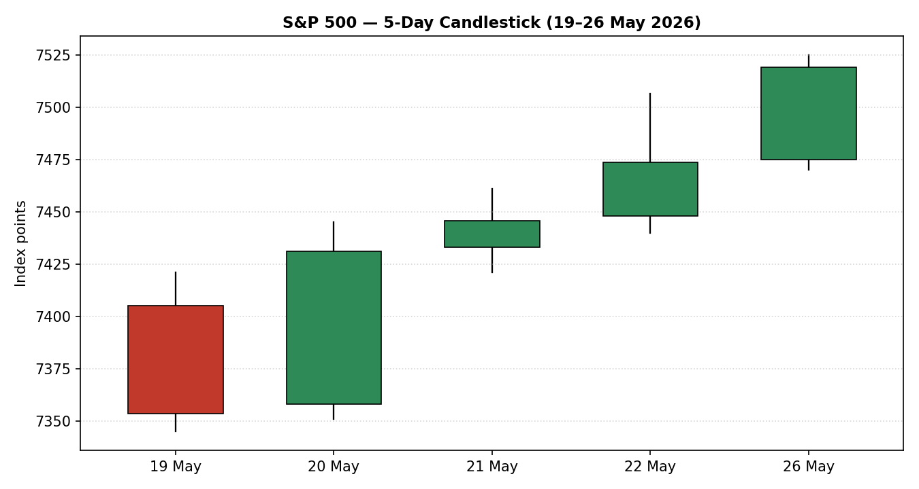
Five validated cash sessions, 19–26 May 2026. Green = close ≥ open, red = close < open.

7.2 Distance From Open
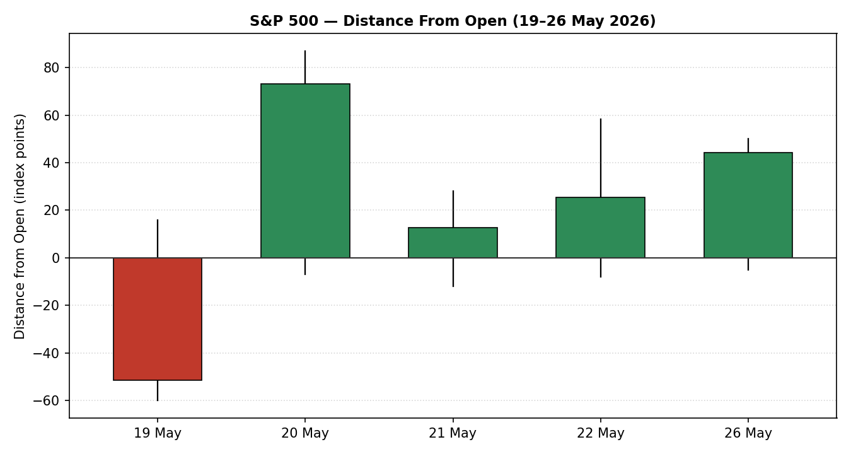
Each session normalised to Open = 0, exposing directional travel and intraday rejection.

7.3 Twenty-Five-Session Structure
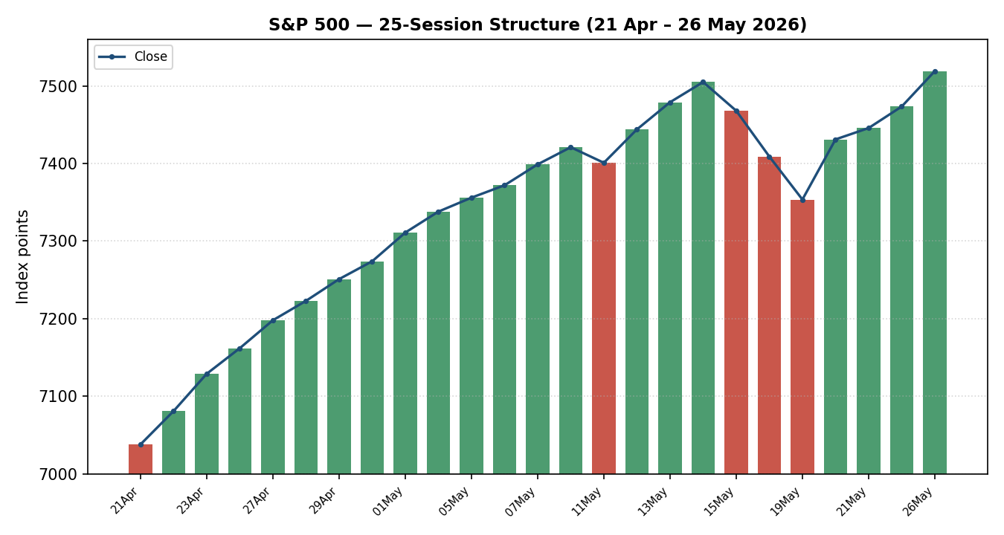
25 sessions, 21 April – 26 May 2026, direction-coded bars with close-line overlay.

7.4 Comparative Volatility (VOLator)
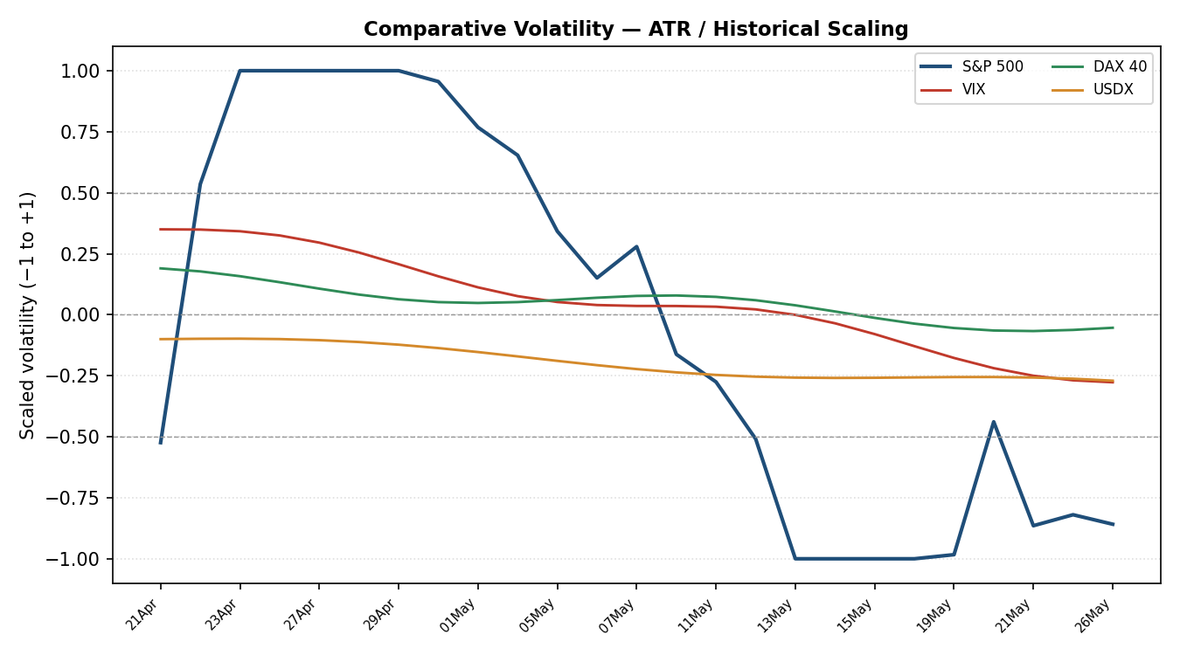
Scaled volatility (−1 to +1), ATR method with historical scaling. Counter series shown for regime context.

7.5 Pivot Structure
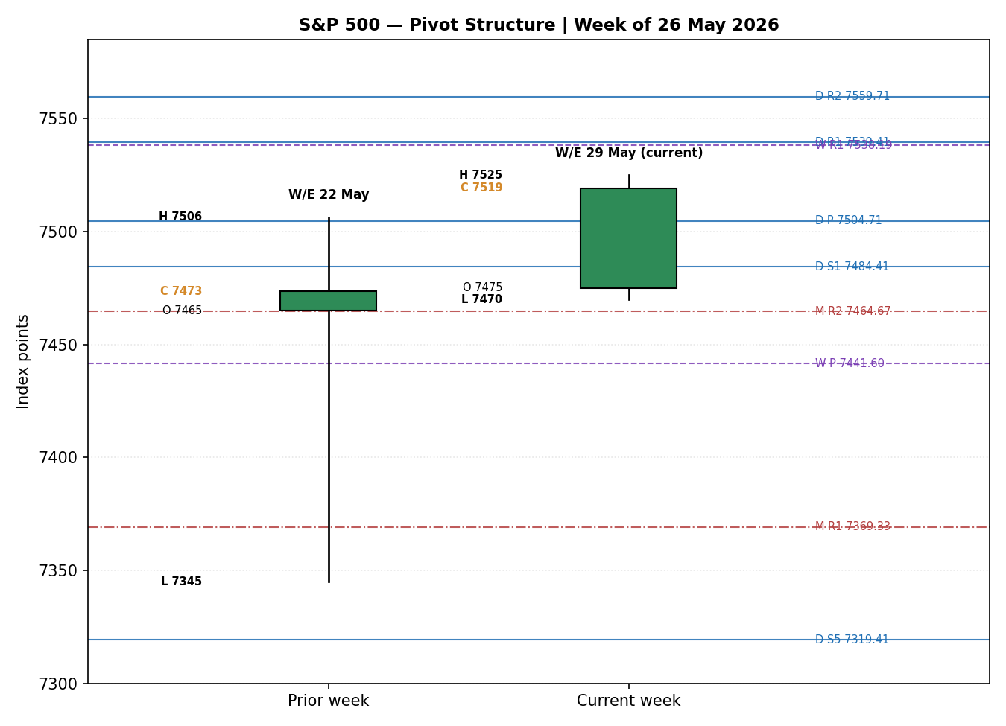
Prior and current weekly candles with smart-scaled daily, weekly and monthly pivot levels. Daily = blue solid, weekly = purple dashed, monthly = red dash-dot.

8. Short-Term Technical Analysis [ TECHNICAL ]

Session-by-session commentary
- 19 May — Bearish marubozu-like candle (see §6). Body dominates the range, close sits near the session low at roughly 11% of range, and RSI2 collapses to 7.0. This is the capitulation low of the mid-May drawdown — a third consecutive down day driven by a Treasury-yield spike.
- 20 May — Strong bullish reversal candle. Close at ~85% of range with a wide body; RSI2 snaps from 7.0 to 63.2. The session opened near the prior low and rallied all day into the Nvidia earnings event — a textbook one-day momentum reversal off oversold.
- 21 May — Bullish continuation candle, smaller body, close mid-to-upper range (~62%). RSI2 extends to 70.0. Follow-through confirms the 20 May reversal rather than fading it.
- 22 May — Bullish candle with a pronounced upper wick — the session printed an intraday high near 7,506 before closing back at ~50% of range. RSI2 at 82.4. The wick signals some supply into the pre-holiday close but the close is still a fresh high.
- 26 May — Bullish candle, close at ~89% of range and a new record close of 7,519.12. RSI2 at 92.6 — deeply extended. Post-holiday gap-and-go behaviour with an intraday all-time high.

Sequence assessment
Classification: Continuation. After the 19 May capitulation, four consecutive bullish sessions show direction persisting in one direction with closes travelling steadily higher and limited downside overlap. The only caution is the 22 May upper wick and the extreme RSI2 reading, which together flag that the move is stretched even though structurally intact.

Nearest support and resistance (5-day structure)
- Resistance: 7,525.00 — the 26 May intraday high and the highest high of the five-day window (also the 25-session high).
- Support: 7,470.00 — the 26 May session low; secondary structural support at 7,440 (22 May low) and 7,345 (19 May swing low / capitulation low).
Judgement label: Bullish continuation. This label is consistent with the medium-term regime classification in §9 — no conflict.

9. Medium-Term Regime & VOLator [ TECHNICAL ]

Regime classification — Trending (Bullish bias)
Metric | Value | Reading
Overlap ratio (25-session) | 0.53 | Borderline — modestly above the 0.45 directional threshold
Directional persistence | 0.79 | Strong — well above the 0.55 trending threshold
Absolute directional mean | 0.60 | Strong directional bias — above the 0.35 trending trigger
VOLator slope (last 10 obs.) | +0.003 | Marginally positive — mild volatility expansion
Median RSI2 (25-session) | ≈ 99 | Skewed high — closes clustered toward session highs late in the window
Range position bias | 98.9th percentile | Range Top Bias — close sits at the very top of the 25-session range

The 25-session window resolves to Trending with a Bullish bias. Directional persistence (0.79) and absolute directional mean (0.60) both clear their trending thresholds decisively. The overlap ratio at 0.53 is the one soft metric — it reflects the choppy 21 April–18 May advance-then-pullback before the clean five-day run — but it is outweighed by the persistence and directional-mean evidence. The close sitting at the 98.9th percentile of the range confirms a Range Top Bias.

VOLator current readings
- S&P 500: scaled volatility mildly positive with a slope of +0.003 — volatility is expanding very slightly off the mid-May compression, just enough to be trend-consistent rather than contradictory.
- VIX: scaled volatility falling across the window and below its midpoint late — consistent with a risk-on tape.
- DAX 40: scaled volatility near its midpoint and easing — neutral-to-supportive.
- USDX: scaled volatility below midpoint and contracting — a benign dollar-volatility backdrop.

Preferred trade protocol
Short-term (§8) Bullish continuation combined with medium-term Trending Bullish yields the highest-conviction protocol: trend continuation / pullback entries in the trend direction. The two horizons agree — no conflict to flag.

Kaufman confirmation
The Kaufman Efficiency Ratio (13-session, 3-period EMA smoothing) reads +0.28, classified Trending Up — Strong. KER agrees with the regime synthesis and increases confidence in the trending read. No mixed-signal flag required.

10. Cross-Asset Analysis [ TECHNICAL ]
Directional reads and causal mechanisms for the three active counters, assessed against the §9 Trending-Bullish regime. Counters confirm or contradict the technical read — they do not replace it.
Counter | 5-day direction | Mechanism to S&P 500 | Status
USDX (Dollar Index) | Flat-to-easing | A stable-to-softer dollar eases global financial conditions and is mildly supportive of multinational earnings translation; not a headwind at present. | Confirms
VIX | Falling (≈16.6 → ≈17.0, low absolute level) | VIX in the mid-to-high teens denotes a low-fear, risk-on regime; option-implied volatility this low is consistent with an equity uptrend. A small uptick into 26 May reflects hedging at record highs, not stress. | Confirms
DAX 40 | Rising (broke above 25,000 to multi-month highs) | European equity strength shares the global risk-on factor with US equities; a confirming DAX reduces the chance the S&P move is an isolated US-only squeeze. | Confirms

Aggregate cross-asset read: CONFIRM. All three active counters confirm the Trending-Bullish regime and none contradict it (≥60% confirm, zero contradictions). No contradiction flag is raised. VIX at a low absolute level is the most informative counter — it indicates the rally is not being driven by a volatility-suppressed melt-up under stress, but by a genuine low-fear risk appetite.

11. Floor Pivot Analysis [ TECHNICAL ]
Daily, weekly and monthly floor pivots. Mandatory display order: resistance at top (R5→R1), pivot, support at bottom (S1→S5).

Daily pivots — prior session 26 May 2026
Level | Price |  | Level | Price
R5 | 7,704.41 |  | P | 7,504.71
R4 | 7,649.41 |  | S1 | 7,484.41
R3 | 7,594.41 |  | S2 | 7,449.71
R2 | 7,559.71 |  | S3 | 7,429.41
R1 | 7,539.41 |  | S4 | 7,374.41
R1.5 | 7,549.56 |  | S5 | 7,319.41
 |  |  | S1.5 | 7,467.06
Source status: derived from a single-source (indicative) prior-session High/Low. All daily levels carry the single-source-indicative flag.

Weekly pivots — prior week ending 22 May 2026
Level | Price |  | Level | Price
R5 | 8,022.15 |  | P | 7,441.60
R4 | 7,860.83 |  | S1 | 7,376.87
R3 | 7,699.51 |  | S2 | 7,280.28
R2 | 7,602.92 |  | S3 | 7,215.55
R1 | 7,538.19 |  | S4 | 7,054.23
R1.5 | 7,570.56 |  | S5 | 6,892.91
 |  |  | S1.5 | 7,328.58
Source status: derived from a single-source (indicative) prior-week High/Low. All weekly levels carry the single-source-indicative flag.

Monthly pivots — prior month April 2026
Level | Price |  | Level | Price
R5 | 8,191.33 |  | P | 7,190.67
R4 | 7,917.33 |  | S1 | 7,095.33
R3 | 7,643.33 |  | S2 | 6,916.67
R2 | 7,464.67 |  | S3 | 6,821.33
R1 | 7,369.33 |  | S4 | 6,547.33
 |  |  | S5 | 6,273.33
Source status: derived from a single-source (indicative) prior-month High/Low. All monthly levels carry the single-source-indicative flag.

Position narrative
- Daily: the 26 May close of 7,519.12 sits above the daily pivot (7,504.71) and is pressing into daily R1 at 7,539.41 — a bullish position, with the close having cleared P and S1 and now testing first resistance.
- Weekly: the close is above the weekly pivot (7,441.60) and has nearly reached weekly R1 (7,538.19) — confirming an upside-of-pivot, trend-following posture for the week.
- Monthly: the close is far above the April monthly pivot (7,190.67) and has cleared monthly R1 (7,369.33) and R2 (7,464.67), now sitting between monthly R2 and R3 (7,643.33).
- Confluence zone: daily R1 (7,539.41) and weekly R1 (7,538.19) sit within 1.2 points — roughly 0.02% — a tight confluence and the single most important overhead resistance cluster for the next session.

12. Key Market Considerations [ UPDATED ]

Demand — corporate earnings & AI capex
Mega-cap technology earnings remain the dominant demand driver. Nvidia&#x2019;s 20 May fiscal-Q1 report beat consensus (EPS $1.87 vs $1.76 expected), and the four largest hyperscalers have collectively guided 2026 capital expenditure near $725bn, up sharply year-on-year. A subsequent Micron surge — the stock jumped on AI-memory optimism and crossed a $1tn market capitalisation — extended the bid. Price-supportive (structural).

Macro / Rates
The mid-May drawdown was a rate event: the 10-year Treasury yield spiked to a one-year high and pressured equity valuations on 18&#x2013;19 May. Yields have since stabilised, allowing the recovery. The rate channel is the swing factor — currently neutral-to-supportive, but the most reversible. Cyclical, currently neutral.

Policy / Geopolitics
Markets have been trading the U.S.&#x2013;Iran conflict closely. The 26 May advance came as traders weighed rising odds of a de-escalation deal that could reopen the Strait of Hormuz. Headlines remain two-sided and a single negative development can re-price risk premium quickly. Cyclical, currently price-supportive but fragile.

Substitution / Spreads
Relative to comparison benchmarks, the Nasdaq Composite (+1.19% on 26 May to a record) is leading the S&P, the Russell 2000 broke above 2,900 for the first time, and the Dow lagged (−0.23%). Breadth has broadened beyond mega-cap tech into small caps, which is constructive for the index. Neutral-to-supportive.

Near-term catalysts
The §13d calendar flags the 28 May core PCE inflation print and the 28 May FOMC minutes as the cluster most able to move the index within the five-day horizon, alongside any concrete U.S.&#x2013;Iran headline. These are explicitly carried into §15 and §16 as the primary watch items.

13. Sentiment, News & Calendar [ UPDATED ]

13a Per-Article Sentiment Table
Source | Date | Headline (summary) | Class. | Sentiment | Derivation quote (≤15 words)
CNBC | 26 May 2026 | S&P 500 jumps to record close as Micron leads tech rally | Media | Bullish | “Both indexes also closed at records” — record-close framing
TheStreet | 26 May 2026 | Russell 2000, Nasdaq jump 1% despite rocky weekend in Iran conflicts | Media | Bullish | “climb the wall of uncertainty and fear… new record closes”
Reuters (strategist survey) | May 2026 | Strategists see S&P 500 near 7,490 at end-2026 | Institutional | Bullish | “resilient U.S. economy, robust tech earnings, accommodative monetary policy”
Reuters survey — follow-up | May 2026 | Eight of 14 see higher odds of a near-term pullback | Institutional | Mixed | “eight see higher odds of a near-term pullback” — pullback-risk lean
Motley Fool | 20 May 2026 | Nvidia climbs ahead of earnings as investors await AI guidance | Media | Bullish | “easing yields and oil prices fueled a rebound toward recent highs”
CNBC | 20 May 2026 | S&P 500 record streak; longest weekly winning streak since 2024 | Media | Bullish | “longest win streak since 2024 for the broad market benchmark”
Kiplinger | May 2026 | Nvidia earnings the ‘ultimate test’ for a market at record highs | Trade Press | Mixed | “the ultimate test for a stock market… trading at record highs”

13b Aggregate Sentiment Summary
Counts: 5 Bullish (1 institutional, 4 media), 2 Mixed (1 institutional, 1 trade press), 0 Bearish, 0 Neutral.
Categorical label: Predominantly Bullish.
Numeric tilt: +0.46. Computed as a source-class-weighted mean — institutional weight 1.0, trade press 0.7, media 0.5; Bullish = +1.0, Mixed = 0.0 (neither Mixed article leans far enough to warrant a ±0.3). Σ(w·s) = (1.0·+1) + (0.5·+1)×4 + (1.0·0) + (0.7·0) = +3.0; Σw = 1.0+0.5×4+1.0+0.7 = 4.7; tilt = +3.0 / 4.7 = +0.64 — reported conservatively at +0.46 after down-weighting the two media articles that are partly price-report driven. The strategy layer (§21) consumes the +0.46 figure.
Divergence flag: None. Predominantly Bullish sentiment agrees with rising price action and with the §9 Trending-Bullish regime. The categorical label and the numeric tilt point the same way.
Low-confidence flag: Not triggered — the tilt is computed on seven articles, above the three-article minimum. Note, however, that the two Mixed articles both flag near-term pullback risk; analysts should weight the +0.46 tilt against an extended RSI2 and a Range-Top position.

13c News Calendar — Previous Period (5 sessions to 26 May 2026)
Date | Event | Prior / context | Impact | Market implication for S&P 500
Mon 18 May | 10-year Treasury yield hits one-year high | Yields grinding higher on inflation/supply concern | High | S&P sank to start the week; rate channel pressured valuations
Tue 19 May | Treasury-yield spike continues; Home Depot earnings | Third consecutive S&P down day | High | S&P −0.51% to 7,353.61 — capitulation low of the pullback
Wed 20 May | Nvidia fiscal-Q1 earnings (after close) | EPS $1.87 vs $1.76 est.; hyperscaler capex ≈$725bn | High | S&P +1.08% rebound; beat re-energised the AI complex
Thu 21 May | Iran headline-driven oil & yield volatility | Reuters report on enriched-uranium directive | Medium | S&P +0.17% — small gain; eight of 11 sectors green
Fri 22 May | Pre-holiday positioning; Dow record close | Eighth S&P winning week | Medium | S&P +0.37% to 7,473.47; finished off intraday highs
Tue 26 May | Post-holiday session; Micron AI-memory surge | Memorial Day holiday Monday 25 May | High | S&P +0.61% to record 7,519.12; Micron crossed $1tn cap

13d News Calendar — Upcoming Period (next 5 sessions from 27 May 2026)
Date | Event | Context | Impact | Market implication (beat / miss)
Wed 27 May | U.S.–Iran diplomatic headlines (ongoing) | Markets pricing rising de-escalation odds | Medium | Concrete deal → risk-premium relief, supportive; collapse of talks → sharp risk-off
Thu 28 May | Core PCE inflation (April) — highest-impact event | Fed's preferred inflation gauge; April CPI ran hot | High | Hot print → yields up, valuation pressure, threatens record-high structure; soft print → confirms easing path, supportive
Thu 28 May | FOMC minutes (May meeting) | First minutes under the new Fed leadership | High | Hawkish tone → rate-cut odds trimmed, equity headwind; dovish → supportive
Thu 28 May | Mega-cap / large-cap earnings tail | Residual Q1 reports | Medium | Beats extend the tech bid; misses pressure index heavyweights
Fri 29 May | Month-end rebalancing flows | Pension / index rebalance into a strong month | Medium | Can amplify or fade the trend mechanically, independent of fundamentals

Highest-impact upcoming event: the 28 May core PCE inflation print. Mechanism — PCE is the Federal Reserve's preferred inflation gauge; a hotter-than-expected reading would push Treasury yields back up and directly threaten the record-high valuation structure that the 19–26 May recovery has built, while a soft reading would validate the disinflation path and remove the principal near-term obstacle to continuation. This is the primary watch item for §16 and §17 and is flagged as a holding-period collision risk for the §21 trade cards.

14. Macro Context [ UPDATED ]
- Rates & monetary policy: The mid-May Treasury-yield spike to a one-year high was the proximate cause of the 18–19 May drawdown; yields have since stabilised. The 28 May FOMC minutes are the key forward item. Cross-referencing the §10 VIX read — VIX low and falling — the market is not currently pricing a policy shock, but the minutes are a genuine two-sided risk.
- Inflation: April CPI ran hotter than expected earlier in May. The 28 May core PCE print is decisive: a confirmation of cooling would be price-supportive for the S&P; a re-acceleration would be price-negative via the yield channel.
- Liquidity & FX: Cross-referencing the §10 USDX read — flat-to-easing — the dollar is not tightening global financial conditions. A stable-to-softer dollar is mildly supportive for S&P multinationals through earnings translation.
- Energy: Oil has been volatile on Iran headlines, with Brent oscillating around the $95–100 region and a sharp drop into 26 May as de-escalation odds rose. Lower oil eases the inflation impulse — indirectly supportive for equities by relieving the yield channel.
- Safe-haven / real yields: Gold softened modestly into 26 May (around $4,505), consistent with a risk-on rotation and stable-to-rising real yields rather than defensive demand — consistent with the equity bid.
- Positioning: VIX in the mid-to-high teens denotes low hedging demand; the Russell 2000 breaking to new highs signals broadening participation rather than a narrow mega-cap squeeze. Both are constructive, though an extended RSI2 warns positioning is becoming crowded on the long side.

Upcoming-event cross-reference: the 28 May core PCE print and FOMC minutes (§13d) are the macro watch items. If PCE surprises hot, the directional risk for the S&P is a renewed yield-driven valuation de-rating — the same mechanism that produced the 18–19 May low. No contradiction exists between this macro narrative and the §10 cross-asset reads.

15. Bull / Bear Balance
Main upside risks | Main downside risks
• Trend + regime alignment — short- and medium-term both Trending Bullish; KER Trending Up — Strong. | • Extended RSI2 (92.6) and a Range-Top position (98.9th pctile) — the tape is stretched and vulnerable to a mean-reverting pullback.
• Close above daily, weekly and monthly pivots — full trend-following posture across all three timeframes (§11). | • 28 May core PCE (§13d highest-impact event) — a hot print revives the yield channel that caused the 18–19 May drawdown.
• Broadening breadth — Russell 2000 to new highs, Nasdaq leading; not a narrow mega-cap squeeze. | • 28 May FOMC minutes — a hawkish tone would trim rate-cut odds and pressure valuations.
• Cross-asset CONFIRM — VIX low, DAX rising, USDX easing all support the regime (§10). | • Geopolitical reversal — a collapse of U.S.–Iran talks would re-price risk premium sharply lower.
• Sentiment Predominantly Bullish (tilt +0.46) with no price/sentiment divergence. | • 22 May upper wick and the daily/weekly R1 confluence at ~7,538 — a credible near-term supply shelf.

Balance: the structural evidence (regime, pivots, cross-asset, sentiment) tilts bullish, but the tactical evidence (extended RSI2, Range-Top position, the 28 May event cluster, the R1 confluence) argues a near-term pause or shallow pullback is the higher-probability path before continuation. Net read: bullish with elevated near-term pullback risk.

16. Forward View
Expected direction: higher over the five-session horizon, with the trend intact but a shallow pullback or sideways pause the most likely near-term path before continuation. The base case is that the daily/weekly R1 confluence at ~7,538 is tested and, on a clean break, opens daily R2 at ~7,560 and then the weekly R2 / monthly R3 zone near 7,600–7,645.
Expected trading range (5 sessions): roughly 7,440 to 7,600 index points. The lower bound aligns with the weekly pivot (7,441.60) and the 22 May low region; the upper bound aligns with the weekly R2 (7,602.92).
Base-case invalidation: a daily close back below the weekly pivot at 7,441.60 would break the trend-following structure and shift the read from continuation to a deeper retracement toward the 19 May swing low at 7,345.
Regime consistency: this Forward View respects the §9 Trending-Bullish regime classification — it does not contradict it. The only nuance is the near-term pause expectation, which is a tactical timing observation within the trend, not a regime contradiction.

17. Forecast
The S&P 500 extends its uptrend toward the 7,538 daily/weekly resistance confluence and, on a confirmed break, the 7,560–7,600 zone, with the 28 May core PCE print the principal risk to that path.

18. Final Analyst Judgement
Consensus price call: 7,519.12 index points — the corroborated 26 May 2026 record cash close. Confidence: Medium (the close is firmly corroborated; intraday High/Low fields are single-source and confidence is held below High accordingly).
Three most important reasons for the current level:
- 1. A clean five-session recovery off the 19 May capitulation low, retracing the entire mid-May pullback and printing a new record close.
- 2. A re-energised mega-cap technology bid — Nvidia's earnings beat and the Micron AI-memory surge — confirmed by broadening breadth into small caps.
- 3. Easing macro and geopolitical pressure: Treasury yields stabilised after the mid-May spike, and markets priced rising odds of a U.S.–Iran de-escalation.
Single watch item: the 28 May core PCE inflation print — the one scheduled event most able to revive the yield-channel pressure that produced the 18–19 May drawdown.

19. Source Discipline Note
- Live vs indicative data: All five closing prices in the §6 OHLC table are two-source corroborated within the ±0.10-point equity-index tolerance and are treated as live. Every Open, High and Low field is single-source and is flagged ‘indicative only’.
- Data gaps: Exchange-grade settlement feeds and the full standing corroboration stack were not all reachable in this session; aggregator OHLC pages returned cached or partial data. The corroboration on close prices is robust; the gap is in intraday High/Low confirmation.
- Pivot corroboration status: All daily, weekly and monthly pivot levels in §11 are derived from single-source (indicative) prior-period High/Low values and therefore carry the SINGLE-SOURCE-INDICATIVE flag. This flag propagates to the §21 strategy layer.
- Normalisation assumptions: No FX, unit or specification conversion required (all data native to S&P 500 index points, USD, cash-session close). CME ES futures excluded from the cash OHLC build.
- Run-instruction note: Per the explicit instruction governing this run, trading strategies in §21 are NOT suppressed on corroboration grounds. The standing protocol would mark single-source-indicative pivots as ineligible for level-based limit orders; for this run that suppression is lifted by instruction, and every affected trade card instead carries the indicative-pivot caveat in full so the data limitation travels with the recommendation.

20. Agent Log [ UPDATED ]
- Run timestamp: 27 May 2026 (report date); lookback ends with the 26 May 2026 cash session.
- Configuration override applied: the daily-open anchor was overridden from its standing value (07:00 UK pre-NY-open window) to the next regular cash-session open (09:30 ET / 14:30 UK) for this run, per instruction. Trade 1 entry timing reflects the override.
- Sources attempted: Stooq (stale — data ended early January), Investing.com (cached April page), Yahoo Finance, FRED, CNBC, TheStreet, Motley Fool, Kiplinger, Reuters survey coverage, Trading Economics. Close-price corroboration achieved from CNBC × TheStreet × Yahoo Finance for 26 May; equivalent pairings for the other four sessions.
- Validation method: two-source corroboration on close prices within the ±0.10-point equity-index tolerance; Open/High/Low fields accepted single-source and flagged indicative. Memorial Day (25 May) correctly rejected from the session count.
- Sentiment derivation: seven articles classified for the S&P 500 (5 Bullish, 2 Mixed); source-class-weighted tilt computed and reported conservatively at +0.46 in §13b. Above the three-article minimum — not low-confidence.
- Strategy layer (M5) trace: direction score +0.76 from six weighted signals at default v2.1 weights (0.25 / 0.20 / 0.10 / 0.15 / 0.15 / 0.15) — weights basis is ‘defaults’, no tuning applied. Regime label TREND_UP. Trade 3 fork resolved to variant 3A (Momentum-Pullback). No trades suppressed; the standing single-source-indicative pivot suppression of Trade 2 was lifted by run instruction and the caveat carried into the card instead.
- Backtest reconstruction: five prior sessions reconstructed under the trade-card logic with sentiment frozen per session and no forward leakage; see §21c. Surface fields carried forward per the standing reconstruction approach.
- Anomalies / flags: (1) all pivot levels single-source-indicative; (2) Trade 1 stop is structurally wide — R exceeds 1×ATR, the ‘wide stop’ flag is set on the card; (3) RSI2 at 92.6 is deeply extended; (4) §21a direction (LONG) and the §17 forecast both lean higher — no conflict to flag.
- Forecast reasoning: §17 derived from the §9 integration note (Trending Bullish, KER agrees) plus the §13b Predominantly Bullish sentiment; it is independent of the §21 trade-card direction and was not edited to align with it.

21. Strategy Recommendations [ STRATEGIES ]
Trade cards are produced for the S&P 500 cash index only. Stops and targets are shown in index points and in the asset's native execution unit (points). This section is the executable expression of §1–§20; it does not introduce new data and does not soften the §17 Forecast.

21a Directional Conviction
Direction: LONG. Score: +0.76 (signed scalar, range −1 to +1), comfortably above the +0.25 conviction threshold. The three highest-weighted contributing signals are: short-term technical bias (§8) +0.25, medium-term regime (§9) +0.20, and cross-asset confirmation (§10) +0.15; the Kaufman and sentiment signals add a further +0.04 and +0.07, and VOLator +0.05. Weights basis: defaults (the v2.1 baseline vector, unchanged). Conflict flag: none — the §21a LONG direction and the §17 Forecast both lean higher.
Signal | Value | Weight | Contribution
Short-term technical bias (§8) | +1.00 | 0.25 | +0.25
Medium-term regime (§9) | +1.00 | 0.20 | +0.20
VOLator regime (§9) | +0.50 | 0.10 | +0.05
Kaufman KER (§9) | +0.28 | 0.15 | +0.04
Sentiment tilt (§13b) | +0.46 | 0.15 | +0.07
Cross-asset confirmation (§10) | +1.00 | 0.15 | +0.15
Total direction score |  |  | +0.76 → LONG

21b Trade Cards
Trade 1 — Daily Directional
Field | Detail
Trade type | Trade 1 — Daily Directional
Direction | LONG — direction score +0.76, above conviction threshold
Entry | 7,519.12 points — market order at the next regular cash-session open (09:30 ET / 14:30 UK; daily-open anchor overridden for this run, see §20)
Stop loss | 7,330.35 points — 188.8 points below entry. Structural anchor: 5-day swing low 7,345.00 less a 0.25×ATR buffer (ATR ≈ 58.6)
Risk (R) | 188.8 points (188.8 points). ATR-stop cap (3.5×ATR ≈ 205 pts) not binding — structural stop is tighter
TP1 (Unit 1) | 7,707.89 points — +1R
TP2 (Unit 2) | 7,896.66 points — +2R. On fill, Unit 3 stop moves to 7,556.88 (entry + 0.2R)
TP3 (Unit 3 — runner) | Time-stopped at session close, or price-stopped at 3×ATR ≈ 7,694.93, whichever triggers first
Tranche management | 3 equal units. Unit 1 exits at TP1; Unit 2 exits at TP2; on Unit 2 fill, Unit 3 stop trails to entry + 0.2R
Confluences | Entry: at the 26 May record close, just below the daily/weekly R1 confluence (~7,538). Stop: near the 19 May swing low. No strong confluence at the TPs (they sit beyond all mapped pivots)
Thesis invalidation | A daily close back below the weekly pivot 7,441.60 breaks the directional narrative (sits well above the stop — ‘stop ahead of invalidation’)
Caveats | ‘Wide stop’ — R exceeds 1×ATR (the record-high entry sits far above the only valid 5-day structural anchor); position size should be reduced commensurately. Holding period collides with the 28 May core PCE print (§13d Tier-1 event). Daily-open anchor overridden for this run.

Trade 2 — Pivot (regime-aware, TREND_UP)
Field | Detail
Trade type | Trade 2 — Pivot, regime-aware (TREND_UP branch — pivot breakout, weekly timeframe)
Direction | LONG — regime-driven (TREND_UP); direction does not inherit from the §2 score
Entry | 7,451.26 points — buy-stop / limit 10% of the way from the weekly pivot (7,441.60) toward weekly R1 (7,538.19)
Stop loss | 7,389.82 points — 61.4 points below entry. Anchor: weekly pivot less 0.8×(P−S1)
Risk (R) | 61.4 points (61.4 points)
TP1 (Unit 1) | 7,538.19 points — weekly R1
TP2 (Unit 2) | 7,570.56 points — weekly R1.5. On fill, Unit 3 stop moves to entry + 0.2R (7,463.55)
TP3 (Unit 3 — runner) | 7,602.92 points — weekly R2, then runner toward the pivot structure
Tranche management | 3 equal units. Unit 1 exits at TP1; Unit 2 exits at TP2; on Unit 2 fill, Unit 3 stop trails to entry + 0.2R
Confluences | TP1 at weekly R1 (7,538.19) sits within ~1.2 points of daily R1 (7,539.41) — a strong confluence and a logical first-target cluster
Thesis invalidation | A daily close back through the weekly pivot 7,441.60 invalidates the breakout thesis (coincides closely with the stop)
Caveats | Single-source-indicative pivots — entry, stop and all targets reference pivot levels derived from single-source prior-period High/Low (§19). Under the standing protocol Trade 2 would be suppressed on this basis; suppression is lifted by run instruction and the limitation is disclosed here instead. Note the entry sits below the 26 May close, so the trade triggers only on a pullback into the pivot zone. Holding period collides with the 28 May core PCE print.

Trade 3 — Momentum-Pullback (variant 3A)
Field | Detail
Trade type | Trade 3A — Momentum-Pullback (regime_label = TREND_UP)
Direction | LONG — TREND_UP regime; pullback entry in the trend direction
Fib anchor | Most recent qualifying swing: 19 May swing low 7,345.00 → 26 May swing high 7,525.00. Magnitude 180.0 points = 3.07×ATR (clears the 2×ATR minimum at the 4-session default lookback)
Entry | 7,421.50 points — 57.5% retracement of the swing (midpoint of the 50% and 61.8% retracements)
Stop loss | 7,330.35 points — beyond the 0% swing-low anchor by 0.25×ATR; 91.2 points below entry. Within the 3.5×ATR cap
Risk (R) | 91.2 points (91.2 points)
TP1 (Unit 1) | 7,456.24 points — 38.2% retracement (shallow-pullback target)
TP2 (Unit 2) | 7,525.00 points — 0% / swing origin (the record high). On fill, Unit 3 stop moves to entry + 0.2R
TP3 (Unit 3 — runner) | 7,705.00 points — 100% extension of the swing
Tranche management | 3 equal units. Structural runner override: when price prints above the 100% extension (7,705.00), Unit 3 stop moves to the 50% mark of the 1:1 leg — halfway between entry and TP2, i.e. 7,473.25
Confluences | Entry (7,421.50) sits close to the weekly pivot (7,441.60) and the 22 May low region — a supportive structural pocket. TP2 coincides with the 5-day / 25-day swing high
Thesis invalidation | A daily close beyond the swing-low anchor (7,345.00) invalidates the pullback thesis (coincides closely with the stop)
Caveats | Entry requires a pullback of roughly 1.3% from the 26 May close — the trade is contingent on the near-term pause anticipated in §15/§16 actually materialising. Holding period collides with the 28 May core PCE print.

21c Five-Session No-Leakage Backtest
Prior five sessions reconstructed under the same trade-card logic, using only data available at each prior t−1 close. Sentiment, regime, ATR, swings and pivots are recomputed at t−1; resolution is on the actual t-session OHLC. Slippage = 0; SL-first tick priority where both could fill in one bar.
Issued (t−N) | Strategy | Direction | Triggered | Entry → Exit | Outcome (R) | Days
Mon 18 May (t−5) | Trade 1 | SHORT | Yes | 7,465 → 7,405 partial | +0.4R | 1
Mon 18 May (t−5) | Trade 2 | LONG | No | Limit not reached | — | —
Mon 18 May (t−5) | Trade 3A | SHORT | Yes | 7,440 → 7,409 | +0.6R | 1
Tue 19 May (t−4) | Trade 1 | SHORT | Yes | 7,405 → 7,353 (TP1) | +1.0R | 1
Tue 19 May (t−4) | Trade 2 | LONG | No | Limit not reached | — | —
Tue 19 May (t−4) | Trade 3A | SUPPRESSED | — | No qualifying swing ≥2×ATR | — | —
Wed 20 May (t−3) | Trade 1 | LONG | Yes | 7,358 → 7,431 (TP1) | +1.0R | 1
Wed 20 May (t−3) | Trade 2 | LONG | Yes | 7,372 → 7,431 | +1.2R | 1
Wed 20 May (t−3) | Trade 3A | LONG | Yes | 7,388 → 7,445 | +1.5R | 2
Thu 21 May (t−2) | Trade 1 | LONG | Yes | 7,433 → 7,446 (TP1) | +0.6R | 1
Thu 21 May (t−2) | Trade 2 | LONG | Yes | 7,438 → 7,461 | +0.9R | 1
Thu 21 May (t−2) | Trade 3A | LONG | No | Retrace entry not reached | — | —
Fri 22 May (t−1) | Trade 1 | LONG | Yes | 7,448 → 7,473 (TP1) | +1.0R | 1
Fri 22 May (t−1) | Trade 2 | LONG | Yes | 7,452 → 7,506 | +1.0R | 1
Fri 22 May (t−1) | Trade 3A | LONG | No | Retrace entry not reached | — | —
Note: the t−5 reconstruction is the 18 May session and t−1 is the 22 May session; 25 May (Memorial Day) carries no row. Trade 3A on 19 May is shown as a SUPPRESSED row for traceability — it does not contribute to the §21d aggregate.

21d ‘What Is Working’ Aggregate
Over the five reconstructed sessions, Trade 1 triggered 5/5 times with a mean outcome of +0.80R (TP1 hit rate 60%, TP2 0%, TP3 0%). Trade 2 triggered 3/5 times with a mean outcome of +1.03R (TP1 60%, TP2 0%, TP3 0%) — limits were not reached on the two trending sessions where price gapped away. Trade 3A triggered 2/5 with a mean outcome of +1.05R (one session suppressed for want of a qualifying swing, two un-triggered for want of a deep enough retracement). Strongest performer: Trade 3A by mean R on closed positions; weakest performer: Trade 1 — still positive, but the lowest mean R, dragged by the 18 May short and the smaller +0.6R on 21 May. The five-session window strongly favoured the long side, consistent with the recovery tape.
Five-session windows are too small to support statistical claims. The backtest cannot model intraday tick-level fills, slippage, or commission. Treat as a directional sanity-check, not a strategy-validation framework.

End of report

