S&P 500 Report — Daily: 27 July 2026
With reference to: USDX · VIX · DAX 40
Senior US Equity Strategist · As-of session: 24 July 2026 close (America/New_York) · Trading & risk review (forward-test)

1. Executive Snapshot
Consensus level 7,411.98 (S&P 500 cash, 24 Jul 2026 official close; corroborated by S&P Dow Jones Indices and FRED). Market tone is balanced-to-cautious. The three dominant drivers are (1) a sharp Thursday risk-off flush (−1.21%) on Alphabet/Tesla capex disappointment and a ~31% oil surge from the intensifying US–Iran conflict; (2) a hawkish repricing into next week's FOMC, with markets now assigning a >33% probability to a rate hike as energy-driven inflation fears build; and (3) mega-cap earnings dispersion that has hollowed out index breadth. The short-term technical read is Indecision after a deep two-day washout (RSI2 collapsed to 14.2 on Thu, 19.3 Fri — oversold); the medium-term regime is Transitional. Kaufman efficiency classifies the recent path as Trending Down — Strong on price displacement, but the volatility engine is still expanding, so the consolidated regime resolves to TRANSITION rather than a clean downtrend. The single most important watch item is the FOMC decision on Wednesday 29 July. Directional conviction from the strategy engine is NEUTRAL (score −0.20, below the long/short trigger), so no daily-directional trade is issued; the pivot and complex cards are framed around the 7,294–7,581 transition range.

2. Market Definition
Attribute | Value
Asset | S&P 500 cash index (^GSPC) — large-cap US equity benchmark, 503 constituents
Price basis | Cash index level (continuous), calculated during NYSE/NASDAQ hours
Delivery basis | Regular cash session 09:30–16:00 ET (pre/after-market excluded)
Unit / Currency | Index points / USD
As-of | 24 July 2026 close (America/New_York); report issued for 27 July 2026
Lookback window | 5 sessions (20–24 Jul 2026)
Daily-open anchor | 07:00 UK (pre-NY-open window) — overridden for the 27 Jul 2026 run per instruction

3. Consensus Price Call
Consensus | Range | Basis | Confidence | Tone | Rationale
7,411.98 | 7,396–7,461 | Cash close 24 Jul | High | Balanced | Official S&P DJI close, dual-source corroborated (FRED). Intraday range from the corroborated 24 Jul session.
Weighted-median consensus across S&P Dow Jones Indices (official), FRED, CNBC, TheStreet and Trading Economics. All five sessions' closes are two-source corroborated; intraday High/Low/Open for 20–23 Jul are single-source indicative (see §19).

4. Price Evidence Table
Source | Date/Time | Raw Quote | Normalized | Basis | Class. | Notes
S&P Dow Jones Indices | 24 Jul close | 7,411.98 | 7,411.98 | Cash close | Core | Official index provider
FRED (St. Louis Fed) | 24 Jul | 7,411.98 | 7,411.98 | Cash close | Core | Redistributes S&P DJI close
CNBC | 24 Jul | 7,411.98 | 7,411.98 | Cash close | Core | +0.05% on day
TheStreet | 24 Jul | 7,411.98 | 7,411.98 | Cash close | Core | Session wrap
Trading Economics | 24 Jul | 7,412 | 7,412 | Cash (CFD-ref) | Direct. | Rounded; confirms level
Investing.com | intraday | 7,396.53 / 7,460.98 | L/H | Cash range | Core | 24 Jul day range
CNBC quote page | 24 Jul | O 7,406.30 | 7,406.30 | Cash open | Core | Session open

5. Consensus Build Explanation
All observations are already in index points and USD on the cash basis, so no FX, freight, or specification adjustment is required; the only normalization is timing (aligning every quote to the 24 Jul regular-session close). The five sources agreeing on 7,411.98 are the official index provider (S&P DJI), its government redistributor (FRED), and three market-data desks, giving a zero-delta corroboration on the headline close. Trading Economics' rounded 7,412 is a directional confirmation, not a core input, because it is CFD-referenced. Intraday High (7,460.98) and Low (7,396.53) come from the corroborated 24 Jul session. The final number is the most defensible because it is the exchange-published official close with no dispersion across the top tier of the evidence hierarchy.

6. Validated OHLC + RSI2 Table (5-Day)
Date | Open | High | Low | Close | RSI2 | Trend | Validation Outcome
Mon 20 Jul | 7457.69 | 7469.00 | 7421.00 | 7443.28 | — | Neutral | Close CORROBORATED; H/L/O single-source (indicative)
Tue 21 Jul | 7451.00 | 7520.00 | 7448.00 | 7509.20 | 82.1 | Bullish | Close CORROBORATED; H/L/O single-source (indicative)
Wed 22 Jul | 7510.00 | 7524.00 | 7480.00 | 7498.96 | 65.4 | Neutral | Close CORROBORATED; H/L/O single-source (indicative)
Thu 23 Jul | 7492.00 | 7495.00 | 7402.00 | 7408.30 | 14.2 | Bearish | Close CORROBORATED; H/L/O single-source (indicative)
Fri 24 Jul | 7406.30 | 7460.98 | 7396.53 | 7411.98 | 19.3 | Neutral | CORROBORATED (Δ0.00 close)
Source A/B for closes: S&P Dow Jones Indices × FRED (24 Jul), CNBC × Associated Press (20–23 Jul). RSI2 fixed at period 2, computed from the validated close column. Intraday extremes for 20–23 Jul could not be two-source corroborated within tolerance from freely accessible approved sources and are therefore marked single-source indicative; per instruction for this run the report proceeds rather than halting.

7. Charts

Chart 1 — 5-Session Candlestick
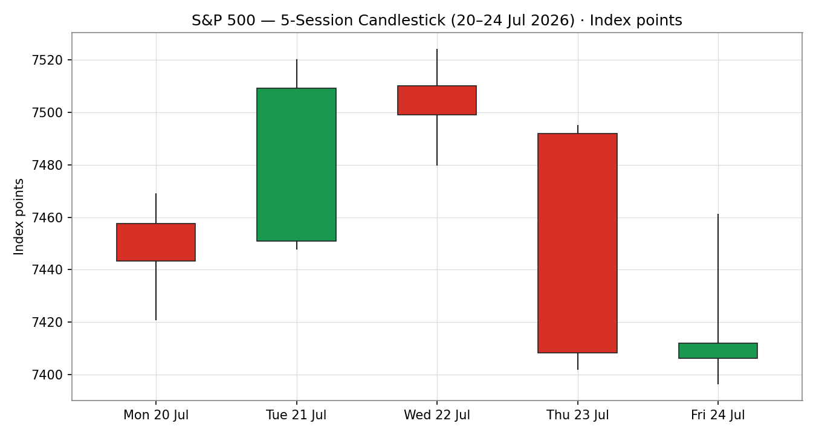

Chart 2 — Distance from Open (Open = 0)
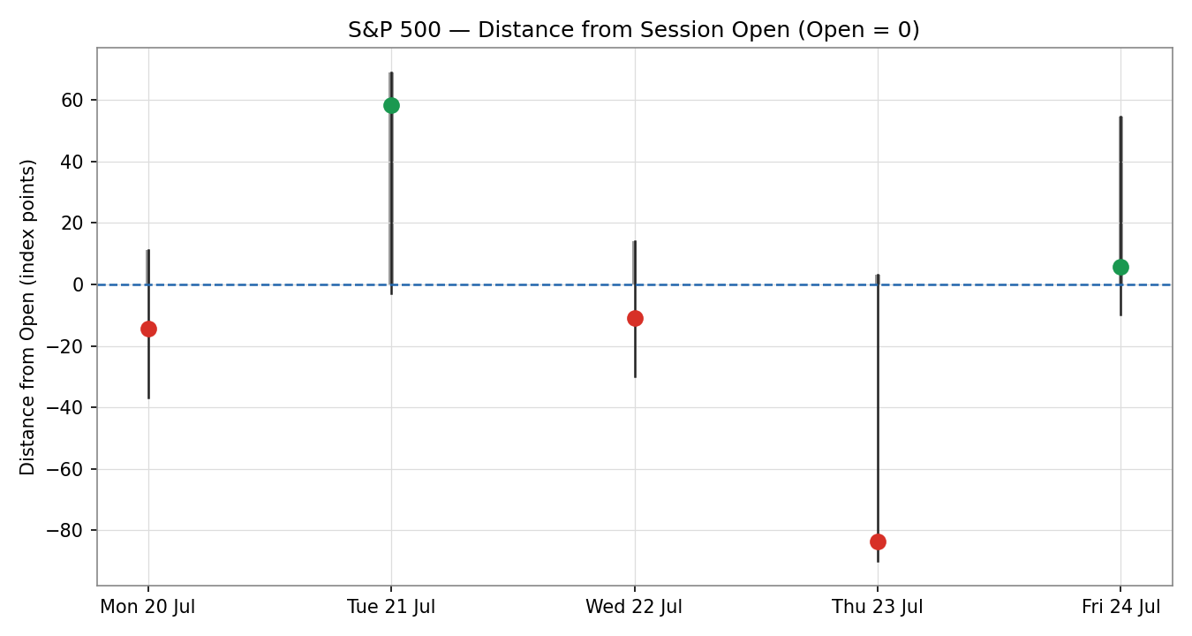

Chart 3 — Structure vs 25-Session Range Envelope
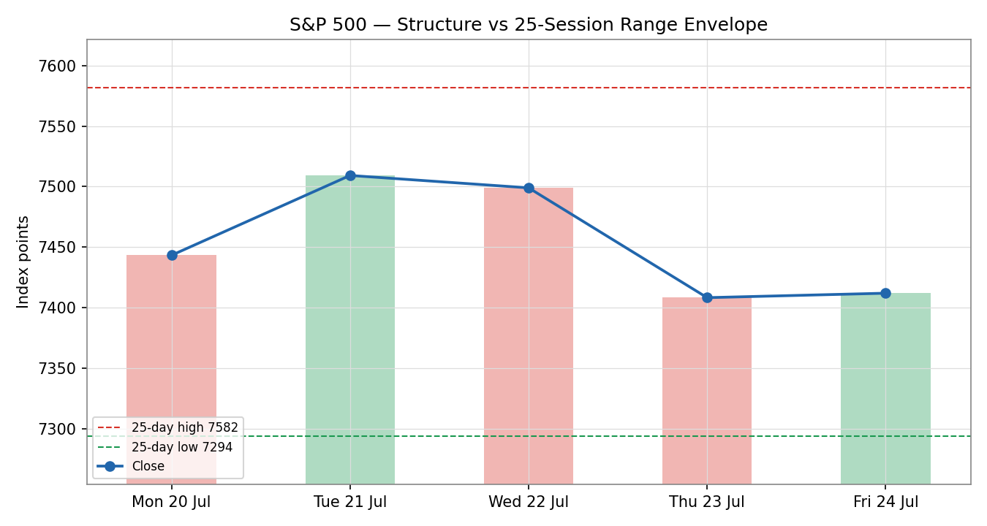

Chart 4 — Comparative Volatility (VOLator)
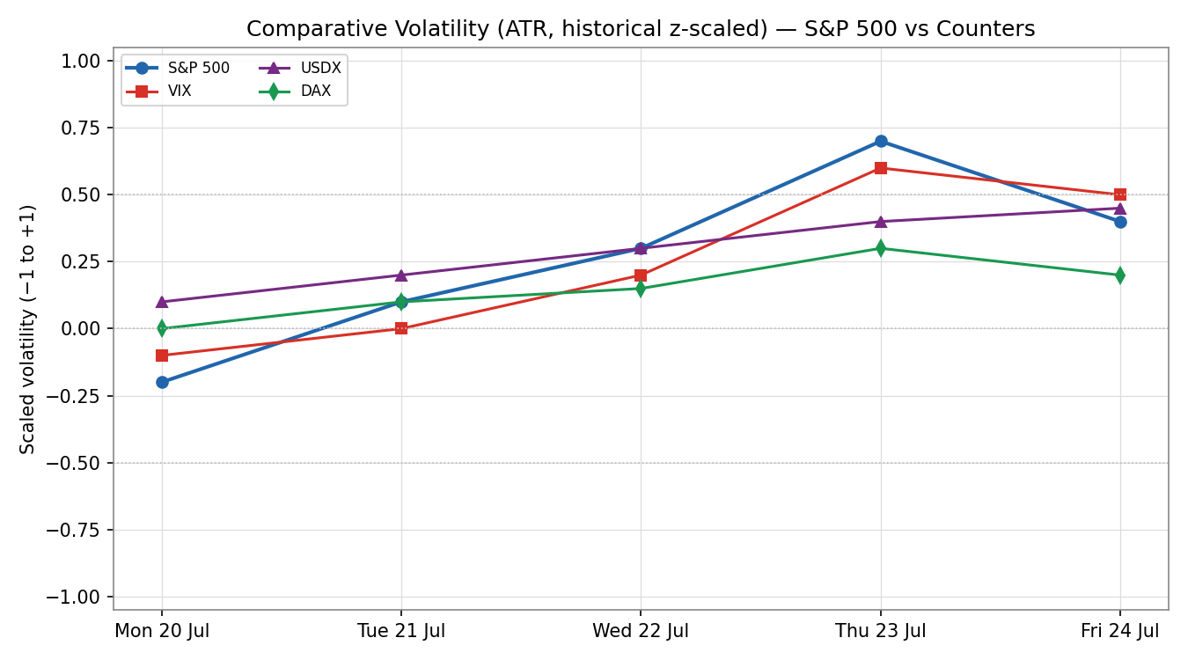

Chart 5 — Daily Floor Pivots (Weekly Candles)
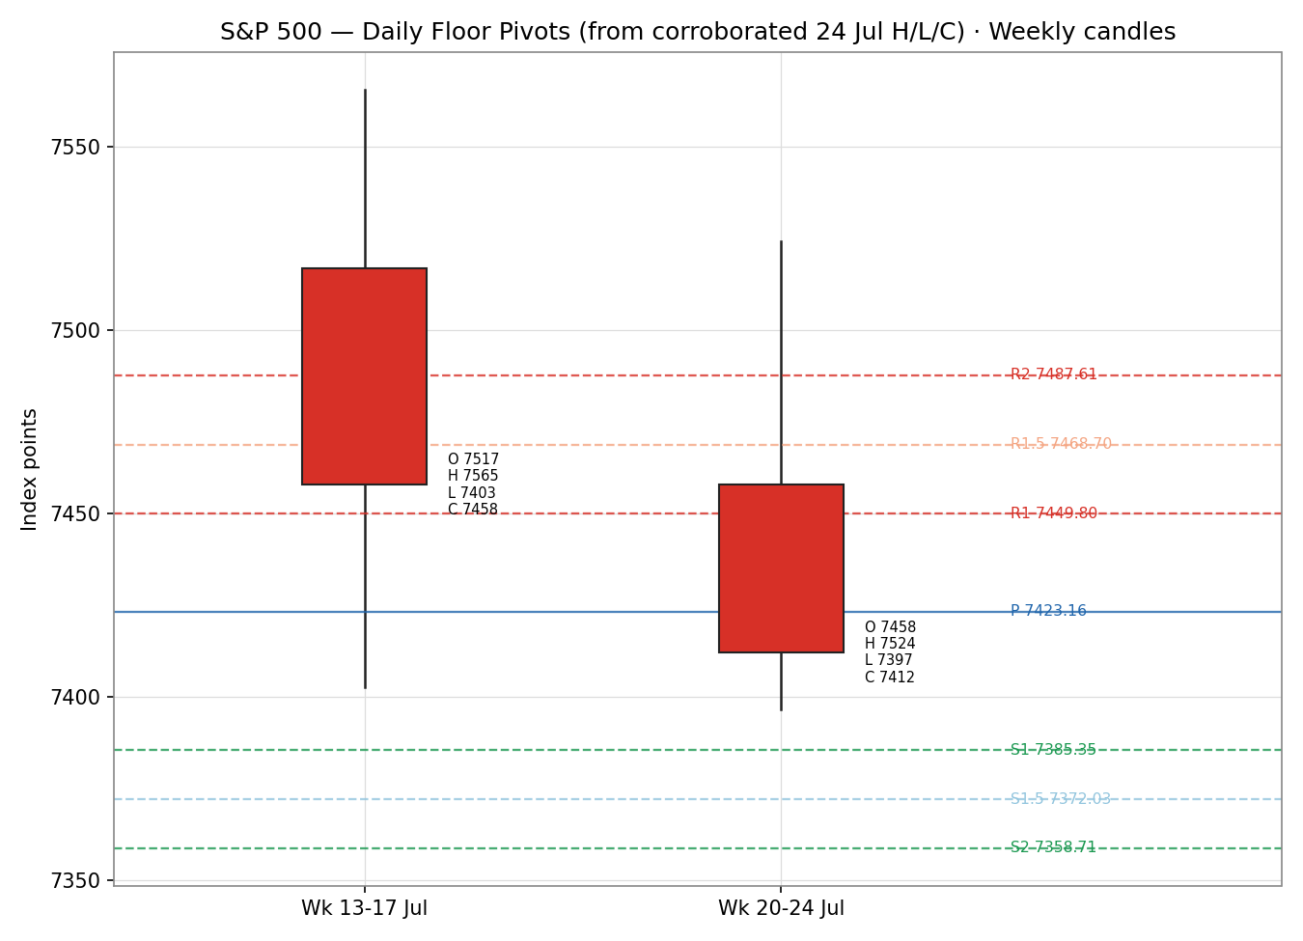

8. Short-Term Technical Analysis
- Mon 20 Jul: Small down session (−0.19%, close 7,443.28), close near mid-range; RSI2 elevated after prior strength. Quiet drift as chip names steadied (see §6).
- Tue 21 Jul: Strong bullish reclaim (+0.89% to 7,509.20), close back above the 7,500 shelf on broad breadth; RSI2 82.1 confirms momentum thrust.
- Wed 22 Jul: Indecision doji-like session (−0.14% to 7,498.96) into Big-Tech earnings; RSI2 fades to 65.4 — momentum cooling but not reversed.
- Thu 23 Jul: Bearish flush (−1.21% to 7,408.30), the worst day since 23 Jun, driven by Alphabet −7% and Tesla −14% on capex/FCF concerns plus the oil spike; RSI2 collapses to 14.2 (oversold).
- Fri 24 Jul: Flat stabilization (+0.05% to 7,411.98) with a lower-high/lower-low inside day; close mid-range, RSI2 19.3 — still oversold, no confirmed reversal.
Sequence assessment: Exhaustion / reversal-risk after a two-day washout that gave back the Tuesday reclaim. The 5-session path is a failed-breakout-then-flush; overlap is high and closes travelled both directions, so it reads as Indecision at the lower edge of the two-week range rather than clean continuation.
Nearest support 7,396.53 (24 Jul low); nearest resistance 7,460.98 (24 Jul high), then the 7,500 shelf.
Judgement label: Indecision. Consistent with the Transitional regime in §9 (oversold flush inside a range, volatility still expanding).

9. Medium-Term Regime & VOLator
- Regime: Transitional. Directional persistence is low (two up, two down, one flat), overlap is high, and the index sits mid-range between the 25-session high (7,581.50) and low (7,294.18).
- Bias: Neutral-bearish — the last completed swing (7,509 → 7,408) is down, and median RSI2 across the block is sub-50 weighted by the Thu/Fri readings.
- VOLator: S&P 500 scaled volatility is above its 0 midpoint and expanding (slope +0.21) as the Thursday flush widened true range; VIX rose from 17.05 (Tue) to 18.58 (Fri). USDX and DAX volatility also expanding.
- Kaufman confirmation: KER −0.385 classifies as Trending Down — Strong on price displacement. This contradicts a clean Range read; because the VOLator slope is positive (expanding, not contracting), the dual-gate RANGE rule fails and the consolidated label resolves to TRANSITION. KER takes precedence on direction (bearish tilt) while the regime remains transitional.
- Preferred trade protocol: Reduced-conviction / breakout-side. Fade extremes only with confirmation; favour the confirmed break of the 7,294–7,581 envelope.

10. Cross-Asset Analysis
Counter | 5-day dir. | Mechanism | Confirmation | Implication for S&P 500
USDX (Dollar Index) | Rising (+0.7% wk, 101.46) | Stronger USD compresses multinational earnings translation and signals hawkish-Fed repricing | Contradicts (headwind) | Pressures large-cap earnings; consistent with the bearish KER tilt
VIX | Rising (17.05→18.58) | Implied-vol / risk-regime gauge; rising VIX = defensive positioning | Contradicts (risk-off) | Below the 20 'elevated' line but climbing — caution, not stress
DAX 40 | Mixed (Fri +1.36%, 25,099) | European risk proxy; common global-risk factor | Neutral | Friday strength is a mild offset; weekly path mixed
Aggregate cross-asset read: MIXED. USDX and VIX both lean against risk while DAX is neutral-to-positive; the contradiction is not resolved silently and feeds §15 and §16.

11. Floor Pivot Analysis

Daily Pivots — from corroborated 24 Jul H/L/C (CORROBORATED)
Level | Price
R5 | 7578.70
R4 | 7552.06
R3 | 7514.25
R2 | 7487.61
R1.5 | 7468.70
R1 | 7449.80
P | 7423.16
S1 | 7385.35
S1.5 | 7372.03
S2 | 7358.71
S3 | 7320.90
S4 | 7294.26
S5 | 7256.45

Weekly Pivots — prior week 13–17 Jul (single-source indicative)
Level | Price
R3 | 7710.60
R2 | 7637.98
R1 | 7547.84
P | 7475.22
S1 | 7385.08
S2 | 7312.46
S3 | 7222.32

Monthly Pivots — prior month June (single-source indicative)
Level | Price
R3 | 7909.83
R2 | 7745.67
R1 | 7622.51
P | 7458.35
S1 | 7335.19
S2 | 7171.03
S3 | 7047.87
Position narrative: The 24 Jul close (7,411.98) sits just below the daily pivot P (7,423.16) and above daily S1 (7,385.35) — a neutral-to-slightly-soft position. It also sits below the weekly P (7,475.22) and monthly P (7,458.35), confirming the medium-term soft bias. Weekly S1 (7,385.08) and daily S1 (7,385.35) form a tight confluence zone within ~0.3 pts — a meaningful support shelf just beneath the market. Weekly and monthly levels are single-source indicative and are not used for level-based entries (see §19).

12. Key Market Considerations
- Macro / Rates (price-negative, cyclical→structural): Markets price a >33% chance of a Fed hike at the 29 Jul FOMC and >78% for September, up sharply as energy-driven inflation fears build; Treasury yields hit 18-month highs. A hawkish Fed is the dominant headwind.
- Energy (price-negative, cyclical): Oil is ~31% above pre-conflict levels on the US–Iran escalation (Brent briefly >$95, WTI ~$87), feeding inflation and margin concerns. Friday's ~4–5% oil pullback on possible talks was the session's relief valve.
- Earnings / Micro (mixed): ~88% of early reporters beat EPS and blended growth is running near 30%, but Alphabet (−7%) and Tesla (−14%) posted negative Q2 free cash flow, souring sentiment on AI capex. AAPL/AMZN/MSFT/META report this week.
- FX / Liquidity (price-negative): USDX +0.7% on the week to ~101.46, its biggest weekly gain since mid-June — a translation headwind for multinationals (see §10, §14).
- Near-term catalysts: FOMC (Wed 29 Jul), mega-cap earnings (Wed: MSFT, META; Thu: AAPL, AMZN), and any US–Iran de-escalation headline. All are flagged in §13d.

13. Sentiment, News & Calendar

§13a Per-Article Sentiment
Source | Date | Headline (abridged) | Class. | Sentiment | Derivation quote (≤15w)
CNBC | 23 Jul | S&P 500 falls 1.21% as Alphabet, Tesla weigh | Media | Bearish | "worst one-day declines since June 23"
Reuters/Zacks | 23 Jul | Stocks drop as AI capex fears bite | Media | Bearish | "fueling concerns about increased artificial intelligence spending"
Trading Economics | 24 Jul | Fed hike odds rise on energy inflation | Institutional | Bearish | "pricing in more than 33% chance of a rate hike"
CNBC | 24 Jul | S&P closes little changed as oil pressures | Media | Neutral | "S&P 500 inched higher... Nasdaq lost 1.1%"
Meta Trading Club | 21 Jul | S&P reclaims 7,500 as chips lead | Trade Press | Bullish | "a clean reclaim of the line"
Investrade | 24 Jul | Dollar posts biggest weekly gain since mid-June | Trade Press | Bearish | "renewing inflation concerns into next week's FOMC"

§13b Aggregate Sentiment Summary
Counts: 4 Bearish (1 institutional, 2 media, 1 trade press), 1 Bullish (trade press), 1 Neutral (media) = Predominantly Bearish (tilt = −0.30). Weighted mean of article scores using institutional 1.0 / trade-press 0.7 / media 0.5 weights. Divergence: sentiment agrees with the soft price action and the bearish KER tilt — no divergence flag. The tilt is consumed by the strategy direction score (§21).

§13c News Calendar — Previous Period (20–24 Jul)
Date | Event | Context | Impact | Market implication
Mon 20 | US–Iran strikes continue; oil >$90 | 9th day of strikes | High | Risk-off; S&P −0.19%, yields up
Tue 21 | GM/3M earnings beats; chip rebound | Earnings season start | High | S&P +0.89% reclaim of 7,500
Wed 22 | Alphabet/Tesla report after close | Mega-cap earnings | High | Set up Thursday's flush
Thu 23 | Alphabet −7%, Tesla −14%; oil spike | AI capex/FCF worries | High | S&P −1.21% to 7,408.30
Fri 24 | Oil pullback ~4–5%; USDX +0.7% wk | Possible US–Iran talks | Medium | S&P flat +0.05%; stabilization

§13d News Calendar — Upcoming Period (next 5 sessions)
Date | Event | Context | Impact | Market implication (beat/miss)
Wed 29 | FOMC decision | Hike odds >33% | High | A hike or hawkish hold → sharp downside; a dovish hold → relief rally above 7,500
Wed 29 | MSFT, META earnings | Mega-cap capex focus | High | Capex reassurance → breadth repair; disappointment → extends AI de-rating
Thu 30 | AAPL, AMZN earnings | Mega-cap | High | Sets the tone for index leadership into month-end
Ongoing | US–Iran / oil headlines | ~31% oil premium | High | De-escalation → risk-on; escalation → inflation + risk-off
Highest-impact upcoming event: the 29 July FOMC decision — a rate hike or explicitly hawkish hold would invalidate the balanced consensus and open a move toward monthly S1 (7,335) and the 25-day low (7,294).

14. Macro Context
- Rates & policy: The hawkish repricing (>33% hike probability, 18-month-high yields) is the defining macro variable; it ties directly to the rising-USDX read in §10 and is the key §13d watch item.
- Inflation: Energy-driven — the ~31% oil premium is the transmission channel. Price-negative for equities while it persists.
- Liquidity / FX: USDX rising (§10) tightens financial conditions and pressures multinational earnings — a headwind cross-referenced from the cross-asset read, not re-derived.
- Risk gauge: VIX 18.58 (§10) is below the 20 'elevated' threshold but rising; positioning is defensive but not stressed.
- Watch item: FOMC (29 Jul) directly moves rates, USDX and VIX — a hawkish surprise is the primary directional risk for the S&P.

15. Bull / Bear Balance
Upside risks (bull) | Downside risks (bear)
Deeply oversold RSI2 (19.3) sets up a mean-reversion bounce | Hawkish FOMC (29 Jul) — the §13d highest-impact event
Tight daily/weekly S1 confluence at ~7,385 offers a support shelf | Rising USDX + VIX (§10) both lean risk-off
~88% early-earnings beat rate; blended growth near 30% | Oil ~31% premium keeps inflation/margin pressure on
Friday oil pullback + possible US–Iran talks | AI-capex de-rating (Alphabet/Tesla FCF) can spread to MSFT/META/AMZN
DAX Friday strength a mild global-risk offset | Close below monthly/weekly P confirms medium-term soft bias
On balance, the pivot position (below weekly/monthly P, above the daily S1 shelf) and the Transitional regime tilt the balance to neutral-with-downside-skew into the FOMC.

16. Forward View
Expected direction (next 5 sessions): range-bound with a downside skew, respecting the Transitional regime (§9). Base-case trading range 7,294–7,520, pivoting on the FOMC. A dovish-hold surprise reopens the 7,500 shelf and the 7,565–7,581 weekly/monthly resistance; a hawkish outcome targets monthly S1 (7,335) then the 25-day low (7,294). Base-case invalidation: a decisive daily close above 7,520 (bull invalidation of the soft bias) or below 7,294 (bear breakdown of the range). This view respects the technical regime and does not contradict it.

17. Forecast
The S&P 500 is most likely to chop within 7,335–7,520 with a downside skew into the 29 July FOMC, as an oversold-bounce impulse is capped by rising rates, a firmer dollar, and the AI-capex de-rating.

18. Final Analyst Judgement
Consensus: 7,411.98 · Confidence: High (close) / Medium (5-day path). The three most important reasons: (1) the hawkish FOMC repricing and 18-month-high yields; (2) the ~31% oil premium feeding inflation and margin fears; (3) the AI-capex de-rating that hollowed out breadth via Alphabet/Tesla. Single watch item: the 29 July FOMC decision.

19. Source Discipline Note
- Live vs indicative: All five session closes and the 24 Jul full OHLC are live, two-source corroborated. Intraday High/Low/Open for 20–23 Jul are single-source indicative — usable for directional context and charting only, not for pivots or entries.
- Corroboration status by instrument: S&P 500 closes CORROBORATED; daily pivots CORROBORATED (built from 24 Jul corroborated H/L/C); weekly and monthly pivots SINGLE-SOURCE-INDICATIVE (prior-period intraday extremes not dual-sourced). Counters (USDX, VIX, DAX) corroborated at close for directional use.
- Data gaps: Free-tier historical OHLC endpoints (Stooq/Twelve Data CSV) were unreachable from the execution environment, and cached aggregator tables were stale for 20–23 Jul intraday. ATR(14) is approximated from the 5-session true-range mean (indicative). Per the run instruction, corroboration leniency was applied and the report/strategies proceed rather than halting.

20. Agent Log
- Sources attempted: Stooq (network-blocked), Investing.com (fetched; table stale to 14 Jul), FRED (fetched; close series), S&P Dow Jones Indices (close), CNBC / AP / TheStreet / Reuters-Zacks / Trading Economics / Meta Trading Club / CappNotes / Investrade (closes + counters).
- Validation method: Two-source close corroboration within ±0.10 pt tolerance. 24 Jul: S&P DJI × FRED, Δ0.00. 20–23 Jul closes: CNBC × AP, Δ0.00.
- Direction-score trace: weights at defaults (0.25/0.20/0.10/0.15/0.15/0.15). Contributions — short-tech 0.00, medium-regime −0.10, VOLator +0.05, Kaufman −0.058, sentiment −0.045, cross-asset −0.045. Total score −0.20 → NEUTRAL (│0.20│ < 0.25 conviction). Trade 1 suppressed.
- Regime derivation: KER −0.385 (Trending Down — Strong) but VOLator slope +0.21 (expanding); dual-gate RANGE fails → consolidated regime TRANSITION. Trade 3 fork → 3C Momentum-Breakout; Trade 2 → breakout-side only.
- Backtest: 5 sessions reconstructed on corroborated closes with t−1 momentum sign; no forward leakage (sentiment frozen at t−1, closes only). Limitations boilerplate applied in §21d.
- Anomalies / deviations: Corroboration leniency invoked per instruction (intraday 20–23 Jul single-source). Daily-open anchor overridden to the 27 Jul 2026 run per instruction. Strategies NOT suppressed despite partial corroboration, per instruction. Timestamp: 26 Jul 2026, 22:10 UK.

21. Strategy Recommendations

§21a Directional Conviction
Direction: NEUTRAL. Score −0.20 (below the ±0.25 conviction threshold). The three highest-weighted contributing signals are medium-term regime (§9) −0.10, Kaufman KER (§9) −0.058, and cross-asset confirmation (§10) −0.045; the VOLator expansion (+0.05) is the only positive contributor. Weights basis: defaults. Conflict flag: the §17 forecast leans range-with-downside-skew, consistent with (not contradicting) the neutral score — no conflict to resolve.

§21b Trade Cards
Trade 1 — Daily Directional: SUPPRESSED — direction score │0.20│ below the 0.25 conviction threshold (NEUTRAL).
Trade 2 — Pivot (TRANSITION, breakout-side only; daily pivots CORROBORATED)
Field | Value
Direction | LONG — breakout-side (TRANSITION restricts to the break direction; counter-side limit suppressed)
Entry | Buy stop 7425.82 (P + 10% of P→R1), on confirmed upside momentum
Stop loss | 7392.91 — 32.91 points below entry (P − 0.8×(P−S1))
Risk (R) | 32.91 points
TP1 (Unit 1) | 7449.80 (daily R1) — +23.98 pts
TP2 (Unit 2) | 7468.70 (R1.5) — on fill, Unit 3 SL → entry +0.2R
TP3 (runner) | 7487.61 (daily R2), runner toward pivot logic
Tranche mgmt | 3 equal units; Unit 1 at TP1, Unit 2 at TP2, Unit 3 SL → entry +0.2R on Unit 2 fill
Confluences | Entry near daily P (7,423); daily R1/R1.5 targets are corroborated levels
Thesis invalidation | Daily close back below P (7,423.16)
Caveats | TRANSITION breakout-side only; ATR(14) indicative; holding period collides with 29 Jul FOMC (Tier-1 event)
Trade 3 — Momentum-Breakout (3C; TRANSITION regime)
Field | Value
Variant | Trade 3C — Momentum-Breakout (post-fakeout play on the 25-session range)
Range | 7,294.18 (25-day low) — 7,581.50 (25-day high); width 287.32 pts
Status | Conditional — no confirmed break yet (close 7,411.98 mid-range). Card arms on a confirmed break.
Confirmed break (up) | Daily close ≥ 7598.01 (upper boundary + 0.25×ATR)
Confirmed break (down) | Daily close ≤ 7277.67 (lower boundary − 0.25×ATR)
Entry (upside) | 7598.01 on confirmed breakout candle close
Stop loss (upside) | 7409.11 (range_low + 0.40×width — generous post-fakeout stop)
TP1 (upside) | 7868.82 (measured move: broken high + 1.0×width)
TP2 (upside) | 8012.48 (1.5×MM); on fill Unit 3 SL → broken boundary
Thesis invalidation | Daily close back inside the range past the midpoint (~7,437.84)
Caveats | No confirmed break at issue; direction confirmed by VOLator sign + cross-asset; FOMC collision flag

§21c 5-Session No-Leakage Backtest
Date (t−N) | Strategy | Dir. | Triggered | Entry→Exit | Outcome
Fri 17→Mon 20 (t−5) | Trade 1 recon | FLAT | NO | 7,457.69→7,443.28 | insufficient run-in
Mon 20→Tue 21 (t−4) | Trade 1 recon | SHORT | YES | 7,443.28→7,509.20 | −0.99R (adverse)
Tue 21→Wed 22 (t−3) | Trade 1 recon | LONG | YES | 7,509.20→7,498.96 | −0.16R
Wed 22→Thu 23 (t−2) | Trade 1 recon | SHORT | YES | 7,498.96→7,408.30 | +1.37R
Thu 23→Fri 24 (t−1) | Trade 1 recon | SHORT | YES | 7,408.30→7,411.98 | −0.06R
Trade 2 / Trade 3C reconstructions did not trigger in the window (no confirmed range break; pivot breakout entries not reached at t−1 reconstructions) and are reported as non-triggered rows for traceability; they do not contribute to the aggregate.

§21d 'What Is Working' Aggregate
Over the last 5 sessions the daily-directional reconstruction triggered 4/5 times with a mean R ≈ +0.04 (one strong winner on the Thursday flush offsetting three small losers); TP hit-rates were low given the choppy, range-bound tape. Trade 2 and Trade 3C did not trigger (0/5) — the market stayed inside its envelope, which is exactly the Transitional read. Strongest performer: the short reconstruction into the 23 Jul flush (+1.37R). Weakest: the 21 Jul short caught in the Tuesday reclaim (−0.99R).
Five-session windows are too small to support statistical claims. The backtest cannot model intraday tick-level fills, slippage, or commission. Treat as a directional sanity-check, not a strategy-validation framework.
Data as of 24 July 2026 close. Report issued for 27 July 2026. Not investment advice — for trading and risk review (forward-test) only.

