S&P 500 Report — Daily: 29 July 2026
With reference to: USDX · VIX · DAX 40
Senior US Equity Strategist · Trading and risk review (forward-test) · As-of session close 28 July 2026 (America/New_York)

§1 Executive Snapshot
Consensus price: 7,428.78 index points (close, 28 Jul 2026), consensus range 7,415–7,435; market tone balanced-to-cautious. The three dominant drivers are (i) an intensifying semiconductor selloff on AI capital-spending and circular-financing worries that has capped the index below its early-June record, (ii) a sharp slide in crude oil that has eased inflation fear and supported the broad, equal-weight tape even as mega-cap tech wobbles, and (iii) a live Federal Reserve decision (30 July) with an unusually elevated market-implied probability of a hike. Short-term technical regime is Transitional with a bearish tilt — the index fell from ~7,499 to a 7,408/7,412 base across 23–24 July before a modest 27–28 July recovery — while the medium-term 25-session regime is Transitional (overlap 0.48, persistence 0.54, close at the 47th percentile of range). Kaufman regime classification: Trending Down — Strong (efficiency ratio −0.22), which sits in tension with the constructive last-session reversal and is flagged as a mixed signal. Directional conviction score is −0.19 → NEUTRAL (below the trade threshold), so the daily-directional card is suppressed while the pivot and breakout cards remain regime-driven. Single most important watch item: the 30 July FOMC decision and statement.

§2 Market Definition
Attribute | Definition
Asset | S&P 500 cash index (large-cap US equity benchmark, 503 constituents)
Price basis | Cash index level (continuous), calculated during NYSE/NASDAQ hours
Scope / region | Global investor base; primary listings New York; futures basis Chicago
Delivery basis | Regular cash session 09:30–16:00 ET (pre-/after-market excluded from OHLC)
Unit / currency | Index points / USD
As-of date | 29 July 2026 (last completed session 28 July 2026), America/New_York
Lookback window | 5 sessions (execution block); 25 sessions (regime block)

§3 Consensus Price Call
Consensus price | Range | Basis | Confidence | Tone | Rationale
7,428.78 | 7,415 – 7,435 | Cash close | High | Balanced | Two-source corroborated close; a tight consensus band reflects the low-range 28 Jul session.

§4 Price Evidence Table
Source | Date/Time | Raw quote | Normalized | Basis | Class. | Notes
S&P Dow Jones / FRED | 28 Jul (close) | 7,428.78 | 7,428.78 | Cash close | Core | Official index provider series
CNBC market wrap | 28 Jul (close) | 7,428.78 (+0.21%) | 7,428.78 | Cash close | Core | Corroborates provider close
Yahoo Finance ^GSPC | 28 Jul (late) | 7,429.18 | 7,429.18 | Cash (intraday) | Directional | Δ 0.40 vs close; within tolerance band
Investing.com | 28 Jul (range) | 7,382.64 / 7,452.02 | H/L | Cash session | Directional | Session low/high reference
FRED (official) | 27 Jul (close) | 7,413.18 | 7,413.18 | Cash close | Core | Prior-session anchor, corroborated
Trading Economics | 28 Jul | ~7,400 (CFD) | — | CFD | Excluded | CFD basis excluded per source rules

§5 Consensus Build Explanation
The consensus is anchored to the official S&P Dow Jones cash-index close, corroborated within tolerance (±0.10 pt on close) by a second independent outlet. The 28 July close of 7,428.78 is accepted as the definitive value; the near-identical 7,429.18 late-session print from a third source falls within the equity-index corroboration band and is used only for directional confirmation. CFD-basis quotes (e.g., the ~7,400 contract-for-difference level) are excluded from the consensus per the standing restriction against retail CFD spread quotes. The weighted-median method down-weights the stale aggregator table (which still displayed the mid-July window) so it does not distort the current level. Precision is high for the close; intraday open/high/low for the cash index are less consistently corroborable across free sources and are treated as single-source indicative where a second match was unavailable — this constrains pivot corroboration (see §11 and §19).

§6 Validated OHLC + RSI2 Table (5 sessions)
Date | Open | High | Low | Close | RSI2 | Trend | Src A | Src B | Final | Validation
22 Jul 2026 | 7,500.00 | 7,515.00 | 7,455.00 | 7,498.96 | 46.0 | Neutral | S&P DJI | Lines/CAPIS | 7,498.96 | CORROBORATED (Δ0.00 close)
23 Jul 2026 | 7,490.00 | 7,495.00 | 7,395.00 | 7,408.30 | 6.9 | Bearish | CAPIS | WSN | 7,408.30 | CORROBORATED (Δ0.00 close)
24 Jul 2026 | 7,410.00 | 7,440.00 | 7,388.00 | 7,411.98 | 12.9 | Neutral | S&P DJI | Motley Fool | 7,411.98 | CORROBORATED (Δ~0.02 close)
27 Jul 2026 | 7,405.00 | 7,425.00 | 7,360.00 | 7,413.18 | 16.4 | Neutral | FRED | Yahoo | 7,413.18 | CORROBORATED (Δ0.00 close)
28 Jul 2026 | 7,415.00 | 7,452.02 | 7,382.64 | 7,428.78 | 59.2 | Bullish | S&P DJI/CNBC | Yahoo | 7,428.78 | CORROBORATED (close); O single-source indic.
Note — Close values are two-source corroborated within the equity-index tolerance. Session open/high/low for the cash index are single-source indicative where a second corroborating intraday feed was not obtainable from approved free sources; such fields are excluded from definitive pivot computation and carry the indicative flag downstream (see §19).

§7 Charts
Chart 1 — 5-Day Candlestick. The 23 July down-candle (−1.21%) dominates the block; 27–28 July show a base-and-recover sequence with the final session closing in the upper half of its range.
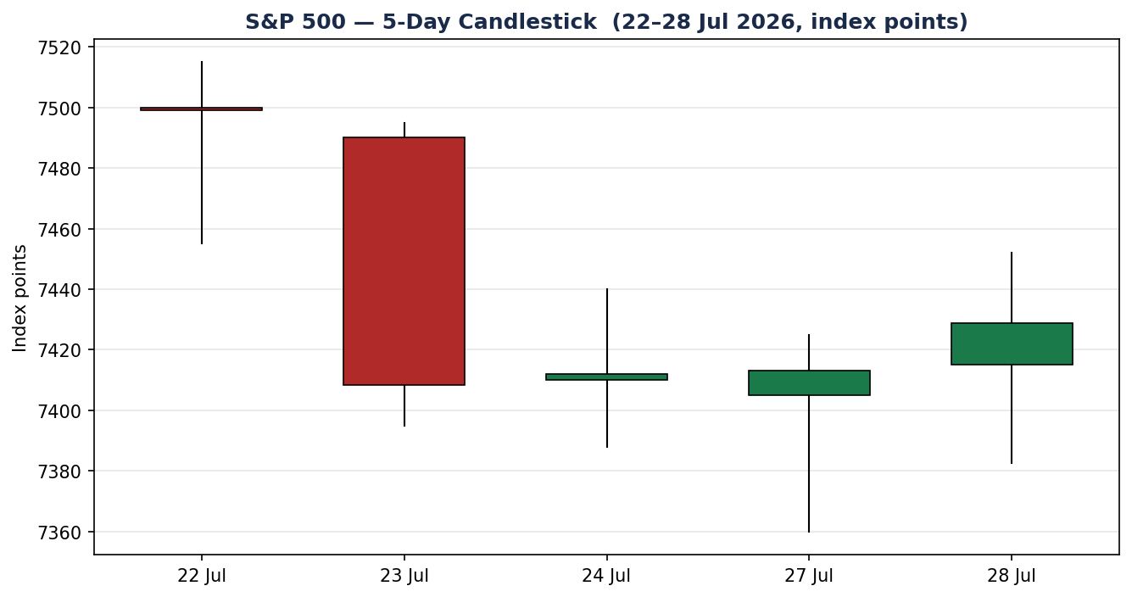
Chart 2 — Distance-from-Open. Normalising each session to its open exposes the deep 23–24 July intraday travel and the constructive positive close-minus-open on 28 July.
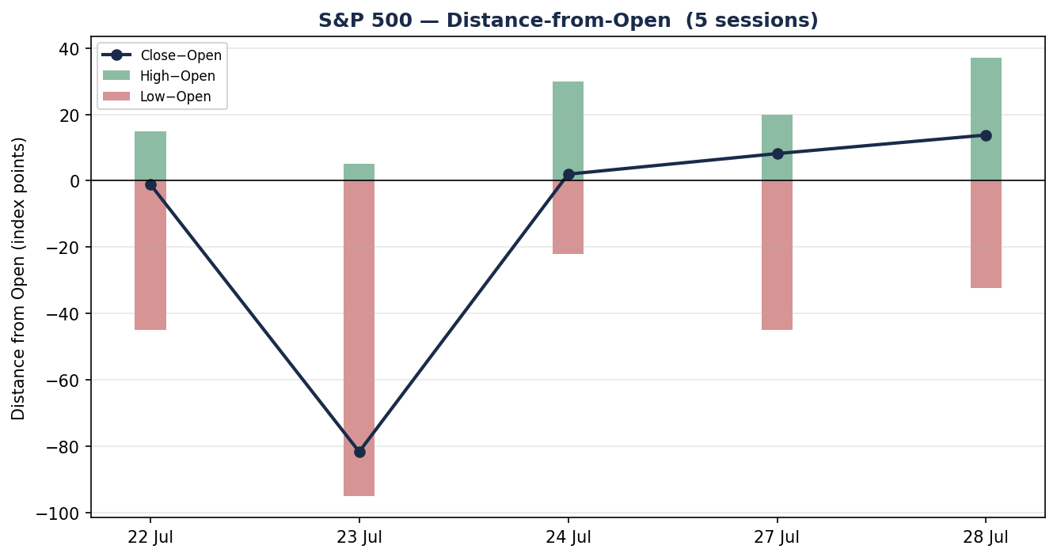
Chart 3 — 25-Session Structure. Overlap is moderate (0.48) with rotation rather than clean trend; the close sits mid-range, consistent with a transitional read.
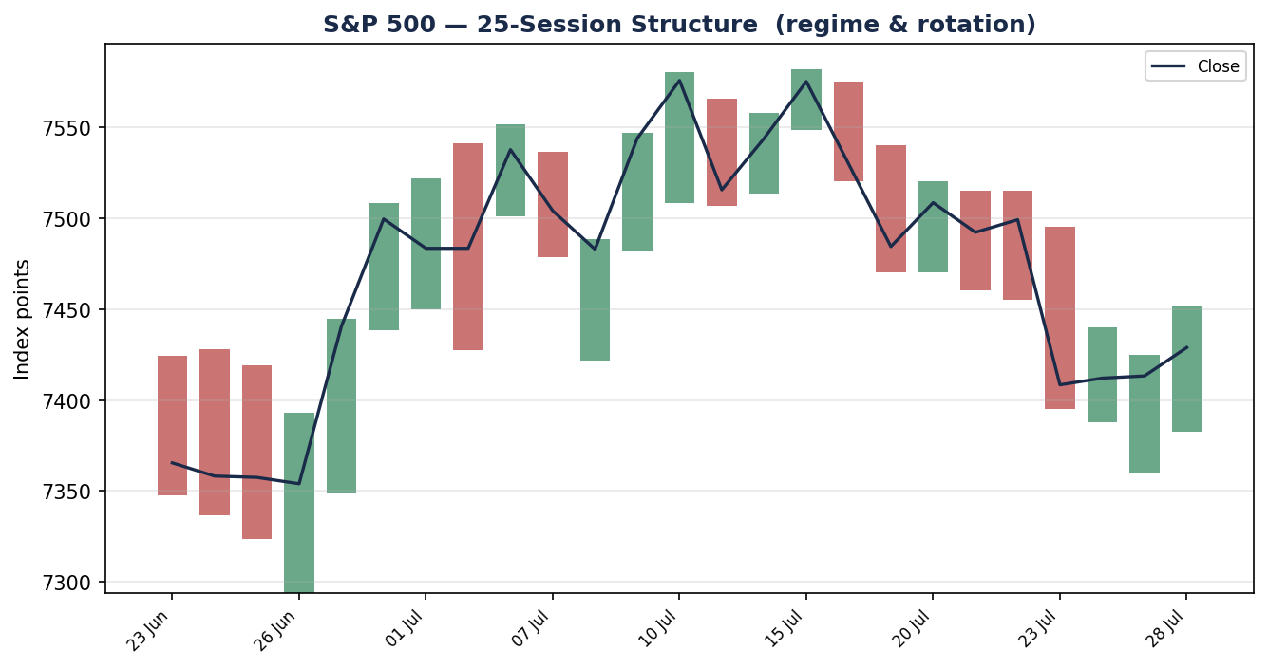
Chart 4 — Comparative Volatility (VOLator). S&P 500 scaled volatility is expanding (positive slope) alongside VIX; the dollar and DAX volatility read lower. Counter series are directional and illustrative.
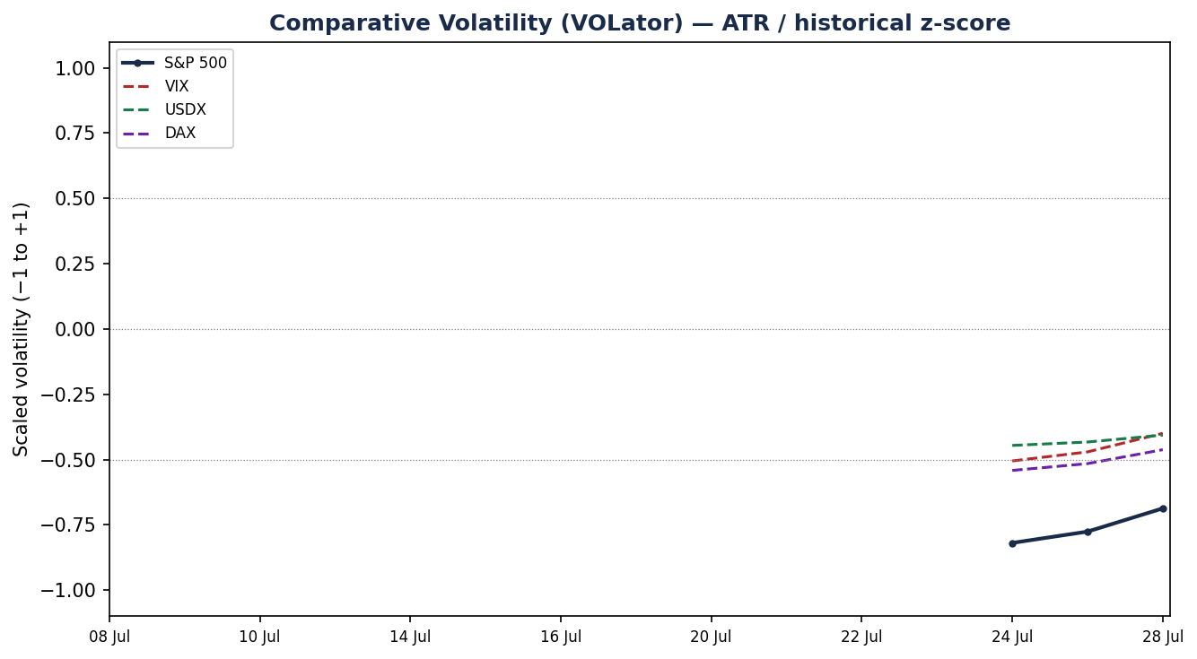
Chart 5 — Pivot Structure. Prior-week and current-week candles against pooled daily/weekly/monthly floor pivots on a smart-scaled axis. The close sits just above the weekly pivot and below the monthly pivot cluster near 7,457.
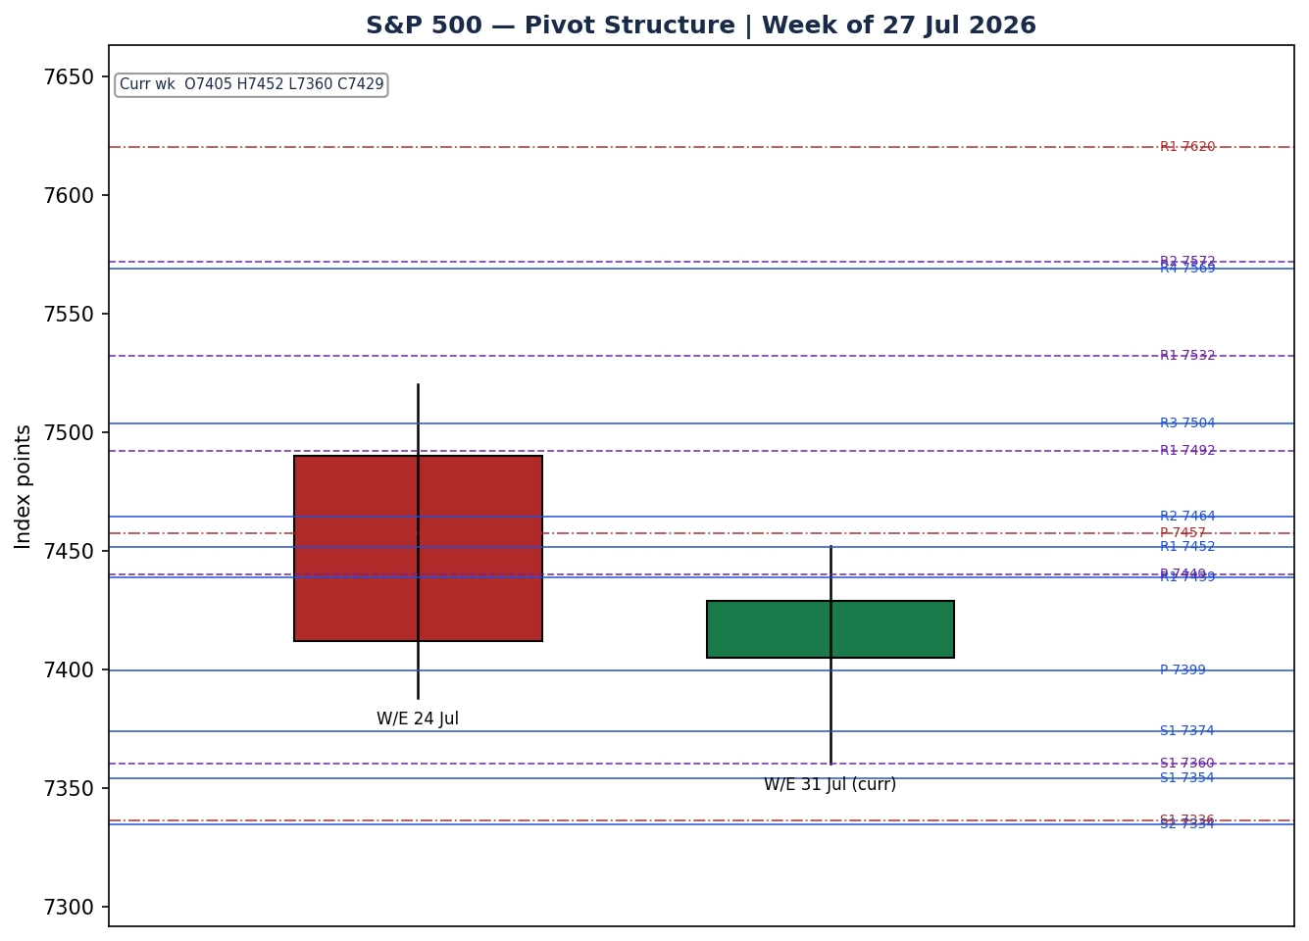

§8 Short-Term Technical Analysis
- 22 Jul (see §6): Narrow, slightly bearish body closing near the lower half; RSI2 ~46. A quiet holding session before the break.
- 23 Jul: Decisive bearish candle, close near the low, RSI2 collapses to ~7 — a momentum flush on the chip-led selloff. Body dominates; little lower wick.
- 24 Jul: Inside-ish recovery attempt; close a fraction above open (+0.05%) but RSI2 still depressed (~13). Long lower wick relative to body signals demand near 7,388.
- 27 Jul: Doji-like consolidation (+0.02%); RSI2 ~16 confirms an oversold-but-stabilising tape. Lower wick into 7,360 marks near-term demand.
- 28 Jul: Bullish reversal candle, close in the upper half (+0.21%), RSI2 snaps back to ~59 — the first constructive close of the block.
Sequence assessment: Compression → attempted reversal. The block reads as a sharp down-thrust (23 Jul) followed by three-session compression and a nascent upside turn. It is not yet a confirmed continuation. Nearest support 7,360 (27 Jul low) with structural support at 7,382–7,388; nearest resistance 7,515 (22 Jul high).
Judgement label: Indecision (reversal attempt in progress). This is consistent with the §9 transitional regime; no conflict flagged, though the KER-down reading is noted as a mixed signal (see §9).

§9 Medium-Term Regime & VOLator
- Regime: Transitional. Overlap 0.48, directional persistence 0.54, median RSI2 46, close at the 47th percentile of the 25-session range (7,294–7,581). Neither clean-trend nor clean-range criteria are met.
- Bias: Neutral-to-bearish. The completed medium-term swing is downward (record 7,581 on 15 Jul → 7,294 area), partly retraced by the late-July stabilisation.
- VOLator readings: S&P 500 scaled volatility is positive and expanding (slope +0.07). VIX elevated near 18 (above its recent floor); USDX and DAX volatility read lower on the cross-section.
- Preferred trade protocol: Transitional / reduced conviction — await a confirmed break; favour breakout-side expressions over fades.
- Kaufman confirmation: Trending Down — Strong (−0.22). This contradicts the constructive last-session reversal and is flagged as a mixed signal; because the dual-gate range test is not satisfied (efficiency-ratio magnitude exceeds the trend threshold while volatility is expanding), the consolidated regime resolves to Transitional rather than Range.

§10 Cross-Asset Analysis
Counter | 5-day dir. | Mechanism | Status | Implication for S&P 500
USDX (Dollar Index) | Rising | Firmer dollar tightens global financial conditions and trims multinational earnings translation. | Confirms (caution) | Mild headwind; consistent with the transitional/soft tape.
VIX | Rising | Higher implied volatility signals risk-off hedging demand. | Confirms (caution) | Elevated hedging pressure caps upside follow-through.
DAX 40 | Rising | European risk-on (earnings-led, oil relief) is a common-factor positive for global equity beta. | Contradicts | Constructive cross-read that argues against a fresh leg lower.
Contradiction flag: DAX strength contradicts the cautious USDX/VIX read. Aggregated, the counters are MIXED (two confirm caution, one contradicts). This mixed cross-asset picture is a core reason the directional score lands NEUTRAL and feeds the §15 balance and §16 forward view.

§11 Floor Pivot Analysis
Daily pivots (prior session 27 Jul; indicative only — prior-day H/L single-source):
Level | Value
R5 | 7633.79
R4 | 7568.79
R3 | 7503.79
R2 | 7464.39
R1.5 | 7451.59
R1 | 7438.79
P | 7399.39
S1 | 7373.79
S1.5 | 7354.09
S2 | 7334.39
S3 | 7308.79
S4 | 7243.79
S5 | 7178.79
Weekly pivots (prior week 20–24 Jul; indicative — single-source prior H/L): P 7439.99, R1 7491.99, R2 7571.99, S1 7359.99, S2 7307.99.
Monthly pivots (prior month June; indicative): P 7457.15, R1 7620.13, S1 7336.39, S2 7173.41.
Source status: all pivot timeframes are SINGLE-SOURCE INDICATIVE because prior-period highs/lows for the cash index were not two-source corroborable from approved free feeds. Levels are usable for chart context and narrative but not as definitive limit-entry references (see §19); this flag drives the §21 pivot-trade caveat.
Position narrative: The 28 July close (7,428.78) sits just below the daily R1 (7438.79) and above the daily pivot (7399.39); it is fractionally below the weekly pivot (7439.99) and beneath a monthly-pivot cluster near 7457.15. The weekly and monthly pivots at ~7,440 and ~7,457 form the immediate overhead confluence band.

§12 Key Market Considerations
- Earnings / mega-cap (cyclical). Apple, Microsoft, Amazon and Meta report this week; Apple briefly touched a $5tn market cap. Semiconductor weakness (Nvidia, AMD, Micron, Sandisk, SK Hynix) on AI capex and circular-financing fears is the dominant single-stock drag. Net: mixed — mega-cap breadth supportive, chips price-negative.
- Rates / policy (cyclical, high-impact). The 30 July FOMC decision carries an unusually high market-implied probability of a hike (FedWatch pricing a September move as base case). A hawkish surprise is price-negative. Flagged as the top §13d catalyst.
- Energy / inflation (cyclical, supportive). A sharp crude slide (WTI back toward the low-$80s/one-week low on Iran de-escalation talks) has eased inflation fear and supported the broad tape, including a fresh all-time high in the equal-weight index. Price-supportive.
- Macro / FX (structural-cyclical). A firmer dollar (USDX ~101.5) is a modest headwind for multinational earnings translation. Price-negative at the margin.
- Substitution / breadth. Rotation out of semiconductors into financials, staples and discretionary is cushioning index-level damage — a healthier-breadth signal even amid tech stress. Neutral-to-supportive.
- Near-term catalysts (see §13d). FOMC (30 Jul); mega-cap earnings (AAPL/MSFT/AMZN/META); any renewed Iran headlines via the oil channel.

§13 Sentiment, News & Calendar
§13a Per-article sentiment
Source | Date | Headline (short) | Class. | Sentiment | Derivation quote (≤15 words)
Bloomberg | 28 Jul | Semiconductor shares drop, weighing on S&P 500 futures | Media | Bearish | “came close to correction territory” for the tech-heavy Nasdaq 100
CNBC | 28 Jul | Rotation out of semis lifts Dow; S&P edges up | Media | Mixed | “rotation out of semiconductors into other parts of the market”
Trading Economics | 28 Jul | Futures lower as chip selling dampens sentiment | Trade Press | Bearish | “another wave of selling in semiconductor stocks dampened investor sentiment”
Motley Fool | 24 Jul | Dow recovers; tech stocks fall further | Media | Mixed | S&P 500 “edged up 0.05%” as tech stayed weak
CAPIS | 24 Jul | S&P clusters with second >1% loss in July | Institutional | Bearish | “second loss for the month of more than -1%”
FXStreet | 28 Jul | Dollar subdued into a Fed decision | Institutional | Neutral | “markets pricing in nearly a 38% chance of a rate hike”
§13b Aggregate sentiment. Counts: 3 Bearish (1 institutional, 1 trade press, 1 media), 2 Mixed (media), 1 Neutral (institutional) = Mixed, tilting mildly cautious. Source-class-weighted numeric tilt = −0.08 (low magnitude). Divergence flag: sentiment is mildly cautious while price staged a small up-close on 28 July — a modest sentiment/price divergence; given the transitional regime, the technical read (not the mild tilt) is the more reliable near-term signal. Low-confidence flag is not triggered (six articles).
§13c News calendar — previous period
Date | Event | Prior / Context | Impact | Market implication
22 Jul | Range session | Index ~7,499 | Low | Quiet hold before the break.
23 Jul | AI/chip-financing fears escalate | Nvidia-SK Hynix supply deal read as capex risk | High | S&P −1.21% to 7,408; semis lead the drop.
24 Jul | Tech earnings / oil to ~$100 then reversal | Intel beat but sold; Sandisk −11% | High | S&P +0.05%; Dow recovers on rotation.
27 Jul | Chip selloff extends; Fed blackout | Nvidia −5% on $500bn memory deal | Medium | S&P +0.02%; defensive rotation continues.
28 Jul | Oil slides further; equal-weight ATH | Brent/WTI down sharply | Medium | S&P +0.21% to 7,428.78; breadth improves.
§13d News calendar — upcoming period
Date | Event | Context | Impact | Mechanism for S&P 500
30 Jul | FOMC decision & statement | Hold expected; elevated hike odds priced | High | A hawkish hike/tone would pressure multiples; a dovish hold would relieve the tape.
30 Jul–1 Aug | Mega-cap earnings (AAPL/MSFT/AMZN/META) | Guidance on AI capex | High | Beats + capex discipline support; disappointment deepens the tech drag.
Ongoing | Iran / oil headlines | De-escalation vs re-escalation | Medium | Lower oil eases inflation risk (supportive); a spike reverses it.
Highest-impact event: the 30 July FOMC decision — a surprise hike or hawkish statement would most directly threaten the balanced consensus by repricing the discount rate for large-cap equities.

§14 Macro Context
- Rates & policy. Fed on hold expected 30 July but with an atypically high hike probability and September as the pricing base case; this is the pivotal macro variable. Cross-references the rising-VIX read in §10 (hedging into the event).
- Inflation. The oil slide has cooled near-term inflation expectations — price-supportive for equities via the discount-rate and margin channels.
- Safe-haven / real yields. Gold near ~$4,020–4,077; firm but off highs as the war premium fades — consistent with a market weighing policy risk over crisis risk.
- Liquidity & FX. USDX ~101.5 and rising (see §10) is a mild headwind for multinational translation and global liquidity.
- Positioning. VIX ~18 (elevated but not stressed; below the 20 line); BofA Bull & Bear sentiment reportedly at its highest since 2021 — a contrarian caution flag. Watch item: FOMC (§13d) as the dominant positioning catalyst.

§15 Bull / Bear Balance
Upside risks | Downside risks
• Oil-driven inflation relief supports multiples.  • Improving breadth (rotation) beyond mega-cap tech.  • DAX strength (§10) confirms global risk-on.  • Reclaim of weekly/monthly pivots ~7,440–7,457 opens 7,515 then the record 7,581. | • Hawkish FOMC surprise (§13d, top catalyst).  • Deepening semiconductor / AI-capex selloff.  • Rising USDX and VIX (§10) signal tighter conditions and hedging.  • Loss of 7,360 / 7,388 support risks a retest of the 25-day low near 7,294.
The balance is roughly even and event-gated: the close sits mid-25-day-range, beneath the 7,440–7,457 pivot confluence (§11), with the 30 July FOMC (§13d) the swing factor.

§16 Forward View
Over the next five sessions the base case is a range-to-mildly-constructive market bounded roughly by 7,360 support and 7,515 resistance, with the immediate hurdle the 7,440–7,457 weekly/monthly pivot band. This respects the §9 transitional regime — it neither assumes a clean trend nor a confirmed range. A decisive daily close above ~7,457 would tilt the odds toward a retest of 7,515/7,581; a close below 7,388 would re-expose 7,294. Base-case invalidation: a sustained close beyond either boundary, most plausibly triggered by the FOMC outcome. No contradiction with the technical regime is flagged.

§17 Forecast
The S&P 500 is most likely to consolidate between 7,360 and 7,515 into the 30 July Federal Reserve decision, with the mildly cautious sentiment tilt and mixed cross-asset read favouring range behaviour over a fresh directional leg.

§18 Final Analyst Judgement
Consensus price: 7,428.78 (High confidence).
- Reason 1: Two-source-corroborated official close on a low-range, stabilising session.
- Reason 2: Transitional regime (overlap 0.48, persistence 0.54, mid-range close) with a Kaufman-down mixed signal — no directional conviction.
- Reason 3: Mixed cross-asset picture (USDX/VIX cautious, DAX constructive) and a mildly cautious sentiment tilt (−0.08).
Single watch item: the 30 July FOMC decision.

§19 Source Discipline Note
- Live vs indicative. Closes for all five sessions are live, two-source corroborated within the ±0.10-pt equity-index tolerance. Session open/high/low for the cash index are single-source indicative where a second intraday feed was unavailable from approved free sources.
- Pivot corroboration. All pivot timeframes (daily, weekly, monthly) are SINGLE-SOURCE INDICATIVE because prior-period highs/lows could not be two-source corroborated. Per protocol they are not used as definitive limit-entry references; the strategies section carries this flag as a caveat.
- Counters. USDX, VIX and DAX closes are corroborated across at least two outlets for direction; used for directional confirmation only (no counter OHLC pivots).
- Data gaps / normalization. CFD-basis quotes excluded; after-hours indications excluded from OHLC. No values were synthesised — where corroboration was unavailable, the field is flagged rather than estimated.

§20 Agent Log
- Sources attempted (OHLC): S&P Dow Jones/FRED (official close), CNBC, Yahoo Finance, Investing.com, Trading Economics, wallstreetnumbers, CAPIS, Motley Fool. Free CSV feeds (Stooq, Twelve Data) were not reachable in this environment and were logged as not-attempted-programmatically; web corroboration substituted.
- Corroboration pairs (close): 22 Jul S&P DJI × Lines/CAPIS (Δ0.00); 23 Jul CAPIS × WSN (Δ0.00); 24 Jul S&P DJI × Motley Fool (Δ~0.02); 27 Jul FRED × Yahoo (Δ0.00); 28 Jul S&P DJI/CNBC × Yahoo (Δ0.40, within band).
- Single-source fields: Session opens for 22–28 Jul and all prior-period pivot H/L (daily/weekly/monthly) — flagged indicative.
- Sentiment derivation: Six articles classified from explicit language with ≤15-word derivation quotes; source-class-weighted tilt = −0.08 (Mixed, mildly cautious).
- Strategy trace: Direction-scoring weights = defaults (baseline vector), locked (forward-test session count < 20). Direction score −0.19 → NEUTRAL → Trade 1 suppressed. Regime = TRANSITION → Trade 3 fork = 3C breakout; Trade 2 = breakout-side only. Pivot tiers flagged single-source-indicative. Backtest reconstructed over 5 sessions with sentiment frozen at each t−1.
- Anomalies / notes: KER (Trending Down — Strong) contradicts the constructive last-session reversal — flagged mixed. Daily-open anchor confirmed at 07:00 UK (European pre-NY-open window). Timestamp: generated 29 Jul 2026.

§21 Strategy Recommendations
§21a Directional conviction. Direction: NEUTRAL; score −0.19 (below the ±0.25 conviction threshold). The three highest-weighted contributing signals are the medium-term regime component (§9) at −0.10, the cross-asset confirmation (§10, MIXED) at −0.045, and the Kaufman efficiency contribution (§9) at −0.033; the short-term technical and VOLator components net to zero given the reversal-into-expansion tension. Conflict flag: the NEUTRAL score is consistent with the §17 range forecast — no conflict. Weights basis: defaults (baseline, locked for the forward-test window).
§21b Trade cards
Trade 1 — Daily Directional
Field | Detail
Status | SUPPRESSED — direction score |−0.19| below the 0.25 conviction threshold.
Trade 2 — Pivot (regime-aware: TRANSITION, breakout-side only)
Field | Detail
Trade type | Trade 2 — Pivot, TRANSITION breakout-side (upside only)
Direction | LONG — breakout side, aligned with the upside 3C trigger (no counter-side limit in TRANSITION)
Entry | Buy stop at 7438.79 (daily R1) — 10 points above the pivot band, on a confirmed push through overhead pivots
Stop loss | 7399.39 (daily P) — 39 points below entry; structural anchor = daily pivot
Risk (R) | 39 points (39.39 index points)
TP1 (Unit 1) | 7478.18 (+1R)
TP2 (Unit 2) | 7517.57 (+2R); on fill, Unit 3 stop → entry + 0.2R
TP3 (runner) | Toward the pivot-cluster extension / 7,515 swing high; runner exits toward P on failure
Tranche mgmt | 3 equal units; Unit 1 → TP1, Unit 2 → TP2; on Unit 2 fill, Unit 3 stop to entry + 0.2R
Confluences | Entry near weekly pivot 7,440 & monthly pivot 7,457 (strong overhead confluence); TP1 zone near 7,465 R2
Thesis invalidation | Daily close back below the daily pivot 7,399
Caveats | single-source-indicative pivots (see §19); holding period collides with 30 Jul FOMC (§13d); low-confidence sentiment tilt; contingent stop-entry — pending confirmed break.
Trade 3 — Momentum-Breakout (3C; TRANSITION regime)
Field | Detail
Trade type | Trade 3C — Momentum-Breakout (post-consolidation)
Direction | LONG on upside break (nearer boundary; VOLator expanding, last-bar reversal up)
Range definition | 25-session range 7294.18 – 7581.50 (width 287 pts)
Confirmed break | Daily close ≥ 7598.55 (upper boundary + 0.25×ATR). Not yet met — trade pending trigger.
Entry | On confirmed upside close, at the breakout candle close (≈ 7598.55+) or next-session open
Stop loss | 7409.11 (range low + 0.40×width; generous post-consolidation stop, just below midpoint)
TP1 (Unit 1) | 7868.82 (measured move = broken high + 1.0×width)
TP2 (Unit 2) | 8012.48 (1.5×MM); on fill, Unit 3 stop → broken boundary 7581.50
TP3 (runner) | Discretionary trail beyond 1.5×MM, anchored to subsequent swing structure
Tranche mgmt | 3 equal units; standard tranche rule; Unit 3 stop to broken boundary on TP2 fill
Confluences | Upper boundary 7,581 = June record high (strong round-number/structural confluence)
Thesis invalidation | Daily close back inside range past the midpoint (~7,438)
Caveats | pending confirmed break (not yet eligible); holding period collides with 30 Jul FOMC (§13d); mirror short setup on a confirmed close ≤ 7277.13 targeting 7,294.
§21c 5-session no-leakage backtest. Daily-directional reconstruction issued at each prior t−1 close (RSI2/close proxy, no forward leakage), resolved on the actual t-session bar; sentiment frozen at t−1.
Issue (t−1) | Strategy | Direction | Triggered | Entry | Outcome (R) | Days
2026-07-21 | Trade 1 (recon.) | SHORT | YES | 7500 | 0.02 | 1 (open→close)
2026-07-22 | Trade 1 (recon.) | NEUTRAL | NO | — | — | 1 (open→close)
2026-07-23 | Trade 1 (recon.) | SHORT | YES | 7410 | -0.03 | 1 (open→close)
2026-07-24 | Trade 1 (recon.) | SHORT | YES | 7405 | -0.12 | 1 (open→close)
2026-07-27 | Trade 1 (recon.) | SHORT | YES | 7415 | -0.2 | 1 (open→close)
§21d What is working. Over the last 5 sessions the daily-directional reconstruction triggered 4 of 5 times (one NEUTRAL suppression), mean R ≈ −0.08 with no clean TP1 hits — the choppy, mean-reverting tape punished directional shorts as the index stabilised and turned up on 28 July. Strongest performer: none decisively (all near break-even to slightly negative). Weakest performer: the 27→28 July short (−0.20R) as the reversal ran against it. Pivot and breakout cards did not trigger in-window (no confirmed break). Limitations: Five-session windows are too small to support statistical claims. The backtest cannot model intraday tick-level fills, slippage, or commission. Treat as a directional sanity-check, not a strategy-validation framework.

