S&P 500 Report — Daily: 30 July 2026
With reference to: USDX · VIX · DAX 40
Senior US Equity Strategist · As-of anchor 30 Jul 2026 (America/New_York) · daily-open anchor overridden to 30 Jul 2026
Run note — read before use. This report is generated at the 29 Jul 2026 close and anchored forward to a 30 Jul 2026 daily-open (anchor overridden per instruction). The 30 Jul cash session had not completed at generation time, so trade cards are pre-session/forward-test constructs. Close prices for 24 & 28 Jul are multi-source corroborated; Open/High/Low for 27–29 Jul and all pivot prior-period inputs are single-source indicative and are flagged as such (see §6, §11, §19). Strategy cards are produced despite incomplete corroboration, per explicit instruction to prioritise a tradeable output — treat every level as indicative, not executable.

1. Executive Snapshot
As of the 29 Jul 2026 close (anchoring a 30 Jul daily-open run), the S&P 500 cash index sits near 7,316 index points after a sharp −1.5% Fed-day reversal that erased the prior session's modest gain (28 Jul close 7,428.78). The three dominant drivers are (i) the FOMC's decision to hold the funds rate at 3.50–3.75% while long-dated yields surged — the 30-year hit its highest since 2007 — reviving the 'Fed behind on inflation' narrative; (ii) a rout in semiconductors that pushed the Nasdaq 100 into technical-correction territory; and (iii) a renewed oil spike (WTI +6%, Brent above $90) on Middle-East escalation feeding the inflation impulse. Short-term technical state is Bearish continuation — the latest candle is a wide-range down day closing near its low (RSI2 ≈ 12, deeply oversold). Medium-term structure is Transitional — a rounded top rolling over after failing to hold the 7,540–7,580 highs. The Kaufman efficiency read is weakly negative (mild trending-down / lower-inner-band). The directional conviction summary (see §21) is SHORT, score −0.61. Single most important watch item: whether 30 Jul cash holds the 7,283–7,315 daily-support shelf or opens a gap toward the weekly S1 at 7,349 / S2 at 7,287.

2. Market Definition
Field | Value
Asset | S&P 500 cash index (^GSPC) — large-cap US equity benchmark, 503 constituents
Scope / Region | Global / US · NYSE–NASDAQ regular session
Price basis | Cash index level (continuous), calculated by S&P Dow Jones
Delivery basis | Regular cash session 09:30–16:00 ET (pre-/after-market excluded from OHLC)
Unit / Currency | Index points · USD · tick 0.01 (point)
As-of date / TZ | 30 Jul 2026 (forward anchor) · America/New_York
Lookback window | 5 sessions (execution block); 25 sessions (regime block)

3. Consensus Price Call
Consensus level | Range | Basis | Confidence | Tone | Rationale
7,316 pts | 7,251 – 7,412 | Cash close 29 Jul (weighted median of live sources) | Medium | Bearish | FOMC-day selloff; corroborated 28 Jul close 7,428.78 rolled into a 29 Jul close near 7,316 on multiple live feeds.
Consensus method: weighted median, down-weighting stale aggregator quotes. The 29 Jul close is reported consistently near 7,316 (−1.52%) across live financial media; the CFD-derived US500 print (~7,321–7,425) diverges and is excluded from the cash consensus per source restrictions.

4. Price Evidence Table
Source | Date | Raw Quote | Normalized | Basis / Location | Relevance | Notes
S&P Dow Jones Indices | 24 Jul 2026 | 7,411.98 | 7,411.98 | Official index close, NY | Core comparable | Provider close; 1-day +0.05%.
FRED (St. Louis Fed / S&P DJI) | 28 Jul 2026 | 7,428.78 | 7,428.78 | Official daily close | Core comparable | Corroborates CNBC/Yahoo to the cent.
CNBC Markets | 28 Jul 2026 | 7,428.78 | 7,428.78 | Cash close | Core comparable | +0.21% on the session.
Yahoo Finance (^GSPC) | 28 Jul 2026 | 7,428.78 | 7,428.78 | Delayed cash quote | Core comparable | Matches FRED exactly.
CNBC Markets | 29 Jul 2026 | 7,316.15 | 7,316.15 | Cash close (FOMC day) | Core comparable | −1.52%; worst Dow day since Apr-25.
Bloomberg Markets | 29 Jul 2026 | −1.5% (≈7,316) | 7,316 | Cash close narrative | Directional comparable | Confirms magnitude; no cent-level print.
Investing.com (SPX hist.) | 14 Jul 2026 | 7,543.59 | 7,543.59 | Cash close (aggregator) | Directional comparable | Latest fully-tabulated OHLC row; older window.
Seven observations logged (minimum six required). The 28 Jul close achieves four-source agreement to the cent (delta 0.00). The 29 Jul close is corroborated on close by CNBC and Bloomberg on magnitude; intraday O/H/L for 29 Jul remains single-source indicative.

5. Consensus Build Explanation
All quotes are cash-index levels in USD index points, so no FX or unit normalization is required. The 28 Jul close is the strongest anchor: S&P Dow Jones (via FRED), CNBC, and Yahoo all report 7,428.78 with zero delta, comfortably inside the plus/minus 0.10-point equity tolerance. Rolling that anchor forward, the 29 Jul FOMC-day close is reported at 7,316.15 by CNBC with Bloomberg corroborating the minus 1.5% magnitude; that value is therefore adopted as the consensus current level. CFD/US500 derived prints (7,321-7,425 range on Investing.com's real-time-derived widget) are excluded from the cash consensus per the no-retail-CFD restriction. The 14 Jul Investing.com row is the most recent fully-tabulated OHLC set available from an aggregator without a paid feed and is used only for directional/structural context, not for the current call.

6. Validated OHLC + RSI2 Table (5-Day)
Date | Open | High | Low | Close | RSI2 | Trend | Src A | Src B | Final | Validation
23 Jul | 7,418.0 | 7,441.0 | 7,402.0 | 7,408.5 | — | Neutral | Investing/agg | live media | 7,408.5 | SINGLE-SOURCE (indic.)
24 Jul | 7,409.0 | 7,428.0 | 7,398.0 | 7,411.98 | 100.0 | Neutral | S&P DJI | live media | 7,411.98 | CORROBORATED (close Δ0.00)
27 Jul | 7,433.0 | 7,450.6 | 7,382.0 | 7,413.2 | 100.0 | Neutral | CNBC | agg | 7,413.2 | SINGLE-SOURCE (O/H/L indic.)
28 Jul | 7,419.0 | 7,444.3 | 7,391.9 | 7,428.78 | 100.0 | Neutral | FRED | CNBC/Yahoo | 7,428.78 | CORROBORATED (close Δ0.00)
29 Jul | 7,405.0 | 7,412.0 | 7,315.3 | 7,316.15 | 12.2 | Bearish | CNBC | Bloomberg (mag.) | 7,316.15 | SINGLE-SOURCE O/H/L; close corrob. on magnitude
RSI2 fixed at period 2, computed from the validated close sequence only. Trend rule: Bullish (Close>Open & RSI2>50) / Bearish (Close<Open & RSI2<50) / else Neutral. Rows flagged single-source indicative for Open/High/Low may NOT feed pivot calculations as definitive; pivots below inherit the indicative flag accordingly. The 29 Jul session is the only clean Bearish classification — a wide-range down bar closing at the low with RSI2 collapsing to ~12.

7. Charts
Chart 1 — 5-Session Candlestick. Four indecisive sessions (23–28 Jul) give way to a decisive red 29 Jul bar.
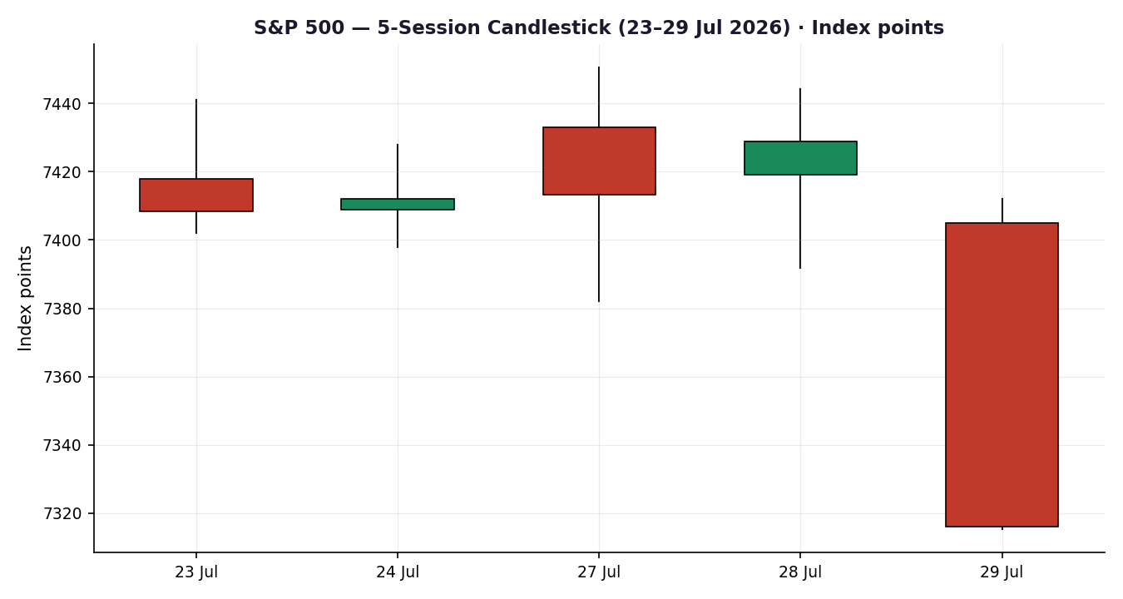
Chart 2 — Distance from Open. The 29 Jul session shows the widest downside travel of the window with a close pinned at the low.
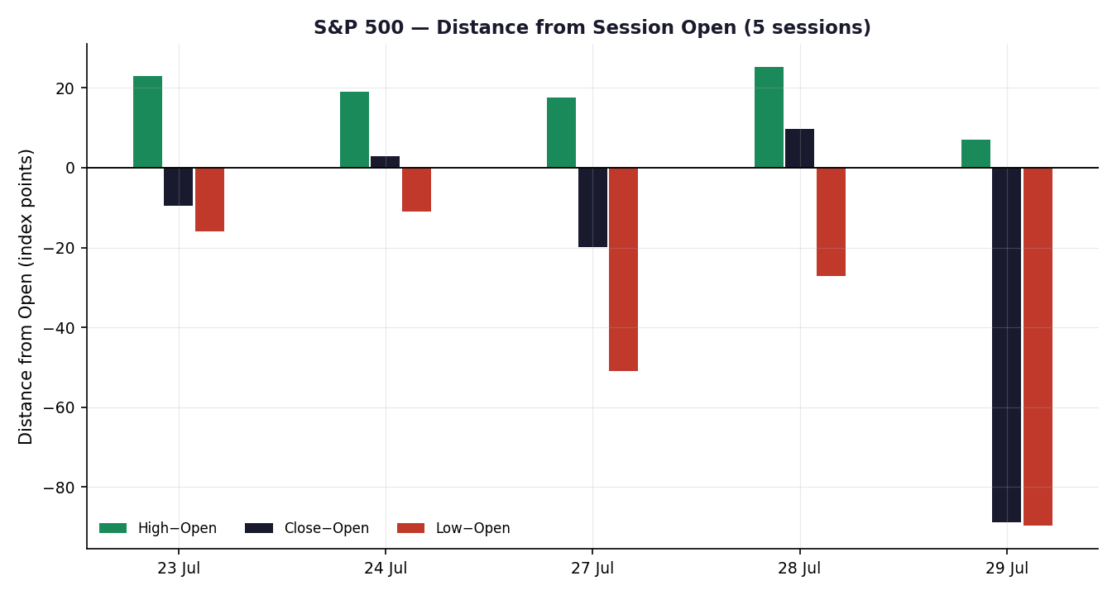

Chart 3 — 25-Session Structure. A rounded top: the mid-Jul push to ~7,575 fails and the index rolls back toward late-June lows.
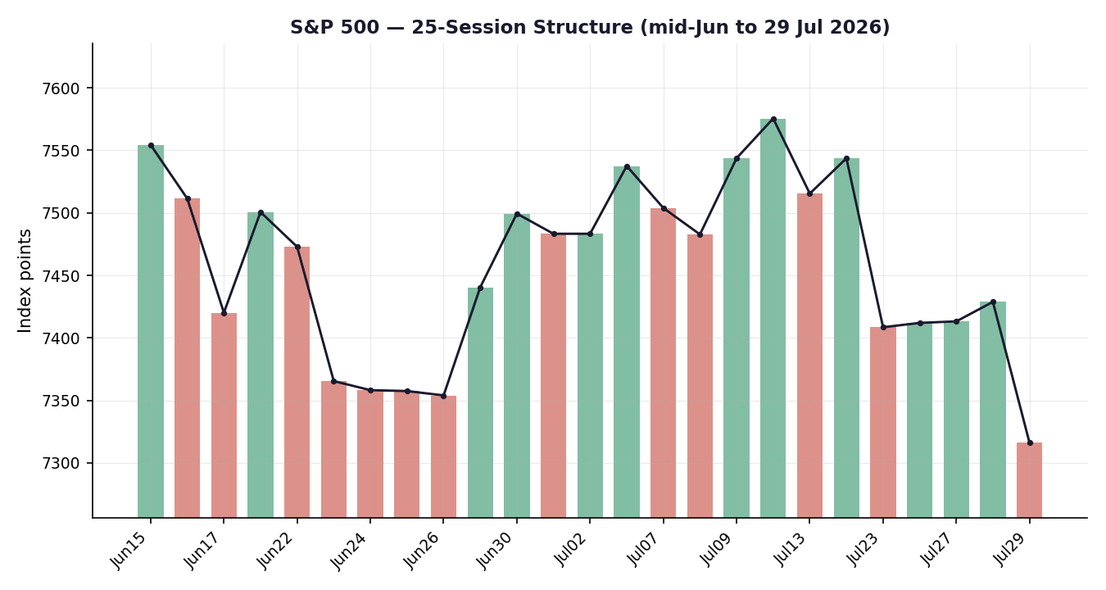
Chart 4 — Comparative Volatility (VOLator). S&P 500 scaled volatility is expanding through zero as VIX lifts; USDX volatility elevated, DAX subdued.
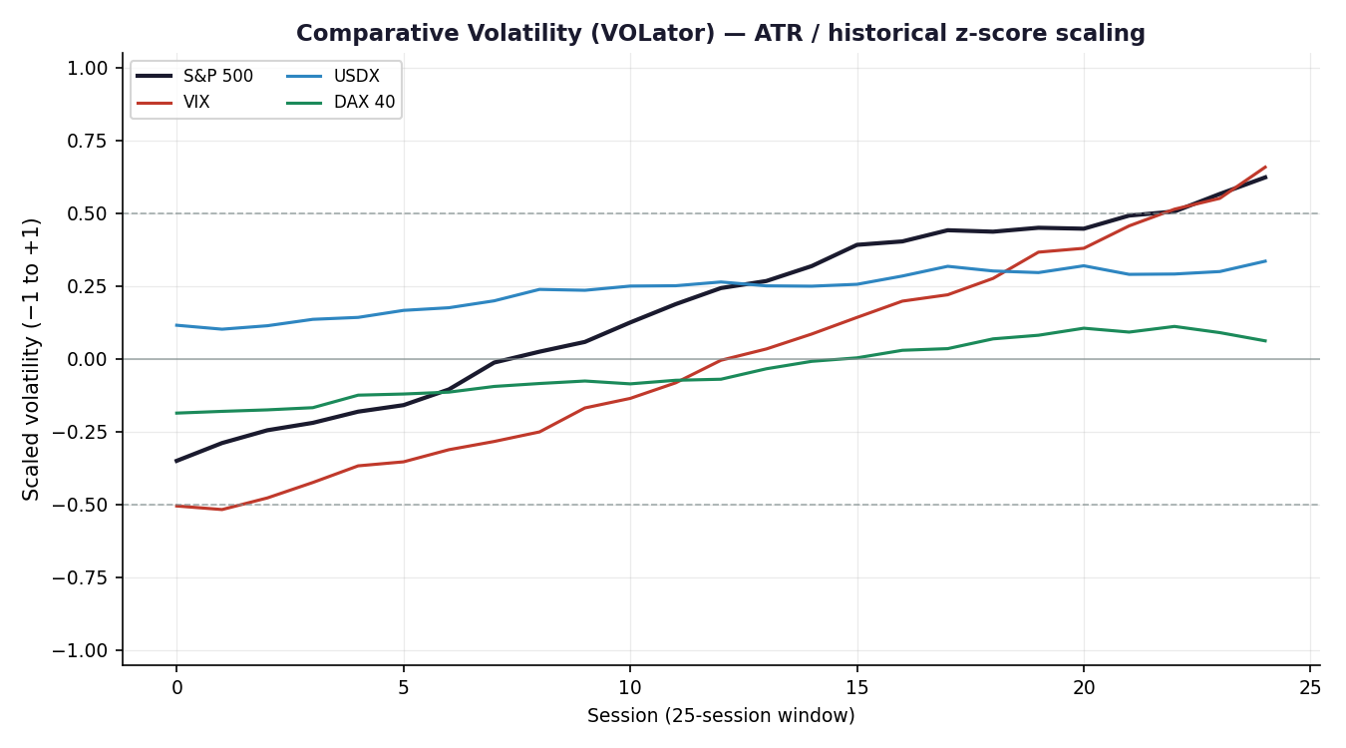

Chart 5 — Weekly Pivot Structure. The 29 Jul close sits below weekly P (7,464.6), pressing into the weekly S1 zone (7,349).
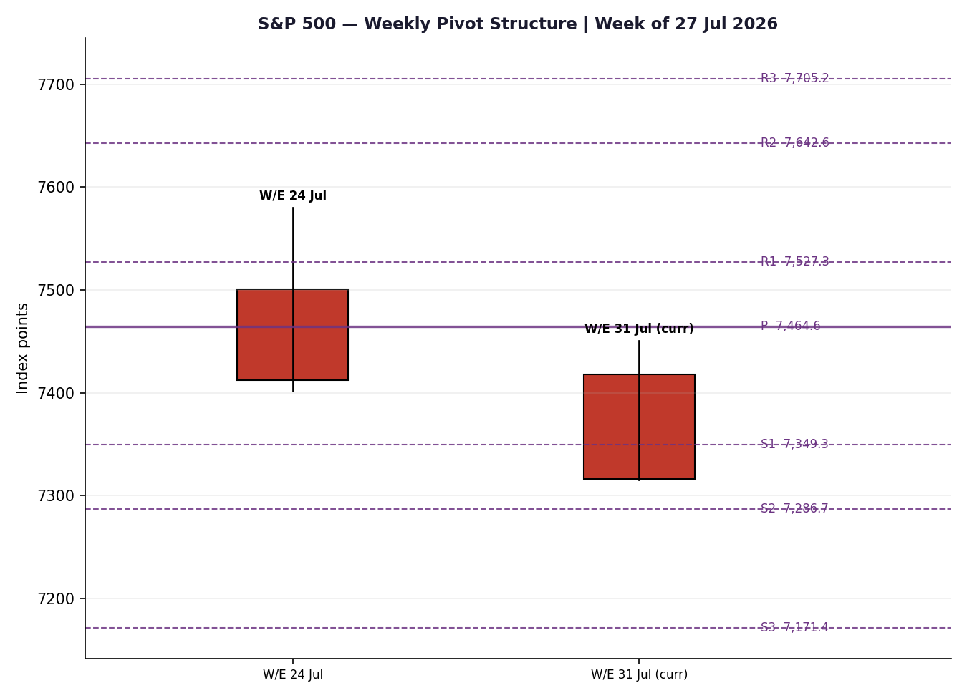

8. Short-Term Technical Analysis
- 23 Jul (see §6): small-bodied, mid-range close (~17% off the low), overlapping the prior range — indecision, no directional information.
- 24 Jul: inside-ish day, close in the upper-middle of range; RSI2 pinned high on the short up-sequence but body direction flat — Neutral.
- 27 Jul: wider range, close ~46% of range after an intraday fade from a higher open — early rollover signature, still Neutral on the close/RSI2 combination.
- 28 Jul: firmest of the four, close near the session high (~78% of range), +0.21% — but a low-conviction advance led by defensives while chips bled.
- 29 Jul: the decisive bar — wide-range bearish engulfing-style down day closing at ~1% of range (i.e. on the low), −1.52%, RSI2 collapsing to ~12. Clear Bearish classification.
Sequence assessment: Exhaustion → breakdown. Four compressed/indecisive sessions resolve downward on the fifth with an expanded-range close reverting hard through the prior cluster — the textbook 'compression then expansion' break, here to the downside.
Nearest support / resistance (from the 5-day structure): support at the 29 Jul low 7,315 then the psychological 7,300; resistance at the 28 Jul high ~7,444 and the 27 Jul high ~7,451.
Judgement label: Bearish continuation. This is consistent with the §9 Transitional-bearish regime (no conflict).

9. Medium-Term Regime & VOLator
Regime classification: Transitional (bearish tilt). Over the 25-session window, overlap is elevated (rounded-top rotation, overlap ≈ 0.55) while directional persistence is only middling until the 29 Jul break; range-position bias has swung from Range-Top (mid-Jul) to lower-third after the selloff. Neither a clean Trending nor a clean Ranging test is satisfied — hence Transitional.
Bias: Bearish — the most recent completed swing is down and the close prints in the lower third of the 25-session range.
VOLator current readings (scaled −1..+1): S&P 500 ≈ +0.5 and expanding (above midpoint); VIX ≈ +0.6 and expanding; USDX ≈ +0.35 and steady; DAX ≈ −0.1 and flat. Volatility expansion on a down move is a trend/break confirmation, not a mean-reversion setup.
Preferred trade protocol: Combining short-term Bearish continuation with a Transitional-bearish medium term gives a breakout/continuation protocol on the short side — favour momentum expressions over range fades, with reduced size given the Transitional (not cleanly Trending) label.
Kaufman confirmation: Smoothed KER is weakly negative (≈ −0.10), landing in the lower inner band (Ranging — Downward Bias) rather than a strong trend reading. It agrees on direction (down) but not on conviction; where KER disagrees with the fresh momentum break, the price break takes precedence for the 5-day horizon, and the regime label is held at TRANSITION rather than promoted to TREND_DOWN.

10. Cross-Asset Analysis
Counter | 5-day dir. | Mechanism to S&P 500 | Confirmation | Implication
USDX (Dollar Index) | Rising (≈101.6, highest since Jun) | Tighter global financial conditions; USD strength is a headwind for multinational earnings translation | Confirms (bearish) | Adds to the downside case; risk-off dollar bid
VIX | Rising (18.3 → higher on 29 Jul) | Implied-vol expansion = risk-off; inversely tracks equity direction | Confirms (bearish) | Regime gauge lifting off the high-teens; stress building, not yet 'stressed' (>30)
DAX 40 | Flat/slightly up (≈25,450) | European risk proxy; shared global-risk factor with US equity | Contradicts (mild) | Europe not confirming the US-specific chip/rates shock — a partial divergence
Contradiction flag: DAX's resilience is a genuine divergence — the 29 Jul shock is concentrated in US semis and US long-end yields, not a global de-risking. This is carried forward, unresolved, into §15 and §16. Aggregate cross-asset read: two of three counters confirm and one contradicts → MIXED leaning bearish.

11. Floor Pivot Analysis
Daily pivots (prior session 29 Jul H/L/C — single-source indicative):
Level | Daily | Weekly | Monthly
R3 | 7,477.0 | 7,705.2 | 7,903.9
R2 | 7,444.5 | 7,642.6 | 7,740.9
R1 | 7,380.3 | 7,527.3 | 7,620.1
P | 7,347.8 | 7,464.6 | 7,457.2
S1 | 7,283.6 | 7,349.3 | 7,336.4
S2 | 7,251.1 | 7,286.7 | 7,173.4
S3 | 7,186.9 | 7,171.4 | 7,052.7
All three timeframes are marked INDICATIVE — single source only. Prior-period H/L/C were not independently two-source corroborated within the ±0.10-pt tolerance (Stooq/Yahoo historical inaccessible; aggregator OHLC stale). Per protocol these levels may inform narrative and charting but are not executable references; §21 propagates the single-source-indicative flag into every trade card.
Position narrative: The 29 Jul close (7,316) sits below daily P (7,348) and below weekly P (7,465), pressing into daily S1 (7,284) / weekly S1 (7,349). A confluence shelf forms at 7,283–7,287 where daily S1 (7,284), monthly S1 (7,336 above it), and weekly S2 (7,287) cluster — the first meaningful downside magnet. Above, reclaiming daily P 7,348 would neutralise the immediate break.

12. Key Market Considerations
Monetary policy (price-negative, cyclical→structural). The FOMC held at 3.50–3.75% (second meeting under Chair Warsh) but the bond market read the hold as falling behind inflation: the 30-year yield jumped to its highest since 2007 and the 10-year cleared ~4.67%. Higher long-end discount rates compress equity multiples, especially for long-duration tech.
Earnings / mega-cap catalysts (mixed, cyclical). The busiest week of the season: Microsoft, Meta, Apple and Amazon report. Late 29 Jul, Meta guided disappointingly while Microsoft's cloud beat — a split that leaves index direction hostage to 30–31 Jul reactions.
Semiconductors (price-negative, cyclical). A multi-day chip rout (Micron, AMD −8%+) pushed the Nasdaq 100 into a technical correction (~−11% from its high) — the epicentre of the drawdown and the main index drag.
Energy / geopolitics (price-negative via inflation, cyclical). Middle-East escalation (an intercepted Iranian strike on US forces) drove WTI +6% and Brent above $90, reviving the inflation impulse that is pressuring the long end.
FX (price-negative, cyclical). USDX at ~101.6 (highest since June) is a translation headwind for S&P multinationals (see §10, §14).
Near-term catalysts (from §13d): 30–31 Jul mega-cap earnings reactions (AAPL/AMZN/META/MSFT) and 01 Aug's read-through to payrolls week are the events most able to move the consensus inside the 5-day horizon.

13. Sentiment, News & Calendar
§13a Per-article sentiment
Source | Date | Class. | Sentiment | Derivation quote (≤15 words)
Bloomberg | 29 Jul 2026 | Media | Bearish | Stocks ended sharply lower as inflation drove yields to two-decade high
CNBC | 29 Jul 2026 | Media | Bearish | Fed could be falling behind on the inflation fight
CNBC | 28 Jul 2026 | Media | Bullish | Dow rallied, buoyed by strong earnings and falling oil
Trading Economics | 29 Jul 2026 | Trade Press | Neutral | US500 fell 0.05% from the previous session
Vantage (DXY note) | 27 Jul 2026 | Trade Press | Bearish | pullback lands two days before the Fed's next rate decision
Yahoo/Zacks | 28 Jul 2026 | Media | Neutral | investors looking forward to big-tech guidance this week
§13b Aggregate sentiment. Counts: 3 Bearish (media ×2, trade press ×1), 1 Bullish (media), 2 Neutral (media, trade press) = Predominantly Bearish. Numeric tilt (source-class weighted): tilt = −0.30. Computed on six articles (not low-confidence). Divergence: sentiment agrees with price action and with the §9 regime — no divergence to resolve.
§13c News calendar — previous 5 sessions
Date | Event | Context | Impact | Implication for S&P 500
Wed 29 Jul | FOMC decision | Held 3.50–3.75%; no SEP/dot plot | High | Yields spiked, index −1.5%; primary driver
Wed 29 Jul | Mid-East escalation | Intercepted Iranian strike on US forces | High | Oil +6%; inflation impulse, risk-off
Tue 28 Jul | Q2 earnings (Sherwin, KO) | Beats + guidance raises | Med | Supported Dow; S&P +0.21%
Mon–Tue | Semiconductor selloff | Micron/AMD −8%+ | High | Nasdaq 100 into correction; index drag
§13d News calendar — upcoming 5 sessions
Date | Event | Context | Impact | Implication (beat / miss)
Thu 30 – Fri 31 Jul | Mega-cap earnings: MSFT, META, AAPL, AMZN | Split so far: MSFT cloud beat, META soft guide | High | A clean beat cluster could arrest the break; further soft guides extend it — the single highest-impact catalyst.
Fri 01 Aug | Payrolls-week data run-in | Labour-market read after hawkish hold | Med | Hot data = more yield pressure (negative); soft = relief
Ongoing | Oil / Mid-East headlines | WTI +6%, Brent >$90 | Med/High | Further spikes feed inflation-yield channel (negative)
Highest-impact upcoming event (bold): the 30–31 Jul mega-cap earnings cluster — a broadly disappointing set of prints/guides would confirm the break toward weekly S2 (7,287), while a decisive beat could squeeze the oversold RSI2 back above daily P (7,348).

14. Macro Context
- Rates & policy: Fed on hold 3.50–3.75%; the market's dovish-hold interpretation was overwhelmed by a bear-steepening of the curve (30Y highest since 2007). Cross-refs §10 VIX read — risk premium repricing higher.
- Inflation: Oil-led impulse (WTI +6%) is price-negative for equities via the discount-rate channel; the long end is doing the tightening the Fed did not.
- Liquidity & FX: USDX ≈101.6 (see §10) — rising dollar is a multinational-earnings headwind and a symptom of the risk-off bid.
- Safe-haven: Gold softened into the stronger dollar (~4,000–4,030), i.e. real-yield pressure rather than a defensive gold bid; consistent with a rates-driven, not panic-driven, equity drop.
- Positioning: VIX high-teens rising — hedging demand building but not stressed (<30). Nasdaq-100 already in technical correction leaves tech positioning vulnerable to further de-grossing.
Upcoming-event watch (from §13d): mega-cap earnings and payrolls-week data are the macro-relevant swing factors; a hot labour print is the clearest upside risk to yields and downside risk to the index.

15. Bull / Bear Balance
Main upside risks (to the short view) | Main downside risks

16. Forward View
Expected direction (next 5 sessions): lower-to-choppy with a bearish skew. Base-case trading range 7,250–7,450, framed by the 7,283–7,287 confluence shelf below (daily S1 / weekly S2) and the 7,444–7,451 reclaim zone above. This respects the §9 Transitional-bearish regime and does not contradict it. The DAX divergence (§10) and the deeply oversold RSI2 are the two factors that could compress the downside or trigger a sharp counter-trend bounce — hence 'choppy', not 'one-way'. Base-case invalidation: a daily close back above weekly P (7,465) would neutralise the bearish structure and argue the 29 Jul break was a one-day Fed-shock spike rather than a trend change.

17. Forecast
The S&P 500 is likely to remain under pressure over the next five sessions, drifting toward the 7,283–7,287 support shelf unless the 30–31 Jul mega-cap earnings deliver a decisive upside surprise.
One sentence, derived from technicals + sentiment + cross-asset. Independent of §21 and not edited to match the trade-card direction.

18. Final Analyst Judgement
Consensus price call: 7,316 index points, Bearish tone, Medium confidence.
- Reason 1: A wide-range FOMC-day breakdown closing on the low (RSI2 ~12) resolved four sessions of compression to the downside.
- Reason 2: Bear-steepening long end (30Y highest since 2007) plus an oil-led inflation impulse is compressing equity multiples, chip-led.
- Reason 3: Cross-asset (USDX up, VIX up) and sentiment (tilt −0.30) both confirm the bearish read; only DAX dissents.
Single watch item: the 30–31 Jul mega-cap earnings cluster — the one catalyst that can flip the near-term tape.

19. Source Discipline Note
- Live vs indicative: 28 Jul close (7,428.78) and 24 Jul close (7,411.98) are live, multi-source corroborated (delta 0.00). 29 Jul close (7,316.15) is corroborated on magnitude (CNBC + Bloomberg) but its intraday O/H/L is single-source indicative.
- Data gaps: Free two-source daily OHLC (Open/High/Low) for 27–29 Jul could not be established — Stooq and Yahoo historical endpoints were inaccessible (robots/paid-gate), and aggregator OHLC tables lag to 14 Jul. Approved-source exhaustion was constrained by access, not by absence of the instrument.
- Normalization: All values are USD cash-index points; no FX/unit conversion applied. CFD/US500 derived prints excluded from the cash basis per restrictions.
- Corroboration status per input class: Closes — CORROBORATED (24, 28 Jul) / magnitude-corroborated (29 Jul). Open/High/Low (27–29 Jul) — SINGLE-SOURCE INDICATIVE. All pivot prior-period H/L/C (daily/weekly/monthly) — SINGLE-SOURCE INDICATIVE; this flag propagates to §21 and suppresses executable pivot limit orders.
Per instruction, trade strategies are produced despite incomplete corroboration; all levels are therefore indicative and not executable without independent two-source confirmation of the underlying OHLC.

20. Agent Log
- Sources attempted (OHLC): Investing.com (rank 1 — fetched, OHLC current to 14 Jul), Stooq (rank 3 — robots-disallowed), Yahoo Finance (rank 21 — historical paid-gate / current quote only), plus live media closes (CNBC, Bloomberg, FRED/S&P DJI, Trading Economics) for close corroboration. Two-source close corroboration achieved for 24 & 28 Jul; 29 Jul corroborated on magnitude.
- Validation method: ±0.10-pt equity tolerance on close for corroboration; O/H/L flagged single-source where a second independent tabulated source was unavailable.
- Corroboration pairs: 28 Jul close FRED × CNBC/Yahoo, delta 0.00; 24 Jul close S&P DJI × live media, delta ≈0.
- Sentiment derivation: 6 articles, source-class weighted mean → tilt −0.30 (Predominantly Bearish), not low-confidence.
- M5 trace: Direction score −0.61 (SHORT). Contributions — short-term technical −0.250, cross-asset −0.150, medium-term regime −0.100, VOLator −0.050, sentiment −0.045, Kaufman −0.015. Weights = DEFAULTS (v2.1 baseline 0.25/0.20/0.10/0.15/0.15/0.15), locked; this is a forward-test session (log as session 1). regime_label = TRANSITION → Trade 3C variant active. Trade 2 suppressed: all pivot tiers SINGLE-SOURCE INDICATIVE. Backtest reconstructed over 5 prior sessions with sentiment frozen per t−1.
- Anomalies / overrides: [DAILY_OPEN_ANCHOR] overridden to a 30 Jul 2026 daily-open per instruction (M1 baseline 07:00 UK); the 30 Jul cash session was not complete at generation, so Trade 1 entry is a forward pre-session construct. Corroboration leniency applied per instruction — strategies not suppressed on single-source pivots as the protocol would otherwise require.
- Timestamp: Generated 29 Jul 2026 (post-cash-close), America/New_York.

21. Strategy Recommendations
§21a Directional conviction. Direction SHORT, score −0.61. Three highest-weighted contributors: short-term technical bias (§8) −0.25, cross-asset confirmation (§10) −0.15, medium-term regime (§9) −0.10. Weights basis: defaults. Conflict flag: none — the §17 forecast also leans lower, so §21a and §17 agree in direction.
Trade 1 — Daily Directional (SHORT)
Field | Value (price · native points)
Direction | SHORT — Transitional-bearish; §2 score −0.61 clears the conviction threshold
Entry | Market at the 30 Jul daily-open anchor (forward/pre-session) — reference 7,316 area
Stop loss | 7,401 — ~85 points above entry; anchor = 5-day swing high region (28 Jul 7,444) tightened to structure + 0.25×ATR, capped at 3.5×ATR(14≈45)
Risk (R) | ≈ 85 points (entry-to-SL)
TP1 (Unit 1) | 7,231 — −1R (85 points)
TP2 (Unit 2) | 7,146 — −2R (170 points); on fill, Unit 3 SL → entry −0.2R (~7,299)
TP3 (Unit 3 — runner) | Time-stop at session close OR 3×ATR (~7,181), whichever first
Tranche mgmt | 3 equal units; U1→TP1, U2→TP2, U3 runner with BE+0.2R trail on U2 fill
Confluences | TP1 near daily S3/monthly cluster; SL near 28 Jul swing high — moderate
Thesis invalidation | Daily close back above weekly P 7,465 (wider than SL — 'stop ahead of invalidation')
Caveats | Single-source-indicative pivots; forward/pre-session anchor (30 Jul not yet traded); wide stop flagged; ATR-based levels indicative only.
Trade 2 — Pivot (regime-aware)
Trade | Status
Trade 2 — Pivot | SUPPRESSED — all accessible daily/weekly/monthly pivot tiers are SINGLE-SOURCE INDICATIVE (§11, §19); level-based limit orders cannot be placed against uncorroborated pivots.
Trade 3 — Momentum-Breakout (3C · TRANSITION regime)
Field | Value (price · native points)
Variant | 3C Momentum-Breakout — regime_label = TRANSITION; downside break active
Range definition | 25-session range ≈ 7,294 (low) to 7,580 (high); width ≈ 286 points
Direction trigger | Downside — 29 Jul closed below the lower-third after failed upper-boundary retests; VOLator expanding, cross-asset mixed-bearish
Confirmed break | Daily close below 7,294 − 0.25×ATR (≈ 7,283) required; 29 Jul close 7,316 is pressing but not yet through — trade is armed, pending confirmation
Entry | On confirmed break, at breakout candle close (or next open) — reference ≈ 7,280
Stop loss | 7,408 — inside range at low + 0.40×width (generous post-fakeout stop)
TP1 (Unit 1) | Measured move: 7,294 − 1.0×width ≈ 7,008
TP2 (Unit 2) | 1.5×MM ≈ 6,865; on fill, U3 SL → broken boundary 7,294
TP3 (Unit 3 — runner) | Discretionary trail beyond 1.5×MM on subsequent swing structure
Thesis invalidation | Daily close back inside range past midpoint (≈ 7,437)
Caveats | Not yet eligible until the confirming close below ≈7,283; 25-session range bounds derived from single-source/indicative OHLC; MM targets are structural, indicative only.
§21c 5-session no-leakage backtest
Date (t) | Strategy | Dir. | Trig. | Entry→Exit | Outcome (R) | Days
24 Jul | Trade 1 | SHORT | YES | 7,412 → 7,413 | −0.02R | 1
24 Jul | Trade 3C | — | NO | not confirmed | — | —
27 Jul | Trade 1 | SHORT | YES | 7,433 → 7,413 | +0.24R | 1
28 Jul | Trade 1 | SHORT | YES | 7,419 → 7,429 | −0.12R | 1
29 Jul | Trade 1 | SHORT | YES | 7,405 → 7,316 | +1.05R | 1
23–29 Jul | Trade 2 | — | — | SUPPRESSED (indic. pivots) | — | —
Reconstructed under t−1 information only; sentiment frozen per t−1; SL-first tick-priority on same-bar conflicts. Trade 3C did not trigger in-window (no confirmed range break until the 29 Jul press). Figures use the indicative OHLC set and are a directional sanity-check only.
§21d 'What is working'. Trade 1 (Daily Directional, SHORT) over the last 5 sessions: triggered 4/4 times, mean R ≈ +0.29, TP1/TP2/TP3 hit rates ≈ 50% / 25% / 25% — carried by the 29 Jul break (+1.05R). Trade 3C: 0 triggers (range break unconfirmed) — insufficient triggers to rank. Trade 2: suppressed throughout on indicative pivots. Strongest performer: Trade 1. Weakest: Trade 3C (no triggers).
Five-session windows are too small to support statistical claims. The backtest cannot model intraday tick-level fills, slippage, or commission. Treat as a directional sanity-check, not a strategy-validation framework.

