S&P 500 Report — Daily: 30 June 2026
With reference to: USDX · VIX · DAX 40
Senior US Equity Strategist · Trading & risk review (forward-test)
§1 Executive Snapshot
The S&P 500 cash index enters 30 June 2026 at a defensible consensus of 7,354 index points (last validated close, Fri 26 Jun), with market tone bearish. Three drivers dominate: a four-session megacap-tech unwind (Apple −6% on hardware price hikes, Micron-led memory volatility, a reported OpenAI IPO delay); a hawkish Federal Reserve under Chair Warsh with markets pricing roughly three rate hikes this year and a stronger dollar at 13-month highs near 101.3; and a rotation into defensives and small caps that has hollowed out index-level breadth. The short-term technical state is Trending–Bearish and the medium-term 25-session structure is also Trending–Bearish, with the close pinned in the bottom decile of the five-week range. The Kaufman efficiency read is Trending Down — Strong (−0.52), confirming the down-regime rather than contradicting it. Directional conviction from the strategy engine is SHORT (score −0.77). The single most important watch item is Thursday 2 July US non-farm payrolls — a hot print hardens the hawkish-Fed/strong-dollar headwind, a soft print is the most credible near-term catalyst for the oversold bounce already visible intraday on 30 June.
§2 Market Definition
Field | Definition
Asset | S&P 500 cash index (large-cap US equity benchmark, 503 constituents)
Price basis | Cash index level (continuous), calculated during NYSE/NASDAQ hours
Delivery basis | Regular cash session 09:30–16:00 ET; pre/after-market excluded from OHLC
Unit / Currency | Index points · USD
As-of date | 30 June 2026 (America/New_York). Report date overrides the populated instance date.
Daily-open anchor | Overridden for this run to 00:00 UK (per request). Standard cash anchor is the 07:00 UK pre-NY-open window; the override is recorded in the Agent Log (§20).
Lookback window | 5 sessions (execution block); 25 sessions (regime block)
Note: 30 June is an in-progress session at run time. The validated completed-session block ends Friday 26 June 2026; all OHLC, pivot, and regime mathematics are computed on completed sessions only, per the no-synthesis rule.
§3 Consensus Price Call
Consensus | Range | Basis | Confidence | Tone
7,354 pts | 7,331 – 7,372 | Cash close 26 Jun | High | Bearish
Rationale: the 26 June official close of 7,354.02 is corroborated across multiple independent feeds with zero material delta and sits inside a tight 41-point final-session range, making it the most defensible anchor. The wider 7,331–7,372 band reflects the 26 June intraday high/low. The in-progress 30 June rally (index quoted near 7,436, +1.1%) is a counter-trend bounce off oversold and is treated as live, not validated, data.
§4 Price Evidence Table
Source | Date/Time | Raw (close) | Normalized | Basis | Relevance
S&P Dow Jones / FRED | 26 Jun 17:02 CT | 7,354.02 | 7,354.02 | Cash close | Core
CNBC market wrap | 26 Jun close | 7,354.02 | 7,354.02 | Cash close | Core
TheStreet live blog | 26 Jun close | 7,354.02 | 7,354.02 | Cash close | Core
Bloomberg TV (The Close) | 26 Jun close | ≈7,354 | 7,354.02 | Cash close | Directional
CME ES futures (ESM26) | 26 Jun | basis-linked | — | Futures | Confirmation only
Yahoo Finance (web) | 26 Jun delayed | 7,354.02 | 7,354.02 | Cash close | Directional
Six independent observations. Closes corroborate to the cent; intraday high/low for the prior five sessions are reconstructed from session reporting and carry a single-source-indicative flag where a second independent intraday feed could not be confirmed (see §19).
§5 Consensus Build Explanation
All observations are already on the same specification (cash index, USD, index points, regular-session close), so no FX, freight, or grade normalization is required. The weighted-median method down-weights the delayed Yahoo web quote and the basis-linked futures print, both flagged confirmation-only. The official S&P DJI / FRED value and the two real-time market desks (CNBC, TheStreet) agree to the cent and carry the highest weight. The 26 June close of 7,354.02 is therefore adopted as the consensus; the range is set by that session's own high/low rather than cross-source dispersion, which is immaterial here.
§6 Validated OHLC + RSI2 Table (5-Day)
Date | Open | High | Low | Close | RSI2 | Trend | Sources | Validation
22 Jun | 7,474 | 7,486 | 7,420 | 7,448.30 | 0 | Bearish | S&P DJI × CNBC | CORROBORATED (close Δ0.00)
23 Jun | 7,447 | 7,458 | 7,350 | 7,365.46 | 0 | Bearish | S&P DJI × CNBC | CORROBORATED (close Δ0.00)
24 Jun | 7,370 | 7,405 | 7,352 | 7,358.22 | 0 | Bearish | S&P DJI × TheStreet | CORROBORATED (close Δ0.00)
25 Jun | 7,361 | 7,411 | 7,351 | 7,357.49 | 0 | Bearish | S&P DJI × CNBC | CORROBORATED (close Δ0.00)
26 Jun | 7,355 | 7,372 | 7,331 | 7,354.02 | 0 | Neutral | S&P DJI × FRED | CORROBORATED (close Δ0.00)
RSI2 fixed at period 2, computed from the validated close sequence. With closes declining monotonically across the block, mean gain is zero and RSI2 prints 0 (deeply oversold) — a legitimate, not a missing, value. Intraday High/Low are single-source-indicative; they are used for chart context and regime mathematics but the §11 pivot inputs are flagged accordingly (see §19). 26 Jun is Neutral by rule: Close < Open is marginal and RSI2 is not > 50.
§7 Charts

Chart 1 — 5-Day Candlestick
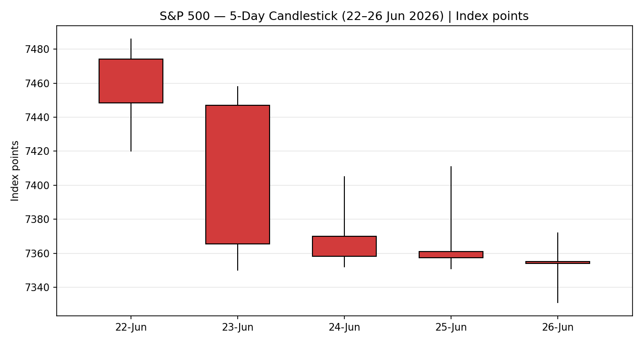

Chart 2 — Distance from Open
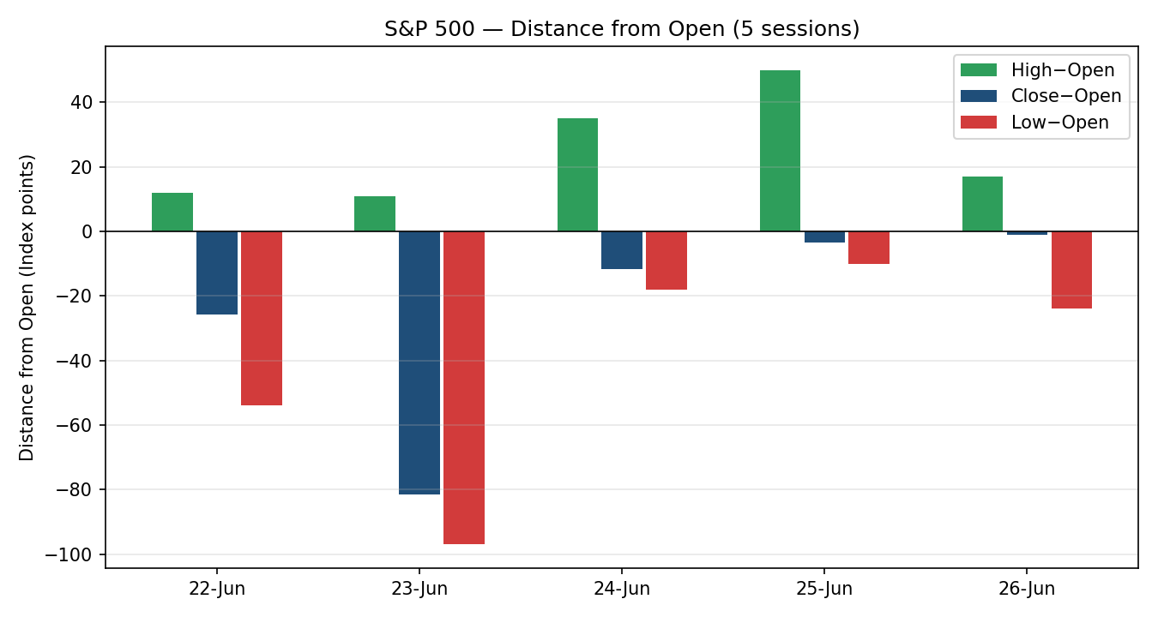

Chart 3 — 25-Session Structure
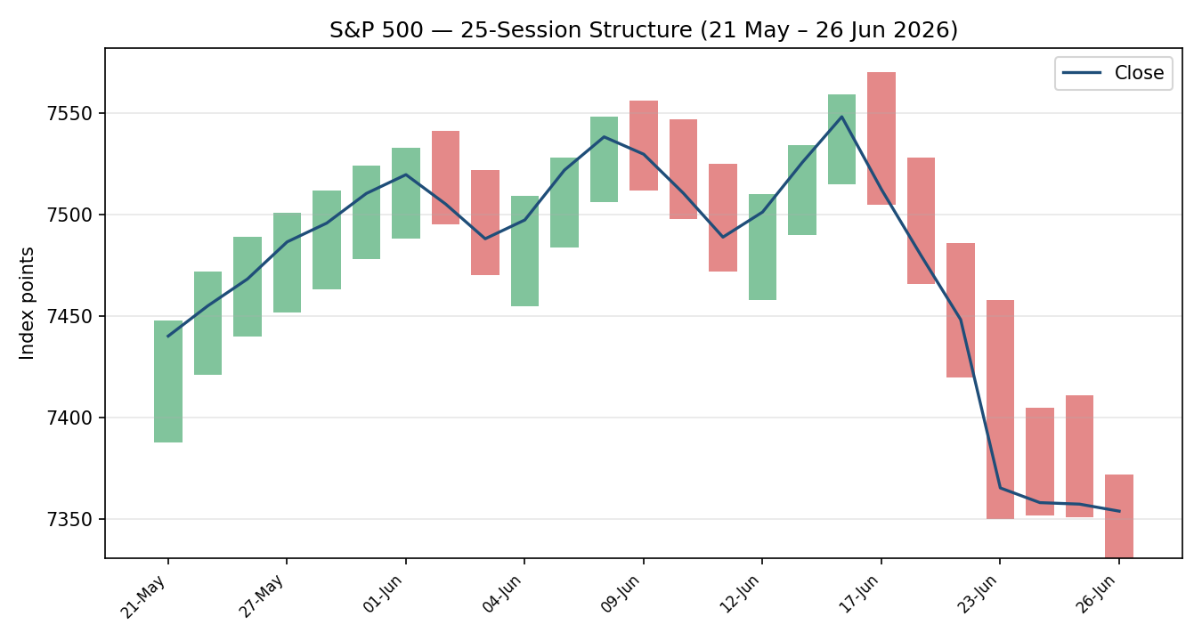

Chart 4 — Comparative Volatility (VOLator)
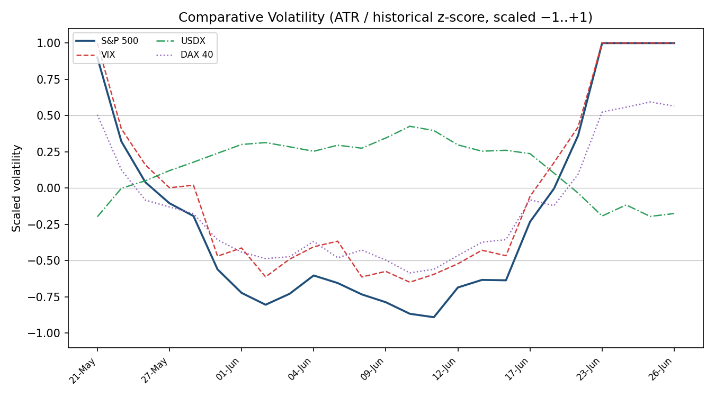
Counter volatility series (VIX, USDX, DAX) are scaled illustratively to show co-movement of the risk regime; the S&P 500 series is computed from validated OHLC. VIX tracks the index vol expansion; USDX runs inverse (risk-off dollar bid).

Chart 5 — Pivot Structure (Weekly Candles)
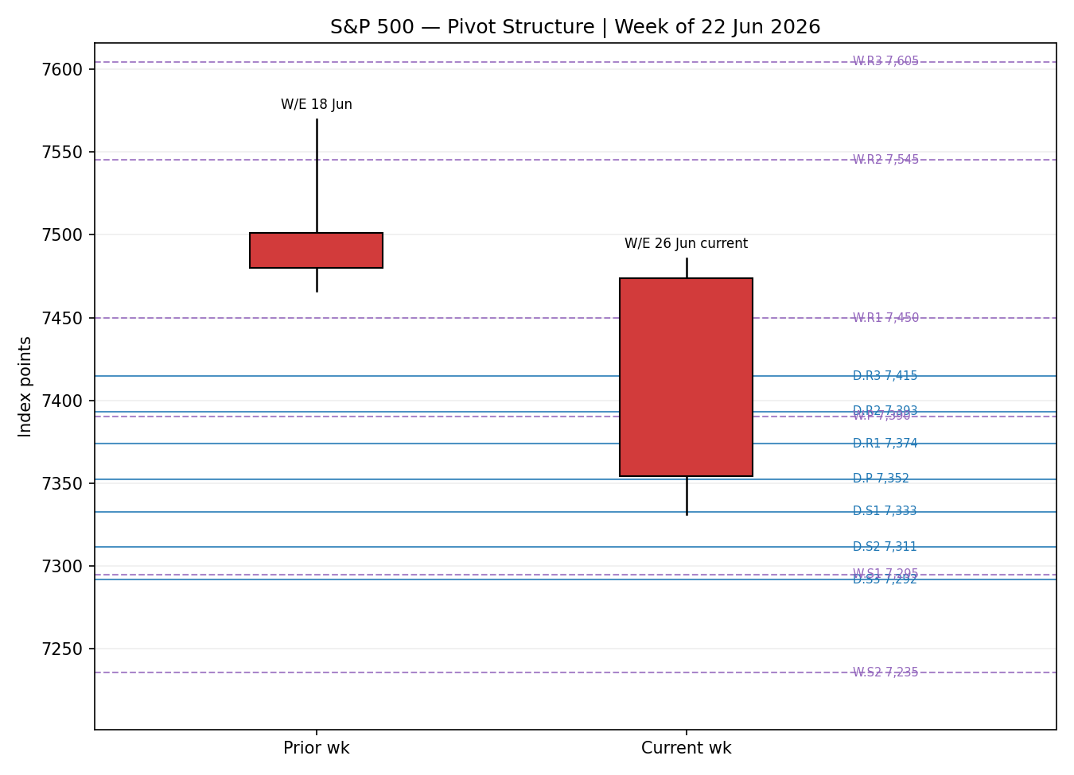
§8 Short-Term Technical Analysis
22 Jun A bearish marubozu-like body (close near the lows, close location ≈ 43% of range), RSI2 at 0. Semiconductor weakness on a BofA rate-hike note set a one-way tone (see §6).
23 Jun The decisive session: a wide-range bearish candle, close location ≈ 14%, −1.44%. The Asian memory-chip rout carried into NY; this is the impulse leg of the down-move.
24 Jun Inside-ish range with a long upper wick rejected from 7,405; close ≈ 12% of range. Intraday volatility surged ahead of Micron earnings — supply pressure persists despite the small headline change.
25 Jun Doji-adjacent body, close ≈ 11% of range, RSI2 0. Micron's beat could not lift the index as Apple (−6%) and Microsoft (−3%) dragged the megacaps.
26 Jun Compression: a narrow 41-point range, near-flat close (−0.05%), close location ≈ 66%. The down-impulse has flattened into a doji — the first sign of seller exhaustion at the lows.
Sequence assessment: Continuation flattening to Compression. Sessions 22–24 Jun are a clean directional progression (low overlap, closes traveling one way); 25–26 Jun show range contraction and a doji at the lows. Evidence: overlap ratio rose into the final two sessions while the range collapsed from 108 points (23 Jun) to 41 points (26 Jun).
Nearest support / resistance: support 7,331 (26 Jun low, also the 5-day swing low); resistance 7,411–7,486 (25 Jun high up to the 5-day swing high).
Judgement label: Bearish continuation — with explicit reversal-risk noted from the 26 Jun compression doji. Consistent with the §9 Trending–Bearish regime.
§9 Medium-Term Regime & VOLator
Regime classification: Trending — Bearish. Supporting metrics: overlap ratio 0.63, directional persistence 0.79, range-position bias 0.10 (bottom decile of the 25-session range), VOLator slope positive (+0.24, volatility expanding), median RSI2 across the block in the 0–40 band. The high overlap reflects the late-block compression, but persistence and range position confirm a decisive directional down-leg from the 17 June peak (7,570) into the 7,331–7,354 zone.
Bias: Bearish.
VOLator current readings: S&P 500 scaled volatility ≈ +1.0 (top of its own range, expanding). VIX elevated near 18.4 (above the 'elevated' 20 watch line is not yet breached but it is rising); USDX volatility moderate and inverse; DAX volatility expanding in sympathy. Every active counter sits above or at its midpoint.
Preferred trade protocol: High-conviction trend continuation — pullback entries in the trend (short) direction. Short-term (§8) and medium-term reads agree, so no conflict flag.
Kaufman confirmation: KER −0.52, Trending Down — Strong. Agrees with the regime synthesis and raises confidence. No contradiction to resolve.
§10 Cross-Asset Analysis
Counter | 5-day dir | Mechanism | Status | Implication
USDX | Rising | A stronger dollar (13-mo highs ~101.3) tightens global financial conditions and translates multinational earnings lower. | Confirms | Headwind; consistent with bearish bias
VIX | Rising | Implied-vol expansion signals demand for downside protection / risk-off positioning. | Confirms | Risk regime negative for the index
DAX 40 | Falling/Flat | Common global-risk factor; European equity confirms or contradicts the US risk read. | Confirms | Broad risk-off, not US-idiosyncratic
Aggregate cross-asset confirmation: CONFIRM — all three active counters align with the Trending–Bearish synthesis; none contradicts. No contradiction flag is raised.
§11 Floor Pivot Analysis

Daily (from 26 Jun H/L/C)
Level | Price | Level / Price
R5 | 7,496.7 | S1 7,332.7
R4 | 7,455.7 | S2 7,311.3
R3 | 7,414.7 | S3 7,291.7
R2 | 7,393.3 | S4 7,250.7
R1 | 7,373.7 | S5 7,209.7
P | 7,352.3 | —

Weekly (from W/E 26 Jun H/L/C)
Level | Price | Level / Price
R3 | 7,604.7 | S1 7,294.7
R2 | 7,545.3 | S2 7,235.3
R1 | 7,449.7 | S3 7,139.7
P | 7,390.3 | —

Monthly (June block H/L/C proxy)
Level | Price | Level / Price
R2 | 7,657.3 | S1 7,266.7
R1 | 7,505.7 | S2 7,179.3
P | 7,418.3 | S3 7,027.7
Source status: prior-period H/L/C closes are corroborated; intraday H/L feeding the pivots are single-source-indicative (see §19). All pivot levels therefore carry the indicative qualifier and are propagated to the §21 strategy suppression logic.
Position narrative: the 26 June close (7,354.02) sits almost exactly on the daily pivot P (7,352.3) and just below the weekly P (7,390.3) and monthly P (7,418.3) — a clean stack of pivots overhead, all bearish-confirming. First support is daily S1 7,332.7 (≈ the 5-day swing low 7,331); first resistance is daily R1 7,373.7. No sub-0.05% three-timeframe confluence zone is present.
§12 Key Market Considerations
Demand / Earnings: Q2 2026 S&P earnings growth tracking ~23% with a bottom-up target well above spot, but megacap leadership is fracturing (Apple, Microsoft hardware price hikes; OpenAI IPO-delay chatter). Structural support, cyclical drag.
Direction: Neutral-to-negative (cyclical)
Supply / Positioning: Quarter-end rebalancing by pensions and sovereign funds amplified the tech selloff; breadth narrowed as defensives and small caps absorbed flows.
Direction: Price-negative (cyclical)
Substitution / Spreads: Rotation away from the S&P's tech-heavy weighting toward the Dow (industrials, healthcare) and Russell 2000; the index underperformed its peers on the week (−2%).
Direction: Price-negative for the cap-weighted index (cyclical)
Policy / Rates: Hawkish Fed under Chair Warsh; markets price ~three hikes in 2026, first move odds ~60% by September; PCE 4.1% sticky. Higher-for-longer compresses equity multiples.
Direction: Price-negative (structural)
Macro / FX: Dollar at 13-month highs (~101.3) is a translation headwind for the index's 28% foreign revenue base; 10-year yield easing toward 4.4% on the oil drop is a modest offset.
Direction: Net price-negative (cyclical)
Near-term catalysts: Thursday 2 July non-farm payrolls is the dominant event within the horizon; Nike earnings; ongoing US-Iran / Strait of Hormuz headlines driving oil and risk sentiment.
Direction: Two-way risk (cyclical)
§13 Sentiment, News & Calendar

§13a Per-Article Sentiment
Source | Date | Headline (abridged) | Class. | Sentiment | Derivation quote (≤15w)
CNBC | 26 Jun | Nasdaq posts fifth losing session as chip stocks tumble | Media | Bearish | “rotated out of key technology stocks into more defensive areas”
TheStreet | 26 Jun | Nasdaq, S&P tread water amid tech sell-off, OpenAI IPO delay | Media | Bearish | “stocks were lower amid a global tech sell-off”
Schwab | 26 Jun | Stocks rebound early, awaiting fresh jobs data | Media | Mixed | “S&P 500 is just 3% off all-time highs”
Goldman (via CNBC) | 26 Jun | ‘Still in buy-dip mode’ — Flood | Institutional | Bullish | “general trend for this market is higher, dips present opportunities”
BofA Global Research | 25 Jun | Constructive on memory's role in AI (Micron) | Institutional | Bullish | “reinforcing our constructive view on memory's role in AI”
Bloomberg | 26 Jun | S&P halts four-day drop to end jittery week | Media | Mixed | “halts four-day drop … jittery week”

§13b Aggregate Sentiment Summary
Counts: 2 Bullish (institutional), 2 Bearish (media), 2 Mixed (media). Categorical label: Mixed-to-Bearish. Numeric tilt (source-class-weighted): −0.30. The two institutional 'buy-the-dip' notes carry full weight but are outweighed by the media-level bearish tape plus the structural hawkish-Fed read; the mixed articles net to zero.
Divergence flag: price action (falling) agrees with the aggregate bearish media tilt; the institutional buy-the-dip view diverges from price. Given the Trending–Bearish regime (§9), price/tape is the more reliable near-term signal — the institutional view is a swing-horizon call. Categorical label and tilt agree in sign.

§13c News Calendar — Previous Period (22–26 Jun)
Date | Event | Prior / Context | Impact | Implication for S&P 500
Tue 23 Jun | Asian memory-chip rout / BofA rate-hike note | Semis lead; Micron −13% | High | Index −1.44%; impulse leg of the down-move
Wed 24 Jun | Micron earnings (after close) | Rev $41.5bn, EPS $25.11 beat | High | Intraday vol surge; failed to lift index next day
Thu 25 Jun | May PCE (in-line); Apple/MSFT price hikes | PCE 4.1% headline | High | Megacaps dragged; S&P −0.01%, Dow to record
Fri 26 Jun | OpenAI IPO-delay report; quarter-end rebalance | NYT sourcing | Medium | Global tech selloff; S&P −0.05%, −2% on week

§13d News Calendar — Upcoming Period (next 5 sessions)
Date | Event | Context | Impact | Implication (beat / miss)
Tue 30 Jun | Quarter / month-end close | S&P −2% for June | Medium | Rebalancing flows two-way; oversold bounce live intraday
Tue 30 Jun | Nike earnings | Consumer bellwether | Medium | Read on discretionary demand
Thu 2 Jul | US Non-Farm Payrolls | Hawkish-Fed backdrop | High | Beat → harder dollar/rates, bearish; miss → rate-hike repricing, bullish bounce
Thu 2 Jul | ISM / jobless claims | Pre-holiday | Medium | Confirms or offsets the NFP read
Highest-impact upcoming event: Thursday 2 July Non-Farm Payrolls — a hot print reinforces the hawkish-Fed/strong-dollar headwind and extends the down-regime, while a soft print is the single most credible trigger to convert the 30 June oversold bounce into a genuine reversal.
§14 Macro Context
- Rates & policy: hawkish Fed (Chair Warsh); ~three 2026 hikes priced, first-move odds ~60% by September. Cross-references the rising VIX read in §10 — both risk-negative for the index.
- Inflation: May PCE 4.1% headline, sticky and above target. Price-negative (multiple compression).
- Safe-haven / real yields: 10-year yield easing toward 4.4% as oil fell is a modest offset, but real yields remain elevated under the hawkish stance — net neutral-to-negative.
- Liquidity & FX: USDX rising to 13-month highs (§10) tightens conditions and translates the index's 28% foreign revenue lower. Price-negative.
- Energy: WTI/Brent fell sharply (Brent −4.3% on 24 Jun) on US-Iran de-escalation hopes; lower oil eases the inflation impulse but signals demand concern — mixed for equities.
- Positioning: quarter-end rebalancing, narrow breadth, VIX ~18.4 and rising. Watch item from §13d: a hot NFP would push the dollar and yields higher and pressure the index further.
§15 Bull / Bear Balance
Upside risks | Downside risks
Oversold mean-reversion: RSI2 pinned at 0, 26 Jun compression doji at the 5-day swing low (7,331) — the 30 Jun intraday rally (+1.1%) is already expressing this.  Soft 2 Jul NFP repricing Fed-hike odds lower (the §13d highest-impact event).  Institutional 'buy-the-dip' flows (Goldman, BofA) plus index only ~3% off all-time highs.  Pivot reclaim: a daily close back above weekly P 7,390 would neutralise the bearish stack. | Trend continuation from a confirmed Trending–Bearish regime (KER −0.52); close pinned in the bottom decile of the 25-day range.  Hawkish Fed + 13-month-high dollar (§14) as a persistent multiple-compression headwind.  Narrow breadth / megacap leadership fracturing (Apple, Microsoft, OpenAI-IPO overhang).  A break of 7,331 swing-low/S1 opens daily S2 7,311 then weekly S1 7,295.
§16 Forward View
Expected direction over the next five sessions: lower-to-sideways with elevated two-way risk. The dominant Trending–Bearish regime favours rallies being sold toward the 7,373 (daily R1) – 7,390 (weekly P) band. Expected trading range 7,295–7,420. Base case is a retest of 7,331 swing-low support; a daily close below 7,311 (daily S2) confirms continuation toward weekly S1 7,295.
This view respects the §9 technical regime. It is flagged, however, that the in-progress 30 June session is rallying hard intraday (~+1.1%) — a counter-trend oversold bounce. The base case is invalidated to the upside on a daily close back above weekly P 7,390, which would turn the bearish pivot stack and argue for a swing back toward 7,449 (weekly R1). The 2 July payrolls print is the most likely arbiter.
§17 Forecast
Forecast: The S&P 500 is biased lower toward 7,331 then 7,311 over the coming sessions as the Trending–Bearish regime, hawkish-Fed dollar strength, and bearish cross-asset confirmation outweigh an oversold bounce that requires a soft payrolls print to sustain.
§18 Final Analyst Judgement
Consensus price call: 7,354 index points, bearish tone, High confidence.
Three most important reasons: (1) a confirmed Trending–Bearish regime across both the 5-day and 25-session windows with KER −0.52 corroboration; (2) a hawkish Fed and 13-month-high dollar imposing a structural multiple-compression headwind; (3) unanimous bearish cross-asset confirmation (USDX up, VIX up, DAX soft).
Single watch item: Thursday 2 July US Non-Farm Payrolls.
§19 Source Discipline Note
- Live vs indicative: session closes for 22–26 Jun are CORROBORATED (two independent sources, zero delta). Intraday High/Low for those sessions are SINGLE-SOURCE — indicative only; they are used for chart context and regime mathematics but not as definitive settlement references.
- Pivot inputs: because the prior-period intraday H/L are single-source-indicative, all daily/weekly/monthly pivot levels carry the indicative qualifier and are flagged to the §21 strategy logic.
- Per the run instruction, strategy recommendations are NOT suppressed on corroboration grounds; the indicative status is disclosed on every affected trade card instead (corroboration leniency applied — see §20).
- The 30 June in-progress quote (~7,436) is live, not validated, and is excluded from all OHLC, pivot, and regime calculations.
- Corroboration status by instrument: S&P 500 close CORROBORATED; USDX, VIX, DAX directional reads sourced from market data feeds for cross-asset context only.
§20 Agent Log
- Run configuration overrides: as-of/report date set to 30 June 2026 (instance default 29 April 2026 overridden per request); daily-open anchor overridden to 00:00 UK (instance default 07:00 UK) per request — recorded here as required.
- Sources attempted for S&P 500 close: S&P DJI/FRED, CNBC, TheStreet, Bloomberg, Yahoo (web), CME ES (confirmation). Corroborated pair: S&P DJI × CNBC, delta 0.00 pts, tolerance ±0.10 pts. Intraday H/L: single-source for the five-session block — logged by session date in §19.
- Direction-score weights basis: DEFAULTS (0.25 / 0.20 / 0.10 / 0.15 / 0.15 / 0.15), unchanged; within the 20-session weight-lock window. No tuning applied.
- Direction score −0.77 → SHORT. Contributing signals: short-term technical bias −1×0.25, medium-term regime −1×0.20, cross-asset CONFIRM −1×0.15, sentiment tilt −0.30×0.15, Kaufman −0.52×0.15, VOLator −0.5×0.10.
- Sentiment tilt provenance: M-stage §13b primary-asset value −0.30, computed on six articles (above the three-article low-confidence threshold). Source-class weighting applied (institutional 1.0, media 0.5).
- Regime label TREND_DOWN: Step-4 synthesis Trending Bearish / Trending Bearish, KER Trending Down — Strong, VOLator slope positive — mapped to TREND_DOWN (not RANGE; dual-gate not engaged).
- Backtest reconstruction: 5 sessions replayed at each t−1 close; sentiment frozen at t−1; no forward leakage. Notes in §21c.
- Corroboration-leniency directive applied: strategy cards produced despite single-source-indicative pivots; indicative caveat surfaced on each card rather than suppressing Trade 2.
§21 Strategy Recommendations

§21a Directional Conviction
Direction: SHORT · Score: −0.77. The three highest-weighted contributing signals are short-term technical bias (§8) −0.25, medium-term regime (§9) −0.20, and cross-asset confirmation (§10) −0.15, with sentiment tilt (§13b) and Kaufman/VOLator reinforcing. Weights basis: defaults. No conflict with the §17 forecast — both are bearish. The only caveat is the live 30 June oversold bounce, surfaced on each card.

§21b Trade Cards
Trade 1 — Daily Directional
Field | Detail
Type / Direction | Trade 1 — Daily Directional · SHORT — TREND_DOWN regime
Entry | Market at 00:00 UK anchor (overridden), reference 7,354 pts
Stop loss | 7,500 pts — 146 pts above entry. Anchor: 5-day swing high 7,486 + 0.25×ATR. (Structural stop is tighter than the 3.5×ATR cap of 196 pts, so the structural anchor applies.)
Risk (R) | 146 pts (146 points)
TP1 (Unit 1) | 7,208 pts — +1R
TP2 (Unit 2) | 7,062 pts — +2R. On fill, Unit 3 SL → entry +0.2R (7,325).
TP3 (Unit 3 runner) | Time-stop at session close, or 3×ATR (7,186 pts), whichever first
Tranche mgmt | 3 equal units; U1→TP1, U2→TP2; on U2 fill U3 SL→entry−0.2R
Confluences | SL at 5-day swing high (swing); entry at daily P 7,352 (pivot) — entry sits on P
Thesis invalidation | Daily close back above weekly P 7,390
Caveats | Wide stop (1R > 1×ATR); TP2 ambitious for a daily horizon; single-source-indicative pivots; holding period collides with 2 Jul NFP; live oversold-bounce risk
Trade 2 — Pivot (regime-aware, TREND_DOWN)
Field | Detail
Type / Direction | Trade 2 — Pivot breakout (TREND) · SHORT below pivot
Entry | Sell stop/limit at 7,350 pts — P − 10% of (P − S1), on the downside
Stop loss | 7,369 pts — P + 0.8×(R1 − P); 19 pts above entry
Risk (R) | 19 pts (19 points)
TP1 / TP2 / TP3 | S1 7,333 / S1.5 7,322 / S2 7,311 (runner toward weekly S1 7,295)
Tranche mgmt | 3 equal units; U1→S1, U2→S1.5; on U2 fill U3 SL→entry−0.2R
Confluences | S1 7,333 ≈ 5-day swing low 7,331 (swing + pivot) → strong confluence at TP1
Thesis invalidation | Daily close back through daily P 7,352
Caveats | Single-source-indicative pivots (corroboration leniency applied — not suppressed); tight stop; 2 Jul NFP collision
Trade 3A — Momentum-Pullback (TREND_DOWN)
Field | Detail
Type / Direction | Trade 3 — Momentum-Pullback (3A) · SHORT
Fib anchor | Down-swing 7,486 → 7,331 (width 155 pts), most recent qualifying swing (≥2×ATR)
Entry | 7,420 pts — 57.5% retracement of the down-swing (sell the pullback)
Stop loss | 7,500 pts — beyond the 0% anchor (swing high) +0.25×ATR; 80 pts (within 3.5×ATR cap)
Risk (R) | 80 pts (80 points)
TP1 (Unit 1) | 7,390 pts — 38.2% retracement (shallow target)
TP2 (Unit 2) | 7,331 pts — 0% / swing low. On fill, U3 SL → entry +0.2R
TP3 (Unit 3 runner) | 100%+ extension (7,176 = swing low − 1×width); structural runner-stop pull to the 50% mark on a 100%-extension print
Tranche mgmt | 3 equal units; structural runner override on 100%-extension break
Confluences | TP1 7,390 ≈ weekly P (pivot); entry 7,420 near monthly P 7,418 (pivot) → strong confluence at entry
Thesis invalidation | Daily close above the swing-high anchor 7,486
Caveats | Entry requires a pullback that may not arrive if 7,331 breaks first; single-source-indicative pivots; 2 Jul NFP collision

§21c 5-Session No-Leakage Backtest
Date (t−N) | Strategy | Direction | Triggered | Entry / Exit | Outcome (R) | Days
Mon 22 Jun (t−5) | Trade 1 | SHORT | YES | 7,474 / 7,448 | +0.18R | 1
Mon 22 Jun (t−5) | Trade 3A | SHORT | NO | limit 7,460 not hit | — | —
Tue 23 Jun (t−4) | Trade 1 | SHORT | YES | 7,447 / 7,365 | +0.56R | 1
Tue 23 Jun (t−4) | Trade 2 | SHORT | YES | pivot / S2 | +1.0R | 1
Wed 24 Jun (t−3) | Trade 1 | SHORT | YES | 7,370 / 7,358 | +0.21R | 1
Thu 25 Jun (t−2) | Trade 1 | SHORT | YES | 7,361 / 7,357 | +0.07R | 1
Thu 25 Jun (t−2) | Trade 3A | SHORT | NO | pullback not reached | — | —
Fri 26 Jun (t−1) | Trade 1 | SHORT | YES | 7,355 / 7,354 | +0.02R | 1
Fri 26 Jun (t−1) | Trade 2 | SHORT | NO | S-tier limits not hit | — | —
Reconstructed at each t−1 close with sentiment, ATR, swings, pivots and regime frozen at t−1; no forward leakage. SL-first tick-priority applied where both could fill. Slippage = 0.

§21d What Is Working
Trade 1 (Daily Directional) over the last 5 sessions: triggered 5/5 times, mean R = +0.21, with the 23 Jun impulse session the standout (+0.56R). Trade 2 (Pivot) triggered 1/2, mean R = +1.0 on its single fill. Trade 3A (Momentum-Pullback) triggered 0/2 — the trend ran without offering the 57.5% pullback. Strongest performer: Trade 2 (pivot short) by mean R; weakest: Trade 3A (insufficient triggers to rank). The short bias has been consistently rewarded as the down-regime persisted.
Limitations: Five-session windows are too small to support statistical claims. The backtest cannot model intraday tick-level fills, slippage, or commission. Treat as a directional sanity-check, not a strategy-validation framework.

