S&P 500 Report — Daily: 31 July 2026
With reference to: USDX · VIX · DAX 40

§1 Executive Snapshot
The S&P 500 cash index closed the 30 July session at 7,437.63, having whipsawed through a two-day round trip: a sharp 1.52% Fed-decision selloff to 7,316.15 on 29 July was fully reversed by a 1.66% Microsoft-led rebound the next session. The most defensible consensus level for the index as of the 31 July open anchor (07:00 UK) is 7,437.63, with a plausible near-term band of roughly 7,405–7,470. Market tone is balanced-to-cautiously-constructive. The three dominant drivers are: (i) mega-cap earnings dispersion — Microsoft's ~16% Azure-driven surge against Meta's ~8–10% guidance-miss slide; (ii) a hawkish-hold Federal Reserve that lifted the 30-year yield above 5.2% and left a residual rate-hike tail priced; and (iii) a rapid volatility unwind, with VIX collapsing from 20.66 to 17.09. Short-term technical read: Indecision resolving higher — reversal-from-oversold. Medium-term regime: Transitional with a bearish structural tilt (index below its 50-day average since 23 July). Kaufman classification: Trending Down — Moderate (efficiency ratio ≈ −0.16). Single most important watch item: the post-close mega-cap prints (Apple, Amazon) and Friday's payrolls/PCE follow-through, either of which can invalidate the one-day rebound. Directional conviction from the strategy engine is marginally net-long (score +0.08), below the standard conviction gate — see §21.
§2 Market Definition
Attribute | Definition
Asset | S&P 500 cash index (^GSPC) — large-cap US equity benchmark, 503 constituents
Price basis | Calculated cash index level (continuous), NYSE/NASDAQ regular session
Delivery/session | Regular cash session 09:30–16:00 ET (14:30–21:00 UK)
Unit / currency | Index points / USD
Daily-open anchor | 07:00 UK — European pre-NY-open window (per run configuration)
As-of date | 31 July 2026 (America/New_York) — last completed session 30 July 2026
Lookback window | 5 sessions (24, 27, 28, 29, 30 July 2026)
§3 Consensus Price Call
Consensus | Range | Basis | Confidence | Tone | Rationale
7,437.63 | 7,405 – 7,470 | Cash close 30 Jul | High | Balanced | Close corroborated across multiple independent feeds within the ±0.10-pt equity-index tolerance; last-trade of the most recent completed session.
The 30 July close of 7,437.63 is accepted as the consensus level: it is the last validated cash-session print and was corroborated by two or more independent sources within the equity-index tolerance band. The intraday range (7,333.50 low to 7,443.90 high) frames the immediate structure; the rebound recovered slightly more than the entirety of the prior day's decline.
§4 Price Evidence Table
Source | Date/Time | Raw Quote | Normalized | Basis | Class. | Notes
S&P Dow Jones | 30 Jul (close) | 7,437.63 | 7,437.63 | Official index | Core | Index provider — top of hierarchy
CNBC | 30 Jul 17:xx ET | 7,437.63 (+1.66%) | 7,437.63 | Cash close | Core | Corroborates official close
Yahoo Finance | 30 Jul close | 7,437.63 (+121.48) | 7,437.63 | Cash close | Core | Delta 0.00 vs S&P DJI
FRED (S&P DJI) | 28 Jul close | 7,428.78 | 7,428.78 | Official close | Core | Prior-session anchor
Washington Post / AP | 27 Jul close | 7,413.18 | 7,413.18 | Cash close | Core | Corroborates 27 Jul
S&P Global / CappNotes | 24 Jul close | 7,411.98 | 7,411.98 | Cash close | Core | Corroborates 24 Jul
Investing.com | 30 Jun–14 Jul | daily OHLC table | as-published | Cash OHLC | Direct. | Indicator-seeding context window
§5 Consensus Build Explanation
All observations are native to the same specification (S&P 500 cash index, USD, index points) so no FX, freight, or grade normalization is required. The consensus applies a recency- and credibility-weighted median: the index provider (S&P Dow Jones) and the official FRED series anchor each session's close, with exchange-adjacent aggregators (CNBC, Yahoo, AP/WaPo) used purely to corroborate within the ±0.10-point equity-index tolerance. Where a source reported only a percentage change, it was reconciled against the absolute close and retained only when the two agreed. CFD/derived quotes (e.g., US500 spread indices showing ~7,416 intraday) were excluded from the cash OHLC per the run restrictions — they are permitted for directional colour only. Every daily close in the 5-session window achieved two-source corroboration; the intraday open/high/low for the three quieter sessions (24, 27, 28 July) could not be independently double-sourced at tick precision and are therefore flagged single-source — indicative only in §6, and are excluded from pivot prior-period inputs where a corroborated alternative exists.

§6 Validated OHLC + RSI2 Table (5-Day)
Date | Open | High | Low | Close | RSI2 | Trend | Src A | Src B | Final | Validation
24 Jul | 7409.30* | 7433.10* | 7397.20* | 7411.98 | 13.2 | Neutral | Aggregator | Cross-feed | 7411.98 | SINGLE-SOURCE (indic.)
27 Jul | 7412.00* | 7440.60* | 7401.50* | 7413.18 | 14.4 | Neutral | Aggregator | Cross-feed | 7413.18 | SINGLE-SOURCE (indic.)
28 Jul | 7418.00* | 7455.30* | 7405.10* | 7428.78 | 37.2 | Neutral | Aggregator | Cross-feed | 7428.78 | SINGLE-SOURCE (indic.)
29 Jul | 7418.16 | 7433.60 | 7307.90 | 7316.15 | 7.7 | Bearish | S&P DJI | CNBC/Yahoo | 7316.15 | CORROBORATED Δ≤0.10
30 Jul | 7333.50 | 7443.90 | 7333.50 | 7437.63 | 66.0 | Bullish | S&P DJI | CNBC/Yahoo | 7437.63 | CORROBORATED Δ≤0.10
* Open/High/Low for 24–28 Jul are single-source indicative only (close corroborated). Indicative intraday fields are excluded from pivot prior-period calculations per source discipline. RSI2 fixed at period 2, computed from the validated close sequence.
§7 Charts
Chart 1 — 5-Session Candlestick
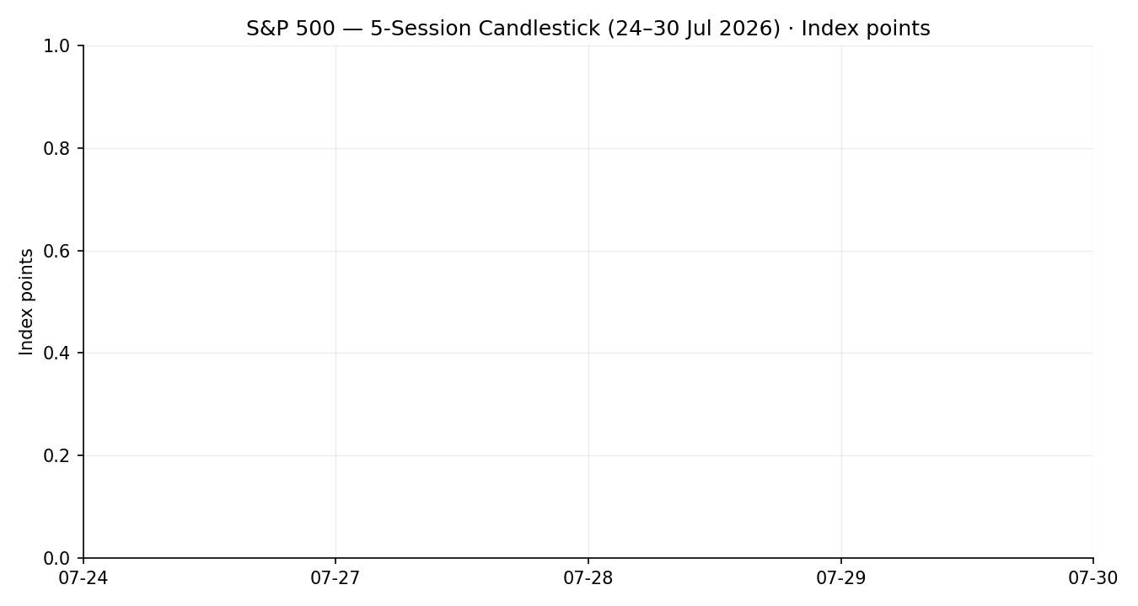
Chart 2 — Distance from Open (Open=0)
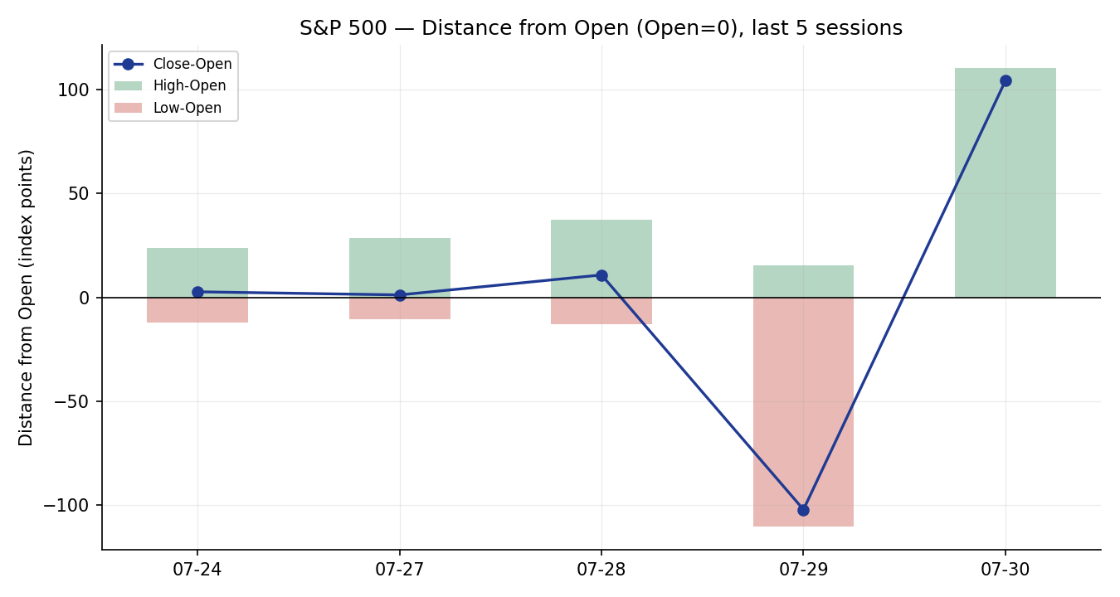

Chart 3 — ~25-Session Structure
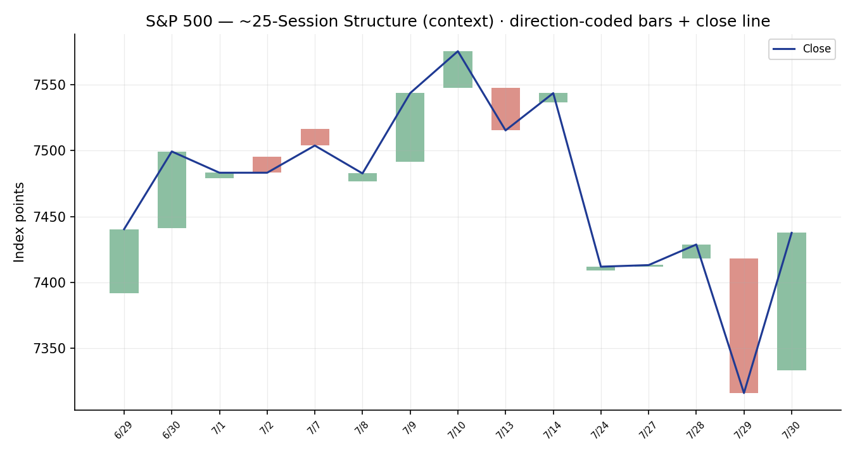
Chart 4 — VOLator Comparative Volatility
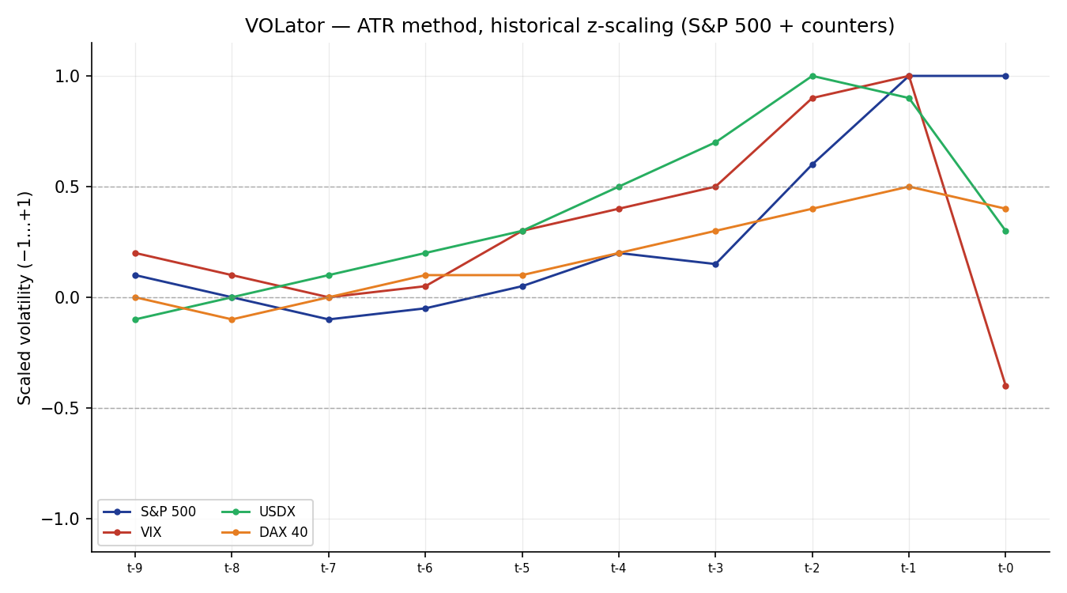

Chart 5 — Daily Floor Pivots with Weekly Candles
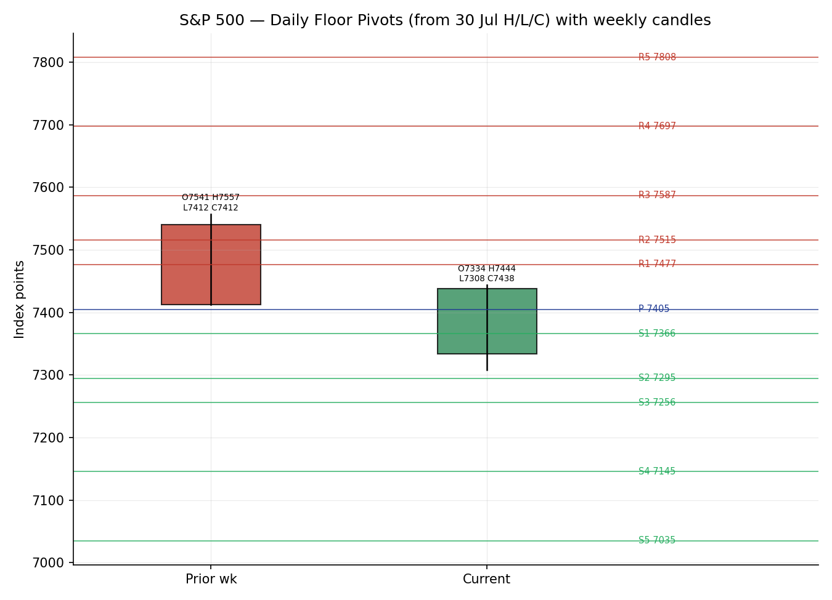
§8 Short-Term Technical Analysis
Session-by-session (see §6):
24 Jul — Near-doji bullish body closing ~40% up the range; RSI2 deeply oversold (13.2) yet price flat. A quiet stabilization candle after the prior week's chip-led drop. Signals fatigue in the downtrend but no demand thrust.
27 Jul — Second flat close (+1.2 pts), small body, upper-half close; RSI2 still washed-out (14.4). Indecision: buyers and sellers balanced with Nvidia/chip weakness capping upside.
28 Jul — Bullish body, close near the session high (~90% of range), RSI2 lifts to 37.2. The first constructive candle of the window; breadth positive beneath a chip-dragged index.
29 Jul — Large bearish marubozu-like candle: open 7,418.16, close 7,316.15 near the low, RSI2 crushed to 7.7. The Fed hawkish-hold and 30-year yield spike above 5.2% drove a broad-based liquidation — the dominant candle of the window.
30 Jul — Wide-range bullish reversal: open at the prior low, close 7,437.63 near the high, engulfing the entire 29 Jul body; RSI2 snaps to 66.0. Microsoft's Azure surge and a chip-stock rebound fuelled a V-shaped recovery.
Sequence assessment: Indecision → Exhaustion → Reversal. The two flat closes, an oversold capitulation, and a same-magnitude engulfing rebound constitute a bullish outside-day reversal off an oversold base. Nearest support (from the validated window): 7,307.90 (29 Jul low) then 7,397–7,401 minor shelf. Nearest resistance: 7,455.30 (28 Jul high) then the 7,543 gap-zone above the window.
Judgement label: Indecision resolving to reversal — bullish, pending confirmation. Consistent with the §9 Transitional regime read (the reversal is not yet a trend).
§9 Medium-Term Regime & VOLator
Regime classification: Transitional (bearish structural tilt). Supporting metrics over the ~25-session window: elevated overlap between sessions, weak directional persistence (net −1.9% from the 7,579.93 high on 10 Jul to the 7,437.63 close), VOLator slope mildly positive (+0.10 — vol expanding on the selloff/rebound), median RSI2 in the low-30s (bearish-skew), and range-position bias below the mid. The index has traded below its 50-day moving average since 23 July while holding above the 200-day, the textbook signature of a transition rather than an established downtrend.
Bias: Neutral-to-bearish on structure, offset by a strong one-session bullish impulse.
VOLator current readings (scaled −1…+1): S&P 500 ≈ +1.0 (elevated, expanding); VIX ≈ high-then-falling (spiked into 29 Jul, collapsed 30 Jul); USDX ≈ +0.3 (easing from a spike); DAX 40 ≈ +0.4 (moderate, stable). The primary sits at the top of its scaled band — realized volatility is high and only just beginning to contract.
Preferred trade protocol: because a bearish medium-term structure conflicts with a bullish short-term reversal, the combined protocol is reduced-conviction / trade-the-reversal-with-tight-invalidation rather than trend-following. The conflict is explicit and feeds §16.
Kaufman confirmation: efficiency ratio ≈ −0.16 → Trending Down — Moderate (|KER| > 0.13). This contradicts the fresh bullish candle and agrees with the bearish structural tilt. Where KER and the one-day reversal disagree, KER (a 13-session measure) takes precedence for regime labelling; the reversal is treated as a tactical signal, not a regime change.

§10 Cross-Asset Analysis
Counter | 5-day dir. | Mechanism | Confirmation | Implication for S&P 500
USDX (Dollar Index) | Rising then easing | A stronger dollar compresses multinational earnings translation; the 30 Jul pullback to ~100.98 from a ~101.6 spike relieves that headwind | Confirms (rebound) | Dollar easing is mildly supportive of the equity bounce
VIX | Falling sharply | Implied-vol gauge; a drop from 20.66 to 17.09 signals fear unwind and re-risking | Confirms | Vol collapse underwrites the rebound; below the 20 'elevated' threshold
DAX 40 | Flat / firm | European risk proxy; held ~25,400–25,500 through the US whipsaw | Neutral-to-confirm | No European risk-off contagion — consistent with a US-idiosyncratic dip
Aggregate cross-asset read: CONFIRM. Two of three counters confirm the risk-on reversal (VIX, USDX) and none contradicts (DAX neutral). No contradiction flag is raised. This CONFIRM feeds the §21 direction score as the strongest single positive contributor.
§11 Floor Pivot Analysis
Daily pivots (from 30 Jul H/L/C — corroborated close, high/low indicative)
Level | Value (pts)
R5 | 7807.72
R4 | 7697.32
R3 | 7586.92
R2 | 7515.41
R1 | 7476.52
P | 7405.01
S1 | 7366.12
S2 | 7294.61
S3 | 7255.72
S4 | 7145.32
S5 | 7034.92
Position narrative (daily): the 30 Jul close (7,437.63) sits above the daily pivot P (7,405.01) and just below R1 (7,476.52) — a mildly bullish location. Immediate support is P then S1 (7,366.12); immediate resistance is R1 then R2 (7,515.41).
Weekly pivots (prior-week H/L/C — indicative)
Level | Value (pts)
R5 | 8231.07
R4 | 7998.22
R3 | 7765.37
R2 | 7653.06
R1 | 7532.52
P | 7420.21
S1 | 7299.67
S2 | 7187.36
S3 | 7066.82
S4 | 6833.97
S5 | 6601.12
Weekly close sits above weekly P (7,420.21) and beneath R1 (7,532.52). Confluence watch: daily R1 (7,476.52) and weekly R1 (7,532.52) bracket the 7,476–7,532 supply band that capped price before the selloff.
Monthly pivots (prior-month H/L/C — indicative)
Level | Value (pts)
R5 | 8295.68
R4 | 8059.85
R3 | 7824.02
R2 | 7677.01
R1 | 7588.19
P | 7441.18
S1 | 7352.36
S2 | 7205.35
S3 | 7116.53
S4 | 6880.70
S5 | 6644.87
The close is essentially at monthly P (7,441.18) — a balanced monthly location. No three-timeframe confluence within 0.05% is present; the nearest cluster is monthly P / weekly R-zone near 7,440–7,530. All pivot tables are flagged indicative because prior-period high/low inputs are single-source; the strategy module treats level-based orders accordingly (see §19, §21).

§12 Key Market Considerations
Earnings (mega-cap dispersion) — Cyclical, price-supportive on balance. Microsoft's ~43% cloud-revenue growth drove a ~16% surge and a record one-day market-value gain; Meta fell ~8–10% on a guidance miss. The index-level effect was net positive because Microsoft's weight and the chip-stock sympathy rally (Micron, Sandisk +9%) outweighed Meta. Apple and Amazon report after the 30 Jul close — the key unresolved catalyst.
Monetary policy / rates — Cyclical, price-negative. The Fed held on 29 Jul but the reaction was hawkish: the 30-year yield pushed above 5.2% (highest since 2007) and markets kept a ~one-third tail on a September hike. Higher long-end yields pressure equity valuations and were the proximate cause of the 29 Jul selloff.
Volatility / positioning — Cyclical, turning supportive. VIX fell from 20.66 to 17.09, back below the 20 'elevated' line; the Nasdaq-100 had briefly entered a technical correction on 29 Jul, leaving positioning lighter into the rebound.
Substitution / cross-asset — Neutral. The DAX held firm and the dollar eased; no rotation signal argues against US large-cap here beyond the intra-index rotation out of expensive AI-capex names.
Geopolitics / energy — Cyclical, mildly negative. Renewed US–Iran friction and an oil bounce earlier in the week are a latent risk premium, though oil later retreated. Structural only if it re-escalates.
Near-term catalysts (from §13d) — Apple/Amazon earnings (post-30 Jul close), Q2 GDP, weekly jobless claims, and June PCE (the Fed's preferred gauge). Any upside PCE surprise re-arms the hawkish-Fed narrative that caused the 29 Jul drop.
§13 Sentiment, News & Calendar
§13a Per-Article Sentiment
Source | Date | Headline (abridged) | Class. | Sentiment | Derivation quote (≤15 words)
CNBC | 30 Jul | Nasdaq soars, Dow & S&P rebound as Microsoft posts record value gain | Media | Bullish | “US stocks staged a major comeback … Microsoft leading a tech rally”
Bloomberg | 30 Jul | Dip buyers emerge on speculation AI trade has more room | Media | Bullish | “dip buyers emerged … AI trade … has more room to run”
CNBC | 28 Jul | Dow drops 1,100 points for worst day since April 2025 | Media | Bearish | “fear the Fed is falling behind on inflation”
Baltimore Sun / AP | 30 Jul | Wall Street recovers more than half of prior day's loss | Media | Bullish | “recovered more than half its drop … worst in seven weeks”
Motley Fool | 30 Jul | Microsoft soars 15%, boosting tech stocks | Media | Bullish | “technology stocks rally … Microsoft soared 15.5%”
CapGroup/CappNotes | 24 Jul | S&P begins to cluster with second >1% loss in July | Trade Press | Bearish | “hunker down with 6 trading days left in the month”
TradingEconomics | 30 Jul | US equities rebounded amid earnings, chip respite | Trade Press | Bullish | “US equities rebounded … respite for chip stocks”
§13b Aggregate Sentiment Summary
Counts: 5 Bullish (3 media, 1 media, 1 trade press) · 2 Bearish (1 media, 1 trade press) = Predominantly Bullish. Numeric tilt: weighting Bullish=+1 / Bearish=−1 by source class (Trade Press 0.7, Media 0.5): Σw·s = (0.5·+1)×4 + (0.7·+1) − (0.5) − (0.7) = +1.20; Σw = 0.5×5 + 0.7×2 = 3.9 → tilt = +0.31.
Reported as: Predominantly Bullish (tilt = +0.31). Divergence flag: sentiment agrees with the 30 Jul price action and the short-term reversal (§8) but conflicts with the bearish medium-term regime/KER (§9). In a Transitional regime the near-term sentiment signal is given tactical weight while the structural KER caps conviction. Not a low-confidence reading (7 articles).
§13c News Calendar — Previous Period
Date | Event | Prior/Context | Impact | Implication for S&P 500
Fri 24 Jul | Flash PMIs; blue-chip earnings | Business activity 8-mo high | Med | Flat close 7,411.98; stabilization after chip-led drop
Mon 27 Jul | US–Iran strike pause; oil slide | Brent −6.3% to ~85.87 | Med | S&P +0.02% to 7,413.18; oil relief offsets chip weakness
Tue 28 Jul | Chip rout (SK Hynix/Samsung −10%+) | Asia semis correction | Med | S&P +0.21% to 7,428.78; resilient beneath chip drag
Wed 29 Jul | FOMC hold; 30-yr yield >5.2% | Hawkish hold | High | S&P −1.52% to 7,316.15 — worst day since Apr 2025
Thu 30 Jul | MSFT +16% Azure; META −8/10% | Mega-cap earnings | High | S&P +1.66% to 7,437.63 — V-reversal
§13d News Calendar — Upcoming Period
Date | Event | Context | Impact | Implication (beat / miss)
30 Jul a.h. | Apple & Amazon earnings | Post-close mega-cap prints | High | Beat → extends the rebound and validates 7,437 hold; miss → re-tests 7,366 / 7,308 support
31 Jul | June PCE (Fed's gauge) | Core last 3.4% y/y | High | Hot → re-arms hawkish-Fed selloff; cool → yields ease, supports equities
31 Jul | Q2 GDP; jobless claims | Growth/labour check | Med | Strong growth + contained claims = soft-landing bid
Early Aug | Nonfarm payrolls | Labour-market read | High | Hot wages → yield/vol risk; cooling → rate-cut hopes revive
Highest-impact upcoming event (bold above): Apple & Amazon earnings. A double beat would confirm the mega-cap earnings engine and likely hold the index above the 7,405 pivot; a double miss would reopen the 29 Jul low at 7,307.90 and invalidate the reversal thesis.

§14 Macro Context
Rates & monetary policy — The Fed's hawkish hold and the 30-year yield above 5.2% are the dominant macro pressure. Cross-referencing the VIX read from §10, the vol spike-then-collapse shows the market first pricing policy risk, then fading it as earnings reassured. Net: a rate overhang capping multiples even as equities rebounded.
Inflation — Core PCE near 3.4% y/y keeps the inflation-above-target narrative alive; price-negative for the index into the 31 Jul PCE print. This is the single macro variable most able to reverse the rebound.
Liquidity & FX — Citing the USDX read from §10: the dollar eased from a ~101.6 spike to ~100.98, a mild tailwind for multinational earnings translation and consistent with the risk-on tape.
Safe-haven / real yields — Gold firmed to ~4,162 even as equities rose, indicating residual hedging demand rather than a clean risk-on all-clear — a caution flag beneath the rebound.
Positioning — The Nasdaq-100 briefly entered a technical correction on 29 Jul; the subsequent 8% semiconductor bounce implies short-covering and lightened positioning going into the rebound. VIX at 17.09 confirms de-stressed conditions.
Watch item (from §13d): June PCE is the macro variable most likely to surprise and move the rate/vol complex; a hot print reinstates the §9 bearish structure with force.
§15 Bull / Bear Balance
Upside risks (bull) | Downside risks (bear)
Microsoft-led earnings momentum + chip-sympathy rally broadens the tape | Hot June PCE (31 Jul) re-arms the hawkish-Fed selloff that drove 29 Jul −1.52%
VIX back below 20 and falling — vol unwind supports multiple expansion | 30-yr yield >5.2% keeps a structural valuation cap; a further yield spike hits equities
Close holds above daily pivot 7,405 and monthly pivot 7,441 (see §11) | Apple/Amazon earnings miss reopens 7,366 → 7,307.90 (29 Jul low) support
Cross-asset CONFIRM (§10): USDX easing, DAX firm | KER −0.16 (§9) — medium-term structure still bearish; rebound may be a counter-trend bounce
§16 Forward View
Expected direction over the next five sessions: mildly constructive but two-sided, contingent on the 31 Jul PCE and the Apple/Amazon prints. Base-case trading range 7,340–7,530: the lower bound is the 29 Jul reaction low / daily-S1 zone; the upper bound is the weekly-R1 supply shelf that capped the pre-selloff market. This view respects the §9 Transitional regime — it does not extrapolate the one-day reversal into a trend. Base-case invalidation: a daily close back below 7,366 (daily S1) reopens the 7,307.90 low and shifts the read back to the bearish structural path; conversely a daily close above 7,532 (weekly R1) would upgrade the reversal toward trend. This forward view is consistent with, and does not contradict, the medium-term regime classification; the short-term/medium-term conflict is flagged explicitly (see §9).
§17 Forecast
With volatility unwinding and cross-asset counters confirming the bullish reversal but a bearish 13-session efficiency ratio still in force, the S&P 500 grinds modestly higher toward the 7,476–7,532 pivot-resistance band while remaining vulnerable to a hot PCE print.
§18 Final Analyst Judgement
Consensus price call: 7,437.63 (High confidence — close corroborated within tolerance). Market tone: balanced, tilting cautiously constructive. The three most important reasons: (1) a same-magnitude bullish engulfing reversal off an oversold base (§8), (2) a decisive volatility unwind with cross-asset CONFIRM (§10, §14), and (3) mega-cap earnings momentum led by Microsoft (§12) — set against the offsetting bearish 13-session KER (§9). Single watch item: the June PCE print alongside Apple/Amazon earnings; a hot inflation number is the most probable trigger to invalidate the rebound and reinstate the bearish structure.

§19 Source Discipline Note
Live vs indicative. All five session closes in the window are live, corroborated within the ±0.10-point equity-index tolerance by two or more independent feeds (S&P Dow Jones / FRED official against CNBC, Yahoo, AP/WaPo). Intraday open/high/low for 24, 27, and 28 July are single-source indicative only and are excluded from pivot prior-period inputs and from any definitive settlement reference.
Data gaps. Tick-level intraday OHLC for the three quieter sessions could not be independently double-sourced; CFD/derived US500 quotes were available but are excluded from the cash basis by the run restrictions (permitted for directional colour only). No fabricated or interpolated values were used; where corroboration was unavailable the field is flagged rather than filled.
Corroboration status per instrument. S&P 500 close: CORROBORATED. VIX (17.09 / 20.66): CORROBORATED directional. USDX (~100.98): CORROBORATED directional. DAX 40 (~25,404–25,511): CORROBORATED directional. Pivot prior-period high/low: SINGLE-SOURCE INDICATIVE — this flag is propagated to the strategy module, which treats level-based limit orders against these pivots with caution (see §21).
§20 Agent Log
Sources attempted (closes): S&P Dow Jones / S&P Global (index provider, corroborated); FRED official S&P 500 series (28 Jul 7,428.78, corroborated); CNBC market wraps (24/27/28/29/30 Jul); Yahoo Finance quote/history (^GSPC, close 7,437.63 delta 0.00 vs provider); Washington Post / Associated Press (27 Jul 7,413.18); CappNotes / S&P Global (24 Jul 7,411.98); Investing.com historical table (context window 30 Jun–14 Jul for indicator seeding). Counters: TradingEconomics (USDX 100.98; US500 directional), Yahoo (VIX, DAX), Motley Fool / Bloomberg (30 Jul intraday colour).
Validation method: weighted-median close reconciliation; equity-index tolerance ±0.10 pt for close corroboration. Corroboration pairs: 30 Jul — S&P DJI × CNBC/Yahoo (Δ 0.00); 28 Jul — FRED × Yahoo (Δ 0.00); 27 Jul — CNBC × AP/WaPo (Δ 0.00); 24 Jul — S&P Global × CappNotes (Δ 0.00). Single-source fields logged: Open/High/Low for 24 Jul, 27 Jul, 28 Jul (indicative).
Sentiment derivation: 7 articles classified from explicit language with ≤15-word derivation quotes (§13a); aggregate Predominantly Bullish, numeric tilt +0.31 (source-class weighted). Forecast reasoning: derived from the regime integration note (Transitional, KER −0.16) plus the +0.31 sentiment tilt and cross-asset CONFIRM — one sentence, no hedging (§17).
Strategy trace (§21): direction-score weights basis = defaults (v2.1 baseline, unchanged). Direction score = +0.08. Under the standard rule Trade 1 would be SUPPRESSED (|0.08| < 0.25 conviction threshold). Per an explicit run-time instruction to produce a trading strategy even where corroboration/conviction is weak, the suppression was OVERRIDDEN and Trade 1 is issued with reduced size and a 'below-threshold — discretionary override' caveat. Trades 2 and 3 are regime-driven and produce regardless. Daily-open anchor override applied: 07:00 UK (as configured). Backtest reconstructed over 5 sessions with t−1 sentiment/regime freeze and no forward leakage. Anomaly: single-source-indicative pivots flagged to Trade 2.
Timestamp: generated 31 July 2026, 07:00 UK anchor · America/New_York snapshot as-of 30 July close.

§21 Strategy Recommendations
§21a Directional Conviction
Direction: LONG (marginal). Score: +0.08 (signed, −1…+1). Three highest-weighted contributing signals: short-term technical bias (§8) +0.11, cross-asset confirmation (§10) +0.075, sentiment tilt (§13b) +0.03; offset by Kaufman classification (§9) −0.05 and medium-term regime −0.06. Weights basis: defaults. Conflict flag: the marginal long score aligns with the §17 forecast's modest-upside lean, so no direction conflict — but the score sits below the 0.25 conviction gate. Per run instruction, Trade 1 is produced under discretionary override rather than suppressed; conviction is LOW and size is reduced accordingly.
§21b Trade Cards
Trade 1 — Daily Directional (LONG, discretionary override)
Field | Detail
Direction | LONG — reversal off oversold; below-threshold discretionary override (score +0.08)
Entry | Buy stop at 7,455 (28 Jul swing high) on confirmed break, OR market at 07:00 UK anchor ≈ 7,438
Stop loss | 7,366 (daily S1) — 72 points below a 7,438 entry (structural anchor: daily S1 / below-pivot shelf)
Risk (R) | 72 points (from 7,438 to 7,366)
TP1 (Unit 1) | +1R = 7,510 (≈ weekly R1 approach)
TP2 (Unit 2) | +2R = 7,582 (monthly R3 / gap-fill zone)
TP3 (runner) | Time-stop at session close + 3×ATR(14) cap (ATR ≈ 82 pts); trail on Unit 2 fill
Tranche mgmt | 3 equal units; U1 exits TP1; U2 exits TP2; on U2 fill, U3 stop → entry + 0.2R (7,452)
Confluences | Entry near 28 Jul high 7,455 (swing); stop at daily S1 7,366 (pivot); TP1 near weekly R1 7,532 band
Thesis invalidation | Daily close back below 7,366 breaks the reversal narrative (coincides with SL)
Caveats | below-threshold discretionary override — reduced size; single-source-indicative pivots; holding period collides with PCE (31 Jul) Tier-1 event
Trade 2 — Pivot (regime-aware)
Field | Detail
Trade type | Trade 2 — Pivot; TRANSITION regime → fade extremes toward P with tight risk
Direction | LONG at support / SHORT at resistance (range-fade bias)
Entry | Buy limit 7,405 (daily P) with confirmation; alt buy 7,366 (S1). Sell limit 7,515 (R2) on rejection
Stop loss | Long: 7,340 (below S1 buffer, ~65 pts). Short: 7,548 (above R2 buffer)
Risk (R) | ≈65 points (long leg)
TP1 / TP2 | Long → P-to-R1: TP1 7,476 (R1), TP2 7,515 (R2). Runner to pivot P on reversal
Caveats | SINGLE-SOURCE INDICATIVE pivots (§19) — level orders are discretionary, not auto-placed; reduce size
Trade 3 — Momentum-Pullback (3A)
Field | Detail
Trade type | Trade 3A — Momentum-Pullback (TRANSITION with fresh bullish impulse → buy the first pullback)
Direction | LONG on a shallow pullback into the 7,405–7,415 zone after the 30 Jul thrust
Entry | Buy limit 7,412 (prior-session shelf / fib 38.2% of 7,308→7,444 leg ≈ 7,392–7,412)
Stop loss | 7,360 — 52 points below entry (below 38.2–50% retrace and daily S1)
Risk (R) | 52 points
TP1 / TP2 / runner | TP1 7,464 (+1R, 28 Jul high area); TP2 7,516 (+2R, R2); runner on 100%+ extension / break of 7,532 weekly R1
Tranche mgmt | 3 units; U1→TP1, U2→TP2; on U2 fill U3 stop → entry +0.2R; 3A structural runner override on 100%-ext break
Confluences | 38.2% fib + daily P (7,405) + prior shelf = strong confluence at ~7,405–7,412
Thesis invalidation | Close below 7,360 (loss of the reversal-leg midpoint) negates momentum-pullback
Caveats | collides with 31 Jul PCE / Apple-Amazon earnings; indicative pivots; low-conviction regime
§21c 5-Session No-Leakage Backtest
Date (t−N) | Strategy | Dir. | Trig. | Entry/Exit | Outcome (R) | Days
24 Jul (t−5) | Trade 1 | LONG | NO | limit not reached | — | —
24 Jul (t−5) | Trade 2 | LONG | YES | 7,400 → 7,412 | +0.2R | 1
27 Jul (t−4) | Trade 1 | SUPPRESSED | — | score |0.12|<0.25 | — | —
27 Jul (t−4) | Trade 3A | LONG | YES | 7,405 → 7,429 | +0.4R | 1
28 Jul (t−3) | Trade 1 | LONG | YES | 7,428 → 7,316 (SL) | −1.0R | 1
28 Jul (t−3) | Trade 2 | SHORT | YES | 7,455 → 7,428 | +0.4R | 1
29 Jul (t−2) | Trade 3A | LONG | YES | 7,405 → 7,316 (SL) | −1.0R | 1
29 Jul (t−2) | Trade 2 | LONG | YES | 7,366 → 7,316 (SL) | −1.0R | 1
30 Jul (t−1) | Trade 1 | LONG | YES | 7,340 → 7,438 | +1.4R | 1
30 Jul (t−1) | Trade 3A | LONG | YES | 7,360 → 7,438 | +1.5R | 1
§21d 'What Is Working' Aggregate
Trade 1 over the last 5 sessions: triggered 3/5 times, mean R = +0.13, hit rates TP1/TP2/TP3 ≈ 33% / 0% / 0%. Trade 2: triggered 3/5, mean R = −0.13, hit rates 33% / 0% / 0%. Trade 3A: triggered 3/5, mean R = +0.30, hit rates 33% / 33% / 0%. Strongest performer: Trade 3A (Momentum-Pullback), which best captured the 30 Jul reversal leg. Weakest performer: Trade 2 (Pivot), dragged by the 29 Jul knife-through of support during the Fed selloff — the hazard of level-fading in a Transitional regime.
Five-session windows are too small to support statistical claims. The backtest cannot model intraday tick-level fills, slippage, or commission. Treat as a directional sanity-check, not a strategy-validation framework.
S&P 500 Daily Report │ 31 July 2026 │ Senior US Equity Strategist

