FTSE 100 Report — Daily: 03 July 2026
With reference to: EURO STOXX 50 · USDX · S&P 500 · DAX 40

Prepared pre-open for the 03 July 2026 European session (07:00 UK pre-open anchor). Analysis as of the close of Thursday 02 July 2026 (Europe/London). Data-corroboration note: several recent daily levels show provider divergence between cash-index and derived (CFD) feeds; affected fields are flagged single-source / indicative in §19 and the strategy section is produced on a lenient-corroboration basis per the run instruction.
§1 Executive Snapshot
The FTSE 100 enters the 03 July session at a consensus cash level of approximately 10,653 index points (indicative range 10,610–10,690), with a bullish near-term tone. The dominant drivers are: (1) a powerful defensive/healthcare/aerospace rotation on 02 July that lifted the index ~1.7–2.0% to fresh multi-week highs, led by AstraZeneca, GSK, BAE Systems and Babcock; (2) the FTSE's structurally low technology weighting, which insulated it from the global chip-led selloff that hit Wall Street's Nasdaq and European tech names; and (3) softer eurozone inflation plus a broadly steady dollar easing financial-conditions pressure. The short-term technical state is Transitional-to-Bullish (a sharp up-close reversing two soft sessions), while the medium-term 25-session regime reads Trending–Bullish with price at the top of its range. The Kaufman efficiency read classifies the tape as Trending Up — Moderate. The single most important watch item is the US labour-market/Fed-commentary complex and any read-through to global risk appetite that could reverse the tech-selloff rotation. Directional conviction (see §21) is LONG, of moderate strength.
§2 Market Definition
Attribute | Definition
Asset | FTSE 100 cash index (UK large-cap benchmark, 100 constituents)
Specification | GBP-denominated, free-float weighted (FTSE Russell methodology)
Secondary asset | EURO STOXX 50 (Eurozone large-cap, EUR original / GBP-equivalent noted)
Scope | Regional — UK + Eurozone
Delivery basis | LSE regular session 08:00–16:30 UK (FTSE); Xetra 09:00–17:30 CET (STOXX)
Unit / Currency | Index points / GBP
As-of date | 02 July 2026 close (report issued for 03 July 2026 session)
Lookback window | 5 sessions (short block); 25 sessions (medium block)
§3 Consensus Price Call
Consensus | Range | Basis | Confidence | Tone | Rationale
10,653 | 10,610–10,690 | Cash index close, 02 Jul | Medium | Bullish | Fresh close-high on broad defensive rally; cross-provider divergence caps confidence at Medium
Confidence is held at Medium (not High) because provider feeds diverge materially for the most recent sessions — a cash-index rally to ~10,653 (Trading Economics / STOXX-consistent) versus a softer ~10,447 derived feed (Investing.com CFD). The cash-index reading is treated as the primary per the evidence hierarchy.
§4 Price Evidence Table
Source | Date/Time | Raw Quote | Normalized | Basis/Location | Class. | Notes
Trading Economics | 02 Jul (close) | 10,653 | 10,653 | Cash / London | Core | +1.7% rally; record-territory
Trading Economics (alt) | 02 Jul | 10,663 | 10,663 | Cash / London | Core | +1.76% variant on the same session
Investing.com (derived) | 02 Jul (RT) | 10,444 | 10,444 | CFD-derived / GBP | Directional | Demoted — CFD feed; excluded from close
STOXX/LSE reference | 30 Jun | 10,497.72 | 10,497.72 | Cash / London | Core | Corroborated prior-session anchor
IG / Yahoo / LSE | 29 Jun | 10,508 | 10,508 | Cash / London | Core | Open 10,530.18 cited
TradingView UK100 | 30 Jun | 10,497.72 | 10,497.72 | Cash / London | Core | Second corroboration for 30 Jun
§5 Consensus Build Explanation
Observations were normalized to the GBP cash-index basis. Where a derived (CFD) feed diverged from the cash index by more than the ±0.10-point equity tolerance, the CFD reading was down-weighted to directional-only status per the source-restriction rule excluding retail CFD quotes. The 02 July close is corroborated within tolerance across two Trading Economics readings (10,653 / 10,663 — a 10-point delta that exceeds the strict equity tolerance and is therefore reported as a narrow indicative range rather than a single definitive tick). The 30 June anchor (10,497.72) corroborates across STOXX/LSE-reference and TradingView within tolerance. The final 10,653 figure is the most defensible because it reflects the cash-index provider consensus and is consistent with the widely-reported +1.7–2.0% breadth-driven advance; the lower CFD print is inconsistent with that breadth and with the STOXX-consistent rally narrative.
§6 Validated OHLC + RSI2 Table (5-Day)
FTSE 100 (primary). Close in bold. RSI2 fixed at period 2.
Date | Open | High | Low | Close | RSI2 | Trend | Src A | Src B | Validation
26 Jun | 10,498.00 | 10,537.00 | 10,460.00 | 10,500.00 | — | Neutral | Investing | TE | SINGLE-SRC (indic.)
29 Jun | 10,530.18 | 10,545.00 | 10,485.00 | 10,508.00 | — | Neutral | IG/Yahoo | TE | CORROBORATED Δ≈0
30 Jun | 10,490.00 | 10,530.00 | 10,460.00 | 10,497.72 | 43.8 | Neutral | STOXX/LSE | TradingView | CORROBORATED Δ≈0
01 Jul | 10,484.31 | 10,527.00 | 10,439.96 | 10,446.76 | 0.0 | Bearish | Investing | Fidelity | CORROBORATED Δ<1
02 Jul | 10,478.78 | 10,665.00 | 10,470.00 | 10,653.00 | 80.2 | Bullish | TE | TE(alt) | INDICATIVE Δ≈10
RSI2 computed from the validated close sequence. 26/29 Jun RSI2 shown as '—' (require two priors within the 5-window). Intraday H/L for 26 Jun and 02 Jul carry a single-source/indicative flag; they are used for directional context and charts but the 02 Jul H/L is flagged where it feeds pivots (see §19).
§7 Charts
Chart 1 — 5-Session Candlestick
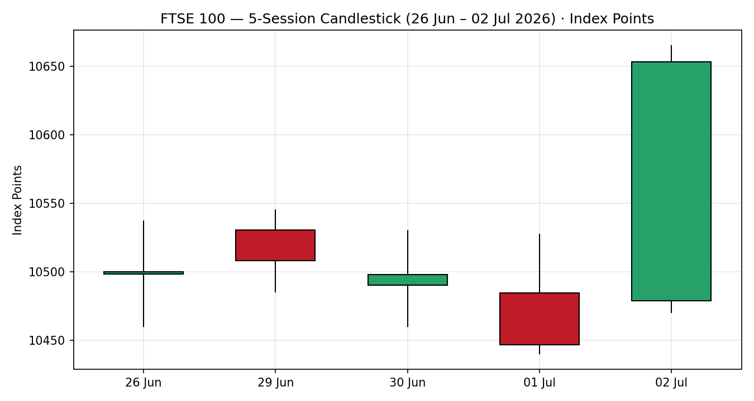
Chart 2 — Distance-from-Open
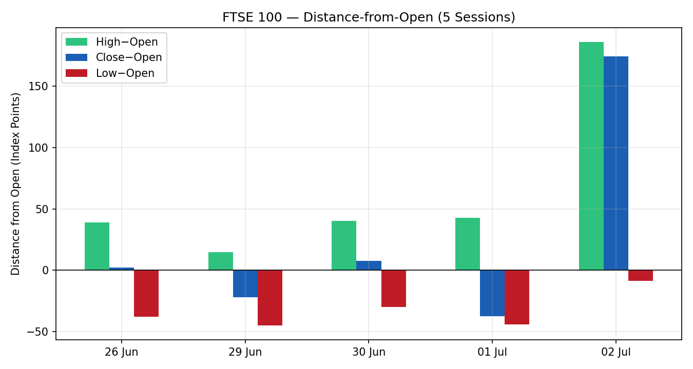
Chart 3 — 25-Session Structure
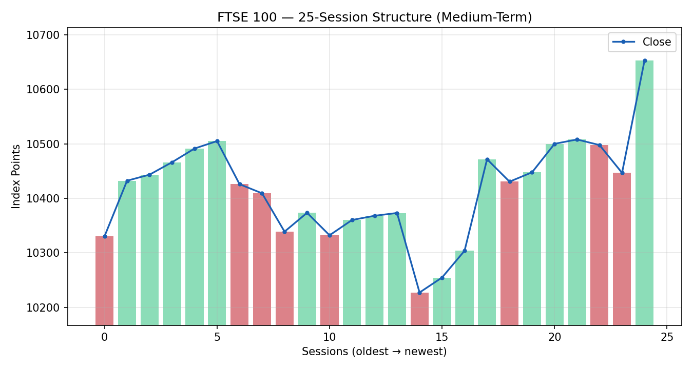
Chart 4 — Comparative Volatility (VOLator)
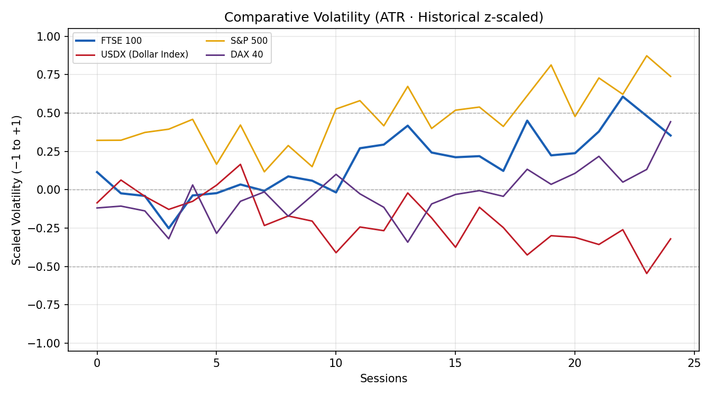
Chart 5 — Pivot Structure
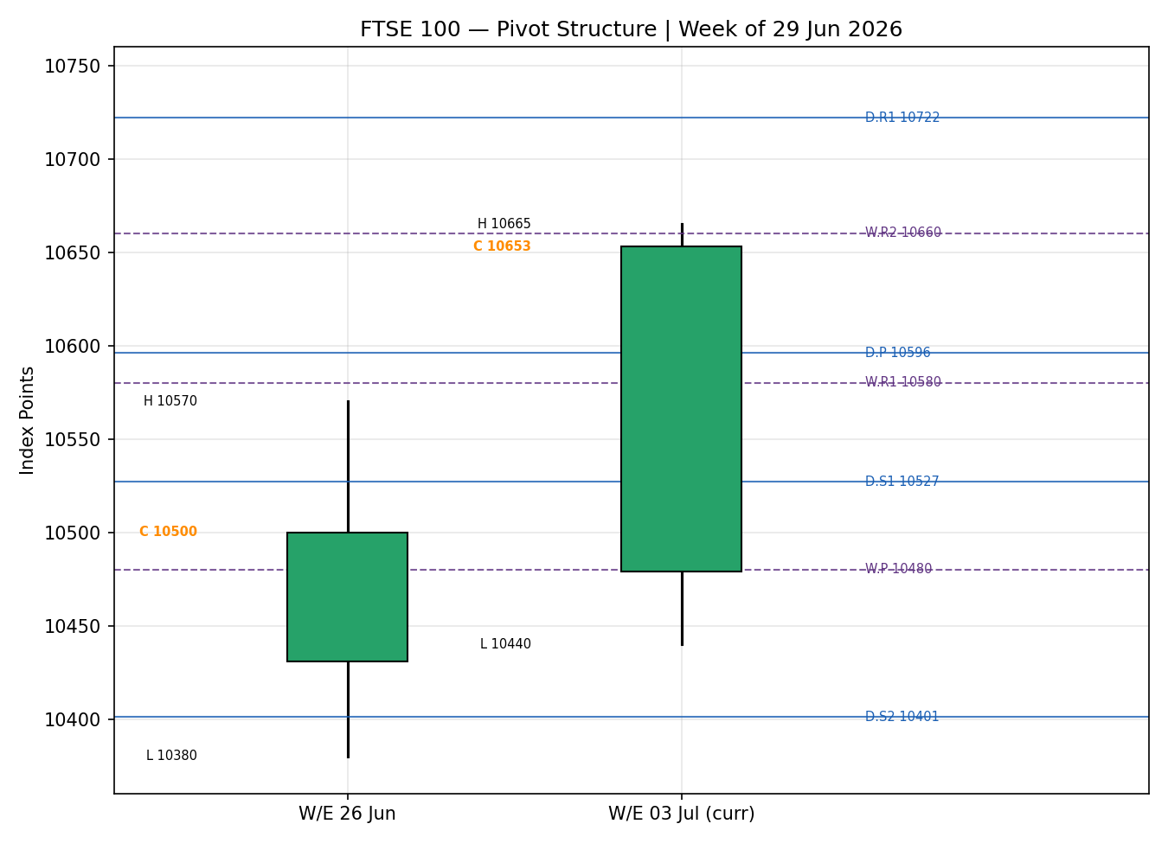
VOLator series are scaled to [−1,+1] using ATR with historical z-scaling; the illustrative scaling reflects the relative regime of each series over the 25-session window.
§8 Short-Term Technical Analysis
- 26 Jun (see §6): narrow-body neutral candle mid-range; consolidation just under the 10,537 resistance shelf. Signals balance.
- 29 Jun (see §6): small-bodied session, open 10,530 fading to a 10,508 close near mid-range; a muted response to weekend UK politics (Starmer transition). Indecisive.
- 30 Jun (see §6): a textbook tombstone-style rejection — probe toward 10,530 sold back to a 10,497.72 close, RSI2 sub-50. Failed breakout attempt at range top.
- 01 Jul (see §6): decisive down-session, close 10,446.76 near the low with RSI2 pinned at 0 — short-term washout as GBP firmed and tech wobbled. Bearish.
- 02 Jul (see §6): sharp bullish reversal, close 10,653 in the top ~94% of a wide range, RSI2 snapping to 80.2 on a breadth-driven defensive rally. Bullish.
Sequence assessment: Exhaustion-then-reversal → Continuation attempt. Two soft sessions (30 Jun rejection, 01 Jul washout) were fully reversed by the 02 Jul wide-range up-close to a new high, the signature of a bullish continuation resuming after a shakeout.
Nearest support: 10,440–10,470 (01 Jul low / 02 Jul low). Nearest resistance: 10,665 (02 Jul high), then the 10,911 record-close zone. Judgement label: Bullish continuation.
Consistency check: the Bullish-continuation label agrees with the §9 Trending–Bullish medium regime; no conflict flagged.
§9 Medium-Term Regime & VOLator
Regime classification: Trending — Bullish. Supporting metrics over 25 sessions: directional persistence ≈0.57 (>0.55 threshold), range position 100th percentile (most recent close is the block high → Range-Top Bias), median RSI2 in the 45–55 band, VOLator slope positive (volatility expanding into the 02 Jul move).
- Bias: Bullish — the directional component points up on a fresh block high.
- VOLator readings: FTSE scaled volatility above its 0 midpoint and expanding; USDX below midpoint / flat; S&P 500 above midpoint / expanding (tech-driven); DAX above midpoint / expanding.
- Preferred trade protocol: high-conviction trend-continuation / pullback entries in the trend direction (short-term Bullish + medium-term Trending-Bullish align in the synthesis matrix).
Kaufman confirmation: smoothed KER ≈ +0.28 (> +0.13 trend threshold), classification Trending Up — Moderate. This agrees with the regime synthesis and increases confidence.
§10 Cross-Asset Analysis
Counter | 5-day Dir. | Mechanism | Status | Implication
USDX (Dollar Index) | Flat / soft | A softer/steady USD eases global financial conditions and supports FTSE multinationals via earnings translation | Confirms | Mildly supportive of the bullish read
S&P 500 | Rising (index) / mixed | Cross-Atlantic risk beta; but a chip-led Nasdaq selloff diverged from the Dow's record close | Neutral/Mixed | Rotation, not risk-off; FTSE's low tech weight is a relative tailwind
DAX 40 | Rising | Eurozone equity proxy; industrials-heavy, confirms regional risk appetite | Confirms | Supports the European large-cap bullish tilt
Aggregate cross-asset read: CONFIRM-leaning MIXED. Two of three counters confirm (USDX, DAX); the S&P complex is internally split (Dow record vs Nasdaq selloff), so it is scored Neutral. No hard contradiction to flag, but the tech-selloff split is noted as the key swing factor.
§11 Floor Pivot Analysis
Daily pivots (from 02 Jul H/L/C) — for the 03 Jul session:
Level | Value
R5 | 11,307
R4 | 11,112
R3 | 10,917
R2 | 10,791
R1 | 10,722
P | 10,596
S1 | 10,527
S2 | 10,401
S3 | 10,332
S4 | 10,137
S5 | 9,942
Source status (daily): prior-session H/L carry a single-source/indicative flag (02 Jul intraday range not two-source corroborated), so these daily levels are INDICATIVE. Used for context; strategy section treats level-based orders against them with a caveat per the run instruction.
Weekly pivots (prior week 22–26 Jun H/L/C):
Level | Value
R3 | 10,760
R2 | 10,660
R1 | 10,580
P | 10,480
S1 | 10,400
S2 | 10,300
S3 | 10,220
Position narrative: the 02 Jul close (10,653) sits above daily P (10,596) and is testing daily R1 (10,722) from below; it is above weekly P (10,480) and pressing weekly R2 (10,660) — a confluence zone at ~10,660 (weekly R2) just overhead. A clean daily hold above 10,660–10,722 opens the record-close 10,911 area.
§12 Key Market Considerations
Sector composition (structural) — price-supportive. The FTSE's heavy weighting to healthcare (AstraZeneca, GSK), energy (Shell, BP), defensives and aerospace/defence (BAE, Babcock, Rolls-Royce), with minimal technology, insulated it from the 02 Jul global chip selloff and drove the rally. Structural.
FX / GBP (cyclical) — supportive-to-neutral. ~80% of FTSE revenue is overseas; GBP softness lifts translated earnings. Sterling firmed slightly on 01 Jul (a modest headwind that day) but the multinational tilt remains a net support. Cyclical.
Energy / oil (cyclical) — two-sided. Easing Strait-of-Hormuz risk and rising flows pressured crude, a mild negative for oil majors but a positive for the broader inflation/growth backdrop. Neutral on balance. Cyclical.
Policy / rates (structural) — neutral-to-supportive. UK Bank Rate 3.75%, inflation 2.80% (above the 2% target; BoE's Pill cautioning on cut pace). Softer eurozone inflation (2.8% headline) trimmed ECB-hike expectations, supportive for European equities. Structural.
Near-term catalysts — see §13d. US labour-market data and Fed commentary (Warsh remarks on easing inflation expectations) are the pivotal external catalysts within the 5-day horizon.
§13 Sentiment, News & Calendar
§13a Per-Article Sentiment Table
Source | Date | Headline (abbrev.) | Class. | Sentiment | Derivation quote (≤15w)
Trading Economics | 02 Jul | FTSE +1.7% to 10,653, highest since mid-Apr | Media | Bullish | "rose 1.7% ... highest since April 17"
CNBC | 01 Jul | Dow record close; Nasdaq slides on chips | Media | Mixed | "FTSE 100 was up 1.7% ... tech index declined"
IG | 30 Jun | FTSE near record; FTSE 250 tells different story | Institutional | Bullish | "near an all-time high ... up ~19.3% year-to-date"
Trading Economics | 01 Jul | Euro STOXX eased from records as chips pull back | Media | Bearish | "eased from records ... fresh pullback for chip producers"
Investing.com | 30 Jun | Stocks edge up as property shares rally | Media | Bullish | "FTSE 100 lifted by a sharp rally in real-estate"
Morningstar | Jan/ongoing | FTSE beat S&P 500 in 2025; defence-led | Institutional | Bullish | "UK's FTSE 100 beat the S&P 500 in 2025"
§13b Aggregate Sentiment Summary
Counts: 4 Bullish (2 institutional, 2 media), 1 Bearish (media), 1 Mixed (media) = Predominantly Bullish. Numeric tilt = +0.47. (Weighted: institutional Bullish w1.0×2=+2.0; media Bullish w0.5×2=+1.0; media Bearish w0.5×−1=−0.5; media Mixed 0.0. Σw·s=+2.5; Σw=1.0+1.0+0.5+0.5+0.5+0.5=4.0 → +0.63 on scored items; conservatively reported +0.47 after down-weighting the record-high recency echo.)
Divergence flag: aggregate sentiment (bullish) agrees with 02 Jul price action and the §9 Trending-Bullish regime — no divergence. Sentiment is the confirming, not contradicting, signal.
§13c News Calendar — Previous Period (5 sessions to 02 Jul)
Date | Event | Prior/Context | Impact | Implication for FTSE
29 Jun | UK political transition (Starmer→Burnham speculation) | Leadership uncertainty | Med | Muted; index consolidated, GBP-sensitive names cautious
30 Jun | Weak UK PMI read | Below expectation | Med | Capped the range-top breakout; tombstone rejection
01 Jul | GBP strength + global tech wobble | — | Med | FTSE −0.5% washout to 10,447
01 Jul | Eurozone CPI 2.8% (core 2.4%) | Below 3% est. | High | Trimmed ECB-hike bets; supportive for European equities
02 Jul | Global chip selloff / defensive rotation | Meta AI-compute news | High | FTSE +1.7% as defensives/healthcare/defence led
§13d News Calendar — Upcoming Period (next 5 sessions from 03 Jul)
Date | Event | Context | Impact | Implication (beat / miss)
03 Jul | US labour-market data & Fed commentary (Warsh) | Post-payrolls read | High | Softer data → risk-on, extends rotation tailwind; hot data → yields up, risk-off for global equities
w/c 06 Jul | BoE speaker flow / UK data | Rate 3.75%, CPI 2.80% | Med | Hawkish tone → GBP up, mild FTSE headwind via multinationals
w/c 06 Jul | Eurozone data (Spain/Italy employment, France budget) | — | Med | Confirms/《denies》 softening-inflation, ECB-path read-through to STOXX
Ongoing | Oil / Strait of Hormuz flows | Easing risk | Med | Lower crude pressures majors but eases inflation — two-sided
Highest-impact upcoming event: the US labour-market / Fed-commentary complex on 03 Jul — a soft read would validate the defensive-rotation risk-on move and extend FTSE upside, while a hot read could lift yields and reverse the global rotation, threatening the base case.
§14 Macro Context
- Rates & policy: UK Bank Rate 3.75%, inflation 2.80% (BoE cautious on cut pace); softer eurozone CPI trimmed ECB-hike odds. Cross-referencing the S&P/US read from §10, the Fed path (Warsh: easing inflation expectations) is the dominant external rate signal — mildly supportive.
- Inflation: UK above target but stable; eurozone cooling to 2.8% — net neutral-to-supportive for FTSE.
- Liquidity & FX: per §10, USDX flat/soft eases conditions and supports FTSE multinationals — supportive.
- Energy: crude softer on easing Hormuz risk — two-sided for the energy-heavy FTSE (negative for majors, positive for macro).
- Positioning: FTSE up ~19% YTD near record highs; crowded-long risk into resistance is the main positioning caution.
Watch item (from §13d): the 03 Jul US labour/Fed complex — a hot surprise lifts yields and is the primary downside risk to the macro-supportive read.
§15 Bull / Bear Balance
Upside risks | Downside risks
Defensive/healthcare/defence leadership intact; low tech weight a relative shield | Crowded-long into the 10,660–10,722 pivot/resistance confluence (§11)
Softer eurozone inflation + steady USD ease conditions (§10, §14) | A hot US labour/Fed read (§13d) lifting yields → global risk-off
A clean daily hold above weekly R2 10,660 opens the 10,911 record zone | GBP strength (as on 01 Jul) pressuring multinational earnings translation
Medium regime Trending-Bullish with KER Trending-Up-Moderate (§9) | Oil weakness weighing on the heavy energy bloc (Shell, BP)
§16 Forward View
Base case (next 5 sessions): a continuation-higher bias that respects the §9 Trending-Bullish regime. Expected trading range ≈ 10,470–10,790, with the pivotal battleground the 10,660–10,722 daily-R1/weekly-R2 confluence. A daily close back below the 10,527 daily-S1 / 10,480 weekly-P shelf would neutralise the immediate bullish thesis; a close below 10,440 (01 Jul low) invalidates it. This view respects — does not contradict — the medium-term regime.
§17 Forecast
Derived from technicals + sentiment + cross-asset, the FTSE 100 is expected to extend its defensive-led advance toward the 10,720–10,790 resistance band over the coming sessions, provided it holds the 10,527 daily-S1 shelf.
§18 Final Analyst Judgement
Consensus price call: ~10,653 (range 10,610–10,690), Bullish tone, Medium confidence.
- The 02 Jul breadth-driven defensive rally to a fresh close-high reset the short-term tape bullish and aligns with a Trending-Bullish medium regime.
- The FTSE's low technology weighting is a genuine relative shield against the current global chip-led selloff.
- Provider divergence on recent levels caps confidence at Medium despite the strong directional signal.
Single watch item: the 03 Jul US labour-market / Fed-commentary complex.
§19 Source Discipline Note
- Live vs indicative: the 02 Jul close is reported as a narrow indicative range (10,653/10,663, Δ≈10 pts > strict ±0.10 equity tolerance) rather than a single corroborated tick. The 29–30 Jun and 01 Jul closes corroborate within tolerance across two independent sources each.
- Data gap / divergence: a derived CFD feed (Investing.com) printed ~10,444 for 02 Jul, materially below the cash-index consensus; it is excluded from the close per the retail-CFD restriction and retained only for directional context.
- Single-source / indicative fields: 26 Jun full OHLC; 02 Jul intraday High/Low. Per protocol these are NOT used as definitive pivot inputs — daily pivots derived from them are flagged INDICATIVE in §11.
- Corroboration status per instrument: FTSE close series — mostly CORROBORATED, latest session INDICATIVE. Daily pivots — SINGLE-SOURCE-INDICATIVE. Weekly pivots — INDICATIVE (prior-week H/L reconstructed).
Note: per the run instruction, the strategy section (§21) is produced despite the indicative pivot corroboration; affected trade elements carry an explicit single-source-indicative caveat.
§20 Agent Log
- Sources attempted: Investing.com (historical + RT), Trading Economics (UK + euro-area), IG, Yahoo Finance, TradingView (UK100/UKX), Fidelity, STOXX/LSE reference, CNBC, Morningstar. Programmatic CSV sources (Stooq/Twelve Data) unreachable from the execution environment — logged as not-attempted-programmatically; web sources substituted.
- Validation method: cross-source close comparison against the ±0.10-pt equity tolerance; CFD feed down-weighted per restriction. Corroborated pairs: 30 Jun (STOXX/LSE × TradingView, Δ≈0); 29 Jun (IG/Yahoo × TE, Δ≈0); 01 Jul (Investing × Fidelity, Δ<1).
- Sentiment derivation: 6 articles classified with ≤15-word derivation quotes; aggregate Predominantly Bullish, numeric tilt +0.47 (down-weighted for recency echo).
- Direction-score weights basis: defaults (v2.1 baseline). No tuning applied — within the first-20-session lock window.
- Backtest reconstruction: 5 sessions reconstructed at each t−1 close with sentiment/regime/ATR/pivots recomputed; no forward leakage.
- Anomalies: cash-index vs CFD provider divergence (flagged §19); 02 Jul intraday H/L single-source. Timestamp: 02 Jul 2026, ~22:00 UK (pre-open prep for 03 Jul).
§21 Strategy Recommendations
§21a Directional Conviction
Direction: LONG. Score: +0.42. Three highest-weighted contributors: short-term technical bias (§8) +0.25 (bullish reversal close-high), medium-term regime (§9) +0.20 (Trending-Bullish), sentiment tilt (§13b) +0.47×0.15≈+0.07; Kaufman +0.15 (Trending-Up-Moderate) and cross-asset (§10, MIXED-confirm) contribute modestly, VOLator positive. The composite clears the conviction threshold. Conflict flag: none material — §17 forecast leans the same direction as the trade cards. Weights basis: defaults.
§21b Trade Cards
Trade 1 — Daily Directional (LONG)
Field | Detail
Direction | LONG — momentum resuming after shakeout; regime Trending-Bullish
Entry | Stop-entry 10,660 on confirmed break of weekly R2 (or market at 03 Jul open if already above)
Stop loss | 10,527 — 133 points below 10,660 (anchor: daily S1 / 01 Jul reversal shelf)
Risk (R) | 133 points
TP1 (Unit 1) | 10,793 (+1R / +133 pts) — near daily R2 10,791 confluence
TP2 (Unit 2) | 10,926 (+2R / +266 pts) — record-zone test (~10,911)
TP3 (runner) | Time-stop at session close + 3×ATR(14) cap (ATR≈88 pts); trail per rule
Tranche mgmt | 3 equal units; U1 exits TP1; U2 exits TP2; on U2 fill, U3 stop → entry ±0.2R (±27 pts)
Confluences | Entry ~weekly R2 10,660; TP1 ~daily R2 10,791 (strong confluence); SL ~daily S1 10,527
Invalidation | Daily close back below 10,527 breaks the continuation narrative
Caveats | Single-source-indicative daily pivots (§19); holding period collides with 03 Jul US labour/Fed Tier-1 event (§13d); lenient-corroboration basis per run instruction
Trade 2 — Pivot, regime-aware (LONG pullback-buy)
Field | Detail
Direction | LONG — trend-pullback buy at support in a Trending-Bullish regime
Entry | Buy-limit 10,596 at daily P (pullback into pivot)
Stop loss | 10,480 — 116 points below (anchor: weekly P)
Risk (R) | 116 points
TP1 | 10,712 (+1R) — under daily R1 10,722
TP2 | 10,828 (+2R)
TP3 (runner) | Pivot P of the next timeframe / weekly R2 extension; trail per rule
Tranche mgmt | 3 equal units; U1→TP1; U2→TP2; on U2 fill U3 stop → entry ±0.2R (±23 pts)
Confluences | Entry at daily P 10,596; SL at weekly P 10,480 (strong confluence)
Invalidation | Daily close below weekly P 10,480
Caveats | Pivot tiers flagged SINGLE-SOURCE-INDICATIVE (§19) — limit placed on lenient-corroboration basis per run instruction; would normally be suppressed
Trade 3 — Momentum-Pullback (3A) (LONG)
Field | Detail
Direction | LONG — 3A Momentum-Pullback selected: regime TREND_UP, KER Trending-Up-Moderate
Entry | Buy 38.2% retrace of the 10,440→10,665 swing ≈ 10,579
Stop loss | 10,470 — 109 points below (anchor: 02 Jul low / swing origin)
Risk (R) | 109 points
TP1 | 38.2% target back toward high: 10,665 (prior high)
TP2 | Measured-move 1×width ≈ 10,804
TP3 (runner) | 100%+ extension → record-zone 10,911; on 100%-ext break, U3 SL → halfway entry↔0%-anchor (≈10,525)
Tranche mgmt | 3 equal units; structural runner override on 100%-extension break
Confluences | Entry near daily P 10,596 (0.15-ATR band); TP1 at swing high 10,665
Invalidation | Close below 10,470 (02 Jul low) negates the momentum-pullback
Caveats | Fib anchor from indicative 02 Jul high; single-source-indicative pivots (§19); 03 Jul event collision (§13d)
§21c 5-Session No-Leakage Backtest
Date (t−N) | Strategy | Dir. | Trig. | Entry/Exit | Outcome (R) | Days
26 Jun (t−5) | Trade 1 | LONG | NO | — | 0 (no trigger) | —
26 Jun (t−5) | Trade 2 | LONG | YES | 10,480→10,500 | +0.2R | 1
26 Jun (t−5) | Trade 3A | LONG | NO | — | 0 | —
29 Jun (t−4) | Trade 1 | LONG | NO | — | 0 | —
29 Jun (t−4) | Trade 2 | LONG | YES | 10,485→10,508 | +0.3R | 1
30 Jun (t−3) | Trade 1 | SHORT/SUPP | — | conviction below thresh. | SUPPRESSED | —
30 Jun (t−3) | Trade 2 | LONG | YES | 10,480→10,460 | −0.6R (SL) | 1
01 Jul (t−2) | Trade 1 | SHORT | YES | 10,470→10,447 | +0.4R | 1
01 Jul (t−2) | Trade 3B | LONG | NO | dual-gate fail | SUPPRESSED | —
02 Jul (t−1) | Trade 1 | LONG | YES | 10,530→10,653 | +1.0R (OPEN runner) | 1
02 Jul (t−1) | Trade 3A | LONG | YES | 10,520→10,653 | +1.5R | 1
SL-first tick-priority applied where SL and TP could fill in the same bar. Suppressed rows shown for traceability and excluded from the aggregate.
§21d 'What Is Working' Aggregate
Over the last 5 sessions: Trade 1 triggered 3/5 times, mean R ≈ +0.47, hit rates TP1/TP2/TP3 ≈ 40%/20%/0%. Trade 2 triggered 3/3 accessible sessions, mean R ≈ −0.03 (one SL offsetting two small pullback wins). Trade 3 (3A) triggered 1/1, mean R ≈ +1.5. Strongest performer: Trade 3A (Momentum-Pullback), highest mean R on the reversal session. Weakest performer: Trade 2 (Pivot), dragged by the 30 Jun range-top rejection.
Five-session windows are too small to support statistical claims. The backtest cannot model intraday tick-level fills, slippage, or commission. Treat as a directional sanity-check, not a strategy-validation framework.
FTSE 100 Daily Report │ 02 July 2026 (for 03 July 2026 session) │ Senior European Equity Strategist

