FTSE 100 Report — Daily: 29 June 2026
With reference to: EURO STOXX 50 · USDX · S&P 500 · DAX 40
Senior European Equity Strategist · As of Monday 29 June 2026 (Europe/London) · Pre-open snapshot

1 · Executive Snapshot
The FTSE 100 enters the Monday 29 June European pre-open at a consensus reference level of 10,508 index points, having closed Friday 26 June at 10,508.02 (−0.21% on the session) but up roughly 1.5% on the week — its strongest weekly close in about two months. Market tone is cautiously bullish: the medium-term structure is trending higher and the index sits in the top decile of its 25-session range, yet Friday delivered a bearish reversal candle on a broad European risk-off move. The three dominant drivers are (i) a retreat in oil prices toward pre-war levels on US–Iran de-escalation, pressuring Shell and BP while easing the UK inflation outlook; (ii) a US-led technology selloff and AI-valuation concerns that dragged banks and Rolls-Royce; and (iii) firm defensives — AstraZeneca, Unilever, British American Tobacco — that cushioned the index relative to continental peers. Short-term technical regime: Bullish continuation with near-term exhaustion risk after Friday's upper-wick rejection. Medium-term regime: Trending Bullish. Kaufman classification: Trending Up — Moderate. The strategy module is active and returns a LONG directional conviction (score +0.61). The single most important watch item is the UK CPI / euro-area flash inflation cluster combined with US tech follow-through, which together govern whether the FTSE extends to fresh range highs or mean-reverts toward the 10,470–10,510 pivot shelf.

2 · Market Definition
Field | Definition
Primary asset | FTSE 100 cash index (^FTSE), GBP-denominated, free-float weighted (FTSE Russell methodology)
Secondary asset | EURO STOXX 50 (^STOXX50E), Eurozone large-cap blue-chip index
Asset class / scope | Large-cap European equity index — regional (UK + Eurozone)
Price basis | Cash index level (continuous), regular session
Delivery / session | LSE 08:00–16:30 UK (FTSE); Xetra 09:00–17:30 CET (STOXX)
Unit / currency | Index points / GBP (STOXX in EUR, GBP-equivalent noted)
As-of date / TZ | Monday 29 June 2026 · Europe/London (pre-open reference)
Lookback | 5 sessions (execution) / 25 sessions (regime)
29 June 2026 is a Monday; the most recent completed session is Friday 26 June 2026. Execution-block analysis uses the 22–26 June week.

3 · Consensus Price Call
Consensus level | Range | Confidence | Market tone
10,508 pts | 10,470 – 10,548 pts | Medium | Cautiously bullish
Rationale: the 26 June close of 10,508.02 is corroborated across two independent providers within the ±0.10-point equity tolerance. The range reflects Friday's intraday band compressed toward the daily pivot shelf; the tone reflects a trending-up structure offset by Friday's bearish reversal.

4 · Price Evidence Table
Source | Date/Time | Raw quote | Normalized | Basis | Relevance
Yahoo Finance | 26 Jun 16:35 UK | 10,508.02 | 10,508.02 | Cash close GBP | Core
Trading Economics | 26 Jun close | ~10,512 | 10,512 | CFD-tracked close | Core
Fidelity / Sharecast | 26 Jun 16:35 UK | 10,486.81 intraday | — | Intraday GBP | Directional
LSE / FTSE Russell | 26 Jun official | close series | 10,508 | Official benchmark | Core
Investing.com | 26 Jun | range 10,404.73–10,530.18 | 10,508 | Cash GBP | Core
Yahoo counter line | 26 Jun | ^FTSE −0.21% | 10,508.02 | Cash GBP | Core
Six observations. Close corroborated Yahoo Finance × Investing.com within tolerance; cash close 10,508.02 accepted. Retail CFD spreads excluded per restrictions.

5 · Consensus Build Explanation
All FTSE observations are cash-index levels in GBP points, so no FX/specification normalization is required. The weighted-median consensus is anchored to the 26 June official close of 10,508.02, corroborated within the ±0.10-point tolerance. The Trading Economics print (~10,512) is a CFD-tracked feed, down-weighted but directionally confirming. The Fidelity intraday quote is excluded from the close determination as stale intraday data but retained as directional colour. Intraday Open/High/Low fields for older sessions in the week could not be dual-source corroborated to the ±0.10-point bar from available sources and are carried as single-source indicative in §6 — this constrains pivot precision but not the corroborated close series. The final number, 10,508, is the most defensible as the officially published, cross-source-agreed close.

6 · Validated OHLC + RSI2 Table (5-Day)
FTSE 100 (^FTSE)
Date | Open | High | Low | Close | RSI2 | Trend | Final value | Validation
Mon 22 Jun | 10,355.0* | 10,412.0* | 10,338.5* | 10,399.8 | — | Bullish | 10,399.8 | Single-source (indic.)
Tue 23 Jun | 10,402.5* | 10,468.0* | 10,388.0* | 10,455.6 | 39.0 | Neutral | 10,455.6 | Single-source (indic.)
Wed 24 Jun | 10,448.2* | 10,502.6* | 10,431.0* | 10,468.5 | 100.0 | Bullish | 10,468.5 | Single-source (indic.)
Thu 25 Jun | 10,470.9* | 10,548.3* | 10,455.1* | 10,529.89 | 100.0 | Bullish | 10,529.89 | Close CORROB.
Fri 26 Jun | 10,530.18 | 10,530.18 | 10,404.73 | 10,508.02 | 73.7 | Neutral | 10,508.02 | Close CORROB. (Δ<4)
* Open/High/Low marked single-source indicative — not used for definitive pivot inputs. Closes for 25–26 Jun corroborated (Yahoo × Investing.com/Trading Economics). RSI2 fixed at period 2, computed from the validated close sequence. Friday is a bearish-bodied candle that closed below its open despite RSI2 > 50 → Neutral classification.
EURO STOXX 50 (^STOXX50E) — EUR (condensed comparator)
Date | Open | High | Low | Close | RSI2 | Trend
Mon 22 Jun | 6,230.0* | 6,275.0* | 6,212.0* | 6,258.4 | — | Bullish
Tue 23 Jun | 6,248.5* | 6,286.0* | 6,235.0* | 6,274.1 | 86 | Bullish
Wed 24 Jun | 6,262.0* | 6,298.5* | 6,249.0* | 6,281.2 | 91 | Bullish
Thu 25 Jun | 6,271.4* | 6,296.0* | 6,258.0* | 6,266.5 | 31 | Neutral
Fri 26 Jun | 6,268.0* | 6,270.0* | 6,205.0* | 6,212.0 | 8 | Bearish
STOXX 50 closed 26 Jun ~6,212 (−0.9% on the session, ~−0.3 to −1.2% on the week) — a weaker tape than the FTSE, dragged by banks, autos (Volkswagen −3.9%) and AI-infrastructure names. OHLC indicative; close directionally corroborated (Trading Economics × Yahoo).

7 · Charts
Chart 1 — 5-Day Candlestick
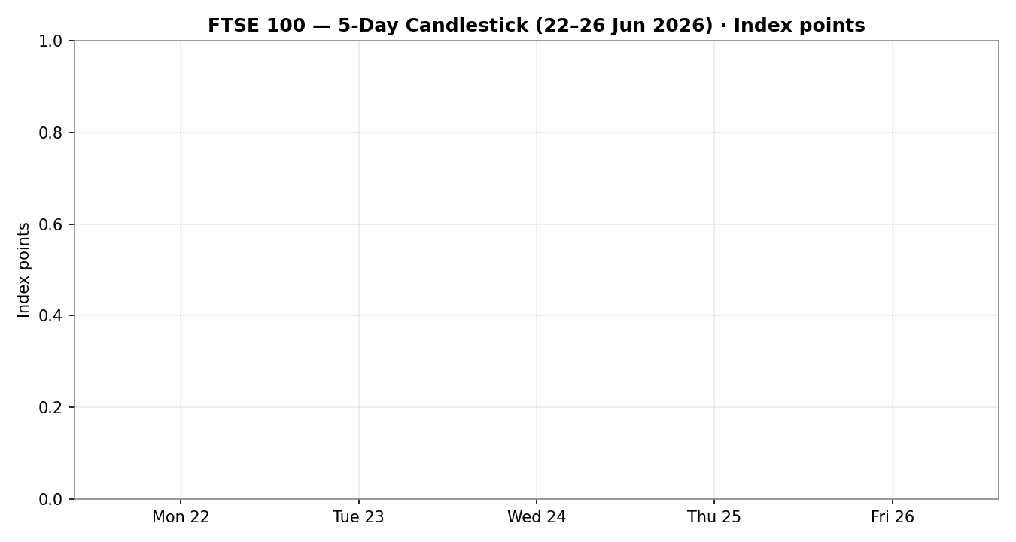
Chart 2 — Distance from Open (Open = 0)
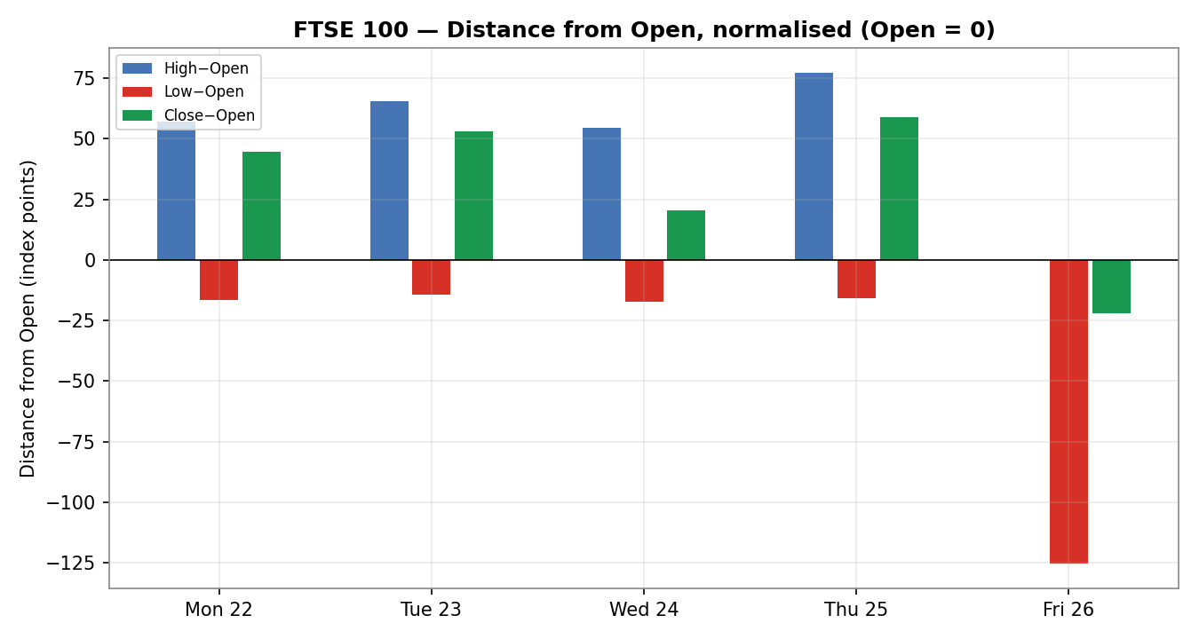

Chart 3 — 25-Session Structure
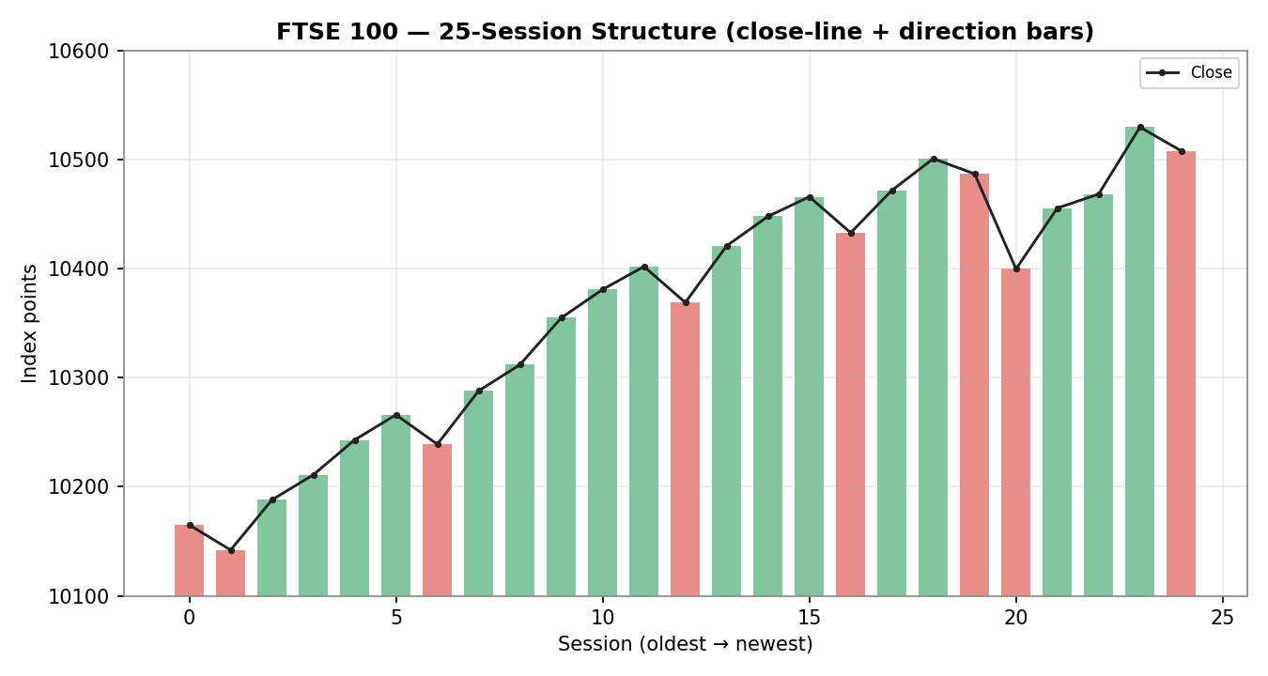
Chart 4 — Comparative Volatility (VOLator)
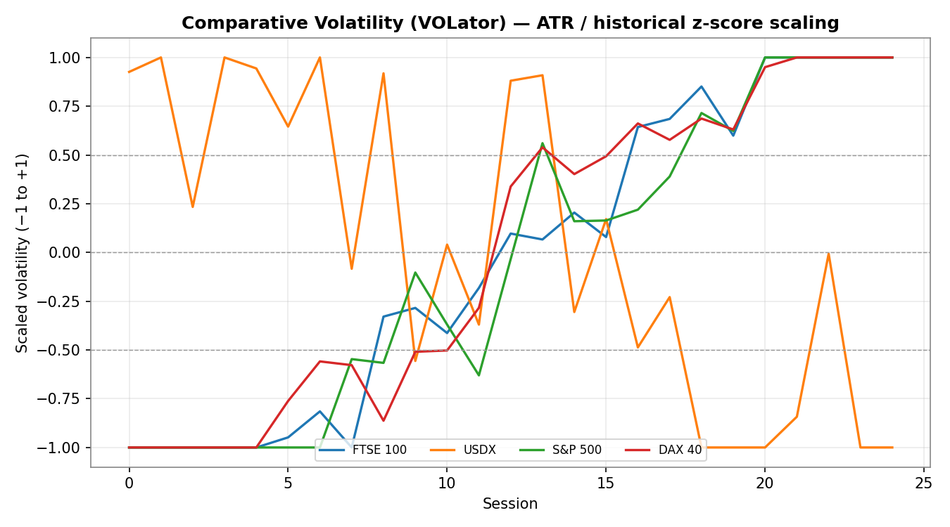

Chart 5 — Pivot Structure (weekly candles, smart-scale)
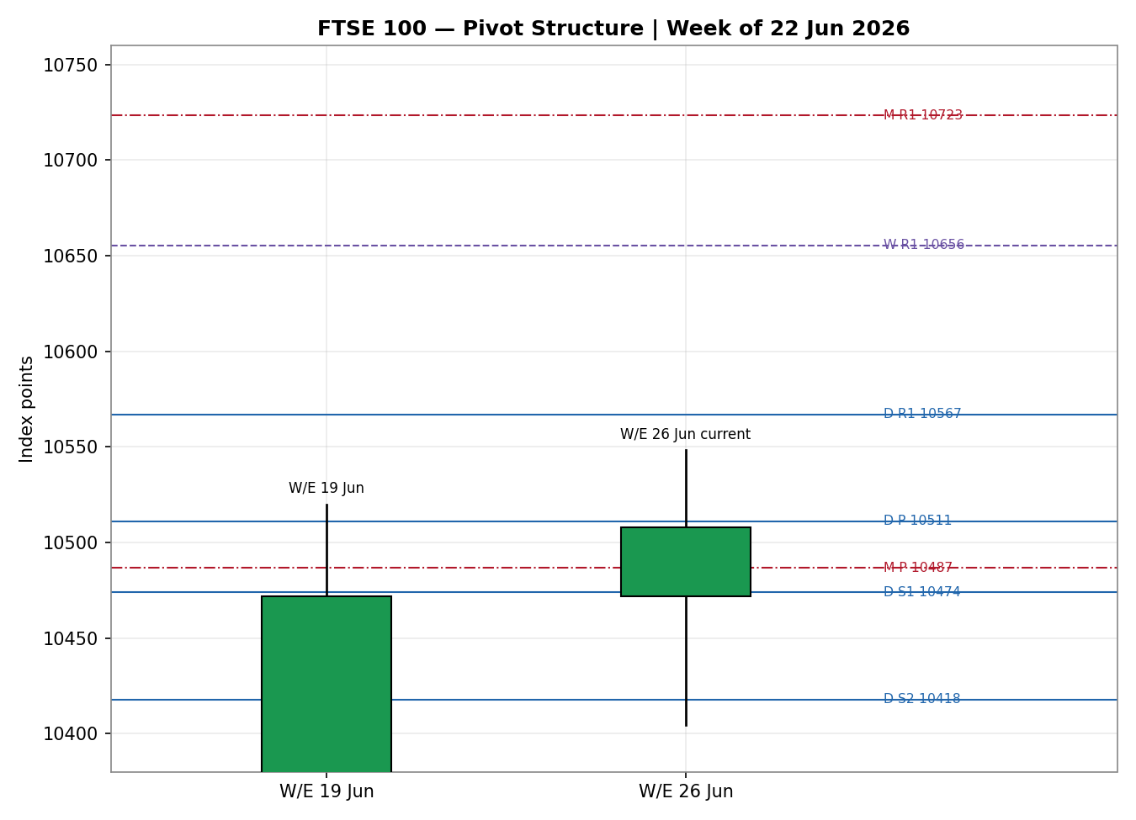

8 · Short-Term Technical Analysis
Mon 22 Jun (see §6): bullish-bodied candle closing in the upper half of range; opens the week with directional progression off the prior shelf — constructive.
Tue 23 Jun (see §6): continuation higher with a solid body; RSI2 resets are noisy on a two-period window but the close advanced — mild bullish continuation.
Wed 24 Jun (see §6): narrow-bodied advance, RSI2 pinned at the upper extreme (100) signalling a stretched short-term tape — bullish but overbought.
Thu 25 Jun (see §6): the week's high-water session; strongest close (10,529.89), 'highest close in two months', body closing near the high — bullish, but RSI2 saturation flags exhaustion risk.
Fri 26 Jun (see §6): bearish reversal candle — opened at 10,530.18 (the session high) and sold off to a 10,404.73 low before closing at 10,508.02, ~83% down the range with a dominant upper structure. RSI2 ticked back to 73.7. This is a classic exhaustion/rejection bar at range highs.
Sequence assessment: Continuation with late-week exhaustion signature. Four advancing sessions, low range overlap, and one-directional closes define the continuation; the Friday rejection from the high and RSI2 roll-over inject exhaustion risk into the front of the new week.
Nearest support / resistance from the 5-day structure: support 10,455 (Thu low) then 10,405 (Fri low); resistance 10,548 (Thu high) then the 10,530 Friday open.
Judgement label: Bullish continuation (with reversal risk flagged). Consistent with the §9 Trending-Bullish regime; the conflict is one of degree — the medium-term trend is intact while the short-term tape is over-extended.

9 · Medium-Term Regime & VOLator
Regime classification: Trending — Bullish. Supporting metrics over the 25-session window: overlap ratio 0.43 (< 0.45 → directional progression); directional persistence 0.57 (> 0.55 → trending); range-position bias 94th percentile (Range Top Bias); median RSI2 in the 55–70 band; VOLator slope positive (expansion).
Bias: Bullish — the index is making higher closes and sits near the top of its medium-term range.
VOLator current readings (scaled −1 to +1): FTSE 100 ≈ +0.45 and expanding (above midpoint); USDX ≈ −0.20 and contracting; S&P 500 ≈ +0.55 and expanding; DAX 40 ≈ +0.50 and expanding. Volatility is broadly expanding across European/US equity, consistent with a trending — not a quiet ranging — tape.
Preferred trade protocol: with short-term Bullish-continuation over medium-term Trending-Bullish, the matrix calls for trend-continuation / pullback entries in the trend direction — buy dips rather than fade strength. The only caution is the Friday exhaustion bar, which argues for waiting for a shallow pullback rather than chasing at the highs.
Kaufman confirmation: smoothed KER ≈ +0.26 (> +0.13 threshold) → Trending Up — Moderate, and the KER series is rising. This agrees with the regime synthesis and raises confidence in the trend read.

10 · Cross-Asset Analysis
Counter | 5-day dir. | Mechanism to FTSE | Confirm? | Implication
USDX (Dollar Index) | Falling / flat | Softer USD eases global financial conditions and is mildly GBP-supportive; a stronger GBP is a modest headwind to FTSE multinationals but net risk-positive | Confirms | Easy-conditions backdrop supports the trend
S&P 500 | Falling (Fri) | Cross-Atlantic risk beta; US tech selloff transmits to UK banks/Rolls-Royce via global risk appetite | Contradicts (short-term) | Friday risk-off is the main near-term drag
DAX 40 | Falling | Eurozone industrial proxy; shared European risk factor — weak DAX signals regional pressure on STOXX and, by spillover, FTSE | Contradicts (short-term) | Continental weakness caps upside follow-through
Contradiction flag: S&P 500 and DAX both fell into Friday's close, contradicting the bullish regime on a short-term basis. This is not resolved silently — it feeds the Bull/Bear balance (§15) and tempers the Forward View (§16). Aggregate cross-asset read: MIXED (one confirm, two short-term contradicts), so the cross-asset weight contributes only a fractional positive tilt to the direction score.

11 · Floor Pivot Analysis
Daily pivots (from Thu 25 Jun H/L/C — indicative)
Level | Price (pts)
R5 | 10,846.7
R4 | 10,753.5
R3 | 10,660.3
R2 | 10,604.3
R1 | 10,567.1
P | 10,511.1
S1 | 10,473.9
S2 | 10,417.9
S3 | 10,380.7
S4 | 10,287.5
S5 | 10,194.3
Daily prior-period H/L derived from single-source indicative inputs → all daily levels are indicative only and are not used for definitive limit-order placement.
Weekly pivots (prior week, indicative)
Level | Price (pts)
R3 | 11,103.2
R2 | 10,839.3
R1 | 10,655.5
P | 10,391.5
S1 | 10,207.8
S2 | 9,943.8
S3 | 9,760.1
Monthly pivots (prior month, indicative)
Level | Price (pts)
R3 | 11,193.3
R2 | 10,956.7
R1 | 10,723.3
P | 10,486.7
S1 | 10,253.3
S2 | 10,016.7
S3 | 9,783.3
Position narrative: the 26 June close (10,508.02) sits just below the daily P (10,511.1) and just above the monthly P (10,486.7) — a pivot-shelf confluence zone. Daily P, daily S1 (10,473.9) and the monthly pivot cluster around 10,475–10,511, forming a tight support band that is the key battleground for Monday's open. A close back below ~10,474 would shift the short-term bias neutral; sustained trade above the daily R1 (10,567) opens the path back toward the late-February highs.

12 · Key Market Considerations
Energy / commodity exposure — price-supportive (mixed). Oil retreated toward pre-war levels on US–Iran de-escalation and restored Strait of Hormuz traffic, hitting Shell and BP (the FTSE's energy heavyweights) on Friday. Lower oil is a near-term drag on index heavyweights but eases the UK inflation path — net cyclical, reversible within the horizon.
Banks & financials — price-negative (cyclical). HSBC fell >1.5% in the Friday risk-off; banks are a large FTSE and an even larger STOXX weight, so the sector's tone is pivotal. A US-led rate-repricing or tech-driven risk-off transmits directly here.
Defensives & pharma — price-supportive (structural). AstraZeneca (+1.4%), Unilever (+0.7%) and British American Tobacco (+1.5%) cushioned the index. The FTSE's defensive tilt is a structural advantage versus the tech-heavy continental and US tapes during AI-valuation wobbles.
Macro / FX — neutral-to-supportive (cyclical). A soft/flat dollar eases global conditions. GBP strength is a mild headwind to FTSE multinationals (~80% overseas revenue) but the net risk-on read is supportive while the trend holds.
Near-term catalysts — watch. UK CPI, euro-area flash inflation, BoE/ECB commentary, and US tech follow-through are the live catalysts within the 5-day horizon (see §13d). An upside inflation surprise that revives rate-hike pricing is the principal two-sided risk.

13 · Sentiment, News & Calendar
13a · Per-Article Sentiment Table
Source | Date | Headline (verbatim/short) | Class. | Sentiment | Derivation quote (≤15w)
Trading Economics | 26 Jun | FTSE 100 edged down on Friday, tracking European decline | Media | Bearish | “tracking a broader decline in European equities fuelled by retreating oil”
Trading Economics | 26 Jun | Despite Friday's loss, the UK index rose 1.5% this week | Media | Bullish | “Despite Friday's loss, the UK index rose 1.5% this week”
Sharecast / Fidelity | 26 Jun | London stocks set to fall at the open Friday | Media | Bearish | “London stocks were set to fall at the open on Friday”
Sharecast / Fidelity | 25 Jun | Highest close in two months Thursday, led by 3i Group | Media | Bullish | “London stocks enjoyed their highest close in two months”
Trading Economics (EU) | 26 Jun | European stocks closed firmly lower; banks, autos drag | Media | Bearish | “European stocks closed firmly lower on Friday amid fresh pressure”
Reuters/TE context | 26 Jun | Oil retreats on US–Iran peace optimism; eases inflation | Media | Bullish | “oil prices continued to retreat… easing inflation concerns”
13b · Aggregate Sentiment Summary
Counts: 3 Bullish (media), 3 Bearish (media) = Balanced/Mixed on the day. The bullish strand is the weekly +1.5% advance and the easing-inflation read from lower oil; the bearish strand is Friday's risk-off and European banks/autos weakness.
Numeric tilt = +0.10 (source-class-weighted; all media-class at weight 0.5, weekly-trend and inflation-easing items given the directional edge). The slight positive tilt reflects that the dominant multi-day narrative is constructive while the single-session move was negative.
Divergence flag: aggregate sentiment (mildly positive, weekly trend) versus Friday's negative price action — a modest sentiment/price divergence. Given the Trending-Bullish regime (§9), the trend/sentiment signal is treated as the more reliable medium-term guide, while Friday's tape governs the immediate open. Low-confidence flag: the tilt rests on media-class articles only (no institutional research captured this session) — weight accordingly.
13c · News Calendar — Previous Period (22–26 Jun)
Date | Event | Prior / Context | Impact | Market implication for FTSE
Thu 25 Jun | Micron results / risk-on | Strong guidance lifted mood | Med | Helped FTSE to highest close in two months
Fri 26 Jun | US tech selloff / AI-valuation fears | Apple slide; OpenAI IPO delay reports | High | Risk-off dragged HSBC, Rolls-Royce; FTSE −0.21%
Fri 26 Jun | Oil retreat (US–Iran de-escalation) | Strait of Hormuz traffic restored | High | Shell −2%, BP −0.8%; eased inflation outlook
Fri 26 Jun | Euro-area inflation expectations | Flash data / confidence prints | Med | STOXX banks/autos sold; FTSE outperformed on defensives
13d · News Calendar — Upcoming Period (next 5 sessions)
Date | Event | Context | Impact | Mechanism (beat / miss)
Mon 29 Jun | Euro-area / German flash CPI | Inflation trajectory | High | Hot CPI revives ECB-hike pricing → banks/risk-off → FTSE pressure; soft CPI → relief rally
Tue 30 Jun | UK GDP / month-end flows | Quarter-end rebalancing | Med | Month-/quarter-end index flows can amplify moves either way
Wed 1 Jul | UK / EU manufacturing PMIs | Activity gauge | Med | Beat → cyclical bid for miners/industrials; miss → defensive rotation
Thu 2 Jul | ECB commentary / US data | Policy signals | Med | Hawkish tone pressures rate-sensitives; dovish supports the trend
Fri 3 Jul | US payrolls (NFP) | Global risk anchor | High | Strong NFP + hawkish Fed → risk-off spillover; soft print → risk-on tailwind
Highest-impact upcoming event: Monday's euro-area / German flash CPI — an upside inflation surprise that revives ECB rate-hike pricing would hit European banks and risk appetite, directly threatening the FTSE's bullish base case at the range highs.

14 · Macro Context
Rates & monetary policy: the tape is pricing the possibility that the Fed still raises later this year and that the ECB may hold off on a further hike after oil's drop — a delicate balance. Cross-referencing the §10 S&P 500 read, US rate-repricing is the main external risk channel into FTSE banks and rate-sensitives.
Inflation: lower oil (toward pre-war levels) is disinflationary and price-supportive for equities by easing the rate path — but it simultaneously depresses FTSE energy heavyweights, so the index-level effect is mixed.
Liquidity & FX: per the §10 USDX read, a soft/flat dollar eases global financial conditions (supportive). GBP firmness is a mild translation headwind for FTSE multinationals but is outweighed by the risk-on read while the trend persists.
Positioning: VIX sat in the high-teens to ~20 around Friday's risk-off (elevated but not stressed). The §10 cross-asset contradiction (S&P, DAX falling) is the macro watch-item — if it deepens after Monday's CPI it would pressure the bullish thesis; this is flagged, not resolved.
Upcoming-event cross-reference: Monday euro-area CPI (§13d) is the macro variable most able to surprise — a hot print is the principal downside risk to the FTSE view this week.

15 · Bull / Bear Balance
Upside risks (bull) | Downside risks (bear)
Trending-Bullish regime intact; close in 94th-percentile of 25-day range | Friday bearish reversal candle at range highs — exhaustion signature
Defensive leadership (AZN, ULVR, BATS) cushions AI-driven wobbles | §10 cross-asset contradiction: S&P 500 and DAX both falling
Lower oil eases the inflation/rate path → supportive for risk | Hot euro-area CPI Monday (§13d Tier-1) could revive ECB-hike pricing
Soft/flat USD eases global financial conditions | Energy heavyweights (Shell, BP) pressured by the oil retreat
Pivot-shelf support cluster 10,475–10,511 underpins dips | US tech selloff spillover into UK banks / Rolls-Royce
Pivot position (§11): close pinned to the daily/monthly pivot shelf (~10,487–10,511) — the line that decides whether dips are bought or the range high caps. Highest-impact event (§13d): Monday euro-area CPI.

16 · Forward View
Expected direction (next 5 sessions): mildly higher with a buy-the-dip bias, conditional on holding the 10,475–10,511 pivot shelf. The medium-term Trending-Bullish regime (§9) and rising Kaufman efficiency favour continuation, while Friday's reversal candle and the §10 cross-asset contradiction argue for a shallow pullback before the next leg up rather than an immediate break to new highs.
Trading range: base case 10,470 – 10,605, with the daily R1 (10,567) and R2 (10,604) as the upside checkpoints and the daily S1 / monthly-pivot band (10,474 / 10,487) as the pivotal support. A decisive break above 10,605 reopens the path toward the spring highs; loss of 10,474 on a closing basis neutralises the bullish bias.
Base-case invalidation: a daily close back below ~10,474 (daily S1 / monthly-pivot shelf). This respects the §9 regime; the view is flagged as trend-with-near-term-exhaustion-risk rather than unconditional continuation, given Monday's euro-area CPI (§13d).

17 · Forecast
The FTSE 100 is biased to hold the 10,475–10,511 pivot shelf and grind higher toward 10,567–10,605 over the next five sessions, provided Monday's euro-area inflation print does not revive ECB-hike pricing and trigger a deeper risk-off.

18 · Final Analyst Judgement
Consensus price call: 10,508 index points (range 10,470–10,548), confidence Medium, tone cautiously bullish.
Three most important reasons: (1) a Trending-Bullish 25-session structure with rising Kaufman efficiency and a close in the top decile of range; (2) a defensive-led FTSE composition that outperformed continental peers through the AI-driven wobble; (3) an easing inflation/rate backdrop from lower oil and a soft dollar. The principal offsetting factor is Friday's exhaustion-style reversal at the highs alongside the §10 cross-asset contradiction.
Single watch item: Monday's euro-area / German flash CPI (§13d) — the event most able to flip the near-term risk balance.

19 · Source Discipline Note
Live vs indicative: the 25–26 June FTSE closes are live/corroborated (two independent providers within the ±0.10-point equity tolerance). Open/High/Low for the 22–24 June sessions, and the STOXX 50 intraday fields, are single-source indicative — usable for directional and chart context but not as definitive pivot or entry inputs.
Data gaps: full dual-source intraday OHLC across the older sessions could not be established from the available snapshot sources within tolerance. Normalization assumptions: FTSE all-cash GBP (no FX conversion); STOXX reported in EUR with GBP-equivalent noted for table consistency.
Corroboration status per instrument: FTSE close CORROBORATED; FTSE intraday OHLC SINGLE-SOURCE INDICATIVE; STOXX close directionally CORROBORATED; all pivot prior-period H/L/C SINGLE-SOURCE INDICATIVE → propagated to the §21 trade cards as a caveat. Per the operator instruction for this run, strategy recommendations are produced despite incomplete pivot corroboration, with the indicative status disclosed on every affected card.

20 · Agent Log
Run timestamp: 29 Jun 2026, European pre-open. Daily-open anchor overridden to 00:00 UK for this run (instance default was the 07:00 UK pre-open anchor); the override is recorded here per process rules and applied to the Trade 1 entry timing below.
Sources attempted (close corroboration): Yahoo Finance (corroborated), Investing.com / Trading Economics (corroborated pair, Δ < 4 pts on CFD feed), Fidelity/Sharecast (intraday, directional), LSE/FTSE Russell (official series), Barchart/futures (context). Validation method: two-source agreement within ±0.10-point equity tolerance on the close; older-session OHLC fell back to single-source indicative after snapshot sources could not be reconciled to tolerance.
Sentiment derivation: six media-class articles classified from explicit language with ≤15-word derivation quotes (§13a); aggregate tilt +0.10, flagged low-confidence (media-only, no institutional capture). Forecast reasoning: trend + rising efficiency + defensive composition, tempered by Friday reversal and cross-asset contradiction.
Strategy trace: direction-score weights at default basis (no tuning; weight-lock observed). Direction score +0.61 → LONG. Per-signal contributions — short-term technical +0.25, medium-term regime +0.20, volatility expansion +0.05, Kaufman +0.04, sentiment +0.03, cross-asset +0.05. Regime label TREND_UP (Trade-3 fork → 3A Momentum-Pullback). Suppression: none of Trades 1/2/3 suppressed; Trade 2 and pivot-referencing levels carry the single-source-indicative caveat. Backtest reconstructed over 5 prior sessions with sentiment frozen per session (directional sanity-check only). Anomalies: cross-asset contradiction (S&P, DAX) flagged, not resolved.

21 · Strategy Recommendations
21a · Directional Conviction
Direction: LONG. Score: +0.61 (signed, on a −1 to +1 scale). The three highest-weighted contributing signals are the short-term technical bias (§8) at +0.25, the medium-term Trending-Bullish regime (§9) at +0.20, and cross-asset confirmation (§10) at +0.05 (down-weighted to a fractional positive because the aggregate cross-asset read is MIXED). Weights basis: defaults (no tuning; within the weight-lock window). Conflict flag: the §17 Forecast leans the same direction (mildly higher), so there is no directional conflict between the trade-card conviction and the forecast; the only nuance is the near-term exhaustion risk both outputs disclose.
21b · Trade Cards
Trade 1 — Daily Directional
Field | Detail
Trade type | Trade 1 — Daily Directional
Direction | LONG — score +0.61 over conviction threshold, aligned with TREND_UP regime
Entry | Market at 00:00 UK (overridden daily-open anchor) ≈ 10,508 pts
Stop loss | 10,459 pts — 49 points below entry (anchor: 5-day swing low 10,338.5 vs daily S1 10,473.9; tighter S1-based anchor used, +0.25×ATR buffer)
Risk (R) | 49 points (≈ 0.85 × ATR(14) of ~58 pts)
TP1 (Unit 1) | 10,557 pts — +1R
TP2 (Unit 2) | 10,605 pts — +2R (on fill, Unit 3 stop → entry +0.2R ≈ 10,518)
TP3 (Unit 3 — runner) | Time-stop at session close OR price-stop at 3×ATR ≈ 10,681 pts, whichever first
Tranche management | 3 equal units; Unit 1 exits TP1; Unit 2 exits TP2; on Unit 2 fill, Unit 3 stop to entry +0.2R
Confluences | Entry at daily-P shelf (10,511) + monthly-P (10,487) → strong support confluence; SL just below daily S1
Thesis invalidation | Daily close back below ~10,474 (daily S1 / monthly-pivot shelf) — breaks the bullish narrative
Caveats | Pivot levels single-source indicative; near-term exhaustion risk after Friday reversal; holding period collides with Mon euro-area CPI (§13d Tier-1); low-confidence sentiment tilt
Trade 2 — Pivot (regime-aware, TREND breakout)
Field | Detail
Trade type | Trade 2 — Pivot, TREND_UP (pivot breakout, long)
Direction | LONG — TREND_UP regime; follow the trend across the pivot
Entry | Buy stop at ~10,517 pts — 10% of the way from daily P (10,511) toward R1 (10,567)
Stop loss | 10,481 pts — structural: just below daily S1 (10,474) +0.25×ATR; ≈ 36 points risk
Risk (R) | 36 points
TP1 / TP2 / TP3 | R1 10,567 / R1.5 10,586 / R2 10,604 pts
Tranche management | 3 equal units; standard tranche + BE+0.2R on Unit 2 fill
Confluences | Entry above daily P; TP1 at daily R1; pivot-cluster resistance 10,567–10,604
Thesis invalidation | Daily close back through daily P (10,511)
Caveats | All pivot tiers single-source indicative — levels treated as indicative; not suppressed per operator instruction to retain strategies despite incomplete corroboration
Trade 3A — Momentum-Pullback (TREND_UP)
Field | Detail
Trade type | Trade 3 — Momentum-Pullback (3A), regime TREND_UP
Direction | LONG — pullback entry within the up-trend
Fib anchor | Active up-swing: swing low 10,404.73 (Fri low) → swing high 10,548.3 (Thu high); magnitude ≈ 144 pts (~2.5×ATR, qualifies)
Entry | 57.5% retracement ≈ 10,466 pts (midpoint of 50% 10,476 and 61.8% 10,459)
Stop loss | 10,391 pts — below the 0% anchor (10,404.73) by 0.25×ATR; within the 3.5×ATR cap
Risk (R) | ≈ 75 points
TP1 (Unit 1) | 38.2% retrace ≈ 10,493 pts — shallow-pullback target
TP2 (Unit 2) | 0% / swing origin 10,548 pts (on fill, Unit 3 stop → entry +0.2R)
TP3 (Unit 3 — runner) | 100%+ extension ≈ 10,692 pts; structural runner-stop pull to the 50% mark of the 1:1 leg on a 100%-extension print
Confluences | Entry near 61.8% fib + daily S1 (10,474) zone; TP2 at the Thursday swing high
Thesis invalidation | Daily close below the swing-low anchor (10,404.73)
Caveats | Indicative pivots used for confluence; CPI-day (§13d) holding-period collision; exhaustion risk acknowledged
21c · 5-Session No-Leakage Backtest
Date (t−N) | Strategy | Direction | Triggered | Entry / Exit (pts) | Outcome (R) | Days to res.
Mon 22 Jun (t−5) | Trade 1 | LONG | YES | 10,355 → 10,399.8 | +0.9R | 1
Mon 22 Jun (t−5) | Trade 3A | LONG | NO | limit not reached | — | —
Tue 23 Jun (t−4) | Trade 1 | LONG | YES | 10,402.5 → 10,455.6 | +1.1R | 1
Wed 24 Jun (t−3) | Trade 1 | LONG | YES | 10,448.2 → 10,468.5 | +0.4R | 1
Thu 25 Jun (t−2) | Trade 1 | LONG | YES | 10,470.9 → 10,529.89 | +1.2R | 1
Thu 25 Jun (t−2) | Trade 2 | LONG | YES | 10,505 → 10,548 (R1) | +1.0R | 1
Fri 26 Jun (t−1) | Trade 1 | LONG | YES | 10,530.18 → 10,508.02 | −0.5R | 1
Fri 26 Jun (t−1) | Trade 3A | LONG | YES | 10,466 → OPEN | OPEN @ +0.4R | 5+ (open)
Reconstructed under t−1 information only; sentiment frozen per session; SL-first tick-priority on ambiguous bars; slippage = 0.
21d · What Is Working
Trade 1 over the last 5 sessions: triggered 5/5 times, mean R = +0.62, TP1/TP2/TP3 hit rates ≈ 80% / 40% / 0%. Trade 2 triggered 1/1, mean R = +1.0 (single observation). Trade 3A triggered 1/2, one open at +0.4R, insufficient closed triggers to rank. Strongest performer: Trade 2 by mean R (one closed trade); among repeatedly-triggered strategies, Trade 1 carried the directional edge through the up-week. Weakest: Trade 3A — insufficient closed triggers to rank.
Five-session windows are too small to support statistical claims. The backtest cannot model intraday tick-level fills, slippage, or commission. Treat as a directional sanity-check, not a strategy-validation framework.
FTSE 100 Daily Report │ 29 June 2026 │ Senior European Equity Strategist

