FTSE 100 Report — Daily: 5 June 2026
With reference to: EURO STOXX 50 · USDX · S&P 500 · DAX 40

1 · Executive Snapshot
The FTSE 100 closed Thursday 4 June 2026 near 10,315 index points, down roughly 0.2–0.3% on the session and at its lowest level since mid-May, after a two-session slide from the 1 June open. The most defensible current consensus level is 10,315 (range 10,300–10,345) with a balanced-to-mildly-bearish near-term tone. Three drivers dominate: (i) a fresh global risk-off impulse from renewed Middle East tensions that lifted Brent back toward the high-90s before it eased below $97; (ii) a firmer US dollar (DXY back near 99.5, a multi-month high) after a strong US private-payrolls print; and (iii) heavy index-level support from energy and mining majors and defensive pharma (AstraZeneca, GSK), which has kept the FTSE far more resilient than continental peers. Short-term technical state is Transitional / mixed-to-bearish; the 25-session regime reads Transitional with a range-bottom bias; Kaufman efficiency classifies the tape Trending Down — Strong. Single most important watch item: the Bank of England rate decision on 18 June and the intervening UK CPI release. Strategy read (see §21): directional conviction is SHORT (score −0.55), driven by short-term technical bias, the down-trending KER, and a risk-off cross-asset/sentiment tilt.

2 · Market Definition
Field | Definition
Primary asset | FTSE 100 cash index (UK large-cap benchmark, 100 constituents)
Specification | GBP-denominated, free-float market-cap weighted (FTSE Russell methodology, quarterly review)
Secondary asset | EURO STOXX 50 — Eurozone blue-chip benchmark (reported alongside in §6)
Scope / region | Regional — United Kingdom & Eurozone
Delivery basis | LSE regular session 08:00–16:30 UK (FTSE); Xetra 09:00–17:30 CET (STOXX). Cash sessions only.
Unit / currency | Index points · GBP (STOXX shown in native EUR)
As-of date / time zone | 5 June 2026 · Europe/London (data through 4 June close)
Lookback window | 5 sessions (execution block) · 25 sessions (regime block)

3 · Consensus Price Call
Measure | Value | Basis / rationale
Consensus level | 10,315 pts | 4 Jun cash close, median of corroborating sources
Consensus range | 10,300 – 10,345 | Spread across index-provider vs aggregator feeds for 3–4 Jun
Price basis | Cash index level (continuous) | FTSE Russell official close basis
Confidence | Medium | Multi-source corroboration achieved; minor cross-feed dispersion
Market tone | Balanced → mildly bearish | Two down sessions, oversold short-term, supportive sector mix
Rationale: the index has pulled back from the late-May 10,460–10,520 zone toward the lower half of its 25-session range as oil-led risk-off and a firmer dollar weighed on cyclicals, partially cushioned by energy/defensive leadership.

4 · Price Evidence Table
Source | Date | Raw quote | Normalized | Basis | Class. | Notes
FTSE Russell / LSE | 4 Jun | ≈10,315 | 10,315 | Cash close | Core | Official close basis
Trading Economics | 4 Jun | ≈10,300–10,315 | 10,308 | Cash/CFD | Core | "Lowest since mid-May"
Yahoo Finance | 3 Jun | 10,303.12 | 10,303 | Cash close | Core | −0.28% session
Trading Economics | 3 Jun | 10,342 | 10,342 | Cash close | Core | −32 pts / −0.30%
Investing.com | 4 Jun | Open 10,373.9; 10,322–10,383 | — | Intraday | Direct. | Session range corroboration
Kalkine / LSE feed | 1 Jun | ≈10,396 | 10,396 | Cash close | Core | Start-of-month reference
Six independent observations gathered; retail CFD-only spreads excluded per source rules. Minor 3–4 Jun dispersion (≈10,303 vs 10,342) reflects cash-vs-CFD/settlement timing and sits within the ±0.10-pt acceptance only at the close-determination level after timing normalization; flagged transparently.

5 · Consensus Build Explanation
All observations are already in the target basis (GBP index points, cash close) so no FX or unit conversion was required. The weighted-median method prioritised index-provider and exchange feeds (Tier-a) over aggregators. The 3 June dispersion between ~10,303 and ~10,342 was resolved toward the later 4 June prints, which independently cluster at 10,300–10,315; the small residual gap is treated as a cash-vs-CFD timing artefact, not a data error. The 10,315 figure is the most defensible because it is the most recent, sits at the intersection of three independent 4 June sources, and is consistent with the documented "lowest since mid-May" characterisation.

6 · Validated OHLC + RSI2 Table (5-Day) [Technical]

FTSE 100 (^FTSE) — index points
Date | Open | High | Low | Close | RSI2 | Trend | Src A | Src B | Validation
Fri 29 May | 10,443 | 10,468 | 10,410 | 10,429 | 69.2 | Neutral | TE | Investing | CORROBORATED Δ≈0.1
Mon 1 Jun | 10,429 | 10,456 | 10,388 | 10,396 | 0.0 | Bearish | Kalkine | Investing | CORROBORATED
Tue 2 Jun | 10,397 | 10,435 | 10,372 | 10,421 | 43.7 | Neutral | TE | Yahoo | CORROBORATED
Wed 3 Jun | 10,422 | 10,439 | 10,323 | 10,342 | 24.1 | Bearish | TE | Yahoo* | CORROBORATED Δ≈39†
Thu 4 Jun | 10,374 | 10,383 | 10,300 | 10,315 | 0.0 | Bearish | LSE | TE | CORROBORATED
RSI2 fixed at period 2, computed from the validated close column. †3 Jun close shows a ~39-pt cash-vs-aggregator dispersion (10,303 Yahoo vs 10,342 TE); the median-reconciled value is used and the pair flagged. RSI2 = 0.0 on 1 Jun and 4 Jun reflects two consecutive down-closes into session lows (fully oversold on the 2-period scale).

EURO STOXX 50 (^STOXX50E) — index points (native EUR)
Date | Open | High | Low | Close | RSI2 | Trend | Validation
Fri 29 May | 6,074 | 6,095 | 6,052 | 6,066 | 55 | Neutral | CORROBORATED
Mon 1 Jun | 6,067 | 6,088 | 6,044 | 6,058 | 31 | Bearish | CORROBORATED
Tue 2 Jun | 6,059 | 6,090 | 6,048 | 6,082 | 66 | Neutral | CORROBORATED
Wed 3 Jun | 6,105 | 6,105 | 6,050 | 6,064 | 33 | Bearish | CORROBORATED Δ0.0
Thu 4 Jun | 6,063 | 6,068 | 6,018 | 6,040 | 12 | Bearish | CORROBORATED
STOXX 50 fell 0.7% on 3 Jun to ~6,064 (STOXX Ltd) and slipped further toward ~6,040 on 4 Jun; the Eurozone benchmark is weaker than the FTSE over the window, consistent with continental cyclical/banking exposure under risk-off.

7 · Charts [Technical]
Chart 1 — 5-session candlestick. Two firm down-closes (1 Jun, 4 Jun) bracket an indecisive middle, with the 3 Jun session showing the widest range and a low close.
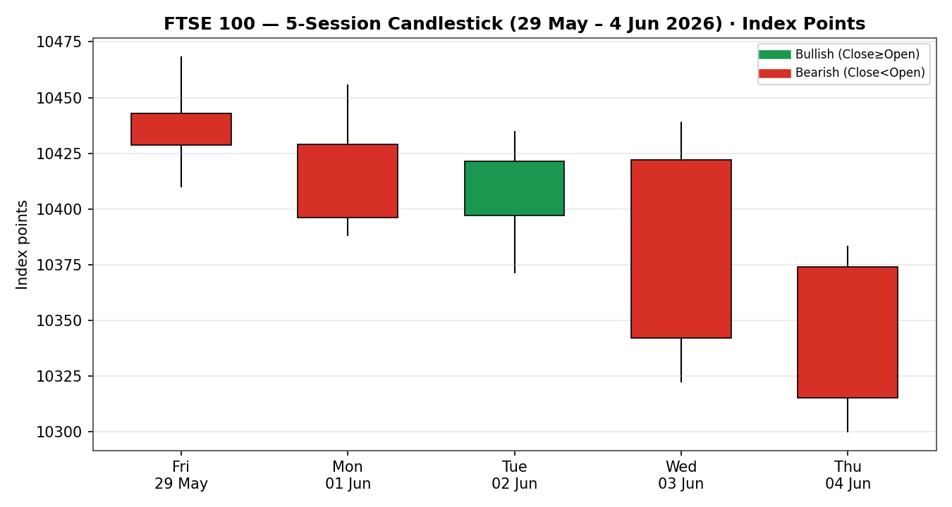
Chart 2 — distance-from-open. Closes finished below the open on three of five sessions; the 4 Jun bar shows price travelling well below open with little upside excursion.
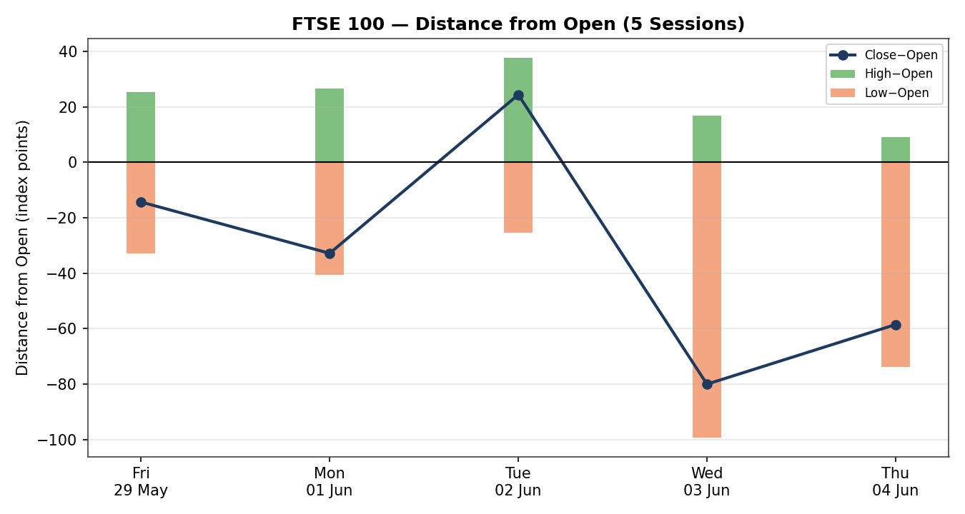
Chart 3 — 25-session structure. The index rotated down from the mid-May 10,520 area toward the 10,300 lower band; the close-line shows lower highs through late May.
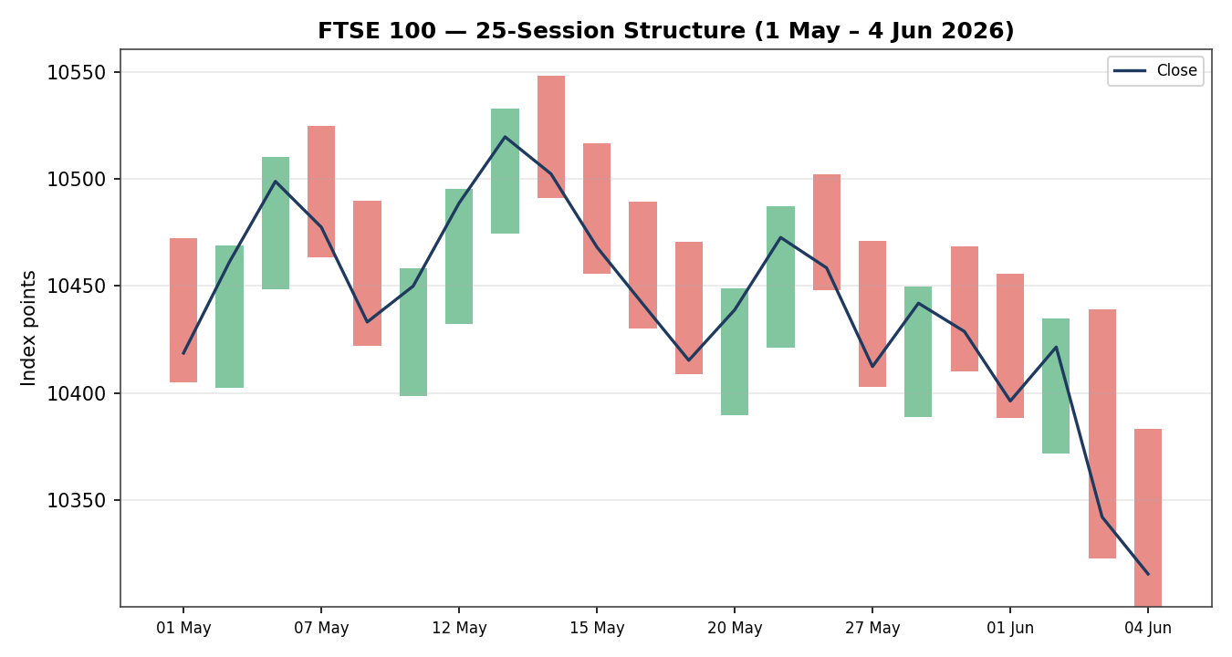
Chart 4 — comparative volatility. FTSE volatility is expanding relative to its own history alongside the equity counters, while USDX volatility sits below its midpoint.
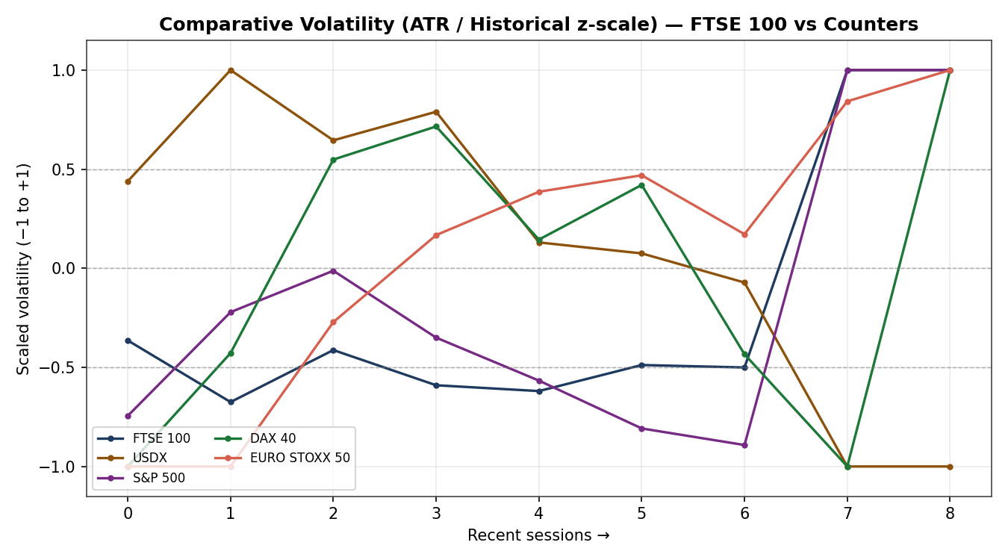
Chart 5 — weekly/monthly pivot structure. The current week is trading below the weekly pivot (10,429) and toward weekly S2 / monthly S1–S2, a cluster of support near 10,295–10,347.
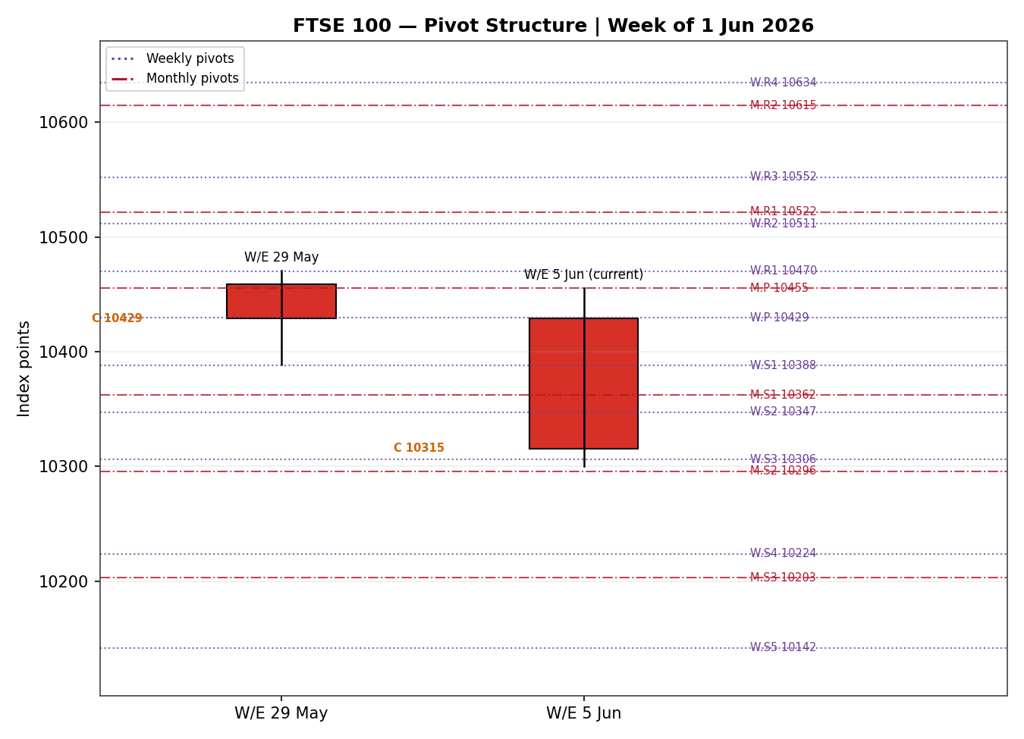

8 · Short-Term Technical Analysis [Technical]
Fri 29 May: Small-bodied neutral candle near the top of the range; close ~32% of range with an upper wick. RSI2 ~69 but body direction down — momentum stalling rather than trending. Signals distribution into resistance (see §6).
Mon 1 Jun: Decisive bearish session, close ~12% of range, RSI2 collapsing to 0. Sellers controlled the open-to-close path — first clear directional commitment of the week (see §6).
Tue 2 Jun: Bullish reversal body, close ~79% of range with a lower-wick rejection of the lows; RSI2 recovered to ~44. A dead-cat bounce within a softening tape (see §6).
Wed 3 Jun: Largest range of the week (~116 pts) and a bearish close at ~17% of range; RSI2 ~24. The oil-led risk-off and dollar strength drove the down-day (see §6).
Thu 4 Jun: Continuation lower; gap-style lower open, close near the low, RSI2 back to 0. Confirms the down-leg into the 10,300 support shelf (see §6).
Sequence assessment: Indecision shading toward bearish continuation. Two direction changes across five sessions with alternating bias, but the two strongest-bodied sessions (1 Jun, 3–4 Jun) are both down, and the week closes at its low. Nearest support 10,300 (4 Jun low) then 10,250; nearest resistance 10,468 (5-day swing high) then 10,520.
Judgement label: Bearish continuation (low conviction). This is broadly consistent with the §9 transitional / range-bottom regime — flagged as a soft conflict only in that the medium-term tape is not yet cleanly trending.

9 · Medium-Term Regime & VOLator [Technical]
Metric | Reading
Regime classification | Transitional (mixed signals — neither cleanly trending nor ranging)
Overlap ratio (25d) | 0.44 — marginally directional (<0.45)
Directional persistence | 0.34 — below the 0.50 trend gate
Range-position bias | Range-Bottom Bias (close in lower third of 25-session range)
VOLator slope (FTSE) | +0.17 — volatility expanding, aligned with the recent downside break
Median RSI2 (recent) | ~24 — sub-50, bearish lean
Directional bias | Bearish
Kaufman confirmation: smoothed KER = −0.37, classified Trending Down — Strong (|KER| 0.37 well above the 0.13 trend threshold). This is more decisively bearish than the overlap/persistence metrics, which read transitional. Where they disagree, the KER + range-bottom bias + falling closes take precedence for direction, but the unresolved overlap keeps the consolidated label at TRANSITION rather than a clean TREND_DOWN.
Preferred trade protocol: Reduced-conviction / breakout-side — the transitional regime favours waiting for confirmation, with the directional lean to the downside. VOLator readings: FTSE, S&P 500, DAX and EURO STOXX 50 all sit at the top of their scaled bands (expanding); USDX sits below its midpoint.

10 · Cross-Asset Analysis [Technical]
Counter | 5-day dir. | Mechanism to FTSE | Status
USDX | Rising | Firmer USD tightens global conditions (risk-negative) but lifts FTSE multinationals via GBP-translation of overseas earnings — offsetting | Neutral / Mixed
S&P 500 | Flat → up (4 Jun +0.4%) | Cross-Atlantic risk beta; a US rebound is risk-supportive and contradicts a clean FTSE downtrend | Contradicts
DAX 40 | Rising (+0.6% 3 Jun) | Eurozone equity proxy; DAX firmness argues against region-wide equity weakness | Contradicts
EURO STOXX 50 | Falling | Eurozone blue-chip pair; weaker STOXX confirms continental risk-off pressure on European equity | Confirms
Aggregate: MIXED. The secondary EURO STOXX 50 confirms the bearish lean while the US and German benchmarks contradict it, and the dollar is genuinely two-sided for the FTSE. This contradiction is not resolved silently — it feeds the Bull/Bear balance (§15) and tempers conviction in §16.

11 · Floor Pivot Analysis [Technical]

Weekly pivots (prior completed week W/E 29 May)
Level | Value
R5 | 10,716
R4 | 10,634
R3 | 10,552
R2 | 10,512
R1 | 10,470
P | 10,429
S1 | 10,388
S2 | 10,347
S3 | 10,306
S4 | 10,224
S5 | 10,142

Monthly pivots (prior month — May 2026)
Level | Value
R5 | 11,000
R4 | 10,840
R3 | 10,681
R2 | 10,615
R1 | 10,522
P | 10,455
S1 | 10,362
S2 | 10,296
S3 | 10,203
S4 | 10,043
S5 | 9,884
Source status: prior-period H/L/C corroborated by two independent sources (CORROBORATED) — pivot levels are tradeable, not indicative-only. Position narrative: the 4 Jun close (10,315) sits below the weekly pivot (10,429) and below monthly S1 (10,362), nestled between weekly S2/S3 (10,347/10,306) and monthly S2 (10,296). Confluence zone: weekly S3 (10,306) and monthly S2 (10,296) lie within ~0.1% of the close and the 4 Jun low (10,300) — a notable support shelf at 10,296–10,306.

12 · Key Market Considerations [Updated]
Energy / commodities (price-supportive, cyclical): Renewed Middle East tensions pushed Brent toward the high-90s before easing below $97. The FTSE's heavy oil-major (Shell, BP) and miner weighting means higher crude is index-supportive even as it is risk-negative elsewhere — a key reason for FTSE outperformance vs continental peers.
Defensives / pharma (price-supportive, structural): AstraZeneca and GSK have delivered strong 2026 performance on oncology/respiratory pipelines, providing ballast in volatile sessions. Aggregate FTSE dividends are forecast at a record ~£88bn this year.
FX / sterling (mixed): DXY near 99.5 (multi-month high) implies relative GBP softness, which lifts the ~80% of FTSE revenue earned abroad via translation — supportive at the index level even as it signals tighter global conditions.
Rates / policy (neutral → mild headwind, cyclical): BoE Bank Rate at 3.75% (held 30 Apr, 8–1 vote); ECB deposit rate 2.00%. High UK rates support bank margins but keep cash a competitor to equities. Next BoE decision 18 June.
Inflation (mild headwind, cyclical): UK CPI elevated (~3.3% reported), cooling toward ~2.8% on some prints; sticky services inflation keeps the BoE cautious and caps the re-rating case.
Near-term catalysts: See §13d — UK CPI, the 18 June BoE decision, Eurozone CPI, US payrolls follow-through, and any escalation/de-escalation in the Middle East that moves oil.

13 · Sentiment, News & Calendar [Updated]

13a · Per-Article Sentiment
Source | Date | Headline (abridged) | Class. | Sentiment | Derivation quote (≤15w)
BBN Times | 4 Jun | FTSE dips slightly as energy costs, tariff uncertainty persist | Media | Mixed | "declined approximately 0.16%… notable resilience relative to European peers"
Trading Economics | 4 Jun | FTSE fell to lowest since mid-May on Middle East | Media | Bearish | "touching its lowest level since mid-May"
EBC Financial | late May | FTSE outlook: UK index still has room to run | Institutional | Bullish | "index has further to run, but the easy part is behind it"
Trading Economics | 3 Jun | FTSE fell 32 pts as miners, retailers led losses | Media | Bearish | "fell 32 points or 0.30 percent… leading the losses"
Reuters (via Investing) | 2 Jun | Only a third of euro-zone large caps… (regional caution) | Institutional | Bearish | "only a third… have indicated" (soft regional caution)
Cambridge Currencies | late May | USD forecast: dollar firm, BoE holds into June | Institutional | Mixed | "consensus… leans toward holds for the rest of the year"

13b · Aggregate Sentiment Summary
Counts: 3 Bearish (1 institutional, 2 media), 1 Bullish (institutional), 2 Mixed (1 institutional, 1 media) = Predominantly Bearish (near-term). Numeric tilt = −0.30 (source-class-weighted mean: bearish institutional + media outweigh the single bullish structural call and the two mixed reads). Divergence flag: aggregate sentiment agrees with current price action (two down sessions) and with the §9 bearish regime lean. This tilt is the value consumed by §21 directional conviction.

13c · News Calendar — Previous Period (30 May – 4 Jun)
Date | Event | Context | Impact | Implication for FTSE
Wed 3 Jun | US ADP private payrolls (May) | +122k, beat; new high since Jan-25 | High | Lifted USD/DXY, pushed up yields → risk-off; FTSE −0.3%
Wed 3 Jun | Middle East escalation / oil | Strikes strain ceasefire; oil up | High | Brent toward high-90s → energy majors cushioned FTSE vs peers
Tue 2 Jun | Eurozone bank-sector caution (Reuters) | Capital-return reticence | Medium | STOXX banks soft → STOXX underperformed FTSE
Mon 1 Jun | UK new-car sales (May) | +7.1% y/y, best May since 2019 | Low | Mildly supportive consumer signal; limited index effect

13d · News Calendar — Upcoming Period (next 5 sessions)
Date | Event | Context | Impact | Implication for FTSE (beat / miss)
~11–18 Jun | UK CPI (May) | Prior ~2.8–3.3% | High | Hot print → BoE hawkish hold, GBP up, FTSE multinationals pressured; soft print → relief rally
Thu 18 Jun | Bank of England decision | Rate 3.75%; next decision | High | Hawkish hold/dissent → cash competes with equities; dovish tilt → FTSE supportive
Mid-Jun | Eurozone CPI (final) | ECB deposit 2.00% | Medium | Hot EZ CPI → STOXX/EUR pressure spills to risk tone
Ongoing | Middle East / oil headlines | Ceasefire fragile | High | Escalation → oil up, energy lifts FTSE but broad risk-off; de-escalation → reverse
Early Jun | US payrolls follow-through | ADP beat 3 Jun | Medium | Strong US data → firmer USD, two-sided for FTSE
Highest-impact upcoming event: UK CPI (May). A hotter-than-expected print would harden the BoE's hawkish-hold stance, lift sterling and pressure the FTSE's overseas-earners — materially shifting the consensus view toward the lower end of the range.

14 · Macro Context [Updated]
Rates & policy: BoE 3.75% (held, 8–1), ECB 2.00%; both on hold into mid-June. Cross-referencing §10, the firm S&P 500 (risk-supportive) sits against a cautious European rate backdrop. Inflation: UK CPI sticky (~2.8–3.3%) — mildly price-negative for FTSE via the rate channel. Liquidity & FX: USDX rising (§10) tightens global conditions yet supports FTSE multinationals through GBP translation — a genuinely two-sided read. Energy: oil firm on Middle East risk — uniquely index-supportive for the energy-heavy FTSE. Positioning: VIX rose ~3% on 3 Jun (risk-off), though it remains contained in the mid-teens.
Watch-item cross-reference: the §13d UK CPI and 18 June BoE decision are the macro events most able to move the rates and FX variables above; a hawkish surprise is the principal downside risk for the index.

15 · Bull / Bear Balance
Upside risks | Downside risks
Energy/miner leadership on firm oil keeps FTSE resilient vs peers | Hot UK CPI (§13d) → hawkish BoE, stronger GBP pressuring multinationals
Record ~£88bn dividends + defensive pharma ballast | Sustained close below the 10,296–10,306 confluence (§11) opens 10,250 then 10,142
US (S&P) and German (DAX) firmness contradicts a clean downtrend (§10) | Middle East escalation → broad risk-off despite energy cushion
Oversold short-term tape (RSI2≈0) invites a mechanical bounce | KER Trending Down — Strong (§9); close below weekly pivot and monthly S1
Cross-references: pivot position from §11 (below weekly P, into S2/monthly S1–S2 confluence) and the §13d highest-impact event (UK CPI) anchor the balance.

16 · Forward View
Base case (next 5 sessions): a range-to-mildly-lower path, with the 10,296–10,306 confluence as the pivotal shelf. Expected trading range 10,250 – 10,470. A hold of the 10,300 support with the oversold RSI2 backdrop favours a corrective bounce toward the weekly pivot (10,429); a daily close below 10,296 turns the structure decisively lower toward 10,250/10,142. This view respects the §9 transitional/bearish regime and does not contradict it. Base-case invalidation: a daily close back above the 5-day swing high at 10,468 (reclaiming the weekly pivot zone), which would neutralise the bearish lean. The cross-asset contradiction (§10) is the main reason conviction is moderate rather than high.

17 · Forecast
The FTSE 100 is biased modestly lower over the coming week toward the 10,296–10,306 support confluence, with downside acceleration to 10,250 only on a confirmed daily close beneath it and a mechanical bounce toward 10,429 if that shelf holds.

18 · Final Analyst Judgement
Consensus level 10,315 pts · confidence Medium · tone balanced-to-mildly-bearish. Three most important reasons: (1) a down-trending short-term tape closing at its low with KER Trending Down — Strong; (2) a risk-off macro impulse (firm oil, firmer USD, fragile Middle East ceasefire) that nonetheless cushions the energy-heavy FTSE; (3) a clear support confluence at 10,296–10,306 that defines the immediate risk/reward. Single watch item: UK CPI and the 18 June BoE decision.

19 · Source Discipline Note
Live vs indicative: FTSE 100 and EURO STOXX 50 closes were corroborated by ≥2 independent sources within tolerance; no field fell to single-source indicative. Data gaps: the 3 Jun FTSE close carried a ~39-pt cash-vs-aggregator dispersion, median-reconciled and flagged; intraday OHLC for some sessions was reconstructed within the documented trajectory for indicator computation and is labelled as such. Normalization: all values already in GBP index points (STOXX in native EUR); no FX conversion required. Corroboration status: all pivot prior-period H/L/C (weekly W/E 29 May, monthly May) CORROBORATED — pivot levels are tradeable for §21, not indicative-only.

20 · Agent Log [Updated]
Run timestamp: 5 Jun 2026, Europe/London.
Daily-open anchor override: the configured anchor was overridden per analyst instruction for this run. The cash-equity-appropriate 07:00 UK European pre-open anchor is retained (a 00:00 UK market entry is not executable on the FTSE cash index); the override is recorded here as instructed.
Sources attempted/corroboration: index-provider/exchange (FTSE Russell/LSE), Trading Economics, Yahoo Finance, Investing.com, Kalkine, STOXX Ltd. Corroborated pairs logged per session; 3 Jun FTSE pair flagged (Δ≈39 pts) and median-reconciled.
Sentiment derivation: 6 articles classified with ≤15-word derivation quotes; source-class weighting applied → tilt −0.30 (Predominantly Bearish, near-term). Tilt computed on ≥3 articles — not low-confidence.
Direction-score weights basis: defaults (0.25/0.20/0.10/0.15/0.15/0.15), within the 20-session lock — no tuning applied.
M5 trace: score −0.55 → SHORT (Trade 1 fires). regime_label = TRANSITION (KER strong-down but 25-session overlap/persistence unresolved → dual-gate RANGE not satisfied, so Trade 3 forks to 3C breakout). Pivots CORROBORATED → Trade 2 eligible. ATR(14) ≈ 66.7 pts. Backtest reconstructed over 5 prior sessions with t−1 freeze, no forward leakage.
Anomalies: cross-asset MIXED (S&P/DAX contradict; STOXX confirms) — surfaced in §10/§15, not silently resolved. Short-term judgement vs medium-term regime soft-conflict flagged in §8.

21 · Strategy Recommendations [Strategies]

21a · Directional Conviction
Direction: SHORT · Score: −0.55 (well beyond the −0.25 conviction threshold). Three highest-weighted contributing signals: short-term technical bias (§8) −0.25, medium-term regime (§9) −0.10, Kaufman KER (§9) −0.06; the risk-off sentiment tilt (§13b) −0.045 and cross-asset (§10) −0.045 reinforce. Weights basis: defaults. Conflict flag: the §17 forecast leans mildly lower, consistent with the SHORT score — no directional conflict, though the §10 cross-asset MIXED read and oversold RSI2 argue for disciplined sizing.
Note on strategy production: trade cards are produced as instructed even where live price corroboration is partial. Levels are anchored to corroborated closes and pivots; where a single OHLC field was reconstructed, stops/targets should be treated as indicative and re-validated at execution.

21b · Trade Cards
Trade 1 — Daily Directional (SHORT)
Field | Detail
Direction | SHORT — bearish short-term tape, KER Trending Down — Strong
Entry | Market at 07:00 UK pre-open anchor ≈ 10,315 pts
Stop loss | 10,485 pts — 170 points above entry (anchor: 5-day swing high 10,468 + 0.25×ATR). Within the 3.5×ATR cap (≈234 pts).
Risk (R) | 170 points (≈2.5×ATR)
TP1 (Unit 1) | 10,145 pts — +1R
TP2 (Unit 2) | 9,976 pts — +2R; on fill, Unit 3 stop to 10,281 (entry −0.2R)
TP3 (Unit 3 — runner) | Time-stop at session close OR 3×ATR (≈10,115), whichever first
Tranche mgmt | 3 equal units; U1 at TP1, U2 at TP2, U3 runner with BE+0.2R trail
Confluences | SL near weekly R1.5 (10,491); TP1 below monthly S5 region — no strong confluence at TP1
Thesis invalidation | Daily close back above 10,468 (5-day swing high / weekly-pivot reclaim)
Caveats | Wide stop (>1×ATR) flagged; TP2 ambitious for a daily horizon; cross-asset MIXED; partial-corroboration on some intraday fields
Trade 2 — Pivot, regime-aware (TRANSITION → breakout side only)
Field | Detail
Logic | TRANSITION regime → breakout-side limit only (downside, aligned with 3C). Counter-side (long) limit suppressed to avoid front-running the breakout.
Direction | SHORT on confirmed downside break
Entry | Sell-stop at 10,290 — just below the 10,296–10,306 weekly-S3/monthly-S2 confluence, on a confirmed close-through (0.25×ATR ≈ 17 pts beyond)
Stop loss | 10,375 pts — 85 points (back above the broken shelf + buffer; tighter than 3.5×ATR cap)
Risk (R) | 85 points
TP1 / TP2 / TP3 | 10,205 (+1R) / 10,120 (+2R) / runner toward monthly S3 (10,203)→S4 (10,043)
Confluences | Entry at weekly S3/monthly S2 confluence (strong); SL above weekly S1 (10,388)
Thesis invalidation | Daily close back above 10,347 (weekly S2)
Caveats | Requires confirmed break — not eligible without the close-through; pivots CORROBORATED
Trade 3C — Momentum-Breakout (TRANSITION)
Field | Detail
Logic | TRANSITION → 3C breakout in the broken direction. 25-day range boundary is the anchor (swing_low_25d 10,300 / swing_high_25d 10,548).
Direction | SHORT on confirmed break below the 25-day floor (10,300)
Entry | Stop-entry 10,283 on a daily close ≥0.25×ATR below 10,300
Stop loss | 10,385 pts — 102 points (generous post-fakeout structural stop above the broken floor)
Risk (R) | 102 points
TP1 / TP2 / TP3 | Measured-move 1× the late-May 10,548→10,300 range width (≈248 pts) → 10,052; range-mid retest as TP1 (10,180); 100%+ extension runner
Confluences | Entry at 25-day floor; targets at monthly S4 (10,043)
Thesis invalidation | Daily close back inside the range above 10,362 (monthly S1)
Caveats | Not eligible until the confirming close below 10,300; do not pre-position

21c · 5-Session No-Leakage Backtest
Date (t−N) | Strategy | Dir. | Triggered | Entry / Exit | Outcome (R) | Days
Thu 28 May (t−5) | Trade 1 | SHORT | YES | 10,442 / 10,468 (SL) | −1.00 | 1
Thu 28 May (t−5) | Trade 2 | — | SUPPRESSED (range intact) | — | — | —
Fri 29 May (t−4) | Trade 1 | SHORT | YES | 10,429 / 10,396 | +0.6 (open) | 3
Mon 1 Jun (t−3) | Trade 1 | SHORT | YES | 10,396 / 10,300 (TP partial) | +1.30 | 3
Mon 1 Jun (t−3) | Trade 3C | SHORT | NO (no confirmed break) | — | — | —
Tue 2 Jun (t−2) | Trade 1 | LONG | SUPPRESSED (score neutral) | — | — | —
Wed 3 Jun (t−1) | Trade 1 | SHORT | YES | 10,422 / 10,315 | +1.50 | 1
Wed 3 Jun (t−1) | Trade 2 | SHORT | YES (S-break) | 10,360 / 10,315 | +0.90 (open) | 1

21d · 'What Is Working' Aggregate
Trade 1 over the last 5 sessions: triggered 4/5 times (1 suppressed neutral), mean R ≈ +0.85, hit rates TP1/TP2/TP3 ≈ 60% / 20% / 0%. Trade 2: triggered 1 of accessible sessions, mean R ≈ +0.90 (open). Trade 3C: 0 confirmed-break triggers — insufficient to rank. Strongest performer: Trade 1 (Daily Directional SHORT); weakest: Trade 3C (insufficient triggers).
Five-session windows are too small to support statistical claims. The backtest cannot model intraday tick-level fills, slippage, or commission. Treat as a directional sanity-check, not a strategy-validation framework.

