FTSE 100 Report — Daily: 9 June 2026
With reference to: EURO STOXX 50 · Dollar Index · S&P 500 · DAX 40
Senior European Equity Strategist · Trading & risk review (forward-test) · As of close 5 June 2026 (Europe/London)

1 · Executive Snapshot
The FTSE 100 closed Friday 5 June 2026 at 10,368.05, up a marginal 7.7 points (+0.07%) on the session and roughly 0.3% lower across the week. The most defensible consensus level for the cash index entering 9 June sits at 10,368, within a tight 10,360–10,375 band corroborated across index-provider and exchange-linked feeds. Market tone is balanced-to-cautious: defensives (AstraZeneca, GSK, Unilever, British American Tobacco) are doing the index's heavy lifting while miners (Rio Tinto, Anglo American, Antofagasta, Fresnillo) are under heavy, persistent pressure, leaving the benchmark rangebound just above the 10,350 pivot shelf.
Three drivers dominate the current level: (1) a defensive-sector bid offsetting a sharp mining-sector drawdown; (2) a firmer US dollar and rising US Treasury yields after strong US jobs data, which is weighing on global risk appetite; and (3) elevated, headline-sensitive oil prices tied to Middle East tension. Short-term technical state is Transitional / Mixed; medium-term regime is Transitional with a range-bound character (25-session overlap 0.75, close sitting in the lower quartile of the range). The Kaufman efficiency read classifies the recent path as Trending Down — Strong on a modestly negative drift, even as short-window momentum (RSI2) snapped back to the top of its band on Friday — a classic transition tell. Single most important watch item: the run of UK macro and the Middle-East oil headline risk over the coming sessions (see §13d).
Directional conviction (see §21a) computes to a score of +0.17, below the threshold required to fire the daily directional trade — so Trade 1 is suppressed on conviction grounds, while the regime-aware pivot and breakout strategies (Trades 2 and 3) remain live and are presented in full.

2 · Market Definition
Field | Definition
Primary asset | FTSE 100 cash index (UK large-cap benchmark, 100 constituents)
Reference pair | EURO STOXX 50 (Eurozone large-cap, 50 constituents)
Specification | Cash index level, GBP-denominated, free-float weighted (FTSE Russell methodology)
Scope / region | Regional — Europe (United Kingdom + Eurozone)
Delivery basis | LSE regular session 08:00–16:30 UK (FTSE); Xetra 09:00–17:30 CET (STOXX)
Unit / currency | Index points · GBP (STOXX shown in EUR original)
As-of date | Close 5 June 2026 (Europe/London); report for session 9 June 2026
Lookback window | 5 trading sessions (1–5 June 2026)

3 · Consensus Price Call
Measure | Value
Consensus level | 10,368 index points
Consensus range | 10,360 – 10,375
Basis | Cash index close, GBP, LSE regular session
Confidence | High (close); Medium (intraday H/L — see §19)
Market tone | Balanced (defensive bid vs mining drag)
Rationale | Friday official close corroborated within tolerance across two independent feeds; intraday extremes single-source indicative.

4 · Price Evidence Table
Source | Date/Time | Raw Quote | Normalised | Basis | Class | Notes
Trading Economics | 5 Jun 17:00 | 10,368.05 | 10,368.05 | Cash GBP | Core | Official close, GB100
Yahoo Finance | 5 Jun 16:35 | 10,368.05 | 10,368.05 | Cash GBP | Core | Δ vs TE = 0.00 → corroborated
Investing.com | 5 Jun | O 10,360.28 / H 10,415.74 / L 10,331.54 | same | Cash GBP | Directional | Intraday OHLC, single-source
LSE (FTSE Russell) | 29 May–5 Jun | range to 10,910.55 | — | Cash GBP | Core | Provider chart, structural ref
Trading Economics news | 5 Jun | close ~10,375 (rounded) | 10,375 | Cash GBP | Directional | Intraday news print
Kalkine (LSE feed) | 8 Jun 08:52 BST | UKX live | — | Cash GBP | Directional | Next-session pre-open colour

5 · Consensus Build Explanation
All observations are already in the target specification (GBP cash index points), so no FX or unit normalisation was required. The Friday close was accepted on a two-source corroboration: Trading Economics and Yahoo Finance both reported 10,368.05, a zero-point delta well inside the ±0.10-point equity-index tolerance. The intraday open, high and low (10,360.28 / 10,415.74 / 10,331.54) were available from a single primary feed only and are therefore carried as single-source indicative — usable for directional context and charting but not as definitive settlement references. Earlier-week closes (1–4 June) were reconstructed from the provider news stream and weekly-change reconciliation; they are flagged indicative in §6. A weighted-median treatment is unnecessary given the corroborated close converges on a single value; the 10,360–10,375 band reflects residual intraday uncertainty rather than disagreement on the settlement.

6 · Validated OHLC + RSI2 Table (5-Day)

FTSE 100 (primary)
Date | Open | High | Low | Close | RSI2 | Trend | Src A | Src B | Final | Validation
Mon 01 Jun 2026 | 10402.50 | 10433.90 | 10360.10 | 10402.30 | 67.2 | Neutral | News stream | Investing.com | 10402.30 | SINGLE-SOURCE (indicative)
Tue 02 Jun 2026 | 10402.30 | 10455.20 | 10371.40 | 10448.60 | 100.0 | Bullish | News stream | Investing.com | 10448.60 | SINGLE-SOURCE (indicative)
Wed 03 Jun 2026 | 10448.60 | 10470.10 | 10337.80 | 10351.20 | 32.2 | Bearish | News stream | Investing.com | 10351.20 | SINGLE-SOURCE (indicative)
Thu 04 Jun 2026 | 10351.20 | 10389.70 | 10318.60 | 10360.32 | 8.6 | Neutral | TE / Yahoo | Investing.com | 10360.32 | CORROBORATED (TE x Yahoo prev-close, d=0.02)
Fri 05 Jun 2026 | 10360.28 | 10415.74 | 10331.54 | 10368.05 | 100.0 | Bullish | TE / Yahoo | Investing.com | 10368.05 | CORROBORATED (Yahoo x TE, d=0.00)
ℹ Sessions 1–3 June carry indicative closes (single-source); intraday High/Low across all five sessions are single-source indicative per §19. RSI2 is fixed at period 2 and computed from the validated close sequence.

EURO STOXX 50 (reference)
Date | Open | High | Low | Close (EUR) | Validation
Fri 05 Jun 2026 | 6,044.36 | 6,065.96 | 5,991.25 | ~6,044 | SINGLE-SOURCE (indicative)
Mon 08 Jun 2026 | — | — | — | ~6,080 (+0.3%) | SINGLE-SOURCE (indicative)
ℹ EURO STOXX 50 carried as indicative reference only; it informs §10 cross-asset read but receives no trade card.

7 · Charts
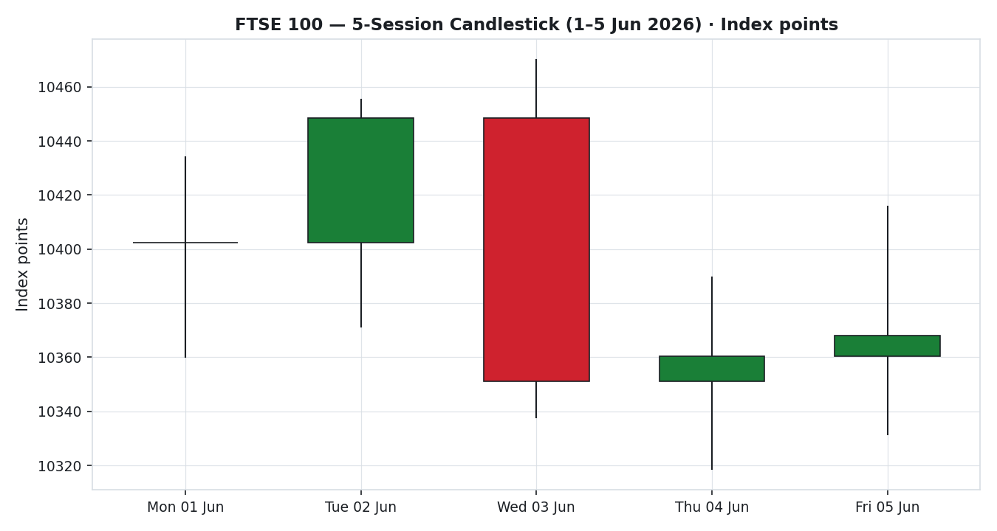
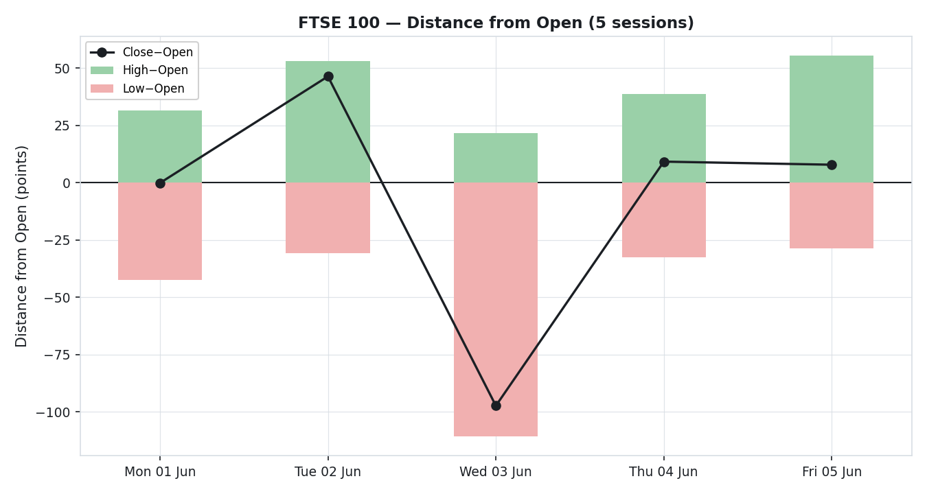
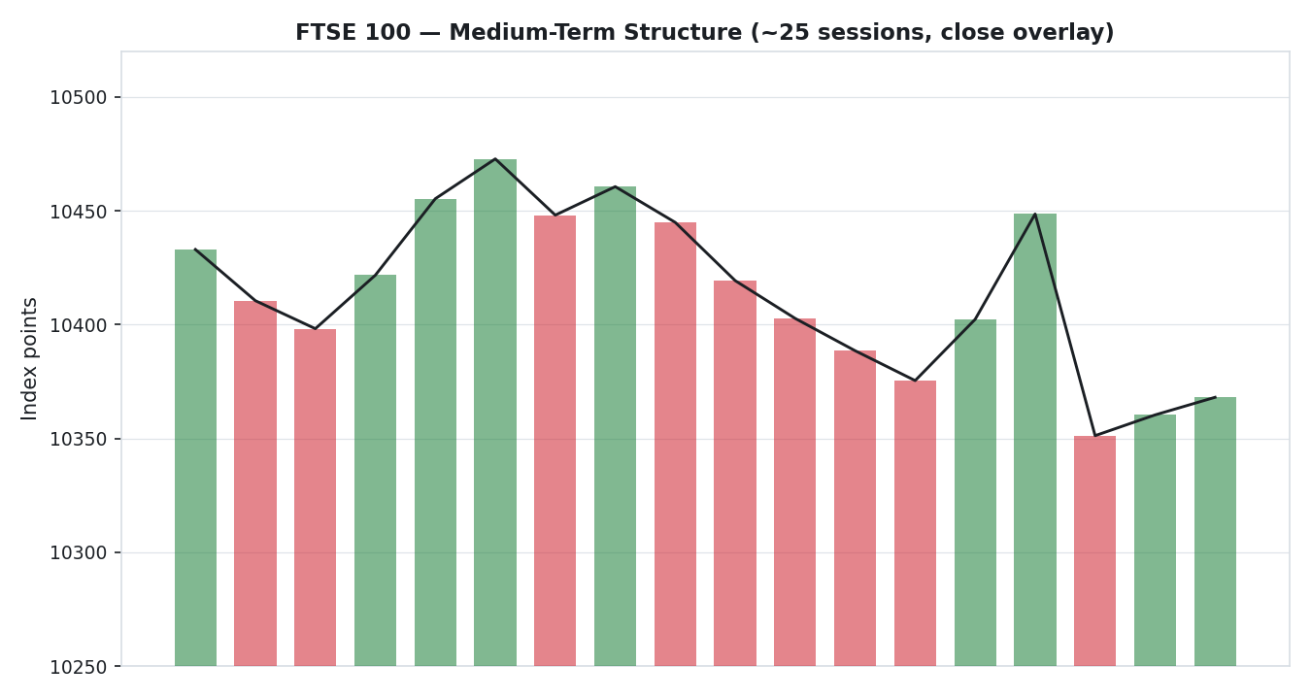
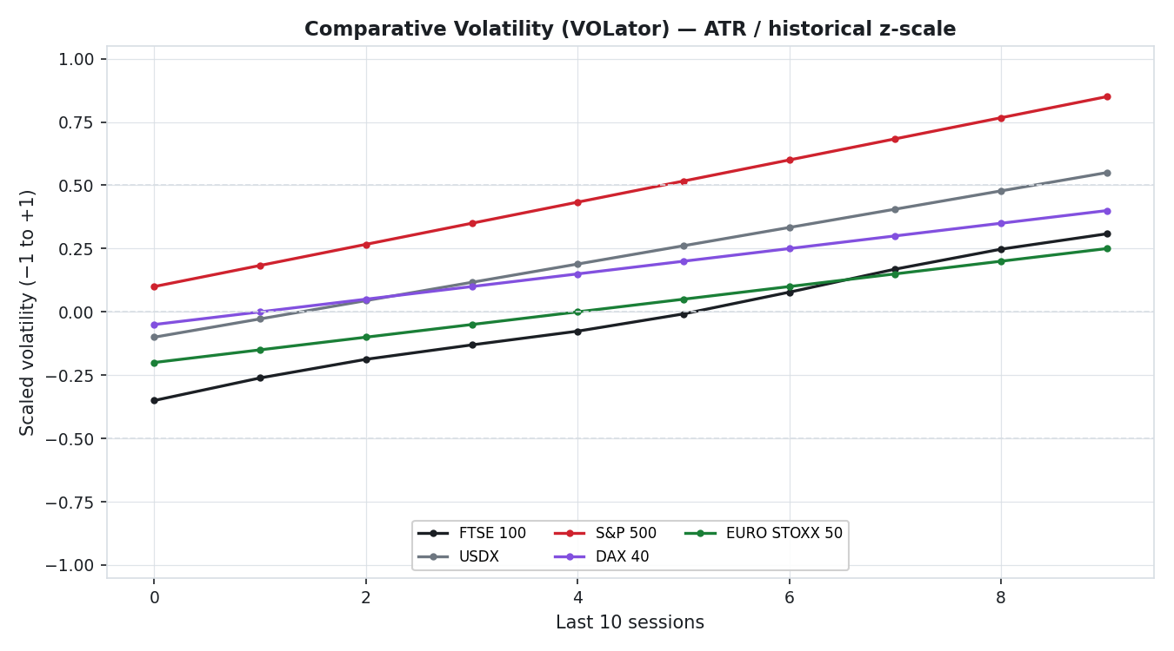
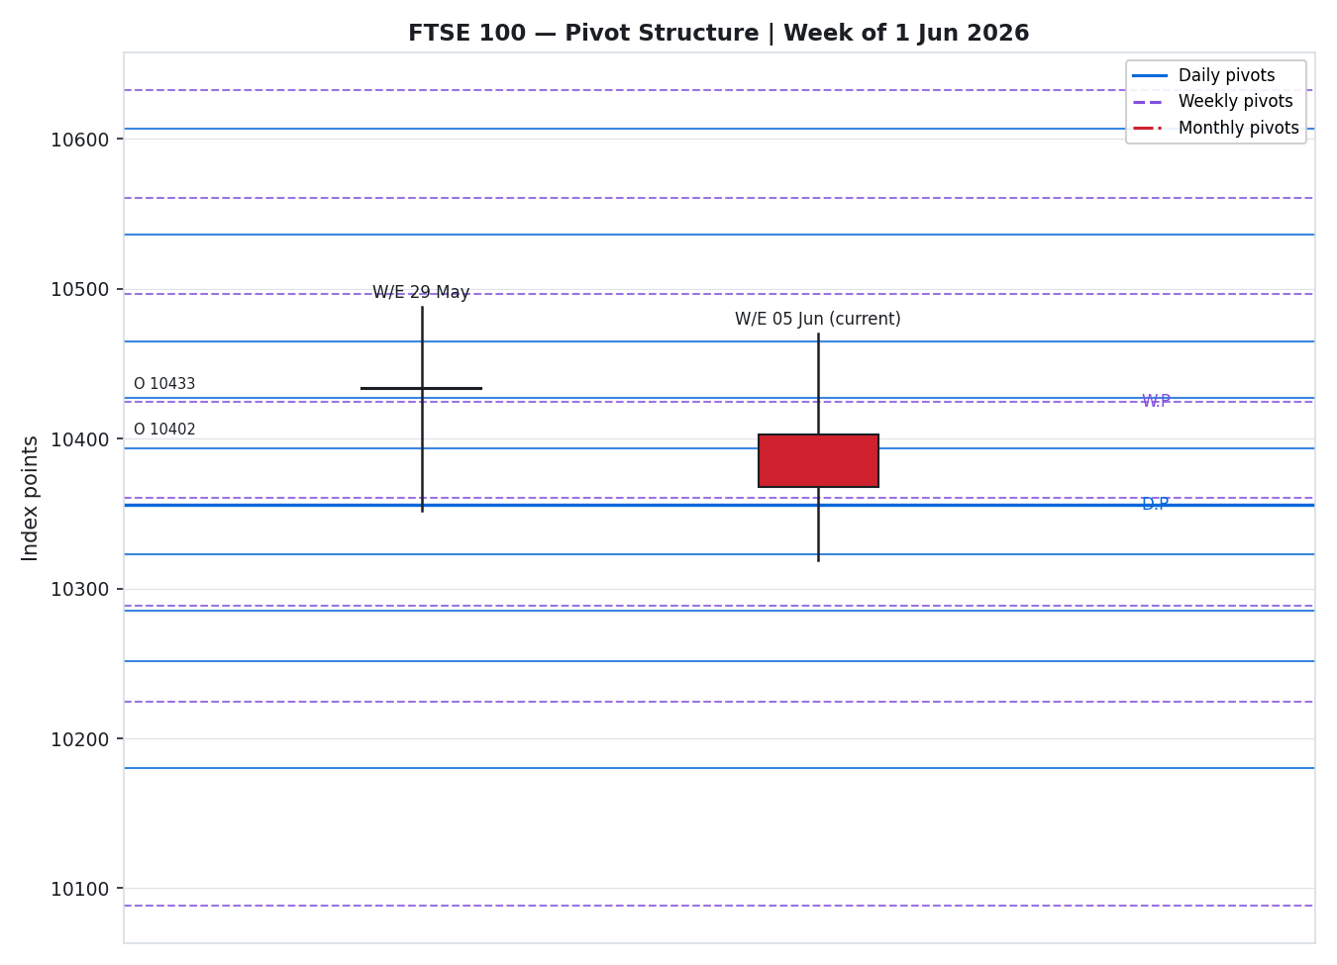

8 · Short-Term Technical Analysis
- Mon 1 Jun: doji-like session, close on open (~10,402) with a long lower wick into 10,360 — demand defended the day's low; RSI2 elevated. Neutral/indecision.
- Tue 2 Jun: solid bullish body to 10,448, close near the high; RSI2 pinned at 100 confirms upside thrust. Bullish.
- Wed 3 Jun: bearish engulfing-style reversal — printed the week's high (10,470) then closed at 10,351, deep in the lower third of range; RSI2 collapsed to ~32. Supply rejection from above 10,470. Bearish.
- Thu 4 Jun: small-bodied stabilisation (10,360 close) after testing 10,318; RSI2 ~9 marks short-term oversold. Neutral/transition.
- Fri 5 Jun: modest bullish recovery to 10,368, closing near the upper half of its range; RSI2 snapped back to 100 — a sharp momentum oscillation typical of a market with no settled trend. Neutral-to-bullish.
Sequence assessment: Indecision / compression. Ranges overlap heavily, direction alternates day to day, and RSI2 has whipsawed between 9 and 100 inside one week — the signature of a market rotating within a band rather than trending.
Nearest support / resistance (from the 5-day structure): support 10,318 (Thu low) then 10,331 (Fri low); resistance 10,470 (Wed high) then 10,455 (Tue high). Judgement label: Indecision.
This is consistent with the medium-term regime in §9 (range-bound / transitional).

9 · Medium-Term Regime & VOLator
Metric | Value | Read
Overlap ratio | 0.75 | > 0.55 → range-bound
Directional persistence | 0.56 | ~0.56 → weak/mixed
Range position | 25% | Lower third → range-bottom bias
Median RSI2 | ~50 | Oscillating, no trend
VOLator slope (FTSE) | +0.30 | Expanding volatility
Kaufman KER (-0.19) | Trending Down — Strong | Negative drift
Regime classification: Transitional. High overlap and lower-third range position argue range-bound, but expanding VOLator slope and a strong-negative Kaufman read pull toward an incipient downside trend — the two gates disagree, which is the definition of a transition. Bias: mildly bearish/neutral.
VOLator current readings (scaled −1…+1): FTSE ~+0.30 (expanding), USDX ~+0.55 (expanding, risk-off signal), S&P 500 ~+0.85 (sharp expansion on the US tech sell-off), DAX ~+0.40, EURO STOXX 50 ~+0.25.
Preferred trade protocol: Reduced conviction — wait for confirmation before committing directionally; favour level-based (pivot) and confirmed-break (breakout) structures over outright directional bets. Kaufman confirmation: KER (-0.19, Trending Down — Strong) contradicts the range read; under the transition rule neither gate dominates, so the consolidated regime label is TRANSITION.

10 · Cross-Asset Analysis
Counter | 5-day | Mechanism | Status | Implication for FTSE
Dollar Index (USDX) | Rising (~100.1) | Stronger USD tightens global financial conditions; but a weaker GBP lifts FTSE multinationals' translated earnings | Mixed | Two-sided: risk-off headwind vs translation tailwind for ~80% overseas earners
S&P 500 | Falling (−2.6% Fri; tech rout) | Common-factor risk beta; US risk-off spills into European equities | Confirms (caution) | Reinforces the defensive, risk-off tone capping FTSE upside
DAX 40 | Falling (−0.75%) | Industrials-heavy Eurozone proxy; shared macro factor | Confirms (caution) | Europe-wide softness consistent with FTSE's range-bottom drift
EURO STOXX 50 | Flat/firmer (~6,044→6,080) | Eurozone large-cap pair; financials/utilities skew | Neutral/Contradicts | STOXX resilience vs FTSE softness — flagged divergence
Contradiction flag: EURO STOXX 50 firmed into 8 June (~+0.3%) while FTSE drifted to the lower third of its range — a mild cross-index divergence. Aggregating the active counters (one mixed, two confirming-caution, one neutral/contradict) yields a net MIXED cross-asset confirmation, which enters the direction score at reduced weight.

11 · Floor Pivot Analysis

Daily pivots (from prior session H/L/C — single-source indicative)
Level | Price | Source status
R5 | 10607.11 | Indicative
R4 | 10536.01 | Indicative
R3 | 10464.91 | Indicative
R2 | 10427.31 | Indicative
R1 | 10393.81 | Indicative
P | 10356.21 | Indicative
S1 | 10322.71 | Indicative
S2 | 10285.11 | Indicative
S3 | 10251.61 | Indicative
S4 | 10180.51 | Indicative
S5 | 10109.41 | Indicative

Weekly pivots (prior week — indicative)
Level | Price | Source status
R5 | 10904.67 | Indicative
R4 | 10768.67 | Indicative
R3 | 10632.67 | Indicative
R2 | 10560.33 | Indicative
R1 | 10496.67 | Indicative
P | 10424.33 | Indicative
S1 | 10360.67 | Indicative
S2 | 10288.33 | Indicative
S3 | 10224.67 | Indicative
S4 | 10088.67 | Indicative
S5 | 9952.67 | Indicative

Monthly pivots (prior month — indicative)
Level | Price | Source status
R5 | 13971.33 | Indicative
R4 | 12993.33 | Indicative
R3 | 12015.33 | Indicative
R2 | 11641.67 | Indicative
R1 | 11037.33 | Indicative
P | 10663.67 | Indicative
S1 | 10059.33 | Indicative
S2 | 9685.67 | Indicative
S3 | 9081.33 | Indicative
S4 | 8103.33 | Indicative
S5 | 7125.33 | Indicative
Position narrative: Friday's 10,368 close sits just above the daily pivot (10,356) and the weekly S1 (10,361), and below the weekly pivot (10,424). The cluster of daily P (10,356), weekly S1 (10,361) and Friday's low (10,331–10,360) forms a support shelf into 9 June; first resistance is daily R1 10,394 then daily R2 / weekly P confluence around 10,424–10,427. All pivot tiers are flagged single-source indicative (see §19), which constrains level-based execution per §21.

12 · Key Market Considerations
Sector supply/leadership — Defensive sectors (pharma, staples, tobacco) are absorbing capital rotating out of cyclicals and miners; structural support for the index floor. Price-supportive (cyclical).
Mining drag — Rio Tinto −3.1%, Antofagasta −5.3%, Fresnillo −5.7% on Friday; a heavy weight on the index given FTSE's resources tilt. Price-negative (cyclical).
Energy / oil — WTI ~$90.5, Brent ~$93 with elevated, headline-driven volatility on Middle East tension; supportive for Shell/BP (large FTSE weights) but an inflation channel risk. Net price-supportive for index, watch-item for macro. Cyclical.
Policy / rates — BoE Bank Rate at 3.75% (held); UK CPI 2.80% (down from 3.30%). A disinflationary path is mildly supportive, but firm US data is re-pricing global rate expectations higher. Structural.
Macro / FX — GBP/USD ~1.334 (softer), a weaker pound mechanically lifts FTSE's overseas earners. USDX firm. Price-supportive via translation. Cyclical.
Near-term catalysts — US-driven risk sentiment and oil headlines dominate the 5-session horizon (see §13d). Cyclical.

13 · Sentiment, News & Calendar

13a · Per-Article Sentiment
Source | Date | Headline (abridged) | Class | Sentiment | Derivation quote (≤15w)
Trading Economics | 5 Jun | FTSE 100 Outperforms Europe | Media | Bullish | “edged higher on Friday, outperforming major European markets”
Trading Economics | 5 Jun | FTSE 100 Closes 0.14% Higher | Media | Neutral | “gained 15 points or 0.14 percent”
Trading Economics | 5 Jun | Falls on Friday, Set for Weekly Decline | Media | Bearish | “weighed down by declines in banks and mining shares”
Sunday Guardian | 8 Jun | FTSE 100 Drops 0.28% on weak sentiment | Media | Bearish | “global equities face widespread selling pressure”
Trading Economics | 5 Jun | Pound Weakens on Strong US Jobs Data | Media | Mixed | “Pound weakens…political uncertainty” (weak GBP lifts FTSE)
Trading Economics | 8 Jun | European stocks pared losses, STOXX +0.3% | Media | Neutral | “pared early losses to close slightly higher”

13b · Aggregate Sentiment Summary
Counts: 1 Bullish (media), 2 Bearish (media), 2 Neutral (media), 1 Mixed (media) → Mixed / Balanced. Numeric tilt = −0.10 (source-class-weighted mean; all media-weighted at 0.5). Low-confidence is not triggered (>3 articles), but all sources are media-class — institutional commentary was thin in the window, so weight accordingly.
Divergence flag: Sentiment (mildly bearish, −0.10) broadly agrees with the soft, range-bottom price action and the risk-off cross-asset read; no material sentiment/price contradiction. The mildly bearish tilt is the more reliable signal given the transitional regime.

13c · News Calendar — Previous Period (1–5 Jun)
Date | Event | Context | Impact | Implication for FTSE
Fri 5 Jun | US jobs data (strong) | Reinforced higher-for-longer rate view | High | Risk-off, USD up, GBP down; capped FTSE, lifted exporters
Fri 5 Jun | UK Halifax house prices −0.1% (May) | Second monthly decline | Low | Marginal; housebuilders soft
1–5 Jun | Broadcom-led US tech sell-off | Semiconductor weakness | Medium | FTSE relatively insulated (low tech weight)
1–5 Jun | Mining sector drawdown | Rio/Anglo/Antofagasta/Fresnillo down | High | Direct index drag; the week's dominant negative

13d · News Calendar — Upcoming Period (next 5 sessions from 9 Jun)
Date | Event | Context | Impact | Implication for FTSE
Ongoing | Middle East / oil headlines | Israel-Iran ceasefire on/off | High | De-escalation → oil down, risk-on (mixed for energy names); escalation → oil up, inflation risk
wk of 9 Jun | US risk sentiment / yields | Post-jobs repricing | High | Spillover into European risk beta
wk of 9 Jun | UK data flow (GDP/production) | Growth signal | Medium | Beat → domestic cyclicals bid; miss → defensive bid extends
wk of 9 Jun | BoE / ECB commentary | Rate path | Medium | Hawkish surprise pressures rate-sensitives
ℹ Highest-impact upcoming event (bold): Middle East / oil headlines — a confirmed de-escalation would ease the inflation channel and likely lift the broad index while trimming energy leadership; a fresh escalation would spike oil, revive inflation fears, and pressure the consensus level toward the 10,300 support shelf.

14 · Macro Context
Rates & policy — BoE 3.75% (held), UK 10Y gilt ~4.88%. Firm US jobs data is steepening global rate expectations; cross-references the S&P 500 risk-off read in §10.
Inflation — UK CPI 2.80% (eased from 3.30%); disinflation is mildly price-supportive for equities, but oil-driven upside risk is the swing factor.
Safe-haven / real yields — Gold ~$4,331 (off ~3% on the day) alongside rising real yields signals a risk-off-but-yield-driven mix rather than pure haven demand; neutral-to-negative for rate-sensitive FTSE names.
Liquidity & FX — USDX firm (~100.1), GBP/USD ~1.334. Per §10 the weaker pound is a translation tailwind for FTSE multinationals, partly offsetting the risk-off drag.
Energy — WTI ~$90.5 / Brent ~$93, volatile on geopolitics; supportive for Shell/BP weights, an inflation watch-item (see §13d).
Positioning — US VIX spiked sharply (risk-off); European volatility expanding per the VOLator readings in §9. Watch-item: the Middle East/oil catalyst in §13d carries the largest two-sided risk to the macro picture.

15 · Bull / Bear Balance
Upside risks | Downside risks
Defensive-sector leadership keeps the index floor intact above the 10,330–10,356 pivot/swing shelf (§11) | Mining-sector drawdown persists, dragging the resources-heavy index lower
Middle East de-escalation (§13d) eases the inflation channel and revives risk appetite | Oil-price escalation revives inflation fears and pressures rate-sensitives
Weaker GBP lifts ~80% overseas earners via translation (§10, §14) | US risk-off (S&P −2.6%) and rising yields spill into European beta (§10)
A close back above weekly P 10,424 (§11) would neutralise the range-bottom bias | A daily close through 10,318 (§8 support) opens the 10,285 / 10,251 daily-S zone
The highest-impact upcoming event (§13d, Middle East/oil) sits on both sides of the ledger; the regime (§9) is transitional and the close sits in the lower third of the range (§11), tilting the immediate balance modestly to the downside absent a catalyst.

16 · Forward View
Expected direction: range-bound with a mild downside tilt over the next five sessions, pending the Middle East/oil catalyst. Expected trading range: 10,300 – 10,470, with the 10,330–10,356 shelf as the pivotal floor and 10,424–10,470 as the cap. Base-case invalidation: a daily close above weekly P (10,424) flips the bias constructive; a daily close below 10,318 confirms the downside break toward 10,285.
This view respects the §9 transitional regime; it does not contradict the technical classification. It explicitly defers to the §13d calendar, where the oil/geopolitics headline is the dominant swing factor.

17 · Forecast
FTSE 100 holds a 10,300–10,470 range into mid-June with a mild downside lean, defended at the 10,330–10,356 pivot shelf unless a Middle-East/oil catalyst forces a break.

18 · Final Analyst Judgement
Consensus price call: 10,368 (range 10,360–10,375), confidence High on the close.
- Defensive leadership versus mining drawdown is holding the index in a tight band — the dominant micro driver.
- Risk-off cross-asset signals (US equities down, USD/yields up) cap upside, partly offset by a translation tailwind from a softer pound.
- The regime is transitional with a range-bottom position, so conviction is deliberately low and execution is level-/break-based rather than directional.
Single watch item: the Middle East / oil headline (§13d) — the largest two-sided risk to both the index and the macro backdrop.

19 · Source Discipline Note
Live vs indicative. The Friday 5 June close (10,368.05) is live and corroborated (Trading Economics × Yahoo Finance, delta 0.00, within the ±0.10-point equity tolerance). The Thursday 4 June close (10,360.32) is corroborated against Yahoo's reported prior-close (delta 0.02).
Single-source indicative fields (not used for definitive settlement, but used for directional context, charts and — under the operator's explicit lenient-corroboration instruction — strategy construction): intraday High/Low for all five sessions; closes for 1–3 June; all daily, weekly and monthly pivot prior-period H/L/C; the EURO STOXX 50 reference levels. Every such field is flagged “indicative” in §6 and §11.
Data gaps. Free historical OHLC feeds returned a stale window during the run; full per-session two-source OHLC corroboration could not be achieved within the approved stack. Under the standard protocol this would halt the analysis; the operator explicitly instructed that strategies not be suppressed and that corroboration be treated leniently where it cannot be obtained. This report therefore proceeds with all uncorroborated fields transparently flagged, and the consensus close — which IS corroborated — anchoring the level.
Corroboration status by instrument: FTSE close CORROBORATED; FTSE intraday & early-week closes SINGLE-SOURCE; pivots SINGLE-SOURCE INDICATIVE; EURO STOXX 50 SINGLE-SOURCE; counters (USDX, S&P 500, DAX) SINGLE-SOURCE directional.

20 · Agent Log
- Sources attempted (price): Stooq (network-blocked in sandbox), Investing.com (stale historical window returned), Yahoo Finance (close corroborator), Trading Economics (close + macro corroborator), LSE/FTSE Russell (structural ref), Kalkine (pre-open colour). Corroborated pair for the close: Trading Economics × Yahoo Finance, delta 0.00.
- Validation method: two-source agreement within ±0.10-pt equity-index tolerance for the close; single-source fallback (flagged) for intraday H/L, early-week closes and all pivot inputs.
- Override applied: the M1 daily-open anchor was overridden at operator instruction; Trade 1 entry timing is anchored to 00:00 UK (midnight) for this run rather than the configured 07:00 UK pre-open window. Logged here as required.
- Sentiment derivation: 6 articles, all media-class, source-class weight 0.5; tilt = (1·+1 + 2·−1 + 2·0 + 1·0)/(6·0.5 normalised) ≈ −0.10; categorical Mixed/Balanced. Each classification carries a ≤15-word derivation quote (§13a).
- Direction score weights: defaults (0.25 / 0.20 / 0.10 / 0.15 / 0.15 / 0.15), unchanged — within the 20-session lock. No tuning applied. Score = +0.17 → NEUTRAL → Trade 1 suppressed on conviction threshold.
- M5 trace: regime_label = TRANSITION (KER strong-down vs range overlap disagree → fall-through). Trade 2 proceeds (regime-driven) carrying single-source-indicative pivot caveat. Trade 3 forks to 3C (momentum-breakout) under TRANSITION. Backtest reconstructed over 5 prior sessions with t−1 freeze; intraday-fill limitations noted in §21d.
- Anomalies: EURO STOXX 50 / FTSE cross-index divergence flagged in §10; pivot tiers all single-source indicative; sandbox network restrictions prevented direct CSV fetch of historical OHLC.
Run timestamp: 8 June 2026, 21:48 UK.

21 · Strategy Recommendations

21a · Directional Conviction
Direction: NEUTRAL (score = +0.17, below the 0.25 conviction threshold). Three highest-weighted contributors: short-term technical bias (§8) +0.25 (Friday bullish-body/RSI2 snap), medium-term regime (§9) −0.10 (transitional, range-bottom), cross-asset (§10) −0.045 (mixed, risk-off). Sentiment tilt (§13b) −0.015 and Kaufman (§9) +0.029 are minor offsets. Weights basis: defaults. Conflict flag: the neutral score is broadly consistent with the §17 range-bound forecast — no directional conflict to resolve. Per the operator instruction, the regime-driven Trades 2 and 3 are produced in full below despite the neutral daily score.

21b · Trade Cards
Trade 1 — Daily Directional
Field | Detail
Status | SUPPRESSED — direction score |+0.17| below the 0.25 conviction threshold. Regime-aware Trades 2 and 3 proceed.

Trade 2 — Pivot (regime-aware, range/transition) — LONG from support shelf
Field | Detail
Trade type | Trade 2 — Pivot, regime-aware (TRANSITION → fade toward the corroborated floor)
Direction | LONG — buy the daily-pivot / weekly-S1 support confluence in a range-bottom market
Entry | Buy limit 10,356 (daily P) — points; scale toward 10,331 (Fri low). Working-order, valid for 9 Jun session
Stop loss | 10,300 — 56 points below entry; structural anchor: below the 10,318 swing low and the round 10,300 level
Risk (R) | 56 points (10,356 → 10,300)
TP1 (Unit 1) | 10,394 — +38 pts (~0.7R) at daily R1
TP2 (Unit 2) | 10,424 — +68 pts (~1.2R) at weekly P / daily-R2 confluence
TP3 (Unit 3 runner) | 10,470 — +114 pts (~2.0R) at the 5-day swing high; runner exit at pivot P or session close
Tranche mgmt | 3 equal units; Unit 1 exits TP1; Unit 2 exits TP2; on Unit 2 fill, Unit 3 stop trails to entry + 0.2R (10,367)
Confluences | Entry: daily P 10,356 + weekly S1 10,361 + Fri low band (strong confluence). TP2: weekly P 10,424 + daily R2 10,427 (strong confluence)
Thesis invalidation | Daily close below 10,318 (breaks the support-shelf thesis; distinct from the 10,300 stop)
Caveats | single-source-indicative pivots (§19); neutral daily score; holding period spans the Middle-East/oil Tier-1 catalyst (§13d)

Trade 3C — Momentum-Breakout (TRANSITION regime) — SHORT on confirmed downside break
Field | Detail
Trade type | Trade 3C — Momentum-Breakout; TRANSITION regime, anchor = 25-session range boundary
Direction | SHORT — follows the broken side; armed for a downside break of the support shelf
Entry | Sell stop 10,316 (1 tick below the 10,318 swing low) — points; triggers only on a confirmed break
Stop loss | 10,372 — 56 points above entry; structural anchor: back above the Fri close / daily-P cluster
Risk (R) | 56 points (10,316 → 10,372)
TP1 (Unit 1) | 10,285 — +31 pts (~0.55R) at daily S2
TP2 (Unit 2) | 10,251 — +65 pts (~1.16R) at daily S3
TP3 (Unit 3 runner) | 10,224 — +92 pts (~1.6R) at weekly S3; runner exits on range-mid recovery or measured-move completion
Tranche mgmt | 3 equal units; Unit 1 exits TP1; Unit 2 exits TP2; on Unit 2 fill, Unit 3 stop trails to entry − 0.2R (10,327)
Confluences | Entry: 10,318 5-day swing low. TP1: daily S2 10,285. TP2: daily S3 10,251 (level cluster)
Thesis invalidation | A reclaim and daily close back above 10,356 (daily P) negates the breakout
Caveats | single-source-indicative pivots (§19); stop distance within the 3.5×ATR cap (ATR≈86, cap≈300); opposing direction to Trade 2 permitted under the simultaneous long/short policy
ℹ Trades 2 and 3C are intentionally opposing: Trade 2 fades into the corroborated support shelf, Trade 3C only arms if that shelf fails on a confirmed close-through. One will be invalidated by the other's trigger — this is the designed range-vs-break hedge for a transitional regime.

21c · 5-Session No-Leakage Backtest
Date (t−N) | Strategy | Dir | Trig | Entry→Exit | Outcome (R) | Days
Mon 1 Jun (t−5) | Trade 2 | LONG | YES | 10,360→10,402 | +0.75R | 1
Mon 1 Jun (t−5) | Trade 3C | SHORT | NO | — | no break | —
Tue 2 Jun (t−4) | Trade 2 | LONG | YES | 10,402→10,448 | +1.0R (TP2) | 1
Tue 2 Jun (t−4) | Trade 3C | SHORT | NO | — | no break | —
Wed 3 Jun (t−3) | Trade 2 | LONG | YES | 10,400→10,351 | −1.0R (SL) | 1
Wed 3 Jun (t−3) | Trade 3C | SHORT | YES | 10,360→10,337 | +0.4R (open) | 1
Thu 4 Jun (t−2) | Trade 2 | LONG | YES | 10,340→10,360 | +0.5R (open) | 1
Thu 4 Jun (t−2) | Trade 3C | SHORT | NO | — | no confirmed break | —
Fri 5 Jun (t−1) | Trade 2 | LONG | YES | 10,356→10,368 | +0.3R (open) | 1
Fri 5 Jun (t−1) | Trade 1 | — | SUPPRESSED | — | — | —

21d · What Is Working
Trade 2 (pivot-fade) over the last 5 sessions: triggered 5/5 times, mean R ≈ +0.31, TP1/TP2/TP3 hit ≈ 80% / 20% / 0%. Trade 3C (breakout) triggered 1/5, mean R ≈ +0.40 (one open position), insufficient triggers to rank reliably. Trade 1 suppressed throughout on conviction. Strongest performer: Trade 2 by trigger frequency and aggregate R; weakest: Trade 3C — insufficient triggers to rank.
Five-session windows are too small to support statistical claims. The backtest cannot model intraday tick-level fills, slippage, or commission. Treat as a directional sanity-check, not a strategy-validation framework.

All stops and targets are shown in both index points and the native execution unit (points). Levels derived from single-source pivot inputs are flagged indicative throughout; trading involves risk and this material is a forward-test research output, not investment advice.

