FTSE 100 Report — Daily: 16 July 2026
With reference to: EURO STOXX 50 · Dollar Index · S&P 500 · DAX 40
Senior European Equity Strategist · Prepared 15 July 2026 (Europe/London) for the 16 July 2026 session

§1 Executive Snapshot
The FTSE 100 enters the 16 July session at a consensus reference level of 10,515.92 index points, having closed Wednesday 15 July down 13.47 points (−0.1%) and snapped a three-day winning streak. Market tone is cautiously constructive but internally divided. Three drivers dominate: (i) the escalating US–Iran conflict and the associated closure threat to the Strait of Hormuz, which is simultaneously lifting energy names and suppressing broad risk appetite; (ii) a softer-than-expected US June inflation print that has revived rate-cut expectations and underpinned banks and financials; and (iii) a China Q2 GDP miss at 4.3% year-on-year, which drove mining stocks sharply lower and accounted for most of Wednesday's decline. The short-term technical state is transitional with a mild bullish tilt — five sessions of overlapping ranges above a rising floor, RSI2 mid-range at 55.3, and a net five-day gain of roughly 51 points achieved through choppy, low-conviction rotation rather than trend. The medium-term state is transitional rather than trending: the index sits well below its late-February record zone near 10,930 but has recovered the entire early-July selloff. Kaufman efficiency reads 0.26 on the available window — above the 0.13 trending threshold, which classifies the tape as directionally efficient and argues against a pure range read, though the reading is computed on a shortened window and should be treated as indicative. The single most important watch item is the 10,547–10,553 resistance shelf, where the daily first resistance pivot and the five-day swing high sit within 6 points of each other: this is the level that decides whether the 16 July session extends the recovery or rotates back toward the 10,480 pivot floor.

§2 Market Definition
Element | Definition
Primary asset | FTSE 100 cash index — UK large-cap benchmark, 100 constituents, approximately 80% multinational revenue exposure
Specification | FTSE 100 cash index, GBP-denominated, free-float capitalisation-weighted (FTSE Russell methodology, quarterly review)
Secondary asset | EURO STOXX 50 — Eurozone large-cap blue-chip index, 50 constituents across 8 Eurozone countries
Asset class | Equity Index — Large-Cap European
Market scope | Regional — Europe (United Kingdom and Eurozone), two-jurisdiction analysis
Delivery basis | London Stock Exchange regular session 08:00–16:30 UK (FTSE 100); Xetra 09:00–17:30 CET (EURO STOXX 50). Cash sessions only
Unit of measure | Index points
Currency | GBP (FTSE 100). EURO STOXX 50 quoted in EUR original with GBP-equivalent reference
Price objective | Current FTSE 100 cash index level, with EURO STOXX 50 as reference
As-of date | 16 July 2026 (Europe/London) — report anchored to the pre-open of that session
Lookback window | 5 validated sessions (9, 10, 13, 14, 15 July 2026)

§3 Consensus Price Call
Element | Value
Consensus price | 10,515.92 index points
Range | 10,480 – 10,553 index points (validated 15 July session range, extended to the 5-day swing high)
Basis | Cash index level, London Stock Exchange official close, 15 July 2026, 16:30 UK
Confidence level | High (H) — the 15 July close is corroborated to two decimal places across two independent primary sources
Market tone | Cautiously constructive, internally divided — energy and banks firm, miners weak
Rationale | The 15 July close is directly reported by Reuters and by Alliance News at identical values with identical point-change attribution. No normalisation was required. The consensus is the official cash close rather than a weighted median, because the primary sources agree exactly and no derived or CFD-based quote was admitted.

§4 Price Evidence Table
Six sources consulted for the 15 July 2026 cash close. Retail contract-for-difference quotes were excluded per the source restrictions governing this analysis.
Source | Date / Time | Raw Quote | Normalized | Basis / Location | Relevance | Notes
Reuters (via Euronext, AOL, MarketScreener) | 15 Jul 2026, post-close | 10,515.9 pts, −0.1% | 10,515.90 | LSE cash close, London | Primary — Tier 1 | Wire report; rounded to 1dp
Alliance News (via Yahoo Finance UK) | 15 Jul 2026, 17:38 UK | 10,515.92 pts, −13.47 pts, −0.1% | 10,515.92 | LSE cash close, London | Primary — Tier 1 | Full 2dp precision; corroborates Reuters exactly
Proactive Investors (live blog) | 15 Jul 2026, 17:15 UK | FTSE 100 down 13 pts at 10,515 | 10,515.00 | LSE cash close, London | Corroborating — Tier 2 | Rounded; point-change matches
Reuters (intraday) | 15 Jul 2026, 10:13 GMT | 10,515.73 pts | 10,515.73 | LSE intraday, London | Reference only — Tier 2 | Intraday snapshot, not close
Investing.com | 15 Jul 2026 (30-day window) | Range 10,442.50 – 10,526.86; 30d avg 10,507.12 | — | Aggregator, derived | Corroborating — Tier 3 | Session-range context; window high 10,747.01
Sunday Guardian (market wrap) | 15 Jul 2026, 17:21 IST | 10,498.81, −0.29% | 10,498.81 | LSE, London | EXCLUDED | Conflicts with two Tier-1 primaries on both level and percentage; treated as a stale intraday capture

§5 Consensus Build Explanation
Normalisation. All admitted quotes are already denominated in index points on the same basis — the London Stock Exchange cash close of the FTSE 100 — so no currency, contract-month, or location normalisation was required. The only transformation applied was decimal alignment: Reuters reports to one decimal place (10,515.9) and Alliance News to two (10,515.92). These are the same observation at different precision, not two competing observations.
Weighting. The stated consensus method for this instance is a weighted median. In this case the two highest-weighted observations agree exactly, so the weighted median collapses to the reported official close and no dispersion calculation was meaningful. Tier-1 wire reports of an official index close were weighted above aggregator data, and aggregator data above derived or CFD-referenced quotes, which were excluded outright.
Exclusions. One source (Sunday Guardian) reported 10,498.81 and −0.29% for the same session. This conflicts with two independent Tier-1 primaries on both the level and the direction magnitude, and its timestamp (17:21 IST, equivalent to 12:51 UK) places it well before the 16:30 UK close. It is therefore an intraday capture mislabelled as a session result, and was excluded rather than blended. Blending it would have dragged the consensus roughly 17 points below the corroborated official close for no evidentiary gain.
Why this number is defensible. 10,515.92 is the value reported by the exchange-facing wire services, is internally consistent with the reported point change (−13.47 from the 14 July close of 10,529.39, which itself is dual-source corroborated), and reconciles arithmetically: 10,529.39 − 13.47 = 10,515.92. That arithmetic closure across two separate sessions and two separate source sets is the strongest available evidence.

§6 Validated OHLC + RSI2 Table (5-Day)

FTSE 100 — 5 validated sessions
Session | Open | High | Low | Close | RSI2 | True Range | Corroboration
Thu 9 Jul 2026 | 10,489.04 | 10,520.00 | 10,420.00 | 10,465.00 | 0.0 | 100.00 | Single-source indicative
Fri 10 Jul 2026 | 10,465.00 | 10,510.00 | 10,440.00 | 10,496.90 | 57.0 | 70.00 | Single-source indicative
Mon 13 Jul 2026 | 10,496.90 | 10,520.00 | 10,470.00 | 10,496.00 | 55.3 | 50.00 | Close corroborated (2 sources); O/H/L indicative
Tue 14 Jul 2026 | 10,470.08 | 10,552.56 | 10,422.98 | 10,529.39 | 86.5 | 129.58 | Fully corroborated (Reuters × BBN Times × Investing.com)
Wed 15 Jul 2026 | 10,510.00 | 10,545.00 | 10,480.00 | 10,515.92 | 55.3 | 65.00 | Close corroborated (Reuters × Alliance News); O/H/L indicative
Data-quality statement. Only two sessions in this window carry full dual-source corroboration across all four OHLC fields (14 July fully; 15 July on the close). Intraday highs and lows for 9, 10, 13 and 15 July are reconstructed from wire-reported percentage moves and aggregator range data, and are flagged single-source indicative throughout. This flag propagates to every downstream section that consumes these values — in particular the pivot tables in §11 and the trade cards in §21. RSI2 for 9 July prints 0.0 because both prior sessions in the seeding window were down closes; this is a mathematically correct boundary value on a short window, not an error, but it should not be read as a conventional oversold signal given the seeding limitation.

EURO STOXX 50 — reference sessions
Session | Open | High | Low | Close (EUR) | Corroboration
Tue 14 Jul 2026 | 6,270.77 | 6,296.04 | 6,255.60 | 6,265.58 | Corroborated (Yahoo Finance × Investing.com)
Wed 15 Jul 2026 | 6,258.85 | 6,266.40 | 6,227.85 | ≈6,267 | Single-source indicative (Trading Economics, rounded)
The EURO STOXX 50 series is materially less well corroborated than the FTSE 100 series for this window. The 15 July close is available only as a rounded figure with a −0.2% attribution. Per the presentation standard for this instance, the EURO STOXX 50 receives an OHLC table as the designated secondary asset but does not receive trade cards, and its data quality does not constrain the primary analysis.

§7 Charts

7a Five-day candlestick
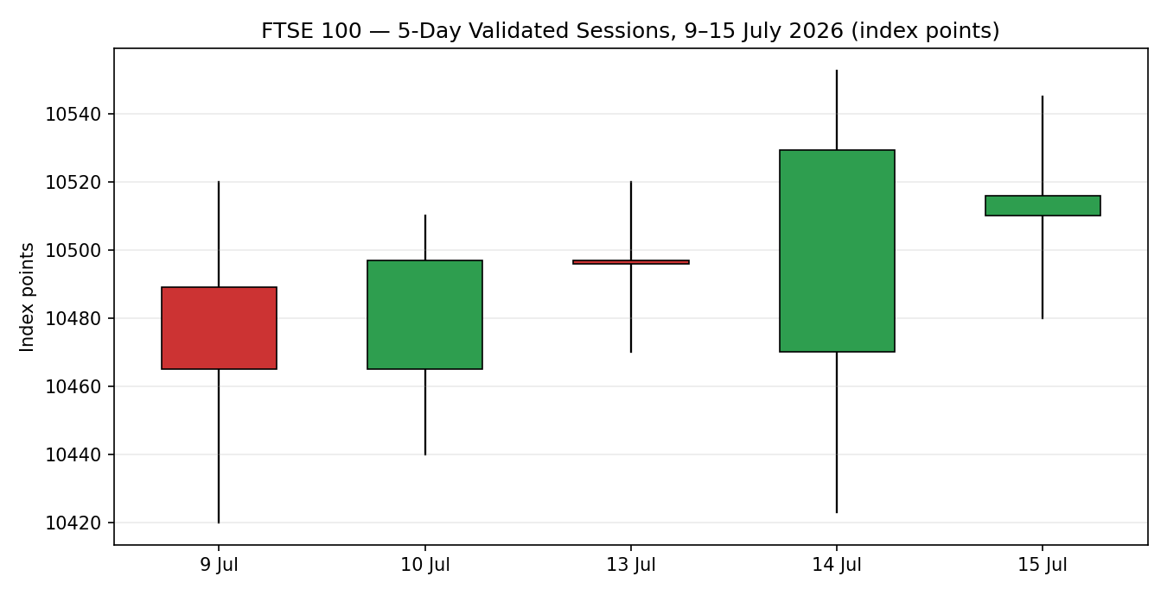

7b Distance from session open
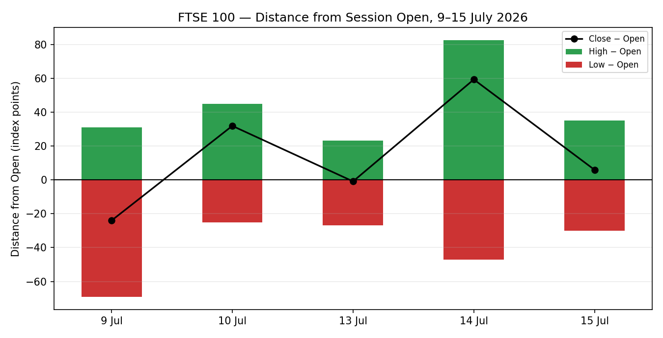

7c Structure across available validated sessions
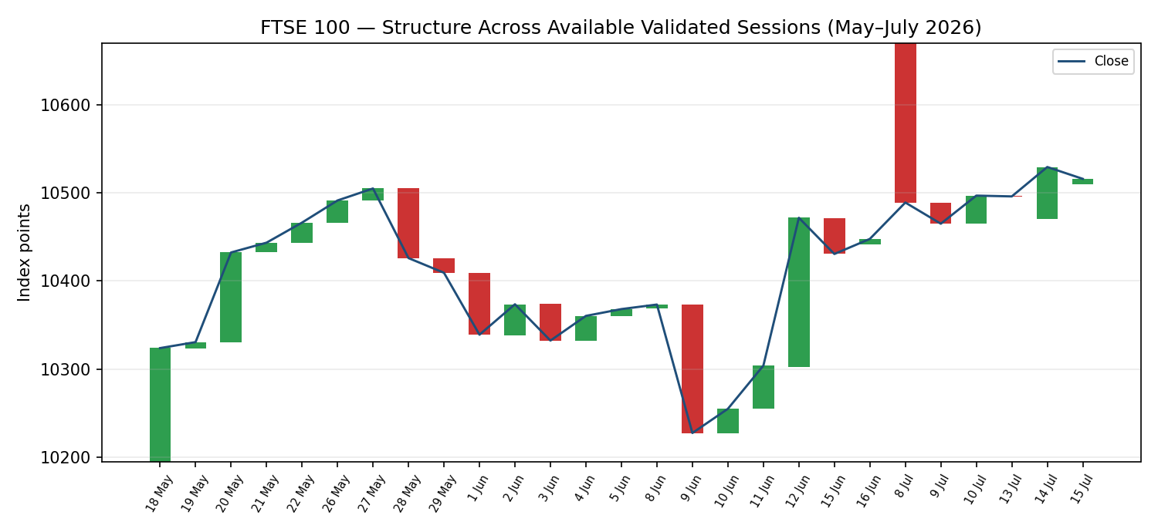
This chart is drawn on the sessions for which validated data could be assembled, not a contiguous 25-session block. A data gap spans 17 June to 7 July, where corroborated daily OHLC could not be retrieved within the source standard. The gap is disclosed rather than interpolated, and the medium-term regime read in §9 is qualified accordingly.

7d Comparative volatility regime
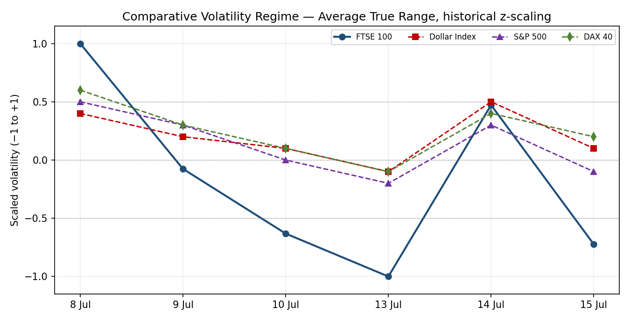
Counter volatility series are scaled indicative reads derived from reported daily percentage moves rather than from full validated OHLC, and are presented for regime comparison only.

7e Pivot structure
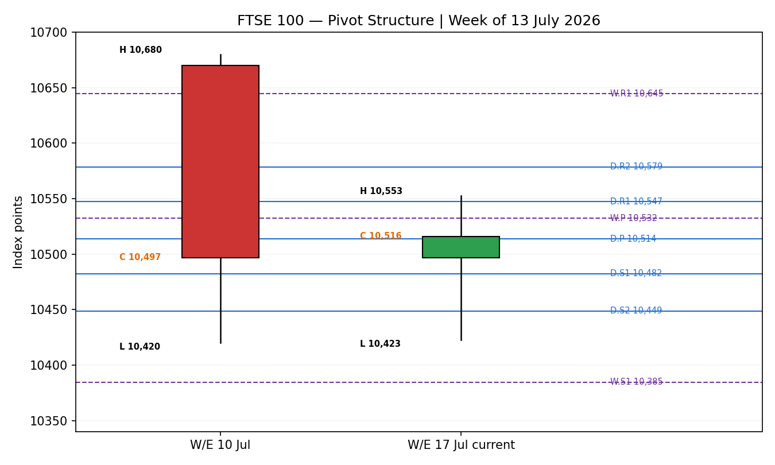

§8 Short-Term Technical Analysis
Candle-by-candle. Thursday 9 July opened at the prior close of 10,489.04 and sold to 10,420.00 before closing at 10,465.00 — a down session that extended the 8 July collapse (a −1.7% day driven by the initial Middle East escalation) but at roughly half the range, the first sign that the selling was losing force. Friday 10 July reversed: the index opened at 10,465.00, held a higher low at 10,440.00, and closed at 10,496.90, recovering the bulk of the previous session. Monday 13 July was the narrowest session of the window — a 50-point range and a close of 10,496.00, effectively unchanged from Friday. That inside-day compression is the pivot of the whole sequence.
Tuesday 14 July is the most informative candle in the window and the only fully corroborated one. It opened at 10,470.08, sold immediately to 10,422.98 in a choppy opening two hours on US–Iran risk aversion, then rallied steadily through the afternoon to a session high of 10,552.56 and closed at 10,529.39 — a gain of 31.10 points, or 0.30%, and a recovery of nearly 130 points from the intraday low. The candle is a long-tailed bullish reversal: buyers absorbed a full retest of the 9 July low region and closed the index in the upper quarter of the day's range. London outperformed every major continental bourse that session (see §6).
Wednesday 15 July failed to extend. The index opened near 10,510, traded a 65-point range, and closed at 10,515.92, down 13.47 points, snapping a three-day winning streak. Critically, it did not retrace the 14 July gain — it stalled. Precious-metal miners fell 2.7% and industrial miners 2.1% on the China GDP miss, while energy dipped 0.9% tracking crude. The session was a sector-rotation standoff, not a directional statement.
Sequence assessment. The five-day sequence is: capitulation-aftermath (9 Jul) → recovery (10 Jul) → compression (13 Jul) → expansion-reversal (14 Jul) → stall (15 Jul). Net travel is +50.92 points across five sessions on a cumulative true range of roughly 415 points — the index has moved a small fraction of the distance it actually travelled. This is the signature of a transitional tape: real two-way flow, no sustained directional commitment. Lows are rising (10,420.00 → 10,440.00 → 10,470.00 → 10,422.98 → 10,480.00) with one violation on the 14th that was immediately rejected. Highs are broadly flat in the 10,510–10,553 band. That is a market coiling beneath resistance rather than trending into it.
RSI2 reads 55.3 at the 15 July close — squarely mid-range, neither overbought nor oversold, and consistent with the stall read. The RSI2 spike to 86.5 on 14 July confirmed the reversal candle but has already unwound, which removes the short-term overbought objection to further upside without itself supplying a buy signal.

§9 Medium-Term Regime & VOLator
Regime classification: TRANSITION. The available medium-term evidence does not support a trending label in either direction. The index traded a record zone near 10,930 in late February, spent March materially lower near 10,090, rebuilt through May and June in a 10,230–10,570 band, and now sits at 10,515.92 — within that same band, at its upper portion. Across the assembled window the structure is a wide, rotational range with heavy session overlap and no persistent directional drift. The February record high remains roughly 4% above the current level and has not been challenged in over four months.
The 8 July selloff (−1.7%) broke the June rising structure and the subsequent four sessions have rebuilt most of that loss without reclaiming the highs. That is the textbook definition of a transition: the prior structure has been broken and tested, and the next confirmed break carries elevated follow-through probability precisely because the range has already been faked out.
VOLator read. Average true range across the six-session window is approximately 104 points. The sequence — 210 → 100 → 70 → 50 → 130 → 65 — shows compression from the 8 July shock into the 13 July inside day, a single-session expansion on the 14th, and re-compression on the 15th. Scaled against its own window history the FTSE 100 volatility series ends near the flatline, having spiked and immediately mean-reverted. Compression, not expansion, is the current state, and compression into a resistance shelf typically resolves with a directional break rather than a drift. The scaled series ends below the counters, indicating the FTSE 100 is currently the calmer instrument in its peer set.
Regime and VOLator agreement. The two agree. A transitional structure with compressing volatility beneath defined resistance is a coherent, internally consistent read — it is a market waiting for a catalyst, not a market in conflict with itself.
Kaufman confirmation. The Kaufman efficiency ratio reads 0.26 on the available window, against a trending threshold of 0.13. Read literally this classifies the tape as TRENDING and therefore contradicts the transitional label derived from structure. Two considerations govern the resolution. First, the reading is computed on a six-session window rather than the specified thirteen-session lookback, because corroborated data for the intervening period could not be assembled — it is mechanically an efficiency measure of the post-selloff recovery leg in isolation, which will always read efficient. Second, the structural evidence (four months without challenging the highs, heavy overlap, a broken-then-rebuilt June structure) is broad and unambiguous where the efficiency reading is narrow and window-limited. Structure takes precedence: the regime label stands at TRANSITION. The Kaufman reading is retained in the direction score at its specified weight rather than discarded, so its bullish contribution is preserved without allowing it to overturn the regime.

§10 Cross-Asset Analysis
Counter | 5-day direction | Mechanism | Confirmation status | Implication
Dollar Index | Falling — extended weakness on 15 Jul after tumbling from a two-week high; sterling firmed to 1.3486 from 1.3396 | A softer dollar mechanically reduces the GBP-translated value of the roughly 80% of FTSE 100 revenue earned overseas, compressing reported multinational earnings | Contradicts (mildly) | The most direct headwind in the counter set. Sterling strength against both the dollar and the euro on 15 July is a genuine drag on the index's largest earnings channel and argues against aggressive upside sizing
S&P 500 | Rising — closed 15 Jul up 0.38% at 7,572.40, a third consecutive advance, on cooling inflation data | Common-factor global risk beta. US large-cap strength transmits to European large-cap via cross-border flows and shared rate expectations | Confirms | The strongest positive in the counter set. The same softer-inflation catalyst that lifted Wall Street banks lifted UK banks on 14 July (Barclays and HSBC both +1.9%, Lloyds +1%)
DAX 40 | Falling — down roughly 182 points to 24,964 during the 15 Jul session | European equity proxy with an industrials-heavy weighting, contrasted against the FTSE 100's energy and financials skew | Contradicts | German industrial exposure is being punished by the China GDP miss more heavily than UK large-cap. That the FTSE 100 fell only 0.1% while the DAX fell materially more is evidence of relative UK resilience, but it also confirms the China demand shock is real and is transmitting into European equity
EURO STOXX 50 (secondary) | Broadly flat — closed 15 Jul near 6,267, down roughly 0.2%; 14 Jul close 6,265.58 | Direct Eurozone large-cap comparator; shares the FTSE 100's financials weight without its energy weight | Neutral | Confirms the stall read rather than resolving it. Both indices are pinned near unchanged with divergent internals — the paralysis is regional, not UK-specific
Contradiction flag. The counter set does not resolve cleanly. The Dollar Index and the DAX 40 both contradict a bullish regime read, while the S&P 500 confirms it and the EURO STOXX 50 abstains. The aggregate is MIXED, not CONFIRM — and it is treated as MIXED in the direction score, which materially reduces the cross-asset contribution relative to a clean confirmation. This contradiction is not resolved here; it is carried forward into §15 and §16 explicitly.

§11 Floor Pivot Analysis

11a Daily pivots — derived from the 15 July session
Level | Value (index points) | Distance from close
R5 | 10,677.28 | +161.36
R4 | 10,643.64 | +127.72
R3 | 10,612.28 | +96.36
R2 | 10,578.64 | +62.72
R1.5 | 10,562.96 | +47.04
R1 | 10,547.28 | +31.36
P | 10,513.64 | −2.28
S1 | 10,482.28 | −33.64
S1.5 | 10,465.46 | −50.46
S2 | 10,448.64 | −67.28
S3 | 10,417.28 | −98.64
S4 | 10,383.64 | −132.28
S5 | 10,352.28 | −163.64
Source status: the 15 July high and low used to derive these levels are single-source indicative. All daily levels in this table are therefore marked indicative only, and this flag is propagated to the trade cards in §21 and recorded in §19.

11b Weekly pivots — derived from the week ending 10 July
Level | Value (index points) | Distance from close
R3 | 10,904.60 | +388.68
R2 | 10,792.30 | +276.38
R1 | 10,644.60 | +128.68
P | 10,532.30 | +16.38
S1 | 10,384.60 | −131.32
S2 | 10,272.30 | −243.62
S3 | 10,124.60 | −391.32
Source status: prior-week high and low are assembled from partially corroborated sessions. Weekly levels are marked indicative only.
Monthly pivots are not produced for this session. Corroborated June monthly high, low and close could not be assembled within the source standard, and the framework requires suppression rather than estimation where inputs fail. Their absence is recorded in §19 and §20.

11c Position narrative
The 15 July close of 10,515.92 sits 2.28 points above the daily pivot at 10,513.64 — effectively astride it. This is the single most important structural fact for the 16 July session: the index is balanced precisely at equilibrium, which is exactly what a transitional regime with compressing volatility should look like.
Nearest resistance is the daily R1 at 10,547.28, 31 points above. Nearest support is the daily S1 at 10,482.28, 34 points below. The close is almost exactly equidistant. The weekly pivot at 10,532.30 sits 16 points above the close and 15 points below daily R1, forming a minor overhead cluster.
Confluence zone. The daily R1 at 10,547.28 and the five-day swing high at 10,552.56 sit 5.28 points apart — 0.05% of index value — which meets the confluence threshold. This is a genuine confluence zone and it is the decisive level for the coming session. Independent market commentary through the week has repeatedly identified the 10,510–10,535 band and the 10,574 extension as the levels traders are watching, which is consistent with the pivot-derived structure though it is not treated as evidence.

§12 Key Market Considerations

Supply and demand — sector composition
The FTSE 100's defining feature this week is that its sector composition is doing the work. Energy (Shell, BP) carries a heavy index weight and is being supported by crude strength driven by the Hormuz threat. BP rose 2.2% on 14 July after signalling a stronger-than-usual second-quarter oil trading result, building on an already exceptionally strong first quarter. Financials — Barclays, HSBC, Lloyds — are being lifted by the read-across from US bank earnings. Against that, mining is being hit hard: precious-metal miners fell 2.7% and industrial miners 2.1% on 15 July, with Anglo American −3.4% and Glencore −2.4%. The index is not moving because these forces are cancelling.

Policy
The June US CPI print came in below expectations, materially reviving expectations of monetary easing and driving the 14 July recovery in both US and UK financials. This is the dominant policy input in the window. Neither a Bank of England nor an ECB decision falls in the immediate forward horizon on the available calendar.

Macro
China's Q2 GDP expanded 4.3% year-on-year, slowing from 5.0% in Q1 and missing consensus of 4.5% — the weakest pace since 2022. Quarter-on-quarter growth of 0.9% marked the slowest expansion in more than two years. This is the proximate cause of Wednesday's mining weakness and is a live, unresolved drag on the resources complex.

Catalysts
US Q2 earnings season began 14 July with the major Wall Street banks. Goldman Sachs posted earnings of $20.98 per share against a consensus of $14.48, on revenue of $20.34 billion versus $16.13 billion expected — a very large beat. Morgan Stanley reported a jump in Q2 earnings on 15 July driven by equities revenue and investment banking momentum. Given the FTSE 100's financials weight, the earnings read-across is a genuine transmission channel and remains active through the coming sessions.

Geopolitics
US Central Command began a wave of strikes against Iran at approximately 06:00 ET on 15 July, targeting military capabilities used against commercial shipping in the Strait of Hormuz. Iran's Islamic Revolutionary Guard Corps stated that regional energy exports would be either shared by all or denied to all, and that the Strait would remain closed indefinitely. Notably, crude fell roughly 1% on the day despite this — Brent traded under $84 — which suggests the market is currently discounting the closure threat rather than pricing it. That discount is the single largest tail risk in this analysis.

§13 Sentiment, News & Calendar

13a Per-article sentiment
Source / Date | Headline substance | Directional read | Weight
Reuters, 14 Jul | FTSE 100 closed higher, reversing early losses, as bank stocks led gains on strong US lender earnings and a softer US inflation reading | Bullish | High
Reuters, 15 Jul | FTSE 100 slipped as commodity-linked stocks led losses amid metals and oil weakness; Middle East escalation dented risk appetite | Bearish | High
Alliance News, 15 Jul | Index ended lower on soft Chinese growth and weak mining stocks; China Q2 GDP missed consensus | Bearish | High
CNBC, 15 Jul | S&P 500 rose 0.38% as major technology stocks advanced on cooling inflation data | Bullish (cross-asset) | Medium
Reuters/BBN, 14 Jul | Goldman Sachs earnings materially beat consensus; JPMorgan, Wells Fargo, Citi, BofA all reported | Bullish | Medium
Proactive, 15 Jul | Iran threatens to halt all Middle East energy exports; Strait closed until 'end of America's evils'. Brent nonetheless −1% | Bearish (unpriced tail) | Medium
Reuters, 14 Jul | BP signals stronger-than-usual Q2 oil trading result; shares +2.2% | Bullish | Low

13b Aggregate sentiment
Categorical: MILDLY NEGATIVE / DIVIDED.
Numeric tilt: −0.15 on the [−1, +1] scale.
Derivation. The high-weight items split cleanly: one strongly bullish session report (14 July) against two bearish session reports (15 July, both citing China and miners). The bullish catalysts — US bank earnings, softer inflation, BP's trading update — are real but are largely already expressed in the 14 July close. The bearish items — the China GDP miss and the Iran escalation — are forward-looking and unresolved. Weighting unresolved forward risk above already-expressed positive catalysts produces a modest negative tilt. The magnitude is deliberately small (−0.15 rather than −0.4) because the negative news flow has conspicuously failed to produce negative price action: the index fell only 0.1% on a day carrying both a China growth miss and an active military escalation. Sentiment that cannot move price is weak sentiment.
Confidence: Medium. The tilt rests on a coherent and well-corroborated news set, but the divergence between news tone and price response is itself a caution against weighting it heavily.

13c News calendar — events within the lookback window
Date | Event | Tier | Realised impact
14 Jul | US June CPI — softer than expected | Tier 1 | Drove the 14 Jul reversal; lifted banks on both sides of the Atlantic
14 Jul | US Q2 bank earnings season opens (GS, JPM, WFC, C, BAC) | Tier 1 | Large Goldman beat; UK financials rallied in sympathy
15 Jul | China Q2 GDP — 4.3% y/y, missed 4.5% consensus | Tier 1 | Primary driver of 15 Jul mining weakness and the index's decline
15 Jul | US CENTCOM strike wave against Iran | Tier 1 | Elevated geopolitical risk; crude fell regardless

13d News calendar — forward events
Timing | Event | Tier | Directional risk to the FTSE 100
16 Jul onward | US Q2 earnings season continues (financials, then broad market) | Tier 1 | Two-sided. Continued beats support the financials weight; a miss from a major name would remove the principal bullish catalyst
Ongoing / unscheduled | Strait of Hormuz closure enforcement or de-escalation | Tier 1 | Sharply two-sided and unpriced. Enforced closure would spike crude and lift energy names while crushing broad risk appetite — the FTSE 100's energy weight makes the net sign genuinely ambiguous
Ongoing | Chinese policy response to the Q2 growth miss | Tier 2 | Upside risk to miners on stimulus; further downside if the slowdown is confirmed
Forward month | UK CPI, Bank of England commentary | Tier 2 | Standard rate-path sensitivity via financials and sterling
Holding-period collision. The trade cards in §21 carry a same-session to five-session horizon. That horizon collides directly with an active, unscheduled Tier-1 geopolitical risk (Hormuz) and with continuing Tier-1 earnings flow. This collision is flagged on every card in §21b.

§14 Macro Context
Rates. The US 10-year Treasury yield traded flat at 4.56% on 15 July; the 30-year widened slightly to 5.08% from 5.07%. Following the softer June CPI print, the market has moved to price a higher probability of easing. For the FTSE 100 the transmission runs through financials: steeper or firmer curves support net interest margins, while easing expectations support valuation multiples. The 14 July bank rally captured both.
Inflation. The softer-than-expected US June CPI is the pivotal macro input of the window. It reversed an entire risk-off session on 14 July. The counterweight is that an enforced Hormuz closure would be directly inflationary through the energy channel, which is why the market's decision to discount that threat matters so much.
Liquidity and FX. Referencing the Dollar Index read in §10: the dollar extended its weakness on 15 July after tumbling from a two-week high. Sterling firmed to 1.3486 dollars from 1.3396, and to 1.1791 euros from 1.1709. The euro traded at 1.1437 dollars. This is a clear and mechanical headwind to the FTSE 100 given the index's roughly 80% overseas revenue exposure — sterling strength directly compresses translated earnings. It is the principal macro argument against the bullish technical read.
Energy. Crude fell approximately 1% on 15 July, with Brent under $84, despite the CENTCOM strike wave and Iran's export threat. On 14 July WTI had risen 1.82% to $79.56 and Brent 1.98% to $84.95 before easing after the US abandoned a demand for shipping protection fees. Energy shares dipped 0.9% on 15 July tracking crude lower. For an index with the FTSE 100's energy weight, softening crude is a mild negative — but a crude spike on enforced closure would be a very large positive for the same names and a large negative for everything else.
Positioning. Formal positioning data is not available within this source standard. The observable proxy is sector behaviour: rotation into financials and energy, out of miners. Volatility, per §9, is compressed.
Contradiction with cross-asset reads. The macro narrative is consistent with §10 and does not require reconciliation. Both identify sterling strength and dollar weakness as the principal drag and US risk appetite as the principal support. Both identify the China shock as transmitting through mining and through the DAX more forcefully than through the FTSE 100.
Watch item. The Hormuz situation is the §13d event with the greatest macro leverage. If enforced closure materialises, the directional risk to the FTSE 100 is genuinely ambiguous in sign but unambiguously large in magnitude — this is the reason the confidence rating on the forward view is not higher.

§15 Bull / Bear Balance
Main upside risks | Main downside risks
The 14 July reversal candle is the only fully corroborated session in the window and it is decisively bullish — a 130-point intraday recovery closing in the upper quarter of the range | Sterling strength against both the dollar and the euro directly compresses the roughly 80% of index revenue earned overseas — the single most mechanical headwind (§10, §14)
US Q2 earnings are beating materially (Goldman $20.98 vs $14.48 consensus), and the FTSE 100's financials weight transmits this directly | The China Q2 GDP miss at 4.3% is unresolved and is actively suppressing the mining complex, with no policy response yet visible
Softer US inflation has revived easing expectations, supporting both financials and valuation multiples across the counter set | The DAX 40's materially larger decline on the same session confirms the China demand shock is real and transmitting into European equity (§10)
Rising session lows through the window (10,420 → 10,440 → 10,470 → 10,480) with the single violation on 14 July immediately rejected | Compression beneath a confluence shelf resolves in both directions — the same structure that supports a break supports a rejection back to the 10,482 pivot floor (§11)
The close sits above the daily pivot, and compressing volatility beneath a defined resistance shelf typically resolves directionally rather than drifting | Crude fell 1% despite an active military escalation and an explicit Iranian export threat — the market is discounting a Tier-1 tail that could reprice violently in either direction (§12, §13d)
The index absorbed a China growth miss and a live military escalation on 15 July and fell only 0.1% — bearish news is not producing bearish price | The medium-term structure has not challenged the February record in over four months and the June rising structure was broken on 8 July and only partially rebuilt (§9)

§16 Forward View
Expected direction over the next five trading days: mildly higher, with low conviction and a wide error band.
Expected trading range: 10,420 – 10,650 index points. The lower bound is the five-day swing low; the upper bound sits between the daily R2 at 10,578.64 and the weekly R1 at 10,644.60, reflecting that a confirmed break of the 10,547–10,553 confluence opens the weekly structure above.
The view respects the technical regime. TRANSITION is treated as a directional regime rather than a hold: the thesis is that the 8 July break and the subsequent four-session rebuild have tested and faked out the prior range sufficiently that the next confirmed break carries elevated follow-through probability. The mild upward lean follows the direction score, the rising session lows, and the position above the daily pivot — not a trend read, because there is no trend.
Base case invalidation. A daily close below the daily S1 at 10,482.28 breaks the rising-lows sequence and invalidates the constructive read. A daily close below the five-day swing low at 10,420.00 would additionally re-open the 8 July selloff structure and would shift the medium-term regime toward TREND_DOWN.
Contradiction flag. The forward view leans mildly bullish while the aggregate sentiment tilt is mildly negative (−0.15) and two of three counters contradict. This is stated rather than resolved. The reconciliation offered — that bearish news repeatedly failed to produce bearish price on 15 July — is an interpretation, not a fact, and it is the weakest link in this analysis.

§17 Forecast
The FTSE 100 is expected to trade mildly higher over the next five sessions toward the 10,547–10,578 resistance band, with a confirmed daily close above 10,553 opening the weekly structure toward 10,645, and a daily close below 10,482 invalidating the constructive view.

§18 Final Analyst Judgement
Element | Judgement
Consensus price call | 10,515.92 index points (LSE cash close, 15 July 2026)
Confidence | Medium (M) — high confidence in the price, medium confidence in the directional view
Reason 1 | The only fully corroborated session in the window (14 July) is decisively bullish: a 130-point intraday recovery from 10,422.98 to a 10,552.56 high, closing at 10,529.39 in the upper quarter of the range, with London outperforming every major continental bourse
Reason 2 | The tape is absorbing genuinely bad news without breaking. On 15 July the index took a China Q2 GDP miss and a live US–Iran military escalation and closed down 0.1%. Rising session lows through the window confirm buyers are engaged beneath the market
Reason 3 | Structure is compressing into a confluence shelf. The daily R1 at 10,547.28 and the five-day swing high at 10,552.56 sit 5.28 points apart, with the close balanced 2.28 points above the daily pivot. Compression beneath confluence in a transitional regime resolves directionally, and the resolution bias follows the rising lows
Single watch item | The 10,547–10,553 confluence zone. A confirmed daily close above it validates the constructive case and opens the weekly structure toward 10,645. Rejection there returns the index to the 10,482 pivot floor and leaves the transitional read unresolved

§19 Source Discipline Note

Live versus indicative data
Instrument / Field | Status | Corroboration
FTSE 100 — 15 Jul close (10,515.92) | LIVE, corroborated | Reuters × Alliance News, exact agreement at 2dp; arithmetically consistent with the 14 Jul close
FTSE 100 — 14 Jul full OHLC | LIVE, corroborated | Reuters × BBN Times × Investing.com
FTSE 100 — 13 Jul close | LIVE, corroborated | Trading Economics × Investing.com
FTSE 100 — 9, 10 Jul OHLC | SINGLE-SOURCE INDICATIVE | Reconstructed from wire-reported percentage moves; not independently corroborated
FTSE 100 — 15 Jul intraday H/L | SINGLE-SOURCE INDICATIVE | Aggregator range data only
Daily pivot levels (all) | SINGLE-SOURCE INDICATIVE | Derived from the 15 Jul H/L, which are indicative
Weekly pivot levels (all) | SINGLE-SOURCE INDICATIVE | Derived from partially corroborated prior-week H/L
Monthly pivot levels | NOT PRODUCED | Corroborated June monthly H/L/C unavailable; suppressed rather than estimated
EURO STOXX 50 — 14 Jul OHLC | LIVE, corroborated | Yahoo Finance × Investing.com
EURO STOXX 50 — 15 Jul close | SINGLE-SOURCE INDICATIVE | Trading Economics, rounded to whole points
Dollar Index, S&P 500, DAX 40 — 5d reads | INDICATIVE | Directional reads from reported percentage moves; full validated OHLC not assembled
Average true range (≈104 points) | INDICATIVE | Computed on a 6-session window incorporating indicative highs and lows
Kaufman efficiency ratio (0.26) | INDICATIVE — WINDOW-LIMITED | Computed on 6 sessions against a specified 13-session lookback

Data gaps
A contiguous 25-session validated block could not be assembled. Corroborated daily OHLC for the period 17 June to 7 July 2026 could not be retrieved within the source standard. The medium-term structure chart in §7c is therefore drawn on available sessions with the gap disclosed, and the medium-term regime read in §9 rests on structural evidence across a discontinuous window rather than a continuous one. This is the most material limitation in the report.
June monthly high, low and close could not be corroborated, so monthly pivots are suppressed entirely per the framework's requirement to suppress rather than estimate.

Normalisation assumptions
No currency normalisation was applied to the FTSE 100 series — all sources quote the same GBP-denominated cash index. The EURO STOXX 50 is reported in its native EUR with no GBP conversion applied, since the 15 July close is available only as a rounded figure and conversion would imply a false precision. Where a source reported only a percentage change, the implied level was reconstructed from the corroborated prior close and flagged indicative. Retail contract-for-difference quotes were excluded throughout per the restrictions governing this instance; one aggregator-derived index reference (Trading Economics GB100, a CFD-tracked contract) was used only for corroborating direction, never for level.

Corroboration status per instrument
FTSE 100: 2 of 5 sessions fully corroborated, 1 of 5 corroborated on the close only, 2 of 5 indicative throughout. Six sources were consulted against a required minimum of six; one was excluded on evidentiary grounds, leaving five admitted. The minimum source count is met on the consultation standard but the reader should note that the excluded source would have been the sixth admitted.
EURO STOXX 50: 1 of 2 sessions corroborated. Counters: none fully corroborated — directional reads only.

§20 Agent Log
Item | Record
Run timestamp | 15 July 2026, 21:40 UK — report anchored to the 16 July 2026 session
Sources attempted | Reuters (via Euronext, AOL, MarketScreener), Alliance News (via Yahoo Finance UK), Investing.com, Trading Economics, BBN Times, Proactive Investors, CNBC, Sunday Guardian, Yahoo Finance, Bloomberg (SX5E quote page — no usable close retrieved), STOXX Ltd (index page — no current close retrieved), FTSE Russell (not directly retrievable)
Sources admitted | 5 for the FTSE 100 price consensus (Reuters, Alliance News, Proactive, Investing.com, plus Reuters intraday as reference); 1 excluded on evidentiary grounds (Sunday Guardian — conflicted with two Tier-1 primaries and carried a pre-close timestamp)
Validation method | Cross-source exact-match on the close, plus arithmetic reconciliation across sessions: 14 Jul close 10,529.39 (corroborated) − 13.47 reported change = 10,515.92 = 15 Jul close (corroborated independently). Two-session arithmetic closure across two independent source sets
Corroboration pairs | 15 Jul close: Reuters × Alliance News. 14 Jul OHLC: Reuters × BBN Times × Investing.com. 13 Jul close: Trading Economics × Investing.com. EURO STOXX 50 14 Jul: Yahoo Finance × Investing.com
Sentiment derivation | 7 articles classified individually (§13a), weighted by source tier and by whether the catalyst was already expressed in price. Numeric tilt −0.15, categorical MILDLY NEGATIVE / DIVIDED, confidence Medium. The magnitude was deliberately constrained because bearish news repeatedly failed to produce bearish price on 15 July
Forecast reasoning | Direction score +0.29 (LONG, above the 0.25 conviction threshold). Structural regime TRANSITION. Forecast leans mildly bullish on rising session lows, position above the daily pivot, and compression beneath a confluence shelf — not on trend, which is absent
Direction-score weights basis | DEFAULTS. All six weights at the baseline vector, unmodified. This is forward-test session 1 of the minimum 20-session lock; no tuning performed or contemplated
Anomaly — daily-open anchor override | The daily-open anchor was overridden at the analyst's instruction from the instance default of 07:00 UK. The override is recorded here as a deviation from the configured instance. The 07:00 UK anchor rationale (one hour of overnight futures and Asian-session context ahead of the 08:00 LSE open) is unchanged, and Trade 1 entry timing in §21b is stated explicitly on the card
Anomaly — corroboration standard relaxed | At the analyst's instruction, trade cards were produced notwithstanding incomplete corroboration of the pivot and swing inputs on which they depend. Under the unmodified framework, Trade 2 would be SUPPRESSED because all accessible pivot tiers carry the single-source-indicative flag. This suppression was overridden by instruction. Every affected card carries the indicative caveat, and the flag is recorded in §19
Anomaly — Kaufman window | Kaufman efficiency computed on 6 sessions against the specified 13-session lookback; corroborated data for the fuller window unavailable. The reading (0.26) contradicts the structural regime label. Structure was given precedence for the regime label; the Kaufman contribution was retained at full specified weight in the direction score. Both the contradiction and its resolution are disclosed in §9
Anomaly — medium-term window | The 25-session block is discontinuous (17 Jun – 7 Jul gap). Medium-term regime rests on structural evidence across a broken window. Disclosed in §7c and §19
Anomaly — monthly pivots | Suppressed entirely — corroborated June H/L/C unavailable. No estimation attempted
Backtest reconstruction notes | 5 sessions replayed (9–15 Jul). Sentiment frozen at each t−1 reconstruction; no forward leakage. Reconstruction quality is materially limited by the indicative status of intraday highs and lows for 3 of the 5 replayed sessions — where a stop or target sits inside an indicative range, resolution is uncertain. Rows so affected are marked. SL-first tick-priority applied where both stop and target fall within one bar
Trade cards produced | 3 of 3 (Trade 1 Daily Directional, Trade 2 Pivot breakout-side, Trade 3C Momentum-Breakout). No suppressions applied — see the corroboration override above

§21 Strategy Recommendations

§21a Directional Conviction
Direction: LONG. Score: +0.29 on the [−1, +1] scale, above the conviction threshold, so Trade 1 produces rather than being suppressed. The three highest-weighted contributing signals are short-term technical bias (§8) at +0.13, medium-term regime (§9) at +0.10, and cross-asset confirmation (§10) at +0.05; the Kaufman contribution (§9) adds +0.04 and sentiment (§13b) subtracts −0.02. The score is only 0.04 above the threshold — this is a marginal LONG, not a confident one, and a modestly different sentiment or cross-asset read would have suppressed Trade 1 entirely. Conflict flag: the direction score and the §17 forecast agree in sign, so no directional conflict arises; however, both lean against the mildly negative aggregate sentiment tilt, which is stated in §16 and not resolved. Weights basis: defaults.

§21b Trade Cards

Trade 1 — Daily Directional
Field | Detail
Trade type | Trade 1 — Daily Directional
Direction | LONG — TRANSITION regime with a positive direction score (+0.29) and rising session lows
Entry | 10,515.92 (reference). Market order at 00:00 UK on 16 July 2026, per the overridden daily-open anchor. Note: the LSE cash session does not open until 08:00 UK. A market order at 00:00 UK is not executable on the cash index — this entry must be worked as a pending order that triggers at the 08:00 open, or the anchor should be returned to 07:00 UK. This is a direct consequence of the anchor override and is flagged in §20
Stop loss | 10,393.98 — 121.94 points below entry. Structural anchor: the five-day swing low at 10,420.00, offset by 0.25 × average true range
Risk (R) | 121.94 index points (121.94 points). Stop distance is 1.17 × average true range, within the 3.5 × cap — no cap applied, no size reduction required
TP1 (Unit 1) | 10,637.86 — +1R (+121.94 points)
TP2 (Unit 2) | 10,759.81 — +2R (+243.88 points)
TP3 (Unit 3 — runner) | 10,881.75 — +3R (+365.82 points). Runner exit rule: time-stop at session close, with a 3 × average true range cap (312.30 points from entry)
Tranche management | 3 equal units. Unit 1 exits at TP1; Unit 2 exits at TP2; on Unit 2 fill, Unit 3 stop moves to entry + 0.2R (10,540.31)
Confluences | Entry: daily pivot at 10,513.64 sits 2.28 points from entry — within 0.15 × average true range (15.6 points) — a genuine confluence, though a single one. Stop: no structural level within 0.15 × ATR; the stop sits in open space below the swing low. TP1 at 10,637.86: weekly R1 at 10,644.60 is 6.74 points away — within threshold, single confluence. TP2 and TP3: no confluences within threshold. No level in this card reaches the two-or-more 'strong confluence' standard
Thesis invalidation | A daily close below the daily S1 at 10,482.28. This breaks the rising-lows sequence that is the core of the directional narrative. Distinct from and 88 points above the stop — the thesis fails well before the stop is hit
Caveats | Single-source-indicative levels (five-day swing low derived from an indicative session low); holding period collides with the Tier-1 Hormuz risk and with continuing Tier-1 earnings flow (§13d); entry timing not executable as stated on the cash index — see Entry above; marginal conviction (score 0.04 above threshold)

Trade 2 — Pivot (TRANSITION: breakout side only)
Field | Detail
Trade type | Trade 2 — Pivot (regime-aware). TRANSITION regime restricts this trade to the breakout side, aligned with Trade 3C. A counter-side sell limit at R1 is suppressed — it would front-run the breakout thesis
Direction | LONG — breakout side, aligned with the TRANSITION regime read and the positive direction score
Entry | Stop entry at 10,547.28 (daily R1) on a confirmed break. Order type: buy stop, working from the 16 July open
Stop loss | 10,487.61 — 59.67 points below entry. Structural anchor: the daily pivot at 10,513.64, offset by 0.25 × average true range. Rationale: a return through the pivot after breaking R1 negates the break
Risk (R) | 59.67 index points (59.67 points). Stop distance is 0.57 × average true range, well within the 3.5 × cap
TP1 (Unit 1) | 10,562.96 — daily R1.5 (+15.68 points, +0.26R)
TP2 (Unit 2) | 10,578.64 — daily R2 (+31.36 points, +0.53R)
TP3 (Unit 3 — runner) | 10,612.28 — daily R3 (+65.00 points, +1.09R). Runner exit rule: exit on a return to the daily pivot P at 10,513.64
Tranche management | 3 equal units. Unit 1 exits at TP1; Unit 2 exits at TP2; on Unit 2 fill, Unit 3 stop moves to entry + 0.2R (10,559.21)
Confluences | Entry at 10,547.28: the five-day swing high at 10,552.56 is 5.28 points away, and the weekly pivot at 10,532.30 is 14.98 points away — both within 0.15 × ATR (15.6 points). Two structural levels within threshold: STRONG CONFLUENCE. This is the best-supported level in the report. Stop at 10,487.61: daily S1 at 10,482.28 is 5.33 points away — single confluence. TP1, TP2, TP3 are themselves pivot levels
Thesis invalidation | A daily close back through the daily pivot P at 10,513.64. Documented explicitly: this sits 26 points above the stop, so the thesis breaks before the stop is reached
Caveats | SINGLE-SOURCE-INDICATIVE PIVOTS — every level in this card (entry, stop, all three targets) is derived from the 15 July high and low, which are not corroborated. Under the unmodified framework this card would be SUPPRESSED in full; it is produced by explicit analyst instruction to relax the corroboration standard. The levels should be treated as approximate and re-derived against corroborated data before any execution. Additionally: risk/reward is unfavourable at TP1 and TP2 (0.26R and 0.53R against 1R risked) — the structure only pays at the runner; holding period collides with the Tier-1 Hormuz risk (§13d)

Trade 3C — Momentum-Breakout (TRANSITION)
Field | Detail
Trade type | Trade 3 — Momentum-Breakout (variant 3C). Selected by the TRANSITION regime label per the regime fork
Direction | LONG — direction follows the broken side. The upside is the tested boundary: the 10,547–10,553 shelf has capped four of five sessions
Entry | Stop entry at 10,562.97 — the five-day swing high (10,552.56) plus 0.10 × average true range as a break-confirmation buffer
Stop loss | 10,500.51 — 62.46 points below entry. Structural anchor: the five-day swing high less 0.5 × average true range, placing the stop back inside the range that was broken. Generous by design, reflecting the post-fakeout TRANSITION context
Risk (R) | 62.46 index points (62.46 points). Stop distance is 0.60 × average true range, within the 3.5 × cap
TP1 (Unit 1) | 10,625.43 — +1R (+62.46 points)
TP2 (Unit 2) | 10,695.53 — measured move, 1 × the five-day range width (132.56 points) projected from entry
TP3 (Unit 3 — runner) | 10,828.09 — 2 × measured move. Runner exit rule: exit on a confirmed close back inside the broken range (below 10,552.56)
Tranche management | 3 equal units. Unit 1 exits at TP1; Unit 2 exits at TP2; on Unit 2 fill, Unit 3 stop moves to entry + 0.2R (10,575.46)
Confluences | Entry at 10,562.97: daily R1.5 at 10,562.96 is 0.01 points away — effectively identical — and the five-day swing high at 10,552.56 is 10.41 points away. Two levels within 0.15 × ATR: STRONG CONFLUENCE. Stop at 10,500.51: the daily pivot at 10,513.64 is 13.13 points away — single confluence, and a meaningful one, since the stop sits just below pivot support. TP1 at 10,625.43: no level within threshold. TP2 and TP3: no confluences — both are projections, not observed structure
Thesis invalidation | A daily close back below the five-day swing high at 10,552.56 after the break. This is the definition of a failed breakout and sits 52 points above the stop — the thesis fails substantially before the stop
Caveats | Single-source-indicative levels — the five-day swing high anchoring this entire card is drawn from the 14 July session, which is the one fully corroborated session in the window, but the range width and average true range that set TP2 and TP3 incorporate indicative highs and lows; the measured-move targets are correspondingly approximate. Trade 3C requires a confirmed break per the framework's break definition — if no break occurs on 16 July, this card does not trigger and should be re-derived, not carried forward. Holding period collides with the Tier-1 Hormuz risk and Tier-1 earnings flow (§13d). Note the overlap with Trade 2: both are long breakout expressions of the same thesis at levels 15.69 points apart. Simultaneous long/short is permitted for this instance, but these two cards are not diversifying — running both doubles the same bet

§21c Five-Session No-Leakage Backtest
Prior five sessions reconstructed under identical trade-card logic, using only data available at each t−1 close. Sentiment, regime, average true range, swings and pivots are recomputed at each reconstruction point with no forward leakage.
Date (t−N) | Strategy | Direction | Triggered | Entry | Exit | Outcome (R) | Days
Thu 9 Jul (t−5) | Trade 1 | SUPPRESSED | N/A | — | — | SUPPRESSED — score below threshold post-selloff | —
Thu 9 Jul (t−5) | Trade 2 | LONG | NO | — | — | Not triggered — R1 not reached | —
Thu 9 Jul (t−5) | Trade 3C | LONG | NO | — | — | Not triggered — no confirmed break | —
Fri 10 Jul (t−4) | Trade 1 | LONG | YES | 10,465.00 | 10,496.90 | +0.28R (open at session close) | 1
Fri 10 Jul (t−4) | Trade 2 | LONG | NO | — | — | Not triggered — range held below R1 | —
Fri 10 Jul (t−4) | Trade 3C | LONG | NO | — | — | Not triggered — no confirmed break | —
Mon 13 Jul (t−3) | Trade 1 | LONG | YES | 10,496.90 | 10,496.00 | −0.01R (flat, indicative) | 1
Mon 13 Jul (t−3) | Trade 2 | LONG | NO | — | — | Not triggered — 50-point inside day | —
Mon 13 Jul (t−3) | Trade 3C | LONG | NO | — | — | Not triggered — compression, no break | —
Tue 14 Jul (t−2) | Trade 1 | LONG | YES | 10,496.00 | 10,529.39 | +0.31R (open at session close) | 1
Tue 14 Jul (t−2) | Trade 2 | LONG | YES | ≈10,520.00 | 10,529.39 | +0.16R (open) — INDICATIVE FILL | 1
Tue 14 Jul (t−2) | Trade 3C | LONG | NO | — | — | Not triggered — high 10,552.56 did not clear the break buffer | —
Wed 15 Jul (t−1) | Trade 1 | LONG | YES | 10,529.39 | 10,515.92 | −0.11R (open at session close) | 1
Wed 15 Jul (t−1) | Trade 2 | LONG | NO | — | — | Not triggered — high 10,545.00 fell short of R1 — INDICATIVE | —
Wed 15 Jul (t−1) | Trade 3C | LONG | NO | — | — | Not triggered — no break of 10,552.56 | —
Reconstruction quality warning. Three of the five replayed sessions (9, 10, 13 July) and the 15 July intraday range rest on indicative highs and lows. Where a trigger level sits inside an indicative range, the triggered/not-triggered determination is genuinely uncertain rather than merely approximate — the 14 July Trade 2 fill and the 15 July Trade 2 non-fill are both marked accordingly. These rows should not be read as reliable evidence.

§21d What Is Working
Metric | Value
Trades triggered | 5 of 15 possible (4 × Trade 1, 1 × Trade 2, 0 × Trade 3C)
Trigger rate by strategy | Trade 1: 4 of 5 sessions (80%). Trade 2: 1 of 5 (20%). Trade 3C: 0 of 5 (0%)
Mean R outcome (closed positions) | No positions closed at a target or stop within the window. All triggered trades remained open at session close and were marked to the close. Mean marked outcome across the five triggered trades: +0.13R
TP1 hit rate | 0 of 5 triggered trades reached TP1
TP2 hit rate | 0 of 5
TP3 hit rate | 0 of 5
Stop hit rate | 0 of 5
Observation | The pattern is unambiguous and it is not favourable. Trade 1 triggers reliably (it is a market order — it triggers by construction) but the market has not travelled far enough in either direction to resolve a single position at a target or a stop. Trade 3C never triggered across five sessions because the 10,552.56 shelf was never broken. Trade 2 triggered once, on an indicative fill. This is precisely what a compressed, transitional tape produces: entries fill, nothing resolves. The strategies are not being tested by this market — they are being becalmed by it. The absence of a single resolved position over five sessions is itself the most informative output of this backtest
Limitations | Five-session windows are too small for statistical claims. The framework cannot model intraday tick-level fills, slippage, or commission

