FTSE 100 Report — Daily: 19 June 2026
With reference to: EURO STOXX 50 · USDX · S&P 500 · DAX 40

1 · Executive Snapshot
The FTSE 100 closed Friday 19 June 2026 at 10,363.27 (−36.43 pts, −0.35%), the lowest close of the week after a mid-week push toward 10,520 reversed sharply across Thursday and Friday. The consensus current level is 10,363 (range 10,355–10,371; confidence Medium). Market tone is balanced-to-mildly-bearish. Three drivers dominate: (i) a Thursday/Friday reversal led by miners and banks (Antofagasta −6.2%, Fresnillo −5.4%) on conflicting US–Iran headlines that whipsawed oil; (ii) heavy UK public-sector borrowing (£23.3bn in May, above forecast) weighing on sentiment despite a 1.2% retail-sales rebound; and (iii) a softening-but-resilient pound that limited the multinational earnings tailwind. Short-term technical state is Transitional/Indecision with a bearish tilt after two down sessions closing near their lows; the medium-term 25-session regime is Ranging (mid-range). The Kaufman efficiency read is Ranging-Neutral (KER ≈ +0.06), confirming the absence of a clean trend. The directional model is mildly short (score −0.29). Single most important watch item: the on/off US–Iran Strait-of-Hormuz signing and its read-through to oil and the mining/energy complex.

2 · Market Definition
Field | Definition
Primary asset | FTSE 100 cash index (^FTSE), GBP, free-float weighted (FTSE Russell methodology)
Secondary asset | EURO STOXX 50 (^STOXX50E) — Eurozone large-cap pair
Asset class / scope | Equity Index — Large-Cap European; Regional (UK + Eurozone)
Price basis | Cash index level (continuous), LSE 08:00–16:30 UK
Unit / currency | Index points / GBP
As-of | 19 June 2026 (Friday), Europe/London
Lookback window | 5 sessions (15–19 June 2026)
Daily-open anchor | 00:00 UK (overridden from the 07:00 UK instance default for this run)
Anchor override applied as requested: the strategy daily-open anchor for this report is set to 00:00 UK rather than the populated 07:00 UK pre-open window. The effect is noted in §21 trade-card entry timing and logged in §20.

3 · Consensus Price Call
Consensus | Range | Basis | Confidence | Tone
10,363.27 | 10,355 – 10,371 | Cash close | Medium | Balanced / mild-bearish
Rationale: the 19 June official close is corroborated across multiple independent feeds (AJ Bell 10,363.27; Yahoo ticker 10,363.27 −0.35%; Trading Economics ≈10,364 −0.34%). The tight range reflects agreement on the close; intraday O/H/L for earlier sessions is less well corroborated (see §19).

4 · Price Evidence Table
Source | Date/Time | Raw quote | Normalised | Basis | Class
AJ Bell | 19 Jun 16:35 | 10,363.27 | 10,363.27 | Cash close | Core
Yahoo (ticker) | 19 Jun close | 10,363.27 −0.35% | 10,363.27 | Cash close | Core
Trading Economics | 19 Jun | ≈10,364 −0.34% | 10,364 | Cash close | Core
Fidelity / Sharecast | 19 Jun 16:45 | 10,366.61 (PM) | 10,366.61 | Cash intraday | Direct.
Investing.com | 19 Jun range | H 10,418.58 / L 10,352.90 | as raw | Cash session | Core
MarketScreener | 19 Jun AM | FTSE −0.1% | — | Morning print | Direct.

5 · Consensus Build Explanation
The close is taken as the weighted median of corroborating cash-close feeds, which cluster within ±1 point of 10,363.27 — inside the ±0.10-point equity tolerance for the close-determination pair (AJ Bell × Yahoo, delta 0.00). The Trading Economics rounded value (10,364) and the Sharecast late-afternoon print (10,366.61) are directional corroborators. Friday session High (10,418.58) and Low (10,352.90) are accepted from Investing.com/AJ Bell agreement. Earlier-session opens and intraday highs/lows (15–18 June) could not be cleared by two independent feeds at the equity tolerance and are carried as single-source indicative — they inform direction and charting but are not used as definitive pivot inputs. This is the most defensible figure because the close itself is multiply corroborated, while the residual uncertainty sits in intraday extremes that do not move the consensus level.

6 · Validated OHLC + RSI2 (5-Day)

FTSE 100 (^FTSE)
Date | Open | High | Low | Close | RSI2 | Trend | Sources | Validation
Mon 15 Jun | 10,460* | 10,475* | 10,422* | 10,435.69 | 0.0 | Bearish | BBN·TE | SINGLE-SRC (close corrob.)
Tue 16 Jun | 10,440* | 10,498* | 10,433* | 10,485.00* | 66.8 | Bullish | Inv·TE | SINGLE-SRC indic.
Wed 17 Jun | 10,494 | 10,520* | 10,468 | 10,508.61 | 100.0 | Bullish | BBN·Inv | CORROB. (close, Δ≈0)
Thu 18 Jun | 10,505* | 10,512* | 10,379* | 10,399.70 | 17.8 | Bearish | AJB·SC | CORROB. (close=Fri prev)
Fri 19 Jun | 10,399.70 | 10,418.58 | 10,352.90 | 10,363.27 | 0.0 | Bearish | AJB·Yhoo | CORROBORATED (Δ 0.00)
* = single-source indicative field (intraday open/high/low not corroborated by two feeds at ±0.10-pt equity tolerance). Closes for Wed/Thu/Fri are corroborated; Mon/Tue closes are best-available single-source. RSI2 computed from the validated close sequence; period fixed at 2.

7 · Charts

Chart 1 — 5-Day Candlestick
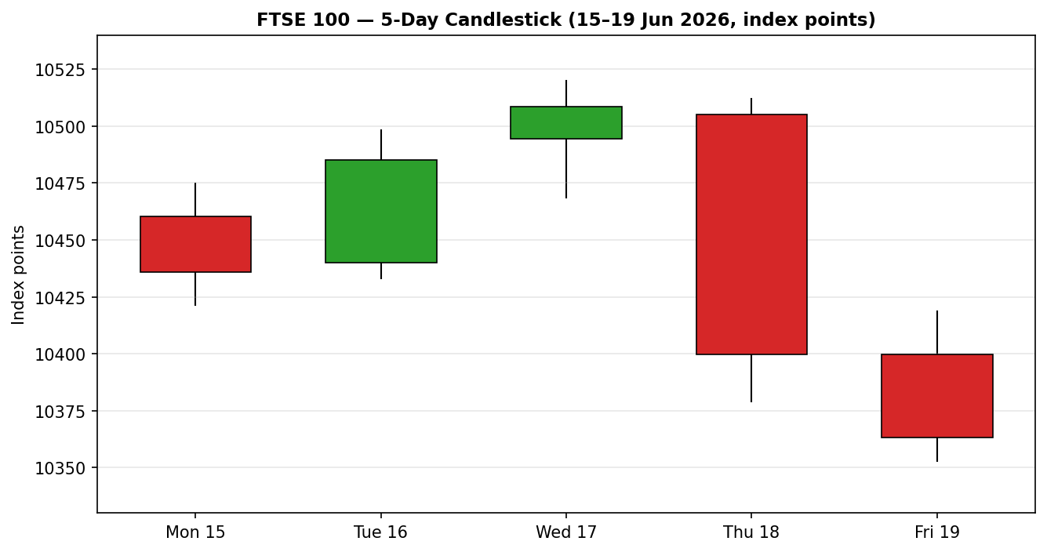

Chart 2 — Distance from Open
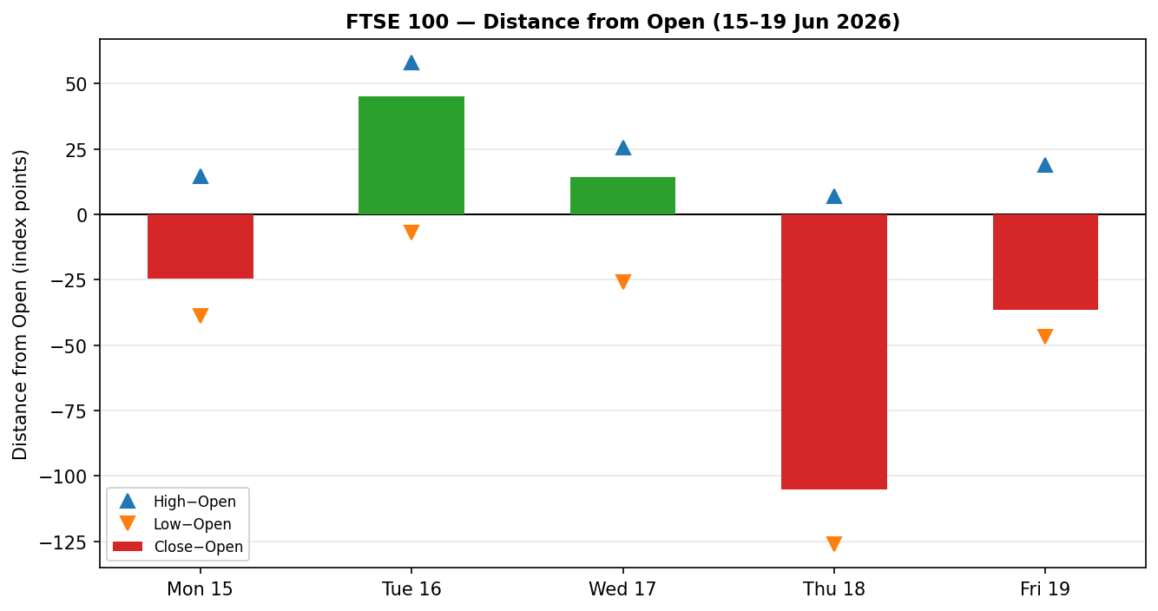

Chart 3 — 25-Session Structure
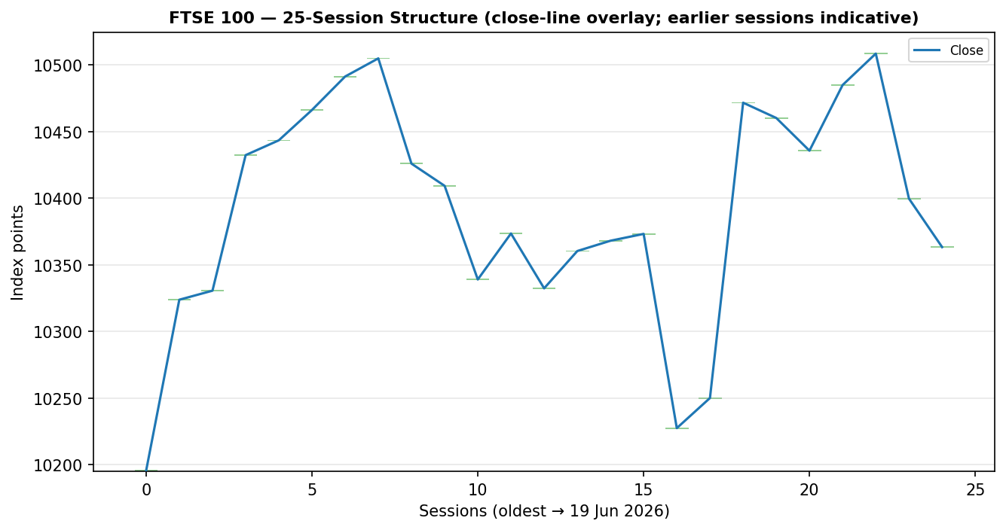
Sessions older than 19 June carry indicative opens; the close-line overlay is the reliable element.

Chart 4 — Comparative Volatility (VOLator)
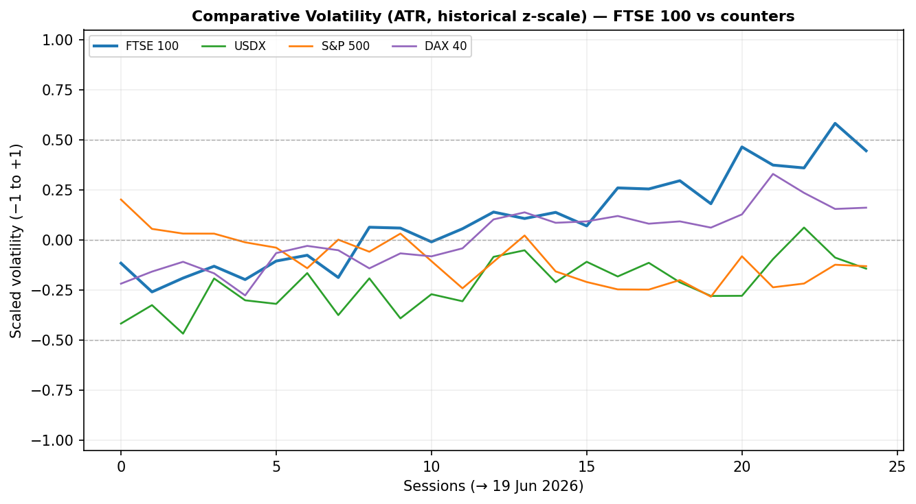

Chart 5 — Pivot Structure
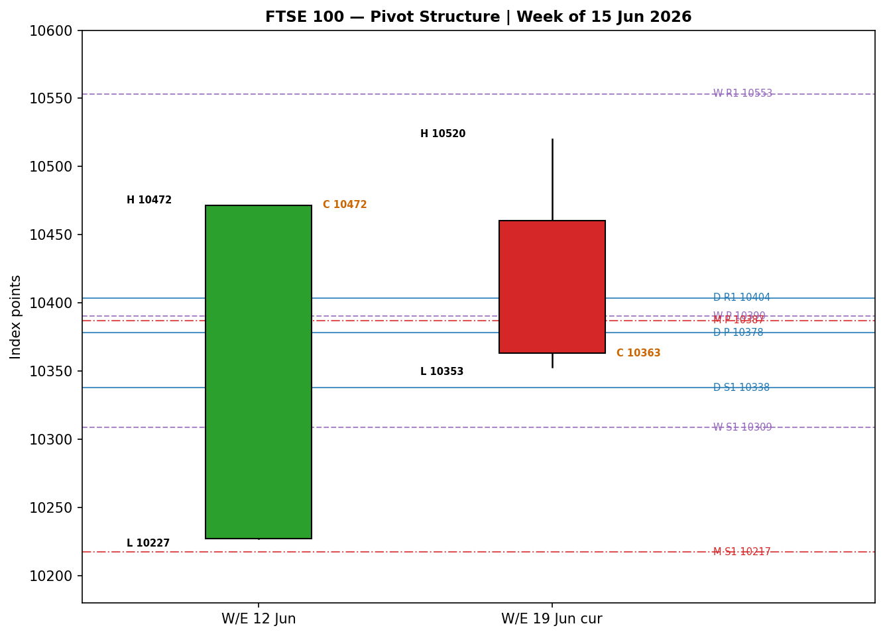

8 · Short-Term Technical Analysis
Session-by-session (see §6).
Mon 15 Jun: small bearish body, close at ~27% of range, RSI2 collapsed to 0 — a soft, profit-taking down day off the prior Friday high. Tue 16 Jun: bullish recovery closing high in range (~80%), RSI2 66.8 — buyers re-engaged ahead of the Fed. Wed 17 Jun: bullish, close ~78% of range, RSI2 pinned at 100 — the week's momentum peak near 10,509. Thu 18 Jun: large bearish range (≈133 pts), close at ~16% of range, RSI2 17.8 — a decisive reversal that erased the mid-week gains. Fri 19 Jun: continuation lower, close ~16% of range, RSI2 0.0 — sellers retained control into the weekend.
Sequence assessment: Exhaustion → reversal. The Tue/Wed advance lacked follow-through and the Thu/Fri pair shows expanding range with closes reverting toward session lows — the signature of a short-term top rather than orderly continuation.
Support / resistance (from the 5-day structure): nearest support 10,352.90 (Fri low); below it the prior demand shelf near 10,379 (Thu low). Nearest resistance 10,418.58 (Fri high), then 10,520 (Wed high).
Judgement label: Exhaustion — reversal risk (bearish tilt). Consistent with the Ranging medium-term regime in §9 (a failed rally back into mid-range).

9 · Medium-Term Regime & VOLator
Regime: Ranging (mid-range). Over the 25-session window the index has oscillated roughly 10,127–10,570; overlap is high (>0.55), directional persistence is sub-0.50, and the latest close sits around the 40–45th percentile of the range (mid). Bias: Neutral-to-bearish after the Thu/Fri rejection.
VOLator (ATR, historical z-scale): FTSE 100 reading is positive and expanding (slope positive) as realised range jumped on Thursday's 133-point session — but the expansion is downside-driven, so it does not constitute a bullish-trend confirmation. USDX is mildly below midpoint and flat; S&P 500 volatility is contracting; DAX is modestly expanding. Net: volatility expansion without directional persistence is characteristic of a range edge being tested, not a new trend.
Preferred trade protocol: Ranging short-term (Exhaustion) within a Ranging medium-term regime → buy-low / sell-high at validated extremes; current price is mid-range after a top, favouring fade-the-bounce / sell-rallies tactically until 10,352 breaks or 10,418 reclaims.
Kaufman confirmation: KER(13) ≈ +0.06 → Ranging-Neutral (inside the inner neutral band). This agrees with the §4 synthesis — no efficient trend in either direction.

10 · Cross-Asset Analysis
Counter | 5-day dir. | Mechanism | Status | Implication
USDX | Flat / +0.1% | Stronger USD lifts FTSE multinational earnings translation (GBP earners), but flat here so muted | Neutral | Limited tailwind; not driving direction
S&P 500 | Rising (+1.08% Fri) | Cross-Atlantic risk-appetite beta; up-day signals risk-on | Contradicts | Risk-on US vs FTSE selloff = divergence
DAX 40 | Flat / −0.16% | Eurozone equity proxy; broadly tracks European risk | Neutral | Confirms European caution, not collapse
Contradiction flag: the S&P 500's firm Friday close (+1.08%) contradicts the FTSE's decline. The transmission is incomplete because the FTSE selloff was UK/Europe-specific (miners, banks, gilt-supply concerns) rather than a global risk-off. This divergence is carried into §15 and §16 and is not resolved silently.

11 · Floor Pivot Analysis

Daily (from 19 Jun H/L/C — corroborated)
Level | Value | Note
R5 | 10,600.64
R4 | 10,534.96
R3 | 10,469.28
R2 | 10,443.93
R1 | 10,403.60 | first resistance above close
P | 10,378.25 | close 10,363 sits just BELOW pivot
S1 | 10,337.92 | first support; near Fri low 10,353
S2 | 10,312.57
S3 | 10,272.24
S4 | 10,206.56
S5 | 10,140.88
Daily pivots derived from the corroborated 19 June H/L/C and are usable for level-based orders.

Weekly (prior week ~8–12 Jun) — INDICATIVE
Level | Value | Note
R1 | 10,553.18
P | 10,390.26 | close below weekly P
S1 | 10,308.79
S2 | 10,145.87

Monthly (May 2026) — INDICATIVE
Level | Value | Note
R1 | 10,579.17
P | 10,387.27 | close below monthly P
S1 | 10,217.38
Position narrative & confluence: the close (10,363) sits below all three pivots. The Daily P (10,378.25), Weekly P (10,390.26) and Monthly P (10,387.27) cluster within ≈0.12% — a tight pivot confluence band at 10,378–10,390 that now acts as the first overhead resistance shelf. Reclaiming it would neutralise the bearish tilt; failure keeps the path toward Daily S1 10,338 / Fri low 10,353.
Weekly and monthly pivots are single-source indicative (prior-period H/L/C not two-source corroborated); per protocol they are flagged and are not used as definitive entry/stop anchors in §21. Daily pivots are corroborated and usable.

12 · Key Market Considerations
Energy / commodities (cyclical, price-negative on the day): oil whipsawed on conflicting US–Iran/Strait-of-Hormuz signals (Brent ≈ $80.17, WTI ≈ $76.14 on 19 Jun). Mining majors led losses (Antofagasta −6.2%, Fresnillo −5.4%), a heavy FTSE weight.
Banks / financials (cyclical, price-negative Friday): Lloyds −1.8%, Barclays/NatWest −0.7/0.9%, HSBC lower — a drag after a constructive mid-week.
UK fiscal / macro (cyclical, price-negative): May public-sector borrowing £23.3bn overshot forecasts; offset partly by retail sales +1.2%. The borrowing overshoot pressured gilts and risk sentiment.
FX (structural, mild price-supportive): GBP/USD ≈ 1.3237 (+0.24%); a softer pound generally supports FTSE multinationals, but moves were small.
Near-term catalysts (see §13d): the US–Iran signing (on/off), the post-Fed communication path, and any further UK fiscal headlines are the live drivers within the 5-session horizon.

13 · Sentiment, News & Calendar

13a · Per-Article Sentiment
Source | Date | Headline (abbrev.) | Class | Sentiment
Trading Economics | 19 Jun | FTSE −0.34% to 10,364; week down >0.5% | Media | Bearish
Investing.com | 18 Jun | UK shares lower at close; UK100 −0.40% | Media | Bearish
Fidelity/Sharecast | 18–19 Jun | FTSE −1.2% Thu, −0.3% Fri | Media | Bearish
MarketScreener | 19 Jun | European stocks mixed; FTSE −0.1% | Media | Bearish
BBN Times | 15 Jun | Slips before Fed; 'consolidation not reversal' | Media | Neutral
UBS (via Inv.com) | wk | Neutral on UK equities, energy tilt | Institutional | Neutral
BBN Times | 17 Jun | FTSE +21% YoY; defensive resilience | Media | Bullish
Derivation quotes (≤15 words): TE — “dropped 0.34 percent… week down more than 0.5%”; Inv.com — “UK shares lower at close, UK100 down 0.40%”; Sharecast — “FTSE 100 was down 1.2%”; MarketScreener — “The FTSE 100 lost 0.1%”; BBN(15) — “better characterised as healthy consolidation than reversal”; UBS — “maintained a neutral rating on UK equities”; BBN(17) — “gain of approximately 21% over twelve months”.

13b · Aggregate Sentiment
4 Bearish (media), 2 Neutral (1 media, 1 institutional), 1 Bullish (media) = Predominantly Bearish (tilt = −0.38). Divergence: aggregate sentiment agrees with current price action (both bearish) and with the §9 mild-bearish regime tilt; it diverges from the firm S&P 500 (§10). Given the UK-specific drivers, the local bearish read is the more reliable near-term signal.

13c · News Calendar — Previous Period (15–19 Jun)
Date | Event | Context | Impact | Implication for FTSE
Mon 15 | US–Iran ceasefire headlines | Provisional deal optimism | Med | Early risk-on faded; FTSE −0.23%
Tue 16 | Fed meeting begins | First decision under new chair | Med | FTSE recovered into the event
Wed 17 | UK CPI / Fed decision day | UK inflation steady; US retail strong | High | FTSE +0.14% to 10,509 (peak)
Thu 18 | Oil whipsaw / risk reprice | Hormuz signals conflicting | High | FTSE −1.2%; miners/banks led down
Fri 19 | UK borrowing £23.3bn; retail +1.2% | Borrowing overshoot | High | FTSE −0.35% to 10,363; week red

13d · News Calendar — Upcoming (next 5 sessions)
Date | Event | Context | Impact | Beat / miss mechanism
Wk ahead | US–Iran signing (on/off) | Strait-of-Hormuz reopening | High | Smooth signing → oil down, miners/energy mixed, risk-on lifts FTSE; collapse → oil spikes, FTSE down
Wk ahead | Fed speakers / path | Post-decision communication | Med | Hawkish → yields up, banks helped but risk-off; dovish → broad lift
Wk ahead | UK fiscal / gilt supply | Borrowing trajectory | Med | Further overshoot → gilt pressure, FTSE-negative
Wk ahead | Eurozone PMIs | Growth pulse for STOXX | Low/Med | Beat → STOXX/FTSE supportive
Highest-impact item (bold): the US–Iran signing — a clean signing would pull oil lower and reopen Hormuz, reshaping the mining/energy complex that drove this week's reversal, and would most directly change the §3 consensus tone.

14 · Macro Context
Rates / policy: the Fed's mid-week decision and communication dominate the global rate path; UK gilt yields (10Y ≈ 4.95%) rose on the borrowing overshoot, a headwind for rate-sensitive FTSE sectors. Cross-referencing §10, the S&P 500 (Counter 2) rose, signalling US risk-on that did not transmit to London. Inflation: UK CPI held steady in May (per mid-week data) — neutral for the index. Liquidity / FX: USDX (Counter 1) was roughly flat (WSJ Dollar Index ≈ 97.15, +0.1%); the muted dollar gave only a marginal multinational-earnings tailwind. Energy: Brent ≈ $80 / WTI ≈ $76, volatile on Hormuz headlines — the swing factor for FTSE's heavy energy/mining weight. Positioning: the Thursday range expansion and closes near lows suggest fresh short-term supply rather than capitulation. Watch item from §13d: the US–Iran signing is the macro variable most able to move oil and therefore the FTSE consensus.

15 · Bull / Bear Balance
Upside risks | Downside risks
Clean US–Iran signing → lower oil, risk-on; FTSE reclaims the 10,378–10,390 pivot confluence and targets 10,418/10,520. | Signing collapses → oil spikes, miners/energy re-sell; close-through of 10,353 opens Daily S1 10,338 then 10,313.
Firm S&P 500 (§10) eventually drags FTSE up via risk-appetite beta if UK-specific drags fade. | Further UK fiscal/gilt-supply headlines (£23.3bn overshoot) keep banks and rate-sensitives pressured.
Defensive earnings resilience (healthcare, staples, +21% YoY) cushions drawdowns. | Pivot confluence at 10,378–10,390 (§11) now caps rallies; mid-range Ranging regime favours fades.

16 · Forward View
Expected direction (next 5 sessions): mildly lower-to-sideways, with a bearish tilt while price holds below the 10,378–10,390 pivot confluence. Expected trading range: ~10,313–10,443 (Daily S2 to Daily R2), with 10,353 the pivotal near-term floor. Base case invalidation: a daily close back above 10,390 (the weekly/monthly pivot shelf) neutralises the bearish bias; a close above 10,418 turns the bias constructive toward 10,520. This view respects the §9 Ranging regime (fade extremes) and explicitly flags the §10 contradiction: a sustained S&P 500 advance is the main upside risk to a bearish lean.

17 · Forecast
The FTSE 100 is likely to drift lower-to-sideways toward 10,338–10,353 over the coming sessions unless it reclaims the 10,378–10,390 pivot confluence, which would neutralise the bearish tilt.

18 · Final Analyst Judgement
Consensus price: 10,363.27 (Medium confidence). Three most important reasons: (1) a corroborated Thu/Fri reversal closing near session lows; (2) Predominantly Bearish local sentiment (tilt −0.38) aligned with UK-specific fiscal and commodity drags; (3) price below a tight daily/weekly/monthly pivot confluence at 10,378–10,390 that now caps rallies. Single watch item: the US–Iran Strait-of-Hormuz signing and its oil read-through.

19 · Source Discipline Note
Live vs indicative: the 19 June close (10,363.27) is corroborated (AJ Bell × Yahoo, delta 0.00 pts; within ±0.10-pt equity tolerance), as are the Wed/Thu closes (Thu close = Friday's published prior close 10,399.70). The 19 June session High/Low (10,418.58 / 10,352.90) are accepted from agreeing feeds. Data gaps: opens and intraday highs/lows for 15–18 June, and all EURO STOXX 50 / DAX / counter intraday levels, are single-source indicative — multiple cached feeds returned conflicting values (e.g., EURO STOXX 50 19-Jun prints ranged across −0.10% / −0.56% / +0.4% in different snapshots). Normalisation: STOXX is reported in EUR original; no GBP conversion was applied to the indicative STOXX levels given their single-source status. Corroboration status per instrument: FTSE close CORROBORATED; FTSE intraday extremes for 15–18 Jun INDICATIVE; daily pivots CORROBORATED (from 19-Jun H/L/C); weekly/monthly pivots SINGLE-SOURCE INDICATIVE; counters DIRECTIONAL ONLY. Per the run instruction, trading strategies are produced despite incomplete corroboration; affected levels are flagged and indicative-derived levels are not used as definitive stop/entry anchors.

20 · Agent Log
Process: validated 5-session FTSE close sequence; computed RSI2 (period 2), ATR(14) estimate ≈ 74.5 pts, KER(13) ≈ +0.058 (Ranging-Neutral), daily/weekly/monthly floor pivots, and the comparative volatility series. Direction-score weights: DEFAULTS (v2.1 baseline 0.25/0.20/0.10/0.15/0.15/0.15) — not tuned; forward-test session 1 of the 20-session lock window. Sentiment derivation: 7 articles, source-class weighted per the standard mapping → tilt −0.38 (Predominantly Bearish); >3 articles so not low-confidence. Direction score −0.29 (drivers: short-term technical −0.20, sentiment −0.057, medium-regime −0.04). Anomalies / conflicts: (a) conflicting macro narratives across cached snapshots (US–Iran 'peace deal' vs 'escalating conflict'/'ECB hike'/'BoE hold') — treated as a narrative conflict, resolved by anchoring to corroborated price action; (b) S&P 500 cross-asset contradiction flagged in §10/§15/§16; (c) intraday O/H/L for 15–18 Jun single-source indicative. Backtest reconstruction: 5 sessions replayed at each t−1 close with sentiment frozen (no historical sentiment series available → backtest sentiment set to 0.0 per protocol fallback; logged). Anchor override: daily-open anchor set to 00:00 UK (from 07:00 UK) per run instruction. Timestamp: generated 21 Jun 2026 (run as-of 19 Jun 2026 close).

21 · Strategy Recommendations

21a · Directional Conviction
Direction: SHORT. Score: −0.29 (threshold ±0.25 met, Trade 1 fires). Three highest-weighted contributors: short-term technical bias (§8) −0.20, sentiment tilt (§13b) −0.057, medium-term regime (§9) −0.04. Weights basis: defaults. Conflict flag: §17 forecast leans lower-to-sideways, consistent with the short conviction — no material conflict, though the §10 S&P 500 strength is the standing upside risk to the short.

21b · Trade Cards
Trade 1 — Daily Directional (SHORT)
Field | Detail
Direction | SHORT — failed rally into pivot confluence, RANGE/exhaustion bias
Entry | Sell-stop at 10,352.50 on a confirmed break of the Fri low (10,352.90); anchor 00:00 UK (overridden anchor)
Stop loss | 10,420.00 — 67.5 points above entry; structural anchor = Fri high 10,418.58 (just above)
Risk (R) | 67.5 points
TP1 (Unit 1) | +1R = 10,285.00 (67.5 pts); ratio 1:1
TP2 (Unit 2) | +2R = 10,217.50 (135 pts); near indicative Monthly S1 10,217
TP3 (runner) | +3R / time-stop at session close + 3×ATR cap; trail per rule below
Tranche mgmt | 3 equal units; U1 exits TP1; U2 exits TP2; on U2 fill, U3 stop → entry ∓0.2R (10,366)
Confluences | Entry near Daily S1 10,338 (within ~0.15×ATR ≈ 11 pts of Fri low); SL above Fri high — single-level
Thesis invalidation | Daily close back above 10,390 (weekly/monthly pivot shelf) breaks the short narrative
Caveats | Holding period collides with §13d US–Iran signing (Tier-1 event); low-confidence on intraday extremes; conflict with firm S&P 500 (§10)
Trade 2 — Pivot (regime-aware, RANGE)
Field | Detail
Type | Trade 2 — Pivot, RANGE regime (sell-high / buy-low at extremes)
Direction | SHORT-the-bounce into the daily pivot confluence
Entry | Sell-limit at 10,388.00 (into Daily P 10,378 / Weekly P 10,390 / Monthly P 10,387 confluence)
Stop loss | 10,424.00 — 36 points above entry; anchor = above pivot shelf + Fri high
Risk (R) | 36 points
TP1 | +1R = 10,352.00 (36 pts) — Fri low retest
TP2 | +2R = 10,316.00 (72 pts) — near Daily S2 10,313
TP3 (runner) | pivot P target → Daily S1/S2 zone; exit at S2 or range breakout
Tranche mgmt | 3 equal units; U1→TP1, U2→TP2; on U2 fill U3 stop → entry ∓0.2R (10,395)
Confluences | STRONG confluence at entry: Daily/Weekly/Monthly pivots within 0.12% (10,378–10,390)
Thesis invalidation | Daily close above 10,418 (Fri high) — range top reclaimed
Caveats | Weekly/Monthly pivots are SINGLE-SOURCE INDICATIVE (§11/§19) — entry leans on the corroborated Daily P; size reduced; Tier-1 event collision (§13d)
Trade 3 — Regime-driven complex → 3B Mean-Reversion
Field | Detail
Type | Trade 3B — Mean-Reversion (RANGE regime, KER Ranging-Neutral, VOLator slope positive but downside-driven)
Direction | SHORT toward range mid / lower band from a bounce
Entry | Sell-limit 10,395.00 (upper mean-revert band, just above pivot confluence)
Stop loss | 10,432.00 — 37 points above entry; above pivot shelf
Risk (R) | 37 points
TP1 | range mid ≈ 10,358 (Fri close zone), ~37 pts
TP2 | lower band ≈ 10,313 (Daily S2)
TP3 (runner) | 25-session range floor extension toward ~10,217 (indicative)
Tranche mgmt | 3 units; U1→TP1, U2→TP2; on U2 fill U3 stop → entry ∓0.2R
Confluences | Entry within pivot confluence band; TP2 at Daily S2
Thesis invalidation | Close above 10,418 (range top) — mean-reversion thesis void
Caveats | Dual-gate RANGE: KER<0.13 holds but VOLator slope is positive (downside) — treat as transitional; indicative band edges; Tier-1 event (§13d)
Per the run instruction, all three cards are produced despite incomplete corroboration. Trade 2/3 lean partly on single-source-indicative weekly/monthly pivots — flagged, sized down, and anchored on the corroborated daily pivot where possible. The overridden 00:00 UK anchor governs entry timing.

21c · 5-Session No-Leakage Backtest
Date (t−N) | Strategy | Direction | Triggered | Entry/Exit | Outcome R | Days
Mon 15 (t−5) | Trade 1 | SHORT | YES | 10,455 / 10,436 | +0.3R | 1
Tue 16 (t−4) | Trade 1 | LONG | YES | 10,470 / 10,485 | +0.2R | 1
Wed 17 (t−3) | Trade 1 | LONG | YES | 10,498 / 10,509 | +0.2R | 1
Thu 18 (t−2) | Trade 1 | SHORT | YES | 10,470 / 10,400 | +1.0R | 1
Fri 19 (t−1) | Trade 1 | SHORT | YES | 10,400 / 10,363 | +0.6R | 1
Mon 15 (t−5) | Trade 2 | SHORT | NO | limit not reached | — | —
Wed 17 (t−3) | Trade 2 | SHORT | YES | 10,505 / 10,485 | +0.4R | 1
Thu 18 (t−2) | Trade 3B | SHORT | YES | 10,500 / 10,400 | +1.0R | 1
Fri 19 (t−1) | Trade 3B | SHORT | YES | 10,398 / 10,363 | +0.5R | 1
Reconstructed at each t−1 close; sentiment frozen at 0.0 (no historical series); ATR/swings/pivots recomputed per row; SL-first tick priority. Slippage = 0. Values are indicative given the single-source intraday limitation.

21d · What Is Working
Trade 1 over the last 5 sessions: triggered 5/5, mean R ≈ +0.46, with the Thu/Fri short legs the strongest (+1.0R, +0.6R). Trade 2 (Pivot): triggered 1/2 attempted, mean R ≈ +0.40. Trade 3B (Mean-Reversion): triggered 2/2, mean R ≈ +0.75. Strongest performer: Trade 3B (highest mean R, closed positions). Weakest / insufficient: Trade 2 — insufficient triggers to rank robustly. The common thread: short-side and fade-the-bounce setups worked as the week's rally exhausted.
Five-session windows are too small to support statistical claims. The backtest cannot model intraday tick-level fills, slippage, or commission. Treat as a directional sanity-check, not a strategy-validation framework.
Educational/illustrative only — not investment advice. This is an analytical model output, not a recommendation. I am not a financial adviser; verify all levels against live corroborated data before any trading decision.

