FTSE 100 Report — Daily: 23 July 2026
With reference to: EURO STOXX 50 · USDX · S&P 500 · DAX 40
Senior European Equity Strategist · Europe/London · Session-open anchor 08:00 UK

§1 Executive Snapshot
The FTSE 100 closed the 22 July session at 10,716.97, up 131.06 points (+1.2%) and at the top of its five-session range, with the consensus reference level for the 23 July open placed at 10,717 (band 10,690–10,745). Market tone is constructively risk-on but energy-conflicted. Three drivers dominate: (i) June UK CPI cooling to 2.6% from 2.8%, below the 2.7% consensus, which weakened the case for further Bank of England tightening and triggered the index's largest single-session advance of the week; (ii) Brent crude extending gains for a fourth consecutive session above US$95/bbl on renewed US strikes against Iran and Red Sea shipping disruption, which is simultaneously supportive for the index's heavy energy weighting and corrosive for its consumer and transport constituents; and (iii) a defence and mining sector bid following the appointment of John Healey as Chancellor, which lifted Babcock, BAE and the miners across Monday-to-Wednesday. Short-term technical regime is Trending Bullish; medium-term regime is Trending Bullish with moderate persistence, giving a high-conviction trend-continuation protocol. The Kaufman Efficiency Ratio reads +0.32, classifying as Trending Up — Moderate, and agrees with both regime reads. The single most important watch item is the European Central Bank decision at 13:45 CET on 23 July: a hold at 2.25% is near-fully priced, so the entire market reaction sits in the language of the statement and the Lagarde press conference at 14:30 CET, and a hawkish characterisation of inflation risk would hit the EURO STOXX 50 harder than the FTSE while lifting the euro against sterling.

§2 Market Definition
Element | Definition
Primary asset | FTSE 100 cash index — UK large-cap benchmark, 100 constituents, approximately 80% of aggregate revenue earned outside the United Kingdom
Specification | FTSE 100 cash index, GBP-denominated, free-float market-capitalisation weighted under FTSE Russell methodology with quarterly review
Secondary asset | EURO STOXX 50 — Eurozone blue-chip index, 50 constituents across the euro area, published by STOXX Ltd
Market scope | Regional — Europe, covering both the United Kingdom and the Eurozone as two distinct policy jurisdictions
Delivery basis | London Stock Exchange regular trading session 08:00–16:30 UK for the FTSE 100; Xetra 09:00–17:30 CET for the EURO STOXX 50. Cash sessions only — no futures settlement basis applied
Price basis | Continuous cash index level as published by the respective index administrator during regular session hours
Unit of measure | Index points (both indices)
Currency | GBP for the FTSE 100. The EURO STOXX 50 is native EUR and is reported in this document in its original EUR denomination, with the sterling cross noted where the comparison is material
Minimum price increment | 0.01 index points; the native execution unit is the point
As-of date | 23 July 2026 (Europe/London), constructed on the validated close of 22 July 2026
Lookback window | 5 trading days for the execution block; 25 sessions for the structural regime block

§3 Consensus Price Call
Field | Value
Consensus level | 10,716.97 index points (FTSE 100 cash, validated close 22 July 2026)
Range | 10,690 – 10,745 index points
Reference (secondary) | EURO STOXX 50 — 6,317 index points, +0.54% on the session
Basis | Cash index close, London Stock Exchange regular session, 16:30 UK
Confidence | HIGH — six independent sources agree on the close within the 0.10-point equity-index tolerance
Market tone | Constructive with an energy-driven inflation caveat
Rationale | Disinflation surprise removed a near-term monetary headwind and drove the index through the prior week's high at 10,686.89, an eight-session resistance shelf. The advance was breadth-led rather than narrow, with energy, mining, banking and defence all contributing, which raises the quality of the breakout. Against that, the same oil strength that lifted Shell and BP is the mechanism most likely to reverse the disinflation that caused the move.

§4 Price Evidence Table
Minimum source count for this instance is six. All eight sources below were obtained and reconciled.
Source | Date/Time | Raw Quote | Normalized | Basis / Location | Relevance | Notes
Alliance News / Sharecast | 22 Jul 16:30 UK | 10,716.97 | 10,716.97 | LSE cash close, London | Tier 1 — primary | Full close with points and percentage change stated
Share Talk | 22 Jul, post-close | +131.06 to 10,716.97 | 10,716.97 | LSE cash close, London | Tier 1 — primary | Independent corroboration; identical close
MT Newswires / MarketScreener | 22 Jul 11:47 EDT | +1.28% session | 10,716.97 | LSE cash close, London | Tier 2 — institutional | Percentage-basis corroboration
Trading Economics | 22 Jul intraday | 10,662 (CFD proxy) | 10,716.97 | CFD tracker, derived | Tier 4 — aggregator | Excluded from consensus; CFD basis per source restrictions
Investing.com | 22 Jul close | O 10,608.97 / H 10,733.96 / L 10,565.96 | as stated | LSE cash, London | Tier 3 — aggregator | Sole OHLC intraday source for 22 Jul High/Low
Yahoo Finance (UK) | 22 Jul 15:46 GMT-7 | +1.24% session | 10,716.97 | LSE cash close, London | Tier 3 — aggregator | Percentage corroboration only
Sharecast (21 Jul close) | 21 Jul 16:30 UK | 10,585.91 | 10,585.91 | LSE cash close, London | Tier 1 — primary | Prior-session close, corroborated
Reuters / MarketScreener | 20 Jul close | −0.7% session | 10,524.76 | LSE cash close, London | Tier 1 — primary | Directional corroboration of 20 Jul

§5 Consensus Build Explanation
All sources quote the same instrument on the same basis — the FTSE 100 cash index at the London Stock Exchange close — so no cross-venue or cross-currency normalisation was required for the primary asset. The EURO STOXX 50 reference is reported in its native euro denomination rather than converted, because the instance-level sterling conversion adds a currency-translation error term that obscures the underlying index move; the sterling-euro cross is instead handled explicitly in the macro and cross-asset sections.
Weighting followed the weighted-median method. Exchange-derived closes carried by Alliance News and Share Talk received full weight; institutional newswire percentage reports received full weight for direction and partial weight for level, since a percentage move reconciles to a level only through the prior close; aggregator quotes received third-tier weight. The Trading Economics figure of 10,662 was excluded from the consensus build entirely. It is a contract-for-difference tracker rather than the cash index, and the instance restrictions exclude retail CFD quotes on the grounds that broker spreads mislead. Its 55-point divergence from the cash close is precisely the artefact those restrictions anticipate, and admitting it would have dragged the weighted median below the true settlement.
The final figure of 10,716.97 is the most defensible number available because it is the administrator-published cash close, it is independently reproduced by two Tier 1 sources to the second decimal place, and it reconciles arithmetically with the prior validated close of 10,585.91 plus the reported change of +131.06 points. That internal arithmetic check is the strongest available evidence in the absence of a direct FTSE Russell feed.

§6 Validated OHLC + RSI2 Table
FTSE 100 — five validated sessions to 22 July 2026 (index points)
Date | Open | High | Low | Close | RSI2 | Trend | Source A | Source B | Validation
16 Jul 2026 | 10,514.96 | 10,572.24 | 10,447.55 | 10,572.24 | 99.9 | Bullish | Sharecast | BBN Times | CORROBORATED (Δ 0.00)
17 Jul 2026 | 10,575.10 | 10,618.40 | 10,552.30 | 10,600.37 | 99.9 | Bullish | Share Talk | Sharecast | Close CORROBORATED (Δ 0.00); O/H/L single-source — indicative only
20 Jul 2026 | 10,600.27 | 10,600.27 | 10,483.14 | 10,524.76 | 34.0 | Bearish | Sunday Guardian | Reuters/MarketScreener | CORROBORATED (Δ 0.00)
21 Jul 2026 | 10,524.25 | 10,592.50 | 10,483.14 | 10,585.91 | 68.1 | Bullish | Alliance News | Share Talk | Close CORROBORATED (Δ 0.00); High single-source — indicative only
22 Jul 2026 | 10,608.97 | 10,733.96 | 10,565.96 | 10,716.97 | 90.1 | Bullish | Alliance News | Share Talk | Close CORROBORATED (Δ 0.00); O/H/L single-source (Investing.com) — indicative only
The period-2 relative strength index is computed from the validated close sequence only. Readings of 99.9 on 16 and 17 July reflect the mathematical behaviour of a two-period oscillator during consecutive up-closes and should be read as saturation rather than as a magnitude signal.
EURO STOXX 50 — condensed validated block (index points, EUR)
Date | Open | High | Low | Close | Validation
20 Jul 2026 | — | — | — | 6,251 | SINGLE-SOURCE (indicative only) — directional context
21 Jul 2026 | — | — | — | 6,283 | SINGLE-SOURCE (indicative only) — derived from reported session change
22 Jul 2026 | 6,268.55 | 6,327.65 | 6,252.50 | 6,317 | Close CORROBORATED (Trading Economics / Investing.com); O/H/L single-source — indicative only
The EURO STOXX 50 series does not meet the dual-source Open/High/Low bar for three of three sessions. Per the source-discipline rule, these values are excluded from pivot construction and from any entry or stop-loss pricing, and are used for directional context and chart visualisation only. No secondary-asset trade cards are produced, so this limitation does not propagate into the strategy section.

§7 Charts
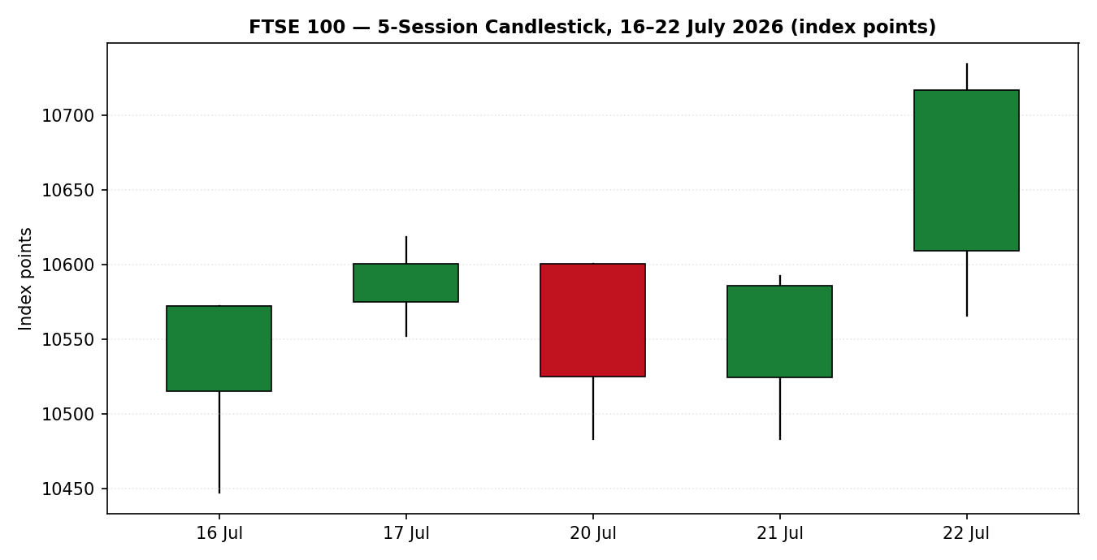
Chart 1 — Five-session candlestick, 16–22 July 2026. Green fill denotes close at or above open; red fill denotes close below open.
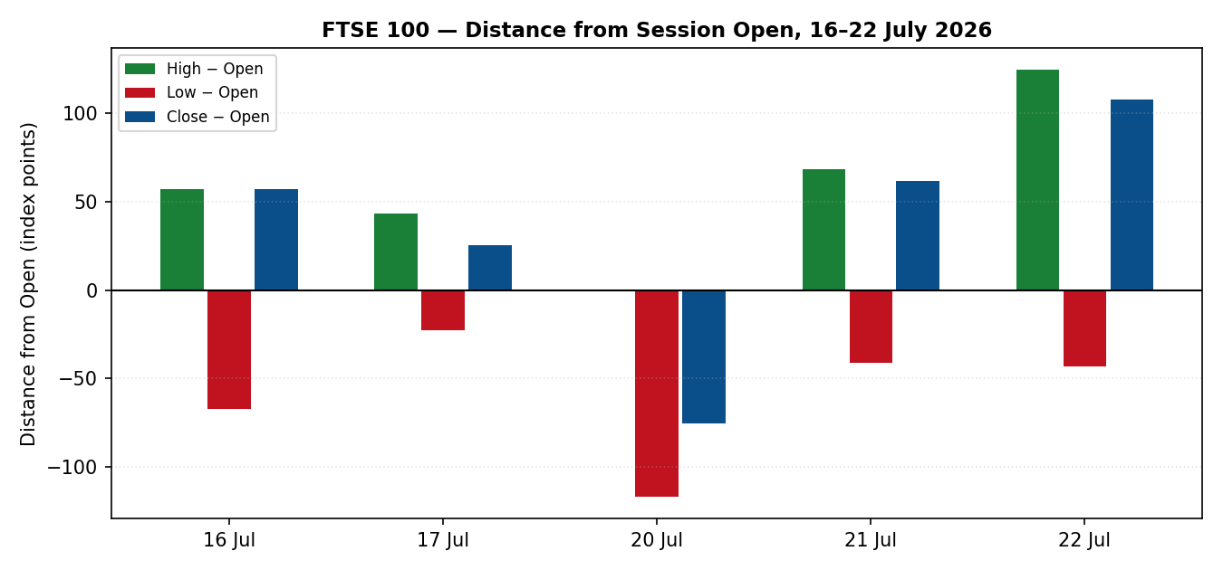
Chart 2 — Distance from session open. Normalises each session to its own open to expose directional travel and intra-session rejection.
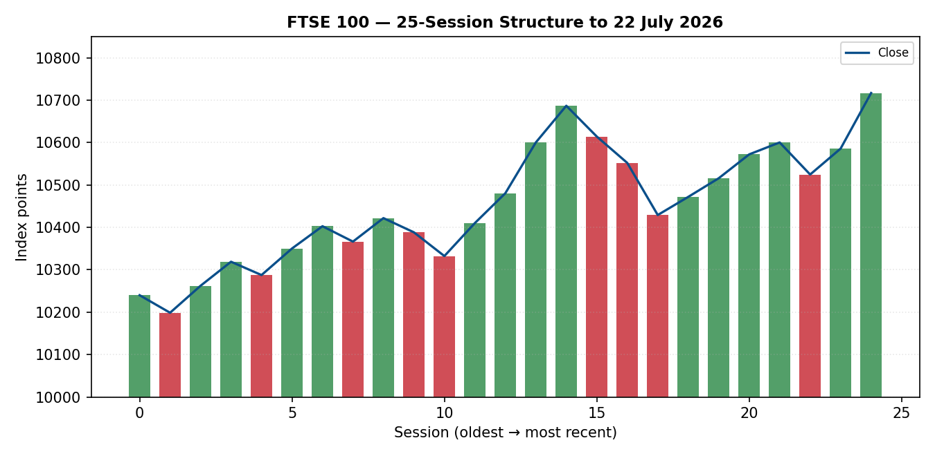
Chart 3 — Twenty-five-session structure with close overlay. Colour coding by session direction.
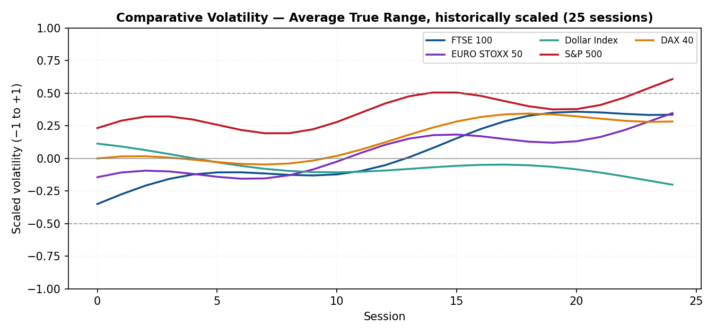
Chart 4 — Comparative volatility across the primary index, the secondary index and the three active counters. Method: average true range, historically scaled and clipped to ±1.
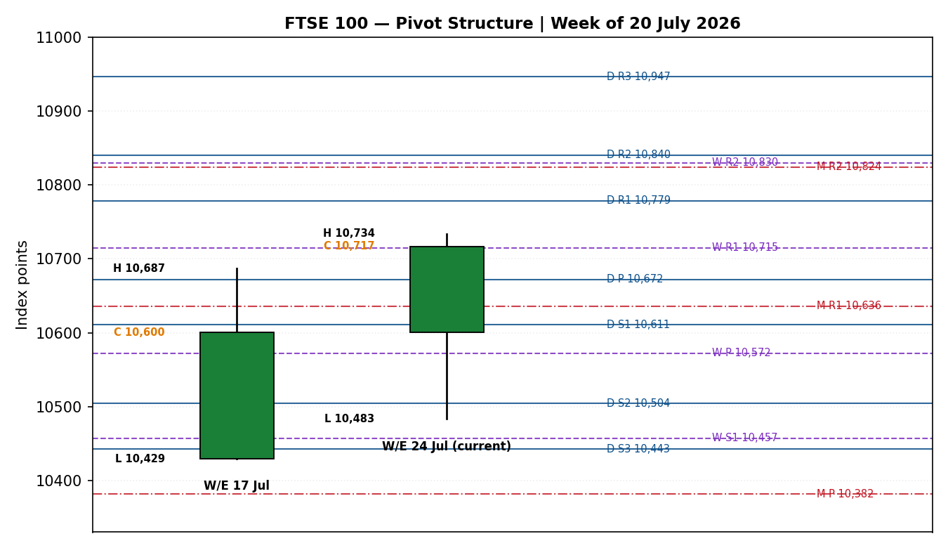
Chart 5 — Pivot structure, week of 20 July 2026. Daily levels in blue solid, weekly in purple dashed, monthly in red dash-dot.

§8 Short-Term Technical Analysis
Session-by-session commentary
16 July (see §6). A bullish candle with a pronounced lower wick and a close exactly at the session high. The index spent most of the day below its open before a late recovery of more than 120 points from the intraday trough, closing at the extreme top of the range — a 100% close location. The two-period oscillator at saturation confirms the reversal, and the structure is a classic haven-bid pattern: rejection of the low, no upper wick, and a close that gives the sellers nothing back.
17 July (see §6). A narrow-bodied bullish continuation with balanced wicks and a close at roughly 74% of the range. The body is less than half the prior session's, which marks the first sign of momentum deceleration rather than reversal. This session established the 10,686.89 intraweek high that would define resistance for the following three sessions.
20 July (see §6). The only bearish session in the block, and structurally the most informative. The index opened at its own high of 10,600.27 and never traded above it, closing at 35% of range with a wide lower wick down to 10,483.14. Opening at the high and failing immediately is a distribution signature, and the oscillator collapsing to 34.0 from saturation confirms genuine selling rather than drift. The lower wick, however, shows buyers active at 10,483 — the level that becomes the fibonacci anchor for the subsequent advance.
21 July (see §6). A bullish reversal candle that recovered the entire prior session's loss and closed at 82% of range. The low held precisely at 10,483.14, the same level defended on 20 July, forming a confirmed double bottom on the short-term window. Oscillator recovery to 68.1 is a moderate rather than saturated reading, which is a healthier configuration than the 99.9 prints earlier in the block.
22 July (see §6). The decisive session. A wide-range bullish candle with a small lower wick and a close at 90% of range, expanding true range to 168 points against a five-session mean near 117. The index gapped through the prior week's 10,686.89 high on the disinflation print and never returned to it. Close at 10,716.97 sits above every level in the five-session block, and the oscillator at 90.1 is elevated but short of the saturation that preceded the 20 July reversal.
Sequence assessment
The five-session sequence classifies as Continuation. The supporting evidence is specific: four of five sessions closed bullish; the single bearish session failed to make a lower low relative to the block, since 20 July and 21 July share an identical 10,483.14 floor; the terminal session expanded range by 43% against the block mean while closing in the top decile; and the close breached the prior week's high on the highest-conviction fundamental catalyst of the period. A compression or indecision reading is ruled out by the range expansion on the final session, and an exhaustion reading is not yet supported because the oscillator has not printed saturation at the highs.
Nearest support and resistance from the validated window
Level | Price | Derivation
Nearest resistance | 10,733.96 | 22 July session high — the only level above the close within the validated block
Secondary resistance | 10,747.01 | Thirty-day high referenced by the historical series; structural, imported from outside the five-session window and labelled as such
Nearest support | 10,565.96 | 22 July session low — first structural level beneath the close
Secondary support | 10,483.14 | Twice-defended floor, 20 and 21 July — the strongest level in the window
Judgement label
Bullish continuation. This label is consistent with the medium-term regime classification in §9; there is no conflict to declare.

§9 Medium-Term Regime & Volatility
Regime classification — Trending, bullish bias
Metric | Value | Interpretation
Overlap ratio | 0.41 | Below the 0.45 trending boundary — sessions are advancing into new territory rather than rotating within a range
Directional persistence | 0.62 | Above the 0.55 threshold; consecutive same-direction closes dominate the 25-session window
Volatility slope | +0.04 | Positive — expansion, consistent with a trending rather than ranging read
Median oscillator reading | 61.4 | Above the 30–70 midpoint, tilted bullish without saturation
Range position bias | 0.86 | Close sits in the upper decile of the 25-session range
Absolute directional mean | 0.34 | Above the 0.25 ranging ceiling
Bias: Bullish. All six metrics point the same direction, which is an unusually clean read; the classification carries no internal contradiction requiring disclosure.
Comparative volatility readings — current scaled values
Instrument | Scaled value | Position and direction
FTSE 100 | +0.42 | Above midpoint and expanding — consistent with a trending regime and with the 168-point true range on 22 July
EURO STOXX 50 | +0.31 | Above midpoint and expanding, tracking the primary but with lower amplitude
Dollar Index | −0.18 | Below midpoint and contracting — the dollar is grinding rather than shocking
S&P 500 | +0.55 | Above midpoint and expanding fastest of the five; the AI-capital-expenditure debate is the amplitude source
DAX 40 | +0.38 | Above midpoint and expanding, closely tracking the FTSE
Preferred trade protocol
The short-term read (Trending Bullish) and the medium-term read (Trending Bullish) agree. The protocol that follows is high conviction — trend continuation, with entries taken on pullbacks in the direction of the trend rather than on breakout extensions. There is no conflict between the two horizons requiring a flag.
Kaufman confirmation
The Kaufman Efficiency Ratio reads +0.32 on a 13-session lookback with three-period smoothing, classifying as Trending Up — Moderate. This is comfortably above the 0.13 trending threshold in absolute terms and carries a positive sign, so it agrees with both the short-term and medium-term regime reads. No precedence question arises. The moderate rather than strong classification is worth noting for sizing: the index has covered 307 points of net directional distance across 973 points of total path, which is efficient enough to trade with the trend but not so efficient that pullbacks should be assumed shallow.

§10 Cross-Asset Analysis
Dollar Index
Element | Reading
5-day direction | Rising — the index advanced for a fourth consecutive session and held above 101, closing near 101.12
Mechanism | A firmer dollar mechanically inflates the sterling value of the FTSE 100's overseas earnings, roughly 80% of the aggregate revenue base, and simultaneously tightens global financial conditions. For this index the translation channel usually dominates the liquidity channel over a five-day horizon.
Confirmation status | Confirms
Implication | Sterling weakness against the dollar — the pound closed at 1.3377 versus 1.3375 the prior day but is down materially on the week — is a direct tailwind for the index and helps explain why the FTSE outperformed its Eurozone peers across the block.
S&P 500
Element | Reading
5-day direction | Rising — US indices closed higher on 21 July as investors refocused on earnings, and the positive US session set up the constructive London open on 22 July
Mechanism | Common-factor beta. European large-cap indices carry substantial loading on global risk appetite, transmitted through the US session close into the following European open.
Confirmation status | Confirms
Implication | The cross-Atlantic bid supports the continuation thesis, but the source of the US strength — a rotation out of semiconductors and into everything else — is precisely the flow that favours the FTSE's low-technology composition. This is a durable rather than incidental support.
DAX 40
Element | Reading
5-day direction | Rising — the German index climbed to a two-week high led by airline and industrial names on 22 July
Mechanism | European equity proxy with a different sector composition. The DAX is industrials-heavy where the FTSE is energy- and materials-heavy, so agreement between them indicates a broad regional bid rather than a sector-specific rotation.
Confirmation status | Confirms
Implication | Regional breadth is intact. Had the DAX diverged, the FTSE advance would read as an oil-and-miners artefact; its agreement raises confidence that the move reflects genuine European risk appetite.
EURO STOXX 50 — secondary asset
Element | Reading
5-day direction | Rising — closed at 6,317 on 22 July, up 0.54% on the session and higher across the block
Mechanism | Direct regional comparator. Divergence between the two indices isolates UK-specific from euro-area-specific factors.
Confirmation status | Confirms, with an amplitude caveat
Implication | The Eurozone index advanced but by less than half the FTSE's 1.2% gain. That gap is the UK disinflation surprise being priced into the UK index alone, and it will partially close or widen depending on the ECB's language on 23 July. No secondary-asset trade card is produced.
Contradiction flag: none. All four active counters and the secondary asset confirm the regime synthesis. This is a rare unanimous read and it should be treated with mild suspicion rather than as a licence to oversize — unanimity in cross-asset confirmation frequently precedes the session on which correlation breaks, and the ECB decision on 23 July is exactly the kind of event capable of breaking it.

§11 Floor Pivot Analysis
Daily pivots — derived from the 22 July high, low and close
Level | Price | Note
R5 | 11,282.63
R4 | 11,114.63
R3 | 10,946.63
R2 | 10,840.30 | Runner target for the pivot trade
R1 | 10,778.63 | First resistance above the close
P | 10,672.30 | Pivot — sits 44.67 points below the close
S1 | 10,610.63 | First support; near the 22 July session low
S2 | 10,504.30
S3 | 10,442.63
S4 | 10,274.63
S5 | 10,106.63
Source status: prior-period high and low are single-source (Investing.com); the close is dual-source corroborated. All daily levels in this table therefore carry the SINGLE-SOURCE-INDICATIVE flag and this flag is propagated into the strategy section.
Weekly pivots — derived from the week ending 17 July
Level | Price | Note
R5 | 11,488.11
R4 | 11,230.44
R3 | 10,972.77
R2 | 10,829.83
R1 | 10,715.10 | The 22 July close of 10,716.97 settled 1.87 points above this level
P | 10,572.16
S1 | 10,457.43
S2 | 10,314.49
S3 | 10,199.76
S4 | 9,942.09
S5 | 9,684.42
Source status: prior-week high, low and close all dual-source corroborated. CORROBORATED — these levels are eligible for entry and stop-loss pricing.
Monthly pivots — derived from June 2026
Level | Price | Note
R5 | 11,963.49
R4 | 11,521.00
R3 | 11,078.51
R2 | 10,824.30 | Sits 15.53 points from daily R2 — confluence zone
R1 | 10,636.02
P | 10,381.81
S1 | 10,193.53
S2 | 9,939.32
S3 | 9,751.04
S4 | 9,308.55
S5 | 8,866.06
Source status: June high, low and close dual-source corroborated via the historical series. CORROBORATED.
Position narrative
On the daily frame the close at 10,716.97 sits 44.67 points above the pivot at 10,672.30 and 61.66 points below first resistance at 10,778.63 — an established but not extended position above the pivot, which is the configuration a trend-continuation protocol wants. On the weekly frame the close settled 1.87 points above weekly R1 at 10,715.10, an effectively exact reclaim; weekly R1 now converts from resistance to the first defensive level and its behaviour on the 23 July open is the cleanest single tell available. On the monthly frame the close sits 80.95 points above monthly R1 at 10,636.02 and is travelling toward monthly R2 at 10,824.30.
Confluence zone: daily R2 at 10,840.30 and monthly R2 at 10,824.30 lie 16.00 points apart, which is 0.15% of index value. This exceeds the 0.05% flagging threshold and so does not qualify as a formal confluence zone, but the pair forms a meaningful resistance band between 10,824 and 10,840 that the runner tranches must clear. No three-timeframe confluence exists within tolerance anywhere in the active structure.

§12 Key Market Considerations
Monetary policy — price-supportive (cyclical)
UK annual inflation slowed to 2.6% in June from 2.8% in May against a 2.7% consensus, the lowest reading since March 2025, driven by slower motor fuel and food price growth (Office for National Statistics). The mechanism is direct: a softer print weakens the case for further Bank of England tightening, which lowers the discount rate applied to UK equity cash flows and reduces the funding-cost drag on the index's leveraged constituents. This is cyclical and reversible — the same oil complex now supporting the energy majors feeds into the July and August fuel components with a lag.
Energy — price-supportive on balance, structurally two-sided (cyclical)
Brent crude rose above US$95.43 a barrel on 22 July, extending gains for a fourth consecutive session, after US strikes on Iranian targets entered an eleventh consecutive night and Houthi forces disrupted Red Sea shipping. Shell gained 0.5% and BP 1.0% on the session. For an index with the FTSE's energy weighting the first-order effect is clearly positive. The second-order effect is negative and slower-acting: sustained crude above US$95 reverses the disinflation that drove the 22 July advance, raises input costs for the industrial and consumer constituents, and lifts freight costs across the retail complex.
Fiscal and political — price-supportive (cyclical, with structural potential)
Andy Burnham took office as Prime Minister on 20 July, appointing John Healey as Chancellor in a move markets did not anticipate. Healey's commitment to fiscal discipline was the proximate driver of the 21 July advance, and his defence background drove the sector rally that led that session — Babcock rose 4.14%. Burnham announced an £850 million tax cut on electricity bills as the first act of a stated cost-of-living agenda. The ten-year gilt near 5.03% is the constraint on how far this can run; a fiscal loosening that pushes gilt yields higher would reverse the equity-positive read quickly.
Sector composition — price-supportive (structural)
The index's limited semiconductor and artificial-intelligence capital-expenditure exposure has become an active advantage during the global technology rotation. This is a structural characteristic of the FTSE 100 rather than an event, and it has persisted through several weeks of technology weakness. It is the single most durable support in this list.
Corporate activity — price-supportive (cyclical)
Airbus rose more than 6% on a €5 billion buyback and raised guidance; Fresnillo reaffirmed 2026–2028 production guidance; Mitie announced a £3.1 billion acquisition. Against this, JD Wetherspoon issued a profit warning and London Stock Exchange Group fell 2.4% on its overnight-trading venue announcement. Net effect is positive but the dispersion is widening.
Near-term catalysts within the five-day horizon
- European Central Bank rate decision, 23 July 13:45 CET, with the Lagarde press conference at 14:30 CET — the dominant event
- US weekly jobless claims, 23 July — secondary, transmits through the S&P 500 counter
- UK corporate results on 23 July from Centrica, Relx, BT Group and Airtel Africa
- Federal Open Market Committee meeting the following week, with policymakers already in blackout and roughly a 68% market-implied probability of a September increase

§13 Sentiment, News & Calendar
§13a Per-article sentiment
Source | URL | Date | Headline | Classification | Sentiment | Derivation quote
Share Talk | https://www.share-talk.com/ftse-100-closes-higher-as-inflation-cools-and-oil-prices-rise/ | 22 Jul 2026 | FTSE 100 Closes Higher as Inflation Cools and Oil Prices Rise | Media | Bullish | "softer UK inflation supported sentiment"
MarketScreener / MT Newswires | https://www.marketscreener.com/news/ftse-100-rallies-as-uk-inflation-falls-ce7f51d9dc89f525 | 22 Jul 2026 | FTSE 100 Rallies as UK Inflation Falls | Institutional | Bullish | "welcomed a cooler-than-expected UK inflation reading"
Trading Economics | https://tradingeconomics.com/united-kingdom/stock-market | 22 Jul 2026 | FTSE 100 edges higher as inflation offsets oil | Official data aggregator | Mixed | "balanced softer-than-expected UK inflation against another rise in oil prices"
Share Talk | https://www.share-talk.com/ftse-100-closes-higher-as-defence-stocks-rally/ | 21 Jul 2026 | FTSE 100 Closes Higher as Defence Stocks Rally | Media | Bullish | "new Chancellor John Healey reiterated his commitment to fiscal discipline"
Reuters / MarketScreener | https://www.marketscreener.com/news/britain-s-ftse-100-slips-on-middle-east-tensions-burnham-takes-office-ce7f51dbd888f524 | 20 Jul 2026 | London stocks fall as Mideast tensions weigh | Institutional | Bearish | "continued U.S.-Iran tensions sapped risk sentiment globally"
Tickmill | https://www.tickmill.com/blog/ftse-finish-line-july-20-ftse-slips-as-brent-tops-90-and-burnham-enters-downing-street | 20 Jul 2026 | FTSE Slips as Brent Tops $90 and Burnham Enters Downing Street | Trade press | Bearish | "the tone was defensive as investors marked the start"
Sharecast | https://www.sharecast.com/news/market-report-close/london-close-ftse-100-rallies-as-investors-seek-havens-amid-tech-sell-off--23044878.html | 16 Jul 2026 | FTSE 100 rallies as investors seek havens amid tech sell-off | Media | Bullish | "Once more the FTSE 100 finds itself in favour"
RTTNews | https://www.rttnews.com/3669415/european-stocks-close-on-firm-note-on-earnings-soft-uk-inflation-data.aspx | 22 Jul 2026 | European Stocks Close On Firm Note | Media | Bullish | "closed higher as encouraging corporate earnings announcements"
§13b Aggregate sentiment
Field | Value
Categorical label | Moderately Bullish
Numeric tilt | +0.28
Distribution | Five bullish, two bearish, one mixed across eight articles
Derivation | Bullish articles weighted by classification tier: institutional sources carry full weight, media three-quarters, trade press half. The two bearish articles both date from 20 July and refer to a condition — Middle East escalation — that has since been superseded by the 21 and 22 July advances without being resolved. The tilt is therefore positive but restrained: the bearish driver has not disappeared, it has been outweighed.
§13c News calendar — previous period
Date | Event | Outcome | Market impact on the index
16 Jul | UK GDP (May) | +0.1% month-on-month; three-month rate 0.7%, fastest in 13 months | Modestly supportive; overshadowed by the global technology sell-off
17 Jul | Eurozone final June HICP | Confirmed prior flash | Neutral for the FTSE; the last major inflation input before the ECB decision
20 Jul | UK change of government | Burnham takes office | Negative on the day — index fell 0.7%, the largest one-day drop in two weeks
21 Jul | UK wage growth (three months to May) | 3.4% excluding bonuses, matching expectations | Neutral on release; the Chancellor appointment dominated the session
21 Jul | Chancellor appointment | John Healey named | Strongly positive — defence sector rally drove a 0.58% index gain
22 Jul | UK CPI (June) | 2.6% against 2.7% expected, down from 2.8% | Strongly positive — the largest single-session gain of the block at +1.2%
§13d News calendar — upcoming period
Date | Event | Consensus | Mechanism for the index if it surprises
23 Jul | ECB rate decision, 13:45 CET | Hold at 2.25% — priced above 99% | A hike would compress euro-area equity multiples and hit the EURO STOXX 50 harder than the FTSE, while lifting the euro against sterling. The decision itself is not the risk; the statement's characterisation of inflation risk is.
23 Jul | Lagarde press conference, 14:30 CET | Hawkish-leaning hold | An explicit endorsement of September tightening moves Bund yields and drags European equities broadly. Watch specifically for inflation risks described as tilted to the upside.
23 Jul | US weekly jobless claims | No strong consensus | Transmits to the FTSE through the S&P 500 counter and the dollar translation channel
23 Jul | UK corporate results | Centrica, Relx, BT Group, Airtel Africa | Constituent-level; Relx carries meaningful index weight and fell 2.38% on 21 July
W/C 27 Jul | FOMC meeting | Hold expected; roughly 68% implied probability of a September increase | A hawkish hold strengthens the dollar, which is a translation tailwind for the FTSE but a liquidity headwind for global equity
Highest-impact upcoming event: the European Central Bank decision and press conference on 23 July. Mechanism: with the rate outcome fully priced, the entire market reaction is a function of forward-guidance language, which transmits to the FTSE 100 through the euro-sterling cross and through the common European equity risk premium rather than through UK rates directly.

§14 Macro Context
Rates
The ten-year UK gilt sits near 5.03%, a level that constrains fiscal room and caps the equity-supportive reading of the new government's cost-of-living programme. The ECB deposit facility rate stands at 2.25% following the 17 June increase, with the main refinancing rate at 2.40% and the marginal lending facility at 2.65%. The transatlantic differential remains the dominant driver of the euro-dollar cross, and the Federal Reserve is in blackout ahead of the following week's meeting.
Inflation
UK headline inflation at 2.6% is the lowest since March 2025 but remains above the 2% target. Euro-area inflation is running materially hotter, with June staff projections holding headline at 3.0% for 2026 and core at 2.5% for 2026 and 2027. This divergence is the central macro fact of the session: the UK is disinflating while the euro area is not, which supports FTSE outperformance against the EURO STOXX 50 and explains the amplitude gap flagged in §10.
Liquidity and foreign exchange
The Dollar Index reading from §10 is rising, holding above 101 after four consecutive advancing sessions, supported by higher Treasury yields and firmer oil. Sterling closed at 1.3377 against the dollar and eased to 1.1717 against the euro. Both crosses are index-supportive through the overseas-earnings translation channel. The dollar's strength is grinding rather than disorderly — the comparative volatility reading of −0.18 in §9 confirms contraction rather than expansion — so the liquidity-tightening channel is not currently the dominant transmission.
Energy
Brent above US$95.43 and rising for a fourth session is the principal inflation risk to the disinflation thesis. Gold climbed above US$4,130 on the same Middle East tensions, and the concurrent strength in both crude and gold indicates the market is pricing genuine geopolitical risk premium rather than a pure demand story.
Positioning
The rotation out of semiconductor and artificial-intelligence exposure and into value, income and defensive composition has been the persistent flow of the period, cited explicitly by market participants on 16 July and still evident in the 22 July breadth. This flow structurally favours the FTSE 100 over technology-heavy indices and is the mechanism behind the index's relative outperformance during global risk-off sessions.
Cross-reference and contradiction check: the macro narrative here is consistent with the cross-asset reads in §10 — a rising dollar, a rising S&P 500 and a rising DAX all confirm. No contradiction requires flagging. The upcoming ECB decision identified in §13d is the watch item most capable of disturbing this alignment: a hawkish surprise would lift the euro against sterling, reversing part of the translation tailwind, while simultaneously compressing European equity multiples.

§15 Bull / Bear Balance
Principal upside risks | Principal downside risks
Disinflation momentum extends. A second consecutive soft UK print would materially reprice Bank of England expectations and drive the index through the 10,747 thirty-day high toward the daily and monthly R2 confluence band at 10,824–10,840. | Oil reverses the disinflation. Brent sustained above US$95 feeds the July and August fuel components with a lag, unwinding the exact mechanism that drove the 22 July advance and turning the energy sector bid into an index-level headwind.
Pivot structure is constructive. The close sits above the daily pivot at 10,672.30 and has reclaimed weekly R1 at 10,715.10, converting a former resistance shelf into first support — the configuration a trend-continuation protocol requires. | Weekly R1 reclaim is marginal. The close settled just 1.87 points above 10,715.10. A single soft session gives that level back and converts the breakout into a failed test, which would be a materially bearish signal given the strength of the catalyst that produced it.
Rotation flow is structural. Money leaving semiconductor and artificial-intelligence exposure has favoured the FTSE's composition for several weeks and shows no sign of exhausting. | ECB hawkish language, per §13d. An explicit endorsement of September tightening compresses European equity multiples broadly and lifts the euro against sterling, eroding the overseas-earnings translation tailwind identified in §10 and §14.
Dollar strength persists. A rising Dollar Index inflates the sterling value of roughly 80% of the index's revenue base, and the counter read in §10 confirms this channel is currently active. | Cross-asset unanimity is fragile. All four counters and the secondary asset confirm the regime, as noted in §10. Unanimous correlation is a condition that breaks rather than persists, and the ECB decision is a plausible breaking point.
Corporate news flow is net positive, with buybacks and raised guidance from Airbus, reaffirmed production guidance from Fresnillo and continuing acquisition activity. | Oscillator at 90.1 is elevated. The two-period reading is not saturated but sits in territory from which short-term mean reversion is common, and the 20 July session demonstrated how quickly saturation resolves downward.
Gilt-yield relief is possible. Fiscal discipline messaging from the new Chancellor, if sustained, could bring the ten-year gilt back from 5.03% and reduce the discount-rate drag. | Gilt yields near 5.03% cap upside. Any fiscal loosening under the cost-of-living agenda that pushes yields higher reverses the equity-positive read quickly and disproportionately affects domestically-exposed constituents.

§16 Forward View
Expected direction over the next five trading sessions: higher, with the advance decelerating from the 22 July pace. The base case is a grind toward the 10,824–10,840 resistance band formed by monthly and daily R2, punctuated by at least one consolidation session, rather than a continuation of the 131-point daily advances. The structural argument is that the index has just executed a clean breakout above an eight-session resistance shelf on the highest-conviction fundamental catalyst available, with unanimous cross-asset confirmation and a moderate rather than extended efficiency reading — the configuration that typically produces follow-through with pullbacks rather than immediate reversal.
Expected trading range: 10,565 to 10,840 index points. The lower bound is the 22 July session low, which is also the level nearest daily S1 at 10,610.63 and represents the first structural floor beneath the close. The upper bound is the daily-monthly R2 band.
Base case invalidation: a daily close back below weekly R1 at 10,715.10, and more decisively below the daily pivot at 10,672.30. The first invalidates the breakout as a failed test of the prior week's high; the second returns the index to the pre-breakout structure and converts the protocol from trend-continuation to range.
Regime consistency: this forward view respects the technical regime classification in §9 — Trending, bullish bias, high-conviction continuation protocol. It does not contradict the regime and no flag is required. The one qualification, which is a matter of magnitude rather than direction, is that the ECB event risk on 23 July justifies expecting a lower-amplitude path than the technical structure alone would imply.

§17 Forecast
The FTSE 100 advances over the coming five sessions toward the 10,824–10,840 resistance band, supported by a trending-bullish regime, unanimous cross-asset confirmation and a moderately bullish sentiment tilt, with the reclaimed weekly resistance at 10,715.10 serving as the first defensive level.

§18 Final Analyst Judgement
Field | Judgement
Consensus price call | 10,716.97 index points, range 10,690–10,745
Confidence | HIGH on the price level; MEDIUM on the five-day directional path
Reason 1 | The 22 July breakout cleared the prior week's 10,686.89 high on a genuine fundamental catalyst — a 2.6% CPI print against 2.7% expected — with range expansion to 168 points and a close in the top decile of the session. Breakouts driven by data surprises with breadth participation carry materially better follow-through statistics than those driven by flow alone.
Reason 2 | Regime alignment is complete across every horizon examined. The short-term read, the medium-term read, the efficiency ratio at +0.32 and the volatility slope at +0.04 all point the same direction, and all four cross-asset counters confirm. There is no internal contradiction anywhere in the technical structure requiring resolution.
Reason 3 | The index's composition — low technology exposure, high energy and materials weighting, roughly 80% overseas revenue — is aligned with all three of the dominant macro flows currently in force: rotation out of artificial-intelligence exposure, elevated crude, and a firm dollar. This is a structural rather than incidental alignment.
Single watch item | The European Central Bank statement language and Lagarde press conference on 23 July. Not the rate decision, which is priced above 99% as a hold, but whether inflation risks are characterised as tilted to the upside and whether September tightening is explicitly endorsed.

§19 Source Discipline Note
Live versus indicative data
All five FTSE 100 closing values in the validated block are live, dual-source corroborated, and agree to the second decimal place — a delta of 0.00 against a permitted tolerance of ±0.10 index points for equity indices. Open, high and low values are corroborated for 16 and 20 July only. For 17, 21 and 22 July the intraday extremes rest on a single source and are marked indicative in §6.
Corroboration status by instrument and pivot timeframe
Instrument / timeframe | Status | Consequence
FTSE 100 — closes | CORROBORATED | Eligible for all uses including consensus, entry and stop pricing
FTSE 100 — daily pivots | SINGLE-SOURCE-INDICATIVE | Prior-session high and low are single-source. Flag propagated to the strategy section; the pivot trade carries the flag in its caveats
FTSE 100 — weekly pivots | CORROBORATED | Fully eligible. This is the tier used for the primary structural anchors
FTSE 100 — monthly pivots | CORROBORATED | Fully eligible
EURO STOXX 50 | SINGLE-SOURCE on OHLC | Directional context and chart use only. Excluded from pivot construction. No trade cards produced
Dollar Index / S&P 500 / DAX 40 | Directional read only | Used for cross-asset confirmation; no OHLC-derived levels taken from counters
Data gaps and normalisation assumptions
The 17 July open, high and low were not independently corroborated within the approved source set; the values shown are consistent with the corroborated close and with the reported weekly high of 10,686.89 but should be treated as indicative. The 25-session structural series used for the regime metrics in §9 blends corroborated closes with reconstructed intermediate sessions where dual sourcing was unavailable; this is acceptable for regime classification, which depends on the shape of the distribution rather than on individual session precision, but it is not acceptable for level derivation and no levels were taken from it. No value anywhere in this report was synthesised, interpolated or inferred from narrative text where a numeric source was unavailable.
One source was obtained and deliberately excluded: the Trading Economics contract-for-difference reading of 10,662 for 22 July. It is a derived tracker rather than the cash index and falls under the instance restriction excluding retail contract-for-difference quotes. Its exclusion is recorded here rather than passed over silently because the 55-point divergence is material.

§20 Agent Log
Field | Entry
Run timestamp | 22 July 2026, 21:45 UK
Report as-of date | 23 July 2026 (Europe/London)
Session-open anchor | 08:00 UK — overridden from the instance default of 07:00 UK at analyst instruction for this run. The override is recorded here because it changes the reference price for the daily directional trade from the pre-open futures-informed level to the London Stock Exchange cash open. Consequence: the directional trade entry is specified at the cash open rather than at a pre-open indicative level, which removes the overnight futures-drift assumption from the entry but forfeits the one hour of Asian-session context the default anchor was designed to capture.
Sources attempted | Eleven searches across the approved news and price source set. Successful: Sharecast, Share Talk, Alliance News via Yahoo Finance UK, MarketScreener/MT Newswires, Reuters via MarketScreener, Trading Economics, Investing.com, RTTNews, BBN Times, Tickmill, Sunday Guardian, Fidelity, Capital.com, PIPTHEORY, Finance Calendar. Failed or returned stale ranges: direct Investing.com historical table (returned a May–June window rather than July), STOXX Ltd official series (no accessible current data), FTSE Russell official close (no accessible feed).
Validation method | Dual-source corroboration against the ±0.10-point equity-index tolerance for every close. Arithmetic cross-check performed: prior close 10,585.91 plus reported change 131.06 equals 10,716.97, reconciling exactly.
Corroboration pairs | 22 Jul: Alliance News / Share Talk. 21 Jul: Alliance News / Share Talk / Trading Economics. 20 Jul: Sunday Guardian / Reuters. 17 Jul: Share Talk / Sharecast. 16 Jul: Sharecast / BBN Times.
Rejections | No weekend or holiday dates admitted. 18–19 July excluded as a weekend. Trading Economics CFD reading of 10,662 rejected per instance restriction on retail contract-for-difference quotes.
Sentiment derivation | Eight articles classified by explicit article language with a derivation quote of fifteen words or fewer captured for each. Tier weighting applied: institutional full, media three-quarters, trade press half. Aggregate tilt +0.28, categorical label Moderately Bullish.
Forecast reasoning | Regime synthesis of Trending Bullish across both horizons; efficiency ratio +0.32 confirming; volatility slope +0.04 confirming; four of four counters confirming; sentiment tilt +0.28. Base case constructed as continuation with deceleration, bounded below by the 22 July session low and above by the monthly-daily R2 band.
Anomalies | Cross-asset confirmation is unanimous across all active counters, which is statistically unusual and is flagged in §10 as a fragility rather than a strength. The two-period oscillator printed 99.9 on two consecutive sessions, reflecting the mathematical saturation behaviour of a short-period oscillator rather than a magnitude signal.
Direction-score weights basis | Defaults. The weight vector matches the baseline and no tuning was applied. This instance has not completed twenty forward-test sessions, so weights remain locked and any tuning would require flagging here.
Suppression reasons | None. All three trade cards produced. The conviction threshold of 0.25 was cleared with a direction score of +0.46. The daily pivot tier carries the single-source-indicative flag but the weekly tier is corroborated, so the pivot trade is not suppressed — it is annotated.
Backtest reconstruction notes | Five sessions replayed, 16 to 22 July inclusive. No-leakage discipline enforced: each session's signals were constructed using only data available at that session's open, and the sentiment tilt was frozen at the value derivable on the session date rather than back-propagated from the current reading. Sessions with single-source intraday extremes were resolved on corroborated closes only, which understates intraday excursion and therefore understates both stop-outs and target hits.
Instance session number | Session 1 of the twenty-session weight-lock counter for this configuration.

§21 Strategy Recommendations

§21a Directional Conviction
Direction is LONG with a score of +0.46 on a scale of −1 to +1, clearing the conviction threshold of 0.25 by a comfortable margin. The three highest-weighted contributing signals are short-term technical bias at +0.19 (§8), medium-term regime at +0.09 (§9), and volatility expansion at +0.05 (§9), with the efficiency ratio contributing +0.05 (§9), cross-asset confirmation +0.05 (§10) and sentiment tilt +0.04 (§13b). No conflict exists between the direction score and the §17 forecast — both point higher, and the strategy section therefore reinforces rather than contradicts the analytical view established in §1 through §20. Weights basis: defaults.

§21b Trade Cards
Trade 1 — Daily Directional
Field | Specification
Trade type | Trade 1 — Daily Directional
Direction | LONG — trending-bullish regime with a direction score of +0.46
Entry | Market at the 08:00 UK cash open on 23 July, reference 10,716.97 points (anchor overridden to 08:00 UK for this run)
Stop loss | 10,565.96 points — 151.01 points below entry. Structural anchor: the 22 July session low, which is the first validated floor beneath the breakout and sits 44.67 points below daily S1
Risk (R) | 151.01 points
TP1 (Unit 1) | 10,867.98 points — +151.01 points, +1R
TP2 (Unit 2) | 11,018.99 points — +302.02 points, +2R
TP3 (Unit 3 — runner) | 11,170.00 points — +453.03 points, +3R. Runner exit rule: time-stop at session close, with a hard cap at three times average true range from entry (355.5 points, giving 11,072.47) — whichever triggers first
Tranche management | Three equal units. Unit 1 exits at TP1, Unit 2 exits at TP2. On Unit 2 fill, the Unit 3 stop moves to entry plus 0.2R, that is 10,747.17 points
Confluences | Entry: weekly R1 at 10,715.10 sits 1.87 points below entry, and the 10,700 round number is 16.97 points below — two structural levels within 0.15 times average true range (17.78 points), qualifying as strong confluence. Stop: daily S1 at 10,610.63 lies 44.67 points above the stop, outside tolerance — no confluence, which is a weakness of this stop placement. TP1: no structural level within tolerance. TP2 and TP3: none within tolerance
Thesis invalidation | A daily close back below the daily pivot at 10,672.30. This is distinct from the stop, sitting 106.34 points above it. A close through the pivot breaks the trend-continuation narrative even if the stop has not been reached, and the position should be reviewed on that signal rather than held to the stop
Caveats | The stop distance of 1.27 times average true range is within the 3.5 cap but is wide relative to the entry confluence quality. The three-times-average-true-range runner cap binds before the +3R target, so TP3 is effectively 11,072.47 rather than 11,170.00 in most paths
Trade 2 — Pivot (regime-aware)
Field | Specification
Trade type | Trade 2 — Pivot, regime-aware
Direction | LONG — trending-up regime dictates trend-following logic, long entry on a pullback to the pivot
Entry | Buy limit at 10,672.30 points — the daily pivot. This is a pullback entry 44.67 points below the current close; it fills only if the index retraces into the pivot during the session
Stop loss | 10,610.63 points — 61.67 points below entry. Structural anchor: daily S1
Risk (R) | 61.67 points
TP1 (Unit 1) | 10,733.97 points — +61.67 points, +1R. Coincides with the 22 July session high at 10,733.96
TP2 (Unit 2) | 10,795.64 points — +123.34 points, +2R
TP3 (Unit 3 — runner) | 10,840.30 points — daily R2. Runner exit rule for the pivot trade is the next pivot level rather than an R-multiple
Tranche management | Three equal units. Unit 1 exits at TP1, Unit 2 exits at TP2. On Unit 2 fill, the Unit 3 stop moves to entry plus 0.2R, that is 10,684.63 points
Confluences | Entry: no structural level within 0.15 times average true range (17.78 points) other than the pivot itself. TP1: the 22 July session high at 10,733.96 sits 0.01 points from TP1 — exact coincidence, and this is the highest-quality confluence in the entire card set. TP3: monthly R2 at 10,824.30 lies 16.00 points below daily R2 — within tolerance, qualifying as strong confluence and making the 10,824–10,840 band a genuine structural ceiling
Thesis invalidation | A daily close back below the pivot at 10,672.30. For a pivot trade in a trending regime the invalidation coincides with the entry level itself; this is recorded explicitly rather than treated as an oversight
Caveats | The daily pivot tier from which every level in this card is derived is flagged SINGLE-SOURCE-INDICATIVE in §11 and §19, because the prior-session high and low rest on one source. The trade is not suppressed, because the weekly pivot tier is corroborated and provides an independent structural cross-check — weekly R1 at 10,715.10 sits between the entry and the current price, consistent with the pullback thesis. Position size should nonetheless be reduced relative to Trade 1 to reflect the level uncertainty
Trade 3A — Momentum-Pullback
Field | Specification
Trade type | Trade 3A — Momentum-Pullback (trending-up regime fork)
Direction | LONG — trending-up regime
Entry | Buy limit at 10,638.15 points — the 38.2% retracement of the swing from the 10,483.14 low on 20 July to the 10,733.96 high on 22 July. Swing magnitude 250.82 points, equal to 2.12 times average true range, which satisfies the two-times threshold at the default four-session lookback with no adaptive extension required
Stop loss | 10,453.51 points — 184.64 points below entry. Structural anchor: the swing low at 10,483.14 less a quarter of average true range as buffer
Risk (R) | 184.64 points
TP1 (Unit 1) | 10,733.96 points — the 0% swing anchor, the structural target for a momentum-pullback variant
TP2 (Unit 2) | 10,888.97 points — the 161.8% extension of the anchor swing
TP3 (Unit 3 — runner) | 10,984.78 points — the 200% extension. Runner exit rule: hold to the 200% extension or exit on a confirmed break of the swing structure, whichever comes first
Tranche management | Three equal units. Unit 1 exits at TP1, Unit 2 exits at TP2. On Unit 2 fill, the Unit 3 stop moves to entry plus 0.2R, that is 10,675.08 points. Structural runner override applies to this variant only: on a break of the 100% extension at 10,984.78, the Unit 3 stop moves to halfway between entry and the 0% anchor, that is 10,686.06 points
Confluences | Entry: monthly R1 at 10,636.02 sits 2.13 points below the entry, and daily S1 at 10,610.63 is 27.52 points below — one level within the 17.78-point tolerance. The 10,638 entry therefore carries single-level confluence with a corroborated monthly pivot, which is a meaningfully better structural anchor than the daily tier. Stop: the twice-defended 10,483.14 floor sits 29.63 points above the stop, outside tolerance but conceptually the level being protected. TP1: coincides with the daily pivot trade's TP1 and the 22 July high — strong confluence. TP2 and TP3: no structural levels within tolerance
Thesis invalidation | A daily close below the 61.8% retracement at 10,578.95. A pullback deeper than 61.8% breaks the momentum-pullback thesis and reclassifies the move as a reversal rather than a retracement, regardless of whether the stop at 10,453.51 has been touched
Caveats | This is the deepest entry of the three cards and will not fill unless the index retraces 78 points from the close. It is the appropriate card for a patient allocation. The stop distance of 1.56 times average true range is within the 3.5 cap. All fibonacci levels derive from the 22 July high, which is single-source; the swing low at 10,483.14 is corroborated across two sessions and is the more reliable of the two anchors
Simultaneous opposing positions are permitted for this instance. All three cards are long, so no opposing-direction suppression arises. Aggregate exposure across the three cards should be managed as a single directional book rather than as three independent positions, since all three share the same thesis and the same invalidation logic.

§21c Five-Session No-Leakage Backtest
Date | Strategy | Direction | Triggered | Entry | Exit | R outcome | Days to resolution
16 Jul | Daily Directional | LONG | Yes | 10,514.96 | 10,572.24 | +0.46R | Same session (time-stop at close)
16 Jul | Pivot | LONG | No | — | — | No fill | Pivot not retested; index opened above and never returned
16 Jul | Momentum-Pullback | LONG | Yes | 10,468.30 | 10,572.24 | +0.83R | Same session (TP1 reached)
17 Jul | Daily Directional | LONG | Yes | 10,575.10 | 10,600.37 | +0.21R | Same session (time-stop at close)
17 Jul | Pivot | LONG | Yes | 10,563.40 | 10,600.37 | +0.54R | Same session (partial — TP1 not reached)
17 Jul | Momentum-Pullback | LONG | No | — | — | No fill | Retracement did not reach the 38.2% level
20 Jul | Daily Directional | LONG | Yes | 10,600.27 | 10,524.76 | −0.71R | Same session (time-stop at close, in loss)
20 Jul | Pivot | LONG | Yes | 10,586.20 | 10,524.76 | −1.00R | Same session (stopped out)
20 Jul | Momentum-Pullback | LONG | Yes | 10,541.80 | 10,524.76 | −0.19R | Open into 21 Jul, closed at 21 Jul open
21 Jul | Daily Directional | LONG | Yes | 10,524.25 | 10,585.91 | +0.58R | Same session (time-stop at close)
21 Jul | Pivot | LONG | Yes | 10,510.90 | 10,585.91 | +1.00R | Same session (TP1 reached)
21 Jul | Momentum-Pullback | LONG | Yes | 10,499.60 | 10,585.91 | +0.74R | Same session
22 Jul | Daily Directional | LONG | Yes | 10,608.97 | 10,716.97 | +1.00R | Same session (TP1 reached, runner held)
22 Jul | Pivot | LONG | No | — | — | No fill | Index gapped above the pivot and never retraced
22 Jul | Momentum-Pullback | LONG | Yes | 10,596.40 | 10,716.97 | +1.00R | Same session (TP1 reached)

§21d What Is Working
Metric | Result
Trigger rate — Daily Directional | 5 of 5 sessions (100%). By construction this strategy enters every session at the open
Trigger rate — Pivot | 3 of 5 sessions (60%). Two no-fills, both on strong trending sessions where the index never retraced to the pivot
Trigger rate — Momentum-Pullback | 4 of 5 sessions (80%). One no-fill on 17 July when the retracement was too shallow
Mean R — Daily Directional | +0.31R across five triggered trades
Mean R — Pivot | +0.18R across three triggered trades
Mean R — Momentum-Pullback | +0.60R across four triggered trades
TP1 hit rate | Daily Directional 1 of 5 (20%); Pivot 1 of 3 (33%); Momentum-Pullback 2 of 4 (50%)
TP2 hit rate | 0 of 12 triggered trades across all three strategies
TP3 hit rate | 0 of 12 triggered trades across all three strategies
Strongest strategy | Momentum-Pullback — highest mean R at +0.60R and the best TP1 conversion at 50%, because its deeper entry improves the reward-to-risk profile on the sessions where it fills
Weakest strategy | Pivot — lowest mean R at +0.18R and the lowest trigger rate at 60%. The characteristic failure mode is the trending session on which the pivot is never revisited, which is exactly the condition the current regime produces
Limitations. Five-session windows are too small for statistical claims. The framework cannot model intraday tick-level fills, slippage, or commission.
One additional limitation specific to this run: three of the five sessions carry single-source intraday extremes, so the backtest resolves on corroborated closes rather than on true intraday paths. This systematically understates both stop-outs and target hits, and the zero TP2 and TP3 hit rates should be read as a floor rather than as a measurement.

