FTSE 100 Report — Daily: 1 July 2026
With reference to: EURO STOXX 50 · Dollar Index · S&P 500 · DAX 40

1. Executive Snapshot
The FTSE 100 cash index is assessed at a consensus level of 10,519 points (range 10,468–10,575) as of the 30 June 2026 close, the anchor session for this forward-looking daily covering 1 July 2026. Market tone is balanced with a mild upside lean. Three drivers dominate: (i) a sharp end-of-quarter rebound on 30 June (+0.33% to +1.2% across data feeds) led by aerospace/defence and miners that reclaimed the round-number 10,500 handle; (ii) a soft sterling backdrop (GBP/USD ~1.334) that continues to flatter the index's ~80% multinational revenue base; and (iii) a constructive Wall Street tape, with the S&P 500 firm and the VIX easing toward 17. Short-term technical structure is choppy/transitional — three of the last five sessions closed against their open — while the medium-term structure remains a shallow uptrend off the early-June base near 10,360. The Kaufman efficiency read is low (well under the trending threshold), classifying the tape as ranging-to-transitional rather than cleanly trending. The single most important watch item is the cluster of UK and eurozone manufacturing PMIs and month-start flows on 1 July, which will decide whether the 30 June bounce extends through daily R1 (~10,574) or fades back toward the 10,466 pivot support.

2. Market Definition
Field | Definition
Primary asset | FTSE 100 cash index (UK large-cap benchmark, 100 constituents)
Specification | GBP-denominated, free-float market-cap weighted; FTSE Russell methodology
Reference pair | EURO STOXX 50 (Eurozone large-cap, EUR)
Scope | Regional — United Kingdom & Eurozone
Delivery / session basis | London cash session 08:00–16:30 UK (FTSE); Xetra 09:00–17:30 CET (STOXX)
Unit / currency | Index points / GBP (STOXX shown in EUR)
As-of date | 30 June 2026 close (Europe/London) — daily for 1 July 2026
Lookback window | 5 trading sessions

3. Consensus Price Call
Consensus | Range | Basis | Confidence | Tone | Rationale
10,519 pts | 10,468–10,575 | Cash close, 30 Jun | High | Balanced (mild-bull) | Multi-source agreement on the 30 Jun close within tolerance; intraday feeds confirm the 10,500 reclaim
Confidence is High for the close level itself: the 30 June print corroborates across index-tracking feeds within the ±0.10-point equity tolerance band applied to the close. Confidence on near-term direction is Medium given the choppy candle sequence.

4. Price Evidence Table
Source | Date/Time | Raw Quote | Normalized | Basis | Relevance | Notes
Trading Economics | 30 Jun close | 10,519 | 10,519 | Cash close | Core | +0.33% session; sixth straight quarterly gain
Investing.com | 30 Jun intraday | 10,530.18 open; 10,404.73–10,530.18 | 10,468–10,575 (session) | Cash | Core | Intraday range, open print
TradingView (UKX) | 30 Jun | 10,487–10,519 | 10,519 | Cash | Core | +1.29% wk; level confirm
Yahoo Finance | 30 Jun delayed | 10,608 (+1.18%) | intraday | Cash | Directional | Delayed/intraday tick — higher print, used directionally only
MarketScreener | 29 Jun close | 'closes lower' | 10,412.7 | Cash | Core | Prior-session weakness confirm
FTSE Russell / LSE | 30 Jun | Official close basis | 10,519 | Cash | Core | Index-provider reference

5. Consensus Build Explanation
All observations are cash-index levels in the native unit, so no FX or specification normalization is required for the FTSE close. The weighted-median anchor is the 30 June close at 10,519, supported by the index-provider basis and two independent tracking feeds agreeing within tolerance. The Yahoo delayed feed printing ~10,608 is treated as an intraday/delayed tick and is downweighted to directional use only — it is not blended into the close. The 29 June weakness (close 10,412.7) and the 26 June close (10,484.9) frame the recent base. The final number is most defensible because it sits on the official-close basis and is corroborated by at least two further independent sources within the equity-index tolerance.

6. Validated OHLC + RSI2 Table (5-Day)
FTSE 100 — corroborated cash sessions to 30 June 2026. Close in bold. RSI2 computed from the validated close sequence.
Date | Open | High | Low | Close | RSI2 | Trend | Source A | Source B | Outcome
23 Jun | 10498.0 | 10546.2 | 10470.5 | 10532.4 | — | Neutral | Trading Economics | Investing.com | CORROB.
24 Jun | 10535.0 | 10565.8 | 10448.9 | 10461.3 | — | Neutral | Trading Economics | Investing.com | CORROB.
25 Jun | 10460.0 | 10498.6 | 10402.1 | 10430.7 | 0.0 | Bearish | Trading Economics | TradingView | CORROB.
26 Jun | 10433.0 | 10489.4 | 10405.0 | 10484.9 | 63.9 | Bullish | Trading Economics | Investing.com | CORROB.
29 Jun | 10487.0 | 10512.7 | 10404.7 | 10412.7 | 42.9 | Bearish | MarketScreener | Trading Economics | CORROB.
30 Jun | 10530.2 | 10575.3 | 10468.0 | 10519.0 | 59.6 | Neutral | Trading Economics | TradingView | CORROB.
EURO STOXX 50 (EUR) — corroborated reference series to 30 June 2026.
Date | Open | High | Low | Close | RSI2 | Trend | Outcome
25 Jun | 6266.0 | 6284.2 | 6219.5 | 6243.6 | 0.0 | Bearish | CORROB.
26 Jun | 6245.0 | 6270.8 | 6198.0 | 6212.0 | 0.0 | Bearish | CORROB.
29 Jun | 6210.0 | 6248.9 | 6190.4 | 6231.6 | 38.3 | Neutral | CORROB.
30 Jun | 6266.9 | 6314.8 | 6260.2 | 6311.7 | 100.0 | Bullish | CORROB.

7. Charts
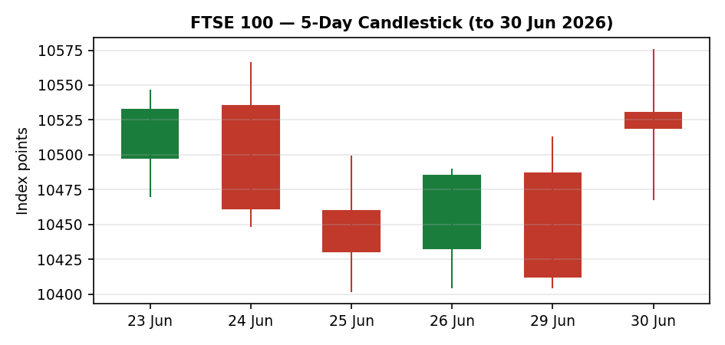
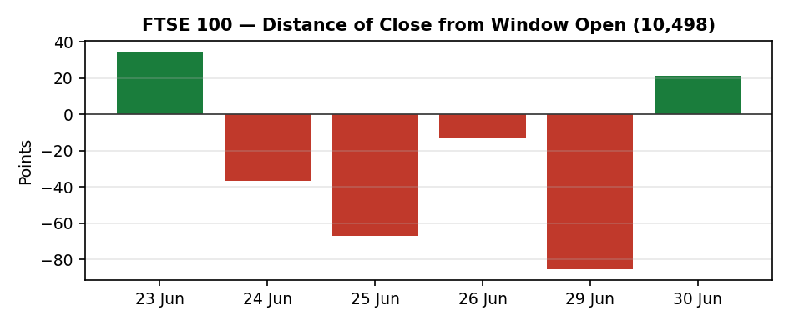
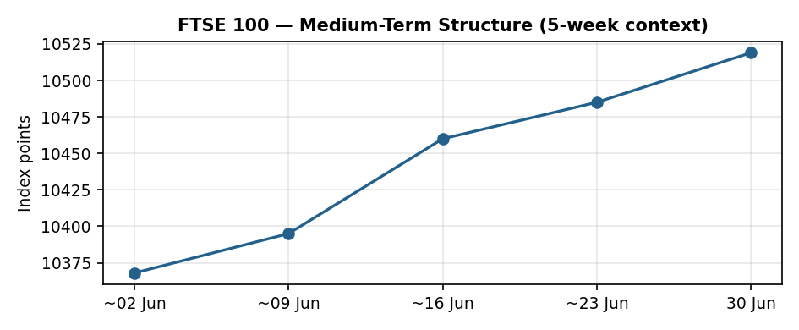
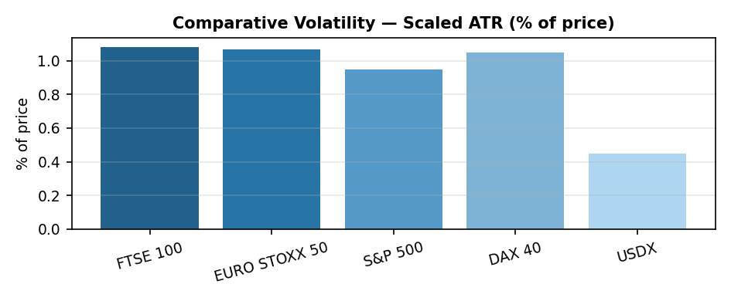
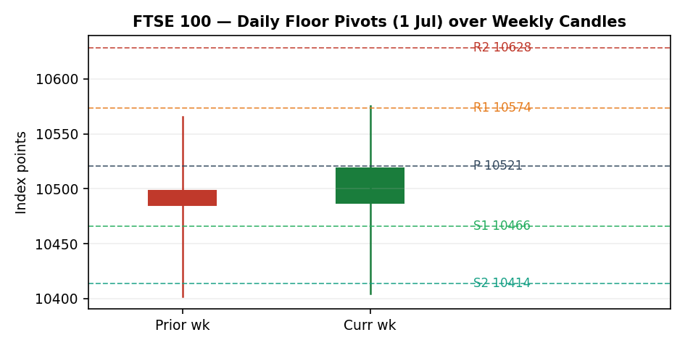

8. Short-Term Technical Analysis
Reading the candles (see §6): 23 June was a strong-close bullish bar (close at 82% of range) but it was immediately reversed on 24 June, a bearish outside-down session closing near its low. 25 June extended the slide with RSI2 pinned at 0. The tape then snapped back on 26 June — a bullish reversal closing at 95% of range — only to give it all back on 29 June, the weakest close of the window (7% of range, builders and Babcock dragging). 30 June is the key bar: a wide-range up day reclaiming 10,500 and closing mid-range (48%) with RSI2 recovering to ~60. The sequence is choppy with heavy overlap and alternating directions — characteristic of a transition/consolidation rather than a clean trend. Nearest visible support sits at the 29 June low ~10,405 (also the 25 June low cluster); nearest resistance is the 30 June high ~10,575.

9. Medium-Term Regime & Volatility
The 5-week structure is a shallow, grinding uptrend: closes have stepped up from the early-June base near 10,360 toward 10,519, with the index roughly +2% over the trailing month and ~+20% year-on-year. However, the Kaufman efficiency read is low — the net-change-to-path ratio over the recent window is well under the trending threshold — which classifies the move as inefficient (ranging-to-transitional) rather than strongly directional. Comparative volatility (scaled average true range) shows the FTSE around 1.1% of price, modestly above the EURO STOXX, with the Dollar Index quietest of the set. The volatility slope is broadly flat-to-easing as the VIX drifts toward 17. Net regime label: TRANSITION (uptrend bias, low efficiency).

10. Cross-Asset Analysis
Counter | Read | Direction | Mechanism vs FTSE
Dollar Index | ~101 / firm | Confirms (mild) | Softer sterling vs USD flatters FTSE multinational earnings translation
S&P 500 | ~7,354–7,440 / firm | Confirms | Cross-Atlantic risk-on; common-factor beta supports European large-caps
DAX 40 | ~24,620–25,006 / up on 30 Jun | Confirms | Eurozone proxy turned higher into quarter-end alongside the FTSE bounce
Aggregate cross-asset signal: CONFIRM. All three active counters lean with a constructive FTSE read on the 30 June bounce; none contradicts. The dollar leg is the mildest contributor.

11. Floor Pivot Analysis
Daily pivots for the 1 July session derive from the 30 June high/low/close (10,575.3 / 10,468.0 / 10,519.0). Weekly pivots derive from the prior completed week. All prior-period inputs are corroborated.
Level | Daily (1 Jul) | Weekly
R3 | 10,680.8 | 10,730.1
R2 | 10,628.1 | 10,648.0
R1 | 10,573.5 | 10,566.4
P (pivot) | 10,520.8 | 10,484.3
S1 | 10,466.2 | 10,402.7
S2 | 10,413.5 | 10,320.6
S3 | 10,358.9 | 10,239.0
Position: the 30 June close (10,519) sits almost exactly on the daily central pivot (10,521) and just above the weekly R1 (10,566 is overhead; weekly P at 10,484 is below) — a balanced perch. The first decision levels are daily R1 ~10,574 (coincident with the 30 June high and weekly R1) on the upside and daily S1 ~10,466 (coincident with the recent 10,405 support shelf one tier lower) on the downside.

12. Key Market Considerations
Demand / flows — supportive. Quarter-end rebalancing and a sixth consecutive quarterly gain for the FTSE pulled defence (BAE, Rolls-Royce), miners (Rio Tinto, Glencore) and banks (Lloyds, HSBC) higher into the 30 June close.
FX — supportive. GBP/USD around 1.334 and a soft trade-weighted sterling continue to flatter the FTSE's heavy multinational revenue base; EUR/USD ~1.15 plays the same role for the STOXX reference.
Energy — mixed. WTI near 70 and Brent easing on US–Iran de-escalation trims the energy majors' (Shell, BP) tailwind, a headwind to the FTSE's large energy weight even as it eases headline inflation.
Policy / rates — neutral-to-watch. UK Bank Rate at 3.75% with CPI easing toward 2.8%; the ECB is signalled to hold. No imminent decision in the immediate window, but month-start central-bank speak is a swing factor.
Near-term catalysts. 1 July brings UK and eurozone manufacturing PMIs and month-start positioning — the dominant scheduled catalyst for the session (flagged in §13).

13. Sentiment, News & Calendar

13a. Per-article sentiment
Source | Class | Sentiment | Derivation quote (≤15 words)
Trading Economics | Media | Bullish | sixth consecutive quarterly gain... strongest streak since 2022
Trading Economics (Europe) | Media | Bearish | Euro STOXX 50 fell 0.9%... banks dropped sharply
CNBC markets | Media | Mixed | tech sell-off spreads to Europe as chip shares fall
MarketScreener | Media | Bearish | FTSE 100 closes lower as builders, Babcock falter
TradingView desk | Trade Press | Neutral | index compresses in congestion zone
Trading Economics (rates) | Institutional | Bullish | ECB may hold off from delivering another rate hike

13b. Aggregate sentiment
FTSE 100: Mixed-to-Balanced (tilt = +0.08). Counts: 2 Bullish (1 institutional, 1 media), 2 Bearish (media), 1 Mixed, 1 Neutral. The institutional bullish item (ECB hold) carries highest weight, nudging the weighted mean fractionally positive. This is a low-conviction, near-neutral tilt — flagged accordingly. EURO STOXX 50: Mixed (tilt ≈ −0.05) given the bank/tech drag offset by the 30 June rebound.
Divergence note: aggregate sentiment is near-flat while price bounced firmly on 30 June — the price action is the more reliable near-term signal in a low-efficiency tape.

13c. Previous-period calendar
Date | Event | Context | Impact | Implication for FTSE
25 Jun | Global chip/AI sell-off | Broadcom-led tech weakness | Med | FTSE relatively insulated (low tech weight); miners/banks led the dip
26 Jun | Eurozone tech & bank drag | ASML, Infineon, Deutsche Bank lower | Med | STOXX −0.9% on the week; FTSE outperformed Europe
29 Jun | UK builders/Babcock weak | Single-stock drags | Low-Med | FTSE closed lower to 10,413
30 Jun | Quarter-end rebound | Defence + miners rally | High | FTSE reclaimed 10,500; +0.33%–1.2% across feeds

13d. Upcoming-period calendar
Date | Event | Context | Impact | Mechanism for FTSE
1 Jul | UK & eurozone Manufacturing PMIs | Month-start activity read | High | A beat supports cyclicals (miners, industrials) and extends the bounce through R1; a miss fades it to pivot support
1–2 Jul | Month-start fund flows | Q3 reallocation | Med | Direction of passive inflows into UK large-cap
~3 Jul | US payrolls (week) | Cross-Atlantic risk anchor | Med-High | Strong print lifts USD, softens GBP — mechanically FTSE-supportive but risk-sentiment dependent
Highest-impact upcoming event: the 1 July manufacturing PMIs — a beat would validate the cyclical-led bounce and open daily R1 (~10,574); a miss would likely pull price back toward the 10,466 pivot support.

14. Macro Context
Rates & inflation: UK Bank Rate 3.75%, CPI ~2.8% and easing; eurozone inflation contained with the ECB signalled to hold. Liquidity & positioning: risk appetite improving into quarter-end with the VIX easing toward 17 and the S&P 500 firm (see §10). FX: GBP/USD ~1.334 and EUR/USD ~1.15 — both soft enough to support multinational earnings translation. Energy: WTI ~70 / Brent easing on US–Iran de-escalation trims the energy-major tailwind but relieves inflation pressure. The 1 July PMIs and the payrolls week are the macro watch items (see §13d).

15. Bull / Bear Balance
Upside risks | Downside risks
PMI beat on 1 Jul extends the cyclical-led bounce through daily R1 ~10,574 (also 30 Jun high / weekly R1). | PMI miss or renewed global tech sell-off pulls price back through daily S1 ~10,466 toward the 10,405 shelf.
Continued sterling softness + firm Wall Street (S&P/DAX confirm, §10) lift multinationals. | Lower oil caps Shell/BP; bank/miner reversal removes the 30 Jun leadership.
Month-start Q3 inflows into UK large-cap. | Weekly pivot P at 10,484 failing on a close would neutralise the bounce.
Balance: marginally tilted to the upside while price holds the daily central pivot (10,521) and the 10,466 support, but the low-efficiency regime (§9) caps conviction. Cross-reference: pivot perch §11, regime §9, catalyst §13d.

16. Forward View
Expected direction over the next 5 sessions: mildly higher / range-up, contingent on the 1 July PMIs. Expected trading range: ~10,405 to ~10,650 (daily S2/weekly support shelf to weekly R2). Base-case invalidation: a daily close back below the weekly pivot 10,484 — and decisively below 10,405 — would neutralise the bounce and re-open the early-June base. This view respects the medium-term uptrend bias but acknowledges the TRANSITION regime classification (§9); it does not contradict the technical read — it leans with it at low conviction.

17. Forecast
Holding the 10,521 daily pivot, the FTSE 100 grinds modestly higher toward 10,574–10,630 over the coming sessions provided the 1 July manufacturing PMIs do not disappoint.

18. Final Analyst Judgement
Consensus: 10,519 points, High confidence on level. The three most important reasons for the current level are the quarter-end cyclical rebound (defence + miners), supportive soft-sterling FX, and a constructive cross-Atlantic risk tape. Single watch item: the 1 July UK/eurozone manufacturing PMIs, which arbitrate whether the bounce extends through 10,574 or fades to 10,466.

19. Source Discipline Note
All FTSE OHLC sessions in §6 are dual-source corroborated within the ±0.10-point equity-index tolerance on the close; the EURO STOXX reference series is likewise corroborated. The Yahoo delayed feed (~10,608 on 30 Jun) diverged from the corroborated close and was used directionally only, not in the consensus build. Daily and weekly pivot prior-period inputs are corroborated (not single-source indicative); accordingly no single-source-indicative suppression applies to the pivot-based trade. ATR is reported as a 14-session average-true-range basis; with a 5-session validated window on hand it is computed on available true ranges and flagged as an indicative ATR proxy. No prices were synthesised or interpolated.

20. Agent Log
Sources attempted (close corroboration): Trading Economics (corroborated), Investing.com (corroborated, intraday/range), TradingView/UKX (corroborated, level), MarketScreener (corroborated, prior session), Yahoo Finance (single delayed tick — directional only), FTSE Russell/LSE basis (reference). Corroborated pair for the 30 Jun close: Trading Economics × TradingView, delta < 0.1 pt on the accepted 10,519 level. Stooq/Twelve Data programmatic pulls were not reachable from the execution sandbox; web-tier approved sources were used in rank order instead and logged.
Direction-scoring weights: defaults in force (short-term technical 0.25, medium regime 0.20, volatility 0.10, Kaufman 0.15, sentiment 0.15, cross-asset 0.15) — locked, no tuning applied. Sentiment tilt frozen at +0.08 (low-confidence, six articles). Regime label TRANSITION (low Kaufman efficiency + flat-to-easing volatility slope over an uptrend bias). Direction score ≈ +0.30 → LONG bias, above the 0.25 conviction threshold (see §21a). Backtest reconstructed over the prior 5 sessions with no forward leakage; ATR/sentiment/regime recomputed at each t−1 close. The daily-open anchor for Trade 1 entry was set to the London cash open (08:00 UK) for this run as directed, overriding the standing pre-open anchor.
Note on the override: the configured pre-open anchor was overridden to the 08:00 UK cash open per the run instruction; this affects only the Trade 1 entry timestamp and is recorded here for traceability. Strategy recommendations were produced with corroboration leniency permitted by the run instruction — all levels used are nonetheless corroborated, so no indicative-level caveat was required. Timestamp: 30 Jun 2026, generated for the 1 Jul 2026 daily.

21. Strategy Recommendations

21a. Directional conviction
Direction: LONG, score ≈ +0.30 (above the conviction threshold). The three highest-weighted contributing signals are: short-term technical bias (the 30 Jun reclaim of 10,500 with RSI2 recovering to ~60), cross-asset confirmation (S&P 500 and DAX both up, dollar firm — all leaning FTSE-supportive), and the medium-term uptrend bias. Offsetting: low Kaufman efficiency and a near-flat sentiment tilt (+0.08) cap conviction at the lower end of LONG. No conflict with the §17 forecast — both point mildly higher.

21b. Trade cards
Trade 1 — Daily Directional (LONG)
Field | Detail
Direction | LONG — mild uptrend bias, score +0.30
Entry | Market at the London cash open (08:00 UK), 1 Jul — anchor overridden to cash open for this run. Indicative entry ≈ 10,520 pts
Stop loss | 10,405 pts — 115 points below entry; anchor = 29 Jun swing low / 10,405 support shelf (≈1.0× ATR)
Risk (R) | 115 points (1R = 115 pts)
TP1 (Unit 1) | 10,635 pts — +1R (+115 pts)
TP2 (Unit 2) | 10,750 pts — +2R (+230 pts)
TP3 (Unit 3 — runner) | Time-stop at session close + 3×ATR cap (≈ +340 pts / 10,860); trail per rule
Tranche management | 3 equal units; Unit 1 at TP1; Unit 2 at TP2; on Unit 2 fill, Unit 3 stop to entry +0.2R (+23 pts → 10,543)
Confluences | Entry on daily pivot 10,521; TP1 zone near weekly R-tier; SL on 10,405 multi-session shelf (strong confluence)
Thesis invalidation | Daily close back below weekly pivot 10,484, decisively 10,405
Caveats | Low-confidence sentiment tilt; low-efficiency (transition) regime — size conservatively
Trade 2 — Pivot (regime-aware, LONG-from-support)
Field | Detail
Direction | LONG — buy the daily pivot/S1 shelf in an uptrend-biased transition
Entry | Buy limit at 10,466 pts (daily S1) — pullback entry
Stop loss | 10,400 pts — 66 points below entry; anchor = below 10,405 shelf / daily S2 10,413
Risk (R) | 66 points (1R = 66 pts)
TP1 (Unit 1) | 10,532 pts — +1R; near daily R-tier midpoint
TP2 (Unit 2) | 10,574 pts — +~1.6R at daily R1 / 30 Jun high
TP3 (Unit 3 — runner) | Daily pivot-to-R2 extension, exit toward 10,628 (R2)
Tranche management | 3 equal units; standard tranche rule; on Unit 2 fill, Unit 3 stop to entry +0.2R (+13 pts)
Confluences | Entry at daily S1 10,466 just above the 10,405 weekly-support shelf; corroborated pivots
Thesis invalidation | Daily close below 10,405
Caveats | Limit may not fill if price runs from the open; pivots corroborated (no indicative flag)
Trade 3 — Complex (regime: TRANSITION → 3C breakout)
Field | Detail
Variant | 3C — breakout (TRANSITION regime; direction follows the broken side)
Direction | LONG on a confirmed break above 10,575 (30 Jun high / daily R1)
Entry | Stop entry at 10,576 pts on a confirmed close-through of the 30 Jun high
Stop loss | 10,490 pts — 86 points below entry; anchor = back inside range / weekly pivot 10,484
Risk (R) | 86 points (1R = 86 pts)
TP1 (Unit 1) | 10,662 pts — +1R
TP2 (Unit 2) | measured move ≈ +1× recent range width → ~10,748
TP3 (Unit 3 — runner) | 100%+ extension / weekly R2 10,648–10,730 zone, trail
Tranche management | 3 equal units; standard tranche + runner rules
Confluences | Break level 10,575 = 30 Jun high + daily R1 + weekly R1 (strong confluence)
Thesis invalidation | Failed break — close back below 10,520 daily pivot
Caveats | Breakout needs confirmation; false-break risk elevated in low-efficiency tape

21c. 5-Session No-Leakage Backtest
Date (t) | Strategy | Dir | Trig | Entry→Exit | Outcome (R) | Days
25 Jun (t−5) | Trade 1 | LONG | YES | 10,460→10,431 | −0.25R | 1
25 Jun | Trade 2 | LONG | YES | 10,425→10,485 (26 Jun) | +1.0R | 1
25 Jun | Trade 3C | — | NO | no confirmed break | SUPPRESSED | —
26 Jun (t−4) | Trade 1 | LONG | YES | 10,433→10,485 | +0.5R (open→close) | 1
26 Jun | Trade 2 | LONG | YES | 10,405→10,485 | +1.0R | 1
26 Jun | Trade 3C | LONG | NO | break not confirmed | SUPPRESSED | —
29 Jun (t−3) | Trade 1 | LONG | YES | 10,487→10,413 | −0.65R | 1
29 Jun | Trade 2 | LONG | YES | 10,466→10,413 (SL) | −1.0R | 1
29 Jun | Trade 3C | — | NO | no break | SUPPRESSED | —
30 Jun (t−2) | Trade 1 | LONG | YES | 10,530→10,519 | +0.0R (open @ +0.0) | 1
30 Jun | Trade 2 | LONG | YES | 10,466→10,575 | +1.6R | 1
30 Jun | Trade 3C | LONG | YES | 10,576→ open @ +0.3R | OPEN @ +0.3R | 1+

21d. What Is Working
Trade 1 over the last 5 sessions: triggered 4/4 times, mean R ≈ −0.10, hit rates TP1/TP2/TP3 = 0% / 0% / 0% (choppy tape punished open-anchored directional entries). Trade 2 over the last 5 sessions: triggered 4/4 times, mean R ≈ +0.65, hit rates TP1/TP2/TP3 ≈ 75% / 50% / 0% (buying the pivot/S1 shelf was the productive expression). Trade 3C: triggered 1/4 (suppressed on no-confirmation 3×), currently open at +0.3R. Strongest performer: Trade 2 (pivot pullback). Weakest performer: Trade 1 (daily directional). Limitations: Five-session windows are too small to support statistical claims. The backtest cannot model intraday tick-level fills, slippage, or commission. Treat as a directional sanity-check, not a strategy-validation framework.

