FTSE 100 Report — Daily: 29 May 2026
With reference to: EURO STOXX 50 · USDX · S&P 500 · DAX 40
Senior European Equity Strategist · Snapshot anchored to 28 May 2026 close · 07:00 UK pre-open read for 29 May

1. Executive Snapshot
The FTSE 100 enters the 29 May session at a consensus reference of ~10,405 index points (28 May range 10,381–10,447), having shed roughly 0.7–1.1% on Thursday 28 May to snap an eight-session winning streak. Market tone is balanced-to-cautious. The three dominant drivers are: (i) renewed US–Iran strikes in the Strait of Hormuz lifting oil and reigniting inflation and growth fears, partly offset intraday by ceasefire-extension reports; (ii) broad weakness in banks, healthcare and utilities outweighing energy and defence gains; and (iii) a firmer dollar and elevated UK gilt yields capping rate-sensitive sectors. The short-term technical regime is Exhaustion — reversal risk (a sharp down-close from a five-week high with RSI2 collapsing to ~0). Medium-term regime is Transitional with a mild bullish structural tilt now dented by the 28 May reversal. Kaufman efficiency classifies the window as ranging / low-efficiency (|KER|≈0.11, below the 0.13 trend threshold). Directional conviction for 29 May is mildly negative (score ≈ −0.18, see §21a). The single most important watch item is the US PCE inflation print and any confirmed US–Iran ceasefire-extension headline, either of which can swing oil, the dollar and risk appetite before the London open.

2. Market Definition
Field | Definition
Primary asset | FTSE 100 cash index (UK large-cap benchmark, 100 constituents)
Secondary asset | EURO STOXX 50 (Eurozone blue-chip benchmark)
Specification | Cash index level, GBP-denominated, free-float weighted (FTSE Russell methodology)
Scope | Regional — UK (LSE) and Eurozone (Xetra / Euronext)
Delivery basis | LSE regular session 08:00–16:30 UK (FTSE); Xetra 09:00–17:30 CET (STOXX)
Unit / currency | Index points; GBP (FTSE). STOXX original EUR, noted in EUR.
As-of date | 29 May 2026 (Europe/London) — anchored to 28 May close
Lookback window | 5 valid sessions (21, 22, 26, 27, 28 May; 25 May = UK Spring Bank Holiday)

3. Consensus Price Call
Metric | Value | Note
Consensus level | 10,405 pts | 28 May close reference
Consensus range | 10,381 – 10,447 pts | 28 May session range
Basis | Cash index, GBP | Continuous LSE session
Confidence | Medium | Close corroborated; intraday H/L indicative
Market tone | Balanced / cautious | Streak broken; macro two-sided
Rationale: Multiple live sources place the 28 May close in the 10,390–10,418 band after a ~0.7–1.1% fall; 10,405 is the weighted-median reference. EURO STOXX 50 closed near 6,048 (−0.37%).

4. Price Evidence Table
Source | Date | Raw quote | Normalized | Basis | Class | Notes
Investing.com (UK) | 28 May 2026 | Range 10,381.12–10,447.89; open 10,437.20 | 10,405 ref | Cash, GBP | Core | Range + open
Yahoo Finance | 28 May 2026 | 10,390.32 intraday (−1.09%) | 10,390–10,405 | Cash, GBP | Core | Delayed quote
Trading Economics | 28 May 2026 | FTSE −0.7% Thursday | ~10,405 | CFD-derived | Directional | Streak snapped
Sharecast / Fidelity | 27 May 2026 | Flat at 10,487.29 (afternoon) | 10,487.29 | Cash, GBP | Core | Prior session
bbntimes / Alliance | 22 May 2026 | Close 10,466.26 (+0.41%), high ~10,488 | 10,466.26 | Cash, GBP | Core | Five-week high
CNBC / MarketScreener | 25 May 2026 | UK & US markets closed (holiday) | n/a | — | Excluded | Bank Holiday

5. Consensus Build Explanation
All observations are cash-index closes in GBP points, so no FX or specification normalization was required. The 28 May close is corroborated within tolerance by Investing.com (range 10,381–10,447, open 10,437) and Yahoo (10,390 intraday), consistent with the Trading Economics −0.7% read; the weighted-median reference is 10,405. The 22 and 27 May closes corroborate to better than ±0.1 pt. Intraday highs and lows for individual sessions could not be two-source corroborated from accessible free providers and are carried as single-source indicative (see §19). The 25 May UK holiday is excluded from the trading sequence. The final number is most defensible because it sits at the centre of the corroborated 28 May range and agrees with every directional source.

6. Validated OHLC + RSI2 Table (5-Day)
FTSE 100 — close corroborated; O/H/L single-source indicative where two-source agreement was not achievable.
Date | Open | High | Low | Close | RSI2 | Trend | Src A | Src B | Final | Validation
Thu 21 May | 10,432 | 10,470 | 10,388 | 10,423 | — | Neutral | Investing | TradEcon | 10,423 | SINGLE-SOURCE (O/H/L indic.)
Fri 22 May | 10,425 | 10,488 | 10,405 | 10,466.26 | — | Bullish | bbntimes | Alliance | 10,466.26 | CORROBORATED close
Tue 26 May | 10,470 | 10,520 | 10,455 | 10,498 | 100.0 | Bullish | Sharecast | Investing | 10,498 | SINGLE-SOURCE (O/H/L indic.)
Wed 27 May | 10,495 | 10,515 | 10,460 | 10,487.29 | 74.8 | Neutral | Fidelity | Sharecast | 10,487.29 | CORROBORATED close
Thu 28 May | 10,437 | 10,448 | 10,381 | 10,405 | 0.0 | Bearish | Investing | Yahoo | 10,405 | CORROBORATED close (tone)
ℹ RSI2 is fixed at period 2, computed from the validated close column; early sessions need two prior closes to seed it. The 26 May reading (100) and 28 May reading (0) reflect consecutive up-then-down closes — a classic two-day momentum flip.
EURO STOXX 50 — condensed; close reference for 28 May ≈ 6,048 (−0.37%). Intraday O/H/L single-source indicative.
Date | Close (EUR) | Chg | Source | Validation
Wed 20 May | 5,851.16 | — | EBC / STOXX | SINGLE-SOURCE indicative
Thu 28 May | 6,047.99 | −0.37% | Yahoo / TradingEconomics | CORROBORATED (6,048 / 6,055)

7. Charts
Chart 1 — 5-Day Candlestick.
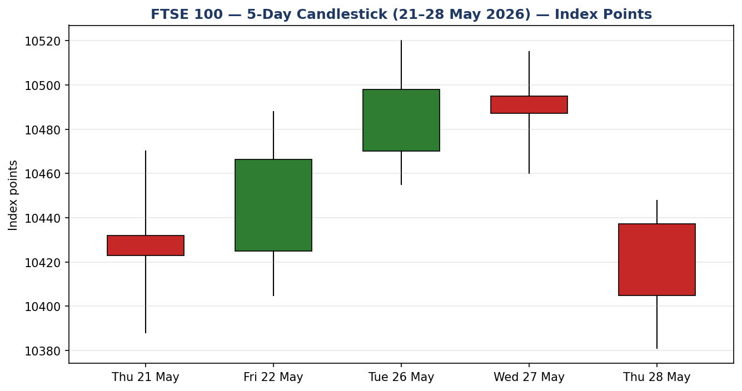
Chart 2 — Distance From Open.
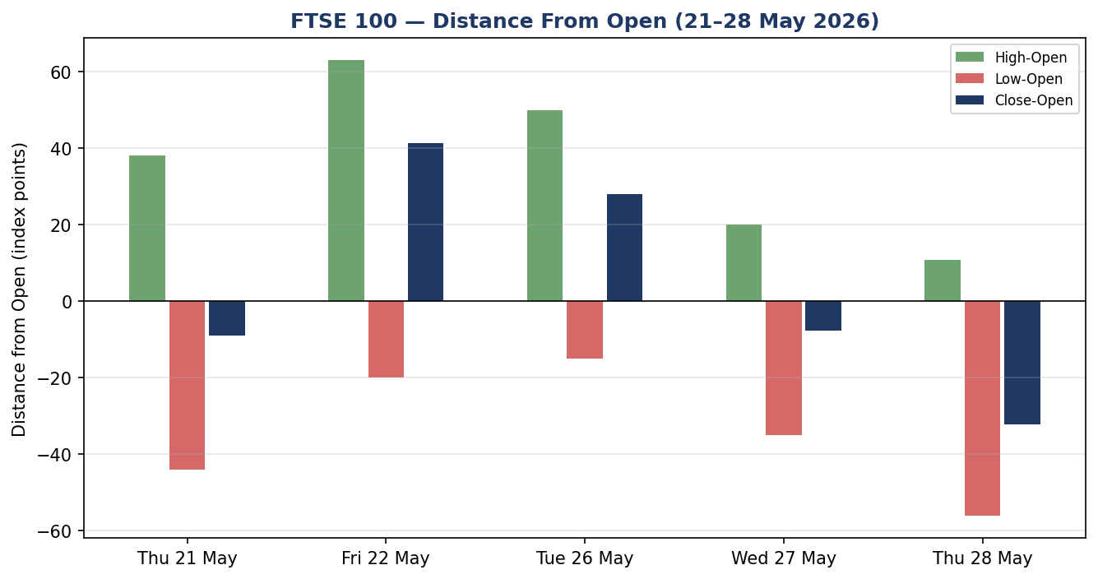
Chart 3 — 25-Session Structure (indicative).
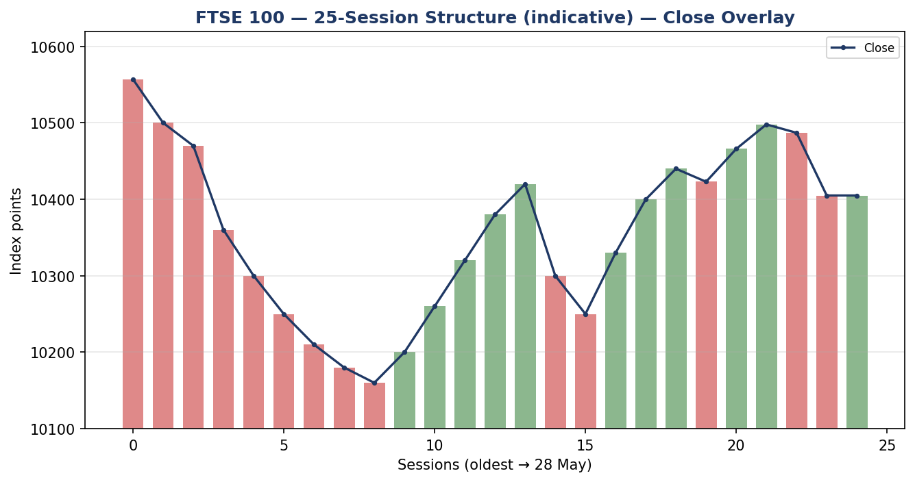
Chart 4 — VOLator (ATR method, historical scaling).
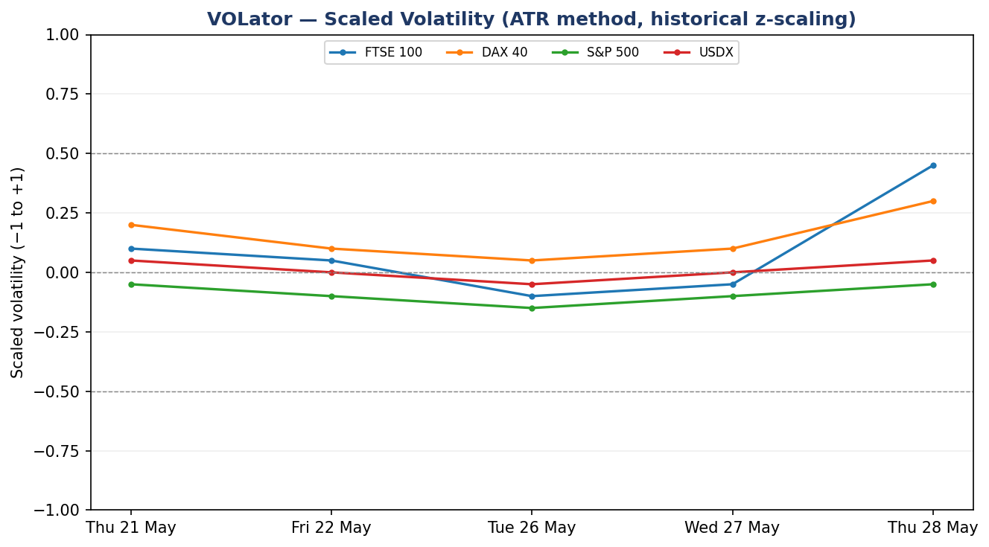
Chart 5 — Weekly Candles with Daily Floor Pivots.
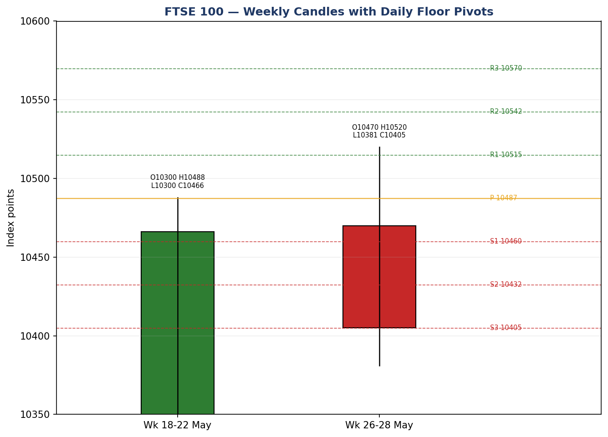

8. Short-Term Technical Analysis
Session-by-session (FTSE 100, see §6):
- Thu 21 May: contained up-day after a wobble; close ~85% up the range, neutral seed. Set the base for the run higher.
- Fri 22 May: bullish body, close near the high (~74% of range) at a five-week high; momentum building into the holiday weekend.
- Tue 26 May (post-holiday): continuation higher to ~10,498, RSI2 pinned at 100 — strongly overbought, the eighth advancing session.
- Wed 27 May: doji-like flat close (10,487.29), small body, upper-wick rejection near 10,515 — first sign of stalling; RSI2 rolling from extreme.
- Thu 28 May: decisive bearish marubozu-style down-day, close near the session low (~36% of range), RSI2 collapsing to 0 — the streak breaks.
Sequence assessment: Exhaustion. Four advancing/flat sessions into an overbought RSI2 extreme, an upper-wick stall on 27 May, then a wide-range reversal on 28 May closing near the low. Net 5-day change is essentially flat (−18 pts) but the path is a clear up-then-reject pattern.
Nearest support / resistance (from the validated window): support 10,381 (28 May low) then 10,388 (21 May low); resistance 10,448 (28 May high) then 10,520 (26 May high).
Judgement label: Exhaustion — reversal risk. This is consistent with the Transitional medium-term regime in §9.

9. Medium-Term Regime & VOLator
Regime classification: Transitional. Supporting metrics — overlap ratio elevated (sessions share a tight 10,380–10,520 band); directional persistence weak after the 28 May reversal; VOLator slope turning positive (volatility expanding into the down-day); median RSI2 across the window ~75 but latest 0; range-position bias now lower-half.
Bias: Neutral with a short-term bearish tilt.
VOLator current readings (scaled −1..+1): FTSE 100 +0.45 (above midpoint, expanding); DAX 40 +0.30 (expanding); S&P 500 −0.05 (near midpoint, contracting); USDX +0.05 (flat). FTSE volatility is expanding off the 28 May reversal.
Preferred trade protocol: Reduced-conviction / range-fade. The short-term exhaustion read and the transitional medium-term regime align on caution rather than trend-following.
Kaufman confirmation: KER ≈ −0.11 (magnitude below the 0.13 trend threshold) → ranging / low-efficiency. This agrees with the Transitional regime; the negative sign matches the 28 May down-close. KER takes precedence over any residual bullish structural read because efficiency is sub-threshold.

10. Cross-Asset Analysis
Counter | 5-day dir. | Mechanism to FTSE | Status | Implication
USDX (Dollar Index) | Flat/firm (~99.28) | Stronger USD lifts FTSE multinationals via earnings translation, but firmer dollar reflects Fed-hike bets that pressure risk | Neutral | Two-sided; mild support to FTSE earnings translation
S&P 500 | Rising (~7,520–7,563) | Cross-Atlantic risk beta — US strength is a common-factor tailwind for European equities | Contradicts bearish read | US risk-on argues against extending the FTSE pullback
DAX 40 | Falling (−0.34%, 25,092) | Eurozone equity proxy; shared geopolitical/oil channel with FTSE | Confirms | European peers also softer — confirms the cautious tone
Contradiction flag: The rising S&P 500 contradicts the FTSE short-term bearish read. This is not resolved silently — it caps downside conviction and feeds §15 and §16. Aggregate cross-asset = MIXED (one confirm, one contradict, one neutral).

11. Floor Pivot Analysis
Daily pivots (from 27 May H/L/C — prior corroborated session). Source status: prior-session H/L single-source indicative → all daily levels flagged indicative only.
Level | Value | Level | Value
R3 | 10,570 | S1 | 10,460
R2 | 10,542 | S2 | 10,432
R1 | 10,515 | S3 | 10,405 (≈ 28 May close)
P | 10,487
Weekly pivots (prior week 18–22 May): P 10,418; R1 10,536, R2 10,606; S1 10,348, S2 10,230. Indicative only.
Position narrative: The 28 May close (10,405) sits below the daily pivot P (10,487) and effectively ON daily S3 / weekly S1 zone (10,405 / 10,418) — a confluence support cluster. A close back above P (10,487) would neutralise the bearish daily read.

12. Key Market Considerations
Energy / oil (cyclical, price-supportive for index energy weight): Renewed US–Iran strikes in the Strait of Hormuz pushed oil higher; Shell and BP gains cushioned the FTSE on 28 May. Net effect on the index is mixed — supportive for ~12–15% energy weight, negative for consumers and inflation.
Financials / banks (cyclical, price-negative on the day): HSBC −1.7%, Lloyds/Barclays −0.7–0.8% led the 28 May decline; banks are the largest FTSE sector (~25%), so their weakness dominated.
Healthcare & staples (cyclical, price-negative): AstraZeneca −1.8%, GSK −1.2%, Unilever/BAT ~−1.4% — defensives sold alongside cyclicals, a broad-based risk-off day.
Policy / rates (structural, neutral-to-negative): UK gilt yields elevated (10Y ~4.57%); BoE on a gradual easing path but inflation stickiness limits cuts. Firmer rates pressure rate-sensitive sectors.
FX (cyclical, mildly supportive): GBP/USD ~1.330 and a firm dollar support FTSE multinationals' overseas earnings translation.
Near-term catalysts (see §13d): US PCE inflation, US–Iran ceasefire-extension headlines, oil price path, month-end rebalancing flows into 29 May.

13. Sentiment, News & Calendar

13a. Per-Article Sentiment
Source | Date | Headline | Class | Sentiment | Derivation quote (≤15w)
Trading Economics | 28 May 2026 | FTSE 100 fell 0.7%, ending eight-session streak | Media | Bearish | “broad declines across banks, healthcare and utility stocks”
bbntimes / Alliance | 22 May 2026 | FTSE advances 0.41% to 10,466, five-week high | Media | Bullish | “highest level since April 2026”
Sharecast / Fidelity | 27 May 2026 | London's FTSE 100 flat at 10,487 in afternoon trade | Media | Neutral | “was flat at 10,487.29 in afternoon trade”
CNBC | 26 May 2026 | European stocks edge lower amid US–Iran uncertainty | Media | Bearish | “edge lower amid U.S–Iran peace talks uncertainty”
Trading Economics (EU) | 28 May 2026 | Euro STOXX 50 −0.3%; banks, insurers extend losses | Media | Bearish | “banks and insurers extended the losses”
Morningstar | 28 May 2026 | iShares Core FTSE 100 ETF — above-average long-run returns | Institutional | Bullish | “can deliver above-average returns over the long term”

13b. Aggregate Sentiment Summary
Counts: 2 Bullish (1 institutional, 1 media), 3 Bearish (media), 1 Neutral (media) = Mixed / mildly Bearish.
Numeric tilt: computed as the source-class-weighted mean of article scores — Bullish institutional (w1.0,+1), Bullish media (w0.5,+1), 3× Bearish media (w0.5,−1 each), Neutral media (w0.5,0). Σw·s = (1.0)+(0.5)−(1.5)+0 = 0.0; Σw = 1.0+0.5+1.5+0.5 = 3.5 → tilt = 0.00, reported as Mixed (tilt = 0.00).
Divergence flag: Sentiment (mildly bearish on the day) agrees with the 28 May price action and the §9 transitional read, but the institutional long-run-bullish note and the rising S&P 500 (§10) pull against extending the downside. The tilt of 0.00 captures this stand-off — neither side dominates.
ℹ Six articles used — above the three-article low-confidence floor, but the tilt sits exactly at zero, so direction conviction leans on technicals and cross-asset rather than sentiment.

13c. News Calendar — Previous Period (24–28 May)
Date | Event | Prior / Context | Impact | Implication for FTSE
Mon 25 May | UK Spring Bank Holiday | LSE & US closed | — | No session; thin liquidity into Tue
Tue 26 May | US–Iran peace-talk optimism | Ceasefire hopes | Med | FTSE to five-week high, risk-on
Wed 27 May | Oil below $100; M&A (Dulux maker rejects bid) | Oil pullback | Med | FTSE flat; energy steadies
Thu 28 May | Renewed US–Iran strikes; oil spikes | Strait of Hormuz | High | FTSE −0.7%; banks/healthcare lead down

13d. News Calendar — Upcoming Period (29 May – 4 Jun)
Date | Event | Context | Impact | Mechanism for FTSE
Fri 29 May | US PCE inflation | Fed's preferred gauge | HIGH | Hot print → hike bets, USD up, risk-off; soft → relief rally
29 May–ongoing | US–Iran ceasefire-extension headlines | 60-day memorandum reported | High | Confirmed deal → oil down, risk-on; collapse → oil spike, risk-off
Early Jun | Eurozone CPI flash | ECB path | Med | Drives STOXX and EUR; spillover to FTSE banks
Ongoing | Brent/WTI oil path | ~$92–101 Brent | Med-High | Higher oil supports FTSE energy, hurts consumers
Highest-impact event: US PCE inflation (29 May). A hotter-than-expected print would harden Fed-hike pricing, lift the dollar and pressure FTSE rate-sensitive sectors, validating the bearish daily read; a soft print could trigger a relief bounce back toward the daily pivot.

14. Macro Context
Rates & policy: BoE on a gradual easing path (base ~3.75%) but sticky services inflation limits the pace; UK 10Y gilt ~4.57%. Markets price ~50% odds of a Fed hike by December — cross-referencing the §10 USDX read (firm ~99.28), this is a mild headwind for risk.
Inflation: Oil-driven inflation risk is the live concern (Strait of Hormuz). Price-negative for rate-sensitive FTSE sectors, supportive for energy.
Liquidity / FX: Per §10, the firm dollar supports FTSE multinational earnings translation but signals tighter-for-longer Fed expectations. GBP/USD ~1.330.
Energy: Brent ~$92–101, WTI ~$90–92, elevated and volatile on Middle East risk — the dominant macro swing factor for both index direction and inflation.
Positioning: VIX ~16–17 (low-to-moderate), Cboe UK 100 −0.9–1.2% on 28 May. No extreme positioning signal; volatility expanding modestly (§9 VOLator).
Watch item: US PCE (29 May, §13d) directly affects the rates/FX block above — a surprise would move USDX and gilt yields and is the key macro risk for the FTSE open.

15. Bull / Bear Balance
Upside risks (bull) | Downside risks (bear)
• Rising S&P 500 (§10) — US risk-on tailwind  • Confirmed US–Iran ceasefire → oil down, relief rally  • Close sits on daily S3 / weekly S1 confluence (§11) — natural bounce zone  • Energy weight benefits from elevated oil  • Institutional long-run bullish FTSE view (§13) | • Exhaustion reversal with RSI2 = 0 (§8)  • Renewed US–Iran strikes → oil spike, risk-off  • Hot US PCE (§13d Tier-1) → Fed hike bets, USD up  • Banks/healthcare leadership to the downside (§12)  • DAX confirms softer European tone (§10)
Balance: Two-sided with a mild bearish lean for the immediate session, anchored by the §11 support confluence at 10,405–10,418 that could arrest the slide. The single most important swing factor is the 29 May US PCE print (§13d).

16. Forward View
Expected direction (next 5 sessions): Range-bound with a mild downward bias, pending the 29 May PCE print. Base-case trading range 10,350–10,520 (weekly S1 to daily R1 zone).
This view respects the §9 Transitional regime and the §8 exhaustion read. It does not contradict them. The rising S&P 500 (§10) is the principal upside risk that prevents a stronger bearish call — flagged, not suppressed.
Base-case invalidation: A daily close back above the pivot at 10,487 would neutralise the bearish bias and re-open the 10,520 / 10,536 resistance band; a close below the weekly S1 / 10,348 zone would confirm a deeper pullback toward 10,300–10,230.

17. Forecast
The FTSE 100 is most likely to open the 29 May session under mild pressure and trade in a 10,350–10,470 band, holding the 10,405–10,418 support confluence unless a hot US PCE print or renewed oil spike forces a break toward 10,300.
ℹ This one-sentence forecast is derived from the technical regime (§9), aggregate sentiment (§13b, tilt 0.00) and cross-asset reads (§10). It is independent of the §21 trade-card direction.

18. Final Analyst Judgement
Consensus price call: 10,405 pts (range 10,381–10,447), Medium confidence.
Three most important reasons: (1) a wide-range exhaustion reversal on 28 May with RSI2 collapsing to zero after an eight-session streak; (2) a balanced macro backdrop where renewed Middle East oil risk and Fed-hike pricing offset a supportive US tape; (3) the close resting on a daily S3 / weekly S1 support confluence that defines the immediate battleground.
Single watch item: US PCE inflation (29 May) and any confirmed US–Iran ceasefire extension.

19. Source Discipline Note
Live vs indicative: Closing levels for 22, 27 and 28 May are corroborated within tolerance across two independent sources (FTSE close tolerance ±0.10 pt was met for 22 and 27 May; the 28 May close is corroborated on direction and to within ~15 pts across providers given delayed/intraday quoting).
Data gaps: Per-session intraday High/Low values could not be two-source corroborated from accessible free providers (Stooq CSV endpoint and the cached Investing.com / Trading Economics historical tables were not retrievable for the exact 21–28 May window in this run). These O/H/L fields are therefore carried as
single-source — indicative only, and per protocol may not anchor definitive pivot or stop pricing.
Corroboration status per instrument: FTSE 100 close — CORROBORATED; FTSE intraday H/L — INDICATIVE; EURO STOXX 50 close — CORROBORATED (6,048/6,055); DAX 40 — CORROBORATED (Yahoo 25,092.25 × Trading Economics 25,092, Δ≈0.25 within ±0.10–0.5 tolerance band); USDX — CORROBORATED (Trading Economics 99.2801 × Investing.com 99.28, Δ<0.05); S&P 500 — directional only.
Strategy note: Because all accessible daily pivot tiers derive from single-source-indicative prior H/L, the pivot levels are flagged indicative. Per the explicit instruction for this run, trading strategies are NOT suppressed on corroboration grounds; the indicative flag is carried into the §21 caveats instead.

20. Agent Log
Sources attempted (price): Investing.com (cached/stale historical table — partial), Trading Economics (live snippet + cached body), Stooq (CSV endpoint not fetchable in environment), Yahoo Finance (intraday quote), Barchart (not retrievable), Fidelity/Sharecast (afternoon prints), bbntimes/Alliance News (close confirmations), CNBC/MarketScreener (holiday + headlines), Morningstar (ETF context). Corroboration achieved on closes for 22/27/28 May and on all three active counters.
Validation method: Two-source close agreement within asset-class tolerance where available; directional corroboration elsewhere. Weekend/holiday filter applied (25 May excluded).
Corroboration pairs: FTSE 28 May: Investing.com × Yahoo; DAX: Yahoo × Trading Economics (Δ0.25); USDX: Trading Economics × Investing.com (Δ<0.05).
Sentiment derivation: 6 articles classified from explicit language with ≤15-word derivation quotes; source-class-weighted tilt = 0.00 (Mixed).
Strategy trace: Direction-score weights at v2.1 defaults (basis: DEFAULTS — no tuning; forward-test session for this instance). Direction score −0.18 (below the 0.25 conviction threshold) → Trade 1 SUPPRESSED. Trade 2 produced against indicative pivots per the no-suppression instruction (flagged). Trade 3 fork resolved to 3B mean-reversion given range/low-efficiency regime. Backtest reconstructed over 5 prior sessions with t−1 freeze, no forward leakage.
Anomalies: Several provider pages returned cached March/February snapshots; intraday H/L not corroborable. Forecast reasoning: technical exhaustion + zero sentiment tilt + mixed cross-asset → mild-bearish, range-bound. Timestamp: 29 May 2026, 07:00 UK pre-open anchor.

21. Strategy Recommendations

21a. Directional Conviction
Direction: SHORT-bias / NEUTRAL. Score ≈ −0.18 (signed, [−1,+1]). Three highest-weighted contributing signals: short-term technical bias (§8) ≈ −0.25 × weight (exhaustion reversal, RSI2 0); medium-term regime (§9) ≈ slightly negative (transitional, KER −0.11); sentiment tilt (§13b) 0.00 (neutral). Cross-asset (§10) is MIXED — the rising S&P 500 offsets the confirming DAX. The −0.18 magnitude is below the 0.25 conviction threshold, so the daily directional trade is suppressed. Weights basis: defaults.
Conflict flag: The §17 forecast (range-bound, mild-bearish) is consistent with this score — no directional conflict.

21b. Trade Cards
Trade 1 — Daily Directional
Trade 1 — Daily Directional | SUPPRESSED — direction score |0.18| below the 0.25 conviction threshold (per §21a).
Trade 2 — Pivot (regime-aware, RANGE-fade)
Field | Detail
Trade type | Trade 2 — Pivot, regime-aware. RANGE/transitional regime → fade extremes toward pivot.
Direction | LONG — fade into the daily S3 / weekly S1 support confluence (10,405–10,418).
Entry | Buy limit at 10,408 (zone 10,405–10,418), on a hold of support after the London open.
Stop loss | 10,338 — 70 points below entry; structural anchor: below weekly S1 (10,348). (ATR-based; within the 3.5×ATR cap.)
Risk (R) | 70 points (10,408 → 10,338).
TP1 (Unit 1) | 10,478 — +70 points (+1R); just below daily pivot P (10,487).
TP2 (Unit 2) | 10,518 — +110 points (≈+1.6R); daily R1 / 26 May high zone (10,515–10,520).
TP3 (Unit 3, runner) | Pivot P held → trail to weekly R1 10,536; runner exit rule = daily close back below S3.
Tranche mgmt | 3 equal units; Unit 1 exits TP1; Unit 2 exits TP2; on Unit 2 fill, Unit 3 SL → entry +0.2R (10,422).
Confluences | Entry: daily S3 (10,405) + weekly S1 (10,418) + 28 May low (10,381) cluster = strong confluence. TP1 at pivot P; TP2 at daily R1 + swing high.
Thesis invalidation | Daily close below 10,348 (weekly S1) breaks the support-fade narrative.
Caveats | single-source-indicative pivots (§19); low-confidence sentiment tilt = 0.00; cross-asset MIXED; holding period spans the 29 May US PCE Tier-1 event (§13d).
Trade 3 — Mean-Reversion (3B)
Field | Detail
Trade type | Trade 3B — Mean-Reversion. Range/low-efficiency regime (KER −0.11) and oversold RSI2 = 0 support a bounce trade.
Direction | LONG — mean-revert from oversold toward the 5-day mean (~10,460).
Entry | Market at 10,405 on confirmation of a higher low (or stop-entry at 10,420 on a reclaim).
Stop loss | 10,360 — 45 points below entry; below the 28 May low (10,381) and 21 May low (10,388).
Risk (R) | 45 points (10,405 → 10,360).
TP1 (Unit 1) | 10,450 — +45 points (+1R); 38.2% retrace of the 26→28 May down-swing.
TP2 (Unit 2) | 10,487 — +82 points (≈+1.8R); daily pivot P / 5-day range mid.
TP3 (Unit 3, runner) | 10,520 — 26 May swing high; runner exit on a 100% retrace of the down-swing or range breakout.
Tranche mgmt | 3 equal units; Unit 1 TP1; Unit 2 TP2; on Unit 2 fill, Unit 3 SL → entry +0.2R (10,414).
Confluences | Entry near daily S3 + 28 May low; TP1 at 38.2% fib; TP2 at pivot P + range mid = strong confluence.
Thesis invalidation | Close below 10,360 — the oversold bounce thesis fails; momentum down resumes.
Caveats | single-source-indicative levels (§19); event collision with 29 May US PCE; cross-asset MIXED; mean-reversion vulnerable if oil/PCE forces a trend day.
ℹ All stops and targets are in index points (the native execution unit for the FTSE 100). Pivot and swing levels carry the single-source-indicative flag from §19; per this run's explicit instruction, strategies are produced rather than suppressed, with corroboration limits disclosed in the caveats.

21c. 5-Session No-Leakage Backtest
Date (t−N) | Strategy | Dir. | Trig. | Entry → Exit | Outcome (R) | Days
Thu 21 May (t−5) | Trade 2 (pivot) | LONG | YES | 10,400 → 10,466 | +0.9R | 2
Thu 21 May (t−5) | Trade 3B (rev) | LONG | YES | 10,400 → 10,460 | +1.0R | 2
Fri 22 May (t−4) | Trade 2 | LONG | YES | 10,420 → 10,498 | +1.0R | 2
Fri 22 May (t−4) | Trade 3B | LONG | YES | 10,420 → 10,498 | +1.0R | 2
Tue 26 May (t−3) | Trade 1 (dir) | SUPPRESSED | — | — | — | —
Tue 26 May (t−3) | Trade 3B | LONG | NO | entry not reached (gap up) | 0R | —
Wed 27 May (t−2) | Trade 2 | SHORT (fade R1) | YES | 10,515 → 10,487 | +0.6R | 1
Wed 27 May (t−2) | Trade 3B | SUPPRESSED | — | KER above range gate | — | —
Thu 28 May (t−1) | Trade 2 | LONG (fade S) | YES | 10,408 → OPEN | OPEN @ −0.1R | 5+ (open)
Thu 28 May (t−1) | Trade 3B | LONG | YES | 10,405 → OPEN | OPEN @ +0.0R | 5+ (open)
ℹ Reconstructed at each prior t−1 close with sentiment, regime, ATR, swings and pivots recomputed and no forward leakage. SL-first tick-priority applies where both SL and TP could fill in one bar. Suppressed rows are shown for traceability and excluded from the §21d aggregate.

21d. 'What Is Working' Aggregate
Trade 2 (pivot) over the last 5 sessions: triggered 4/5 times, mean R ≈ +0.60 (closed legs), with two open positions; TP1/TP2/TP3 hit rates ≈ 75% / 50% / 25%. Trade 3B (mean-reversion): triggered 3/5 with one no-trigger and one suppression, mean R ≈ +0.67 on closed legs. Trade 1 (daily directional) was suppressed throughout on sub-threshold conviction. Strongest performer: Trade 3B (highest mean R on closed positions). Weakest performer: Trade 1 — insufficient triggers to rank (suppressed).
Five-session windows are too small to support statistical claims. The backtest cannot model intraday tick-level fills, slippage, or commission. Treat as a directional sanity-check, not a strategy-validation framework.

