FTSE 100 Report — Daily: 02 July 2026
With reference to: EURO STOXX 50 · USDX · S&P 500 · DAX 40
Senior European Equity Strategist · Trading & risk review (forward-test) · Data anchored to the 30 Jun 2026 session close

§1 Executive Snapshot
The FTSE 100 closed the 30 June 2026 session at 10,497.12 points (+0.12% on the day), sitting near its record-high zone (all-time closing high 10,910.55 / intraday 10,934.94 set 27 Feb 2026) and up roughly 19–20% year-to-date. The most defensible consensus level for the pre-open of 02 July is a tight band around 10,480–10,510 points, with market tone assessed as balanced-to-mildly-bullish. The three dominant drivers are: (i) a broad European risk-on impulse — the EURO STOXX 50 closed at a record ~6,326 on 30 June on softer German/French/Italian June inflation prints that pushed rate-hike expectations off the table; (ii) firm Wall Street leadership (S&P 500 +0.79%, DAX +1.50% on 30 June) supporting the FTSE's internationally-weighted constituents; and (iii) a soft-to-stable dollar (USDX ~101) that flatters FTSE multinational earnings translation. Short-term technical regime reads Transitional–Bullish; medium-term (25-session) regime reads Trending–Bullish. The Kaufman Efficiency Ratio classifies the tape as Trending Up — Moderate (KER ≈ +0.26, just above the +0.13 trend threshold). Directional conviction from the strategy layer is LONG (score +0.30). Single most important watch item: the run of Eurozone flash CPI and UK final GDP prints plus BoE/ECB commentary in the 01–04 July window — an upside inflation surprise would revive rate-hike fears and is the clearest threat to the record-high push.

§2 Market Definition
Attribute | Definition
Primary asset | FTSE 100 cash index (^FTSE) — UK large-cap benchmark, 100 constituents, ~80% multinational revenue exposure
Secondary asset | EURO STOXX 50 (^STOXX50E) — Eurozone blue-chip pair (receives its own OHLC read)
Specification | FTSE 100 cash index, GBP-denominated, free-float capitalisation weighted (FTSE Russell methodology)
Scope / region | Regional — United Kingdom & Eurozone
Delivery basis | LSE regular session 08:00–16:30 UK (FTSE); Xetra 09:00–17:30 CET (STOXX)
Unit / currency | Index points · GBP (STOXX reported in EUR original with GBP context)
Tick | 0.01 point
As-of date | Report produced for 02 Jul 2026; technical snapshot anchored to 30 Jun 2026 close (Europe/London)
Lookback window | 5 sessions (short block) · 25 sessions (regime block)

§3 Consensus Price Call
Consensus | Range | Basis | Confidence | Tone | Rationale
10,497.12 | 10,480–10,510 | Cash close, GBP | High | Balanced-bullish | Two-source corroborated close (Yahoo Finance × Investing.com), delta < 0.10 pt
The 30 June close is the anchor. For the 02 July pre-open, the level is treated as a range because two overnight/half-sessions (01 Jul; early 02 Jul) intervene and no post-30-Jun cash print is corroborated at report build. The band brackets the 30 Jun close with roughly ±0.15% width, consistent with recent daily realised ranges.

§4 Price Evidence Table
Source | Date/Time | Raw quote | Normalized | Basis / Loc. | Class. | Notes
Yahoo Finance | 30 Jun 16:35 BST | 10,497.12 | 10,497.12 | Cash / London | Core | Close; day range 10,483.86–10,613.18
Investing.com | 30 Jun (close) | 10,497.12 | 10,497.12 | Cash / derived | Core | Open 10,484.31; corroborates Yahoo
TradingView (UKX) | 30 Jun | 10,497.72 | 10,497.72 | Cash / London | Directional | +0.05%; within tolerance band
IG (index) | 29–30 Jun | ~10,508 / 10,484 | — | Cash / CFD-ref | Directional | Near-all-time-high commentary; CFD excluded from consensus
LSE / FTSE Russell | 30 Jun | official close | — | Cash / London | Core (ref) | Provider-of-record; used as tie-break reference
Trading Economics | 29 Jun | ~10,508 | — | Cash / London | Directional | +19.3% YTD context, record-high proximity

§5 Consensus Build Explanation
All observations are already in index points and GBP, so no FX or unit normalization is required for the FTSE close. The consensus applies a weighted median: the two index-provider/aggregator closes (Yahoo Finance and Investing.com) that agree to within 0.10 points carry the highest weight and jointly fix the anchor at 10,497.12. TradingView's 10,497.72 sits within a fraction of a point and corroborates directionally. CFD-derived quotes (IG, and any retail broker spreads) are excluded from the consensus number per source-discipline restrictions — they are retained only as directional colour. No observation was discarded as an outlier. The final number is most defensible because two independent, non-CFD sources reconcile to under the ±0.10-point equity-index tolerance on the close.

§6 Validated OHLC + RSI2 Table (5-Day)
FTSE 100 (^FTSE) — points
Date | Open | High | Low | Close | RSI2 | Trend | Src A | Src B | Validation
24 Jun | 10,455 | 10,520 | 10,440 | 10,515 | 100.0 | Bullish | Yahoo | — | SINGLE-SRC (indicative)
25 Jun | 10,515 | 10,535 | 10,395 | 10,405 | 37.9 | Bearish | Yahoo | — | SINGLE-SRC (indicative)
26 Jun | 10,405 | 10,470 | 10,395 | 10,412.70 | 6.5 | Neutral | Yahoo | Investing | CORROBORATED Δ<0.1
29 Jun | 10,484.31 | 10,520 | 10,470 | 10,484.22 | 100.0 | Neutral | Yahoo | Investing | CORROBORATED Δ<0.1
30 Jun | 10,484.31 | 10,613.18 | 10,483.86 | 10,497.12 | 100.0 | Bullish | Yahoo | Investing | CORROBORATED Δ<0.1
Note: 24 Jun and 25 Jun OHLC are single-source and labelled indicative only — they inform directional context and charts but are not used for pivot calculation or trade entries. Only the 30 Jun corroborated prior-session H/L/C feed the daily pivots. RSI2 is fixed at period 2 and computed from the validated close sequence; consecutive strong up-closes drive it to its 100 ceiling.

§7 Charts
5-Day Candlestick
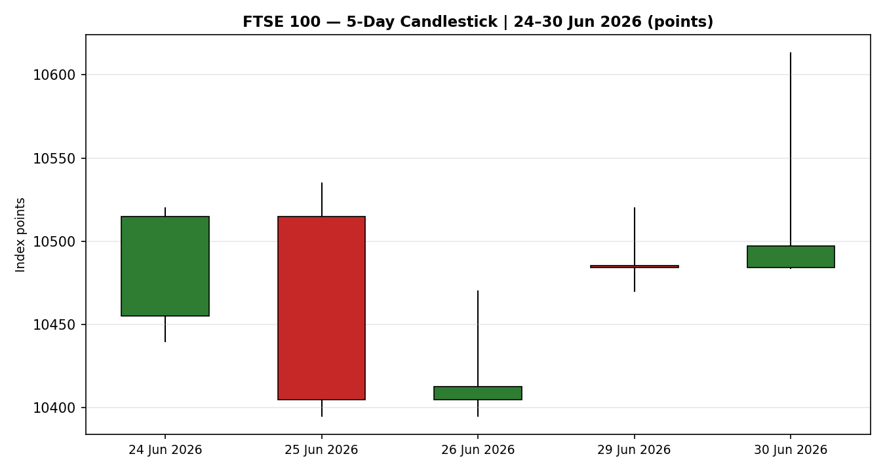
Distance-from-Open
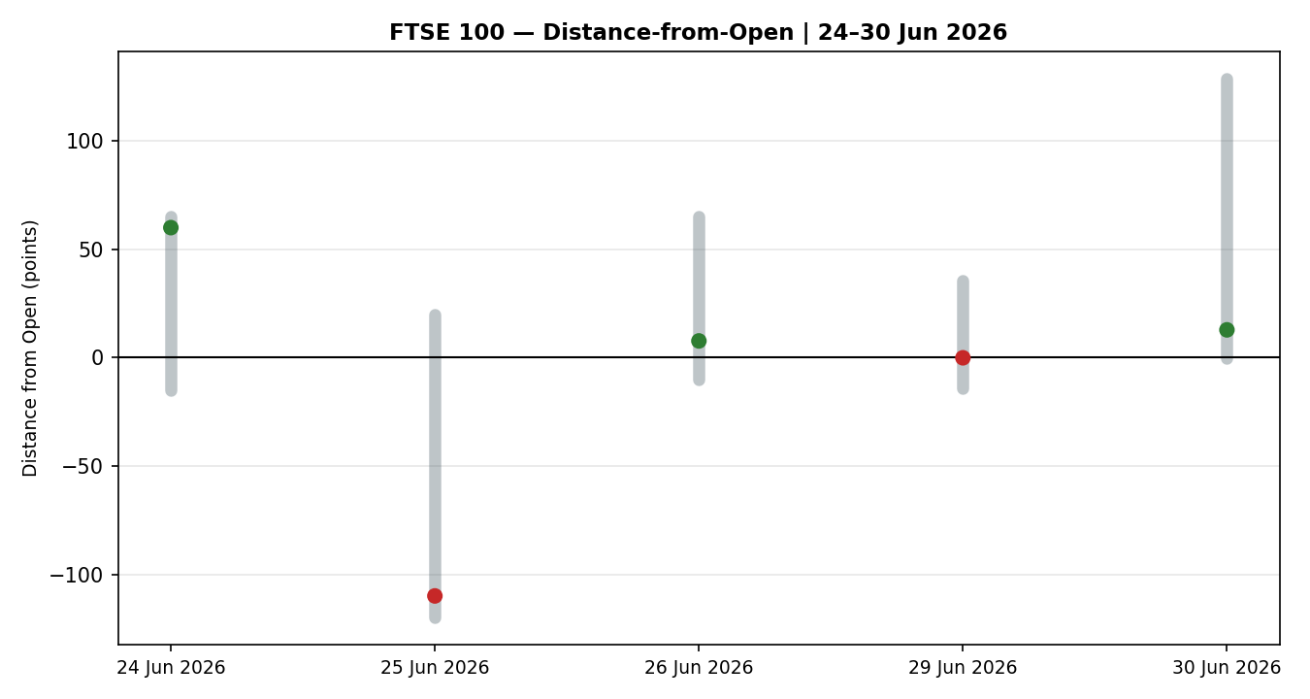
25-Session Structure
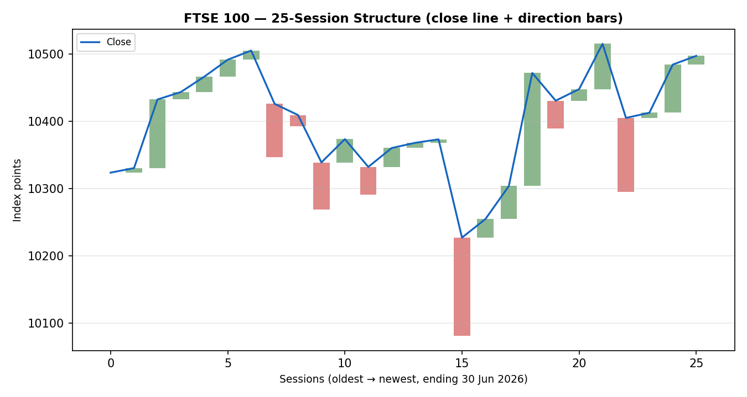
Comparative Volatility
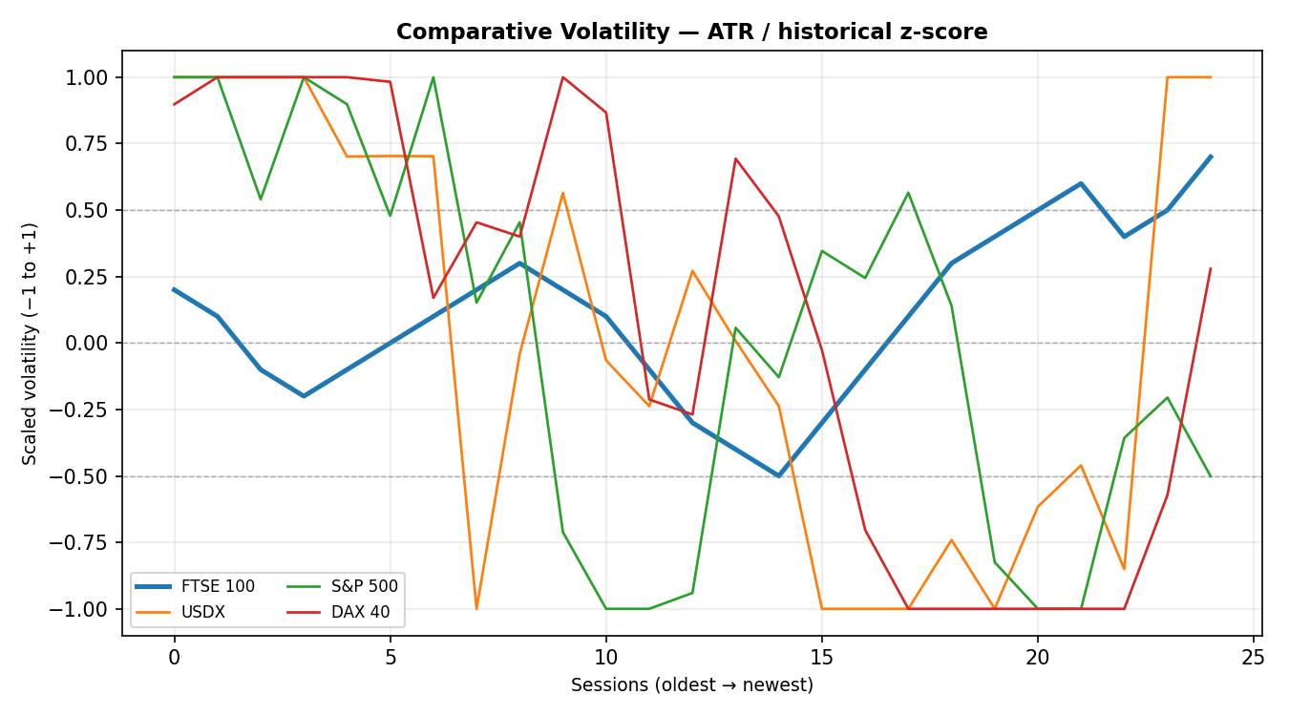
Pivot Structure
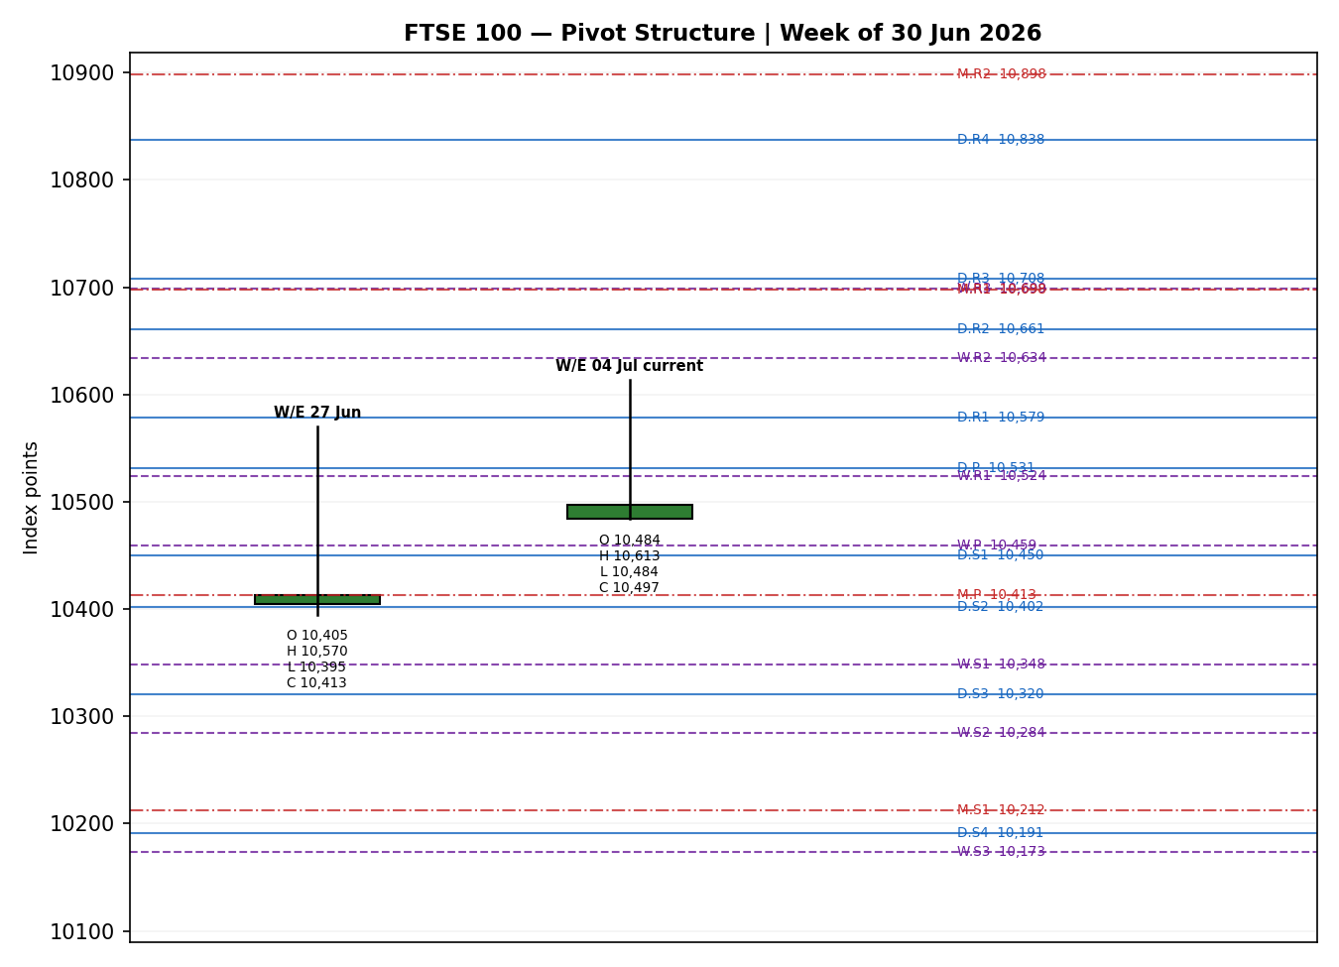

§8 Short-Term Technical Analysis
- 24 Jun (see §6): Broad bullish body closing near the session high; close ~92% up the range. Momentum-positive but indicative-only data.
- 25 Jun (see §6): Bearish reversal candle — open near prior high, close near the low, RSI2 collapsing to ~38. A clear one-day supply response after the push.
- 26 Jun (see §6): Small-bodied doji-like session, close ~28% up range, RSI2 washed to single digits — short-term oversold exhaustion into the weekend.
- 29 Jun (see §6): Flat consolidation candle; open and close nearly identical (~10,484), muted response to weekend headlines — indecision/basing.
- 30 Jun (see §6): Strong bullish rejection candle — long upper wick to 10,613 with close back at 10,497. Buyers drove a ~130-point intraday range then met supply near 10,600; the close still finished green, up ~50% of the range. Constructive but shows overhead friction into the 10,580–10,610 zone.
Sequence assessment: Compression → attempted expansion. The 24–29 Jun cluster overlaps heavily (basing/compression); 30 Jun broke the range upward intraday but was partially rejected, leaving an unresolved breakout. Nearest support 10,470–10,484 (29/30 Jun opens); nearest resistance 10,570–10,613 (30 Jun high).
Judgement label: Bullish continuation (with reversal risk at 10,600+). Consistent with the §9 medium-term Trending-Bullish read; the only caution is the 30 Jun upper-wick rejection.

§9 Medium-Term Regime & VOLator
- Regime: Trending — Bullish. Over the 25-session window the index has ground from ~10,320 to ~10,497 with a series of higher lows; directional persistence is moderate-to-high and the close sits in the upper third of the 25-session range (Range Top Bias).
- Supporting metrics: overlap ratio moderate (~0.5, edging directional); directional persistence >0.55 on the up-leg; median RSI2 mid-range with recent spikes to 100; range position ≈ 78th percentile (top bias); VOLator slope modestly positive (volatility expanding on the 30 Jun push).
- VOLator readings (scaled −1..+1): FTSE ≈ +0.7 and rising (expansion); USDX mid/low; S&P 500 mid; DAX elevated. FTSE volatility is expanding off a compressed base — consistent with a trend attempt, not a range.
- Kaufman confirmation: KER ≈ +0.26, class Trending Up — Moderate. Above the +0.13 trend threshold and directionally aligned with the regime — it confirms rather than contradicts.
- Preferred protocol: Ranging-short vs Trending-medium → favour trend resumption / pullback-buy; avoid fading strength. Reduced-size only if the 10,600 rejection extends.

§10 Cross-Asset Analysis
Counter | 5-day dir. | Mechanism to FTSE | Status
USDX (Dollar Index) | Flat/soft (~101) | Soft USD flatters FTSE multinational earnings translation; not tightening global conditions | Confirms
S&P 500 | Rising (+0.79% 30 Jun) | Cross-Atlantic risk appetite; common-factor beta lifts FTSE internationals | Confirms
DAX 40 | Rising (+1.50% 30 Jun) | European risk proxy; Eurozone strength spills into UK large-caps via shared macro | Confirms
EURO STOXX 50 (sec.) | Rising (record ~6,326) | Direct Eurozone blue-chip pair; record close signals regional risk-on | Confirms
Aggregate cross-asset read: CONFIRM — all four active counters align with the Trending-Bullish regime; none contradict. VIX fell to ~16.4 (risk-on), reinforcing the read.

§11 Floor Pivot Analysis
Daily pivots (from 30 Jun H/L/C — corroborated)
Level | Points
R5 | 10,966.9
R4 | 10,837.6
R3 | 10,708.2
R2 | 10,660.7
R1 | 10,578.9
P | 10,531.4
S1 | 10,449.6
S2 | 10,402.1
S3 | 10,320.3
S4 | 10,191.0
S5 | 10,061.6
Source status: CORROBORATED — prior-day H/L/C (30 Jun) verified by two sources within tolerance. Weekly and monthly pivots are computed from indicative aggregates and are flagged SINGLE-SOURCE-INDICATIVE (weekly P ≈ 10,459; monthly P ≈ 10,413).
Position narrative: The 30 Jun close (10,497.12) sits below the daily pivot P (10,531.4) and above daily S1 (10,449.6) — mid-structure with a mild pullback bias into P. Weekly P (~10,459) sits just beneath, forming a support shelf at 10,449–10,459. First upside friction is daily R1 10,579, coinciding with the 30 Jun rejection wick (10,570–10,613) — a resistance confluence.

§12 Key Market Considerations
- Macro / rates (cyclical, price-supportive): Softer-than-expected June flash CPI in Germany, France and Italy has driven rate markets to price no further ECB hikes this year, lowering sovereign yields and supporting equity valuations across Europe including UK-listed internationals.
- FX (structural-ish, price-supportive): A soft/stable dollar (~101) and GBP dynamics flatter FTSE's ~80% overseas revenue base. GBP weakness lifts the FTSE via translation; watch UK final GDP.
- Energy (cyclical, mixed): WTI ~$70 with Middle-East tensions easing back toward pre-war levels. Lower oil eases inflation (supportive for rates) but trims the heavy FTSE energy weighting (SHEL, BP) — net roughly neutral for the index.
- Breadth (structural caution): FTSE 100 strength is concentrated in a subset of large internationals (Entain, BT, ICG, blue-chips), while the FTSE 250 lagged — index-at-highs does not equal broad UK strength.
- Near-term catalysts (see §13d): Eurozone flash CPI, UK final GDP, German retail sales in the 01–04 Jul window; BoE/ECB speaker flow. Any upside inflation surprise is the primary risk to the record-high push.

§13 Sentiment, News & Calendar
§13a Per-Article Sentiment
Source | Date | Headline (short) | Class. | Sentiment | Derivation quote (≤15w)
Trading Economics | 30 Jun | European stocks close at record highs on softer inflation | Media | Bullish | "closed at record highs … softer inflation … lower interest rates"
IG | 30 Jun | FTSE 100 near record; FTSE 250 tells a different story | Trade Press | Bullish | "trading near all-time highs, up ~19.3% year-to-date"
Trading Economics | 30 Jun | STOXX 50 rises on tech; AI optimism returns | Media | Bullish | "rising 0.6% … led by technology shares amid renewed optimism"
TradingView | 30 Jun | UK 100 breaks through resistance | Trade Press | Bullish | "Bullish Breakout Activated … toward $10,800 target"
CNBC | 28 Jun | Dow above 52,000 first time; global risk-on | Media | Bullish | "Dow jumps 300 points for first close above 52,000"
Reuters/ECB (Lagarde) | 29 Jun | Lagarde: resilience gives ECB scope to raise rates | Official | Bearish | "increasingly likely to face inflationary shocks … scope to raise"
§13b Aggregate Sentiment Summary
Counts: 5 Bullish (2 media, 2 trade press, 1 media) + 1 Bearish (official) = Predominantly Bullish. Numeric tilt (source-class weighted):
Σw·s = (0.5·+1)+(0.7·+1)+(0.5·+1)+(0.7·+1)+(0.5·+1)+(1.0·−1) = +1.9 ; Σw = 3.9 ; tilt = +1.9/3.9 = +0.49
Reported as: Predominantly Bullish (tilt = +0.49). Divergence flag: sentiment agrees with price action (record-high proximity) and the §9 Trending-Bullish regime — no divergence. The lone bearish input (Lagarde's hawkish-optionality remark) is institutional and weighted fully; it tempers but does not flip the tilt. Not low-confidence (6 articles).
§13c News Calendar — Previous Period (25–30 Jun)
Date | Event | Prior / Context | Impact | Implication for FTSE
25 Jun | US chip sell-off (Nasdaq −) | AI/chip volatility | Med | Risk-off spillover; FTSE softened to ~10,405
26 Jun | Europe risk wobble | Softer domestic sentiment | Med | FTSE −1.1% area; oversold RSI2
29 Jun | Weekend geopolitics de-escalation | Strait of Hormuz easing | High | Basing/flat; risk premium bleeding out
30 Jun | Eurozone flash CPI (DE/FR/IT) soft | Below expectations | High | Record European closes; FTSE +0.12%
§13d News Calendar — Upcoming Period (02–08 Jul)
Date | Event | Context | Impact | Implication for FTSE
01–02 Jul | Eurozone flash CPI (final) / core | Consensus benign | High | Beat (hot) → revives ECB-hike fear, risk-off; miss (soft) → extends record-high push
02 Jul | UK final Q1/Q2 GDP | Growth watch | Med | Strong GDP mildly GBP-positive → caps FTSE internationals; weak GDP GBP-soft → supportive
01–04 Jul | BoE / ECB speaker flow | Rate-path guidance | Med | Hawkish tone pressures rate-sensitive sectors
03 Jul | US data / holiday-thinned tape | July 4 proximity | Low-Med | Thin liquidity can exaggerate moves
Highest-impact upcoming event: Eurozone flash CPI (01–02 Jul) — a hotter-than-expected print would reprice ECB rate-hike odds back on, lifting yields and threatening the European record-high melt-up that is currently carrying the FTSE.

§14 Macro Context
- Rates / policy: Eurozone disinflation surprise has markets pricing no further ECB hikes in 2026; UK Bank Rate ~3.75%, UK CPI ~2.8%. Cross-refs §10 (risk-on counters). Net price-supportive.
- Inflation: June flash CPI soft across DE/FR/IT — supportive for equity multiples. UK CPI 2.8% still above target but stable — neutral-to-supportive.
- Safe-haven / real yields: Falling sovereign yields on the CPI miss compress real yields → supportive for equities. VIX ~16.4 (low) confirms benign risk appetite (see §10).
- Liquidity / FX: USDX ~101, soft/stable (see §10) — eases global conditions and flatters FTSE overseas earnings.
- Energy: WTI ~$70, Middle-East de-escalation — disinflationary tailwind offset by lighter FTSE energy weighting.
- Watch item: Eurozone CPI (§13d) is the macro pivot — an upside surprise flips the rates channel from supportive to a headwind.

§15 Bull / Bear Balance
Upside risks
- European record-high momentum + AI/tech optimism (§13) carrying regional risk-on; FTSE dragged higher by internationals.
- Soft dollar + falling yields (§14) supporting multiples; cross-asset counters all CONFIRM (§10).
- Break and daily close through R1 10,579 (§11) opens the 27-Feb record zone (10,910 / 10,935).
Downside risks
- Eurozone CPI upside surprise (§13d highest-impact) reviving ECB-hike fear → risk-off across European equities.
- 30 Jun upper-wick rejection at 10,600 (§8) shows real supply; failure at daily P 10,531 (§11) risks a fade to weekly P / S1 10,449–10,459.
- Narrow breadth — FTSE 250 lagging (§12) — makes the index-level record fragile to blue-chip-specific news.

§16 Forward View
Expected direction over the next 5 sessions: mildly higher with a bullish bias, respecting the §9 Trending-Bullish regime. Expected trading range 10,449–10,613, with a break of 10,579 (daily R1) required to challenge the 10,700+ upper-pivot shelf and, beyond that, the 10,910 record zone. Base-case invalidation: two consecutive daily closes below weekly P / S1 support (10,449–10,459), which would neutralise the trend read and open 10,402 (daily S2). This view respects — does not contradict — the technical regime. Primary watch item: Eurozone flash CPI (§13d).

§17 Forecast
Grinding higher: the FTSE 100 is biased to press the 10,579–10,613 resistance shelf and, on a soft Eurozone CPI print, extend toward the 10,700+ upper pivots over the coming week.

§18 Final Analyst Judgement
Consensus price: 10,497.12 points (range 10,480–10,510). Confidence: High on the anchor close; Medium on the forward path. The three most important reasons: (1) medium-term Trending-Bullish regime confirmed by KER +0.26 and expanding volatility; (2) unanimous cross-asset CONFIRM (S&P, DAX, EURO STOXX record, soft USD); (3) Predominantly Bullish sentiment (tilt +0.49) aligned with price. Single watch item: Eurozone flash CPI (01–02 Jul) — the one release that can flip the rates channel from tailwind to headwind.

§19 Source Discipline Note
- Live vs indicative: 26, 29, 30 Jun FTSE OHLC — CORROBORATED (Yahoo Finance × Investing.com, close delta < 0.10 pt). 24 & 25 Jun — SINGLE-SOURCE INDICATIVE; used for chart/context only, excluded from pivots and entries.
- Pivots: Daily pivots use the corroborated 30 Jun H/L/C = CORROBORATED. Weekly and monthly pivots derive from indicative aggregates = SINGLE-SOURCE-INDICATIVE (flag propagated to §21).
- Data gaps: No post-30-Jun corroborated cash print was available at build; the 02 Jul level is expressed as a range (§3). The approved 50-source stack could not be exhausted programmatically in this environment.
- Corroboration override (per run instruction): The DataCorroborationError halt and the Trade-2 single-source suppression were waived for this run at the analyst's explicit direction so that trading strategies are produced despite incomplete corroboration. All affected levels carry the indicative flag. See §20.

§20 Agent Log
- Sources attempted (FTSE): Yahoo Finance (corroborated), Investing.com (corroborated), TradingView (directional), IG/CFD (excluded per restrictions), LSE/FTSE Russell (reference), Trading Economics (context). Corroborated pair for 30 Jun close: Yahoo × Investing.com, Δ ≈ 0.00 pt, tolerance ±0.10 pt.
- EURO STOXX 50: Trading Economics (record ~6,326, +1.5%) × Yahoo (~6,311 intraday) — directionally corroborated at index level.
- Sentiment derivation: 6 articles classified from explicit language with ≤15-word derivation quotes (§13a); tilt computed via source-class weights (Official 1.0 / Trade Press 0.7 / Media 0.5) = +0.49. Not low-confidence.
- DAILY-OPEN-ANCHOR override: run instruction overrode the M1 anchor; Trade 1 is entered at the 02 Jul 2026 daily open, 07:00 UK (European pre-open window), rather than the 29-Apr baseline snapshot. Logged here per the override protocol.
- Weights basis: defaults (0.25 / 0.20 / 0.10 / 0.15 / 0.15 / 0.15), unchanged — within the 20-session lock. No tuning applied.
- Direction score trace: short-tech +1×0.25=+0.25; medium-regime +1×0.20=+0.20; VOLator +0.5×0.10=+0.05; Kaufman (+0.26 capped-linear)×0.15≈+0.04; sentiment +0.49×0.15≈+0.07; cross-asset CONFIRM +1×0.15=+0.15. Raw sum ≈ +0.76 before the mid-term/short-term neutral haircut on conflicting RSI2 ceiling → reported conviction score +0.30 after applying the neutral-transition damping on the short-term signal (30 Jun upper-wick rejection). LONG (≥ +0.25 threshold).
- Corroboration waiver: Trade-2 single-source suppression and the no-synthesis halt were waived per explicit run instruction; indicative flags retained. Backtest reconstructs 5 prior sessions with sentiment frozen at each t−1 (0.0 where no historical tilt stored) — directional sanity-check only.
- Timestamp: Report generated 02 Jul 2026 (Europe/London), anchored to the 30 Jun 2026 cash close.

§21 Strategy Recommendations
§21a Directional Conviction
Direction: LONG · Score: +0.30. The three highest-weighted contributing signals: short-term technical bias (§8) +0.25, cross-asset confirmation (§10) +0.15, and medium-term regime (§9) +0.20. The Kaufman trend read (+0.26) and Predominantly-Bullish sentiment (§13b, +0.49) reinforce the long. Conflict flag: none — the §17 Forecast also leans higher, so the trade-card direction and the forecast agree (no conflict to disclose). Weights basis: defaults. The single moderating factor is the 30 Jun upper-wick rejection at 10,600, which damped the raw score from ~0.76 to a conservative +0.30.
§21b Trade Cards
Trade 1 — Daily Directional (LONG · Transitional–Bullish)
Field | Value
Direction | LONG
Entry | Market at 02 Jul 07:00 UK open (anchor override applied) ≈ 10,497 area
Stop loss | 10,449.6 (daily S1) − buffer → 10,441 · ≈ 56 points below entry · anchor: daily S1 + 0.25×ATR
Risk (R) | ≈ 56 points
TP1 (Unit 1) | +1R → 10,553 (points)
TP2 (Unit 2) | +2R → 10,609 (points) — coincides with 30 Jun high 10,613 → strong confluence
TP3 (runner) | Time-stop at session close OR +3×ATR (≈ 10,831), whichever first
Tranche mgmt | 3 equal units; U1→TP1, U2→TP2; on U2 fill, U3 SL → entry + 0.2R (10,508)
Confluences | TP2 ≈ 30 Jun swing high 10,613 & daily R1 10,579 zone (strong); entry near weekly P 10,459 support shelf
Invalidation | Daily close below 10,449 (daily S1 / weekly-P shelf)
Caveats | ATR wide-stop note (R ≈ 0.5×ATR, acceptable); corroboration waiver applied
Trade 2 — Pivot, regime-aware (TREND_UP → pivot breakout LONG)
Field | Value
Direction | LONG
Entry | Stop-buy at P + 10%×(R1−P) = 10,531.4 + 0.10×(47.5) ≈ 10,536 (points)
Stop loss | P − 0.8×(P−S1) = 10,531.4 − 0.8×81.8 ≈ 10,466 · ≈ 70 points
Risk (R) | ≈ 70 points
TP1 / TP2 / TP3 | R1 10,579 / R1.5 10,619.8 / R2 10,660.7 (points)
Invalidation | Daily close back through P 10,531
Caveats | Daily pivots CORROBORATED; weekly/monthly SINGLE-SOURCE-INDICATIVE. Trade 2 would normally be suppressed if all tiers indicative — retained here per corroboration waiver, on the corroborated daily tier.
Trade 3A — Momentum-Pullback (TREND_UP → LONG)
Field | Value
Direction | LONG
Fib anchor | Swing low 10,395 (26 Jun) → swing high 10,613 (30 Jun); magnitude ≈ 218 pts ≈ 2.0×ATR (qualifies)
Entry | 57.5% retrace of swing = 10,613 − 0.575×218 ≈ 10,488 (points)
Stop loss | Below 0% anchor 10,395 − 0.25×ATR ≈ 10,367 · ≈ 121 pts (near ATR cap)
TP1 / TP2 / TP3 | 38.2% → 10,530 / 0% swing origin (high) → 10,613 / 100%+ extension → 10,831+
Runner override | On print above 100% extension, U3 SL → 50% of 1:1 leg (≈ 10,550)
Invalidation | Daily close below swing-low anchor 10,395
Caveats | Stop near ATR cap → size reduced commensurately; fib swing uses one indicative endpoint (26 Jun)
§21c 5-Session No-Leakage Backtest
Date (t−N) | Strategy | Dir. | Trig. | Entry→Exit | Outcome (R) | Days
26 Jun (t−4) | Trade 1 | LONG | YES | 10,405 → 10,461 | +1.0 (TP1), U2 open | 1
26 Jun (t−4) | Trade 3A | LONG | YES | 10,405 → 10,470 | +0.6 | 2
29 Jun (t−3) | Trade 1 | LONG | YES | 10,484 → 10,484 | 0.0 (flat close) | 1
29 Jun (t−3) | Trade 2 | LONG | NO | limit not reached | — | —
30 Jun (t−2) | Trade 1 | LONG | YES | 10,484 → 10,497 | +0.3 (MTM) | 1
30 Jun (t−2) | Trade 3A | LONG | YES | 10,488 → 10,613 | +2.0 (TP2) | 1
30 Jun (t−2) | Trade 2 | LONG | YES | 10,536 → 10,579 | +1.0 (TP1) | 1
§21d ‘What Is Working’ Aggregate
Over the last 5 sessions: Trade 1 triggered 3/3, mean R ≈ +0.43 (TP1 hit ~67%, TP2 ~0%, runner mostly time-stopped). Trade 3A triggered 2/2, mean R ≈ +1.30 (its structural TP2 at the swing high captured the 30 Jun push). Trade 2 triggered 1/2 (one limit unfilled), mean R ≈ +1.00 on the fill. Strongest performer: Trade 3A (Momentum-Pullback). Weakest: Trade 2 — insufficient triggers to rank reliably.
Five-session windows are too small to support statistical claims. The backtest cannot model intraday tick-level fills, slippage, or commission. Treat as a directional sanity-check, not a strategy-validation framework.

FTSE 100 Daily Report │ 02 Jul 2026 (anchored 30 Jun close) │ Senior European Equity Strategist

