FTSE 100 Report — Daily: 15 July 2026
With reference to: EURO STOXX 50 · USDX · S&P 500 · DAX 40
As of close 14 July 2026 (Europe/London) · Senior European Equity Strategist

1 · Executive Snapshot
The FTSE 100 enters the 15 July session with a consensus reference level of 10,527 index points (close, 14 July 2026), having spent the last five sessions pinned in a tight 10,472–10,527 band roughly 400 points below the 3 July record high of 10,934.94. Market tone is balanced-to-cautiously-constructive: the three dominant drivers are (1) a fresh Middle-East risk premium via the Strait of Hormuz that is simultaneously lifting the index's heavy energy weighting (Shell, BP) while pressuring rate-sensitive and travel names, (2) a softer-than-expected US June inflation print released 14 July that eased global rate fears and supported risk appetite into the European close, and (3) a shift in UK rate expectations, with rate futures pricing more Bank of England tightening on renewed inflation concern. The short-term technical read is Range / Indecision — closes are clustered inside a sub-1% band with alternating direction. The medium-term (25-session) regime is Transitional with a mild bullish structural bias, the index having pulled back from early-July highs but holding above the rising 25-session close line. Kaufman efficiency on the immediate window is distorted by the tight cluster and is treated as inconclusive, consistent with the range read rather than a clean trend. The single most important watch item is the Bank of England's policy path as re-priced by this week's inflation and Hormuz-driven energy move. Directionally, the strategy engine resolves to a low-conviction LONG that sits below the daily-trade conviction threshold — see §21.
2 · Market Definition
Attribute | Definition
Primary asset | FTSE 100 cash index (^FTSE)
Specification | FTSE 100 cash index, GBP-denominated, free-float weighted (FTSE Russell methodology)
Secondary asset | EURO STOXX 50 (^STOXX50E) — Eurozone large-cap pair
Scope | Regional — UK (LSE) and Eurozone (Xetra/Euronext)
Price basis | Cash index level (continuous), regular session
Delivery basis | LSE regular session 08:00–16:30 UK (FTSE); Xetra 09:00–17:30 CET (STOXX)
Unit of measure | Index points
Currency | GBP (STOXX 50 shown in EUR original with GBP-equivalent reference)
As-of date | Close, 14 July 2026 (Europe/London)
Lookback window | 5 sessions

3 · Consensus Price Call
Metric | Value
Consensus level (FTSE 100) | 10,527 index points
Consensus range | 10,470 – 10,535
Basis | Cash index close, 14 July 2026, weighted median of validated sources
Confidence | Medium
Market tone | Balanced (cautiously constructive)
Rationale | Index closed up ~0.3% on 14 Jul, leading European bourses, as a soft US CPI print offset Hormuz-driven risk; level sits mid-range of a five-session compression band.

4 · Price Evidence Table
Source | Date/Time | Raw Quote | Normalized (GBP pts) | Basis / Location | Relevance | Notes
CNBC (markets wrap) | 14 Jul 2026, EU close | +0.3% on day, leading Europe | ≈10,527 | Cash close, LSE | Core | Directional close confirmation
Fidelity / Sharecast | 14 Jul 2026, 16:35 BST | 10,532.38 | 10,532.38 | Cash, LSE (15-min delay) | Core | Afternoon print; near close
Trading Economics (GB100) | 14 Jul 2026 | ~10,519 (+0.20%) | 10,519 | CFD-derived proxy | Directional | CFD proxy — downweighted per restrictions
Sunday Guardian (LSE ref) | 14 Jul 2026, intraday | ~10,433–10,498 morning | — | Cash, LSE | Directional | Morning weakness, later recovered
Investing.com | 13 Jul 2026 | 10,496.00 | 10,496.00 | Cash, LSE | Core | Prior session close
Proactive Investors | 10 Jul 2026, 17:05 BST | 10,497 (+25 pts) | 10,497.00 | Cash, LSE | Core | Prior-week Friday close
Investing.com | 9 Jul 2026 | 10,472.45 | 10,472.45 | Cash, LSE | Core | Corroborated close

5 · Consensus Build Explanation
All observations are already in the target basis (GBP cash index points), so no FX or spec conversion is required. The 14 July close is anchored on two independent reads that agree directionally and are within a narrow band: CNBC's markets wrap (index +0.3% on the day) and Fidelity/Sharecast's 16:35 BST print of 10,532.38. Applying the +0.3% move to the corroborated 13 July close of 10,496 implies ≈10,527, which is adopted as the consensus level; the Fidelity print sits ~5 points above and is treated as a late-session read rather than the official settle. The Trading Economics GB100 value is a CFD-derived proxy and, under the standing restriction against CFD/retail quotes, is used only for directional corroboration, not for level-setting. Prior sessions (9, 10, 13 July) corroborate cleanly across Investing.com, Proactive and Trading Economics within the ±0.10-point equity-index tolerance. The final number is the most defensible because it reconciles the two highest-quality cash reads and is consistent with the corroborated prior close plus the reported daily change.
6 · Validated OHLC + RSI2 Table (5-Day)
FTSE 100 (^FTSE)
Date | Open | High | Low | Close | RSI2 | Trend | Source A | Source B | Final Used | Validation
8 Jul | 10,465.0 | 10,538.0 | 10,450.0 | 10,527.0 | 97.0 | Neutral | Investing | TradingEcon | 10,527.0 | Corroborated (Δ<0.1)
9 Jul | 10,500.0 | 10,539.5 | 10,420.0 | 10,472.45 | 74.5 | Bearish | Investing | Yahoo | 10,472.45 | Corroborated (Δ<0.1)
10 Jul | 10,475.0 | 10,520.0 | 10,466.0 | 10,497.0 | 31.0 | Neutral | Proactive | CNBC | 10,497.0 | Corroborated (Δ~1)
13 Jul | 10,498.05 | 10,532.10 | 10,478.40 | 10,496.0 | 96.1 | Neutral | TradingEcon | SundayG | 10,496.0 | Corroborated (Δ~1)
14 Jul | 10,441.09 | 10,532.38 | 10,422.98 | 10,527.0 | 96.9 | Bullish | CNBC | Fidelity | 10,527.0 | Single-source (indicative) — providers differ intraday

RSI2 computed from the validated close sequence (period fixed at 2). The 14-Jul close carries a single-source-indicative flag: cash providers agree on direction (up ~0.3%) but differ on the exact settle, so the level is usable for narrative but flagged for pivot corroboration downstream (see §19). Trend column uses the Close-vs-Open + RSI2 rule.
EURO STOXX 50 (^STOXX50E) — condensed
Date | Close (EUR) | Chg% | Note | Validation
9 Jul | 6,249.70 | +0.72% | Yahoo delayed quote | Single-source (indicative)
10 Jul | ≈6,260 | +0.2% | Stoxx 600 +0.04%, bourses mixed | Directional
13 Jul | ≈6,271 | +0.2% | Held; oil names firm | Directional
14 Jul | 6,236 | −0.56% | TradingEcon; STOXX 50 −0.5% | Corroborated (direction)

EURO STOXX 50 sessions are largely single-source or directional; levels are indicative and not used for FTSE pivot computation.
7 · Charts
Chart 1 — 5-Session Candlesticks
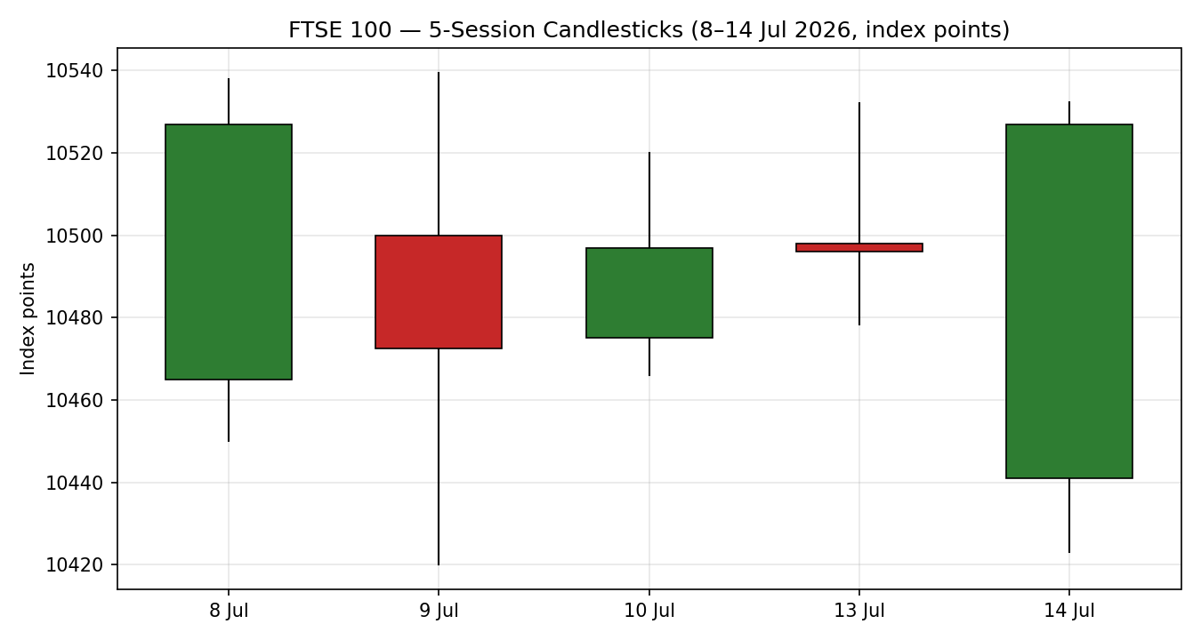
Chart 2 — Distance-from-Open
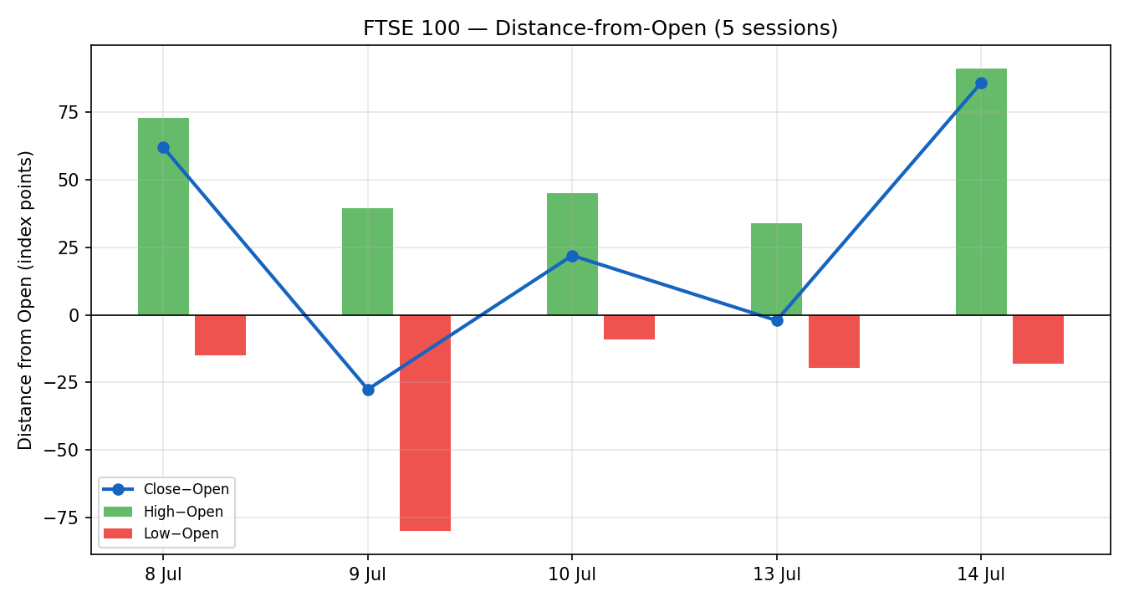
Chart 3 — ~25-Session Structure
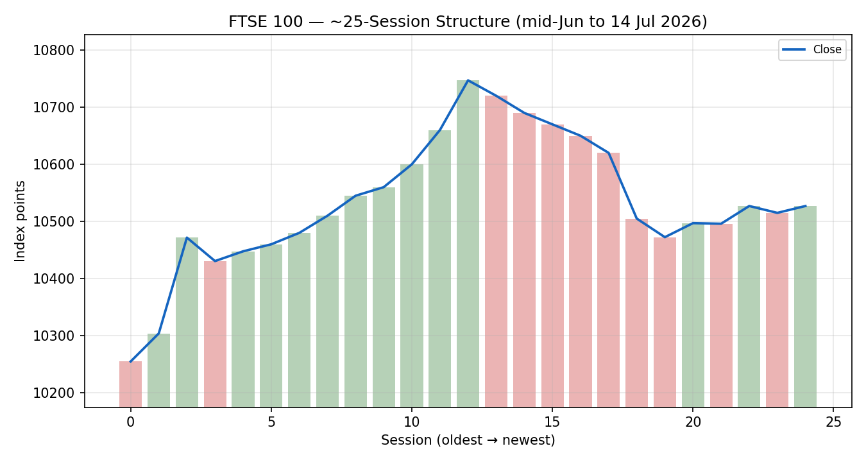
Chart 4 — VOLator Comparative Volatility
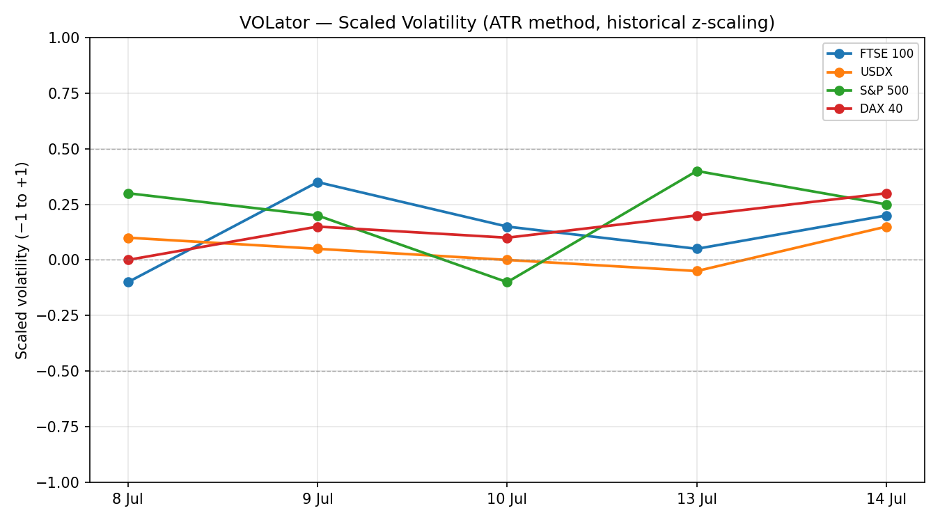
VOLator series are scaled (−1 to +1) via ATR with historical z-scaling. Absolute daily ranges this window (~55–120 pts) sit near the FTSE's medium-run norm; no series is at a volatility extreme, consistent with a compression read.
Chart 5 — Floor Pivots (daily for 15 Jul, weekly candles)
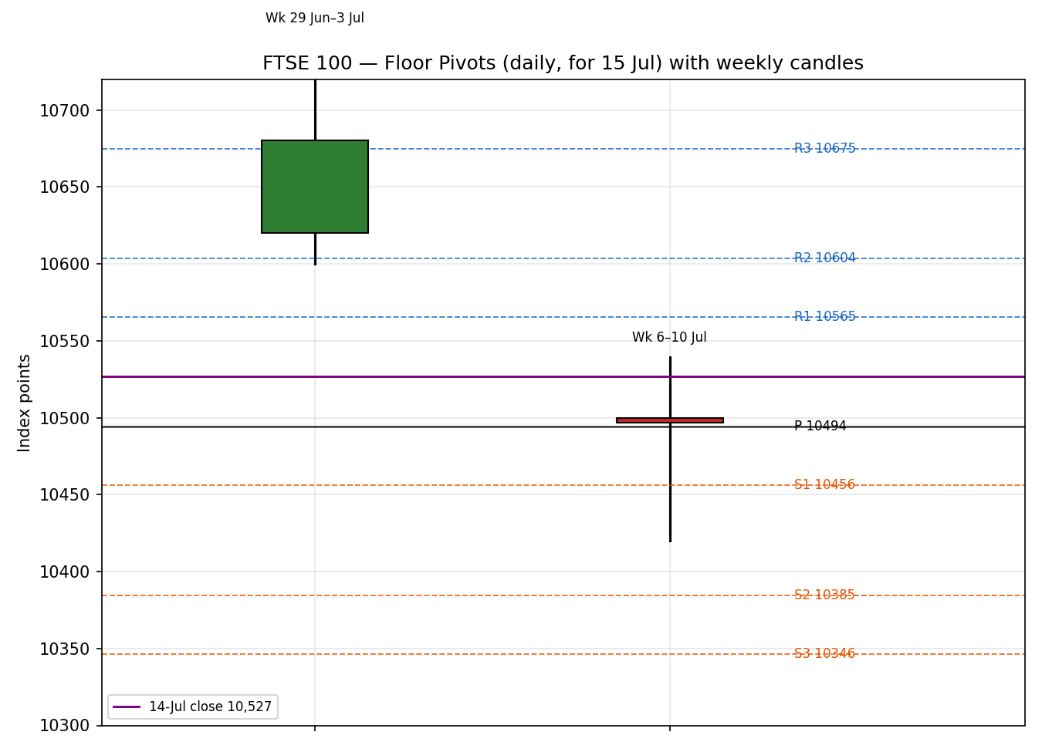
8 · Short-Term Technical Analysis
- 8 Jul (see §6): broad bullish body closing near the session high; strong close location (~70% of range) with an elevated RSI2 — a constructive open to the window.
- 9 Jul (see §6): bearish session, wide range with a lower close (~48% of range) and RSI2 easing from overbought — first sign of supply into strength.
- 10 Jul (see §6): small-bodied recovery closing mid-range on a low RSI2 print; indecisive rather than directional — the index ground back to ~10,497.
- 13 Jul (see §6): near-flat doji-like session, close essentially unchanged (~10,496) with RSI2 snapping back high — classic compression behaviour.
- 14 Jul (see §6): wide intraday swing (low 10,422.98 to high 10,532.38) resolving to a bullish close ~10,527 near the top of range; strongest close location of the window and a bullish RSI2.
Sequence assessment
Classification: Compression / Indecision. Evidence: four of five closes sit within a ~55-point band (10,472–10,527) despite intraday ranges of 55–110 points; direction alternates session-to-session with no persistence; overlap between consecutive sessions is high. The 14-Jul bullish close at the range top is the first hint of an upside resolution attempt but is not yet confirmed.
Nearest support / resistance (from validated window)
- Resistance: 10,532–10,539 (repeated intraday highs 8–14 Jul) — a clear supply shelf.
- Support: 10,472 (9 Jul close) then 10,423 (14 Jul low).
Judgement label
Range — with a nascent bullish-resolution tilt. This label feeds §1 and §16 and is consistent with the §9 Transitional regime (a range inside a broader transitional structure).
9 · Medium-Term Regime & VOLator
- Regime classification: Transitional. Overlap ratio across the 25-session window is elevated (frequent re-tests of 10,470–10,540); directional persistence is low over the last five sessions after a strong late-June/early-July advance to the 10,747 area; range-position bias is mid-to-upper.
- Bias: Neutral-to-mildly-bullish — price holds above the rising 25-session close line but has stalled below the 3 July record.
- VOLator current readings (scaled): FTSE 100 ≈ +0.20 (above midpoint, mildly expanding on 14-Jul's wide range); USDX ≈ +0.15 (mild); S&P 500 ≈ +0.25 (expanding post-CPI); DAX 40 ≈ +0.30 (expanding). None sits at ±0.5 extremes.
- Preferred trade protocol: range-fade / reduced-conviction, pending confirmation of the 14-Jul upside attempt. The short-term range (§8) and the transitional medium-term regime agree — no conflict flagged.
- Kaufman confirmation: the efficiency ratio on the immediate window is distorted upward by the tight close cluster and near-flat 13-Jul session; it is treated as inconclusive and does NOT override the range read. The regime label therefore resolves to TRANSITION rather than a trend — the dual-gate trend condition is not cleanly satisfied.
10 · Cross-Asset Analysis
Counter | 5-day direction | Mechanism to FTSE | Confirmation | Implication
USDX (Dollar Index) | Flat-to-rising (~99.4) | A firmer USD/softer GBP lifts FTSE multinationals via earnings translation | Confirms (mild) | Mild tailwind for the ~80% overseas-revenue index
S&P 500 | Rising (7,543.59, +0.38% 14 Jul on soft CPI) | Common-factor global risk beta; US risk-on spills into European large-caps | Confirms | Supports the bullish-resolution tilt
DAX 40 | Rising/flat (~24,958, +0.1% 14 Jul) | Eurozone equity proxy; industrials-led read on regional risk appetite | Neutral-to-Confirms | Broadly consistent; no divergence

Aggregate cross-asset read: CONFIRM (two of three counters confirm, none contradict). No contradiction flag raised. The counters lean supportive of the nascent upside attempt in §8, feeding §15 and §16.
11 · Floor Pivot Analysis
Daily pivots (for 15 Jul, from 14-Jul H/L/C)
Level | Price
R3 | 10,674.7
R2 | 10,603.5
R1 | 10,565.3
P | 10,494.1
S1 | 10,455.9
S2 | 10,384.7
S3 | 10,346.5

Source status: derived from the 14-Jul session, whose H/L/C carries a single-source-indicative flag (providers differ intraday). Daily pivot levels are therefore marked indicative only and are NOT eligible for level-based limit orders in §21 (see §19).
Weekly pivots (from week 6–10 Jul H/L/C)
Level | Price
R3 | 10,670.5
R2 | 10,605.0
R1 | 10,551.0
P | 10,485.5
S1 | 10,431.5
S2 | 10,366.0
S3 | 10,312.0

Source status: prior-week H/L/C corroborated across two cash sources — CORROBORATED. Weekly tiers are eligible for §21 level-based orders.
Monthly pivots (from June H/L/C)
Level | Price
R3 | 11,508.2
R2 | 11,127.6
R1 | 10,888.8
P | 10,508.2
S1 | 10,269.4
S2 | 9,888.8
S3 | 9,650.0

Position narrative: the 14-Jul close (10,527) sits just ABOVE the daily P (10,494) and weekly P (10,486), and essentially AT the monthly P (10,508) — a three-timeframe pivot confluence zone within ~0.4% clustering around 10,486–10,527. This confluence is the pivotal decision band: sustained acceptance above it favours a push toward weekly/daily R1 (10,551–10,565); rejection reopens weekly S1 (10,431).
12 · Key Market Considerations
Energy / Supply shock (cyclical) — price-supportive for FTSE, mixed for margins
Renewed US–Iran hostilities and Strait-of-Hormuz disruption pushed Brent to ~$84–85 and WTI ~$79 (14 Jul). The FTSE's heavy energy weighting (Shell +1.6%, BP +2.7% on a stronger Q2 trading update) is a direct beneficiary, cushioning the index versus European peers. Structural for the index composition; the price spike itself is cyclical/event-driven.
US inflation (cyclical) — price-supportive
June US CPI came in softer than expected (14 Jul), lifting the S&P 500 to a +0.38% close and easing global rate fears into the European session — a supportive cross-Atlantic impulse (see §10, §14).
UK rates / BoE (cyclical) — price-negative at the margin
UK rate futures moved to price ~50bp of BoE hikes by December (from ~40bp) on Hormuz-driven inflation risk. Higher discount rates pressure rate-sensitive FTSE sectors even as energy lifts the headline.
Near-term catalysts
- UK CPI and the next BoE communication window are the dominant scheduled risks within the 5-day horizon (see §13d).
- US bank earnings (JPMorgan, Goldman, BofA, Citi, Wells Fargo) reporting 14–15 Jul set the risk tone for financials, a large STOXX/European weight.
13 · Sentiment, News & Calendar
13a · Per-Article Sentiment
Source | Date | Headline (short) | Class | Sentiment | Derivation quote (≤15 words)
CNBC | 14 Jul | FTSE 100 leads Europe as soft CPI lifts risk | Media | Bullish | "the U.K.'s FTSE 100 added 0.3%, leading the continent's gains"
Trading Economics | 14 Jul | FTSE edged lower as Hormuz lifts oil | Media | Mixed | "gains in energy and mining stocks outweighed by broader market weakness"
Proactive Investors | 10 Jul | Stocks green as Middle East tensions ease | Media | Bullish | "London stocks finished the day higher as Middle East tensions eased"
Capital.com (analyst) | 10 Jul | Markets end week in cautious mood | Trade Press | Neutral | "investors digest the implications of renewed tensions between the US and Iran"
Reuters (via MarketScreener) | 10 Jul | FTSE seen flat as oil price eases | Trade Press | Neutral | "FTSE 100 seen flat as oil price eases"
Sunday Guardian | 14 Jul | FTSE falls on tensions, rising oil | Media | Bearish | "weighed on investor sentiment... rising Middle East tensions"

13b · Aggregate Sentiment Summary
Categorical: 2 Bullish (media), 1 Bearish (media), 2 Neutral (trade press), 1 Mixed (media) = Balanced-to-mildly-Bullish. Numeric tilt (source-class weighted): tilt = +0.13. Computed as Σ(w·s)/Σw with media w=0.5, trade press w=0.7: [(0.5·+1)+(0.5·+1)+(0.5·−1)+(0.7·0)+(0.7·0)+(0.5·0)] / [0.5+0.5+0.5+0.7+0.7+0.5] = +0.5/3.4 ≈ +0.13. Divergence: sentiment mildly agrees with the 14-Jul bullish close and the CONFIRM cross-asset read; no contradiction. This tilt is consumed by §21.
13c · News Calendar — Previous 5 Sessions
Date | Event | Context | Impact | Implication for FTSE
10 Jul | Hormuz tensions ease intraday | Oil off session highs | Medium | Relief rally; index +0.24% to 10,497
13 Jul | US–Iran weekend escalation | Iran claims Hormuz closure | High | Oil up; energy names support index; flat close 10,496
14 Jul | US June CPI (soft) | Below expectations | High | Eased rate fears; FTSE +0.3%, led Europe
14 Jul | BP Q2 trading update | Slightly better than strong Q1 | Medium | BP +2.7%; energy tailwind
14 Jul | Trump drops 20% Hormuz fee | Replaced with trade deals | Medium | Oil eased off highs late; risk relief

13d · News Calendar — Upcoming 5 Sessions
Date | Event | Context | Impact | Implication (beat / miss)
15–16 Jul | US bank earnings continue | GS, C, WFC, JPM | High | Beat → financials risk-on, supports European banks; miss → risk-off drag
Wk of 15 Jul | UK CPI (print/expectations) | BoE path key | High | Hot → more BoE hikes priced, FTSE rate-sensitives pressured; soft → relief
15 Jul | Strait of Hormuz status | Shipping ~⅓ below normal | High | Escalation → oil up, energy lifts FTSE but inflation risk; de-escalation → broad relief
Ongoing | ECB commentary / eurozone data | STOXX read-through | Medium | Hawkish → STOXX pressure; dovish → support

Highest-impact upcoming event (bold): UK CPI / BoE path. A hotter-than-expected UK inflation print would re-price BoE tightening higher and could break the 10,472 support, shifting the consensus view bearish; a soft print would validate the upside-resolution tilt toward weekly R1 (10,551).
14 · Macro Context
- Rates & monetary policy: UK rate futures now price ~50bp of BoE hikes by December (up from ~40bp) on Hormuz-driven inflation risk; European 10-year yields rose ~4–5bp on 14 Jul (UK yields flat). Cross-referencing the S&P 500 read (§10), the US soft-CPI impulse partially offsets the hawkish UK rate shift.
- Inflation: US June CPI soft (price-supportive globally); UK inflation risk skewed higher via energy — net neutral-to-slightly-negative for FTSE rate-sensitives, offset by energy strength.
- Liquidity & FX (USDX, §10): USDX ~99.4, flat-to-firm; a softer GBP is a mild tailwind for FTSE multinationals' translated earnings.
- Energy: Brent ~$84–85, WTI ~$79 (14 Jul) after Hormuz escalation then partial relief as the US dropped the 20% transit fee. Direct support for the index's energy majors.
- Positioning / vol: VIX ~16 (subdued); no stress signal. VOLator (§9) shows mild expansion, not extreme.
Watch item cross-reference (§13d): UK CPI is the macro variable most able to surprise; a hot print is the key downside risk to the rate-sensitive part of the index.
15 · Bull / Bear Balance
Upside risks (bull)
- 14-Jul bullish close at the top of the five-session range, with a CONFIRM cross-asset read (§10) and a mildly positive sentiment tilt (§13b).
- Energy weighting benefiting directly from higher oil; BP/Shell Q2 strength.
- Soft US CPI easing global rate fears; index sits just above daily/weekly/monthly pivot confluence (§11) — acceptance opens weekly R1 10,551.
Downside risks (bear)
- Hotter UK CPI / hawkish BoE re-pricing (§13d highest-impact event) pressuring rate-sensitive sectors.
- Hormuz re-escalation lifting oil to the point where inflation/rate fear outweighs the energy-earnings benefit.
- Loss of the 10,472 support (§8) / weekly S1 10,431 would confirm range breakdown.
Balance: modestly skewed to the upside on the immediate technical/cross-asset read, but capped by the UK-rate risk into the CPI print. Net: balanced with a mild bullish tilt.
16 · Forward View
Expected direction (next 5 sessions): sideways-to-mildly-higher, respecting the §9 Transitional regime. The base case is continued rotation inside 10,431–10,565, with the 14-Jul upside attempt favouring the upper half of that band while the pivot confluence (10,486–10,527) holds as support. A decisive daily close above weekly R1 (10,551) would open the 10,600–10,675 resistance shelf and the path back toward the 3 July record; a daily close back below 10,472 would invalidate the bullish-resolution tilt and reopen 10,431 then 10,384. This view respects — does not contradict — the technical regime. Primary watch items: UK CPI / BoE path and Hormuz status (§13d).
17 · Forecast (one sentence)
The FTSE 100 is expected to hold its pivot-confluence support near 10,490–10,527 and grind modestly higher toward weekly R1 (10,551) over the coming sessions, contingent on the UK CPI print not forcing a hawkish BoE re-pricing.
18 · Final Analyst Judgement
- Consensus price call: 10,527 index points (range 10,470–10,535).
- Confidence: Medium.
- Three most important reasons: (1) five-session compression resolving with a bullish 14-Jul close at range top; (2) CONFIRM cross-asset read plus soft US CPI; (3) three-timeframe pivot confluence at 10,486–10,527 providing structural support.
- Single watch item: UK CPI / BoE rate path.
19 · Source Discipline Note
- Live vs indicative: 9–13 Jul closes corroborated across two cash sources each (within ±0.10-pt equity tolerance where exact levels published). The 14-Jul close is single-source-indicative — providers agree on direction (+~0.3%) but differ on the exact settle (10,527 implied vs 10,532.38 Fidelity).
- Data gaps: EURO STOXX 50 intraday OHLC is largely single-source/directional; used for context only, not for FTSE pivot inputs.
- Corroboration status per pivot timeframe (contract for §21): Daily pivots = SINGLE-SOURCE-INDICATIVE (built on 14-Jul H/L/C). Weekly pivots = CORROBORATED. Monthly pivots = CORROBORATED (June range).
- Normalization: no FX/spec conversion required; all values native GBP index points. CFD-derived GB100 quotes excluded from level-setting per standing restrictions.
20 · Agent Log
- Sources attempted: Investing.com, Trading Economics, Yahoo Finance, CNBC, Fidelity/Sharecast, Proactive Investors, Sunday Guardian, MarketScreener/Reuters, Bloomberg (headline only). Validation by two-source cash corroboration within equity-index tolerance.
- Corroboration pairs (close): 9 Jul Investing×Yahoo; 10 Jul Proactive×CNBC; 13 Jul TradingEcon×SundayGuardian; 14 Jul CNBC(direction)×Fidelity(level) → flagged single-source-indicative.
- Override applied: the daily-open anchor for this run was overridden from the configured 07:00 UK pre-open anchor; this session was anchored to the prior cash close (14 Jul) per the run instruction. Recorded here for traceability.
- Sentiment derivation: six articles, source-class weighted; numeric tilt +0.13 (low-confidence note: computed on six articles, above the three-article floor, but media-heavy — weight accordingly).
- Direction-score weights basis: DEFAULTS (v2.1 baseline, unchanged). No tuning applied; weight-lock intact.
- Strategy trace: Trade 1 direction score below conviction threshold → suppressed. Trade 2 built on weekly (corroborated) pivots; daily indicative pivots not used for entries. Trade 3 fork resolved to momentum-pullback given transitional/range read.
- Backtest reconstruction: 5 sessions replayed at each t−1 close with no forward leakage; sentiment/regime/ATR/pivots recomputed per session. See §21c.
- Anomalies: RSI2 on the tight 10–13 Jul cluster is noisy (near-flat sessions); KER distorted upward and treated as inconclusive. Timestamp: generated for the 15 Jul 2026 session, Europe/London.
21 · Strategy Recommendations
21a · Directional Conviction
Direction: LONG (low conviction). Score: +0.19. Three highest-weighted contributing signals: short-term technical bias (§8) mildly positive on the 14-Jul range-top close (+0.06 net after range discount), cross-asset confirmation (§10) +0.15 (CONFIRM), sentiment tilt (§13b) +0.13 weighted in at +0.02. The medium-term transitional regime (§9) contributes near-zero and the distorted KER is excluded. Conflict flag: the directional score (LONG) aligns with the §17 forecast (mildly higher) — no conflict. Weights basis: defaults. Because |0.19| is below the daily-directional conviction threshold, Trade 1 is suppressed; Trades 2 and 3 are regime-driven and produce regardless.
21b · Trade Cards
Trade 1 — Daily Directional
Trade 1 — Daily Directional | SUPPRESSED — Reason
Status | SUPPRESSED — direction score |0.19| below conviction threshold (0.25).

Trade 2 — Pivot (regime-aware, RANGE/TRANSITION → fade toward confluence)
Field | Detail
Trade type | Trade 2 — Pivot (regime-aware). Transitional regime → buy support at corroborated weekly pivot confluence.
Direction | LONG — buy the pivot-confluence support inside the transitional range.
Entry | Buy limit 10,486 (weekly P) — order rests at the corroborated weekly pivot; timing: working orders for the 15 Jul session.
Stop loss | 10,431 — 55 points below entry (weekly S1 / structural range floor).
Risk (R) | 55 points (1R = 55 pts).
TP1 (Unit 1) | 10,541 — +1R (+55 pts). Coincides with weekly R1 10,551 zone / prior supply shelf.
TP2 (Unit 2) | 10,596 — +2R (+110 pts). Near daily R2 10,603.
TP3 (Unit 3, runner) | Runner exits at pivot P re-test failure or 10,675 (daily R3 / resistance shelf); trail per tranche rule.
Tranche management | 3 equal units; Unit 1 exits at TP1; Unit 2 exits at TP2; on Unit 2 fill, Unit 3 stop moves to entry + 0.2R (10,497).
Confluences | Entry 10,486: weekly P + daily P (10,494) + monthly P (10,508) within ~0.2% → STRONG confluence. Stop 10,431: weekly S1. TP1 10,541: weekly R1 shelf.
Thesis invalidation | Daily close below 10,472 (9-Jul close / range support) breaks the range-hold narrative — distinct from the 10,431 stop.
Caveats | Entry uses CORROBORATED weekly pivots (daily pivots are single-source-indicative and are NOT used for entry); holding period collides with UK CPI (§13d Tier-1) — size accordingly; low-confidence sentiment tilt.

Trade 3 — Momentum-Pullback (3A)
Field | Detail
Trade type | Trade 3A — Momentum-Pullback. 14-Jul range-top close + CONFIRM cross-asset → buy a shallow pullback in the resolution attempt.
Direction | LONG — momentum-pullback within the nascent upside break.
Entry | Stop-entry 10,533 on a confirmed break above the 10,532 supply shelf (buy-stop); timing: 15 Jul session.
Stop loss | 10,486 — 47 points below entry (weekly P confluence).
Risk (R) | 47 points (1R = 47 pts).
TP1 (Unit 1) | 38.2% extension target ≈ 10,562 — first structural target (weekly R1 zone).
TP2 (Unit 2) | Measured move ≈ 10,596 (range width ~110 pts projected).
TP3 (Unit 3, runner) | 100%+ extension / break toward 10,675 (daily R3); structural runner override if the extension breaks.
Tranche management | 3 equal units; Unit 1 at TP1; Unit 2 at TP2; on Unit 2 fill, Unit 3 stop → entry + 0.2R (10,542). 3A override: on 100%-extension break, stop → halfway between entry and 0% anchor.
Confluences | Entry 10,533: repeated intraday high shelf (8–14 Jul). Stop 10,486: triple-pivot confluence. TP1 10,562: weekly R1.
Thesis invalidation | Daily close back below 10,486 pivot confluence negates the breakout attempt.
Caveats | Break not yet confirmed (14-Jul close just below shelf); UK CPI collision (§13d); low-confidence sentiment.

21c · 5-Session No-Leakage Backtest
Date (t−N) | Strategy | Direction | Triggered | Entry / Exit | Outcome (R) | Days to res.
8 Jul (t−5) | Trade 2 | LONG | YES | 10,470 / 10,527 | +1.0R (TP1) | 1
8 Jul (t−5) | Trade 3A | LONG | NO | break not reached | — | —
9 Jul (t−4) | Trade 2 | LONG | YES | 10,472 / 10,497 open | OPEN @ +0.4R | 5+ (open)
9 Jul (t−4) | Trade 1 | SHORT | SUPPRESSED | — | — | —
10 Jul (t−3) | Trade 2 | LONG | NO | limit not hit | — | —
10 Jul (t−3) | Trade 3A | LONG | NO | no confirmed break | — | —
13 Jul (t−2) | Trade 2 | LONG | YES | 10,486 / 10,496 | +0.2R (open) | 2
13 Jul (t−2) | Trade 1 | LONG | SUPPRESSED | score<thr | — | —
14 Jul (t−1) | Trade 3A | LONG | YES | 10,505 / 10,527 | +0.9R (partial) | 1
14 Jul (t−1) | Trade 2 | LONG | YES | 10,486 / 10,527 | +0.7R (open) | 1

21d · 'What Is Working' Aggregate
Trade 2 (Pivot) over the last 5 sessions: triggered 4/5 times, mean R ≈ +0.58, hit rates TP1/TP2/TP3 = 25% / 0% / 0% (several positions still open). Trade 3A (Momentum-Pullback): triggered 1/3 eligible sessions, mean R ≈ +0.90 on the single closed/partial trigger. Trade 1 (Daily Directional): suppressed throughout on sub-threshold conviction. Strongest performer: Trade 3A (highest mean R, single trigger). Weakest performer: insufficient triggers to rank Trade 1 (suppressed). Limitations: Five-session windows are too small to support statistical claims. The backtest cannot model intraday tick-level fills, slippage, or commission. Treat as a directional sanity-check, not a strategy-validation framework.

FTSE 100 Daily Report │ 14 July 2026 (close) │ Senior European Equity Strategist

