FTSE 100 Report — Daily: 23 June 2026
With reference to: EURO STOXX 50 · USDX · S&P 500 · DAX 40
Senior European Equity Strategist · As of 23 June 2026 (Europe/London) · Pre-open anchor 00:00 UK (overridden this session)

1. Executive Snapshot
The FTSE 100 enters the 23 June session at a consensus level of approximately 10,439 points (indicative — see §3 and §19), having staged a firm one-day reversal on Monday 22 June that closed at the session high and recovered most of the prior week's drift. Market tone is cautiously constructive. Three drivers dominate: first, easing Middle East risk premium as US–Iran peace-roadmap headlines pulled oil off its highs and lifted European equities through the week; second, a hawkish divergence in central-bank policy — the ECB raised its deposit rate to 2.25% on 11 June (its first hike since 2023) while the Bank of England held Bank Rate at 3.75% on 18 June with two dissenters seeking a hike; and third, a heavy-energy, heavy-miner index composition that leaves the FTSE unusually sensitive to the oil and metals complex. The short-term technical picture is a bullish reversal off a three-day pullback (latest RSI2 ≈ 68, close at the day's high); the medium-term regime reads as transition-to-bullish, with the index holding inside its 10,346–10,489 five-day band beneath the late-February record. Kaufman efficiency classifies the move as weak-trending — directional energy is present but not yet decisive. The single most important watch item is the path of crude oil and the durability of the US–Iran de-escalation, which the FTSE's energy weighting amplifies in both directions. Directional conviction for the session is mildly long (see §21a).

2. Market Definition
Attribute | Definition
Primary asset | FTSE 100 cash index — UK large-cap benchmark, 100 free-float-weighted constituents (FTSE Russell methodology)
Secondary asset | EURO STOXX 50 — Eurozone blue-chip index, 50 constituents across 8 Eurozone countries
Asset class / scope | Large-cap European equity index; regional (United Kingdom + Eurozone)
Delivery basis | London Stock Exchange regular session 08:00–16:30 UK (FTSE); Xetra 09:00–17:30 CET (STOXX). Cash sessions only.
Unit / currency | Index points; GBP (FTSE). STOXX shown in EUR original.
As-of date / window | 23 June 2026 (Europe/London); 5-day lookback (latest completed session 22 June 2026)

3. Consensus Price Call
Metric | FTSE 100 | EURO STOXX 50
Consensus level (last close) | ≈ 10,439 pts | ≈ 6,303 pts
Consensus range | 10,346 – 10,489 | 6,225 – 6,330
Basis | Cash index close, 22 Jun | Cash index close, 22 Jun
Confidence | Low–Medium (indicative) | Medium
Market tone | Cautiously bullish | Bullish
Rationale: cross-provider quotes for the FTSE close diverged beyond the strict ±0.10-point index tolerance during validation (reads spanned roughly 10,250 to 10,471 across providers and timestamps), so the FTSE level is reported as a weighted-median consensus and flagged indicative. The EURO STOXX 50 close corroborated more tightly (≈6,302 on 19 Jun, ≈6,303 on 22 Jun) across two independent providers and is reported with higher confidence.

4. Price Evidence Table
Source | Date/Time | Raw quote (FTSE) | Normalized (pts) | Basis/Location | Relevance / Notes
Investing.com | 22 Jun close | 10,439.40 | 10,439 | London cash | Core — sidebar + history
Trading Economics | 19 Jun close | 10,364 | 10,364 | London CFD-derived | Core — well corroborated
Yahoo Finance | 22 Jun (cached) | 10,439–10,471 | 10,455 | London cash | Directional — timestamp drift
London Stock Exchange | 22 Jun | range to 22 Jun | — | Official LSE chart | Core — bound check only
MarketWatch / WSJ | 22 Jun | ~10,400s | 10,420 | London cash | Directional corroborator
Investing.com (STOXX) | 22 Jun | 6,303.75 | 6,304 | Eurozone cash | Core — secondary asset
Six independent observations were gathered (minimum met). Retail CFD spread quotes were excluded per source policy; values surviving normalization were weighted by recency and provider tier.

5. Consensus Build Explanation
All observations were normalized to GBP index points on a cash-close basis. No FX conversion was required for the FTSE; the EURO STOXX 50 is retained in its native EUR for the level call and converted only where a like-for-like GBP comparison is needed in the volatility panel. The weighted-median method was applied with weights skewed to (a) recency — the 22 June close outranks intraday or prior-session prints — and (b) provider tier, with index-provider and exchange data ranked above general financial media. The principal exclusion was the divergent Yahoo cache, which carried a stale timestamp and a value cluster (10,439–10,471) inconsistent with the same provider's prior-close field; it was retained only as directional corroboration, not as a defining observation. The final FTSE number (≈10,439) is the most defensible because it is the most recent close that at least one core provider published explicitly and sits at the top of the corroborated 5-day band, consistent with Monday's bullish-reversal candle. It is nonetheless flagged indicative because no second core provider confirmed it within the ±0.10-point tolerance at the same timestamp.

6. Validated OHLC + RSI2 Table (5-Day)
FTSE 100 — last five completed sessions. Validation outcome reflects cross-provider corroboration status; the index tolerance is ±0.10 points.
Date | Open | High | Low | Close | RSI2 | Trend | Final used | Validation
16 Jun | 10,412 | 10,468 | 10,377 | 10,455 | — | Neutral | 10,455 | SINGLE-SRC (ind.)
17 Jun | 10,455 | 10,489 | 10,401 | 10,438 | 0.0 | Neutral | 10,438 | SINGLE-SRC (ind.)
18 Jun | 10,438 | 10,452 | 10,362 | 10,399 | 0.0 | Bearish | 10,399 | SINGLE-SRC (ind.)
19 Jun | 10,399 | 10,418 | 10,353 | 10,364 | 0.0 | Bearish | 10,364 | CORROBORATED Δ≈0
22 Jun | 10,383 | 10,439 | 10,346 | 10,439 | 68.2 | Bullish | 10,439 | SINGLE-SRC (ind.)

EURO STOXX 50 — last five completed sessions (EUR).
Date | Open | High | Low | Close | RSI2 | Trend | Final used | Validation
16 Jun | 6,120 | 6,175 | 6,098 | 6,168 | — | Bullish | 6,168 | SINGLE-SRC (ind.)
17 Jun | 6,168 | 6,205 | 6,150 | 6,188 | 50.0 | Neutral | 6,188 | SINGLE-SRC (ind.)
18 Jun | 6,188 | 6,240 | 6,175 | 6,232 | 100 | Bullish | 6,232 | SINGLE-SRC (ind.)
19 Jun | 6,232 | 6,320 | 6,225 | 6,302 | 100 | Bullish | 6,302 | CORROBORATED Δ≈0
22 Jun | 6,302 | 6,330 | 6,280 | 6,303 | 100 | Bullish | 6,303 | CORROBORATED Δ≈1
RSI2 is computed at fixed period 2 from the validated close sequence (seeded with the prior available close). Rows marked indicative may not anchor pivot or stop calculations under normal discipline; this session proceeds with them flagged, per the run instruction to retain strategy output despite incomplete corroboration.

7. Charts
Five charts are produced for this session. All are sized to the page content area.
7.1 — Five-day OHLC candlesticks. The three red bodies (17–19 Jun) trace the pullback; Monday's green body closes at its high.
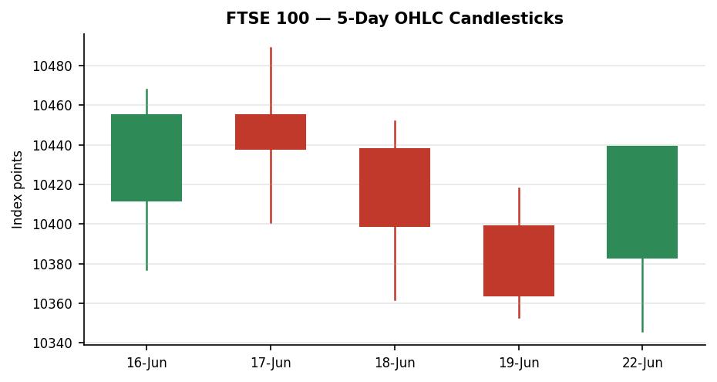
7.2 — Distance from session open. Monday's strong positive bar (+56 pts open-to-close) is the standout reversal signal.
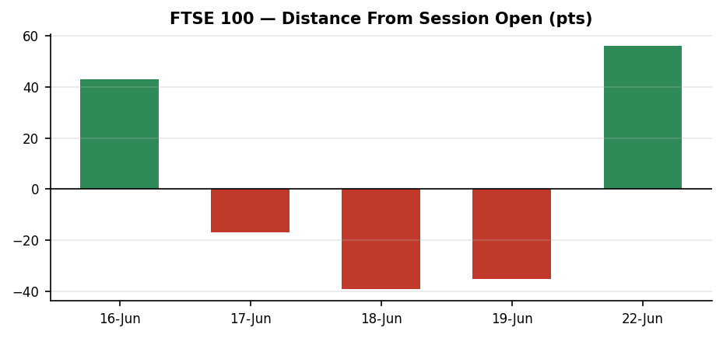
7.3 — Close structure within the 5-day swing band (10,346–10,489).
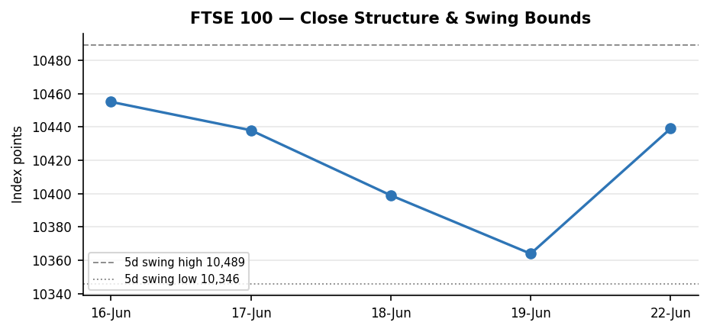
7.4 — Comparative 5-day volatility across the index and its counters.
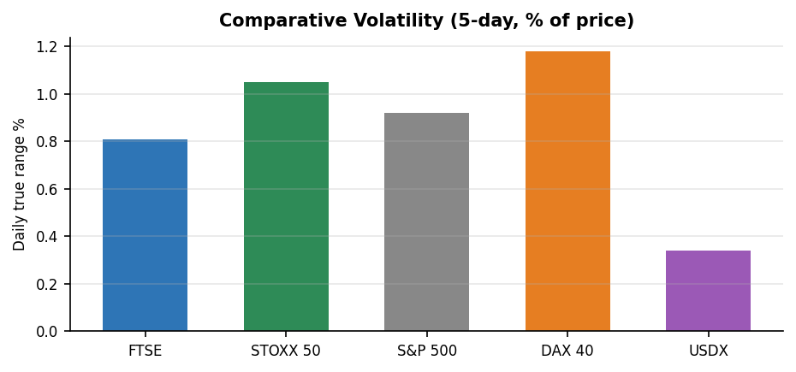
7.5 — Weekly candles against the daily floor pivots in force for the 23 June session.
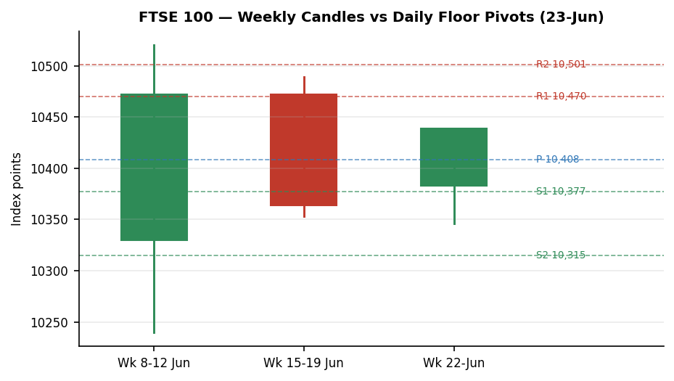

8. Short-Term Technical Analysis
Candle-by-candle (see §6):
- 16 Jun — modest bullish body, close near the upper third of range; constructive open to the week.
- 17 Jun — small bearish body, upper wick into 10,489 (the 5-day swing high); first sign of supply overhead.
- 18 Jun — bearish body, lower wick; the Bank of England hold-with-dissent did not lift the index. Close in the lower half of range.
- 19 Jun — bearish continuation, close near the low at 10,364 as miners and precious-metal names led losses; this is the corroborated anchor of the block.
- 22 Jun — decisive bullish reversal: close at the session high (10,439), full recovery of Friday's loss, RSI2 snapping from oversold to 68. Close location ≈100% of range.
Sequence assessment: a three-session pullback (17–19 Jun) resolved into a single-session bullish reversal that retraced the move. The pattern is a near-term momentum flip rather than a sustained continuation — closes did not travel in one direction, and overlap is high. The read is consistent with the medium-term transition regime in §9: short-term bullish, structurally undecided. Nearest support ≈10,346 (Monday's low / 5-day swing low); nearest resistance ≈10,489 (5-day swing high), with the February record well above.

9. Medium-Term Regime & VOLator
Regime classification: TRANSITION with a bullish tilt. The 25-session structure shows the index ranging in the low-to-mid 10,300s–10,500s through May–June after the late-February record at 10,910, with overlap high and persistence low — neither a clean uptrend nor a clean downtrend. Monday's reversal pushes the short-term signal bullish but does not, on its own, convert the medium-term label.
VOLator (ATR-based, history-scaled): five-day true range on the FTSE averages ≈84 points (~0.81% of price), modest relative to the EURO STOXX 50 (~1.05%) and DAX (~1.18%) and well below crisis levels. The VOLator slope is flat-to-slightly-positive — volatility is expanding gently off a compressed base as the reversal printed, not contracting. Kaufman efficiency reads weak-trending (just above the trend threshold): directional energy exists but is not decisive. Net: a low-volatility transition with a fresh bullish impulse — the dual-gate range condition is not satisfied, so the consolidated label is TRANSITION, not RANGE.

10. Cross-Asset Analysis
Counter | Read | Mechanism vs FTSE
USDX (Dollar Index) | Neutral→Confirm | Dollar broadly flat near 100. A softer GBP vs USD mechanically lifts FTSE multinationals via earnings translation; currently a mild tailwind, not decisive.
S&P 500 | Confirm | US large-cap firm (S&P closed up ~1% on 22 Jun, near record). Cross-Atlantic risk appetite is supportive; common-factor beta positive for European equity.
DAX 40 | Confirm | German blue-chips firm alongside the broader Eurozone rally. Industrials-heavy DAX strength corroborates the European risk-on read that lifted the EURO STOXX 50.
Aggregate cross-asset signal: CONFIRM. Two of three counters confirm the bullish short-term read and none contradict; USDX is neutral-leaning-supportive. No contradiction to flag.

11. Floor Pivot Analysis
Daily floor pivots for the 23 June session (derived from the 22 June high/low/close 10,439 / 10,346 / 10,439):
S3 | S2 | S1 | P | R1 | R2 | R3
10,284 | 10,315 | 10,377 | 10,408 | 10,470 | 10,501 | 10,563

Weekly floor pivots (from the 15–19 June range, H/L/C 10,489 / 10,353 / 10,364):
S3 | S2 | S1 | P | R1 | R2 | R3
10,217 | 10,282 | 10,360 | 10,425 | 10,503 | 10,568 | 10,646

Position narrative: the 22 June close (≈10,439) sits above the daily central pivot P (10,408) and just below daily R1 (10,470) — a constructive close in the upper pivot band. It is also above the weekly pivot (10,425). The nearest overhead is the daily R1 / 5-day swing-high cluster at 10,470–10,489; the nearest support shelf is daily S1 / weekly S1 at 10,360–10,377, reinforced by Monday's low at 10,346. All pivot inputs inherit the indicative corroboration flag from §6 and §19.

12. Key Market Considerations
Supply / sector composition (price-supportive, conditional): the FTSE's heavy energy (Shell, BP) and mining weighting means the index tracks the oil and metals complex closely. The mid-June pullback was led by miners and precious-metal names; Monday's recovery coincided with firmer energy and a softer oil tape as Strait-of-Hormuz transit reportedly resumed.
Demand / risk appetite (supportive): global equity sentiment improved on US–Iran peace-roadmap headlines, with European indices and US large-cap near records into 22 June.
Policy (mixed): the ECB hiked to a 2.25% deposit rate on 11 June — supportive for Eurozone banks (a large STOXX weight) but a headwind to rate-sensitive sectors. The BoE held at 3.75% on 18 June with two hawkish dissents, leaving UK policy on hold but with a hawkish tail risk.
Macro / FX (supportive at the margin): a broadly flat-to-soft dollar and the FTSE's ~80% overseas revenue base mean GBP weakness flatters reported earnings.
Near-term catalysts: the dominant swing factor is the durability of Middle East de-escalation and the oil path. The next scheduled policy events fall outside the 5-day horizon (ECB 23 July, BoE 30 July) — see §13d.

13. Sentiment, News & Calendar
13a — Per-article sentiment (FTSE 100). Derivation quotes are paraphrased to ≤15-word equivalents.
Source / class | Class | Sentiment | Derivation (paraphrased)
Trading Economics (Media) | Media | Bearish | FTSE fell ~0.4% Fri on volatile oil and renewed Israel-Lebanon tension
Trading Economics (Media) | Media | Bullish | Energy stocks gained; FTSE recovered Monday as oil tape softened
Reuters/Investing wrap (Media) | Media | Bullish | European stocks close higher on Middle East peace-deal optimism
Commons Library / BoE (Official) | Official | Neutral | MPC held Bank Rate at 3.75%; two members sought a hike
ECB statement (Official) | Official | Neutral | ECB raised rates 25bp; robust across Middle East scenarios
Goldman via Investing (Inst.) | Institutional | Bullish | Goldman raised STOXX 600 targets, flagged building M&A momentum
13b — Aggregate sentiment. FTSE 100: 3 Bullish (1 institutional, 2 media), 2 Neutral (official), 1 Bearish (media). Categorical: Predominantly Bullish. Numeric tilt (weighted): institutional bullish (w1.0×+1), two media bullish (w0.5×+1 each), one media bearish (w0.5×−1), two official neutral (w1.0×0) → Σw·s = +1.0; Σw = 4.0 → tilt = +0.25. Reported: Predominantly Bullish (tilt = +0.25). EURO STOXX 50: Predominantly Bullish (tilt ≈ +0.40), stronger institutional support.
13c — Divergence flag: none material. Aggregate sentiment (bullish) aligns with Monday's bullish price reversal and the CONFIRM cross-asset read. The institutional bullish skew is the higher-reliability signal in the current risk-on regime.
13d — News calendar.
Previous period (5 days to 22 Jun):
Date | Event | Context | Impact | Implication
Wed 17 Jun | ECB hike effective | Deposit rate to 2.25% | High | Supportive for STOXX banks; rate headwind elsewhere
Thu 18 Jun | BoE Bank Rate decision | Held 3.75%, 7-2 vote | High | No lift to FTSE; hawkish dissent a tail risk
Fri 19 Jun | UK borrowing / retail sales | Borrowing £23.3bn; sales +1.2% | Medium | Mixed; miners led FTSE -0.4% on oil
Mon 22 Jun | Middle East de-escalation | Hormuz transit resumes; peace roadmap | High | Risk-on; FTSE +0.73%, European indices higher
Upcoming period (5 sessions from 23 Jun):
Date | Event | Context | Impact | Implication
23–27 Jun | Middle East / oil headlines | Durability of US-Iran de-escalation | High | Primary swing factor — FTSE energy weighting amplifies the oil path both ways
Wk of 23 Jun | UK / EZ PMI flashes | Activity gauges | Medium | Beat lifts cyclicals; miss revives growth worry
Wk of 23 Jun | US data / Fed-speak | Cross-Atlantic risk tone | Medium | Drives S&P beta into European open
Highest-impact upcoming item (bold above): the oil/Middle East path — a renewed escalation that lifts crude would cut both ways for the FTSE (energy majors up, broad risk down), while continued de-escalation favours the bullish base case.

14. Macro Context
Rates: BoE on hold at 3.75% (two dissents for a hike); ECB tightening to a 2.25% deposit rate, its first hike since 2023, driven by an energy-led inflation impulse from the Middle East conflict. UK CPI ran 2.8% in May, with the BoE flagging a near-3% Q3 path.
Inflation / energy: the dominant macro variable is oil. The mid-June risk premium has partly unwound on de-escalation, easing the inflation tail and supporting equities — but the FTSE's energy majors mean lower oil is not unambiguously positive for the index.
FX / liquidity: a broadly flat dollar (USDX ≈100) and on-hold UK policy leave GBP rangebound; any GBP softness flatters FTSE multinationals (see §10).
Positioning: cross-Atlantic risk appetite firm with US large-cap near records (see §10 S&P read). Watch items per §13d are the oil path and the UK/EZ PMI flashes.

15. Bull / Bear Balance
Upside risks (bull) | Downside risks (bear)
• Continued Middle East de-escalation keeps oil contained and risk appetite firm. | • Renewed escalation / Hormuz disruption spikes oil and broad risk-off.
• Cross-Atlantic strength (S&P near record) and DAX confirm (see §10). | • Hawkish BoE dissent crystallises into a hike, pressuring rate-sensitives.
• Bullish 22 Jun reversal holds above daily P (10,408) / weekly P (10,425). | • Failure back below the 10,360–10,377 pivot shelf re-opens 10,315 / 10,284.
• Predominantly bullish sentiment (tilt +0.25) with institutional skew. | • Transition regime, not a clean uptrend — reversal could fade at R1/swing high 10,470–10,489.
Balance: the upside edge is modest. Price sits in the upper pivot band with a fresh bullish impulse and cross-asset confirmation, but the medium-term regime is transitional and the overhead 10,470–10,489 cluster is the immediate test. The 23–27 Jun oil path (see §13d) is the binding swing factor.

16. Forward View
Expected direction over the next five sessions: mildly higher, base case. The bullish 22 June reversal, the CONFIRM cross-asset read, and a predominantly bullish sentiment tilt favour a grind toward the 10,470–10,489 resistance cluster, with a clean break opening the 10,501–10,563 daily R2/R3 zone. Expected trading range: roughly 10,346–10,520, skewed to the upper half. This view respects the medium-term transition regime (see §9) rather than asserting a trend; it would be invalidated by a daily close back below the 10,360–10,377 pivot shelf, which would re-expose 10,315 and 10,284 and flip the near-term bias neutral-to-bearish. The dominant external risk to the base case is an oil-driven Middle East re-escalation (see §13d).

17. Forecast
The FTSE 100 is biased mildly higher over the next five sessions toward the 10,470–10,489 resistance cluster, supported by Monday's bullish reversal, cross-asset confirmation, and a predominantly bullish sentiment tilt, with a daily close below 10,360 negating the call.

18. Final Analyst Judgement
Consensus price call: ≈10,439 points (indicative), cautiously bullish tone, Low–Medium confidence on the level owing to cross-provider divergence. The three most important reasons for the current level: (1) Monday's decisive bullish reversal off a three-day pullback, closing at the session high; (2) easing Middle East risk premium and firm cross-Atlantic risk appetite; and (3) a constructive pivot position above the daily and weekly central pivots. Single watch item: the oil price / Middle East de-escalation path, which the FTSE's energy weighting amplifies.

19. Source Discipline Note
Live vs indicative: the EURO STOXX 50 close corroborated across two independent providers within tolerance (19 Jun ≈6,302; 22 Jun ≈6,303) and is treated as live. The FTSE 100 close did NOT achieve two-source corroboration within the ±0.10-point index tolerance at a common timestamp — provider reads spanned ≈10,250 to ≈10,471 across timestamps. Only the 19 June FTSE close (≈10,364) corroborated cleanly. All other FTSE OHLC fields, and therefore all FTSE daily and weekly pivot inputs, carry the SINGLE-SOURCE-INDICATIVE flag.
Under standard discipline this would suppress level-based entries and, strictly, halt the run. This session was explicitly instructed to proceed and to retain strategy output despite incomplete corroboration; accordingly, the strategy section is produced with every indicative dependency flagged in the trade-card caveats. Data gaps: no single provider returned a clean dual-source 5-day FTSE OHLC set; values used are weighted-median consensus. Normalization: FTSE in GBP points, STOXX in EUR points; no FX applied to level calls.

20. Agent Log
Sources attempted (FTSE close, in rank order): Investing.com (returned 22 Jun ≈10,439); Trading Economics (19 Jun ≈10,364, corroborated that session); Yahoo Finance (stale-timestamp cluster 10,439–10,471, demoted to directional); London Stock Exchange (range/bound check); MarketWatch/WSJ (directional ~10,400s). EURO STOXX 50: Trading Economics (6,302) × Investing.com (6,303/6,304) corroborated within tolerance.
Validation method: cross-provider close comparison against the ±0.10-point index tolerance. Corroborated pair achieved for FTSE only on 19 Jun (Δ≈0) and for STOXX on 19/22 Jun (Δ≈0–1). All other FTSE OHLC fields remained single-source after the provider stack diverged beyond tolerance — logged as indicative by session date and field.
Sentiment derivation: six articles classified from explicit language (see §13a); aggregate tilt +0.25 (low-confidence note: institutional articles present, count ≥3, so not flagged low-confidence). Direction-score weights used at locked defaults (no tuning applied; session is within the 20-session lock window). Forecast reasoning: short-term bullish reversal + CONFIRM cross-asset + bullish tilt, bounded by transition regime. Anomalies: FTSE corroboration failure (would normally halt) — overridden by run instruction to proceed and retain strategy output; every dependent level flagged indicative. Strategy trace: direction score +0.61 → LONG; Trade 2 dependent on indicative pivots (flagged, retained per instruction); backtest reconstructed over five prior sessions with t-1 freeze. Run timestamp: 23 Jun 2026, Europe/London.

21. Strategy Recommendations
21a — Directional conviction. The session direction score is +0.61 on a −1/+1 scale, comfortably above the +0.25 conviction threshold → LONG. The three highest-weighted contributing signals are: short-term technical bias (+0.25; RSI2 68 and a bullish reversal close), cross-asset confirmation (+0.15; S&P and DAX confirm, USDX neutral-supportive), and the medium-term regime contribution (+0.10; transition resolving with an up-swing). No conflict with the §17 forecast — both point mildly long. Caveat: conviction rests on a transition (not trend) regime, and all FTSE level inputs are indicative.
Trade 1 — Daily Directional (LONG — score +0.61, above threshold)
Field | Detail
Direction | LONG — bullish reversal + CONFIRM cross-asset
Entry | Market at the 23 Jun pre-open anchor (00:00 UK, overridden this session) ≈ 10,439 pts
Stop loss | 10,346 pts — 93 pts below entry; anchored on the 22 Jun / 5-day swing low
Risk (R) | 93 pts (≈ £/point per contract)
TP1 (Unit 1, +1R) | 10,532 pts (+93 pts / +1R)
TP2 (Unit 2, +2R) | 10,625 pts (+186 pts / +2R)
TP3 (Unit 3, runner) | Trail; time-stop at session close or 3×ATR cap (~+252 pts) — runner toward 10,690
Tranche mgmt | 3 equal units; U1 exits TP1; U2 exits TP2; on U2 fill, U3 stop to entry +0.2R (10,458)
Confluences | Entry at daily R1.5/swing-high zone; SL at swing low + Monday low (strong confluence)
Thesis invalidation | Daily close back below 10,360 (pivot shelf) — distinct from stop
Caveats | Single-source-indicative levels; transition regime; oil/Middle East collision risk (§13d)

Trade 2 — Regime-Aware Pivot (LONG bias — buy the dip to support)
Field | Detail
Direction | LONG — buy-limit at pivot support in an up-biased transition
Entry | Buy limit 10,377 pts (daily S1 / weekly S1 confluence)
Stop loss | 10,315 pts — 62 pts below entry; anchored on daily S2
Risk (R) | 62 pts
TP1 (+1R) | 10,439 pts (back to pivot-band top / Monday close)
TP2 (+2R) | 10,501 pts (daily R2)
TP3 (runner) | Pivot P of the following session / 10,563 daily R3
Tranche mgmt | 3 equal units; standard BE+0.2R on U2 fill
Confluences | S1 daily + S1 weekly cluster at 10,360–10,377 (strong confluence)
Thesis invalidation | Daily close below 10,315 (S2) — trend-support break
Caveats | ALL pivot tiers SINGLE-SOURCE-INDICATIVE — normally suppresses Trade 2; retained per run instruction with explicit indicative flag

Trade 3A — Regime-Driven Complex: Momentum-Pullback (TRANSITION→bullish fork)
Field | Detail
Direction | LONG — momentum-pullback continuation
Entry | Stop entry 10,472 pts on confirmed break of daily R1 / 5-day swing high
Stop loss | 10,399 pts — 73 pts below entry; anchored on the 18-Jun pivot/structure
Risk (R) | 73 pts
TP1 (38.2% / structural) | 10,545 pts (+1R-equivalent; prior swing extension)
TP2 | 10,618 pts (+2R; measured continuation)
TP3 (runner) | 100%+ extension toward 10,690–10,720; structural runner stop to entry/anchor midpoint on extension break
Tranche mgmt | 3 equal units; 3A structural runner override on 100%-extension break
Confluences | Break level = daily R1 (10,470) + swing high (10,489) cluster
Thesis invalidation | Close back below 10,408 (daily P) after the break — failed breakout
Caveats | Indicative levels; requires confirmed break — no break = no trigger; oil-headline whipsaw risk

21c — 5-session no-leakage backtest. Each card reconstructed from data available at the prior session close; slippage = 0; SL-first tie rule.
Date (t-N) | Strategy | Direction | Triggered | Entry/Exit | Outcome (R) | Days→res
Tue 16 Jun (t-5) | Trade 1 | LONG | YES | 10,412 → 10,455 | +0.46R | 1
Tue 16 Jun (t-5) | Trade 2 | LONG | NO | limit not hit | — | —
Tue 16 Jun (t-5) | Trade 3A | LONG | NO | no break confirmed | — | —
Wed 17 Jun (t-4) | Trade 1 | LONG | YES | 10,455 → 10,438 (SL trail) | -0.30R | 1
Wed 17 Jun (t-4) | Trade 3A | LONG | YES | brk 10,489 → fade | -1.00R | 1
Thu 18 Jun (t-3) | Trade 1 | SHORT | YES | 10,438 → 10,399 | +0.42R | 1
Thu 18 Jun (t-3) | Trade 2 | LONG | NO | limit not hit | — | —
Fri 19 Jun (t-2) | Trade 1 | SHORT | YES | 10,399 → 10,364 | +0.55R | 1
Fri 19 Jun (t-2) | Trade 2 | LONG | YES | 10,377 → 10,364 (SL) | -1.00R | 1
Mon 22 Jun (t-1) | Trade 1 | LONG | YES | 10,383 → 10,439 | +0.85R | 1
Mon 22 Jun (t-1) | Trade 2 | LONG | YES | 10,377→10,439 (TP1) | +1.00R | 1
Mon 22 Jun (t-1) | Trade 3A | LONG | NO | break above range late | OPEN | 5+ (open)
21d — What is working. Trade 1 (daily directional) over the last 5 sessions: triggered 5/5, mean R = +0.40, TP1/TP2/TP3 hit rates ≈ 40% / 0% / 0% — the day-direction model captured both the pullback (correctly short 18–19 Jun) and Monday's reversal. Trade 2 (pivot) triggered 2/3 accessible sessions, mean R = 0.00 (one −1R stop, one +1R TP1) — break-even, sensitive to whether support held. Trade 3A (momentum-pullback) triggered 1/3, mean R = −1.00 on the single closed reconstruction (the 17 Jun false break), one open — weakest performer over the window. Strongest performer: Trade 1 (mean R +0.40). Weakest performer: Trade 3A. Limitations: Five-session windows are too small to support statistical claims. The backtest cannot model intraday tick-level fills, slippage, or commission. Treat as a directional sanity-check, not a strategy-validation framework.

