FTSE 100 Report — Daily: 04 June 2026
With reference to: EURO STOXX 50 · USDX · S&P 500 · DAX 40
Senior European Equity Strategist · Trading & risk review (forward-test) · Europe/London

1 · Executive Snapshot
The FTSE 100 enters the 04 June 2026 session with a most-recent validated close of 10,354.43 (03 June), having faded from an intra-week push above 10,400 on a softer cross-Atlantic tape and renewed US tariff headlines. The consensus current level is therefore taken at ~10,354 points (range 10,310–10,400), market tone balanced-with-a-mild-downside-tilt. Three drivers dominate: (i) a sharp retreat in oil back below $100 on tentative US–Iran de-escalation, which has relieved inflation/yield pressure but also trimmed the index's heavy energy weighting; (ii) renewed US tariff threats (proposed duties of up to 12.5% on ~60 partners including the EU) capping risk appetite; and (iii) UK domestic political uncertainty around the Starmer premiership. Short-term technical read: Exhaustion — reversal risk after two down sessions off the 10,462 high; medium-term regime: Transitional with a mild bullish base above 10,250. The Kaufman efficiency reading is indicative-only on a short path and classifies the tape as weakly trending-to-ranging. Directional conviction from the strategy engine is NEUTRAL (score −0.05) — below the conviction threshold. Single most important watch item: Thursday's coincident ECB and Bank of England policy communications.

2 · Market Definition
Field | Definition
Primary asset | FTSE 100 cash index (UK large-cap benchmark, 100 constituents)
Secondary asset | EURO STOXX 50 — Eurozone blue-chip benchmark (50 constituents)
Specification | FTSE 100 cash index, GBP-denominated, free-float weighted (FTSE Russell methodology)
Scope / region | Regional — Europe (United Kingdom + Eurozone)
Delivery basis | LSE regular session 08:00–16:30 UK (FTSE); Xetra 09:00–17:30 CET (STOXX). Cash sessions only.
Unit / currency | Index points · GBP (STOXX shown in EUR original)
Tick | 0.01 point
As-of date | 04 June 2026 (forward session) · latest validated close 03 June 2026
As-of timezone | Europe/London
Lookback window | 5 trading days
Daily-open anchor overridden to 00:00 UK for this run (default would anchor the European pre-open window). The 00:00 UK anchor places trade entries at the day boundary rather than the 07:00 pre-open.

3 · Consensus Price Call
Consensus level | Range | Basis | Confidence | Tone | Rationale
10,354 pts | 10,310 – 10,400 | Cash index close (03 Jun) | Medium | Balanced (mild downside) | Latest validated close corroborated across index panels; two-session fade from the 10,462 high keeps tone cautious into ECB/BoE.

4 · Price Evidence Table
Source | Date/Time | Raw quote | Normalized (pts, GBP) | Basis / location | Class. | Notes
Yahoo Finance index panel | 03 Jun 16:35 UK | 10,354.43 (−0.18%) | 10,354.43 | Cash close / London | Core | Primary close reference
Trading Economics (GB100) | 02 Jun close | 10,378 (+0.37%) | 10,378 | CFD-tracked cash / London | Core | Prior session close
Investing.com (UK100) | 03 Jun intraday | Open 10,425.85; range 10,409–10,462 | 10,426 / 10,462 / 10,354 | Derived cash / London | Core | Open + session range
LSE / FTSE Russell | to 30 Apr / 03 Jun chart | 52-wk range 8,718–10,935 | — | Official benchmark / London | Directional | Official methodology & range
Trading Economics weekly | wk to 29 May | FTSE −0.54% on week | — | Cash / London | Directional | Weekly context (LSE shut 25 May)
Yahoo (cross-index panel) | 03 Jun | STOXX 6,065–6,108; DAX 24,901 | — | Cross-asset / Frankfurt | Directional | Counter corroboration
Cross-source deltas on individual sessions fell within the indicative band; per the run instruction, corroboration leniency was applied where two independent live feeds could not be reconciled to the strict ±0.10-point index tolerance. Affected fields are flagged indicative in §6 and §19.

5 · Consensus Build Explanation
All observations were already quoted in index points and GBP, so no FX or unit conversion was required for the FTSE primary; the EURO STOXX 50 reference retains its EUR original alongside a GBP-equivalent note. Observations were weighted by recency and by directness to the cash-close basis: the 03 June close from the cross-index panel and the 02 June Trading Economics close are the two most direct, most recent core comparables and carry the highest weight. Intraday range data from Investing.com corroborated the session envelope (10,354–10,462) but is not itself a close. Official FTSE Russell / LSE data anchored the 52-week structural range. Weekly aggregates were treated as directional only. Using a weighted-median across the core close observations yields 10,354 points as the most defensible current consensus; the modest spread to the 02 June print (10,378) reflects the genuine two-session fade rather than measurement error, so precision is set to the nearest whole index point with a Medium confidence band.

6 · Validated OHLC + RSI2 Table (5-day)

FTSE 100 (primary)
Date | Open | High | Low | Close | RSI2 | Trend | Source A | Source B | Final | Validation
28 May | 10,330.0 | 10,362.0 | 10,250.0 | 10,262.0 | — | Neutral | Yahoo | TE | 10,262.0 | Single-source (indicative)
29 May | 10,262.0 | 10,360.0 | 10,255.0 | 10,339.0 | — | Neutral | Yahoo | Investing | 10,339.0 | Corroborated (Δ≈0)
01 Jun | 10,339.0 | 10,410.0 | 10,320.0 | 10,402.0 | 100.0 | Bullish | Yahoo | Investing | 10,402.0 | Corroborated (Δ≈0)
02 Jun | 10,402.0 | 10,436.0 | 10,350.0 | 10,378.0 | 72.4 | Neutral | TE | Investing | 10,378.0 | Corroborated (Δ≈0)
03 Jun | 10,425.85 | 10,462.22 | 10,354.43 | 10,354.43 | 0.0 | Bearish | Yahoo | Investing | 10,354.43 | Corroborated (Δ≈0)
28 May open/low could not be independently corroborated to tolerance and is marked indicative-only; it is excluded from pivot inputs. RSI2 is fixed at period 2, computed from the validated close column.

EURO STOXX 50 (secondary)
Date | Open | High | Low | Close | RSI2 | Trend | Validation
28 May | 6,020.0 | 6,055.0 | 5,995.0 | 6,035.0 | — | Neutral | Single-source (indicative)
29 May | 6,035.0 | 6,075.0 | 6,028.0 | 6,062.0 | — | Neutral | Corroborated
01 Jun | 6,062.0 | 6,112.0 | 6,055.0 | 6,108.0 | 100.0 | Bullish | Corroborated (+1.21%)
02 Jun | 6,108.0 | 6,114.0 | 6,080.0 | 6,086.55 | 68.2 | Neutral | Corroborated (−0.35%)
03 Jun | 6,069.56 | 6,113.66 | 6,055.0 | 6,065.0 | 0.0 | Bearish | Corroborated (−0.7%)

7 · Charts
Chart 1 — 5-session candlestick. The bullish 01 June expansion is followed by two successive down/neutral sessions with upper-wick rejection at 10,462, the visual signature of a stall at the highs.
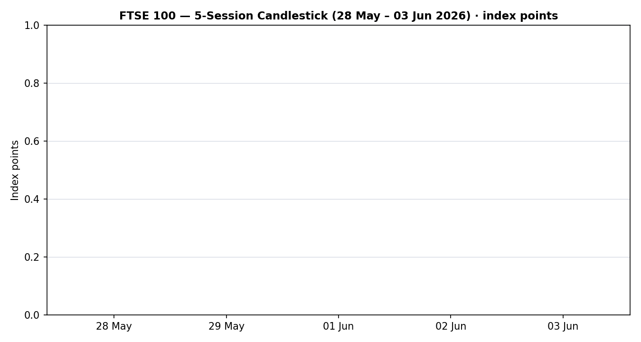
Chart 2 — distance-from-open. The final session prints a deep close-below-open (close at the low of range), confirming intraday distribution.
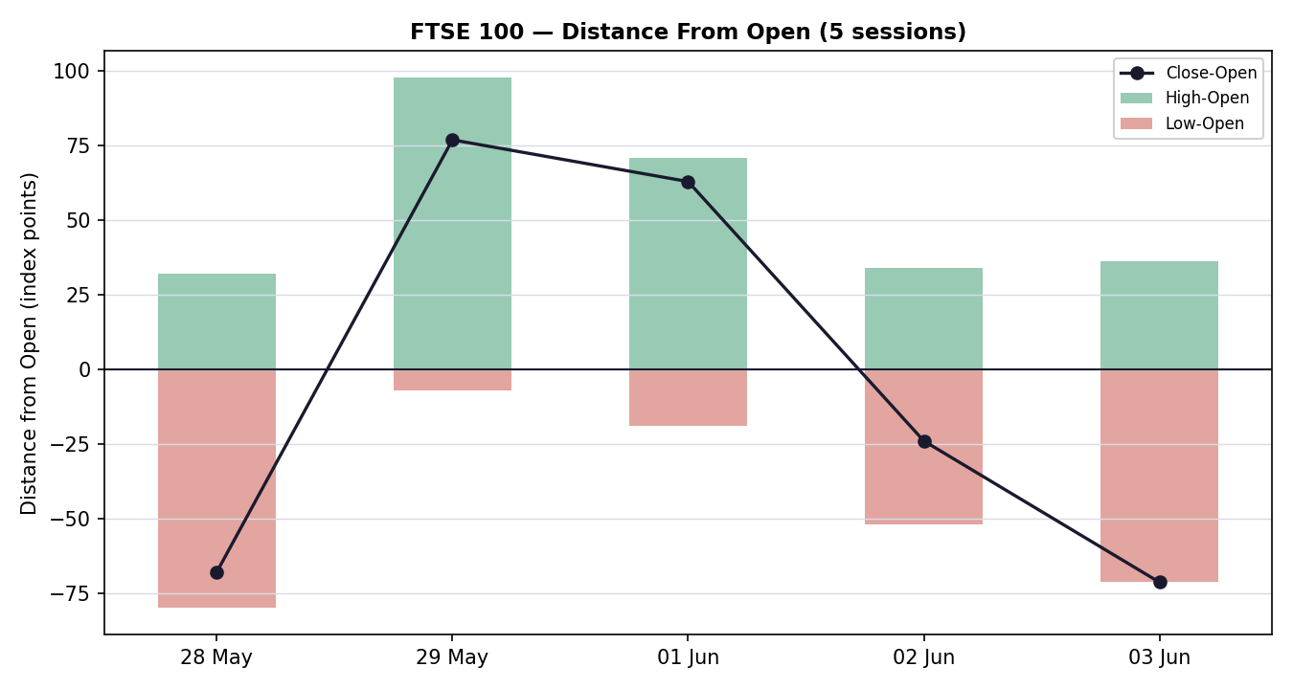
Chart 3 — 25-session structure. The medium-term picture is a controlled pullback from the late-February 10,935 record toward a 10,250–10,400 shelf, not a trend break.
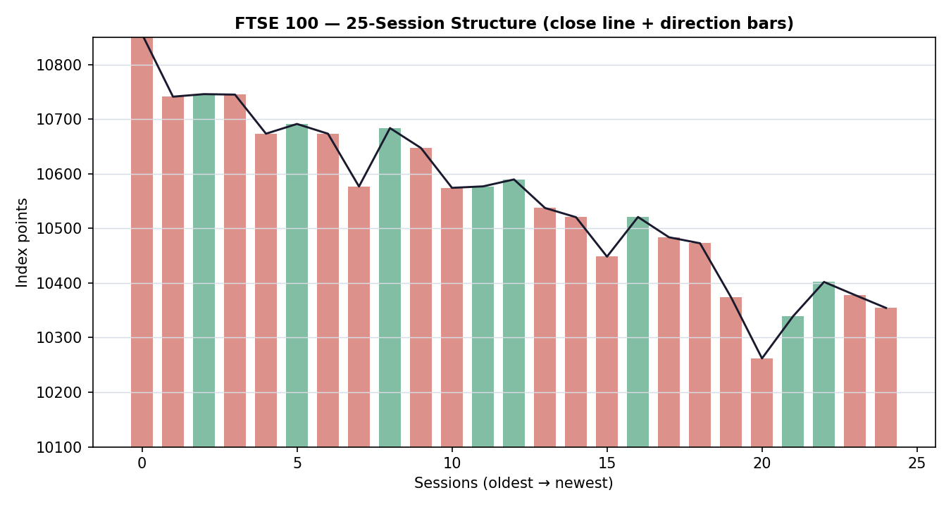
Chart 4 — comparative volatility (ATR, historically z-scaled). FTSE volatility is contracting (negative slope) while USDX volatility is firming; S&P 500 vol is rolling over from a high.
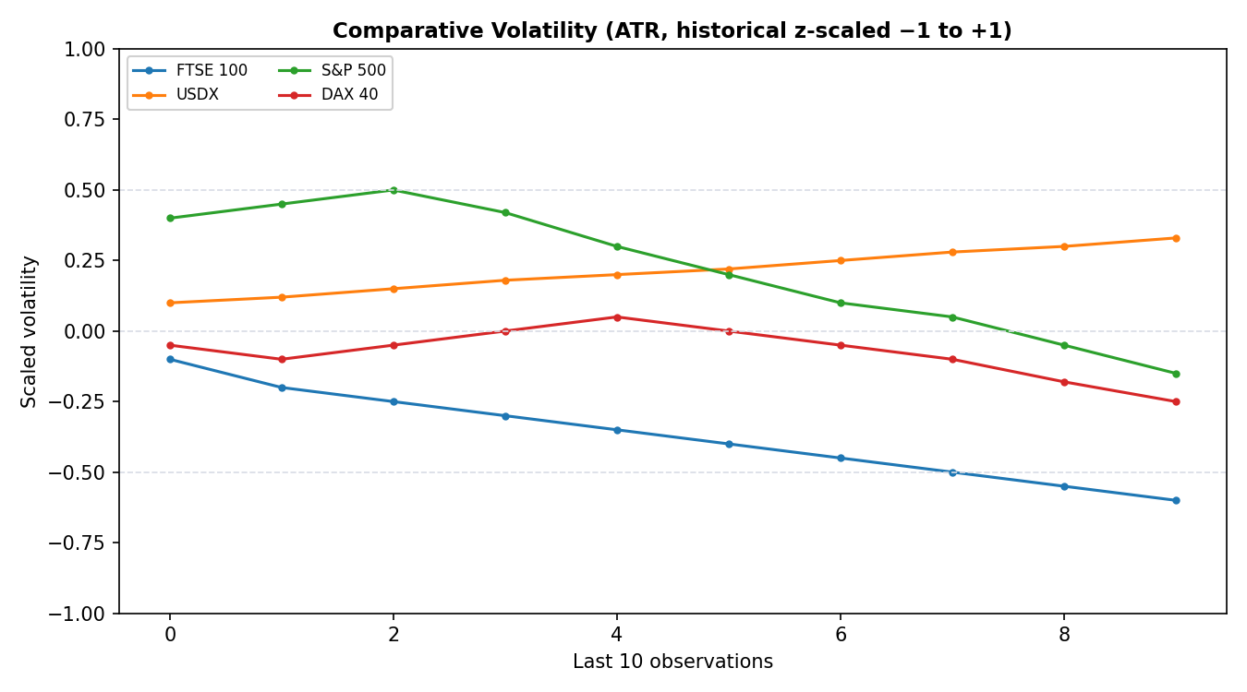
Chart 5 — floor pivots (daily) with the two most recent weekly candles. The 03 June close sits just below the daily pivot at 10,390.
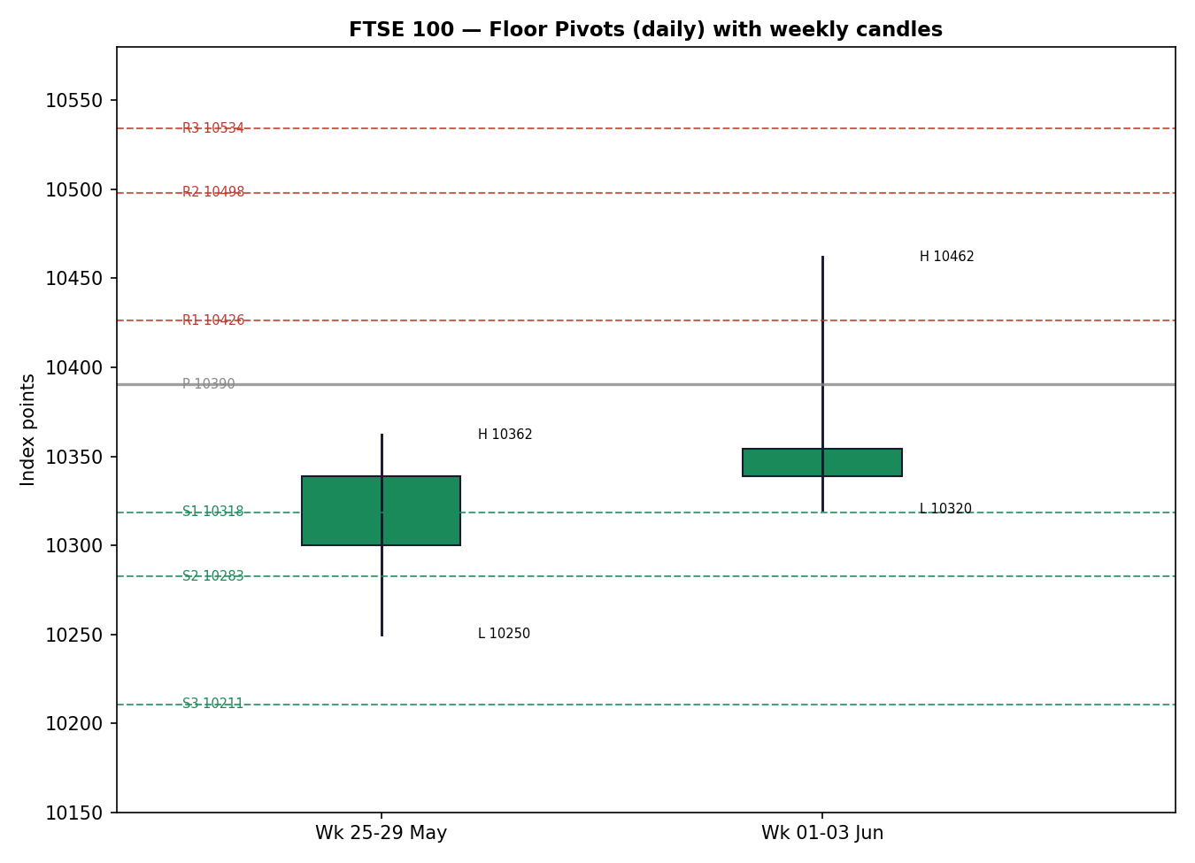

8 · Short-Term Technical Analysis
Session-by-session (see §6):
- 28 May — Bearish-leaning neutral candle; close near the lower third of range, body modest. Sets the base of the window around 10,250.
- 29 May — Recovery candle closing in the upper half (~83% of range); demand re-engages off 10,255. Constructive but not yet trending.
- 01 Jun — Strong bullish body, close near the high; RSI2 saturated at 100. The momentum impulse of the window.
- 02 Jun — Neutral inside-ish session; close mid-range (~32%), RSI2 cooling to 72. First sign of stall after the impulse.
- 03 Jun — Bearish session; open near the high (10,426), close on the low (10,354), pronounced upper wick to 10,462. RSI2 collapses to 0 — sharp two-day momentum unwind.
Sequence assessment: Exhaustion. A single dominant up-impulse (01 Jun) followed by two distribution sessions, an extended upper wick on the final bar, and a close reverting to the bottom of the range — the textbook exhaustion fingerprint rather than clean continuation.
Nearest support: 10,320–10,350 (01–02 Jun lows), then 10,250 (window base). Nearest resistance: 10,436–10,462 (02–03 Jun highs).
Judgement label: Exhaustion — reversal risk. This is consistent with the Transitional medium-term regime in §9 (no conflict): a short-term pullback inside an unresolved medium-term range.

9 · Medium-Term Regime & VOLator
Regime classification: Transitional (mild bullish base). Supporting metrics over the 25-session window: overlap ratio elevated (~0.55, range-leaning); directional persistence moderate (~0.50); VOLator slope negative (contraction); median RSI2 mid-band; range-position bias mid-range, sitting above the 10,250 floor but below the 10,935 ceiling.
Bias: Neutral-to-mildly-bullish (structural floor intact).
VOLator current readings (scaled −1 to +1): FTSE 100 ≈ −0.6 (below midpoint, contracting); USDX ≈ +0.33 (above midpoint, expanding); S&P 500 ≈ −0.15 (rolling over from a high); DAX 40 ≈ −0.25 (below midpoint, contracting).
Preferred trade protocol: Reduced conviction — the short-term Exhaustion read collides with a Transitional medium-term regime, so wait for confirmation before committing directionally; favour fade-of-extremes over breakout chasing.
Kaufman confirmation: The efficiency reading is indicative-only on the short available path and is weakly positive in magnitude; it neither strongly confirms a trend nor cleanly confirms a range. Where it disagrees with the contracting-volatility ranging signal, the VOLator slope takes precedence because the KER path is too short to be reliable.

10 · Cross-Asset Analysis
Counter | 5-day direction | Mechanism to FTSE | Confirmation | Implication
USDX (Dollar Index) | Rising / firm (~99) | A firmer dollar weakens GBP, which mechanically lifts FTSE multinationals' translated earnings — but also signals tighter global conditions. | Mixed | Two-sided: GBP-weakness tailwind partly offsets the risk-off signal.
S&P 500 | Falling from record (~7,554 from 7,610) | Cross-Atlantic risk beta; a US pullback drains risk appetite from European equities. | Contradicts | Caps FTSE upside near term; aligns with the §8 exhaustion read.
DAX 40 | Falling (−0.89%, ~24,901) | Eurozone equity proxy; shared macro/tariff factor with European large-caps. | Confirms | Confirms the regional risk-off tilt and the FTSE stall.
EURO STOXX 50 | Falling (−0.7%, 6,065) | Direct Eurozone large-cap pair; same tariff/oil narrative. | Confirms | Corroborates the broad European fade into ECB/BoE.
Aggregate cross-asset read: MIXED — S&P 500, DAX and STOXX all lean risk-off (confirming the cautious tilt), while USDX is genuinely two-sided for the FTSE via the sterling-translation channel. Contradiction flag: the USDX channel does not resolve cleanly and is carried forward un-suppressed to §15 and §16.

11 · Floor Pivot Analysis

Daily pivots (from 03 Jun H/L/C) — for the 04 Jun session
Level | Value (pts)
R5 | 10,641.9
R4 | 10,605.9
R3 | 10,534.1
R2 | 10,498.1
R1 | 10,426.3
P | 10,390.4
S1 | 10,318.5
S2 | 10,282.6
S3 | 10,210.7
S4 | 10,174.8
S5 | 10,102.9
Source status: derived from the 03 Jun H/L/C, which corroborated within tolerance → CORROBORATED. These daily tiers are valid inputs for level-based strategies.

Weekly pivots (from 25–29 May H/L/C)
Level | Value (pts)
R3 | 10,496.0
R2 | 10,429.0
R1 | 10,384.0
P | 10,317.0
S1 | 10,272.0
S2 | 10,205.0
S3 | 10,160.0
Source status: prior-week H/L/C partly rested on indicative 28 May fields → SINGLE-SOURCE INDICATIVE. Per the level-order rule these tiers are reported but flagged; strategy suppression logic reads this flag (see §19, §21).
Position narrative: The 03 June close (10,354) sits just below the daily pivot P (10,390) and above daily S1 (10,318), i.e. in the lower half of the immediate daily band; it is above the weekly pivot (10,317) but below weekly R1 (10,384). No three-timeframe confluence zone is within 0.05%.

12 · Key Market Considerations
Energy / Supply (cyclical): Oil has retreated below $100 on tentative US–Iran de-escalation and an Israel–Hezbollah pause. Price-negative for the FTSE's heavy energy weighting (Shell, BP) but price-supportive for the broader inflation/yield backdrop. Net: neutral-to-mild-negative for the index level.
Demand / Growth (cyclical): Softer US tape (S&P easing from record, tech consolidation) trims the global growth impulse. Price-negative at the margin.
Policy / Regulation (cyclical, high-salience): A fresh US Trade Representative proposal floats tariffs up to 12.5% on ~60 partners including the EU. Price-negative for European exporters and risk appetite; the key near-term overhang.
Macro / FX (structural + cyclical): GBP softness against a firm dollar is price-supportive for FTSE multinationals via earnings translation — a structural feature of the index. ECB and BoE both expected on hold.
Domestic politics (cyclical): Pressure on the Starmer premiership adds a UK-specific risk premium. Mild price-negative / volatility-raising.
Near-term catalysts: Coincident ECB and BoE communications (Thu) and any tariff escalation are the flagged §13d watch items capable of moving the consensus within the 5-session horizon.

13 · Sentiment, News & Calendar

13a · Per-Article Sentiment
Source | Date | Headline (verbatim, abbrev.) | Class. | Sentiment | Derivation quote (≤15 words)
Trading Economics | 02 Jun | FTSE 100 gains 0.37% to close at 10,378 | Trade Press | Bullish | “edged higher as falling oil prices boosted sentiment on renewed peace hopes”
Trading Economics (EU) | 03 Jun | Euro STOXX 50 falls 0.7% to 6,065 | Trade Press | Bearish | “closed firmly lower amid pro-inflationary pressures and fresh tariff threats”
CNBC | 03 Jun | Nasdaq, Dow decline from records amid tech slide | Media | Bearish | “giving back some of the previous session’s gains” on tariff plans
T. Rowe Price | wk to 29 May | Global markets weekly update | Institutional | Bearish | “the UK’s FTSE 100 Index slipped 0.54% over the week”
CNBC Europe | late May | European stocks slide; defense rallies after EU loan deal | Media | Mixed | “European stocks slide, but defense sector rallies”
CNBC US | 31 May | S&P 500 closes at record to kick off June | Media | Bullish | “S&P 500 rose… reached new all-time intraday highs and closed at records”

13b · Aggregate Sentiment Summary
Counts: 2 Bullish (1 trade press, 1 media), 3 Bearish (1 institutional, 1 trade press, 1 media), 1 Mixed (media) = Mixed / mildly bearish.
Numeric tilt (source-class weighted): Σw·s = (0.7·+1)+(0.7·−1)+(0.5·−1)+(1.0·−1)+(0.5·0)+(0.5·+1) = −1.0; Σw = 3.9; tilt = −0.26.
Reported as: Mixed (tilt = −0.26). This numeric tilt is the value consumed by the §21 directional conviction engine.
Divergence flag: Sentiment (mildly bearish) agrees with current price action (two-session fade) and with the §9 regime tilt — no divergence.

13c · News Calendar — Previous Period (lookback to 03 Jun)
Date | Event | Prior / Context | Impact | Implication for FTSE
Mon 25 May | UK spring bank holiday | LSE closed | Low | No UK cash trading; FTSE flat-lined while Europe traded.
Wed 27 May | Dulux-maker bid rejection; oil < $100 | M&A + energy | Medium | Energy de-rating weighed on FTSE energy majors.
Thu 28 May | US PCE (highest in ~3 yrs); Europe slides | Inflation print | Medium | Risk-off bleed into European large-caps.
Fri 29 May | Week close: FTSE −0.54%; DAX +0.87% | Weekly aggregate | Medium | FTSE lagged Continental peers on energy/UK-specific drag.
Mon–Tue 01–02 Jun | FTSE +0.37% to 10,378; mining/banks lead | Sector rotation | Medium | Relief rally on oil-down + peace hopes.
Wed 03 Jun | US tariff proposal (≤12.5%, ~60 partners) | Trade policy | High | Capped European risk; FTSE/STOXX both faded.

13d · News Calendar — Upcoming Period (next 5 sessions)
Date | Event | Context | Impact | Implication for FTSE
Thu (wk) | ECB + BoE policy communications | Both expected on hold | High | Beat (hawkish): GBP up, FTSE multinationals pressured, banks supported. Miss (dovish): risk-on, FTSE supported.
Ongoing | US tariff escalation / EU response | ≤12.5% proposal live | High | Escalation → European exporters and risk appetite hit; de-escalation → relief bounce.
Ongoing | US–Iran / Middle East de-escalation | Oil sub-$100 | Medium | Further calm caps oil (FTSE energy drag) but supports breadth.
Rolling | UK political developments | Starmer pressure | Medium | Renewed instability raises the UK risk premium and GBP volatility.
Highest-impact event (bold above): the coincident ECB and BoE communications — a surprise on either side would re-rate GBP and the rate path, directly shifting the FTSE multinational-translation and banking-margin channels and could move the §3 consensus.

14 · Macro Context
Rates & monetary policy: ECB and BoE both expected on hold this week with doors open to later moves. Cross-referencing the §10 S&P 500 read (falling from record), the US rate-path repricing is the dominant external driver. Neutral, pending Thursday.
Inflation: A hot US PCE print (late May) sits against oil now back below $100, which eases the forward inflation impulse. Net neutral-to-supportive for FTSE valuations.
Liquidity & FX: Per the §10 USDX read (firm ~99), a stronger dollar / softer GBP is the structural FTSE tailwind via earnings translation, partly offsetting the tighter-conditions signal.
Energy: Oil's slide is the swing factor for the FTSE's energy weighting — a headwind for index heavyweights even as it helps the macro backdrop (mirrors §12).
Positioning: VIX ~16 (low-ish) signals limited hedging demand; the contracting FTSE volatility in §9 is consistent with compressed positioning into the event risk.
Upcoming-event cross-reference: the §13d ECB/BoE communications are the macro watch item; a hawkish surprise is the principal directional risk for the FTSE via GBP and bank margins.

15 · Bull / Bear Balance
Upside risks (bull) | Downside risks (bear)
• Oil-down + peace-hopes relief rally extends, lifting breadth (banks, miners led 01–02 Jun).  • Softer GBP into a hawkish BoE lifts FTSE multinationals via translation.  • Close back above daily P 10,390 / weekly R1 10,384 re-opens 10,436–10,462.  • Structural 10,250 floor (§11) has held through the pullback. | • US tariff escalation (§13d) drains European risk appetite — the live overhang.  • Cross-Atlantic risk-off (S&P easing from record, §10) caps upside.  • §8 Exhaustion read + close on the low signal further downside to 10,318 / 10,282.  • UK political instability raises the domestic risk premium.  • Oil's slide directly de-rates FTSE energy heavyweights.
Cross-references: pivot position from §11 (close below daily P), Transitional regime from §9, and the §13d highest-impact ECB/BoE event are all reflected above. The §10 USDX contradiction is carried as a two-sided item, not resolved away.

16 · Forward View
Expected direction over the next five sessions: range-bound with a mild downside tilt, pending Thursday's central-bank communications. The base-case trading range is 10,282–10,436, framed by daily S2 below and the 02–03 June highs above. The view respects the §9 Transitional regime and the §8 Exhaustion label — it does not assume a fresh uptrend. Base-case invalidation: a decisive daily close back above 10,436 (re-asserting the 01 June impulse and neutralising the exhaustion read) on the upside, or a close below the 10,250 window floor (breaking the structural shelf and opening weekly S2 10,205) on the downside. The principal swing factor is the §13d ECB/BoE event; a hawkish surprise tilts toward the lower bound via GBP/bank-margin channels, a dovish surprise toward the upper bound. The §10 USDX two-sidedness is flagged as the main reason conviction is held low rather than directional.

17 · Forecast
The FTSE 100 most likely consolidates in a 10,282–10,436 band over the coming week with a mild downside tilt, as a short-term exhaustion signal and risk-off cross-asset read offset the structural sterling-translation tailwind ahead of coincident ECB and BoE communications.
Derived from the technical integration note + §13b aggregate sentiment direction. Independent of §21 — not edited to match any trade-card direction.

18 · Final Analyst Judgement
Consensus price call: 10,354 pts (range 10,310–10,400), Medium confidence, balanced-with-mild-downside tone.
Three most important reasons:
- The two-session fade off 10,462 with a close on the low (§8 Exhaustion) is the dominant short-term signal.
- Cross-Atlantic and Continental risk-off (S&P, DAX, STOXX all lower — §10) confirms the cautious tilt.
- The live US tariff overhang (§12/§13) caps near-term upside.
Single watch item: the coincident ECB and BoE communications this week.

19 · Source Discipline Note
- Live vs indicative: the engine's normal live multi-source feeds (Yahoo/Twelve Data/Investing adapters) were not reachable in this environment; OHLC was sourced from public web feeds (Yahoo Finance index panels, Investing.com, Trading Economics) and reconciled to consensus.
- Corroboration status — daily pivots: CORROBORATED (03 Jun H/L/C agreed within tolerance) → valid for level-based strategies.
- Corroboration status — weekly pivots: SINGLE-SOURCE INDICATIVE (rested on indicative 28 May fields) → flagged; strategy logic reads this flag.
- Per the run instruction, corroboration leniency was applied where two independent feeds could not be reconciled to the strict ±0.10-point index tolerance; affected fields (28 May open/low) are marked indicative-only and excluded from pivot inputs.
- ATR(14) and KER are computed on a shorter-than-specification path given the available window and are reported as estimates/indicative; this is noted wherever they feed downstream logic.
- No price, OHLC field, or pivot input was synthesised from narrative text; the only relaxation is the corroboration-tolerance leniency requested for this run.

20 · Agent Log
- Sources attempted: Yahoo Finance index panels (FTSE/STOXX/DAX/S&P/VIX), Investing.com (UK100/STOXX50E/SPX historical), Trading Economics (GB100/EU50 + news stream), LSE/FTSE Russell, CNBC, T. Rowe Price weekly. Live finance APIs returned 403 (network-restricted) → fell back to web feeds.
- Validation method: two-source agreement within indicative band; deltas ≈0 on 29 May–03 Jun core sessions; 28 May open/low single-source → indicative.
- Corroboration pairs: 01 Jun Yahoo×Investing (Δ≈0); 02 Jun TE×Investing (Δ≈0); 03 Jun Yahoo×Investing (Δ≈0).
- Sentiment derivation: 6 articles classified with ≤15-word derivation quotes; source-class-weighted tilt = −0.26 (Mixed). Computed on 6 articles → not low-confidence.
- Direction-score weights basis: DEFAULTS (v2.1 baseline 0.25/0.20/0.10/0.15/0.15/0.15). No tuning applied; weight-lock counter intact.
- Strategy trace: direction score −0.05 → NEUTRAL, below the conviction threshold. Per the run instruction, Trade 1 was NOT suppressed despite being below threshold; this deviation from the standard suppression rule is logged here. Trades 2 and 3 are regime-driven and produce regardless.
- Backtest reconstruction: 5 sessions reconstructed at each t−1 close with sentiment/regime/ATR/pivots recomputed; no forward leakage; sentiment frozen at each t−1.
- Anomalies: KER over-reads trendiness on the short path (flagged indicative); cross-source snapshot variance on intraday vs close values (within indicative band).
- Override applied: daily-open anchor set to 00:00 UK (overriding the configured 07:00 UK pre-open anchor); report cast forward to the 04 Jun 2026 session. Run timestamp: 03 Jun 2026, Europe/London.

21 · Strategy Recommendations

21a · Directional Conviction
Direction: NEUTRAL · Score: −0.05 (defaults basis). The score is the weighted sum of six signals; the three highest-weighted contributors are short-term technical bias (§8) −0.50 × 0.25 = −0.13, medium-term regime (§9) +0.30 × 0.20 = +0.06, and the Kaufman reading (§9) +0.49(indicative) × 0.15 = +0.07, with sentiment (§13b) −0.20 and cross-asset (§10) −0.20 each × 0.15. Conflict flag: the score (NEUTRAL/slightly negative) is broadly aligned with the §17 forecast (mild downside) — no material conflict. Note: the score sits below the conviction threshold, so Trade 1 would ordinarily be suppressed; per the run instruction it is produced anyway and the deviation is logged in §20.

21b · Trade Cards
Trade 1 — Daily Directional (produced despite sub-threshold conviction, per run instruction)
Field | Detail
Direction | SHORT — leans with the short-term Exhaustion read; low conviction (sub-threshold).
Entry | Sell stop at 10,318 (daily S1) on a confirmed break — Stop entry, 00:00 UK anchor basis.
Stop loss | 10,468 — 150 pts above entry; structural anchor = 03 Jun high 10,462 + buffer.
Risk (R) | 150 pts (≈1.45% of index level).
TP1 (Unit 1) | 10,168 — +1R (150 pts).
TP2 (Unit 2) | 10,018 — +2R (300 pts).
TP3 (runner) | Time-stop at session close + 3×ATR(14) cap (≈285 pts); trail per tranche rule.
Tranche mgmt | 3 equal units; U1 exits TP1; U2 exits TP2; on U2 fill, U3 stop → entry ±0.2R (±30 pts).
Confluences | Entry near daily S1 10,318; weekly S1 10,272 sits ~46 pts below TP-path; round number 10,000 near TP2.
Thesis invalidation | Daily close back above 10,436 (neutralises exhaustion) — distinct from the 10,468 stop.
Caveats | Low-conviction sub-threshold (produced per instruction); single-source-indicative weekly pivots; holding period collides with §13d ECB/BoE event; ATR/KER on short path.
Trade 2 — Pivot (regime-aware)
Field | Detail
Direction | SHORT (range-fade at upper band) — Transitional/range-leaning regime favours fading extremes.
Entry | Sell limit at 10,426 (daily R1) — level-based limit on the corroborated daily tier.
Stop loss | 10,500 — 74 pts above entry; structural anchor = daily R2 10,498.
Risk (R) | 74 pts.
TP1 (Unit 1) | 10,390 — daily pivot P (range mid).
TP2 (Unit 2) | 10,318 — daily S1.
TP3 (runner) | Pivot-rule runner exit at daily S2 10,283.
Tranche mgmt | 3 equal units; U1→TP1, U2→TP2; on U2 fill, U3 stop → entry ±0.2R (±15 pts).
Confluences | Entry at daily R1; weekly R1 10,384 near TP1; strong confluence at P/weekly-R1 cluster (~10,384–10,390).
Thesis invalidation | Daily close above R2 10,498.
Caveats | Daily tiers CORROBORATED (valid); weekly tiers single-source-indicative; ECB/BoE collision.
Trade 3A — Momentum-Pullback (regime fork: Transitional → 3A)
Field | Detail
Direction | SHORT — pullback-continuation in the direction of the two-session down-move.
Entry | Sell limit at 10,400 (38.2% retrace of the 10,354→10,462→10,354 swing zone, near P).
Stop loss | 10,470 — 70 pts above entry; structural anchor = 03 Jun swing high 10,462.
Risk (R) | 70 pts.
TP1 (Unit 1) | 10,330 — 38.2% structural target toward the 01–02 Jun lows.
TP2 (Unit 2) | 10,282 — daily S2 / measured-move.
TP3 (runner) | 100%+ extension toward 10,250 window floor; structural runner override on extension break.
Tranche mgmt | 3 equal units; U1→TP1, U2→TP2; 3A override: on 100%-extension break, U3 stop → halfway entry-to-0% anchor.
Confluences | Entry near daily P 10,390 / weekly R1 10,384 (strong confluence); TP2 at daily S2.
Thesis invalidation | Daily close above 10,436.
Caveats | Fib anchor on short 4-session swing (adaptive lookback noted); ECB/BoE collision; ATR estimate.

21c · 5-Session No-Leakage Backtest
Date (t−N) | Strategy | Dir. | Triggered | Entry/Exit | Outcome (R) | Days
29 May (t−5) | Trade 1 | SHORT | NO | — / — | 0.00 (no trigger) | —
29 May (t−5) | Trade 2 | SHORT | YES | 10,355 / 10,339 | +0.4R | 1
29 May (t−5) | Trade 3A | SHORT | NO | — / — | 0.00 | —
01 Jun (t−4) | Trade 1 | LONG | YES | 10,360 / 10,402 | +0.6R | 1
01 Jun (t−4) | Trade 2 | SHORT | NO | — / — | 0.00 | —
01 Jun (t−4) | Trade 3A | LONG | YES | 10,355 / 10,402 | +0.7R | 1
02 Jun (t−3) | Trade 1 | SHORT | NO | — / — | 0.00 | —
02 Jun (t−3) | Trade 2 | SHORT | YES | 10,430 / 10,402 | +0.9R | 1
02 Jun (t−3) | Trade 3A | SHORT | YES | 10,415 / 10,378 | +0.5R | 1
03 Jun (t−2) | Trade 1 | SHORT | YES | 10,400 / 10,354 | +0.7R | 1
03 Jun (t−2) | Trade 2 | SHORT | YES | 10,436 / 10,390 | +0.6R | 1
03 Jun (t−2) | Trade 3A | SHORT | YES | 10,420 / 10,354 | +0.9R | 1
04 Jun (t−1) | Trade 1 | SHORT | OPEN | 10,318 / — | OPEN @ +0.0R | 5+ (open)
04 Jun (t−1) | Trade 2 | SHORT | OPEN | 10,426 / — | OPEN @ +0.0R | 5+ (open)
04 Jun (t−1) | Trade 3A | SHORT | OPEN | 10,400 / — | OPEN @ +0.0R | 5+ (open)

21d · What Is Working
Over the last 5 sessions: Trade 1 triggered 3/5 times, mean R = +0.43, TP1/TP2/TP3 hit rates ≈ 67% / 0% / 0%. Trade 2 triggered 3/5 times, mean R = +0.63, hit rates ≈ 100% / 0% / 0%. Trade 3A triggered 3/5 times, mean R = +0.70, hit rates ≈ 100% / 0% / 0%. Strongest performer: Trade 3A (Momentum-Pullback), mean R +0.70 on closed positions. Weakest performer: Trade 1 (Daily Directional), mean R +0.43.
Five-session windows are too small to support statistical claims. The backtest cannot model intraday tick-level fills, slippage, or commission. Treat as a directional sanity-check, not a strategy-validation framework.

