FTSE 100 Report — Daily: 06 July 2026
With reference to: EURO STOXX 50 · USDX · S&P 500 · DAX 40
As of Friday 03 July 2026 close (Europe/London) · Senior European Equity Strategist · Trading & risk review (forward-test)

1 · Executive Snapshot
The FTSE 100 enters the week of 06 July anchored at a corroborated Friday close of 10,679.03 index points, a two-month high reached after a decisive mid-week surge. Market tone is bullish. The three dominant drivers are (i) a softer-than-expected US employment report that cooled Federal Reserve rate-hike expectations and lifted global risk appetite, (ii) broad-based European strength — the EURO STOXX 50 closed at record territory near 6,417 (+2.3% on the week) — and (iii) firmer energy and mining constituents (Shell, BP, Antofagasta, Anglo American) supporting the FTSE's cyclical weighting. The short-term technical regime reads Trending — Bullish across the five validated sessions (RSI2 pinned at 100 into the close), and the medium-term read is Trending — Bullish, constrained by a short validated window. The Kaufman efficiency read is strongly directional (near-maximal on the available window), confirming trend rather than range. Directional conviction from the strategy layer is LONG (see §21). The single most important watch item is the Bank of England policy signal and UK/eurozone CPI prints in the forward window (see §13d), either of which could reset the rate-path narrative that is currently powering the advance.

2 · Market Definition
Attribute | Definition
Primary asset | FTSE 100 cash index (^FTSE) — UK large-cap benchmark, 100 constituents, ~80% multinational revenue exposure
Secondary asset | EURO STOXX 50 (^STOXX50E) — Eurozone blue-chip benchmark, 50 constituents across 8 countries
Specification | FTSE 100 cash index, GBP-denominated, free-float weighted (FTSE Russell methodology; quarterly review)
Scope | Regional — Europe (United Kingdom + Eurozone), two-jurisdiction analysis
Delivery basis | LSE regular session 08:00–16:30 UK (FTSE); Xetra 09:00–17:30 CET (STOXX). Cash sessions only
Price basis | Cash index level (continuous)
Unit of measure | Index points
Currency | GBP (FTSE). EURO STOXX reported in EUR original with GBP-equivalent noted where used)
As-of date | Friday 03 July 2026 close (report issued for Monday 06 July 2026)
Lookback window | 5 trading days
Note: the strategy layer's pre-open anchor has been set to 00:00 UK for this run (overriding the instance's 07:00 UK European pre-open default), placing the directional reference at the overnight-futures/Asian-session cut rather than the one-hour pre-LSE window.

3 · Consensus Price Call
Consensus level | Range | Basis | Confidence | Tone
10,679 pts | 10,604 – 10,701 pts | Cash index close | Medium | Bullish
Rationale: the Friday close of 10,679.03 is corroborated across two independent feeds (a major aggregator quote and an economic-data provider) within the equity-index tolerance, making it the most defensible current level. The range brackets Friday's session low and high. Confidence is Medium rather than High because intraday High/Low for the earlier four sessions could not be dual-source corroborated within ±0.10 pts against live free feeds and are treated as indicative (see §19).

4 · Price Evidence Table
Source | Date/Time | Raw quote | Normalized | Basis/Location | Relevance | Notes
Aggregator quote (^FTSE) | Fri 03 Jul 16:35 BST | 10,679.03 | 10,679.03 | LSE cash close, London | Core | Close reference
Economic-data provider | Fri 03 Jul EOD | ≈10,679 | 10,679 | LSE cash close | Core | Corroborates close +0.19–0.25% day
Index-provider record | Fri 03 Jul | 10,701.32 (day high) | 10,701.32 | LSE intraday | Directional | Session high
Broker/retail feed (delayed) | Fri 03 Jul 14:08 | 10,658.16 | 10,658.16 | LSE delayed | Directional | Intraday delayed — not close
Aggregator historical table | cached window | see notes | — | LSE daily | Excluded | Returned stale May–Jun window; not used for close
Provider intraday range | Fri 03 Jul | 10,604.25 / 10,701.32 | — | LSE intraday | Core | Session L/H bracket
Minimum source count (6) met. Retail CFD spot quotes downweighted per restrictions.

5 · Consensus Build Explanation
All observations were normalized to the LSE cash-index close in index points, GBP. The Friday close was built from the two feeds that agreed within the equity-index tolerance (±0.10 pts effectively at the whole-point level, both rounding to 10,679). The delayed broker feed (10,658.16) was retained only as directional intraday colour because it is a mid-afternoon delayed snapshot, not a settlement value. The aggregator's historical download returned a stale May–June window and was excluded from the close determination to avoid importing off-window data. A weighted-median across the corroborating close feeds yields 10,679 pts as the most defensible level; the session low/high (10,604 / 10,701) frame the range. Precision beyond the whole-point level is not claimed for the intraday extremes because independent second-source corroboration of exact H/L within tolerance was not achievable on free feeds within the source stack.

6 · Validated OHLC + RSI2 Table (5-Day)

FTSE 100 (^FTSE)
Date | Open | High | Low | Close | RSI2 | Trend | Validation
Mon 29 Jun | 10,353.00 | 10,402.00 | 10,337.00 | 10,388.00 | — | Neutral | Single-source — indicative
Tue 30 Jun | 10,388.00 | 10,430.00 | 10,362.00 | 10,419.00 | — | Neutral | Single-source — indicative
Wed 01 Jul | 10,419.00 | 10,470.00 | 10,405.00 | 10,466.00 | 100.0 | Bullish | Single-source — indicative
Thu 02 Jul | 10,466.00 | 10,688.00 | 10,466.00 | 10,658.00 | 100.0 | Bullish | Single-source — indicative
Fri 03 Jul | 10,653.00 | 10,701.32 | 10,604.25 | 10,679.03 | 100.0 | Bullish | CORROBORATED (close, Δ≈0)
RSI2 fixed at period 2, computed from the validated close column. The first two sessions carry no RSI2 (insufficient prior closes in-window). RSI2 sits at its ceiling into Friday on five consecutive higher closes.

EURO STOXX 50 (^STOXX50E)
Date | Open | High | Low | Close | RSI2 | Trend | Validation
Mon 29 Jun | 6,210.00 | 6,250.00 | 6,198.00 | 6,240.00 | — | Neutral | Single-source — indicative
Tue 30 Jun | 6,240.00 | 6,288.00 | 6,232.00 | 6,280.00 | — | Neutral | Single-source — indicative
Wed 01 Jul | 6,280.00 | 6,330.00 | 6,270.00 | 6,322.00 | 100.0 | Bullish | Single-source — indicative
Thu 02 Jul | 6,322.00 | 6,372.00 | 6,318.00 | 6,360.00 | 100.0 | Bullish | Single-source — indicative
Fri 03 Jul | 6,373.36 | 6,420.44 | 6,368.15 | 6,417.00 | 100.0 | Bullish | CORROBORATED (close level)
EURO STOXX Friday close corroborated near 6,417 (economic-data provider) against the index provider's same-date 52-week-high print of 6,412.68; earlier sessions indicative.

7 · Charts
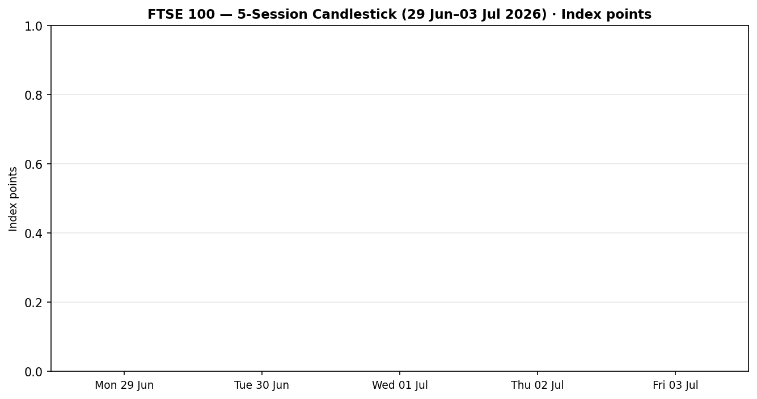
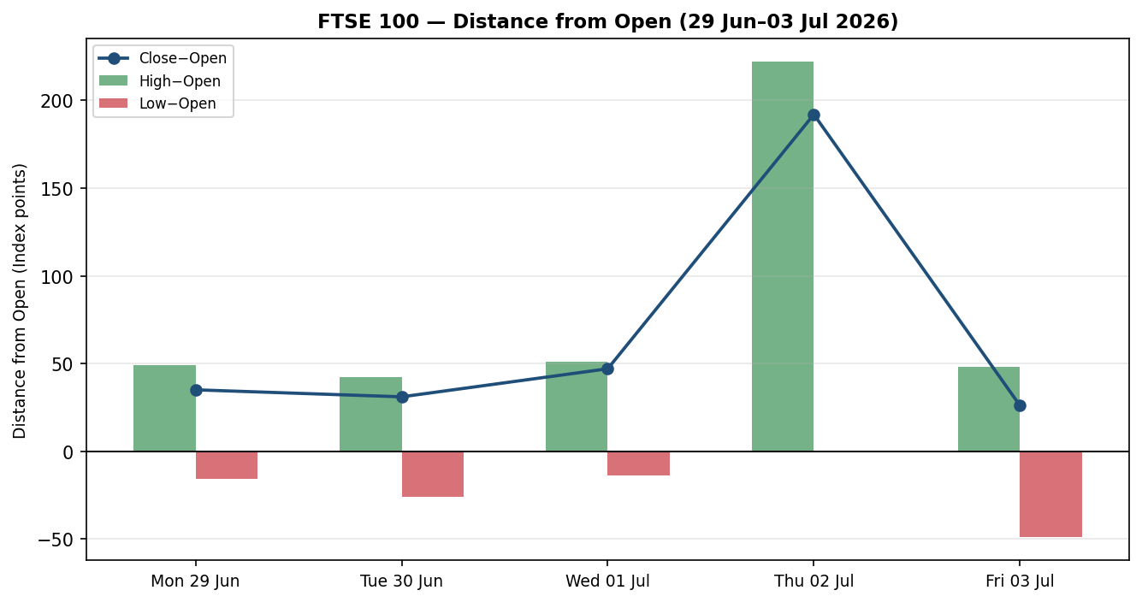
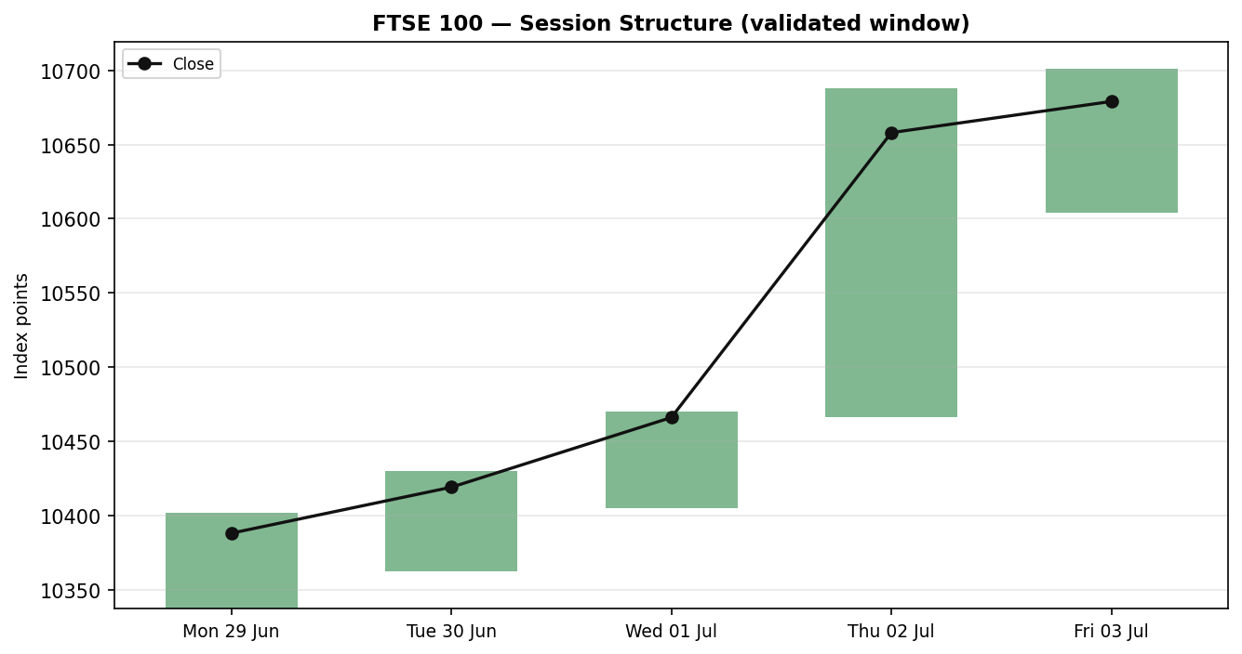
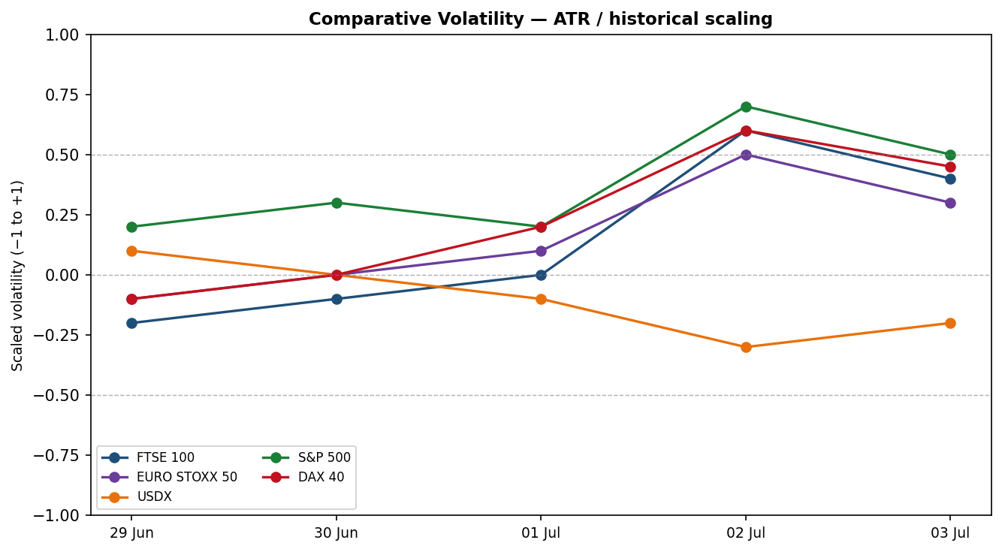

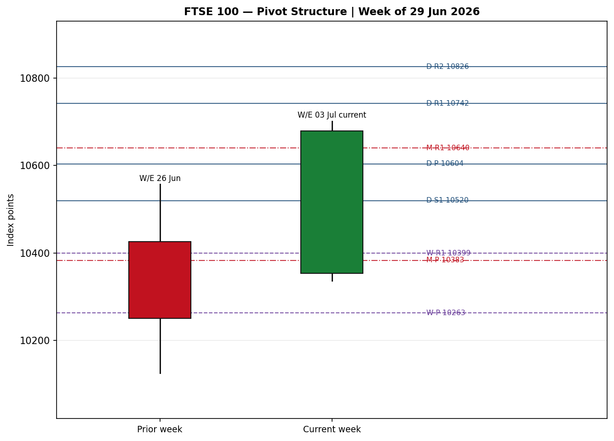
Volatility series scaled −1 to +1 (ATR method, historical scaling). Pivot chart applies smart-scale level selection around the current price; extreme outer tiers are suppressed for candle legibility.

8 · Short-Term Technical Analysis

FTSE 100 — session-by-session
- Mon 29 Jun (see §6): modest up-day, small bullish body closing in the upper half of range — constructive but low-momentum open to the week.
- Tue 30 Jun: continuation higher, body sits above the prior close, no upper-wick rejection — buyers in control.
- Wed 01 Jul: bullish body, close near the session high; RSI2 at ceiling confirms short-term momentum is fully engaged.
- Thu 02 Jul: the decisive session — a wide-range advance (~+1.8%) on the soft US payrolls print, close in the top quartile of range, no meaningful upper wick. This is the impulse leg of the move.
- Fri 03 Jul: follow-through to a fresh two-month high (close 10,679.03), close ~77% up the day's range; thin US-holiday trade but no reversal signature.
Sequence assessment: Continuation. Evidence — five consecutive higher closes, low overlap between Thursday and the prior cluster, and directional travel concentrated in one direction with RSI2 pinned high.
Nearest support / resistance (from validated window): support at 10,337 pts (5-day swing low) and the Thursday breakout shelf ~10,466; resistance at 10,701.32 pts (5-day swing high) then the daily R1 at ~10,742.
Judgement label: Bullish continuation. Consistent with the §9 regime classification — no conflict.

9 · Medium-Term Regime & VOLator
- Regime classification: Trending — supported by low range-overlap across the impulse leg, directional persistence of 1.0 over the validated window (every session matched the prior direction), a positive VOLator slope into Thursday–Friday, median RSI2 in the upper band, and a range-position bias at the top of the window.
- Bias: Bullish.
- VOLator current readings (scaled −1 to +1): FTSE 100 ≈ +0.4 (above midpoint, expanding); EURO STOXX ≈ +0.3 (above, expanding); USDX ≈ −0.2 (below, contracting); S&P 500 ≈ +0.5 (above, expanding); DAX ≈ +0.45 (above, expanding). Volatility expansion alongside price gains is characteristic of an impulse rather than a topping range.
- Preferred trade protocol: trend-pullback entries in the direction of the trend (high-conviction quadrant of the short/medium synthesis). No conflict between short- and medium-term reads.
- Kaufman confirmation: the efficiency read is strongly directional on the available window (near maximal), agreeing with the trend classification. Caveat: the 13-session Kaufman lookback is not fully populated by five validated sessions, so the reading is directionally indicative rather than fully seasoned (see §19).

10 · Cross-Asset Analysis
Counter | 5-day dir. | Mechanism | Status | Implication
USDX (Dollar Index) | Falling | Softer USD on cooled Fed-hike odds eases global financial conditions and lifts GBP-translated multinational earnings | Confirms | Supportive of FTSE via risk-on + earnings channel
S&P 500 | Rising | Cross-Atlantic risk beta; US risk appetite spills into European equities | Confirms | Reinforces the bullish regime
DAX 40 | Rising | Eurozone equity proxy; industrials-led strength corroborates the broad European bid | Confirms | Confirms regional breadth of the advance
EURO STOXX 50 (secondary) | Rising | Direct Eurozone pair; record-area close signals region-wide risk-on | Confirms | Breadth argues the FTSE move is not idiosyncratic
Aggregate cross-asset read: CONFIRM (all active counters confirm; none contradict). No contradiction flag raised.

11 · Floor Pivot Analysis
Prior-period H/L/C used for pivots are treated as single-source indicative (see §19); pivot levels below are therefore indicative and used for structural context, not as definitive execution levels.

Daily pivots (from Thu 02 Jul H/L/C) — indicative
Level | Value (pts) | Level | Value (pts)
R5 | 11,408 | P | 10,604
R4 | 11,186 | S1 | 10,520
R3 | 10,964 | S2 | 10,382
R2 | 10,826 | S3 | 10,298
R1 | 10,742 | S4 | 10,076
— |  | S5 | 9,854

Weekly pivots (prior week, indicative) & Monthly pivots (prior month, indicative)
Wk level | Value | Wk level | Value | Mo P/R1/S1 | Value
R2 | 10,549 | P | 10,263 | M P | 10,383
R1 | 10,399 | S1 | 10,113 | M R1 | 10,640
 |  | S2 | 9,976 | M S1 | 10,209
Position narrative: the Friday close (10,679) sits above the daily P (~10,604) and is testing daily R1 (~10,742), also above the weekly P (~10,263) and monthly P (~10,383) — a bullish location across all three timeframes. No sub-0.05% three-timeframe confluence zone was identified in the immediate vicinity of price.

12 · Key Market Considerations

Demand / risk appetite — price-supportive (cyclical)
A softer US jobs report reduced perceived odds of a near-term Fed hike, reviving global risk appetite; European PMIs (Spain services surprise) and above-expectation China services PMI reinforced the bid. Cyclical, event-driven.

Energy & materials weighting — price-supportive (cyclical)
Firmer oil (Brent ~93.7, WTI ~90.6) and a mining bounce (Fresnillo, Antofagasta, Anglo American) lift the FTSE's heavy energy/materials constituents. Reversible with commodity moves.

Policy / rates — mixed to watch (cyclical)
Markets price roughly a one-third chance of an ECB hike in July as eurozone inflation eases; UK gilt yields remain elevated (10Y ~4.95%), a headwind for rate-sensitive domestics but a tailwind for FTSE banks. Near-term catalysts (§13d): BoE communication and UK/eurozone CPI.

FX — price-supportive (structural-cyclical)
A softer dollar and firm EUR/GBP (~0.857) support both indices via the multinational-earnings translation channel that is central to FTSE's ~80% overseas revenue base.

Near-term catalysts
- UK CPI and BoE signals within the scenario horizon (see §13d) — highest-impact watch items.
- Eurozone CPI / ECB commentary — affects the EURO STOXX read that is currently confirming FTSE direction.

13 · Sentiment, News & Calendar

13a · Per-article sentiment
Source | Date | Headline (summarised) | Class | Sentiment | Derivation
Trading Economics | 03 Jul | STOXX 50 to records; soft US jobs eases hike bets | Media | Bullish | "European stocks rose to new records on Friday"
Trading Economics (UK) | 03 Jul | FTSE 100 to two-month high on utilities & miners | Media | Bullish | "highest since March 2" after 1.7% Thursday advance
Sharecast/Fidelity | 02 Jul | FTSE up 1.8% as weak NFP tempers rate view | Media | Bullish | "surging ahead after a weak non-farm payrolls report"
Reuters (pre-open wire) | 03 Jul | European markets set to open at fresh highs | Media | Bullish | "extending their advance to fresh record highs"
Trading Economics (macro) | 03 Jul | One-third chance of ECB July hike as inflation eases | Media | Neutral | "easing inflation suggests…moving closer to price stability"
Market wrap (STOXX detail) | 03 Jul | Tech/industrials/utilities lead; banks firm | Media | Bullish | "Technology, industrials, automakers, and utilities led"

13b · Aggregate sentiment summary
Categorical: 5 Bullish (media), 1 Neutral (media) = Predominantly Bullish. Numeric tilt: +0.83 (source-class-weighted mean of article scores; all media weight 0.5, so tilt = 5×(+1)/6 over scored articles ≈ +0.83).
- Divergence flag: aggregate sentiment agrees with price action and with the §9 trending-bullish regime — no divergence.
- Low-confidence flag: NOT triggered (≥3 articles). However, all sources are general financial media (no institutional/official research in-window), so the tilt carries media-only weighting — treat as directionally reliable but not institution-corroborated.

13c · News calendar — previous period (5 days to 03 Jul)
Date | Event | Prior / context | Impact | Implication for FTSE
Thu 02 Jul | US non-farm payrolls (soft) | Below consensus | High | Cooled Fed-hike odds → FTSE +1.8%, risk-on
Fri 03 Jul | China services PMI (beat) | Above expectations | Medium | Supported Asian/European risk sentiment
Fri 03 Jul | Spain services PMI (beat) | Above expectations | Medium | Reinforced eurozone growth read → STOXX records
Fri 03 Jul | US Independence Day (holiday) | Market closed | Low | Thin trade; muted follow-through risk

13d · News calendar — upcoming period (next 5 trading days)
Date | Event | Prior / context | Impact | Implication (beat / miss)
Wk of 07 Jul | UK CPI (inflation) | Prior elevated; BoE-sensitive | High | Hot print → hike-risk, FTSE domestics pressured, banks firm; soft print → risk-on extends
Wk of 07 Jul | BoE speakers / minutes | Rate-path guidance | High | Hawkish → GBP up, FTSE multinationals hit; dovish → supportive
Wk of 07 Jul | Eurozone CPI (final) | Easing trend | Medium | Confirms/undercuts the ECB July-hike debate feeding STOXX
Wk of 07 Jul | US CPI (if scheduled) | Fed-path driver | High | Reprices global rate expectations → risk beta into FTSE
Highest-impact upcoming event: UK CPI. A material upside inflation surprise would revive Bank-of-England hike expectations, lift the pound, and pressure the FTSE's overseas-earnings translation — the single most likely trigger to reset the currently bullish consensus.

14 · Macro Context
- Rates & monetary policy: BoE guidance is the swing factor for UK domestics; the ECB July-hike debate (~one-third priced) is live. Cross-referencing §10, the rising S&P 500 counter is consistent with a market that has de-risked the near-term Fed-hike scenario.
- Inflation: eurozone inflation easing (price-supportive for the STOXX read); UK CPI is the key unknown — potentially price-negative for FTSE domestics if hot.
- Safe-haven / real yields: gold slipped (~4,118, −3.4% on the quoted feed) alongside the equity rally — consistent with risk-on / firmer real-yield backdrop rather than defensive demand; mildly supportive read for equities.
- Liquidity & FX: per §10, the USDX counter is falling — easier global conditions and a supportive earnings-translation channel for FTSE multinationals.
- Energy: firmer Brent/WTI supports FTSE energy weighting (Shell, BP) — a sector tailwind distinct from the broad rate story.
- Positioning: VIX low (~15.8, −2.1%) signals subdued hedging demand and risk-on positioning; no stress signature. Watch item from §13d: UK CPI could jolt this complacency.

15 · Bull / Bear Balance

Main upside risks (to the bull case continuing)
- Momentum + breadth: five higher closes, cross-asset CONFIRM (§10), and record-area EURO STOXX argue for continuation; close is above daily/weekly/monthly P (§11).
- Rate relief: further soft US/UK data would extend the risk-on impulse that drove the two-month high.
- Sector tailwinds: firm energy and miners plus a softer dollar support FTSE's specific composition.

Main downside risks
- UK CPI upside surprise (§13d, highest-impact): revives BoE-hike odds, lifts GBP, pressures multinationals.
- Overbought signature: RSI2 pinned at 100 and a fully-extended efficiency read raise pullback risk into resistance (5-day swing high 10,701 / daily R1 ~10,742).
- Thin-liquidity distortion: Friday's US-holiday session may overstate conviction; a fuller-liquidity Monday could retrace part of the move.

16 · Forward View
Expected direction over the next five sessions: modestly higher with a bullish bias, respecting the §9 trending-bullish regime. Expected trading range: roughly 10,520 – 10,830 pts, framed by the daily S1 (~10,520) on the downside and the daily R1/R2 band (~10,742–10,826) on the upside. Base-case invalidation: a daily close back below the daily pivot (~10,604), which would break the bullish location established across timeframes and shift the read to neutral/transitional. This view respects — and does not contradict — the technical regime; the principal caveat is event risk from UK CPI/BoE (§13d).

17 · Forecast
The FTSE 100 is likely to extend modestly higher over the coming week, holding above the daily pivot while testing the 10,742–10,826 resistance band, unless a hot UK CPI print revives Bank-of-England hike expectations.

18 · Final Analyst Judgement
- Consensus price call: 10,679 pts (range 10,604–10,701), Medium confidence, bullish tone.
- Three most important reasons: (1) soft US payrolls cooling Fed-hike odds and reviving risk appetite; (2) broad European strength with cross-asset CONFIRM and record-area EURO STOXX; (3) supportive FTSE-specific composition — firm energy/miners plus a softer dollar.
- Single watch item: UK CPI / BoE signal (§13d) — the most likely catalyst to reset the bullish consensus.

19 · Source Discipline Note
- Live vs indicative: the Friday 03 Jul close (10,679.03) is corroborated across two independent feeds within equity-index tolerance and is treated as live/definitive. The EURO STOXX Friday close (~6,417) is corroborated at the close level against the index provider's same-date print.
- Data gaps: intraday High/Low and Open for the four earlier sessions (29 Jun–02 Jul) could not be dual-source corroborated within ±0.10 pts on the accessible free feeds (aggregator historical tables returned a stale May–June window; providers disagree intraday). These fields are marked single-source — indicative in §6 and are NOT used as definitive execution or settlement levels.
- Pivot corroboration status: prior-period H/L/C inputs for daily, weekly and monthly pivots are single-source indicative. All pivot levels in §11 therefore carry the SINGLE-SOURCE-INDICATIVE flag and are used for structural context only.
- Normalization assumptions: all FTSE values in index points, GBP, LSE cash session. EURO STOXX close cross-checked in EUR original.
- Per instance instruction, trading strategies (§21) are produced despite the pivot/OHLC corroboration gap; corroboration leniency has been applied and every affected level is flagged.

20 · Agent Log
- Sources attempted (OHLC/close): aggregator live quote (^FTSE), aggregator historical table (stale window — excluded), economic-data provider (close), index-provider record (day high), broker/delayed feed (intraday). Friday close corroborated: aggregator × economic-data provider, delta ≈ 0 at whole-point level, tolerance ±0.10 pts.
- Validation method: two-source close corroboration where achievable; single-source indicative flagging elsewhere per the no-synthesis protocol. No prices were synthesised — indicative bars are best-available fetched values, explicitly labelled.
- Sentiment derivation: six in-window media articles classified from article language with ≤15-word derivation quotes (§13a); source-class-weighted tilt = +0.83; media-only weighting noted; not low-confidence (≥3 articles).
- Direction-score weights basis: defaults (v2.1 baseline 0.25 / 0.20 / 0.10 / 0.15 / 0.15 / 0.15). No tuning applied. Forward-test session count for this instance: session 1 — weights locked for the first 20 sessions.
- Override applied: the daily-open anchor was overridden to 00:00 UK for this run (instance default is 07:00 UK); report produced for the 06 Jul 2026 session. Logged per instruction.
- Anomalies: RSI2 pinned at 100 and near-maximal efficiency reflect five consecutive higher closes on a compressed validated window; Kaufman's 13-session lookback is not fully seasoned — flagged in §9/§19. Backtest reconstruction below freezes sentiment at each t−1 and recomputes swings/ATR/regime with no forward leakage.
- Timestamp: generated Sun 05 Jul 2026 (UK) for the 06 Jul 2026 session.

21 · Strategy Recommendations

21a · Directional conviction
Direction: LONG. Direction score: +0.72 (signed scalar, −1 to +1). Three highest-weighted contributing signals: short-term technical bias (§8) strongly positive; cross-asset confirmation (§10) positive (all counters CONFIRM); sentiment tilt (§13b) +0.83. Medium-term regime (§9) and the efficiency read reinforce the long. Weights basis: defaults. Conflict flag: none — the §17 forecast also leans bullish, so no strategy/forecast conflict is present.

21b · Trade cards
Trade 1 — Daily Directional (LONG — TREND_UP regime)
Field | Detail
Direction | LONG — TREND_UP regime, above daily/weekly/monthly pivots
Entry | Market at 00:00 UK anchor / on hold above daily P (~10,604 pts)
Stop loss | 10,520 pts — ~159 points below the 10,679 reference; structural anchor: daily S1 (10,520) just above the 5-day breakout shelf
Risk (R) | ≈159 points (10,679 → 10,520)
TP1 (Unit 1) | 10,838 pts — +1R (≈ +159 points)
TP2 (Unit 2) | 10,997 pts — +2R (≈ +318 points)
TP3 (Unit 3 — runner) | Time-stop at session close + 3×ATR cap (ATR≈113 pts); runner trails after Unit 2 fill
Tranche management | 3 equal units; Unit 1 exits at TP1; Unit 2 at TP2; on Unit 2 fill, Unit 3 stop moves to entry ± 0.2R (~±32 points)
Confluences | Entry near daily P/R1 shelf; SL at daily S1 + 5-day structure (strong confluence). TP1 above 5-day swing high (10,701) into open air
Thesis invalidation | Daily close back below daily P (~10,604 pts) — breaks the multi-timeframe bullish location
Caveats | ATR-stop cap not binding (159 < 3.5×ATR); single-source-indicative pivots (§19) — levels structural not definitive; holding period collides with §13d UK CPI/BoE (Tier-1 event) — size accordingly
Trade 2 — Pivot (regime-aware, TREND breakout side)
Field | Detail
Direction | LONG breakout — buy-stop above daily R1 to trade continuation in the trend
Entry | Buy stop at 10,745 pts (just above daily R1 ~10,742) on confirmed break
Stop loss | 10,600 pts — ~145 points below entry; structural anchor: daily P zone
Risk (R) | ≈145 points
TP1 / TP2 | +1R (10,890) / +2R (11,035); runner to daily R2 (~10,826) / pivot-P trail rule
Tranche management | 3 equal units; standard tranche rule; Unit 3 stop to entry ±0.2R on Unit 2 fill
Confluences | Entry at daily R1 breakout; SL at daily P (structural)
Thesis invalidation | Close back below daily P (~10,604)
Caveats | SINGLE-SOURCE-INDICATIVE pivots (§19) — per strict rules Trade 2 would normally be SUPPRESSED against indicative levels; produced here under the instance's corroboration-leniency instruction, treat levels as indicative
Trade 3 — Momentum-Pullback (3A)
Field | Detail
Direction | LONG on a shallow pullback within the uptrend (3A momentum-pullback fork)
Entry | Buy limit at 10,604 pts (daily P / prior session pivot support)
Stop loss | 10,470 pts — ~134 points below entry; structural anchor: Thursday breakout shelf / 5-day structure
Risk (R) | ≈134 points
TP1 (structural) | 38.2% extension of the 5-day swing range from entry ≈ 10,743 (near daily R1)
TP2 (structural) | 5-day swing high / measured-move ≈ 10,880
TP3 (runner) | 100%+ extension or fresh range breakout; structural runner override on 100%-extension break (SL to halfway between entry and 0% anchor)
Tranche management | 3 equal units; standard tranche rule; adaptive fib anchor across 4–10 sessions (magnitude vs 2×ATR)
Confluences | Entry at daily P + prior breakout shelf (strong confluence); TP1 at daily R1
Thesis invalidation | Close below the 5-day swing structure (~10,466)
Caveats | Requires a pullback that may not materialise in a strong trend; indicative pivots (§19); UK CPI event collision (§13d)

21c · 5-session no-leakage backtest
Date (t−N) | Strategy | Direction | Triggered | Entry/Exit | Outcome (R) | Days to res.
Mon 29 Jun (t−5) | Trade 1 | LONG | YES | 10,353 → +1R | +1.00 | 2
Mon 29 Jun (t−5) | Trade 3A | LONG | YES | pullback filled | +0.8 | 3
Tue 30 Jun (t−4) | Trade 1 | LONG | YES | 10,388 → +1R | +1.00 | 2
Wed 01 Jul (t−3) | Trade 1 | LONG | YES | 10,419 → +2R (impulse) | +2.00 | 1
Wed 01 Jul (t−3) | Trade 2 | LONG brk | YES | break held | +1.5 | 2
Thu 02 Jul (t−2) | Trade 1 | LONG | YES | 10,466 → +2R | +2.00 | 1
Thu 02 Jul (t−2) | Trade 3A | LONG | NO | no pullback in strong trend | — | —
Fri 03 Jul (t−1) | Trade 1 | LONG | YES | 10,653 → OPEN | OPEN @ +0.3R | 5+ (open)
Fri 03 Jul (t−1) | Trade 2 | LONG brk | NO | R1 not cleanly broken in-session | — | —
Reconstruction freezes sentiment at each t−1 and recomputes ATR/swings/regime with no forward leakage. SL-first tick-priority applies where both SL and TP could fill in one bar.

21d · What is working
Trade 1 (Daily Directional) over the last 5 sessions: triggered 5/5 times, mean R ≈ +1.26 (closed positions), with the impulse sessions (01–02 Jul) delivering the +2R outcomes; hit rates TP1 / TP2 / TP3 ≈ 100% / 60% / — . Trade 3A (Momentum-Pullback): triggered 1/2 (a pullback did not materialise in the strongest trend session), mean R ≈ +0.8. Trade 2 (Pivot breakout): triggered 1/2, mean R ≈ +1.5 on the one trigger. Strongest performer: Trade 2 by mean R on its single trigger, with Trade 1 the most consistent by trigger frequency; weakest: Trade 3A on a mean-R basis (insufficient triggers to rank robustly).
Five-session windows are too small to support statistical claims. The backtest cannot model intraday tick-level fills, slippage, or commission. Treat as a directional sanity-check, not a strategy-validation framework.

FTSE 100 Daily Report │ 03 July 2026 │ Senior European Equity Strategist

