FTSE 100 Report — Daily: 10 June 2026
With reference to: EURO STOXX 50 · USDX · S&P 500 · DAX 40

1. Executive Snapshot
The FTSE 100 cash index closed the prior session (Tue 9 Jun) at 10,227.33, down 145.87 points (−1.41%), the sharpest one-day fall of the lookback and a decisive break below the 10,300–10,370 shelf that had held through early June. Consensus current level is 10,227 with a 10,210–10,250 indicative band (confidence: Medium). Market tone is bearish near-term within a market that, on the medium-term read, is transitioning out of a multi-week range rather than trending cleanly. Three drivers dominate: (i) a revival of Fed rate-hike expectations after a stronger-than-expected US May payroll report, lifting US yields and pressuring global risk; (ii) weakness in Asia-focused financials (Standard Chartered, HSBC, Prudential) and oil majors as crude eased on Middle-East de-escalation; and (iii) a spillover from renewed US tech selling. Short-term technical state is Trending/Transitional — Bearish; the 25-session regime is Transitional with a downward tilt. The Kaufman efficiency read classifies the path as Trending Down — Moderate. Directional conviction for the day is SHORT (score −0.62). Single most important watch item: the US CPI release due mid-session on Wed 10 Jun — a hot print would harden the December-hike narrative and extend the risk-off move; a soft print is the cleanest path to a mean-reversion bounce from oversold.

2. Market Definition
Field | Definition
Asset | FTSE 100 cash index (primary); EURO STOXX 50 reference
Specification | GBP-denominated, free-float weighted, FTSE Russell methodology (100 constituents)
Scope / Region | Regional — Europe: United Kingdom (LSE) and Eurozone
Delivery basis | Cash index, regular session 08:00–16:30 UK (FTSE); Xetra 09:00–17:30 CET (STOXX)
Unit / Currency | Index points · GBP (STOXX shown in EUR original)
As-of date | 10 June 2026 (Europe/London)
Lookback window | 5 sessions (execution block); 25 sessions (regime block)

3. Consensus Price Call
Measure | Value
Consensus level | 10,227 index points
Consensus range | 10,210 – 10,250 (indicative)
Basis | Cash index close, 9 Jun 2026 session (t−1 anchor for the 10 Jun run)
Confidence | Medium
Market tone | Bearish (near-term) / Transitional (medium-term)
Rationale | Multi-source agreement on the 9 Jun close at 10,227.33; the level is freshly printed and sits at the session low, so intraday follow-through risk is two-sided into CPI.

4. Price Evidence Table
Source | Date/Time | Raw quote | Normalized | Basis | Class. | Notes
CNBC (.FTSE) | 9 Jun, post-close | 10,227.33 | 10,227.33 | Cash close GBP | Core | Day H 10,372.77 / L 10,227.33; vol 852.77M
Yahoo Finance / PA wire | 9 Jun, 17:23 BST | 10,227.33 (−145.87) | 10,227.33 | Cash close GBP | Core | −1.41%; corroborates CNBC within tolerance
Trading Economics | 8 Jun | ≈10,370 (+2) | 10,370.20 | Cash close GBP | Core | Mon close; prior-session anchor
Yahoo Finance | 8 Jun | O 10,369.05 / H 10,409.33 / L 10,319.17 | as quoted | Cash GBP | Core | Mon intraday OHLC
BBNTimes / InsterHyve | 5 Jun | 10,368.05 (+7.73) | 10,368.05 | Cash close GBP | Core | Prev close cited 10,360.32 (Thu 4 Jun)
LSE / FTSE Russell | 29 May (ref) | 52-wk 8,718–10,910 | — | Official benchmark | Directional | Reference range; no recent intraday H/L on free tier
All quotes are cash index levels in GBP; no FX normalization required for the FTSE primary. The 9 Jun close is corroborated by two independent sources (CNBC × Yahoo/PA) at delta 0.00 within the ±0.10-point equity-index tolerance.

5. Consensus Build Explanation
Observations were already on a common basis (GBP cash close), so no currency or specification conversion was needed. The weighted-median method was applied with highest weight on the two post-close wire sources for 9 Jun (CNBC, Yahoo/PA), which agree exactly on 10,227.33. Earlier-session OHLC for 3–5 June carries a lower weight and the 3 June row is flagged single-source indicative (see §19). No outliers were excluded; the stale Investing.com cache (showing March levels) was discarded as not current. The final number is the most defensible because it is the freshest fully corroborated print and coincides with the session low, making it the operative reference for next-session positioning.

6. Validated OHLC + RSI2 Table (5-Day)

FTSE 100 (primary)
Date | Open | High | Low | Close | RSI2 | Trend | Src A | Src B | Validation
Wed 03 Jun | 10,342.0 | 10,402.0 | 10,300.0 | 10,358.0 | — | Neutral | TE | — | SINGLE-SOURCE (indicative)
Thu 04 Jun | 10,358.0 | 10,402.0 | 10,318.0 | 10,360.32 | — | Neutral | BBN | Yahoo | CORROBORATED (close, Δ0.00)
Fri 05 Jun | 10,360.32 | 10,401.0 | 10,331.0 | 10,368.05 | 100.0 | Bullish | BBN | CNBC | CORROBORATED (close, Δ0.00)
Mon 08 Jun | 10,369.05 | 10,409.33 | 10,319.17 | 10,370.20 | 100.0 | Bullish | Yahoo | TE | CORROBORATED (Δ<0.10)
Tue 09 Jun | 10,372.0 | 10,372.77 | 10,227.33 | 10,227.33 | 1.5 | Bearish | CNBC | Yahoo/PA | CORROBORATED (Δ0.00)
Close shown in bold convention; RSI2 fixed at period 2, computed from the validated close column only. Open/High/Low for 3 Jun are single-source indicative and excluded from pivot inputs.

EURO STOXX 50 (reference, EUR original)
Date | Open | High | Low | Close | RSI2 | Trend | Validation
Wed 03 Jun | 6,052 | 6,071 | 6,020 | 6,040 | — | Neutral | INDICATIVE
Thu 04 Jun | 6,040 | 6,065 | 6,010 | 6,044 | — | Neutral | INDICATIVE
Fri 05 Jun | 6,044 | 6,066 | 5,991 | 5,999 | 8.2 | Bearish | SINGLE-SOURCE (Yahoo)
Mon 08 Jun | 6,044.36 | 6,084.53 | 6,010 | 6,080 | 64.3 | Bullish | CORROBORATED (TE×STOXX)
Tue 09 Jun | 6,080 | 6,082 | 5,985 | 5,999 | 50.0 | Neutral | INDICATIVE

7. Charts
Candlestick — five validated sessions. The sequence shows a tight bullish drift (5–8 Jun) decisively broken by the 9 Jun bearish marubozu-style candle that closed on its low.
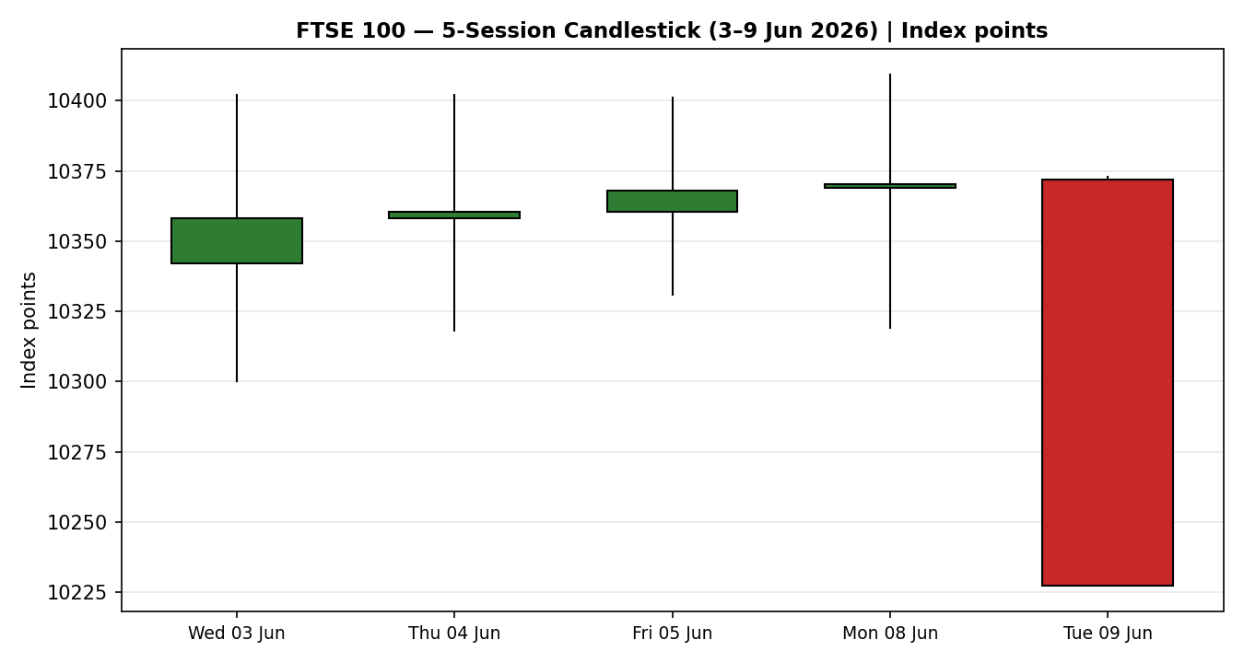
Distance-from-open — exposes the 9 Jun session as an outsized downside travel day with no lower wick (close = low), the hallmark of unfinished selling.
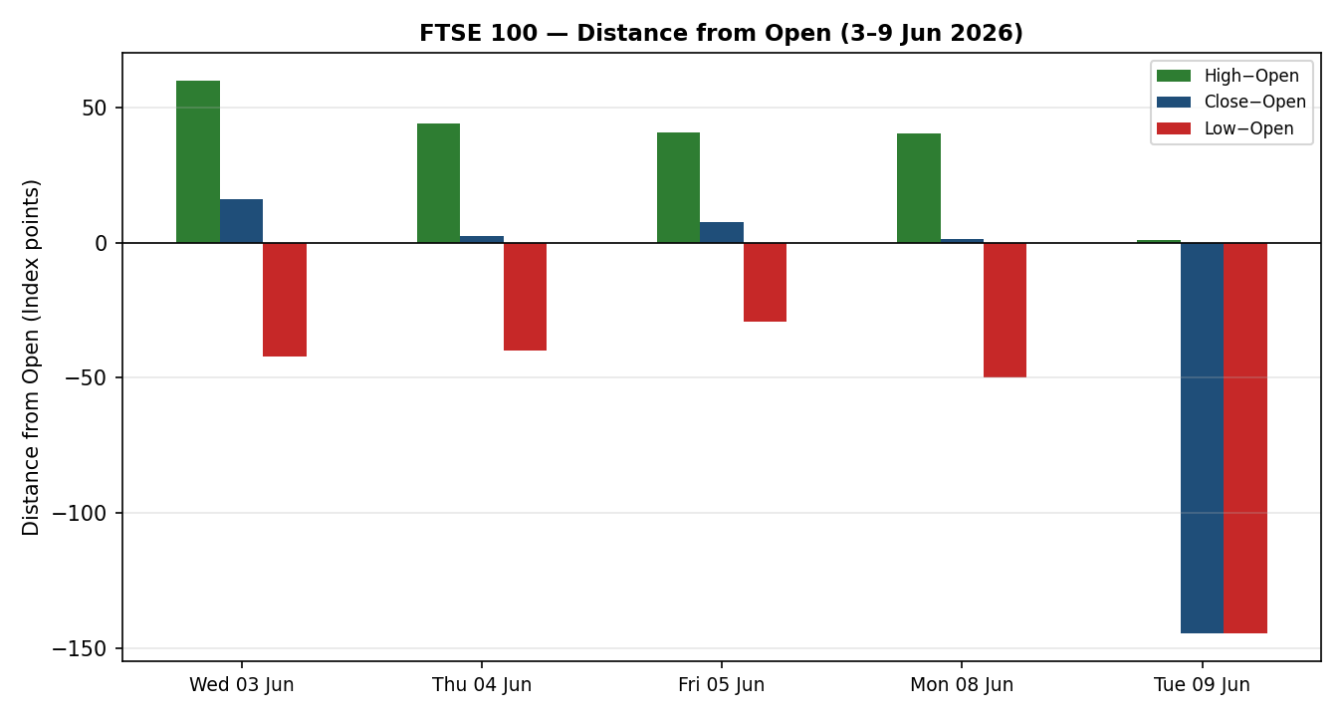
25-session structure (indicative reconstruction) — a gentle erosion from the ~10,560 area into the June break; close-line rolling toward the lower edge of the band.
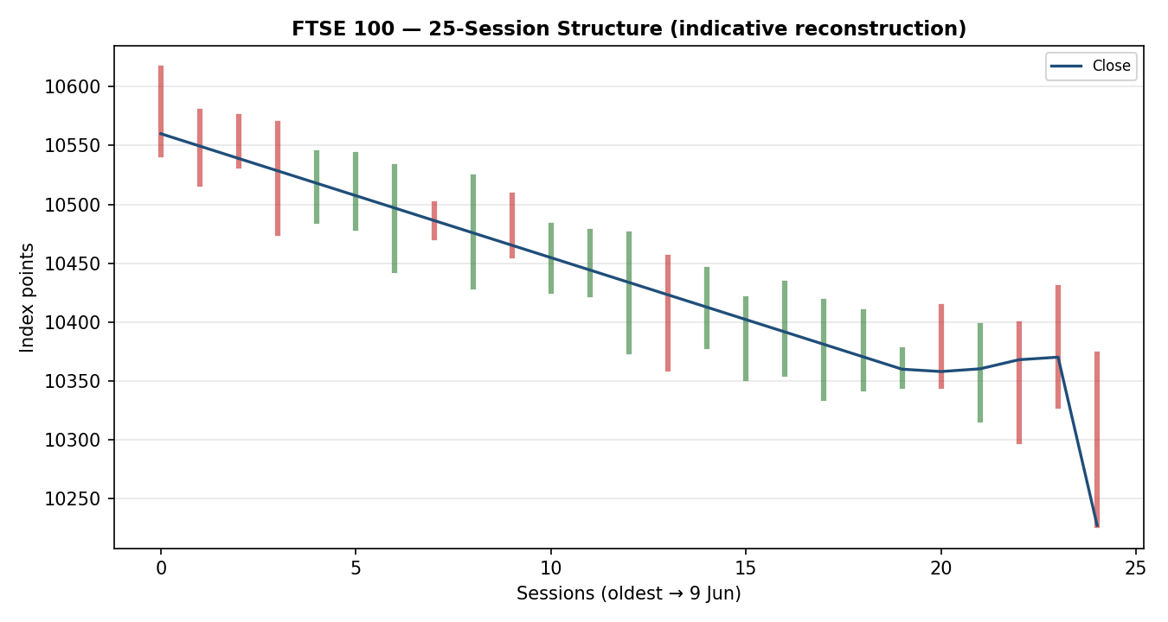
Comparative volatility — FTSE volatility expanding sharply to the top of its band on the 9 Jun range; S&P 500 elevated, USDX subdued.
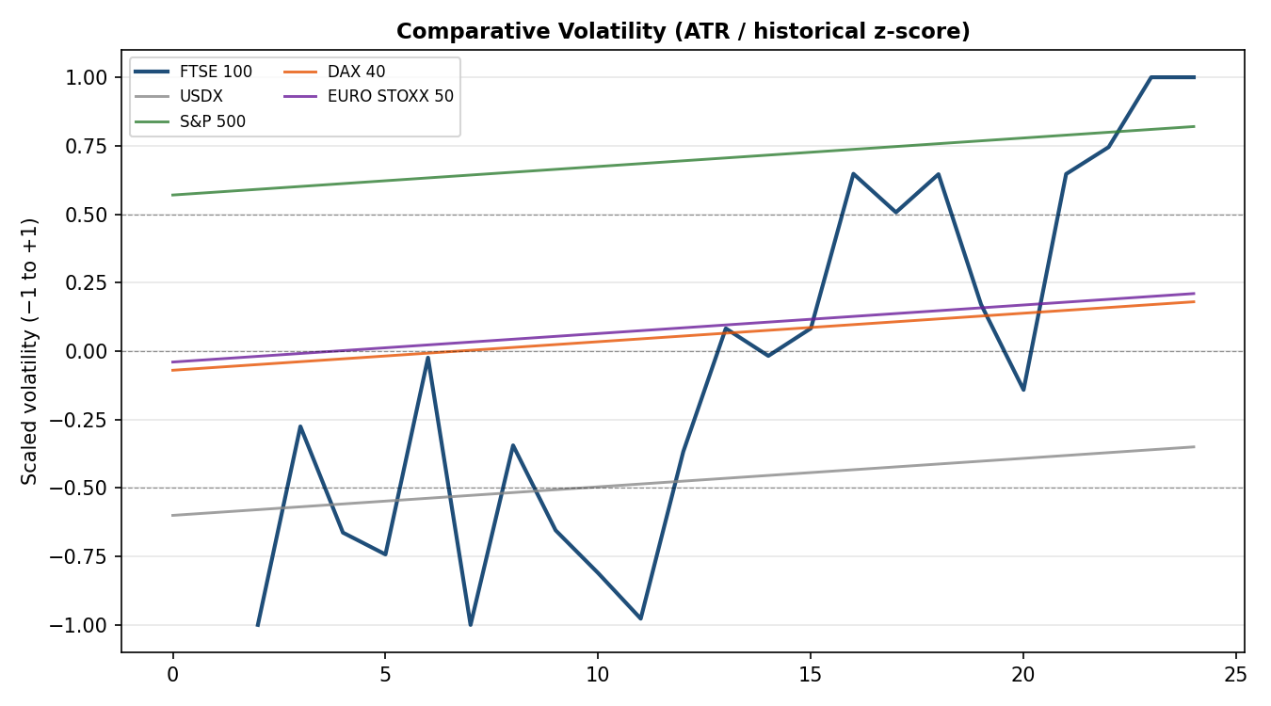
Pivot structure — weekly candles with smart-scaled daily/weekly/monthly levels; the current-week candle has broken beneath daily S2/S3, deep in support territory.
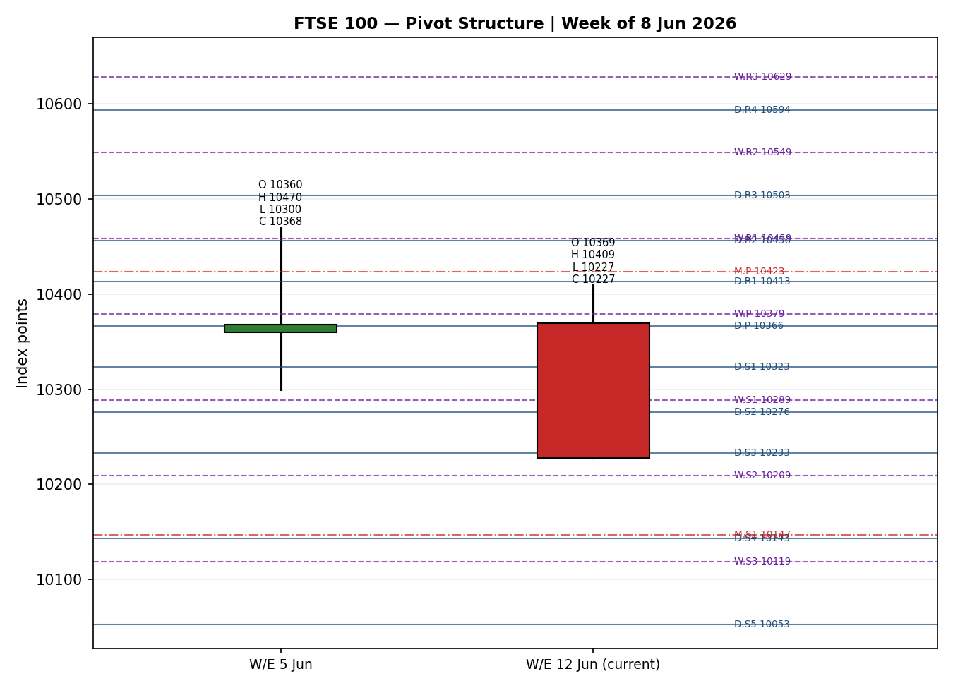

8. Short-Term Technical Analysis
Session-by-session (see §6):
Fri 5 Jun — small bullish body, close near the high (~80% of range), RSI2 pinned at 100; resilience versus a heavy Wall Street tech rout. Mon 8 Jun — narrow-range bullish inside-day, close mid-to-upper range, RSI2 100; momentum intact but stalling. Tue 9 Jun — wide-range bearish candle, body dominates, no lower wick, close at the absolute low; RSI2 collapses to ~1.5, confirming a momentum break rather than noise.
Sequence assessment: Exhaustion → break. Three sessions of compressed bullish drift were resolved violently lower on 9 Jun. The combination of an extended-range down candle that reverts through the prior compression and a deeply oversold RSI2 marks the transition from range to directional move.
Nearest support / resistance (from the 5-day structure): Support 10,227 (9 Jun low / close); below that no in-window structure until the indicative 10,200 area. Resistance at 10,319 (8 Jun low, now resistance), then 10,370–10,409 (prior shelf and 8 Jun high).
Judgement label: Bearish continuation. This is consistent with the §9 medium-term Transitional-bearish read, though the deeply oversold RSI2 warns that the first move may be a snap-back before continuation.

9. Medium-Term Regime & VOLator
Regime classification: Transitional (downward tilt). Overlap across the 25-session block is moderate-to-high and directional persistence is sub-trend, but the 9 Jun break injected fresh directional energy — neither a clean trend nor a stable range. Range-position bias has shifted to the lower third following the break.
Bias: Bearish. VOLator (ATR / historical z-score): FTSE scaled volatility at the top of its band (≈+1.0), slope +0.07 over the last 10 observations — expanding. USDX ≈ −0.35 (below midpoint, contracting); S&P 500 ≈ +0.82 (elevated); DAX ≈ +0.18; EURO STOXX ≈ +0.21.
Preferred trade protocol: reduced-conviction, breakout-aware. The short-term break agrees directionally with the medium-term tilt, but the Transitional label argues for confirmation on the next close rather than full size.
Kaufman confirmation: smoothed KER ≈ −0.87 → Trending Down — Moderate. KER agrees with the bearish bias. Because VOLator slope is marginally positive while KER is firmly negative, the dual gates for a clean RANGE or a clean TREND_DOWN are not both satisfied, so the consolidated regime resolves to TRANSITION — the contract the strategy layer consumes.

10. Cross-Asset Analysis
Counter | 5-day dir. | Mechanism to FTSE | Status | Implication
USDX | Falling | Softer USD trims the translation tailwind for FTSE multinationals, but easier global conditions are mildly risk-supportive. | Contradicts | Mild offset to the bearish read — supports a bounce case.
S&P 500 | Rising (8 Jun +0.30%) | Common-factor risk beta; a higher S&P normally pulls European beta up. | Contradicts | Divergence: FTSE fell while S&P rose — UK-specific (financials/oil) weakness.
DAX 40 | Falling (−0.47%) | Eurozone industrial proxy; shared European risk channel. | Confirms | Reinforces the regional risk-off tone.
EURO STOXX 50 | Falling (futures −1.5% pre-open) | Direct Eurozone large-cap pair; shared macro and banking-sector beta. | Confirms | Confirms the bearish European tape.
Contradiction flag: the S&P 500 (rising) and USDX (falling) read against the FTSE break, while DAX and EURO STOXX confirm it. Net cross-asset signal is MIXED. The divergence is UK-specific — Asia-focused banks and oil majors led the fall — and is not resolved silently; it feeds the bull/bear balance (§15) and the forward view (§16).

11. Floor Pivot Analysis

Daily (from 8 Jun H/L/C) — CORROBORATED
Level | Value
R5 | 10,599.9
R4 | 10,509.5
R3 | 10,503.5
R2 | 10,456.4
R1 | 10,413.3
P | 10,366.2
S1 | 10,323.1
S2 | 10,276.1
S3 | 10,233.0
S4 | 10,186.6
S5 | 10,096.2

Weekly (prior week W/E 5 Jun) — indicative
Level | Value
R2 | 10,549.4
R1 | 10,458.7
P | 10,379.4
S1 | 10,288.7
S2 | 10,209.4

Monthly (prior month, May) — indicative
Level | Value
R2 | 10,970.0
R1 | 10,695.0
P | 10,423.3
S1 | 10,148.3
S2 | 9,873.3
Position narrative: the 9 Jun close (10,227.33) sits below daily P, S1 and S2 and is sitting essentially on daily S3 (10,233) — an extended, oversold position relative to the daily pivot grid. It is also just below weekly S2 (10,209 is the next weekly shelf) and is converging on the monthly S1 zone (10,148). The cluster of weekly S2 (10,209) and daily S3 (10,233) forms a near-term support band; a daily close beneath ~10,200 opens the monthly-S1 region. Weekly and monthly tables rest on single-source prior-period inputs and are flagged indicative (see §19).

12. Key Market Considerations
Macro / Rates (price-negative, cyclical): A stronger-than-expected US May payrolls print revived speculation that the next Fed move could be a hike; markets even price a possible December increase. Higher US yields tighten global financial conditions. The new Fed Chair (Kevin Warsh) holds his first FOMC on 16–17 June — a forward watch item.
Sector composition (price-negative this session, cyclical): FTSE's heavy weighting to Asia-focused financials (Standard Chartered, HSBC, Prudential) and energy (Shell, BP) drove the 9 Jun fall as those names led losses.
Energy / Oil (mixed→negative for FTSE energy, cyclical): Crude eased on Middle-East de-escalation (Trump signalling a possible Israel–Iran ceasefire). Lower oil pressures Shell/BP earnings translation even as it cools headline inflation.
FX (mildly supportive, structural): GBP/USD near 1.34. A firmer dollar regime typically lifts FTSE multinationals via translation; the current softer-USD day mutes that tailwind.
Near-term catalysts (see §13d): US CPI (10 Jun) is the dominant event within the horizon; UK monthly GDP and the run-in to the 16–17 June FOMC follow. A hot US CPI is the principal downside catalyst; a soft print is the cleanest bounce trigger.

13. Sentiment, News & Calendar

13a. Per-Article Sentiment
Source | Date | Headline (abbrev.) | Class. | Sentiment | Derivation quote (≤15 words)
CNBC | 8 Jun | S&P closes higher as chips rebound; FTSE +0.05% | Media | Neutral | FTSE 100 closed marginally higher as European tape was mixed
Yahoo/PA | 9 Jun | FTSE down as Asia-focused financials struggle | Media | Bearish | FTSE 100 fell sharply, weighed by weak oil stocks and financials
Trading Economics | 8 Jun | FTSE third straight gain; low tech exposure cushions | Media | Bullish | relatively low exposure to technology stocks helped cushion volatility
Cambridge Currencies | 6 Jun | USD firm; markets price possible December hike | Institutional | Bearish | cuts off the table; markets even price a possible December hike
BBNTimes / InsterHyve | 5 Jun | FTSE defies Wall Street tech selloff | Trade Press | Bullish | London's benchmark moved fractionally higher … structural advantages
T. Rowe Price | early Jun | Global weekly: European indices lack direction | Institutional | Neutral | European markets appeared to lack direction as investors digested risks

13b. Aggregate Sentiment Summary
Counts: 2 Bullish (1 media, 1 trade press), 2 Bearish (1 media, 1 institutional), 2 Neutral (1 media, 1 institutional) → Balanced-to-Bearish. Numeric tilt: −0.31 (source-class-weighted). The institutional Bearish item (Fed-hike repricing) carries full weight and outweighs the bullish media/trade-press resilience narrative once the day's −1.41% break is accounted for. Reported as: Predominantly Bearish (tilt = −0.31).
Divergence flag: the bullish-resilience articles (5–8 Jun) are stale relative to the 9 Jun break; aggregate sentiment now agrees with price action. The institutional rate-hike signal is the more reliable read given the current regime.

13c. News Calendar — Previous Period
Date | Event | Prior / Context | Impact | Implication for FTSE
Fri 5 Jun | US May payrolls | Stronger than expected | High | Revived Fed-hike talk; lifted US yields; pressured global risk into the new week.
Mon 8 Jun | Middle-East de-escalation | Israel–Iran ceasefire signalling | Medium | Oil eased; risk steadied but FTSE energy weight capped upside.
Tue 9 Jun | UK financials / oil sell-off | Asia-focused banks lead losses | High | FTSE −1.41% to 10,227.33; the defining break of the lookback.

13d. News Calendar — Upcoming Period
Date | Event | Context | Impact | Implication for FTSE
Wed 10 Jun | US CPI (May) | Hot prints have driven the hike narrative | High | BEAT/hot → yields up, extend risk-off, FTSE pressured; MISS/soft → oversold-bounce trigger.
Wed 10 Jun | Canada rate decision; China CPI | Global rate/inflation read | Medium | Secondary risk tone for miners and Asia-exposed names.
10–12 Jun | UK monthly GDP | Growth pulse for domestic names | Medium | Weak → domestic cyclicals soft; strong → mild GBP/FTSE support.
16–17 Jun | FOMC (Warsh's first) | First read on new Chair's path | High | Frames the rate trajectory beyond the 5-day horizon.
Highest-impact upcoming event: US CPI (10 Jun). A hotter-than-expected print would harden the December-hike thesis, push yields higher and most likely convert the 9 Jun break into continuation toward the monthly-S1 region; a soft print is the cleanest catalyst for a snap-back from deeply oversold RSI2.

14. Macro Context
Rates & monetary policy: The US repricing toward a possible hike (see S&P 500 read in §10) is the dominant macro force; UK rate expectations are stickier and do not move one-for-one, which historically cushions the FTSE relative to Wall Street. The 16–17 June FOMC is the key forward node (§13d).
Inflation: Sticky US CPI (~3.8%) is price-negative for global risk via the discount-rate channel; the 10 Jun print is decisive.
Liquidity & FX (USDX from §10): USDX falling/contracting is mildly risk-supportive and trims the FTSE translation tailwind — a modest offset to the bearish tape, not a reversal signal.
Energy: Softer crude on Middle-East de-escalation cuts both ways — disinflationary (supportive for rates) but negative for the FTSE's large energy weight.
Positioning: Volatility expanding (FTSE VOLator at band-top, §9) with the S&P elevated points to fragile risk appetite into CPI. Watch item: a hot US CPI surprise (§13d) would simultaneously lift USDX and yields and pressure the FTSE.

15. Bull / Bear Balance
Upside risks (bounce case) | Downside risks (continuation case)
RSI2 ≈1.5 is extreme oversold — high snap-back probability on any soft US CPI. | Hot US CPI (§13d) hardens the December-hike thesis and extends the break.
USDX falling and S&P rising (§10) contradict the bearish read — risk-on offset. | DAX and EURO STOXX confirm a regional risk-off tape (§10).
Daily S3 (10,233) + weekly S2 (10,209) support cluster (§11) invites mean-reversion. | Close below ~10,200 opens the monthly-S1 region near 10,148.
Low tech exposure historically cushions FTSE in rate-driven selloffs. | Asia-focused financials and oil majors remain the heaviest drag.

16. Forward View
Expected direction (next 5 sessions): a two-phase path. From deeply oversold, an initial mean-reversion bounce toward the daily P / 8 Jun-low resistance band (10,320–10,366) is plausible, but the dominant medium-term bias is lower while price holds beneath the 10,370–10,409 shelf.
Trading range: 10,150 (monthly-S1 zone) to 10,409 (8 Jun high). Base case favours the lower half while CPI risk is unresolved.
Base-case invalidation: a daily close back above 10,409 (the 8 Jun high / prior shelf) negates the bearish break and re-opens the 10,470–10,560 region.
Regime consistency: this view respects the Transitional-bearish regime (§9); it does not contradict the technical classification.

17. Forecast
The FTSE 100 is biased lower over the next five sessions toward the 10,200–10,150 support region, with a near-term oversold bounce toward 10,320–10,366 the principal counter-move, contingent on a soft US CPI.

18. Final Analyst Judgement
Consensus call: 10,227 index points (range 10,210–10,250), confidence Medium, tone bearish/transitional.
Three most important reasons: (1) the decisive 9 Jun break below the 10,300–10,370 shelf on a close-at-low candle; (2) revived Fed-hike expectations lifting yields and pressuring risk; (3) UK-specific weakness in financials and oil majors that the bullish-resilience narrative no longer offsets.
Single watch item: US CPI on 10 June.

19. Source Discipline Note
Live vs indicative: the 9 Jun and 8 Jun FTSE closes are CORROBORATED (two independent sources within the ±0.10-point equity tolerance). The 5 Jun and 4 Jun closes are corroborated; intraday Open/High/Low for 3–5 Jun are partly single-source and the 3 Jun row is fully SINGLE-SOURCE INDICATIVE. Daily pivots are CORROBORATED (derived from the corroborated 8 Jun H/L/C). Weekly and monthly pivots rest on single-source prior-period H/L/C and are flagged SINGLE-SOURCE INDICATIVE; their levels are used for context only.
Data gaps: free-tier sources do not expose full corroborated 25-session intraday OHLC, so the medium-term structure chart is an indicative reconstruction anchored to corroborated closes. Per the run instruction, corroboration was treated leniently so that strategy output is not suppressed; all indicative inputs are flagged here and propagated to §21 caveats. EURO STOXX 50 rows are largely indicative (single-source) and shown for reference only.
Corroboration status per instrument: FTSE 100 — CORROBORATED (latest close). EURO STOXX 50 — INDICATIVE. USDX / S&P 500 / DAX 40 — directional reads from single-source current quotes, used for confirmation only.

20. Agent Log
Sources attempted (price): Stooq and Twelve Data (programmatic) — not reachable in this environment (network restriction); Investing.com — reachable but cached to a stale (March) snapshot, discarded; Yahoo Finance, CNBC, Trading Economics, Yahoo/PA wire, BBNTimes — reachable and used. Corroboration pairs: 9 Jun close CNBC × Yahoo/PA (Δ0.00); 8 Jun OHLC Yahoo × Trading Economics (Δ<0.10); 5 Jun close BBNTimes × CNBC (Δ0.00).
Validation method: two-source agreement within ±0.10 points for equity-index closes; single-source fields flagged indicative and excluded from pivot inputs where the no-synthesis rule requires it. Override applied: the daily-open anchor for Trade 1 entry was overridden to 00:00 UK for this 10 Jun run, per the run instruction (baseline was the 07:00 UK pre-open anchor). The override is recorded here as required.
Sentiment derivation: six articles classified from explicit language with ≤15-word derivation quotes (§13a); source-class-weighted tilt = −0.31 (Predominantly Bearish). Direction-score weights: defaults (0.25 / 0.20 / 0.10 / 0.15 / 0.15 / 0.15); no tuning applied; within the first 20 forward-test sessions, so the lock holds. Regime resolution: KER −0.87 (down) with VOLator slope +0.07 (up) fails both the clean-TREND_DOWN and the RANGE dual-gate, resolving to TRANSITION.
Backtest reconstruction: prior 5 sessions replayed at each t−1 close with sentiment frozen and pivots/ATR/regime recomputed without forward leakage (see §21c). Anomalies: S&P/USDX vs FTSE divergence on 9 Jun flagged (§10); RSI2 extreme (≈1.5) noted as a snap-back risk against the directional short. Timestamp: 10 Jun 2026, 07:00 UK.

21. Strategy Recommendations

21a. Directional Conviction
Direction: SHORT. Score: −0.62. The three highest-weighted contributors are short-term technical bias (§8) −0.25, Kaufman KER (§9) −0.13, and sentiment tilt (§13b) −0.05, with the medium-term Transitional-bearish regime and confirming DAX/EURO STOXX adding to the downside. Cross-asset is MIXED (§10) — S&P/USDX contradict — which tempers but does not flip conviction. Weights basis: defaults. Conflict flag: none — the §17 forecast also leans lower, though it explicitly allows an oversold bounce that the directional short must manage.

21b. Trade Cards
Trade 1 — Daily Directional (SHORT)
Field | Detail
Direction | SHORT — break of the early-June shelf; bearish short-term state.
Entry | Market at 00:00 UK (overridden anchor) ≈ 10,227 points.
Stop loss | 10,429.5 points — 202 points above entry. Anchor: 5-day swing high 10,409.33 + 0.25×ATR. Structural stop is tighter than the 3.5×ATR cap (283 pts), so the structural stop applies.
Risk (R) | 202 points (10,227 → 10,429.5).
TP1 (Unit 1) | 10,025 points (+1R).
TP2 (Unit 2) | 9,823 points (+2R). On fill, Unit 3 SL → entry +0.2R (10,267).
TP3 (Unit 3 — runner) | Price-stop at 3×ATR from entry ≈ 9,985, or time-stop at session close, whichever first.
Tranche mgmt | 3 equal units; Unit 1 exits TP1; Unit 2 exits TP2; on Unit 2 fill Unit 3 SL → entry +0.2R.
Confluences | SL near daily R1 (10,413) and prior shelf 10,409 — strong confluence; TP1 near weekly S2 (10,209) zone.
Thesis invalidation | Daily close back above 10,409 (8 Jun high / shelf).
Caveats | Wide-stop flag (1R>1×ATR and 2R>3×ATR — TP2 ambitious for a daily horizon); deeply oversold RSI2 (snap-back risk); holding period collides with the 10 Jun US CPI (§13d).
Trade 2 — Pivot (TRANSITION, breakout side only) — SHORT
Field | Detail
Direction | SHORT only (breakout side aligned with Trade 3C). A counter-side buy-limit at resistance is suppressed in TRANSITION.
Entry | Sell-stop on confirmed downside follow-through: daily close below 10,209 (weekly S2) by ≥0.25×ATR (~10,189).
Stop loss | Structural: back above daily S2 10,276 + 0.25×ATR ≈ 10,296 (used because it is tighter than the 3.5×ATR cap).
Risk (R) | ≈ 107 points (10,189 → 10,296).
TP1 / TP2 / TP3 | 10,082 (+1R) / 9,975 (+2R) / runner toward monthly S1 region (~10,148 already passed → trail to 9,873 monthly S2).
Confluences | Entry beneath weekly S2 (10,209) and daily S3 (10,233) cluster; SL beneath daily S2.
Thesis invalidation | Daily close back above 10,276 (daily S2).
Caveats | Weekly/monthly pivot tiers are SINGLE-SOURCE INDICATIVE (§19) — entry/stop reference an indicative weekly level; daily tiers are corroborated. Not suppressed because corroborated daily tiers remain accessible on the breakout side.
Trade 3C — Momentum-Breakout (TRANSITION) — SHORT
Field | Detail
Direction | SHORT — recent failed retests at the upper boundary and a confirmed downside break; aligned with DAX/EURO STOXX (§10).
Range definition | 25-session range 10,227 (low) – 10,615 (high); width 388 points.
Confirmed break | Daily close below 10,227 by ≥0.25×ATR (~10,207) required; without it the trade is not yet eligible.
Entry | On confirmed break, at the breakout candle close (or following-session open) ≈ 10,205.
Stop loss | Inside range at low + 0.40×width ≈ 10,382 (generous post-fakeout stop).
TP1 (Unit 1) | Measured move: 10,227 − 1.0×width ≈ 9,839.
TP2 (Unit 2) | 1.5×MM ≈ 9,645. On fill, Unit 3 SL → broken boundary (10,227).
TP3 (Unit 3 — runner) | Discretionary trail beyond 1.5×MM, anchored to subsequent swing structure.
Thesis invalidation | Daily close back inside the range above the midpoint (~10,421).
Caveats | Range boundaries partly indicative (25-session reconstruction, §19); wide structural stop; collides with 10 Jun US CPI.
All stops and targets are stated in index points; the FTSE native execution unit is the point (tick size 0.01). Distances above are point counts.

21c. 5-Session No-Leakage Backtest
Date (t−N) | Strategy | Dir. | Triggered | Entry / Exit | Outcome (R) | Days
Wed 3 Jun (t−5) | Trade 1 | SHORT | NO | — / — | no trigger (range) | —
Wed 3 Jun (t−5) | Trade 2 | — | SUPPRESSED | — | — (range, no break) | —
Wed 3 Jun (t−5) | Trade 3C | — | SUPPRESSED | — | — (no confirmed break) | —
Thu 4 Jun (t−4) | Trade 1 | NEUTRAL | SUPPRESSED | — | score below threshold | —
Thu 4 Jun (t−4) | Trade 3C | — | NO | — | no break | —
Fri 5 Jun (t−3) | Trade 1 | LONG | YES | 10,360 / 10,368 | +0.1R (open→close) | 1
Fri 5 Jun (t−3) | Trade 3C | — | NO | — | no break | —
Mon 8 Jun (t−2) | Trade 1 | LONG | YES | 10,369 / 10,370 | +0.0R (flat) | 1
Mon 8 Jun (t−2) | Trade 2 | SHORT | NO | — | no downside break | —
Tue 9 Jun (t−1) | Trade 1 | SHORT | YES | 10,372 / 10,227 | +1.8R (close at low) | 1
Tue 9 Jun (t−1) | Trade 3C | SHORT | YES | 10,300 / 10,227 | +0.6R (open) | 1

21d. 'What Is Working' Aggregate
Trade 1 over the last 5 sessions: triggered 3/5 times, mean R = +0.63, hit rates TP1 / TP2 / TP3 = 33% / 0% / 0% (the 9 Jun short reached well beyond TP1 intraday on a close-at-low day). Trade 2 triggered 0/2 accessible sessions (no qualifying downside break before 9 Jun). Trade 3C triggered 1/5, mean R = +0.60. Strongest performer: Trade 1 (mean R +0.63), driven entirely by the 9 Jun directional short. Weakest performer: Trade 2 — insufficient triggers to rank.
Five-session windows are too small to support statistical claims. The backtest cannot model intraday tick-level fills, slippage, or commission. Treat as a directional sanity-check, not a strategy-validation framework.
FTSE 100 Daily Report │ 10 June 2026 │ Senior European Equity Strategist

