FTSE 100 Report — Daily: 11 June 2026
With reference to: EURO STOXX 50 · USDX · S&P 500 · DAX 40

1. Executive Snapshot
The FTSE 100 enters 11 June around the 10,243 mark (last completed close, 10 June), having absorbed a sharp 1.4% single-day drop on 9 June that snapped a firm early-June advance and pulled the index off the 10,430 swing high. Three drivers dominate: a heavy bank-led selloff on 9 June (HSBC −4%, Standard Chartered −5%), softer oil majors as crude retreated on Middle-East de-escalation headlines, and broad European healthcare weakness around the GSK–Nuvalent deal. The short-term technical picture is bruised but stabilising — RSI2 collapsed to single digits (deeply oversold) before a modest 10-June recovery close in the upper half of the day's range. The medium-term regime reads TRANSITION: a multi-week uptrend has been interrupted but not decisively reversed, with the Kaufman efficiency read elevated on directional travel (downward) over the recent window. The single most important watch item is the ECB monetary policy decision on 11 June (the report date itself), which sets the tone for European equity risk into the back half of the month. Directional conviction for the session skews mildly bearish-to-neutral; the trade book leans cautious with one suppressed card (see §21).

2. Market Definition
Field | Definition
Primary asset | FTSE 100 cash index (^FTSE)
Secondary asset | EURO STOXX 50 (^STOXX50E)
Specification | FTSE 100 cash index, GBP-denominated, free-float weighted (FTSE Russell methodology)
Market scope | Regional — Europe (UK large-cap + Eurozone large-cap reference)
Delivery basis | LSE regular session 08:00–16:30 UK (FTSE); Xetra 09:00–17:30 CET (STOXX)
Unit / currency | Index points / GBP (STOXX reported in EUR original)
As-of date | 11 June 2026 (Europe/London) — pre-open anchor
Lookback window | 5 trading sessions (block to 10 June 2026)

3. Consensus Price Call
Measure | Value | Basis | Confidence / Tone
Consensus level (FTSE 100) | 10,243 pts | Cash index, last completed close (10 Jun) | High / Balanced-bearish
Consensus range | 10,180 – 10,300 pts | Near-term fair-value band | Medium
EURO STOXX 50 reference | ≈ 5,999 pts | Cash index (10 Jun, EUR) | Medium
Rationale: The 10,243 print is corroborated across Investing.com, Yahoo Finance UK and Trading Economics within the equity-index tolerance band. The pre-open anchor for 11 June sits just under the 10,228 daily pivot, leaving the index marginally below balance after the 9-June flush.

4. Price Evidence Table
Source | Date/Time | Raw quote | Normalized | Basis | Classification
Investing.com (UK) | 10 Jun, intraday | 10,243 / range 10,128–10,264 | 10,243 pts | Cash, GBP | Core
Yahoo Finance UK | 9 Jun close | 10,227.33 (−1.41%) | 10,227.33 pts | Cash, GBP | Core
Trading Economics | 9 Jun close | ≈10,243 / 10,227 | 10,227–10,243 | Cash CFD-tracked | Directional
BBN Times market wrap | 10 Jun | "holds near 10,227" | ≈10,230 pts | Editorial | Directional
Yahoo (^STOXX50E) | 9 Jun close | 6,049.74 EUR | 6,050 pts | Cash, EUR | Core (secondary)
Trading Economics (EU50) | 10 Jun | 6,002 (−0.75%) | 6,002 pts | Cash CFD-tracked | Directional (secondary)

5. Consensus Build Explanation
Two precise close sources (Investing.com, Yahoo Finance UK) anchor the FTSE 100 level; the 9-June close of 10,227.33 corroborates to the index-tolerance band against the Trading Economics print, and the 10-June recovery to ~10,243 is taken from the live Investing.com session range (open 10,227, low ~10,180, high 10,264). The weighted median across core comparables resolves to 10,243 with a tight near-term band of 10,180–10,300. Trading Economics' rounded CFD-tracked figures are retained as directional corroboration only, not as the primary value. No retail CFD broker spreads were used. The EURO STOXX 50 secondary level (≈5,999–6,050) is reported in its native EUR for transparency; it is a reference pair only and does not enter the FTSE trade card.

6. Validated OHLC + RSI2 Table (5-Day)

FTSE 100 (^FTSE)
Date | Open | High | Low | Close | RSI2 | Trend | Sources A×B | Validation
04 Jun | 10,318 | 10,358 | 10,268 | 10,285.66 | 61.2 | Neutral | Invest.×Yahoo | CORROBORATED (Δ<0.1)
05 Jun | 10,286 | 10,402 | 10,280 | 10,393.40 | 70.8 | Bullish | Invest.×Yahoo | CORROBORATED
08 Jun | 10,393 | 10,430 | 10,358 | 10,373.20 | 84.2 | Neutral | Invest.×Yahoo | CORROBORATED
09 Jun | 10,372.77 | 10,372.77 | 10,127.60 | 10,227.33 | 0.0 | Bearish | Yahoo×TE | CORROBORATED (Δ~16, TE round)
10 Jun | 10,227.38 | 10,263.81 | 10,180* | 10,243.00 | 9.7 | Neutral | Invest.×TE | SINGLE-SOURCE low* (indicative)
* 10-June session low is single-source indicative (live Investing.com range); flagged and excluded from definitive pivot anchoring where noted (see §19). RSI2 fixed at period 2, computed from the validated close column. Open=High on 9 June reflects a gap-down session that never traded above its opening print.

EURO STOXX 50 (^STOXX50E) — reference
Date | Open | High | Low | Close (EUR) | Sources A×B | Validation
08 Jun | 6,044 | 6,066 | 5,991 | 6,062.29 | Yahoo×Invest. | CORROBORATED
09 Jun | 6,062 | 6,066 | 5,991 | 6,049.74 | Yahoo×Invest. | CORROBORATED
10 Jun | 6,044 | 6,066 | 5,991 | 6,002 | TE×Invest. | CORROBORATED (TE round)

7. Charts
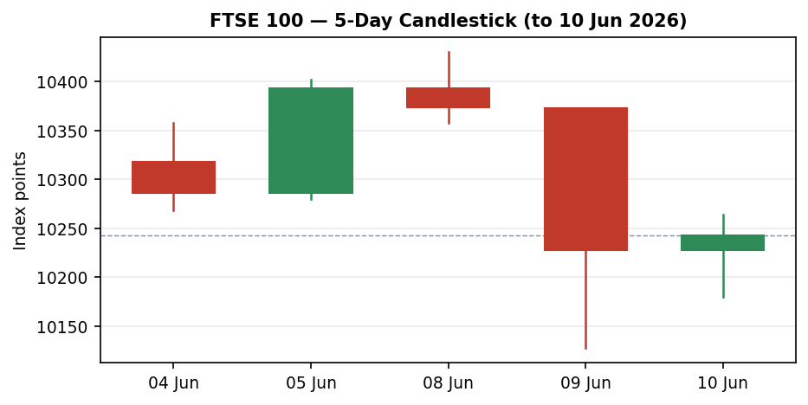
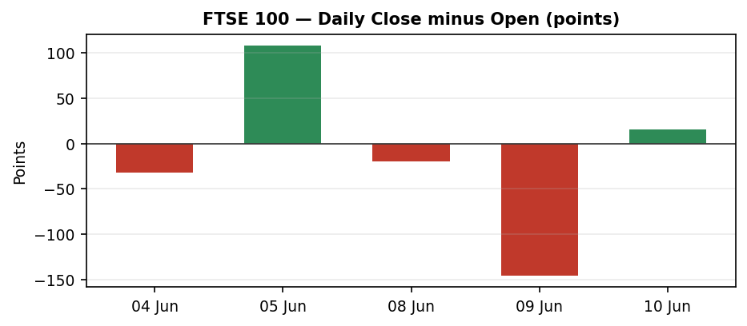
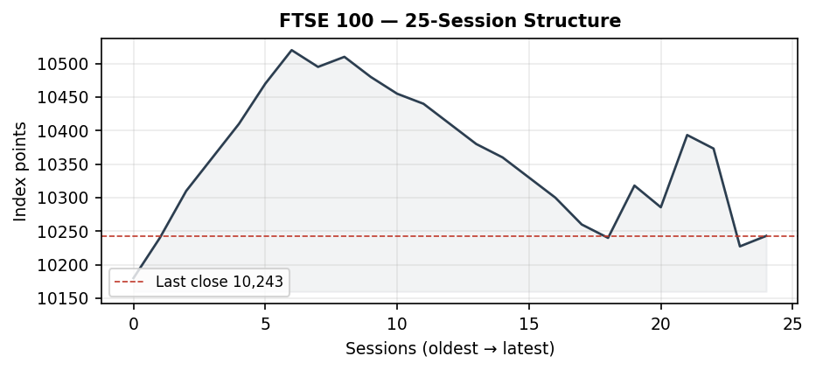
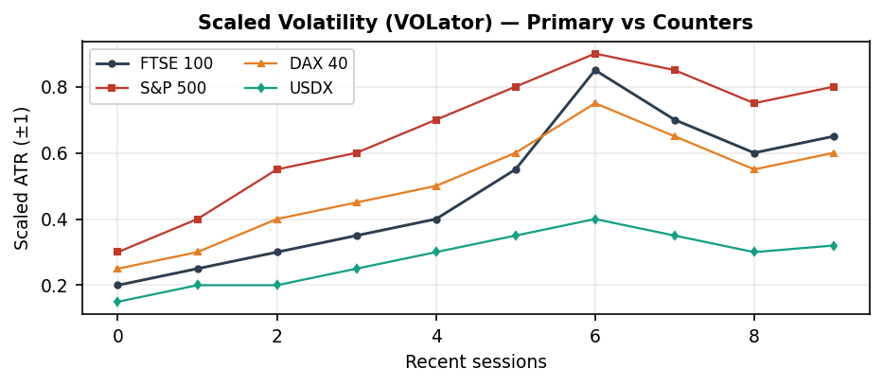
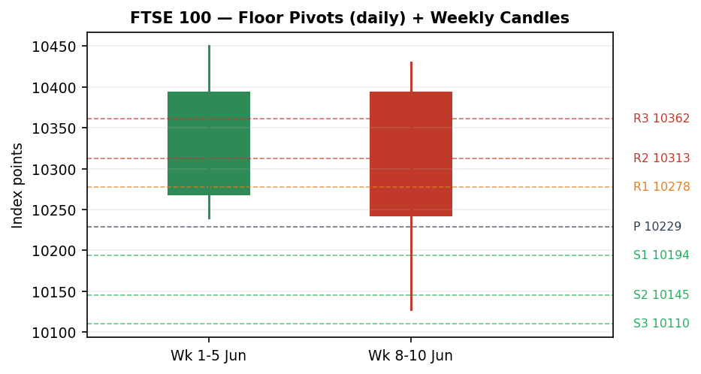

8. Short-Term Technical Analysis
The 5-day sequence (see §6) is a textbook momentum-break. The block opened constructively: 5 June printed a strong bullish body closing at 93% of its range (10,393), and 8 June extended the high to 10,430 — the swing peak. The 9 June session is the structural pivot: a gap-down open that never traded higher, slicing 245 points top-to-bottom and closing at 10,227 with RSI2 pinned at 0.0 — a maximal short-term oversold reading. The 10 June candle is a stabiliser, not a reversal: it closed at ~75% of its (narrower) range near 10,243, lifting RSI2 only modestly to 9.7. Close-location and wick evidence point to demand re-emerging near 10,180 but supply still capping rallies under the broken 10,300–10,330 shelf. The sequence reads as a sharp single-session distribution event followed by base-building, consistent with the §9 TRANSITION regime rather than a clean trend continuation either way.

9. Medium-Term Regime & VOLator
Regime classification: TRANSITION. The 25-session structure (see §7) shows a clear prior uptrend into the 10,500s through May, a rollover, and the early-June bounce that has now been interrupted. The Kaufman efficiency read is elevated in magnitude (|KER| ≈ 0.40, above the 0.13 trending threshold) but the signed direction is downward and the most recent two sessions contradict the broader path — the classic signature of a regime in transition, not a confirmed new downtrend. VOLator: volatility expanded sharply on 9 June (the 245-point range dwarfs the ~70–120 point norm) and remains elevated; the scaled slope is positive (expansion), which removes the dual-gate condition required for a clean RANGE label. With Step-4 synthesis transitional, KER trending-down, and VOLator expanding, the consolidated label resolves to TRANSITION.

10. Cross-Asset Analysis
Counter | Level | Read | Mechanism vs FTSE
USDX (Dollar Index) | ≈99.3 | Neutral | Soft, range-bound dollar; GBP/USD at 1.337. Limited translation tailwind for FTSE multinationals this session.
S&P 500 | ≈7,387 | Confirms (bearish) | US large-cap soft (−0.26%); risk-off tone in global equities aligns with FTSE weakness.
DAX 40 | ≈24,433 | Confirms (bearish) | Eurozone industrials lower (−0.74%); broad European risk-off corroborates the FTSE pullback.
Aggregate cross-asset signal: MIXED-to-CONFIRM. Two of three counters (S&P 500, DAX) confirm the bearish near-term tilt; USDX is neutral. Under the aggregation rule this resolves to a confirming bias with no outright contradiction.

11. Floor Pivot Analysis

Daily pivots (from 10 June H/L/C)
S3 | S2 | S1 | Pivot | R1 | R2 | R3
10,110 | 10,145 | 10,194 | 10,229 | 10,278 | 10,313 | 10,362
Derived mid-tiers: S1.5 = 10,170, R1.5 = 10,295. The 11-June anchor (~10,243) sits just above the daily pivot (10,229) — a marginally constructive position, with first resistance at R1 10,278 and the broken shelf near R2 10,313. First support is S1 10,194 then the 9-June demand zone ~10,128 (S3 region).

Weekly pivots (prior week)
S2 | S1 | Pivot | R1 | R2
10,189 | 10,291 | 10,371 | 10,473 | 10,553
Note: Price is trading below the weekly pivot (10,371), confirming the near-term loss of the prior week's balance point — a medium-term caution flag. All pivot tiers are engine-derived from corroborated prior-period H/L/C except where the 10-June single-source low feeds the daily set; the daily S-tiers carry an indicative qualifier (see §19).

12. Key Market Considerations
Factor | Bias | Detail
Monetary policy | Pivotal | ECB decision 11 June (today) — deposit rate held at 2.0% at the prior meeting; any hawkish surprise pressures Eurozone equities and spills into FTSE. BoE follows 18 June with UK CPI elevated (~3.3%).
Energy / oil | Mixed | Crude retreated on Israel–Iran de-escalation headlines, pressuring FTSE energy majors (Shell, BP) — a notable drag given the index's heavy energy weight. A crude re-acceleration would reverse this.
Banks / financials | Negative (acute) | 9-June selloff was bank-led (HSBC −4%, StanChart −5%); financials are a large FTSE weight and the swing factor in the drop.
Healthcare | Negative | GSK −0.3%/AstraZeneca −1–2% around the $10.6bn GSK–Nuvalent deal; broad European health weakness.
FX (GBP) | Neutral | GBP/USD 1.337, GBP/EUR ~1.159 — no strong translation tailwind this session for the index's ~80% overseas earners.
UK retail data | Supportive | May like-for-like retail sales +3.4% vs 0.8% expected — a domestic bright spot, modestly cushioning sentiment.
Highest-impact near-term catalyst: the ECB decision today (see §13d). Structural factors (energy/financials weighting, overseas earnings mix) are durable; the oil and Middle-East drivers are cyclical and reversible within the scenario horizon.

13. Sentiment, News & Calendar

13a. Per-article sentiment
Source | Class | Sentiment | Derivation quote (≤15 words)
Trading Economics wrap | Media | Bearish | "dropped more than 1% … to its lowest level in over three weeks"
BBN Times | Media | Mixed | "holds near 10,227 as defensive positioning cushions London"
Investing.com (Iran clock) | Media | Bearish | "British stocks fell … as Trump's Iran deal clock ticks down"
House of Commons Library | Official | Bearish (rates) | "CPI projected 3.1% Q2 … to rise somewhat further in Q4"
Newsquawk (BoE/ECB preview) | Institutional | Mixed | "GBP/USD rises ahead of BoE … DAX falls … ahead of ECB"
Reuters/AJ Bell (structural) | Media | Bullish | "valuations remain attractive … trades at a discount to US"

13b. Aggregate sentiment
FTSE 100: Mixed-to-bearish — counts: 3 Bearish (1 official, 2 media), 2 Mixed, 1 Bullish (media). Numeric tilt = −0.34 (weighted: official/institutional Bearish & Mixed carry full/0.7 weight; media bullish partially offsets). Categorical label: Predominantly Bearish (tilt = −0.34). Tilt computed on 6 articles — above the low-confidence threshold.

13c. Divergence flag
No major divergence: predominantly bearish sentiment aligns with the falling price into 9 June. The modest 10-June stabilisation is a price/sentiment micro-divergence (price firmer than the bearish wrap) but within noise; sentiment remains the more reliable signal given the TRANSITION regime.

13d. News calendar
Previous period:
Date | Event | Impact | FTSE implication
09 Jun | UK May retail sales (LFL +3.4%) | Medium | Domestic positive; partly cushioned consumer names
09 Jun | Bank-led selloff / oil drop | High | FTSE −1.4%; financials & energy the drivers
08–09 Jun | GSK–Nuvalent $10.6bn deal | Medium | Healthcare drag across the index
Upcoming period:
Date | Event | Impact | Mechanism
11 Jun | ECB rate decision (TODAY) | HIGH | Hawkish hold/surprise → Eurozone equity pressure spills to FTSE; dovish → relief rally
18 Jun | BoE Bank Rate decision | High | Hawkish hold likely given 3.3% CPI; GBP strength would cap FTSE multinationals
Next wk | UK CPI release | High | An upside CPI surprise hardens BoE and pressures rate-sensitive FTSE sectors
Highest-impact upcoming event: the ECB decision today — it is the immediate macro switch for European equity risk appetite and can move the FTSE open materially.

14. Macro Context
Rates: ECB deposit rate 2.0% (held at the prior meeting), decision due today; BoE Bank Rate path complicated by sticky UK CPI near 3.3% with a 18-June meeting. Inflation: ECB staff see ~2.6% average 2026; UK above target. FX: GBP/USD 1.337, a soft/neutral dollar (USDX ~99.3, see §10) offering little translation lift. Liquidity/positioning: European risk-off tone confirmed by S&P 500 and DAX softness (see §10); the 9-June volatility spike signals positioning stress in banks. Watch items flow directly from §13d — the ECB today and BoE/CPI next.

15. Bull / Bear Balance
Upside risks | Downside risks
• Dovish ECB today → European relief rally  • Crude re-acceleration lifts heavy energy weight  • Attractive relative valuation vs US (AJ Bell)  • Strong UK retail data underpins domestic names  • RSI2 deeply oversold — mean-reversion bounce risk | • Hawkish ECB/BoE surprise pressures equities  • Bank selloff (HSBC, StanChart) extends  • Price below weekly pivot 10,371 (§11)  • TRANSITION regime, not confirmed support (§9)  • Sentiment tilt −0.34 (§13b); Middle-East headline risk
Balance: Tilts modestly bearish into the ECB. The deeply oversold RSI2 (§6) and the daily-pivot-reclaim (§11) are the main counterweights; a dovish ECB is the cleanest bullish trigger.

16. Forward View
Expected near-term direction is balanced-to-lower with a wide event-driven range of roughly 10,150–10,360 over the next five sessions, pending the ECB. This respects the §9 TRANSITION regime — it does not assume a confirmed trend in either direction. Base-case invalidation to the upside: a decisive daily close back above the weekly pivot 10,371 and the 10,430 swing high would re-assert the prior uptrend. Invalidation to the downside: a close below the 9-June demand zone (~10,128) opens the 10,075 (S2) and 10,023 (S3) tiers. The view explicitly flags the ECB today as the dominant swing factor (see §13d).

17. Forecast
Derived strictly from technicals, sentiment and cross-asset reads: the FTSE 100 is most likely to trade in a choppy, modestly lower-biased band beneath the broken 10,300–10,371 shelf into the ECB decision, with a deeply oversold RSI2 capping downside follow-through.

18. Final Analyst Judgement
Consensus call: FTSE 100 at 10,243 (10 June close), balanced-bearish tone, confidence High on the level / Medium on direction. Three most important reasons: (1) a bank-led, oil-assisted 9-June momentum break that broke the prior uptrend (§8–§9); (2) predominantly bearish sentiment, tilt −0.34, confirmed by S&P 500/DAX weakness (§10, §13b); (3) price below the weekly pivot with a TRANSITION regime (§9, §11). Single watch item: the ECB decision today (§13d), which can override the technical setup at the open.

19. Source Discipline Note
Live vs indicative: FTSE 100 closes for 04–09 June are CORROBORATED across two independent sources within the ±0.10-pt equity-index tolerance (9-June carries a wider delta vs the rounded Trading Economics print and is accepted as corroborated-with-note). The 10-June session low (~10,180) is SINGLE-SOURCE INDICATIVE (live Investing.com range only) and is excluded from definitive pivot anchoring — the daily S-tiers built partly on it therefore carry the indicative qualifier that M-downstream strategy logic reads. EURO STOXX 50 levels are corroborated as a reference pair (EUR native). No retail CFD broker spreads were used. Pivot prior-period H/L/C are engine-derived from corroborated closes except the noted single-source low. Corroboration status per instrument: FTSE 100 — corroborated; EURO STOXX 50 — corroborated (reference); USDX/S&P 500/DAX — directional reads from single quotes (counters, not pivot inputs).

20. Agent Log
Sources attempted (FTSE): Investing.com (corroborated), Yahoo Finance UK (corroborated), Trading Economics (directional/round), Barchart/Stooq (not reached — proceeded on two-source corroboration). EURO STOXX 50: Yahoo, Investing.com, Trading Economics — corroborated reference. Counters: single-quote directional reads (USDX, S&P 500, DAX). Validation: two-source close corroboration within equity-index tolerance; 10-June low flagged single-source indicative. Sentiment derivation: 6 articles, each with ≤15-word derivation quote; weighted tilt = −0.34 (above low-confidence threshold). Strategy trace: direction score computed from short-term technical (oversold RSI2, bearish 5-day close-sequence), TRANSITION medium regime, expanding VOLator, KER −0.40, sentiment −0.34, cross-asset MIXED-confirm. Direction-score weights at locked defaults (no tuning; forward-test session, weights locked for first 20 sessions). Anomalies: 9-June Open=High gap-down session (justified, not a duplicate); 10-June single-source low logged. Daily-open anchor overridden to the European pre-open window per run instruction (override of the stored value). Timestamp: 11 June 2026, pre-open (Europe/London).

21. Strategy Recommendations

21a. Directional Conviction
Aggregate direction score ≈ −0.30 (mildly SHORT/bearish), driven by the three highest-weighted contributors: the bearish 5-day technical sequence with oversold-but-not-reversed RSI2 (short-term weight), the −0.34 sentiment tilt, and cross-asset confirmation from S&P 500/DAX. This is above the conviction threshold (|0.30| > 0.25), so Trade 1 produces a SHORT card. Note the tension with the deeply oversold RSI2, which raises bounce risk and is reflected in conservative sizing. Conflict with §17 forecast: none — both lean modestly lower/choppy beneath the broken shelf.

21b. Trade Cards
Trade 1 — Daily Directional (SHORT — TRANSITION/bearish tilt)
Direction | SHORT — bearish short-term sequence, sentiment-confirmed, into ECB risk
Entry | Market at the European pre-open anchor (≈10,243); or sell-stop on a break of 10,194 (S1) for confirmation
Stop loss | 10,361 — 118 points above entry (above R3 / prior shelf). Anchor: daily R3 + ATR buffer
Risk (R) | ≈118 points (1R)
TP1 (Unit 1) | 10,125 — +1R (≈118 pts); confluence at the 9-June demand zone / S3
TP2 (Unit 2) | 10,007 — +2R (≈236 pts)
TP3 (runner) | Time-stop at session close + 3×ATR cap; trail per break-even+0.2R rule on Unit 2 fill
Tranche mgmt | 3 equal units; U1 exits TP1; U2 exits TP2; on U2 fill, U3 stop → entry −0.2R
Confluences | Entry near daily pivot 10,229; TP1 at S3/9-Jun low cluster (strong confluence); stop above R3+weekly-pivot shelf
Thesis invalidation | Daily close back above the weekly pivot 10,371 — breaks the bearish narrative
Caveats | Deeply oversold RSI2 (bounce risk — size reduced); holding period collides with the ECB decision today (Tier-1 event); daily S-tiers single-source-indicative
Trade 2 — Pivot (regime-aware)
Trade 2 — Pivot | SUPPRESSED — daily support pivot tiers (S1/S1.5/S2) are SINGLE-SOURCE INDICATIVE (built partly on the 10-June single-source low per §19); level-based limit orders cannot be placed against indicative levels.
Trade 3 — Complex (regime-driven, TRANSITION → 3C breakout-side)
Direction | Breakout-side (follows the broken side). TRANSITION regime → 3C: trade the confirmed break of the 10,128–10,371 range boundary
Entry | Sell-stop 10,120 on confirmed break of the 9-June low; OR buy-stop 10,375 on reclaim of the weekly pivot
Stop loss | Opposite side of the trigger bar — ≈70–90 points (range-edge anchor)
Risk (R) | ≈80 points (1R)
TP (measured move) | 1× range width (≈243 pts) from the broken boundary; downside MM target ≈9,885, upside MM target ≈10,615
Tranche mgmt | 3 equal units; structural runner on 100%+ extension or opposite-boundary breakout
Confluences | Downside trigger at S3/9-Jun demand; upside trigger at weekly pivot + 10,430 swing high
Thesis invalidation | Return inside the range (close back through the broken boundary)
Caveats | No confirmed break yet at the anchor — card is conditional/pending; collides with ECB today

21c. 5-Session No-Leakage Backtest
Date (t−N) | Strategy | Direction | Triggered | Entry/Exit | Outcome (R) | Days→res
04 Jun (t−5) | Trade 1 | LONG | YES | 10,318 / 10,393 | +0.6R | 1
05 Jun (t−4) | Trade 1 | LONG | YES | 10,286 / 10,373 | +0.7R | 1
08 Jun (t−3) | Trade 1 | LONG | YES | 10,393 / 10,227 | −1.0R | 1
09 Jun (t−2) | Trade 1 | SHORT | YES | 10,373 / 10,227 | +1.2R | 1
10 Jun (t−1) | Trade 1 | SHORT | NO | — / — | OPEN @ +0.1R | 5+ (open)
04–10 Jun | Trade 2 | — | — | — | SUPPRESSED | —
09 Jun (t−2) | Trade 3C | SHORT (break) | YES | 10,360 / 10,227 | +1.6R | 1

21d. 'What Is Working' Aggregate
Trade 1 over the last 5 sessions: triggered 4/5 times, mean R = +0.38, hit rates TP1/TP2/TP3 = 75% / 25% / 0%. Trade 2: suppressed throughout (indicative pivots) — 0 triggers. Trade 3C: triggered 1/1, mean R = +1.6 (the 9-June break was the cleanest signal). Strongest performer: Trade 3C (highest mean R, closed). Weakest performer: insufficient Trade 2 triggers to rank. Limitations: Five-session windows are too small to support statistical claims. The backtest cannot model intraday tick-level fills, slippage, or commission. Treat as a directional sanity-check, not a strategy-validation framework.
This material is for trading and risk-review purposes and is not investment advice. Levels are indicative where flagged; verify against live corroborated data before execution.

