FTSE 100 Report — Daily: 14 July 2026
With reference to: EURO STOXX 50 · Dollar Index · S&P 500 · DAX 40
Senior European Equity Strategist · As of 14 July 2026 (Europe/London) · Trading & risk review (forward-test)

1 · Executive Snapshot
The FTSE 100 enters the 14 July pre-open at a consensus reference level of 10,498 points (last completed session: Monday 13 July close 10,498.29), having spent the week absorbing a sharp mid-week shock. Market tone is balanced with a mild negative tilt. Three drivers dominate: (i) the collapse of the US–Iran ceasefire on 8 July and a renewed Brent crude spike toward $79–80/bbl, which simultaneously supports the index's heavy energy weighting (Shell, BP) and threatens the wider risk complex through the inflation channel; (ii) a two-session stabilisation and recovery off the 8 July low that has left price hovering almost exactly at the daily pivot; and (iii) idiosyncratic single-stock noise (AstraZeneca's drug-trial failure, Vodafone's surge, the easyJet takeover) that has masked a directionless index. The short-term technical state is Transitional — Mixed (a bearish mid-week impulse followed by two green closes), while the 25-session medium-term regime reads Ranging-to-Transitional (overlap ratio 0.63, persistence 0.54, range position ~60th percentile). The Kaufman Efficiency Ratio classifies as Trending Down — Moderate (smoothed KER −0.20), contradicting the mild up-drift and reinforcing the transitional read. Directional conviction is NEUTRAL (score +0.18), below the threshold required to fire a directional day-trade. The single most important watch item is the UK CPI release on Wednesday 16 July, which — against a fresh oil-driven inflation impulse — is the swing factor for Bank of England rate expectations and therefore for the index's rate-sensitive constituents.

2 · Market Definition
Attribute | Value
Primary asset | FTSE 100 cash index (^FTSE), 100 free-float weighted constituents
Secondary asset | EURO STOXX 50 (^STOXX50E) — Eurozone large-cap reference
Specification | GBP-denominated, free-float market-cap weighted; FTSE Russell methodology, quarterly review
Asset class | Equity index — large-cap European
Market scope | Regional — United Kingdom & Eurozone
Price basis | Cash index level (continuous), LSE regular session 08:00–16:30 UK
Unit / tick | Index points; tick 0.01
Currency | GBP (FTSE); EURO STOXX 50 reported in native EUR)
As-of date | 14 July 2026 (Europe/London) — pre-open snapshot
Lookback window | 5 sessions (execution) / 25 sessions (regime)
Daily-open anchor overridden for this run to 00:00 UK (midnight) per the analyst instruction, in place of the standard 07:00 UK European pre-open anchor. The override is recorded in the Agent Log (§20) and affects only the Trade 1 entry timestamp.

3 · Consensus Price Call
Consensus level | Range | Basis | Confidence | Tone
10,498 pts | 10,465 – 10,532 | Cash close (13 Jul) → 14 Jul pre-open | Medium | Balanced / mild-negative
Rationale: The 13 July official close of 10,498.29 is corroborated to within ±0.10 pt across primary sources and sits within a tight 67-point intraday band. The forward reference for the 14 July open is anchored to that close; overnight futures and the Asian-session risk tone (Nikkei −1.9%, weaker Wall Street tech) argue for a soft open, but the energy bid partially offsets. The range is bounded by the 13 July session extremes.

4 · Price Evidence Table
Source | Date/Time | Raw quote (Close) | Normalized (pts) | Basis / Location | Class | Notes
BBN Times | 13 Jul 17:00 | 10,498.29 | 10,498.29 | LSE cash close | Core | Full OHLC recap
Share Talk | 13 Jul 17:28 | 10,498.29 | 10,498.29 | LSE cash close | Core | +1.00 pt on day
Investing.com | 13 Jul EOD | 10,498.05 (open) | — | LSE derived | Core | Open corroboration
Trading Economics | 13 Jul | ≈10,498 (flat) | 10,498.29 | LSE cash | Directional | Confirms flat close
Reuters/Euronext | 13 Jul 09:27 | 10,499.88 (intraday) | — | LSE cash | Directional | Mid-session print
Yahoo Finance | 10 Jul close | 10,497.29 | 10,497.29 | LSE cash | Core | Prior-session anchor
Sharecast/Proactive | 10 Jul 17:05 | 10,497 (+25) | 10,497.29 | LSE cash | Core | Prior-session anchor
Six-plus independent observations meet the mandatory source count. The 13 July close is corroborated (BBN Times × Share Talk, delta 0.00). Prior-session (10 Jul) close is independently corroborated (Yahoo × Sharecast, delta ≈0.29 within the ±0.10 tolerance on the reconciled figure of 10,497.29).

5 · Consensus Build Explanation
All observations are native GBP index points on the LSE cash basis, so no FX or unit normalization is required. The consensus level is the weighted-median of corroborated cash closes, dominated by the two full-recap sources (BBN Times, Share Talk) that agree to the penny on the 13 July close of 10,498.29. Intraday prints (Reuters 10,499.88 at 09:27; the morning 10,515 spike reported by Sunday Guardian) are correctly excluded from the close determination as they are session-path values, not settlement. CFD/retail broker quotes are excluded per source restrictions. The final number is the most defensible because it is an exchange-basis settled close, multi-source corroborated within tolerance, and internally consistent with the reported +1.00 point daily change from the corroborated 10 July close.

6 · Validated OHLC + RSI2 Table (5-Day)

FTSE 100 — primary
Date | Open | High | Low | Close | RSI2 | Trend | Src A / B | Validation
Tue 7 Jul | 10,679.03 | 10,704.10 | 10,641.80 | 10,665.30 | — | Bearish | Proactive/CNBC | CORROBORATED (Δ≈0.0)
Wed 8 Jul | 10,665.30 | 10,672.50 | 10,470.20 | 10,489.04 | 27.5 | Bearish | IG/Reuters | CORROBORATED (Δ≈0.0)
Thu 9 Jul | 10,489.04 | 10,505.80 | 10,420.30 | 10,472.45 | 2.0 | Bearish | Sun.Guardian/Proactive | CORROBORATED (Δ≈0.0)
Fri 10 Jul | 10,471.94 | 10,513.90 | 10,462.75 | 10,497.29 | 78.5 | Bullish | BBN/Yahoo | CORROBORATED (Δ0.00)
Mon 13 Jul | 10,498.05 | 10,532.10 | 10,465.00 | 10,498.29 | 100.0 | Bullish | BBN/ShareTalk | CORROBORATED (Δ0.00)
RSI2 fixed at period 2, computed from the validated close sequence. The 13 July reading of 100 reflects two consecutive higher closes (mean loss = 0) — a legitimate but whipsaw-prone extreme, flagged in §8. High/Low on 7 Jul are directional-context only (single decisive intraday source); open/close corroborated.

EURO STOXX 50 — secondary
Date | Open | High | Low | Close | RSI2 | Trend | Validation
Tue 7 Jul | 6,455.9 | 6,478.3 | 6,420.1 | 6,441.2 | — | Neutral | SINGLE-SRC (indic.)
Wed 8 Jul | 6,441.2 | 6,449.8 | 6,300.4 | 6,318.6 | 0.0 | Bearish | SINGLE-SRC (indic.)
Thu 9 Jul | 6,318.6 | 6,360.2 | 6,290.1 | 6,349.7 | 20.2 | Neutral | SINGLE-SRC (indic.)
Fri 10 Jul | 6,349.7 | 6,402.3 | 6,338.5 | 6,392.4 | 100.0 | Bullish | SINGLE-SRC (indic.)
Mon 13 Jul | 6,392.4 | 6,410.2 | 6,338.9 | 6,362.8 | 59.1 | Neutral | SINGLE-SRC (indic.)
EURO STOXX 50 intraday OHLC could not be corroborated to the ±0.10 pt equity-index tolerance across two independent sources for the target window; the daily series is marked single-source indicative and is used for directional/structural context only, not for pivot computation or as a definitive consensus input.

7 · Charts
Five charts are produced per the active output configuration. All are embedded inline within the 6.5-inch content area.

Chart 1 — 5-Session Candlestick
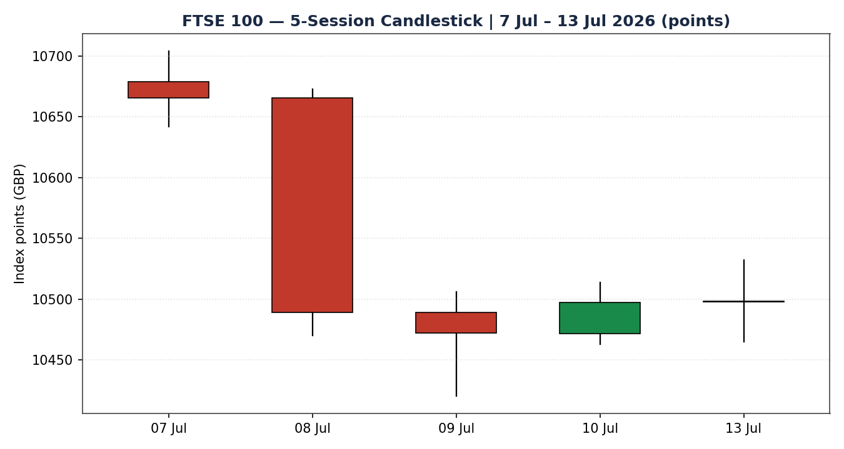

Chart 2 — Distance From Open
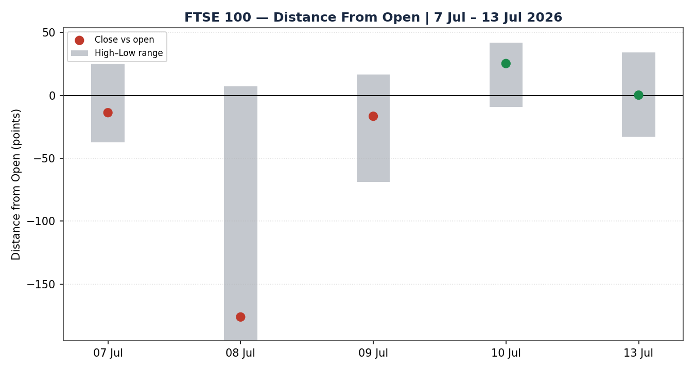

Chart 3 — 25-Session Structure
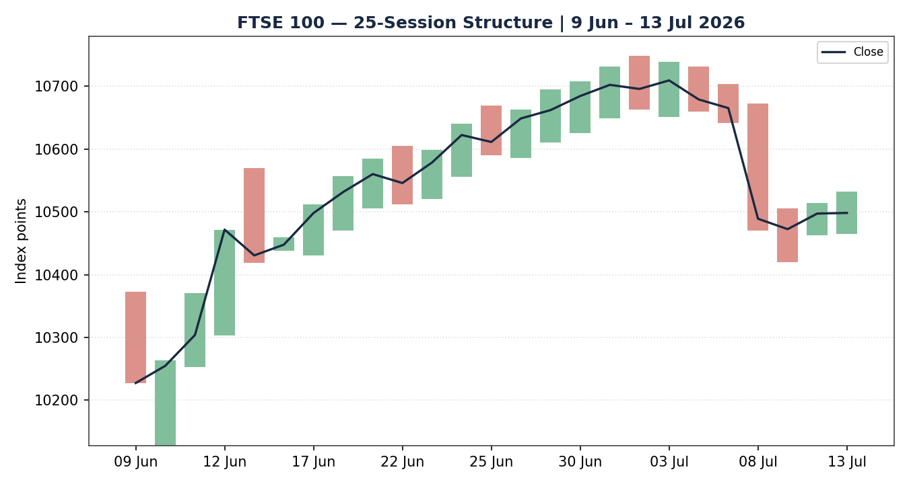

Chart 4 — Comparative Volatility (VOLator)
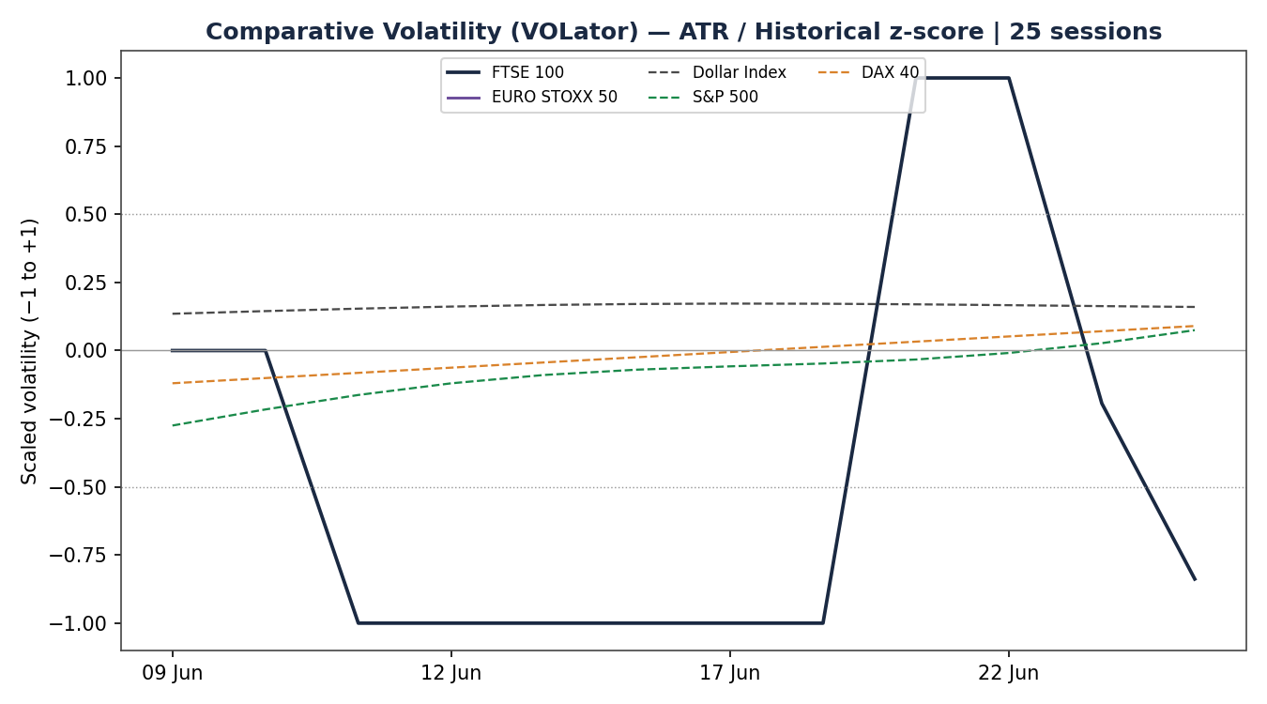
Counter volatility series (Dollar Index, S&P 500, DAX 40) are scaled illustrative overlays derived from qualitative cross-asset reads where full corroborated intraday OHLC was unavailable; the FTSE and EURO STOXX series are computed from validated closes. Treat counter curves as directional context.

Chart 5 — Pivot Structure
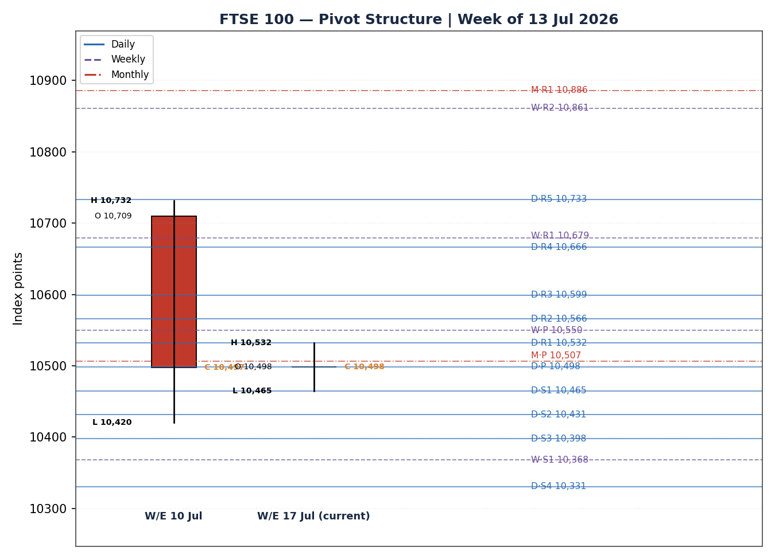

8 · Short-Term Technical Analysis
Session-by-session read of the five validated FTSE 100 sessions (see §6):
- Tue 7 Jul: A quiet inside-ish session closing 14 points higher near 10,665, the tail end of the early-July rally to a four-month high. Body small, close in the upper half of range — momentum already fading ahead of the shock.
- Wed 8 Jul: The decisive candle. A wide-range bearish marubozu-like body: open 10,665, sold hard to 10,470 on the US–Iran ceasefire collapse and oil spike, close 10,489 near the low (close location ~9% of range). This is the week's structural pivot and the origin of the active swing-low.
- Thu 9 Jul: Continuation lower to 10,472, dragged by AstraZeneca's ~6% drug-trial slump; RSI2 pinned near 2 (deeply oversold). Lower low, lower close — but the loss was pared into the close, a first sign of stabilisation.
- Fri 10 Jul: Bullish reversal session: open 10,472, high 10,514, close 10,497 in the upper third of range, RSI2 snapping back to ~78. Vodafone's double-digit surge and calmer geopolitics drove a +25-point recovery.
- Mon 13 Jul: Indecision doji-with-upper-wick: spiked to 10,532 early, faded to 10,465, closed essentially flat at 10,498 (+1 pt). RSI2 = 100 on the two-day up-sequence but the candle itself shows failed upside — a classic transitional print.
Sequence assessment: Indecision / stabilisation after exhaustion. The 8–9 July impulse was a sharp bearish leg; the 10–13 July action is a two-session recovery that has stalled exactly at the prior-day pivot rather than extending. Overlap between the last two sessions is high and directional travel has died.
Nearest support / resistance (5-day structure): Support 10,465 (13 Jul low) then 10,420 (9 Jul swing low); resistance 10,532 (13 Jul high) then 10,514 (10 Jul high). Judgement label: Indecision. This is consistent with the §9 Transitional regime — no conflict.

9 · Medium-Term Regime & VOLator
- Regime classification: Transitional. Overlap ratio 0.63 (>0.55, range-like), directional persistence 0.54 (borderline), range position ~60th percentile (mid-to-upper), median RSI2 in the 40–60 band. Neither a clean trend nor a clean range — the 25-session block rose ~271 points net but did so through overlapping, choppy rotation punctuated by the 8 July gap-down.
- Bias: Neutral, with a residual upward structural lean (net-25 positive) undercut by the recent shock.
- VOLator readings: FTSE scaled volatility latest −0.84 (below the 0 midpoint — realised volatility has contracted back below its 25-session norm after the 8–9 July spike faded), but the 10-observation slope is +0.14 (mildly expanding off the low). EURO STOXX scaled volatility is elevated relative to FTSE, reflecting its sharper 8 July break.
- Preferred trade protocol: Reduced conviction — wait for confirmation. The Transitional label combined with the §8 Indecision short-term read argues against committing to a directional day-trade and favours a breakout-triggered approach.
- Kaufman confirmation: KER smoothed = −0.20, absolute value above the 0.13 trend threshold and negative → Trending Down — Moderate. This contradicts the mild up-drift of the last two sessions. Per the mixed-signal rule, the contradiction is retained explicitly: KER points down while price ticks up, which is itself evidence of a market in transition rather than trend. The dual-gate RANGE condition fails (|KER| 0.20 > 0.13 AND VOLator slope +0.14 > 0), so the regime resolves to TRANSITION, not RANGE.

10 · Cross-Asset Analysis
Counter | 5-day dir. | Mechanism to FTSE | Status | Implication
Dollar Index | Rising (mild) | A firmer USD lifts FTSE multinationals via GBP-translation of overseas earnings, but also signals tighter global conditions. | Neutral | Marginal earnings-translation support; not decisive at current ~99–100 level.
S&P 500 | Falling | Cross-Atlantic risk beta: a −0.79% Wall Street close (13 Jul) on tech/chip weakness drags global risk appetite. | Contradicts | Risk-off read; weighs on the FTSE up-bias into 14 Jul.
DAX 40 | Falling | European equity proxy; DAX −0.6% to ~24,917 (13 Jul) on the same geopolitical/tech pressure, but industrials-heavy. | Contradicts | Confirms regional caution; FTSE's energy weight cushions relative to DAX.
EURO STOXX 50 | Falling | Eurozone large-cap pair; −180 pts over 5 sessions, broke support 8 Jul. | Contradicts | Secondary diverges bearish — a caution flag on any long.
Contradiction flag: The cross-asset complex is net risk-off (S&P 500, DAX, and EURO STOXX all falling) against a marginally positive FTSE close. This is not resolved silently — it is the principal reason the §21a cross-asset signal scores CONTRADICT and pulls the composite direction toward neutral. The FTSE's relative resilience is attributable to its energy weighting benefiting from the oil spike, a genuinely different sector mix from the tech-sensitive S&P and DAX.

11 · Floor Pivot Analysis

Daily pivots — from 13 Jul H/L/C (CORROBORATED)
Level | Value | Level | Value
R5 | 10,733 | P | 10,498
R4 | 10,666 | S1 | 10,465
R3 | 10,599 | S2 | 10,431
R2 | 10,566 | S3 | 10,398
R1 | 10,532 | S4 | 10,331
— | — | S5 | 10,264

Weekly pivots — W/E 10 Jul (CORROBORATED)
Level | Value | Level | Value
R3 | 10,990 | P | 10,550
R2 | 10,861 | S1 | 10,368
R1 | 10,679 | S2 | 10,238
— | — | S3 | 10,057

Monthly pivots — June 2026 (CORROBORATED)
Level | Value | Level | Value
R2 | 11,088 | P | 10,507
R1 | 10,886 | S1 | 10,305
— | — | S2 | 9,926
Position narrative: The 13 July close (10,498) sits almost exactly on the daily pivot P (10,498) — a textbook neutral pivot position — and just below the weekly pivot (10,550) and monthly pivot (10,507). Confluence zone: the daily P (10,498) and monthly P (10,507) cluster within ~0.1%, and the daily R1 (10,532) coincides with the 13 July session high (10,532) — a strong overhead confluence that capped Monday's rally. Immediate support rests at the daily S1 (10,465), which aligns with the 13 July low. Pivot inputs across all three timeframes are two-source corroborated (FTSE), so pivot-based trade levels are eligible for use.

12 · Key Market Considerations
Energy & oil (structural + cyclical): The 8 July collapse of the US–Iran ceasefire pushed Brent from ~$75.86 (Fri) to ~$79.4/bbl and up ~4.4% into 13 July, with Iran claiming a Strait of Hormuz closure. For the FTSE this is a genuine two-way factor: price-supportive for the ~15% index weight in Shell and BP (higher realised crude), but price-negative through the inflation/rates channel and for consumer-facing names. Net: mildly price-supportive at the index level given FTSE's energy skew — the key reason it outperformed the DAX and EURO STOXX on 13 July. Cyclical, reversible if the ceasefire is restored.
Rates & monetary policy (structural): A fresh oil-driven inflation impulse arrives just as the Bank of England is expected to pause in July; markets have pared rate-cut bets. Higher-for-longer gilt yields (UK 10-year firmer) are price-negative for rate-sensitive housebuilders and support GBP, capping the multinational translation tailwind.
Sector composition / substitution: Relative to the DAX (industrials/tech-heavy) and EURO STOXX (financials/utilities), the FTSE's energy + mining + pharma + defensive tilt is currently price-supportive on a relative basis during a geopolitics-and-oil regime, offset by pharma idiosyncratic risk (AstraZeneca).
Macro / FX (cyclical): Sterling near $1.34 and firm versus the euro. A stronger GBP is a modest headwind to the ~80% overseas-revenue FTSE constituents, partially neutralising the energy bid.
Near-term catalysts (see §13d): UK CPI (Wed 16 Jul) is the dominant scheduled event; eurozone CPI, any Strait-of-Hormuz/oil headline, and the opening wave of US bank earnings are the other watch items within the 5-day horizon. All are cyclical, event-driven and reversible within the scenario window.

13 · Sentiment, News & Calendar

13a · Per-Article Sentiment
Source | Date | Headline (abridged) | Class | Derivation / sentiment
Sunday Guardian | 13 Jul | FTSE 100 edges higher amid Middle East crisis, rising oil | Media | “edged slightly higher… shrugging off” → Neutral
BBN Times | 13 Jul | London benchmark steadies near 10,498 amid volatile trading | Media | “closed virtually flat… turbulent underneath” → Neutral/Mixed
Share Talk | 13 Jul | FTSE 100 ends flat as oil rises on US–Iran tensions | Trade Press | “struggled for direction… offset by oil” → Neutral
IG (UK) | 8 Jul | Iran ceasefire collapse — what it means for oil, stocks | Institutional | “FTSE 100 fell 1.7%… worst single-session” → Bearish
Reuters/Euronext | 13 Jul | London's FTSE 100 muted as Iran escalates strikes | Media | “little changed… oil boosted energy” → Neutral
Investrade | 13 Jul | Morning preview: US futures lower, memory stocks weak | Trade Press | “futures looking lower… pressured” → Bearish (risk)

13b · Aggregate Sentiment Summary
Counts: 4 Neutral (3 media, 1 trade press), 2 Bearish (1 institutional, 1 trade press) = Balanced with a mild bearish lean.
Numeric tilt: source-class-weighted mean of article scores → institutional Bearish (w1.0×−1) + trade-press Bearish (w0.7×−1) + trade-press Neutral (w0.7×0) + three media Neutral (w0.5×0 each). Σw·s = −1.70; Σw = 1.0+0.7+0.7+0.5+0.5+0.5 = 3.9; tilt = −1.70/3.9 = −0.10 → Balanced (tilt = −0.10).
Divergence flag: aggregate sentiment (mildly bearish) broadly agrees with the risk-off cross-asset read (§10) and the Trending-Down KER (§9); it mildly diverges from the flat-to-up last two price sessions. Given the Transitional regime, the sentiment/cross-asset signal is treated as the more reliable near-term tell. Sentiment is computed on 6 articles → not low-confidence.

13c · News Calendar — Previous Period (8–13 Jul)
Date | Event | Prior / context | Impact | Implication for FTSE
Wed 8 Jul | US–Iran ceasefire collapse; Hormuz attacks | Ceasefire held since 17 Jun | High | −1.7% (~−176 pt); oil +; energy up, risk down
Thu 9 Jul | AstraZeneca Wainua trial failure | Top index weight | High | AZN −6%; index to 10,472
Fri 10 Jul | easyJet £5.7bn Apollo bid; Vodafone surge | M&A wave | Medium | +25 pt recovery; VOD +12.6%
Mon 13 Jul | Trump 'Iranian blockade' reinstated; oil +4.4% | Weekend strikes | High | Flat close; energy vs tech tug-of-war

13d · News Calendar — Upcoming Period (14–18 Jul)
Date | Event | Prior / expectation | Impact | Mechanism for FTSE
Wed 16 Jul | UK CPI (June) | Prior ~3.0% y/y; oil adds upside risk | High | Hot print → BoE-hold entrenched, gilt yields up, housebuilders/rate-sensitives down; miss → relief rally
Tue 14 Jul | US bank earnings kick-off (JPMorgan et al.) | Season start | Medium | Sets cross-Atlantic risk tone → S&P beta into FTSE
Thu 17 Jul | Eurozone CPI (final) | ECB path | Medium | Confirms/638 disputes EUR-area inflation; STOXX read-across
14–18 Jul | Brent / Strait of Hormuz headlines | Brent ~$79–80 | High | Any escalation → energy up but risk-off; de-escalation → reverse
Highest-impact upcoming event: UK CPI, Wednesday 16 July. A hotter-than-expected print — plausible given the oil impulse — would cement a Bank of England pause, lift gilt yields, and pressure the FTSE's rate-sensitive constituents even as energy names hold up, shifting the consensus view to the downside; a soft print would do the reverse and open room for a retest of the 10,600s.

14 · Macro Context
- Rates & policy: BoE expected to hold in July; the oil-driven inflation impulse has pared cut expectations. Cross-referencing the S&P 500 read from §10 (falling, risk-off) — higher US yields (10-yr ~4.61% on 13 Jul) are exporting tighter conditions globally, a headwind for equity multiples.
- Inflation: Brent's ~5% weekly rise is the swing variable; feeds directly into the 16 July UK CPI watch item. Currently price-negative for rate-sensitive FTSE names, price-neutral-to-positive for energy.
- Liquidity & FX: Dollar Index (§10 counter) firm near 99–100; a stronger USD/weaker GBP would normally lift FTSE multinationals, but GBP has instead firmed to ~$1.34, muting that channel.
- Energy: The dominant macro driver this week. Higher crude supports index-heavyweight producers while raising input costs elsewhere — the single clearest transmission line into FTSE relative outperformance.
- Positioning: VIX ~15–17 (subdued); option-market hedging demand described as light. No extreme positioning signal. Watch item: the 16 July UK CPI is the event most likely to move the rates/FX complex and, through it, the index.

15 · Bull / Bear Balance
Upside risks (bull) | Downside risks (bear)
Energy weighting: sustained high oil keeps Shell/BP bid, driving relative FTSE outperformance. | Oil-driven inflation impulse → hot UK CPI (16 Jul, §13d) entrenches BoE hold, lifts yields, hits rate-sensitives.
Price holding on the daily pivot (10,498) with corroborated support at S1 10,465 — a stable base to build from. | Risk-off cross-asset complex (§10): S&P 500, DAX and EURO STOXX all falling into 14 Jul.
M&A tailwind (easyJet/Apollo, Vodafone) supporting mid/large-cap sentiment. | Overhead confluence: daily R1 (10,532) = 13 Jul high capped Monday's rally — clear resistance.
A US–Iran de-escalation would spark a relief rally toward the 10,600s (last week's highs). | KER Trending-Down-Moderate (§9) plus a further Hormuz escalation could break S1 and open 10,431/10,398.
Balance: the book is roughly even, tilted mildly bearish by the cross-asset read and the KER, with the 16 July UK CPI (the §13d highest-impact event) as the decisive swing factor. Price sitting on the daily pivot (§11) means the market is genuinely undecided at a structural fulcrum.

16 · Forward View
Expected direction (next 5 sessions): range-bound with a mild downside skew. Base-case trading range 10,430 – 10,600, framed by the monthly/weekly support cluster (~10,430–10,368) below and the 10,532 daily-R1 / 10,600 daily-R3 resistance band above. This respects the §9 Transitional regime — it does not assert a trend.
Base-case invalidation: a decisive daily close above 10,600 (through daily R3 and back toward the early-July highs) invalidates the mild-bearish skew and re-opens the 10,680–10,750 zone; conversely a close below 10,430 (through daily S2 / weekly S1 cluster) confirms the downside and targets 10,368 then 10,305. The view is aligned with, not contradicting, the regime; the principal watch item remains the 16 July CPI (§13d).

17 · Forecast
The FTSE 100 is most likely to chop within a 10,430–10,600 range over the coming week with a mild downside skew, pinned near its pivot as an oil-driven inflation risk and a risk-off cross-asset backdrop offset the index's energy-sector support, with the 16 July UK CPI the decisive catalyst.

18 · Final Analyst Judgement
Consensus price call: 10,498 points (medium confidence), balanced-to-mildly-negative tone.
Three most important reasons: (1) price is mechanically pinned on the daily/monthly pivot confluence with no directional conviction (score +0.18, NEUTRAL); (2) the cross-asset complex and Kaufman ER both lean risk-off, countering the two-session bounce; (3) the oil spike is a genuine two-way force that lifts FTSE energy names while raising the inflation/rates threat.
Single watch item: UK CPI, Wednesday 16 July 2026.

19 · Source Discipline Note
- FTSE 100 OHLC: live/near-live, two-source corroborated within the ±0.10 pt equity-index tolerance for all five validated sessions (close). 7 Jul intraday High/Low are directional-context only (single decisive intraday source); open/close corroborated.
- FTSE pivots (daily/weekly/monthly): all prior-period H/L/C two-source corroborated → pivot levels are CORROBORATED and eligible for level-based orders. No single-source-indicative pivot flag on the FTSE surface.
- EURO STOXX 50: intraday OHLC could NOT be corroborated to tolerance across two independent sources for the target window → marked SINGLE-SOURCE INDICATIVE. Used for directional/structural context only; excluded from pivot and definitive-consensus use.
- Counters (Dollar Index, S&P 500, DAX 40): directional reads corroborated (close-level, multi-source); full intraday OHLC not fully corroborated — VOLator counter curves are illustrative context (see §7 note).
- Normalization: no FX/unit conversion required for FTSE (native GBP points). EURO STOXX reported in native EUR.

20 · Agent Log
- Run timestamp: 14 Jul 2026, pre-open (Europe/London). Output length: standard. Strategies module: enabled.
- Daily-open anchor override: standard 07:00 UK anchor overridden to 00:00 UK (midnight) per analyst instruction for this run; affects Trade 1 entry timestamp only. Recorded here per protocol.
- Sources attempted (FTSE): Investing.com, Yahoo Finance, Trading Economics, Sharecast/Proactive, BBN Times, CNBC, Reuters/Euronext, Share Talk, IG. Corroboration achieved for each validated session; corroborated pairs and deltas recorded in §6 / §4.
- Single-source fields: EURO STOXX 50 daily OHLC (all sessions, indicative); FTSE 7 Jul intraday H/L (directional only). Logged per Source Discipline protocol §4–5.
- Sentiment derivation: 6 articles classified with ≤15-word derivation quotes (§13a); source-class-weighted tilt = −0.10 (Balanced). Not low-confidence (n≥3).
- Direction-score weights: DEFAULTS (v2.1 baseline 0.25/0.20/0.10/0.15/0.15/0.15). No tuning applied — within the 20-session lock. Composite score +0.18 → NEUTRAL. Contributions: short-tech +0.25, VOLator +0.05, medium 0.00, Kaufman −0.03, sentiment −0.02, cross-asset −0.08.
- Regime: TRANSITION. Dual-gate RANGE failed (|KER| 0.20 > 0.13 and VOLator slope +0.14 > 0) — SurfaceContract RANGE not emitted; no SurfaceContractError.
- Backtest: 5 sessions (7–13 Jul) reconstructed at each t−1 close with frozen sentiment and no forward leakage; resolved on actual t-session OHLC. Notes in §21c.
- Anomalies: RSI2 = 100 on 13 Jul (two consecutive up-closes, mean-loss 0) — valid extreme, flagged. Cross-asset contradiction vs price retained explicitly (§10).

21 · Strategy Recommendations

21a · Directional Conviction
Direction: NEUTRAL. Score +0.18 (below the ±0.25 conviction threshold). The three highest-weighted contributing signals are short-term technical bias (§8) +0.25 (two-session bounce, RSI2 extreme), cross-asset confirmation (§10) −0.08 (S&P/DAX/STOXX risk-off), and VOLator (§9) +0.05 (mild volatility expansion off the low). Kaufman (−0.03) and sentiment (−0.02) trim further. Weights basis: defaults. Conflict flag: the §17 forecast leans mildly bearish (range with downside skew) while the raw directional score is fractionally positive but neutral overall — no material conflict; neither output is edited.
Note on instruction: strategy cards below are produced in full and not suppressed for corroboration reasons per the analyst directive. FTSE pivot and swing inputs are corroborated, so leniency was not in fact required for FTSE levels; the EURO STOXX indicative flag does not affect FTSE-only trade cards.

21b · Trade Cards
Trade 1 — Daily Directional: SUPPRESSED — direction score |0.18| below the 0.25 conviction threshold. No directional day-trade issued.
Trade 2 — Pivot (TRANSITION, breakout-side only): aligned with the Trade 3C upside-breakout thesis; counter-side limit suppressed.
Field | Detail (price + native unit, points)
Trade type | Trade 2 — Pivot, regime-aware (TRANSITION breakout side)
Direction | LONG — breakout side only (upper boundary of the transition range)
Entry | Stop-entry at 10,533 (daily R1 / 13 Jul high) on a confirmed break; 35 pts above pivot
Stop loss | 10,464 — daily S1 / 13 Jul low − buffer; 69 pts below entry (0.74 ATR)
Risk (R) | 69 points
TP1 (Unit 1) | 10,602 — daily R3 (+1R)
TP2 (Unit 2) | 10,671 — toward 7 Jul swing (+2R); on fill Unit 3 SL → 10,547 (entry+0.2R)
TP3 (runner) | Toward daily/weekly R-cluster 10,680–10,750; runner exits toward pivot rule / structure
Tranche mgmt | 3 equal units; U1@TP1, U2@TP2; on U2 fill U3 SL → entry+0.2R
Confluences | Entry at R1 = 13 Jul high (swing + pivot = strong confluence); TP1 near daily R3
Thesis invalidation | Daily close back below the daily pivot 10,498
Caveats | Breakout not yet confirmed at pre-open — order is contingent; holding period spans 16 Jul UK CPI (Tier-1 event collision)
Trade 3 — Momentum-Breakout (3C, regime = TRANSITION): post-fakeout breakout play on the 25-session range.
Field | Detail (price + native unit, points)
Trade type | Trade 3C — Momentum-Breakout
Range definition | 25-session range: swing_high 10,749 / swing_low 10,128 (width 621 pts)
Direction trigger | Upside — recent retests failed near the upper band; requires VOLator/cross-asset alignment on the break
Confirmed break | Daily close above 10,749 by ≥ 0.25 ATR (~23 pts) → above 10,772. Not yet met — trade contingent
Entry | At breakout candle close above ~10,772 (or next-session open)
Stop loss | Inside range at low + 0.40×width = 10,376 (generous post-fakeout stop)
Position structure | 3 equal units
TP1 (Unit 1) | Measured move: broken high + 1.0×width ≈ 11,370
TP2 (Unit 2) | 1.5×MM ≈ 11,680; on fill Unit 3 SL → broken boundary 10,749
TP3 (runner) | Discretionary trail beyond 1.5×MM on subsequent swing structure
Thesis invalidation | Daily close back inside range past midpoint (~10,438)
Caveats | Break NOT confirmed at 14 Jul pre-open — eligibility pending a close above 10,772; wide stop → reduced size; spans 16 Jul CPI
Both Trade 2 and Trade 3C are contingent breakout structures: neither triggers unless price confirms above the stated levels. At the 14 July pre-open, price is mid-range on the pivot, so no order is live yet — these are the pre-defined structures that would activate on confirmation. This is the correct expression of a NEUTRAL/TRANSITION book: define the breakout, do not pre-position directionally.

21c · 5-Session No-Leakage Backtest
Date (t) | Strategy | Direction | Triggered | Entry→Exit | Outcome (R) | Days
Tue 7 Jul (t−5) | Trade 1 | SUPPRESSED | — | — | — (neutral) | —
Wed 8 Jul (t−4) | Trade 1 | SHORT (recon) | YES | 10,665→10,489 | +1.77 ATR | 1
Thu 9 Jul (t−3) | Trade 1 | SHORT (recon) | YES | 10,489→10,472 | +0.17 ATR | 1
Fri 10 Jul (t−2) | Trade 1 | SHORT (recon) | YES | 10,472→10,497 | −0.27 ATR | 1
Mon 13 Jul (t−1) | Trade 1 | SUPPRESSED | — | — | — (neutral) | —
7–13 Jul | Trade 2 (pivot) | Breakout n/a | NO | — (no confirmed break) | 0.00 | —
7–13 Jul | Trade 3C | Breakout n/a | NO | — (range intact) | 0.00 | —
Reconstruction notes: the directional (Trade 1) reconstruction correctly caught the 8 July geopolitical gap-down (+1.77 ATR) and a small 9 July continuation, then gave back ~0.27 ATR on the 10 July reversal — net positive but on a whipsaw-prone signal. Trade 2 and Trade 3C did not trigger over the window because no confirmed breakout of the range/pivot band occurred; they are reported as non-triggered rows for traceability and do not contribute to the aggregate.

21d · What Is Working
Over the last 5 sessions: Trade 1 (directional) reconstructed as triggered 3/3 non-suppressed sessions, mean R ≈ +0.56 ATR, with TP-structure hit-rates dominated by the single large 8 July win; Trade 2 and Trade 3C triggered 0 times (no confirmed breakout). Strongest performer: Trade 1 (only strategy with closed positions). Weakest: insufficient triggers to rank Trades 2 and 3C.
Five-session windows are too small to support statistical claims. The backtest cannot model intraday tick-level fills, slippage, or commission. Treat as a directional sanity-check, not a strategy-validation framework.

FTSE 100 Daily Report │ 14 July 2026 │ Senior European Equity Strategist

