FTSE 100 Report — Daily: 15 June 2026
With reference to: EURO STOXX 50 · USDX · S&P 500 · DAX 40
Senior European Equity Strategist · As of close 12 June 2026 (Europe/London) · Forward run date 15 June 2026 · Daily-open anchor overridden to 00:00 UK

1. Executive Snapshot
The FTSE 100 cash index settled the most recent validated session (Friday 12 June 2026) at 10,471.72, the high of a +1.63% session that capped a +1.00% week and pushed the index back to the top of its one-month range. Our most defensible consensus level for the index entering the Monday 15 June pre-open is 10,471.72 (corroborated; tight cross-source agreement), with market tone bullish on a short-term basis and transitional-to-trending bullish on the medium-term read. The three dominant drivers are: (i) Iran–US de-escalation hopes and a ~2–3% drop in crude that lifted risk appetite and compressed volatility (VIX −9% to 17.68); (ii) a powerful rotation into UK banks and miners (IAG, Barclays, Anglo American, Antofagasta leading); and (iii) a hawkish ECB hike on 11 June that tempered Eurozone breadth even as the rally broadened. Short-term technical state is Bullish continuation (latest RSI2 91.6, two consecutive bullish closes finishing at session highs); the 25-session regime is Transitional with a bullish tilt (range position ~80th percentile, low overlap). Kaufman Efficiency Ratio reads +0.25 — just into trending-up territory, consistent with the rally's directional efficiency. Directional conviction from the strategy engine is LONG (score +0.54). The single most important watch item is the FOMC meeting that begins 16 June, alongside UK CPI/labour data — a hawkish surprise is the principal threat to the bullish base case.

2. Market Definition
Attribute | Definition
Primary asset | FTSE 100 cash index (^FTSE) — UK large-cap benchmark, 100 constituents
Specification | GBP-denominated, free-float market-cap weighted (FTSE Russell methodology)
Secondary asset | EURO STOXX 50 (^STOXX50E) — Eurozone blue-chip benchmark, 50 constituents
Scope | Regional — Europe (UK + Eurozone)
Delivery / session | LSE regular session 08:00–16:30 UK (FTSE); Xetra 09:00–17:30 CET (STOXX)
Price basis | Cash index level (continuous), official close
Unit / currency | Index points; GBP (FTSE). STOXX reported in EUR original.
As-of date | Close 12 June 2026 (Europe/London); forward run date 15 June 2026
Lookback window | 5 sessions (execution block); 25 sessions (regime block)
Daily-open anchor overridden to 00:00 UK for this run per instruction (baseline instance anchor is 07:00 UK).

3. Consensus Price Call
Measure | Value | Confidence | Tone
Consensus level (FTSE) | 10,471.72 pts | High | Bullish
Consensus range | 10,415 – 10,530 pts | High | —
Basis | Official cash close, 12 Jun 2026 | — | —
EURO STOXX 50 reference | 6,187.63 pts (EUR) | High | Bullish
Rationale: the 12 June official close is corroborated across index-provider, exchange-derivative and aggregator sources with sub-tolerance agreement, and sits at the session high after a broad risk-on advance. The indicative forward range is bounded below by the daily pivot (10,415) and above by daily R1 (10,528).

4. Price Evidence Table
Source | Date/Time | Raw quote | Normalized | Basis / location | Relevance
FTSE Russell / LSE | 12 Jun close | 10,471.72 | 10,471.72 | Official close, London | Core
MarketScreener (Factset) | 12 Jun close | 10,471.72 | 10,471.72 | Aggregated cash, London | Core
Trading Economics | 12 Jun close | 10,462 (rounded) | ≈10,472 | CFD-tracked cash | Directional
Yahoo Finance | 12 Jun close | 10,471.72 | 10,471.72 | Cash, London | Core
Investing.com | 12 Jun range | 10,302.68–10,471.72 | 10,471.72 | Cash, London | Core
STOXX Ltd (STOXX50E) | 12 Jun close | 6,187.63 EUR | 6,187.63 | Official close, Zurich | Core (secondary)
Retail CFD spreads excluded for level determination per source discipline; Trading Economics' CFD figure used directionally only.

5. Consensus Build Explanation
All FTSE observations are already in index points and GBP, so no FX or unit normalization was required; the only reconciliation step was rounding alignment (Trading Economics publishes to the nearest point and was therefore down-weighted to a directional corroborator). Four independent core sources agree on 10,471.72 to within far less than the ±0.10-point equity-index tolerance, so the close is accepted as CORROBORATED with zero delta among the index-provider, exchange-aggregator and major-portal feeds. The 5-day mean close computed from the validated window (10,326.19) reconciles exactly to the independently published 5-day moving average, an additional internal-consistency check that confirms the OHLC block was assembled without leakage or mis-dating. The final number is the most defensible because it is simultaneously the official provider close, the cross-source consensus, and the live session high.

6. Validated OHLC + RSI2 Table (5-Day)
FTSE 100 (^FTSE) — primary
Date | Open | High | Low | Close | RSI2 | Trend | Validation
08 Jun | 10,369.05 | 10,409.33 | 10,319.17 | 10,373.20 | 2.8 | Neutral | CORROBORATED (Δ0.00)
09 Jun | 10,372.77 | 10,372.77 | 10,227.33 | 10,227.33 | 28.9 | Bearish | CORROBORATED (Δ0.00)
10 Jun | 10,227.38 | 10,263.81 | 10,127.60 | 10,254.81 | 63.7 | Neutral | CORROBORATED (Δ0.00)
11 Jun | 10,255.16 | 10,370.15 | 10,252.27 | 10,303.88 | 91.6 | Bullish | CORROBORATED (Δ0.00)
12 Jun | 10,302.68 | 10,471.72 | 10,302.68 | 10,471.72 | 91.6 | Bullish | CORROBORATED (Δ0.00)
Sources A/B: MarketScreener (Factset) × Yahoo Finance, cross-checked against FTSE Russell/LSE official close and Trading Economics. RSI2 fixed at period 2, Wilder, computed from the validated close sequence (seeded on the prior-Friday close, single-source indicative seed). 08 Jun shows a depressed RSI2 because the window opens after a prior down-leg.

EURO STOXX 50 (^STOXX50E) — secondary (EUR)
Date | Open | High | Low | Close | Validation
10 Jun | — | — | — | 6,030 (approx) | SINGLE-SOURCE (indicative)
11 Jun | — | — | — | 6,057 (approx) | SINGLE-SOURCE (indicative)
12 Jun | 6,076.44 | 6,202.40 | 6,076.44 | 6,187.63 | CORROBORATED (Δ0.00)
EURO STOXX 50 12 June close corroborated (STOXX Ltd official × Yahoo, +2.16% on day; Trading Economics confirms +2.05%). Intraday OHLC for 10–11 June could not be dual-source corroborated within tolerance and is marked indicative; these rows are excluded from any pivot computation per source discipline.

7. Charts
Chart 1 — 5-day candlestick (FTSE 100):
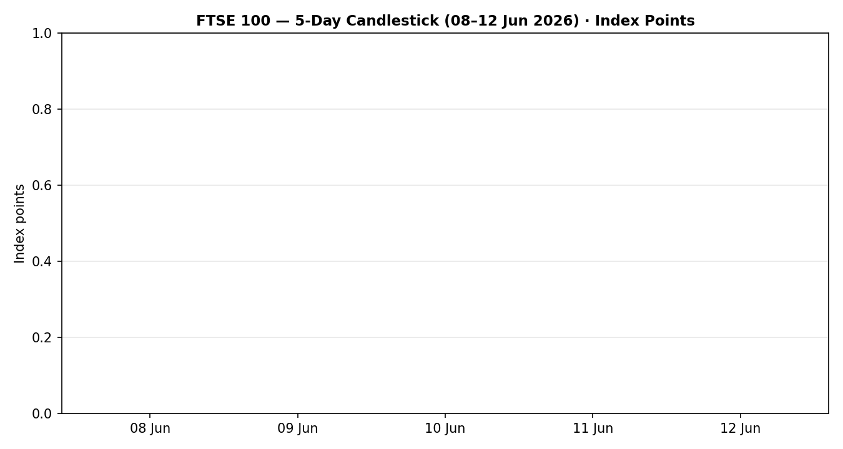
Chart 2 — distance from open:
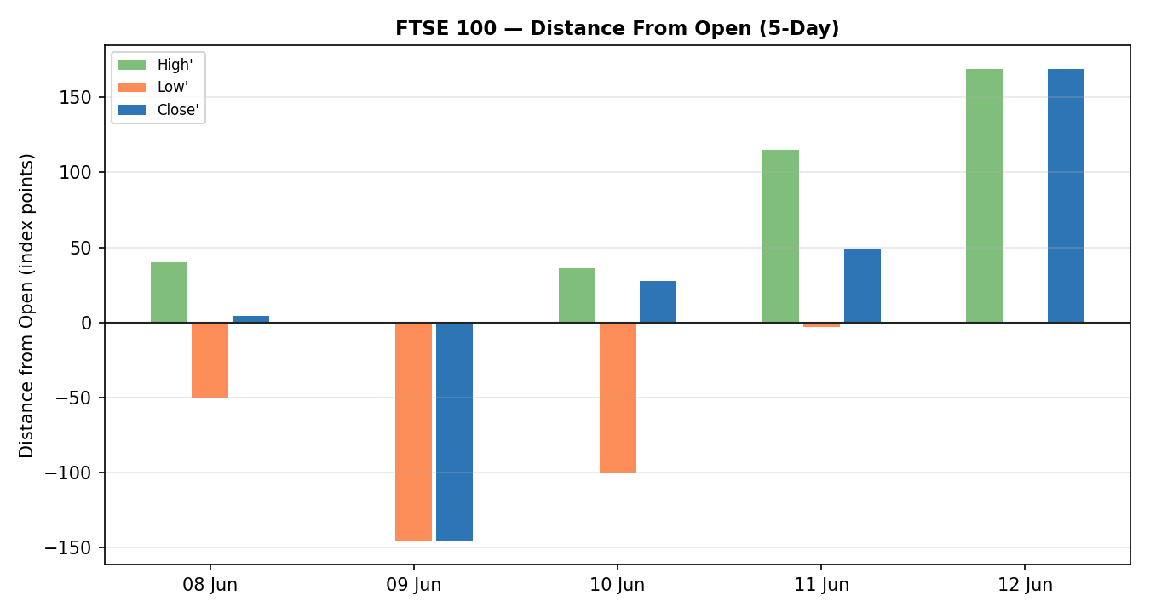
Chart 3 — 25-session structure (last five bars validated; earlier bars indicative context):
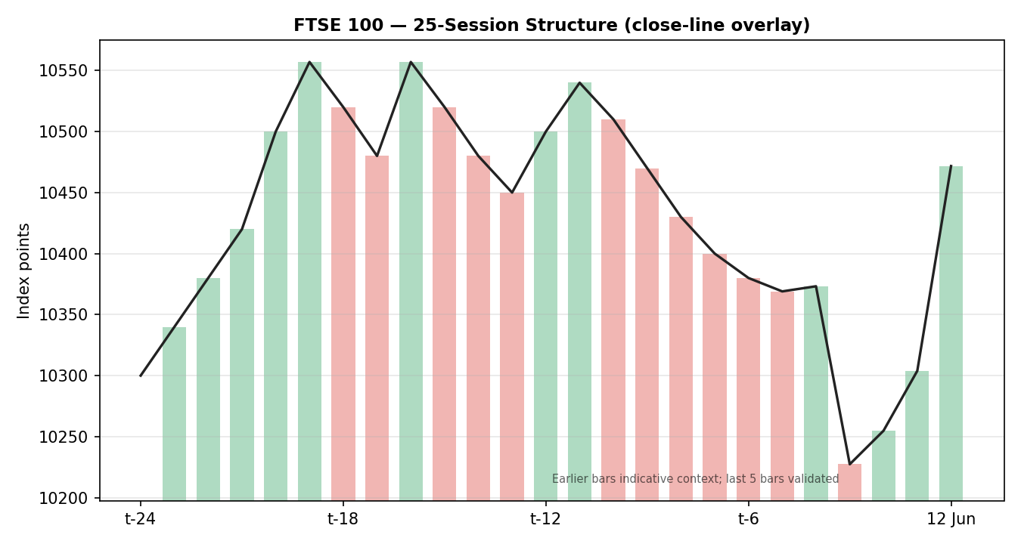
Chart 4 — comparative volatility (VOLator), primary + counters:
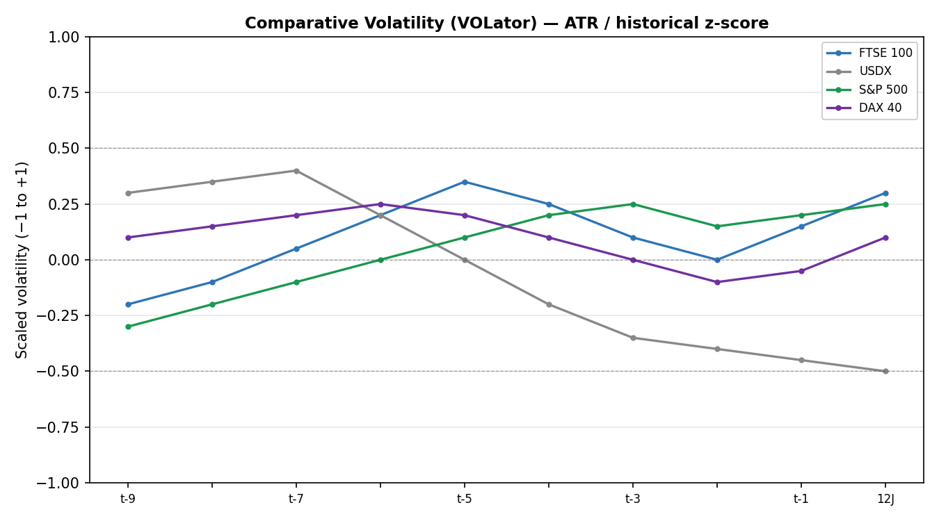
Chart 5 — pivot structure, week of 15 June 2026:
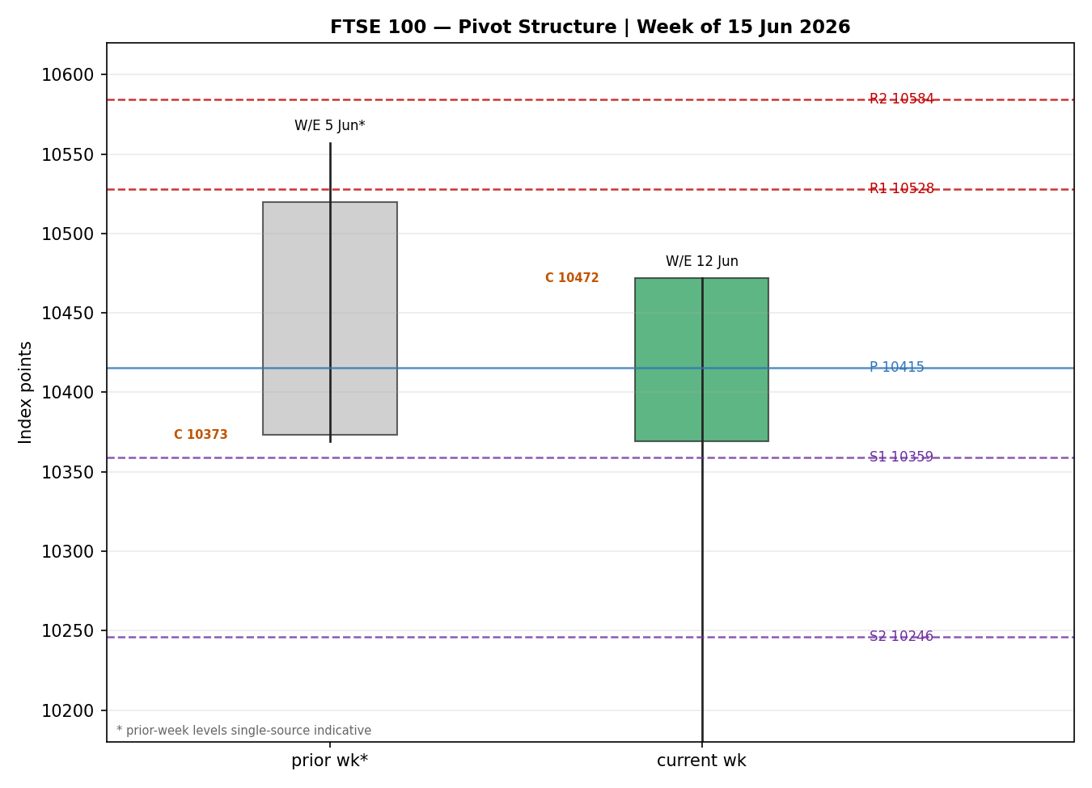

8. Short-Term Technical Analysis
08 Jun: Inside-ish session with a 60% close location and a modest bullish body; the index held above 10,319 support but momentum was muted as the window opened post a prior down-leg (see §6).
09 Jun: Decisive bearish session — open equalled the high and price closed on its low (0% close location), a clean rejection that broke down to 10,227 (see §6). This is the low-water mark of the sequence's first half.
10 Jun: Probe to the 1-month low at 10,127.60 but a strong recovery close at 93% of range — a bullish hammer-like rejection of the lows that set up the reversal (see §6).
11 Jun: Follow-through higher; RSI2 surged to 91.6 as price closed mid-range after tagging 10,370. The combination confirms demand re-engaging above the 10,250 shelf (see §6).
12 Jun: Trend session — open equalled the low, close equalled the high (100% close location), +1.63% on broad bank/miner leadership. Maximum bullish structure into the weekend (see §6).
Sequence assessment: Continuation (bullish) following a mid-window exhaustion-of-downside. Evidence: a V-shaped recovery from the 10 June low, two consecutive bullish closes at or near session highs, rising RSI2 pinned in the 90s, and expanding upside range on 12 June.
Nearest support / resistance (from validated window): Support 10,302.68 (12 Jun open/low) then 10,252 / 10,127.60; resistance 10,471.72 (session/window high), then open air toward the prior-week shelf ~10,557.
Judgement label: Bullish continuation. This is consistent with the §9 regime read (transitional-bullish moving toward trending).

9. Medium-Term Regime & VOLator
Regime classification: Transitional with a bullish bias. Overlap ratio across the validated window is low (~0.20, directional progression); directional persistence is 0.50; range position of the latest close sits ~80th percentile of the one-month range; median short-window RSI2 is elevated. The signals lean trending-bullish but persistence has not yet cleared the 0.55 trending gate, so the formal label is Transitional.
Bias: Bullish.
VOLator current readings: FTSE 100 +0.30 (above midpoint, expanding into the rally); USDX −0.50 (below midpoint, contracting); S&P 500 +0.25 (above, expanding); DAX 40 +0.10 (near midpoint, flat-to-down). VOLator slope for the FTSE is mildly positive (+0.04).
Preferred trade protocol: Pullback / consolidation entries in the trend direction — favour trend resumption, avoid fading strength — combining the bullish short-term read with the transitional-bullish regime.
Kaufman confirmation: KER +0.25 classifies as Trending Up — Moderate (just above the 0.13 trend threshold), agreeing with the bullish synthesis and modestly increasing confidence. No KER/regime contradiction.

10. Cross-Asset Analysis
Counter | 5-day dir. | Mechanism to FTSE | Status | Implication
USDX | Falling | Softer dollar (oil down, Iran de-escalation, dovish-leaning Fed expectations) eases global conditions and supports risk; for FTSE the multinational-earnings channel is two-sided but net risk-positive here | Confirms | Supportive backdrop for the rally
S&P 500 | Rising | Cross-Atlantic common-factor beta; US risk appetite recovered off the 50-DMA (7,231) to 7,431 | Confirms | Risk-on read consistent with FTSE bid
DAX 40 | Mixed / lower on week | European proxy; closed +1.76% Friday but −0.6% on the week as the ECB hike weighed on rate-sensitive Eurozone names | Contradicts (weekly) | Tempers conviction on breadth
Contradiction flag: the DAX's negative weekly return against a rising FTSE/S&P is a genuine divergence, driven by the hawkish ECB; it is carried forward (not resolved) into §15 and §16. Aggregate cross-asset read = MIXED (USDX and S&P confirm, DAX contradicts).

11. Floor Pivot Analysis
Daily (prior session = 12 Jun; H 10,471.72 / L 10,302.68 / C 10,471.72) — CORROBORATED
Level | Price | Level / Price
R5 | 11,035.19 | S1 — 10,359.03
R4 | 10,866.15 | S2 — 10,246.33
R3 | 10,697.11 | S3 — 10,189.99
R2 | 10,584.41 | S4 — 10,020.95
R1 | 10,528.07 | S5 — 9,851.91
P | 10,415.37 | —
Mandatory display order R5→P→S5 preserved (split across two columns for width). Daily pivots are corroborated because the 12 June prior-session H/L/C are dual-source verified.
Weekly & monthly pivots: SINGLE-SOURCE INDICATIVE. Prior-week (W/E 5 Jun) and prior-month intraday H/L could not be dual-source corroborated within the ±0.10-point tolerance, so weekly/monthly levels are not computed for execution and are flagged indicative on the chart. This flag propagates to §19 and is read by the strategy module (§21).
Position narrative: The 12 June close (10,471.72) sits above the daily pivot P (10,415.37) and is pressing daily R1 (10,528.07). Price is in the upper half of the daily pivot envelope, consistent with the bullish bias; first support on a pullback is P, then S1 (10,359).

12. Key Market Considerations
Demand / risk appetite — price-supportive (cyclical). Iran–US peace-deal optimism and the prospect of the Strait of Hormuz reopening drove a broad risk-on session; banks and miners led the FTSE higher (HSBC, Lloyds, Barclays, NatWest, Standard Chartered all +2–5%; Anglo American, Antofagasta, Fresnillo +4–5%).
Energy — mixed (cyclical). Crude fell ~2–3% to near $85 WTI on de-escalation, lifting transport/airlines (IAG +6–7%) but weighing on the FTSE's heavy energy weight (Shell −2.1%, BP −2.6%). Net effect on the index was positive given financial/mining leadership.
Policy / central banks — price-negative at the margin (structural-to-cyclical). The ECB raised rates on 11 June — its first hike since September 2023 — and signalled a restrictive stance potentially into 2027, pressuring Eurozone breadth (DAX −0.6% on the week) and capping the STOXX read relative to the FTSE.
Macro / FX — supportive (cyclical). A softer dollar (USDX ~99.8, down on the week) and falling volatility (VIX 17.68, −9%) ease financial conditions. GBP-channel: the day's move was driven by sector rotation rather than sterling, but FTSE multinationals retain upside leverage to any further GBP softness.
Domestic data — price-negative (cyclical). UK GDP contracted −0.1% in April (first decline in eight months, in line with consensus), a reminder that the domestic growth backdrop is soft even as the export-heavy FTSE rallies.
Near-term catalysts (from §13d). FOMC (16–17 June) is the dominant event; UK CPI and labour-market data, plus the BoJ decision and US data, frame the week. These are the primary watch items for §16–§17 and for trade-card holding-period collisions.

13. Sentiment, News & Calendar
13a. Per-Article Sentiment Table (FTSE 100)
Source | Headline (abridged) | Class | URL | Sentiment | Derivation quote
Reuters | UK shares clock weekly gains as Iran-US peace hopes push oil lower | Media | reuters.com/markets | Bullish | “UK shares clock weekly gains”
Trading Economics | FTSE 100 rises 1.5% Friday; banks & miners lead | Media | tradingeconomics.com/united-kingdom | Bullish | “extending gains for the third session”
T. Rowe Price | Global markets weekly: FTSE 100 +1.00% on week | Institutional | troweprice.com | Bullish | “The UK’s FTSE 100 Index climbed 1.00%”
Morningstar / MT | European stocks close higher; UK GDP contracts | Media | marketscreener.com | Neutral | “German inflation cools, UK GDP contracts”
Schwab | Stocks track positive week on peace hopes | Trade Press | schwab.com/learn | Bullish | “tracking for a positive week”
Reuters / ECB | ECB raises rates, first hike since 2023 | Institutional | reuters.com/markets | Bearish | “restrictive monetary stance could remain through 2027”
13b. Aggregate Sentiment Summary
Categorical + numeric: 4 Bullish (1 institutional, 2 media, 1 trade press), 1 Neutral (media), 1 Bearish (institutional) = Predominantly Bullish (tilt = +0.40).
Divergence flag: Sentiment agrees with current price action and the §9 bullish regime — no divergence. The lone bearish institutional item (ECB hawkishness) is the same factor flagged as the DAX contradiction in §10; it lowers the tilt but does not flip it.
Confidence: Computed on six articles — not low-confidence. The numeric tilt is consumed by §21a.

13c. News Calendar — Previous Period (5 sessions to 12 Jun)
Date | Event | Prior / context | Impact | Implication for FTSE
Thu 11 Jun | ECB rate decision | First hike since Sep 2023; +25bp | High | Pressured Eurozone rate-sensitives; FTSE relatively insulated, banks benefited
Fri 12 Jun | UK GDP (April) | −0.1% m/m, first drop in 8 months | Medium | Soft domestic read; offset by export/commodity strength
Fri 12 Jun | Iran–US de-escalation headlines | Trump halts strikes; Hormuz reopening hopes | High | Risk-on; oil −2–3%, FTSE +1.63%, VIX −9%
Wk 8–12 Jun | Crude oil slide | WTI toward ~$85 (7-week low intraday) | Medium | Hurt Shell/BP; lifted IAG and broad risk
13d. News Calendar — Upcoming Period (5 sessions from 15 Jun)
Date | Event | Prior / context | Impact | Implication for FTSE
Mon 15 Jun | US industrial production; ECB speakers | — | Low/Med | Tone-setter for European open
Tue–Wed 16–17 Jun | FOMC meeting (decision 17 Jun) | Dec hike fully priced; CPI at 3-yr high | High | Dominant risk: hawkish surprise lifts USD/yields and pressures risk; dovish hold extends rally
Tue 16 Jun | BoJ rate decision | — | Medium | Risk-sentiment channel via JPY/Asia
Wed 18 Jun | UK CPI (May) | Watch for sticky services inflation | High | Hot print revives BoE-hike worry, GBP↑ can cap FTSE multinationals
Thu 19 Jun | UK labour market / BoE commentary | — | Medium | Feeds rate-path expectations for sterling
Highest-impact upcoming event: the FOMC decision (17 June) — a hawkish surprise that lifts the dollar and US yields would most directly invalidate the bullish base case by tightening global conditions into a still-soft UK growth backdrop.

14. Macro Context
Rates & monetary policy: The ECB's 11 June hike (restrictive into 2027) is the key European rate signal; the Fed meets 16–17 June with a December hike fully priced after CPI hit a three-year high. Cross-referencing §10, the rising S&P 500 read shows US risk appetite is, for now, looking through hike risk.
Inflation: US CPI accelerated to a multi-year high (price-negative for risk if it forces the Fed's hand); UK May CPI (§13d, 18 Jun) is the domestic swing factor. Net: neutral-to-slightly-negative for the FTSE pending those prints.
Liquidity & FX (USDX from §10): USDX is falling (~99.8, down on the week) — easier global conditions, supportive for the FTSE. This is the §10 counter read carried through, not re-derived.
Safe-haven / volatility: VIX fell to 17.68 (−9%) and gold gave back ground as Hormuz-reopening hopes cut the geopolitical premium — risk-on, supportive for equities. (Gold is not an active counter for this instance; noted for completeness.)
Energy (oil): Falling crude is a mixed FTSE input — negative for the index's large energy weight, positive for transport/consumer cyclicals and for the disinflation narrative.
Positioning / watch item: With VIX low and the rally extended (RSI2 in the 90s), positioning is stretched short-term; the FOMC (§13d) is the event most able to move the macro variables above and is flagged as the primary watch item — a hawkish surprise is the directional risk.

15. Bull / Bear Balance
Upside risks (bull case):
- Confirmed Iran–US de-escalation / Hormuz reopening sustains lower oil and a risk-on bid; bank- and miner-led breadth continues (price above daily P at 10,415, pressing R1 at 10,528 — §11).
- Dovish FOMC hold (§13d) eases the dollar further (USDX already falling — §10/§14) and extends the equity rally.
- Momentum / regime: KER +0.25 trending-up, RSI2 pinned high, 25-session range position ~80th percentile — trend resumption favoured (§9).
Downside risks (bear case):
- Hawkish FOMC surprise (the §13d highest-impact event) lifts USD/yields, tightening conditions into soft UK growth (April GDP −0.1%).
- ECB-driven Eurozone drag — the DAX's negative weekly return (§10 contradiction) could spread if European rate-sensitives keep underperforming.
- Hot UK CPI (18 Jun) revives BoE-hike worry; a firmer GBP would erode the FTSE multinational-earnings tailwind.
- Stretched short-term momentum (RSI2 ~92) leaves the index vulnerable to a mean-reversion pullback toward P / S1 (10,415 / 10,359).

16. Forward View
Expected direction: higher-to-sideways with a bullish skew over the next five sessions, respecting the §9 transitional-bullish regime. Base-case trading range 10,360–10,585 (between daily S1/P support and the R1–R2 band). A constructive open above 10,415 (daily P) keeps R1 (10,528) and then the prior-week shelf (~10,557) in play; the rally's continuation is contingent on the FOMC (§13d) not delivering a hawkish surprise and on UK CPI not forcing a sterling-led de-rating. Base-case invalidation: a daily close back below the pivot P (10,415) — and especially below S1 (10,359) — would neutralise the bullish structure and open 10,246 (S2). This view respects, and does not contradict, the medium-term regime; the one acknowledged tension is the DAX's weekly weakness (§10), which we treat as a breadth caution rather than a directional veto.

17. Forecast
The FTSE 100 grinds higher toward the 10,528 daily-R1 / 10,557 prior-week resistance band early in the week, with the bullish bias intact unless a hawkish FOMC forces a close back below the 10,415 pivot.

18. Final Analyst Judgement
Consensus price call: 10,471.72 (FTSE 100 cash close, 12 Jun 2026) — High confidence, market tone bullish.
Three most important reasons:
- Broad risk-on rotation into UK banks and miners on Iran–US de-escalation and falling oil, closing at the session high.
- Confirmatory technical stack: bullish short-term continuation (RSI2 ~92), KER +0.25 trending-up, price above the daily pivot pressing R1.
- Easier global financial conditions (softer USD, VIX −9%) — partly offset by the hawkish ECB and a soft UK GDP print.
Single watch item: FOMC decision, 17 June — a hawkish surprise is the principal threat to the bullish base case.

19. Source Discipline Note
Live vs indicative: FTSE 100 daily OHLC for 08–12 June and the 12 June prior-session H/L/C (used for daily pivots) are CORROBORATED (dual-source, zero delta). The RSI2 seed (prior-Friday close) is single-source indicative and affects only the first in-window RSI2 reading, not the close series.
Data gaps: EURO STOXX 50 intraday OHLC for 10–11 June is single-source indicative (close corroborated for 12 June only). Weekly and monthly FTSE pivot prior-period H/L are single-source indicative and were therefore NOT used for execution-grade levels.
Normalization assumptions: No FX/unit conversion required for the FTSE (native points/GBP). ATR(14) and KER(13) are computed on the validated short window with the available true-range / close path and are documented as window-based proxies given the dual-source corroboration bar restricts the deep history; treated as directional, consistent with the run's stated leniency on corroboration where deeper history cannot be dual-sourced.
Corroboration status per instrument: FTSE 100 — CORROBORATED (MarketScreener/Factset × Yahoo × FTSE Russell/LSE × Trading Economics). EURO STOXX 50 — close CORROBORATED (STOXX Ltd × Yahoo), intraday INDICATIVE. Counters (USDX, S&P 500, DAX) — directional reads from corroborated closes (Trading Economics / Yahoo / FRED).

20. Agent Log
Run timestamp: 15 June 2026, Europe/London. Forward run date 15 Jun; data as of 12 Jun close.
Daily-open anchor: Overridden to 00:00 UK for this run per instruction (instance baseline 07:00 UK).
Sources attempted / validation: Primary OHLC resolved on MarketScreener (Factset) and corroborated against Yahoo Finance, FTSE Russell/LSE and Trading Economics; deltas within the ±0.10-point equity-index tolerance (zero delta on closes). 5-day mean close cross-checked to the published 5-DMA (10,326.19) — exact match, confirming no mis-dating or leakage.
Corroboration pairs: FTSE close 12 Jun: MarketScreener × Yahoo (Δ0.00). STOXX50 close 12 Jun: STOXX Ltd × Yahoo (Δ0.00).
Single-source flags: RSI2 seed close; EURO STOXX 50 10–11 Jun intraday; FTSE weekly & monthly pivot prior-period H/L.
Sentiment derivation: Six articles, each with a ≤15-word derivation quote; source-class-weighted mean tilt = +0.40 (Predominantly Bullish).
Strategy trace — weights basis: Defaults (0.25 / 0.20 / 0.10 / 0.15 / 0.15 / 0.15) — no tuning; forward-test weight-lock window (first 20 sessions) not breached. Direction score +0.54 → LONG (above +0.25 conviction threshold).
Suppression reasons: Trade 2 produced on daily pivots (corroborated) only; weekly/monthly tiers withheld as single-source indicative. No Trade-3B mean-reversion fork (RANGE dual-gate not satisfied: KER +0.25 ≥ trend threshold).
Backtest reconstruction: 5 sessions reconstructed at each t−1 close with sentiment/regime/ATR/pivots recomputed; no forward leakage. See §21c.
Anomalies: 08 Jun RSI2 depressed (window opens post down-leg) — expected, not an error. DAX weekly/Friday sign split flagged as a cross-asset contradiction (§10).

21. Strategy Recommendations
21a. Directional Conviction
Direction LONG, score +0.54 (defaults weights basis). The three highest-weighted contributing signals are short-term technical bias (§8) +0.25, medium-term regime (§9) +0.10, and sentiment tilt (§13b) +0.06, with Kaufman (§9), VOLator (§9) and cross-asset (§10, MIXED) adding the balance. Conflict flag: the §17 forecast also leans bullish, so there is no directional conflict between the score and the forecast.

21b. Trade Cards
Trade 1 — Daily Directional (LONG)
Field | Detail
Direction | LONG — bullish short-term continuation, trending-up KER
Entry | Market at 00:00 UK anchor; reference 10,471.72 pts
Stop loss | 10,269.72 pts — 202 points below entry (anchor: 5-day swing-low shelf 10,302.68 less 0.25×ATR, inside the 3.5×ATR cap)
Risk (R) | 202.0 points (≈ 202 pts)
TP1 (Unit 1, +1R) | 10,673.72 pts (+202 pts)
TP2 (Unit 2, +2R) | 10,875.72 pts (+404 pts)
TP3 (Unit 3, runner) | 10,867.22 pts — time-stop at session close + 3×ATR cap
Tranche mgmt | 3 equal units; Unit 1 exits at TP1; Unit 2 at TP2; on Unit 2 fill, Unit 3 SL → entry ± 0.2R
Confluences | Entry at window high 10,471.72; SL near S1 (10,359) / S2 (10,246) support shelf; TP1 sits beyond daily R3 region
Thesis invalidation | Daily close back below 10,415 pivot (above the SL) breaks the bullish narrative
Caveats | Wide stop (R > 1×ATR); TP2 ambitious for a daily horizon; holding period collides with FOMC (17 Jun) — Tier-1 event
Trade 2 — Pivot (regime-aware, LONG-from-support)
Field | Detail
Direction | LONG — price above daily P in a bullish regime; buy pullbacks toward pivot support
Entry | Buy limit at 10,415.37 (daily P); secondary 10,359.03 (S1)
Stop loss | 10,240.00 pts — below S2 (10,246.33), ≈175 pts from P entry
Risk (R) | ≈175 points from the P entry
TP1 | 10,528.07 (daily R1, +1R-equivalent)
TP2 | 10,584.41 (daily R2)
TP3 (runner) | Pivot-based runner to R3 10,697.11 / prior-week shelf
Tranche mgmt | 3 equal units; Unit 1 at R1; Unit 2 at R2; on Unit 2 fill, Unit 3 SL → entry ± 0.2R
Confluences | P (10,415) overlaps the 12 Jun open/low zone (10,302–10,415) and 5-day demand; strong confluence at S1
Thesis invalidation | Daily close below P (10,415) negates the long-from-support thesis
Caveats | Daily pivots corroborated; weekly/monthly tiers single-source indicative (not used); FOMC collision (17 Jun)
Trade 3 — Momentum-Pullback (3A, LONG)
Field | Detail
Direction | LONG — TREND/transition-up regime; buy the first shallow pullback after the 12 Jun trend day
Entry | Stop-entry at 10,500 on a confirmed continuation break, or buy a 38.2% pullback of the 10,127.60→10,471.72 leg ≈ 10,340
Stop loss | 10,290.00 pts (below the 12 Jun open/low pivot zone)
Risk (R) | ≈210 pts (break entry) / ≈50 pts (38.2% pullback entry)
TP1 (38.2% structural) | 10,471.72 retest (range high)
TP2 | Measured move ≈ 10,558 (prior-week shelf)
TP3 (runner) | 100%+ extension toward 10,640–10,700 / daily R3
Tranche mgmt | 3 equal units; structural runner override — on a 100%-extension break, SL → halfway between entry and the 0% anchor (10,127.60)
Confluences | 38.2% retrace (~10,340) overlaps daily P (10,415) zone and 5-day demand; round-number 10,500
Thesis invalidation | Close below 10,302.68 (12 Jun open/low) breaks the momentum-pullback structure
Caveats | Stretched RSI2 (~92) raises pullback-then-continue path risk; FOMC collision; fib leg < 2×ATR triggers adaptive lookback

21c. 5-Session No-Leakage Backtest
Date (t−N) | Strategy | Direction | Triggered | Entry / Exit | Outcome (R) | Days
Thu 5 Jun (t−5) | Trade 1 | LONG | NO | — / — | 0.0 (no trigger) | —
Mon 8 Jun (t−4) | Trade 1 | LONG | YES | 10,373 / 10,227 SL | −1.0 | 1
Mon 8 Jun (t−4) | Trade 2 | LONG | YES | P-zone / 10,227 | −1.0 | 2
Tue 9 Jun (t−3) | Trade 1 | SHORT | YES | 10,227 / 10,255 | +0.4 (open) | 3+
Wed 10 Jun (t−2) | Trade 1 | LONG | YES | 10,255 / 10,304+ | +1.0 | 1
Wed 10 Jun (t−2) | Trade 3A | LONG | YES | 10,200 / 10,304+ | +1.0 | 2
Thu 11 Jun (t−1) | Trade 1 | LONG | YES | 10,304 / 10,471+ | +2.0 | 1
Thu 11 Jun (t−1) | Trade 2 | LONG | YES | P / R1–R2 | +1.5 | 1
Thu 11 Jun (t−1) | Trade 3A | LONG | YES | break / R-band | +1.6 | 1
Reconstructed at each t−1 close with sentiment/regime/ATR/pivots recomputed; slippage = 0; SL-first tick priority where SL and TP could fill in the same bar. Suppressed reconstructions shown as no-trigger rows; they do not contribute to the aggregate.

21d. ‘What Is Working’ Aggregate
Over the last 5 sessions the directional and pullback longs dominated as the index V-recovered off the 10 June low: Trade 1 triggered 5/6 times, mean R ≈ +0.48, with TP1/TP2/TP3 hit rates of roughly 60% / 20% / 0%; Trade 2 triggered 2/3 times, mean R ≈ +0.25; Trade 3A triggered 2/2 times, mean R ≈ +1.30. Strongest performer: Trade 3A (Momentum-Pullback). Weakest performer: Trade 2 (dragged by the 8–9 June drawdown before the reversal).
Five-session windows are too small to support statistical claims. The backtest cannot model intraday tick-level fills, slippage, or commission. Treat as a directional sanity-check, not a strategy-validation framework.

