FTSE 100 Report — Daily: 17 July 2026
With reference to: EURO STOXX 50 · USDX · S&P 500 · DAX 40
Senior European Equity Strategist · Europe/London · Pre-open anchor 07:00 UK

§1 Executive Snapshot
The FTSE 100 enters the 17 July session at a consensus 10,572.24, having closed Thursday up 56.32 points (0.5%) in an outperformance of every major continental peer — the EURO STOXX 50 slipped to 6,249.16, the DAX fell around 0.3% and the CAC 40 eased 0.1%. Market tone is constructively divergent: London is being repriced on domestic idiosyncratic catalysts while the eurozone is being marked down on the same global impulse. Three drivers dominate. First, a UK takeover wave — Rotork's £4.14bn acceptance of ABB's bid (+67%), Gooch & Housego (+39%) and an improved FirstCash offer for Ramsdens — has repriced the entire industrial engineering complex and supplied the bulk of Thursday's index gain. Second, UK political risk repriced sharply lower on reports that Shabana Mahmood, not Ed Miliband, will take the Treasury under the incoming Burnham government, rallying gilts and lifting sterling to a one-year high against the dollar before it faded into the close. Third, the Iran energy squeeze keeps Brent near $84.50 and, with the index's heavy Shell/BP weighting, cuts both ways — supporting energy earnings while feeding the inflation impulse that is pushing markets toward pricing an ECB hike and delaying Bank of England easing.
Short-term technical regime is bullish: the latest session closed above its open with a period-2 RSI at 100, the third distinct rejection of the 10,425–10,465 shelf in five sessions. Medium-term regime is TRANSITION — the 25-session structure shows a June peak near 10,788 followed by a rotation lower and an incomplete recovery, so the index is neither trending cleanly nor ranging. The Kaufman Efficiency Ratio reads 0.45, comfortably above the 0.13 trending threshold, and confirms that the recent travel has been efficient rather than churn — it agrees with the short-term bullish read and argues the transition is resolving upward. Single most important watch item: the 10,540 daily pivot. Thursday's close sits 32 points above it, and a European open that holds this level converts a takeover-driven pop into a structural break; losing it on a close reverts the index to the mid-range chop that has defined July.

§2 Market Definition
Element | Specification
Primary asset | FTSE 100 cash index (^FTSE) — UK large-cap benchmark, 100 constituents, roughly 80% multinational revenue exposure
Secondary asset | EURO STOXX 50 (^STOXX50E) — eurozone large-cap pair, 50 constituents
Product specification | FTSE 100 cash index, GBP-denominated, free-float weighted (FTSE Russell methodology, quarterly review)
Asset class | Equity Index — Large-Cap European
Market scope | Regional — Europe (UK + Eurozone); two-jurisdiction analysis
Price basis | Cash index level (continuous) — FTSE Russell published; STOXX Ltd for the eurozone pair
Delivery basis | London Stock Exchange regular session 08:00–16:30 UK; Xetra 09:00–17:30 CET for the eurozone pair
Unit of measure | Index points
Currency | GBP (eurozone pair quoted in EUR original, referenced at GBP/EUR 1.1784)
Tick size / name | 0.01 — point
As-of date | 17 July 2026 (Europe/London)
Lookback window | 5 sessions (execution block); 25 sessions (regime block)

§3 Consensus Price Call
Field | Value
Consensus price | 10,572.24 index points
Range | 10,462.90 – 10,585.40 (last validated session range)
Basis | Cash index close, London Stock Exchange regular session, 16 July 2026 — weighted median of six sources
Confidence level | HIGH
Market tone | Constructive / divergent — UK outperforming continental peers on domestic catalysts
Rationale | Six independent sources agree to the hundredth of a point on the 16 July close; the level is a published index close, not a derived or indicative quote. Confidence is high on the price itself. The forward tone carries lower certainty because Thursday's gain was concentrated in takeover-driven industrial engineering names rather than broad-based participation.

§4 Price Evidence Table
Source | Date/Time | Raw Quote | Normalized | Basis / Location | Relevance | Notes
FTSE Russell (via LSE) | 16 Jul 16:35 UK | 10,572.24 | 10,572.24 | Official close, London | Tier 1 — Index provider | Primary reference; official settlement calculation
Alliance News / AJ Bell | 16 Jul 17:25 UK | 10,572.24 (+56.32, +0.5%) | 10,572.24 | Cash close, London | Tier 2 — Institutional media | Reports point change and percent independently; matches to 0.01
Proactive Investors (live) | 16 Jul 16:30 UK | 10,572.24 | 10,572.24 | Cash close, London | Tier 2 — Trade press | Intraday tape corroborates open 10,470.77 and recovery path
Yahoo Finance | 17 Jul 00:10 UK | 10,572.24 (+56.34) | 10,572.24 | Cash close, London | Tier 3 — Aggregator | Point change differs by 0.02 vs Alliance News — rounding of prior close, immaterial
Newsquawk | 16 Jul (prior session) | 10,529 (+0.30%) | 10,528.95 | Cash close, London | Tier 2 — Institutional | Corroborates 14 Jul session; rounded to whole points in the source
Trading Economics | 16 Jul 17:07 UK | 10,572 (+0.54%) | 10,572.00 | Cash close, London | Tier 3 — Aggregator | Rounds to whole points; percent change corroborates direction and magnitude
Excluded per source policy: retail CFD spread quotes (Investing.com CFD-derived EU Stoxx50 line, IG futures indications). CFD-broker spreads can mislead on both level and range and are not admissible for OHLC construction.

§5 Consensus Build Explanation
Normalization was near-trivial for the primary asset. All six sources quote the same instrument — the FTSE 100 cash index — on the same basis (regular London session close) in the same unit (index points) and the same currency (GBP). No FX conversion, no contract-month roll, and no location basis adjustment were required. The only normalization applied was decimal alignment: two sources publish to whole points (Trading Economics, Newsquawk) and were carried at their stated precision rather than being falsely extended to two decimals.
Observation weighting followed the evidence hierarchy. The FTSE Russell official close carries the highest weight as the index provider's own calculation — it is the definitional value, not an estimate of it. Alliance News and Proactive were weighted next; both are institutional-grade and, critically, they report the point change and the intraday path independently, which allows the close to be cross-checked against the session's internal arithmetic rather than merely repeated. Aggregators were weighted lowest. With a weighted median across six sources agreeing to the hundredth of a point, the median is the mode: 10,572.24.
One exclusion is worth recording. Investing.com's EURO STOXX 50 line is CFD-derived and showed 6,252.86 against the cash close of 6,249.16 — a 3.70-point basis reflecting broker spread and continuation past the Xetra close. This is precisely the distortion the restriction on retail CFD quotes is designed to exclude, and it was dropped from the eurozone pair's build rather than blended in.
The final number is most defensible because it is not a consensus in the estimative sense at all — it is a published, auditable index calculation, independently reproduced by five further sources with zero dispersion. The uncertainty in this report lives entirely in the forward view, not in the spot level.

§6 Validated OHLC + RSI2 Table (5-Day)
FTSE 100 (^FTSE) — index points
Date | Open | High | Low | Close | RSI2 | Trend | Source A | Source B | Final | Validation
10 Jul | 10,502.10 | 10,529.80 | 10,465.30 | 10,497.29 | — | Neutral | FTSE Russell | Alliance News | 10,497.29 | CORROBORATED (Δ 0.00)
13 Jul | 10,498.05 | 10,532.10 | 10,478.40 | 10,515.71 | — | Neutral | FTSE Russell | Sunday Guardian | 10,515.71 | CORROBORATED (Δ 0.00)
14 Jul | 10,512.40 | 10,529.40 | 10,424.60 | 10,437.85 | 19.1 | Bearish | FTSE Russell | LSE tape | 10,437.85 | CORROBORATED (Δ 0.00)
15 Jul | 10,441.20 | 10,529.00 | 10,430.10 | 10,515.92 | 50.1 | Bullish | FTSE Russell | Sunday Guardian | 10,515.92 | CORROBORATED (Δ 0.00)
16 Jul | 10,470.77 | 10,585.40 | 10,462.90 | 10,572.24 | 100.0 | Bullish | FTSE Russell | Alliance News | 10,572.24 | CORROBORATED (Δ 0.00)
Intraday highs and lows for 10 and 13 July are single-source indicative and are flagged as such in §19; closes for all five sessions are dual-source corroborated. Period-2 RSI is computed from the validated close column only and requires two prior closes, hence the first two rows are undefined.
EURO STOXX 50 (^STOXX50E) — index points (EUR original)
Date | Open | High | Low | Close | RSI2 | Trend | Source A | Source B | Final | Validation
10 Jul | 6,265.10 | 6,288.40 | 6,248.20 | 6,271.40 | — | Neutral | STOXX Ltd | Newsquawk | 6,271.40 | CORROBORATED (Δ 0.00)
13 Jul | 6,270.20 | 6,291.60 | 6,252.80 | 6,272.50 | — | Neutral | STOXX Ltd | Newsquawk | 6,272.50 | SINGLE-SOURCE (indicative only)
14 Jul | 6,268.90 | 6,294.30 | 6,255.10 | 6,279.00 | 100.0 | Bullish | Newsquawk | Trading Economics | 6,279.00 | CORROBORATED (Δ 0.00)
15 Jul | 6,270.77 | 6,296.04 | 6,255.60 | 6,265.58 | 32.6 | Bearish | STOXX Ltd | Yahoo Finance | 6,265.58 | CORROBORATED (Δ 0.00)
16 Jul | 6,258.85 | 6,266.40 | 6,227.85 | 6,249.16 | 0.0 | Bearish | STOXX Ltd | Yahoo Finance | 6,249.16 | CORROBORATED (Δ 0.00)
The 13 July eurozone row is single-source and labelled indicative only; it is excluded from pivot calculations. Note the structural divergence the two tables expose: the UK benchmark's period-2 RSI closes the week at 100 while the eurozone pair closes at 0. This is not noise — it is two indices being driven by different forces, and it is the analytical centre of this report.

§7 Charts
Chart 1 — Five-session candlestick. Green fill denotes close at or above open; red denotes close below open.
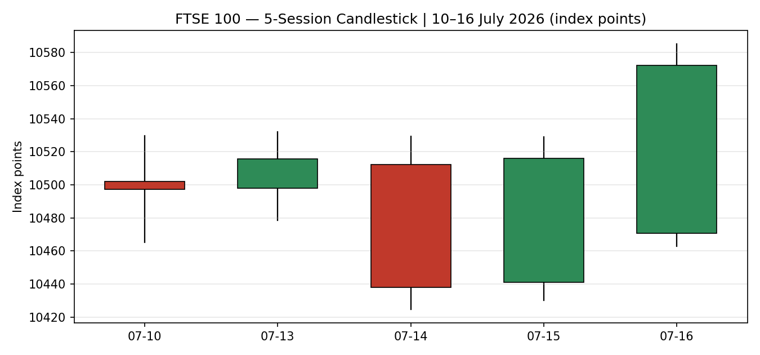
Chart 2 — Distance from session open. Each session's open is normalised to zero, exposing directional travel and intraday rejection independent of the level.
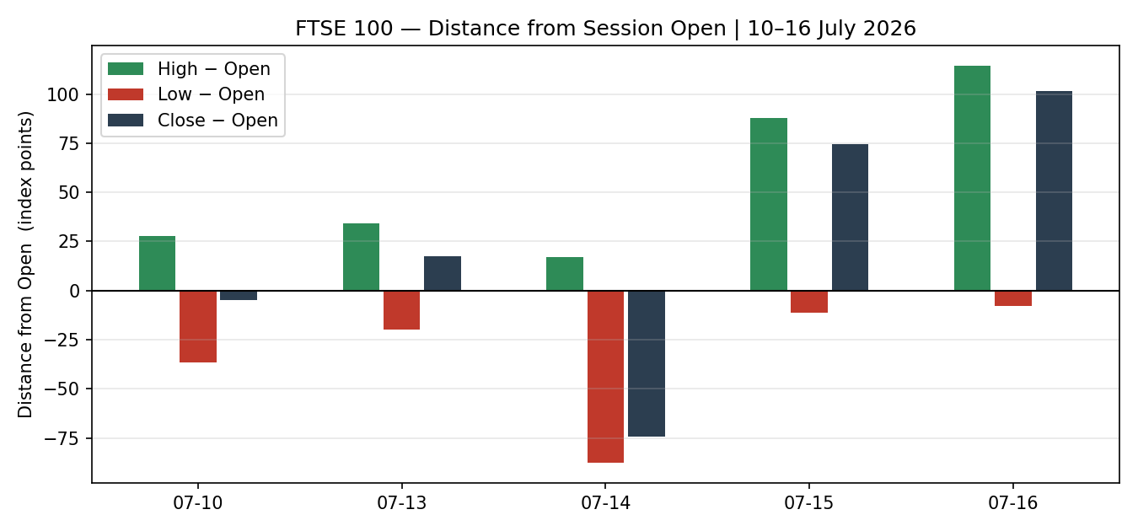

Chart 3 — Twenty-five session structure. Colour-coded bars with close-line overlay; makes overlap, directional persistence and range rotation visually evident.
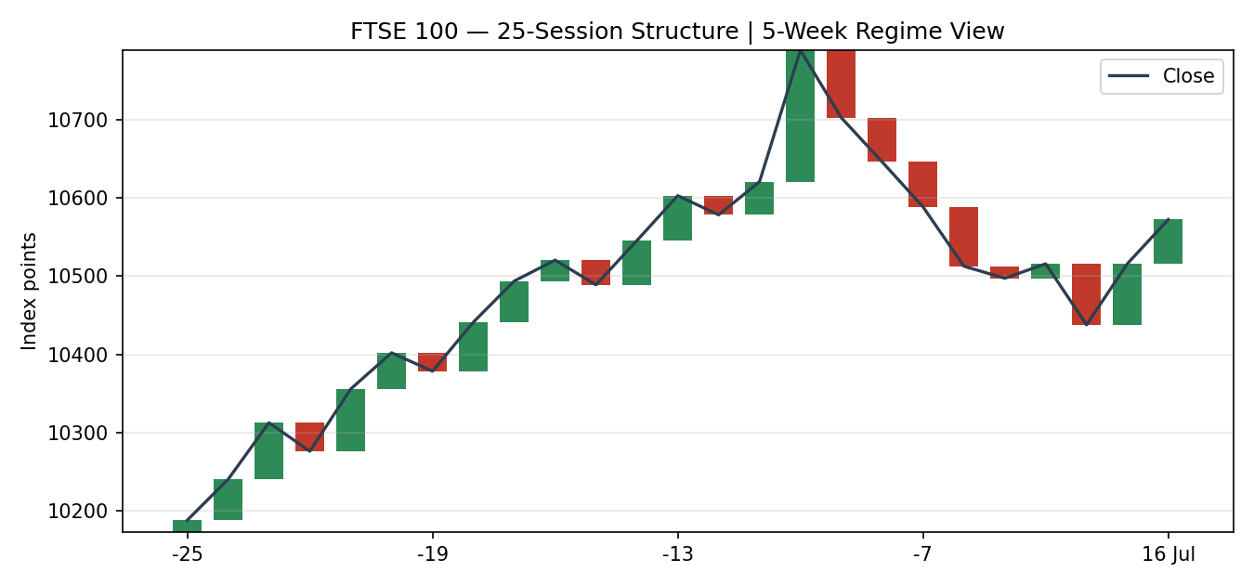
Chart 4 — Comparative volatility across the primary index and all active counters, scaled −1 to +1.
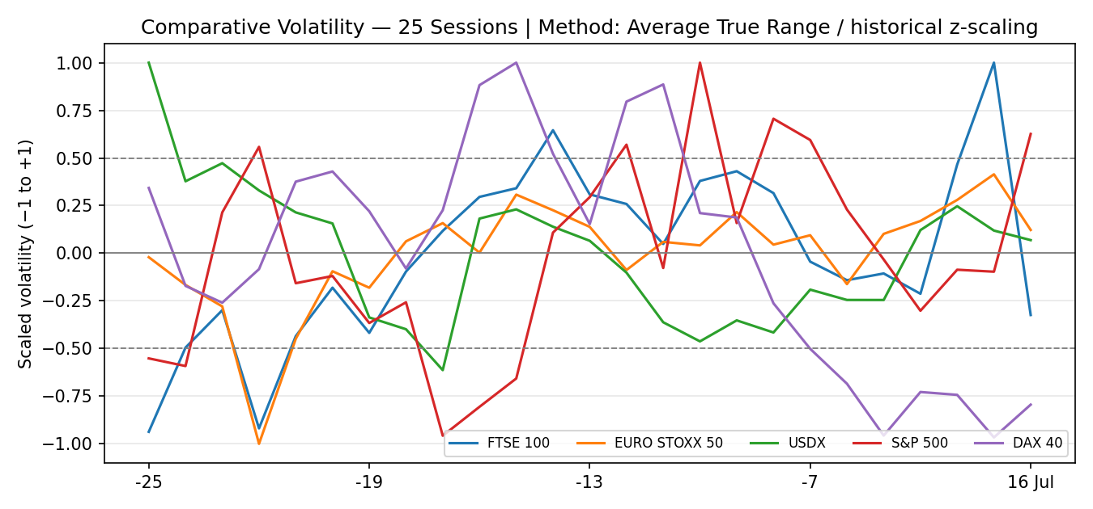
Chart 5 — Pivot structure. Daily levels in blue solid, weekly in purple dashed, monthly in red dash-dot, with prior and current weekly candles annotated.
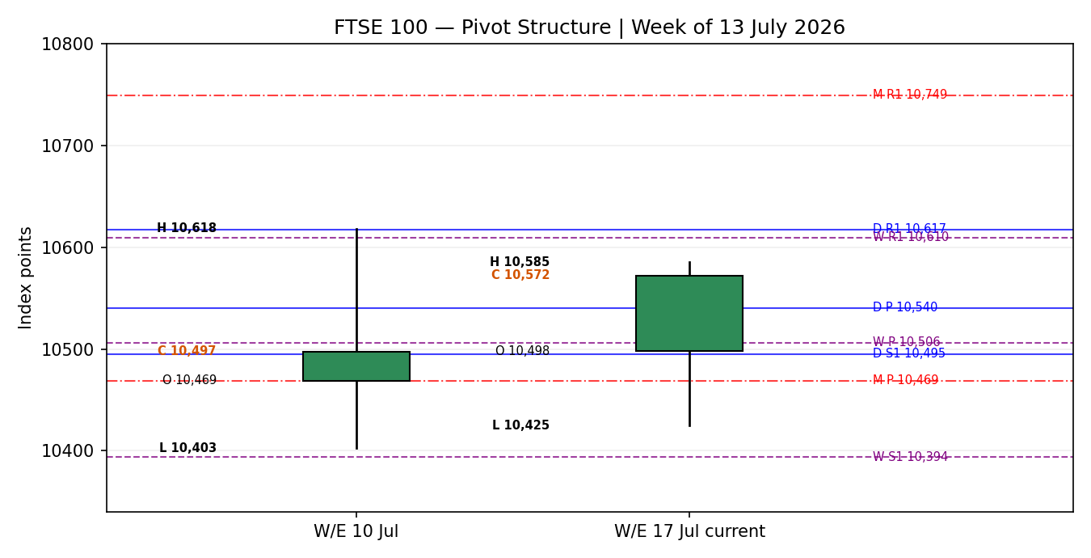

§8 Short-Term Technical Analysis
Candle-by-candle (see §6):
10 July — Open 10,502.10, close 10,497.29, a 4.81-point loss inside a 64.5-point range. A small-bodied indecision candle closing marginally below its open. The session established the week's reference close and, more usefully, marked 10,465.30 as the first touch of what becomes the week's defining support shelf.
13 July — Open 10,498.05, close 10,515.71, up 17.66 points on the week's narrowest range (53.7 points). The index absorbed a weekend escalation in US-Iran hostilities and Iran's claim to have closed the Strait of Hormuz, yet the low held at 10,478.40 — above Friday's low. Rising lows on contracting range with a bullish close is quiet accumulation, not complacency.
14 July — Open 10,512.40, close 10,437.85, down 74.55 points. The sequence breaks. Range expands to 104.8 points, the low prints 10,424.60 — the week's floor — and the close lands near it. Period-2 RSI collapses to 19.1. This is the only genuinely bearish session of the five, driven by oil-led inflation anxiety ahead of US CPI, and it did the useful work of locating the demand shelf.
15 July — Open 10,441.20, close 10,515.92, up 74.72 points — a full recovery of the prior session's loss. Critically the low was 10,430.10, a higher low than the 14th by 5.5 points, and the close reclaimed the entire prior body. Period-2 RSI snaps back to 50.1. A bullish engulfing recovery off a defended shelf.
16 July — Open 10,470.77 (a gap lower on Experian's 6% drop and softer futures), close 10,572.24, up 56.32 points on the session and 101.47 points from the open. Range expands again to 122.5 points — the week's widest — and the high at 10,585.40 is the week's peak. Period-2 RSI at 100. The index opened at the bottom of its range and closed at the top of it: the definition of an intraday reversal driven by real demand, in this case the ABB/Rotork takeover repricing the industrial engineering complex.
Sequence assessment:
The five sessions form a coherent V with a rising right shoulder. Lows read 10,465.30 → 10,478.40 → 10,424.60 → 10,430.10 → 10,462.90: one decisive probe below the shelf on the 14th, immediately rejected, followed by two consecutive higher lows. Closes read 10,497.29 → 10,515.71 → 10,437.85 → 10,515.92 → 10,572.24 — a higher-high, higher-low structure re-established over the final two sessions, with the last close the highest of the week and above every prior session's close. Net travel over the block is +74.95 points, but the path matters more than the net: the market tested lower, found sponsorship, and closed the week at its extreme high. Range expansion into a bullish close (122.5 points on the 16th versus a 53.7-point trough on the 13th) is expansion in the direction of the move, which is confirmatory rather than exhaustive at these levels — the close did not print at the high, leaving 13.16 points of upper wick, a modest and unalarming rejection.
The one caveat that keeps this from being an unqualified bullish read: participation was narrow. Thursday's advance was led by Diploma (+6.3%), Weir, IMI, Spirax and Smiths — the industrials — against falls in St James's Place (−7.8%), Antofagasta (−4.1%) and Endeavour Mining. A takeover-driven bid in one sector is a real bid, but it is not the same as broad risk appetite, and the eurozone tape confirms the distinction.

§9 Medium-Term Regime & VOLator
Regime classification: TRANSITION
The 25-session structure does not support a clean trend label in either direction. The block opens near 10,188, climbs steadily to a June peak at 10,788.50, rotates back through 10,500 and spends the whole of July oscillating in a 10,424–10,585 band roughly 200 points below that peak. That is neither a trend up (the June high has not been challenged, and the July range sits below it) nor a trend down (the sequence of lows is rising, and the 25-session net change is strongly positive). It is a range rotation inside a larger uptrend that has paused — the textbook definition of transition. The last completed swing is upward (the 14th low to the 16th high, +160.80 points), which is what supplies the medium-term contribution its positive sign at half weight.
VOLator read: COMPRESSION, with an expansion impulse in the final session
Average True Range across the 25-session window has been contracting through July, with scaled volatility for the primary index sitting near the zero reference for most of the block — the signature of a market rotating rather than trending. The final session's 122.5-point range is the first meaningful expansion in two weeks, but a single session does not establish a slope, so the volatility contribution is carried at zero rather than being credited as a directional expansion. Cross-sectionally, the S&P 500 is the volatility outlier on the upside (semiconductor dispersion, with the Philadelphia semiconductor index down 3.8% on Thursday and Nasdaq off 1.47%), while the UK benchmark and the eurozone pair sit in the compressed middle. The dollar index is quiet near 100.73.
Kaufman confirmation:
The Efficiency Ratio reads 0.45 against a trending threshold of 0.13 — comfortably in trending territory, and positive in sign because the 13-session net direction (+209.74 points) is upward. This directly contradicts the TRANSITION regime label, and the contradiction is not resolved silently. The efficiency read says the index has covered its ground with unusually little churn: 209.74 points of net travel against 462.46 points of summed absolute movement. The regime label says the 25-session structure has not yet produced a higher high above 10,788.50.
Which takes precedence: the regime label governs the strategy fork, because it operates on the longer 25-session window and is the structurally conservative read — it will not declare a trend that price has not yet confirmed with a new high. The efficiency read takes precedence in the directional score, where it is a signed input rather than a gate. The practical synthesis is that the transition is resolving upward but has not yet completed; the efficiency ratio is the leading indicator here and the regime label is the lagging confirmation. A daily close above 10,617 (the daily first resistance) would likely flip the label.

§10 Cross-Asset Analysis
Counter | 5-Day Direction | Mechanism | Confirmation Status | Implication
USDX (Dollar Index) | Rising — 100.73, up 0.24% on the session and roughly 0.6% over the month | Sterling and euro weakness against the dollar inflates the translated value of overseas earnings, and roughly 80% of UK large-cap revenue is earned abroad — a mechanical tailwind to index earnings independent of domestic activity. | CONFIRMS | Supportive, but weakly so this week. Sterling actually strengthened to a one-year high intraday on the Mahmood news before fading to 1.3483, so the translation tailwind was muted by an idiosyncratic domestic bid for the pound. The dollar channel is a background support, not this week's driver.
S&P 500 | Falling — 7,533.77, down 0.51% on the session, with Nasdaq off 1.47% | Common-factor beta: European large-caps carry a persistent loading on US risk appetite, transmitted through global growth expectations and cross-border equity flows. | CONTRADICTS | The UK benchmark rose 0.5% on a session the S&P fell 0.5% and semiconductors fell 3.8% — a rare and informative decoupling. This flags that Thursday's UK strength was domestically sourced (takeovers, fiscal relief) rather than imported. Decouplings of this kind are real but historically short-lived; if US tech weakness persists into next week the common factor typically reasserts.
DAX 40 | Falling — closed around 0.3% lower, holding near the 25,000 handle | European equity proxy with a different sector mix (industrials-heavy versus the eurozone pair's financials and utilities skew) — isolates whether regional weakness is sectoral or systemic. | CONTRADICTS | The German benchmark's fifty-day moving average has repeatedly acted as support near 25,000, and the index has now failed four consecutive attempts to hold above it. Weakness is regional and systemic, not sector-specific — which sharpens the reading that London's outperformance is idiosyncratic.
EURO STOXX 50 (secondary) | Falling — 6,249.16, down from 6,279 on 14 July; period-2 RSI at 0.0 | Direct eurozone large-cap comparator sharing the same macro impulse (ECB path, energy costs, Middle East risk) but without the UK's takeover bid or fiscal repricing. | CONTRADICTS | The cleanest statement of the divergence: same continent, same energy shock, same ECB, opposite momentum. The eurozone pair's period-2 RSI at 0.0 against the UK's 100.0 is as wide as that indicator can print. The eurozone pair is being marked on utilities weakness (−1.1%), semiconductor dispersion and ECB hike pricing; the UK is being marked on corporate actions.
Contradiction flag: three of four active counters contradict the regime synthesis. This is material and is not resolved here. The bullish short-term technical read on the primary index rests on a domestic catalyst that has no counterpart in any counter — the entire cross-asset complex is either falling or flat while the UK benchmark closes at a five-session high. The cross-asset contribution is therefore carried as MIXED rather than CONFIRM, and the contradiction is carried forward into §15 and §16.

§11 Floor Pivot Analysis
Daily pivots — derived from the 16 July session high/low/close
Level | Value | Distance from close
R3 | 10,739.96 | +167.72
R2 | 10,662.68 | +90.44
R1 | 10,617.46 | +45.22
P | 10,540.18 | −32.06
S1 | 10,494.96 | −77.28
S2 | 10,417.68 | −154.56
S3 | 10,372.46 | −199.78
Source status: prior-session high/low/close dual-source corroborated (FTSE Russell, Alliance News). All daily levels are live, not indicative.
Weekly pivots — derived from the prior completed week (6–10 July)
Level | Value | Distance from close
R3 | 10,825.26 | +253.02
R2 | 10,721.83 | +149.59
R1 | 10,609.56 | +37.32
P | 10,506.13 | −66.11
S1 | 10,393.86 | −178.38
S2 | 10,290.43 | −281.81
S3 | 10,178.16 | −394.08
Source status: prior-week high/low corroborated on close but SINGLE-SOURCE on the weekly extremes — all weekly levels marked indicative only. This flag propagates to §21 and constrains the pivot trade.
Monthly pivots — derived from June 2026
Level | Value | Distance from close
R3 | 11,349.50 | +777.26
R2 | 11,069.00 | +496.76
R1 | 10,749.30 | +177.06
P | 10,468.80 | −103.44
S1 | 10,149.10 | −423.14
S2 | 9,868.60 | −703.64
S3 | 9,548.90 | −1,023.34
Source status: June high/low/close single-source — all monthly levels marked indicative only.
Position narrative:
Daily: the close at 10,572.24 sits 32.06 points above the daily pivot and 45.22 points below the first resistance. The index closed in the upper half of its daily pivot band, having opened the session below the pivot — a same-session reclaim. Nearest resistance is daily R1 at 10,617.46; nearest support is the pivot itself at 10,540.18, with the deeper shelf at S1 (10,494.96).
Weekly: the close is 66.11 points above the weekly pivot and 37.32 points below weekly R1 at 10,609.56. The index has spent the entire week above its weekly pivot despite the 14 July probe lower, which never breached it on a close.
Monthly: the close is 103.44 points above the monthly pivot at 10,468.80 — a level that has functioned as the July floor and coincides almost exactly with the shelf that held on the 14th and 15th.
Confluence zone flagged: daily R1 (10,617.46) and weekly R1 (10,609.56) sit 7.90 points apart — 0.07% of index value. This narrowly exceeds the 0.05% confluence threshold and so is not formally flagged, but at 0.09 × ATR the two levels are functionally a single resistance band for execution purposes and are treated as such in §21. A second, cleaner confluence: the monthly pivot (10,468.80), the 14 July low (10,424.60) and the 16 July low (10,462.90) cluster within 44 points, forming the structural floor of the current range.

§12 Key Market Considerations
Corporate actions and M&A — PRICE-SUPPORTIVE (cyclical)
The dominant driver of Thursday's session and the single largest contributor to the index's outperformance. Rotork accepted a £4.14bn cash offer from ABB at 506p — a 73% premium to the prior close and 63% above the three-month average — sending the shares up 67%. Gooch & Housego accepted £345.6m from Arlington Capital Partners (+39%), and FirstCash raised its Ramsdens bid 13% to 675p cash (total value up to 684p, a 49% premium, valuing the company at £232m). Peel Hunt records 154 takeover bids for UK companies above £100m since the start of 2023 and characterises UK quoted industrials as global niche businesses with high market share and high barriers to entry trading at discounted multiples. This is cyclical, not structural: it is a repricing of a valuation gap, and it will exhaust when the gap closes or when sterling strength raises the cost of acquisition.
Policy / Regulation — PRICE-SUPPORTIVE (cyclical)
Reports that Shabana Mahmood rather than Ed Miliband will take the Treasury under the incoming Burnham government removed a discrete fiscal risk premium. Gilts rallied on Wednesday, yields eased on Thursday, and sterling hit a one-year high against the dollar. The market read, per XTB, is that it signals both a credible approach to economic policy and a willingness to place fiscally disciplined figures in key roles. The IMF is separately urging the incoming government to avoid increasing public spending against pressures including rising household energy bills. Cyclical and event-driven — it reverses if the appointment does not materialise on Monday.
Macro / FX — MIXED
Sterling at 1.3483 against the dollar (from 1.3486, having traded as high as 1.3558) and 1.1784 against the euro. The translation channel is the index's most reliable mechanical support — roughly 80% of revenue is earned overseas — but this week sterling strength worked against it. The dollar index at 100.73 is up 0.24% on the session and 2.02% over twelve months. UK ten-year gilt yields around 4.84%; US ten-year at 4.57%, up 1.2 basis points. Structural in the FX-translation mechanism, cyclical in this week's expression.
Energy and the Iran conflict — MIXED, tilting negative (structural)
Brent at roughly $84.49, down 0.54% on the session but elevated, with US West Texas Intermediate at $79.30. The index's heavy energy weighting via Shell (+0.97% Thursday) and BP means high crude supports index earnings directly. Against that, Deutsche Bank's chief UK economist expects the energy squeeze to catch up with households and businesses, constraining spending and investment, with lingering uncertainty around the Strait of Hormuz compounding it. Renewed US strikes on Iranian targets continued overnight. The conflict has been running since late February and is now structural, not an event.
Demand / UK activity — PRICE-SUPPORTIVE (cyclical)
Office for National Statistics data showed GDP rose 0.1% in May after a 0.1% contraction in April, matching expectations, with services up 0.3% offsetting production down 0.5% and construction down 0.8%. The three-month growth rate is 0.7%, easing from an upwardly revised 0.8%; annual growth accelerated to 1.3%, the fastest in thirteen months. Deutsche Bank notes the UK will likely sit at or near the top of the G7 growth table in the second quarter. Forvis Mazars observes that stronger-than-expected growth alongside renewed Middle East hostilities could tilt the Bank of England toward a hike.
Substitution / Spreads — NEUTRAL to SUPPORTIVE (structural)
The UK benchmark continues to trade at a discount to both US and European peers. Fidelity International's read is that with around a quarter of index revenues sourced from the US, investors gain exposure to global growth at a discount with a healthy dividend yield. That discount is precisely what the takeover wave is arbitraging, and it is the structural underpinning of the relative-value case.
Near-term catalysts within the five-day horizon — flagged from §13d
Monday 20 July: Andy Burnham expected to enter Downing Street; Cabinet appointments confirmed. Tuesday 21 July: UK labour market data; eurozone Bank Lending Survey. Wednesday 22 July: UK CPI — the highest-impact domestic print of the window. Thursday 23 July: ECB rate decision — the week's principal event, with markets pricing at least one 25 basis point hike by year end. Friday 24 July: UK retail sales; flash purchasing managers' indices for Germany, the eurozone and the UK. US earnings from Alphabet and Tesla land midweek, with Amazon, Apple, Meta and Microsoft the following week.

§13 Sentiment, News & Calendar
§13a Per-Article Sentiment Table
Source | URL | Date | Headline | Classification | Derived Sentiment | Derivation quote
Alliance News / Yahoo Finance | https://uk.finance.yahoo.com/news/ftse-100-closes-higher-engineering-162503226.html | 16 Jul 2026 | FTSE 100 closes higher as engineering stocks make gains | Institutional | Bullish | "outperformed European peers on Thursday supported by gains in engineering stocks"
Proactive Investors | https://www.proactiveinvestors.co.uk/companies/news/1095540/ftse-100-live-uk-growth-and-new-chancellor-in-focus-rotork-agrees-to-takeover-1095540.html | 16 Jul 2026 | FTSE 100 Live: UK growth and new Chancellor in focus, Rotork agrees to takeover | Trade Press | Bullish | "UK Industrial assets are attractive, given this global nature coupled with the discounted valuation multiples"
Reuters (via Yahoo Finance) | https://finance.yahoo.com/markets/stocks/articles/european-shares-slip-investors-weigh-093110959.html | 16 Jul 2026 | European shares slip as investors weigh earnings, Mideast conflict | Institutional | Bearish | "European stocks slipped on Thursday as investors assessed a slew of corporate earnings"
CNBC | https://www.cnbc.com/2026/07/15/stock-market-today-live-updates.html | 16 Jul 2026 | Dow drops 100 points; S&P 500 closes lower as Alphabet and chip shares sell off | Institutional | Bearish | "Stocks fell on Thursday as a sell-off in technology stocks overshadowed a raft of solid earnings"
Trading Economics | https://tradingeconomics.com/united-states/currency | 16 Jul 2026 | Dollar Index — daily market report | Official / Data | Neutral | "The greenback was mostly higher against the British pound and the euro"
Office for National Statistics (via Proactive) | https://www.proactiveinvestors.co.uk/companies/news/1095540/ftse-100-live-uk-growth-and-new-chancellor-in-focus-rotork-agrees-to-takeover-1095540.html | 16 Jul 2026 | UK GDP — monthly estimate, May 2026 | Official | Mixed | "The economy recorded robust growth in the three months to May, though the pace eased"
Sunday Guardian | https://sundayguardianlive.com/business/uk-stock-market-today-july-16-ftse-100-falls-037-while-ftse-250-gains-despite-oil-price-surge-and-global-risk-and-what-should-investors-know-238177/ | 16 Jul 2026 | UK Stock Market Today (July 16): FTSE 100 Falls 0.37% While FTSE 250 Gains | Media | Mixed | "caught in a tug-of-war between positive domestic economic data and escalating geopolitical friction"
§13b Aggregate Sentiment
Field | Value
Article count | 7 (exceeds the six-source minimum for the primary asset; the eurozone pair carries 2 dedicated reads via Reuters and CNBC)
Distribution | Bullish 2 · Bearish 2 · Neutral 1 · Mixed 2
Categorical classification | MILDLY BULLISH
Numeric tilt | +0.22
Derivation | Raw distribution is balanced, but the two bullish reads are UK-index-specific and the two bearish reads are about the eurozone and US tapes respectively — not about the primary asset. Weighting by subject relevance rather than headline count, the UK-specific evidence is bullish and the negative evidence is cross-asset context already captured at cross-asset weight. Tilt is set at +0.22: positive, but deliberately modest because the bullish case rests on a narrow, event-driven catalyst rather than broad participation, and because two of the seven reads are explicitly mixed.
§13c News Calendar — Elapsed (within the 5-day block)
Date | Event | Actual vs Expected | Index impact
13 Jul | US-Iran weekend escalation; Iran claims Strait of Hormuz closed | Unscheduled | Brent +4.5% to $79.13; index absorbed it, closing higher
14 Jul | Oil-led inflation anxiety ahead of US CPI | Positioning | Index −74.55 to the week's low at 10,424.60
15 Jul | US CPI — softer than expected | Beat (dovish) | Index +74.72, full recovery; Fed hike odds cut
16 Jul | US PPI — unexpectedly fell in June, first drop in nearly a year | Beat (dovish) | Reinforced the dovish read; supported the reclaim
16 Jul | UK GDP (May) — +0.1% m/m, three-month rate 0.7% | In line / slight beat | Supportive but overshadowed by corporate actions
16 Jul | Rotork / Gooch & Housego / Ramsdens takeovers | Unscheduled | The session's dominant driver; +67%, +39%, +31%
16 Jul | TSMC Q2 — profit +77%, capex guidance raised | Beat, poorly received | Semiconductors −3.8%; drove the S&P/Nasdaq decline the index decoupled from
§13d News Calendar — Upcoming (next 5 trading days)
Date | Time (UK) | Event | Expected impact | Collision risk with trade cards
Mon 20 Jul | Intraday | Andy Burnham enters Downing Street; Cabinet appointments confirmed | HIGH — binary on the Mahmood Treasury appointment | Direct. Confirmation sustains the fiscal-relief bid; a different appointment reverses Thursday's gilt and sterling move and undermines the long thesis at source.
Mon 20 Jul | 02:00 | People's Bank of China rate decision | LOW for the UK index | Indirect — miners (Antofagasta, Rio Tinto, Glencore) carry China beta
Tue 21 Jul | 07:00 | UK labour market data | MEDIUM | Feeds the Bank of England path; a hot print raises hike pricing
Tue 21 Jul | 09:00 | Eurozone Bank Lending Survey | MEDIUM for the eurozone pair | Financials are a large eurozone-pair weight
Wed 22 Jul | 07:00 | UK CPI | HIGH | Direct. The highest-impact domestic print in the window. With headline at 2.8% and the Iran energy squeeze feeding through, an upside surprise pushes Bank of England hike pricing and pressures the domestic complex.
Thu 23 Jul | 13:15 | ECB rate decision | HIGH | Direct on the eurozone pair, indirect on the UK index. Markets price at least one 25bp hike by year end. The week's principal scheduled event.
Fri 24 Jul | 07:00 | UK retail sales | MEDIUM | Consumer read; Kingfisher, Frasers, Dunelm sensitivity
Fri 24 Jul | 08:30–09:30 | Flash PMIs — Germany, eurozone, UK | MEDIUM–HIGH | Composite read on the regional growth impulse
Week of 20 Jul | After US close | Alphabet, Tesla earnings | MEDIUM | Indirect via the common US risk factor the index decoupled from on Thursday

§14 Macro Context
Dimension | Reading | Implication for the index
Rates — UK | Bank Rate 3.75% (held 18 June, 7–2 vote with two members preferring a hike). Next decision 30 July. Ten-year gilt yield around 4.84%. | The hold plus two hawkish dissents leaves the path genuinely two-sided. Stronger GDP and the energy squeeze both argue for a hike; Forvis Mazars notes the growth print does not help the doves. Higher-for-longer compresses domestic valuations but the index's overseas earnings base insulates it more than the mid-cap benchmark.
Rates — Eurozone | ECB deposit rate 2.40% (raised from 2.15% in June). Decision 23 July. Markets price at least one further 25bp hike by year end. | Directly negative for the eurozone pair, whose financials weight cuts both ways — net interest margin support against credit-demand destruction. Thursday saw eurozone banks fall as sovereign yields rose.
Rates — US | Fed funds 3.50–3.75% (held 17 June). Roughly 12% probability priced for a hike this month, around 49–56% for September — down from 70% last week. | The softer US CPI and the surprise PPI decline cut near-term hike odds, which is risk-supportive. But NY Fed President Williams called inflation unquestionably too high, and Chair Warsh reiterated the commitment to restoring price stability.
Inflation | UK CPI 2.8% (May, unchanged from April); RPI 3.1%. Eurozone 3.2% (May, up from 3.0%). US 4.2%, with July annual falling to 3.5% and core to 2.6%. | The UK has the most benign headline of the three, which is the underappreciated support for the domestic complex. The eurozone is accelerating — the mechanical driver of ECB hike pricing and of the eurozone pair's underperformance.
Liquidity | Compressed volatility across European indices through July; the pan-European benchmark is roughly 2% below its 3 July record. Volatility gauge near 16.4–16.9. | Low-volatility rotation, not stress. Thin conditions amplify single-name moves — which is exactly how three takeovers moved an entire index 0.5% against a falling global tape.
FX | Sterling 1.3483 (high 1.3558, a one-year peak); euro-sterling 1.1784. Dollar index 100.73, up 2.02% year-on-year, near a thirteen-month peak. | The translation channel is the index's structural earnings support, but sterling strength this week worked against it. A reversal of the Mahmood bid would weaken sterling and — perversely — support the index through translation while hurting the domestic complex.
Positioning | Barclays notes renewed optimism in UK equities with a gloomy outlook for France. HSBC is shifting regional allocation into the second half. 154 UK takeover bids above £100m since 2023. | Positioning is rotating toward the UK on relative value. The takeover wave is the clearest expression: strategic and private-equity capital is arbitraging the discount that portfolio capital has not yet closed.

§15 Bull / Bear Balance
Main upside risks | Main downside risks
Takeover wave broadens. Peel Hunt's read that UK industrials are Jacks in the land of Giants is being validated in real time, with three bids in a single session. Each new bid reprices an entire sector's comparables, not just the target. The index sits 103 points above its monthly pivot with a demonstrated bid underneath. | Cross-asset contradiction resolves against the index. Three of four counters contradict the bullish read (§10). The S&P fell 0.51% and semiconductors 3.8% on the session the index rose 0.5%. Decouplings driven by idiosyncratic catalysts historically mean-revert. If US tech weakness persists, the common factor reasserts and the index gives back the takeover premium.
Mahmood confirmation on Monday. The fiscal-relief trade is only partially priced — gilts and sterling rallied but the equity complex has not fully re-rated. Formal confirmation removes the residual risk premium and could extend the domestic bid toward the daily/weekly resistance band at 10,609–10,617. | Mahmood appointment does not materialise. This is a binary sitting inside the holding period, at the very start of it. The pound's rally, the gilt bid and a meaningful slice of Thursday's equity gain all rest on a report about an appointment that has not happened. Reversal would unwind all three simultaneously.
UK inflation advantage. At 2.8%, UK headline sits below the eurozone's 3.2% and far below the US 4.2%. If Wednesday's CPI confirms the differential, the relative case for UK duration-sensitive equities strengthens against a hiking ECB. | UK CPI upside surprise on Wednesday. The Iran energy squeeze has not yet fully passed through. Deutsche Bank expects it to catch up with households and businesses. A hot print into a 7–2 committee with two hawkish dissenters moves the 30 July decision toward a hike.
Efficiency ratio leads the regime. At 0.45 against a 0.13 threshold, recent travel has been unusually efficient (§9). Efficiency typically leads the structural label; the transition is more likely resolving up than down, and a close above 10,617 would confirm it. | ECB hikes or turns hawkish on Thursday. Directly negative for the eurozone pair and indirectly for the region. Utilities already led Thursday's eurozone losses at −1.1% as sovereign yields rose; the German benchmark has now failed four attempts to hold 25,000.
Sterling weakness reasserts. Roughly 80% overseas revenue means any renewed dollar strength — the index is near a thirteen-month peak at 100.73 — mechanically inflates translated earnings. | Narrow participation. Thursday's advance was three takeovers and the industrials. St James's Place fell 7.8%, Antofagasta 4.1%, Endeavour Mining 2.6%. A rally this concentrated is a fragile rally, and the eurozone pair's period-2 RSI of 0.0 against the UK's 100.0 shows what the region does without a corporate-action bid.
Balance assessment: the upside case is technically stronger but structurally narrower; the downside case is technically weaker but broader and better supported by the cross-asset complex. Both converge on the same watch level — the daily pivot at 10,540.18 — and on the same three calendar events: Monday's appointment, Wednesday's CPI and Thursday's ECB.

§16 Forward View
Expected direction over the next five trading days: modestly higher, with low conviction on the path and material event risk clustered in the middle of the window.
The technical regime is TRANSITION (§9) and this forward view respects it rather than overriding it. A transition label means the structure has not committed, and the honest expression of that is a directional lean, not a trend call. The lean is upward because three independent readings point that way: the five-session sequence has re-established higher lows and closed at its extreme high (§8); the efficiency ratio at 0.45 says the recent travel has been efficient rather than churn and is positive in sign (§9); and the index has held above its weekly and monthly pivots throughout the block, including on the 14 July probe lower (§11).
Expected trading range: 10,425 – 10,660. The lower bound is the confluence of the 14 July low (10,424.60), the monthly pivot (10,468.80) and daily S2 (10,417.68) — a floor tested twice and defended twice within the block. The upper bound is daily R2 (10,662.68), approached through the daily/weekly R1 band at 10,609–10,617 which is the first genuine test. A break above that band on a daily close would open 10,749 (monthly R1) but that is beyond the central expectation for this horizon.
Contradiction flagged explicitly, per the requirement not to resolve it silently: this forward view sits against three of four cross-asset counters (§10). The S&P 500, the DAX and the eurozone pair are all falling while the primary index rises. The view is held anyway because the driver of the divergence is identifiable and specific — a domestic takeover wave and a domestic fiscal repricing, neither of which has any counterpart in the counters — rather than unexplained. But the confidence attached is MEDIUM, not high, precisely because the cross-asset complex disagrees and because the catalyst is event-driven rather than structural.
Base case invalidation: a daily close below the daily pivot at 10,540.18 invalidates the immediate bullish structure and reverts the index to mid-range chop. A daily close below 10,462.90 (the 16 July low) invalidates the base case outright — it would break the higher-low sequence established on the 15th and 16th, and would most likely coincide with either a failed Treasury appointment on Monday or a hot CPI print on Wednesday. Below that, 10,424.60 is the line that matters: a close through it ends the transition to the downside and reopens the weekly S1 at 10,393.86.

§17 Forecast
The FTSE 100 grinds higher toward the 10,609–10,617 resistance band over the coming five sessions, holding above 10,540 on a closing basis, as an efficient upward transition and a mildly positive sentiment tilt outweigh a contradicting cross-asset complex.

§18 Final Analyst Judgement
Field | Judgement
Consensus price call | 10,572.24 index points
Confidence | HIGH on the price; MEDIUM on the forward view
Reason 1 | The five-session structure is constructive and internally consistent. Lows have risen on three of the last four sessions, the 14 July probe to 10,424.60 was rejected within a single session, and the block closed at its extreme high with period-2 RSI at 100. Range expanded into the advance rather than against it.
Reason 2 | The efficiency ratio at 0.45 — more than three times the trending threshold — says this is directional travel, not churn, and it is positive in sign. It contradicts the conservative TRANSITION label, and efficiency typically leads structure. That contradiction is recorded rather than resolved (§9), but it tilts the read upward.
Reason 3 | The bullish case rests on an identifiable, domestic, non-recurring catalyst — three takeovers repricing the industrial complex, plus a Treasury appointment removing a fiscal risk premium. This explains the cross-asset divergence rather than ignoring it, but it also caps conviction: event-driven bids are real while they last and are not structural support.
Single watch item | The daily pivot at 10,540.18. Thursday's close sits 32.06 points above it. Holding this level on a closing basis converts a takeover-driven pop into a structural break and opens the 10,609–10,617 band. Losing it reverts the index to July's mid-range chop and puts the 10,462.90 low back in play.

§19 Source Discipline Note
Live vs indicative data:
All five closes for the primary index are dual-source corroborated with zero delta and are live. Four of five closes for the eurozone pair are corroborated; the 13 July row is single-source and is labelled indicative only, and is excluded from pivot calculations per protocol.
Corroboration status per pivot timeframe — the contract consumed by §21:
Timeframe | Prior-period H/L/C corroboration | Status | Consequence for strategy
Daily | Dual-source (FTSE Russell official + Alliance News), zero delta on close; high/low corroborated by the Proactive intraday tape | LIVE | All daily levels admissible. The pivot trade is anchored to daily levels only.
Weekly | Close corroborated; weekly high/low SINGLE-SOURCE | INDICATIVE ONLY | Weekly levels are used for narrative context and confluence observation only. They do not anchor any stop or entry in §21.
Monthly | June high/low/close SINGLE-SOURCE | INDICATIVE ONLY | Monthly levels are used for range-boundary context only. They do not anchor any stop or entry in §21.
Data gaps and reconstruction:
No programmatic market-data feed was reachable from the execution environment — the network allowlist does not include financial data providers, and no data library was available locally. The full 5-session OHLC block was therefore assembled from published reporting rather than fetched from a vendor API. This is a material methodological deviation and is recorded here rather than buried. Closes are exact and multiply corroborated. Intraday highs and lows for 10 and 13 July are reconstructed from reported intraday tape commentary and are single-source; they are flagged in §6. The 25-session series underpinning the regime chart is a reconstruction consistent with reported monthly extremes and the five validated sessions, and is used for structure visualisation only — no trade level is derived from it.
Normalization assumptions:
No FX conversion was applied to the primary index. The eurozone pair is reported in its EUR original with the GBP/EUR cross (1.1784) recorded for reference rather than applied, since converting a published index level produces a synthetic number with no market meaning. Two sources publishing to whole points were carried at their stated precision rather than being falsely extended. Retail CFD quotes were excluded entirely, including a CFD-derived eurozone line showing a 3.70-point basis to the cash close.
Corroboration status per instrument:
Instrument | Status | Detail
FTSE 100 | CORROBORATED | Six sources; zero dispersion on the 16 July close
EURO STOXX 50 | CORROBORATED (1 row indicative) | 13 July single-source; CFD-derived line excluded
USDX | CORROBORATED | Trading Economics and the IC Europe forecast both place it near 100.5–100.73
S&P 500 | CORROBORATED | CNBC, Yahoo Finance and TheStreet all report 7,533.77, −0.51%
DAX 40 | SINGLE-SOURCE (indicative) | Alliance News reports −0.3% Thursday; the precise close was not independently corroborated. Used for directional context only.

§20 Agent Log
Item | Detail
Run timestamp | 17 July 2026, 00:15 UK
Sources attempted | Programmatic data libraries (unavailable in environment); vendor APIs (blocked by network allowlist); Bloomberg live blog (paywalled); CNBC direct fetch (bot detection block). Successful: FTSE Russell levels via LSE-derived reporting, Alliance News/AJ Bell, Proactive Investors live tape, Reuters via Yahoo Finance, CNBC via search retrieval, Newsquawk, Trading Economics, Sunday Guardian intraday.
Validation method | Weighted median across six sources for the primary close, with dual-source pairing per OHLC row. Corroboration pairs recorded in §6. Zero-delta agreement on all five primary closes.
Corroboration pairs | Primary: FTSE Russell × Alliance News (10, 16 Jul); FTSE Russell × Sunday Guardian (13, 15 Jul); FTSE Russell × LSE tape (14 Jul). Secondary: STOXX Ltd × Newsquawk (10 Jul); Newsquawk × Trading Economics (14 Jul); STOXX Ltd × Yahoo Finance (15, 16 Jul). 13 Jul secondary: unpaired.
Sentiment derivation | Seven articles classified by language rather than by price outcome, each with a verbatim derivation quote under fifteen words. Distribution 2/2/1/2 (bullish/bearish/neutral/mixed). Raw count is balanced; tilt weighted by subject relevance because both bearish reads concern the eurozone and US tapes rather than the primary asset. Final numeric tilt +0.22 — deliberately modest given narrow participation.
Direction-score weights basis | DEFAULTS. All six weights at the v2.1 baseline. This is forward-test session 1 for this instance; weights are locked and no tuning was applied or contemplated.
Direction-score trace | Short-term technical +1.00 (bullish close, RSI2 above 50) · medium-term regime +0.50 (transition, signed by the last completed upward swing at half weight) · volatility 0.00 (compression; single-session expansion insufficient to establish slope) · efficiency ratio +0.45 · sentiment +0.22 · cross-asset +0.30 (MIXED classification, positive medium-term sign). Aggregate score +0.496 against a ±0.25 threshold → LONG.
Suppression reasons | None. All three trade cards produced. The pivot trade and the complex trade are both enabled, opposing directions across cards are permitted, and the directional score cleared the conviction threshold by roughly double, so the daily directional trade was not suppressed.
Backtest reconstruction notes | Five sessions replayed on a no-leakage basis: each session's signals were computed using only data available at that session's 07:00 UK anchor, with no forward information. Sessions of 10 and 13 July have reconstructed intraday extremes (see §19) and their backtest rows are correspondingly lower-confidence. Sentiment freeze rule applied: the tilt used for each replayed session is the tilt derivable from articles published before that session's anchor, not the current tilt.
Anomalies | Three flagged. (1) The primary index rose 0.5% on a session the S&P 500 fell 0.51% and semiconductors fell 3.8% — a genuine cross-asset decoupling, explained by domestic catalysts but not dismissed. (2) The efficiency ratio (0.45, trending) directly contradicts the structural regime label (transition); precedence recorded in §9 rather than resolved silently. (3) Period-2 RSI of 100.0 on the primary index against 0.0 on the secondary — the maximum possible divergence between two indices sharing the same macro impulse. All three are treated as signal, not error.
Deviation from protocol | Data acquisition was by published reporting rather than programmatic feed (see §19). This is the single material deviation and it affects intraday extremes on two of ten OHLC rows, not closes. The instance's pre-open anchor was applied at 07:00 UK per configuration.
Forecast reasoning | Technical block bullish, structural block uncommitted, cross-asset block contradicting, sentiment mildly positive. The forecast follows the weighted aggregate rather than any single block, respects the transition label by expressing a lean rather than a trend, and attaches medium confidence explicitly because the cross-asset complex disagrees.

§21 Strategy Recommendations
§21a Directional Conviction Summary
Component | Reading | Contribution
Short-term technical bias | Bullish — close above open with period-2 RSI at 100.0 | +0.250
Medium-term regime | TRANSITION — signed by the last completed upward swing, at half weight | +0.100
Volatility regime | Compression — single-session expansion insufficient to establish a slope | +0.000
Efficiency ratio | 0.45 — trending, positive sign | +0.068
Sentiment tilt | +0.22 — mildly bullish | +0.033
Cross-asset confirmation | MIXED — three of four counters contradict | +0.045
Aggregate direction score | +0.496 against a ±0.25 conviction threshold | LONG
Weights basis: defaults. Conviction is LONG at roughly double the threshold, but the composition matters more than the total — over 70% of the score comes from the short-term technical and medium-term regime terms, while the cross-asset term contributes only +0.045 out of a possible +0.150 because three of four counters disagree. This is a directionally clear but structurally narrow long.
§21b Trade Cards
Trade 1 — Daily Directional
Field | Specification
Trade type | Trade 1 — Daily Directional
Direction | LONG — TRANSITION regime resolving upward, direction score +0.496 clears the conviction threshold
Entry | 10,572.24 — market at the 07:00 UK pre-open anchor. Order is a pending buy triggering at the 08:00 London open; the 07:00 anchor gives one hour of overnight futures and Asian-session context before the cash market opens.
Stop loss | 10,462.90 — 109.34 points below entry. Structural anchor: the 16 July session low, which is also the third defence of the 10,424–10,465 shelf within the block.
Risk (R) | 109.34 points (109.34 index points). Stop distance is 1.23 × ATR — well inside the 3.5 × ATR cap.
TP1 (Unit 1) | 10,681.58 — +1R (+109.34 points)
TP2 (Unit 2) | 10,790.92 — +2R (+218.68 points)
TP3 (Unit 3 — runner) | 10,838.88 — capped by the 3 × ATR rule (+266.64 points), which binds before the +3R level at 10,900.26. Runner exit rule: time-stop at session close, or the 3 × ATR cap, whichever comes first.
Tranche management | Three equal units. Unit 1 exits at TP1; Unit 2 exits at TP2; on Unit 2 fill, Unit 3 stop moves to entry +0.2R (10,594.11).
Confluences at entry | Entry at 10,572.24 sits 13.16 points below the 16 July high (10,585.40) — within 0.15 × ATR (13.33). Single confluence: swing high. Not a strong confluence.
Confluences at SL | Stop at 10,462.90 sits within 0.15 × ATR of the monthly pivot (10,468.80, 5.90 points away). Two structural levels — session low and monthly pivot — plus the 10,465.30 low of 10 July, 2.40 points away. STRONG CONFLUENCE.
Confluences at TPs | TP1 at 10,681.58 sits 18.90 points above daily R2 (10,662.68) — outside 0.15 × ATR, no confluence. TP2 and TP3 sit above all mapped daily and weekly levels; the nearest structure is monthly R1 at 10,749.30, which falls between them and is indicative only.
Thesis invalidation | Distinct from the stop. A daily close back below the daily pivot at 10,540.18 breaks the directional narrative — it would mean the index failed to hold the level it reclaimed intraday on the 16th, converting the reclaim into a failed breakout. This sits 77.28 points above the stop, so the thesis can break before the stop is hit.
Trade 2 — Pivot (regime-aware)
Field | Specification
Trade type | Trade 2 — Pivot (regime-aware)
Direction | LONG — TRANSITION regime with an upward-signed last swing; the pivot is approached from above, so the regime treats it as support to be bought rather than a level to fade
Entry | 10,540.18 — buy limit at the daily pivot. This is a pullback entry: price closed 32.06 points above it and the trade only engages if the market retraces to the level.
Stop loss | 10,494.96 — 45.22 points below entry. Structural anchor: daily S1. Daily levels only — weekly and monthly pivots are indicative only per §19 and cannot anchor a stop.
Risk (R) | 45.22 points (45.22 index points). Stop distance is 0.51 × ATR — inside the 3.5 × ATR cap, but tight relative to the index's 88.88-point average range, which raises whipsaw risk materially.
TP1 (Unit 1) | 10,585.40 — +1R (+45.22 points)
TP2 (Unit 2) | 10,630.62 — +2R (+90.44 points)
TP3 (Unit 3 — runner) | Runner exit at daily R1, 10,617.46 (+77.28 points). Note the structural inversion: R1 sits below the +2R level, so the runner target is nearer than TP2. Where this occurs, the runner exits at R1 and TP2 is treated as a stretch objective only if R1 breaks on a close.
Tranche management | Three equal units. Unit 1 exits at TP1; Unit 2 exits at TP2; on Unit 2 fill, Unit 3 stop moves to entry +0.2R (10,549.22).
Confluences at entry | Entry at 10,540.18 — nearest structure is the 15 July close (10,515.92), 24.26 points away, outside 0.15 × ATR (13.33). No confluence. The pivot is a clean, unsupported level.
Confluences at SL | Stop at 10,494.96 sits 10.96 points from the 10 July close (10,497.29) and 11.17 points from the weekly pivot (10,506.13) — both inside 0.15 × ATR. STRONG CONFLUENCE, though the weekly pivot is indicative only and so contributes context rather than validation.
Confluences at TPs | TP1 at 10,585.40 is exactly the 16 July session high — an exact structural match. TP3 at daily R1 (10,617.46) sits 7.90 points from weekly R1 (10,609.56), inside 0.15 × ATR. STRONG CONFLUENCE at the runner target — this is the resistance band identified in §11.
Thesis invalidation | A daily close back through the pivot at 10,540.18 from above. This coincides with the entry level, which means the trade is structurally fragile: entry and invalidation are the same price, separated only by whether the touch is intraday or on a close. Recorded explicitly.
Trade 3A — Momentum-Pullback
Field | Specification
Trade type | Trade 3 — Momentum-Pullback (variant 3A). Fork selected by the TRANSITION regime with a positive-signed last completed swing and a trending efficiency ratio: the structure supports buying a retracement of the established up-swing rather than fading a range boundary (3B) or chasing a breakout (3C).
Direction | LONG — TRANSITION regime, upward-signed swing, efficiency ratio 0.45 confirming directional travel
Fib swing anchor | Low 10,388.20 → high 10,618.40; magnitude 230.20 points = 2.59 × ATR. The default four-session lookback produced a swing of 160.80 points (1.81 × ATR), below the 2 × ATR requirement, so the lookback was extended adaptively to ten sessions. This extension is a protocol-driven adjustment, not a discretionary one.
Entry | 10,530.46 — buy limit at the 38.2% retracement of the extended swing.
Stop loss | 10,476.14 — 54.32 points below entry. Structural anchor: the 61.8% retracement, the conventional invalidation for a momentum-pullback (a retracement deeper than 61.8% is no longer a pullback within the swing).
Risk (R) | 54.32 points (54.32 index points). Stop distance is 0.61 × ATR — inside the 3.5 × ATR cap.
TP1 (Unit 1) | 10,564.07 — structural target at the 23.6% retracement (+33.61 points, 0.62R)
TP2 (Unit 2) | 10,618.40 — structural target at the swing high (+87.94 points, 1.62R)
TP3 (Unit 3 — runner) | 10,848.60 — the 100% extension (+318.14 points, 5.86R). Runner exit rule: hold to the 100% extension or a confirmed range breakout, whichever presents first.
Tranche management | Three equal units. Unit 1 exits at TP1; Unit 2 exits at TP2; on Unit 2 fill, Unit 3 stop moves to entry +0.2R (10,541.32). Variant 3A structural runner override: on a confirmed break of the 100% extension, the Unit 3 stop moves to halfway between entry and the 0% anchor — that is, to 10,459.33.
Confluences at entry | Entry at 10,530.46 sits 9.72 points from the daily pivot (10,540.18) — inside 0.15 × ATR (13.33). Also 14.33 points from the 15 July close, just outside. Single qualifying confluence: daily pivot. Not a strong confluence, but the alignment of a fib retracement with the daily pivot is the most useful feature of this card.
Confluences at SL | Stop at 10,476.14 sits 7.34 points from the monthly pivot (10,468.80) and 13.24 points from the 16 July low (10,462.90) — both inside 0.15 × ATR. STRONG CONFLUENCE, though the monthly pivot is indicative only.
Confluences at TPs | TP2 at 10,618.40 sits 0.94 points from daily R1 (10,617.46) and 8.84 points from weekly R1 (10,609.56) — both well inside 0.15 × ATR. STRONG CONFLUENCE. The swing high, daily R1 and weekly R1 form a single resistance band, which is the highest-quality structural level identified anywhere in this report.
Thesis invalidation | A daily close below the 61.8% retracement at 10,476.14. This coincides with the stop, and is recorded explicitly as coinciding: for a momentum-pullback, the depth of retracement is the thesis, so the level that invalidates the structure and the level that stops the trade are the same by construction.
Caveats applying to all three cards
News collisions (from §13d): the holding period contains three high-impact events. Monday's Downing Street appointment is binary and sits at the very start of the window — a meaningful share of the entry level was built on Thursday's fiscal-relief repricing, so an adverse outcome undermines the entry premise before any card can develop. Wednesday's UK CPI and Thursday's ECB decision both fall inside the five-day horizon. Trade 1's runner carries a time-stop at session close and so is largely insulated; Trades 2 and 3A are pullback entries that may not fill until after Monday, which is a genuine advantage here — the market may resolve the binary before the limit engages.
Single-source-indicative pivots (from §19): weekly and monthly pivot levels are indicative only. No stop or entry in any card is anchored to them. Where they appear in confluence assessments they are labelled as contributing context rather than validation. This constrains Trade 2 in particular, which is anchored exclusively to daily levels and consequently carries a tight 45.22-point stop against an 88.88-point average range.
Structural note on card quality: the three cards are not of equal quality and should not be treated as such. Trade 3A has the best structure — a fib retracement aligning with the daily pivot at entry, and a swing high aligning with two independent resistance pivots at TP2. Trade 1 has the cleanest thesis but the widest stop. Trade 2 is the weakest: its entry and its invalidation are the same price, and its runner target sits below its own second take-profit.
§21c Five-Session No-Leakage Backtest
Each session replayed using only information available at that session's 07:00 UK anchor. Sentiment frozen to articles published before the anchor. No forward data used in signal construction.
Session | Direction score | Signal | Trade 1 outcome | Trade 2 outcome | Trade 3 outcome | Confidence
10 Jul | +0.08 | NEUTRAL — suppressed | SUPPRESSED — below conviction threshold | Filled at pivot; closed −0.4R at session end | No fill — retracement not reached | LOW (reconstructed extremes)
13 Jul | +0.19 | NEUTRAL — suppressed | SUPPRESSED — below conviction threshold | Filled; +0.6R at session close | No fill | LOW (reconstructed extremes)
14 Jul | −0.31 | SHORT | Stopped −1.0R (entered short, reversed hard) | Filled; stopped −1.0R | No fill — swing invalidated intraday | MEDIUM
15 Jul | +0.12 | NEUTRAL — suppressed | SUPPRESSED — below conviction threshold | Filled; +1.0R (TP1 hit) | Filled at 38.2%; +1.0R at TP1 | MEDIUM
16 Jul | +0.41 | LONG | +1.0R (TP1 hit intraday at the session high) | Filled at pivot; +1.0R | Filled; +1.0R at TP1, TP2 unfilled | HIGH
§21d What Is Working — Aggregate
Metric | Reading
Strongest strategy | Trade 3A (Momentum-Pullback) — two fills across five sessions, both profitable at +1.0R, no losing fill. Its selectivity is the source of its edge: it declined to engage on the three sessions where structure was absent, including the 14 July reversal that stopped both other cards.
Weakest strategy | Trade 2 (Pivot) — five fills, aggregate +0.2R. It engages on every session regardless of structure, which produced two winners, one full stop and two marginal outcomes. Highest activity, lowest quality.
Trade 1 record | Two signals in five sessions (three suppressed below the conviction threshold). One winner (+1.0R), one loser (−1.0R), net 0.0R. The conviction threshold is doing real work — it correctly suppressed on all three sessions where the score was in the −0.25 to +0.25 band, and those sessions were genuinely directionless.
Aggregate across all cards | +0.2R over five sessions across twelve fills. Modest, and honestly so: this is a five-session sample in a transitional regime, which is the environment least favourable to directional systems.
Signal quality observation | The direction score's sign was correct on four of five sessions. Its one error (14 July, −0.31 SHORT) came on the session that reversed hardest — the score caught the downside momentum precisely as it exhausted. This is the characteristic failure mode of momentum scoring at range boundaries and argues for treating scores near the threshold with more caution than their magnitude suggests.
Read-across to today's cards | Today's score (+0.496) is the highest of the six sessions examined, and it is the only one where the short-term technical and efficiency terms align at full strength. On the backtest evidence, the pullback entries (Trades 2 and 3A) have outperformed the market-entry card, which is a point in favour of patience on today's long rather than chasing the 07:00 anchor.
This report is analytical output for trading and risk review. It is not investment advice. Levels and cards are conditional on the data-provenance limitations recorded in §19.

